Insect pests of citrus in Bangladesh

Sl. No. | Name of Crops | Name of insect pests | Scientific name | Status
1 | Lemon (Elachi lebu) | Lemon butterfly | Papilio demoleus L. | Major
 |  | Lemon butterfly | Papilio polytes L. | Minor
 |  | Citrus Leaf miner | Phyllocnistis citrella St. | Major
 |  | Citrus red scale | Aonidiella aurantii Maskel | Minor
 |  | Citrus yellow scale | Aonidiella citrina Coq. | Minor
 |  | Citrus mealy bug | Pseudococcus filamentosus Cockrell | Minor
 |  | Citrus mealy bug | Pseudococcus citri (Risso) | Minor
 |  | Citrus mealy bug | Pseudococcus virgatus Cockrell | Minor
 |  | Citrus psyllid bug | Diaphornia citri Kuwayana | Minor
 |  | Citrus aphid | Toxoptera aurantii Boyer de Fonscolombe | Minor
 |  | Citrus blackfly | Aleurocanthus woglumi Ashby | Minor
 |  | Citrus whitefly | Dialeurodes citri Ashmead | Minor
 |  | Citrus leaf folder | Psorosticha zizyphi Stainton | Minor
 |  | Bark and stem borer | Indarbela quadrinotata (Walker) | Minor
 |  | Citrus stem borer | Chelidonium cinctum Guerin-Meneville | Minor
 |  | Thrips | Scirtothrips citri Moulton | Minor
 |  | Termite | Odontotermes obesus Rambur | Minor
 |  | Citrus red mite | Tetranychus spp. | Minor
2 | Lime (Kagozi lebu) | Lemon butterfly | Papilio demoleus L. | Major
 |  | Lemon butterfly | Papilio polytes L. | Minor
 |  | Citrus Leaf miner | Phyllocnistis citrella St. | Major
 |  | Citrus red scale | Aonidiella aurantii Maskel | Minor
 |  | Citrus yellow scale | Aonidiella citrina Coq. | Minor
 |  | Citrus mealy bug | Pseudococcus filamentosus Cockrell | Minor
 |  | Citrus mealy bug | Pseudococcus citri (Risso) | Minor
 |  | Citrus mealy bug | Pseudococcus virgatus Cockrell | Minor
 |  | Citrus psyllid bug | Diaphornia citri Kuwayana | Minor
 |  | Citrus blackfly | Aleurocanthus Woglumi Ashby | Minor
 |  | Citrus Leaf folder | Psorosticha zizyphi Stainton | Minor
 |  | Bark and stem borer | Indarbela quadrinotata (Walker) | Minor
 |  | Thrips | Scirtothrips citri Moulton | Minor
 |  | Termite | Odontotermes obesus Rambur | Minor
 |  | Citrus red mite | Tetranychus spp. | Minor
3 | Mandarin (Kamala) | Lemon butterfly | Papilio demoleus L. | Minor
 |  | Lemon butterfly | Papilio polytes L. | Minor
 |  | Citrus Leaf miner | Phyllocnistis citrella St. | Major
 |  | Citrus red scale | Aonidiella aurantii Maskell | Minor
 |  | Citrus yellow scale | Aonidiella citrina Coq. | Minor
 |  | Citrus mealy bug | Pseudococcus filamentosus Cockrell | Minor
 |  | Citrus mealy bug | Pseudococcus citri (Risso) | Minor
 |  | Citrus mealy bug | Pseudococcus virgatus Cockrell | Minor
 |  | Citrus psyllid bug | Diaphornia citri Kuwayana | Minor
 |  | Orange fruitfly | Bactrocera dorsalis Hendel | Major
 |  | Citrus aphid | Toxoptera aurantii Boyer de Fonscolombe | Minor
 |  | Citrus black fly | Aleurocanthus woglumi Ashby | Minor
 |  | Citrus leaf folder | Psorosticha zizyphi Stainton | Minor
 |  | Orange bug | Rhynchocoris humeralis Thunberg | Minor
 |  | Orange spined bug | Biprorulus bibax Breddin | Major
 |  | Bark and stem borer | Indarbela quadrinotata (Walker) | Minor
 |  | Citrus stem borer | Chelidonium cinctum Guerin-Meneville | Minor
 |  | Thrips | Scirtothrips citri Moulton | Minor
 |  | Termite | Odontotermes obesus Rambur | Minor
 |  | Citrus red mite | Tetranychus spp. | Minor
4 | Sweet orange (Malta) | Lemon butterfly | Papilio demoleus L. | Major
 |  | Lemon butterfly | Papilio polytes L. | Minor
 |  | Citrus Leaf miner | Phyllocnistis citrella St. | Major
 |  | Citrus red scale | Aonidiella aurantii Maskell | Minor
 |  | Citrus yellow scale | Aonidiella citrina Coq. | Minor
 |  | Citrus mealy bug | Pseudococcus filamentosus Cockrell | Minor
 |  | Citrus mealy bug | Pseudococcus citri (Risso) | Minor
 |  | Citrus mealy bug | Pseudococcus virgatus Cockrell | Minor
 |  | Citrus psyllid bug | Diaphornia citri Kuwayana | Minor
 |  | Citrus psyllid bug | Euphalerus citrii Kuwayana | Minor
 |  | Orange fruitfly | Bactrocera dorsalis Hendel | Major
 |  | Citrus aphid | Toxoptera aurantii Boyer de Fonscolombe | Minor
 |  | Citrus blackfly | Aleurocanthus woglumi Ashby | Minor
 |  | Citrus leaf folder | Psorosticha zizyphi Stainton | Minor
 |  | Orange spined bug | Biprorulus bibax Breddin | Major
 |  | Bark and stem borer | Indarbela quadrinotata (Walker) | Minor
 |  | Citrus stem borer | Chelidonium cinctum Guerin-Meneville | Minor
 |  | Thrips | Scirtothrips citri Moulton | Minor
 |  | Termite | Odontotermes obesus Rambur | Minor
 |  | Citrus red mite | Tetranychus spp. | Minor
5 | Pummelo (Batabi lebu) | Lemon butterfly | Papilio demoleus L. | Major
 |  | Lemon butterfly | Papilio polytes L. | Minor
 |  | Citrus leaf miner | Phyllocnistis citrella St. | Major
 |  | Citrus red scale | Aonidiella aurantii Maskell | Major
 |  | Citrus yellow scale | Aonidiella citrina Coq | Minor
 |  | Citrus mealy bug | Pseudococcus filamentosus Cockrell | Major
 |  | Citrus mealy bug | Pseudococcus citri (Risso) | Major
 |  | Citrus mealy bug | Pseudococcus virgatus Cockrell | Minor
 |  | Citrus psyllid bug | Diaphornia citri Kuwayana | Minor
 |  | Orange fruitfly | Bactrocera dorsalis Hendel | Minor
 |  | Citrus blackfly | Aleurocanthus woglumi Ashby | Minor
 |  | Citrus leaf folder | Psorosticha zizyphi Stainton | Minor
 |  | Bark and stem borer | Indarbela quadrinotata (Walker) | Minor
 |  | Citrus stem borer | Chelidonium cinctum Guerin-Meneville | Minor
 |  | Thrips | Scirtothrips citri Moulton | Minor
 |  | Termite | Odontotermes obesus Rambur | Minor
 |  | Citrus red mite | Tetranychus spp. | Minor
6 | Citrone (Jamir) | Lemon butterfly | Papilio demoleus L. | Major
 |  | Lemon butterfly | P. polytes L. | Minor
 |  | Citrus leaf miner | Phyllocnistis citrella St. | Major
 |  | Citrus red scale | Aonidiella aurantii Maskel | Minor
 |  | Citrus yellow scale | Aonidiella citrina Coq. | Minor
 |  | Citrus mealy bug | Pseudococcus filamentosus Cockrell | Minor
 |  | Citrus psyllid bug | Diaphornia citri Kuwayana | Minor
 |  | Citrus black fly | Aleurocanthus woglumi Ashby | Minor
 |  | Citrus leaf folder | Psorosticha zizyphi Stainton | Minor
 |  | Thrips | Scirtothrips citri Moulton | Minor
 |  | Citrus red mite | Tetranychus spp. | Minor
7 | Satkara | Lemon butterfly | Papilio demoleus L. | Major
 |  | Lemon butterfly | P. polytes L. | Minor
 |  | Citrus leaf miner | Phyllocnistis citrella St. | Major
 |  | Citrus red scale | Aonidiella aurantii Maskel | Minor
 |  | Citrus yellow scale | Aonidiella citrina Coq. | Minor
 |  | Citrus mealy bug | Pseudococcus filamentosus Cockrell | Minor
 |  | Citrus psyllid bug | Diaphornia citri Kuwayana | Minor
 |  | Citrus black fly | Aleurocanthus woglumi Ashby | Minor
 |  | Citrus leaf folder | Psorosticha zizyphi Stainton | Minor
 |  | Thrips | Scirtothrips citri Moulton | Minor
 |  | Citrus red mite | Tetranychus spp. | Minor
8. | Ada lebu | Lemon butterfly | Papilio demoleus L. | Major
 |  | Lemon butterfly | P. polytes L. | Minor
 |  | Citrus leaf miner | Phyllocnistis citrella St. | Major
 |  | Citrus red scale | Aonidiella aurantii Maskel | Minor
 |  | Citrus yellow scale | Aonidiella citrina Coq. | Minor
 |  | Citrus mealy bug | Pseudococcus filamentosus Cockrell | Minor
 |  | Citrus psyllid bug | Diaphornia citri Kuwayana | Minor
 |  | Citrus black fly | Aleurocanthus woglumi Ashby | Minor
 |  | Citrus leaf folder | Psorosticha zizyphi Stainton | Minor
 |  | Thrips | Scirtothrips citri Moulton | Minor
 |  | Citrus red mite | Tetranychus spp. | Minor
9 | Jara lebu | Lemon butterfly | Papilio demoleus L. | Major
 |  | Lemon butterfly | P. polytes L. | Minor
 |  | Citrus leaf miner | Phyllocnistis citrella St. | Major
 |  | Citrus red scale | Aonidiella aurantii Maskel | Minor
 |  | Citrus yellow scale | Aonidiella citrina Coq. | Minor
 |  | Citrus mealy bug | Pseudococcus filamentosus Cockrell | Minor
 |  | Citrus psyllid bug | Diaphornia citri Kuwayana | Minor
 |  | Citrus black fly | Aleurocanthus woglumi Ashby | Minor
 |  | Citrus leaf folder | Psorosticha zizyphi Stainton | Minor
 |  | Thrips | Scirtothrips citri Moulton | Minor
 |  | Citrus red mite | Tetranychus spp. | Minor

List of Insect Pests distribution of Citrus in Bangladesh (Crop wise)

Sl. No. | Common name | Scientific name (family and order) | Name of the crops attacked | Status
1 | Lemon butterfly | Papilio demoleus L. (Papilionidae: Lepidoptera) | Lemon, Lime, Mandarin, Sweet orange & other citrus | Major
2 | Lemon butterfly | Papilio polytes L. (Papilionidae: Lepidoptera) | Lemon, Lime, Mandarin, Sweet orange | Minor
3 | Citrus leaf miner | Phyllocnistis citrella St. (Phyllocnistidae: Lepidoptera) | All Citrus | Major
4 | Citrus red scale | Aonidiella aurantii Maskell (Coccidae: Hemiptera) | All Citrus | Minor
5. | Citrus yellow scale | Aonidiella citrina Coq (Coccidae: Hemiptera) | All Citrus | Minor
6 | Citrus mealy bug | Pseudococcus filamentosus Cockrell (Pseudococcidae: Homoptera) | All Citrus | Major
7 | Citrus psyllid bug | Diaphornia citri Kuwayana (Psyllidae: Homoptera) | All Citrus | Minor
8 | Orange fruitfly | Bactrocera dorsalis Hendel (Tephritidae: Diptera) | Mandarin, Sweet orange, Pummelo | Major
9 | Citrus aphid | Toxoptera aurantii Boyer de Fonscolambe (Aphididae: Homoptera) | Mandarin, Sweet orange, Lemon | Major
10 | Citrus blackfly | Aleurocanthus woglumi Ashby (Aleyrodidae: Homoptera) | All Citrus | Minor
11 | Citrus Leaf folder | Psorosticha zizyphi Stainton (Oecophoridae: Lepidoptera) | All Citrus | Minor
12 | Orange bug | Rhynchocoris humeralis Thunberg (Pentatomidae: Hemiptera) | Mandarin | Minor
13 | Orange spined bug | Biprorulus bibax Breddin (Pentatomidae: Hemiptera) | Mandarin, Malta | Major
14 | Bark and Stem borer | Indarbela quadrinotata (Walker) (Metarbelidae: Lepidoptera) | Mandarin, Sweet orange, Lemon, Lime, Pummelo and other citrus | Minor
15 | Citrus Stem borer | Chelidonium cinctum Guerin-Meneville (Cerambycidae: Coleoptera) | Lemon, Mandarin, Sweet orange, Pummelo and other citrus | Minor
16 | Thrips | Scirtothrips citri Moulton (Thripidae: Thysanoptera) | All Citrus | Minor
17 | Termite | Odontotermes obesus Rambur (Termitidae: Isoptera) | All Citrus | Minor
18 | Citrus red mite | Tetranychus spp. (Tetranychidae: Acarina) | Lemon, Lime, Mandarin, Sweet orange & other citrus | Minor

Figure-1: Photographs of Major Insect pests of Citrus
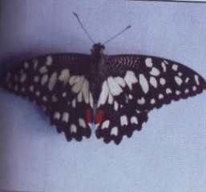
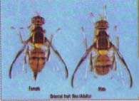
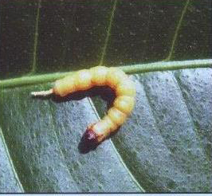
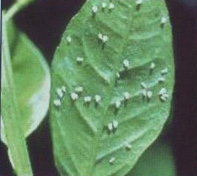
Lemon Butterfly
Citrus Leaf Miner
Citrus Fruit Fly
Larvae of Citrus Stem Borer
Citrus White Fly
Citrus Mealy Bug
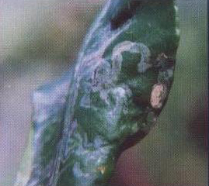
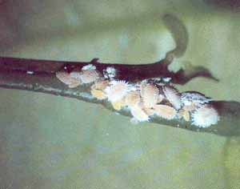

Diseases of citrus with causal organism in Bangladesh

SL. No | Crop | Disease | Causal Organism | Status
1 | Lemon (Elachi lebu) | Die-back | Colletotrichum spp. | Major
 |  | Scab | Elsinoe facetii | Minor
 |  | Black rot | Guignardia citricarpa | Minor
 |  | Canker | Xanthomonas campestris | Major
 |  | Greening | Greening Fastidious Bacteria (GFB) | Minor
 |  | Nematode | Tylenchus semepenitrans, Pratylenchus sp., Radopholus similis | Minor
2 | Lime (Kagozi lebu) | Die-back | Colletotrichum spp. | Major
 |  | Gummosis | Phytophthora citrophthora | Minor
 |  | Scab | Elsinoe facetii | Minor
 |  | Black rot | Guignardia citricarpa | Minor
 |  | Brown spot | Cercospora angolensis | Minor
 |  | Canker | Xanthomonas campestris | Minor
 |  | Greening | Greening Fastidious Bacteria (GFB) | Minor
 |  | Nematode | Tylenchus semepenitrans, Pratylenchus sp., Radopholus similis | Minor
3 | Pummelo (Batabi lebu) | Gummosis | Phytophthora citrophthora | Major
 |  | Die-back | Colletotrichum spp. | Minor
 |  | Nematode | Tylenchus semepenitrans, Pratylenchus sp., Radopholus similis | Minor
4 | Mandarin (Kamala) | Die-back | Colletotrichum spp. | Major
 |  | Gummosis | Phytophthora citrophthora | Minor
 |  | Scab | Elsinoe facetii | Minor
 |  | Black rot | Guignardia citricarpa | Minor
 |  | Canker | Xanthomonas campestris | Major
 |  | Greening | Greening Fastidious Bacteria (GFB) | Minor
 |  | Dry rot | Rhizoctonia/Fusarium spp. | Major
 |  | Nematode | Tylenchus semepenitrans, Pratylenchus sp., Radopholus similis | Minor
5 | Sweet orange (Malta) | Die-back | Colletotrichum spp. | Minor
 |  | Gummosis | Phytophthora citrophthora | Minor
 |  | Brown spot | Cercospora angolensis | Minor
 |  | Greening | Greening Fastidious Bacteria (GFB) | Minor
 |  | Nematode | Tylenchus semepenitrans, Pratylenchus sp., Radopholus similes | Minor
6 | Citrone (Jamir) | Die-back | Colletotrichum spp. | Minor
 |  | Gummosis | Phytophthora citrophthora | Minor
 |  | Scab | Elsinoe facetii | Minor
 |  | Black-spot | Guignardia citricarpa | Minor
 |  | Brown spot | Cercospora angolensis | Minor
 |  | Canker | Xanthomonas campestris | Minor
 |  | Nematode | Tylenchus semepenitrans, Pratylenchus sp., Radopholus similes | Minor
7 | Satkara | Die-back | Colletotrichum spp. | Major
 |  | Gummosis | Phytophthora citrophthora | Minor
 |  | Scab | Elsinoe facettii | Minor
 |  | Canker | Xanthomonas axonopodis | Minor
 |  | Sooty mold | Capnodium spp | Major
 |  | Nematode | Tylenchus semepenitrans, Pratylenchus sp., Radopholus similes | Minor
8 | Ada lebu | Canker | Xanthomonas campestris | Major
 |  | Scab | Elsinoe facetii | Minor
 |  | Gummosis | Phytophthora citrophthora | Major
 |  | Die-back | Colletotrichum spp. | Major
 |  | Greening | Greening Fastidious Bacteria (GFB) | Minor
 |  | Sooty mold | Capnodium spp | Minor
 |  | Nematode | Tylenchus semepenitrans, Pratylenchus sp., Radopholus similes | Minor
9 | Jara lebu | Canker | Xanthomonas campestris | Minor
 |  | Die-back | Colletotrichum spp. | Major
 |  | Scab | Elsinoe facetii | Minor
 |  | Greening | Greening Fastidious Bacteria (GFB) | Minor
 |  | Sooty mold | Capnodium spp | Minor
 |  | Nematode | Tylenchus semepenitrans, Pratylenchus sp., Radopholus similes | Minor

Crop wise distribution of Citrus disease in Bangladesh

Sl. No. | Disease | Causal Organism | Affected Citrus
1 | Die-back | Colletotrichum spp. | Lemon, Lime, Mandarin, Malta, Jamir
2 | Canker | Xanthomonas campestris | Lemon, Lime, Mandarin, Jamir
3 | Gummosis | Phytophthora citrophthora | Lime, Mandarin, Malta, Pummelo, Jamir
4 | Scab | Elsinoe facetii | Lemon, Lime, Mandarin, Jamir
5 | Black rot | Guignardia citricarpa | Lemon, Lime, Mandarin, Jamir
6 | Greening | Greening Fastidious Bacteria (GFB) | Lemon, Lime, Mandarin, Malta, Jamir
7 | Brown spot | Cercospora angolensis | Lemon, Lime, Malta, Jamir
8 | Blue/Green mold | Penicillium sp. | Mandarin, Malta, Lemon, Lime
9 | Sooty mould | Capnodium sp. | Mandarin, Malta, Satkara, Jara lebu, Ada lebu
10 | Pink | Botrybasidium salmonicolor | Mandarin, Malta, Jara lebu, Ada lebu
11 | Nematode | Tylenchus semepenitrans, Pratylenchus sp., Radopholus similis | All Citrus

Figure-2: Photographs of Major Diseases of Citrus
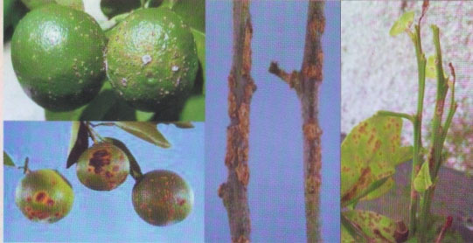
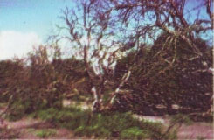
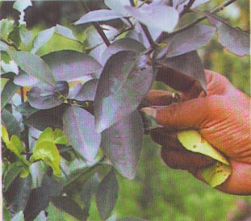
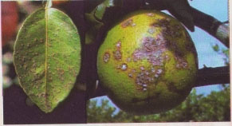
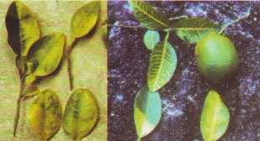
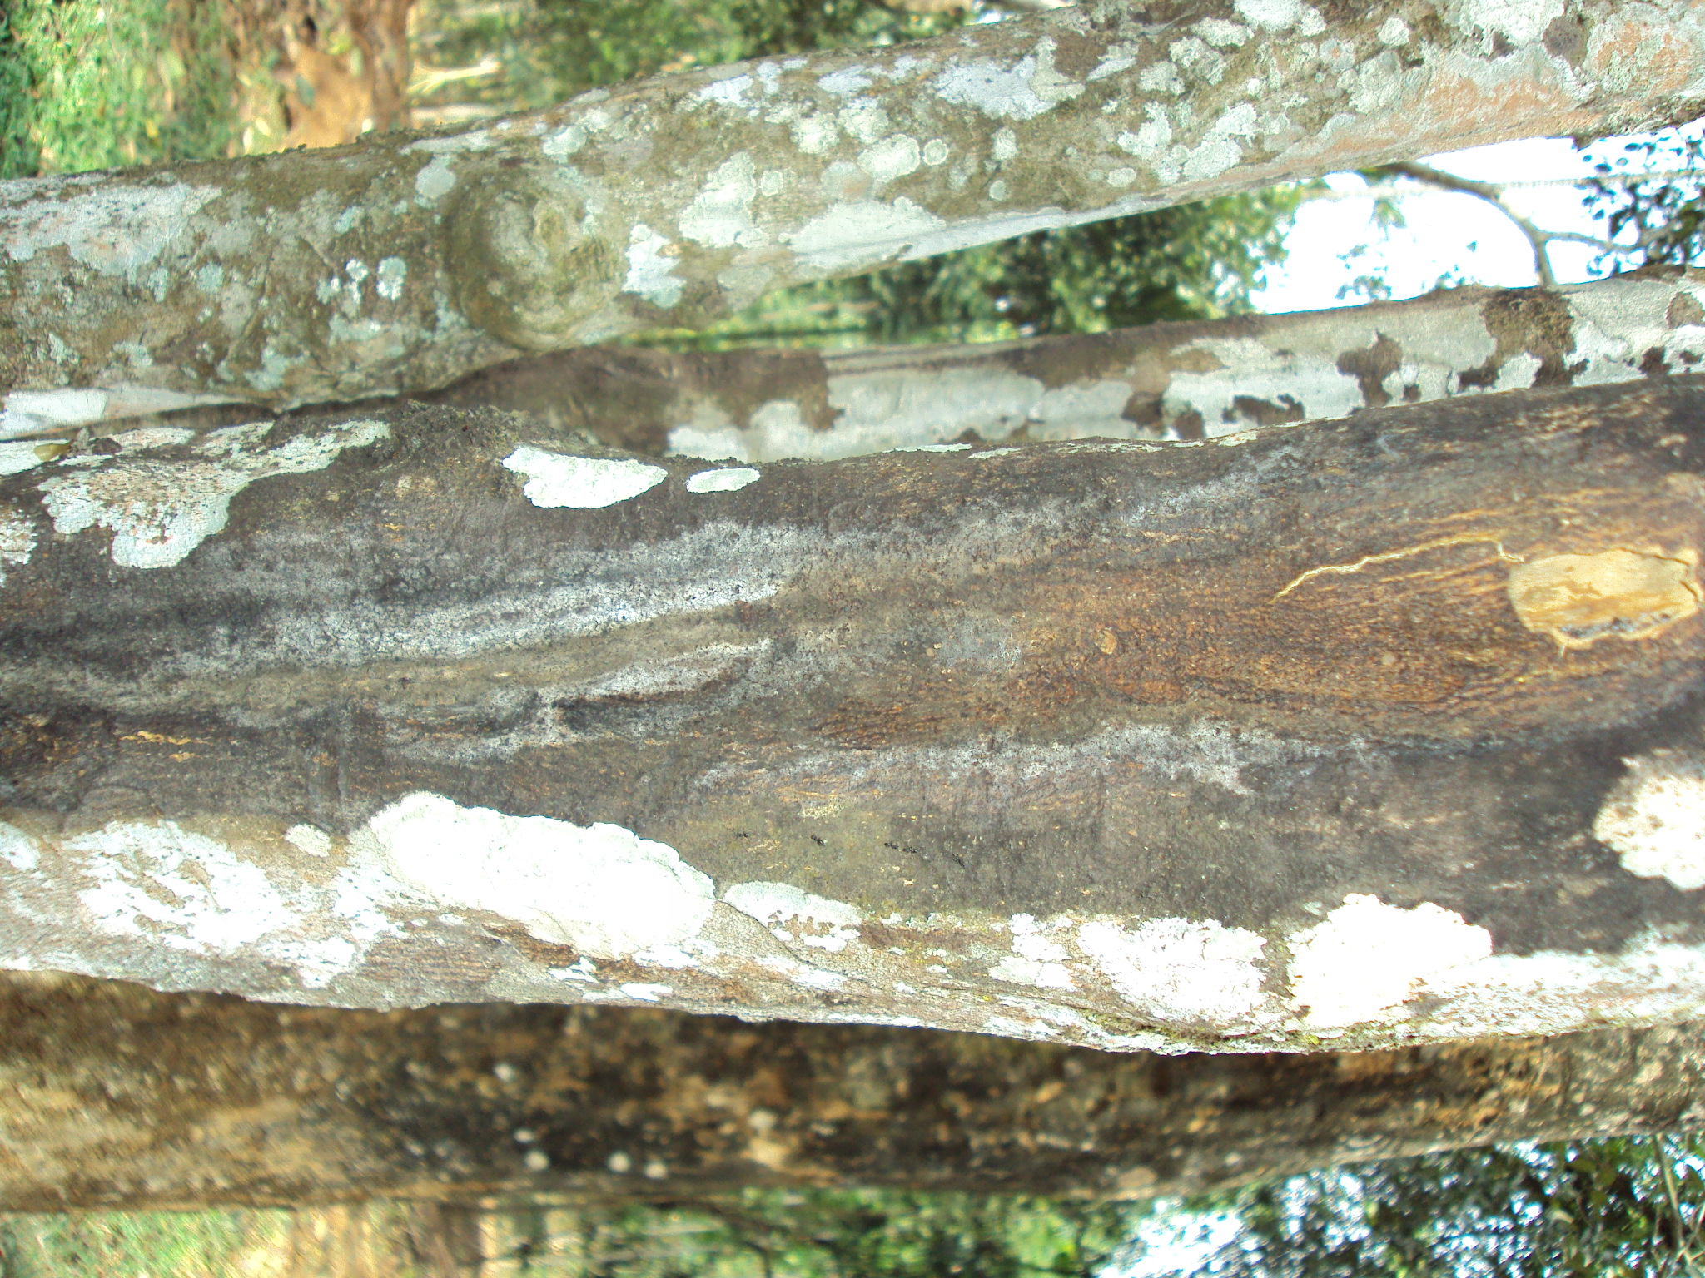
Citrus Canker
Citrus Die-Back
Citrus Greening
Citrus Gummosis
Sooty Mold
Greasy Spot

