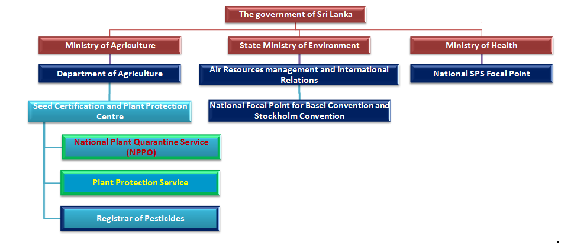

All border management activities,

Issuance of PSC,

Notifications,

Surveillance,

PRA,

Inspection and

laboratory testing etc.

Pesticide regulations

Within country Pest management

Outbreak management