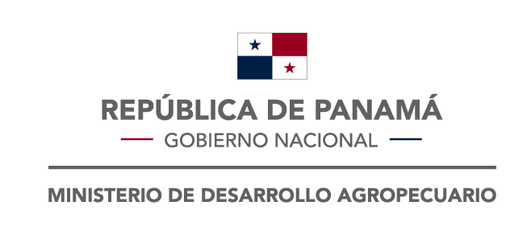 | Republic of Panamá  Ministry of Agricultural Development  National Directorate of Plant Health  Obligations of National Reports IPPC  DNSV-DVF-I-F02  Notification of non-compliance and emergency action |  |  | Validity :2020-12-07  Versión :2  Approved : National  Director /  Focal Point
1. Reference Code:
2. Exporter  - Name:  - Ubication:  - Country: |  |  | 3. Importer  - Name:  - Ubication:  - Country:
4. Identity of the shipment  - Reference document:  - Document number:  - Product:  - Scientific Name:  - Expedition country:  - Expedition date: |  |  | 5. Transport  - Transport mode:  - Identification:  - Entry point:  - Interception date:
6. Cause of Non-compliance
- Cause:

- Scientific name (pest):

- Official laboratory reference :
7. Phytosanitary action applied to the shipment
- Action:

- Affected part of the shipment:

- Aplication date:

8. Free text:

9. Exporter NPPO  - Name:  - Country: |  | 10. Importer NPPO  - Name NPPO:  - Responsable:  - Contact:  - Date:

