AFRICAN UNION |  | UNION AFRICAINE
الإتحاد الإفريقي |  | UNIÃO AFRICANA
Yaoundé, CAMEROUN P. O. Box 4170 Téléphone 221 19 69 Fax : 221 19 67 E-mail : au-cpi@au-appo.org
INTER-AFRICAN PHYTOSANITARY COUNCIL CONSEIL PHYTOSANITAIRE INTERAFRICAIN

Final Report
of
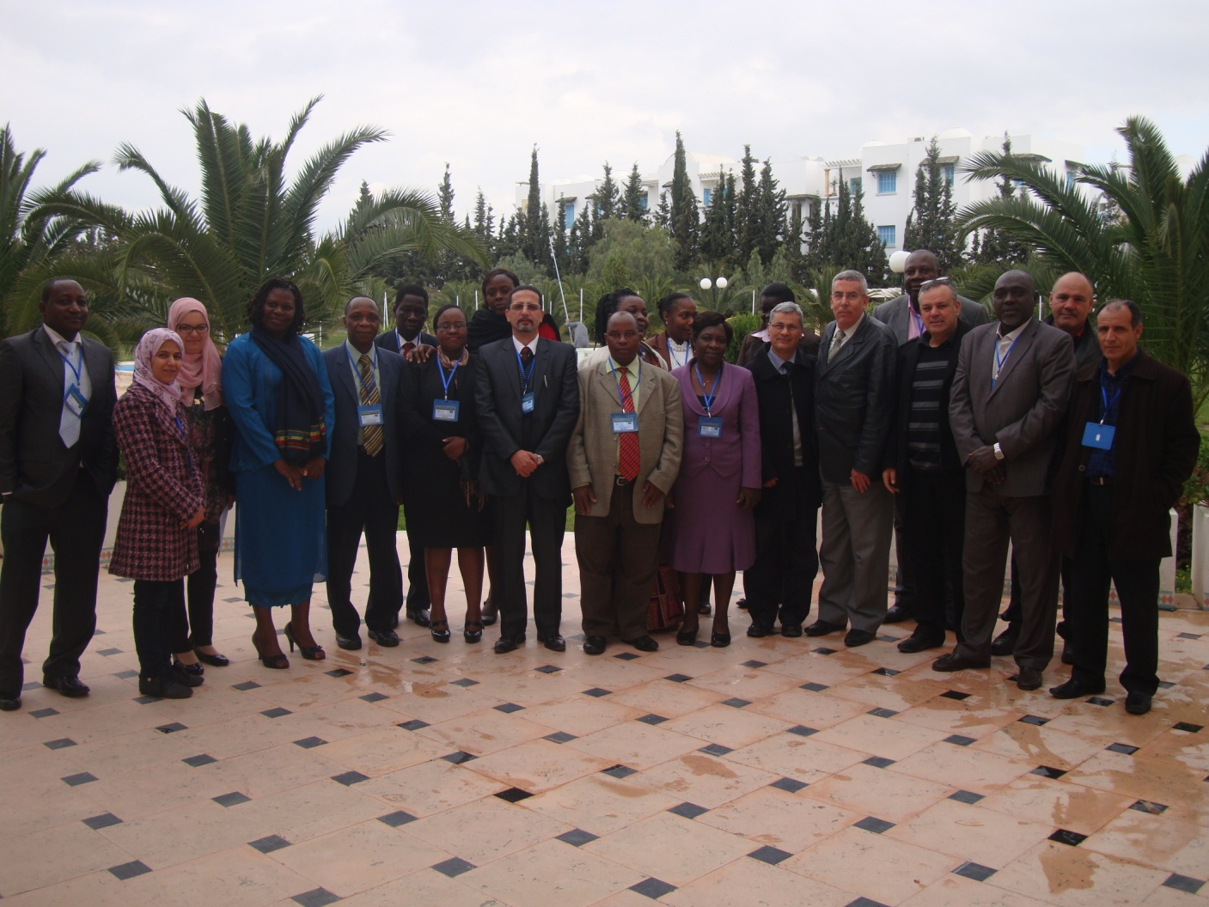
Technical Meeting for Preparation of Common Position at the 9th CPM Meeting 10th -13th March 2014, Tunis, Tunisia

Contents

Page

I. Background …………………………………………………………….……….. 3
II. Expert meeting …………………………………………………………………. 4
III. Preparatory Meeting ………………………………………………………..….. 6
1. Introduction ……………………………………………………………..…….. 6
2. Table of Common Position …………………………………………………… 8
IV. Annex ………………………………………………………………………… 20

I. Background

A number of African Member states are contracting parties to the International Plant Protection Convention (IPPC), an international treaty that aims to secure coordinated and effective action to prevent and control the introduction and spread of pests of plants and plant products. This is achieved through the setting, adoption and implementation of international standards for phytosanitary measures. The standards setting process is vested in the IPPC while the adoption and implementation is vested in the Commission on Phytosanitary Measures (CPM) and contracting parties respectively.
As a governing body, the CPM convenes annually to discuss pertinent issues pertaining to governance, capacity development, dispute settlement and adoption of international standards among others. The IPPC contracting parties from the African continent participate annually in the CPM meeting normally held late March to early April each year. Prior to this meeting, the IPPC secretariat posts on the International Phytosanitary Portal (IPP) the Agenda items for discussions during the CPM meeting.
Prior to the CPM, IAPSC prepare for meeting of some African contracting parties to get one African common Position (The selected countries represent the main 8 Regional Economic Communities REC’s). This has been a common practice from IAPSC; this year hold in Tunis, Tunisia in preparation for the CPM 9 (31st March - 4th April 2014) in Rome, that witnessed the participation of 42 African countries. The meeting was held with the main objective of assisting countries in preparation of African position on the various items on the Agenda of CPM 9.

II. Experts Meeting (10th March 2014)

Prior to the main meeting, an Experts meeting was held on 10th March comprising of AU-IAPSC technical team and 3 Experts (2 members of the Standards Committee and 1 member of the CPM Bureau representative for the African region) in the presence of General Director of plant protection in Tunisia. Specifically, the Experts meeting was attended by the following-:
  - Dr Lucien Kouame, CPM Bureau Member Representative for Africa Region
  - Mrs Woode Ruth, SC member
  - Mrs Ndikontar Alice, SC member
  - Gemel Merhabani General Director of Plant Protection (Tunisia)
  - Prof. Amer Abdel Fattah, Senior Scientific Officer AU-IAPSC
  - Mrs. Akao Grace Plant Health Officer AU-IAPSC
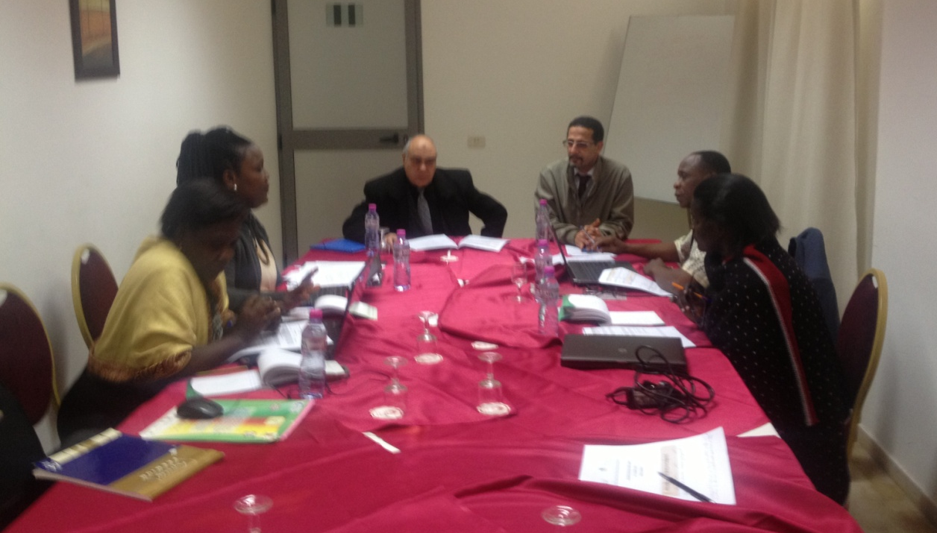

The agenda for the Experts meeting included
- Experts meeting on Strategies for Common Position: updates from last SC meeting
- Review and Analysis of draft standards submitted for adoption for CPM9
- Draft proposals for discussion in plenary and strategy for attendance
This meeting discussed Strategies for Common position and updates from the last Standards Committee meeting. It also reviewed and analyzed draft standards submitted for CPM 9 and considered a proposal for discussion in the plenary and strategy for attendance.
The AU-IAPSC technical team presented the draft agenda to the experts who reviewed the agenda items for the preparatory meeting and considered it fairly adequate to capture the interest areas of African MS; this was in consideration that other sub-items of the CPM agenda had not been posted at the time of preparation of the agenda for the preparatory meeting. The meeting considered the need for MS to take common positions on the proposed items for discussions on the draft agenda, of great importance were the items under CPM9 agenda: International Standards Setting under which were a number of draft ISPMs for adoption during CPM 9.
The members of the Standards Committee provided an update on what was discussed during the last Standards Committee meeting held in November 2013, which included selection of draft ISPMs for adoption during the forth-coming CPM meeting. They both pointed out the significance of an ISPM on International Movement of grain that was also discussed during the SC meeting as well as the status of the draft. Members were informed on the limited participation of African member states in submitting comments on the first Draft Specification on international movement of Grain. The SC members promised to remind MS during the main meeting on the need to submit comments when the second Specification will be posted for member comments.
In the review and analysis of draft standards submitted for CPM 9 adoption, which consisted of
- Specific phytosanitary treatments for fruit fly (Tephritidae) species as Annexes to ISPM 28
- Draft ISPM: Determination of host status of fruit flies (Tephritidae)
- Draft Annex to ISPM 26: Control measures for an outbreak within a fruit fly-pest free area (2009-007) and
- Draft Appendix 1 to ISPM 12:2011 (2006-003): Electronic Phytosanitary Certificates, information on Standard XML Schemas and exchange mechanisms,
The Experts noted that they would encourage MS to adopt a common position in supporting the adoption of the Draft ISPMs and Annexes during the CPM9. Experts explained that for a formal objection to be raised, one needs to have concrete supportive scientific evidence arrived at through repeated scientific experiments. The capacity to prove otherwise scientific work is still limited in Africa and therefore it places Africa in a no objection position.
While discussing the Agenda item “Draft proposal for Discussions in the plenary and Strategy for Attendance” the Experts noted that due to the limited participation of MS in this preparatory meeting (absence of Uganda, Kenya and Madagascar was noted), it would be rather unrealistic assigning the few countries present in the main meeting the responsibility of tabling the agreed common positions during the CPM, but rather, an African meeting be held in Rome prior to the CPM to allocate these responsibilities. This will also give an opportunity to present before other MS what was agreed upon during the preparatory meeting.

III. Preparatory meeting (11th-13th March 2014)
1. Introduction
The preparatory meeting was attended by participants from the following African Countries:
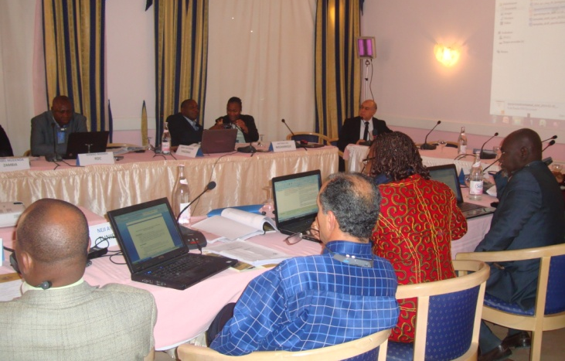
Burkina Faso, Chad, DRC, Gabon, Lesotho, Malawi, Mozambique, Tanzania, Tunisia, and Zambia; in addition to the experts and AU staff. The following countries confirmed participation (Uganda, Kenya and Madagascar) but did not report for the preparatory meeting.
During the main meeting, the CPM Bureau Member provided clarifications on matters concerning the CPM and the CPM recommendations. Meanwhile regarding positions that were unclear to MS, the SC members sought an on-line clarification from the IPPC secretariat and relayed this to MS during the discussions.
-Opening Ceremony
The meeting was kick-started by an opening ceremony which saw the delivery of the welcome speech by the Director AU-IAPSC that was delivered by Prof. Amer Abdel Fattah on behalf of the Director IAPSC. An opening speech by the host country Tunisia was delivered by the General Director of Nabel Province, Mr. Reda.
-Election of the Bureau and adoption of the Agenda
The bureau was composed as follows:
Chair: Tunisia
Rapporteurs: Gabon (Francophone) and Lesotho (Anglophone)
Facilitation: Provided by AU- IAPSC.
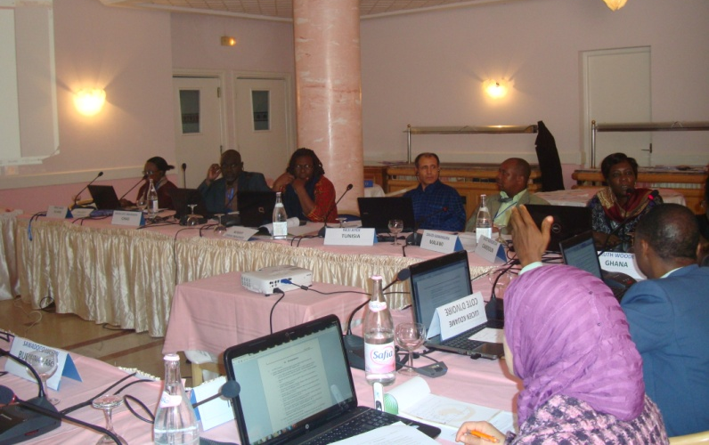

Proceedings of the workshop: Introducing the workshop, the facilitator proposed an Agenda which was discussed. Some participants mentioned that many points in the CMP 9 agenda were not included. The AU-IAPSC clarified that at the time the provisional agenda was compiled, a number of sub- agenda items either missing at the portal or was posted in only in one language and therefore could not be reviewed during the meeting. The proposed agenda was finally adopted with the understanding that other points of interest could be discussed as the agenda proposed by facilitator proceeds.
The different agenda points were discussed.
-Presentation of Objectives and Expected outputs
The objectives of the workshop was presented before MS by Mrs. Akao Grace, highlighting the major objective, specific objectives and expected outputs, she pointed out that specifically, that the meeting was aimed at providing a forum to review the draft Agenda for the 9th CPM Session and adopt a strategy and common position for pertinent Agenda items considered beneficial to the Africa Region. Members would then analyze the final draft ISPMs submitted for adoption during the CPM and where appropriate, propose a formal objection on the proposed draft ISPMs for adoption.
Furthermore, meeting was similarly intended to provide an opportunity to benefit from explanations regarding the background and content of documents on the CPM 9 agenda.
The AU-IAPSC would then compile the outcomes of the meeting including the common positions adopted, roles and responsibilities of MS in tabling the common positions during the CPM, compiling substantive comments made on draft ISPMs for adoption and circulate to all NPPOs for use by their delegates at CPM 9. Similarly, IAPSC would compile and avail all comments on the various items on the agenda of CPM 9 to African participants to better prepare them for the meeting.
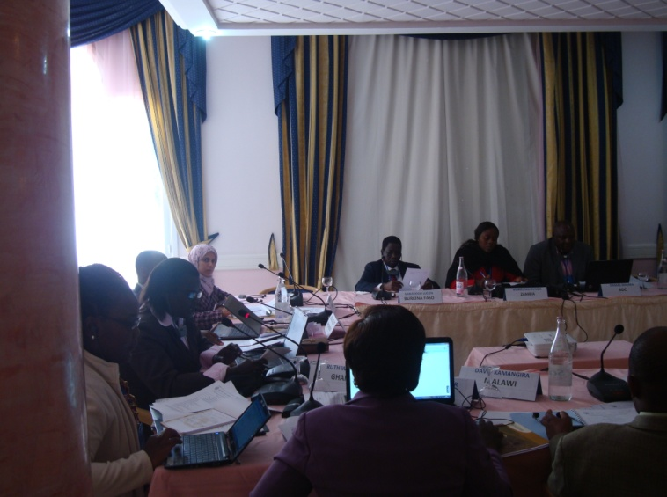
The table below shows the different points of consensus of the workshop. It is also important to note that the ECCAS REC had held a regional meeting to discuss the CPM9 agenda items and the conclusion of the ECAAS meeting was similarly reviewed and where considered appropriate incorporated into the common positions reached as presented in the table below.

2. Table of common positions from the workshop

8. Governance: Commission on phytosanitary measures (CPM)
CPM-9 Agenda Point | Document | Workshop Position / Observations / Comments | Discussion
8.1 Partnerships | CPM 2014/21 | - Clarify the different levels of relationships between IPPC and other organizations  - Any partnership requiring the signature of a Memorandum of Understanding needs the mandatory approval of CPM and advice from FAO Legal Service prior to signature  - It is necessary that the levels of relationships requiring the approval of CPM be determined (partnership implies a more significant and strong commitment between two parties)  - The content of the document needs to be consistent with the title relationship’ and not ''partnership'' (Relationship is in line with the title of the document which presents three models of relationship and not partnerships) | After reviewing the report of CPM-8 (2013), in particular the point on Partnership, it was agreed on the need for the IPPC Secretariat to clarify the levels of partnerships and to determine the type of partnership requiring approval from CPM.

8. Governance: Commission on phytosanitary measures (CPM)
 | Document | Workshop Position / Observations / Comments | Discussion
- Process for adopting recommendations | CPM 2014/07 | No objection for the adoption of the proposed procedure. However, we wish the Report of the Commission to mention the need for clarification on the criteria for what can be considered a recommendation.  The following three criteria were proposed :  1. The topic must be of an emergency concern  2. The topic must be of general interest to Contracting Parties  3. The topic must not be a candidate for the development of a standard theme.  NB: The intervention must be made before the adoption by the CPM | Discussions focused on the importance of a recommendation on aquatic plants. To this end, a clarification on the invasiveness of aquatic plants was provided by SC members

9- International standard setting
 | Document | Workshop Position / Observations / Comments | Discussion
9.1-  Report on the activities of the Standards Committee | CPM 2014 /18 and  CPM 2014/INF/06 | This is a document for information and not for a decision to be made by CPM; so it has to be numbered as such and classified INF, i.e. CPM2014/INF/06  In all CPM previous meetings, this type of document was an "INF" document

9 – International standard setting
 | Document | Workshop Position / Observations / Comments | Discussion
9.2 -  Adoption of International Standards on Phytosanitary Measures | CMP 2014/03_06 ISPM 28: Cold treatment for Ceratitis capitata on Citrus limon | MS agreed to support the adoption at the CPM 9.  However, a revised version of the document needs to be published by the Secretariat to reflect the formal objection made by Japan (to be checked on www.ippc.int before CPM session)
 | CPM 2014/03_01 : Electronic phytosanitary certification | MS agreed to support the adoption at the CPM 9
 | CPM 2014/03_02 Determination of host status to fruit flies (Tephritidae) (2006-031) | MS agreed to support the adoption at CPM 9
 | CPM 2014/03_03 ISPM 26: Control measures for an outbreak within a fruit fly pest free area (2009-007) | MS agreed to support the adoption at CPM 9
 | CPM 2014/03_04 ISPM 28: Cold treatment for Ceratitis capitata on Citrus sinensis | MS agreed to support the adoption during the CPM 9
 | CPM 2014/03_05 ISPM 28: Cold treatment for Ceratitis capitata on Citrus reticulate x C. sinensis | MS agreed to support the adoption During the CPM 9
 | CPM 2014/03_06 ISPM 28: Cold treatment for Ceratitis capitata on Citrus limon | Member States agreed to support the adoption during the CPM
 | CPM 2014/03_07 ISPM 28: Cold treatment of Bactrocera tryoni on Citrus sinensis | MS agreed to support the adoption at the CPM 9
 | CPM 2014/03_08 ISPM 28: Cold treatment for Bactrocera tryoni on Citrus reticulata x C. sinensis | MS agreed to support the adoption during the CPM 9  However, it was noted that all proposed treatments focused on a single variety of plant. It would be desirable to extend these treatments to other varieties
 | CPM 2014/03_09 ISPM 28: Cold treatment of Bactrocera tryoni on Citrus limon | MS agreed to support the adoption at the CPM 9
 | CPM 2014/03_10 ISPM 28: Cold treatment for Ceratitis capitata on Citrus paradisi | MS agreed to support the adoption at the CPM 9
 | CPM 2014/03_11 ISPM 28: Vapour heat treatment for Bactrocera cucurbitae on Cucumis melo var. reticulata | MS agreed to support the adoption during CPM 9

9 – International standard setting
 | Documents |  | Workshop Position / Observations / Comments | Discussion
9.4 – Topics for IPPC standards | CPM 2014 /19 Rev1
9 – International standard setting
 |  | Documents | Workshop Position / Observations / Comments | discussion
9.3 -  Noting translation adjustments to International Standards for Phytosanitary Measures adopted at CPM-8 (2013) |  | CPM 2014 /19 Rev1 | This document was a notification document that indicated the work accomplished by the various Language Review Groups (Chinese, French, Russian and Spanish) on the ISPMs adopted during the CPM 8.  MS only took note

9 – International standard setting
 | Documents | Workshop Position / Observations / Comments | Discussion
9.4.1 -  Adjustments to the List of topics for IPPC standards | CPM 2014/04 | It is proposed to adopt the proposals for  - adding topics to the list of topics for standards  - deleting topics to the list  - the change of priority  - CPM is invited to .... request the Secretariat to update the list of topics accordingly ….. and publish the updated version of the PPI:  Member States agreed that  Referring to point No. 4 above, regarding the posting of information, including adopted standards, on IPP is a regular mission of IPPC Secretariat. There is no point to remind the Secretariat for that in the document; and therefore this particular section ought to be deleted from Document 2014/04 | A long discussion took place on this agenda item. Central Africa proposed to delete from the list the topic ‘Harmonization of descriptive elements contained in phytosanitary certificates’ because this topic did not follow the normal process of topic selection; the Standards Committee members present at the workshop gave some information on the matter. But no consensus was reached. As a consequence, Central Africa decided to maintain the observation and present it at CPM

9 – International standard setting
 | Document | Workshop Position / Observations / Comments | Discussion
9.4.2 – Update on the topic: International movement of grain (2008-007) | CPM 2014 /06 | This document must be classified as an information document, that is CPM2014/INF/ 06

9 – International standard setting
 | Documents | Workshop Position / Observations / Comments | Discussion
- Update on the topic: Minimizing pest movement by sea containers (2008-001) | CPM 2014 /11 | - This document must be classified as an information document, that is CPM2014/INF/11  - The actual document and future steps in relation with this point must follow the different options adopted by the CPM. | Information on the progress of work in relation to this standard was provided by a member of the Standards Committee  Given the importance of this issue for Africa, the Meeting recommends that IAPSC to make appropriate arrangements (organizing meetings for African experts) to allow Africa committee members to go to meetings with some clear guidance from Africans

9 – International standard setting
 | Documents | Workshop Position / Observations / Comments | Discussion
9.5 – Update on the development of a Framework for standards | CPM 2014 /05 | This document is a report of the group responsible for developing the framework for standards, it should be considered as an information document. This is a document that should be classified INF or will CPM2014/INF / ......

9 – International standard setting
 | Documents | Workshop Position / Observations / Comments | discussion
- Strengthening the implementation of the IPPC and the ISPMs | CPM 2014/20 Rev 1 | - Paragraph No. 17 is also a recommendation for CPM and not a paragraph by itself. This should be the 7th bullet point of paragraph 6  - To clarify the actual meaning document of "TEST’’ for a better understanding  - Open-ended group : a). we support the creation of an open-ended group on the matter; b.) we request that the Secretariat be a member of this group and that the representation of all the Contracting Parties be taken into consideration; c). we seek clarification on the funding arrangements for this group; d). the terms of reference of this group need to be drafted for a better understanding of its mission  - The pilot programme : a). we seek more clarification on the "pilot" aspect; b). the programme should be representative of the needs of Contracting Parties; c). we request clarification on the source of funding ; d). given the time allowed for the "pilot" work, it would be necessary to specify the content of the work to be carried out in order to anticipate the programming and preparation | This is a very strategic document. It would be useful for Africa Region to be fully represented both in the open ended working group and in the pilot programme. To this end, a call was made to IAPSC to coordinate the Region for defining its strategy in relation to this document

10 –IPPC Strategic Framework and Resource Mobilization
 | Documents | Workshop Position / Observations / Comments | Discussion
10.4.1 Status of ISPM 15 Mark Registration | CPM 2014/13 | The mail mentioned in this document in relation with the registration of the ISPM 15, has not yet reached NPPO of many Contracting Parties.  Member states acknowledged the importance and commitment to register ISPM 15 Mark, with countries sharing their experiences. It was observed that all countries irrespective of their status at the IPPC seem to hold stake in the “Mark” because at any one point they may receive or export goods packaged in wood material. | It will be useful for IAPSC to look for ways and means to coordinate the registration and renewal of ISPM 15 logo for African countries

15 – Adoption of CPM Recommendations
 | Documents | Workshop Position / Observations / Comments | discussion
15 – Adoption of CPM Recommendations | CPM 2014/14 | MS agreed to support the adoption of CPM recommendations

General recommendations
- To IAPSC
- Make necessary arrangements for the nominations of African representatives in the different bodies of IPPC;
- Sunday, March 30th is reserved for the meeting of the Capacity Development Committee (CDC) at FAO Headquarters. IAPSC should make necessary arrangements for the transfer of African coordination meeting in the morning of Monday, March 31st, 2014; as well as other coordination meetings of the week (room reservation, information of participants .... ) ;
- The meeting hoped that the Africa Region organizes and defines its strategy in relation to the document "Strengthening the implementation of the Convention and the ISPM.
- Take every necessary actions with regard to the African strategy for an outstanding participation of Africa.
- To the Participants/ Contracting Parties
- Read the message CPM Bureau and IPPC Secretariat posted on the IPP in relation with the organization of the CMP9
- Keep the conclusions of this workshop very confidential.

IV. Annexes
Annex 1: Workshop Agenda for a Technical meeting for preparation of common position at the 9th CPM Meeting 10th -13th March 2014, Tunis, Tunisia.

Time | Activities | Presenters
Day 01: Monday 10/03/2014
09:00-11:00 | Experts meeting on Strategies for Common Position: updates from last SC meeting | Experts/IAPSC
11:00-11:30 | Health Break
11.30-13:00 | Review and Analysis of draft standards submitted for adoption for CPM9 | Experts
13:00-14:00 | Lunch Break
14:00 – 16:00 | Draft proposals for discussion in plenary and strategy for attendance | Experts
16:00 – 16:30 | Health Break
16:30 17:30 | Arrangement of logistics for Main meeting | IAPSC
Day 2: Tuesday 11/03/2014
8:30- 09:00 | Registration of participants | Secretariat
09:00-10:00 | Opening ceremony
 | - Welcome remarks NPPO Tunisia  Remarks by Director IAPSC  - Opening Speech  - Presentation from NEPPO | NPPO Tunisia  Dr. Jean Gérard MEZUI M`ELLA  Representative of the Ministry responsible for Agriculture, Tunis  NEPPO
10:00-10:30 | - Introductions  -Review and adoption of the Agenda  - Objectives of the meeting;  Election of the Bureau (Chair and rapporteurs)  Group photo | Prof. Amer Fattah/Mrs Akao Grace
10:30-11:00 | Health Break
 | CPM Agenda 8: Governance: Commission on Phytosanitary Measures | Chair
11:00-11:30 | Process of adopting Recommendations (CPM 2014/07)
 | CPM Agenda 9: International Standards Setting
11:30-12:00 | - Report on the activities of the Standards Committee | Chair
12:00-13:00 | Adoption of international standards for phytosanitary measures:  Topics for IPPC Standards  - CPM 2014/03_09: ISPM 28: Cold treatment of Bactrocera tryoni on Citrus limon
13.00-14.00 | Lunch break
14:00-16:00 | - CPM 2014/03_11: ISPM 28: Vapour heat treatment for Bactrocera cucurbitae on Cucumis melo var. reticulata  - CPM 2014/03_06:ISPM 28: Cold treatment for Ceratitis capitata on Citrus limon  - CPM 2014/03_08: ISPM 28: Cold treatment for Bactrocera tryoni on Citrus reticulata x C. sinensis  - CPM 2014/03_10: ISPM 28: Cold treatment for Ceratitis capitata on Citrus paradisi
16:00-16:30 | Health break
16:30-17:00 | - CPM 2014/03_05: ISPM 28: Cold treatment for Ceratitis capitata on Citrus reticulate x C. sinensis
Day 3:Wednesday 12/03/2014
08:30-9:30 | - CPM 2014/03_07:ISPM 28: Cold treatment of Bactrocera tryoni on Citrus sinensis  - CPM 2014/03_04: ISPM 28: Cold treatment for Ceratitis capitata on Citrus sinensis
09:30-10:30 | - CPM 2014/03_02: Determination of host status to fruit flies (Tephritidae) (2006-031)
10:30- 11:00 | Health Break
11:00-13:00 | - CPM 2014/03_02: Draft Annex to ISPM 26: Control measures for an outbreak within a fruit fly-pest free area (2009-007)  - CPM 2014/03_01: Electronic Phytosanitary Certificates, information on Standard XML Schemas  And exchange mechanisms (Draft Appendix 1 to ISPM 12:2011 (2006-003)
13:00-14:00 | Lunch Break
14:00-14:30 | - Noting translation adjustment to the international standards for phytosanitary measures adopted at CPM8 (2013) | Chair
14:30-16:00 | Topics for IPPC standards  - Adjustment to the list of IPPC standards  - Update on the topic International movement of Grain  - Update on the topic : Minimizing Pest movement by Sea containers (Proposed Survey)
16:00-16:30 | Health Break
16:30-17:00 | Update on the development of a framework for standards
Day 4: Thursday 13/03/2014
 | CPM Agenda 10: IPPC Strategic Framework and Resource Mobilization | Chair
08:30-10:00 | - Strengthening Implementation of the IPPC and ISPM  - Status of ISPM 15 Mark registration
10:00-10:30 | Health Break
10:30-13:00 | - Resource mobilization efforts and results  Discussions on common positions and Strategies for presentations  - Presentation and discussion on Agreed Common position on Draft ISPMs
13.00-14.00 | Lunch-Break
14:00-14:30 | - Designation of MS and alternates for presentation of Common Positions at CPM 9 | Rapportuers/NPPOs/Experts
14:30-15:00 | - Simulation of presentation of Common positions by MS
15:00-15:30 | Closing Ceremony

Annex 3: List of Participants
a. List of Participant
BURKINA FASO  Mr Lucien Savadogo  Directeur de la Protection VégétauxetConditionnement  Ministère de l’Agricultureet de la Sécurité Alimentaire ; 01BP 5362  Ouagadougou 01, BURKINA FASO  Tel: +226 71 89 59 65  Tel : +226 50361915  E-mail: sawadogolucien12@yahoo.fr | GABON  Mme Séraphine Ada Ella épouse Minko  Chef de Service de la Législation Phytosanitaire  Ministère de l’Agriculture, de l’Elevage, de la Pêche et de la Sécurité Alimentaire  B.P. 551  Libreville, GABON  Tel : +241 07171427/241 06634795  E-mail : minkoseraphine@yahoo.fr
DRC CONGO  IrMamba Mamba Damas  Chef de Division et Point de contact CIPV  Ministère de l’Agriculture et du Développement Rural  Croisement des avenues Boulevard de 30 Juin et Batetela  Commune de la Gombe, Kinshasa, RDC  Tel : +243 812 959 330  E-mail : damasmamba@yahoo.fr;  damasmmb5@gmail.com | LESOTHO  Dr. Lefulesele Lebesa  Chief Research Officer  Ministry of Agriculture and Food Security  Department of Agricultural Research  P.O. Box 829  Maseru 100, LESOTHO  Tel: +266 22 312 395/585/2095  Fax: +266 22 310362  E-mail: lefulesele@gmail.com
MOZAMBIQUE  Antonia Augusto Sabonete Vaz  Agronomic Engineer-Plant Protection  Department  National Directorate of Agragrian Services  Ministry of Agriculture  Eduardo Mondlane Avenue 2960  Maputo, Mozambique  Tel: +258 846 988 646  Fax: +258 214 15110  E-mail: avaz5099@gmail.com | MALAWI  Mr David Kamangira  Senior Deputy Director/IPPC Contact Point  Department of Agricultural Research Services  Ministry of Agriculture and Food Security  P.O. Box 30779  Lilongwe 3, MALAWI  Tel: +265 888 342 712/265 999 122 199  Fax: +265 1 707 378  E-mail: davidkamangira1@gmail.com;  Or agric-research@sdnp.org.mw
TANZANIA  Mr. Mdili Sambayi Katemani  Plant Quarantine Inspector  Ministry of Agriculture ,Food Security and Cooperatives, Plant Health Services  P.O. Box 9071  Temeke Road  Dar es Salaam, TANZANIA  Tel : +255 659 387 945  E-mail : catemanmdily@yahoo.com;  PPS@Kilimo.go.tz | TUNISIA  Dr. Jamel Merhaben  Directeur Général  Ministère de l’Agriculture  Tunis, TUNISIE  Tel : +216 986 11 11  Fax : + 216 71 784 419  E-mail : merhaben-j@yahoo.fr
TCHAD  Mr Moussa Abderaman Abdoulaye  Directeur Adjoint de la Protection des Végétaux et du Conditionnement  Ministère de l’Agriculture et de l’Irrigation  N’Djamèna, TCHAD  B.P. 1551  N’Djamèna, TCHAD  Tel : +235 6632 5252  Fax : +235 2252 4509  E-mail : charafa2009@gmail.com | TUNISIA  Mr Neji Aydi  Service Protection des Maladies des Plantes  Direction Générale de la Protection et du Contrôle de la Qualité des ProduitsAgricoles  Tel : + 216 21 624 212  E-mail : nejiaydi@yahoo.fr
ZAMBIA  Ms Mable Mudenda  Senior Agricultural Research Officer  Zambia Agriculture Research Institute  Ministry of Agriculture and Livestock  P/Bag 7 Chilanga  Lusaka, ZAMBIA  Tel : + 260 972 413 204  Fax : +260 278131  E-mail : banji.mudenda@gmail.com | TUNISIA  Mme Afef Salhi  Ingénieur Principal  Ministère de l’Agriculture et des Ressources Hydrauliques de Tunisie  18, rue de Palestine-Belvédère,  Tunis – 1002, TUNISIE  Tel : +216 9788 7976  Fax : +216 718 30156  E-mail : afef-salhi@live.fr

b. List of experts

Dr Lucien KOUAME
Inspecteur/Membre Représentant Afrique au Bureau CMP
Ministère de l’Agriculture
01 B.P. 944
Abidjan 01, COTE D’IVOIRE
Tel : +225 079 037 54/+255 2021 8442
E-mail: l_kouame@yahoo.fr

Mrs Alice Ndikontar
Senior Plant Health Officer
Department of Regulation and Quality Control of Inputs and Agricultural Products - MINADER
Ministry of Agriculture and Rural Development ; P.O. Box 812
Yaoundé, CAMEROON
Tel: +237 775 612 40
E-mail: ndikontarali@yahoo.co.uk

Mrs Ruth Woode
Deputy Director
Plant Protection and Regulatory Services Directorate
Ministry of Food and Agriculture
P.O. Box M37
Accra, GHAHA
Tel : +233 244 507 687
E-mail: wooderuth@yahoo.com

c. List of Organizers:

AU-IAPSC
Prof. Abdelfattah Amer Mabrouk
Senior Scientific Officer, Entomology
AU-IAPSC
P.O. Box 4170
Yaoundé, CAMEROON
Tel: +237 222 02108
Mobile : +237 776 531 38
E-mail: abdelfattahsalem@ymail.com or mabroukdn@hotmail.com

Mrs Grace Akao
Plant Health Officer
African Union/Interafrican Phytosanitary Council (AU-IAPSC)
P.O. Box 4170
Yaoundé, CAMEROON
Tel: +237 222 02108
E-mail:graceenoka@gmail.com or akaog@africa-union.org;
AU-IBAR
Ms Odile Nzirabatinya
Assistant Accountant
AU-IBAR
P.O. Box 30786
Nairobi, KENYA
Tel: +254 3674 000
Fax : +254 3674 341
E-mail: odile.nzirabatinya@au-ibar.org

Ms Shadra Zaid
Administrative Assistant
AU-IBAR
P.O. Box 30786
Nairobi, KENYA
Tel: +254 3674 000
Fax : +254 3674 341
E-mail: shadra.zaid@au-ibar.org

d. List of Interpreters

1. Mr Kasdaghli Lotfi
Interpreter
Ave. Tahir Guiga
8050 -Hammamet, Tunis
Tunisia
Tel : +216 52 454 822
E-mail : lotfikaz@topnet.tn

2. Ms Assia Limem
Interpreter
Tunis, TUNISIA
E-mail : essia.limem@hotmail.com

