Phytosanitary Measures Research Group Meeting
24-27 September 2019
Cairns, Australia

The venue for this year’s meeting of the Phytosanitary Measures Research Group is the Shangri-La Hotel, The Marina, Cairns, Australia.
The Shangri-La is a five-star Hotel conveniently situated at the Marina. The hotel has uninterrupted panoramic views of Trinity Bay, world-class Marlin Marina and breath-taking mountain ranges allowing you to experience tropical north Australia at its best.
The hotel is set on the southern end of the vibrant Cairns Esplanade. It is a tranquil location, with the Pier Shopping Centre at its doorstep and a five minute walk to the centre of the city and shopping district. All rooms have balconies with most having water views. The average room rate per night is $USD136 which includes a full buffet breakfast.
To make a booking go to the Shangri-La Hotel, The Marina, Cairns website and enter your stay requirements such as check-in date, check-out date, number of rooms, adults and children. Under the “Special Rate” area, select “Group Code” and enter the Group Code DEP220919. Click the availability button to continue. If all the search criteria are correct and rooms are still available, the group rate will be returned in the availability search result. Next, follow the on-screen instructions to complete the online booking.
The Shangri-La is a 10 minute drive to Cairns Domestic and International Airports. Airport transfers can be arranged through the hotel or you can take a taxi for approximately $AU18.
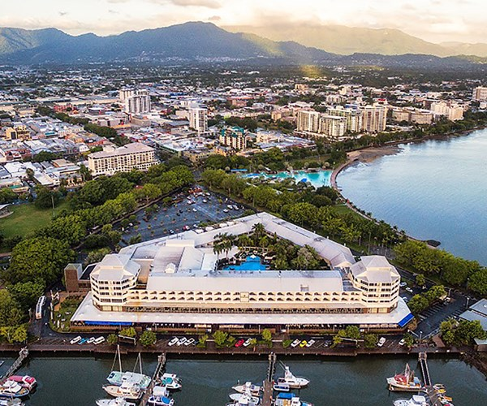

HOTEL FACILITIES
The hotel comprises 255 spacious guest rooms and suites, all with balconies and most with water views. Guest rooms have spectacular views over Marlin Marina, Trinity Bay, Cairns City, rainforest gardens or the hotel’s sparkling pool. Rooms include:
- Free Wi-Fi
- a balcony or courtyard
- “North to Go” - In room catering delivery
- Breakfast available from 7am-10.30am
- meal options available from 10.30am-10.00pm
- dinner available from 5.30pm-10.00pm
- Electronic safe
- Hairdryer
- Mini-bar
- Tea and coffee making facilities
- Iron and ironing board
RESTAURANTS AND BARS
- North Bar and Kitchen - Modern Australian Restaurant
- North Garden
- Pool Bar - Beverages and Snacks
RECREATION FACILITIES
- Outdoor swimming pool
- Children’s pool
- Table Tennis
- 24-hour gymnasium
- Giant chess board
SERVICES
- 5 minute walk to city centre
- 10 minute walk to Cairns Convention Centre
- 10 minute drive to Cairns Airport
- Airport transfers
- Tour desk
- Car rental, taxis and limousine services
- Undercover, secure car parking facilities
- Same-day laundry and dry cleaning
- Foreign exchange services
- Safe deposit box
- Shopping Centre - The Pier

HOTEL CONTACT INFORMATION
Address | Pierpoint Road Cairns, Queensland, 4870, Australia
Phone | (61 7) 4031-1411
Email | slmc@shangri-la.com

LOCAL INFORMATION
Tourist activities: If you are intending to arrive early or stay on after the meeting, check out some of the amazing natural treasures and attractions Cairns has to offer at: https://www.cairns-australia.com/cairns-tourist-information.html.
Getting around: Information on buses and taxis in Cairns can be found at: https://www.cairns-australia.com/getting-around-cairns.html. If you are planning to drive, please remember to keep left, always give way to your right at roundabouts and watch for animals on the roads at night. Check-out cars to rent at: https://www.cairns-australia.com/directory/car-hire.
Weather: Cairns is tropical and in September the weather is normally mild and dry with a typical daytime minimum/maximum of 18ºC/26ºC (64ºF/79ºF).
Local currency: Australian dollar ($AU1.00 = $US0.70).
Power and appliances: Mains voltage in Australia is 230V 50Hz. Most countries have appliances that work on the same mains voltage. Exceptions to this are Japan, USA and Canada which use 100/120V 50/60Hz. The plugs in Australia have two flat metal pins shaped live a "V" and a third flat pin in the centre.
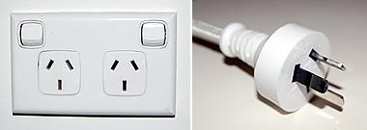
Outlet and plug

