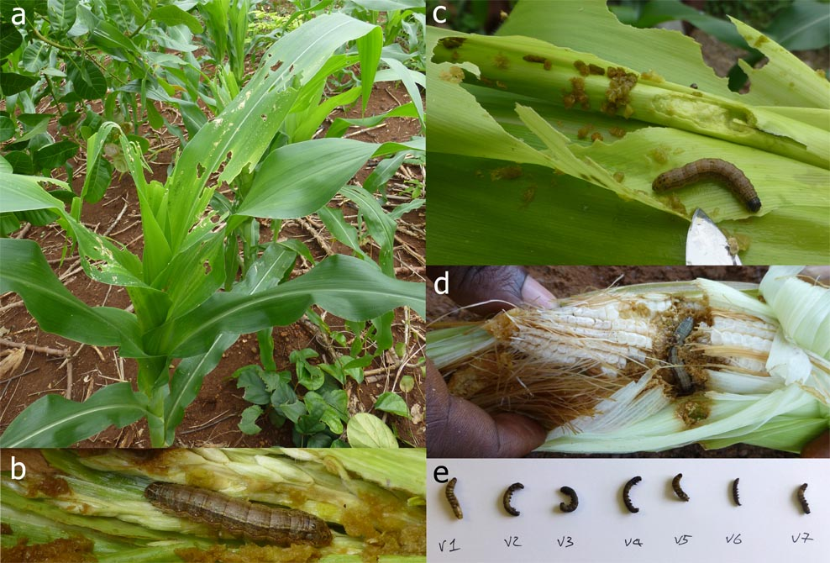
Field observations. Images of (a) damage, (b-d) live larvae and (e) preserved larvae from field work.

