

***MINISTRY OF AGRICULTURAL DEVELOPMENT***

NATIONAL DIRECTION FOR PLANT HEALTH

**NOTIFICATION**

The Republic of Panama, through MIDA (Ministry of Agricultural Development) and the National Plant Protection Authority (DNSV), reports the country's phytosanitary situation about the pest known as **Huanglongbing or HLB of citrus, caused by the bacterium Candidatus liberibacter Spp and transmitted by its vector Diaphorina citri.**

For the purpose of this notification, the provisions of **ISPM No. 17 "NOTIFICATION OF PESTS" and ISPM No. 8 "DETERMINATION OF THE SITUATION OF A PLAGUE IN AN AREA" of the International Plant Protection Convention (IPPC).**

The Department of Phytosanitary Surveillance of the DNSV through the Specific Pests Section, carried out in 2016 epidemiological surveillance actions, attending a report on the presence of a tree with symptoms similar to those reported for this disease, in the Republic of Costa Rica, very close to the border with Panama in the province of Bocas del Toro in the community of Guabito.

The procedure was to apply a detection survey in the border area, which included sampling of citrus plants with characteristic symptoms of the disease and performing field test (starch - iodine); The samples that reacted to this test were sent to the Plant Health Laboratory for confirmation through the **PCR** (Polymerase Chain Reaction) test.

When positive samples in the community of Las Tablas were confirmed, it was established as a strategy for the surveillance of this disease the following:

1. Delimitation surveys to know how far the disease had spread.
2. Record of data on the results obtained in the field.
3. Declare the presence of HLB and implement an Emergency Plan.
4. Prohibition of the mobilization of citrus material from Bocas del Toro to the rest of the country.

Surveys were conducted throughout the province of Bocas del Toro, also in the provinces of Chiriquí, Veraguas, Coclé, Panama West and the rest of the country.

The results of the detection and delimitation surveys determined that HLB has been dispersed within the province of Bocas del Toro, from Las Tablas and Guabito on the border to Catalina Pass, in the municipality of Punta de Peña, in the district of Chiriquí Grande, 119 km Away.

The data was collected inside and outside the province of Bocas del Toro to May 2017:

**Rest of the country:**

Surveys of detection: 534 farms

Suspicious samples analyzed in laboratory: 379

Positive Samples: 0

**In Bocas del Toro:**

Delimitation surveys: 842 farms and / or backyards

Samples analyzed in laboratory: 445

Positive Samples: 44.

**Official control:**

HLB containment actions:

Elimination of diseased trees: 333 trees

Control of Psilido vector: 20,248 trees sprayed with insecticides.

Control of mobilization: 2 interceptions with 200 citrus plants seized and destroyed.

The National Plant Protection Authority, based on the provisions of ISPMs 8 and 17, states that the phytosanitary status of the Huanglongbing citrus or HLB pest in the Republic of Panama, is of plague **Present in the province of Bocas del Toro, under official control, confirmed by surveys.**

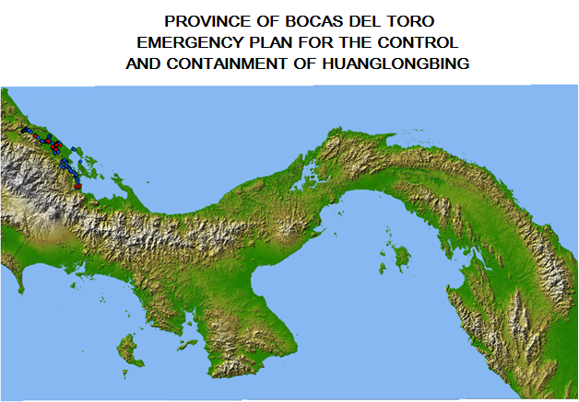

Positive farms or back yards

Negative farms or back yards