REPORT FOR THE ESTABLISHMENT OF PEST FREE AREAS FROM
MEDITERRENENAN FRUIT FLY IN ESKİŞEHİR PROVINCE (2021)
1. | Project Coordinator and Institute | : | Dr. Vildan BOZKURT  Plant Protection Central Research Institute
2. | Project Assistants and Institution | : | Eda GÖZÜKARA, Ekrem ADA  Agriculture and Forest Directorate of Eskişehir Province
3. | Project Start Date | : | 2016
4. | Report Term | : | 1/01/2021-31.12.2021
5. | Districts Included Project | : | Eskişehir (Mahmudiye, Mihalgazi, Mihallıççık, Odunpazarı, Sarıcakaya, Tepebaşı districts)
6. | Target Fruit of Project | : | Cherry

7. SUMMARY
One of the provinces, where the “Mediterranean Fruit Fly Ceratitis capitata (Diptera: Tephritidae) Monitoring Project”launched in our country in 2016, is Eskişehir. Establishment of pest free areas for Mediterranean fruit fly study conducted in Eskişehir, which is one of the important cherry production areas. Studies was conducted in 2021 under the coordination of Plant Protection Central Research Institute (PPCRI) as in 2018-2019-2020. Medfly Ceratitis capitata (Diptera: Tephritidae) is an harmful organism that is subject to quarantine and has zero tolerance in export. Fruit flies constitute an important group of pests that restrict the entry of agricultural products that are host of Medfly. This study has been planned to conduct studies for determination, establishment and protection of areas free from Mediterranean fruit fly (Medfly) in cherry production areas.
It was planned to carry out this study in Eskişehir province with the aim of determining the areas free from medfly, which is a problem in fruit export. Through this study, it is aimed to determine the free areas from Medfly Ceratitis capitata Diptera: Tephritidae) and to ensure the new exporting countries for Turkey's exports.
Thus;
- To ensure cherry exports to Far East countries,
- To avoid returns due to infested medfly products
- To grow healthy, reliable and controlled products for export,
- To increase marketing oppurtunities of agricultural products will be provided.
As a result of this study, it is aimed to monitor Medfly population with pheromone traps in cherry orchards and to take measures to expand the pest free areas and to maintain the pest free areas, and so eliminating the Medfly from being a problem in cherry export. At the same time, with this study, adult monitoring of medfly was conducted with traps hanged in cherry orchards and it was determined that no pests were found in this area. Fruit countings have been made and it has been demonstrated that the fruit is not damaged by Medfly. In areas where cherries are grown, the areas free from Medfly are marked on the map. Leaflets, brochures, posters, etc. were distributed to create awareness in the society about the pest. Outputs of project will be used by the Ministry of Agriculture and Forestry, Chambers of Agriculture, Exporters' Associations, Producers' Associations and Producers.

8. MATERIAL AND METHOD
The main materials of the study were cherry orchards, delta-type traps with Trimedlure, lenses, plastic bags, plastic cuvettes and other laboratory materials. Before starting the work “Establishment of Pest Free Area for the Mediterranean fruit fly in Eskisehir, provincial and district officials were determined from the Directorate of Agriculture and Forestry of Eskişehir Province, and Project teams were formed and the orchards to be worked were determined. It was planned to send the results of the study to PPCRI by the technical officials of the province. All the data obtained by the concerned expert from the Coordinator PPCRI were evaluated and a report was prepared to present to the relevant office at the Ministry of Agriculture and Forestry.
The studies carried out for the establishment of pest free area from fruit flies have been carried out on the based on the requirements including the following details compatible with the International Standards on Phytosanitary Measures. These standards are:

ISPM 4 Requirements For The Establishment Of Pest Free Areas
ISPM 6 Surveillance
ISPM 8 Determination Of Pest Status In An Area
ISPM 10 Requirements For The Establishment Of Pest Free Places Of Production And Pest Free Production Sites
ISPM 26 Establishment Of Pest Free Areas For Fruit Flies (Tephritidae)

Pest Free Area (PFA) is defined as the “an area in which a specific pest does not occur as demonstrated by scientific evidence and in which, where appropriate, this condition is being officially maintained” (ISPM 4).

Three main elements have been taken into account within the scope of ISPM 4 in order to establish a pest free area from Medfly which does not cause damage in cherry fruit in Turkey, and to maintain this condition. These tree main elements are;

A. Studies Conducted for Establishment Pest Free Area
a) Data collection (geographical information about orchards)
b) Surveys (trapping, detection, limitation)
c) Regulatory activities (fruit countings and fruit sampling for inspection)
d) Checking activities (review and evaluation)
e) Documentation (reports, work plans)

- Data Collection
In the cherry orchards, pest monitoring and detection studies were carried out through delta-traps with trimedlure. Medfly traps were counted weekly throughout the year, and the data obtained were recorded.
- Survey (monitoring with traps and detection)
Survey teams were established in Mihallıççık, Odunpazarı, Sarıcakaya, Mihalgazi, Mahmudiye and Tepebaşı districts of Eskişehir Province. The presence/absence of the pest was monitored by conducting surveys by these teams. The survey program, prepared in line with the ISPM 6 requirements, has been implemented. In order to determine the presence of the medfly, it was made by placing Delta-traps containing Trimedlure, which are adult-male-specific, to monitor the population. For this purpose, traps were hung in orchards selected from 4 different directions of the district to represent the area. In addition to the orchards that were choosen in previous years to monitor the pest, 2 traps were placed 1,5 m high at each orchard at a distance of at least 1 km away. Traps hanged totally 23 plots in Eskişehir province. In 2021 trap monitoring study contuniued regularly in 12 parcel, 1150 decares cherry production orchards in Mihalıççık district.

Planning the locations of traps: Traps were hung places such as orchards, wholesale market halls.
Trap density: In order to determine the trap density in accordance with the aim of the survey, presence and type of the host, topography, pest status, and attractant type are among the factors taken into account. For this reason, there are 5 orchards in Mahmudiye district, where fruit production is made intensively, 1 orchard in Mihalgazi district, 12 orchards in Mihalıççık district, 1 market place in Odunpazarı district, 3 orchards in Sarıcakaya district, 1 orchard in Tepebaşı District, a total of hanged traps in 23 points. Hence, traps were placed in cherry, nectarine, persimmon, pomegranate, peach, apple, jujube orchards in Mahmudiye, Mihalgazi, Mihallıççık, Odunpazarı, Sarıcakaya, Tepebaşı districts where fruit production was made intensively.
Trap records: Data, obtained from survey, such as trapped individual numbers, trap location, cherry tree where traps were placed, type of trap and attractant, control dates were recorded. Trap controls were made weekly and recorded throughout 2021. The pheromone capsules in the trap were changed every 4 weeks.

- Regulatory activities (fruit countings and fruit sampling for inspection)
In the orchards in Mihalıççık district, where we conduct in 12 orchard medfly free area study in 2021 year. Fort his aim, 100 cherry fruits from each of the 10 trees selected during the harvest in each of 12 orchards were recorded by being counted as undamaged, damaged / infested. In a total of 12 plots, 12.000 cherry fruits from 120 trees were visually checked and no damaged / infested fruits were found (Annex: 6). After the harvesting, Medfly trap controls continued.

- Checking Activities (review and evaluation)
Investigations were carried out by the expert to supervise and evaluate trap applications. The technical staff who carried out studies informed by the expert of PPCRI, the coordinator institute that does not directly take part in the execution of project, and the effectiveness and settlement areas of the traps were checked in the field. Field inspections were carried out in the phenological period of cherry before harvesting. The investigation included procedures that are related to trap materials, layout of the trap locations, trap location maps, trap conditions, trap control frequency, record and identification, diagnosis of Medfly, fruit sampling and counting method and signboard preparation.

- Documentation (reports, work plans)
Information on training activities carried out in cherry fruit growing areas to raise public awareness about the medfly and fruit counting results and trap countings records were collected by Eskişehir provincial Directorate of Agriculture and Forestry. Records were send to the Plant Protection Central Research Institute by responsible technical staff of Eskişehir provincial Directorate of Agriculture and Forestry. Coordinator Institute prepared a report and presented to the General Directorate of Food and Control.

- Phytosanitary Measures Required for Sustaining Pest Free Area
In case of the Medfly detection, appropriate control methods such as; cultural measures, biotechnical control method and if necessary chemical control will be implemented in accordance with the Agricultural Control Technical Instruction. Suggestions will be given with licensed plant protection products when it is necessary.

In cooperation with the Agriculture and Forestry Provincial / District Directorates for the control of medfly, public awareness was tried to be established to make collective Medfly control aplication

In the orchards where the host of the pest is produced, transport vehicles, processing and packaging facilities, at the sales points, such as wholesale market hall, markets etc., wherever pests can be seen and survive, such as animal manure heaps, garbage and where waste materials are collected around, it is aimed to control the pest. In medfly control, it is aimed to increase the knowledge and experience of the producers, grow healthy, reliable and controlled products, raise awareness in the sector, increase marketing opportunities, facilitate trade and ensure sustainable production.

It was recommended that all the proper methods of control, that can be used all together, such as cultural measures, biotechnical control and chemical control, in line with Integrated Pest Management principles. In order to make eradication effective in the case of determination of medfly in the area designated as the free area IPM principles will be implemented. It was planned to create a buffer zone in cases where geographical isolation is considered insufficient in preventing entry to pest free area or if there is no other way to prevent medfly movement to pest free area. Thus, the number of traps will be increased at the zone of transition between districts, and a buffer zone will be established.

- Controls to Confirm that Free Area is Sustained
Phytosanitary measures are implemented and investigations are carried out to verify the status of a pest free area and to sustain pest free area status. These controls include the following issues:
- Inspection of exported products
- Monitoring surveys
- Notifications of researchers, consultants or inspectors to NPPO about the presence of any harmful organism.

9. RESULTS AND DISCUSSION
Survey studies were carried out throughout year with delta-traps containing trimedlure,which were hung to investigate the presence or absence of medfly in cherry orchards in 2021. Within the scope of the 2021 medfly free area study, traps placed 12 plots cherry production area whose width is 1.150 decare in Mihalıççık district. These traps checked regularly throughout year and no medfly adults were seen in traps. As part of the Mediterranean fruit fly-free field study in 2021, pheromone traps hanged in the 1.150 decare cherry production area in 12 parcels (M1-M2-M3-M4-M5-A1-A2-A3-M10-M11-M12-M15) in Mihalıççık district were regularly checked and Mediterranean fruit fly was not found in that region in during the controls.
Within the scope of Monitoring Project other than Medfly Free Area Project, adult medflies started to seen in 5 traps in Mahmudiye district in August, in 3 traps in Sarıcakaya district from the beginning of July. The first adult was observed in October in 1 trap in Mihalgazi district, and no medfly was observed in 1 trap in Tepebaşı district and 1 trap in Odunpazarı district.

Trap controls were done weekly, and all information about the traps was recorded. The location of the trap, the size of the area (decare), latitude and longitude information, lot and block information, names of orchard owners, plant type, trap and attractant type, trap placement and control dates were recorded. The location of the traps was determined through the GPS device and records were taken. The locations of traps, in Mihallıççık, Mihalgazi, Odunpazarı, Tepebaşı, Mahmudiye and Sarıcakaya districts, are marked according to GPS coordinates on the map (Annex 1, 2, 3, 4).
The data obtained from traps located in Mihallıççık, Mihalgazi, Odunpazarı, Tepebaşı, Mahmudiye and Sarıcakaya districts are included in the trap charts of the medfly that belongs to Eskişehir. When the charts in Annex 5 are examined, it is seen that no adult medfly is caught in the traps in cherry orchards in all locations where the trap is hung in Mihalıççık district (Annex 5).
In fruit controls, fruit samples were taken from the cherry fruits of the trees in 12 parcels determined from the orchards followed by trap before harvest and 1000 fruits are counted in each orchard. In Eskişehir province, no dead-alive medfly larvae were found by controlling the cherry fruits, visually (Annex 6).
As supervision actions, the studies conducted were evaluated by the expert. These studies were carried out by the experts of the Central Plant Protection Research Institute, the coordinator institute, which does not directly participate in trap applications. In addition, the areas where the monitoring traps are placed and their status of effectiveness are examined in the field. Fruit count was seen to be applied according to sampling method. In the wake of the examination, the settlement status of the traps, controlled on the map, has been marked and it has been demonstrated through observations that the control intervals are compatible with the accepted standards. During the study, by defining the lack of knowlege, special recommendations were made to overcome these knowledge deficiencies.

Geographical location information: Eskişehir is located between 29-32 degrees east longitudes and 39-40 degrees north latitudes in the northwest of Central Anatolia Region. The surface area of ​​Eskişehir is 13.652 km².

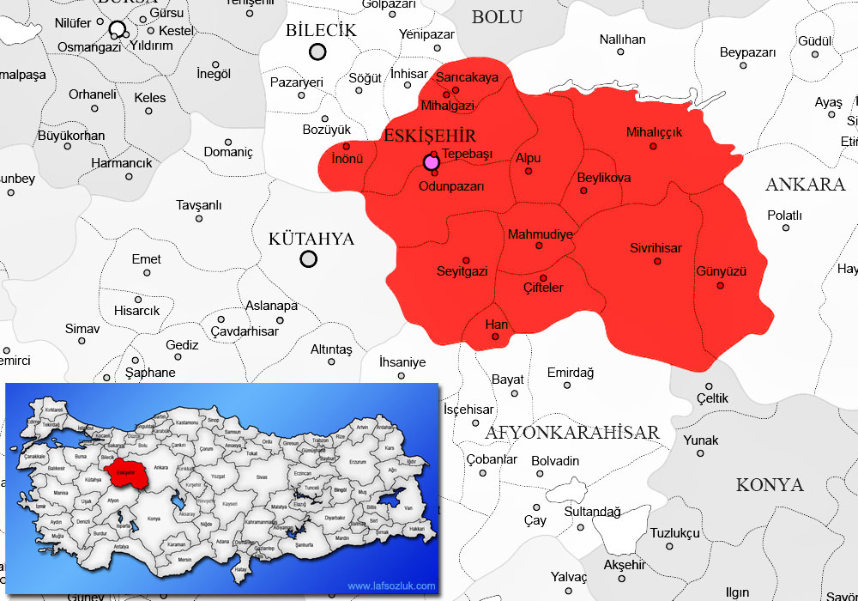
Eskişehir Province Map

The highest mountain is Türkmendağı Hill with 1825 meters. A small part of Seyitgazi, one of the districts of Eskişehir, is under the influence of the Aegean climate, the whole area of Sarıcakaya District and a part of the Centrum and Mihallıçık districts are under the influence of the Blacksea climate. However, Eskişehir generally takes its geographical character from the Central Anatolia Region. A harsh continental climate prevails in Eskişehir. There is a temperature difference between day and night. Surrounded by natural borders such as Bozdağ and Sündiken Mountains from the north, Emirdag from the south, the Central Asian Valley from the east and the Turkmen Mountain from the west, it is approximately 13,653 km². Eskişehir province constitutes 1.8% surface area of Turkey. The altitude of the city center according to sea level is 792 m. Eskişehir province is surrounded by Emirdağ and İhsaniye districts of Afyonkarahisar from the south, Yunak of Konya from southeast, Polatlı, Nallıhan and Beypazarı of Ankara from the east, Göynük of Bolu from the northwest, Gölpazarı, Söğüt, Bozüyük districts of Bilecik and Kütahya from the west. The province approximately has 22% mountainside and 26% plain area. The topographic structure of Eskişehir province, located in the northwest corner of Central Anatolia, is constituted by plains in the Sakarya and Porsuk basins and the mountains surrounding them. Basin plains are surrounded by the Bozdağ-Sündiken Mountain Range from the north and the Türkmen Mountain, Yazılıkaya Plateau and Emirdağ, located on the east edge of the Inner West Anatolian threshold, from the west and south. The valleys have generally deepened as a result of prolonged erosion of external factors. Valley slopes are slightly inclined and slope erosion is strong. In the province where the hill ridges are flat and round apart from the young formations, the closed basin situation is not very common. There is a continuous slope towards the sea. Mountains surround the plains of the province from various directions. Bozdağ and Sündiken Mountains, are among the inner mountain ranges of Anatolia, are located in the north of the province, in the west-east direction. Sivrihisar Mountains, starting from the Sakarya arc, extend in the southeast-northwest direction in the southeast corner of Eskişehir province.
Sivrihisar Mountains extending to Kaymaz Subdistrict are located on a threshold-like plateau. High hills are seen from place to place on the wide threshold which has the appearance of a plateau after the Kaymaz Sub-District. Starting in the south of Eskişehir city center, this plateau-like wavy area lengthens in the west direction. It forms the Küçük Türkmen Mountain in the south of the Sarısu Plain and merges with the Domaniç Mountains outside the provincial borders. The most important elevation between Kaymaz Subdistrict and Centrum is the foothill of Koca Kır Plateau descending to Porsuk Plain. When you go west from Porsuk Stream, you can reach Küçük Türkmen Mountain, which is 1.255 meters high. The original Türkmen Mountain starts from the south of Porsuk Dam and extends to the Sakarya Plain with its extensions. The highest point of Eskişehir province is Turkmen Mountain Hill with 1,825 meters. Other important elevations are Kırgıl Hill, Kuyu Hill, Yaylacık Hill, Deve Eriği Hill, Deve Hill and Oluk Mountain.

Climate of Eskişehir:
Eskişehir has a terrestrial climate feature due to its geographical conditions, elevations, landforms, distance to the sea. On the one hand, it has the effects of the climate belonging to Aegean and Marmara regions since it is close to the Aegean and Marmara regions. In Eskişehir, winter is partly cloudy, snowy, spring is moderately rainy and summer is less cloudy and clear, usually. The annual average temperature is 10,9 °C. According to the monthly average, the coldest month of the year is January with -2 °C. From the middle of December to the middle of February, very cold days and frost occur. Degrees ranging from -10 ° C to -25 ° C can be seen. However, in January, warm days between 10 ° and 15 ° C are also seen. More frosts occur in March. In the second half of spring, the maximum temperature rises above 20 ° C. The hottest days are seen in June, July and August. The lowest temperature is 10 °C-15 °C. The highest temperature in the second half of July and in the first half of August ranges from 30 °C to 40 °C. The most obvious event that shows the continental climate feature is also the large temperature differences between 12 °C and 29 °C at night and day temperature. The average temperature in October is around 10 °C. Precipitation in Eskişehir are seen in the form of snow and rain in the winter. From December, precipitation is mostly in the form of snow. The weather starts to warm up from the end of April. Spring rains in Eskişehir come from west and southwest and rain in a downpour. The average annual rainfall is 378.9 kg/m³. In July and August, it shows the Mediterranean summer drought characteristics. But very mildly, it also receives the Blacksea summer rains. Rain in October, slush in November indicates the onset of winter. In Eskişehir, winds blow from east to west in winter. Northwest winds prevail in the first months of spring. At the end of spring, winds from southwest, west and northwest are seen. In the summer season, daily strong eastern winds can be seen temporarily. In autumn, east, northeast and southeast winds appear from the end of September. According to the 2011 data of the General Directorate of Meteorology; The coldest month is January, the warmest month is July. The highest temperature was measured as 36,2 °C in July. The lowest temperature was measured as -11,3 °C in December. Eskişehir Province has a harsh continental climate. Summers are hot and dry, winters are harsh and rainy. The temperature difference between day and night is high.

Considering that the pest does not develop below 10 ° C, it is thought that the medfly can not maintain its life cycle due to the harsh winter conditions in Eskişehir. Since Eskişehir is located at the transition point and especially on the route of the transportation vehicles, it is considered to be highly possible for the pest to be transmitted by transportation of contaminated fruits.

Training Studies;
A preparatory meeting for technical staff was held and a work plan was put forward. Various contact meetings were organized by technical staff to meet the needs of the region. Training materials, such as posters, brochures, leaflets, were prepared and liflets were distributed to inform the public, within the scope of expanding awareness activities about the pest. It was aimed to raise social awareness through training activities.

To Keep Area Free From The Pest;
In order to ensure collective control in line with the principles of Integrated Pest Management, cooperation was made with the relevant institutions.
Agriculture and Forestry Provincial Directorate of Eskişehir provided materials such as plastic bags etc. for the medfly control and preventive measures. In the harvested orchards, it was recommended to collect the leftover fruits on tree or ground and leave them under the sun inside black plastic bags.
In order to be implement in places where medfly will be determined, suggestions have been given in order to apply appropriate methods of control such as cultural measures, biotechnical control in accordance with the Plant Protection Technical Instructions and, if necessary, to control chemically through registered plant protection products.

It was provided that product remains and fruit wastes, which are host, are collected from wholesale market halls, street markets, dumps, drainage channels and were buried deeply in soil, and pesticide treatments were done to common areas which are contamination resources and animal feces are collected.

The producers were informed about distinguishing and sorting of contaminated fruit, collecting them under suitable conditions without spreading to the environment, and destroying them by deeply burying in the soil, and taking the necessary precautions to prevent the transmission of medfly during transportation.

10. SUGGESTIONS
In line with “National Action Plan for Mediterranean Fruit Fly Control”, it should be planned to cooperate with local authorities to control the fruit entries and exits ,and to carry out the transportations under controlled conditions in order to prevent medfly contamination to the provinces where pest free area studies are carried out. It should be provided that the places with high probability of contamination such as uncared orchards, fruits returned in packaging facilities, fruit markets, entrances of production areas are kept under control.
It is advised to obtain production records of the host fruit species in the region and not to plant the fruit species known as the hosts of the pest in cherry orchards.
In conclusion; Medfly trap monitoring has started in cherry orchards determined in Eskişehir since 2016-2017, and gradually increased area, under control, has been checked regularly by the technical staff of Agriculture and Forest Directorate of Eskişehir Province and Mihallıççık, Mihalgazi, Odunpazarı, Tepebaşı, Mahmudiye and Sarıcakaya District Agricultural and Forestry Directorates.
Within the scope of the Medfly free areae establishment works, no Medfly adults were found in 12 cherry orchards with a cherry production area of ​​1.150 decares in the trap, in Mihalıççık district in Eskişehir province in 2021, where altitudes and locations are given in the chart. Medfly adults, larvae and damage were not observed in the traps hanged and cherry fruits in districts where traps were placed in 1.150 decares cherry orchard in Mihalıççık district.

In 2021, within the scope of the “Establishment of Pest Free Area Studies of the Mediterranean fruit fly” in Mihalıççık district of Eskişehir province, traps placed in 12 plots 1.150 decare cherry production area. Controls were made regularly and no medfly were found in the traps. In addition to the growing areas in previous year, Medfly adults in traps has not been observed in 1150 decare additional cherry growing area in Mihalıççık, in 2021 within the scope of the pest free area expansion works. If it is deemed appropriate by our Ministry, it is deemed pertinent to continue in 2022 Medfly Free Area Works in cherry production area of Eskişehir Province.

In the new working period in Eskişehir 2022, the control and preventive measures against the Medfly will be carried out in compatible with the " National Action Plan for Mediterranean Fruit Fly Control " prepared by Turkish Ministry of Agriculture and Forestry and entered into force on 13 December 2019. Activities was planned to continue about management of Medfly by using preventive cultural measures, biotechnical control methods and chemical control on the different hosts. By evaluating these methods, collective control application will be carried out simultaneously and in compatible with Integrated Pest Management principles.
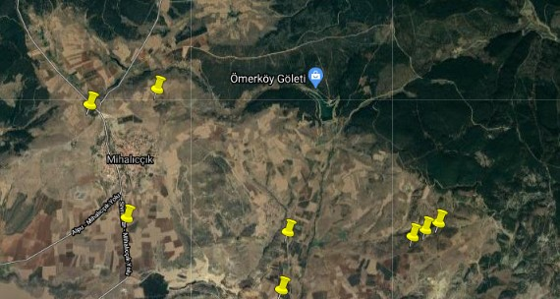
Annex 1. Medfly Trap Locations in Mihallıççık District

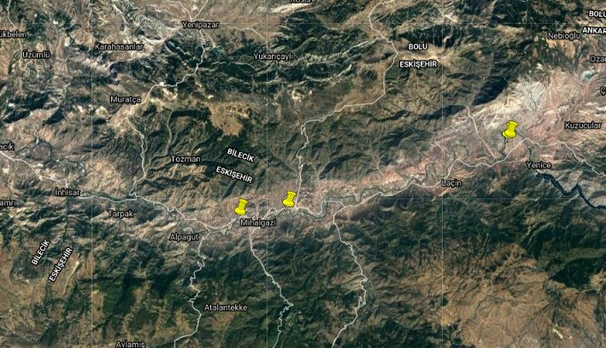

Annex 2. Medfly Trap Locations in Mihalgazi District

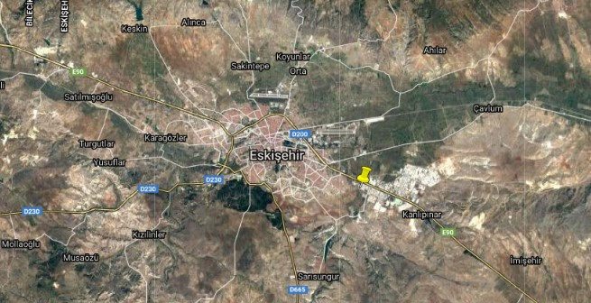

Annex 3. Medfly Trap Location in Eskişehir Centrum

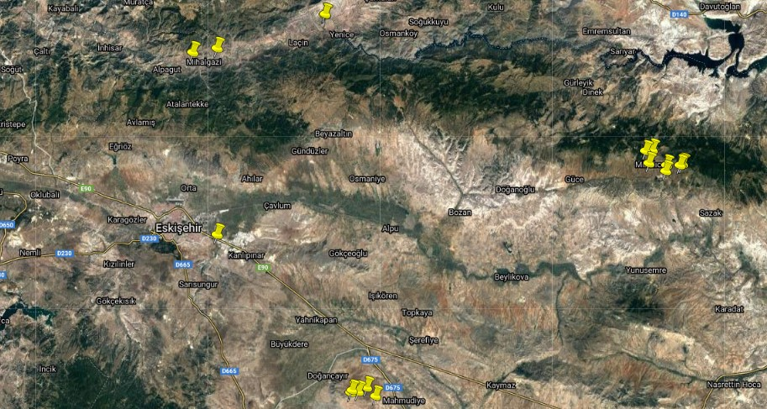
Annex 4. General View of Medfly Trap Locations in Eskişehir

Annex 5. Medfly Trap Monitoring Charts of Eskişehir Province, 2021

 | 2021 YILI AKDENİZ MEYVE SİNEĞİ KONTROL RAPORU |  |  |  |  |  |  |  |  |  |  |  | 2021 YILI AKDENİZ MEYVE SİNEĞİ SÜRVEYi
 | MİHALLIÇÇIK |  |  |  |  |  |  |  |  |  |  |  | ODUNPAZARI | SARICAKAYA |  |  | MİHALGAZİ | MAHMUDİYE |  |  |  |  | TEPEBAŞI
 | M1 | M2 | M3 | M4 | M5 | A1 | A2 | A3 | M10 | M11 | M12 | M15 | HAL | SN1 | SE1 | ST2 | MT1 | ME1 | MŞ1 | ME3 | ME4 | ME5 | TS1
 | 1260901 | 1260902 | 1260903 | 1260904 | 1260905 | 1260906 | 1260907 | 1260908 | 1260913 | 1260914 | 1260915 | 1260918 | 1261009 | 1261110 | 1261111 | 1261112 | 1260813 | 1260714 | 1260715 | 1260716 | 1260717 | 1260718 | 1260718
Enlem | 39º52'33,7'' | 39º52'25,6'' | 39º85'29,3'' | 39º51'15,7'' | 39º84'39'' | 39º51'13'' | 39º51'8,7'' | 39º51'6,4'' | 39º88'24,5'' | 39º88'36,8'' | 39º89,13'' | 39º84'96'' | 39,74344 | 40º05'11,6'' | 40º05'19'' | 40º02'05'' | 40º01'42,4'' | 39º30'6,91'' | 39º29'42,7'' | 39º29'16'' | 39º29'42,9'' | 39º29'51,9'' | 39°46'4.29
Boylam | 31º30'7,5'' | 31º25'15,9'' | 31º53'6,1'' | 31º29'41,5'' | 31º52'80'' | 31º33'50'' | 31º33'39,8'' | 31º33'28,5'' | 31º49'85,8'' | 31º50'44,7'' | 31º48'26'' | 31º52'96'' | 30,611974 | 30º49'52'' | 30º49'59'' | 30º38'41'' | 30º33'45,8'' | 30º55'5,61'' | 30º53'59,1'' | 30º56'11'' | 30º53'12,1'' | 30º53'19'' | 30°28'42.01
Yükseklik | 1337 | 1344 | 1230 | 1194 | 1240 | 1255 | 1238 | 1250 | 1345 | 1356 | 1406 | 1232 | 11 | 253 | 267 | 209 | 195 | 923 | 941 | 916 | 966 | 966 | 795
Tuzak Tipi | Delta | Delta | Delta | Delta | Delta | Delta | Delta | Delta | Delta | Delta | Delta | Delta | Delta | Delta | Delta | Delta | Delta | Delta | Delta | Delta | Delta | Delta | Delta
Cezbedici | Trimedlure | Trimedlure | Trimedlure | Trimedlure | Trimedlure | Trimedlure | Trimedlure | Trimedlure | Trimedlure | Trimedlure | Trimedlure | Trimedlure | Trimedlure | Trimedlure | Trimedlure | Trimedlure | Trimedlure | Trimedlure | Trimedlure | Trimedlure | Trimedlure | Trimedlure | Trimedlure
Bitki/Yer | Kiraz | Kiraz | Kiraz | Kiraz | Kiraz | Kiraz | Kiraz | Kiraz | Kiraz | Kiraz | Kiraz | Kiraz |  | Nektarin,Erik | Elma | T.Hurması,Hünnap,Nar,İncir | Nar, T.Hurması,İncir | Elma | Şeftali | Elma | Elma | Elma | Kiraz-Elma
Alan (da) | 20 | 22 | 50 | 28 | 40 | 330 | 300 | 170 | 22 | 37 | 27 | 60 |  | 198 | 490 | 5 | 2 | 52 | 32 | 11 | 47 | 48 | 22
11 Oca 2021 | tuzak asıldı | tuzak asıldı | tuzak asıldı | tuzak asıldı | tuzak asıldı | tuzak asıldı | tuzak asıldı | tuzak asıldı | tuzak asıldı | tuzak asıldı | tuzak asıldı | tuzak asıldı |  |  |  |  |  |  |  |  |  |  | tuzak asıldı
1 Şub 2021 |  |  |  |  |  |  |  |  |  |  |  |  | tuzak asıldı | tuzak asıldı | tuzak asıldı | tuzak asıldı | tuzak asıldı
9 Şub 2021 |  |  |  |  |  |  |  |  |  |  |  |  |  |  |  |  |  | tuzak asıldı | tuzak asıldı | tuzak asıldı | tuzak asıldı | tuzak asıldı
12 Şub 2021 | 0 | 0 | 0 | 0 | 0 | 0 | 0 | 0 | 0 | 0 | 0 | 0 | 0
9 Mar 2021 | 0 | 0 | 0 | 0 | 0 | 0 | 0 | 0 | 0 | 0 | 0 | 0 | 0
5 Nis 2021 | 0 | 0 | 0 | 0 | 0 | 0 | 0 | 0 | 0 | 0 | 0 | 0 | 0
13 Nis 2021 |  |  |  |  |  |  |  |  |  |  |  |  |  | 0 | 0 | 0 | 0 |  |  |  |  |  | 0
15 Nis 2021 |  |  |  |  |  |  |  |  |  |  |  |  |  |  |  |  |  | 0 | 0 | 0 | 0 | 0
19 Nis 2021 | 0 | 0 | 0 | 0 | 0 | 0 | 0 | 0 | 0 | 0 | 0 | 0 | 0
21 Nis 2021 |  |  |  |  |  |  |  |  |  |  |  |  |  | 0 | 0 | 0 | 0 |  |  |  |  |  | 0
29 Nis 2021 |  |  |  |  |  |  |  |  |  |  |  |  |  | 0 | 0 | 0 | 0
3 May 2021 | 0 | 0 | 0 | 0 | 0 | 0 | 0 | 0 | 0 | 0 | 0 | 0 | 0 |  |  |  |  |  |  |  |  |  | 0
20 May 2021 | 0 | 0 | 0 | 0 | 0 | 0 | 0 | 0 | 0 | 0 | 0 | 0 | 0
21 May 2021 |  |  |  |  |  |  |  |  |  |  |  |  |  | 0 | 0 | 0 | 0 |  |  |  |  |  | 0
25 May 2021 |  |  |  |  |  |  |  |  |  |  |  |  |  | 0 | 0 | 0 | 0
26 May 2021 |  |  |  |  |  |  |  |  |  |  |  |  |  |  |  |  |  | 0 | 0 | 0 | 0 | 0
1 Haz 2021 | 0 | 0 | 0 | 0 | 0 | 0 | 0 | 0 | 0 | 0 | 0 | 0 | 0
8 Haz 2021 |  |  |  |  |  |  |  |  |  |  |  |  |  | 0 | 0 | 0 | 0 |  |  |  |  |  | 0
9 Haz 2021 |  |  |  |  |  |  |  |  |  |  |  |  |  |  |  |  |  | 0 | 0 | 0 | 0 | 0
15 Haz 2021 |  |  |  |  |  |  |  |  |  |  |  |  |  | 0 | 0 | 0 | 0
23 Haz 2021 |  |  |  |  |  |  |  |  |  |  |  |  |  | 0 | 0 | 0 | 0 |  |  |  |  |  | 0
30 Haz 2021 | 0 | 0 | 0 | 0 | 0 | 0 | 0 | 0 | 0 | 0 | 0 | 0 | 0
1 Tem 2021 |  |  |  |  |  |  |  |  |  |  |  |  |  | 1 | 0 | 0 | 0
6 Tem 2021 | 0 | 0 | 0 | 0 | 0 | 0 | 0 | 0 | 0 | 0 | 0 | 0 | 0
8 Tem 2021 |  |  |  |  |  |  |  |  |  |  |  |  |  | 1 | 0 | 0 | 0 |  |  |  |  |  | 0
9 Tem 2021 |  |  |  |  |  |  |  |  |  |  |  |  |  |  |  |  |  | 0 | 0 | 0 | 0 | 0
12 Tem 2021 |  |  |  |  |  |  |  |  |  |  |  |  | 0 | 1 | 0 | 0 | 0 |  |  |  |  | 0 | 0
28 Tem 2021 |  |  |  |  |  |  |  |  |  |  |  |  | 0 | 1
29 Tem 2021
30 Tem 2021 | 0 | 0 | 0 | 0 | 0 | 0 | 0 | 0 | 0 | 0 | 0 | 0
3 Ağu 2021 |  |  |  |  |  |  |  |  |  |  |  |  |  |  |  |  |  | 0 | 1 | 0 | 0 | 0 | 0
4 Ağu 2021 |  |  |  |  |  |  |  |  |  |  |  |  | 0 | 4 | 0 | 0 | 0
5 Ağu 2021 | 0 | 0 | 0 | 0 | 0 | 0 | 0 | 0 | 0 | 0 | 0 | 0
9 Ağu 2021 | 0 | 0 | 0 | 0 | 0 | 0 | 0 | 0 | 0 | 0 | 0 | 0
10 Ağu 2021 |  |  |  |  |  |  |  |  |  |  |  |  | 0 | 17 | 0 | 0 | 0
11 Ağu 2021 |  |  |  |  |  |  |  |  |  |  |  |  |  |  |  |  |  | 0 | 7 | 0 | 0 | 0 | 0
17 Ağu 2021 | 0 | 0 | 0 | 0 | 0 | 0 | 0 | 0 | 0 | 0 | 0 | 0
19 Ağu 2021 |  |  |  |  |  |  |  |  |  |  |  |  | 0 | 23 | 0 | 0 | 0
20 Ağu 2021 |  |  |  |  |  |  |  |  |  |  |  |  |  |  |  |  |  | 0 | 10 | 1 | 0 | 0 | 0
24 Ağu 2021 | 0 | 0 | 0 | 0 | 0 | 0 | 0 | 0 | 0 | 0 | 0 | 0
6 Eyl 2021 | 0 | 0 | 0 | 0 | 0 | 0 | 0 | 0 | 0 | 0 | 0 | 0
7 Eyl 2021 |  |  |  |  |  |  |  |  |  |  |  |  |  |  |  |  |  | 0 | 14 | 1 | 0 | 0 | 0
9 Eyl 2021 |  |  |  |  |  |  |  |  |  |  |  |  | 0 | 53 | 0 | 1 | 0
14 Eyl 2021 | 0 | 0 | 0 | 0 | 0 | 0 | 0 | 0 | 0 | 0 | 0 | 0
15 Eyl 2021 |  |  |  |  |  |  |  |  |  |  |  |  |  |  |  |  |  | 0 | 8 | 0 | 0 | 0
16 Eyl 2021 |  |  |  |  |  |  |  |  |  |  |  |  |  | 5 | 0 | 0 | 0
21 Eyl 2021 | 0 | 0 | 0 | 0 | 0 | 0 | 0 | 0 | 0 | 0 | 0 | 0
22 Eyl 2021 |  |  |  |  |  |  |  |  |  |  |  |  |  |  |  |  |  | 1 | 24
23 Eyl 2021 |  |  |  |  |  |  |  |  |  |  |  |  |  | 6 | 0 | 2 | 0
27 Eyl 2021 | 0 | 0 | 0 | 0 | 0 | 0 | 0 | 0 | 0 | 0 | 0 | 0
30 Eyl 2021 |  |  |  |  |  |  |  |  |  |  |  |  |  |  |  |  |  | 1 | 96 | 0 | 0 | 1
1 Eki 2021 |  |  |  |  |  |  |  |  |  |  |  |  |  | 21 | 0 | 19
6 Eki 2021 |  |  |  |  |  |  |  |  |  |  |  |  |  |  |  |  |  | 3 | 17 | 0 | 0 | 0
11 Eki 2021 |  |  |  |  |  |  |  |  |  |  |  |  |  | 36 | 0 | 70 | 1
12 Eki 2021 |  |  |  |  |  |  |  |  |  |  |  |  |  |  |  |  |  | 2 | 23 | 0 | 0 | 5
13 Eki 2021 | 0 | 0 | 0 | 0 | 0 | 0 | 0 | 0 | 0 | 0 | 0 | 0
26 Eki 2021 |  |  |  |  |  |  |  |  |  |  |  |  |  |  |  |  |  | 2 | 17 | 0 | 2 | 10
28 Eki 2021 |  |  |  |  |  |  |  |  |  |  |  |  |  | 201 | 68 | 305 | 4
1 Kas 2021 |  |  |  |  |  |  |  |  |  |  |  |  |  |  |  |  |  | 1 | 13 | 0 | 1 | 1
5 Kas 2021 |  |  |  |  |  |  |  |  |  |  |  |  |  | 104 | 75 | 43 | 1
11 Kas 2021 |  |  |  |  |  |  |  |  |  |  |  |  |  | 91 | 33 | 123 | 0
12 Kas 2021 |  |  |  |  |  |  |  |  |  |  |  |  |  |  |  |  |  | 0 | 0 | 0 | 0 | 4
16 Kas 2021 |  |  |  |  |  |  |  |  |  |  |  |  |  | 72 | 7 | 132 | 2
17 Kas 2021 |  |  |  |  |  |  |  |  |  |  |  |  |  |  |  |  |  | 0 | 12 | 0 | 0 | 0
22 Kas 2021 |  |  |  |  |  |  |  |  |  |  |  |  |  | 51 | 5 | 23 | 1
2 Ara 2021 |  |  |  |  |  |  |  |  |  |  |  |  |  | 2 | 0 | 0 | 0
8 Ara 2021 |  |  |  |  |  |  |  |  |  |  |  |  |  | 0 | 0 | 0 | 0
14 Ara 2021 |  |  |  |  |  |  |  |  |  |  |  |  |  | 0 | 0 | 0 | 0

Annex 6. Medfly Fruit Counting Charts of Eskişehir Province, 2021
 |  |  |  |  |  |  |  |  | MİHALLIÇÇIK
 | M1 | M2 | M3 | M4 | M5 | A1 | A2 | A3 | M10 | M11 | M12 | M15
 | 1260901 | 1260902 | 1260903 | 1260904 | 1260905 | 1260906 | 1260907 | 1260908 | 1260913 | 1260914 | 1260915 | 1260918
Enlem | 39º52'33,7'' | 39º52'25,6'' | 39º85'29,3'' | 39º51'15,7'' | 39º84'39'' | 39º51'13'' | 39º51'8,7'' | 39º51'6,4'' | 39º88'24,5'' | 39º88'36,8'' | 39º89,13'' | 39º84'96''
Boylam | 31º30'7,5'' | 31º25'15,9'' | 31º53'6,1'' | 31º29'41,5'' | 31º52'80'' | 31º33'50'' | 31º33'39,8'' | 31º33'28,5'' | 31º49'85,8'' | 31º50'44,7'' | 31º48'26'' | 31º52'96''
Yükseklik | 1337 | 1344 | 1230 | 1194 | 1240 | 1255 | 1238 | 1250 | 1345 | 1356 | 1406 | 1232
Tuzak Tipi | Delta | Delta | Delta | Delta | Delta | Delta | Delta | Delta | Delta | Delta | Delta | Delta
Cezbedici | Trimedlure | Trimedlure | Trimedlure | Trimedlure | Trimedlure | Trimedlure | Trimedlure | Trimedlure | Trimedlure | Trimedlure | Trimedlure | Trimedlure
Bitki/Yer | cherry | cherry | cherry | cherry | cherry | cherry | cherry | cherry | Kiraz | Kiraz | Kiraz | Kiraz
Alan (da) | 20 | 22 | 50 | 28 | 40 | 330 | 300 | 170 | 22 | 37 | 27 | 60
8 Haz 2021 |  |  |  | 0 | 0 | 0 | 0 | 0 | 0 | 0
23 Haz 2021 | 0 | 0 | 0 |  |  |  |  |  |  |  | 0 | 0

Annex 7. Medfly Fruit Counting Samples in Eskişehir Province, 2021
