ACTION REPORT FOR THE ESTABLISHMENT OF FREE AREAS FROM
MEDITERRENENAN FRUIT FLY IN KONYA PROVINCE (2021)
1. | Project Coordinator and Institute | : | Dr. Vildan BOZKURT  Plant Protection Central Research Institute
2. | Project Assistants and Institution | : | Kenan ERDOĞAN  Konya Directorate of Provincial Agriculture and Forestry
3. | Start Date of Project | : | 2016
4. | Report Term | : | 1/01/2021-31.12.2021
5. | Districts Included Project | : | Akşehir, Hadim, Halkapınar, Bozkır, Taşkent Districts
6. | Target Fruit of Project | : | Cherry

7. SUMMARY
Konya is one of the provinces in which the “Mediterranean Fruit Fly Ceratitis capitata (Diptera: Tephritidae) Monitoring Project” was carried out in Turkey launched in 2016. Establishment of pest free areas for Mediterranean fruit fly study conducted in Konya, which is one of the important cherry production areas. Studies was conducted in 2021 under the coordination of the Ankara Plant Protection Central Research Institute (PPCRI) as in 2019 and 2020. Mediterranean fruit fly Ceratitis capitata (Diptera: Tephritidae) is a harmful organism that is subject to external quarantine and has zero tolerance in export. Fruit flies constitute an important group of pests that restrict the entry of plant products which its hosts.

This study has been planned to conduct studies for determination, establishment and protection of areas free from Mediterranean fruit fly (Medfly) in cherry production areas. This study was planned to carry out in Konya province in order to determine areas that are free from the quarantine organism Mediterranean fruit fly, which is an important problem in fruit export. With this study, it is aimed to determine the areas free from Mediterranean fruit fly (Ceratitis capitata Diptera: Tephritidae) and to ensure the new exporting countries for Turkey's exports.
So;
- To ensure cherry exports to Far East countries,
- To avoid returns due to infested medfly products
- To grow healthy, reliable and controlled products for export,
- To increase marketing oppurtunities of agricultural products will be provided.

As a result of this study, it is aimed to monitor medfly population with pheromone traps in cherry orchards and to take measures to expand the pest free area and to maintain the pest free area, and so eliminating the Medfly from being a problem in cherry export. At the same time, with this study, adult monitoring of medfly was made with traps hanged in cherry orchards and it was determined that no pests were found in this region. Fruit counts have been made and it has been demonstrated that the fruit is not damaged. In areas where cherries are grown, the areas free from medfly are marked on the map. Leaflets, brochures, posters, etc. were distributed to create awareness in the society about the pest. Outputs of project will be used by the Ministry of Agriculture and Forestry, Chambers of Agriculture, Exporters' Associations, Producers' Associations and Producers.

8. MATERIALS AND METHODS
The main materials of the study were cherry orchards, delta-type traps containing Trimedlure, loupe, plastic bags, plastic tubs and other laboratory materials. Before starting the work for “Establishment of Pest Free Area for the Mediterranean fruit fly in Konya province”, project team were determined from the provincial and district technical staff of Provincial Directorate of Agriculture and Forestry and the cherry orchards determined.

An informative meeting was held by the experts from the Coordinator Institute Ankara Plant Protection Central Research Institute (PPCRI) about the works to be carried out with the technical staff of Konya Agriculture and Forestry Provincial and District Directorate. It is planned to send the results of the study to the project coordinator Institute by the technical responsible staff of province. The expert at the Coordinator Institute Ankara PPCRI combined all the data obtained by the relevant technical staff and a report was prepared to be submit to the relevant office at the Ministry of Agriculture and Forestry.

The studies carried out for the establishment of pest free area have been carried out on the basis of the requirements including the following details compatible with the International Standards on Phytosanitary Measures. These standards are:

ISPM 4 Requirements For The Establishment Of Pest Free Areas
ISPM 6 Surveillance
ISPM 8 Determination Of Pest Status In An Area
ISPM 10 Requirements For The Establishment Of Pest Free Places Of Production And Pest Free Production Sites
ISPM 26 Establishment Of Pest Free Areas For Fruit Flies (Tephritidae)

Pest Free Area (PFA) is defined as the “an area in which a specific pest does not occur as demonstrated by scientific evidence and in which, where appropriate, this condition is being officially maintained” (ISPM 4).

Three main elements have been taken into account within the scope of ISPM 4 in order to create a pest free area from Mediterranean fruit fly, which does not cause damage in cherry fruit in Turkey, and to maintain this condition. These tree main elements are;

1.Studies Conducted for Establishment Pest Free Arae
  - Data collection (geographical information about orchards)
  - Survey (Monitoring through traps, detection, restriction)
  - Regulation Actions ( Fruit sample collection and counting)
  - Inspection Actions (check and evaluation)
  - Documentation (reports, work plans)

- Data collection:
In the cherry orchards, pest monitoring and detection studies were carried out through delta-traps with trimedlure. Medfly scores in traps were counted weekly throughout the year, and the data obtained were recorded. Geographical information about orchards was recorded.
- Survey (monitoring with traps and detection)
Survey teams were established in Akşehir, Hadim, Halkapınar, Bozkır and Taşkent districts of Konya province. The presence/absence of the pest was monitored by conducting surveys by these teams. The survey program, prepared in line with the ISPM 6 requirements, has been implemented. In order to determine the presence of the Medfly, it was made by placing Delta-traps containing Trimedlure, which are adult-male-specific, to monitor the population. For this purpose, traps were hung in orchards selected from 4 different directions of the district to represent the area. In addition to the orchards that were trapped in previous years to monitor the pest, 2 traps were placed 1,5 m high at each orchard at a distance of at least 1 km away.
Planning the locations of traps: Traps were hung on areas by taking into accounts areas in the Afyon-Konya highway that may be infested with the medfly such as; fruit market, wholesale market, cold storage house and fruit processing facility, settlements and cherry orchards.
Trap density: In order to determine the trap density in accordance with the aim of the survey, presence and type of the host, topography, pest status, and attractant type are among the factors that taken into account.
Trap records: Data, obtained from survey, such as trapped individual numbers, trap location, plants where traps were placed, type of trap and attractant, control dates were recorded. Trap controls were made weekly throughout 2020 and recorded. The pheromone capsules in the trap were changed every 4 weeks.
- Regulation Actions ( Fruit sample collection and counting)
In 2020, in each orchard followed by means of traps, during the harvest, 100 cherry fruits from selected 10 trees were visually checked and recorded as intact, oviposited/infected with larvae. After harvest, medfly observations continued by trap.
- Inspection Actions (check and evaluation)
Investigations were carried out to supervise and evaluate trap applications. The technical staff who carried out studies informed by the expert of PPCRI, the coordinator institute that does not directly take part in the execution of project, and the effectiveness and settlement areas of the traps were checked in the field. It was planned to conduct at least twice a year inspection, and inspections were carried out in the phenological period of cherry before harvest. The investigation included procedures that are related to trap materials, layout of the trap locations, trap location maps, trap conditions, trap control frequency, record and identification, diagnosis of medfly, fruit sampling and counting method.
- Documentation (reports, work plans)
Information on training activities carried out in cherry fruit growing areas to raise public awareness about the medfly and fruit counting results and trap countings records were collected. Records were send to the Plant Protection Central Research Institute by responsible technical staff of Konya provincial Directorate of Agriculture and Forestry. Coordinator Institute prepared a report. And report were presented as a report to the General Directorate of Food and Control.

- Phytosanitary Measures Required for Sustaining Pest Free Area
In case of the Medfly detection, appropriate control methods such as; cultural measures, biotechnical control method and if necessary chemical control will be implemented in accordance with the Agricultural Control Technical Instruction. Suggestions will be given with registered plant protection products when it is necessary. In cooperation with the Agriculture and Forestry Provincial / District Directorates for the control of medfly, public awareness was tried to be established to make collective Medfly control application.

In the orchards where the host of the pest is produced, transport vehicles, processing and packaging facilities, at the sales points, such as wholesale market hall, markets etc., wherever pests can be seen and survive, such as animal manure heaps, garbage and where waste materials are collected around, it is aimed to control the pest. In medfly control, it is aimed to increase the knowledge and experience of the producers, grow healthy, reliable and controlled products, raise awareness in the sector, increase marketing opportunities, facilitate trade and ensure sustainable production.

In case of determination of Medfly in the designated as the pest free area it will be recommended that all the proper methods of control, that can be used together, such as cultural measures, biotechnical control and chemical control, in line with Integrated Pest Management principles.
It was planned to create a buffer zone in cases where geographical isolation is considered insufficient in preventing entry to pest free area or if there is no other way to prevent medfly movement to pest free area. Thus, the number of traps will be increased at the zone of transition between districts, and a buffer zone will be established.

- Controls to Confirm that Freenes is Sustained
Phytosanitary measures are implemented and investigations are carried out to verify the status of a pest free area and to sustain pest free area status. These controls include the following issues:
- Inspection of exported products
- Monitoring surveys
- Notifications of researchers, consultants or inspectors to NPPO about the presence of any harmful organism.

9. RESULTS AND DISCUSSION
Surveys were carried out throughout year with delta-traps containing trimedlure, which were hung to investigate the presence or absence of medfly in cherry orchards in 2020. Trap controls were done weekly, and all information about the traps was recorded. The location of the trap, the size of the area (decare), latitude and longitude information, names of orchard owners, plant type, trap and attractant type, trap placement and control dates were recorded. The locations of the traps were determined by GPS and were marked with GPS coordinates on the map. This the study was carried out in districts of Konya such as; Akşehir, Hadim, Halkapınar, Bozkır and Taşkent. For these districts, the trap monitoring charts of the Medfly are given in the annex. In Çimendere Neighborhood of Akşehir District, medfly traps checked regularly, in 2020 and counting results are given in Table 1.

TABLE 1. MEDFLY TRAP COUNTİNG RESULTS OF ÇİMENDERE NEİGHBORHOOD IN AKŞEHİR DISTRICT LOT-BLOCK=185-1 (38,23320265- 31,43514631)

DATE | ADULT NUMBER ON TRAP (CHERRY )
6 Jan 2021 | 0
13 Jan 2021 | 0
27 Jan 2021 | 0
4 Feb 2021 | 0
18 Feb 2021 | 0
25 Feb 2021 | 0
4 Mar 2021 | 0
11 Mar 2021 | 0
18 Mar 2021 | 0
25 Mar 2021 | 0
1 April 2021 | 0
8 April 2021 | 0
15 April 2021 | 0
22 April 2021 | 0
29 April 2021 | 0
6 May 2021 | 0
20 May 2021 | 0
27 May 2021 | 0
3 June 2021 | 0
10 June 2021 | 0
17 June 2021 | 0
24 June 2021 | 0
1 July 2021 | 0
8 July 2021 | 0
14 July 2021 | 0
29 July2021 | 0
5 Agu 2021 | 0
12 Agu 2021 | 0
19 Agu 2021 | 0
26 Agu 2021 | 0
2 Sept 2021 | 0
9 Sept 2021 | 0
16 Sept 2021 | 0
23 Sept 2021 | 0
30 Sept 2021 | 0
14 Oct. 2021 | 0
21 Oct. 2021 | 0
28 Oct. 2021 | 0

When trap countings of Çimendere Neighborhood (Konya province-Akşehir district), given in Table 1, is examined, it is seen that no medfly adult was caught by traps until cherry harvested.

In Akşehir district of Konya province, 2 traps were placed in Çimendere neighborhood (38,23320265- 31,43514631 lot-block numbers 185-1) to follow medfly presence/absence status, on 06.01.2021. Çimendere neighborhood is a mountainous region, and altitude above sea level is 1.728 meters in the highest place, 1.376 meters in the lowest and 1.561 meters in center. Due to its high position, the forest land of neighborhood has quite high proportion and the agricultural land is narrow. In the neighborhood, 489 decares of agricultural land has been recorded in the farmer registration system, the largest agricultural land width is 1,632 m² and the production area is limited. Fruits are grown in 227 decares and vegetables in 25 decares and production is not commercial. The fruit production area comprises 197 decares of sourcherry, 19 decares of cherry, 7 decares of apple, 3 decares of plum and 7 decares of walnut. Cherry orchards in Çimendere neighborhood can be said to be free from Medfly by the end of the year.
Maps, show medfly trap locations of Çimendere Neighborhood of Akşehir District in 2021, are given in Figure 1a, Şekil 1b and Şekil 1c.

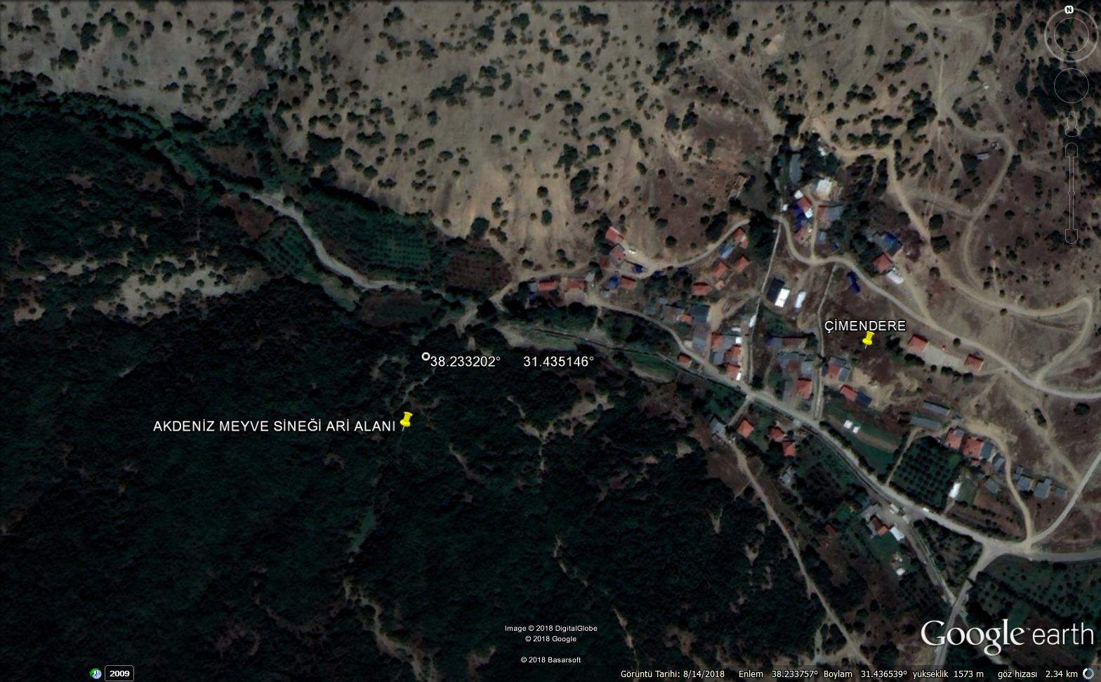
Figure 1a. Çimendere Neighborhood Medfly Traps in Konya-Akşehir

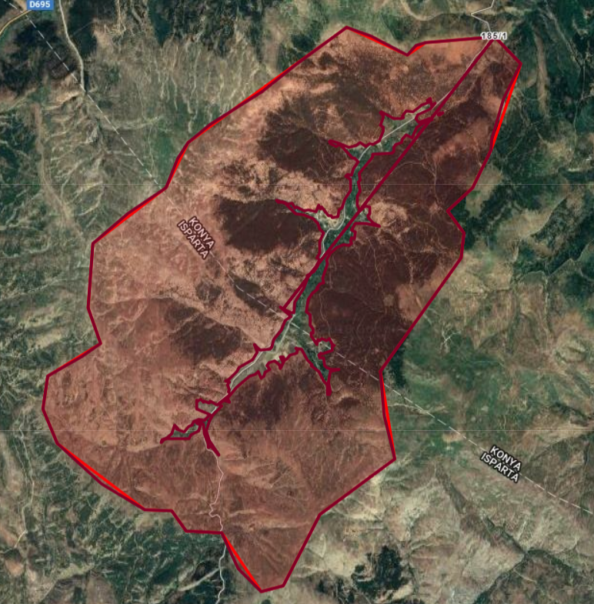
Figure 1b. Çimendere Neighborhood in Akşehir District of Konya

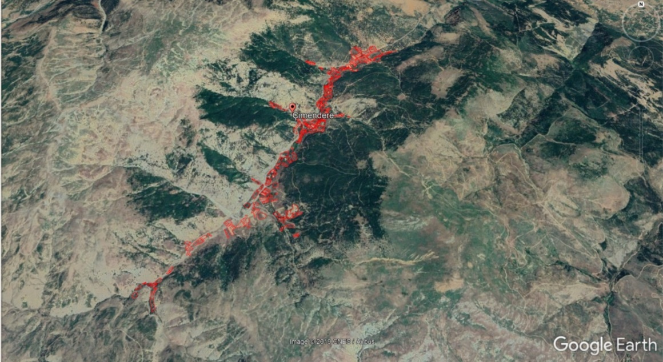
Figure 1c. Agricultural Land of Çimendere Neighborhood

Two traps were placed in the Karabük locality of Armağanlar Neighborhood on 17.03.2021, which is thought to be Medfly free area in Hadim District of Konya Province in 2021. The records obtained by regular monitoring and counting of pheromone traps in the cherry orchard in Hadim district in 2021 are given in Table 2. As it can be understood from Table 2, there was no trapped Medfly adults in traps all year round in the orchard at Armağanlar Mahallesi of Hadim district (lot/block: 360/1, (Latitiude-longitude: 36,9803-32,3879)). No Mediterranean fruitfly was caught in the traps that were monitored throughout the year in İbrahim ŞEN's cherry orchard with a size of 5,126.90 m² located at the GPS point. It is possible to say that the cherries, grown in this plot, are free of Medfly.

Table 2. Medfly Trap Counting Results Karabük Locality in Armağanlar Neighborhood of Hadim District of KONYA province in 2021
DATE | TRAP 1 | TRAP 2
Ada/Parsel: 360/1, (36,9803-32,3879) 5.126,90 m² -İbrahim ŞEN
17.03.2021 | 0 | 0
26.03.2021 | 0 | 0
09.04.2021 | 0 | 0
22.04.2021 | 0 | 0
07.05.2021 | 0 | 0
21.05.2021 | 0 | 0
04.06.2021 | 0 | 0
11.06.2021 | 0 | 0
18.06.2021 | 0 | 0
25.06.2021 | 0 | 0
16.07.2021 | 0 | 0
29.07.2021 | 0 | 0
06.08.2021 | 0 | 0
13.08.2021 | 0 | 0
20.08.2021 | 0 | 0
27.08.2021 | 0 | 0
10.09.2021 | 0 | 0
28.09.2021 | 0 | 0
14.10.2021 | 0 | 0
26.10.2021 | 0 | 0
05.11.2021 | 0 | 0
26.11.2021 | 0 | 0
08.12.2021 | 0 | 0
22.12.2021 | 0 | 0

Map, shows medfly trap locations of Hadim District, is given in Figure 2. 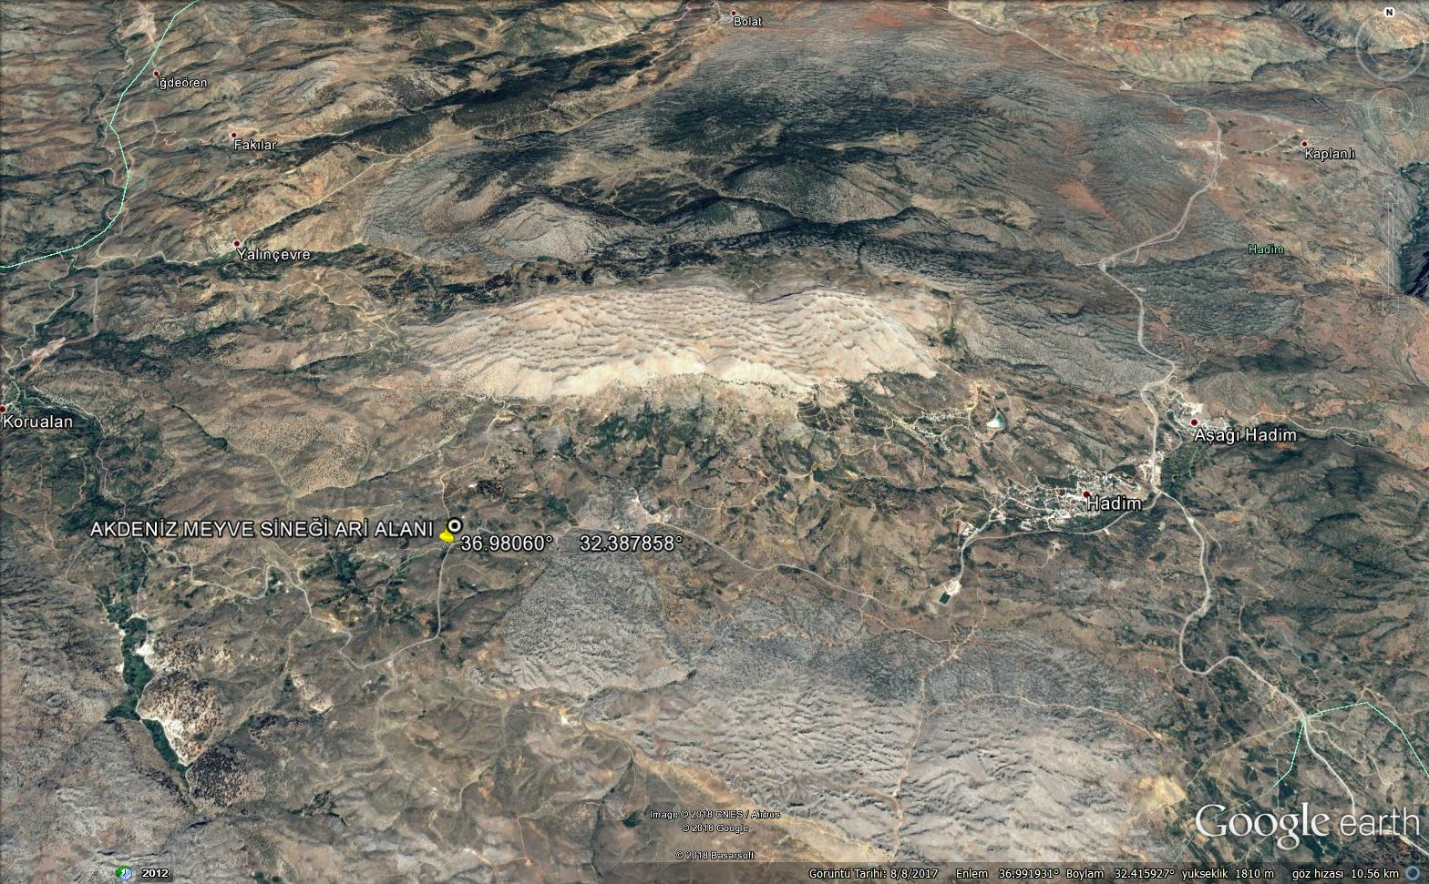
Figure 2. Medfly Traps Location in Konya-Hadim

Eskihisar neighborhood in Halkapınar district of Konya is a hilly area and it is a neighborhood where cherry production is intense. According to the Farmer Registration System (FRS) data, 2021, fruits are grown in 650 decares and cereals are cultivated in 1400 decares. The fruit area consists of 386 decares of cherry, 52 decares of apple, 15 decares of sour cherry, 129 decares of grapevine and 69 decares of walnut. Two traps were placed in each 2 different orchards in Eskihisar Neighborhood of Halkapınar district in Konya province to monitor medfly presence/absence on 11.03.2021. The results were given in Tables 3a and 3b which were obtained by weekly observations of traps. As of this date, we can conclude that Eskihisar neighborhood is a medfly free area.

Table 3a . MEDFLY TRAP COUNTING RESULTS, ESKİHİSAR NEIGHBORHOOD OF HALKAPINAR DISTRICT – Cherry orchard 1 -Lot-Block=128-30
(Latitude-Longitude: 34º 13' 01.00'' - 37º 23' 27.04'') Altitude: 1.172 m

Control Date | ORCHARD 1  (Trap 1 ) Cherry | ORCHARD 1  (Trap 2) Cherry
11.03.2021 | 0 | 0
17.03.2021 | 0 | 0
25.03.2021 | 0 | 0
02.04.2021 | 0 | 0
08.04.2021 | 0 | 0
16.04.2021 | 0 | 0
22.04.2021 | 0 | 0
05.05.2021 | 0 | 0
20.05.2021 | 0 | 0
26.05.2021 | 0 | 0
03.06.2021 | 0 | 0
09.06.2021 | 0 | 0
17.06.2021 | 0 | 0
21.06.2021 | 0 | 0
07.07.2021 | 0 | 0
16.07.2021 | 0 | 0
28.07.2021 | 0 | 0
05.08.2021 | 0 | 0
07.08.2021 | 0 | 0
13.08.2021 | 0 | 0
17.08.2021 | 0 | 0
25.08.2021 | 0 | 0
01.09.2021 | 0 | 0
07.09.2021 | 0 | 0

Çizelge 3b. MEDFLY TRAP COUNTING RESULTS, ESKİHİSAR NEIGHBORHOOD OF HALKAPINAR DISTRICT – Cherry orchard 2
Lot-Block=128-116 (Latitude-Longitude: 34º 13' 49.09''- 37º 20' 32.06'')

Control Date | ORCHARD 2  (Trap 1 ) Cherry | ORCHARD 2  (Trap 2) Cherry
11.03.2021 | 0 | 0
17.03.2021 | 0 | 0
25.03.2021 | 0 | 0
02.04.2021 | 0 | 0
08.04.2021 | 0 | 0
16.04.2021 | 0 | 0
22.04.2021 | 0 | 0
05.05.2021 | 0 | 0
20.05.2021 | 0 | 0
26.05.2021 | 0 | 0
03.06.2021 | 0 | 0
09.06.2021 | 0 | 0
17.06.2021 | 0 | 0
21.06.2021 | 0 | 0
07.07.2021 | 0 | 0
16.07.2021 | 0 | 0
28.07.2021 | 0 | 0
05.08.2021 | 0 | 0
07.08.2021 | 0 | 0
13.08.2021 | 0 | 0
17.08.2021 | 0 | 0
25.08.2021 | 0 | 0
01.09.2021 | 0 | 0
07.09.2021 | 0 | 0

Fruit counting results are given in Table 4 and 5. Regularly monitored countings in Eskihisar neighborhood is a rough region and it is a neighborhood where cherry production is made intensely in Halkapınar district.
Table 5. CHERRY FRUIT COUNTING RESULTS IN HALKAPINAR DISTRICT (ESKİHİSAR NEIGHBORHOOD)
Lot-Block=128-116 (34º 13' 49.09''- 37º 20' 32.06'') (Orchard 2)

 |  |  | Undamaged | Damaged
1 | 1.Row | 4. Cherry tree | 100 | 0
2 | 2. Row | 3. Cherry tree | 100 | 0
3 | 3. Row | 4. Cherry tree | 100 | 0
4 | 4. Row | 6. Cherry tree | 100 | 0
5 | 5. Row | 5. Cherry tree | 100 | 0
6 | 6. Row | 7. Cherry tree | 100 | 0
7 | 7. Row | 5. Cherry tree | 100 | 0
8 | 8. Row | 6. Cherry tree | 100 | 0
9 | 9. Row | 10.Cherry tree | 100 | 0
10 | 10. Row | 8. Cherry tree | 100 | 0
Table 4. MEDFLY FRUIT COUNTING RESULTS IN HALKAPINAR DISTRICT (ESKİHİSAR NEIGHBORHOOD)
Lot-Block =128-30 ( 34º 13' 01.00'' - 37º 23' 27.04'') (Orchard 1)

 |  |  | Undamaged | Damaged
1 | 1. Row | 1.Cherry tree | 100 | 0
2 | 2. Row | 4.Cherry tree | 100 | 0
3 | 3. Row | 3.Cherry tree | 100 | 0
4 | 4. Row | 5.Cherry tree | 100 | 0
5 | 5. Row | 1.Cherry tree | 100 | 0
6 | 6. Row | 6.Cherry tree | 100 | 0
7 | 7. Row | 5.Cherry tree | 100 | 0
8 | 8. Row | 4.Cherry tree | 100 | 0
9 | 9. Row | 1.Cherry tree | 100 | 0
10 | 10. Row | 8.Cherry tree | 100 | 0

In Figure 3 and Figure 4, trap locations are seen in Konya Province Halkapınar District, Eskihisar Neighborhood, in 1st orchard and 2nd orchard.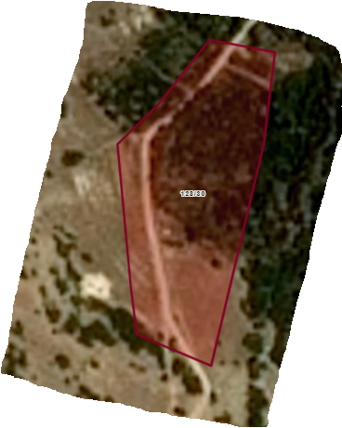
Figure 3. Konya-Eskihisar Neighborhood of Halkapınar District Trap Location 2.orchard

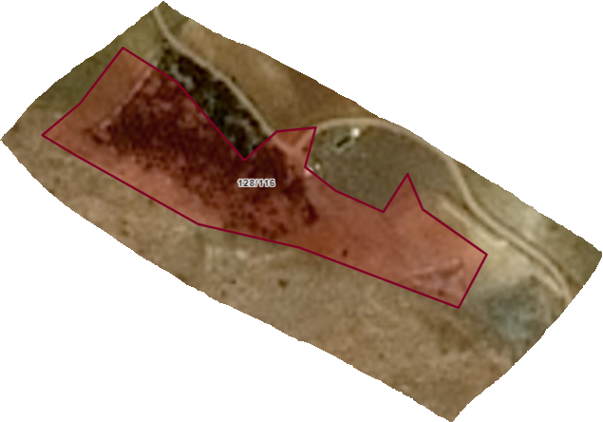
Figure 4 Konya- Eskihisar Neighborhood of Halkapınar District Trap Location 2. orchard

In Konya Province at Bozkır District 2 traps were placed in an orchard in the Harmanpınar neighborhood on 23.02.2021. Weekly monitoring records are given in Table 6. On the same dates, traps were placed and monitored in other neighborhoods as well. Harmanpınar neighborhood is a flat area in Bozkır district and it is an area where apple cultivation is made intensely. Fruits are grown in 564 decares and cereals are grown 500 decares area. Fruit growing area comprises 479 decares of apple, 12 decares of cherry, 0.134 decares of plum, 47 decares of grapevine and 25 decares of pear. We can conclude that cherry orchards are free from Medfly in Harmanpınar neighborhood acording to the Table 6.
Table 6. Bozkır District Harmanpınar Neighborhood Medfly Counting Results
When Table 6 is examined the Mediterranean fruit fly trap counts in 2021 in Konya province, Bozkır District, Harmanpınar street, it is seen that no Mediterranean fruit fly adult was caught in the traps until the cherry is harvested in the location where the trap is hung. It is possible to say that the cherry orchards in the Harmanpınar neighborhood are free from the Mediterranean fruit fly.

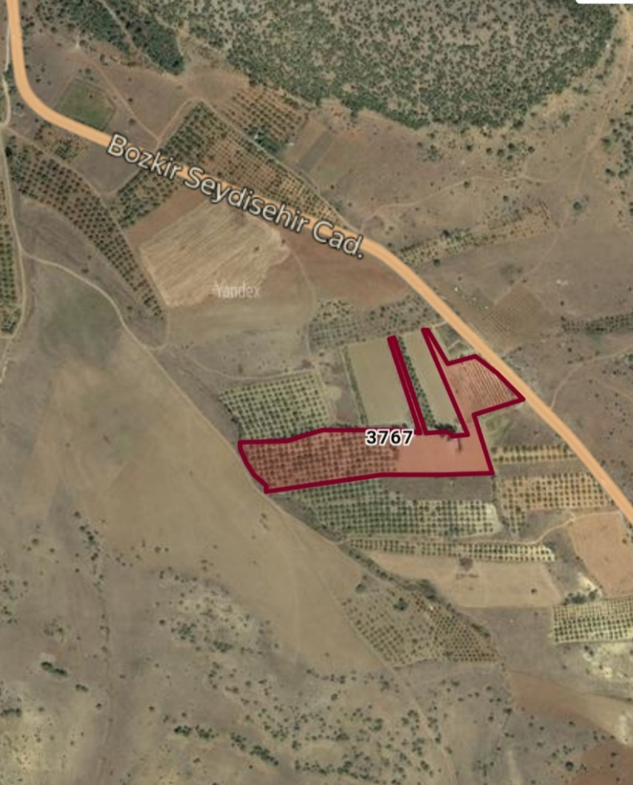
Figure 5. Bozkır District Harmanpınar Neighborhood Trap Area

In Konya, Bektaş neighborhood of Taşkent district, Medfly traps placed 14 decares of cherry orchard (0900 Ziraat variety), belongs to Mahir ALTIPARMAK, on 08.01.2021. As of September 16, 2021, no Mediterranean fruit fly adults were found in the traps in Taskent district. Medfly trap counting results were given in Table 7.

Table 7. Medfly Trap Counting Results of Bektaş Neighborhood of Taşkent district
Table 7. Medfly Trap Counting Results of Bektaş Neighborhood of Taşkent district Lot-Block= (3692717- 32464012)
DATE | ORCHARD 1 TRAP 1 ORCHARD 1 TRAP 2
08.01.2021 | 0 | 0
05.02.2021 | 0 | 0
12.03.2021 | 0 | 0
08.04.2021 | 0 | 0
22.04.2021 | 0 | 0
6.05.2021 | 0 | 0
07.05.2021 | 0 | 0
20.05.2021 | 0 | 0
04.06.2021 | 0 | 0
17.06.2021 | 0 | 0
24.06.2021 | 0 | 0
30.06.2021 | 0 | 0
2.07.2021 | 0 | 0
9.07.2021 | 0 | 0
14.07.2021 | 0 | 0
30.07.2021 | 0 | 0
04.08.2021 | 0 | 0
11.08.2021 | 0 | 0
18.08.2021 | 0 | 0
25.08.2021 | 0 | 0
16.09.2021 | 0 | 0

In fruit controls and countings, fruit samples were taken from the fruits of the trees determined from the orchards followed by trap before harvest and 1000 fruits were counted in each orchard. In Konya province, no dead-alive Medfly larvae were found by controlling the cherry fruits, visually.
In addition, the cherry samples were sent to Ankara Central Plant Protection Research Institute Laboratory to be examined and no dead or alive medfly larvae were found as a result of examination.
Supervision actions include the evaluation of the work carried out. These studies were carried out by the experts of the Plant Protection Central Research Institute, the coordinator institute, which does not directly participated in trap applications. In addition, the areas where the monitoring traps are placed and their status of effectiveness are examined in the field. Fruit count was seen to be applied according to sampling method. In the wake of the examination, the settlement status of the traps, controlled on the map, has been marked and it has been demonstrated through observations that the control intervals are in compatible with the accepted standards. During the study, by defining the deficiencies, special recommendations were made to overcome these deficiencies.

Geographical location information: Konya province is located in the south of Central Anatolia Region. Konya province and it’s districts map is given in Figure 8. Konya is geographically located between 37.871540 and 32.498914 (latitude and longitudes), and is located at foothill of Alâeddin Hill, whose altitude above sea level reaches 1.080 meters. Konya province’s altitude above sea level is approximately 1,020 meters.
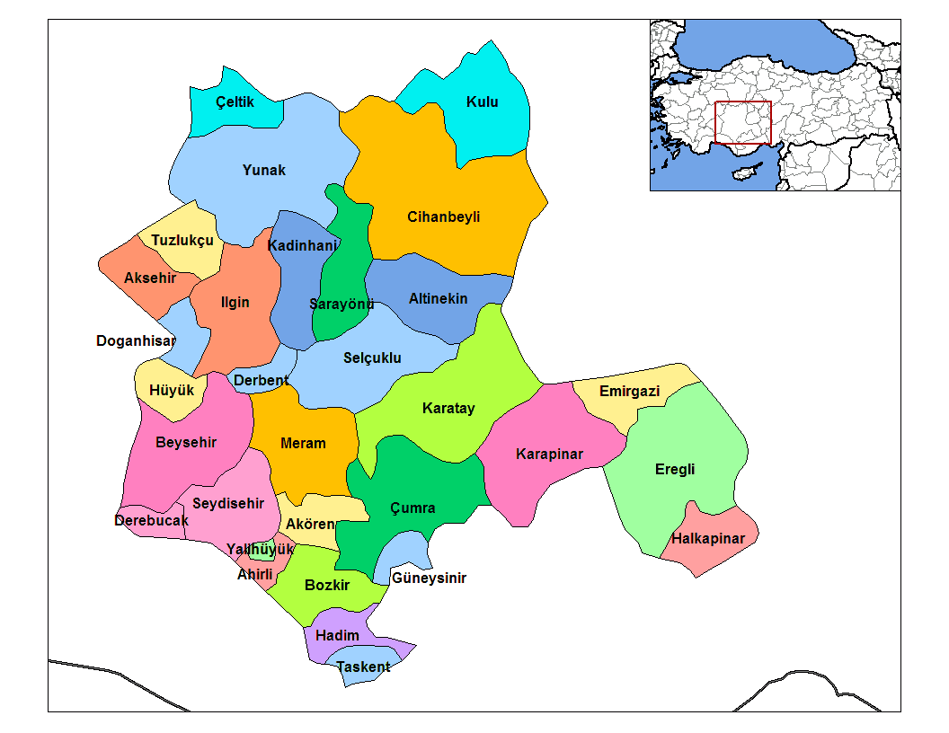
Figure 6. Map of Konya Province and It’s Districts

Climate of Konya:
Continental climate prevails in Konya. Summers are hot and dry, winters are snowy and rainy. The temperature difference between night and daytime is between 16-22 °C in summer. This difference can be reduced to 9-12 C in spring and winter months due to humidity. Snow cover remains for an average of 3 months. Although Konya is located in the southernmost region of Central Anatolia, it is colder than other cities in the Central Anatolia Region. Because the Middle Taurus Mountains completely prevent sea effect. The lowest temperature measured is -29 °C, and the highest temperature is 41 °C. The most snowy month is February and the coldest month is January. Considering that the medfly does not develop below 10 °C, it is concluded that the medfly can not maintain its life cycle and can not get over the winter due to harsh winter conditions. The hottest months are July and August. The average temperature in January is -0.5 °C and the average temperature in July is 23 °C.
Konya province receives annually least rain in Turkey. The elevations in the northern part of the province generally extend in the east-west direction. The most important one is Bozdağlar. The mountain ranges in the west of Konya extend from north to south. Sultan Mountains (2169 meters), Aladaglar (2339 meters), Loras (2040 meters), Esenler (1951m) are located in the northernmost part of Konya. The southern part of the region is bordered by the Taurus mountains. In this tectonic belt, there are Geyik (3130 meters), Bolkar mountains (3134 meters), Aydos mountains (3240 meters).
Training Works;
Brochures, liflets, etc. (250 pieces) training materials were prepared for informing the public within the scope of creating awareness activities. An contact meeting was held with cherry producers from various districts of Konya province about medfly. The leaflets prepared are given in Figure 7a, Figure 7b.
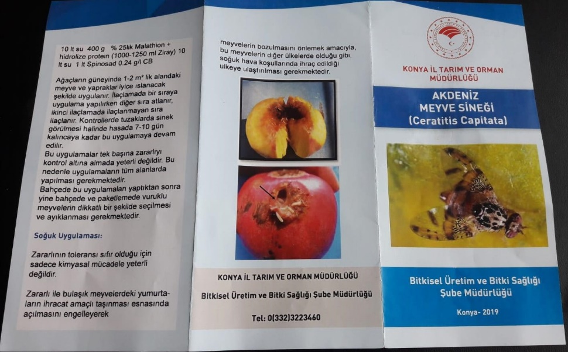
Figure 7a. Leaflets prepared for training

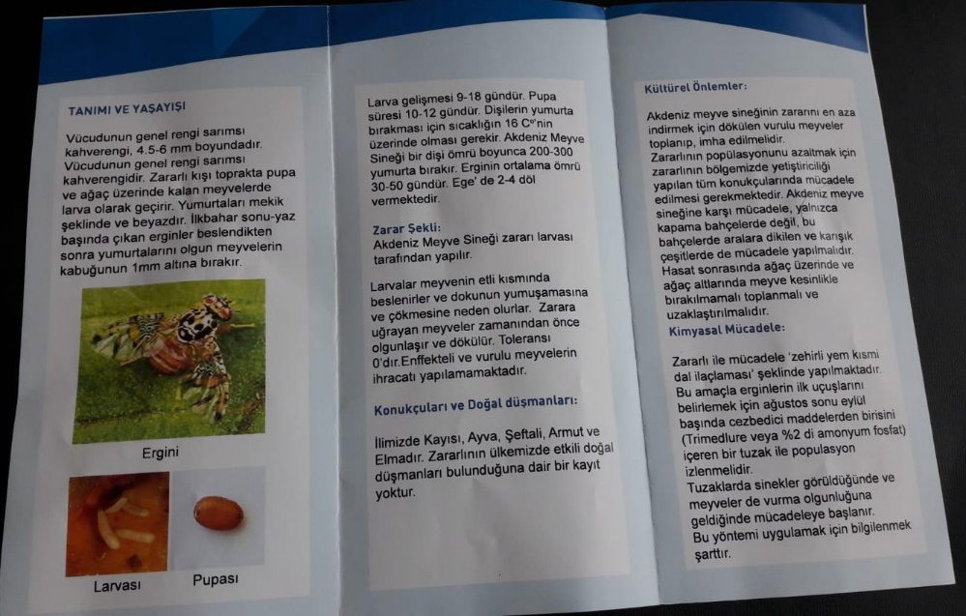
Figure 7b. Leaflets prepared for training

To Keep Area Free from the Pest;
Through providing training to farmers by Agriculture and Forestry Directorate of Konya Province, they were informed about identification of the pest, taking measures such as collecting contaminated fruits before Medflies spread to environment and burying deeply into soil and controlling the pest collectively.

In order to control medfly and take preventive measures, requirements such as plastic bags etc. were provided. In harvested orchards, applications were made to collect leftover fruits on tree or ground and leave them inside plastic black bags under the sun.
In order to be implemented in places where Medfly will be determined, suggestions have been given in order to apply appropriate methods of control such as cultural measures, biotechnical control in accordance with the Plant Protection Technical Instructions and, if necessary, to control chemically through registered plant protection products.

Recommendations were given about collecting product remains and fruit wastes, which are host, from wholesale market halls, street markets, dumps, drainage channels and burying them deeply in soil.

Recommendations should be made to obtain production records of the host fruit species in the region and not to plant fruit species known as the host of the pest in cherry orchards.

10. SUGGESTIONS
In line with “National Action Plan for Mediterranean Fruit Fly Control”, it should be planned to cooperate with local authorities to control the fruit entries and exits. In order to prevent Medfly contamination to the provinces where pest free area studies are carried out the transportations should be done under controlled conditions.

It should be provided that the places with high probability of contamination such as unattended orchards, fruits returned in packaging facilities, fruit markets, entrances of production areas are kept under control.

Recommendations should be made not to plant fruit species known as the host of the Medfly in cherry orchards. The local people should avoid from all kind of activities that will allow the pest to spread naturally. It is necessary that to ensure that kind of processes should be carried out under controlled conditions.

IN CONCLUSION;
Within the scope of establishing medfly free area, medfly was monitored through traps in cherry orchards, whose altitude above sea levels and locations are given;
Akşehir (Çimendere locality (38,23320265- 31,43514631 185-1 Lot-Block),
Hadim (Armağanlar neighborhood-Karabük locality Lot-Block: 360/1, (36,9803-32,3879),
Bozkır (Harmanpınar neighborhood Lot-Block sel=0-3767 (37,212817- 32,181867),
Halkapınar (Eskihisar neighborhood):
Orchard 1/Ada-Parsel=128-30 (34º 13' 01.00'' - 37º 23' 27.04''),
Orchard 2/ Lot-Block =128-116 (34º 13' 49.09''- 37º 20' 32.06''),
Taşkent (Bektaş Mahallesi Lot-Block =3692717- 32464012) districts of Konya, no medfly was found in the traps and in fruit examinations until the cherry was harvested in the monitored orchards.
The regions, where the traps are placed, have a cold and quite snowy weather. These are the areas where spring comes late, autumn starts early, nights are cool and altitude above sea levels are high. Cherry is harvested out of season, especially in Hadim and Taşkent districts.
In cherry orchards of districts followed by traps, medfly adult, larvae and damage were not observed in trap controls and cherry fruit examinations. If it is deemed appropriate by the Ministry, it is deemed pertinent to continue Medfly Free Area Works in cherry production area of Konya Province.

In the new working period, the control and preventive measures against the Medfly will be carried out in compatible with the " National Action Plan for Mediterranean Fruit Fly Control " prepared by Turkish Ministry of Agriculture and Forestry and entered into force on 13 December 2019. Activities was planned to continue about management of Medfly by using preventive cultural measures, biotechnical control methods and chemical control on the different hosts. By evaluating these methods, collective control application will be continued to carry out simultaneously and in compatible with Integrated Pest Management principles.

