YOZGAT PROVINCE
ACTION REPORT FOR THE ESTABLISHMENT OF PEST FREE AREAS FROM MEDITERRENENAN FRUIT FLY (2021)

1. | Project Coordinator and Institute | : | Dr. Vildan BOZKURT  Plant Protection Central Research Institute
2. | Project Assistants and Institution | : | MSc. Hatice ASİL  MSc. Abdulmuttalip EFENDİLER  Agricultural Engineer Salih SEREN  Agriculture and Forest Directorate of Yozgat Province  Agricultural Engineer Nur PEHLİVAN  Agriculture and Forest Directorate of Kadışehri District
3. | Start Date of Project | : | 2019
4. | Report Term | : | 1/01/2021-31.12.2021
5. | Districts Included Project | : | Yozgat (Kadışehri districts)
6. | Target Fruit of Project | : | Cherry

7. Summary
“The Medfly Free Area Studies” was conducted in Yozgat, which is one of the cherry production areas. Studies conducted in 2021 under the coordination of Plant Protection Central Research Institute (PPCRI). Medfly Ceratitis capitata (Diptera: Tephritidae) is an harmful organism that is subject to quarantine and has zero tolerance in export. Fruit flies constitute an important group of pests that restrict the entry of agricultural products that are hosts of Medfly. This study has been planned to conduct studies for determination, establishment and protection of areas free from Medfly in cherry production areas.
It was planned to carry out these studies in Yozgat province with the aim of determining the areas that are free from Medfly, which is an important problem in fruit export. Through this study, it is aimed to determine the areas free from Medfly and to ensure the new exporting countries for Turkey's exports.
So;
- To ensure cherry exports to Far East countries,
- To avoid returns due to infested medfly products
- To grow healthy, reliable and controlled products for export,
- To increase marketing oppurtunities of agricultural products will be provided.
As a result of this study, it is aimed to monitor Medfly population with pheromone traps in cherry orchards and to take measures to expand the pest free areas and to maintain the pest free area, and so eliminating the Medfly from being a problem export. At the same time, with this study, adult monitoring of Medfly was made with traps hanged in cherry orchards and it was determined that no Medfly were found in this area. Fruit counts have been made and it has been demonstrated that the cherry fruit is not damaged. In these areas where cherries are grown, the areas free from Medfly are marked on the map of Yozgat province. Leaflets, brochures, posters, etc. were distributed to create awareness in the society about the pest. Outputs of project will be used by the Ministry of Agriculture and Forestry, Chambers of Agriculture, Exporters' Associations, Producers' Associations and Producers.

8. MATERIAL AND METHOD
The main materials of the study were cherry orchards, delta-type traps with Trimedlure, lenses(Loupe), plastic bags, plastic cuvettes and other laboratory materials. Before starting the work for “Establishment of Pest Free Area for the Mediterranean fruit fly in Yozgat”, project team were determined from the provincial and district technical staff of Provincial Directorate of Agriculture and Forestry and the orchards determined.

An informative meeting was held by the experts from the Coordinator Institute Ankara Plant Protection Central Research Institute (PPCRI) about the works to be carried out with the technical staff of Yozgat Agriculture and Forestry Provincial and District Directorate. It was planned to send the results of the study to the project coordinator Institute by the technical responsible staff of province. The expert at the Coordinator Institute Ankara PPCRI combined all the data obtained by the relevant technical staff and a report was prepared to be submit to the relevant office at the Ministry of Agriculture and Forestry.

These studies carried out for the establishment of pest free areas from fruit flies have been carried out based on the requirements covering the following details according to the International Standards on Phytosanitary Measures. These standards are:

ISPM 4 Requirements For The Establishment Of Pest Free Areas
ISPM 6 Surveillance
ISPM 8 Determination Of Pest Status In An Area
ISPM 10 Requirements For The Establishment Of Pest Free Places Of Production And Pest Free Production Sites
ISPM 26 Establishment Of Pest Free Areas For Fruit Flies (Tephritidae)

Pest Free Area (PFA) is defined as the “an area in which a specific pest does not occur as demonstrated by scientific evidence and in which, where appropriate, this condition is being officially maintained” (ISPM 4).
Three main elements have been taken into account within the scope of ISPM 4 in order to create a pest free area from Mediterranean fruit fly which does not cause damage in cherry fruit in Turkey and to maintain this condition, These tree elements are;

A. Studies Conducted for Establishment Pest Free Area
a) Collection of data (geographical information about orchards)
b) Surveys (trapping, detection, limitation)
c) Regulatory activities (fruit countings and fruit sampling for inspection)
d) Checking activities (review and evaluation)
e) Documentation (reports, work plans)

- Data collection:
In the cherry orchards, pest monitoring and detection studies were carried out through delta-traps with trimedlure. Medfly scores in traps were counted weekly throughout the year, and the data obtained were recorded. Geographical information about orchards was recorded.
- Surveys (monitoring with traps and detection)
Technical teams have been formed on the basis of province and districts, and 2 survey teams have been formed, 1 in the center of Yozgat and 1 in the Kadışehri district. The survey program, prepared in line with the ISPM 6 requirements, has been implemented. In order to determine the presence of the medfly, it was made by placing Delta-traps containing Trimedlure, which are adult-male-specific, to monitor the population. For this purpose, traps were hung on trees selected from 4 different directions to represent the orchard in the Kabalı village of Kadışehri. Two monitor traps were hung at a height of 1.5 m of tree from the ground.
Planning the locations of traps: Traps were hung on areas in the Kadışehri Municipal dump and the fruit purchase and sale market in areas determined to take into account areas that may be infested.
Trap density: In order to determine the trap density in accordance with the aim of the survey, presence and type of the host, topography, pest status, and attractant type are among the factors taken into account. For this reason, traps were hung in the cherry orchard in the Kabalı village of Kadışehri, the only place where fruit was produced.
Trap records: Data, obtained from survey, such as trapped adult numbers, trap location, plants where traps were placed, type of trap and attractant, control dates were recorded. Trap control and record were made weekly throughout the year in 2021. The pheromone capsules in the trap were changed every 4 weeks.
c) Regulatory Activities (fruit countings and fruit sampling)
In 2021, each of the orchards were monitored with the traps 10 trees selected during the harvest and 100 cherry fruits collected from each 10 trees and they were visually checked and recorded after counting in the form of clean / wormy fruit. Totally 1000 fruit were controlled. Medfly monitoring with traps were continued after the fruit harvest.
d) Inspection Actions (check and evaluation)
Inspection of trap applications were made by the expert on the orchard to checked and evaluate of the studies. The Plant Protection Central Research Institute has carried out training activities, which is a coordinator institute that does not directly take part in this study. Institute conducted to the training studies for the technical staff who carry out to trap applications studies and inspected to the activity, density of trap and locations of the traps at the orchards. It was planned to control these studies at least twice a year by the institute. Field inspections were conducted during the ripening period of cherry before harvest. Investigation contained of trap materials, trap locality, trap locality maps, trap conditons, trap control frequency, recording and definition of Medfly, diagnosis, method of sampling and counting fruit and signboard preparation.
e) Documentation (reports, work plans)
Information on training activities carried out in cherry fruit growing areas to raise public awareness about the medfly and fruit counting results and trap countings records were collected. Records were send to the Plant Protection Central Research Institute by responsible technical staff of Yozgat provincial Directorate of Agriculture and Forestry. Coordinator Institute prepared a report. And report were presented as a report to the General Directorate of Food and Control.
B. Phytosanitary Measures Required for Sustaining Pest Free Area
In case of the Medfly detection, appropriate control methods such as; cultural measures, biotechnical control method and if necessary chemical control will be implemented in accordance with the Agricultural Control Technical Instruction. Suggestions will be given with licensed plant protection products when it is necessary. In cooperation with the Agriculture and Forestry Provincial / District Directorates for the control of medfly, public awareness was tried to be established to make collective Medfly control aplication.
It is aimed to control pests wherever can be seen, such as in the orchards where the host of the pest is produced, transport vehicles, processing and packaging facilities, market etc. at the sales points and survival places, animal manure, garbage and where piles of rubbish and waste materials is collected places in the environment. In the Medfly control, it is aimed to increase the knowledge and experience of the producers to grow healthy, reliable and controlled products, to raise awareness in the sector, to increase marketing opportunities, to facilitate trade and ensure sustainable production.

In the case of determination of Medfly in the designated area as the free area, it will be recommended that all the proper methods of control, that can be used together, such as cultural measures, biotechnical control and chemical control, in line with Integrated Pest Management principles. It was planned to create a buffer zone in cases where geographical isolation is considered insufficient in preventing entry to pest free area or if there is no other way can not find to prevent medfly movement to pest free area. Thus, the number of traps will be increased at the zone of transition between districts, and a buffer zone will be established.

C.Controls to Confirm that Freenes is Sustained
Phytosanitary measures are implemented and investigations are carried out to verify the status of a pest free area (PFA) and to sustain pest free area status. These controls include the following issues:
- Inspection of exported products
- Monitoring surveys
- Notifications of researchers, consultants or inspectors to NPPO about the presence of any harmful organism.

9. RESULTS AND DISCUSSION
Technical teams were formed within the scope of "The Establishment of Pest Free Areas for Mediterrenenan fruit fly” in Yozgat province in 2021. From Yozgat Provincial Directorate of Agriculture and Forestry Agr. Eng. Msc. Hatice ASİL, Agr. Eng. Msc. Abdulmuttalip EFENDİLER and Agr. Eng. Salih SEREN from Kadışehri District Agriculture and Forestry Directorate Agr. Eng. Nur PEHLİVAN have been appointed and these teams have been informed about the study of Medfly and pest free area.
Surveys were carried out throughout year with delta-traps containing trimedlure, which were hung to investigate the presence or absence of medfly in cherry orchards in 2021 in Yozgat. Within the scope of the Medfly free area studies in 2021, a trap was hung in an area of 5,600 decares in the Kabalı village of Kadışehri district. In this orchard Ziraat 900 and Lambert varieties, cherry production is made with the presence of 40,875 trees. Trap controls were done weekly and all information about the traps was recorded. The location of the trap, the size of the area (decare), latitude and longitude information, plant type, trap and attractant type, trap placement and control dates were recorded. The location of the traps was determined through the GPS device and records were taken. The locations of traps, in Kabalı village of Kadışehri district of Yozgat province are marked according to GPS coordinates on the map (Table 1, Figure 1-2,).
Table 1. Trap Points in Yozgat Province Kadışehri Kabalı Village Orchards
Trap number | Latitute | Longitude
1 | 39⁰57'11'' | 35⁰39'30''
2 | 39⁰57'16'' | 35⁰39'55''
3 | 39⁰56'51'' | 35⁰39'33''
4 | 39⁰56'56'' | 35⁰40'19''
5 | 39⁰56'13'' | 35⁰39'46''
6 | 39⁰56'21'' | 35⁰40'26''
7 | 39⁰55'47'' | 35⁰39'53''
8 | 39⁰56'01'' | 35⁰ 40'44''
9 (garbage dump) | 39⁰99'82'' | 35⁰ 82'02''
10(bazaar) | 39⁰99'82'' | 35⁰ 79'20''

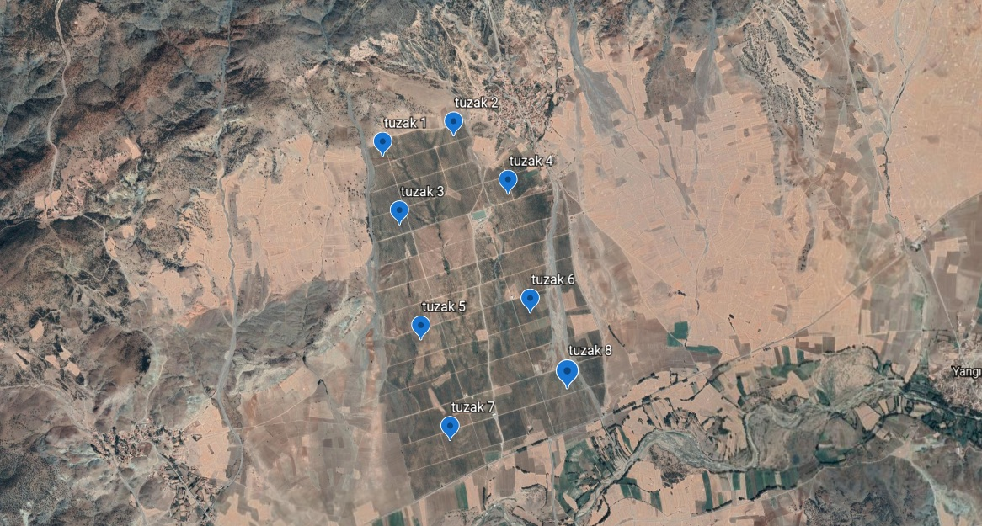
Figure 1. Mapping of Yozgat Province Kadışehri Kabalı Village Trap Points
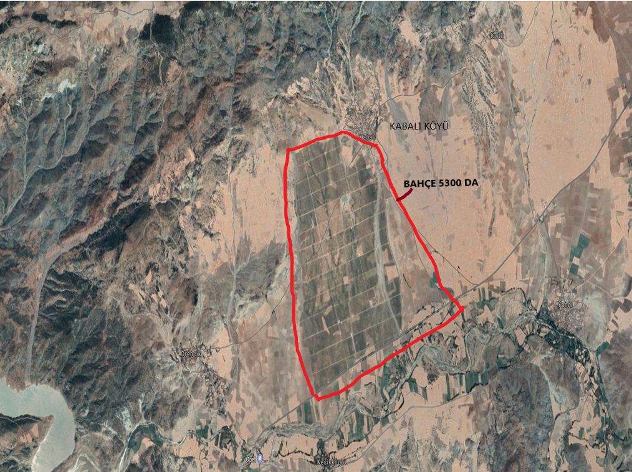
Figure 2. Kadışehri District of Yozgat Province Fruit Orchard Area

There is no other extensive orchard in Kabalı Village or close to it except this orchard planted over 5600 decare area. The structure of the orchard is rough and its altitude varies between 890 m and 1008 m. In this orchard, there are 3300 da apple, 1050 da cherry, 300 da peach-nectarine and 100 da quince trees. In Yozgat province, the Medfly Free Area study is carried out only in the area where this orchard is (Figure 3).
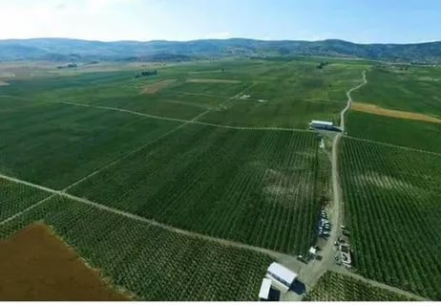
Figure 3. The Fruit Production Area in Kadışehri District of Yozgat

Trap was hung in 10 different points, 8 in 1 garden in Kabalı village, 1 in Vegetable bazaar and 1 in Municipal dumpster(garbage dump) in the town of Kadışehri in 15.02.2021, Yozgat where trap follow-ups were made. The data obtained by the counting of traps are included in the trap follow-up charts of Mediterranean fruit of the town of Kabalı village of Kadışehri, Yozgat province, given in Table 2. When the charts in Table 2 are examined, it is seen that no adult medfly is caught in the traps in cherry orchards in all locations where the trap is hung. It was determined that no adult was caught in the traps between February and end of November 2021.

Table 2. Yozgat Province Kadışehri District Kabalı Village Medfly Trap Counting Results
Counting Date | Counted Traps
 | 1. | 2. | 3. | 4. | 5. | 6. | 7. | 8. | 9. | 10.
22.02.2021 | 0 | 0 | 0 | 0 | 0 | 0 | 0 | 0 | 0 | 0
26.02.2021 | 0 | 0 | 0 | 0 | 0 | 0 | 0 | 0 | 0 | 0
05.03.2021 | 0 | 0 | 0 | 0 | 0 | 0 | 0 | 0 | 0 | 0
12.03.2021 | 0 | 0 | 0 | 0 | 0 | 0 | 0 | 0 | 0 | 0
19.03.2021 | 0 | 0 | 0 | 0 | 0 | 0 | 0 | 0 | 0 | 0
26.03.2021 | 0 | 0 | 0 | 0 | 0 | 0 | 0 | 0 | 0 | 0
02.04.2021 | 0 | 0 | 0 | 0 | 0 | 0 | 0 | 0 | 0 | 0
09.04.2021 | 0 | 0 | 0 | 0 | 0 | 0 | 0 | 0 | 0 | 0
16.04.2021 | 0 | 0 | 0 | 0 | 0 | 0 | 0 | 0 | 0 | 0
22.04.2021 | 0 | 0 | 0 | 0 | 0 | 0 | 0 | 0 | 0 | 0
30.04.2021 | 0 | 0 | 0 | 0 | 0 | 0 | 0 | 0 | 0 | 0
07.05.2021 | 0 | 0 | 0 | 0 | 0 | 0 | 0 | 0 | 0 | 0
11.05.2021 | 0 | 0 | 0 | 0 | 0 | 0 | 0 | 0 | 0 | 0
21.05.2021 | 0 | 0 | 0 | 0 | 0 | 0 | 0 | 0 | 0 | 0
28.05.2021 | 0 | 0 | 0 | 0 | 0 | 0 | 0 | 0 | 0 | 0
04.06.2021 | 0 | 0 | 0 | 0 | 0 | 0 | 0 | 0 | 0 | 0
11.06.2021 | 0 | 0 | 0 | 0 | 0 | 0 | 0 | 0 | 0 | 0
18.06.2021 | 0 | 0 | 0 | 0 | 0 | 0 | 0 | 0 | 0 | 0
25.06.2021 | 0 | 0 | 0 | 0 | 0 | 0 | 0 | 0 | 0 | 0
05.07.2021 | 0 | 0 | 0 | 0 | 0 | 0 | 0 | 0 | 0 | 0
16.07.2021 | 0 | 0 | 0 | 0 | 0 | 0 | 0 | 0 | 0 | 0
26.07.2021 | 0 | 0 | 0 | 0 | 0 | 0 | 0 | 0 | 0 | 0
30.07.2021 | 0 | 0 | 0 | 0 | 0 | 0 | 0 | 0 | 0 | 0
06.08.2021 | 0 | 0 | 0 | 0 | 0 | 0 | 0 | 0 | 0 | 0
13.08.2021 | 0 | 0 | 0 | 0 | 0 | 0 | 0 | 0 | 0 | 0
20.08.2021 | 0 | 0 | 0 | 0 | 0 | 0 | 0 | 0 | 0 | 0
27.08.2021 | 0 | 0 | 0 | 0 | 0 | 0 | 0 | 0 | 0 | 0
03.09.2021 | 0 | 0 | 0 | 0 | 0 | 0 | 0 | 0 | 0 | 0
10.09.2021 | 0 | 0 | 0 | 0 | 0 | 0 | 0 | 0 | 0 | 0
22.09.2021 | 0 | 0 | 0 | 0 | 0 | 0 | 0 | 0 | 0 | 0
30.09.2021 | 0 | 0 | 0 | 0 | 0 | 0 | 0 | 0 | 0 | 0
08.10.2021 | 0 | 0 | 0 | 0 | 0 | 0 | 0 | 0 | 0 | 0
15.10.2021 | 0 | 0 | 0 | 0 | 0 | 0 | 0 | 0 | 0 | 0
22.10.2021 | 0 | 0 | 0 | 0 | 0 | 0 | 0 | 0 | 0 | 0
29.10.2021 | 0 | 0 | 0 | 0 | 0 | 0 | 0 | 0 | 0 | 0

In fruit controls, fruit samples were taken from the fruits of the trees determined from the orchards monitored with the traps before harvest and 1000 fruits are counted in each orchard. In Yozgat province, no dead-alive medfly larvae were found by controlling the cherry fruits, visually. In the orchard of Kadışehri district of Yozgat province 100,000 cherry fruits from 1000 trees were visually checked and suspicious ones were opened and examined than no dead-alive medfly larvae were found by controlling the cherry fruits, visually (Table 3, Figure 4).
Table 3. Fruit counting results in Kabalı Village/Kadışehri/Yozgat
Medfly Fruit Counting Report, Kadışehri
Number |  | Undamaged | Damaged
1 | - Row | 100 | 0
2 | - Row | 100 | 0
3 | - Row | 100 | 0
4 | - Row | 100 | 0
5 | - Row | 100 | 0
6 | - Row | 100 | 0
7 | - Row | 100 | 0
8 | - Row | 100 | 0
9 | - Row | 100 | 0
10 | - Row | 100 | 0

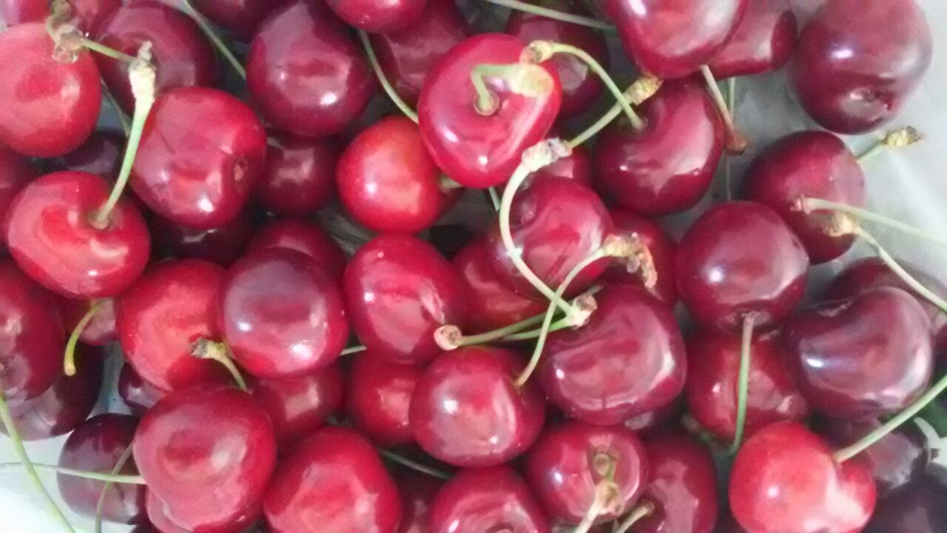
Figure 4. Fruit Control
Medfly was not found in fruit controls and monitoring by traps. Medfly damage or its adults couldn’t be determined.
As supervision actions, the studies conducted were evaluated. These studies were carried out by the experts of the Central Plant Protection Research Institute as the coordinator institute, which does not directly participate in trap applications. In addition, the areas where the monitoring traps are placed and their status of effectiveness are examined in the field. Fruit count was seen to be applied according to sampling method. During the inspection the settlement status of the controlled traps has been marked on the map and it has been demonstrated through observations that the control intervals are compatible with the accepted standards. During the study, by defining the deficiencies, special recommendations were made to overcome these deficiencies (Fig. 3 ).

Geografic information; The land structure of Kadışehri district which is located within the borders of Yozgat province, is partially mountainous and its height from the sea is 925 m. The height of the orchard was is 970-1008 m where the study is conducted. The county in the north; Deveci Mountains, Yılman Hill in the east and in the west; Ördede Hill surrounds. Land structure in the south takes a wavy appearance. There is no important river outside Küçüköz, which passes through the district center.

Deveci Mountains, located in the northern parts of Kadışehri, are the most important ridges. The southern part of the district consists of wide plains. Çekerek River, which is one of the branches of Yeşilırmak, the most important river of the region. Lands are generally suitable for dry farming. Apart from cereal products, grapes and small amounts of fruit are grown. Alluvial soils, which were transported from Deveci mountains through erosion, increased productivity in agricultural areas. Agricultural lands are on wide plains and around 20,000 decares. Yozgat province and districts map was given in Figure 5.

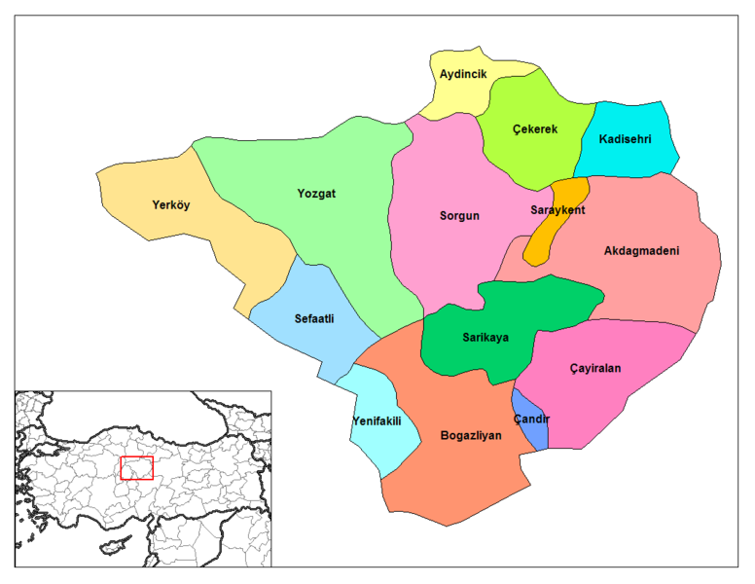
Figure 5. Yozgat province and districts map

Climate of Yozgat Province -Kadışehri district
The district has a continental climate in terms of climate due to its location in the Central Anatolia region. In terms of precipitation regime, it has the characteristics of the Black Sea region climate. Due to the elevation and distance from the sea, it has a cold and snowy winters and a hot and dry summers. Spring and autumn rains form rain. The hottest month (July) average is 19.7 ° C, the coldest month (January) average is -1.9 ° C. The lowest temperature encountered in Yozgat until today was recorded as -24.4 ° C (23.02.1985) and the highest temperature as 38.8 ° C (30.07.2000). The number of days in Yozgat when the temperature drops to zero degrees, that is, the days with frost events is 105.6 days. Annual rainfall in the district of Kadışehri is 570 mm. Most of the precipitation in the district falls in the beginning of spring, autumn and summer (June). The annual and daily night and day temperature differences in the district are high.

Steppes are widespread vegetation in Yozgat. Mountains in many places are covered with oak forests around the center district. Considering that the Medfly does not develop below 10 ° C; due to the harsh winter conditions, it is thought that it cannot continue its life cycle in this district. Although Yozgat location is at the crossroads, due to it is not on any transportation route of Kabalı village where fruit production is made; For this reason, it is considered that the probability of contamination of Medfly ise quite low with the infested fruits.

Training Studies;
A preparatory meeting for technical staff was held and a work plan was put forward. Various meetings were organized by technical staff to meet the needs of the region. Information about the project works was given to 8 technical staff who manage the orchard management. Training materials such as posters, brochures, leaflets were prepared and distributed to inform the public, within the scope of expanding awareness activities about the pest.

To Keep Area Free From The Pest;
In order to ensure collective control in line with the principles of Integrated Pest Management, cooperation was made with the relevant institutions. Yozgat Provincial Directorate of Agriculture and Forestry and Baharsun Enerji Tarım Hayvancılık İnşaat San. ve Tic. AŞ. provided materials such as plastic bags etc. for the Medfly control and preventive measures. In the harvested orchards, it was recommended to collect the leftover fruits on tree or ground and leave them under the sun inside black plastic bags.

In order to be implement in places where Medfly will be determined, suggestions have been given in order to apply appropriate methods of control such as cultural measures, biotechnical control in accordance with the Plant Protection Technical Instructions and, if necessary, to control chemically through registered plant protection products.

It was provided that product remains and fruit wastes, which are host, are collected from wholesale market halls, street markets, dumps, drainage channels and were buried deeply in soil, and insecticide treatments were done to common areas which are contamination resources and animal feces are collected.
In addition, 1500 geese, ducks and chicken breeding are carried out to be used for biological control of the pests in the orchard. It will be an important advantage to increase the amount of these animals to control the pest that spend their biological period under the soil or under the ground. They can be used to take under control both possible Medfly infestation and pests that overwinters a certain biological period such as cherry fruit fly in the soil.

10. SUGGESTIONS
In order to prevent medfly contamination in the provinces where pest free area studies are carried out it should be planned to cooperate with local authorities to control the fruit entries and exits. Transportations should be carried out the under controlled conditions in line with “National Action Plan for Mediterranean Fruit Fly Control”,

It should be provided that the places with high probability of contamination such as unattended orchards, fruits returned in packaging facilities, fruit markets, entrances of production areas are kept under control. Recommendations should be made not to plant fruit species known as the host of the Medfly in cherry orchards. The local people should avoid from all kind of activities that will allow the pest to spread naturally. It is necessary that to ensure that kind of processes should be carried out under controlled conditions.

In the new study period, the control and preventive measures against the Medfly will be carried out in compatible with the " National Action Plan for Mediterranean Fruit Fly Control " prepared by Turkish Ministry of Agriculture and Forestry and entered into force on 13 December 2019. Activities was planned to continue about management of Medfly by using preventive cultural measures, biotechnical control methods and chemical control on the different hosts. By evaluating these methods, collective control application will be carried out simultaneously and in compatible with Integrated Pest Management principles.

As a conclusion; during the studies carried out in 2021, Medfly detection was not detected in traps in Kabalı Village cherry production areas in Yozgat province. Traps of Medfly was hanged in 5.600 decares of fruit orchards. 1.050 decares of it is cherry orchards and their checks were made regularly. Any Medfly adult was found during the controls. If deemed appropriate by Turkish Ministry of Agriculture and Forestry, it will be planned to continue “Establishment of Medfly Free Area Studies” Kadışehri District -Kabalı village in Yozgat Province in 2022.

