Implementation of the IPPC and ISPMs
A Discussion Paper for the Strategic Planning Group
October 2013

Table of Contents
1. BackGround 3
2. Purpose 3
3. Establishing A Common Vision 4
3.1. Outcomes for CPs 4
3.2. Outcomes for the IPPC 4
3.3. Outcomes for FAO 4
3.4. Outcomes for External Funding Organisations 5
4. Guiding Principles for an Implementation Work Area 5
4.1 CPM directed 5
4.2 Cooperation and coordination within and between IPPC Secretariat, CPM and NPPOs 5
4.3 Targeted and focused effort 5
4.4 All ISPMs & IPPC provisions 6
4.5 Measurable progress and impact 6
4.6 Flexible and adaptable 6
4.7 Focus on feasibility and sustainability 6
5 The Structure of the Implementation Work Area 6
5.1 Strategy 6
5.2 Work Area Governance 7
5.3 Work Area Coordination 7
5.4 General model 8
6 Establishment of an Implementation Programme 8
6.1 Summary of Proposed Programme Establishment Steps 8
6.2 Subject Identification 8
6.3 Programme Development 9
6.4 Consultation, Recommendation, and CPM Decision 10
6.5 Programme Finalisation 10
6.6 Programme Delivery 10
6.7 Programme Review 11
7 Implications for Existing Bodies 11
8. Conclusion 12
Appendix One: General Model of Implementation Work Area and Relationship to Other Work Areas 14
Appendix Two: Hierarchy of Terms 15

- Background
The IPPC exists for the purpose of “securing common and effective action to prevent the spread and introduction of pests of plants and plant products and to promote appropriate measures for their control”.
At CPM-8 (2013), a paper was presented by New Zealand raising the opportunity for IPPC contracting parties (CPs) to establish a greater focus on implementation and inviting further discussion (Ref: CPM 2013/INF/13 Implementation of the IPPC and ISPMs). The paper highlighted that, over the past 20 years, IPPC CPs and the IPPC Secretariat have developed and adopted over 30 ISPMs with a number of annexes and appendixes, and that these standards provide for the foundation to establish fully functioning national phytosanitary systems. The paper suggested that it may now be timely to obtain greater value from the investment made in developing this foundation by shifting our emphasis and focusing more on the implementation of the IPPC and ISPMs.
The paper noted that many countries are unable to fully implement the Convention or ISPMs because they do not have the expertise or the basic resources; this applies to many countries, not only those asking for capacity development. More support material, such as explanatory papers, training material, guides and technical manuals, will help, but good implementation requires a broad consideration of multiple aspects of an NPPO’s phytosanitary system. It may require NPPOs to make legislative or regulatory amendments, develop new systems and processes, adopt new technology, adopt new industry practices, and often all of these in combination. Many of these needs should be considered when standards are first being drafted, and throughout the process until well after they have been adopted.
Implementation ensures that the articles of the Convention and the ISPMs adopted by the CPM have a positive impact on the purpose for which the IPPC was established. Through implementation, NPPOs are better able to protect their own agriculture and environments. Implementation also encourages both cooperation and harmonization with neighbours and trading partners, furthering the goals of preventing the introduction and spread of pests.
It was suggested that an implementation programme for the CPM should cover the full breadth of the IPPC and its ISPMs and service the needs of all members of CPM, not only those members needing capacity development. An implementation programme would need to be CPM directed, integrated across the breadth of the CPM’s work and aligned to contracting parties’ needs.
During the brief discussion at CPM-8, many supportive comments were made by CPs. There was general agreement that implementation should be carefully considered at the CPM Bureau meeting and Strategic Planning Group (SPG) meeting before being further discussed at CPM-9.

- Purpose
This paper builds on the New Zealand paper presented at CPM-8 and provides guidance on how an implementation programme could be established. The proposals presented are intended to aid and stimulate discussion and should not be seen as a preferred approach or an established position. The paper builds on an earlier version that was discussed by the Bureau in June 2013 and incorporates Bureau member’s feedback. It presents a proposed way forward to aid the SPG to have a structured discussion in its October 2013 meeting.

- Establishing A Common Vision
At CPM-8 (2013) there was agreement on the need for further discussion on implementation at Bureau and SPG. Comments and interventions made in plenary by members indicated an openness and support for a greater focus on implementation.
Describing and agreeing on a vision and desired outcomes of a new venture helps a group to focus on and develop a common vision for the future.
The vision could be of the nature : An effective implementation work programme for the IPPC and its ISPMs through international cooperation.
The outcomes described below are presented from the perspective of parties with an interest in the success of the IPPC.
  - Outcomes for CPs
      - Contracting parties are more capable of implementing the convention and ISPM’s
      - More effective application of phytosanitary measures (e.g. surveillance, pest free areas, treatments, etc.)
      - Development of more effective phytosanitary import regulations
      - Market access negotiations facilitated by common approaches and improved understanding of phytosanitary measures
      - Reduction in pest spread and new introductions and avoidance of negative pest impacts on productivity, profitability, and biodiversity
      - Improved achievement of the purpose of the convention to which contracting parties have agreed: “With the purpose of securing common and effective action to prevent the spread and introduction of pests of plants and plant products and to promote appropriate measures for their control…”

  - Outcomes for the IPPC
      - Improved implementation will result in better delivery of IPPC strategic objectives to:
        - protect sustainable agriculture and enhance food security through the prevention of pest spread;
        - protect the environment, forests and biodiversity from plant pests;
        - facilitate economic and trade development through the promotion of harmonised scientifically based phytosanitary measures; and
        - develop phytosanitary capacity for members to accomplish A, B, and C.
- Greater efforts needed from the Secretariat to obtain adequate funding for the programmes.
  - Outcomes for FAO
      - FAO can see the IPPC delivering real value from its core funding and contributing strongly to achieving the FAO Strategic Objectives relevant to the IPPC mandate
      - FAO can see the IPPC as a well directed treaty organisation under article XIV of the FAO Constitution which could benefit from more autonomy and greater investment of FAO funds.
  - Outcomes for External Funding Organisations
- External funding organisations see that investments made into the IPPC work programme deliver tangible value to CPs. Their funds make a difference.
  - Earmarking the funds for implementation gives the donors a better understanding of spending and increases accountability of IPPC for these funds
- External funders see a well organised suite of opportunities which they can direct funds towards.

- Guiding Principles for an Implementation Work Area
Following on from the outcomes described above, examining some guiding principles will assist in identifying the most important aspects of a new system or programme as it is designed and implemented. An assessment can be made of whether or not any new design or process is consistent with these principles. Once implemented, performance against these principles can be continually reviewed. The principles below are derived from the CPM 2013/INF/13 and the discussion at the July 2013 Bureau discussion.
  - CPM directed
      - Recognises the importance of this work for all contracting parties
      - At a minimum, this would require CPM to set the priorities for this area of work, but it is preferable that the CPM agrees to/adopt the overall framework for the implementation program so that it reflects the identified needs of its members
      - Direction, oversight and accountability needs to be ensured – particularly with some of the cross-functionality and coordination that will be involved.
  - Cooperation and coordination within and between IPPC Secretariat, CPM and NPPOs
      - This ensures a coordinated approach and access to the full knowledge and resources available across the spectrum of IPPC activity.
      - Working together is the key
      - CPM will achieve more with the collaboration and combined efforts of the Secretariat staff, all subsidiary bodies, and other groups
  - Targeted and focused effort
      - This principle recognises that CPM will achieve more and deliver greater benefits to CPs as a whole when important priorities are targeted for focused effort
      - Implementation programmes must be structured to ensure they meet the real needs of CPs. Evidence of the difficulties CPs are having with an ISPM or provisions of the IPPC should be a pre-requisite for any proposal. Equally, proposed solutions should be only those things that would meet the needs of contracting parties and should be carefully evaluated to ensure they are broadly applicable and practical. This requires a clear and agreed understanding of what are the greatest implementation needs, and where the biggest difference can be achieved
      - Some subjects could be a pre-requisite to improved implementation across a wide number of areas, e.g. surveillance underpins many aspects such as pest reporting, determining pest status in an area, pest eradication programmes, etc.
  - All ISPMs & IPPC provisions
- Our implementation efforts are not restricted to the ISPMs but to all aspects of the convention and the ability of contracting parties to implement it
  - Measurable progress and impact
      - While establishing a programme, clear targets should be set for what is to be delivered and what results/change we are aiming to achieve. At the end of each programme, achievement should be measured against the agreed targets. In this way progress can be demonstrated and we can learn from both successes and failures
      - Set a baseline. An assessment of the situation before and after the implementation of a standard would be very desirable
  - Flexible and adaptable
      - Programmes need to be flexible to accommodate changing circumstances and evolving needs that typically eventuate over the life of a multi-year programme. They also need to be developed so that their outputs recognise the unique needs of contracting parties and can be adapted and applied in a wide variety of situations.
  - Focus on feasibility and sustainability
Programmes must be feasible for NPPOs in terms of cost, expertise, etc. and must be sustainable. Emphasis must be placed on developing programmes that NPPOs can practically sustain once they are fully developed.

- The Structure of the Implementation Work Area
It is proposed that a new Implementation work area is established to operate alongside the current work areas of Standard Setting, Capacity Development, National Reporting, and Dispute Settlement. A strategy, governance arrangement and coordination mechanism would be established for this work area, as it has been for the others.

  - Strategy
    - A strategy for the work area would be established with:
      - A clear current state description (the need to change and what is to be achieved)
      - Desired Outcomes (e.g. as described above)
      - Agreed Principles to guide the work (e.g. as described above)
      - A high level approach that will be taken in this work area, including a method for how priorities are selected
      - Priority subject areas consistent with CPM decisions on which the work will focus for the period of the strategy
      - A Communication Plan for the work area or at least specifics that can be included in the overall communications plan, etc.
    - Resource acquisition plan
    - The Strategy would be reviewed once every three years.

  - Work Area Governance
    - CPM directs the Implementation work area, and institutes a governance arrangement that ensures the activities undertaken in the implementation work area are approved by CPM, i.e. the CPM decides the priorities and agrees the work plan, including the resources to be made available to the programmes.
    - The Triennial Review Group (TRG) could be tasked with reviewing IRSS type surveys and other information to identify priorities for implementation programmes, and work with the Secretariat to:
      - develop programmes for CPM consideration
      - provide input as needed into Secretariat management of the implementation programmes
      - Monitor to ensure programme targets are achieved
    - The Bureau would consider the recommendations from the TRG and IRSS
    - The CPM could delegate to the Bureau the high level oversight of the work area and specifically recommend new implementation programmes. However, the Bureau would not provide any detailed or frequent management input.
    - Between Bureau meetings, the Implementation Coordination Unit (the IPPC Coordinator plus two Secretariat staff persons) would provide guidance to the implementation work programmes.
    - The SPG would consider programmes developed prior to examination by the CPM.
    - The CPM would give explicit approval for new implementation programmes to proceed.

  - Work Area Coordination
    - The Work area would be managed by the IPPC Coordinator who ensures efficient coordination, timely day-to-day decisions, and alignment with CPM directions. The Bureau provides guidance to the Coordinator as needed.
    - The Coordinator could be assisted by a small Implementation Coordination Unit (ICU).
    - One option to staff the ICU is to redirect the current staff involved in the IRRS programme. The work of the IRSS is well aligned to a new Implementation work area. The IRSS work would become a subset of the Implementation work area and would focus on identifying and establishing future implementation programmes, coordinating across existing programmes (once established), and reporting on progress and value delivered.
    - The coordination arrangement would recognise and support the cross-cutting nature of implementation programmes (that they need delivery from across multiple work areas within the IPPC), and ensures an integrated approach to the work across all of the IPPC work areas.
    - The ICU would report to the Coordinator and provides day-to-day coordination across and within each of the approved implementation programmes. A high level of coordination is required due to the integrated nature of each programme that will have various projects being delivered from various work areas of the IPPC (and potentially externally, e.g. other parts of FAO or regional bodies).
    - The coordination function must be light (lacking unnecessary bureaucracy), but provide effective coordination of all elements of the programmes.
    - The finalised plan for each implementation programme should guide day-to-day delivery and decision-making.

  - General model
    - A general model is shown in the diagram on Appendix One. It comprises a strategy, governance, and coordination mechanism for the work area and each implementation programme.
    - It is suggested that Implementation programmes should be 1 – 3 years and that 2 – 3 programmes could run at any particular time, depending on resources available.

- Establishment of an Implementation Programme
  - Summary of Proposed Programme Establishment Steps
The steps in the process to establish a new Implementation Programme within this Implementation Work Area are proposed to be:
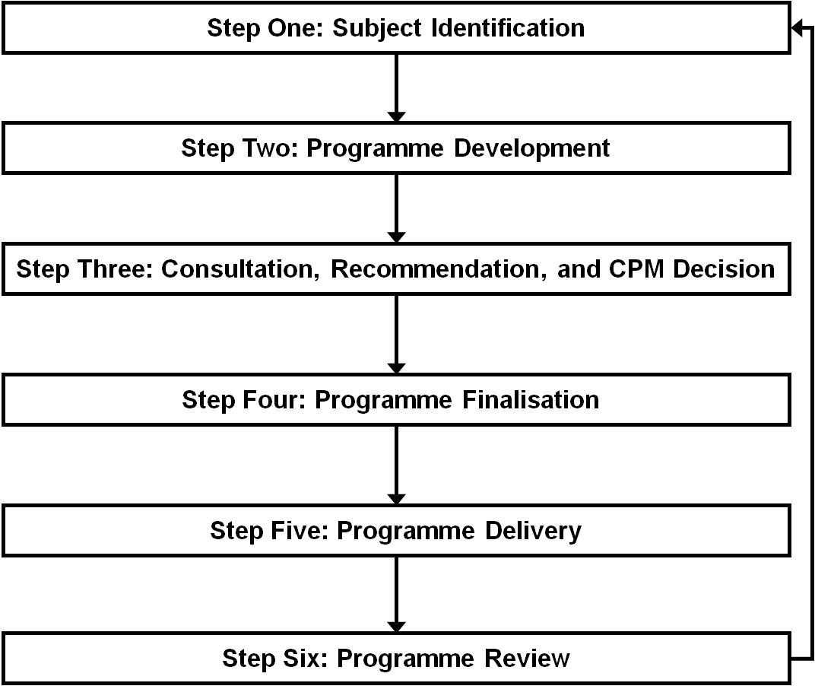

  - Subject Identification
    - This involves the identification of suitable parts of the convention or an ISPM where an implementation programme is needed and would have the potential to add significant value. There will be many possible areas to focus on, and in each area there will be many possible implementation challenges and many possible solutions. Subject identification could be led by the TRG who would seek input from all IPPC bodies. The SPG, SC, CDC, SBDS, and the Secretariat itself will all be important. The IRSS and its questionnaire results will be a particularly valuable source of information.
    - In addition to identifying an implementation need, some clear opportunities to improve implementation (potential projects) need to be identified at this stage in order to make an early assessment of the size of the opportunity.
    - Possible programmes and projects within the programmes should be evaluated at an early stage against the Guiding Principles (4.1 above), particularly driven by contracting parties’ needs.
    - At this point, some early prioritisation recommendations could be made by the TRG with input from the Bureau, the SPG and the Secretary. This would ensure not too many items are going through to the programme development phase (next step) at any one time.

  - Programme Development
    - Once a problem and opportunity have been identified at a broad level, a draft programme should be developed, including a statement of funding source. This would require:
      - A clear description of the implementation challenge.
      - A clear description of opportunities to address the challenge. This will often require a suite of different efforts from different IPPC bodies and projects. Integration of effort at this point is important and could be facilitated by the Secretariat.
      - A draft budget for the work should be developed. This will help assess the value of the solution verses the cost. Even at this early stage it can help donors identify elements they might wish to participate in.
      - The principle regarding Targeted and Focussed Effort needs to be considered at this point.
      - Coordination by the Implementation Coordination Unit across all relevant work areas. The Implementation Coordination Unit will have the responsibility of producing the required documentation.
    - Programme Plan
The draft programme plan should include:
    - a clear description of the implementation challenge that is being addressed
    - the goal of the programme and targets that have been agreed
    - the suite of projects that would be delivered to address the implementation challenges
    - a draft budget with possible funding sources and other resources including staff training, and management resource
    - a draft communications plan
      - a draft monitoring and reporting plan
    - The draft programme plan should be documented without too much detail, but sufficient to allow for meaningful consultation and informed decision-making. Remember that, at this point, there could be several implementation programme proposals being developed and a future prioritisation decision required (i.e. don’t want to invest too many resources prior to a decision that the programme will in fact proceed).

  - Consultation, Recommendation, and CPM Decision
    - The draft programme, containing a statement of objectives, benefits, costs, constraints and estimated delivery time, should be presented to the SPG (or TRG) for consideration. The SPG will:
      - Check that the implementation challenge has been clearly described and can be easily understood, and that there is some agreement that it is significant and needs attention.
      - Check that the draft programme comprises a suite of projects that is capable of delivering practical benefits to contracting parties with implementation challenges in this area.
      - Check that the draft programme is appropriate when considered against the Guiding Principles.
      - Provide feedback as necessary to ensure the programme is fit to be considered by the CPM.
    - SPG should make recommendations on priorities to CPM if there are already approved implementation programmes underway or if there is more than one being proposed. Prioritisation should be linked directly to the importance as seen by the contracting parties and the anticipated benefits to be delivered by the draft programme.
    - CPM should make a formal decision to proceed with the programme in whole or part.

  - Programme Finalisation
    - Once the programme has been approved by the CPM, the details of the work within the programme can be finalised.
    - More detailed budgets will be developed and funding sources and other resources (e.g. expertise) need to be identified.
    - Firm targets for delivery (what will be delivered by when) and impact (what difference will it make) should be established in order to set clear expectations and to form the basis for future reviews.
    - Each of the IPPC work areas will need to schedule the relevant parts of the implementation programme into their work programmes.
    - The relevant work areas can then proceed with their aspects of delivering the work.

  - Programme Delivery
    - Delivery includes the development of management, operational, and technical guidance and support material such as:
      - Management Guidance and Support - Communication; resource acquisition; legislation and regulation development; coordination within department, with other in-country agencies, with trade partners; stakeholder involvement; public awareness; training systems.
      - Operational Guidance and Support – priority setting; strategic and operational planning; training (guides, manuals, courses, workshops); specific technique or methodology development; information sharing and reporting; database management; auditing and verification; non-compliance response; training systems.
      - Technical Guidance and Support – specific techniques, methodology, supplier lists; use of virtual systems; specific data collection, record-keeping and reference systems; training systems.
    - Within an implementation programme, the materials developed should be broadly applicable across a range of contracting parties. They may, however, be complemented by country-specific materials and efforts that would sit outside the implementation programme (e.g. country specific CDC projects), but be recognised and integrated where it would add value.
    - Coordination mechanisms will need to be established by the ICU to ensure the bodies delivering various aspects of the implementation programme stay aligned so that we maintain a full view of the progress of the programme. This will also assist in delivering consistent and comprehensive communications out to contracting parties and others with an interest in the implementation programme.
    - The IPPC Secretariat Coordinator will provide oversight of programme delivery (supported via the work of the ICU).

  - Programme Review
    - The IPPC Coordinator should provide regular reports to the Bureau and annual reporting to the SPG and CPM.
    - During this phase monitoring and reporting will ensure that:
      - the agreed programme is being delivered
      - appropriate coordination is happening across work areas
      - the programme targets are being met
      - commitments made to donors have been fulfilled.
    - Where a discernable and significant value delivered can be identified, this should be used in internal and external communications to highlight the value being delivered by the IPPC.
    - Feedback from donors and contracting parties should be sought to check if they are satisfied and if they have feedback.
    - Resources budgeted, needed and actually allocated should be reviewed.
    - Each implementation programme should be completed with a post-delivery review to learn lessons that might help in the development and delivery of future implementation programmes.

- Implications for Existing Bodies
Implications are very dependent on decisions still to be made on the governance model. A few implications can be suggested:
  - CPM
    - A new standing agenda item should be added for CPM decisions on new implementation programmes and for updates on current programmes.
  - Bureau
    - Should play a significant role in governance of the work area.
  - Secretariat
    - Potentially a significant change to the operation of staff in the secretariat and the role of the Coordinator. These changes largely driven by the extent of coordination across work areas that will now be required, plus the resources needed to provide administrative support and day-to-day leadership for the new work area.
  - SPG
    - A new standing agenda item could be added to evaluate draft implementation programme proposals and make recommendations to CPM
  - SC
    - Should be able to highlight implementation issues in advance of new Standards being adopted. Should be able to contribute significantly to the development of technical guidance and support materials related to ISPMs. Associated technical panels could also play a role in developing or reviewing guidance and training materials related to ISPMs.
  - CDC
    - Most involved in building capacity among contracting parties for improved implementation.
    - Will need to work out how to integrate implementation programme projects into its work plan and work out how to manage these alongside country-specific capacity development projects.
    - Will be able to bring contracting parties views on needs to the Subject Identification phase and an understanding of practicalities of capacity development to Programme Development and Delivery.
    - May be most impacted by this new work area so will have to work to get close alignment and joint understanding.
  - SBDS
    - May be able to identify some implementation issues if more disputes (informal or formal) come to its attention.
  - TRG
    - Can contribute strongly to Subject Identification as it reviews survey results and proposes new work to identify implementation challenges. TRG could take on a much more significant role.
  - IRSS
- Critical that the work of the IRSS is incorporated into the almost all phases of an implementation programme but especially Subject Identification and Programme Review. IRRS resources could be transformed to form an implementation coordination unit for the implementation work area.

8. Conclusion
The Convention is quite clear in stating the need for implementation. The reference in Article XI states – “The function of the Commission shall be to promote the full implementation of the objectives of the Convention ...and, in particular.... “ . Article XX states that “The contracting parties agree to promote the provision of technical assistance to contracting parties, especially those that are developing contracting parties, either bilaterally or through the appropriate international organizations with the objective of facilitating the implementation of the Convention”. However, whilst CPM supports the proposal that the IPPC places more focus on the implementation of the Convention and its standards, IPPC CPs should recognize the constraints and difficulties of input into such a work area. Support for this work area will likely reduce the resources available for other goals such as the standard setting programme. This work programme will involve the development of further infrastructure so CPs need to remember the severe resource constraints that limit the activities of the CPM.
There are perhaps ways of lessening the impact of this proposal. The first programmes could be in the nature of pilot programmes. For example, the area of surveillance could be considered with the base information already gathered by IRSS, or CPs might prefer to look at trade related conflicts where the consideration of application of specific standards may be of help or new ones developed. Such work might be sufficient to prove the workability of the concept programme. Other methods to facilitate this work area could be the increased liaison between RPPOs and NPPOs in the development of programmes and the securing of resources. The FAO could be asked to supply additional resources for such a new programme initiative.
There is no doubt there could be difficulties in establishing the systems for this work area: the Secretariat would have to develop closer collaboration amongst its staff and with the leaders of the various IPPC bodies; not all CPs will want to become involved in implementation programmes – the ISPM may not be of import to them because their needs, interests and political deem otherwise.
Despite these difficulties it is still thought worthwhile to develop an implementation work area to assist those CPs that are having problems in implementing ISPMs. It is recommended thqt SPG considers the points outlined in this paper and continue the development of a work area that can be proposed to CPM 9.

Appendix One: General Model of Implementation Work Area and Relationship to Other Work Areas
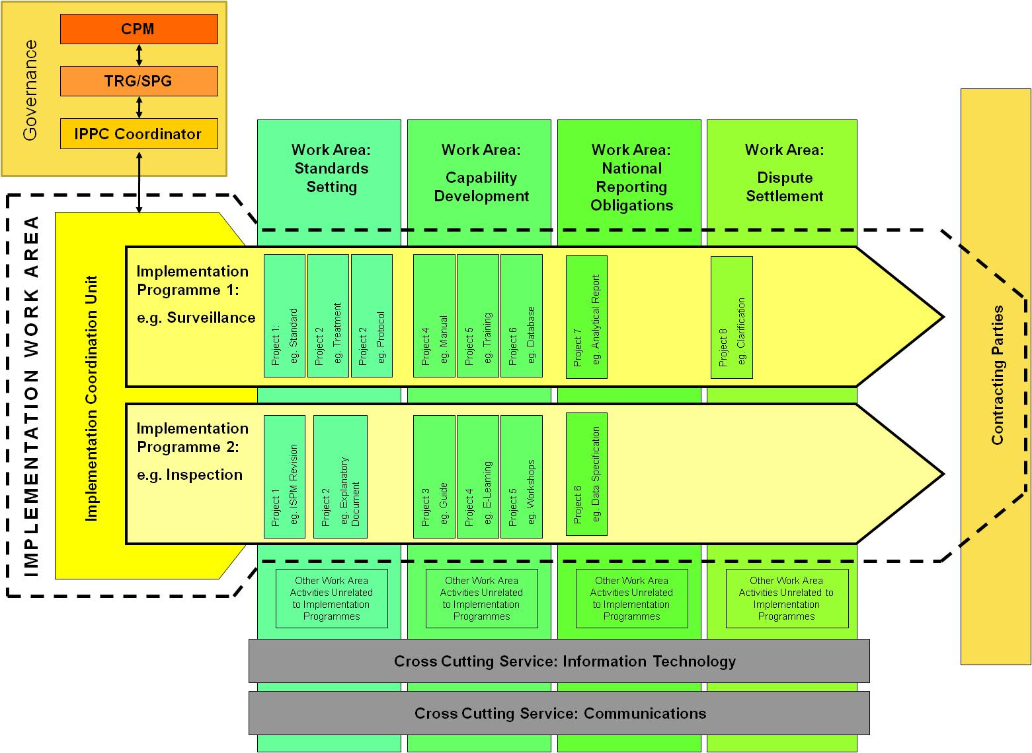

Appendix Two: Hierarchy of Terms
Many terms can be used to describe the various levels of programmes and projects and tasks etc. Confusion can result of people speak at cross-purposes using different terms. So solely for the purpose of clarity when discussing this paper, the following hierarchy of terms has been used:

Level 1: | Work Area | e.g. Implementation Work Area or Standard Setting Work Area
Level 2: | Programme | e.g. Under the Implementation work area there may be 2 or 3 or 4 programmes. These are specific areas of focus for implementation and each area will have been agreed by CPM.
Level 3: | Project | e.g. Under each programme there may be multiple projects that collectively will result in improved implementation.
Level 4: | Task | e.g. Within a project there will be multiple tasks. Tasks have not been shown in the Appendix One general model as they are a very low level of detail.

International Plant Protection Convention (1997). Article I, paragraph 1. Emphasis added.
The Director General’s Medium Term Plan 2014-17 and Programme of Work and Budget 2014-15. http://www.fao.org/docrep/meeting/027/mf490e.pdf
Appendix Two provides a hierarchy of terms used in this paper to describe the structure of what is proposed in this paper. It includes work area, programme, project, and task. It is hoped these terms can be used in a consistent way to avoid confusion during discussion.

