NOTE FROM SECRETARIAT: The proper formatting for tables and keys will be applied before publishing the diagnostic protocol.

Draft annex to ISPM 27: Dendroctonus ponderosae (2006-019)
Status box
This is not an official part of the standard and will be modified by the IPPC Secretariat after adoption
Date of this document | 2016-12-15
Document category | Draft annex to ISPM 27 (Diagnostic protocols for regulated pests)
Current document stage | To DP notification period for adoption
Origin | Work programme topic: Insects and mites  Original subject: Dendroctonus ponderosae syn. Scolytus scolytus (2006-019)
Major stages | 2006-05 SC added original subject: Dendroctonus ponderosae syn. Scolytus scolytus (2006-019)  2015-03 Expert Consultation (EC)  2015-05 Revised draft after EC with new title: Dendroctonus ponderosae (2006-019)  2015-06 Technical Panel on Diagnostic Protocols (TPDP) meeting revision  2015-09 Revised draft DP with TPDP and EC comments addressed  2015-11 SC noted title change from “Dendroctonus ponderosae syn. Scolytus scolytus (2006-019)” to “Dendroctonus ponderosae (2006-019)”  2015-12 SC approved draft DP for consultation (2016_eSC_May_02)  2016-02 First Consultation  2016-11 TPDP recommended to SC for adoption (2016_eTPDP_Nov_03)  2016-11 SC e-decision for approval for adoption (2017_eSC_May_04)
Discipline leads history | 2012-11 Norman BARR (US, discipline lead)  2012-11 Géraldine ANTHOINE (FR, referee)
Consultation on technical level | The first draft of this protocol was written by (lead author and drafting team):  - Ms Linda Semeraro (Australia) (lead author)  - Mr Edson Tadeu Iede (Brazil)  - Ms Brigitta Wessels-Berk (Netherlands)  - Mr Hume Douglas (Canada)  - Mr Jean-Francois Germain (France)  In addition, the draft has been subjected to expert review and the following international experts submitted comments:  - Ms Ramona Vaitkevica (State Plant Protection Service of Latvia)  - Mr Christopher H.C. Lyal (Natural History Museum, United Kingdom)  - Mr Muchemi Samuel (International Centre of Insect Physiology and Ecology (ICIPE), Kenya)  - Mr Jiri Hulcr (University of Florida, Institute of Food and Agriculture Sciences, Gainesville, Florida, United States)  - Mr Masaaki Genka (Yokohama Plant Protection Station, The Ministry of Agriculture, Forestry and Fisheries of Japan)  - Mr Guilherme Schnell e Schuhli (Empresa Brasileira de Pesquisa Agropecuaria, EMBRAPA, Brazil)
Main discussion points during development of the diagnostic protocol | - Title of protocol changed to not include syn. Scolytus scolytus, as S. scolytus is a different species.  - DNA barcode method is not included because no publication on D. ponderosae barcode identification exists and only one record of D. jeffreyi is available. This is the TPDP recommendation.  - Use of Bouchard (2011) classification of tribe Hylurgini instead of tribe Tomicini as used by Bright (2014).  - Separate adult from larvae diagnosis in protocol.
Notes | This is a draft document.  2015-10 Edited  2016-10 Edited

CONTENTS [to be added later]

Adoption
- This diagnostic protocol was adopted by the Commission on Phytosanitary Measures in XXXX [to be completed after adoption].
- The annex is a prescriptive part of ISPM 27 (Diagnostic protocols for regulated pests).

1. Pest Information
- There are 20 Dendroctonus species that have been recognized worldwide (Table 1) and described in the literature (Armendáriz-Toledano et al., 2015). These beetles are phloeophagous (bark-feeding) insects that live beneath the bark layer of trees where the adults and larvae form characteristic galleries (Wood, 1982). The galleries may be engraved in both the inner bark layer and the wood. Most of the species are present only in North and Central America, but two species are native or endemic to Europe and Asia (Six and Bracewell, 2015; CABI, 2016a). The species Dendroctonus valens LeConte has been recently introduced to Asia (CABI, 2016b).
- Dendroctonus ponderosae Hopkins, 1902 is a destructive pest of pine trees (Keeling et al., 2013). Adults and larvae kill the trees by directly feeding on and girdling them. In addition, D. ponderosae acts as a vector of at least three species of blue stain fungi, including Ceratocystis montium (Rumbold) J. Hunt, Grosmannia clavigera (Robinson-Jeffery and Davidson) Zipfel, de Beer and Wingfield (=Ophiostoma clavigerum (Robinson-Jeffery and Davidson) Harrington) and Leptographium longiclavatum Lee, Kim and Breuil (Figure 1), which block nutrient and water flow, contributing to the decline of the health of infected trees (Amman and Cole, 1983; Rice et al., 2008; CABI, 2015; Six and Bracewell, 2015).
- D. ponderosae has been known to cause up to 85 percent tree mortality in pine tree stands and can kill many healthy pine trees (CABI, 2015). Serious outbreaks can cause millions of hectares of damage to pine forests and have a devastating ecological and economic impact (Keeling et al., 2013; Janes et al., 2014). D. ponderosae spreads within its native range by flight; each generation can migrate several kilometres. The beetles usually attack older trees or weakened pines, but during epidemics, D. ponderosae may attack trees with rapid growth rates and non-Pinus coniferous species. Janes et al. (2014) identified four oscillating phases of D. ponderosae population dynamics: (1) small population size, with the beetles restricted to “low-quality hosts” or trees in poor health; (2) incipient epidemics, during which the beetles mainly attack trees with a large diameter; (3) epidemics, during which the beetles attack healthy trees; and (4) post-epidemic collapse. Historically, cycles of these phases occur every 20–40 years in areas where D. ponderosae is endemic, with epidemics lasting on average for five years.
- D. ponderosae is known to be present in North America (CABI, 2015). Major tree hosts for this pest include Pinus contorta (lodgepole pine), Pinus lambertiana (sugar pine), Pinus monticola (western white pine) and Pinus ponderosa (ponderosa pine). Other minor host species from which D. ponderosae has been collected include Picea engelmannii (Engelmann spruce), Pinus aristata (Rocky Mountain bristle cone pine), Pinus albicaulis (whitebark pine), Pinus balfouriana (foxtail pine), Pinus coulteri (big-cone pine), Pinus edulis (pinyon pine), Pinus flexilis (limber pine), Pinus monophylla (single-leaf pinyon pine), Pinus strobiformis (southwestern white pine) and Pinus sylvestris (Scots pine) (CABI/EPPO, 1997). Some of these records are incidental.
- Attack on a pine tree is initiated by unmated adult female D. ponderosae, which release pheromones to attract males (CABI, 2015). Females bore straight vertical egg galleries along the phloem or inner bark. Male beetles help build the galleries by removing frass and later plug the entrance with frass. Eggs are laid individually or in clusters along the gallery, surrounded by tightly packed frass, and hatch 7 to 14 days after laying (CABI/EPPO, 1997). Females begin laying eggs about seven days after the initial attack on a tree and cease when temperatures become too cold to continue. Egg laying occurs during summer up to early autumn in North America (CABI, 2015). D. ponderosae has four larval instars (CABI/EPPO 1997). The larvae feed on phloem, together constructing a radiating series of feeding galleries (Figures 2 and 3). Infestation usually occurs over a five week period, but may happen in as little as three or four days. In most cases the adults remain within the galleries and die after the production of one brood (CABI/EPPO 1997). However, some adult beetles may instead re-emerge to begin a new gallery. It sometimes takes only one generation of D. ponderosae to kill a healthy tree.
- D. ponderosae is typically univoltine (one generation per year), but can be semivoltine (one generation every two years) where the climate is cooler, such as at higher elevations (Bentz et al., 2013). Mitton and Ferenberg (2012) reported that there were up to two generations per year in warm climates on certain pine species. Adults can be found on or under bark or in flight searching for a new host. Eggs, larvae and pupae are found internally under bark of shoots, or in branches and trunks. The species usually overwinters as second or third instar larvae but occasionally other life stages can be found along with larvae in colder months.
- Table 1. Dendroctonus species
Species | Author | Distribution
Dendroctonus adjunctus | Blandford | North America
Dendroctonus approximatus | Dietz | North America
Dendroctonus armandi | Tsai and Li | Asia
Dendroctonus brevicomis | LeConte | North America
Dendroctonus frontalis | Zimmermann | North and Central America
Dendroctonus jeffreyi | Hopkins | North America
Dendroctonus mesoamericanus | Armendáriz-Toledano & Sullivan | Central America
Dendroctonus mexicanus | Hopkins | North and Central America
Dendroctonus micans | Erichson | Europe and Asia
Dendroctonus murrayanae | Hopkins | North America
Dendroctonus parallelocollis | Chapuis | North America
Dendroctonus ponderosae | Hopkins | North America
Dendroctonus pseudotsugae | Hopkins | North America
Dendroctonus punctatus | LeConte | North America
Dendroctonus rhizophagus | Thomas & Bright | North America
Dendroctonus rufipennis | (Kirby) | North America
Dendroctonus simplex | LeConte | North America
Dendroctonus terebrans | (Olivier) | North America
Dendroctonus valens | LeConte | North America and Asia
Dendroctonus vitei | Wood | North America
- Source: Based on Wood (1982), Bright (2014), Armendáriz-Toledano et al. (2015) and CABI (2016a, 2016b).

2. Taxonomic Information
- Name: Dendroctonus ponderosae Hopkins, 1902
- Synonym: Dendroctonus monticolae Hopkins, 1905
- Taxonomic position: Insecta, Coleoptera, Curculionidae, Scolytinae, Hylurgini
- Common names: Mountain pine beetle, Black Hills beetle (in English only)
- Scolytinae Latreille, 1804, the subfamily to which Dendroctonus Erichson, 1836 belongs, was long treated as a family of the Curculionoida. Recently Bright (2014) continued to refer to the group as the family Scolytidae following Wood (1982, 1986), while Jordal et al. (2014) presented phylogenetic evidence for subfamily status for the Scolytinae. In Alonso-Zarazaga and Lyal (2009) and Hulcr et al. (2015), Dendroctonus belongs to the tribe Hylurgini. Diagnostic characters for adult Hylurgini (=Tomicini) are presented in Wood (1986).
- This diagnostic protocol follows the classification set out in Bouchard et al. (2011), where the group is treated as a subfamily of the Curculionidae – the Scolytinae – and is divided into 26 extant tribes (Hulcr et al., 2015), one of which is Hylurgini Gistel, 1848, to which Dendroctonus belongs.

3. Detection
- It is useful when examining wood to look for evidence of circular holes (1.5–3.5 mm in diameter) or frass in suspected material.
- Larvae and pupae are found in the host plant or wood products only under bark or in the phloem, not in the wood or xylem. Trees can be examined externally for symptoms of infestation while pine or other coniferous wood products, particularly unprocessed logs, dunnage, crates or pallets with bark, should be examined for galleries and beetles (adults and larvae).
- The entrance tunnel of galleries created by this pest is short and perpendicular to the trunk. The egg gallery which initially ascends diagonally from the entrance tunnel is vertical and only slightly wider than the adult beetle. The egg tunnel may be 32 to 50 cm long. The egg niche pattern is characteristic for D. ponderosae, alternating between groups of one to five niches (CABI/EPPO, 1997). Larvae mine tunnels that begin more or less parallel to the egg gallery and then widen and diverge from it. These tunnels are 1–4 cm long, terminating in a pupal chamber. Eventually the beetles exit the tunnel through the bark to the outside.

3.1 Symptoms of infestation in the field
- Four general symptoms indicate possible attack of D. ponderosae in living pine trees:
- - yellowing, dying needles at the base or top of the crown
- - entrance tunnels on trunks, often with popcorn-sized, dark red–orange to cream-coloured exudate (pitch tubes) (Figure 4)
- - visible frass (reddish boring dust in bark crevices)
- - vertical, J-shaped maternal galleries ranging in length from 10 to 122 cm (average about 25 cm) (CABI, 2015) and lateral larval galleries under the outer bark layer (Figures 2 and 3).
- After a few months to a year (depending on location and temperature) the attacked tree will change leaf colour from yellowish green to red. Attacks on P. ponderosa and P. contorta cause needles to change from yellowish green in spring to bright orange by mid-summer.

3.2 Samples from plants and wood products
- The bark can be removed from affected plant or wood products using a sharp, strong knife or a small axe (Kelley and Farrell, 1998). The wood underneath the bark layer and the inner bark should be visually examined for vertical galleries. A 40× magnifying lens can be used to inspect for galleries and for adults, larvae and eggs. If gallery engravings are present, some of the bark or affected material should be collected and, if possible, photographed. Infested material can be transported in a sealed bag or container. Double bagging is advisable to prevent escape of the beetles.
- Detected adults, larvae, pupae or eggs can be removed using forceps. Larvae can be placed in boiling water to fix them. Specimens should then be placed into a glass vial containing 70–80% ethanol. Adults can also be placed into a dry tube and then in a freezer at –20 °C for at least 24 h or at –80 °C for at least 6 h before point or card-mounting. Doing so will preserve the reference material well for morphological identification (section 4.1).
- It is important to collect any adults that are present because adults have more reliable characters for identification; it is not possible to identify juveniles to species based on morphology alone. In the laboratory, adult specimens should be pinned for examination while larvae, pupae and eggs should be placed in ethanol. See section 4.1.1 for details on preparation of specimens for morphological examination.

4. Identification
- D. ponderosae can be identified by examination of the adult external morphological characters. Features of the adult body are illustrated and labelled in Figures 5 and 6. Descriptions of and keys to bark beetle species based on adult life stage are available. Generic keys of Scolytinae larvae are available in Thomas (1957, 1965) but juvenile stages are difficult to identify as there are fewer distinct characters to differentiate between the species. Currently, it is not possible to identify Dendroctonus larvae to the genus or species level with confidence. The shape and form of the galleries may be useful in detection and identification but are not sufficient for identification without adult specimens for confirmation.
- As yet, no reliable molecular tests can be recommended to distinguish between D. ponderosae and other Dendroctonus species with similar morphology. At present, there are no protocols using universally adapted polymerase chain reaction methods for the identification of D. ponderosae to the exclusion of the closely related species D. jeffreyi. Hence there remains the need to rely on morphological identification.

4.1 Morphological identification of adults

4.1.1 Preparation of adults for morphological examination
- The ethanol-preserved specimens (section 3.2) are transferred to a small Petri dish filled with 70–80% ethanol to be cleaned from dirt, debris and frass. Specimens can be cleaned by gentle brushing with a fine hair brush. Adult specimens preserved in ethanol to be point or card-mounted, should first be dried by removing the specimen from ethanol, blotting it with paper towel and allowing it to air-dry for 2–5 min. Specimens removed from –20 or –80 °C freezers should be placed on blotting paper and thawed for 10–20 min or until any visible condensation evaporates from the specimen. A triangular card mount is most appropriate for small beetles and attaching the beetle to the card along the right lateral side of its thorax is common practice. Ideally the left lateral, dorsal and ventral aspects should be free and visible to facilitate comparison with other pinned specimens and images. Once adults are pinned, they may be examined under a dissecting microscope of at least 40× magnification (a higher magnification may be preferable). Strong, diffuse lighting is very important for examination of adult bark beetles as their surface sculpturing is characteristic. As adult bark beetles can be very shiny, light reflected from specimens may sometimes interfere with examination of characters. The sheen can be reduced by placing tracing paper or drafting film over the microscope’s light source.

4.1.2 Diagnostic characters of adults of the subfamily Scolytinae
- The main diagnostic features of Scolytinae are presented below and are based on key characters highlighted in Wood (1982, 1986), Anderson (2002), Rabaglia (2002) and Hulcr et al. (2015). Wood (1986) also provided a key to the world genera of Scolytinae and Anderson (2002) included a key to the Scolytinae genera of North America.
- body cylindrical
- head enlarged
- snout or rostrum very short or non-existent (Figure 7)
- antennae elbowed and clubbed
- antennae geniculate with a single to seven-segmented funicle; the three- or four-segmented antennal club has apical sutures (Figure 8), which may be transverse, sinuate, recurved or procurved
- pregular sclerite (=submentum) ventrally distinctly visible, with pregular suture (Figure 9)
- legs and antennae short and retractable
- at least one pair of tibiae usually with stout spines or denticles (teeth) along the lateral outer margins (Figure 10); lateral denticles on foretibiae usually socketed
- tarsi with four visible segments (Figure 10)
- length of the first tarsal segment not more than that of the second or third tarsal segments (Figure 10).

4.1.3 Diagnostic characters of adults of the genus Dendroctonus
- Following Wood (1982 and 1986), the following characters are diagnostic for Dendroctonus:
- body length between 2.5 and 9.0 mm
- male frons evenly convex but slightly impressed medially (Figure 11)
- anterior margin of pronotum distinctly emarginate (Figure 12)
- pronotum punctate (Figures 4 and 12), without asperities, to micro-asperate
- scutellum visible (Figure 13(a)), small, rounded or depressed
- anterior margin of elytra procurved with crenulations (Figure 13(a)); elytral bases slightly notched at scutellum in dorsal view
- procoxae contiguous (Figure 14(b))
- lateral precoxal prothoracic ridge not developed (Figure 14(b))
- antennal funicle five-segmented (Figure 8)
- antennal club symmetrical, strongly flattened, subcircular, with three sutures that are transverse to slightly procurved (Figure 8).

4.1.3.1 Key to distinguish Dendroctonus adults in Scolytinae
- The following key, adapted from diagnostic characters listed in Rabaglia (2002), can be used to distinguish Dendroctonus from other genera commonly encountered in Pinus spp.
- 1. Anterior margin of elytra straight or transverse, without crenulations (Figure 13(b)); pronotum usually armed with asperities and head usually concealed dorsally by declivous pronotum (Figure 15)................................................................................................................................not Dendroctonus
- Anterior margin of elytra procurved (in dorsal view) and/or armed with crenulations (Figure 13(a)); head usually visible dorsally (Figures 16 and 12) ............................................................2
- 2. Prothoracic precoxal area longer than diameter of forecoxa, and lateral margin with a distinct ridge (Figure 14(a)).............................................................................................................not Dendroctonus
- Prothoracic precoxal area shorter than diameter of forecoxa, and lateral margin with a weakly developed ridge or no ridge (Figure 14(b))...................................................................................3
- 3. Antennal club not symmetrical, with sutures fused and oblique or obsolete.......................................................................................................................not Dendroctonus
- Antennal club symmetrical, with sutures transverse or slightly procurved (Figure 8).......................................................................................................................................4
- 4. Anterior margin of pronotum transverse and no medial notch visible; antennal funicle six- or seven-segmented...................................................................................................................not Dendroctonus
- Anterior margin of pronotum distinctly emarginate or slightly notched medially (Figures 16 and 12); antennal funicle five-segmented, club sutures slightly procurved (Figure 8)...............................................................................................................................Dendroctonus

4.1.4 Identification of adults of Dendroctonus ponderosae

4.1.4.1 Diagnostic characters
- Diagnostic characters of D. ponderosae adults are based on key characters and descriptions in Wood (1982).
- Male 3.5–6.8 mm (average male: 5.5 mm). Approximately 2.2 times as long as wide. Mature adults black, pterothorax brown, some teneral stages light brown. Females appear externally similar to males except epistomal process less distinct and crenulations on elytra and granulations on declivity larger. Frons: convex with a narrow median line only lightly impressed, not deeply grooved (Figure 11). Epistomal process half as wide as width between the eyes (measured between posterior inner lateral margin of eye), epistomal process with oblique lateral arms; brush of yellow setae present beneath (Figure 11). Pronotum widest at the base, constricted anteriorly, with surface shining between closely spaced granulose punctures (Figure 12(a)). Pronotum without callus. Elytral declivity dull with interstria 1 strongly elevated; interstria 2 impressed; interstriae bear granules in one row (not random) (Figure 17).

4.1.4.2 Similar species
- D. ponderosae is morphologically similar to D. jeffreyi (Figure 18), which makes them difficult to distinguish. The pronotal punctures are separated by a distance not greater than the diameter of the puncture in D. ponderosae, while D. jeffreyi has finer pronotal punctures more widely separated (at least twice the diameter of one puncture), and they are not as deep (Figure 12). The body length of D. ponderosae (average male body length 5.5 mm) is slightly less than that of D. jeffreyi (average male body length 6 mm). D. jeffreyi has a distribution range only from South Oregon (United States) to North Baja California (Mexico), while D. ponderosae is present throughout the middle and western parts of North America. The host plant range of D. jeffreyi is more restricted than that of D. ponderosae, with D. jeffreyi usually attacking only Pinus jeffreyi and rarely P. ponderosa. D. ponderosae is distinguished from D. frontalis by its larger size: the latter species has males that are only 2.0–3.2 mm (average 2.8 mm) long. Unlike D. frontalis, specimens of D. ponderosae lack a pronotal callus in the female and distinct groove in the middle of the frons.
- In the United States, Ips pini (Say) is often found in the same tree with D. ponderosae during non-outbreak periods, but these two species are not easily confused as they have different parent galleries and adult Ips have distinct teeth around the lateral margin of the elytral declivity. However, larvae of these species and their galleries may appear very similar. Confirmation of beetle species should be specimen-based and for morphological identification, adult specimens should be examined.

4.1.4.3 Simplified key to adults of Dendroctonus species
- The following key, a simplified version of a key from Wood (1982), can be used to differentiate D. ponderosae from 16 Dendroctonus species from North America. Three species D. armandi, D. mesoamericanus and D. micans found in Asia, Central America and Europe/ Asia respectively, are not included in the key. See Table 1 for a complete list of described species worldwide.
- 1. Frons with narrow deep median groove (Figure 19) extending from just above epistomal process to upper level of eyes (Figure 20); epistomal process laterally reaching margin of eyes, lateral margin raised (Figure 20); males with one or two tubercles on lateral area of frons (except D. adjunctus); if protuberance obscure in female then a transverse elevated callus (collar-like sculpturing) on lateral and dorsal pronotum is present (obscure in D. adjunctus) (Figure 7); usually smaller than 7.5 mm (in Pinus spp.)...................................................................................................................not D. ponderosae
- Frons without deep median groove (Figure 11); epistomal process relatively narrower and less prominent; males without raised tubercles on frons; pronotal transverse elevated callus not present in either sex; larger species, usually about 5.0–9.0 mm in body length (in Pinus spp. and other conifers)................................................................................................................................2
- 2. Coarse granulation around the episternal area; coarse pronotal punctures separated by a distance less than the diameter of one puncture and some punctures bearing a small granule; elytral declivity with relatively large granules forming a single line (uniserial) along each interstria; elytral interstria 2 strongly impressed, interstria 1 strongly elevated, interstria 3 weakly elevated; surface of declivity dull and minutely rugulose (Figure 17)..............................................................................D. ponderosae
- Not with the above combination of characters................................................not D. ponderosae (and not the similar species D. jeffreyi)

4.2 Morphological identification of larvae
- While adult specimens (in good condition) are the only way to confirm the identification of D. ponderosae using morphological methods, in the absence of an adult specimen, it is useful to examine larvae. However, there is potential for confusion among Scolytinae species, which may appear very similar at the larval stage. Larvae of D. ponderosae share morphological features with other species in the genus Dendroctonus and with species in other genera of Scolytinae. Nevertheless, examination of larvae may be useful in determining if the specimen is consistent with the known morphology of the species, and may help to support diagnosis of a specimen as either not D. ponderosae or suspected or possible D. ponderosae.

4.2.1 Preparation of larvae for morphological examination
- The ethanol-preserved specimens (section 3.2) are transferred to a small Petri dish filled with 70% ethanol for morphological examination. Specimens should be clean of dirt, debris and frass for examination. Specimens can be cleaned by gentle brushing with a fine hair brush. They may be examined under a dissecting microscope of at least 40× magnification (a higher magnification may be preferable).

4.2.2 Diagnostic characters of larvae of the subfamily Scolytinae
- Mature larvae of this subfamily are 4–6 mm long, and have no legs. The body is C-shaped and subcylindrical (Figure 21), with three thoracic and ten abdominal segments. Larvae have white bodies with dark brown chewing mouthparts (mandibles). The head capsule is lightly sclerotized, usually amber or light brown, and as long as broad; the antennae have only one segment; and the cranium has a Y-shaped ecdysial suture (Figure 22). The thorax bears three pairs of pedal lobes that each have two to four setae. Each abdominal segment has two or three tergal folds. The prothorax and the first eight segments of the abdomen bear spiracles (Bright, 1991). Eggs are smooth, oval, white, translucent (CABI/EPPO, 1997).

4.2.3 Diagnostic characters of larvae of the genus Dendroctonus
- The following characters are based on Thomas (1957).
- The general appearance of these larvae is as for other Scolytinae. They are C-shaped, white or cream coloured larvae with lightly sclerotized heads. Mature specimens are large (2–9 mm). The diagnostic characters of Dendroctonus larvae include having head free (almost entirely visible dorsally), anterior margin of frons without tubercles, and mandibles with three incisorial teeth (Figure 23). The postlabium has a posterior pair of setae closer together than the median pair (Figure 24(a)), each lateral cluster of post-labial setae is triangular in configuration, and the shape of the premental sclerite is triangular and proximally abruptly narrowed – it appears as a distinct projection from the main body of the sclerite (Figure 24(a)). The pedal lobes are smooth but may be surrounded by spinules (but not inside the pedal lobe area), with three or four setae on each lobe (Figure 25).

4.2.3.1 Key to distinguish Dendroctonus larvae in Scolytinae
- This key is based on work by Thomas (1957), with only 15 genera examined from mostly North American fauna. It serves as a guide to highlight further some distinctive larval characters of Dendroctonus.
- 1. Premental sclerite of labium proximally triangular in shape, or with distinct narrow projection (Figure 24(a), (b)); postlabial setae in triangular arrangement, middle pair furthest apart; no tubercle on anterior margin of frons.................................................................................................Dendroctonus
- Premental sclerite proximally broadly rectangular (Figure 24(c)) or if triangular then postlabial setae linear (Figure 24(b)) or not as above; tubercle may or may not be present on anterior margin of frons (Figure 26)...............................................................................not Dendroctonus

4.2.4 Identification of larvae of Dendroctonus ponderosae

4.2.4.1 Diagnostic characters
- The following key characters are based on Thomas (1965).
- Mature larvae are between 4.3 and 5.2 mm long. The head capsule is evenly pigmented, light amber, and as long as broad. Diagnostic characters include frons with a prominent pair of elevations posterior of mid frons (Figure 22(a)), and tubercle on the inner basal angle of the mandible (Figure 23).

4.2.4.2 Key to distinguish larvae of Dendroctonus ponderosae from the larvae of other Dendroctonus species
- The following key is based on Thomas (1965) and is restricted to North American species.
- 1. Spiracular tubercles absent; dorsal surface without sclerotized plates on abdominal segment 8 and/or 9; frons bearing either two rounded protuberances (elevations) (Figure 22(a)) or a single rounded protuberance (Figure 22(b)).......................................................................................................2
- Spiracular tubercles sclerotized; sclerotized dorsal plates present on abdominal segments 8 and/or 9 (Figure 27) or if spiracular tubercles and abdominal plates absent, then frons smooth, without protuberance or with a transverse ridge...............................................not D. ponderosae
- 2. Paired protuberances posterior on upper frons (Figure 22(a)); mandibles with dorsal tubercle near inner basal angle (Figure 23).....................................................................D. ponderosae and D. jeffreyi
- Single protuberance on frons, not paired; mandibles without tubercle.............not D. ponderosae
- D. ponderosae and D. jeffreyi larvae are morphologically distinct from other Dendroctonus species but cannot be separated from each other. It is important to note that specimens which match the above morphological characters for D. ponderosae or which are suspect should ideally be sent to a Scolytinae specialist as identification cannot be readily confirmed based on larvae alone.

5. Records
- Records and evidence should be retained as described in section 2.5 of ISPM 27 (Diagnostic protocols for regulated pests).
- In cases where other contracting parties may be affected by the results of the diagnosis, in particular in cases of non-compliance (ISPM 13 (Guidelines for the notification of non-compliance and emergency action)) and where D. ponderosae is found in an area for the first time, the following records and evidence and additional material should be kept for at least one year in a manner that ensures traceability: preserved pinned or slide-mounted specimens, and photographs of distinctive taxonomic structures.

6. Contact Points for Further Information
- Further information on this protocol can be obtained from:
- State Government of Victoria, Department of Economic Development, Jobs, Transport and Resources (DEDJTR), AgriBio, La Trobe University, 5 Ring Road, Bundoora, VIC 3083, Australia (Linda Semeraro; e-mail: Linda.Semeraro@ecodev.vic.gov.au).
- Embrapa Florestas, Empresa Brasileira de Pesquisa Agropecuaria, EMBRAPA, Estrada da Ribeira, km 111, Colombo, PR, Brazil (Caixa Postal 319, CEP 83411-000, Brazil) (Edson Tadeu Iede; e-mail: iedeet@cnpf.embrapa.br).
- Plant Protection Service, PO Box 9102, 6700 HC Wageningen, Netherlands (Brigitta Wessels-Berk; e-mail: b.f.wessels-berk@minlnv.nl).
- Embrapa Florestas, Empresa Brasileira de Pesquisa Agropecuaria, EMBRAPA, Estrada da Ribeira, km 111, Colombo, PR, Brazil (Caixa Postal 319, CEP 83411-000, Brazil) (Guilherme Schnell e Schühli; e-mail: guilherme.schuhli@embrapa.br).
- Canadian National Collection of Insects, Arachnids and Nematodes, Agriculture and Agri-Food Canada, K.W. Neatby Building, 960 Carling Avenue, Ottawa, Ontario K1A0C6, Canada (Hume Douglas; e-mail: hume.douglas@agr.gc.ca).
- Anses-Laboratoire de la Santé des Végétaux, station de Montpellier, CBGP campus international de Baillarguet CS 30016, FR-34988 Montferrier-sur-Lez, France (Jean-François Germain; e-mail: jean-francois.germain@anses.fr; tel.: +33 4 67 02 25 68).
- School of Forest Resources and Conservation, University of Florida, Gainesville, FL 32611, United States (Jiri Hulcr; e-mail: hulcr@ufl.edu; tel.: +1 352 273 0299).
- Forest Health Protection, United States Department of Agriculture (USDA) US Forest Service, 3CE, 201 14th St, SW, Washington, DC 20250, United States (Robert J. Rabaglia; e-mail: brabaglia@fs.fed.us; tel.: +1 703 605 5338).
- A request for a revision to a diagnostic protocol may be submitted by national plant protection organizations (NPPOs), regional plant protection organizations (RPPOs) or Commission on Phytosanitary Measures (CPM) subsidiary bodies through the IPPC Secretariat (ippc@fao.org), which will in turn forward it to the Technical Panel on Diagnostic Protocols (TPDP).

7. Acknowledgements
- The first draft of this protocol was written by Linda Semeraro (DEDJTR, Australia (see preceding section)), Hume Douglas, (Canadian National Collection of Insects, Arachnids and Nematodes, Agriculture and Agri-Food Canada (see preceding section)), Brigitta Wessels-Berk (Plant Protection Service, Netherlands (see preceding section)), Jean-François Germain (Anses-Laboratoire de la Santé des Végétaux, France (see preceding section)), Edson Tadeu Iede (Empresa Brasileira de Pesquisa Agropecuaria, EMBRAPA, Brazil (see preceding section)) and Norman Barr (USDA Animal and Plant Health Inspection Service, United States).
- Mallik Malipatil (DEDJTR, Australia) provided initial advice and guidance during the preparation of the protocol.
- The following experts reviewed the protocol: Mark Blacket (DEDJTR, Australia), Jiri Hulcr (University of Florida, United States), Christopher Lyal (Natural History Museum, United Kingdom), Dorothy Opondo (Kenya Plant Health Inspectorate Service), Robert Rabaglia (USDA US Forest Service, United States), and Ramona Vaitkevica (State Plant Protection Service of Latvia).

8. References
- The present annex may refer to international standards for phytosanitary measures (ISPMs). ISPMs are available on the International Phytosanitary Portal (IPP) at https://www.ippc.int/core-activities/standards-setting/ispms.
- Alonso-Zarazaga, M.A. & Lyal, C.H.C. 2009. A catalogue of family and genus group names in Scolytinae and Platypodinae with nomenclatural remarks (Coleoptera: Curculionidae). Zootaxa, 2258: 1–134.
- Amman, G.D. & Cole, W.E. 1983. Mountain pine beetle dynamics in lodgepole pine forests, Part II: Population dynamics. General Technical Report INT-145. Ogden, UT, United States Department of Agriculture Forest Service, Intermountain Forest and Range Experimental Station. 60 pp.
- Anderson, R.S. 2002. Family 131. Curculionidae Latreille 1802. In R.H. Arnett, Jr, M.C. Thomas, P.E. Skelley & J.H. Frank, eds. American beetles, Vol. 2. Polyphaga: Scarabaeoidea through Curculionoidea, pp. 722–815. Boca Raton, FL, CRC Press. xiv + 861 pp.
- Armendáriz-Toledano, F., Niño, A., Sullivan, B.T., Kirkendall, L.R. & Zúñiga, G. 2015. A new species of bark beetle, Dendroctonus mesoamericanus sp. nov. (Curculionidae: Scolytinae), in Southern Mexico and Central America. Annals of the Entomological Society of America, doi:http://dx.doi.org/10.1093/aesa/sav020.
- Bentz, B., Vandygriff, J., Jensen, C., Coleman, T., Maloney, P., Smith, S., Grady, A. & Schen-Langenheim, G. 2013. Mountain pine beetle voltinism and life history characteristics across latitudinal and elevational gradients in the western United States. Forest Science, 60(3): 434–449.
- Bouchard, P., Bousquet, Y., Davies, A.E., Alonso-Zarazaga, M.A., Lawrence, J.F., Lyal, C.H.C, Newton, A.F., Reid, C.A.M., Schmitt, M., Ślipiński, S.A. & Smith, A.B.T. 2011. Family-group names in Coleoptera (Insecta). ZooKeys, 88: 1–972.
- Bright, D.E. 1991. Scolytidae (Curculionoidea). In F.W. Stehr, ed. Immature insects, Vol. 2, pp. 613–616. Dubuque, IA, Kendall Hunt Publishing Company. 975 pp.
- Bright, D.E. 2014. A catalog of Scolytidae and Platypodidae (Coleoptera), Supplement 3 (2000–2010), with notes on subfamily and tribal reclassifications. Insecta Mundi, 0356: 1–336.
- CABI. 2015. Dendroctonus ponderosae datasheet. Invasive Species Compendium. Wallingford, UK, CABI. Available at http://www.cabi.org/isc/datasheet/18354 (last accessed 4 November 2015).
- CABI. 2016a. Dendroctonus micans datasheet. Invasive Species Compendium. Wallingford, UK, CABI. Available at http://www.cabi.org/isc/datasheet/18352 (last accessed 25 September 2016).
- CABI. 2016b. Dendroctonus valens datasheet. Invasive Species Compendium. Wallingford, UK, CABI. Available at http://www.cabi.org/isc/datasheet/18360 (last accessed 26 September 2016).
- CABI/EPPO (European and Mediterranean Plant Protection Organization) (I.M. Smith, D.G. McNamara, P.R. Scott & M. Holderness, eds.) 1997. Quarantine pests for Europe, 2nd edn. Wallingford, UK, CABI. 1425 pp.
- Hopkins, A.D. 1909. Contributions towards a monograph of the Scolytid beetles. Part 1: Dendroctonus beetles. USDA Bureau of Entomology. Technical Series 17, Part 1. 164 pp.
- Hulcr, J., Atkinson, T., Cognato, A., Jordal, B. & McKenna, D. 2015. Morphology, taxonomy and phylogenetics of bark beetles. In F. Vega & R. Hofstetter, eds. Bark beetles: Biology and ecology of native and invasive species, pp. 41–84. London/San Diego, CA/Waltham, MA/Oxford, UK, Academic Press. 640 pp.
- Janes, J.K., Li, Y., Keeling, C.I., Yuen, M.M.S, Boone, C.K., Cooke, J.E.K., Bohlmann, J., Huber, D.P.E., Murray, B.W., Coltman, D.W. & Sperling, F.A.H. 2014. How the mountain pine beetle (Dendroctonus ponderosae) breached the Canadian Rocky Mountains. Molecular Biology and Evolution, doi:10.1093/molbev/msu135.
- Jordal, B.H., Smith, S.M. & Cognato, A.I. 2014. Classification of weevils as a data-driven science: Leaving opinion behind. ZooKeys, 439: 1–18.
- Keeling, C.I., Yuen, M.M.S, Liao, N.Y., Docking, T.R., Chan, S.K., Taylor, G.A., Palmquist, D.L., Jackman, S.D., Nguyen, A., Li, M., Henderson, H., Janes, J.K., Zhao, Y., Pandoh, P., Moore, R., Sperling, F.A.H., Huber, D.P.W., Birol, I., Jones, S.J.M. & Bohlmann, J. 2013. Draft genome of the mountain pine beetle, Dendroctonus ponderosae syn. Scolytus scolytus Hopkins, a major forest pest. Genome Biology, 14: R27.
- Kelley, S.T. & Farrell, B.D. 1998. Is specialization a dead end? The phylogeny of host use in Dendroctonus bark beetles (Scolytidae). Evolution, 52: 1731–1743.
- Mitton, J.B. & Ferenberg, S.M. 2012. Mountain pine beetle develops an unprecedented summer generation in response to climate warming. American Naturalist, 179: 163–171.
- Rabaglia, R.J. 2002. XVII. Scolytinae Latrielle 1807. In R.H. Arnett, Jr, M.C. Thomas, P.E. Skelley & J.H. Frank, eds. American beetles, Vol. 2. Polyphaga: Scarabaeoidea through Curculionoidea, pp. 792–805. Boca Raton, FL, CRC Press. xiv + 861 pp.
- Rice, A.V., Thormann, M.N. & Langor, D.W. 2008. Mountain pine beetle-associated blue-stain fungi are differentially adapted to boreal temperatures. Forest Pathology, 38: 113–123.
- Six, D.L. & Bracewell, R. 2015. Dendroctonus. In F. Vega & R. Hofstetter, eds. Bark beetles: Biology and ecology of native and invasive species, pp. 305–350. London/San Diego, CA/Waltham, MA/Oxford, UK, Academic Press. 640 pp.
- Thomas, J.B. 1957. The use of larval anatomy in the study of bark beetles (Coleoptera: Scolytidae). The Canadian Entomologist, Supplement V, 3–45.
- Thomas, J.B. 1965. The immature stages of Scolytidae: The genus Dendroctonus Erichson. The Canadian Entomologist, 97: 374–400.
- Wood, S.L. 1982. The bark and ambrosia beetles of North and Central America (Coleoptera: Scolytidae), a taxonomic monograph. Great Basin Naturalist Memoirs, No. 6. 1359 pp.
- Wood, S.L. 1986. A reclassification of the genera of Scolytidae (Coleoptera). Great Basin Naturalist Memoirs, No. 10. 126 pp.
- Zimmerman, E.C. 1994. Australian weevils, Vol. II. Melbourne, Australia, CSIRO Publishing. 755 pp.

9. Figures
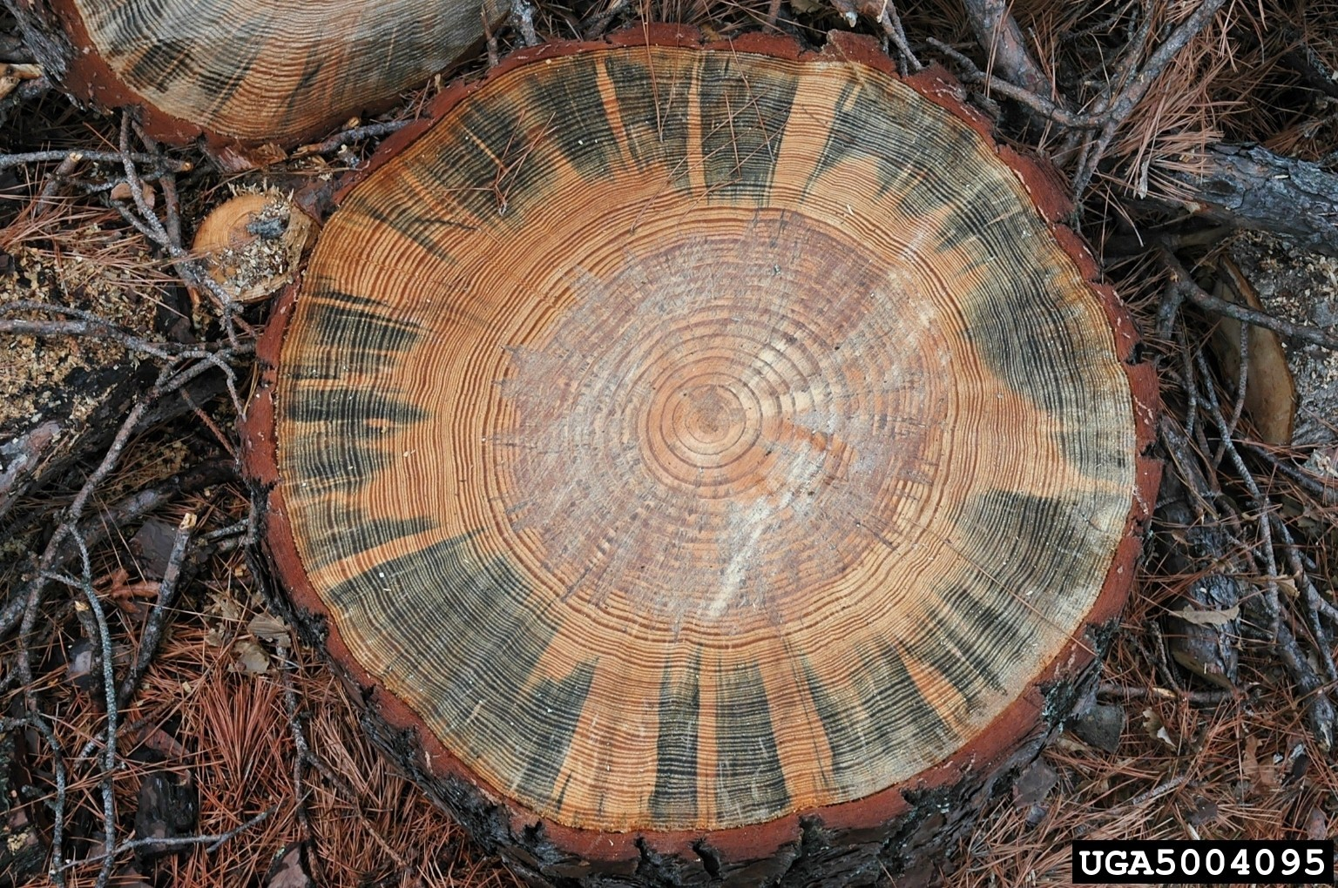
- Figure 1. Blue stain fungus affecting pine wood.
- Photo R.F. Billings, Texas A&M Forest Service, United States, Bugwood.org.
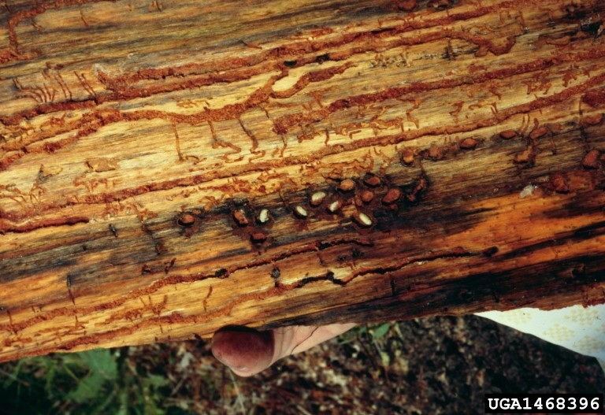
- Figure 2. Dendroctonus ponderosae galleries.
- Photo USDA Forest Service - Ogden , USDA Forest Service, Bugwood.org
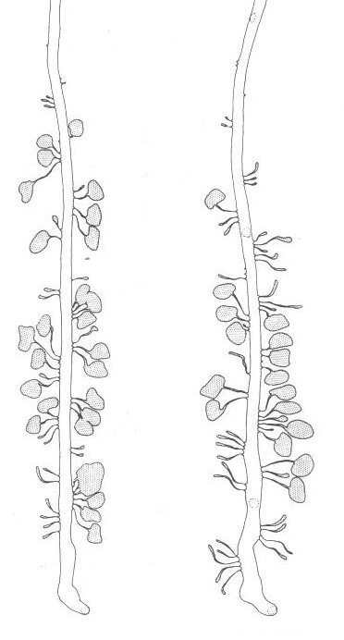
- Figure 3. Dendroctonus ponderosae, egg and larval galleries.
- Source: Wood (1982; p. 172).
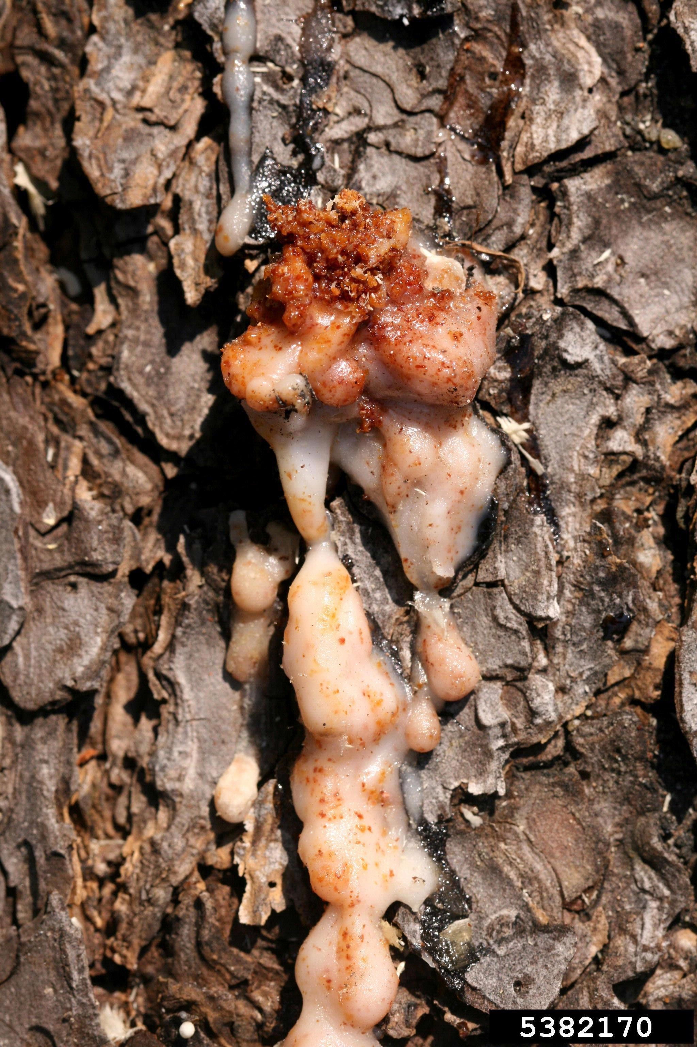
- Figure 4. Pitch tube, evidence of attack by Dendroctonus ponderosae on ponderosa pine.
- Photo W. Cranshaw, Colorado State University, United States, Bugwood.org.
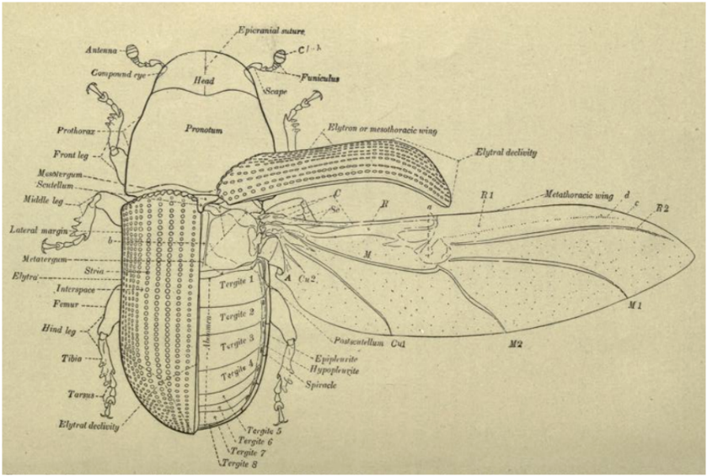
- Figure 5. Dendroctonus valens, showing adult beetle in dorsal aspect.
- Source: Hopkins (1909; p. 6).
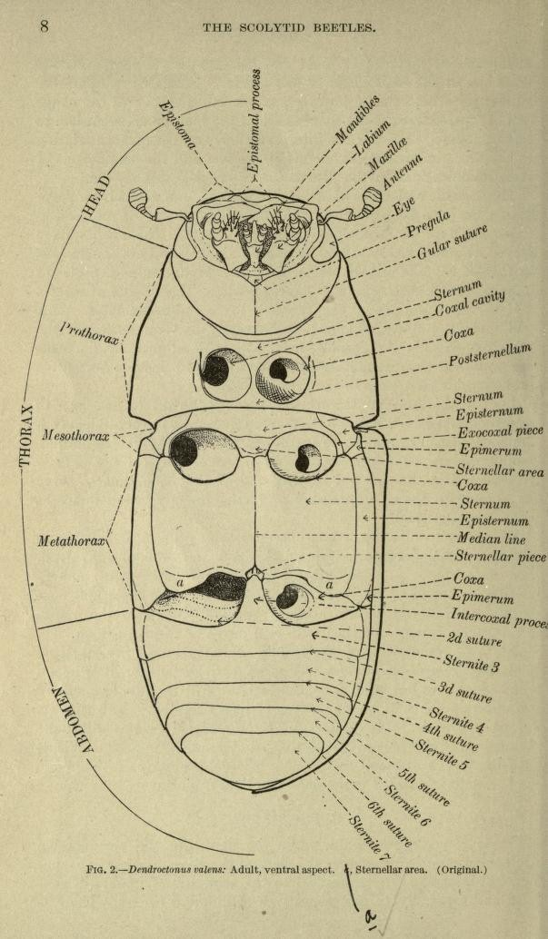
- Figure 6. Dendroctonus valens, showing adult beetle in ventral aspect.
- Source: Hopkins (1909; p. 8).
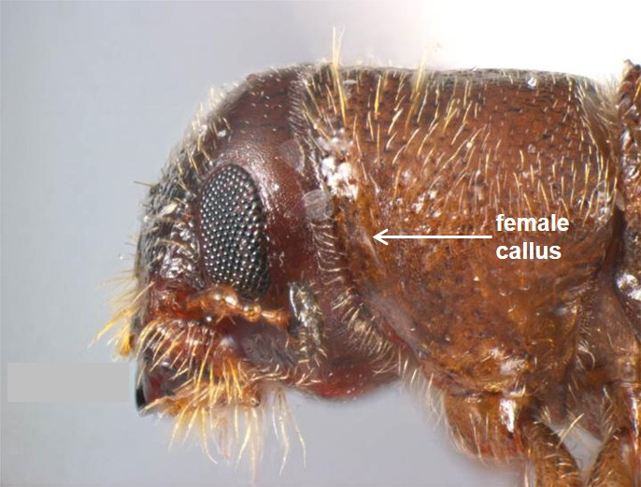
- Figure 7. Dendroctonus frontalis, lateral head and pronotum.
- Photo S. Hinkley and K. Walker, Museum Victoria, Australia, PaDIL.

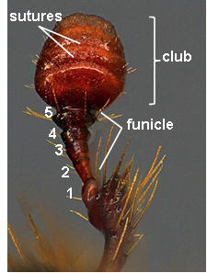
- Figure 8. Scolytinae antenna
- Photo courtesy of S.A. Valley, Oregon Department of Agriculture, United States.
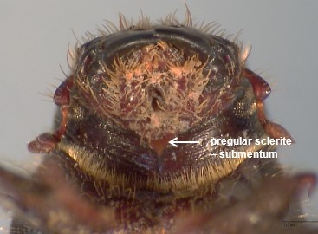
- Figure 9. Dendroctonus terebrans ventral aspect of head showing pregular sclerite (=submentum).
- Photo courtesy of L. Semeraro, Agriculture Victoria, Department of Economic Development, Jobs, Transport and Resources, Australia.

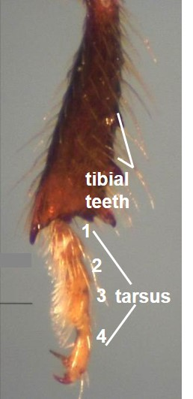
- Figure 10. Dendroctonus frontalis, hind tibia.
- Photo courtesy of L. Semeraro, Agriculture Victoria, State Government of Victoria Department of Economic Development, Jobs, Transport and Resources, Australia.
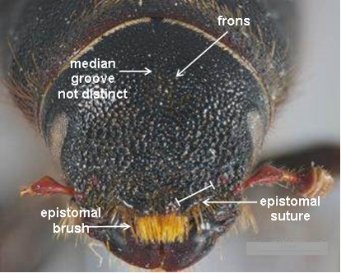
- Figure 11. Dendroctonus ponderosae, dorsal aspect of face and frons area.
- Photo S. Hinkley and K. Walker, Museum Victoria, Australia, PaDIL.

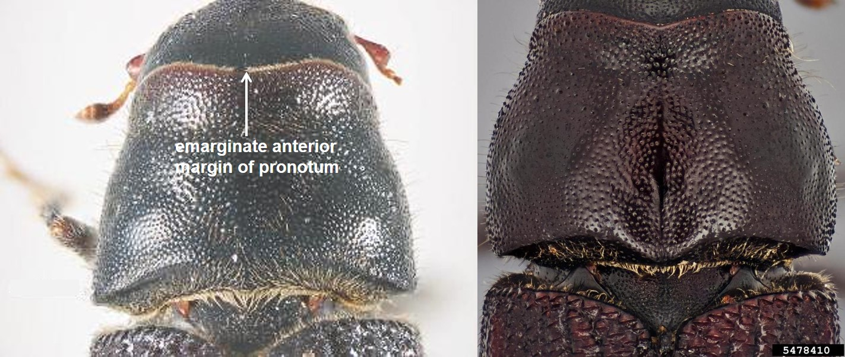
- Figure 12. Dorsal aspect of head and pronotum in (a) Dendroctonus ponderosae (figure to the left) and (b) Dendroctonus jeffreyi (figure to the right).
- Photos (a) S. Hinkley and K. Walker, Museum Victoria, Australia, PaDIL and (b) S.A. Valley, Oregon Department of Agriculture, United States, Bugwood.org.
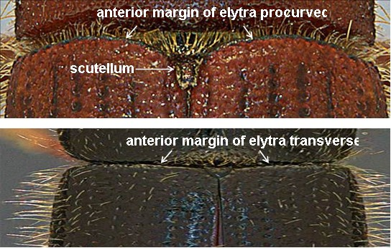
- Figure 13. Shape of elytral base (not Dendroctonus ponderosae): (a) procurved (upper figure) and (b) transverse (down figure).
- Photos courtesy of S.A. Valley, Oregon Department of Agriculture, United States.

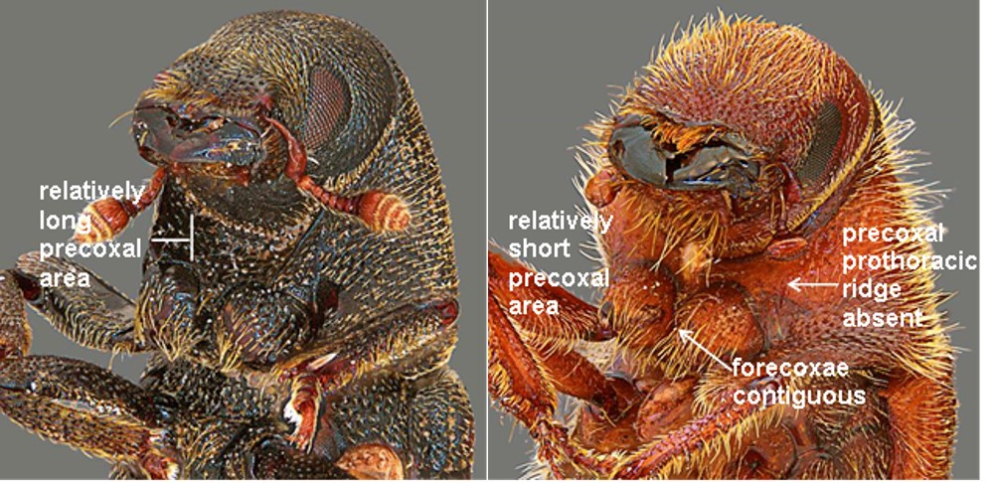
- Figure 14. Anteroventral aspect (not Dendroctonus ponderosae): (a) presence of precoxal ridge, contiguous forecoxae (=procoxae) (figure to the left) and (b) absence of precoxal ridge, separate forecoxae (figure to the right).
- Photos courtesy of S.A. Valley, Oregon Department of Agriculture, United States.
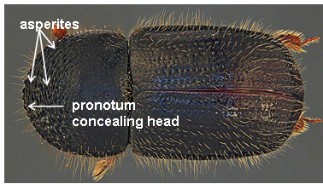
- Figure 15. Scolytinae (not Dendroctonus ponderosae), dorsal aspect of habitus showing basic body division.
- Photo courtesy of S.A. Valley, Oregon Department of Agriculture, United States.

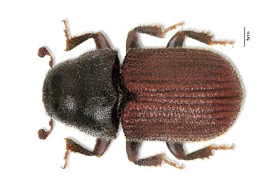
- Figure 16. Dendroctonus ponderosae, dorsal habitus aspect showing entire specimen (shape, surface sculpturing and coloration)
- Photo courtesy of K. Bolte, Canadian Forest Service, Canada.
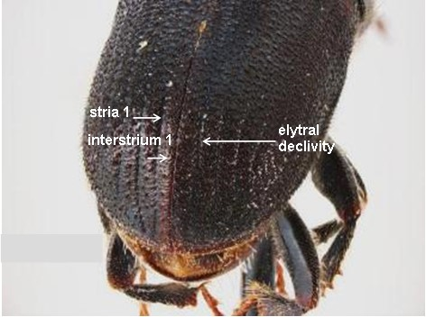
- Figure 17. Dendroctonus ponderosae, caudal aspect showing elytral declivity.
- Photo S. Hinkley and K. Walker, Museum Victoria, Australia, PaDIL.
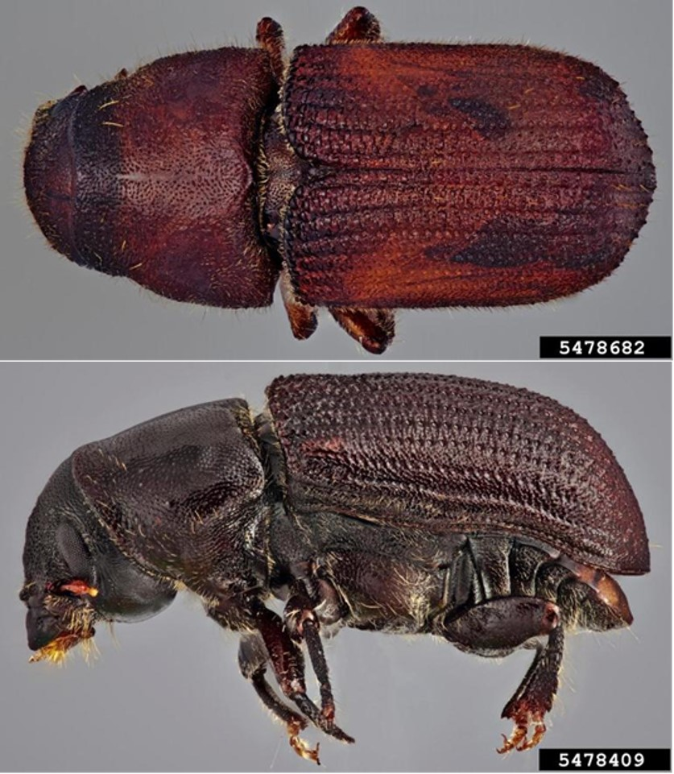
- Figure 18. Dendroctonus jeffreyi: (a) dorsal aspect, habitus (upper figure) and (b) lateral view (down figure).
- Photos S.A. Valley, Oregon Department of Agriculture, United States, Bugwood.org
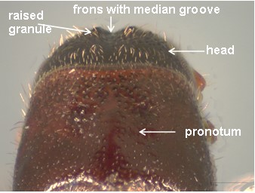
- Figure 19. Dendroctonus frontalis, dorsal aspect of head and pronotum.
- Photo S. Hinkley and K. Walker, Museum Victoria, Australia, PaDIL.
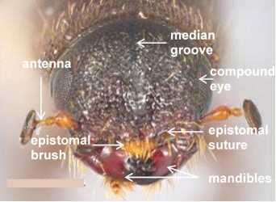
- Figure 20. Dendroctonus frontalis, face.
- Photo State Government of Victoria Department of Economic Development, Jobs, Transport and Resources, Australia.
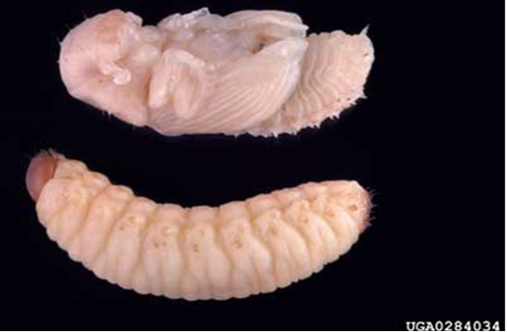
- Figure 21. Dendroctonus terebrans larva and pupa.
- Photo G.J. Lenhard, Louisiana State University Agriculture Center, United States, Bugwood.org.

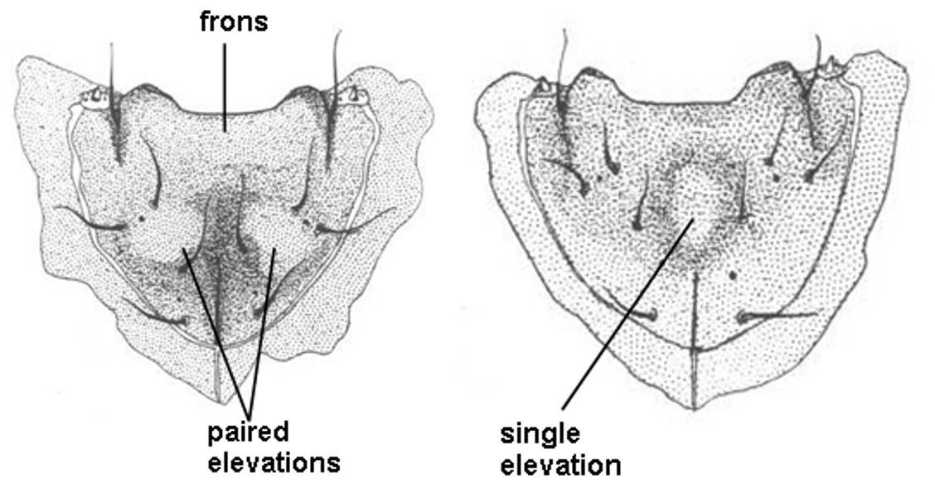
- Figure 22. Dorsal aspect of larval head showing frons with (a) paired elevations in Dendroctonus ponderosae and (b) a single elevation in Dendroctonus frontalis.
- Source: Thomas (1965; p. 381).
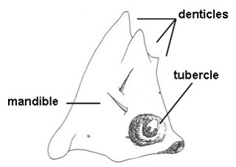
- Figure 23. Larva of Dendroctonus ponderosae, mandible.
- Source: Thomas (1965; p. 385).
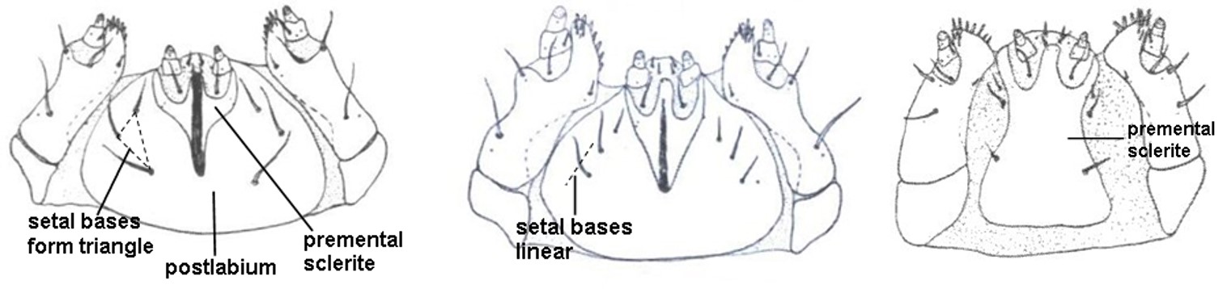
- Figure 24. Scolytinae larvae, ventral aspect of head, showing (a) triangular premental sclerite and pattern of postlabial setal bases, (b) linear postlabial setal bases and (c) rectangular premental sclerite.
- Source: Thomas (1965; pp. 39–40).
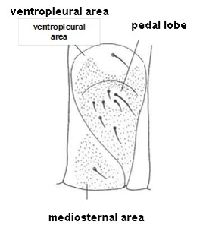
- Figure 25. Scolytinae larva, pedal lobe.
- Source: Zimmerman (1994; p. 672).
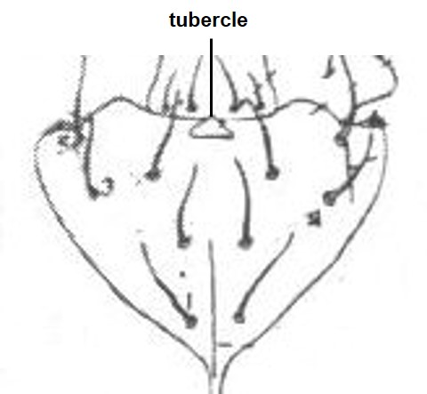
- Figure 26. Larva (Hylurgops pinifex – not Dendroctonus species), frons with anterior median tubercle.
- Source: Modified from Thomas (1957; p 33).
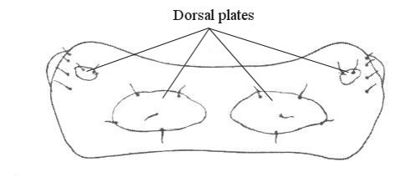
- Figure 27. Dendroctonus valens, dorsal aspect of abdominal segments showing sclerotized plates.
- Source: Thomas (1957; p. 43).

