TC-RPPO
30 October – 3 November, 2017
Paris, France

PROPOSAL TO ESTABLISH AN IPPC FORMAT FOR A REGULAR PHYTOSANITARY CONFERENCE: THE “INTERNATIONAL PHYTOSANITARY CONFERENCE”

- The proposal to establish an IPPC format for a regular phytosanitary conference, the “International Phytosanitary Conference”, was submitted by Kenya to the Strategic Planning Group (SPG) in 2016. Comment were provided and Kenya revised the proposal which was presented to the 2017 SPG and is available in Annex 1.
- The TC-RPPO is asked:
- To review the proposal and provide feedback.

Annex 1: Kenya’s proposal to establish an IPPC format for a regular phytosanitary conference: the “International Phytosanitary Conference”
- Introduction
- The International Plant Protection Convention (IPPC) specifies that contracting parties agree to cooperate in the development of international standards. Consequently the IPPC established an ambitious work programme to develop and adopt “International Standards on Phytosanitary Measures” (ISPM). The convention makes also provision for application of phytosanitary measures by governments to protect their plant resources from harmful pests which may be introduced through international trade. Phytosanitary measures include any legislation, regulations or official procedure aimed at preventing the introduction and spread of harmful pests. Phytosanitary measures play an important role in trade facilitation, and the protection of plant resources and the environment. Non-compliance to these measures may lead to introduction of harmful or quarantine pests which not only leads to restriction in market access but can adversely affect agricultural production and the environment. However, if phytosanitary measures are not technically justified and applied in a reasonable manner, they can constitute unnecessary barriers to trade.
- Proposal
- Kenya proposes that, as an element of the “Review of the Status of Plant Health in the World” (IPPC Article XI), the Commission on Phytosanitary Measures (CPM) considers to establish the format for a regular conference on plant health matters. This regular conference should be named “International Phytosanitary Conference”.
- It is proposed that the CPM investigates and decides on possible format details including:
- Selection of venue
- Organizational procedures
- Programmatic structure
- Budgetary rules
- Roles of host countries
- Kenya further proposes that the proceedings of the conferences are published as the “Review of the Status of Plant Health in the World”.
- In consideration of the proposals made, it is important for the IPPC to consider the International Phytosanitary Conference as part of its calendar of activities and to lobby members to host it.
- Justification and importance of a Phytosanitary Conference
- Article XI of the IPPC (Commission on Phytosanitary Measures) sub-section 2 (a) states “the functions of the Commission shall be to promote the full implementation of the objectives of the Convention and, in particular, to review the state of plant protection in the world and the need for action to control the international spread of pests and their introduction into endangered areas”. This task of the CPM has not been addressed at all since the CPM had been established. This proposal to establish a regular phytosanitary conference and to publish their proceedings offers the possibility to address a key component of the CPM tasks in a regular manner.
- Timing
- It is suggested that the format for the “International Phytosanitary Conference” is adopted by the CPM in 2018. This would leave time to organize the next meeting of the “International Phytosanitary Conference” during the International Year of Plant Health (IYPH) in 2020. This would then allow to have the proceedings of the conference be published as the “Review of the Status of Plant Health in the World” and as a major output of the IYPH 2020.
- Activities
- Key activities to support the next conference:
- Adoption of conference as an activity of IPPC;
- Lobby for support from members and fundraise for the conference in 2020;
- Agree on venue for the conference;
- Creation of a publication format to ensure publishing of the phytosanitary papers;
- Establishment of an organizational structure to organize the conference e.g. technical, planning or oversight matters;
- Mobilisation of funds;
- Holding of the conference.
- Areas of budgetary consideration

- The areas of budgetary consideration should be as below:
- Venue
- Accommodation and meals for delegates
- Official Cocktail/dinner (optional)
- Side events/training
- Conference materials – bags, flask disk, pens, name tags, note books, folders,
- Promotion/visibility costs – posters, roadside banner, Podium banner, adverts, Promotional brochure, creation of website/page, conference brochure, photography, décor, reporters
- Facilitators and support staff costs
- Review of papers and abstracts
- Transport costs - Buses for field work, airport pickups
- Exhibition (optional)
- Security
- Printing the Abstract Book
- Proceeding book
- Scholarship for delegates
- Keynote Speakers Costs
- Communication costs
- Under the IPC 2016 held in Kenya: The total expense incurred was US 77,000.00 (as per 16 items above). The funds were received from Exhibitors, Participants, IITA, Monsanto, Syngenta, Syngenta Foundation, SMAP, RIIP, CABI/AAPBP and savings from COPE activities. Exhibitors paid 300 US $ per both (24 booths were available; 23 were used); the participants’ fees was US 500 (meals [2 teas and lunch], conference stationary, field trip). Only 25 percent of participants paid for their expenses the rest was supported by funds received for the conference. There was a little surplus recorded.
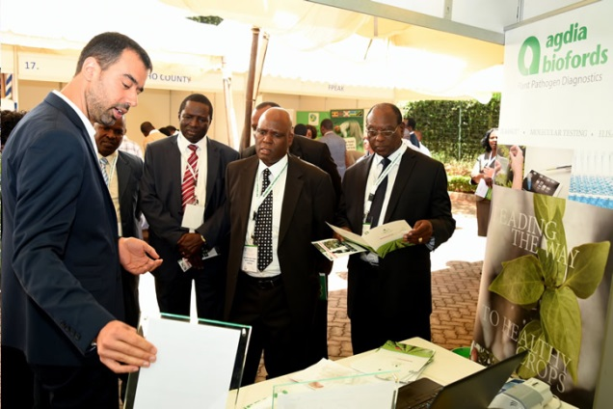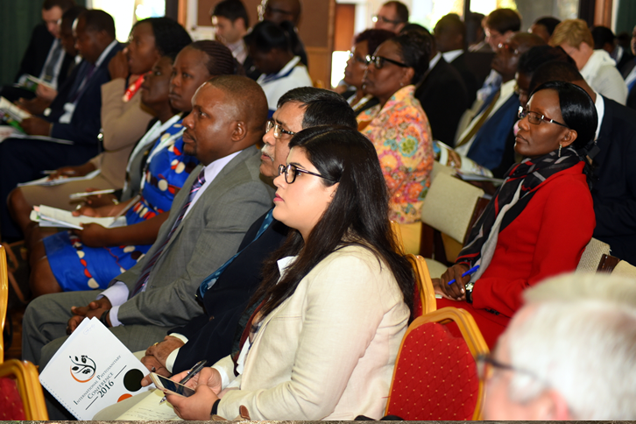
International Exhibitor (agdia biofords) Participants during the conference
- Annex
- Report from the International Phytosanitary Conference 2016
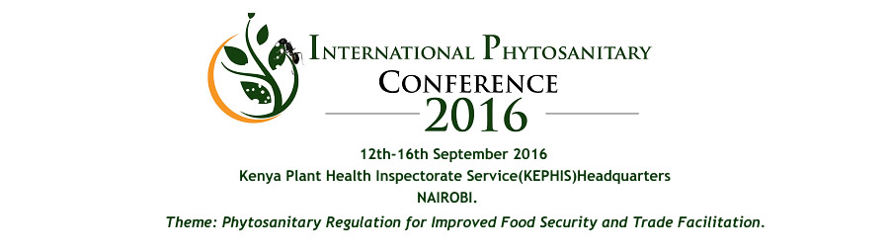
KEPHIS/COPE organized the first International Phytosanitary Conference from 12th to 16th September 2016 at KEPHIS Hq, Karen, in Nairobi whose theme was “Phytosanitary regulation for improved trade facilitation and food security”. The conference created opportunities for participants from the NPPOs and those in agricultural trade to share their success as well as challenges encountered. The conference also offered the participants an opportunity to discuss emerging issues such as new pest outbreaks.
- The official opening was on 13th September 2016 by Dr. Richard L. Lesiyampe, Principal Secretary, State Department of Agriculture in Kenya. . He mentioned that between 1900 till now, many new pests have come to Africa from other countries. Pests have no borders and can travel thousands of kilometers, destroying crops in their path. Globally, pests and diseases affect the quality of crops and reduce crop production by 33% resulting in loss of income and disruptions of international markets, thus affecting trade between countries. In addition, KALRO DG – Dr. Kireger, Board Member – Eng. Chome, EU rep - Klaus Gauch and USAID rep – Mr. Andrew Read were present to grace the occassion. The Director, AU-IAPSC Dr. Mezui gave his remarks on 12th September 2016. During the official opening ceremony, 220 participants were present. Over 110 delegates from 25 countries i.e. Belgium, Benin, Colombia, Finland, France, Ghana, India, Kenya, Lebanon, Liberia, Malawi, Mexico, Namibia, Netherlands, Nigeria, Rwanda, Sierra leone, South Africa, Switzerland, Tanzania, Uganda, United Kingdom, Zambia, Zimbabwe and Cameroun were present. Participants were from NPPOs, Government Departments/agencies (HCD, PCPB, KALRO), Counties (Kericho), Embassies (US, Netherlands, EU), Multinational Organization/agencies & Industry (IITA, Syngenta, International Flower Trade Association, Monsanto, CIMMYT, CIP, CIAT, AFSTA, TMEA, DAI, Flamingo Horticulture, Frigoken, FPEAK, KHC, ICARDA, Kenya Seed Company, Syngenta Foundation, SMAP and CABI). Local and international universities also participated during the conference.
- Participants were invited to contribute papers of abstracts for oral or poster presentations within the eight thematic areas. The conference was carried out with oral presentations in the main hall, posters presentations outside the main hall, side meetings and exhibitions were also held. Oral presentations were done in eight sessions each handling a specific thematic area. The main theme was “Phytosanitary Regulation for Improved Trade Facilitation and Food Security”; the eight Conference themes were namely:
- Pest Surveillance in Phytosanitary Systems
- Import Control and Quarantine Regulations
- Pest Diagnostics in Phytosanitary Systems
- Export Control in Phytosanitary Systems
- Industry views on Phytosanitary Systems
- Technologies and Innovation in Phytosanitary Systems
- Field visit - Practical application of Phytosanitary requirements
- Emerging Phytosanitary Issues and capacity building
- There were five key objectives for the conference namely:
- To provide a forum to share achievements, challenges and opportunities in application of phytosanitary measures towards assuring food security.
- To provide NPPOs with an opportunity to create linkages and promote market access regionally and internationally.
- To identify potential areas of collaboration on phytosanitary regulations at regional and international levels in trade facilitation.
- To share and develop solutions on phytosanitary issues with the industry.
- Prioritize per country and Focus on most important crops, trade and work funds available. Share available information and avoid duplication. Ensure sustainability
- 65 abstracts were received and reviewed accordingly; 14 were presented as posters. A book of abstracts was developed for use in the conference. The papers linked to these abstracts were presented in different sessions and summarized below:
- Session 1: Pest Surveillance in Phytosanitary Systems
- Surveillance was noted as a process of collecting and recording data on pest occurrence or absence by survey, monitoring or other procedures.
- Pests outbreaks do not stop at national borders, hence the need for national and even cross border cooperation in monitoring pest spread, raise awareness among farmers and promote appropriate control measures.
- There is need for Regional capacity building and frameworks in pest monitoring and surveillance (e.g. fruit fly diagnostics).
- There was call for involvement of various actors in Plant health systems in the development and utilization of plant clinic data in surveillance and minimization of pesticides risks: the role of CABI’s Plantwise as an interactive system for agricultural advisory service was noted.
- Notorious pests from the various presentations include; false codling moth (FCM), Tuta absoluta, Fruit flies, maize lethal necrotic disease (MLND) among others.
- Session 2: Import control and Quarantine Regulations
This session was noted as very though provoking. Issues that came out:
- The proposal on the initiative to declare 2020 as the international Year of Plant Health was presented with a special focus on the benefits for stakeholders and the phytosanitary research community; it was well received.
- Seed certification can be a means of curbing emerging diseases e.g. MLND.
- Pathways of pest introductions include: sea containers, planting material such as seeds, Germplasm and Packaging material.
- Ghana, Zambia and Kenya demonstrated importance of seed certification standards as a management for phytosanitary risk and NOT technical barrier to international seed trade.
- Phytosanitary Concern in International Movement of Sea Containers was discussed and noted that only Australia, United States and China have taken action.
- There is great concern for failure of other port agencies especially customs to declare wood as required under ISPM 15.
- Special session on Challenges to international exchange of germplasm
- Emphasis was given to safe germplasm with the statement “there are no chances of recalling germplasm” adopted.
- Germplasm is a pathway of pest introduction and there are policy gaps in restricting trans-boundary movement of pests through plant germplasm exchange.
- There is need to sensitize breeders on the IPPC.
- It was noted that international plant protection convention (IPPC) only listens to national plant protection organizations (NPPO) and not individuals.
- There was a wakeup call on current requirements on Bio-safety and bio-security which WTO noted and accepted to take action.
- Session 3: Pest diagnostics in phytosanitary systems
- There are new challenges as world has become a global village resulting in challenges in diagnostic systems for NPPOs in Africa.
- Diagnosis needs experience and adoption of new approaches and methods available which are quick and precise.
- Simple tools on diagnostics were demonstrated by Agdia-Biofords, France.
- DNA bar-coding should be widely adopted a tool for identification of insect pest and virus vectors in phytosanitary systems.
- Digital imagery of pests and LAMP (loop-mediated isothermal amplification) were explained as diagnostic tools.
- Tool kits required for physical identification of pest were demonstrated especially for the False Codling Moth (FCM).
- It was noted there are several techniques used in testing for quarantine pests before Phytosanitary measures are applied.
- Tanzania and Uganda demonstrated challenges due to porous borders with neighboring countries.
- Session 4: Export control in phytosanitary systems
- As work on technology progresses, it is important to promote inter-regional trade but ensure safety as Africa imports more food than she exports.
- The role of trade logistic providers in phytosanitary compliance should be noted and there is need to create awareness based on fact that improper documentation results in massive rejections of exports/imports.
- Application of ISPM 15 on wood packaging need to be enhanced to cover all consignments where wood packaging is used.
- There are available resources for NPPOs at www.phytosanitary.info.
- Session 5: Technologies and Innovation in Phytosanitary Systems
- Technology is the way to ensure efficiency in service delivery and also in surveillance and solving other related phytosanitary challenges
- Use of ICT and other new technologies was emphasized and tested methods discussed as below:
- ICT4 Plant Health - a new frontier for Early Warning Systems – CABI.
- Inclusion of Small Scale Farmers in Global Value Chains: Kenyan Traceability Project for Beans and Peas in Pod Farmers – HCD and USAID/KAVES.
- Electronic solutions for agricultural systems – Muddy boots.
- Monsanto presented technologies of seed with the call «when farmer succeeds we succeed»
- Ephyto application for enhanced phytosanitary compliance – KEPHIS
- Bio-pesticides – Real IPM, ICIPE
- Bio-efficacy of some natural plants on the oil palm leaf miner
- Insurance of crop was noted as necessary and Acre Africa funded by Syngenta foundation did a presentation. Role of insurance in mitigating against crop losses including those caused by pests to be explored

- Session 6: Industry views on phytosanitary systems
- Use of bio-pesticides as a component in IPM critical in the reduction of pesticide risks such as MRLs and resistance development.
- Need for NPPOs to be more responsive and involve private sector on solving Phytosanitary issues around Pest risk assessments (PRAs), surveillance and interceptions.
- Need to support small scale farmers access markets through training and awareness on SPS issues and compliance as well as early warning systems.
- Session 7: Field Visit Practical application of Phytosanitary requirements
- Great potential in the use of innovative and sustainable technologies such as biogas facility to generate power in farms, use of nematodes in enhancing the performance of farm compost manure, development of bio-control products in the management of chronic pests.
- Session 8: Emerging Phytosanitary Issues and capacity building
- Phytosanitary systems/NPPOs were noted to be at various levels of development i.e. weak, moderate or strong.
- Public, private partnerships are the way to go.
- Awareness creation on the STDF facility especially capacity building was presented.
- Gaps exist in Phytosanitary research especially in Africa and STDF promised to consider this theme by possibly starting an Africa phytosanitary research fund.
- What is ailing Phytosanitary systems in Africa was presented around policy, infrastructure and political issues.
- Exhibition
23 exhibitors were present; they included KEPHIS, COPE, Koppert Biologicals, IITA (2 booths), CABI, ETG, CIP, Kenya Com-Rabbit Consortium, GTIL, Dudutech, SGS, NIC Bank, Crop Nuts, Seed Co. (AgriSeed), Elgon Kenya, Kericho County, FPEAK, Muddy Boots, Kenya Horticultural Council, Simlaw, Agdia biofords, Monsanto.
Key note speakers:
Dr. Julian Smith | FERA Science Ltd, UK | Emerging phytosanitary challenges and market requirements
Ms. Silvie Mamias | Union Fleurs, Belgium | Industry views on phytosanitary systems
Ms. Marjan folkers | NPPO Netherlands | Pest surveillance in phytosanitary systems
Dr. Roger Day | CABI | Phytosanitary regulation in international trade
Prof. James Muthomi | University of Nairobi | Pest diagnostics in phytosanitary systems
Mr. Ralf Lopian | NPPO Finland | The initiative to declare 2020 as the International Year of Plant Health: Impacts and opportunities for authorities, private enterprises and phytosanitary research
Dr. Lava Kumar | IITA | Emerging Challenges in germplams exchange

- Side events handled: PRA, ISPM 15, STDF projects, e-phyto, Seed Cert and Plant Variety Protection, Kenya Standing Technical Committee on Imports and Exports (focusing on approval of biopesticides), Youth Agenda and KEPHIS, Analytical Chemistry Laboratory activities.
- Media coverage: The event was well covered in both the print and electronic media.
- Print Media - The Business Daily, the Star, the People and the Standard;
- Electronic Media/TV - KTN, NTV, KBC, Citizen TV, KASS TV and radio, Xinhua News Agency, Farmers TV.
- Conference benefits
- New opportunities – COPE to be possibly used as reference training facility by certain African countries.
- Other NPPOs interested in visiting KEPHIS for study tours – Ghana, Zambia e.g. for see electronic systems and how we collect fees charged.

- Resolution from the conference
During the conference participants agreed that it would be highly desirable to establish an agreed format of an international phytosanitary conference to be held every two years under the authority of the IPPC. The conference participants also thought that such conferences could be combined with the celebrations of an International Day of Plant Health as foreseen in the preliminary outputs for the International Year of Plant Health 2020 and the proposed date for cerebration was given as 6/12/2021. It was thought important that the proceedings of these conferences need to be published, possibly into a journal format, and thus could be considered an important component of the review of the state of plant protection in the world.

