Notes from Secretariat: The paragraph numbers and formatting will be adjusted after adoption.

[1]Draft annex to ISPM 27: Ips spp. (2006-020)
[2]Status box
[3]This is not an official part of the standard and will be modified after adoption
[4]Date of this document | [5]2018-06-13
[6]Document category | [7]Draft annex to ISPM 27 (Diagnostic protocols for regulated pests)
[8]Current document stage | [9]To DP notification period
[10]Major stages | [11]2006-05: Standards Committee (SC) added original subject: Ips spp. (2006-020)  [12]2016-12: Expert consultation  [13]2017-02: Technical Panel on Diagnostic Protocols (TPDP) face-to-face meeting  [14]2017-06: SC approved for consultation (e-decision)  2017-07 Consultation period  2017-10: Responses to comments from consultation completed  2018-02 TPDP meeting. TPDP approved to submit to SC for approval for adoption.  2018-04 SC approved for the DP notification period (e-decision 2018_eSC_May_10)
[15]Discipline leads history | [16]2012-11 Norman BARR (US, Discipline lead)  [17]2012-11 Liping YIN(CN, Referee)
[18]Consultation on technical level | [19]The first draft of this protocol was written by (lead author and DP drafting group):  [20]Mr Hume Douglas (CA, lead author)  [21]Mr Anthony Cognato (US, co-author)  [22]Ms Brigitta Wessels-Berk (NL, co-author)  [23]In addition, the draft has also been subject to expert review and the following international experts submitted comments: Graham Thurston (CA), Hiroaki Shirato (JP), Torstein Kvamme (NO) and Bjørn Økland (NO).
[24]Main discussion points during development of the diagnostic protocol | - [25]Diagnostic tool for Ips spp. on world basis in development. Diagnostic notes published by Cognato (2015).  - [26]Inclusion of DNA barcode method: How to use phylogenetic data from Cognato (2000) and Cognato and Sun (2007) for DNA-based diagnostics.  - [27]Intended level of “expert” to decide if inclusion of features for subfamily and tribe are needed.
[28]Notes | [29]This is a draft document.  [30]2017-04 Edited  2017-11 Edited  [31] Consultation period: Please note that some paragraph numbers may be missing from the document or not be in a chronological order. This is due to technical problems in the OCS but it does not affect the integrity of the content of the document.  2018-02 Edited
[32]
[33]Adoption
[34]This diagnostic protocol was adopted by the Standards Committee on behalf of the Commission on Phytosanitary Measures in ---- [to be completed after adoption].
[35]The annex is a prescriptive part of ISPM 27.

[36]1. Pest Information
[37]Ips species (Coleoptera: Curculionidae: Scolytinae: Ipini), commonly known as bark beetles, are sub-cortical phloem feeders in Pinaceae (conifer trees), especially Pinus (pine), Picea (spruce) and Larix (larch or tamarack) species (Cognato, 2015). In non-outbreak times, Ips beetles mainly inhabit weak or dead trees (Cognato, 2015). Adults and larvae kill healthy trees during outbreaks (Cognato, 2015) by destroying the phloem and cambium in tree trunks and limbs when feeding and tunnelling (Furniss and Carolin, 1977). Outbreaks can destroy thousands of hectares of healthy trees (Cognato, 2015). Some or all Ips bark beetles also transmit pathogenic fungi (Krokene and Solheim, 1998; Meng et al., 2015), in particular blue stain fungi (genera Grosmannia and Ceratocystis, Ascomycota: Sordariomycetes, Figure 1). Ceratocystis fungi from Ips beetles also interfere with biological control of the conifer pest Sirex noctilio Fabricius (Hymenoptera: Siricidae) (Yousuf et al., 2014). Certain climatic conditions may promote Ips outbreaks (Wermelinger, 2004; Breshears et al., 2005; Marini et al., 2017). Trees injured in outbreaks are sometimes later killed by Dendroctonus bark beetles (Furniss and Carolin, 1977).
[38]Native Ips species are present in all countries where Pinus and Picea occur naturally (Cognato, 2015). Two Ips species (I. apache and I. grandicollis) also occur as exotic species, especially in temperate southern hemisphere regions (Knizek, 2011; Cognato, 2015) where Pinus has been planted. Some Ips species use Larix as the principal host genus in their native range (Table 1). A few species use Abies (fir) and Cedrus (true cedar) as hosts during outbreaks (Wood and Bright, 1992). Ips species are not limited to the principal host genera provided in Table 1, as other conifers could be attacked when a principal host is not available.
[39]There are 37 valid Ips species worldwide (Table 1). Phylogenetic analyses of the Ipini prompted transfer of several species to the genera Pseudips (Cognato, 2000) and Orthotomicus (Cognato and Vogler, 2001). Cognato (2015) reviews the phylogeny, taxonomy, diagnosis and biology of all Ips species.
[40]Table 1. Worldwide list of Ips species with distribution and principal host genera (from Cognato, 2015). Principal host genera refer to hosts from which Ips species are most commonly collected in native range. Species targeted by this protocol are underlined.
[41]Species | [42]Authority | [43]Native Distribution* | [44]Principal host genera
[45]Ips acuminatus | [46](Gyllenhal, 1827) | [47]Eurasia | [48]Pinus
[49]Ips amitinus | [50](Eichhoff, 1872) | [51]Eurasia (west) | [52]Picea, Pinus
[53]Ips apache | [54]Lanier, 1991 | [55]North America (south) | [56]Pinus
[57]Ips avulsus | [58](Eichhoff, 1868) | [59]North America (east) | [60]Pinus
[61]Ips bonanseai | [62](Hopkins, 1905) | [63]North America (south) | [64]Pinus
[65]Ips borealis | [66]Swaine, 1911 | [67]North America (north) | [68]Picea
[69]Ips calligraphus | [70](Germar, 1824) | [71]North America, Caribbean | [72]Pinus
[73]Ips cembrae | [74](Heer, 1836) | [75]Eurasia (widespread) | [76]Larix
[77]Ips chinensis | [78]Kurenzov & Kononov, 1966 | [79]Eurasia (southeast) | [80]Pinus
[81]Ips confusus | [82](LeConte, 1876) | [83]North America (west) | [84]Pinus
[85]Ips cribricollis | [86](Eichhoff, 1869) | [87]North America (south), Central America, Caribbean | [88]Pinus
[89]Ips duplicatus | [90](Sahlberg, 1836) | [91]Eurasia (widespread) | [92]Picea
[93]Ips emarginatus | [94](LeConte, 1876) | [95]North America (west) | [96]Pinus
[97]Ips grandicollis | [98](Eichhoff, 1868) | [99]North America (east, south) | [100]Pinus
[101]Ips hauseri | [102]Reitter, 1894 | [103]Eurasia (central) | [104]Picea
[105]Ips hoppingi | [106]Lanier, 1970 | [107]North America (southwest) | [108]Pinus
[109]Ips hunteri | [110]Swaine, 1917 | [111]North America (west) | [112]Picea
[113]Ips integer | [114](Eichhoff, 1869) | [115]North America (west, south) | [116]Pinus
[117]Ips knausi | [118]Swaine, 1915 | [119]North America (west) | [120]Pinus
[121]Ips lecontei | [122]Swaine, 1924 | [123]North America (south) | [124]Pinus
[125]Ips longifolia | [126](Stebbing, 1909) | [127]Eurasia (central) | [128]Pinus
[129]Ips montanus | [130](Eichhoff, 1881) | [131]North America (west) | [132]Pinus
[133]Ips nitidus | [134]Eggers, 1933 | [135]China | [136]Picea
[137]Ips paraconfusus | [138]Lanier, 1970 | [139]North America (west) | [140]Pinus
[141]Ips perroti | [142]Swaine, 1915 | [143]North America (north) | [144]Pinus
[145]Ips perturbatus | [146](Eichhoff, 1869) | [147]North America (north) | [148]Picea
[149]Ips pilifrons | [150]Swaine, 1912 | [151]North America (west) | [152]Picea
[153]Ips pini | [154](Say, 1826) | [155]North America (widespread) | [156]Pinus
[157]Ips plastographus | [158](LeConte, 1868) | [159]North America (west) | [160]Pinus
[161]Ips schmutzenhoferi | [162]Holzschuh, 1988 | [163]Asia (Himalayas) | [164]Larix, Picea, Pinus
[165]Ips sexdentatus | [166](Boerner, 1767) | [167]Eurasia (widespread) | [168]Pinus, Picea
[169]Ips shangrila | [170]Cognato & Sun, 2007 | [171]Asia (east) | [172]Picea
[173]Ips stebbingi | [174]Strohmeyer, 1908 | [175]Eurasia (central) | [176]Picea, Pinus
[177]Ips subelongatus | [178](Motschulsky, 1860) | [179]Eurasia (east) | [180]Larix
[181]Ips tridens | [182](Mannerheim, 1852) | [183]North America (west) | [184]Picea
[185]Ips typographus | [186](Linnaeus, 1758) | [187]Eurasia (north and west) | [188]Picea
[189]Ips woodi | [190]Thatcher, 1965 | [191]North America (west) | [192]Pinus
[193]* South = tropical and subtropical parts of North America. North America refers to the North American continent including countries north of Colombia. Widespread may not include all countries in the continent.
[194]Most attacks are initiated by male beetles, who create a nuptial chamber under the bark and release semiochemicals to attract males and females to colonize the same tree. The polygynous males attract up to six females to the nuptial chamber (diameter: 7-15 mm). Females mate with the resident male and then create radiating egg galleries along the inner bark (Cognato, 2015; Figures 2 and 3). Females each lay eggs along their tunnel, these hatching after about seven days (Chararas, 1962). Larval galleries radiate from the “Y”- or “H”-shaped egg galleries (Figures 2 and 3), spreading over a span of 10–30 cm. Development requires six weeks in warm temperatures, allowing up to five generations per year in warm areas. In cooler areas, development requires up to two years (Furniss and Carolin, 1977). Adult beetles overwinter within parental breeding galleries, in forest litter, or in living wood tissue (Chansler, 1964; Lanier, 1967).

[195]2. Taxonomic Information
[196]Name: Ips DeGeer, 1775
[197]Synonyms:
[198]Cumatotomicus Ferrari, 1867
[199]Cyrtotomicus Ferrari, 1867
[200]Taxonomic Position: Insecta, Coleoptera, Curculionidae, Scolytinae, Ipini
[201]Table 2. Common names and synonyms of target Ips species, sorted by subgenera. Synonymy follows Knizek (2011).
[202]Subgenus | [203]Ips species | [204]Common name | [205]Synonyms
[206]Bonips  [210]  [214]  [218]  [222]  [226]  [230]  [234] | [207]Ips pini (Say, 1826)  [211]  [215]  [219]  [223]  [227]  [231] | [208]pine engraver beetle  [212]  [216]  [220]  [224]  [228]  [232] | [209]Bostrichus dentatus Sturm, 1826
 |  |  | [213]Bostrichus pallipes Sturm, 1826
 |  |  | [217]Bostrichus pini Say, 1826
 |  |  | [229]Tomicus praefrictus Eichhoff, 1868
 |  |  | [233]Tomicus rectus LeConte, 1868
 |  |  | [225]Tomicus oregonis Eichhoff, 1869
 |  |  | [221]Ips laticollis Swaine, 1918
 | [235]Ips plastographus (LeConte, 1868)* | [236]California pine engraver | [237]Tomicus plastographus LeConte, 1868
[238]Cumatotomicus  [242]  [246]  [250] | [239]Ips sexdentatus (Boerner, 1767)  [243]  [247]  [251] | [240]six-toothed bark beetle  [244]  [248]  [252] | [241]Dermestes sexdentatus Boerner, 1767
 |  |  | [249]Ips pinastri Bechstein, 1818
 |  |  | [253]Ips stenographus Duftschmid, 1825
 |  |  | [245]Ips junnanicus Sokanovskiy, 1959
[254]Granips  [258]  [262]  [266]  [270]  [274]  [282]  [286]  [290]  [294] | [255]Ips calligraphus (Germar, 1824)  [259]  [263]  [267]  [271] | [256]sixspined Ips, coarsewriting engraver  [260]  [264]  [268]  [272] | [257]Bostrichus calligraphus Germar, 1824
 |  |  | [261]Bostrichus exesus Say, 1826
 |  |  | [273]Tomicus praemorusus Eichhoff, 1868
 |  |  | [269]Tomicus interstitialis Eichhoff, 1869
 |  |  | [265]Ips ponderosae Swaine, 1925
 | [275]Ips confusus (LeConte, 1876) | [276]piñon Ips | [277]Tomicus confusus LeConte, 1876
 | [283]Ips grandicollis (Eichhoff, 1868)  [287]  [291] | [284]southern pine engraver  [288]  [292] | [285]Ips chagnoni Swaine, 1916
 |  |  | [289]Tomicus cacographus LeConte, 1868
 |  |  | [293]Tomicus grandicollis Eichhoff, 1868
 |  |  | [new para]Ips cloudcrofti Swaine, 1924
 | [295]Ips lecontei Swaine, 1924 | [296]Arizona fivespined Ips | [297]none
 | [279]Ips paraconfusus Lanier, 1970 | [280]California fivespined Ips | [281]none
[298]Ips  [302]  [306]  [310]  [314]  [318]  [322]  [326]  [330]  [334]  [338]  [342]  [346]  [350]  [354] | [299]Ips amitinus (Eichhoff, 1872)  [303] | [300]small spruce bark beetle, eight-toothed spruce bark beetle  [304] | [301]Tomicus amitinus Eichhoff, 1872
 |  |  | [305]Ips amitinus var. montanus Fuchs, 1913
 | [307]Ips cembrae (Heer, 1836)  [311]  [315]  [319] | [308]large larch bark beetle  [312]  [316]  [320] | [309]Bostrichus cembrae Heer, 1836
 |  |  | [313]Ips cembrae var. engadinensis Fuchs, 1913
 |  |  | [317]Ips fallax Eggers, 1915
 |  |  | [321]Ips shinanoensis Yano, 1924
 | [323]Ips duplicatus (Sahlberg, 1836)  [327]  [331]  [335]  [339] | [324]northern bark beetle  [328]  [332]  [336]  [340] | [325]Bostrichus duplicatus Sahlberg, 1836
 |  |  | [329]Tomicus rectangulus Ferrari, 1867
 |  |  | [333]Tomicus judeichi Kirsch, 1871
 |  |  | [337]Tomicus infucatus Eichhoff, 1877
 |  |  | [341]Tomicus infucatus Eichhoff, 1878
 | [343]Ips subelongatus (Motschulsky, 1860) | [344]larch bark beetle, oblong bark beetle | [345]Tomicus subelongatus Motschulsky, 1860
 | [347]Ips typographus (Linnaeus, 1758)  [351]  [355] | [348]eight-toothed spruce bark beetle  [352]  [356] | [349]Dermestes typographus Linnaeus, 1758
 |  |  | [353]Bostrichus octodentatus Paykull, 1800
 |  |  | [357]Ips japonicus Niisima, 1909
[358]No subgenus (Incertae sedis) | [359]Ips hauseri Reitter, 1894 | [360]Kyrgyz mountain engraver, Hauser’s engraver | [361]Ips ussuriensis Reitter, 1913
[362]*Ips plastographus has two subspecies, I. p. plastographus (LeConte) and I. p. maritimus Lanier.

[363]3. Detection
[365]Ips bark beetles can be found in boles and limbs of the tree genera Pinus, Picea, Larix and Cedrus. Pinus and Picea wood are of primary economic importance to the world lumber trade. If bark is present, round wood, handicrafts, dunnage, crates or pallets suspected of originating from these tree genera could harbour Ips. Flying adult beetles are collected using a well-developed system of semiochemical lure-based traps (Fettig and Hilszczański, 2015).
[364]Larvae and pupae are found in the host plant or wood products only immediately underneath the bark or in the phloem, not deeper in the wood or xylem (although some overwintering adults tunnel into the xylem, Lanier, 1967). Trees can be examined externally for symptoms of infestation (circular holes and red-brown boring dust, Figure 4).

[366]3.1 Symptoms of infestation in living trees
[367]Four general symptoms indicating possible attack in living Pinaceae trees are as follows:
- [368]Yellowing, dying needles on the crown, a branch or all of the tree.
- [369]Appearance of red-brown or yellow-brown boring dust on the bark or near the tree (Figure 4). Ips beetles often cause resin leakage, but only rarely cause appearance of resinous pitch tubes on the surface of the bark as in Dendroctonus colonization.
- [370]Presence of intersecting maternal galleries up to 30 cm long, with lateral larval galleries, under the bark (Figures 2 and 3).
- [371]Appearance of many small holes on the bark (e.g. ten or more 3-5 mm diameter holes in a 10 cm × 10 cm area). This is consistent with the post-emergence stage of Ips infestation. At this time the progeny has emerged from the tree to find unexploited bark tissue in which to establish new galleries.
[372]Several months or more after successful colonization, the attacked tree may change leaf colour to yellow-green or red as the tree dies. Ips beetles sometimes kill healthy trees when beetle populations are high, although some trees recover even after the beetles have successfully reproduced in their tissues.

[373]3.2 Collecting specimens from plants and wood products
[374]The bark can be removed from affected trees or wood products using a sharp, strong knife or a small axe. The wood underneath the bark layer and the inner bark can be inspected for “H”- or “Y”-shaped galleries (or similar, Figures 2 and 3). A 40× magnifying lens can be used to inspect galleries for adults, larvae and eggs. If gallery engravings are present, some of the bark or affected material should be collected and photographed. Infested materials can be transported using a sealed bag or container. Double bagging of samples is useful for preventing escape.
[375]Detected adults, larvae, pupae or eggs can be removed using forceps. Larvae can be placed for 30 to 60 seconds in near boiling water (90 °C to 100 °C) to fix for long-term preservation. Specimens should then be stored in a glass vial containing 70% to 80% ethanol. Adults can be killed in ethanol or by placement into a dry tube and then in a freezer at either −20 °C for at least 24 h or −80 °C for at least 6 h before card- or point-mounting on a pin. If specimens are to be saved for DNA analysis it is recommended that they be stored in a preservative such as a high percentage (>95%) of ethanol or propylene glycol.
[376]It is necessary to collect any adults present because adults have important diagnostic morphological characters. It is not possible to identify juveniles to genus or species level based on morphology. In the laboratory, adult specimens should be mounted for examination while larvae, pupae or eggs should be examined in ethanol. See sections 4.1 and 4.2 for details on preparation of specimens for identification.

[377]4. Identification
[378]The genus Ips can be recognized and identified to species level by adult external morphology. Adult structures are illustrated in Figures 5 and 6. Descriptions and regional keys to the species of Ips based on morphology are available (Balachowsky, 1949; Kurenzov and Kononov, 1966; Grüne, 1979; Schedl, 1981; Wood, 1982; Holzschuh, 1988; Lanier et al., 1991; Pfeffer, 1995; Cognato and Sun, 2007). A generic key to Scolytinae larvae of eastern Canada is available (Thomas, 1957) but juvenile stages cannot be used for reliable identification on a global scale. Although Ips species have been discovered and identified using DNA sequence data (Cognato and Sun, 2007), validated protocols for universal DNA identification of Ips species have not yet been developed (Chang et al., 2012). Additional work is needed to demonstrate that DNA sequence records provide accurate identification of the target species and to determine how to interpret DNA similarity between the target and non-target species.

[379]4.1 Morphological identification of beetle adults

[380]4.1.1 Preparation of adults for morphological examination
[381]Ethanol preserved specimens (section 3.2) are transferred to a dish filled with 70% to 80% ethanol, to be cleaned of dirt, debris and frass. Specimens can be cleaned by gently brushing with a fine-hair artist’s paint brush. The integument must be clean to show the surface texture and setal punctures. Adult specimens preserved in ethanol to be point-mounted on a pin should first be dried by removing the specimen from ethanol, blotting it with paper towel and allowing it to air-dry for 2–5 min. Specimens removed from −20 or −80 °C freezers should be placed on blotting paper and thawed for 10–20 min or until any visible condensation evaporates from the specimen. A triangular point mount can be used, attaching the beetle to the point along the right side of its thorax. Specimens may, alternatively, be glued ventrally to the middle of an 11 × 4.5 mm mounting card. Ideally the left lateral, dorsal and ventral views should be free and visible for examination. Once adults are pinned, they may be examined under a dissecting microscope capable of 40× magnification or higher (a higher magnification may be preferable). Strong, diffuse lighting is important for examination of adult bark beetles to see the surface sculpturing. Because adult bark beetles are shiny, light reflected from specimens may make it difficult to see surface structures. The sheen can be reduced by placing tracing paper or translucent drafting film between the light source and the specimen.

[382]4.1.2 Identification of adults in the subfamily Scolytinae
[383]Wood (1986) provides a key to the world genera of Scolytinae. Rabaglia (2002) provides an updated key to the North American genera of Scolytinae. The Scolytinae can be recognized by the following set of adult morphological characters (Hulcr et al., 2015):
- [384]Body cylindrical (nearly circular in cross-section).
- [385]Head width in dorsal view at least half of pronotal width.
- [386]Legs and antennae (Figure 7) short (shorter than maximum body width in most, hind legs up to two-thirds of body length in a few Xyleborini), and flattened in cross-section in most.
- [387]Tarsi of legs with four visible tarsomeres (tiny fourth tarsomere is hidden between the third and fifth).
- [388]Antennae (Figures 5, and 8(e) to (g)) are geniculate (bent or elbowed) with: a long basal segment (the scape); an angled junction with a series of one to seven bead-like antennomeres (the funicle); and a compressed 3-segmented apical club (intersegmental sutures visible or not).
- [389]The head anterior to the eyes is not elongated into a snout (Figures 6, and 8(a) to (d)). A snout or rostrum is present in most other Curculionidae (weevils).
[390]Additional confirmatory characters for use in diagnosing damaged specimens are as follows:
- [391]Eyes flush (level) with surface of head (Figures 8(a) to (d)). Eyes of many similar-shaped Bostrichidae protrude.
- [392]Ventrally, the pregular sclerite (= submentum) is visible with a pregular suture present (Figure 6: pregula).
- [393]Anterior legs of Ips and most other Scolytinae have socketed denticles on their apical and posterior edges (Figure 9(a)). Such spine-like hairs are also present in three other weevil subfamilies. Magnification greater than 100× is required to separate socketed denticles from nearby non-socketed spines.
- [394]The first tarsomere (the basal tarsal “segment”) is approximately as long as the second and third tarsomeres combined (Figure 5).

[395]4.1.3 Identifying adults of the tribe Ipini Bedel, 1888
[396]Ips belongs to the tribe Ipini and can be distinguished from most other Scolytinae by the concave elytral declivity surrounded by large spines. The following tribal-level diagnostic characters are modified from Wood (1986):
- [397]Compound eye (Figures 5, and 8(a) to (d)) sinuate (narrowed at mid-height), ventral half narrower than dorsal part.
- [398]Antennal scape (basal segment) slender elongate, funicle 5-segmented, club either obliquely truncate or sutures on posterior face strongly displaced toward apex (Figures 5, and 8(e) to (g)).
- [399]Pronotum (Figures 5 and 10) strongly declivous on anterior half (posterior half approximately horizontal, anterior half descends abruptly), with large asperities (broad spines).
- [400]Procoxae contiguous, intercoxal piece deeply notched or absent.
- [401]Protibia with three or four socketed denticles (Figure 9(a)).
- [402]Scutellum visible in dorsal view (Figures 5 and 11(a)).
- [403]Elytral declivity moderately sulcate to strongly excavated, sides with tubercles or spines in most (Figures 7 and 12).
- [404]Vestiture hair-like (not scale-like or wider at midlength than at base), except for branched hairs at anterior opening of prothorax (Figure 8(g), row of hairs to right of antennal club).
[405]Also: Frons sexually dimorphic in most.

[406]4.1.4 Identification of Ips adults
[407]Ips can be separated from other members of the tribe Ipini by features of the antennal club and elytral declivity, combined. The following diagnostic characters are modified from Wood (1986), as modified by Cognato (2000) and Cognato and Vogler (2001):
- [408]Body length 2.1–8.0 mm (most are larger than 3 mm). Other Ipini are 1.0–4.3 mm long.
- [409]Antennal club flattened (thickness less than one-third maximum width) and marked by sutures (Figures 8(e) to (g)). Sutures nearly straight to strongly bisinuate (not procurved).
- [410]Elytral declivity broadly and deeply excavated, with sides acutely elevated and armed by three or more pairs of spines (Figures 7, 10 and 12). Apices of spines aligned with edge of declivity. Second spine (beginning from dorsal part of declivity) acute in lateral profile. Lower edge of concavity with an acutely elevated, explanate transverse ridge separating declivital excavation from apical edge (Figure 12(f)). Apex of declivity is not visible in dorsal view.
[411]Ips is most similar in appearance to two other Ipini genera that also inhabit Pinaceae: Orthotomicus Ferrari, 1867 and Pseudips Cognato, 2000. Ips can be distinguished from Orthotomicus by the pointed second spine of its elytral declivity (right-angled in many Orthotomicus) and the broader explanate edge of its elytral declivity (Figure 12(f) vs 12(g)). Ips can be distinguished from Pseudips by its straight, bisinuate or acutely angulate antennal club sutures (Figures 8(e) to (g)). These sutures are broadly procurved (curved away from the antennal base at the midline of the club) in Pseudips, and also in the tropical, angiosperm feeding Acanthotomicus Blandford, 1894 and the warm-climate, ambrosia feeding Premnobius Eichhoff, 1878. Pityogenes Bedel, 1888 and Pityokteines Fuchs, 1911 are conifer-feeding Ipini, recognized by their small size (1.8–3.7 mm) and the rounded edges of their elytral declivity. The tropical, ambrosia fungus feeding Premnophilus Brown, 1962 lacks visible antennal sutures.
[412]Most Ips species are grouped into subgenera, based on phylogenetic results by Cognato and Vogler (2001) and Cognato and Sun (2007). Diagnostic characteristics (external morphology only) of subgenera are as follows: Cumatotomicus Ferrari, body length >5 mm, spines on first and second elytral intervals on declivity; Bonips Cognato, elytral declivity with four spines per side, elytral disc without punctures on intervals; Granips Cognato, elytral declivity with five to six spines per side; Ips DeGeer, elytral declivity with four spines per side, elytral disc without punctures on intervals; Incertae sedis, several Ips species outside any named subgenus. It is not necessary to identify to subgenus level in order to identify Ips species.

[413]4.1.5 Key to distinguish Ips adults from other Scolytinae
[414]The following key is modified from Wood (1986).
[415]1. Anterior edge of elytra procurved or armed with spines or asperities (Figure 11(b)) not Ips
[416]– Anterior edge of elytra straight or transverse, without asperities (Figure 11(a)) 2
[417]2. Apex of protibiae and dorsal (outer) ridge with only a single spine (Figure 9(b), circled part), or mesotibiae wider at midlength than apex not Ips
[418]– Apex of protibiae with multiple spines and denticles (Figure 9(a)), and mesotibiae widest at apex (as in Figures 9(a) and (b)) 3
[419]3. Eye sharply, deeply emarginate, lower half usually almost equal in width to upper half; elytral declivity flattened to convex, unarmed by spines or large tubercles not Ips
[420]– Eye shallowly sinuate (Figure 8(a)), its lower half distinctly narrower than above; elytral declivity elaborately excavated, with lateral edges armed by three to six pairs of spines (Figures 7, 10 and 12) 4
[421]4. Elytral declivity narrowly bisulcate, sides broadly elevated, rounded, and armed by three or fewer pairs of spines; posterior margin of declivity rounded; most shorter than 3 mm not Ips
[422]– Elytral declivity broadly, deeply excavated, sides acutely elevated and armed by three or more pairs of spines (Figures 7, 10 and 12), posterior edge of declivity with an acutely elevated (Figures 12(f) and (g), circled), transverse ridge separating declivital excavation from elytral apex; most longer than 3 mm 5
[423]5. With one or more of the following characteristics: sutures of antennal club absent, or procurved; elytral declivity with spines between the edge of the declivity and the elytral suture; second declivital spine obtuse or right-angled in lateral profile, or explanate apex of declivity absent or narrower or wider than length of second declivital spine (Figure 12(g)). Body length 1.4–4.3 mm not Ips
[424]– Sutures of antennal club weakly to strongly bisinuate (Figures 8(e) to (g)); elytral declivity with all spines in line with edge of declivity (Figures 7, 10 and 12), second declivital spine acute in lateral profile; explanate apex of declivity wider than length of second declivital spine (Figure 12(f)). Body length 2.1–8.0 mm Ips

[425]4.1.6 Species identification of Ips adults
[426]Diagnostic characters of Ips spp. adults are based on key characters and diagnostic notes in Cognato (2015). The closely-related (Cognato and Sun, 2007) species I. confusus and I. paraconfusus, and also I. cembrae and I. subelongatus, are not fully distinguished from each other in the key to species. This may be important as these species may differ in their biology and distribution and whether they are a regulated pest or not (Stauffer et al., 2001). Additional examination by Ips specialists with appropriate reference collections is required to identify these beetles to species level using morphology (Cognato, 2015). DNA studies have been published to support identification of I. confusus and I. paraconfusus (Cognato et al., 1995; Cognato and Sun, 2007) and I. cembrae and I. subelongatus (Stauffer et al., 2001; Cognato and Sun, 2007) but these studies have not yet been developed into identification tests. In this protocol, 14 species are treated as target species (section 4.1.8) based on their known pest status according to CABI and EPPO (1997). However, other Ips can also cause tree mortality, especially if introduced outside their native ranges.
[427]Ips species are distinguished primarily by characters of the elytra and frons. Experts usually begin identifications by counting declivital spines. Here the following characters are useful: the number of spines on the declivity (not including small denticles on the first elytral interval); the distance from the first spine to the elytral suture relative to its height or to its distance from the second spine (Figures 13(a) and (b)); and the shininess of the declivity compared to the elytral dorsal surface (Figure 12(a) vs (b)). Several characters come from the third declivital spine (Figure 14): its pointedness (acute, subacute or nearly right-angled, and obtuse or rounded) and its profile (simple (triangular); straight sided with acute apex; pedunculate (narrower near base than near apex); hooked (with second point on ventral side); double pointed (appearing like two basally fused spines)). On the elytral disc (the horizontal part of the elytra), the presence or absence of punctures on the interstriae (elevated smooth surfaces between striae) are important (Figures 13(c) and (d)), especially on the second and third interstriae midway between the anterior edge of the elytra and the declivity.
[428]On the frons (Figures 8(a) to (d)) the following presence or absence characters are used: presence or absence of a median tubercle; of a median carina (between median tubercle and labrum if both present); of a median fossa or pit (above median tubercle if present); of scattered circular tubercles; of setae; of dense setal brushes obscuring integument; or of setal punctures. A few species pairs can only be distinguished by the number of ridges on the pars stridens (Lanier et al., 1991), a stridulatory organ at the posterior of the head capsule. However, this technique is not included in this protocol because it is only required for a few localized non-target species and because it requires removal of the head.

[429]4.1.7 Key to diagnose adults of target Ips species
[430]NT = non-target species.
[431]1. Elytral declivity with three spines (Figure 12(c)); or frons with dense setae hiding part of integument; or frons protruding near epistoma; or frons without tubercles above level of eyes non-target species: I. acuminatus (Gyllenhal), some I. borealis Swaine, some I. pilifrons Swaine, some I. tridens Swaine
[432]– Elytral declivity with four to six spines (Figures 12(a), (b), and (d) to (g)); frons evenly convex, not partly hidden by dense setae, and with tubercles above level of eyes (Figure 8(c)) 2
[433]2. Elytral declivity with six spines per side (Figure 12(a), counts do not include small spines on the first interval) 3
[434]– Elytral declivity with four to five spines per side (Figures 12(b), and (d) to (g)) 5
[435]3. Elytral disc without punctures between striae (Figure 13(c), on interstriae 2–3 between basal quarter and apical third); elytral declivity with fourth spine largest (Figure 10(d)); and frons with transverse carina I. sexdentatus (Boerner)
[436]– Elytral disc with punctures between striae (Figure 13(d), as restricted above); elytral declivity with third spine largest in most (Figure 12(a), although fourth spine is largest in some ♀ I. calligraphus); frons without transverse carina 4
[437]4. Pronotal width 1.7 mm or less I. apache Lanier (NT)
[438]– Pronotal width 2.0 mm or more I. calligraphus (Germar)
[439]5. First suture of antennal club nearly straight (Figure 8(e)) 6
[440]– First and second suture of antennal club sinuate or acutely angulate (Figures 8(f) and (g)) 8
[441]6. Elytral declivity with third spine tapered (Figure 14(a)) or straight-sided with tapered apex (Figure 14(b)) I. borealis Swaine, part (NT)
[442]– Elytral declivity with third spine pedunculate (Figure 14(c)) 7
[443]7. Frons with median tubercle (Figure 8(a)); body length 3.5-4.8 mm (Palaearctic) I. amitinus (Eichhoff)
[444]– Frons without median tubercle; body length 2.7- 3.5 mm (Nearctic) I. perroti Swaine (NT)
[445]8. Sutures of antennal club acutely angulate (Figure 8(g)); elytral declivity with five spines in most (Figures 12(b) and (d)) 9
[446]– Sutures of antennal club sinuate (Figure 8(f)); elytral declivity with four spines (Figures 12(e) and (f)) 19
[447]9. Elytral declivity with four spines (Figures 12(e) and (f)) 10
[448]– Elytral declivity with five spines (Figures 12(b) and (d)) 11
[449]10. Frons with median epistomal tubercle connected to frontal tubercle by a vertical carina (Figure 8(b), requires magnification >50× and diffuse light) I. integer (Eichhoff) (NT)
[450]– Median epistomal tubercle not connected to frontal tubercle I. plastographus (LeConte)
[451]11. Frons with median tubercle split (Figure 8(d)) (or transverse pair of tubercles) ♂ I. lecontei Swaine
[452]– Frons with median tubercle entire (Figure 8(a)) or absent 12
[453]12. Frons with median tubercle absent (females only) 13
[454]– Frons with single entire median tubercle (males & females) 15
[455]13. Distance between first and second declivital spines greater than from suture to first spine (Figure 13(a)) I. lecontei Swaine and I. grandicollis (Eichhoff)
[456]– Distance between first and second declivital spines not greater than from suture to first spine (Figure 13(b)) 14
[457]14. Frons with central fovea impressed (circular impression mid frons, above tubercle if present) I. confusus (LeConte) and I. paraconfusus Lanier; I. hoppingi Lanier (NT)
[458]– Frons with central fovea not impressed I. montanus (Eichhoff) (NT)
[459]15. Distance between first and second declivital spines greater than from suture to first spine (Figure 13(a)) I. grandicollis (Eichhoff) part; I. paraconfusus Lanier, part;
I. cribricollis (Eichhoff) (NT)
[460]– Distance between first and second declivital spines not greater than from suture to first spine (Figure 13(b)) 16
[461]16. Frons with central fovea weak (shallow concavity) or absent non-target species, including I. hoppingi Lanier
[462]– Frons with central fovea impressed 17 (diagnostically difficult species)
[463]17. Elytral declivity with third spine pointed (Figures 14(a) to (c), acute or subacute) 18
[464]– Elytral declivity with third spine rounded (Figure 14(e), not at arrow) ♂ I. confusus (LeConte)
[465]18. Frons with median tubercle separated from epistoma by distance less than half its diameter, central carina absent ♂ I. paraconfusus Lanier, part; I. montanus (Eichhoff), part (NT)
[466]– Frons with median tubercle (Figure 8(a), circled) separated from epistoma (Figure 8(a), arrow) by distance equal to or more than half its diameter, central carina present (Figure 8(b)) or absent..................................................................................................I. montanus (Eichhoff), part (NT)
[467]19. Frons with median tubercle absent 20
[468]– Frons with single entire median tubercle (Figure 8(a)) 27
[469]20. Elytral disc without punctures between striae (Figure 13(c)) 21
[470]– Elytral disc with punctures between striae (Figure 13(d)) 24
[471]21. Elytral declivity with third spine simple: tapered from base (Figure 14(a)), or straight-sided with tapered apex (Figure 14(b)) 22
[472]– Elytral declivity with third spine apex emarginate (Figure 14(d)) I. emarginatus (LeConte) (NT)
[473]22. Body length 2.0-3.0 mm non-target species: I. avulsus (Eichhoff), I. bonanseai (Hopkins) (some ♀)
[474]– Body length 3.0-4.5 mm 23
[475]23. Frons with central fovea impressed non-target species: I. nitidus Eggers, I. bonanseai (Hopkins), I. perturbatus (Eichhoff)
[476]– Frons with central fovea absent ♀ I. pini (Say), part, also non-target species:
I. bonanseai (Hopkins) (♀) and I. perturbatus (Eichhoff)
[477]24. Elytral declivity with distance between first and second spines less than height of first spine I. cembrae (Heer) and I. subelongatus (Motschulsky)
[478]– Elytral declivity with distance between first and second spines greater than or equal to height of first spine 25
[479]25. Elytral declivity with third spine tapered and acute (Figure 14(a)), or straight-sided with tapered or rounded apex (Figure 14(b)) 26
[480]– Elytral declivity with third spine straight-sided with acute apex, pedunculate (Figure 14(c)), or bidentate (Figure 14(d)) non-target species: I. nitidus Eggers,
I. chinensis Kurentsov & Kononov, I. knausi Swaine, I. stebbingi Strohmeyer
26. Elytral declivity with distance between bases of spines 2 and 3 similar to (at least 85%) distance between spines 1 and 2 I. hauseri Reitter
– Elytral declivity with spine 2 closer to spine 3 than to spine 1 (distance between 2 and 3 is less than 75% of distance between 1 and 2) I. duplicatus (Sahlberg) (some ♀)
[481]27. Elytral disc without punctures between striae (Figure 13(c)) 28
[482]– Elytral disc with punctures on interstriae (Figure 13(d)) 31
[483]28. Elytral declivity with third spine evenly tapered (Figure 14(a)) or emarginate at apex (Figure 14(d)) some ♀ of I. pini (Say), and non-target species:
I. avulsus (Eichhoff), I. bonanseai (Hopkins), I. emarginatus (LeConte)
[484]– Elytral declivity with third spine pedunculate (Figure 14(c)) or straight-sided with tapered apex (Figure 14(b)) 29
[485]29. Elytral declivity with matt appearance (Figure 12(c)); if declivity shiny then frons with median tubercle up to three times tubercle diameter from base of epistomal setae, frons median tubercle not connected to epistoma by carina, elytral declivity with third spine pedunculate I. typographus (Linnaeus) and I. nitidus Eggers (NT)
[486]– Elytral declivity shiny (Figure 12(b)) and frons with median tubercle two to three times tubercle diameter from base of epistomal setae, frons median tubercle connected to epistoma by carina or not, and elytral declivity with third spine pedunculate or not 30
[487]30. Head with median frontal tubercle connected to epistomal tubercle (Figure 8(a), requires magnification >50× and diffuse light) I. bonanseai (Hopkins) (NT)
[488]– Head with median frontal tubercle not connected to epistomal tubercle I. pini (Say), part
[489]31. Head without median epistomal carina; frons median tubercle separated from base of epistomal setae by at least twice its diameter (Figure 8(a)), median fovea present, vertex with many coarse punctures; elytral declivity with third spine straight-sided with acute apex, or pedunculate (Figure 14(c)) I. duplicatus (Sahlberg) (♂ & most ♀)
[490]– Any of above not true: head without epistomal carina; frons median tubercle separated from base of epistomal setae by only its diameter, median fovea absent, vertex with few scattered punctures; elytral declivity with third spine evenly tapered (Figure 14(a)) or apically emarginate (Figure 14(d)) non-target species: I. borealis Swaine and I. knausi Swaine

[491]4.1.8 Diagnostic notes on target species (Modified from Cognato, 2015)
[492]Notes on diagnosis, distributions and hosts are provided below to supplement information presented in the species key. Body lengths are rounded to the nearest 0.5 mm (except for I. pini and I. montanus).
[493]Subgenus Bonips
[494]I. pini (Say, 1826) (Figure 7). Principal hosts: Pinus spp. Diagnosis: I. pini has four spines on the elytral declivity, and lacks punctures on elytral intervals 2 and 3 near the midlength of the disc. Body length: 3.0 to 4.5 mm. I. pini should be diagnosed using the key or a full description that includes interspecific variation and sexual dimorphism. This species differs from the related species I. avulsus and I. bonanseai as follows:
- [495]I. avulsus (Eichhoff, 1869). Principal hosts: Pinus spp. Differs from I. pini in the non-pedunculate profile of the third spine of the male declivity, the short expansion of the declivital apex, and its smaller size, 2.1–2.8 mm (Wood, 1982).
- [496]I. bonanseai (Hopkins, 1905). Principal hosts: Pinus spp. Differs from I. pini in that the median frontal tubercle is connected to the epistomal tubercle, and it is a smaller size, 2.9–3.4 mm.
[497]I. plastographus (Eichhoff, 1868), (I. p. plastographus (LeConte) and I. p. maritimus Lanier), (Figures 8(a) and 12(j)). Principal hosts: Pinus contorta and P. muricata. Diagnosis: This species has four spines on the elytral declivity and is similar to I. pini (Figure 7). Body length: 3.5-6.5 mm. I. plastographus lacks a frontal carinate elevation and differs from the related species I. integer as follows:
- [498]I. integer (Eichhoff, 1869). Principal hosts: Pinus spp. Sibling species to I. plastographus, diagnosable by the connection of the median epistomal and frontal tubercles by a carinate elevation or by molecular phylogenetics (Cognato and Sun, 2007). These species are potentially sympatric in northwestern North America. However, I. plastographus is mostly restricted to two hosts, P. contorta and P. muricata.
[499]Subgenus Cumatotomicus
[500]I. sexdentatus (Boerner, 1767) (Figure 10(d)). Principal hosts: Pinus spp. and Picea spp. Diagnosis: I. sexdentatus has six spines on the elytral declivity. This species differs from all other Ips spp. in having the largest spine in the fourth position (Figure 10(d)). Body length: 4.5-8.0 mm. This Palaearctic species is not closely related to the North American six-spined species I. calligraphus (Figure 12(a)) and I. apache, which have the largest spine in the third position.
[501]Subgenus Granips
[502]I. calligraphus (Germar, 1824) (Figure 12(a)). Principal hosts: Pinus spp. Diagnosis: I. calligraphus has six spines on the elytral declivity (Figure 12(a)) and its general appearance is like I. apache. Body length: 3.5-7.0 mm. This species differs from I. sexdentatus in that the third declivital spine of I. calligraphus is the largest. It is distinguished from other Ips spp. by the presence of three spines beyond the third declivital spine. It differs from I. apache (Lanier et al., 1991) in the distance between the ridges of the pars stridens and by being a larger size, with a pronotal width of 2.0-2.1 mm (1.6 mm in I. apache).
[503]I. confusus (LeConte, 1876) (Figure 10(b)). Principal hosts: Pinus edulis and P. monophylla. Diagnosis: I. confusus has five spines on the elytral declivity. Body length: 3.0-5.5 mm. This protocol does not reliably distinguish I. confusus from I. paraconfusus. Ips confusus differs from I. paraconfusus in the distance between the ridges of the pars stridens.
- [504]I. hoppingi Lanier, 1970. Principal hosts: Pinyon pines including Pinus cembroides and P. discolor. Sibling species to I. confusus, from which it is diagnosed by the distance between the ridges of the pars stridens (Lanier, 1970) or by molecular phylogenetics (Cognato and Sun, 2007).
- [505]I. montanus (Eichhoff, 1881). Differs from I. confusus and I. paraconfusus in the absence of the frontal fovea; the male major median frontal tubercle displaced from the epistoma; and some specimens are larger, 4.6–5.4 mm.
[506]I. paraconfusus Lanier, 1970. Principal hosts: Pinus attenuata, P. coulteri, P. jeffreyi, P. lambertiana and P. ponderosa. Diagnosis: Body length: 3.5-5.0 mm. This species has five spines on the elytral declivity and is most like I. confusus (Figure 10(b)). The Ips species that are most similar to I. paraconfusus differ from it as follows: I. confusus differs in characters of the pars stridens (not presented here); I. montanus has more and larger frontal punctures, lacks a median frontal fovea, the male major median frontal tubercle is displaced from the epistoma, and some specimens are larger, 4.6–5.4 mm; and I. hoppingi is only partly distinguishable from I. paraconfusus by methods presented here.
[507]I. grandicollis (Eichhoff, 1868) (Figures 8(c, g), 12(b), 15). Principal hosts: Pinus spp. Diagnosis: Body length: 2.5-5.0 mm. There are five spines on the elytral declivity and its general appearance is like I. confusus (Figure 10(b)). This species differs from I. confusus in that declivital spine 1 is closer to the second spine than to the suture, and from I. cribricollis in the width of the female pars stridens and the presence of a central fovea on the male frons in I. grandicollis (Lanier, 1987).
[508]I. lecontei Swaine, 1924 (Figure 12(i)). Principal hosts: Pinus ponderosa and P. pseudostrobus. Diagnosis: Body length: 3.5-5.0 mm. This species has five spines on the elytral declivity and is most like I. confusus (Figure 10(b)). This species differs from all other species with five declivital spines in having a pair of median frontal tubercles on the epistoma (Figure 8(d)).
[509]Subgenus Ips
[510]I. amitinus (Eichhoff, 1872) (Figure 10(a)). Principal hosts: Picea spp. and Pinus spp. Diagnosis: I. amitinus has four spines on the elytral declivity. Body length: 3.5-5.0 mm. This species differs from all other Eurasian Ips spp. in that the antennal club sutures are nearly straight (as in Figure 8(e)). Body length: 3.5-5.0 mm. It differs from the morphologically similar North American I. perroti (2.5-3.5 mm) in its larger size.
[511]I. cembrae (Heer, 1836) (Figure 12(l)). Principal hosts: Larix spp. Diagnosis: Body length: 4.0-6.5 mm. I. cembrae has four spines on the elytral declivity and is most like I. typographus (Figure 10(e)). This species differs from I. typographus by having a shiny elytral declivity and interstrial punctures of the elytral disc. It differs from the morphologically similar North American Picea-feeding species and I. woodi in the space between the first and second spines, which is less than the length of the first spine in I. cembrae. It differs from its sister-species I. subelongatus in its less setose elytral declivity, but these species are best diagnosed using DNA data (Stauffer et al., 2001).
[512]I. subelongatus (Motschulsky, 1860) (Figure 12(k)). Principal hosts: Larix spp. Diagnosis: There are four spines on the elytral declivity. Body length: 4.0-6.5 mm. This species differs from I. typographus (Figure 10(e)) in having a shiny elytral declivity and interstrial punctures of the elytral disc. This species differs morphologically from I. cembrae only slightly, in having a more densely setose elytral declivity. DNA methods have been reported for distinguishing between these two species (Stauffer et al., 2001). It differs from the morphologically similar North American Picea-feeding species and I. woodi in the space between the first and second spines, which is less than the length of the first spine in I. subelongatus.
[513]I. duplicatus (Sahlberg, 1836) (Figure 10(c)). Principal hosts: Picea spp. Diagnosis: I. duplicatus has four spines on the elytral declivity. Body length: 2.5-4.5 mm. This species differs from many other Ips spp. in the position of the first spine of the elytral declivity, which is closer to the elytral suture than to the second spine. It differs from the morphologically similar Himalayan species, North American Picea-feeding species and I. woodi, in having a sparsely granulate frons. This species differs from the similar I. hauseri (Figure 12(h)) in the close proximity of the bases of spines 2 and 3 in I. duplicatus (less than the distance between the first and second spines).
[514]I. typographus (Linnaeus, 1758) (Figure 10(e)). Principal hosts: Picea spp. Diagnosis: I. typographus has four spines on the elytral declivity. Body length: 3.5-5.5 mm. This species differs from most other species in its dull elytral declivity (in most specimens) and impunctate interstriae on the basal half of the elytral disc. I. nitidus can be distinguished from most I. typographus specimens by its shiny declivity, and all specimens can be distinguished by phylogenetic analysis of DNA (Cognato and Sun, 2007). It differs from the morphologically similar Himalayan species, North American Picea-feeding species and I. woodi in having a major median frontal tubercle.
[515]No subgenus: Incertae sedis
[516]I. hauseri Reitter, 1894 (Figure 12(h)). Principal hosts: Picea spp. Diagnosis: Body length: 3.5-5.5 mm. There are four spines on the elytral declivity and its general appearance is like I. duplicatus (Figure 10(c)). This species differs from all other European Ips spp. in the position of the first spine of the elytral declivity, which is closer to the elytral suture than to the second spine. It differs from the morphologically similar Himalayan species, North American Picea-feeding species and I. woodi by having a sparsely granulate frons. This species differs from its sister species I. duplicatus in the separation of the bases of the second and third spines (nearly equal to the distance between the first and second spines in I. hauseri).

[517]4.2 Morphological identification of larvae in the subfamily Scolytinae
[518]While adult specimens are needed to confirm the genus-level identification of Ips species, it is useful to examine larvae if no adults are available. However, they may be confused with other similar Scolytinae larvae.
[519]Ips larvae are indistinguishable from some species in other genera. Morphological examination of larvae will not allow positive identification but may allow elimination of some candidate genera. Methods are provided to indicate if a larva is either not Ips or suspected to be Ips.

[520]4.2.1 Preparation of larvae for morphological examination
[521]The ethanol preserved specimens can be transferred to a small Petri dish filled with 70% ethanol for morphological examination. Specimens should be clean of debris and frass prior to examination (especially the head). Specimens can be cleaned by gently brushing with a fine camel-hair brush. They may be examined under a dissecting microscope capable of 40× magnification or higher (higher magnification is better).

[522]4.2.2 Identifying larvae in the subfamily Scolytinae
[523]Mature larvae are 2–6 mm long. Larvae of this subfamily have no legs (Figure 15). The body is soft with three thoracic segments and ten abdominal segments. The mouthparts and head capsule are sclerotized, and are pale brown in most specimens. The head capsule is globular and not retracted into the first thoracic segment; the antennae have one segment; and the cranium has a “Y”-shaped ecdysial suture. The thorax has three pairs of pedal lobes (where legs would be), each with two to four setae. Each abdominal segment has two or three tergal (dorsal) folds. The prothorax and the first eight abdominal segments bear spiracles (Bright, 1991).
[524]Ips larvae are difficult to distinguish from larvae of weevils (and of other Curculionidea in general). They are mainly recognizable as Scolytinae because of their presence in complex gallery systems with multiple larvae. Other non-Scolytinae beetle larvae that may co-occur in such galleries have thoracic legs allowing them to actively colonize bark beetle galleries.

[525]4.2.3 Key to distinguish final instar Ips larvae from some other Scolytinae
[526]Ips larvae in their final instar stage may be distinguished from some other Nearctic and Palaearctic conifer-feeding genera. The key below is based on work by Thomas (1957), with only 15 genera examined from mostly North American fauna. This key may help determine that some larvae are not Ips, but it should not be used for positive identification of Ips. Ips larvae cannot be identified to species level using morphology.
[527]1. Posterior part of the premental sclerite rectangular, lightly pigmented (Figure 16(c)) Not Ips
[528]– Posterior part of the premental sclerite of the labium acute, and dark at midline (Figures 16(a) and (b)) 2
[529]2. The three postlabial setae (ventral side of head capsule) arranged in a triangle (middle pair most distant from each other) (Figure 16(b)), or posterior pair not the most distant from each other across midline of head Not Ips
[530]– The three postlabial setae arranged in a line (Figure 16(a)), and posterior pair furthest apart 3
[531]3. Six or more dorsal epicranial setae on head capsule Not Ips
[532]– Five or fewer dorsal epicranial setae on head capsule 4
[533]4. Labial palps 1-segmented, or appearing 1-segmented Not Ips
[534]– Labial palps 2-segmented (Figure 16(a), near midline) 5
[535]5. Epipharynx with three pairs of median setae Not Ips
[536]– Epipharynx with more than three pairs of median setae 6
[537]6. Labium with two anteromedian setae Not Ips
[538]– Labium with four anteromedian setae, outer pair smaller Ips (and some other genera)

[539]5. Records
[540]Records and evidence should be retained as described in section 2.5 of ISPM 27 (Diagnostic protocols for regulated pests).
[541]In cases where other contracting parties may be adversely affected by the results of the diagnosis, the following records and evidence and additional material should be kept for at least one year in a manner that ensures traceability: preserved pinned or slide-mounted specimens and photographs of distinctive taxonomic structures.

[542]6. Contact Points for Further Information
[543]Further information on this protocol can be obtained from:
[544]Michigan State University, 288 Farm Lane, Room 243 Natural Science Building, East Lansing, MI 48824, United States of America (Anthony I. Cognato; e-mail: cognato@msu.edu; tel.: +1 517 432 2369).
[545]NPPO–NL, Ministry of Economic Affairs, NVWA (Dutch Food and Consumer Product Safety Authority), National Reference Centre, Geertjesweg 15, 6706 EA, Wageningen, Netherlands (Brigitta Wessels-Berk; e-mail:b.f.wessels@nvwa.nl; tel.: +31 3 17 49 68 35, +31 8 82 23 29 41).
[546]Canadian National Collection of Insects, Arachnids and Nematodes, Agriculture and Agri-Food Canada, K.W. Neatby Building, 960 Carling Avenue, Ottawa, Ontario, K1A0C6, Canada (Hume Douglas; e-mail: hume.douglas@canada.ca; tel.: +1 613 759 7128).
[547]Norwegian Institute of Bioeconomy Research, Division of Biotechnology and Plant Health, Box 115, N-1431 Ås, Norway (Torstein Kvamme; e-mail: Torstein.Kvamme@nibio.no; tel.: +47 915 73 942).
[548]A request for a revision to a diagnostic protocol may be submitted by national plant protection organizations (NPPOs), regional plant protection organizations (RPPOs) or Commission on Phytosanitary Measures (CPM) subsidiary bodies through the IPPC Secretariat (ippc@fao.org), which will in turn forward it to the Technical Panel on Diagnostic Protocols (TPDP).

[549]7. Acknowledgements
[550]The first draft of this protocol was written by Hume Douglas (Agriculture and Agri-food Canada, Canada (see preceding section)), with content from Anthony I. Cognato (Michigan State University, United States of America (see preceding section)), and editing by Brigitta Wessels-Berk (Netherlands Food and Consumer Product Safety Authority, Netherlands (see preceding section)) and Norman Barr (United States Department of Agriculture, Animal and Plant Health Inspection Service, United States of America). K. Savard (Agriculture and Agri-Food Canada, Canada) provided additional images.
[551]Thanks are also due to the reviewers of this protocol, including: Bjørn Økland (Norwegian Institute of Bioeconomy Research, Norway), Torstein Kvamme (Norwegian Institute of Bioeconomy Research (see preceding section)), Hiroaki Shirato (Ministry of Agriculture, Forestry and Fisheries, Yokohama Plant Protection Station, Japan) and Graham S. Thurston (Canadian Food Inspection Agency, Canada).

[552]8. References
[553]The present annex refers to ISPMs. ISPMs are available on the International Phytosanitary Portal (IPP) at https://www.ippc.int/core-activities/standards-setting/ispms.
Balachowsky, A. 1949. Coléoptères Scolytides. Faune de France, 50. Paris, Lechevalier. 320 pp.
[554]Breshears, D.D., Cobb, N.S., Rich, P.M., Price, K.P., Allen, C.D., Balice, R.G., Romme, W.H. et al. 2005. Regional vegetation die-off in response to global-change-type drought. Proceedings of the National Academy of Sciences of the United States of America, 102: 15144–15148.
[555]Bright, D.E. 1991. Scolytidae (Curculionoidea). In: F.W. Stehr, ed. Immature insects, Volume 2, pp. 613–616. Iowa, Kendall/Hunt Publishing Company. 975 pp.
[556]CABI & EPPO (European and Mediterranean Plant Protection Organization) (I.M. Smith, D.G. McNamara, P.R. Scott & M. Holderness, eds.) 1997. Quarantine pests for Europe, 2nd edn. Wallingford, UK, CABI. 1425 pp.
[557]Chang, H., Hao, D.-J., Xiao, R.-T., Liu, Y., Qian, L., An, Y.-L. & Yang, X.-J. 2012. DNA barcoding based on the mitochondrial CO I gene sequences for Ips species (Coleoptera: Scolytidae). Acta Entomologica Sinica, 55: 1075–1081.
[558]Chansler, J.F. 1964. Overwintering habits of Ips lecontei Sw. and Ips confusus (Lec.) in Arizona and New Mexico. United States Department of Agriculture, Forest Service Research Note RM-27. Fort Collins, CO, Rocky Mountain Forest and Range Experiment Station.
[559]Chararas, C. 1962. Etude biologique des scolytides des conifères. Encyclopédie Entomologique, Series A, No. 38. Paris, Paul Lechevalier. 556 pp.
[560]Cognato, A.I. 2000. Phylogenetic analysis reveals new genus of Ipini bark beetle (Scolytidae). Annals of the Entomological Society of America, 93: 362–366.
[561]Cognato, A.I. 2015. Biology, systematics, and evolution of Ips. In: F.E. Vega & R.W. Hofstetter, eds. Bark beetles: biology and ecology of native and invasive species, pp. 351–370. San Diego, CA, Elsevier. 620 pp.
Cognato, A.I., Rogers, S.O., & Teale, S.A. 1995. Species diagnosis and phylogeny of the Ips grandicollis group (Coleoptera: Scolytidae) using Random Amplified Polymorphic DNA. Annals of the Entomological Society of America, 88: 397–405.
[562]Cognato, A.I. & Sun, J.H. 2007. DNA based cladograms augment the discovery of a new Ips species from China (Coleoptera: Curculionidae: Scolytinae). Cladistics, 23: 539–551.
[563]Cognato, A.I. & Vogler, A.P. 2001. Exploring data interaction and nucleotide alignment in a multiple gene analysis of Ips (Coleoptera: Scolytinae). Systematic Biology, 50: 758–780.
[564]Fettig, C.J. & Hilszczański, J. 2015. Management strategies for bark beetles in conifer forests. In: F.E. Vega & R.W. Hofstetter, eds. Bark beetles: biology and ecology of native and invasive species, pp. 555–584. San Diego, CA, Elsevier. 620 pp.
[565]Furniss, R.L. & Carolin, V.M. 1977. Western forest insects. United States Department of Agriculture (USDA) Forest Service, Miscellaneous Publication No. 1339. Washington, DC, USDA. 654 pp.
[566]Grüne, S. 1979. Brief illustrated key to European bark beetles. Hannover, Germany, M. & H. Schaper. 182 pp.
[567]Holzschuh, C. 1988. Eine neue Art der Gattung Ips aus Bhutan (Coleoptera: Scolytidae). Entomologica Basiliensia, 12: 481–485.
[568]Hopkins, A.D. 1909. Practical information on the scolytid beetles of North American Forests. I. Barkbeetles of the genus Dendroctonus. United States Department of Agriculture Bureau of Entomology Technical Bulletin, 83: 1–169.
[569]Hulcr, J., Atkinson, T.H., Cognato, A.I., Jordal, B.H. & McKenna, D.D. 2015. Morphology, taxonomy and phylogenetics of bark beetles. In: F.E. Vega & R.W. Hofstetter, eds. Bark beetles: biology and ecology of native and invasive species, pp. 41–84. Amsterdam, Elsevier. 620 pp.
[570]Knizek, M. 2011. Subfamily Scolytinae Latreille, 1804. In: I. Löbl & A. Smetana, eds. Catalogue of palaearctic Coleoptera 7: Curculionoidea I, pp. 204–250. Stenstrup, Denmark, Apollo Books. 373 pp.
[571]Krokene, P. & Solheim, H. 1998. Pathogenicity of four blue-stain fungi associated with aggressive and nonaggressive bark beetles. Phytopathology, 88: 39–44.
[572]Kurenzov, A.I. & Kononov, D.G. 1966. [A new species of bark beetles (Ipidae Coleoptera).] In: A.I. Cherepanow, ed. [New species of fauna of Siberia and adjoining regions], pp. 29–33. Novosibirsk, the Russian Federation, Institute of Biology, Academy of Sciences of the USSR, Siberian Branch (in Russian).
[573]Lanier, G.N. 1967. Ips plastographus (Coleoptera: Scolytidae) tunneling in sapwood in lodgepole pine in California. The Canadian Entomologist, 99: 1334–1335.
[574]Lanier, G.N. 1970. Biosystematics of North American Ips (Coleoptera: Scolytidae): Hopping’s group IX. The Canadian Entomologist, 102: 1139–1163.
[575]Lanier, G.N. 1987. The validity of Ips cribricollis (Eich.) (Coleoptera: Scolytidae) as distinct from I. grandicollis (Eich.) and the occurrence of both species in Central America. The Canadian Entomologist, 119: 179–187.
[576]Lanier, G.N., Teale, S.A. & Pajares, J.A. 1991. Biosystematics of the genus Ips (Coleoptera: Scolytidae) in North America: Review of the Ips calligraphus group. The Canadian Entomologist, 123: 1103–1124.
Marini, L., Økland, B., Jönsson, A.M., Bentz, B., Carroll, A., Forster, B., Grégoire, J.-C. et al. 2017. Climate drivers of bark beetle outbreak dynamics in Norway spruce forests. Ecography, 40: 1–10.
[577]Meng, X., Lu, Q., Liu, X., Jiao, X., Liang, J. & Zhang, X. 2015. The species specific associations between Ips subelongatus and ophiostomatoid fungi. Acta Ecologica Sinica, 35: 313–323.
[578]Pfeffer, A. 1995. Zentral- und westpaläarktische Borken- und Kernkäfer (Coleoptera: Scolytidae, Platypodidae). Basel, Switzerland, Pro Entomologia, Naturhistorisches Museum. 310 pp.
[579]Rabaglia, R.J. 2002. XVII. Scolytinae Latrielle 1807. In: R.H. Arnett, Jr., M.C. Thomas, P.E. Skelley & J.H. Frank, eds. American beetles. Vol. 2. Polyphaga: Scarabaeoidea through Curculionoidea, pp. 792–805. Boca Raton, FL, CRC Press. xiv + 861 pp.
Schedl, K.E. 1981. 91. Familie: Scolytidae (Borken- und Ambrosiakäfer). In: H. Freude, K.W. Harde & G.A. Lohse, eds. Die Käfer Mitteleuropas, Bd. 10: Bruchidae, Anthribidae, Scolytidae, Platypodidae, Curculionidae I, pp. 34–99. Krefeld, Germany, Goecke & Evers. 310 pp.
Stauffer, C., Kirisits, T., Nussbaumer, C., Pavlin, R. & Wingfield, M.J. 2001. Phylogenetic relationships between the European and Asian eight spined larch bark beetle populations (Coleoptera, Scolytidae) inferred from DNA sequences and fungal associates. European Journal of Entomology, 98: 99–105.
[580]Thomas, J.B. 1957. The use of larval anatomy in the study of bark beetles (Coleoptera: Scolytidae). The Memoirs of the Entomological Society of Canada, 89(S5): 3–45.
Wermelinger, B. 2004. Ecology and management of the spruce bark beetle Ips typographus – a review of recent research. Forest Ecology and Management, 202: 67–82.
[581]Wood, S.L. 1982. The bark and ambrosia beetles of North and Central America (Coleoptera: Scolytidae), a taxonomic monograph. Great Basin Naturalist Memoirs, 6: 1–1359.
[582]Wood, S.L. 1986. A reclassification of the genera of Scolytidae (Coleoptera). Great Basin Naturalist Memoirs, 10: 1–126.
[583]Wood, S.L. & Bright, D.E. 1992. A catalog of Scolytidae and Platypodidae (Coleoptera), Part 2: Taxonomic index. Great Basin Naturalist Memoirs, 13: 1–1553.
[584]Yousuf, F., Gur, G.M., Carnegie, A.J., Bedding, R.A., Bashford, R., Gitau, C.W. & Nicol, H.I. 2014. The bark beetle, Ips grandicollis, disrupts biological control of the woodwasp, Sirex noctilio, via fungal symbiont interactions. FEMS Microbial Ecology, 88: 38–47.

[585]9. Figures
[586]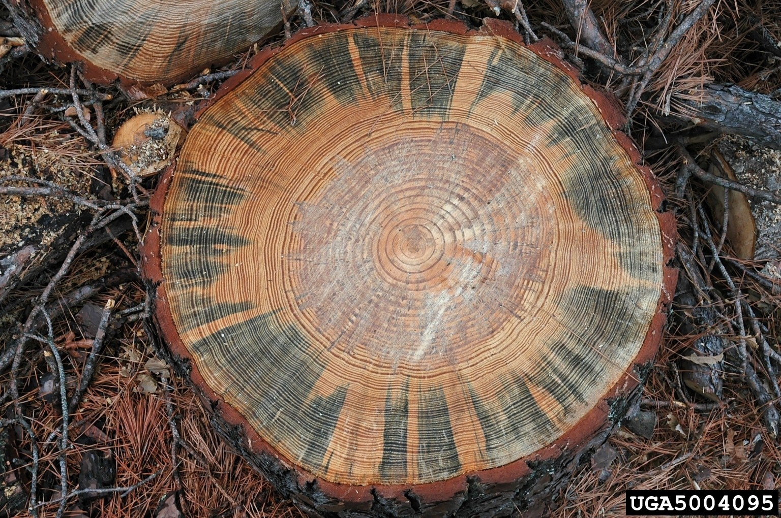
[587]Figure 1. Blue stain fungus (Ceratocystis sp.) affecting wood of Pinus sp. Scale bar: 5 cm
[588]Source: Ronald F. Billings, Texas Forest Service, United States of America, Bugwood.org.
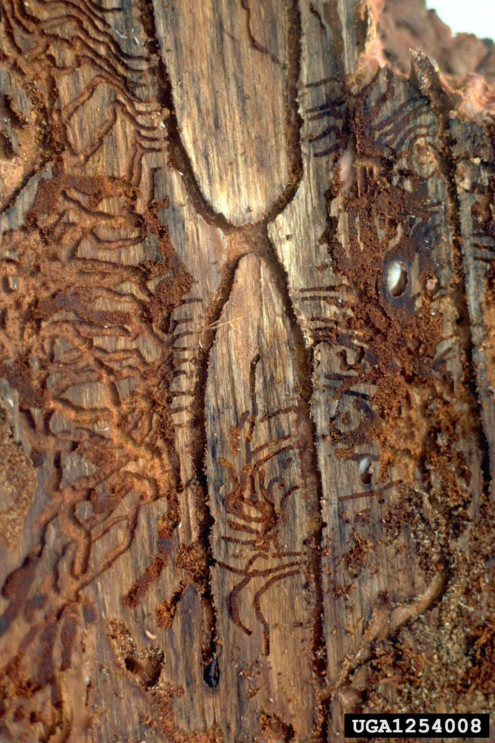
[589]
Figure 2. Partial Ips calligraphus maternal galleries in Pinus wood with radiating and intersecting larval galleries. The central “H”-shaped gallery was built by one male and four females. One adult female (black) and two pupae (white) are shown with arrows. Scale bar: 5 cm.
[590]Source: William M. Ciesla, Forest Health Management International, Bugwood.org
[591]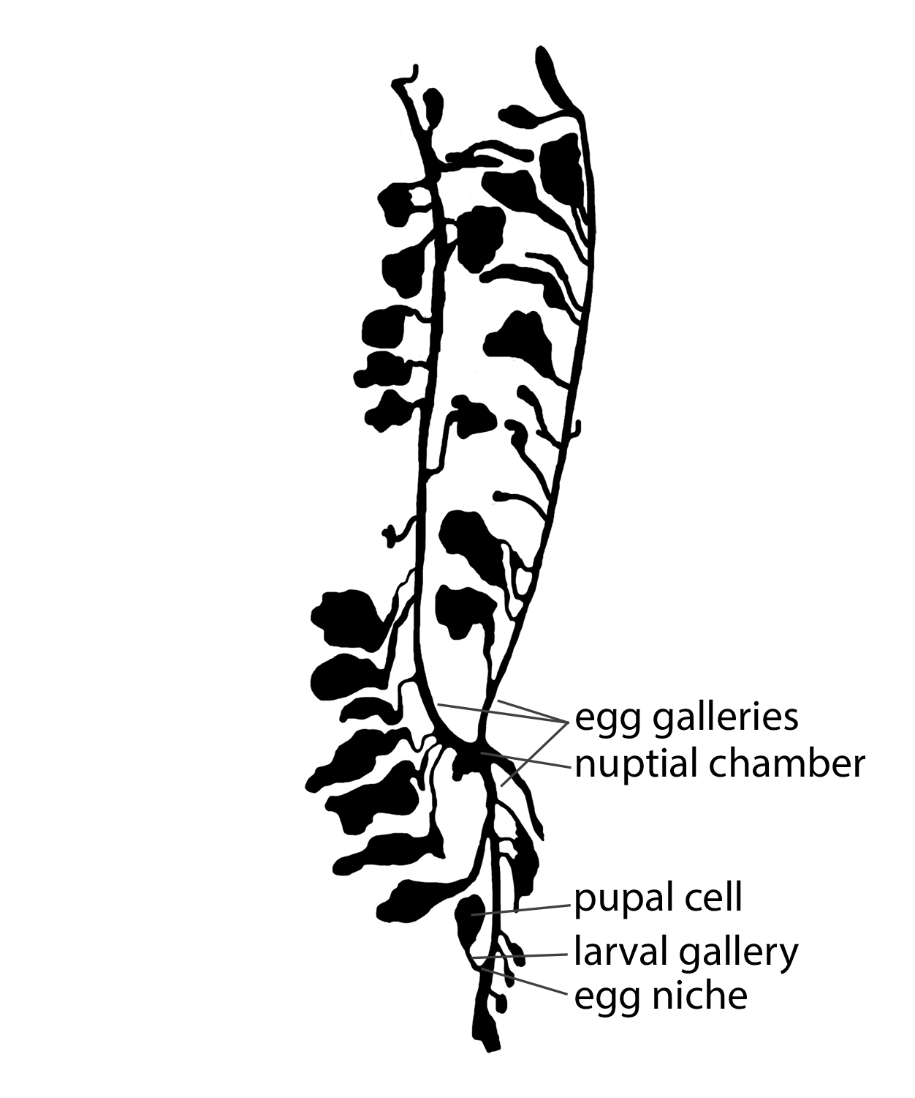
[592]Figure 3. Partial Ips pini gallery system. The central “Y”-shaped gallery was built by one male and three females. Scale bar: 5 cm.
[593]Drawing courtesy of K. Savard, Agriculture and Agri-Food Canada, Ottawa, Canada.
[594]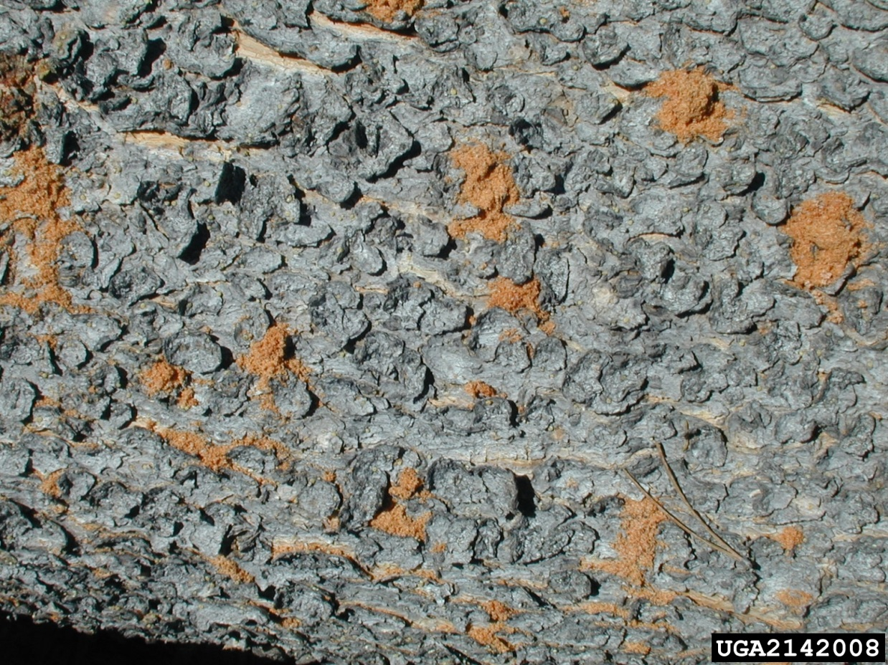
[595]Figure 4. Bark of fallen Pinus sp. tree with boring dust from dense population of Ips pini. Scale bar: 5 cm.
[596]Source: Brytten Steed, United States Department of Agriculture Forest Service, Bugwood.org.
[597]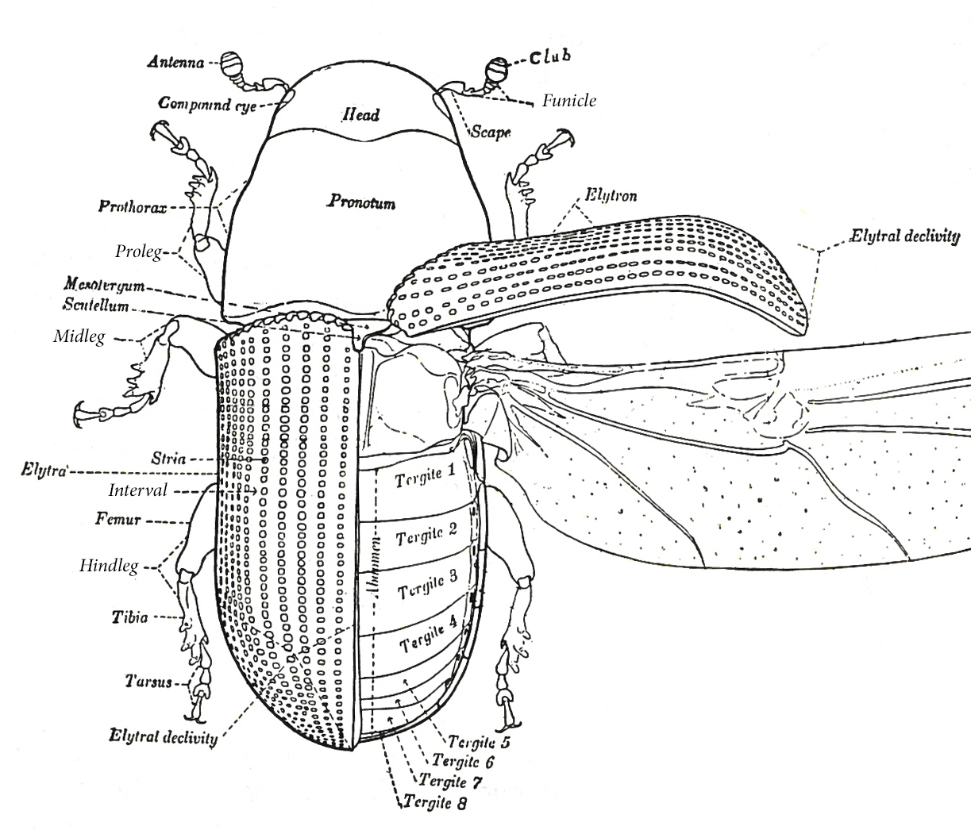Figure 5. Morphology of an adult bark beetle (Dendroctonus valens) in dorsal view.
[598]Modified from Hopkins (1909).
[599]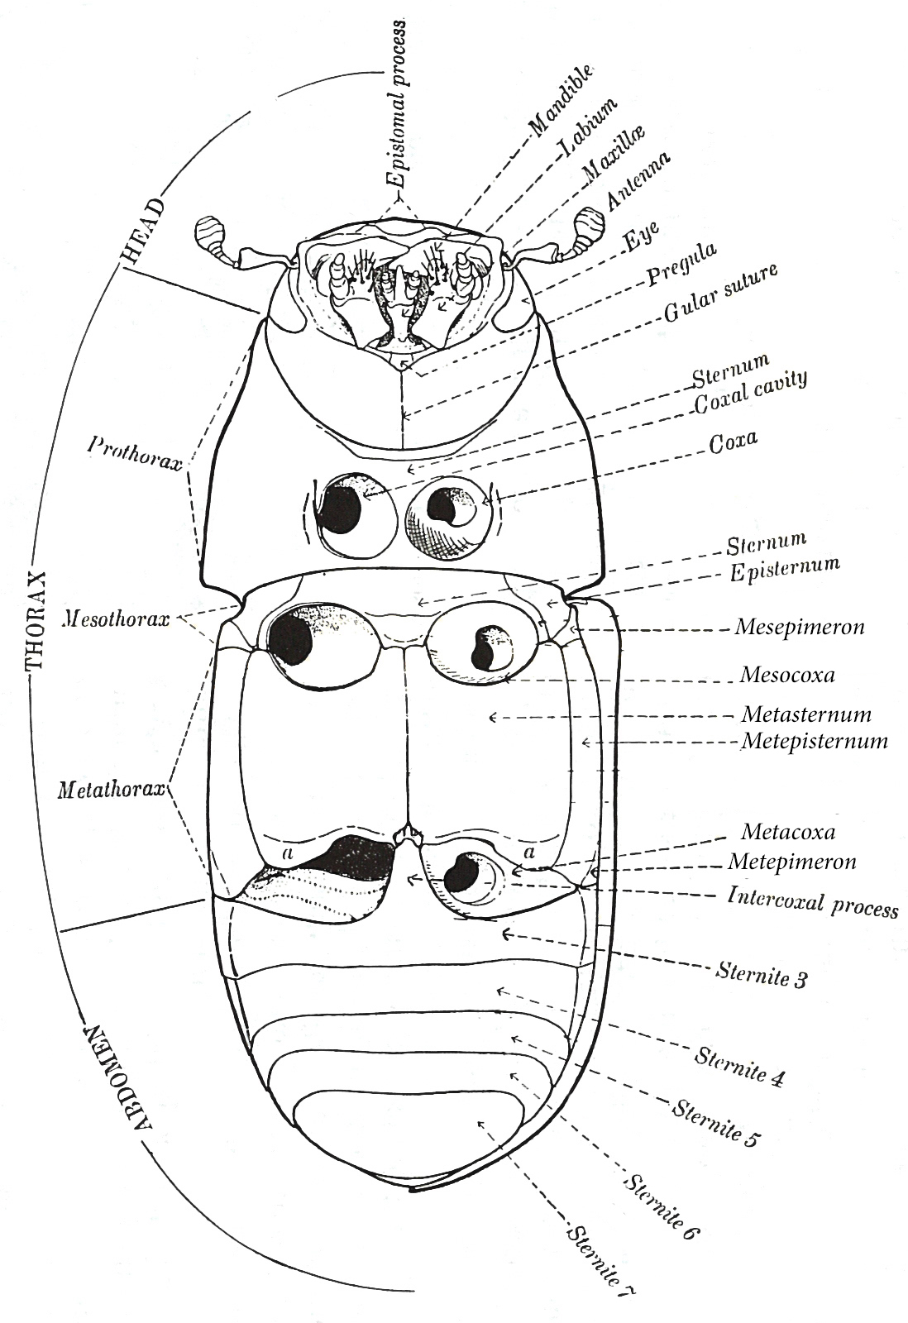
[600]Figure 6. Morphology of an adult bark beetle (Dendroctonus valens) in ventral view.
[601]Modified from Hopkins (1909).
[602]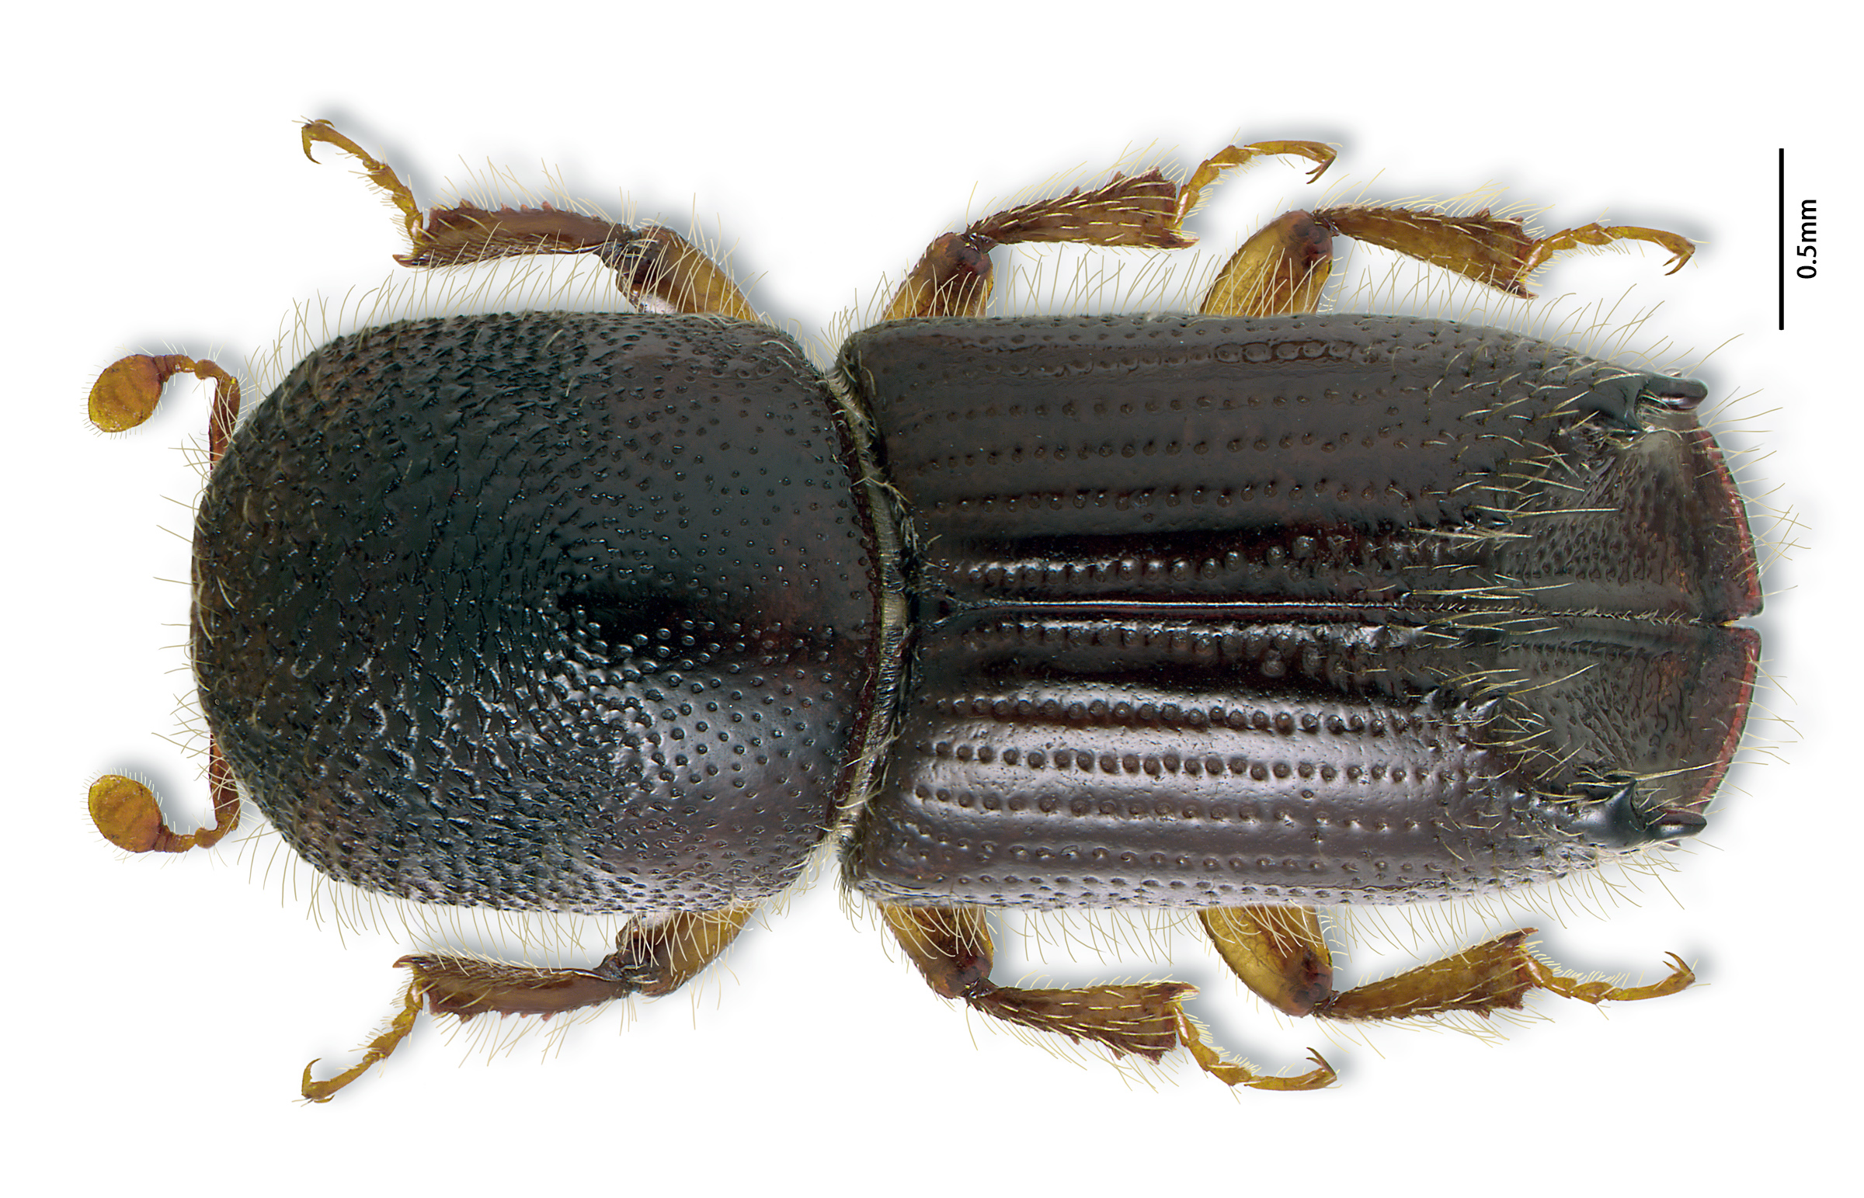Figure 7. Ips pini: dorsal habitus of adult.
[603]Photo courtesy of K. Bolte, Canadian Forest Service, Ottawa, Canada.
[604]

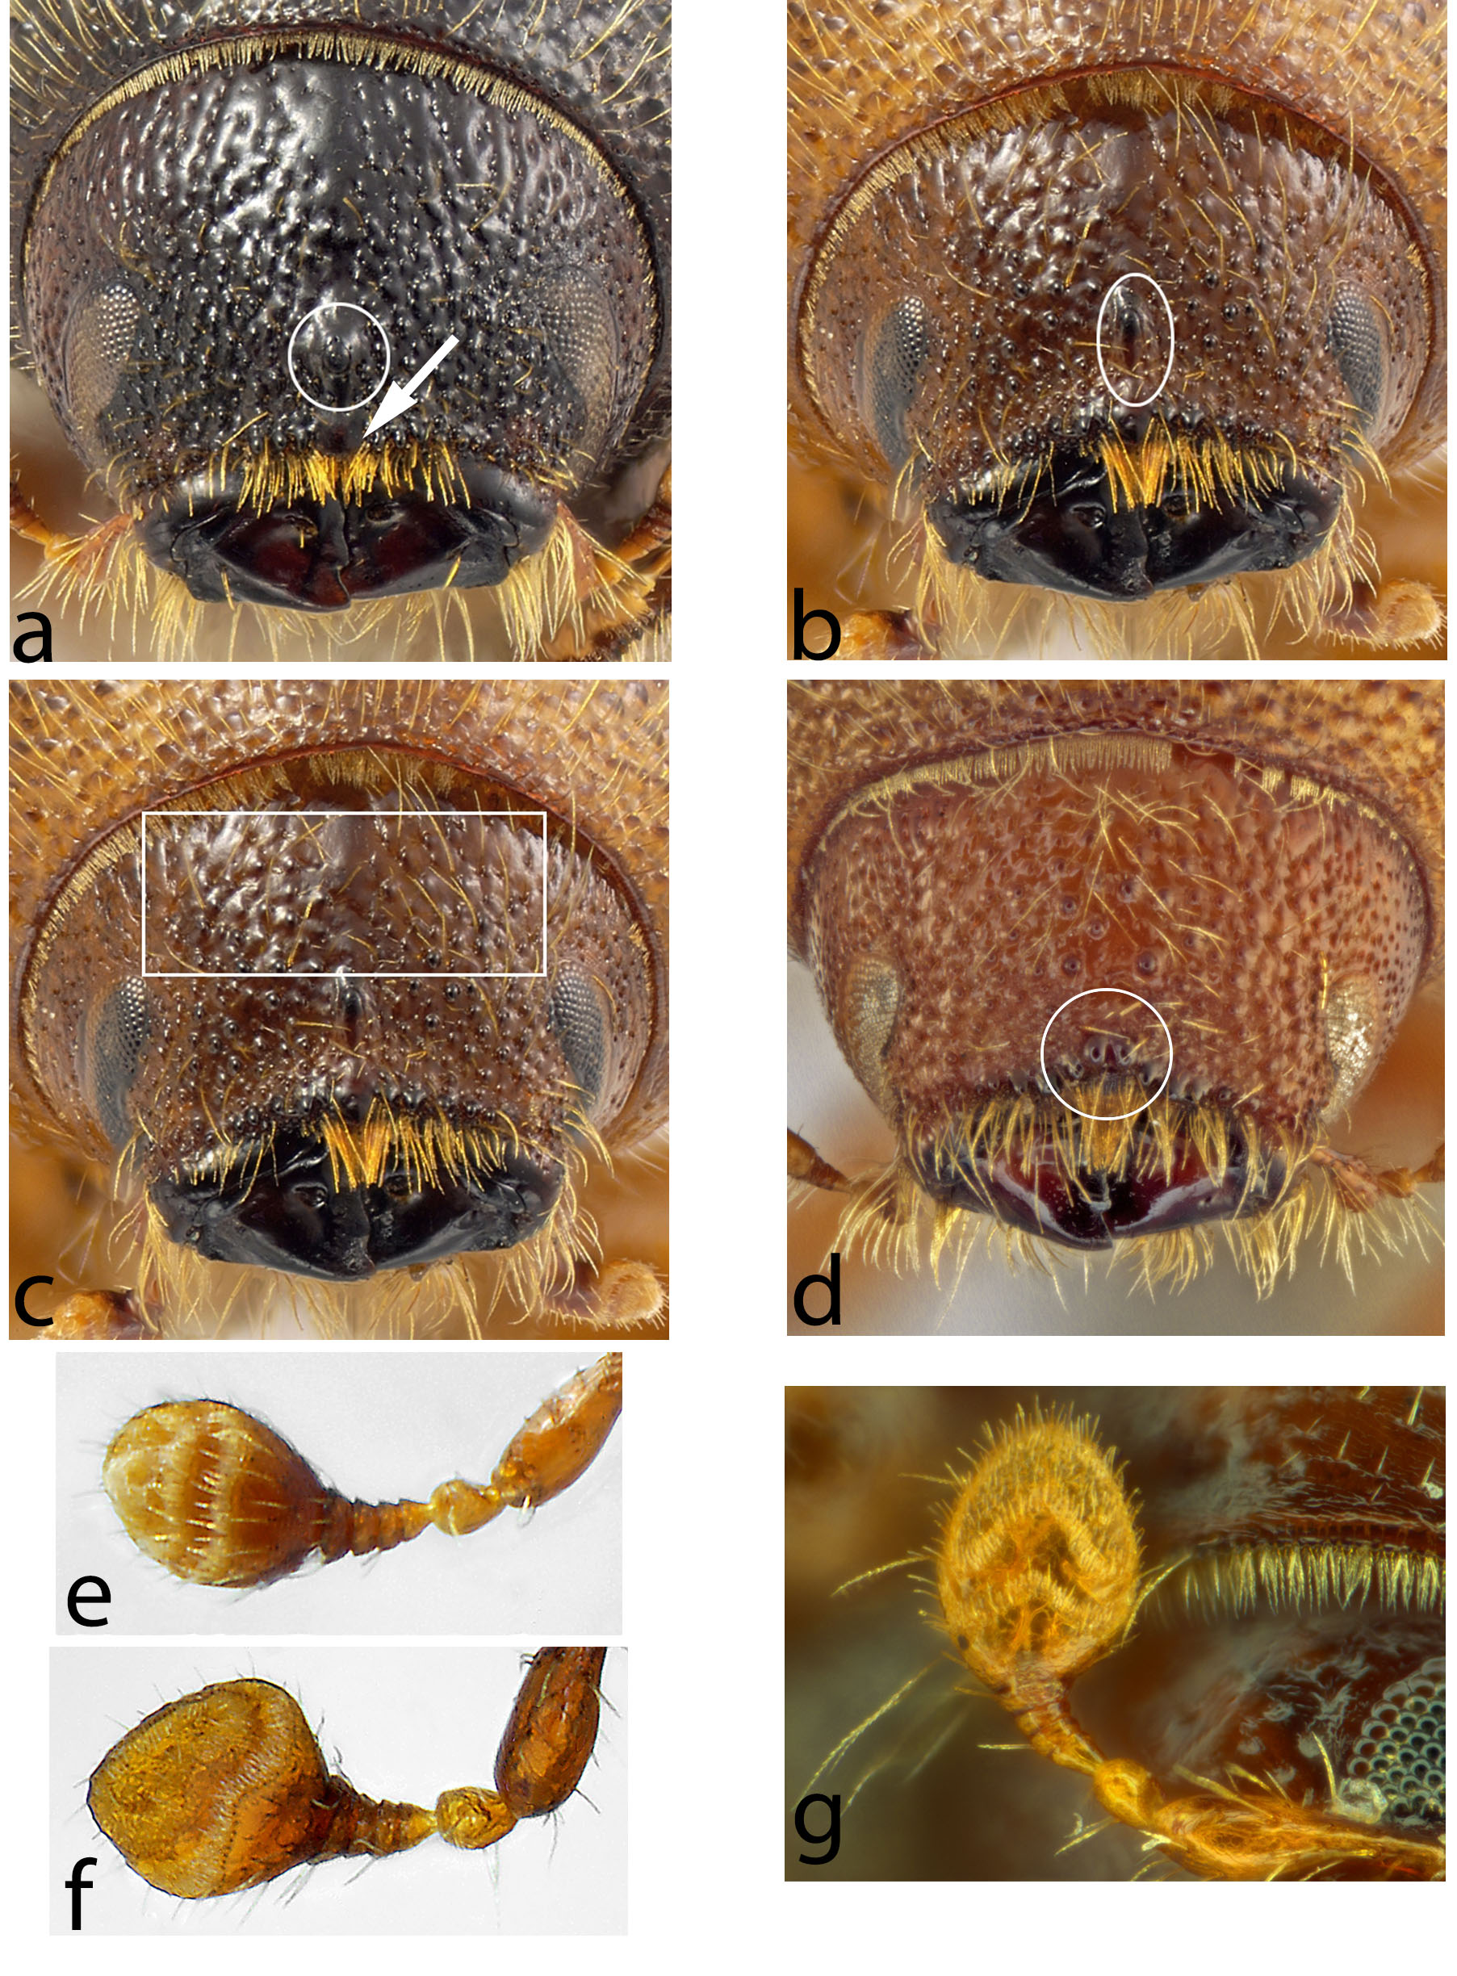

[605]Figure 8. (a)–(d) Head of Ips spp.: (a) I. plastographus with round median tubercle (circled) and epistoma marked with an arrow; (b) I. integer with elongate frontal tubercle (in vertical white oval); (c) I. integer with tubercles on frons above eyes highlighted; (d) I. lecontei with split frontal tubercle. (e)–(g) Antenna of Ips spp.: (e) I. perroti (straight sutures); (f) I. tridens (bisinuate sutures); (g) I. grandicollis (angulate sutures).
[606]Photos courtesy of (a)–(c), (e) and (f) K. Bolte, Canadian Food Inspection Agency; (d) K. Savard, Agriculture and Agri-Food Canada, Ottawa, Canada (AAFC); (g) H. Douglas (AAFC).

[607]
[608]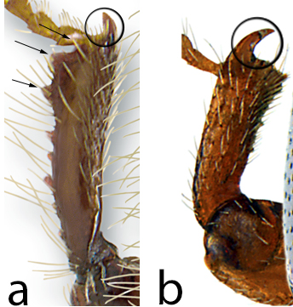
[609]Figure 9. Front tibia of Scolytinae spp.: (a) Ips pini, (b) Scolytus multistriatus. Arrows indicate socketed denticles; circle surrounds apical non-socketed spine.
[610]Photos courtesy of K. Bolte, Canadian Forest Service, Ottawa, Canada.
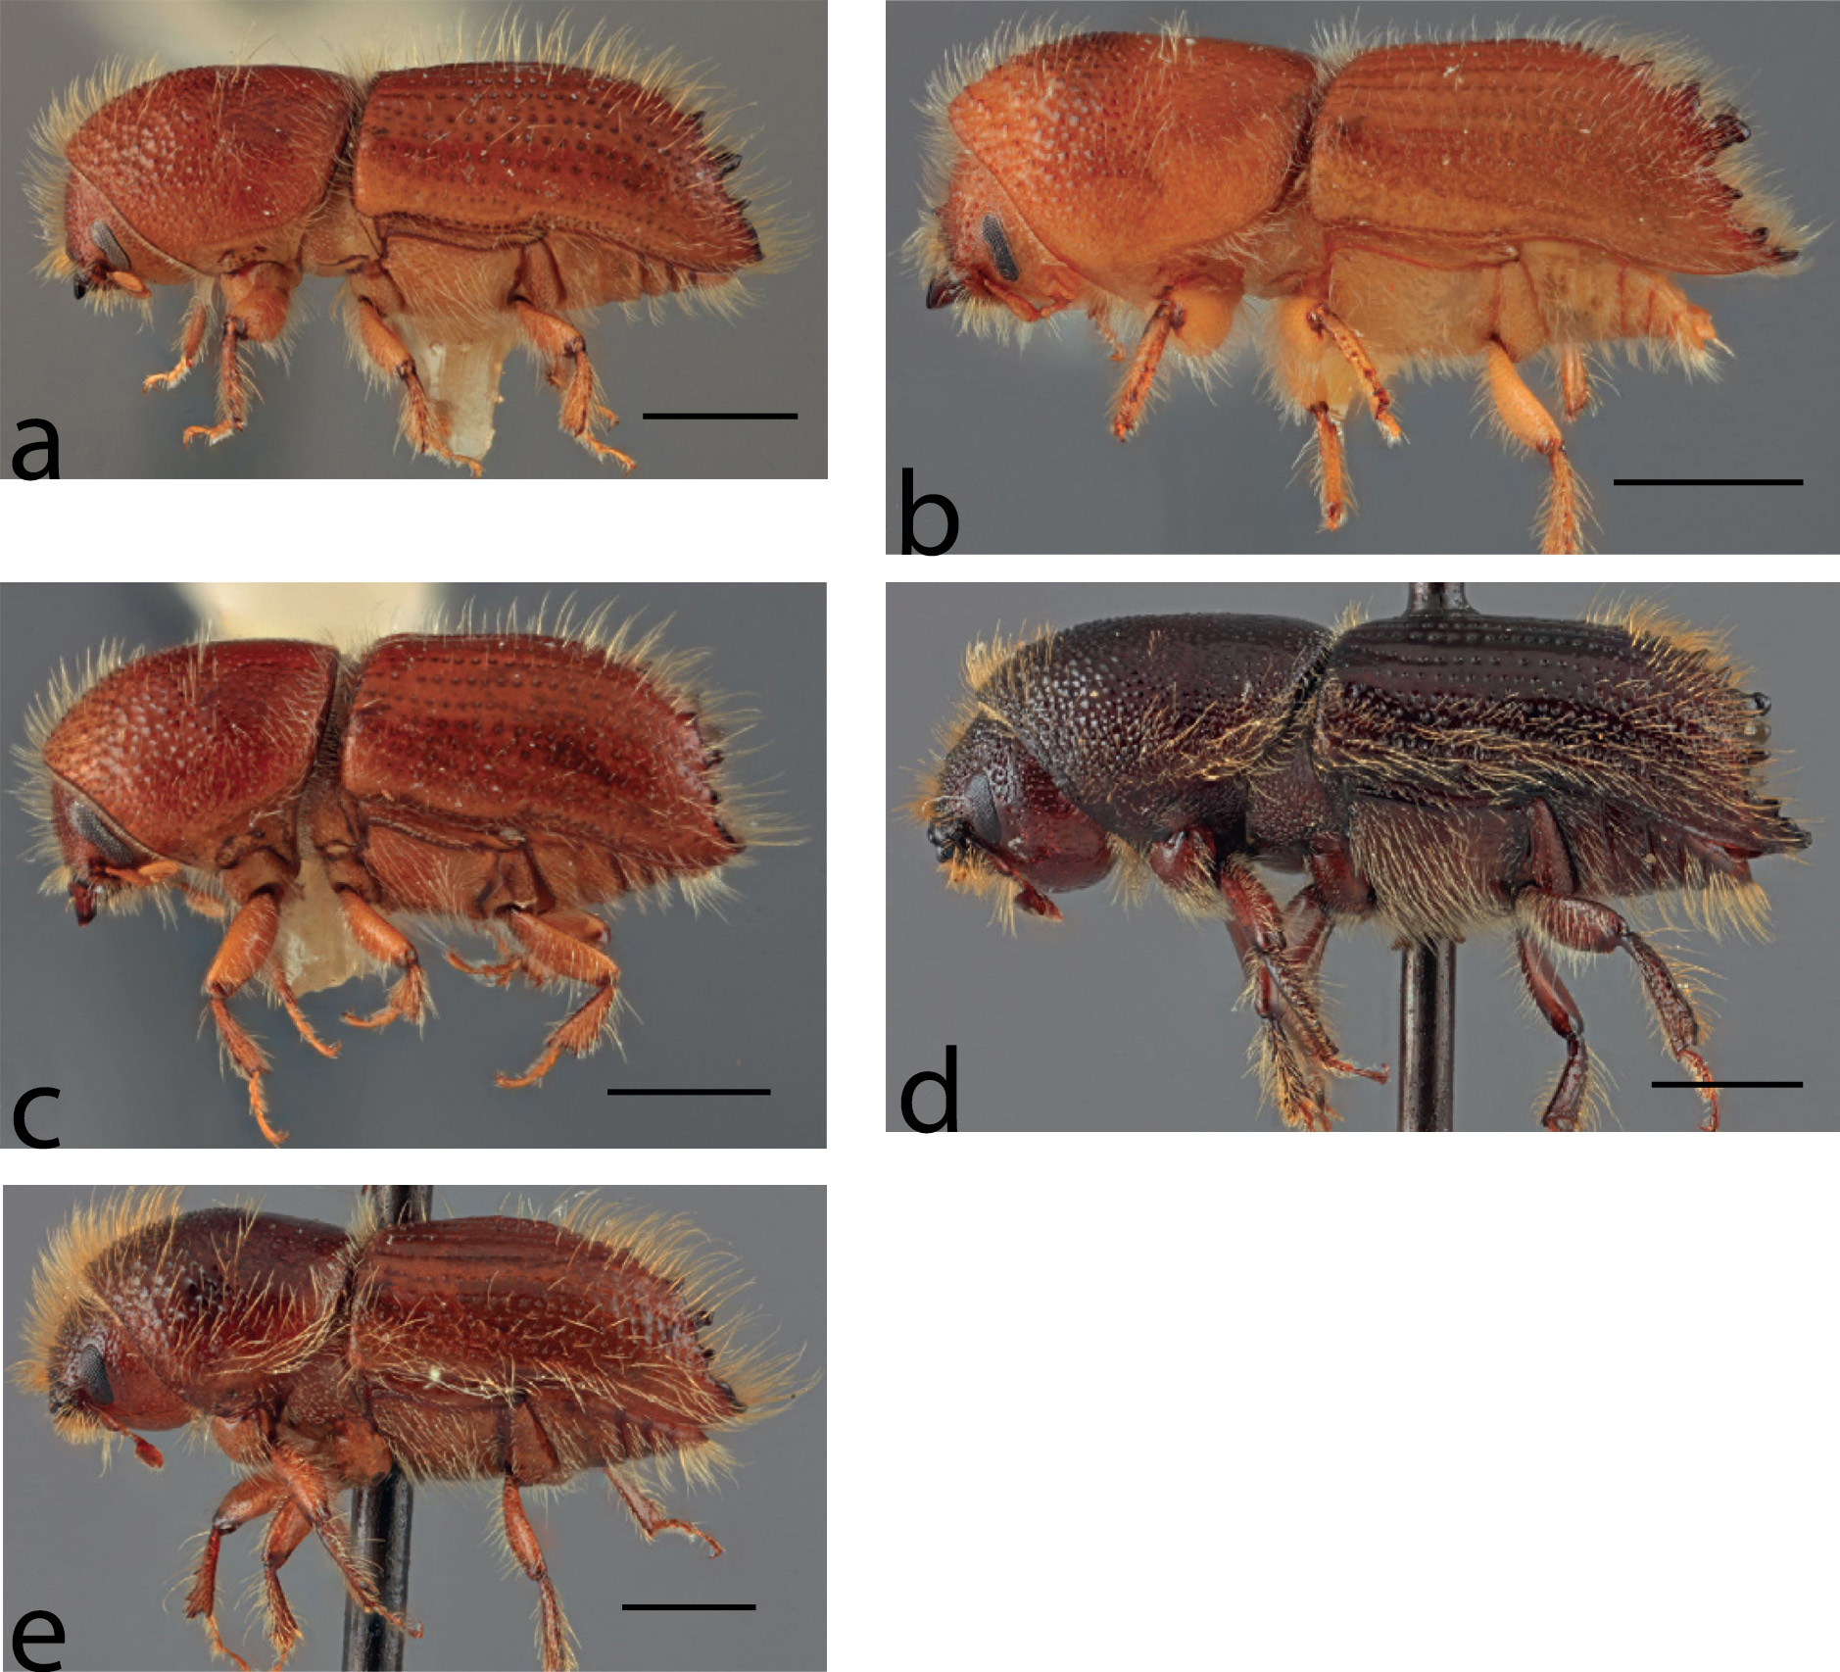
[611]Figure 10. Lateral habitus of Ips spp.: (a) I. amitinus (four spines); (b) I. confusus (five spines); (c) I. duplicatus (four spines); (d) I. sexdentatus (six spines); (e) I. typographus (four spines). Scale bars: 1 mm.
[612]Source: Cognato (2015).
[613]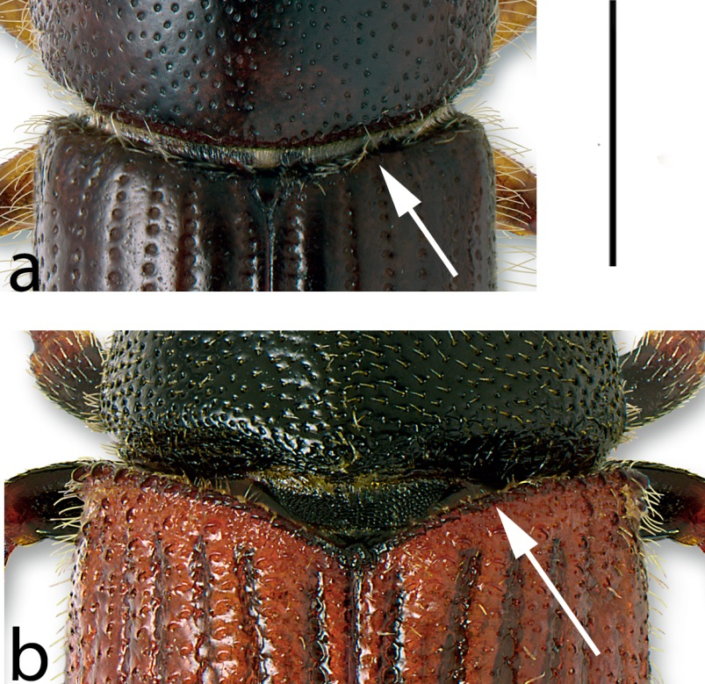
[614]Figure 11. Shape of elytral base (arrow): (a) not procurved and smooth, Ips pini; (b) procurved and asperate (with spines), Phloeosinus punctatus. Scale bar: approximately 1 mm.
[615]Photos courtesy of K. Bolte, Canadian Forest Service, Ottawa, Canada.
[616]
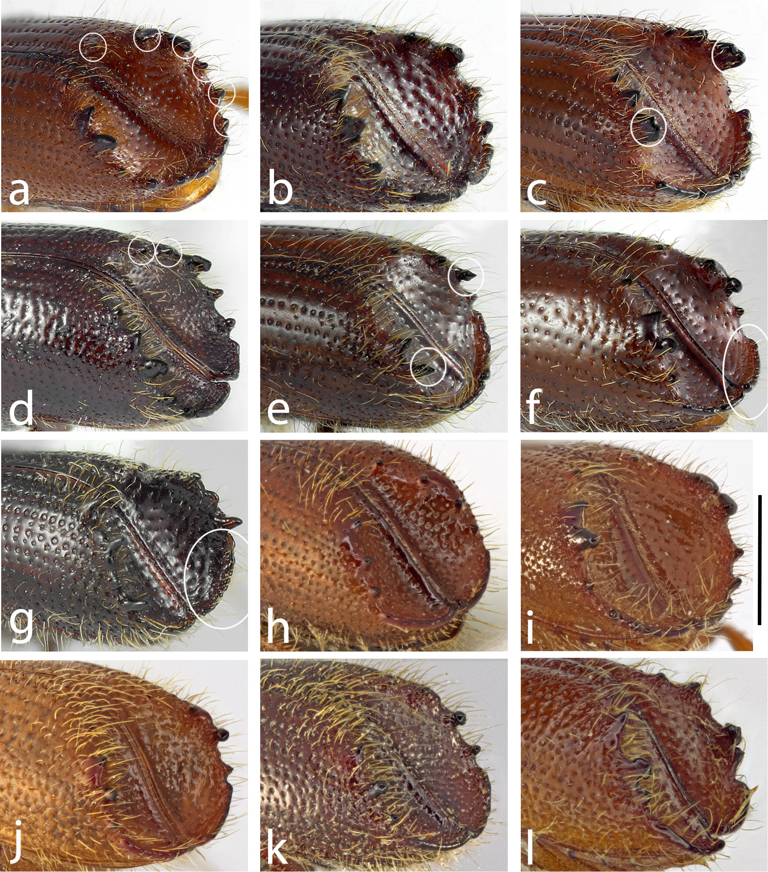
[617]Figure 12. Elytral declivity of Ipini spp.: (a) I. calligraphus (six spines); (b) I. grandicollis (five spines); (c) I. emarginatus (bidentate third spine); (d) I. montanus (five spines); (e) I. perturbatus (third spine pedunculate and acute); (f) I. tridens (explanate apex of declivity); (g) Orthotomicus latidens (smaller explanation of apex of declivity); (h) I. hauseri (third spine tapered and acute); (i) I. lecontei (third spine hooked and obtuse); (j) I. plastographus (third spine pedunculate and subacute); (k) I. subelongatus (third spine pedunculate and subacute); (l) I. cembrae (third spine pedunculate and subacute). Scale bar: 1 mm.
[618]Photos courtesy of (a to g) K. Bolte, Canadian Food Inspection Agency, Ottawa, Canada; (h to l) K. Savard, Agriculture and Agri-Food Canada, Ottawa, Canada.
[619]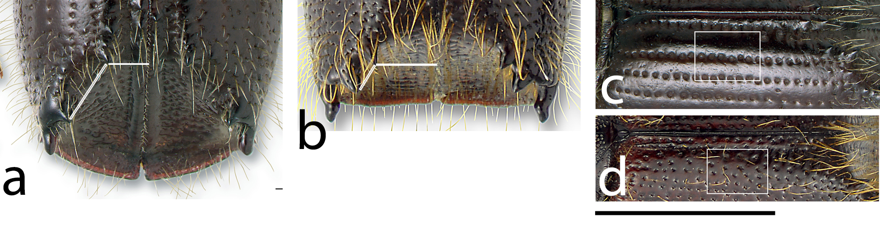
[620]Figure 13. (a)–(b) Elytral declivity of Ipini spp. showing relative distances between first spine and suture vs first and second spines: (a) I. pini (first spine closer to suture); (b) Pseudips mexicanus (first spine closer to second spine). Scale bar: 1 mm. (c)–(d) Elytral disc of Ipini spp. showing punctation of elytral intervals (between major strial rows of punctures): (c) I. pini (without punctures); (d) Pseudips mexicanus (punctate). Scale bar: 1.5 mm.
Photos courtesy of K. Bolte, Canadian Food Inspection Agency, Ottawa, Canada.
[621]
[622]
[623]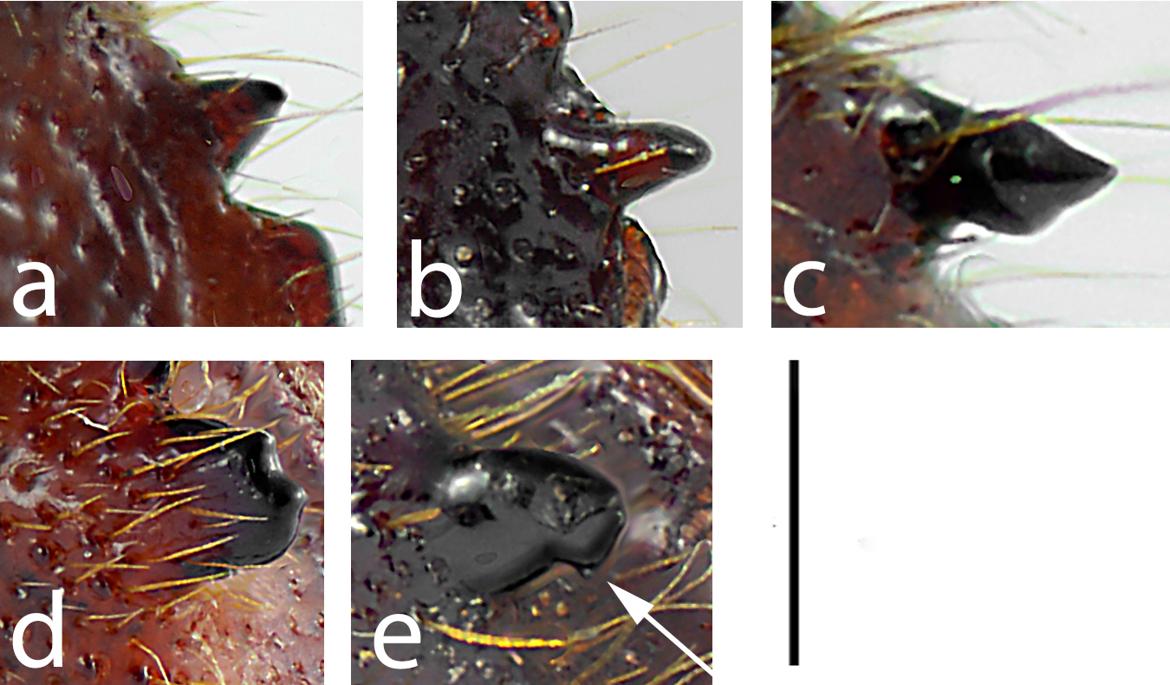
[624]Figure 14. Shape of spines of elytral declivity of Ips spp.: (a) tapered; (b) straight-sided with tapered apex; (c) pedunculate (narrowed near base); (d) bidentate (two apices); (e) hooked (point on posterior edge shown with arrow). Scale bar: 0.5 mm.
[625]Photos courtesy of K. Bolte, Canadian Food Inspection Agency, Ottawa, Canada.
[626]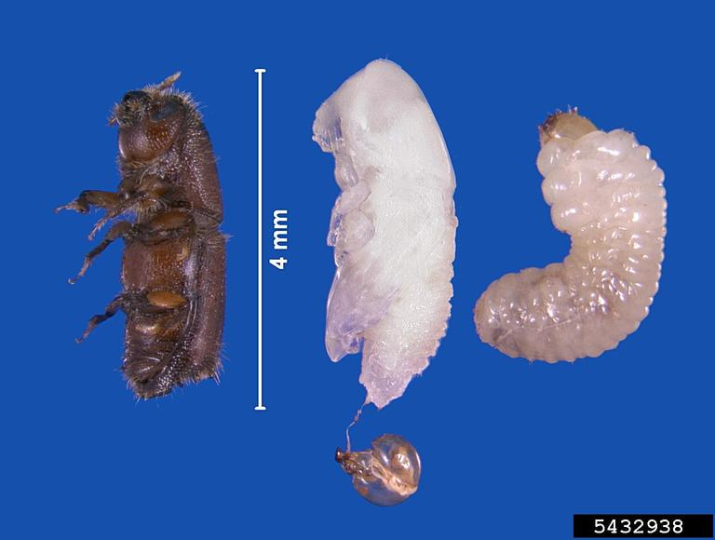
[627]Figure 15. Ips grandicollis: from left to right, adult, pupa (with larval head capsule attached) and larva.
[628]Source: Erich G. Vallery, USDA Forest Service - SRS-4552, Bugwood.org.
[629]
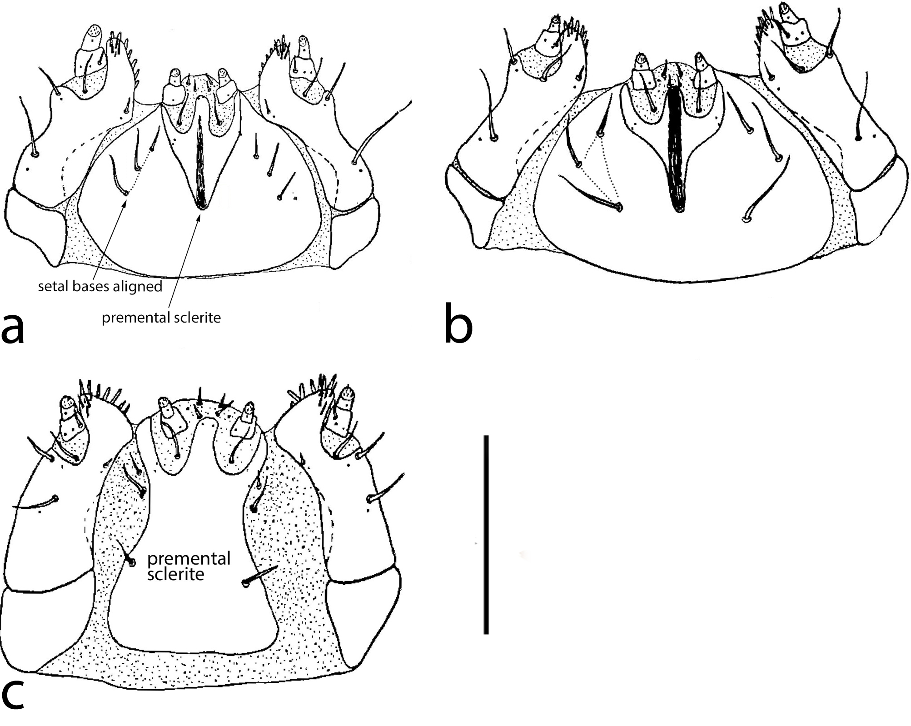
[630]Figure 16. Scolytinae larvae, ventral view of mouthparts: (a) Ips pini, showing triangular premental sclerite and aligned postlabial setal bases; (b) Polygraphus rufipennis with postlabial setal bases arranged in triangle; (c) Trypodendron lineatum with premental sclerite rectangular. Scale bar: 0.5 mm.
[631]Source: Thomas (1957).

