Emerging Pests

1. Summary
- There is a gap between ambitions for a world plant health organisation and the current reality of small teams working with limited resources to develop and implement international and regional standards for phytosanitary measures. The questions around emerging pests - what they are and who should be doing what about them - must be answered at a global level if we are to decide whether and how to fill that gap. This paper will suggest that:

- The CPM Bureau has previously proposed useful criteria for defining emerging pests but the interaction between these criteria needs to be further discussed to see if it is possible to identify a limited list of a few ‘priority emerging pests’ at global level;
- A pest may be an emerging pest independently of whether, where and how it is regulated;
- The remit of the IPPC, and most RPPOs and NPPOs, extends beyond regulated pests and in principle may include emerging pests which are not regulated;
- In the absence of substantial additional resources, if those bodies take responsibility for emerging pests they risk spreading their efforts too thinly and being able to do nothing well;
- Not all emerging pests can have the same priority for co-ordinated action at global or regional level
- Even with limited resources, a process analogous to a simple form of Pest Risk Analysis could be used to identify ‘priority emerging pests’, and suggest appropriate risk management actions, responsible partners for those actions and potential coordinators.

2. Background
- The terms ‘emerging pest’, ‘emerging risk’ and ‘emerging pest risk’ are being used increasingly in the IPPC community. However there is no agreed-upon definition, nor a common understanding of the role with regard to such pests of the IPPC, RPPOs and NPPOs. At the 29th (2017) TC, it was agreed that NAPPO (on behalf of all RPPOs) would prepare a request to the TPG for developing a definition of ‘emerging pest’and that RPPOs would share at the 30th TC their thoughts and experience on methods which might be used to assess whether organisms qualify as emerging pests. The IPPC Secretariat asked for a paper to be developed on the issue of emerging pests for discussion at the SPG in October 2018. The concept of ‘emerging pest risks’ also appears in the draft IPPC Strategic Framework for 2020-2030, which will be discussed at the same meeting.

3. Definitions
- The TPG has been asked to consider developing a definition for ‘emerging pest’ for inclusion in the Glossary of Phytosanitary Terms. Some points can be made even before there is an agreed definition.
- ‘Emerging’ is an inherently temporary status and logically cannot continue indefinitely. However, a pest may ‘emerge’ in a region long after it has finished ‘emerging’ in another region and has become a routine problem managed by routine controls. For example when EPPO was developing recommendations for Japanese beetle (Popillia japonica) to address a recent outbreak in Europe, reference was made to experience in North America nearly a hundred years previously. So, an organism may be an ‘emerging pest’ nationally, regionally or globally.
- Another important point is that an emerging pest may or may not qualify as a regulated pest. The criteria are independent and have a different conceptual basis. It would therefore be possible to propose and populate a matrix as follows, with some organisms in each of the six cells:
 | Quarantine Pest | RNQP | Not QP or RNQP
Emerging Pest
Not Emerging Pest

- This could be done for any geographical area, except that in principle an organism is unlikely to be a quarantine pest in its area of origin.
- In developing a paper for the 27th TC, EPPO and NAPPO concluded that the linked term ‘priority pests’ is only meaningful in relation to the resources for which such a pest has priority. Without resources there is no point in priorities. The combined term ‘priority emerging pests’ has been introduced in this paper.
- The concept of ‘emerging risks’ is broader than emerging pests, and relevant in many disciplines. The European Food Safety Agency defines an ‘emerging risk’ to human, animal and/or plant health as ‘a risk resulting:
(i) from a newly identified hazard to which significant exposure may occur or
(ii) from an unexpected new or increased significant exposure or susceptibility to a known hazard’.
- Adapting that definition to the plant health sector, EFSA have defined an ‘emerging plant health risk’ as ‘a risk resulting:
(i) from a newly identified plant pest for which a significant probability of introduction and/or spread may occur, or
(ii) from an unexpected new or increased significant probability of introduction and/or spread of an already known plant pest (e.g. a new or a modified pathway of introduction, a change in agriculture or forestry practice, a change in pest/disease management or the cultivation of a new crop), or
(iii) from a new or an increased susceptibility of the host plants to a known plant pest’.

(Pautasso et al. 2015)
- Thus an ‘emerging risk’ to plant health might arise from an emerging pest, a new pathway, a newly created vulnerability such as widespread planting of a susceptible cultivar, withdrawal/loss of an effective control method, or development of increased pest resistance to a control method.

4. Remit
- The 1951 text of the IPPC included:
Article VII INTERNATIONAL CO-OPERATION
...
a) Each contracting Government agrees to co-operate with FAO in the establishment of a world reporting service on plant diseases and pests, making full use of the facilities and services of existing organizations for this purpose, and, when this is established, to furnish to FAO periodically the following information: (i) reports on the occurrence, outbreak and spread of economically important pests and diseases of plants and plant products which may be of immediate or potential danger; (ii) information on means found to be effective in controlling the pests and diseases of plants and plant products. b) Each contracting Government shall, as far as is practicable, participate in any special campaigns for combating particular destructive pests or diseases which may seriously threaten crop production and need international action to meet the emergencies. (emphasis is ours here and in other extracts below)
- Even in 1951 the IPPC scope mentioned a ‘particular reference to pests and diseases of importance to international trade’. However changes to the IPPC in 1997, consequent on the WTO SPS Agreement, shifted the focus still further on to technical justification at a national level for phytosanitary measures applied to trade pathways. This change coincided with the allocation for the first time of significant resources to the IPPC. The 1997 IPPC still included a broader ambition to secure ‘common and effective action to prevent the spread and introduction of pests of plants and plant products, and to promote appropriate measures for their control’, but the IPPC Secretariat has never been resourced to fulfil that ambition.
- The IPPC Strategic Framework for 2012-2019 included the following paragraph:
A core contribution of the IPPC to managing these global challenges is developing and maintaining an effective and credible forum where plant protection officials can communicate, debate, and cooperate in joint actions and measures to address long term and newly emerging global plant health issues.
- On the other hand, the IPPC Secretariat Enhancement Evaluation in 2015 reported the views of the OIE (the World Organisation for Animal Health) as follows:
202. IPPC actively sought input from Codex and OIE for improving the standard setting process by involving them in the Focus Group on Improving the IPPC Standard Setting Process (July, 2011). Although OIE admires the very thorough and solid process of standard setting in IPPC, they also think it is quite rigid and time consuming, making it very difficult to quickly agree to a harmonized response addressing an emerging plant health risk and rapidly including latest scientific insights in the approved standards.
- Turning to the regional level, each RPPO has a different remit according to its constitution, but it is clear from discussions in the TC that these go well beyond assisting member countries with setting and implementing trade related measures. All RPPOs do some scanning of the horizon for new and emerging risks. EPPO’s activities in this respect, as just one example, are described in Pautasso et al. (2015). EPPO has maintained an ‘Alert List’ since 1999 to draw the attention of EPPO member countries to certain pests possibly presenting a risk to them and to achieve early warning. Organisms can be entered rapidly onto this list following analysis of new information by the Information Officer. The list is also used by EPPO to select candidates which may be submitted to a full Pest Risk Anlaysis (PRA). The current version of the EPPO ‘Alert List’ is at
https://www.eppo.int/ACTIVITIES/quarantine_activities.
- Within the EPPO region, at about the same time as the changes to the IPPC, phytosanitary services in EU countries were adapting to the introduction of the EU Single Market. This led to a different approach to risk management with less emphasis on national PRAs and measures at borders between EU countries and more on a regionally co-ordinated management of emerging plant health risks, in many cases on the basis of EPPO PRAs and Standards. Such regional co-ordination can address all pathways, not just international trade. For example, natural spread can be restricted through containment measures in buffer zones and suppression in adjoining infested areas.
- Other RPPOs, for example NAPPO, also work on co-ordinated approaches to emerging pests, such as contingency planning, factsheets, information exchange, surveillance plans, research co-ordination and workshops. Presentations from the 2017 TC with RPPO lists of emerging pests and related activities are available at https://www.ippc.int/en/core-activities/external-cooperation/partners/technical-consultation-among-rppos/2017-29th-tc-among-rppos-1/. Fusarium oxysporum Tropical Race 4 was mentioned by seven of the ten RPPOs as an emerging risk. Huanglongbing and Tuta absoluta were both mentioned by three RPPOs, Cassava mosaic virus, Khapra beetle, banana bunchy top and Xylella fastidiosa by two.

5. Resources
- The CPM Bureau meeting, in June 2017, recorded that:
... in general IPPC focuses on quarantine pests and is seen as mainly standard setting organization while dealing with emerging issues or pests as a new role for IPPC would require major time investment and funding. Taking that into account, the Bureau agreed that RPPOs should be given a major role in identifying emerging issues from information solicited in their region, which should be coordinated at the TC-RPPOs level and then reported after their selection and prioritization to the CPM.
The Bureau decided that a new arrangement for processing emerging issues would be that RPPOs have a quarterly conference coordinated by the IPPC Secretariat to discuss emerging issues and decide if they are global or regional in nature, and to identify possible (individual or coordinated) actions and recommendations to contracting parties (establishment of surveillance, sharing of PRAs, etc.). The Secretariat will engage with the TC Chair and discuss these proposed arrangements for discussion by the SPG and TC-RPPOs at the end of October for decision at the CPM 13 (2018).
- It is not clear in the first sentence of this extract whether the ‘focus’ refers to the IPPC as a document, or to the IPPC governance through which contracting parties have agreed (for good reasons) to focus resources on this aspect of the IPPC remit, partly by adopting a narrower interpretation of the term ‘phytosanitary measure’ than in Article II of the IPPC.
- The RPPOs are willing within their respective remits to help identify and address the risks from emerging pests, but ‘giving [them] a major role’ does not solve the resource problem, which is a constraint also at RPPO level. The idea of some form of quarterly contact to pick up emerging pest risks is sound but requires central resourcing to drive the process, and some clarity as to how RPPOs identify emerging pest risks and how the network of IPPC, RPPOs, NPPOs and others can then respond.

6. Criteria and Assessment
- The Bureau meeting in June 2017 suggested that pests that:
- had made a continental jump
- have a wide host range and where hosts are widely distributed
- have large potential for damage and economic loss across continents
- [show] evidence of a shift in the risk
- have an impact on natural environment as well as on production
- have an ability for crop destruction and the ability to eliminate entire production areas.

- could qualify as emerging pests. The examples they proposed were Tuta absoluta and pine wood nematode (Bursaphelenchus xylophilus). It is not clear from the Bureau report how the different criteria were intended to interact. If all criteria must be met then few if any organisms would qualify. If only one of the criteria has to be satisfied there could be several hundred candidates. A decision tree or scoring matrix is needed to apply the criteria in practice to produce a manageable list of a few emerging pests at global level. The scheme on the following page is intended as an example of the sort of approach which might be tried.
- Factors other than those identified by the Bureau could be incorporated. For example, for an organism to be a globally emerging pest, it might be considered a requirement that it poses a threat to at least two continents.
- A pest may be identified as an ‘emerging pest’ at regional or global level, for example through an RPPO Alert List. Relevant evidence may come from official reports of geographical spread or changing impact, scientific literature or press reports, or from sentinel plant networks, for example.
- Once identified as an ‘emerging pest’ it could be subjected to an analysis to confirm (or not) whether it is a ‘priority emerging pest’ by assessing its risks relative to other ‘emerging pests’ and to identify potential risk management options. This would not be ‘Pest Risk Analysis’ in the narrow sense of the agreed interpretation in ISPM5, but could use some of the questions posed and information gathered in the course of a PRA carried out according to ISPM11. There is a hint of this broader approach in ISPM2 which refers to ‘- hazards identified outside the scope of the IPPC and to be communicated to other authorities.’ Like a pest-specific PRA, it would be at the taxonomic level of species but could be at a higher or lower taxonomic level if justified. The process would have to be fit for purpose and proportionate to the amount of resources available against priority emerging pests.
- Some of the key features and sometimes differences from PRA would be:
- The analysis would be carried out at global or regional level
- The analysis would specifically compare risks to enable prioritisation between pests
- Risk management would cover not only possible phytosanitary measures (in the narrow sense) but also needs for:
- Research
- Guidance
- Communications materials
- Accessible and effective control methods
- Biological control options
- Plant breeding responses
- The analysis would identify potential partners and stakeholders forco - ordinated action against the pest and a potential co-ordinating body
- The analysis would be subject to some form of consultation
- 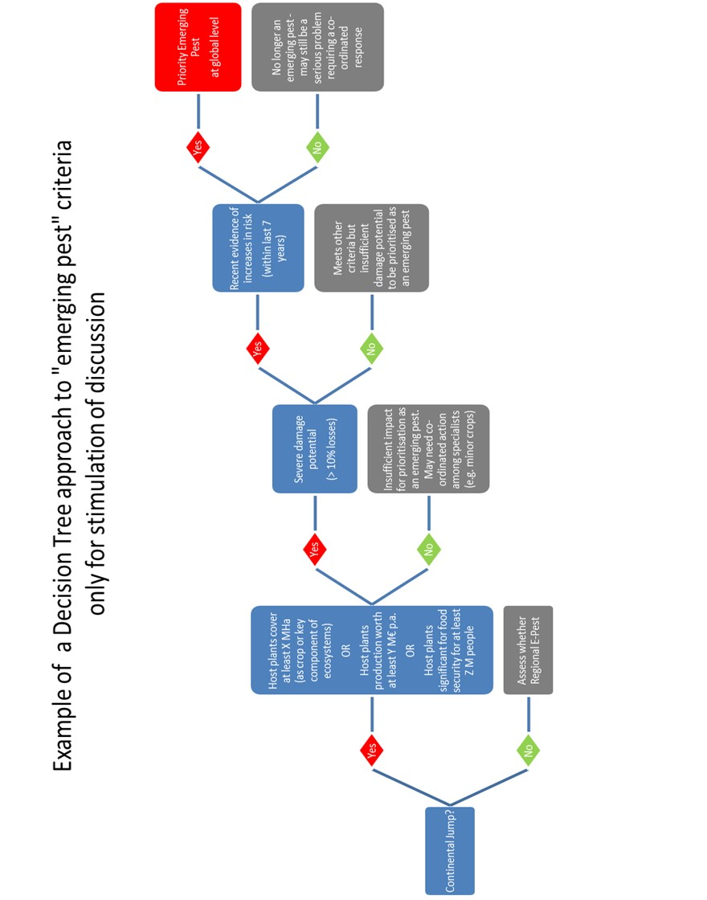

7. Co-ordination
- The minimum response to a priority emerging pest would be to co-ordinate the action being taken against it by different bodies and stakeholders. If there are no resources to do the co-ordination, or no resources to carry out actions to be co-ordinated, there is no point in identifying priority emerging pests. Co-ordination of action against a priority emerging pest would not necessarily be done by the IPPC Secretariat though the IPPC Secretariat and relevant RPPOs should be involved in the network to ensure that phytosanitary aspects (in the narrow sense) are taken fully into account.
- Others who might carry out co-ordination could include:
- RPPOs
- NPPOs
- FAO Divisions or Regions
- CABI
- CGIAR associated institutes
- Charitable foundations
- Grower and commodity organisations
- Participation in the co-ordinated action could be open, with appropriate safeguards against conflicts of interest, to:
- Plant breeding companies
- Crop protection companies
- Biological control manufacturers
- Academic researchers
- Many of the existing mechanisms for supporting national action against regulated pests could also be relevant against priority emerging pests, for example datasheets, diagnostic protocols, workshops for sharing experience, standards for testing efficacy of controls. So although resources would be required to carry out any of these actions, it would not always be necessary to establish new mechanisms.

8. Conclusions
- It is only useful to identify emerging pests if resources are available to co-ordinate action against them globally or regionally. Pest risk analysis (in the ordinary sense of the words) could be used to assess risks and identify possible risk management options against emerging pests. Any proposed scheme for doing this could be tested against benefits which it might have achieved had it been in place to address recently emerged pests (which are still emerging in some regions) such as Tuta absoluta, Halyomorpha halys, Drosophila suzukii and Spodoptera frugiperda.

9. Reference
Pautasso M, Petter F, Rortais A and Roy A-S (2015) Emerging risks to plant health: a European perspective CAB Reviews 2015 10, No. 021.

