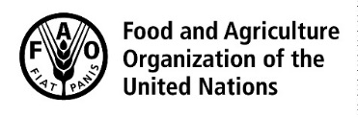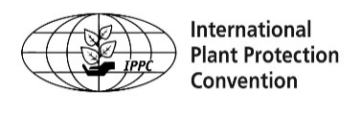

Strategic Framework for
the International Plant Protection
Convention (IPPC) 2020-2030

Protecting the World’s Plant Resources from Pests

Required citation:
FAO. 2019. Strategic framework for the International Plant Protection Convention (IPPC) 2020–2030. Rome. Published by FAO on behalf of the IPPC Secretariat. 23 pp. Licence: CC BY-NC-SA 3.0 IGO.

The designations employed and the presentation of material in this information product do not imply the expression of any opinion whatsoever on the part of the Food and Agriculture Organization of the United Nations (FAO) concerning the legal or development status of any country, territory, city or area or of its authorities, or concerning the delimitation of its frontiers or boundaries. The mention of specific companies or products of manufacturers, whether or not these have been patented, does not imply that these have been endorsed or recommended by FAO in preference to others of a similar nature that are not mentioned.

The views expressed in this information product are those of the author(s) and do not necessarily reflect the views or policies of FAO.

ISBN [insert number]
© FAO, 2019

Some rights reserved. This work is made available under the Creative Commons Attribution-NonCommercial-ShareAlike 3.0 IGO licence (CC BY-NC-SA 3.0 IGO; https://creativecommons.org/licenses/by-nc-sa/3.0/igo/legalcode).

Under the terms of this licence, this work may be copied, redistributed and adapted for non-commercial purposes, provided that the work is appropriately cited. In any use of this work, there should be no suggestion that FAO endorses any specific organization, products or services. The use of the FAO logo is not permitted. If the work is adapted, then it must be licensed under the same or equivalent Creative Commons licence. If a translation of this work is created, it must include the following disclaimer along with the required citation: “This translation was not created by the Food and Agriculture Organization of the United Nations (FAO). FAO is not responsible for the content or accuracy of this translation. The original English edition shall be the authoritative edition.”

Disputes arising under the licence that cannot be settled amicably will be resolved by mediation and arbitration as described in Article 8 of the licence except as otherwise provided herein. The applicable mediation rules will be the mediation rules of the World Intellectual Property Organization http://www.wipo.int/amc/en/mediation/rules and any arbitration will be conducted in accordance with the Arbitration Rules of the United Nations Commission on International Trade Law (UNCITRAL).

Third-party materials. Users wishing to reuse material from this work that is attributed to a third party, such as tables, figures or images, are responsible for determining whether permission is needed for that reuse and for obtaining permission from the copyright holder. The risk of claims resulting from infringement of any third-party-owned component in the work rests solely with the user.

Sales, rights and licensing. FAO information products are available on the FAO website (www.fao.org/publications) and can be purchased through publications-sales@fao.org. Requests for commercial use should be submitted via: www.fao.org/contact-us/licence-request. Queries regarding rights and licensing should be submitted to: copyright@fao.org.

Strategic Framework for the International Plant Protection Convention (IPPC) 2020–2030

Protecting the World’s Plant Resources from Pests

Developed by the Commission on Phytosanitary Measures

Food and Agriculture Organization of the United Nations
Rome, 2019

Purpose of this document
This document aims to communicate the work of the Commission on Phytosanitary Measures (herein referred to as “the Commission”) and its priorities for the coming ten years.
Readers will be able to understand the International Plant Protection Convention (IPPC), the work carried out by the Commission, what the Commission is trying to achieve, and why it matters.
This document will guide the plant health activities of the Commission and its main partners – the national plant protection organizations (NPPOs) of contracting parties and regional plant protection organizations (RPPOs) – over the period 2020 to 2030. Ten years is a long time though, so as we move forward we expect to adapt and respond to ensure that we stay on course, not with what we decide today, but with where we need to be in the future.

Who should read this document and why
The target audiences for this document are broad.

- Contracting parties, national plant protection organizations and regional plant protection organizations – will use this document at all levels of government and across governmental and non-governmental organizations to communicate how the work of the Commission supports a country to achieve its goals in the areas of plant protection, food security, protection of forests and the environment, and safe trade and economic development. This strategic framework can be used by contracting parties, NPPOs and RPPOs to align their own strategies and activities to achieve the objectives of the IPPC.
- Agricultural producers, farmers, exporters and importers – will better understand the threat of plant pests and the vital need for plant protection services and measures, including global plant health standards, to safeguard sustainable agricultural productivity and profitability.
- FAO divisions or departments and other relevant international organizations – will be able to see the work the IPPC Secretariat is doing that could relate to their activities and programmes. They might also see how the IPPC Secretariat could benefit from knowing about or contributing to their work. This will increase the opportunities for alignment of effort, improve resource utilization, and increase the chance of delivering better results.
- Donor agencies – will be able to identify opportunities to achieve their goals through working with the IPPC community. They might find specific areas where they want to invest to effect change at a global level, or it may help them to identify priority areas as they work with individual countries.
- Contracting party delegates to the annual Commission meetings – will use this document to stay focused on agreed objectives and key result areas when determining priorities for the coming years. Effecting change can take many years, so this document will help them remember what they considered to be important and why and help them to clarify the reasons for changing direction and for building in flexibility for adjustment to changes.

CONTENTS
1. Executive summary 8
2. Introduction 11
3. Plant pests 12
4. Operating environment 2020–2030 13
4.1 Increasing and more diversified trade 13
4.2 Structural and operational changes in the way national plant protection organizations work 14
4.3 Scientific and capacity development 16
4.4 Impacts of climate change on plant health 16
5. Mission, vision and goal of the International Plant Protection Convention (IPPC) 18
6. Core activities 19
6.1 Standard setting 19
6.2 Implementation and capacity development 19
6.3 Communication & international cooperation 21
7. Strategic objectives 23
7.1 Enhance global food security and increase sustainable agricultural productivity 24
7.2 Contribution to the UN 2030 Sustainable Development Agenda 25
7.3 Protect the environment from the impacts of plant pests 25
7.4 Contribution to the UN 2030 Sustainable Development Agenda 26
7.5 Facilitate safe trade, development and economic growth 26
7.6 Contribution to the UN 2030 Sustainable Development Agenda 28
8. IPPC development agenda 2020–2030 29
8.1 Harmonization of electronic data exchange: 29
8.2 Commodity- and pathway-specific ISPMs: 30
8.3 Management of e-commerce and postal and courier pathways: 31
8.4 Developing guidance on the use of third-party entities: 32
8.5 Strengthening pest outbreak alert and response systems: 33
8.6 Assessment and management of climate change impacts on plant health: 35
8.7 Global phytosanitary research coordination: 35
8.8 Diagnostic laboratory networking: 36

Abbreviations and acronyms

CITES Convention on International Trade in Endangered Species of Wild Fauna and Flora Convention (note that in this document references to “the Convention” are to the International Plant Protection Convention)
CPM Commission on Phytosanitary Measures (referred to as “the Commission” in this document)
ePhyto electronic phytosanitary certificate
EPPO European Plant Protection Organization
FAO Food and Agriculture Organization of the United Nations
IPPC International Plant Protection Convention (referred to as “the Convention” in this document)
ISPM International Standard for Phytosanitary Measures
IYPH International Year of Plant Health
NPPO national plant protection organization
RPPO regional plant protection organization
SPS Agreement The Agreement on the Application of Sanitary and Phytosanitary Measures (of the World Trade Organization)
UN United Nations
WCO World Customs Organization
WTO World Trade Organization

1. Executive summary

- The introduction and spread or outbreak of plant pests significantly affects food security, biodiversity and economic prosperity. A vast range of plant pests threaten global food production, the productivity and biodiversity of forests and the wild flora of the natural environment. Preventing those pests spreading and establishing in new countries and regions is the aim of national plant protection organizations (NPPOs) and the International Plant Protection Convention (IPPC). Prevention is invariably more cost effective than the alternatives of maintaining long-term control, containment, eradication or, in the worst case, the consequences of unchecked impact. The NPPO is the competent authority for a country: it is responsible for providing and receiving government to government phytosanitary assurances and should be resourced to fulfil its functions competently.
- The IPPC is the global international treaty for protecting plant resources (including forests, aquatic plants, non-cultivated plants and biodiversity) from both direct and indirect damage by plant pests, for facilitating safe trade through common and effective action to prevent the introduction and spread of plant pests, and to promote appropriate measures for their control. International standards developed within the framework of the IPPC, under the auspices of the IPPC Secretariat, are the only international standards for phytosanitary measures recognized by the World Trade Organization’s (WTO’s) Agreement on the Application of Sanitary and Phytosanitary Measures (the SPS Agreement). The IPPC has 183 contracting parties and its implementation is governed by the Commission on Phytosanitary Measures (CPM, herein referred to as “the Commission”), which mainly identifies actions to control the spread of pests into new areas, develops and adopts international plant health standards and recommendations to harmonize international trade, and assists countries in the implementation of those actions and standards. This document communicates the work of the Commission and its priorities for the coming ten years.
- The IPPC strategic framework 2020–2030 has been developed to support NPPOs and the Commission in their work to overcome the emerging challenges linked to the growth and increasing diversity of global trade in food, agricultural and forestry products, and the increasing volume and speed of passenger and freight movements. It provides a new operating environment to address the expected structural and operational changes that NPPOs will encounter during 2020–2030. Such changes include developments in data processing and transmission as well as considerations of how far, for example, border clearance processes can be simplified to facilitate fast trade of perishable products. Advances in science and capacity developments, such as remote sensing, will significantly affect plant health activities as will the mitigation of climate-change related impacts on agriculture and plant health. All these and other changes and their impacts on the operating environment of NPPOs and the Commission have been considered in the development of this strategic framework.
- The IPPC strategic framework reflects the strategic mission, vision and goal of the IPPC, and describes the operational elements that will help deliver these. These comprise three core activities, three strategic objectives and a development agenda with eight priority programmes of new work areas. (Please also see the one-page graphic at the end of this executive summary.)
- The core activities identified are primarily the tools used to achieve the strategic objectives of the IPPC.
- The standard setting core activity is an important tool to further international harmonization and its positive effects on international trade and preventing the spread of plant pests. The WTO SPS Agreement recognizes standards developed under the auspices of the IPPC Secretariat as the only international standards for plant health. International harmonization through the development of International Standards for Phytosanitary Measures (ISPMs) is one of the “raisons d’être” of the IPPC and stands at the forefront of the Commission’s efforts to prevent the spread of plant pests.
- Implementation and capacity development is an important core activity and essential component of IPPC work. Without proper capacity development to enable the Convention and its standards to be effectively implemented by contracting parties, setting standards is worthless. Through the suite of ISPMs and capacity development programmes, the Commission provides the framework for the NPPOs and the support to help NPPOs build capacity to carry out their functions. Without strong implementation and capacity development activities, the aims of the IPPC – to prevent the spread of pests – will become pointless, especially for the nations that are the poorest and most affected by climate change.
- Communication & international cooperation as a core activity is an essential tool aimed at ensuring that the potential for serious negative impacts from introduced pests worldwide is understood and that plant health is included in the policy considerations of relevant intergovernmental and non-governmental organizations. Professional communication with key audiences and intensive cooperation with other international organizations are particularly important to maintain impetus following the International Year of Plant Health 2020.
- Each of the three strategic objectives has a number of key result areas, which outline the impact the Commission expects to see when the Commission, contracting parties, RPPOs and partner organizations successfully work together to deliver this strategic framework. Results will be delivered through both the IPPC core work and the IPPC development agenda.
- Strategic objective A – Enhance global food security and increase sustainable agricultural productivity. This aims to reduce the international spread of pests, as the losses caused by the spread of a new pest into new areas or crops can be much more catastrophic than endemic pests in a given area. The impact of plant pests on food security is particularly evident in the developing world, where plant health regulatory frameworks often lack capacity. If the spread of pests is reduced and pest management is improved, crop productivity can increase and production costs can be reduced.
- Strategic objective B – Protect the environment from the impacts of plant pests. Plant pests that are invasive alien species can have a significant and devastating impact on the terrestrial, marine and freshwater environments, agriculture and forests. Strategic Objective B addresses environmental concerns related to plant biodiversity and emerging problems associated with plant pests as invasive alien species and the impacts of climate change.
- Strategic objective C – Facilitate safe trade, development and economic growth. Trade in plants and plant products is a critically important part of most national economies. It is evident that earnings from this trade stimulate economic growth and brings well-being and prosperity to rural communities and agricultural sectors. The main potential pathway for the global spread of pests is through international trade, so the IPPC aims to maximize the benefits of trade by enabling countries to reduce the risk of international pest spread through the application of harmonized phytosanitary standards. IPPC standards help countries to develop import and export systems that manage the pest risks associated with trade in plants and plant products. When properly implemented, trade can occur safely (i.e. without spreading plant pests).
- The IPPC development agenda 2020–2030, with its eight key development programmes, identifies priority new work aligned to the IPPC’s vision, mission, and strategic objectives. The identification of these priority programmes is based on the likely changes to the operational environment of national, regional and global plant protection organizations and associated opportunities and challenges. The key development programmes are firmly grounded within the strategic objectives of the strategic framework and ensure that the Commission is well positioned to continue development and coordination of international plant health activities to well beyond 2030. While the development agenda items present great opportunities to advance the mission of the IPPC, progressing them is dependent on securing adequate resources. Each of the eight programmes is described in detail in this strategic framework, including the outcome envisaged for 2030.
- The Commission will review and adapt the development agenda or other parts of the strategic framework as often as may be needed through its two main strategic planning groups: the IPPC Strategic Planning Group and the CPM Bureau.

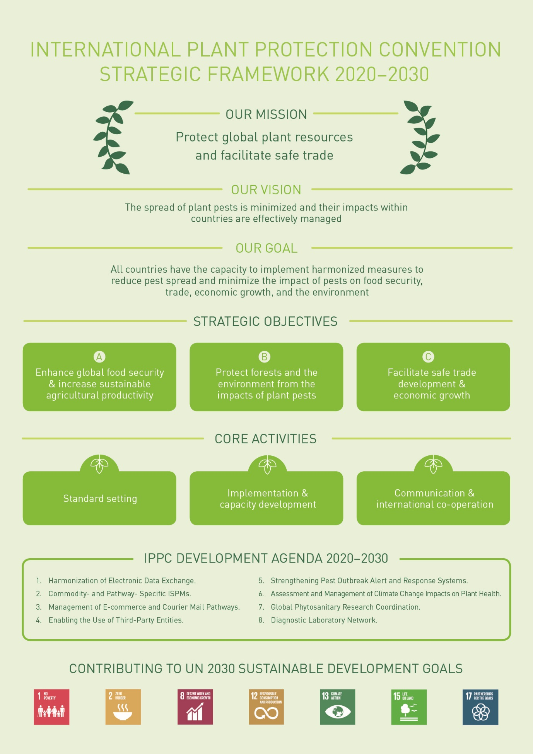

2. Introduction
- The International Plant Protection Convention (IPPC; herein also referred to as “the Convention”) is the global international treaty for protecting plant resources (including forests, aquatic plants, non-cultivated plants and biodiversity) from plant pests and for facilitating safe trade through common and effective action to prevent the spread and introduction of plant pests and to promote appropriate measures for their control.
- The IPPC is deposited with and administered through the Food and Agriculture Organization of the United Nations (FAO). It was established as a convention in 1951, it entered into force in 1952 and was amended in 1979 and 1997. The Commission on Phytosanitary Measures (CPM, herein referred to as “the Commission”), is the governing body for the IPPC. The work plan approved by the Commission is administered by the IPPC Secretariat.
- The scope of the IPPC extends beyond the protection of all cultivated plants to the protection of natural flora and plant products. It includes both direct and indirect damage by pests and plants as pests (collectively called pests under the IPPC). It also covers vehicles, aircraft and vessels, containers, storage places, soil and other regulated articles that can harbour or spread pests.
- The IPPC provides a framework and a forum for international cooperation, harmonization of action, and technical exchange between contracting parties. International standards developed within the framework of the Convention, under the auspices of the IPPC Secretariat, are the only international standards for phytosanitary measures recognized by the World Trade Organization’s (WTO’s) Agreement on the Application of Sanitary and Phytosanitary Measures (the SPS Agreement).
- Implementation of the IPPC involves collaboration by national plant protection organizations (NPPOs), which are the official services established by contracting parties to carry out the functions specified by the IPPC, and regional plant protection organizations (RPPOs), which act as coordinating bodies at a regional level to achieve the objectives of the IPPC.
- The Commission comprises delegates from each of the contracting parties: 183 as of July 2019. The Commission meets during March or April each year, usually at FAO headquarters in Rome, Italy, to promote cooperation and agree on a work plan to implement the objectives of the IPPC. In particular, the Commission:
- reviews the state of plant protection around the world
- identifies actions to control the spread of pests into new areas
- develops and adopts international plant health standards and recommendations
- approves programmes to support implementation of the IPPC and adopted standards
- cooperates with international organizations on matters covered by the Convention.

- The Convention has become particularly significant and relevant in light of the evolving plant health risks associated with the increasing movement of plants and people, climate change, and the spread of pests, and the need to ensure food security, to protect plant resources and biodiversity, and to support the safe expansion of global trade and economic growth opportunities for all.

3. Plant pests

- The introduction and spread or outbreak of plant pests has significantly affected food security and economic prosperity. A vast range of plant pests threaten global food production (including production of animal feed), the productivity and biodiversity of forests and the wild flora of the natural environment. Some historical impacts of plant pests are well known, such as:
- citrus greening disease (caused by ‘Candidatus Liberibacter asiaticus’) on citrus in parts of the Americas, Asia and Africa
- coffee leaf rust (caused by Hemileia vastatrix) on coffee in Sri Lanka, Central America and Brazil
- Dutch elm disease (caused by Ophiostoma ulmi) on elm in Europe and the United States of America
- fall armyworm (Spodoptera frugiperda) in the Americas and more recently in Africa and Asia
- fusarium wilt on bananas (caused by Fusarium oxysporum f.sp. cubense) in Latin America, Asia, Australia and Africa
- gypsy moth (Lymantria dispar) in the north-eastern forests of North America
- phylloxera (caused by Daktulosphaira vitifoliae) on grapes in Europe and the United States of America
- potato blight (caused by Phytophthora infestans) on potatoes in Ireland
- South American leaf blight of rubber (caused by Microcyclus ulei) on rubber in Brazil
- symptoms caused by Xylella fastidiosa across a broad range of hosts in parts of the Americas, Asia and Europe
- yellow rust (caused by Puccinia striiformis) on wheat in North America, Europe, Asia, North and East Africa.

- Although the impacts of pests range from negligible to extremely high, it is often difficult to fully assess these impacts ahead of time. Preventing pests from spreading and establishing in new countries and regions is invariably more cost effective than maintaining long-term control, containment, eradication, or the consequences of unchecked impact. Some illustrative case studies of pests can be found in the text boxes (Pest Case Studies 1–4).
Pest Case Study 1: Halyomorpha halys, the brown marmorated stink bug (BMSB)
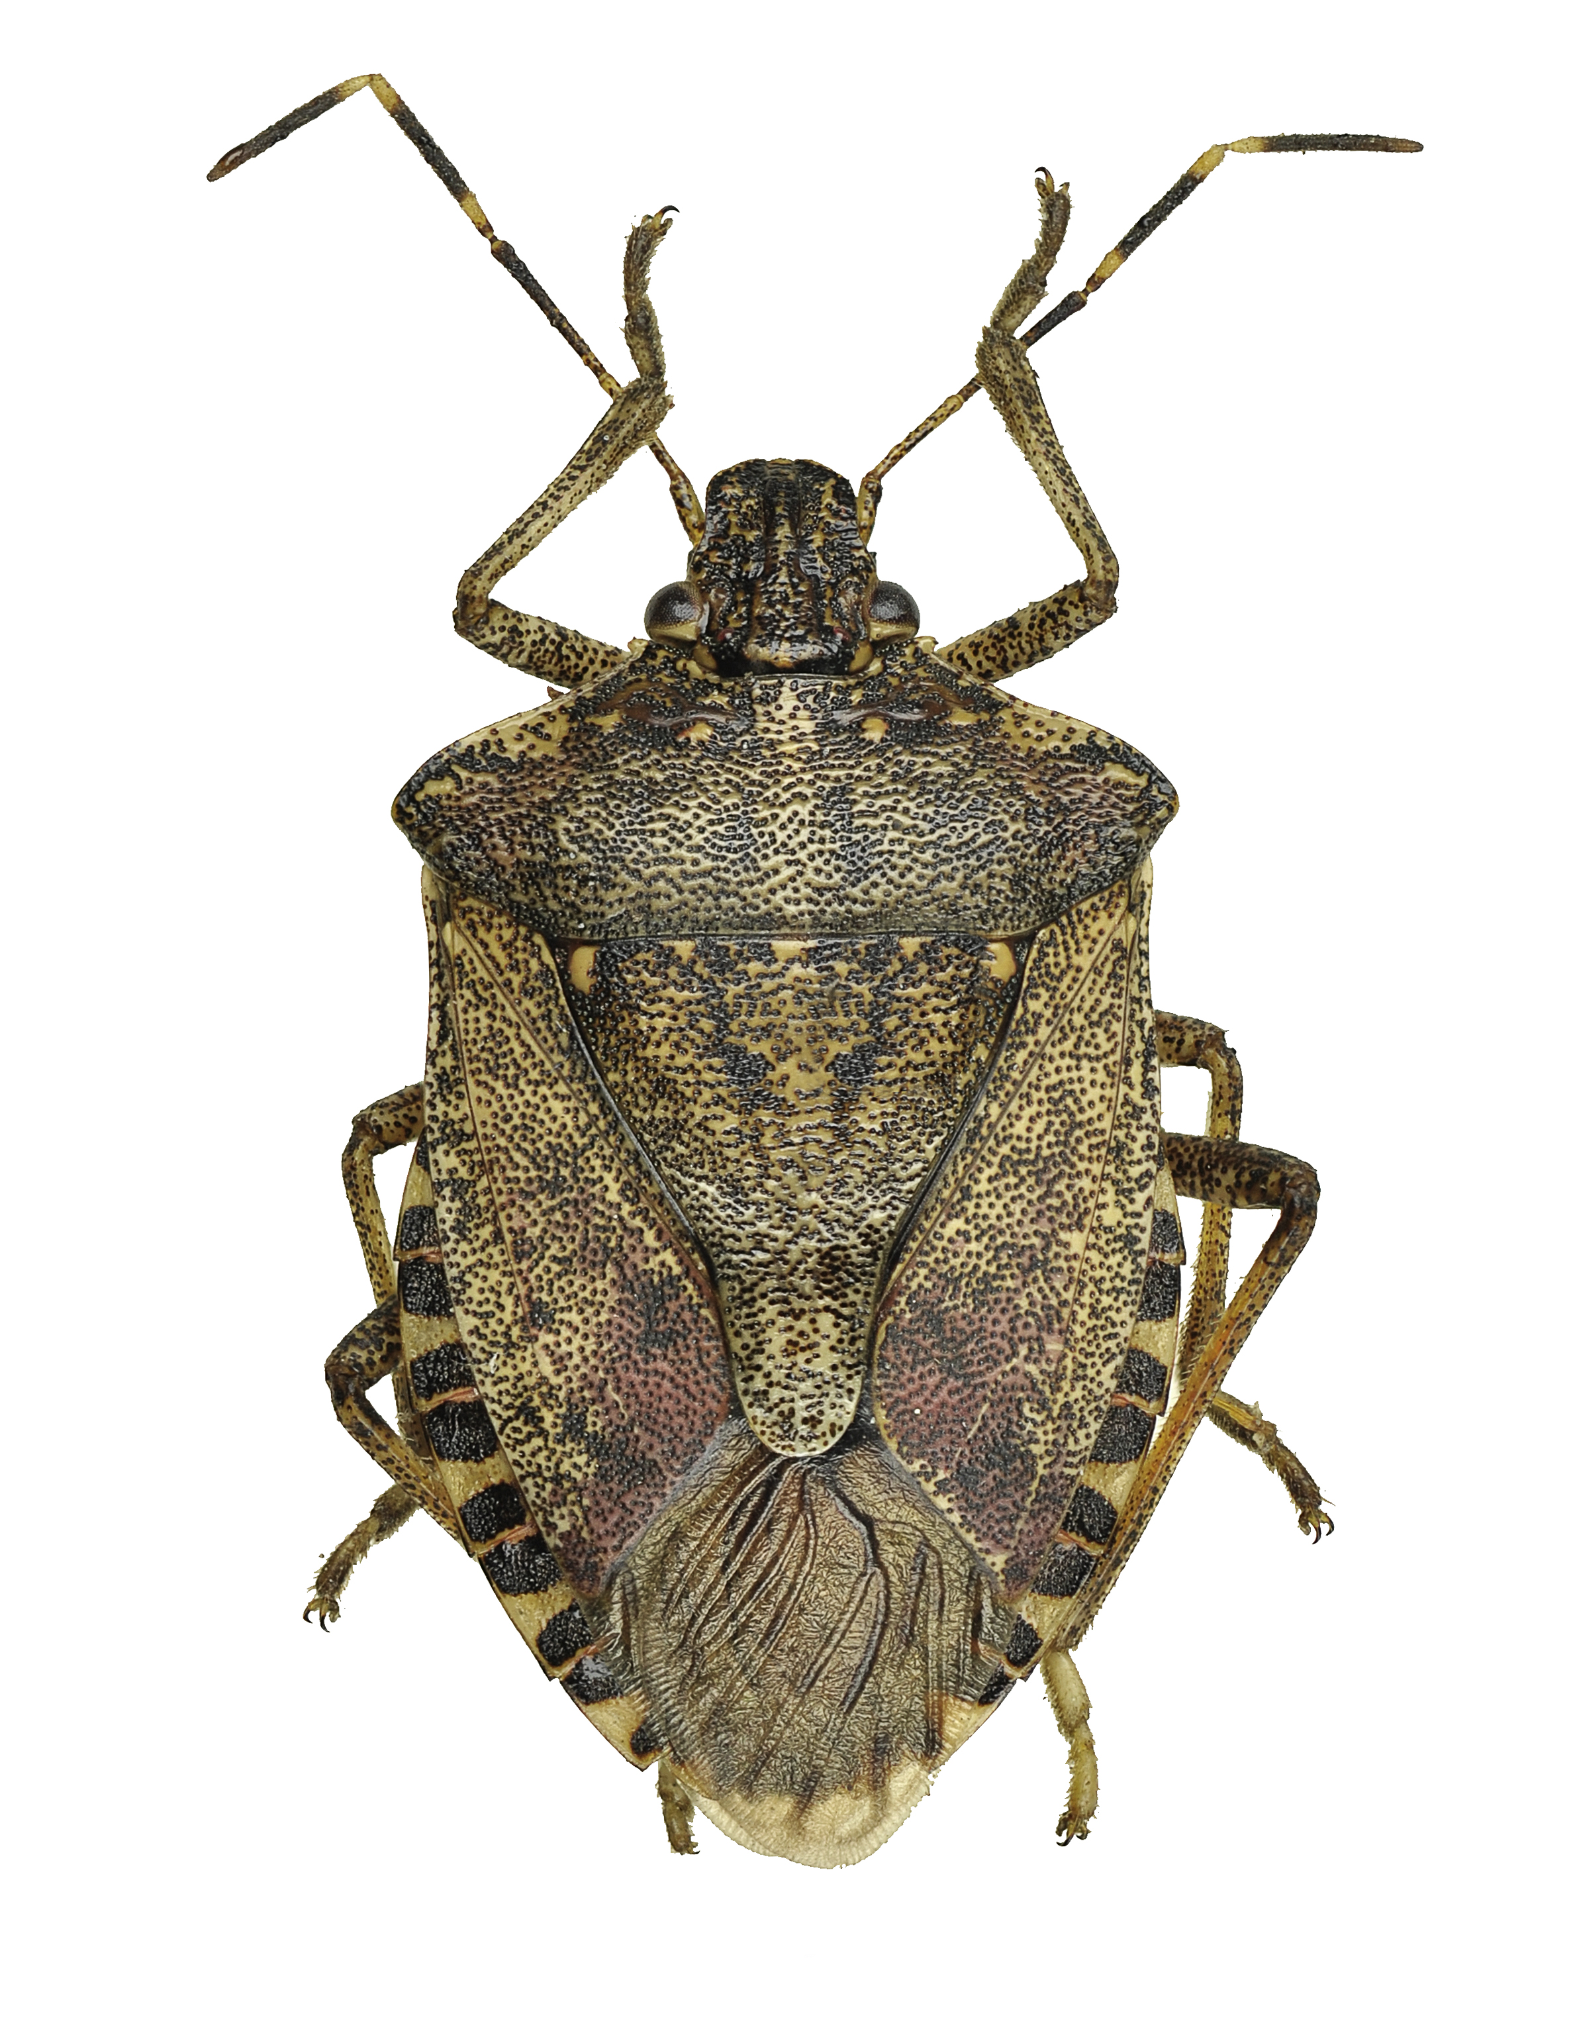Halyomorpha halys, the brown marmorated stink bug (BMSB), is native to Asia. It has invaded both Europe and the United States of America, where it has spread quickly. In the mid-Atlantic region, serious losses have been reported for a range of crops. Hosts in invaded areas include many fruit trees, vegetables, row crops, ornamentals and native vegetation. It is associated with economically significant crop losses and public nuisance in both its native and invaded areas, as well as being a vector of Phytoplasma diseases. In autumn, adults can aggregate in very large numbers in houses and other artificial structures, emitting a pungent smell when disturbed. This aggregative association with artificial structures (such as shipping containers) also increases the likelihood of long-distance transport of BMSB as a contaminating pest. The Commission has adopted an International Standard for Phytosanitary Measures (ISPM) on the international movement of used vehicles, machinery and equipment to minimize the probability of introduction of contaminating pests on these pathways.

4. Operating environment 2020–2030
- To plan for the future, it is important to try to envision what the future might look like. Rather than attempt to make specific predictions, a useful approach is to identify and extrapolate emerging major trends and some of their drivers. These provide a general picture of the future that this strategic framework needs to address, both in terms of challenges and opportunities. Some of the major trends expected to be present during this period, with relevance to the Commission and its contracting parties, are described below.

4.1 Increasing and more diversified trade
- Global trade in forestry, food and agricultural products has tripled in value terms since the turn of the millennium and it is expected that this trend will continue. Political stability will tend to support trade growth, while instability will be a disruptor. In 2015, FAO noted that the global trade in food products will continue to expand rapidly, but that the structure and pattern of trade will differ significantly by commodity and by region. FAO also predicted that “greater participation in global trade is an inevitable part of most countries’ national trade strategies”, but that “the process of opening up to trade, and its consequences, will need to be appropriately managed if trade is to work in favour of improved food security outcomes”. In addition, how commodities are traded is anticipated to change. The geographical separation of individual steps in the production chains will affect trade and require countries to cooperate. Specific developments in this area are expected to be as follows:
Pest Case Study 2: Xylella fastidiosa (Xf)
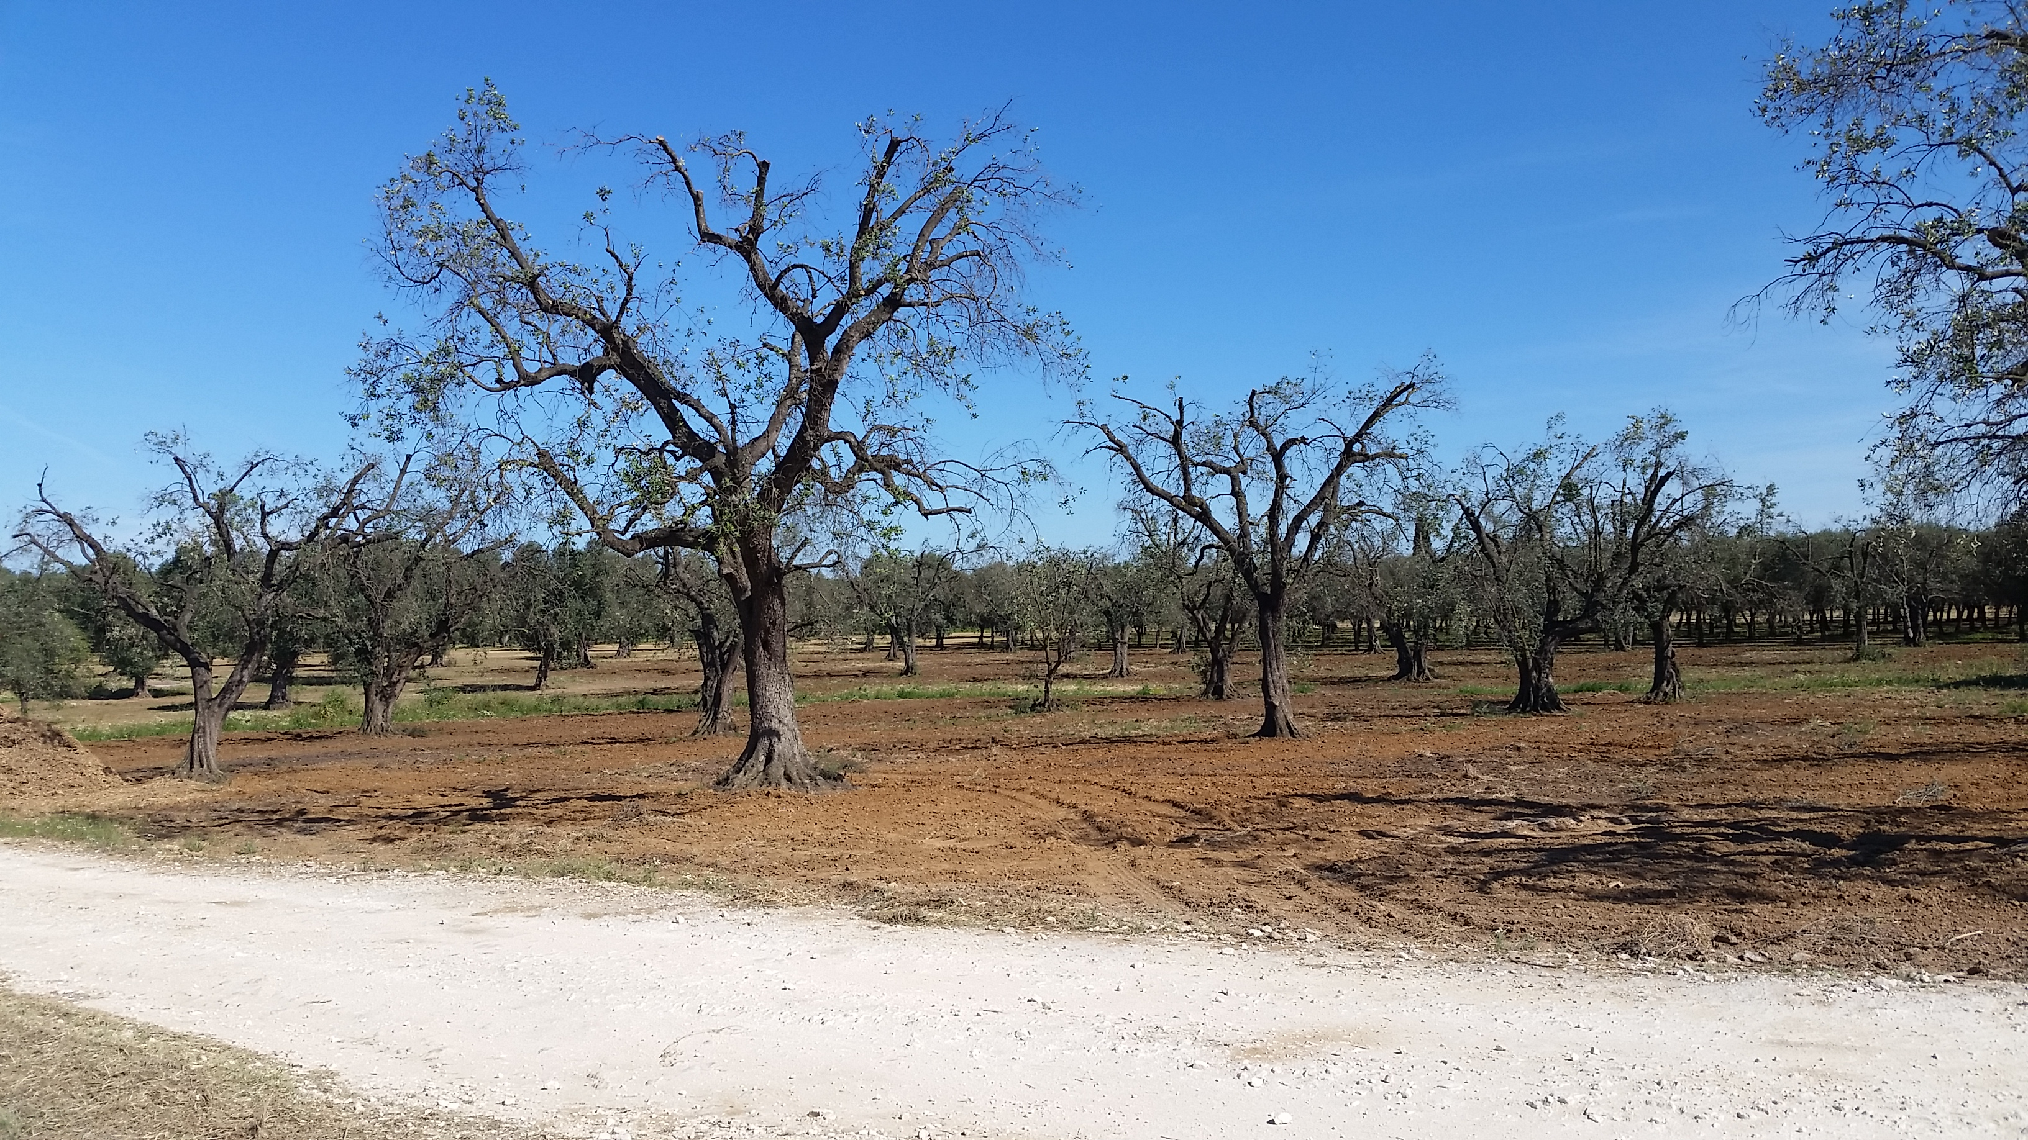Xylella fastidiosa (Xf) is the causal agent of Pierce’s disease of grapevines, and of diseases of many other important crops (including citrus, avocado, olives and stonefruits), ornamental and forestry plants. The bacterium is vectored by xylem-feeding insects, particularly sharpshooters and spittle bugs. The host range of Xf is wide and is expanding rapidly as it encounters new hosts and new vectors in invaded ranges. Over 500 plant species can be affected by one or more of its subspecies or strains. In the 1990s, a strain emerged in Brazil as citrus variegated chlorosis disease (CVC). This disease rapidly became one of the most economically important diseases of orange production, causing annual losses of several million dollars (USD). Xylella fastidiosa has now emerged and spread in some European countries, causing a serious outbreak on olives. In Italy, it is rapidly spreading and threatening the traditional olive industry and associated activities and traditions. This disease is now causing serious economic, environmental, social and trade impacts. Forty million hectares of olive trees in the Mediterranean basin are in real danger of being destroyed by this disease with serious potential impact on national economies and the livelihoods of farmers. The Commission has adopted a diagnostic protocol for Xylella fastidiosa.

  - Governments will continue to pursue economic growth strategies that rely on expanding trade and seeking access to new markets.
  - Some countries may transition away from agriculture towards tourism or a more industrialized base for their economies.
  - The volume and speed of passenger and freight movements will continue to increase, presenting the potential for pests to move faster than ever before.
  - Complex global supply–production chains will result in goods crossing multiple borders for processing before being sold as finished products. The importance of traceability and phytosanitary security will increase.
  - Trading directly with consumers (including e-commerce) will continue to expand rapidly, decreasing the size and increasing the number of consignments to be assessed for phytosanitary risk.

4.2 Structural and operational changes in the way national plant protection organizations work
National plant protection organizations have undergone considerable changes in the past 20 years. The increase in the volume and diversity of traded commodities requiring phytosanitary certification or checking at borders has led to considerable operational changes for NPPOs. Developments in data processing and transmission have made it possible to communicate phytosanitary-relevant information in real time. Producers and other stakeholders have increasingly understood the benefits of plant health standards and procedures to their business prospects. They are increasingly willing to cooperate with NPPOs to streamline production and regulatory activities. As public funding comes under pressure, NPPOs will need to make further efficiency gains and increase collaboration to achieve necessary plant health goals. The main developments in this area are expected to be as follows:
Pest Case Study 3: Bursaphelenchus xylophilus, the pine wood nematode (PWN)
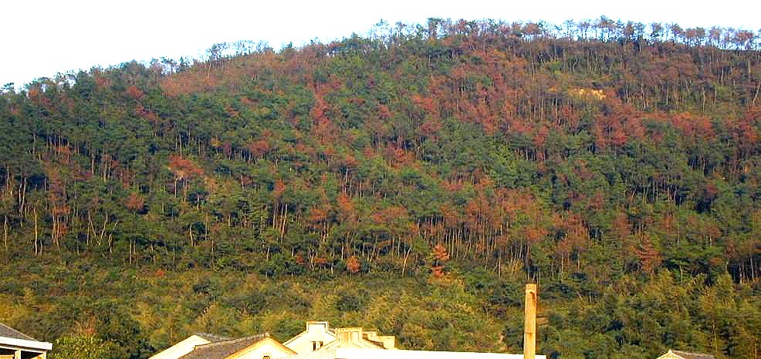Bursaphelenchus xylophilus, the pine wood nematode (PWN), is the causal agent of the economically and environmentally significant “pine wilt disease” in species of pine (Pinus spp.). It is native to North America and is vectored by species of the wood-inhabiting longhorn beetle Monochamus. Pine wood nematode was introduced into Asia (Japan) at the turn of the twentieth century via timber exports, and has now spread into China and the Republic of Korea. It was first detected in Europe (Portugal) in 1999 and now threatens to spread across Europe. The spread of the disease from tree to tree is primarily through the vector (Monochamus spp.), and the emergence of adult beetles from PWN infested wood is believed to be the most likely method of introduction. Local species of Monochamus that can vector PWN are found throughout the Northern Hemisphere. As well as affecting forestry production, PWN infestation can also have significant environmental repercussions, such as biodiversity loss or increased erosion in alpine environments. In the Republic of Korea, it is estimated that economic losses in forest and crop production have been over USD 600 million over 20 years, with additional ecological and social impacts. Prior to the adoption of the standard related to the use of wood packaging material (ISPM 15), wood packaging was considered to be the main pathway for the spread of PWN. The Commission has adopted a set of ISPMs to assist in PWN management.
  - Border clearance processes will be simplified to get products to consumers faster, creating challenges for import inspection. The WTO Trade Facilitation Agreement will support these changes.
  - Importing industry participants will increasingly take responsibility from exporting countries for ensuring that pest risks are managed, through private standards and commercial arrangements.
  - Changes will occur in production practices (e.g. vertical farming), enabling new approaches to pest management.
Pest Case Study 4: Spodoptera frugiperda, known as fall armyworm (FAW)
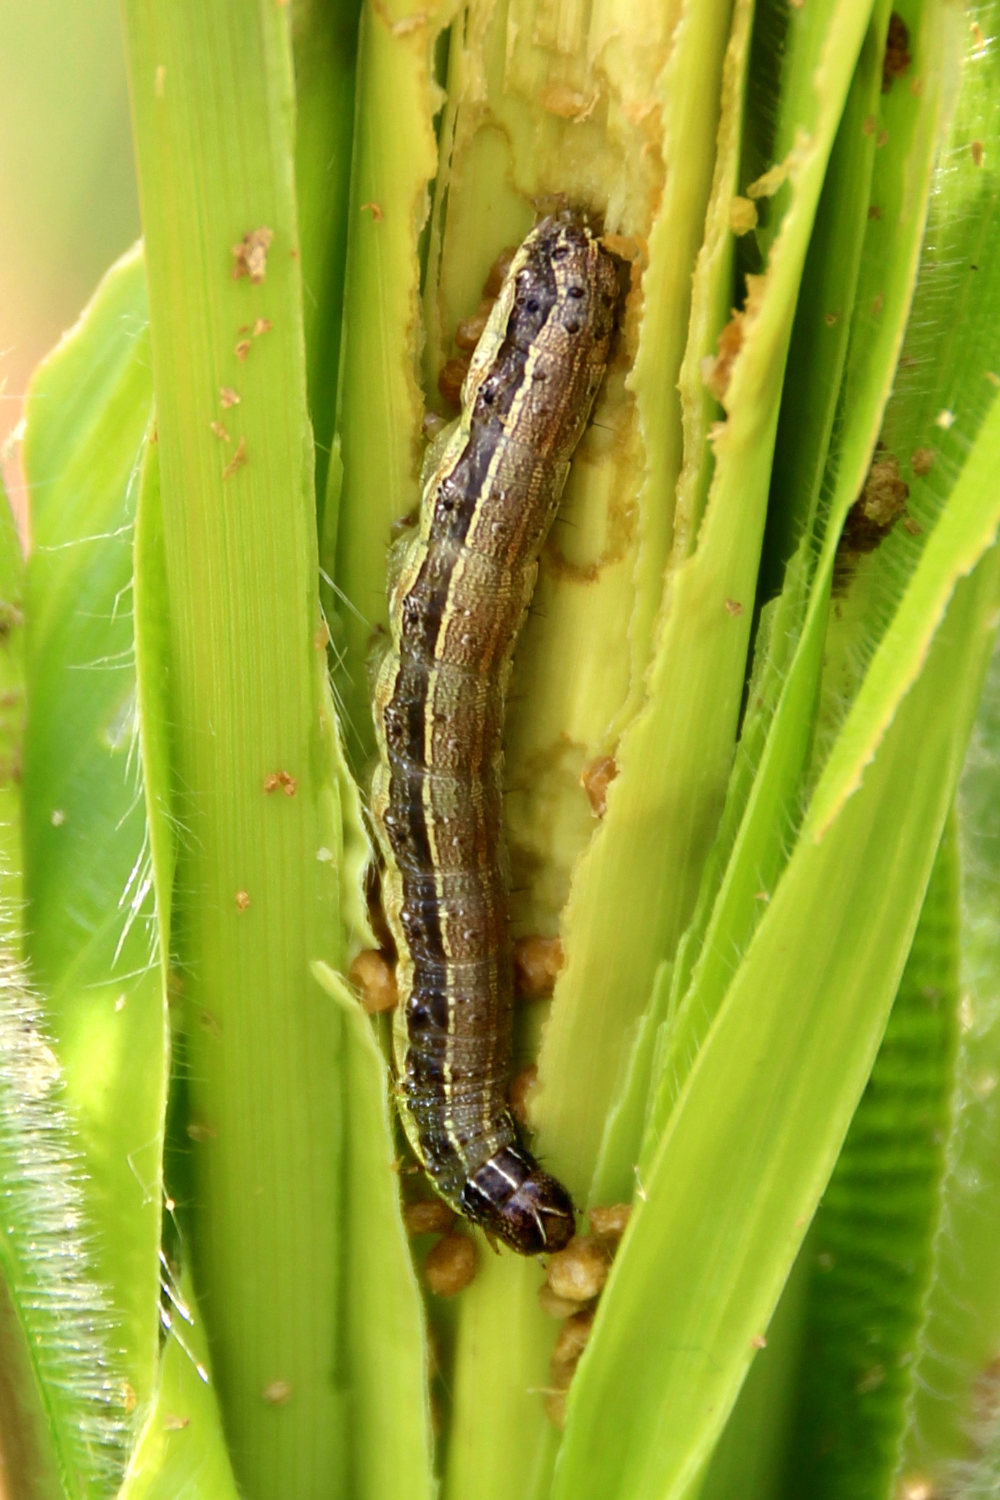
Spodoptera frugiperda, known as fall armyworm (FAW), is an insect that is native to tropical and subtropical regions of the Americas. In its larval stage, it can cause significant damage to crops if not well managed. It prefers maize, but can feed on more than 80 other species of plants, including rice, sorghum, millet, sugarcane, vegetable crops and cotton. Recently it has become a major concern in Africa. Within only a few years, since its first occurrence in January 2016, it has quickly spread across virtually all of sub-Saharan Africa. In addition, it has spread to India and China in 2017–2018. Because of increasing trade and the moth’s strong flying ability, it has the potential to spread further. Farmers and NPPOs need substantial support to sustainably manage the pest in their cropping systems. It has the potential to significantly reduce food production, with a yield reduction in cereal crops of up to 50 percent. In Africa, FAW has been devastating millions of hectares of maize and sorghum and threatens the food security of about 200 million people.
  - Communication, data exchange and management capabilities will enable easier access to specialist expertise and sharing of information for pest risk analysis.
  - Funding of public sector and international organizations will become more constrained, putting pressure on agencies to innovate to find efficiencies in the management of pest risk (e.g. targeted inspection and other risk-based interventions).
  - The public will continue to demand transparency and “‘open government”. To maintain their public-agency “social licence to operate”, NPPOs will therefore need to communicate more effectively about what they do, why they do it, and the public benefit.
  - Importing countries will expect higher levels of protection, and disagreements on appropriate phytosanitary measures are expected to intensify, slowing market access negotiations or disrupting existing trade.
  - Consumer demand will continue to increase for fresh fruits and vegetables free of pesticide residues. This will become more challenging as pests spread across borders and will require new improved approaches to the management of pest risk by exporting and importing countries.
  - The role of RPPOs to develop regional standards and then assist less developed countries to implement them will become increasingly important. RPPOs and NPPOs may have to adapt their current operating models.

4.3 Scientific and capacity development
- Although overall research in traditional, plant-health related disciplines is expected to decline, it is expected that a number of research developments will significantly affect plant health activities. Continuing developments in molecular biology and genetic sequencing are expected to deliver new tools but also new challenges for plant health diagnostics. Developments in information technology and remote sensing applied to plant health, and increased data analytics capabilities, will open doors for new approaches in surveying and monitoring for plant pests. Some of these positive developments will be constrained by capacity limitations in developing countries and especially in the least developed countries. The capacity of such countries needs to be strengthened to allow them to participate in world trade. The main developments in this area are expected to be as follows:
  - Scientific advances will allow faster detection of pests and provide new methods to manage pests and their spread.
  - New research methods may contribute to the development of pest resistant plants.
  - Detection of new pests without reliable information on their potential to cause harm will present challenges to risk management.
  - “Big data” and advanced analytical tools will provide new opportunities to detect patterns and to target pest surveillance and border inspections.
  - Differing capacities among countries to monitor and respond to pest risks will impact trade and put neighbouring countries at risk.
  - Less developed countries may continue to face difficulties acquiring technology, retaining expertise, and setting up viable phytosanitary systems for participation in agricultural trade. However, some technologies may become cheaper and more universally available, which would benefit developing countries.

4.4 Impacts of climate change on plant health
- The mitigation of climate-change related impacts on agriculture and plant health will present a major challenge to NPPOs and international organizations in the plant health field. Changes in food production patterns and trade will become apparent over the next two decades. The resulting changes in plant health, such as anomalies in pest epidemiology and frequent expansion of pest distributions, will provide challenges, especially in the areas of surveillance, monitoring and pest risk analysis. The danger of pests adapting to changed climate parameters may cause new pest risk to major staple crops. The main developments in this area are expected to be:
  - Climate change will result in more frequent extreme weather events, potentially leading to altered locations and methods of food production around the world.
  - Climate change will affect pest epidemiology, pest distribution and host distribution, and thereby pest impacts.
  - Water security will become an increasing challenge for more regions in the world, affecting where crops are grown and marketed.
  - New or mutated pests or their more aggressive strains will emerge and have a significant impact on crop productivity and quality, the environment and trade.

5. Mission, vision and goal of the International Plant Protection Convention (IPPC)

- To implement the IPPC, the Commission has the following mission, vision and goal:
Mission
Protect global plant resources and facilitate safe trade.
Vision
The spread of plant pests is minimized and their impacts within countries are effectively managed.
Goal
All countries have the capacity to implement harmonized measures to prevent pest introductions and spread, and minimize the impacts of pests on food security, trade, economic growth, and the environment.

6. Core activities

6.1 Standard setting
- The WTO SPS Agreement recognizes standards developed under the auspices of the IPPC Secretariat as the only international standards for plant health. International Standards for Phytosanitary Measures (ISPMs) are adopted by the Commission and come into force once countries establish aligned requirements within their national legislation. The IPPC standards are recognized as the basis for phytosanitary measures applied in trade by the members of the WTO.
- The IPPC standard setting work is led by the Commission’s Standards Committee. The Standards Committee is supported by various technical panels, expert working groups, and the IPPC Secretariat.
- Three main types of standards have been developed to provide an internationally agreed approach for the harmonization of phytosanitary regulations and to guide and assist NPPOs in performing their various functions:
- Foundational standards – These establish internationally accepted principles and approaches for NPPOs to undertake such activities as pest risk analysis, establishing pest free areas, surveillance, establishing a phytosanitary certification system, and pest reporting.
- Phytosanitary treatments (ISPM 28 (Phytosanitary treatments for regulated pests) with its annexes) – These establish internationally accepted treatments for pests on commodities, such as irradiation, fumigation and temperature treatment.
- Diagnostic protocols (ISPM 27 (Diagnostic protocols for regulated pests) with its annexes) – These are targeted at specific pests and establish the internationally accepted method for accurate diagnostic identification.
- In addition, CPM recommendations are also adopted on a range of topics that are highly relevant to contracting parties but not deemed suitable for the development of an ISPM. The Commission is now starting to develop more ISPMs for specific commodities and pathways. Examples include ISPM 15 on the international movement of wood packaging material, ISPM 38 on the international movement of seeds and ISPM 41 on the international movement of used vehicles, machinery and equipment. Developing a suite of such ISPMs would fill a significant need when used as the starting point for market access agreements. They have the potential to significantly simplify bilateral trade negotiations. Similarly, ISPMs for pathways (such as used vehicles, machinery and equipment) will do much to limit the spread of pests, including those that are invasive alien species that commonly spread as contaminating pests.
- The Standards Committee works hard to ensure that ISPMs are not only based on science and are technically robust, but that they are also practical and can be implemented in real situations. Increasingly, the IPPC is inviting industry bodies to participate in expert working groups to provide advice on development of ISPMs. Industry perspectives will further enhance the value of ISPMs, but some conflicts of interest may also arise and these need to be recognized and managed.
6.1.1 2030 key result areas
- SS1: Prioritized commodities and pathways are covered by commodity- or pathway-specific ISPMs adopted or being developed by the Commission.
- SS2: NPPOs base their phytosanitary systems and import requirements on adopted ISPMs.

6.2 Implementation and capacity development
- The IPPC is typically referred to as a standard setting body. However, the IPPC has long recognized the futility of setting standards without also supporting capacity development to enable the IPPC and its standards to be effectively implemented by contracting parties.
- Within each contracting party, fully functioning NPPOs are charged with operating an effective national system to prevent the introduction and spread of pests. Delivery of the system often requires the joint effort of multiple government agencies and the private sector. The phytosanitary capacity evaluation tool was developed by the Commission many years ago to help countries evaluate their capacity to implement the IPPC. This forms the basis for many capacity development plans, and also provides an insight into global capacity needs and programmes.
- Through the suite of ISPMs and capacity development programmes, the Commission provides the framework for the NPPOs and the support to help NPPOs build capacity to carry out their functions. Examples of national capacity include the ability to establish and operate an import regulatory system, the ability to conduct pest risk analysis, pest surveillance and pest eradication operations, and the ability to operate an export system capable of providing official assurances through phytosanitary certification.
- The Commission collaborates with donor partners and contracting parties to help NPPOs to develop the required capacity. This collaborative work is essential for countries to capitalize on the economic growth opportunities available through trade development and to protect their agricultural production and natural resources.
- In 2014, the Commission agreed to significantly strengthen its focus on implementation of the IPPC and ISPMs. Since then:
  - the first major implementation pilot programme has been established, focused on pest surveillance
  - the IPPC Secretariat has been reorganized to focus more strongly on implementation and capacity development
  - a new subsidiary body has been created, the Implementation and Capacity Development Committee, charged with oversight of the long-term IPPC capacity development strategy.
- Within the Implementation and Capacity Development Committee, subgroups have been established to manage and govern dispute avoidance and settlement and the implementation review and support system.
- Substantial efforts are being focused on implementation and capacity development; however, they are limited by the extra-budgetary resources that can be secured (additional to the FAO regular programme funds). Fortunately, development agencies are willing to assist with programmes to increase the capacity of countries to improve their economy through trade, and to provide support to communities to manage pest problems. Capacity development projects can have a major positive impact on the ability of NPPOs to discharge their responsibilities if their needs are well defined through the IPPC phytosanitary capacity evaluation system tool. The project to develop and implement a global ePhyto (electronic phytosanitary certificate) hub and generic ePhyto national system funded by the Standards and Trade Development Facility and contracting party contributions is an outstanding example of this (see inset box).

The “ePhyto Solution Project” was developed to provide all IPPC contracting parties that are interested, developed or developing alike, with the opportunity to exchange phytosanitary certificate information digitally. The project established a central hub as a harmonized exchange tool to facilitate the exchange of electronic certificates as an alternative to the current practice of exchanging paper certificates, and also a simple generic system (generic ePhyto national system) for developing countries for the production, sending and receipt of electronic phytosanitary certificates. The establishment of these tools will improve the security of official communications between countries and facilitate trade flows. It will also eliminate the cost and complexity of countries developing individual systems for electronic data exchange and the necessity to negotiate exchange protocols on a country by country basis.

6.2.1 2030 key result areas
- ICD 1: The state of plant health in the world is understood, needs are known and mechanisms to facilitate action are functioning.
- ICD 2: The phytosanitary capacity evaluation tool has been widely used by contracting parties to understand their strengths and weaknesses and develop plans to address capacity deficiencies.
- ICD 3: The IPPC Secretariat is resourced to help contracting parties access assistance to address phytosanitary capacity needs.

6.3 Communication & international cooperation
- The communications efforts of the Commission are aimed at ensuring understanding of the potential for serious negative impacts from introduced pests worldwide. This must be understood not just by the plant health community but also by key audiences such as the general public, national governments, and decision makers (policy and financial) if it is to be recognized that plant health is an important national and global priority that justifies and receives appropriate and sustainable support.
- These communication efforts are guided by the IPPC communications strategy. The four objectives of the IPPC communications strategy are to:
  - increase global awareness of the importance of the Convention and of the vital importance to the world of protecting plants from pests
  - highlight the role of the Commission, supported by the IPPC Secretariat, as the sole international plant health standard setting body with the objective of helping to ensure the safe trade of plants and plant products
  - improve the implementation of ISPMs
  - support the activities of the IPPC Secretariat’s resource mobilization programme.

- The Commission and IPPC Secretariat make use of many different opportunities to reach out internationally so that the IPPC’s mission is well understood. Annual themes were introduced to promote specific aspects of the IPPC mandate on an annual basis. For the period 2016–2019, the IPPC work programme focused on the following themes:
  - 2016 Plant Health and Food Security
  - 2017 Plant Health and Trade Facilitation
  - 2018 Plant Health and Environmental Protection
  - 2019 Plant Health and Capacity Development.

- In addition, through the efforts of contracting parties to the IPPC, the United Nations (UN) proclaimed 2020 the International Year of Plant Health (IYPH). The Commission, and the IPPC Secretariat on its behalf, will contribute to this by developing an environment in which to celebrate the IYPH2020 programme at national, regional and global level.
- The IPPC Secretariat, on behalf of the Commission, maintains strong links with treaties and organizations that share common interests (e.g. WTO, Convention on Biological Diversity). These relationships can range from informal flexible arrangements to highly defined relationships. This cooperation is essential to mainstream plant health considerations and policies into the general debate on environmental and development issues. A higher level of cooperation with relevant international organizations is particularly needed with regard to climate change and capacity building to ensure that the evaluations of climate change impacts incorporate pest related impacts and that the attention of potential donor organizations is drawn to the phytosanitary capacity building needs of developing country NPPOs.
- The IPPC Secretariat has strong relationships with all RPPOs in facilitating implementation of the IPPC by contracting parties. National or regional FAO offices also play an important role in the implementation of the IPPC and its standards.
6.3.1 2030 key result areas
- CIC 1: The IPPC Secretariat is effectively communicating phytosanitary issues and the importance of plant health.
- CIC 2: The IPPC Secretariat successfully cooperates with other international organizations and global forums to further increase the visibility of the Convention and its objectives in international policies.
- CIC3: The IPPC Secretariat is effectively coordinating with FAO to ensure that national or regional FAO offices play an important role in the implementation of the IPPC and its standards.

7. Strategic objectives
- As an international body, the Commission is focused on outcomes at a global level. The IPPC is the primary international treaty for protecting global plant resources (including forests, non-cultivated plants and biodiversity) from plant pests and for facilitating the safe movement of plants, plant products and other regulated articles in international trade. The core purpose of the IPPC is to prevent the international spread of plant pests and reduce their impact, but this only matters if it enables the achievement of broader outcomes. Achieving the purpose of the Convention contributes positively to outcomes that are important to the entire world.
- The Commission has identified three strategic objectives that capture the major contributions it makes in a global context. While contracting parties and RPPOs cannot be completely accountable for any of the objectives, they can play an important role, and must ensure that efforts stay focused on achieving results in these areas. The three strategic objectives are equally important and the Commission’s work programme must be balanced to ensure that the collective work programme contributes to the achievement of all three objectives.
- The Commission’s three strategic objectives are to:
  - enhance global food security and increase sustainable agricultural productivity
  - protect the environment from the impacts of plant pests
  - facilitate safe trade, development and economic growth
- These objectives are described below (A–C), including the corresponding key result areas. The key result areas outline the impact the Commission expects to see under each strategic objective when the Commission, contracting parties, RPPOs and partner organizations successfully work together to deliver this strategic framework.
- The IPPC, as a convention established under FAO Article XIV, plays a critical role in supporting each of these strategic objectives through its associated programmes, standards and actions.
- All IPPC core activities contribute to these strategic objectives. The IPPC 2020–2030 development agenda initiatives will also make a significant contribution. Delivery of the development agenda, however, will depend on whether sufficient resources can be secured through the FAO regular programme funding and other financial sources.
- Within the framework of the IPPC, the contracting parties and RPPOs play a critical role in advancing the implementation of the Convention at a national and regional level. The NPPOs of contracting parties are important partners to the Commission in terms of developing concrete actions at a national level to fulfil their mandated role, implement the IPPC and ISPMs, and prevent the spread of pests that can affect agriculture, food security and biodiversity. The NPPO is the competent authority for a country: it is responsible for providing and receiving government to government phytosanitary assurances and should be resourced to fulfil its functions competently. RPPOs are also critically important in coordinating these efforts at a regional level and especially in developing and implementing capacity building activities. In addition, RPPOs may be able to undertake specific tasks in implementing this strategic framework on behalf of the Commission. For this reason, effective partnerships with contracting parties and RPPOs are essential for achieving progress with these strategic objectives.

7.1 Enhance global food security and increase sustainable agricultural productivity
- High impact pests can challenge primary production, food and feed supplies in all nations. In 2006, Oerke estimated global crop losses due to pests varied from about 50 percent in wheat to more than 80 percent in cotton production, with estimated losses of 26–29 percent for soybean, wheat and cotton, and 31, 37 and 40 percent for maize, rice and potatoes, respectively. The losses caused by the spread of a new pest into new areas or crops can be much more catastrophic, sometimes causing total loss of crops until new strategies can be deployed to combat the pest. As pest spread is managed, crop losses are reduced and food security increased.
- Food security – the availability of and access to adequate food supplies – is affected by many factors, including population dynamics, land-use choices, climate change, crop production practices, management of pests, access to genetic resources, new production technologies, trade, food aid, and rural development.
- Demographic trends may exert pressure on food security globally but particularly in developing regions. Overall, FAO estimates that global agricultural output needs to expand by about 70 percent to meet the food needs of the population expected in 2050. Crop production is expected to continue to account for over 80 percent of the world’s food.
- Crop production intensification and pest management strategies need to be more sustainable than current or historical ones (i.e. they must value and enhance ecosystem services such as soil nutrient dynamics, pollination and water conservation). They must also build on elements that include integrated pest management, biological control of pests, conservation agriculture, and access to and sustainable use of plant genetic resources, while also reducing soil, air and water pollution.
- The impact of plant pests on food security is particularly evident in the developing world where plant health regulatory frameworks often lack capacity. Contracting parties should be ensuring that their plant health regulatory frameworks are appropriately structured, resourced and implemented to avoid pests putting their food security at risk. The Commission, and the IPPC Secretariat on its behalf, can provide support to contracting parties so that they have the skills, capacity and knowledge they need to do this.
- If pest spread is reduced and existing pests are better managed, crop productivity will increase and production costs fall. This would result in significant economic benefits to growers, importers, consumers and governments. Growers would be more able to produce food for their own consumption, domestic supply and exports.
7.1.1 2030 key result areas
- A1: All NPPOs have effective pest surveillance systems in place for timely detection of new pest arrivals and monitoring spread.
- A2: All NPPOs have strong capacities to monitor, detect, diagnose, report, and prepare rapid responses to pest outbreaks, so that these pests do not have major impacts on food supplies and they do not spread and thereby threaten other regions and trading partners.
- A3: A plant health emergency response system is in place that facilitates timely action against new pest incursions and supports countries with emergency response systems tools and knowledge.
- A4: Sustainable pest risk management options, such as systems approaches, are implemented widely to minimize pest impacts right through the production process and harvesting, and to minimize the need for end-point treatments.
- A5: All NPPOs have pest risk analysis capacity in place to identify and mitigate pest risks to crop production.
- A6: Pest risk prevention is integrated throughout the production, processing and trade chain of plants and plant products.

7.2 Contribution to the UN 2030 Sustainable Development Agenda
- The work of the IPPC to enhance global food security and increase sustainable agricultural productivity strongly supports the UN 2030 sustainable development goals 2 and 12.
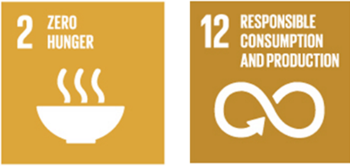

Goal 2. End hunger, achieve food security and improved nutrition and promote sustainable agriculture.
Goal 12. Ensure sustainable consumption and production patterns.

7.3 Protect the environment from the impacts of plant pests
- Awareness has increased of the significant and devastating impact that invasive alien species can and do have on terrestrial, marine and freshwater environments, and on agriculture and forests. The IPPC and its associated standards and operational framework are applied to address environmental concerns related to plant biodiversity and emerging problems associated with invasive alien species that are plant pests. Continuing concern about climate change and the protection of forests and the environment compels the Commission, RPPOs and contracting parties to be aware of the potential for pest distribution and impacts to change with the changing climate. Governments will need to match their policies on minimizing harm to forests and the environment, and minimizing climate change and the spread of invasive alien species, with the need to maintain sustainable food production in order to ease poverty and feed their populations. Identification and promotion of environmentally sustainable measures to manage pests (including pest plants) will be needed.
- As climate change impacts are felt more widely, more frequent extreme weather events have the potential to increase the rate of natural windborne spread of pests. Climate is often a limiting factor for a pest both in terms of its survival and fecundity. As climates modify, plant and pest ranges will change and pest impacts have the potential to increase significantly.
- Importantly, the Commission has recognized the need to protect environments from pests in ways that don’t themselves have negative environmental impacts. Acceptance of sustainable pest risk management options, such as systems approaches, are reducing reliance on end-point chemical-based and other treatments. The prevention of pest spread also significantly reduces the need to use harmful chemicals in the environment or to resort to destructive methods of control, which can be particularly damaging in forests.
- The Commission and IPPC Secretariat engage with their counterparts for biodiversity and environment related conventions, international collaborations, and capacity development arrangements such as the Convention on Biodiversity, the Global Environmental Facility and the Green Climate Fund. Whereas the Convention on Biodiversity addresses biodiversity and the environment in general, the IPPC deals specifically with those invasive alien species that are pests of plants, with IPPC standards being established and guidance provided for protection against such pests. Many ISPMs have elements directed to the protection of biodiversity. The IPPC standards on pest risk analysis (ISPM 2, ISPM 11, and ISPM 21), for example, can be essential and important tools for the assessment of environmental pest risks. The standard concerning the treatment of wood packaging material (ISPM 15) is aimed at management of tree and wood pests that can affect forest biodiversity or wood production.
- The Commission has and continues to progress the development of a number of other standards, guidance and recommendations dealing with the potential movement of plant pests important to the protection of biodiversity. These deal with invasive aquatic plants, minimizing pest movement by sea containers and air containers, and reducing the pest risk from waste material from ships.
- The IPPC Secretariat, on behalf of the Commission, also makes accessible a wide range of resources for environmental agencies to take action against pests that have environmental and biodiversity impacts.
7.3.1 2030 key result areas
- B1: Contracting parties recognize the management of environmental plant pests as part of their responsibilities and work with national environmental sector agencies to support pest management programmes aimed at environmental protection.
- B2: Contracting parties have mechanisms in place to control the spread of environmental contaminating pests on non-plant trade pathways (e.g. invasive ants on vehicles and machinery, or gypsy moth egg masses on sea containers and vessels).
- B3: Mechanisms are in place to share adaptation strategies for responding to the impacts of climate change.
- B4: Agencies with environmental and forest biodiversity stewardship responsibilities regularly access information and other resources managed by the IPPC Secretariat.
- B5: Contracting parties continue to improve their capacity to implement key IPPC standards which directly address the spread of forest and environmental pests, such as ISPM 15 on wood packaging materials and other such standards, to contain the global spread of pests which threaten forests, biodiversity and non-cultivated flora.

7.4 Contribution to the UN 2030 Sustainable Development Agenda
- The work of the IPPC for this strategic objective strongly supports the UN 2030 sustainable development goals 13 and 15.
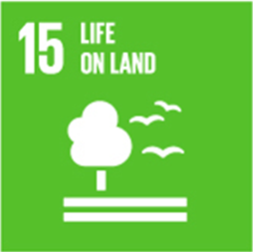
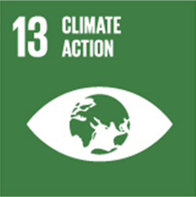
Goal 13. Take urgent action to combat climate change and its impacts.
Goal 15. Protect, restore and promote sustainable use of terrestrial ecosystems, sustainably manage forests, combat desertification, and halt and reverse land degradation and halt biodiversity loss.

7.5 Facilitate safe trade, development and economic growth
- Trade is a critically important part of most national economies. Trade in plants and plant products, and the earnings from this trade, stimulates economic growth and brings well-being and prosperity to rural communities and agricultural sectors. The main pathway for the global introduction and spread of pests is through international trade.
- Minimizing production losses from pests and reducing pest control costs and side effects is important for maximizing returns for domestic growers. Preventing the spread of pests to new areas, eradicating newly established pest populations, or creating recognized pest free areas, pest free places of production and pest free production sites, all simplify access to export markets. Exporting countries need strong phytosanitary systems to assure their trading partners that the imports they receive will not come with pests that would harm the importing country’s economy or environment. When exporting countries have established strong phytosanitary certification systems and therefore provide reliable phytosanitary assurances to the importing countries, trade pathways are smoothed and barriers to trade can be reduced.
- Economies and citizens benefit from imported plant products through availability of a greater variety of products and year-round access. Imports are also an important source of new plant varieties or breeding material to grow the agricultural economy. Importing countries need effective systems to understand and manage the pest risks that may be associated with trade in plants and plant products. This capability supports the establishment of technically justified phytosanitary measures, robust border controls and science-based trade negotiations.
- The IPPC standards (ISPMs) help countries develop import and export systems that manage the pest risks associated with trade in plants and plant products. When properly implemented, trade can occur safely (i.e. without spreading plant pests). When countries operate their phytosanitary systems according to the Convention and harmonized measures adopted by the Commission, trading partners have a common understanding, they can trust each other’s assurances, and trade negotiations should be simpler and quicker.
- The WTO Trade Facilitation Agreement entered into force on 22 February 2017 after two-thirds of members completed their domestic ratification process. This agreement will support NPPOs in their responsibilities relating to import-based risk prevention and management. In this regard, there will be increasing imperatives to work more closely with border agencies, including customs. The Commission and IPPC Secretariat will seek to increase collaboration with the World Customs Organization (WCO) and the WTO on the trade facilitation agenda.
7.5.1 2030 key result areas
- C1: Commodity-specific standards with harmonized phytosanitary measures have facilitated and accelerated trade negotiations and simplified safe trade in plant products.
- C2: Detections of pests in trade pathways are declining as exporting countries take more responsibility for managing the pest risk associated with exports, and importing countries report detections more quickly and more consistently.
- C3: NPPOs have built capacity and been supported to establish phytosanitary export assurance and phytosanitary certification systems that are robust and are trusted by trading partners.
- C4: The efficiency of administering phytosanitary certification systems has improved and the circulation of fraudulent certificates has been eliminated through electronic phytosanitary certification systems including the generic ePhyto national system and the global ePhyto hub.
- C5: NPPOs have access to expert advice to enable resolution of bilateral trade concerns of a phytosanitary nature.
- C6: NPPOs are able to meet regularly to deliberate on phytosanitary research and emerging issues and other matters of common interest.
- C7: Contracting parties have legislation in place to enable implementation of ePhyto.

7.6 Contribution to the UN 2030 Sustainable Development Agenda
- The work of the IPPC for this strategic objective strongly supports the UN 2030 sustainable development goals 1, 8 and 17.
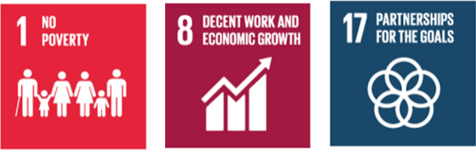
Goal 1. End poverty in all its forms everywhere.
Goal 8. Promote sustained, inclusive and sustainable economic growth, full and productive employment and decent work for all.
Goal 17. Strengthen the means of implementation and revitalize the global partnership for sustainable development.

8. IPPC development agenda 2020–2030

- The IPPC development agenda 2020–2030 aims to identify priority programmes of new work aligned to the Commission’s vision, mission, and strategic objectives. The identification of these priority programmes is based on the prospective changes to the operational environment of national, regional, and global plant protection organizations.
- The Commission, as an international body with an underlying secretarial structure, will be subject to the policy and budgetary changes of its hosting entity, FAO. The success of the Commission to deliver on the purpose of the Convention will ultimately be measured in terms of its ability to support the needs of contracting parties to stop the spread and reduce the impact of pests, but it will also be measured on its contribution to the achievement of the UN sustainable development goals. In the face of possible budgetary constraints, the Commission may have to streamline operations and integrate operational delivery much more closely with relevant FAO departments and offices.
- The IPPC development agenda 2020–2030 helps to address these anticipated changes to the operational environment of the Commission by proposing several development programmes for the 2020–2030 period. Delivery of these programmes will contribute significantly to the achievement of the strategic objectives of the Commission and the UN 2030 sustainable development goals. The development programmes are firmly grounded within the strategic objectives. They ensure that the Commission is well positioned to continue development and coordination of international plant health activities to well beyond 2030.
- Eight key development programmes have been identified. Each of these is described by the outcome envisaged for 2030 and then a more detailed description of each development programme is given. While the development agenda items present great opportunities to advance the mission of the IPPC, progressing them is dependent on securing adequate resources.
- The Commission will review and adapt the development agenda or other parts of the strategic framework as often as may be needed through its two main strategic planning groups: the IPPC Strategic Planning Group and the CPM Bureau.

8.1 Harmonization of electronic data exchange:
Implementing a global system for production and exchange of electronic phytosanitary certificate (ePhyto) information
8.1.1 Desired 2030 outcome:
- A global system for production and exchange of electronic phytosanitary certificate information is fully operational and integrated at a country level into trade single windows. The system is supported by a sustainable business model and is self-funded. A significant global effort to implement it in all countries has been completed. The system has strengthened and simplified safe trade in plants and plant products, reducing transaction costs, expediting the clearance of compliant products and eliminating fraud.
8.1.2 Description:
- Electronic systems to facilitate the implementation of the IPPC and its standards have been focused on by the Commission for several years. The establishment of an international hub for the exchange of electronic phytosanitary certificate information and the development of a generic ePhyto national system have received much attention and been viewed as being key to facilitating safe trade. The successful establishment of an ePhyto system firmly positions the Commission within the safe trade facilitation sphere and underlines the Commission’s ability to contribute more than just ISPMs to support trade objectives.
- The development of any electronic system faces the prospect of rapidly advancing technology, which makes it impossible to fathom now what the developments and opportunities will be from 2020 to 2030. For the Commission, the aim must be to keep abreast of the newest developments in electronic systems and identify their potential to enable implementation of the IPPC and its ISPMs. This would primarily focus on information exchange activities and further extension of the ePhyto system. An activity of the Commission could be to investigate the value of a centralized phytosanitary import requirements database, based on information uploaded by each importing country. This could make it easier to achieve a common understanding of each country’s phytosanitary requirements. In addition, such a database could be connected to an extended ePhyto system to simplify the certification process. Other notification requirements, such as notification of non-compliance, could be incorporated into the ePhyto system.
- Going forward, the Commission will work closely with the WCO and other relevant organizations regarding implementation of the Trade Facilitation Agreement, particularly the development and implementation of the single window concept. This will ensure that the global ePhyto solution being developed under the auspices of the IPPC Secretariat is aligned with the broader Trade Facilitation Agreement single window model. The right of member countries to determine for their own country how electronic phytosanitary certificate information interfaces with single window systems will be recognized.
- Intensifying the Commission’s efforts to maintain or develop electronic systems to facilitate the international harmonization of electronic data exchange would significantly contribute to safe trade development and the implementation of the IPPC and its standards.
- Activities to be carried out during 2020–2030 could include the following:
  - Successfully establish the IPPC ePhyto hub as the international system for exchange of electronic phytosanitary certificate information.
  - Complete establishment of the IPPC generic ePhyto national system for production, sending and receiving of electronic phytosanitary certificate information.
  - Where needed, support contracting parties to implement the ePhyto hub and the generic ePhyto national system.
  - Investigate the possible incorporation of other databases into the ePhyto hub or associating them with the electronic certification requirements.
  - Establish pilot projects for new or improved electronic systems.

8.2 Commodity- and pathway-specific ISPMs:
ISPMs developed for specific commodities and pathways, with accompanying diagnostic protocols, phytosanitary treatments and guidance
8.2.1 Desired 2030 outcome:
- Many new ISPMs have been adopted and implemented for specific commodities and pathways, with, as required, accompanying diagnostic protocols and phytosanitary treatments to support implementation. They provide NPPOs with harmonized phytosanitary measures, which they may use to support their pest risk analysis activities and import regulatory systems, or to establish export-oriented production systems. This has simplified trade and expedited market access negotiations.
8.2.2 Description:
- Trade is no longer characterized by the exchange of finished products alone, but also by the co-production of goods between countries. Some of the largest agricultural companies diversify their presence and production around the world. This enables companies to move plants and plant products around the world to respond to fluctuations in demand, as well as to source agricultural materials from different countries and regions. Furthermore, intensification of agricultural development efforts result in increased trade and exchange of plant propagation materials and movement of workers, increasing the risks of cross-border or intercontinental transmission of some pests. Thus, plant health strategies must evolve to prevent, respond and manage pest risks as business practices and production methods change.
- The Commission can respond by generating commodity- and pathway-specific standards that will facilitate safe trade and reflect both traditional and changing business practices for the international movement of plants and plant products. These standards should be accompanied by pest-specific diagnostic protocols, phytosanitary treatments, surveillance methods, risk-based sampling provisions and other guidance material which will help countries to fully implement new standards. The commodity- and pathway-specific ISPMs may also include provisions for verification, such as audits.
- In most cases, trade can only occur after bilateral negotiation between countries to ensure that they are satisfied that phytosanitary risks will be appropriately managed. These negotiations are based on WTO SPS principles and IPPC standards. Over the years, multiple trading partners bilaterally negotiate rules to manage pest risks associated with a commodity or pathway, even though it is often the case that many of the pests associated with the commodity are identical in each of the bilateral negotiations. Significant advances in trade facilitation would be made if standards (ISPMs) were developed that established harmonized pest risk management options for the major pests or major groups of pests associated with a commodity or a pathway. Countries would still be free to negotiate measures for pests of concern not properly covered by the commodity- or pathway-specific ISPM, if technically justified.
- Future standard setting will focus more and more on commodity- or pathway-specific topics rather than on broad conceptual and foundational issues that have been largely addressed. In order to establish a relevant work programme for commodity- or pathway-specific ISPMs, it is necessary to first determine carefully the structure, format, content, breadth of coverage and implementation of such standards, taking into account the fact that the needs may differ for different types of commodities and pathways. These are the precursors before concrete standard setting can commence.
- The development of commodity- and pathway-specific standards may also incorporate additional activities with regard to new phytosanitary treatments. Many of the commodity- and pathway-specific ISPMs may need to include new phytosanitary treatments, which could be readily applied by NPPOs and have a very low environmental impact while still being efficacious against target pests. For this reason, it could be necessary for the Commission to intensify its activities relating to the adoption of new phytosanitary treatments.
- Activities to be carried out during 2020–2030 could include the following:
  - Develop and agree on the structure, format and content of commodity- and pathway-specific ISPMs and apply these concepts to the development of commodity- or pathway-specific ISPMs.
  - Conduct an assessment of the critical factors necessary for an NPPO to effectively implement a commodity standard, and the barriers that have to be overcome.
  - Agree on the criteria to prioritize a list of commodity- and pathway-specific ISPMs and, if appropriate, establish a work programme for the development of commodity- and pathway-specific ISPMs.
  - As part of performance monitoring after implementation, evaluate the economic, trade, food security and environmental benefits delivered by a selection of commodity- or pathway-specific standards.
  - Intensify current activities relating to phytosanitary treatments.
  - As necessary, establish working groups to develop alternative pest risk management approaches for individual pests, pathways or commodities.

8.3 Management of e-commerce and postal and courier pathways:
A coordinated international effort to address the spread of pests and pest host material sold through e-commerce and distributed through postal mail and courier pathways
8.3.1 Desired 2030 outcome:
- A coordinated international effort has substantially reduced the spread of pests and pest host material sold through e-commerce and distributed through mail and courier pathways. Volumes of high-risk plant material traded online in small quantities and shipped via courier pathways are sourced from authorized or accredited plant-health export programmes, and compliance is tracked and enforced in collaboration with other border agencies, the international postal services and courier services.
8.3.2 Description:
- Sales of plants, plant products, and pests ordered through the Internet (e-commerce) and courier mail services have increased significantly in the years since the IPPC and most ISPMs were adopted. E-commerce is fuelling an increasing volume and diversity of traded commodities. In many cases, online traders of plants, plant products, and other regulated articles are not aware of applicable regulations and do not consider a customer’s location before agreeing to a sale or trade and shipping their purchases to them. This lack of knowledge of a customer’s location can lead to consignments of regulated articles being imported into a country without any effort to meet the phytosanitary import requirements of the customer’s country.
- It is expected that e-commerce and the shipment of products via courier services will grow significantly. This will be associated with an upsurge in regulated articles traded and shipped internationally by mail or courier services. Phytosanitary organizations around the world will need efficient tools and procedures to screen courier mail and packages. In addition, international harmonization of measures and procedures for e-commerce and courier mail operators may be the most efficient way to address this problem. Cooperation with other sectors such as customs (WCO) and the prevention of trade in endangered species (the Convention on International Trade in Endangered Species of Wild Fauna and Flora (CITES)), which face similar problems as the phytosanitary services, may help to develop a far reaching and efficient international system.
- Activities to be carried out during 2020–2030 could include the following:
  - Implement an international communications effort targeting both companies that trade through e-commerce channels and consumers to ensure that they understand that the importing country may have phytosanitary requirements, why those requirements exist, and how to comply with phytosanitary import requirements.
  - Establish an inter-agency network (CITES, WCO, IPPC and other interested agencies) to create synergy in developing a joint policy and recommendations with regard to e-commerce and courier and postal pathways. A joint inter-agency toolkit could also be developed for the regulation and screening of e-commerce and courier and postal pathways.
  - Develop and implement policies, programmes or mechanisms for sharing information on best practices, encouraging traders to follow requirements, etc.

8.4 Developing guidance on the use of third-party entities:
Enabling use of third parties to perform phytosanitary actions such as treatments or inspections
8.4.1 Desired 2030 outcome:
- Countries wanting to use third parties will have access to harmonized resources to support them to do this in an effective manner with the necessary management processes and controls. Standards have been adopted and implemented that give guidance on the use of third-party entities to perform various phytosanitary actions, such as treatments, inspections and pest diagnosis. The standards ensure that, when governments choose to take this option, the actions continue to be carried out to the same standard and level of phytosanitary security.
8.4.2 Description:
- Many NPPOs encounter unexpected problems while performing their functions, such as short-term new pest eradication or surveillance activities, which cannot be addressed by regular NPPO staff. In such situations, the availability of third-party entities to overcome such shortcomings may be beneficial. Because the NPPO is responsible for the outcome of activities undertaken by third-party entities on its behalf, the decision to use third-party entities is a voluntary one and lies with the NPPO.
- The Convention allows phytosanitary actions to be carried out by public officers and properly authorized third parties. Authorization of third-party entities to perform specific phytosanitary actions such as inspection, testing, surveillance, pest diagnosis, treatment and auditing on behalf of the NPPO is now common in many countries. In some cases, the authorization process is regulated by general country legislation which is not necessarily specific to plant health. In the absence of harmonized guidance, NPPOs have used a variety of systems for authorizing third-party entities and widely varying levels of oversight, control and verification take place. This variation could contribute to a reduced confidence in the reliability of actions undertaken by the third-party entities. This in turn could lead to trade difficulties where importing countries impose additional import requirements to increase their confidence in the safety of the import.
- Activities to be carried out during 2020–2030 could include the following:
  - Adopt a relevant ISPM (or ISPMs) and guidance on authorization of third-party entities to perform phytosanitary actions such as inspection, sampling, testing, surveillance, monitoring and treatment on behalf of NPPOs.
  - Explore how confidence in authorization programmes can be increased internationally (e.g. through an international authorization system).
  - Provide capacity development resources as needed to assist NPPOs wishing to start using a third-party entity model.

8.5 Strengthening pest outbreak alert and response systems:
A global pest alert and response system to communicate emerging pest risks, so countries can proactively adapt their phytosanitary systems to reduce the risk of introduction, and to strengthen country and regional abilities to respond effectively to pest outbreaks including new incursions
8.5.1 Desired 2030 outcome:
- A global pest alert system with mechanisms to evaluate and communicate emerging pest risks is in place, providing regular information to NPPOs on changes in pest status around the world. NPPOs are using this to quickly adapt their phytosanitary systems to reduce the risk of introduction and spread. In the case of outbreaks, strengthened pest outbreak response systems and tools are helping countries take much more timely action, especially against new incursions. NPPOs, RPPOs and the FAO have collaborated to develop and roll out a comprehensive but easy to use toolbox to help countries respond quickly and effectively. RPPOs are playing an active role in assisting NPPOs and are coordinating outbreak responses across their regions.
8.5.2 Description:
- The speed and volume of internationally traded commodities provides the opportunity for pests to spread into new areas with considerable swiftness. For NPPOs to keep abreast of rapidly changing pest occurrences and distribution scenarios, considerable investment in scanning for emerging risks is necessary. This scanning activity is undertaken by some countries and RPPOs but is not always shared widely.
- A global pest alert system could receive outputs from countries and RPPOs already conducting such scanning, and make the outputs more readily available and digestible by all contracting parties. For countries or regions not already well covered, a generic tool could be developed to allow easy entry and dissemination of information on emerging pest risks. RPPOs could play an important role across regions in identifying and communicating emerging pest risks.
- Having an improved situational awareness of changes in pest risk will help countries to proactively adapt their phytosanitary systems to reduce the risk of introduction and establishment of pests.
- Consideration also needs to be given to ways of improving pest reporting from countries. A pest alert system would function best for all concerned if it allows and promotes efficient, timely and comprehensive pest reporting by all contracting parties.
- Outbreaks of pests can present significant challenges to the countries and regions in which these pests occur. Challenges such as the lack of know-how, lack of tools, or insufficient plant health capacity in science or operational delivery are in many cases not addressed sufficiently to prevent further spread and mitigate impacts on crops and the environment. This results in unnecessary threats to food security, the environment and trade.
- The risk of new pest outbreaks (including incursions) can be reduced by phytosanitary actions on trade pathways, but not eliminated. It is therefore critical that countries are able to detect and respond quickly, through access to appropriate incursion response support. In many cases, regional coordination structures to efficiently control cross-border pests have not been developed. RPPOs have an important coordination role to play within regions, supporting NPPOs responding to pest outbreaks and facilitating assistance by neighbouring countries.
- There is an urgent need to increase the capacity of countries to respond and this can, at least in part, be achieved through the establishment of an easily accessible toolbox of resources. Such resources could be developed under the Commission’s work programme or simply made available by contracting parties. The Commission also has a role to facilitate the uptake of such resources in advance of an outbreak through training and other implementation activities. In addition, the Commission could explore the possibility of establishing voluntary funding mechanisms to assist countries for which funding is the critical limiting factor in successfully responding to pest outbreaks.
- Activities to be carried out during 2020–2030 could include the following:
  - Determine and understand the global state of emerging pest risk scanning and reporting at NPPO and RPPO levels, and user requirements for an enhanced pest alert system.
  - Continue to work with countries to facilitate the development of pest surveillance systems, based on IPPC standards and other technical guidance, necessary for early detection and response to emerging pest risks.
  - Develop a system to coordinate the dissemination of information on emerging pest risks and changes in pest status, including establishing common data standards for all countries and regions engaged in this activity.
  - Set-up a generic system that countries and RPPOs could use to enter and report emerging pest risks, including changes in pest status.
  - Explore new ways to facilitate timely reporting of new incursions and to remove current barriers that work against proactive pest reporting.
  - Develop a clear IPPC mandate, policy and structure including, if appropriate, the integration of the Emergency Prevention System for Transboundary Animal and Plant Pests and Diseases (EMPRES) plant health activities into an overall plant health mandate. Establish a network of phytosanitary emergency response expertise.
  - Help ensure that expertise and response resources are engaged in a timely manner.
  - Develop a simple and effective incursion response toolbox that countries can use, including contingency response plans, delimitation methods, diagnostic protocols, containment protocols, lists of lures, attractants and control agents, control options, phytosanitary treatments, etc.
  - Facilitate advocacy initiatives with potential donors, to seek support in implementing the incursion response toolbox developed.
  - Establish a strengthened international pest outbreak response system under the IPPC providing unique opportunities to address catastrophic pest outbreaks, such as the recent outbreak of fall armyworm (Spodoptera frugiperda) in Africa, by speedily providing expertise and methodologies for pest eradication. Create an international donor initiative to finance the system, as although the benefits can be substantial, the resources needed to establish and maintain such a system will exceed those currently available to the IPPC Secretariat.

8.6 Assessment and management of climate change impacts on plant health:
Initiating a work programme to assess and manage the impacts of climate change on plant health and international trade of plants and plant products
8.6.1 Desired 2030 outcome:
- The impacts of climate change on plant health and the safe trade of plants and plant products are evaluated, especially in relation to pest risk assessment and pest risk management issues, and phytosanitary issues are adequately reflected in the international climate change debate under the Intergovernmental Panel on Climate Change.
8.6.2 Description:
- Trade offers a way to resolve challenges such as regional food shortages due to climate change impacts. However, climate change impacts on plant pests and pest vectors also threaten the international trading system, as international trade provides a pathway for plant pests and pest vectors to spread into new areas of the world. To realize the potential benefits of international agricultural trade it is therefore imperative to strengthen phytosanitary activities with regard to climate change. Since pest and plant distribution, pest epidemiology and pest impacts may change considerably as a result of climate change, robust surveillance and monitoring systems are vital at national, regional and international levels. Knowledge about pests and the potential changes in life cycles, epidemiology and pathogenicity that may be induced by climate change is essential when undertaking pest risk assessments to determine steps and actions to manage these pest risks effectively and economically.
- Greater attention must be paid to phytosanitary issues in general policy considerations on climate change. It is essential that phytosanitary policies and strategies are adequately reflected in the work of the Intergovernmental Panel on Climate Change. Political weight and subsequent funding for phytosanitary needs at a national, regional and international level will only be available when phytosanitary issues are recognized as an important component of the climate change debate.
- Up until now, the Commission has given only rudimentary consideration to issues related to climate change. If such issues are to receive more attention in the work programme of the Commission, it is imperative that they be addressed in a systematic manner. This may be best achieved through the creation of a task force on climate change to define ambitious and proportionate priorities for action.
- Activities to be carried out during 2020–2030 could include the following:
  - Explore how far the Commission needs to address climate change issues and their impact on plant health policies.
  - Establish, if appropriate, an appropriate forum for the systematic analysis and discussion of climate change and plant health.
  - Develop recommendations with regard to climate change and plant health and, if necessary, of associated guidelines for pest risk analysis and surveillance.
  - Mainstream phytosanitary policies into the climate change debate.

8.7 Global phytosanitary research coordination:
A voluntary mechanism for global phytosanitary research coordination, to accelerate development of science to support all regulatory phytosanitary activities
8.7.1 Desired 2030 outcome:
- An analysis of international phytosanitary research structures and policies has been conducted to explore how far international coordination of plant health research could help countries to avoid overlap in research activities and to utilize research resources in the most efficient and effective manner. Possibilities for establishing an international phytosanitary research collaborative structure have been explored and, if appropriate, the structure has been established.
8.7.2 Description:
- International research collaboration across nations, institutions and disciplines leads to higher quality science, efficiencies of resource use, better outcomes and wider adoption of results. However, these benefits of collaboration only occur where there is mutual interest and alignment of goals (including a “vision”), effective leadership, facilitation of processes and structures, support for collaboration, and ultimately funding – for both research and collaboration. In addition, the need to develop a balanced portfolio of research work, ranging from strategic to applied research, is essential in creating synergistic collaboration.
- To establish an international research collaboration, it is important to develop a Commission policy on the matter and to agree on structures. Collaboration with international plant health research organizations (e.g. Euphresco) may provide useful perspectives on policy and structures. The complete administration and governance of this activity could be delegated to RPPOs, thus avoiding resource demands on the IPPC Secretariat.
- The development of an initiative to establish a global phytosanitary research coordination policy and structure is an important component of the Commission’s strategic objectives.
- Activities to be carried out during 2020–2030 could include the following:
  - Analyse existing international research coordination policies and structures.
  - Explore the benefits of developing an IPPC policy and structure for international research coordination, especially with regard to determining the role of RPPOs in such coordination.
  - Adopt an IPPC international research coordination and policy and structure.
  - Establish, if appropriate, an international phytosanitary journal for publication of phytosanitary research findings.

8.8 Diagnostic laboratory networking:
Establishing a network of diagnostic laboratory services and diagnostic protocols to help countries identify pests in a more reliable and timely manner
8.8.1 Desired 2030 outcome:
- An international network of diagnostic laboratory services provides reliable and timely pest identifications. National laboratories with strong diagnostic functions are officially recognized as capable of offering reliable services within regions or globally, reducing the need for all countries to develop duplicated capacity.
8.8.2 Description:
- Diagnostic expertise is one of the major capabilities for the proper functioning of any NPPO. For many countries, however, the availability of diagnostic expertise or services is severely restricted because of limited structural capacity and know-how. Any country wishing to take part in the trade of agricultural commodities must be able to demonstrate that its products are free from pests. To do that, access to diagnostic services is essential. In addition, importing countries need proper access to diagnostic expertise to be able to detect pests in imported commodities and therefore prevent the entry of regulated pests that may cause considerable damage to agriculture or the environment.
- Establishing world-class diagnostic laboratories and keeping up with advances in diagnostic technology is extremely costly. It is becoming apparent that, for many countries, the only viable option to access high-end diagnostic services will be through cooperation across countries to remotely access diagnostic capacity at an international, regional or subregional level. For example, a diagnostic laboratory established on a subregional level could effectively and efficiently serve the needs of several countries in the region. Country A in the region may have a laboratory for entomology while country B may specialize in plant pathogens and country C nematodes, and so on. In the near future, joint diagnostic centres and laboratories may be the only way for many countries to access state-of-the-art diagnostic services.
- The Commission could help address the lack of access to diagnostic capacity in many countries by establishing a voluntary network of diagnostic laboratories. Existing generic laboratory standards could also be applied more widely. In addition, the IPPC could develop a project model for subregional diagnostic centres, which could serve as a blueprint for donors when providing technical assistance to developing countries (e.g. via the Standards and Trade Development Facility).
- Activities to be carried out during 2020–2030 could include the following:
  - Conceive a model for the establishment of subregional joint diagnostic laboratories and proficiency testing.
  - Adopt required standards and diagnostic protocols.
  - Facilitate the establishment of an international laboratory network.
  - Establish and communicate a listing of available diagnostic laboratories and their expertise.

IPPC
The International Plant Protection Convention (IPPC) is an international plant health agreement that aims to protect cultivated and wild plants by preventing the introduction and spread of pests. International travel and trade are greater than ever before. As people and commodities move around the world, organisms that present risks to plants travel with them.

Viale delle Terme di Caracalla, 00153 Rome, Italy
Tel: +39 06 5705 4812
Email: ippc@fao.org - Web: www.ippc.int

http://www.fao.org/publications/soco/the-state-of-agricultural-commodity-markets-2015-16/en/
The use of extremely large data sets that may be analysed computationally to reveal patterns, trends and associations
Oerke, E.-C. 2006. Crop losses to pests. The Journal of Agricultural Science, 144(1): 31–43. Available at https://doi.org/10.1017/S0021859605005708 (last accessed 1 July 2019)
https://www.un.org/sustainabledevelopment/sustainable-development-goals/

