[PleaseReview document review. Review title: 2019 First Consultation Draft annex to ISPM 27: Diagnostic protocol for Striga spp. (2008-009). Document title: 2008-009_Striga_2019-05-31.docx]

[1]DRAFT ANNEX to ISPM 27: Striga spp. (2008-009)
[2]Status box
[3]This is not an official part of the standard and it will be modified by the IPPC Secretariat after adoption.
[4]Date of this document | [5]2018-05-31
[6]Document category | [7]Draft annex to ISPM 27 (Diagnostic protocols for regulated pests)
[8]Current document stage | [9]To first consultation
[10]Origin | [11]Work programme topic: Plants, CPM-2 (2007)  [12]Original subject: Striga spp. (2008-009)
[13]Major stages | [14]2007-03 CPM-2 added topic (2007-001) to work programme.  [15]2008-04 CPM-3 added subject Striga spp. (2008-009) to work programme, priority 1.  [16]2014-10 Diagnostic Protocol (DP) drafting group formed.  [17]2018-02 Technical Panel on Diagnostic Protocols (TPDP) reviewed.  [18]2018-06 DP drafting group revised.  [19]2018-08 TPDP e-forum.  [20]2018-10 DP drafting group revised.  [21]2018-11 Expert consultation.  [22]2019-02 DP drafting group revised.  [23]2019-03 TPDP e-decision to submit to SC for approval for first consultation (2019_eTPDP_Feb_01).  [24]2019-03: SC e-decision (2019-eSC_May_13) suspended to allow for editorial review  [25]2019-05: SC approved for first consultation (2019-eSC_Nov_01)
[26]Discipline leads history | [27]Ms Liping YIN (CN, Discipline lead)  [28]Ms Géraldine ANTHOINE (FR, Referee)
[29]Consultation on technical level | [30]The first draft of this protocol was written by:  - [31]Mr Lytton John MUSSELMAN (US, Lead author)  - [32]Ms Ruojing WANG (CA, co-author)  - [33]Ms Jayani Nimanthika WATHUKARAGE (LK, co-author)  - [34]Mr. Ran-Ling Zuo (CN, co-author)  - [35]Ms Teresa Cortes (CL, co-author)  [36]Comments were provided by Ms Liping YIN (CN).  [37]In addition, the draft has also been subject to expert review and the following international experts submitted comments: Chris PARKER (GB), Barbara WATERHOUSE (AU), Gregory CHANDLER (AU) and Sathish PUTHIGAE (NZ).
[38]Main discussion points during development of the diagnostic protocol | [39]
[40]Notes | [41]This is a draft document  [42]2019-04 Edited
[43]
[44]CONTENTS
[45][to be added later]

[46]Adoption
[47]This diagnostic protocol was adopted by the Standards Committee on behalf of the Commission on Phytosanitary Measures -- [to be completed after adoption].
[48]The annex is a prescriptive part of ISPM 27 (Diagnostic protocols for regulated pests).

[49]1. Pest Information
[50]The genus Striga Lour. (witchweeds) comprises approximately 42 species of obligate root parasitic plants (Mohamed et al., 2001). Striga is mainly distributed in tropical and subtropical regions, and some species are major pests of agricultural crops in these regions. Crops parasitized by Striga exhibit reduced growth, with substantial yield losses in severe cases of up to 85%, depending on the level of resistance and tolerance of the specific host genotype (Rodenburg et al., 2005). Symptoms of parasitism include yield suppression or reduction, stunted growth, and a drought-like appearance of the leaves.
[51]The greatest damage to crops is caused by three species: Striga asiatica, S. gesnerioides and S. hermonthica (Mohamed et al., 2001). S. asiatica and S. hermonthica are among the most economically damaging weeds in the world. In Africa, these two pests attack grain crops and cereals, including Zea mays (maize), Pennisetum spp. (pearl millet), Eleusine coracana (finger millet), Panicum spp., Eragostis tef (teff) and Sorghum bicolor (sorghum), with some impacts on Saccharum spp. (sugarcane) and Oryza sativa (dryland rice), and can reduce the crop yield value by USD 7 billion every year (Ejeta, 2007; Csurhes et al., 2016). S. gesnerioides is the only Striga species that attacks a dicotyledon host and usually infects Fabaceae, especially Vigna unguiculata (cowpea), Convolvulaceae, Euphorbiaceae and Nicotiana tabacum (tobacco, Solanaceae).
[52]S. asiatica is native to Africa, India, and China (APHIS, 2011) and may represent a series of related species (Mohamed et al., 2001). It has spread to parts of North America and the Asia Pacific region (Nail et al., 2014).
[53]S. gesnerioides is found throughout much of Africa, the Arabian peninsula and the Indian subcontinent. This parasite is particularly damaging to Vigna unguiculata (cowpea) (Musselman and Parker, 1981a). S. gesnerioides is quite variable, with morphotypes associated with different hosts.
[54]S. hermonthica is native to savannah ecosystems where wild grasses (Poaceae, such as Andropogon species and Setaria sphacelata) are the hosts. However, S. hermonthica infestation of crops such as Z. mays, Sorghum bicolor, Pennisetum spp. and Panicum spp. can cause devastating yield losses, and the problem is increasing (Ejeta, 2007).
[55]Unlike Striga, plants of the related genus Orobanche lack chlorophyll and are fleshy with scale-like leaves and smaller flowers that are never red or pink. Striga is entirely Old World and tropical whereas Orobanche is more widespread and is present in both temperate and semitropical regions (Joel et al., 2007).
[56]Striga has great reproductive ability, with a maximum fecundity in the order of 200 000 seeds per plant. Striga seeds are tiny and dust-like, and can disperse over long distances via wind, water or birds and as contaminants in agricultural products (e.g. grain, seeds, livestock feed or bedding materials, and nursery stocks). Striga seeds found in field soils can be as dense as 882 000 seeds per m² (Van Mourik, 2007). They can also contaminate soil, tools, vehicles and equipment during transportation or storage.
[57]The time to flowering of the Striga species varies. For example, S. gesnerioides ﬂowers as it emerges from the soil, whereas S. asiatica and S. hermonthica begin flowering about four weeks after emergence (Berner et al., 1996). Most Striga species are self-pollinating, but S. hermonthica and S. aspera are out-crossers, requiring insects for pollination (Aigbokhan et al., 1998). Some Striga seeds can tolerate short-term waterlogging (Nail et al., 2014). The temperature response of S. asiatica appears to affect both the relative suitability of a location for growth and its cold tolerance limits. The minimum temperature for development has been found to be 20 °C; the upper limit for growth, 42 °C; and the optimal temperature range for growth, 30–34 °C (Patterson et al., 1982).

[58]2. Taxonomic Information
[59]Name: Striga Lour. (1790)
[60]Synonyms: None
[61]Taxonomic position: Lamiales, Orobanchaceae
[62]Common name: Witchweed
[63]Three most economically damaging species of Striga:
[64]Name: Striga asiatica (L.) Kuntze
[65]Common name: Red witchweed
[66]Synonyms: Striga hirsuta Benth.
[67]Striga asiatica var. lutea (Lour.) M.R.Almeida
[68]Name: Striga gesnerioides (Willd.) Vatke
[69]Common name: Cowpea witchweed
[70]Synonyms: Buchnera gesnerioides Willd.
[71]Buchnera orobanchoides R.Br.
[72]Striga orobanchoides Benth.
[73]Name: Striga hermonthica (Delile) Benth.
[74]Common name: Purple witchweed
[75]Synonyms: Buchnera hermonthica Delile
[76]Striga hermonthica subsp. senegalensis (Benth.) Maire
[77]Striga senegalensis Benth.

[78]3. Detection

[79]3.1 Sampling and sample submission
[80]The samples taken from imported consigments should be submitted to a laboratory for inspection.
[81]When surveys are carried out to detect Striga in fields, soil seed banks are usually sampled. Soil samples are collected and submitted to the laboratory for further diagnostic analysis.

[82]3.1.1 Sampling procedures
[83]A consignment lot of seeds, grain, or other agricultural commodity that contains intact seeds with a homogenous or uniform distribution, should be sampled according to ISPM 31 (Methodologies for sampling of consignments). Consignments of processed grain, flour or non-pelleted animal feed that are suspected to have been contaminated with Striga should be sampled in accordance with ISPM 31.

[84]3.1.2 Sub-sampling of the working sample for inspection
[85]Samples submitted to a laboratory should be drawn from a composite sample, which is a mixture of primary samples. The sample size recommended by the International Seed Testing Association is 25 000 seeds or a maximum of 1 kg sample (ISTA, 2018). The weight of 25 000 seeds can be referenced from International Seed Testing Rule Table 2A (ISTA, 2018), or determined by the laboratory with a thousand-seed weight test. For example, the weight of 25 000 seeds will be 1 kg for Z. mays, O. sativa and Hordeum vulgare and 20 g for Panicum spp. (millet, ISTA (2018), Table 2A). Immediately after sampling, submitted samples should be packed and sealed in an appropriate bag or container protected from contamination or leaking, with clear labels on seed lot, crop species and associated information to allow sample traceability. When a small package is less than 25 000 seeds, an appropriate bag sampling procedure should be performed after determining how many bags are equivalent to 25 000 seeds. When the whole lot is less than 25 000 seeds, the whole lot should be examined without sub-sampling procedures.
[86]When receiving a submitted sample, the laboratory should analyse a minimum of 25 000 seeds of the commodity, which may or may not constitute the whole submitted sample. If the submitted sample is more than the minimum sample weight, the sample weight should be reduced to the minimum quantity using a mechanical sample divider (e.g. a rotary or soil divider) or by a hand-halving method. The sample should be rejected when its weight is significantly less than the minimum sample weight.

[87]3.2 Detection method for seeds of Striga species
[88]The analysis of the working sample for the presence of Striga seeds is achieved by either washing and filtration or by dry sieving the working sample.
[89]After washing or sieving, the filter paper, sieves and screenings should be carefully examined with a stereo microscope of at least 40× magnification. A clean soft brush may be used to transfer the screenings into a suitable container (e.g. Petri dish), making sure there are no remaining seeds in the brush or the collecting pan.

[90]3.2.1 Washing and filtration
[91]The whole sample is washed in water, the wash water filtered, and the residue collected on the surface of a filter paper (15 cm diameter), which is then analysed. The seed weight-to-water volume ratio should be 1:2; for example, 250 g of seed added to 500 mL of water containing one or two drops of surfactant. Large submitted samples may require washing in small batches but the whole sample should be analysed.

[92]3.2.2 Dry sieving
[93]The whole submitted subsample is “dry” sieved using a sieve (250 µm and 150 µm sieves: 150 µm sieve for clean Striga seeds, 250 µm sieve for Striga seeds and debris) and a bottom collection tray that is shaken by a mechanical shaker (e.g. 40 shakes/second for at least two minutes) or shaken manually. If the shaking is manual, the sample should be shaken vigorously for a longer period until the finer material is fully separated. The size of the holes in the screen-sieve should be adequate to retain the commodity seeds on top and allow the finer dust-like material including Striga seeds to go through to the collection tray. The same technology could be used for separation of Striga seeds from flour using a sieve of mesh size 70–100 µm. In such situations it is expected that the seeds are retained on top of the sieve and the flour particles allowed to go through to the collection tray.

[94]4. Identification

[95]4.1 Identification method
[96]Classification and identification of Striga species depends largely on floral characters. Inspection, however, usually targets seeds of imported agricultural commodities such as grain, seeds and feed, which are suspected to be contaminated with Striga seeds. Striga seeds can contaminate seeds or grain by multiple pathways via transportation, storage and trade. Morphological identification of Striga seeds or plants is based on known reference specimens, literature descriptions and taxonomic identification keys. Considerable data from molecular studies of Striga are available and could be helpful for species determination, but until methods can be simplified and uniform they are of limited value for phytosanitary purposes.

[97]4.2 Identification of seeds of Striga species
[98]Seed identification of Striga species is based on seed size, shape, surface texture and colour. The capsules of Striga are loculicidal, containing a large number of seeds in various shapes, including elliptic, ovate, rectangular, D-shaped, trigonous, rhombic, or irregular (Figure 1). However, capsules are usually broken, damaged or removed in most contaminated commodities during their processing. Striga seeds are dust-like particles, 0.2–0.6 mm long and 0.1–0.3 mm wide; their surface has twisted and longitudinally linear ridges; they are translucent; and seed colour varies from light brown to dark brown, from orange to golden brown, and from grey to light black, glistening under high-magnification microscopy (e.g. 20× to 40× magnification). The embryo is linear, and a sparse endosperm is present.
[99]Other dust-like seeds are those of the genera Orobanche (Figure 2), Phelipanche and Alectra, which are a similar size but have a regularly reticulated surface. Seeds of Alectra are truncate at the apex. In general, the seed surface of Orobanche and Phelipanche is deeply honeycombed and lacks the spiral, ornamented ridges of Striga (Musselman and Parker, 1981b). Using a microscope, these seeds can be distinguished from Striga. Pictures of seeds of S. asiatica, S. gesnerioides and S. hermonthica are shown in Figures 1A to 1E and seed characteristics are summarized in Table 1.
[100]Table 1. Summary of main characteristics of seed morphology of the three most economically damaging Striga species
[101]Seed characters
[102]Species | [103]Size (mm) | [104]Shape | [105]Surface texture | [106]Colour | [107]Photo
[108]S. asiatica | [109]0.33 | [110]Ovate | [111]Lengthwise lines or ridge lines, with reticular spinal processes | [112]Golden brown | [113]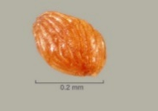
[114]S. generioides | [115]0.25 | [116]Usually trigonous or D-shaped | [117]Smooth and honeycombed | [118]Grey to light black | [119]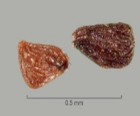
[120]S. hermonthica | [121]0.30 | [122]Usually elliptic or ovate | [123]Prominent lengthwise lines; honeycombed and often twisted | [124]Varying from light to dark brown | [125]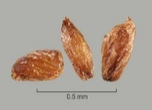

[126]4.2.1 Capsule morphology of important species of Striga
[127]Capsule morphology is important in separating major groups of Striga species. The number of ribs in the calyx and their width and ornamentation can be helpful in determining taxa. See Figure 3 and Ramaiah et al. (1983) for images of seed capsules.
[128]Morphological differences in the capsules can be used for identification. The capsule of S. asiatica is 7 mm long and 2 mm wide; the capsule of S. gesnerioides is 10–20 mm long and 3 mm wide; while the capsule of S. hermonthica is 12–15 mm long and 2–2.5 mm wide (Musselman and Hepper, 1986).

[129]4.2.2 Seed morphology of Striga asiatica
[130]The seed of S. asiatica is golden brown, very small and oval in shape with a netted surface featuring lengthwise lines or ridge lines (Figures 1A to 1C). These ridges, which often form a twisted pattern, have reticular spinal processes. The surface texture of the seed coat is key to identification (Global Invasive Species Database: IUCN, n.d.). The seed typically weighs 3.7 µg and is about 0.33 mm long, this being one-twentieth of the length of a tobacco seed (Cochrane and Press, 1997).

[131]4.2.3 Seed morphology of Striga gesnerioides
[132]Seeds of S. gesnerioides (Figure 1D) are about 0.25 mm long, usually trigonous or D-shaped, less commonly in other irregular shapes. The colour varies from grey to light black; the surface is smooth and honeycombed.

[133]4.2.4 Seed morphology of Striga hermonthica
[134]Seeds of S. hermonthica (Figure 1E) are about 0.30 mm long, usually elliptic or ovate, with their colour varying from light to dark brown. They have a honeycombed surface with prominent lengthwise lines, often appearing twisted.

[135]4.3 Plant identification
[136]Striga seedlings appear underground as white tender shoots attached to the roots of host plants via haustoria. This means that by the time the host stems emerge, Striga is already growing below the soil surface and damaging the host. The mature plants have green leaves sparsely covered by short white, stiff hairs that give a scabrous feel to the leaf surface (like sandpaper). The plants are usually 15–30 cm high but may be as high as 60 cm. They flower after rains (with a flower length below 1.5 cm). When a suitable host is present, Striga seeds require one to two weeks of moisture and temperatures of at least 20 °C (with 25–35 °C being optimal) before they germinate. The morphological characteristics of the three most economically damaging species are listed below, and summarized in Table 2.
[137]Table 2. Summary of main characteristics of plant morphology of the three most economically damaging Striga species
[138]Fundamental characters of floral apparatus
[139]Species | [140]Plant size (cm) | [141]Stem | [142]Pubescence | [143]Flower colour | [144]Capsule  (L×W in mm)
[145]S. asiatica | [146]10–30 | [147]Erect, square, usually branched in agricultural fields, wild plants often unbranched | [148]Strigose | [149]Most commonly scarlet red, rarely yellow or white | [150]7 × 2
[151]S. gesnerioides | [152]11–25 | [153]Many stems arising from a usually bulbous base; numerous adventitious roots | [154]Puberulent | [155]Purple, pink or yellow, depending on host | [156]10–20 × 3
[157]S. hermonthica | [158]70–100 | [159]Usually unbranched | [160]Strigose | [161]Pink | [162]12–15 × 2.0–2.5
[163]L, length; W, width.

[164]4.3.1 Striga asiatica
[165]Annuals, 10–30 cm tall, entirely hirsute. Stems erect, square, sometimes branched. Leaf blade linear to narrowly lanceolate, 5–20 mm × 1–4 mm. Flowers axillary, in a raceme. Calyx 4–8 mm, 10-ribbed; 5 lobes, as long as tube, subulate. Corolla usually red, rarely yellow or white; tube 0.8–1.5 cm, apically strongly curved; upper lip 2-lobed. Capsule ovate, enveloped in persistent calyx (Figure 4A).

[166]4.3.2 Striga gesnerioides
[167]Annual or weakly perennial or monocarpic, 11–25 cm tall with many adventitious roots from the base. Usually light green or yellow green, succulent; many closely packed stems at the soil surface. Stem square with obtuse angles; leaves appressed to the stem, 5–10 mm × 2–3 mm. Leaves and stems puberulent, or almost glabrous. Corolla usually purple, rarely pink or yellow. Flowers opposite or alternate, mostly with two flowers for each node, rarely three, no fragrance. Bract and sepal of equal length; corolla 1.2–1.5 cm long (Figure 4B; Mohamed et al., 2001).

[168]4.3.3 Striga hermonthica
[169]Annual, up to 90 cm tall. Stem square, furrowed; branched from middle, densely scabrous. Leaves 15–18 mm, opposite, linear or narrowly elliptic, longer than internodes; margin entire, veins obscure. Lower floral bracts 12–50 mm long and 2–5 mm wide, longer than calyx; upper bracts lanceolate, equal to or longer than calyx. Flowers opposite, forming a lax raceme denser above middle. Calyx 5-ribbed, 7–12 mm long; tube 5–10 mm long; sepal with 5 unequal lobes of 2–4 mm, shorter than corolla tube. Corolla pink or light purple, rarely white (Figures 4C and 4D; Mohamed et al., 2001).
[170]S. hermonthica can be confused with S. aspera, which is a widespread species in sub-Saharan Africa that differs by the position of the bend in the corolla. The bend is at the level of the calyx in S. hermonthica and the mid-calyx in S. aspera. Overall, S. aspera has smaller corollas, stems and leaves and is a more delicate plant (Figure 5).

[171]5. Records
[172]Records and evidence should be retained as described in section 2.5 of ISPM 27 (Diagnostic protocols for regulated pests). In cases where other contracting parties may be affected by the results of the diagnosis, the records and evidence and additional material should be kept for at least one year in a manner that ensures traceability.

[173]6. Contact Points for Further Information
[174]Further information on this protocol can be obtained from:
[175]Department of Biological Sciences, Old Dominion University, 110 Mills Godwin Life Sciences Bldg, Norfolk, VA 23529, United States of America (Lytton John Musselman; email: lmusselm@odu.edu; tel.: +1 757 6833597; fax: +1 757 6835283).
[176]Saskatoon Laboratory-Seed Science and Technology Section, Canadian Food Inspection Agency (CFIA), 301–421 Downey Road, Saskatoon, Saskatchewan, Canada S7N 4L8 (Ruojing Wang; email: ruojing.wang@canada.ca; tel.: +1 306 3854859; fax: +1 306 3854944).
[177]Huangpu Customs District People's Republic of China, Chuangye Rd 17, Xiagang Street, Huangpu District 510730, Guangzhou, Guangdong, China (Ran-Ling Zuo; email: zrlspace@163.com; tel.: +86 020 82092124).
[178]National Plant Quarantine Service, Canada Friendship Road, Katunayake, Sri Lanka (Jayani Nimanthika Wathukarage; email: jayaninimanthika@gmail.com; tel.: +94 11 2252029).
[179]A request for a revision to a diagnostic protocol may be submitted by national plant protection organizations (NPPOs), regional plant protection organizations (RPPOs) or Commission on Phytosanitary Measures (CPM) subsidiary bodies through the IPPC Secretariat (ippc@fao.org), who will forward it to the Technical Panel on Diagnostic Protocols (TPDP).

[180]7. Acknowledgements
[181]The first draft of this protocol was written by Lytton John Musselman (see preceding section), Ruojing Wang (see preceding section), Jayani Nimanthika Wathukarage (see preceding section) and Ran-Ling Zuo (see preceding section). The following experts provided comments on earlier versions that improved the quality of the protocol: Chris Parker (Bristol, United Kingdom of Great Britain and Northern Ireland), Barbara Waterhouse (Northern Australian Quarantine Strategy, Cairns, Australia), Gregory Chandler (Australian Department of Agriculture and Water Resources, Australia) and Sathish Puthigae (New Zealand Ministry for Primary Industries, New Zealand).

[182]8. References
[183]The present annex may refer to ISPMs. ISPMs are available on the International Phytosanitary Portal (IPP) at https://www.ippc.int/core-activities/standards-setting/ispms.
[184]Aigbokhan, E.I., Berner, D.K. & Musselman, L.J. 1998. Reproductive ability of hybrids of Striga aspera and Striga hermonthica. Ecology and Population Biology, 88(6): 563–567.
[185]APHIS (United States Department of Agriculture, Animal and Plant Health Inspection Service). 2011. Witchweed: a parasitic pest. Plant Protection and Quarantine Factsheet. USA, APHIS. 2 pp. Available at https://www.aphis.usda.gov/publications/plant_health/2011/witchweed_parasitic_pest.pdf (last accessed 11 June 2018).
[186]Berner, D., Carsky, R., Dashiell, K., Kling, J. & Manyong, V. 1996. A land management based approach to integrated Striga hermonthica control in sub-Saharan Africa. Outlook on Agriculture 25(3): 157–164.
[187]Cochrane, V. & Press, M.C. 1997. Geographical distribution and aspects of the ecology of the hemiparasitic angiosperm Striga asiatica (L.) Kuntze: A herbarium study. Journal of Tropical Ecology 13: 371–380.
[188]Csurhes, S., Markula, A. & Zhou, Y. 2016. Invasive plant risk assessment – witchweeds: Striga spp. Queensland, Australia, Department of Agriculture and Fisheries, Biosecurity Queensland. 17 pp. Available at https://www.daf.qld.gov.au/__data/assets/pdf_file/0009/67644/Witchweed-risk-assessment.pdf (last accessed 11 June 2018).
[189]Ejeta, G. 2007. The Striga scourge in Africa: A growing pandemic. In: G. Ejeta & J. Gressel, eds. Integrating new technologies for Striga control: Towards ending the witch-hunt, pp. 3–16. Singapore, World Scientific Publishing. 356 pp.
[190]ISTA (International Seed Testing Association). 2018. Sampling. In: International rules for seed testing, Chapter 2, pp. i–2-44(44). Bassersdorf, Switzerland, ISTA. Available at https://doi.org/10.15258/istarules.2018.02 (last accessed 11 June 2018).
[191]IUCN (International Union for Conservation of Nature). n.d. Global Invasive Species Database. Species profile Striga asiatica. Available at http://www.iucngisd.org/gisd/speciesname/Striga+asiatica (last accessed 12 June 2018)
[192]Joel, D.M., Herschenhorn, J., Eizenberg, H., Aly, R., Ejeta, G., Rich, P.J., Ransom, J.K., Sauerborn, J. & Rubiales, D. 2007. Biology and management of weedy root parasites. Horticultural Reviews, 33: 267–349.
[193]Mohamed, K.I., Musselman, L.J. & Riches, C.R. 2001. The genus Striga (Scrophulariaceae) in Africa. Annals of the Missouri Botanical Garden, 88: 60–103.
[194]Musselman, L.J. & Hepper, F.N. 1986. The witchweeds (Striga, Scrophulariaceae) of the Sudan Republic. Kew Bulletin, 41(1): 205–221.
[195]Musselman, L.J. & Parker, C. 1981a. Studies on indigo witchweed, the American strain of Striga gesnerioides (Scrophulariaceae). Weed Science 29(5): 594–596.
[196]Musselman, L.J. & Parker, C. 1981b. Surface features of Striga seeds (Scrophulariaceae). Adansonia, 20: 431–437.
[197]Nail, K., Kriticos, D.J., Scott, J.K., Yonow, T. & Ota, N. 2014. Striga asiatica (witchweed). HarvestChoice Pest Geography. International Science & Technology Practice & Policy (InSTePP)–HarvestChoice. 6 pp. Available at http://www.instepp.umn.edu/sites/default/files/product/downloadable/Striga%20asiatica.pdf (last accessed 11 June 2018).
[198]Patterson, D.T., Musser, R.L., Flint, E.P. & Eplee, R.E. 1982. Temperature responses and potential for spread of witchweed (Striga lutea) in the United States. Weed Science, 30: 87–93.
[199]Ramaiah, K.V., Parker, C., Vasudeva Rao, M.J. & Musselman, L.J. 1983. Striga identification and control handbook. Information Bulletin No. 15. Patancheru, India, International Crops Research Institute for the Semi-Arid Tropics. 52 pp. Available at: http://oar.icrisat.org/1221/1/RA_00426.pdf (last accessed 28 January 2018).
[200]Rodenburg, J., Bastiaans, L., Weltzien, E. & Hess, D.E. 2005. How can selection for Striga resistance and tolerance in sorghum be improved? Field Crops Research, 93(1): 34–50.
[201]Van Mourik, T.A. 2007. Striga hermonthica seed bank dynamics: process quantification and modelling. Wageningen University, Wageningen, Netherlands. 123 pp. (PhD thesis)

[202]9. Figures 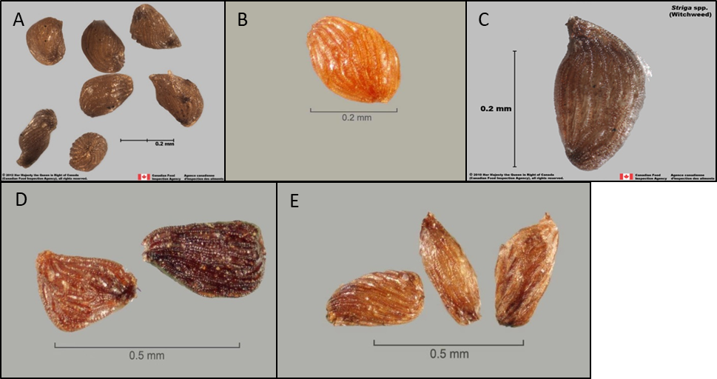
[203]Figure 1. Seeds of Striga species: (A), (B), (C) Striga asiatica; (D) Striga gesnerioides; (E) Striga hermonthica.
[204]Photos courtesy of (A) and (C) Canadian Food Inspection Agency; (B), (D) and (E) Julia Scher, Federal Noxious Weeds Disseminules, United States Department of Agriculture Animal and Plant Health Inspection Service Plant Protection and Quarantine, http://idtools.org/id/fnw/index.php
[205]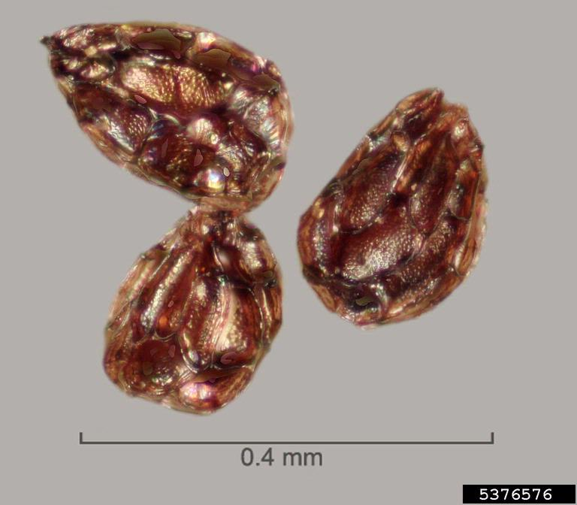
[206]Figure 2. Seeds of Orobanche minor (small broomrape).
[207]Photo courtesy of Julia Scher, Federal Noxious Weeds Disseminules, United States Department of Agriculture Animal and Plant Health Inspection Service Plant Protection and Quarantine, http://idtools.org/id/fnw/index.php
[208]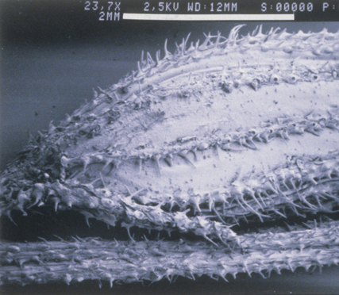
[209]Figure 3. Scanning electron micrograph of seed capsule of Striga asiatica.
[210]Photo courtesy of Lytton John Musselman, Old Dominion University, Norfolk, VA, United States of America.
[211]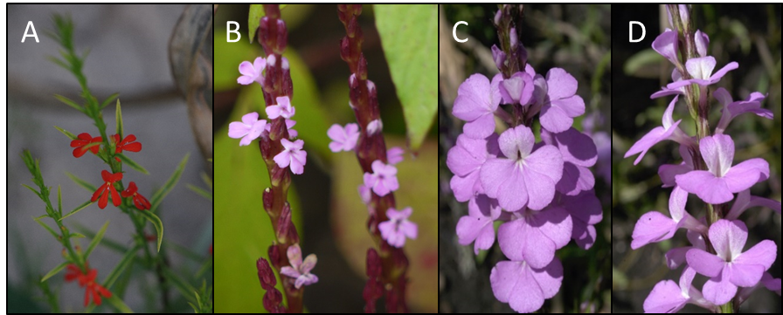
[212]Figure 4. Flowers of Striga species: (A) Striga asiatica; (B) Striga gesnerioides; (C) and (D) Striga hermonthica.
[213]Photos courtesy of (A), (C) and (D) Lytton John Musselman, Old Dominion University, Norfolk, VA, United States of America; (B) Dinesh Valke, Thane, India, https://commons.wikimedia.org/wiki/File:Striga_gesnerioides_(3976973632).jpg.
[214]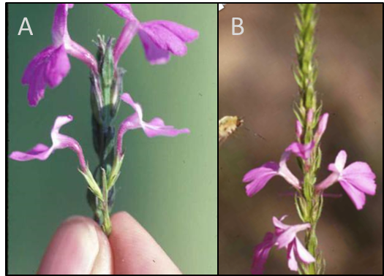
[215]Figure 5. Characteristic corolla bend in flowers of Striga aspera (A); absent in Striga hermonthica (B).
[216]Photos courtesy of Lytton John Musselman, Old Dominion University, Norfolk, VA, United States of America.

