The Global Action for Fall Armyworm Control

Action framework (2020 – 2022)

Working together to tame the Global Threat

March 2020

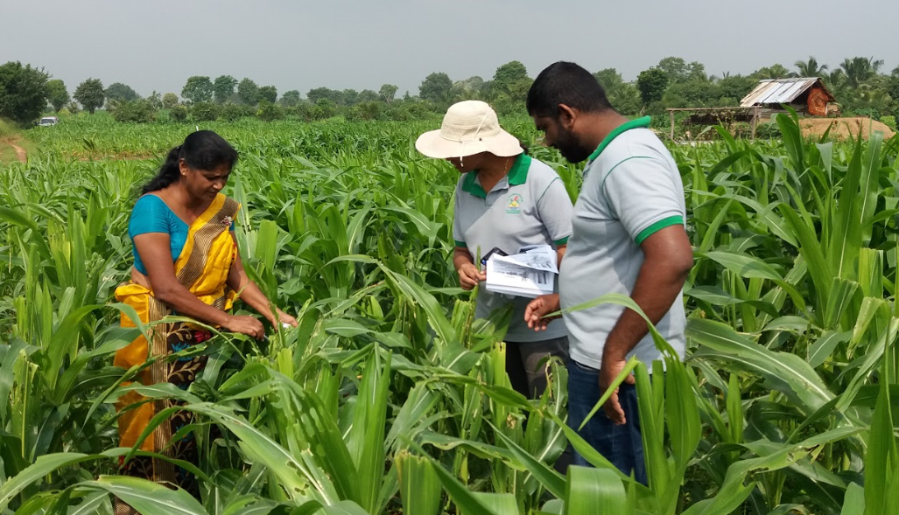
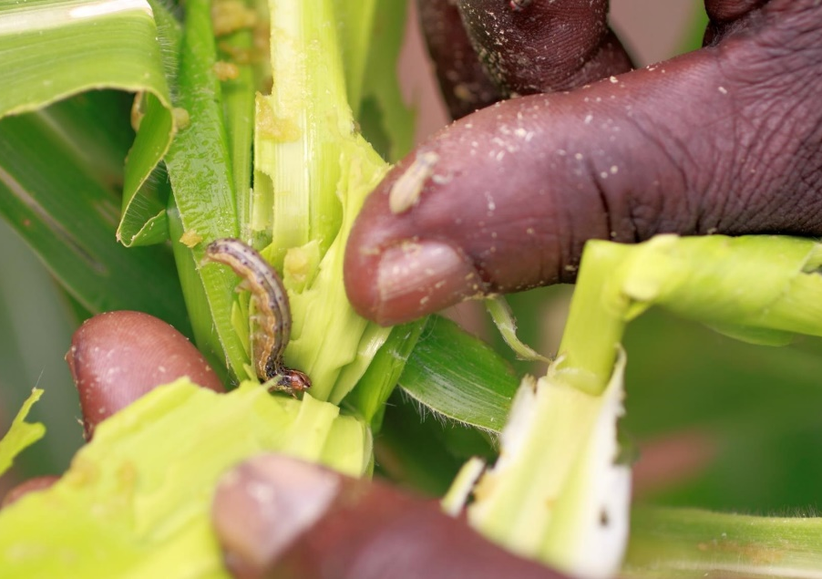
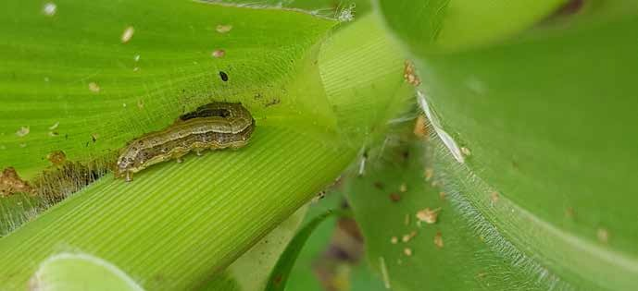
© FAO/Anne-Sophie Poisot
© FAO/Anne-Sophie Poisot

Contents
The Global Action for Fall Armyworm Control 1
Acronyms 6
Introduction 7
Fall Armyworm threat to Food Security and the Environment 7
The Insect Pest, Fall Armyworm 8
The Preferred Host of Fall Armyworm- Maize 9
Scope of the Action 10
Rationale 12
Distribution of FAW 12
Impacts of the FAW 12
Problem analysis and the theory of change 14
The Theory of Change 15
Basis of the programme 17
FAO Comparative advantages (Related work and experience) 17
Stakeholders and Stakeholder Engagement 20
Knowledge Management and Communication 24
The Action Framework 27
Goal 27
Objectives 27
Expected outcomes 27
Implementation of the Global Action 28
Estimated budget 29
Sustainability and Financing Mechanism 29
Implementation plan 31
Partnership and coordination 31
Partnership with national governments 35
Strategy 36
Technical oversight and support 36
Management and Operational Support 36
Operational modalities 37
Statistics 37
Information Technology 37
Monitoring, performance assessment and reporting 37
Risk management 38
1.1. Programme timeline 38
Bibliography 39
Annex I: Logical Framework: Expected Outcomes, Outputs and Planned Activities 40

Executive Summary
- The Fall Armyworm (FAW) is a polyphagous insect pest who feeds on maize and on more than 80 crops, including sorghum, millet, sugarcane, vegetable crops and cotton. It is a transboundary pest able to fly over 100 km in a single night.
- Native to the Americas, FAW was first detected in West and Central Africa in early 2016. Within two years, it spread to almost all sub-Saharan Africa. By November 2019, the pest was confirmed in Sudan, Egypt and Yemen, as well as in many Asian countries including India, Bangladesh, Sri Lanka, Thailand, Myanmar, China, Indonesia, Philippines, Laos, Malaysia, Vietnam, Cambodia, the Republic of Korea and Japan. This invasive strong flying insect pest continues to spread.
- FAW causes considerable yield losses in maize and in other key staple cereal crops such as sorghum, millet, and wheat, threatening food security and the livelihoods of hundreds of millions of smallholder farmers and consumers. It is estimated that, only for 12 African countries, FAW can cause losses of 8.3 million to 20.6 million metric tons of maize annually, equivalent of US$ 2.5 billion – US$ 6.2 billion and enough to feed 40 to 100 million people.
- Population migration to urban cities from rural agrarian communities is most likely to result from FAW infestation determining it as a major threat to food security and livelihoods of hundreds of millions of the world’s poorest.
- Another major problem associated to FAW infestation is the increased use of hazardous pesticides as they are representing an immediate available solution to farmers but, at the same time, harmful to humans, animals, aquatic life and environmental health.
- FAW is a major threat to crop production. It has a direct effect at socio- economic level by negatively impacting on food and income. It increases global food insecurity, malnutrition, poverty within smallholder farmers.
- FAO proposes a bold, transformative and coordinated Global Action for FAW Control. A total budget of USD 500 million is needed to implement the Global Action in 65 target countries in Africa, Near East and Asia-Pacific in 2020-2022. An estimated USD 400 million will be needed for the global action and USD 100 million for global coordination.
- The goal is to improve food security and the livelihoods of millions of smallholder farmers and reduce environmental pollution through management and control of FAW. The programme will produce several outputs that would lead to the following outcomes:
- Global, regional, national and farmer-level coordination and collaboration on FAW control enhanced, resulting in implementation of eco-system friendly IPM practices and policies.
- Reduce crop yield losses caused by FAW.
- Prevent the further spread of FAW.
- The Global Action Programme builds on the work and lessons learnt from the FAO-FAW Strategic Framework which started in 2017. The framework established a partnership for the sustainable management of the Fall Armyworm in Africa, the Near East and Asia dealing with FAW management and testing ecosystem-friendly pest management practices, monitoring and early warning systems, innovations, enabling policies and coordination mechanisms.
- The Global Action will strengthen national governments capacity for immediate support to farmers, capacity development on Integrated Pest Management and community-based actions.
- A radical change is needed to turn the awareness of the problem into action and solutions residing in the immediate response from the Global Community to mainstream funds and capacity and act faster than the FAW spreads.

- Farmers, research partners, academia, Private sector and NGOs are all called upon to contribute to the Global Action for Fall Armyworm Control and to ultimately achieve the 2030 Agenda for Sustainable Development, including Sustainable Development Goals 1, 2, 3, 5, 12, 13 and 17.
- Let us work hand-in-hand to control the global menace of FAW.

Acronyms
ADB Asian development bank
AGE Joint FAO/IAEA Division of Nuclear Techniques in Food and Agriculture
ADG Assistant Director-General
AGP Plant Production and Protection Division
AGRA Alliance for a Green Revolution in Africa
AU African Union
AfDB African Development Bank
APPC Asia and Pacific Plant Protection Commission
AUC African Union Commission
CAAS Chinese Academy for Agricultural Sciences
CABI Centre for Agriculture and Biosciences International
CGIAR Consultative Group on International Agricultural Research
CILSS Permanent Interstate Committee for drought control in the Sahel
CIMMYT International Maize and Wheat Improvement Center
DFID Department for International Development (UK)
DG Director-General
DDN Deputy Director-General Climate and Natural resources
DDO Deputy Director-General Operations
DDP Deputy Director-General Programmes
ECOWAS Economic Community of West African States
EPPO/OEPP European Plant Protection Organization
EU European Union
EMBRAPA Brazilian Agricultural Research Corporation
FAO Food and Agriculture Organization of the United Nations
FAW Fall Armyworm
FAMEWS Fall Armyworm Monitoring & Early Warning System
FEWSNET Famine Early Warning Systems Network
FFS Farmer Field
GEF Global Environment Facility
GIZ German Agency for International Cooperation
IAEA The International Atomic Energy Agency
ICBA International Center for Biosaline Agriculture
ICIPE International Centre of Insect Physiology and Ecology
ICRISAT International Crop Research Institute for the Semi-Arid Tropics
IBMA International Biocontrol Manufacturers Association
IFA International Fertilizer Association
IITA International Institute of Tropical Agriculture
IPM Integrated Pest Management
IPPC International Plant Protection Convention
IAPSC Inter African Phytosanitary Council
HPPs Highly hazardous pesticides
NPPO National Plant Protection Organization
NORAD The Norwegian Agency for Development Cooperation
PAN Pesticide Action Network
PSP Partnerships Division, FAO
REC Regional Economic Communities
RPPOs Regional Plant Protection Organizations
SADC Southern African Development Community
SSC South-South Cooperation
USAID United States Agency for International development
WTO World Trade Organization

Introduction

Fall Armyworm threat to Food Security and the Environment
- Fall armyworm (FAW), Spodoptera frugiperda, is native to the tropical and subtropical Americas, where it has been known for several decades as an economic pest of many crop species, especially maize. FAW is now cosmopolitan in distribution (Figure 1). It was first detected outside its native range in Central and Western Africa in early 2016 (Benin, Nigeria, Sao Tome and Principe, and Togo). Within two years, it was reported to have invaded all sub-Saharan Africa, except Lesotho. By July 2018, it was confirmed in the Near East, in Yemen and in India in the Asia region. By December 2018, it had been confirmed in Bangladesh, Sri Lanka and Thailand. By October 2019, FAW has been confirmed in several more countries in Asia region including Myanmar, China (including the Province of Taiwan), Indonesia, Philippines, Indonesia, Laos, Malaysia, Vietnam, Cambodia, the Republic of Korea (South Korea) and Japan. In addition to the confirmation in Yemen in 2018, FAW has also been confirmed in Northern Africa and Egypt in 2019. Between January and March 2020, FAW reached Mauritania, Timor Leste and Australia (see http://www.fao.org/fall-armyworm/en/ for the current status of FAW spread).
Figure 1: Fall armyworm status of spread as of March 2020
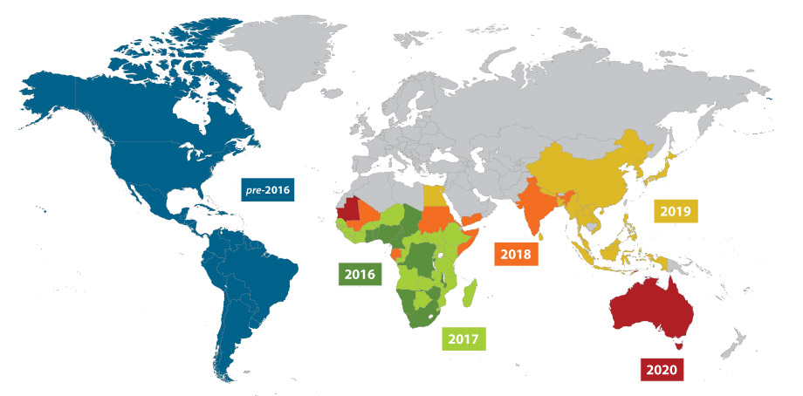

Figure 1. Geographic distribution of Fall Armyworm as of March 2020
- The modality of introduction of the FAW from its native home in the tropical and sub-tropical regions of the America to Africa after several decades, then quickly to Asia and the Near East is still speculative. Its full range of ecological fitness is also well known, but so far, it has shown a high level of ecological adaptation. A scale up of FAO’s engagement to support countries and farmers is needed in Africa, Asia, and the Near East where the FAW has spread and is spreading quickly across countries and borders. The pressure to scale up response is further compounded by the potential risk of introduction and spread in southern Europe, and Pacific countries like Australia and New Zealand.
- FAW is a highly destructive. CABI in 2017 estimated that FAW has the potential to cause maize yield losses of 8.3 to 20.6 million tonnes (which could feed 40.8 million to 101 million people) annually, valued at between US$2.5 to US$6.2 billion, in the absence of proper control methods, in 12 Africa’s maize-producing countries (Day et al., 217). The FAW does not distinguish between large-scale crop production and smallholder, subsistence production. Most affected farmers are smallholder farmers growing maize, sorghum, millet, sugarcane, cowpea and certain vegetable crops. These farmers have only limited access to information, tools, technologies and management practices to forecast, recognize and manage an infestation of their fields with FAW. Once their fields are infested, they neither have the financial means nor a management strategy to combat it.
- Although there are some management practices that can be quickly adapted to the conditions in Africa, the Near East, and Asia, such management techniques need to be tested and validated under local divers farming systems and landscapes. Some short-term research needs to be conducted to rapidly validate additional potential and un-proven management practices. Communication and training campaigns must be scaled up to help farmers and their organizations learn about FAW biology and ecology and how to manage it. Decision-makers must be aware of the potential threat and have access to information and advice regarding effective and sustainable policies and programmes. While it is attractive for farmers to receive handouts of large purchase of pesticides from their caring government, the approach is a sustainable response.
- Recognizing the significance of the threat pose by FAW, several countries in Africa (similarly in recently affected countries in Asia) have already begun programmes, but mostly by providing pesticides to farmers. These are expensive emergency response that are mostly ineffective and have long-term risks to humans and the environment and are ultimately not sustainable. The government of Zambia, for instance, allocated US$ 3 million to smallholder maize farmers in 2017 for pesticides, including provision for replanting 90,000 hectares affected. Similarly, the Government of Ghana provided US$ 4 million as an emergency measure to procure plant protection products. The Government of Rwanda mobilized the armed forces to engage in mechanical control, crushing egg masses, and treating infested fields. The much cheaper and safer part of the approach in Rwanda, of mobilizing the army to scout fields and crush egg masses was applaudable.
- However, this is not considered a long-term sustainable solution. A complete range of science- based solutions will have to be tested and evaluated against efficacy and cost-benefit analysis in order to support producers to adopt and scale up different options, such as biopesticides use, biotechnology solutions, less toxic chemicals and agronomic practices.
- It must be noted that before the introduction of FAW, most smallholder farmers in Africa in particular, but also Asia, do not use pesticides in their maize production. FAO and partners have made a lot of efforts to educate and discourage the emergency responses based largely on the purchase and distribution of highly hazardous pesticides (HPPs) to farmers even without any training on appropriate use and management for the control of FAW.
- It is not only unsustainable; it is highly damaging in the long run to human health and the environment. Particularly, it is detrimental to biodiversity and kills natural enemies of the FAW in the cropping system. The already known facts about FAW quickly developing resistance to many active substances also puts Africa and Asia on an unsustainable and dangerous risk of the “pesticide treadmill”.

The Insect Pest, Fall Armyworm
- The fall armyworm (FAW) Spodoptera frugiperda (J. E. Smith) (Lepidoptera: Noctuidae), is a moth (adult stage) genus of insect with a damaging phytophagous stage called the larva or caterpillar known to feed on several different crop species including maize (which it prefers), sorghum, millet, sugarcane, vegetable crops and cotton. FAW armyworm is a transboundary pest, the adult moths being able to fly over 100 km in a single night. The insect is native to tropical and subtropical regions of the Americas, where it has been known for over a century as an economic pest of maize and remained in that part of the world until it was first detected in West and Central Africa in early 2016. It is unclear how the cross into Africa occurred, but DNA barcoding evidence has shown that the haplotype present in Africa originated from Florida and the Caribbean.
- The life cycle of FAW in Latin America (FAO 2017) is completed in about 30 days (at a daily temperature of ~28°C) during the warm summer months but may extend to 60-90 days in cooler temperatures. The FAW life cycle includes egg, 6 growth stages of caterpillar development (instars), pupa and moth. The life cycle of FAW does not have the ability to diapause (a biological resting period), where conditions remain suitable (as in many sub-Saharan countries where there is no winter), the populations are endemic. In non-endemic areas, migratory FAW arrive when environmental conditions allow and may have as few as one generation before they become locally extinct.
- The number of eggs per mass varies considerably but is often 100 to 200, and total egg production per female averages about 1,500 with a maximum of over 2,000. Duration of the egg stage is only 2 to 3 days during the warm summer months. The FAW typically has six larval instars. Larvae tend to conceal themselves during the brightest time of the day. Duration of the larval stage is 14 – 30 days depending on the prevailing temperature from warm to cooler. The larva pupates in the soil at a depth of 2 to 8 cm. The larva constructs a loose cocoon by tying together particles of soil with silk around itself. Pupation could also happen when the larva only finds some debris but not soil. The pupal stage lasts for 8 to 9 days, then an adult moth emerges. Adults are either male or female with distinct forewings coloration, and they are nocturnal. After a preoviposition period of 3 to 4 days, the female moth normally deposits most of her eggs during the first 4 to 5 days of life, but some oviposition occurs for up to 3 weeks. Duration of adult life is about 10 days, with a range of about 7-21 days.
- FAW can feed on over 80 different crop species, making it one of the most damaging crop pests. The larvae consume the leaves, creating holes and ragged leaf edges. Feeding through the maize whorl can cause a line of identical “shot” holes, when the leaf unfurls. At maize reproductive and maturity stage, the larvae also feed on the tassels, burrow into the cobs and remain within feeding on the kernels potentially cause a complete loss of such unfortunate maize stand. FAW is known to cause significant damage to economically important cultivated grasses including maize, sorghum, sugar cane, but also vegetables and cotton. During the maize vegetative phase, constant feeding results in skeletonized leaves and heavily windowed whorls loaded with larval frass.

The Preferred Host of Fall Armyworm- Maize
- FAW is feeds on over 80 crop species, including sorghum, wheat, sugarcane, millets, cotton and vegetables but primarily maize for which it has its preference. Maize is susceptible to infestation by FAW at all stages of its development cycle, and severe losses occurs when the whorl is destroyed, reducing photosynthetic area and compromising the grain yield. Even more consequential, is at the later developmental stages when the larvae feed on the tassels, burrow into the cobs and remain within feeding and destroying the kernels and directly resulting in yield loss.
- The global importance of FAW is related to the importance of maize worldwide. This is particularly so for several 100s of millions of farmers and others in the maize value chain in developing countries including in Africa and Asia whose food security and livelihoods depends on it both as a staple food and a cash crop. It is the most-produced cereal worldwide. In Africa alone, more than 300 million people depend on maize as their main food crop. Maize is also very important as feed for livestock. About 90% of the global maize production is yellow maize. In Africa however, about that same percentage (90%) of the maize produced is white maize.
- Maize happens to originate from the same region as FAW. It originated from Mexico, where it was domesticated from its wide relative 1000s of years back. It then spread widely in Latin America, the Caribbean, Northern America, and from there to Europe through explorers and traders, then to Asia and Africa. The spread was through deliberate introductions because of its ease of cultivation, high energy value for both human and livestock, and its several industrial uses. Its wide climatic adaptability and availability of varieties for different climatic regions through concerted breeding efforts also were critical to it being the crop of the world.
- Maize production in Africa is very low comparatively. Its production is besieged by several threats such as pathogens (fungi, viruses, bacterial), weeds, nematodes, insect pests, low quality seed, none or low levels of mechanization, lack of good post-harvest management, and drought etc. Yield losses can be sometimes up to 100%, thereby dramatically affecting the lives of farmers, consumers and the food security of these countries.
- In Africa, maize (white maize) is mostly produced for consumption in different forms, but mostly as dried harvested grains milled into flour for making different kinds of meals. Excess of family consumption needs are sold usually at very low prices for consumption in urban cities, or eventually other uses such as livestock feed and brewery industry.
- In Asia, maize is important as a livestock feed and a staple food, as well as a raw material for starches and sugars used in food processing and other industries. The crop’s importance has continued to grow due to the increasing and competing demands in the three areas- food, feed, and industry. Unlike Africa, most of the maize production is yellow maize and most production is used as livestock feed compared to the amount consumed directly as food.

Scope of the Action
- This 3-year Global Action (GA 2020-2022) is the key instrument proposed by FAO to have a radical and direct impact on the FAW threat. It is a proposal for a massive scale up of activities building on the major achievements and lessons learned from the FAO five-year programme of action that FAO developed and started in 2018. FAW has quickly spread to many countries in Asia, the Near East and additional countries in Africa since the development of the FAO five-year action, and the risk of further introduction and spread and impact on the global food security and livelihoods have increased. The global action will catalyse FAW affected countries’ capacity to react and protect food production from threats that new emerging transboundary pests represents.
- The Action needs 500 Million USD to:
- Establish and implement a global coordination system that will connect the national FAW response efforts directly to the global political level support.
- Massively scale-up capacity development on integrated management of FAW in affected countries in Africa, Asia and the Near East, to sustainably manage FAW and reduce crop yield losses
- Ensure the risk of further introduction and spread to new areas is reduced
- Also, in October 2018, in a FAW Research for development (R4D) meeting held in Addis, Ethiopia the global leadership of FAO in coordinating all partnership research and development efforts towards the sustainable management of FAW in the new countries and regions was reconfirmed. The meeting identified gaps and corresponding recommended actions in all the different technical areas of the Framework for Partnership on FAW sustainable management effort. FAO through this Action will coordinate and lead the global collaboration with the research institutions, academia, public and private sector to address these gaps and develop integrated pest management strategies for sustainable management of FAW in Africa, Asia, and the Near East.
- The Global Action will strengthen national governments’ capacity to take a coordinated approach to managing FAW. Farmers need immediate information and capacity development, so that they can respond to FAW infestation in their farms and reduce yield losses.
- The Action will be implemented in three regions: Africa, Near East and Asia with a special focus on the countries of the Hand-in-Hand Initiative. The selection of countries considers three main criteria:
- Level of infestation for radical work on IPM Capacity development
- Risk of further FAW introduction and spread for immediate prevention action to apply phytosanitary measures
- “Matchmaking” between countries with the highest poverty and hunger rates and those countries most able to offer support in line with the Hand-in-Hand Initiative
- The global action approach will facilitate the flow and use of information, knowledge, products and services.
Table 1: Proposed actions in target countries according to FAW infestation

AFRICA

Pest situation | *Countries |  |  | Threat | Proposed actions
Widely present | - Nigeria  - Tanzania  - Kenya  - Mozambique  - Zambia  - Zimbabwe  - Malawi  - Uganda | - Burkina Faso  - Mali  - Madagascar  - Niger  - Guinea-Bissau  - Ethiopia  - D.R. Congo |  | Immediate threat to Food Security | Immediate: Capacity development in Early warning system and Monitoring and IPM
Present | - Angola  - South Sudan  - Burundi  - C. African Republic  - Chad  - Somalia |  | - Comoros  - Djibouti  - Rwanda  - Sao Tome e Principe  - Eswatini  - South Africa | Threat to Food security | Short term: Capacity development in Early warning system and Monitoring and IPM and improve phytosanitary measures to prevent further introduction and spread.
Not known to be present | - Lesotho |  |  |  | Prevent introduction and spread: Capacity development in Early warning system and Monitoring and IPM and improve phytosanitary measures to prevent further introduction and spread.
ASIA- PACIFIC
Infestation situation | Countries |  | Threat | Proposed actions
Widely present | - Afghanistan  - Bangladesh  - Sri Lanka  - China  - India | - Vietnam  - Thailand  - Myanmar  - Nepal | Immediate threat to Food Security | Immediate: Capacity development in Early warning system and Monitoring and IPM
Present | - Cambodia  - Indonesia  - Philippines  - Lao  - Australia |  | Threat to Food security | Short term: Capacity development in Early warning system and Monitoring and IPM and improve phytosanitary measures to prevent further introduction and spread.
Not known to be present | - DPR Korea  - Iran  - Mongolia  - Papua New Guinea  - Pakistan | - Fiji  - New Caledonia  - Vanuatu  - New Zealand |  | Prevent introduction and spread: Capacity development in Early warning system and Monitoring and IPM and improve phytosanitary measures to prevent further introduction and spread.

Near East
Infestation situation | Countries |  | Threat | Proposed actions
Widely present | - Yemen  - Sudan  - Egypt |  | Immediate threat to Food Security | Immediate: Capacity development in Early warning system and Monitoring and IPM
Present | - Mauritania |  | Threat to Food security | Short term: Capacity development in Early warning system and Monitoring and IPM and improve phytosanitary measures to prevent further introduction and spread.
Not known to be present | - Morocco  - Algeria  - Iraq  - Jordan  - Lebanon | - Libya  - Oman  - Saudi Arabia,  - Syrian Arab Republic  - Tunisia |  | Prevent introduction and spread: Capacity development in Early warning system and Monitoring and IPM and improve phytosanitary measures to prevent further introduction and spread.
*Priority Countries for the Hand-in-Hand Initiative are highlighted in red

Rationale

Distribution of FAW
- FAW is a transboundary pest that is now almost cosmopolitan in distribution. It was first detected in Central and Western Africa in early 2016 (Benin, Nigeria, São Tome and Principe, and Togo), and within two years, it was reported to have invaded all sub-Saharan Africa, except Lesotho. The pest has now been confirmed also in Asian countries including- India, Bangladesh, Sri Lanka, Thailand, Myanmar, China (including the Province of Taiwan), Indonesia, Philippines, Indonesia, Laos, Malaysia, Vietnam, Cambodia, the Republic of Korea, Japan, and in the Near East, Sudan, Yemen and Egypt.
- The ability to be introduced and spread fast into new areas, multiply and establish an economic pest population levels quickly makes FAW a huge threat to food security and livelihoods of millions in places where the FAW has invaded and many more millions on its path. Before invading Africa in 2016 (when it was detected), FAW was known to be a serious economic pest of maize especially, in tropical and sub-tropical areas of the Western Hemisphere for many decades. FAW crossing over the Atlantic Ocean to the Eastern Hemisphere, with its first detection in West and Central African Countries in 2016 and rapid spread through countries and continents quickly change its status to a global pest with huge impacts implications for the world. The rate of spread and places of establishment in the new hemisphere, in addition to its wide host-range indicate that the risk of spread to more places within countries, to new countries and regions in the Eastern Hemisphere (including Europe and Australia) is high. Except for a coordinated and committed large global intervention effort, FAW has proven to further make achievement of the 2030 agenda for sustainable development goals (SDGs) impossible. Already, the current distribution in Africa, Asia and the Near East constitutes a threat to food security and livelihoods of global magnitude.

Impacts of the FAW
- FAW is a damaging pest of economic importance. Its direct impact is mainly economic through yield reduction of the crops it attacks, particularly maize, and other cereal crops. In addition, there are indirect impacts which occur as a result of the yield loss in both quantity and quality, control actions in terms of time and costs. They include reduced food and income (potentially increasing food insecurity, malnutrition, and poverty), as well as broader economic, social, health and environmental impacts.
- The arrival and spread of FAW in Africa justifiably caused immediate panic in African countries, many of which are already going through one or more crisis that limit food production and availability. Based on the known behaviour of FAW in its native lands in the Americas, the early experiences in Africa, and the fact that the pest is endemic in sub-Saharan Africa due to conditions favourable for survival all year round, the threat on food security and rural livelihoods is huge. Also, the benefits of natural suppression by natural enemies that the pest had co-evolved with in the Americas might not be of immediate realization in the pest’s new ecosystems. In a survey study in 2017 by CABI, estimated losses reported from 12 African countries ranged from 8.3 to 20.6 million tons (equivalent of US$ 2,481 – 6,187 billion) of maize per annum (Day et al., 2017). In similar surveys by CABI in 2018, the average maize losses reported by farmers in Ghana was 26.6% and in Zambia 35%, equivalents of US$177 million and US$159 million in Ghana and Zambia, respectively, much lower compared to the 2017 estimates (Rwomushana et al. 2018), but still substantial.
- Following the introduction of many African countries by FAW, some studies have attempted to estimate actual yield loss at field/farm level using farmer surveys (questionnaire, focus groups). Results include up to 77% yield loss in maize in Zambia (FAO, 2017); 22% in maize in Mozambique (FAO, 2017); 32% and 47% in maize in Ethiopia and Kenya (Kumela, 2018); 26% and 35% in maize in Ghana and Zambia, respectively (Rwomushana, 2018). Losses assessed through field trials were 11‐18% in maize in Ethiopia (Kassie, 2018), and 6.9‐13.9% in maize in Zimbabwe (Baudron, 2018). Farmer surveys and field trial data can be extrapolated to national level.
- Actual yield losses in poor-resourced farmers’ fields already with factors that inherently keep yields low are likely high for maize under any heavy infestation levels. Maize is attacked by FAW at virtually all the developmental stages of the maize thereby causing severe losses when the whorl is destroyed. At the later development stages the larvae also can feed on the tassels, burrow into the cobs and destroy the kernels, as well as expose the cob to infection by microorganisms including the mycotoxin (e.g. aflatoxin) producing fungi. Such cobs are 100% lost as they become non-harvestable. Also, it adds to the mycotoxin threat to food security and international trade. This is in addition to the justifiable new scrutiny that movement export of crops that are host plants for FAW from developing countries with confirmed presence of FAW will come under new scrutiny from importing countries that are free of the pest.
- The potential impact on the budding private seed sector in many of these countries and therefore the further drag on attainment of the 2030 agenda for sustainable development goals particularly of zero hunger, no poverty is huge. The damages to maize seed production fields does only affect the availability of seed to farmers in the following growing seasons but also becomes an additional barrier to the economic viability of the emerging private seed sector.
- International trade could also seriously be impacted by FAW introduction of the developing nations of Africa and Asia through heightened phytosanitary concerns. Commodity exports from countries and regions in the Eastern Hemisphere with confirmed FAW presence will come under stricter screening or outright ban by countries and regions (Europe in particular) that don’t yet have FAW. For instance, following establishment of FAW in Africa, the EU instigated emergency measures requiring strict phytosanitary controls in exporting countries to reduce the risk of the pest reaching Europe, and as such two in 2017 and 17 in 2018 consignments from Africa containing FAW were intercepted in Europe, and 17 in 2018 (Rwomushana et al. 2018). This confirms the risk of spread to Europe via trade (in addition to the risk of natural migration of the strong flying moth to Europe), but also underscores the further potential social-economic impact on the crop value chain, bring down the prices that the farmers can receive for their harvest, therefore their livelihoods.
- Population migration to urban cities from rural agrarian communities is most likely the rapid spread and ability of FAW to cause crop damage and increase food insecurity and rural poverty. This has the potential for a cascading effects of increased food insecurity, poverty and pressure on the social-economic systems of the countries.
- In addition to the social-economic and food security impacts of FAW, the introduction of FAW in Africa and Asia caused panics to farmers and governments due to the destructive nature of the pest and insufficient knowledge of management practices to reduce yield loss. Some governments in Africa even hand out pesticides to farmers. The cost and the potential risk health and environmental effects of indiscriminate, and unguided use of synthetic pesticides (including highly hazardous pesticides) significantly increase the potential impacts of FAW in Africa, Asia and the Near East. The responses highlight the potential for negative human and environmental health impacts. Huesing et al. (2018) noted that this action can results in critical problems including:
- Substantial environmental and human health issues, arising from both the initial application of hazardous chemicals and continued exposure to pesticide residues on consumed produce or in the production environment.
- Damage to populations of natural enemies and predators of FAW and other major pests in the cropping systems, further impeding sustainable management of FAW and other pests.
- High risk of pesticide exposure particularly for women and children at farm level, as women mostly manage smallholder farming with their children in many parts of the developing world, as in many African countries.

Problem analysis and the theory of change
- The ability to spread fast, multiply quickly to establish an economic pest population levels and destructively feeding on a wide range of crops makes FAW a unique threat to food security and livelihoods of 100s of millions in Africa, Asia and the Near East in places where the FAW has invaded and many more on its path in the Eastern Hemisphere. FAW crossing over the Atlantic Ocean from the Americas (where it has been a serious economic pest for several decades) to the Eastern Hemisphere, with its first detection in West and Central African Countries in 2016 and rapid spread through countries and continents has huge impacts implications for global food security, poverty reduction, resilience to climate change, human and environmental health.
- The rate of spread and places of establishment in the new hemisphere, in addition to its wide host-range indicate that the risk of spread to more places within countries, to new countries and regions in the Eastern Hemisphere (including Europe and Australia) is high. Already, the current distribution in Africa, Asia and the Near East constitutes a threat to food security and livelihoods of global magnitude.
- The Problem: Maize (but also other crops) is being attacked by FAW currently in 44 countries- 27 in sub-Saharan Africa, 13 in Asia, and four in the Near East, and another 21 countries- one in sub-Saharan Africa, 10 each in Asia and the Near East are potentially infested (see Table 1). The rapid spread and extent of infestation by FAW is causing moderate to severe yield losses in the 44 countries where FAW have been confirmed. The rate of misuse (including overuse) of pesticides (some of which belong to the HHPs labels) in most of these countries have dramatically increased as farmers and governments panic to control the pest, which is inherently difficult to kill by pesticide sprays because of its behaviour on the plant- leading to repeated and use of overdose sprays. These two linked problems have the potential effects of increased food insecurity, poverty, human and environmental health problems, loss of biodiversity and reduced resilience to climate change.
- In addition to the 27 countries in Africa, Asia and the Near East that may be infested already or could be infested within the next year or two, other new areas (including Europe and Australia, New Zealand) in the Eastern Hemisphere could become infested. The introduction and spread to new areas could be via international trade and or the unique transboundary nature and ability of FAW moth to fly long distances and to adapt to a wide range of climates.
- Infestations and continuous spread of FAW is aided by some key deficiencies in most of these countries in Africa and Asia-Pacific. They include:
- lack of, or inadequate, inclusive coordination among key stakeholders;
- lack of effective pest monitoring and early warning system;
- lack or inadequate knowledge on FAW sustainable management;
- poor or lack of phytosanitary measures and implementation;
- poor agricultural extension and farmer communication systems.

The Theory of Change
- There are numerous technical, coordination and political challenges bedevilling prevention and control of FAW in Africa, Asia and the Near East (Figure 2) for which a radical and transformational global intervention as the 500 million USD 3-year Global Action Programme is what is needed. The cost of no action or half-hazard support /action will be far more costly. The Global Action Program intervention seeks to remove these technical, coordination and political barriers to make progress towards the sustainable management of FAW. A non-exhaustive list of these barriers at technical level, coordination level and political level that must be removed to change the current situation and have new outcomes are shown in the theory of change schema (Figure 2) in the second column depicted as “Barriers to FAW management”.
- The Global Action programme for sustainable management of FAW is designed around the elimination of these barriers through see Figure 2):
- Massive scale up of capacity development of each of the target beneficiary countries on Integrated Pest Management of FAW
- This include in addition to FAO and partners in-country capacity development, building of strategic partnership with research institutions such as the CGIAR, academia, public and private sectors to develop innovative ecosystem-based IPM technologies for sustainable management of FAW.
- Policy review and coordination, standard stetting, and surveillance, risk assessment and phytosanitary measures development and implementation to reduce the risk of further FAW spread
- Establish and implement a global coordination system that will connect the national FAW response efforts directly to the global political level support
- This global action is expected to produce several outputs (see outcomes outputs and planned activities) leading to transformational immediate outcomes and paradigm shift contributing towards impact socio-economic and environmental levels (Figure 2).
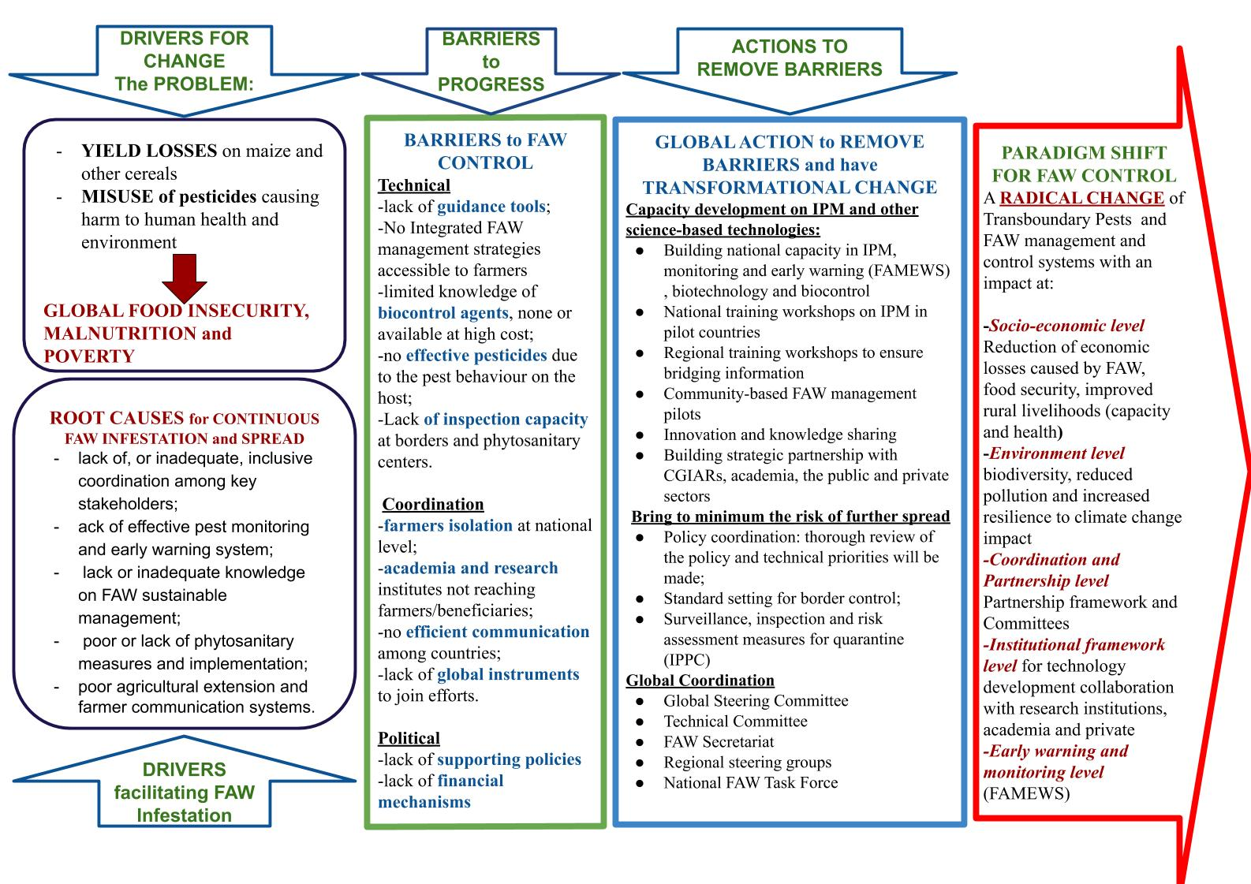
Figure 2: Theory of change of the global action for FAW management

Basis of the programme
- The FAW Global Action Programme is a three-year initiative that seeks to dramatically reduce harmful effects of FAW on agriculture production. At the end of the three years interventions, countries will have developed capacity in sustainable management of FAW, reduced considerably yield losses and reduced the risk of further introduction and spread to new areas.
- The Global Action Programme builds on the work and lessons learnt of the FAO-FAW Strategic Framework Programme started in 2018. This framework established a partnership for the sustainable management of the Fall Armyworm in Africa, the Near East and Asia dealing with FAW management and testing ecosystem-friendly pest management practices, monitoring, and early warning, innovations, enabling policies and coordination mechanisms.
- The three-year Global Action Programme aims at scaling up FAW management efforts at global level to reach 65 target countries (Table 1) comprising 44 countries- 27 in sub-Saharan Africa, 13 in Asia, and four in the Near East where FAW presence is confirmed and another 21 countries- one in sub-Saharan Africa, 10 each in Asia-Pacific and the Near East potentially infested (Not known to be present). The proposed intervention will remove barriers to sustainable management of FAW in the affected countries and its introduction into other regions.
- The modus operandi will be at national, regional and global level ensuring groundwork with beneficiaries, smallholder farmers, and at the same time decision processes on supportive and enabling policies to scale up IPM, early warning, monitoring and phytosanitary measures.
- The sound technical level is ensured by the already established partnership framework, and it will be further strengthened, allowing Research Institutes as CGIAR centers, Academia and the Private sector to contribute and deliver innovative technologies to benefit farmers.
- The transformational approach of the Global Action for FAW management calls for innovative global coordination and action. A global steering committee chaired by the FAO Director General will oversee the coordination and implementation of the activities and connect the national groundwork to the global political level. A technical Committee will advise the global steering committee and a FAW Secretariat, hosted by the Division of Plant Production and Protection (AGP) of FAO in coordination with the IPPC Secretariat, will be responsible for the day-to-day work.
- The Global action will strengthen national governments capacity to assist farmers for an immediate intervention. The action will design and implement appropriate IPM-based packages relevant for diverse agro-ecologies, cropping systems landscapes, value-chains and socio-economic contexts of the farming communities in Africa and Asia.
- Capacity development on Integrated Pest Management and community-based pilots will use innovations and technologies proposed by research partners in order to benefit the farmers directly and reduce yield losses in eco-friendly manner.

FAO Comparative advantages (Related work and experience)
- FAO is already supporting member countries through impact assessments, developing Monitoring and Early Warning systems and response strategies. It has implemented several projects in the past regarding transboundary pests, locust and pesticide management. In doing so, sub-regional and country offices have always played a crucial role in coordinating the work.
- FAO maintains strong collaboration networks with international partners from the public and private sectors, civil society, farmer organizations, to exchange information and knowledge on pest and pesticide management worldwide. In the case of FAW, FAO is amongst others working together with CGIAR Centres and other advanced research organizations to coordinate research agendas, avoiding silos but also duplication of work.
- Officers are representing the organization across the globe. FAO’s staff members – both in Headquarters and in the field via the decentralized offices– have the best technical knowledge in pest management, early warning and monitoring of pests, and in international governmental collaboration. It can respond quickly to needs of member countries, also through emergency interventions and by adapting field-tested strategies to various contexts.
- Farmer Field Schools (FFS) will play a central role in informing farmers about FAW management, as they are an important means of conveyance. FAO pioneered the FFS approach in 1998 and since then, FFS have been established in over 90 countries. Over the years, FAO developed a strong network of Farmer Field Schools. There is no doubt that due to its long-time experience, FAO is in the best position and more than well prepared to integrate FAW management in FFS curricula.
- With more than 50 years of experience, FAO has substantial internationally recognized technical expertise on transboundary pest management and pesticides. Moreover, FAO is a strong partner of state and non-state actors alike, such as national governments, ministries, the private sector, universities and research centres. This includes support to the development and implementation of national policies and pest management programmes.
- FAO provides support to the implementation of related guidance documents, such as the code of conduct on pesticides and the pesticide registration toolkit. With its broad expertise, neutral position, strong partnership networks and support to the implementation of the instruments mentioned above, FAO is well positioned to successfully bring all stakeholders together to successfully manage the outbreak of the FAW in Africa, the Near East and Asia-Pacific.
- Specifically, this project will build on the following strengths:
- FAO is a neutral forum and convening body for bringing together interested parties, such as national and county government departments, the private sector, international and regional organizations, research institutes, technical experts and donors, and achieving consensus on the way forward, based on the various experiences, lessons learnt, current situation and future needs. FAO will coordinate the global support to countries for managing the FAW outbreak and to mitigate the impact in the countries already affected and to contain further introduction and spread.
- FAO works at a global level to provide services and products (FFS Guide & trainings, Pesticide policy advice, FAMEWS and FAW Risk systems). Across Africa and Asia-Pacific, FAO works closely with regional organizations via the FAO Regional Offices, at sub-regional level with the RECs, and at the national level, directly helping member countries develop and implement their programmes and policies via the FAO Representation in each country. FAO works closely with the Inter African Phytosanitary Council, the North East Plant Protection Organization, and the Asia and Pacific Plant Protection Commission.
- FAO has tremendous technical expertise on crop pests and diseases management and pesticide risk reduction, within AGP. The Division has expertise on management and control of emerging pests and diseases that include FAW. AGP is already providing substantial support on sustainable FAW management to countries via:
- Trainings on local production of biocontrol agents
- The provision of information material (available in all UN languages and Portuguese), such as the FAW Guidance notes:
- Fall Armyworm: Pesticide Risk Reduction
- Fall Armyworm Scouting
- Fall Armyworm Trapping
- Fall armyworm early action policy guide
- Fall Armyworm in Africa: FAO’s position on the use of genetically modified maize
- FFS Guide on Integrated Pest Management of Fall Armyworm
- The development of FAMEWS, the Monitoring and Early Warning system, that also provides free advice for farmers.
- Organization of a Consultative Meeting on FAW in Asia
- Workshop on sustainable FAW management in Cabo Verde
- Regional Workshop on Sustainable Management of Fall Armyworm in Asia in Kuming City, Yunnan Province, China, 11-15 November 2019
- The International Plant Protection Convention (IPPC) is the sole global treaty recognized by the World Trade Organization Agreement on Sanitary and Phytosanitary Measures (WTO SPS Agreement) as standards setting and implementation body for plant health. The IPPC aims to secure coordinated, effective action to prevent and to control the introduction and spread of pests of plants and plant products in order to preserve food security, to protect biodiversity and to facilitate trade. The Convention provides a framework and a forum for international cooperation, harmonization and technical exchange between contracting parties.

Organization of the IPPC:
- The number of contracting party signatories to the Conventionn as of March 2020 is 184
- Each contracting party should establish a National Plant Protection Organization (NPPO) and nominate an Official IPPC contact point.
- Ten (10) Regional Plant Protection Organizations (RPPOs) have been established to coordinate NPPOs in various regions of the world.
- The IPPC Secretariat liaises with over 35 international and regional organizations to help build regional and national capacities.
- The IPPC Secretariat is provided by the Food and Agriculture Organization of the United Nations (FAO-UN).
- Since its establishment, the IPPC Secretariat has helped ensure food security and contributed to protecting biodiversity, as well as provided the framework for facilitating safe trade. The major work area and achievement for the IPPC Secretariat are as follow:
- Standard setting: Over 100 ISPMs have been adopted in 1993-2018 within which 55% were tech-related and 45% were trade-related.
- Implementation and capacity development: Without proper implementation and capacity development to enable the Convention and its standards to be effectively implemented by contracting parties, setting standards is worthless. The IPPC Secretariat implemented its Phytosanitary Capacity Evaluation (PCE) in over 60 contracting parties since 2000 to help build capacity in NPPOs to carry out their functions. Over 30 Guides and Training Materials have been developed to provide accurate and easy understanding, best practices and lessons learned to NPPOs. Phytosanitary Technologies related to phytosanitary issues such as early-detection, inspection, diagnostic, surveillance, pest reports and eradication are being implemented in pilot countries to find an integrated best solution or practise for maintain Pest Free Area (PFA).
- Communication & international cooperation: This core activity is an essential tool aimed at ensuring that the potential for serious negative impacts from introduced pests worldwide is understood and that plant health is included in the policy considerations of relevant intergovernmental and nongovernmental organizations.
- FAO is already successfully coordinating FAO’s Programme on coordinating a sustainable management of FAW, bringing together fast-tracked emergency response, all technical areas, communications and training, with FAO’s Headquarters, the Regional Offices, the Sub-regional Offices, National Offices, Resilience Hubs, NGOs and research institutes into one coherent, consistent programme (see figure 3).
- 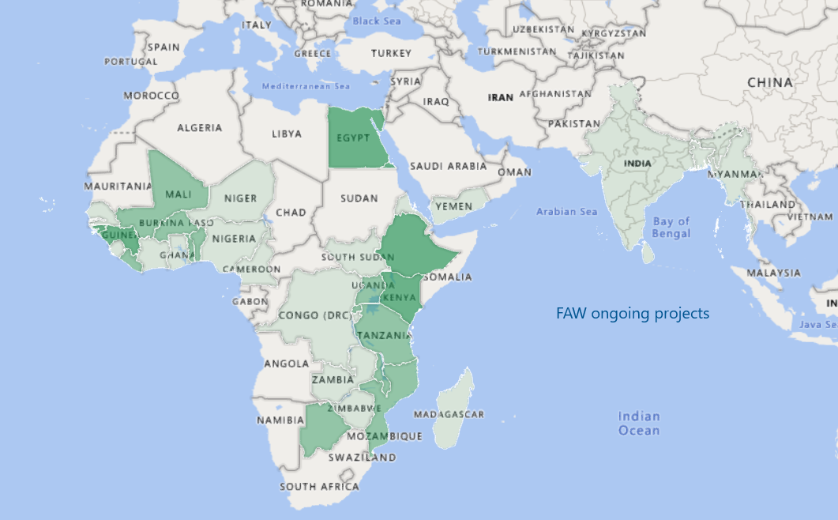
Figure 3: Countries with ongoing FAW projects, supported by AGP

Stakeholders and Stakeholder Engagement
- Since the introduction and spread of FAW in Africa, FAO has been working with a lot of different stakeholders and partners (Table 2). It was based on this that FAO following a stakeholder consultative meeting in Nairobi, Kenya in April 2017 developed the framework for partnership. In this scale up global action programme, the further stakeholder mapping will be done and a stakeholder engagement matrix (Table 2) developed to ensure an inclusive partnership and effective stakeholder engagement.
- The activities of the proposed global action for FAW management will be carried out in close collaboration with different partners, such as but not limited to national governments, ECOWAS/CILSS, AGRA, APPPC, CAAS, COMESA, FEWSNET, CABI, CGIAR Centers (CIMMYT, IITA, ICRAF, etc.), ICIPE, SADC/CCARDESA, ASARECA, CORAF, AUC, NIBIO, MARA, IPPPC, Farmers’ Associations, National Agricultural Universities, civil society and the private sector.
- Following the arrival of FAW in Africa, FAO has led or participated in several meetings to identify and engage with stakeholders:
- Consultative Meeting (Harare, Zimbabwe, 14-16 February 2017)
- Stakeholders Consultation Meeting on “Fall Armyworm in Africa: Status and Strategy for Effective Management” (Nairobi, Kenya, 27-28 April 2017)
- Consultation Meeting with Partners (Accra, Ghana, 17 July 2017)
- Global FAW Experts Meeting (18-20 July 2017, Accra Ghana)
- Farmer Field Schools FAW Curriculum development Workshop (Accra, Ghana, 21-25 July 2017)
- FAW Training of Trainers (Addis Ababa, Ethiopia, 24-28 July 2017)
- FAW Training of Trainers (Abuja, Nigeria, 5-9 September 2017)
- Farmer Field School Training (Abuja, Nigeria, 10-15 September 2017)
- Sub-regional Workshop (Entebbe, Uganda, 18-20 September 2017)
- Consultative Meeting on FAW in Asia (Bangkok, Thailand, 20-22 March 2019)
- Multi-stakeholder Regional Workshop on Innovations for Smallholder Farmers for sustainable management of Fall Armyworm in Africa and Near East. (Praia, Cabo Verde 21-24 October 2019)
- Regional Workshop on Sustainable Management of Fall Armyworm in Asia in Kunming City, Yunnan Province, China, 11-15 November 2019.

Figure 4: The response of FAO 2017-2019

Table 2: Stakeholder Engagement Matrix
Stakeholder Name | Stakeholder Type | Stakeholder profile | Consultation Methodology | Consultation  Findings | Expected timing  (for Stakeholder Engagement Plans Only) | Comments
African Union | Indirect Beneficiary | Regional Government Institution/body | Several meetings have been conducted to identify and meet stakeholders:  - Consultative Meeting (Harare, Zimbabwe, 14-16 February 2017)  - Stakeholders Consultation Meeting on “Fall Armyworm in Africa: Status and Strategy for Effective Management” (Nairobi, Kenya, 27-28 April 2017)  - Consultation Meeting with Partners (Accra, Ghana, 17 July 2017)  - Global FAW Experts Meeting (18-20 July 2017, Accra Ghana)  - Farmer Field Schools FAW Curriculum development Workshop (Accra, Ghana, 21-25 July 2017)  - FAW Training of Trainers (Addis Ababa, Ethiopia, 24-28 July 2017)  - FAW Training of Trainers (Abuja, Nigeria, 5-9 September 2017)  - Farmer Field School Training (Abuja, Nigeria, 10-15 September 2017)  - Sub-regional Workshop (Entebbe, Uganda, 18-20 September 2017)  - Consultative Meeting on FAW in Asia (Bangkok, Thailand, March 2019)  - Multi-stakeholder Regional Workshop on Innovations for Smallholder Farmers for sustainable management of Fall Armyworm in Africa and Near East. (Praia, Cabo Verde 21-24 October 2019) | FAO has developed a Framework for partnership that brings together all partners into a coordinated and coherent structure.  To strengthen global coordination, FAO has facilitated the establishment of twelve Technical Working Groups (TWG), which became functional during the second half of 2017.  In addition to the technical partnership with various stakeholders, the establishment of a larger consortium of resource partners around a larger FAW fund is proposed to support the implementation of the framework programme of FAO for the sustainable management of FAW.
Consultative Group for Agricultural Research (CGIAR) CYMMIT, ICRISAT, IITA | Indirect Beneficiary | Research Institute
International Centre of Insect Physiology and Ecology (ICIPE) | Indirect Beneficiary | Research Institute
EMBRAPA | Indirect Beneficiary | Research and Development Agency
Centre for Agriculture and Biosciences International (CABI) | Indirect Beneficiary | Research Institute
Farmers | Direct beneficiary | Local Community | Farmers and Local communities were identified during a series of meetings and trainings and through already existing FFS training courses. | The outcome of the meetings and consultations was clearly that many farmers do not have the necessary support to identify and manage the FAW in their fields. They will greatly benefit from the global, coordinated effort to sustainable manage the FAW.
NPPOs
RPPOs
(+) Add stakeholders as necessary

- All meetings and consultations had representatives of national governments, sub-regional and regional bodies (including AU), CGIAR Centers, other research and development agencies, the private sector, resource partners and civil society.
- FAO has worked with member countries and many partners to develop the Framework for Partnership. This Framework has been endorsed by all participating partners and provides the overarching framework for working in partnership in the proposed global action for FAW management programme.

Knowledge Management and Communication
- Knowledge Sharing
- Given the complexity of the serious threat that the FAW represents, collective global action is needed. Currently, the partnership comprises governmental and non-governmental stakeholders, public and non-public sector partners and a vast number of research centres. Stakeholders and actors need to be informed not only about the status of the project, but also about actions that have been taken, results, lessons learned and the further development and adaptation of the project. Within FAO’s Programme for action on the sustainable management of the Fall Armyworm, the information and knowledge sharing are coordinated by the Farmer Education and Communications Technical Working Group, which brings together all communication partners
- Therefore, FAO together with its partners, is producing information and knowledge products and makes them easily available. Access to information and knowledge is considered the key element of the project. Technical extension leaflets targeting farmers and extension workers on FAW management decisions specifically on identification, prevention, monitoring and direct control are being finalized by FAO and CABI to be widely disseminated.
- To date, FAO has developed significant communication and information products in the implementation of its Programme for action:
- Synthesis Report from the Fall Armyworm Expert Meeting
- FAO Programme for Action: Sustainable Management of the Fall Armyworm in Africa
- Briefing Notes on FAO’s Actions on FAW, including up-dated maps of distribution
- Development and publication of the Farmer Field Schools Guide for Managing Fall Armyworm in Africa.
- Development and deployment of a mobile application for the Fall Armyworm Monitoring and Early Warning System (FAMEWS)
- Series of webinars on FAMEWS
- Development of a Risk Model and Mapping for FAW
- Publications of Guidance Notes on FAW:
- Fall Armyworm: Pesticide Risk Reduction
- Fall Armyworm Scouting
- Fall Armyworm Trapping
- How to manage Fall Armyworm: A quick guide for smallholders
- Fall armyworm early action policy guide
- Fall Armyworm in Africa: FAO’s position on the use of genetically modified maize
- Training Videos (e.g. Programme of Action against the Fall Armyworm in Africa, Best Practices for Fall Armyworm Management in Africa)
- However, a new communication plan will be developed to complete the action started and with the following objectives:
- raising awareness of the threat Fall Armyworm poses to global food security and to the livelihoods of smallholder farmers
- catalysing knowledge and action on integrated sustainable solutions and achieve continued support for the Global Action
- communicating impact and advocate for change to strengthen and transform sustainable management and innovation approaches for FAW
- making partnerships and cooperation efforts visible
- outreach based on leaving no one Behind principle
- The target audience will be the General public to raise public opinion, politics and policy makers responsible for a decision making process, member countries and their governments (including governments and FAO Reps), actual and potential partners (including academia, research organizations, private sector and NGOs), rural areas and farmer organizations and Civil society. Finally, global media.
- Specific objectives are:
- Visibility and Unclear what this means.. Enhance the visibility of cooperation efforts and advocate for change/innovative approach to mainstream global action;
- Reporting for long-term impact. Share knowledge build information and document progress on collective results and on integrated sustainable solutions to combat FAW.
- Capacity development and programme support. Promote the results of Global Action, support a participative exchange of information, and provide continual communication support.
A list of tools and activities is here following:
Digital
TOOLS/PRODUCTS | DETAILS | ACTIVITY | TARGET AUDIENCE
Website | The purpose is to be a reliable source of information and provide dynamic information in a user-friendly way. It will convey specific, helpful information to users so that they can learn something new or understand a topic better | Regular updates to the Fall Armyworm and IPPC websites | All
Social Media | The purpose is the share, interact, market (promote our work) and connect with users. It will raise awareness of the threat of FAW and the need for Global Action | Social media posts through Corporate channels, where and when appropriate | All
Videos | The purpose is to create compelling and effective messages to connect with viewers. Videos can be testimonials, scene setters, human-centered, documentaries and interviews | Different types of videos should be produced to reach a range of target audiences and convey messages, advised to produce for events and to communicate results | All
Podcasts and audiograms | This tool allows users more flexibility on how they listen to it when compared with traditional print articles or websites when users must focus more attention on the task | Recordings/interviews on specific topics with engaging speakers should be developed over the course of the project duration, when appropriate | General public, partners, media

Media
TOOLS/PRODUCTS | DETAILS | ACTIVITY | TARGET AUDIENCE
Media advisories | The purpose is to provide details of upcoming events and create media interest | Developed on a need basis | Journalists
Press releases/news stories | The purpose is to create a short, compelling news story | Developed to communicate results or a impactful story, when appropriate | All
Op-eds | The purpose is to reflect a prominent expert’s opinion about the subject and is usually published in a newspaper or magazine | Media interest is needed to publish it | Experts and partners
Interviews | The purpose is for journalists to collect information from decision makers, experts, farmers and present them to their readers | Interviews with engaging speakers should be developed over the course of the project duration, when appropriate | All stakeholders
Print
TOOLS/PRODUCTS | DETAILS | ACTIVITY | TARGET AUDIENCE
Publications | The purpose is to communicate scientific work and can complement teaching and training | Developed to communicate important technical/policy information, when appropriate | All
Leaflets, brochures, flyers | The purpose is to provide a summary of publications, events, etc. | Developed as a complementary product, when needed | All
Progress reports | The purpose is to communicate progress | Developed as requested by donor/partners | Donors and partners
Scientific papers | The purpose is to share original research work | Developed when needed | Experts and partners

- Once the priorities are defined and milestones identified, a detailed roadmap will be developed to strategically map communication activities to reach larger audiences and mainstream communications.
- Recurring activities
TOOLS/PRODUCTS | DETAILS | ACTIVITY | TARGET AUDIENCE
Fall Armyworm website | The website will also be a repository of up-to-date information including recent:  - news items  - information materials and publications | Regular updates | All
Social media | Posts on to raise awareness on FAW, the app and the Global Action | Schedule post in OCC’s social media plan | All
- Provisions for feedback
- Feedback is important to understand the effectiveness of communication products.
- Metrics will be identified for the different products. For example:
TOOLS/PRODUCTS | METRICS
Video | Number of views, shares and comments
Flyer | Number of copies distributed, number of downloads
Media advisory | Number of views, media pick up
Webpage | Number of views  Website traffic
Social media video | Number of views, likes, shares and comments  Share of voice
Brochure | Number of copies distributed, number of downloads
Press release | Number of views, media pick up

The Action Framework

Goal
- To combat FAW, a 3-year Global Action (GA 2020-2022) is the key instrument proposed by FAO to have a radical and direct impact on the FAW threat. The new action programme seeks a massive scale up of activities to reach millions of affected and could be affected farmers. The goal is to improve food security and the livelihoods of millions of smallholder farmers and reduce environmental pollution through sustainable management of FAW.

Objectives
- The main objectives are to:
- Establish a global coordination network and regional and sub-regional collaboration platforms on the sustainable management of FAW.
- Develop the national and community capacity of FAW affected countries on integrated pest management to sustainably manage FAW and reduce crop yield losses.
- Coordinate the development of improved policies, standards and measures to reduce the risk of further introduction and spread of FAW to non-affected areas and countries.

Expected outcomes
- The expected outcomes of the Action include (see also Logical Framework in Annex I):
OUTCOME 1:
- Global, regional, national coordination on Fall armyworm sustainable management enhanced
Indicator 1: A global coordination system with effective communication strategies for stakeholder engagement and productive partnerships, and regional collaboration for FAW sustainable management in place

Activities
- The outcome will be achieved by:
- - A global coordination that will provide policy support and technical support, approve the workplan, oversee the implementation of the global action, and facilitate resource mobilization as well as coordination between global, regional and national activities.
- -A Global outreach campaign that will reinforce the coordination role. Information will be timely posted on the website.
OUTCOME 2:
- Crop yield loss caused by FAW are reduced
Indicator 1: Number of countries that have implemented IPM practices and other technologies and policies for the sustainable management of FAW
Indicator 2: Reduction in maize yield loss to in target countries that have implemented IPM practices, technologies and policies for the sustainable management of FAW
Indicator 3: Number of innovative technologies and guidance developed and disseminated to countries

Activities
- The outcome will be achieved through key activities:
- --Awareness raising and developing and implementation of national action plans for FAW management, and developing policies for sustainable management of FAW;
- --Establishing national monitoring and early warning systems, and promoting regional and global cooperation and information sharing on monitoring;
- --Developing and testing of ecosystem-based IPM technologies and practices adapted to different local scenarios;
- --Scaling up ecosystem-based IPM at regional level, and training and disseminating FAW IPM information through farmer field schools.

OUTCOME 3:
- Risk of further introduction and spread of FAW to new areas reduced
Indicator 1: Preventive measures in place in target countries (including regions that are not yet affected and new areas in affected countries)
Activities
The outcome will be achieved by:
--Developing guidance on prevention of further spread of FAW;
--Implementation of standards for inspection and surveillance through collaborative efforts with support from the International Plant Protection Convention (IPPC) Secretariat;
--Regional and national training workshop and collaboration on prevention of FAW.

Implementation of the Global Action
- The implementation of the activities identified by the global action is based on 5 key principles
- Awareness-raising among all partners and stakeholders at global, regional and national levels to inspire the active engagement of all relevant stakeholders in the global action. A complete range of disciplines and stakeholders will be involved in the activities.
- Coordination from global level though the Steering and Technical Committees down to the national level based on the establishment of FAW National Task Forces. The global partnership on FAW sustainable management will be strengthened to bring together all partners into a coordinated and coherent structure, in which they can use their comparative advantages in complimentary and synergistic ways, to maximize efficiency and effectiveness of the FAW response.
- Technical Support. Innovative approaches and Integrating technologies including new digitalization tools, developed and available for area specific strategies, will be applied for monitoring and early warning; prevention and control; surveillance and diagnoses. Technical support will be guided by Technical Steering Committee and assisted by six Working Groups (TWGs).
- Resource Mobilization. Funds will be mobilized from all relevant sources, national budgets, private sector, development partners, development banks and FAO contribution.
- Communication. Outreach strategies at all levels, dissemination of knowledge material to increase visibility and outreach will complement the global action. Technical information will transferred to smallholder farmers in the communication.

Estimated budget
- The three-year Global Action for sustainable management of FAW is estimated to require a total funding of USD 500 million, the majority of which will be secured at the national level (see table 3)..
- FAO will ensure the coordinating and bridging role, and will provide some in-kind regular programme support to the initiative. Countries will be called to identify national budgets that would cover the FAW framework activities for three years at national level to scale up FAW management. In addition, relevant donor-funded projects will also contribute to the Global Action.
- The activities for FAW management and control will also scale up national and regional capacities for transboundary pest management.

Activity Group | Estimated budget (USD)
- Global Coordination: | 50 000 000
- Steering Committee, Technical Committee, Regional and Sub-regional Committees, National Task Forces, and Secretariat | 30 000 000
- Outreach and Communication | 20 000 000
- Global Action: | 450 000 000
  - Capacity development on integrated management of FAW (IPM)
- Community-based FAW management pilots;  - Innovation and knowledge sharing | 400 000 000
- Building of strategic partnerships with academia, and the public and private sectors to develop IPM of FAW | 25 000 000
- Risk of further introduction and spread of FAW to new areas reduced  Policy coordination; Standard setting for border control; Surveillance, inspection and risk assessment measures for quarantine | 25 000 000
Total budget | USD 500 000 000
Table 3: Estimated Budget for Implementation of 3-Year Global Action for the Sustainable Management of FAW (2020-2022)

Sustainability and Financing Mechanism
- Fall Armyworm Programme of action started in early 2018 with a total budget of 27 million USD and 63 projects funded internally by FAO Technical Cooperation Programme (TCP) and one coordination project funded by the Norwegian Agency for cooperation (NORAD).
- The Global Action for sustainable FAW management needs to reach 65 countries in Africa, Asia and the Near East, 44 of which are already experiencing the devastating effects of FAW damage to maize and other crops, and 21 yet to confirm the presence of the pest but well on its pathway. The pest infestation needs to be managed to reduce yield losses, and further introduction and spread of the pest need to be prevented. To succeed, it aims at leveraging USD 500 million (Table 3) based on the following financing mechanisms:

- To ensure sustainability of the action, long-term results and impact, a key financial mechanism in the mix is the contributing-beneficiary government funds devoted to the FAW management based on national strategy of the intervention. It is crucial for that the donor agencies, development banks and development agencies cost-share the burden of the massive intervention at national level, then scale it up to global level.
- In addition, once these funds are made available, it is envisaged that the private sector will be attracted to unlock resources at national and regional level and build new initiatives for youth employment and capacity development in all technical aspects of the programme.
- African Development Bank has pledged 50 million USD to invest in the West African countries as part of a regional intervention ‘leaving no farmer behind’ with high risk on poverty and food security. China has invested 121 million USD in FAW management at national level. Some African governments, Ghana, Nigeria and Zambia have already invested 3, 6, and 4 million USD respectively in their national FAW management strategy (Table 4). FAO is providing technical support to countries to develop their national FAW management strategy and budget plans. It is hoped that every country will identify funds and make investments into their national FAW management strategy under this Global Action programme. This is a key mechanism for sustainability, since FAW can only be managed to reduce damage and yield losses once it is present, it can’t be eradicated unfortunately. Introduction and spread could be prevented but it also requires sustained prevention measures and programme in place.
- As of Nov 22, 2019, the global action for sustainable FAW management is only 282 million away from its target amount of 500 million to reach 100s of millions of smallholder farmers in 65 countries in Africa, Asia and the Near East with sustainable FAW management, and protect many more countries, in Europe and the Asia regions from this invasive pest introduction.
- Through awareness raising, it is expected that other Development Banks will similarly invest in the global action fund.
- The UN investment programmes through the UN Multi-Partner Trust Funds (MPTFs) and Joint Programmes (JPs) will also seek for an opportunity to unlock resources and open the door for long-term sustainability to come and exit doors of external intervention of development agencies.
Table 4: FAO Fall Armyworm programme funding status (Nov 2019)
Donor | Funds available under the 5-year Programme Framework (USD)
FAO Financing Mechanisms
FAO TCP | 27 million
FAO Regular Programme | 7 hundred
Ghana | 3 million
Zambia | 4 million
Nigeria | 6 million
China | 121 million
Development Partners
NORAD | 1.2 million/year
Development Banks
African Development Bank (ECOWAS countries) | 50 million (pledged)
TOTAL | 218 million
To be mobilized | (282 million)

Implementation plan

Partnership and coordination
- During the first major stakeholder consultation meeting on FAW in Africa “Status and Strategy for Effective FAW Management”, 27-28 April 2017, in Nairobi FAO was confirmed as the global taskforce lead to coordinate response to FAW introduction and spread. In FAO, the coordinator of FAW is anchored within the Plant Production and Protection Division (AGP). Since 2017, FAO has initiated and supported several national partnership projects, most funded through FAO internal funding mechanism for member countries, and a few others through bilateral and multi-lateral donor funding to respond to the FAW infestations in Africa, and recently, Asia. The IPPC Secretariat is also based within FAO and plays an instrumental role in preventing the introduction and spread of pests of plant.
- FAO works closely with its development and resource partners to maximize coordinated results and minimize duplications. Inspired and based on the important discussions and outcomes of the April 2017 consultation meeting in Nairobi, FAO in cooperation with the FAW coordination technical working group (see Figure 5) developed the FAW Framework for Partnership for sustainable management of Fall Armyworm that takes into account all FAW response interventions in regardless of funding sources. The framework for partnership is understood to be a living document that should be reviewed and updated as when needed by partners and other relevant stakeholders, e.g. in the light of the radical change in the FAW distribution landscape since 2018. However, the basic tenets of the partnership framework are established.
- The framework seeks to bring together all partners into a coordinated and coherent structure, in which they can use their comparative advantages in complimentary and synergistic ways, to maximize efficiency and effectiveness of the FAW response. Key partners such as AGRA, USAID, DFID, the World Bank, the European Commission, IITA, CABI, and ICIPE attended a follow up meeting to discuss and review the proposed key components of the framework for coordinated FAW management, to identify who is doing what (and who is planning what) and to explore areas of collaboration including resources required to ensure a response to FAW at scale. FAO has very strong partnership networks in Africa, the Near East and Asia with ICIPE, National Research organizations, ICRISAT, CAAS, CIMMYT, CABI, IITA-TAAT and APPPC etc. NPPOs and RPPOs also represent key partners for prevention of the FAW.
- The Framework for partnership for the sustainable management of the Fall Armyworm in Africa, the Near East and Asia is divided into six components:
- Management of FAW: Farmer education & communication
Millions of smallholder farmers are facing FAW in their crops. They rapidly need the knowledge, recommendations, and tools available to make good management decisions in their fields. Awareness raising and mass communication campaigns are needed, farmer education through several fora (national extension programmes, plant health clinics, and Farmer Field Schools) must as rapidly as possible be implemented across the continent. Farmers, governments and extension systems also need sound technical and policy advice, to avoid the use of highly hazardous pesticides and the promotion of safer alternatives.
- Testing and validation of FAW management practices
Most of the smallholder maize, sorghum and millet farmers across Africa (as well as in Asia, and the Near East) do not use inputs in their production. They mostly grow for household consumption and typically receive very low prices for any excess they sell. The options available to them are often limited to locally available tactics, such as the use of soaps, ash, lime, soil, or local botanicals for direct control, and the recycling of locally procured pathogens. Such local controls need to be tested and understood. Other, more proven tactics, such as the ‘push-pull’ use of repellent and attractive plants, need to be tested in different environments and in different cropping- systems. This is urgent need to test and validate many of the locally available practices.
- Monitoring, risk assessment & early warning
The appropriate monitoring and use of the information and modelling to develop risk models and maps, as well as information actionable at a local level is fundamental for the prioritization of resources. A data collection application will be developed, linked to a platform that provides real-time data viewing & analysis, and linkage to a risk model and risk mapping.
- Longer-term research & innovations
There are many promising and possible responses to FAW in Africa that require long-term research an investment in innovations. From digital sensors and diagnostics to landscape ecology and molecular biology, there are many areas that merit research and local capacity- development.
- Policy & regulatory support
Farmers’ decisions in the field are directly influenced by national policies and regulations. For FAW management this is especially true for pesticides policies, regulations and programs.
- Coordination
- FAW response requires good coordination, from a local, through national to international levels. National Task Forces should be established in each country and the technical working groups should be supported at an international level.
Global Coordination
- To strengthen global coordination, FAO has facilitated the establishment of twelve Technical Working Groups (TWGs), which became functional during the second half of 2017. They bring together experts from relevant development partners to share, review, discuss, prioritize and develop joint work plans and proposals. The 12 TWGs directly support the different technical areas in the six components of the framework as described in figure x at international level.
- Further, in this global action for FAW management, the establishment of global, regional and sub-regional committees and groups (see figure 6) in addition to national task forces is proposed to support the global program.
- The work at national level will be directly linked to the global political level through the establishment of a Global FAW Steering Committee, chaired by the FAO Director-General (DG). This Committee will bring together high-level decision makers and technical leaders to guide the further development and implementation of the Programme. It will endorse the action plan for 2020-2022 and guide further investment. The Vice Chair will be the USAID Chief Scientist. Additional Vice Chairs will be from Africa (DG, ICIPE), Asia (Vice President, CAAS), Near East (DG, ICBA), and Latin America (President, EMBRAPA). Other Steering Committee members will include representatives from: Bill and Melinda Gates Foundation, EU Commission, Croplife International, Pesticide Action Network, AfDB, ADB, IADB, World Bank, WTO, FAO DDN. The Secretary of the Global FAW Steering Committee will be the Director of FAO’s Plant Production and Protection Division (AGP). The Steering Committee is foreseen to meet every four months (virtually).
- Other committees to be established include:
- The Technical Committee will provide technical advice to the Global Steering Committee. This Committee will be chaired by the USAID Chief Scientist. The Vice Chair will be the AG-ADG, FAO. Other members of the Technical/Advisory Committee will include the CGIAR (ICRISAT, IITA, CYMMIT), CAAS, USAID, CABI, ICIPE, DFID, GIZ, EMBRAPA, Croplife International, NORAD, IPPC, FAO-AGE, among others.
- FAW coordinating unit/Secretariat led by the Director of the Plant Production and Protection Division (AGP) will be responsible for the day-to-day implementation, coordination and monitoring of the global action. The secretariat will also liaise with all other key internal and external partners to ensure a successful implementation of the Action in cooperation with the IPPC Secretariat.
- Regional steering groups will be set up for Europe and the Pacific, Africa, Near East and Asia, chaired by the FAO- ADG Regional Representatives and including relevant key stakeholders, to lead and coordinate regional activities.

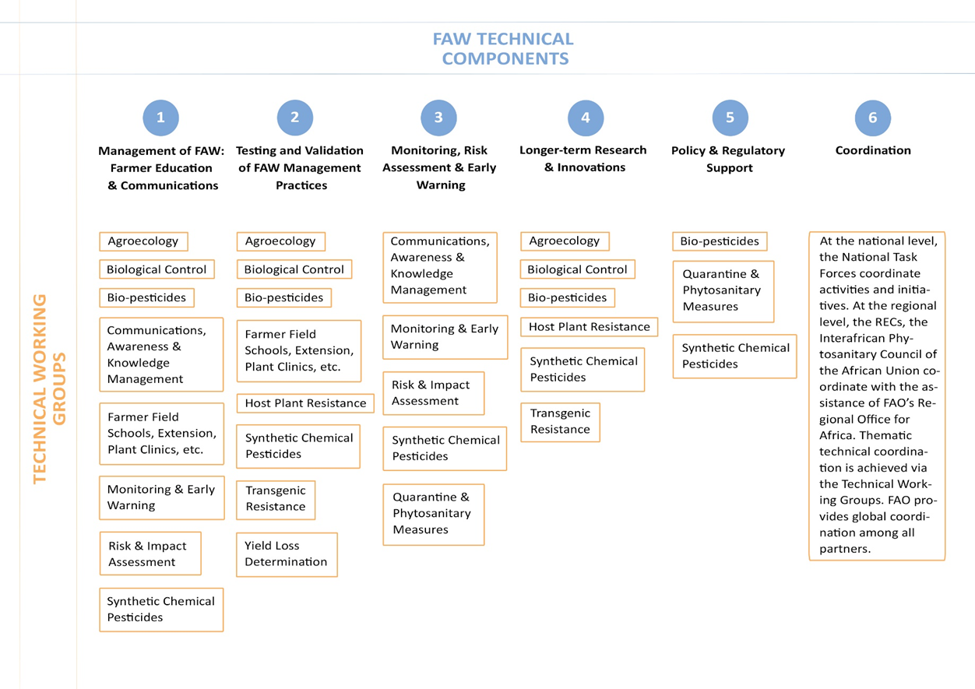
Figure 5: Technical Working Groups support to frame components

- Sub-regional steering groups will be set up in all target sub-regions. They will be chaired by the FAO Sub-regional coordinators who will coordinate activities at the sub-regional level.
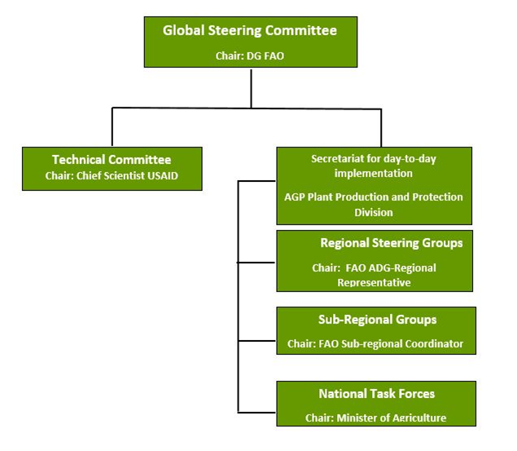
Figure 6: The Global Action for FAW management global coordination arrangement
- A national FAW taskforce will be set up every pilot country chaired by the Ministries of Agriculture and relevant departments, to implement national activities. FAO has since 2017 been supporting and facilitating the establishment and capacity building of national task forces on FAW management in FAW affected countries. This will continue under this global action programme.

Partnership with national governments
- Some countries already have their own national responses and programmes, usually through the Ministries of Agriculture. Through the Global Action for Fall Armyworm Control, FAO will support each country to develop coherent national FAW sustainable management plans, put preventive measures in place to reduce the risk of further introduction and spread, provide advice, guidance, and ensure adequate capacity to sustainably manage FAW at all level.
- Partner national governments will facilitate programme activities and will nominate their focal points to be part of the Regional and Sub-Regional Steering committees and the National FAW Task Forces. Governments will provide all facilitations for the implementation of the programme activities, such as local transportation, custom clearance for needed equipment, clearance of international personnel, etc.

Strategy
- All the activities under this programme will be globally coordinated.
- The programme will be overseen by a Global Steering Committee which will meet 3-4 times per year to:
- Assess the new developments in the global FAW situation and the efficiency of the Action at regional level.
- Evaluate the annual progress report of the Action.
- Approve the annual work plan for the Action based on national and regional priorities.
- The programme will be open for partnership and cooperation with other stakeholders including regional and international organizations, farmer cooperatives, NGOs, private companies, research institutions etc. for promoting the national FAW IPM strategies, and development and validation of advanced management technologies.

Technical oversight and support
- Technical oversight will be provided by the Plant Production and Protection Division and the IPPC Secretariat at FAO headquarters through its designated FAW Chief Technical Adviser. FAO will provide technical and organizational support through facilitation of the Steering Committees and Technical Working Groups, facilitation of conferences, meetings, scientific visits and video conferences. FAO will provide support to research activities and farmer training works, and through the development of global action plans to ensure a global coordinated approach, avoiding overlap and duplication.
- The programme will draw on the technical expertise and experience from all relevant technical divisions in FAO. The FAO Technical Network on Sustainable Crop Production and Agroecology will be used to further disseminate information about the FAW and the status of implementation of the programme.
- Elements of the Norwegian pest and disease app – VIPS – and the Chinese Monitoring and Early Warning System will be integrated into the FAO app for data and information collection to support the FAW Monitoring and Early Warning (FAMEWS).
- Technical oversight and input to the programme activities and strategy will also come from the Technical Committee and the twelve TWGs, which are composed of world experts in each of the thematic areas of the sustainable FAW management components. National experts and representatives from regional economic committees and national research centres such as the Brazilian Agricultural Research Corporation are represented in these groups. They make recommendations about priorities and gaps and play technical advisory role in the Programme.
- The day-to-day implementation and technical oversight of the project is provided by FAO, with the Director of the Plant Production and Protection (AGP) designated as the Senior Manager in FAO responsible for the oversight. He is supported by the Deputy Director of AGP, the IPPC Secretary, and the Chief Technical Advisor for Fall Armyworm, a Senior Officer of FAO who provides the day-to-day coordination of the Action.

Management and Operational Support
- FAO will develop the appropriate Letters of Agreement or Contracts under which the obligations and responsibilities of all parties will be defined. FAO specifically leaves certain work to partners’ comparative advantages and organizational missions better dedicated to those areas of work (e.g. longer-term research). As part of the FAO FAW programme, collaborative projects under the global action programme will be reviewed and discussed every six months.

Operational modalities
- FAO will apply direct Implementation modality using relevant manual sections of FAO for staff recruitment, for procurement of goods and services from profit firms (MS 502) or services from non-profit organizations (MS 507), etc. This will be done according to DGB/2014/14 in collaboration with DPS (Partnerships and South-South Cooperation Division).
- Letter of Agreements (LoAs): The FAW global action programme will facilitate the signing of LoAs to support FAW research, training and study tours.

Statistics
- FAO will be identifying with farmers and other stakeholders, standard data to be collected and recorded in the field for monitoring FAW and meeting their expectations of the FAMEWS. This is a requirement before field tools such as a mobile phone app, databases and geographic information systems can be developed. It will allow the same data to be collected in all countries to facilitate comparative analysis and harmonized training. FAO will also be reviewing existing pest monitoring and early warning systems (where they exist) with partners and their potential for integration into FAMEWS.

Information Technology
- In order to allow for the on-time delivery of information materials, FAO has set up a FAW webpage. It contains information useful for stakeholders, including national governments, media representatives and the general public. Regular updates are provided on the status of FAW, actions being taken for management, new research findings and information documents. All publicly available FAW global action programme documents will be uploaded here.

Monitoring, performance assessment and reporting
- The Action monitoring will be the overall responsibility of the Budget Holder (BH) and the technical supervision and guidance of the Lead Technical Officer (LTO), both at FAO. The Programme Coordinator and the Program Officer will coordinate the monitoring process. The monitoring activity will be reported through planned periodical evaluation analysis exercises and the programme’s phase lifecycle mid-term review. The experiences generated will be document and disseminated through predetermined programme communication means.
- Programme performance assessment is the overall responsibility of the BH, who shall coordinate the preparation of progress reports, mid-term assessments and Terminal Reports. The LTO will provide technical review and clearance of the reports and ensure inputs from other Technical Officers from within the PTF and from other partners.
- Technical progress reporting will be under the FAO output indicators 2 and 5, done 6 monthly and is the overall responsibility of the Secretariat. The following reports will be prepared on an annual basis by the Secretariat:
- • Financial report: a general overview and status of funds received and disbursed including breakdown for each country.
- • Technical report: a progress report detailing results for each target country.
- The Office of Evaluation (OED) conducts evaluations of FAO programmes and projects at the global, regional and national levels for increased accountability and learning, focusing on the Organization’s strategic positioning and results. OED reports to the FAO Governing Bodies and the Director General.
- A strong and reliable monitoring and evaluation (M&E) system is essential to the success of this Action because of:
- the innovative nature of the programme, necessitating the need to draw useful lessons and guide and inform both the management and implementation of the project;
- the changing circumstances due to the evolving political and vulnerability context, which could necessitate possible adjustments as well as the rescheduling of programmed activities.
- At planning stage, FAO will facilitate the development of a robust M&E plan and implementation design for use at the global, regional, sub-regional and national level activities and projects.
- Technical concerns that are beyond the capacity of the national implementation teams will be referred to the technical services at the national level or technical divisions at FAO headquarters.

Risk management
- The complexity of the Action, with potentially several projects and activities running parallel at different geographical and political zones from global to community levels in Africa, Asia and the Near East provides no doubt that a strong risk identification and management plan is needed. FAO’s experience and technical competence in this area assures things will be done properly to ensures the programme’s success. The risk identification and management plan will be done during the work planning meeting following the launch of the programme.

Programme timeline
- The Global Action for sustainable management of FAW will be implemented according to the general schedule outlined in the following table.
Period | Key Activity Schedule
2019 (Q4) - 2020 (Q1) | Formulate global action plan; launch Global Action; establish Global Action Steering Committee; organize parallel actions at regional/sub-regional/national levels.
2020 (Q2-Q4) | Steering and Technical Committees, Outreach strategy development; preparation of communication materials; National inception workshops and technical trainings; baseline data review; science-based technologies validated at field level; national task forces set up; regional coordination set up; High-Level Conference on FAW Control.
2021 | Promotion/dissemination of communication materials; award successful pilots; knowledge sharing activities; regional workshops; capitalization of knowledge and innovations; implement measures to minimize risk of further FAW spread.
2022 | Consolidation of results and evaluation of impact, plan phase 2.
Table 3: Implementation schedule of FAO three-year Global Action programme for sustainable management of FAW

Bibliography
Baudron, F., Zaman-Allah, M.A, Chaipa, I., Chari, N., Chinwada, P (2019). Understanding the factors influencing fall armyworm (Spodoptera frugiperda J.E. Smith) damage in African smallholder maize fields and quantifying its impact on yield. A case study in Eastern Zimbabwe, Crop Protection 120: 141–150. https://doi.org/10.1016/j.cropro.2019.01.028
CABI (2017). Fall Armyworm: Impacts and Implications for Africa. Evidence Note September 2017. https://www.cabi.org/isc/FullTextPDF/2018/20187200429.pdf
Daryanto S., Wang L., Jacinthe P-A. (2016). Global Synthesis of Drought Effects on Maize and Wheat Production. PLoS ONE 11(5): e0156362. https://doi.org/10.1371/journal.pone.0156362
Day, R., Abrahams, P., Bateman, M, Beale, T., Clottey, V., Cock, M, Colmenarez, Y., Corniani, N., Early, R., et al. (2017). Fall Armyworm: Impacts and Implications for Africa. Outlooks on Pest Management, 28(5):196-201. DOI: https://doi.org/10.1564/v28_oct_02
FAO (2017a). Fall Armyworm Life Cycle (in Latin America). http://www.fao.org/3/a-i7424e.pdf
FAO. (2017b). FAO Advisory Note on Fall Armyworm (FAW) in Africa. FAO, Rome.
Huesing, J.E., Prasanna, B.M., McGrath, D., Chinwada, P., Jepson, P., Capinera,J.L. (2018). Integrated Pest Management of Fall Armyworm in Africa: An Introduction. In Prasanna, B.M., Huesing, J. E., Eddy R., Peschke, V. M. (Eds.) (2018). Fall Armyworm in Africa: A Guide for Integrated Pest Management, First Edition. Mexico, CDMX: CIMMYT.
Kassie M., Stage J., Diiro G., Muriithi B., Muricho G., Ledermann S.T., Pittchar J., Midega C., Khan Z (2018). Push–pull farming system in Kenya: Implications for economic and social welfare. Land Use Policy 77: 186-198, https://doi.org/10.1016/j.landusepol.2018.05.041
Kumela T., Simiyu J., Sisay B., Likhayo P., Mendesil E., Gohole L. & Tefera T. (2019). Farmers' knowledge, perceptions, and management practices of the new invasive pest, fall armyworm (Spodoptera frugiperda) in Ethiopia and Kenya, International Journal of Pest Management, 65: 1-9. https://doi.org/10.1080/09670874.2017.1423129
Rwomushana, I., Bateman, M., Beale, T., Beseh, P., Cameron, K., Chiluba, M., Clottey, V., Davis, T., Day, R., Early, R., Godwin, J., Gonzalez-Moreno, P., Kansiime, M., Kenis, M., Makale, F., Mugambi, I., Murphy, S., Nunda. W., Phiri, N., Pratt, C., Tambo, J. (2018). Fall armyworm: impacts and implications for Africa, Evidence Note Update, October 2018.
Shiferaw B., Prasanna B., Hellin J., Banziger M. (2011). Crops that feed the world 6. Past successes and future challenges to the role played by maize in global food security. Food Security 3: 307–327.

Annex I: Logical Framework: Expected Outcomes, Outputs and Planned Activities
The global action for FAW management programme contributes to food security and improvement of livelihood of smallholder farmers by equipping them to sustainably manage FAW in their cropping systems. The following are the expected outputs and planned activities according to the three main desired outcomes from section 4.3:
Outcome (1) Global coordination
Output 1: Committees and Working Groups for implementation and coordination set up.
Indicator: Number and type of committees and groups established
Activities:
  - Establish the Global steering committee
  - Establish Technical/Advisory Committee
  - Establish Regional-, Sub-Regional Steering groups
  - Establish National Task Forces
  - Establish FAW Secretariat
  - Establish FAW phytosanitary network (IPPC secretariat with relevant RPPOs and NPPOs)
Outcome (1) Global coordination
Output 2: Regional collaboration on monitoring and sustainable management of FAW promoted
Indicator: Number of virtual meetings
Activities:
  - Regional collaboration mechanisms fitted to local needs established, such as regional FAW technical working groups (including the national FAW task forces).
  - FAW monitoring data collection and data sharing.
  - Organize annual regional meetings to strengthen collaboration and sharing of experiences and lessons learned on FAW monitoring and management.
Outcome (1) Global coordination
Output 3: Global outreach strategy developed
Indicator: Number of new communication strategies and communication products developed
Activities:
  - Develop outreach strategy (FAW website, newsletters and social media strategies) at global, regional and national levels.
  - Develop regional and national communication strategies
  - FAW monitoring data collection and data sharing.
  - Organize global conference in March 2020
Outcome (2) Reduced crop yield loss
Output 1: National inception workshops in each target country organized
Indicator: % number of national inception workshops held
Activities:
  - Strengthening FAW National Task Forces
  - Support baseline data analysis, taking into consideration national policies, pest management systems and all relevant data
  - Support and facilitate the planning and implementation of national inception workshops to develop national action plans for FAW management
Outcome (2) Reduced crop yield loss
Output 2: Regional maize cropland distribution and selected priority pilot study areas identified
Indicator: Number of pilot areas identified
Activities:
  - Conduct key stakeholders’ planning meeting to plan, review and endorse work plan and responsibilities
  - Support the respective counties’ Ministries of Agriculture to develop improved regional maize cropland distribution mapping using satellite images and ground reference data (where available) for identification of study areas.
  - Plan and conduct a participatory identification, selection and measurement of representative parcels based on criteria such as geographical distribution, climate, maize variety, and yield variation
Outcome (2) Reduced crop yield loss
Output 3: Yield measurement (quantitative and qualitative) methods and tools harmonized and standardized
Indicator: Number of new standardized tools
Activities:
- Conduct research to improve yield measurement methods approaches such as crop cutting and harvesting unit sampling (quantitative approach) in countries
- Review and standardize yield (quantitative and qualitative) measurement tools
- Use nutrient composition analysis by new standardized tools for qualitative evaluation of maize yield
Outcome (2) Reduced crop yield loss
Output 4: National data collection on FAW infestation and yield losses improved
Indicator: Number of new data collection systems established
Activities:
- Review and harmonize countries’ FAW infestation and yield loss estimation data collection methods, and build national and community capacity on harmonized and improved methodologies
- Conduct yield loss and relationship with FAW infestation study in pilot countries
Outcome (2) Reduced crop yield loss
Output 5: National plans for sustainable management of FAW developed
Indicator: Number of national FAW sustainable action plans developed
Activities:
- Support and facilitate countries to develop national strategies for sustainable management of FAW.
- Support policy analysis
- Support development of enabling policies for sustainable management
Outcome (2) Reduced crop yield loss
Output 6: National FAW Monitoring and Early Warning Systems improved
Indicator 1: % of target countries with Monitoring and Early Warning System of FAW in place
Indicator 2: Number of new technologies or best practices developed and piloted
Activities:
- FAO FAW Secretariat, in collaboration with Penn State University, NIBIO and China determine and implement synergies among the Monitoring and Early Warning Systems.
- Conduct targeted and tailored national training workshops on application of Monitoring and Early Warning Systems such as FAMEWS (combined with the forecast and information service on integrated management of pests, diseases and weeds – VIPS – and the Monitoring System developed by China).
- Promote regional collaboration on Monitoring and Early Warning data sharing.
- Enhance tools for global monitoring, including alert devices for advising to member countries.
Outcome (2) Reduced crop yield loss
Output 7: Ecosystem-based IPM practices integrating local solutions for sustainable FAW management developed and implemented
Indicator: % of target countries that has access to new IPM practices and policies for the sustainable management of FAW
Activities:
- Develop and strengthen strategic partnership for FAW management research for development (R4D) with all relevant stakeholders, particularly, national and international agricultural research institutions (including the CGIAR centres), academia, public and private sectors.
- Coordinate the development of ecosystem-based IPM technologies and practices adapted to local scenarios through selected community pilot testing for the sustainable management of FAW.
- Validate and disseminate new IPM technologies and innovations to farmers.
Outcome (2) Reduced crop yield loss
Output 8: National capacity for sustainable management of FAW enhanced.
Indicator: % of maize farmers who have developed the skills to use sustainable FAW management practices in each target country
Activities:
- Organize national training workshops on IPM in pilot countries, involving Farmer Field School facilitators, key farmers, extension officers, government officials and the private sector.
- Continue and scale up ongoing Farmer Field School training of facilitators and master trainers.
- Organize regional training workshops with national focal points to ensure knowledge sharing and capitalisation, including South-South Cooperation
- Conduct training on pesticides risk assessment and on pesticide registration

- Facilitate training and information sharing of knowledge and innovation in smallholder sustainable management among national stakeholders through Farmer Field School.
- Organize cross-community visits to IPM of FAW testing and validation pilot sites for sharing of experiences among the various participating communities.
Outcome (2) Reduced crop yield loss
Output 9: Information material on sustainable FAW management developed and disseminated
Indicator: Number and type of new information and didactical materials developed
Activities:
- Support the national FAW task forces to produce and disseminate free information and learning materials based on lessons learnt from the Americas, Africa and Asia, to farmers, extensionists and government officials.
- In collaboration with national FAW programmes, scale up the development and translation into local languages of regional and local FFS FAW guides, FAMEWS, and video demonstrations/training of low cost IPM options for FAW.
- Develop information technology (IT) for farmers’ easy access to information on sustainable FAW management (e.g. through FAMEWS).
Outcome (3) Reduced risk of FAW introduction and spread to new areas
Output 1: Guidance document on the prevention of FAW drafted
Indicator: Number of formulated guides
Activities:
- Draft a guidance document on the prevention of FAW (including standards for inspection and surveillance) through collaborative efforts of the Technical Working Groups and Regional Steering Groups with support from the International Plant Protection Convention (IPPC) Secretariat.
Outcome (3) Reduced risk of FAW introduction and spread to new areas
Output 2: Regional guidance on prevention of FAW validated and made available.
Indicator: Number of regional workshops organized
Activities:
- Support and organize regional workshops to validate and release guidance on the prevention of FAW (including border control).
Outcome (3) Reduced risk of FAW introduction and spread to new areas
Output 3: National guidance on prevention of FAW validated and made available
Indicator: Number of national workshops organized
Activities:
- Support and organize national workshops to validate and release guidance on the prevention of FAW
Outcome (3) Reduced risk of FAW introduction and spread to new areas
Output 4: National and regional trainings for pest risk assessment conducted.
Indicator: Number of training courses organized
Activities:
- Organize national and regional trainings of trainers on pest risk assessment for FAW and registration of FAW as a regulated quarantine pest in the countries with PSE and IPPC support.
Outcome (3) Reduced risk of FAW introduction and spread to new areas
Output 5: National and regional trainings on preventive measures (surveillance and inspection) conducted.
Indicator: Number of training courses organized
Activities:
- Organize and coordinate trainings for trainers on FAW surveillance and inspection with IPPC support.
Outcome (3) Reduced risk of FAW introduction and spread to new areas
Output 6: National and regional trainings on pest outbreak and alert systems.
Indicator: Number of training courses organized
Activities:
- Organize and coordinate trainings for trainers on pest outbreak and alert system for FAW with IPPC support.

Day et al. (2017). Fall Armyworm: Impacts and Implications for Africa. Outlooks on Pest Management, 28(5):196-201. DOI: 10.1564/v28_oct_02.
FAO (2017)……

