FAO Global Action for Fall Armyworm (FAW) Control: Preventing FAW introduction into new areas

- Fall Armyworm (FAW) has increasingly spread around the world over the last few years, affecting many countries in Africa, the Near East, Asia and the Pacific. As a result of its rapid and inexorable spread, the pest became soon a threat to global food security and the livelihoods of millions of smallholder families all over the world.
- To respond to this global threat and scale-up international efforts to stop and control the spread of FAW worldwide, FAO launched a three-year Global Action for Fall Armyworm Control. As the international standards setting body for plant health, the International Plant Protection Convention (IPPC) is called upon to make its part and play a crucial role in implementing the global action to reduce the risk of further introduction of FAW into new territories.
+ Background Information on Fall Armyworm
- Fall Armyworm (Spodoptera frugiperda) is a polyphagous insect that feeds mainly on maize and more than 80 other crops, including wheat, sorghum, millet, sugarcane, vegetable crops and cotton. FAW is a global threat to food security, impacting food production and the rural livelihoods of millions. Based on FAO estimates from 12 African countries, up to 17.7 million tonnes of maize could be lost annually due to FAW, equivalent to USD 2.5 - 6.2 billion, and enough to feed tens of millions of people.
- FAW is a transboundary pest able to fly up to 100 km in a single night. Its high reproductive rate, natural spread capacity and the new opportunities presented by international trade increase its potential to spread rapidly worldwide with devastating consequences on plant health and food security. Once established in a new territory, FAW is impossible to eradicate and stop it from spreading is now a global challenge.
- Native to Americas, FAW is now established in Africa, the Near East, Asia, and the Pacific. The pest was first detected in Central and Western Africa in early 2016, and within two years it was reported to have invaded all sub-Saharan Africa, except Lesotho. Between 2018 and 2019, FAW invaded Asia and the Near East. As of now, the pest is affecting many countries in these two regions, including India, Bangladesh, Sri Lanka, Thailand, Myanmar, China, Indonesia, the Philippines, the Lao People’s Democratic Republic, Malaysia, Viet Nam, Cambodia, the Republic of Korea, Japan; as well as Sudan, Yemen and Egypt. In the first quarter of 2020, FAW was officially reported in Australia, Mauritania, and Timor-Leste.
- FAO is constantly monitoring the geographic distribution of Fall Armyworm worldwide. To find out more on FAW global spread, check the map at the FAW webpage.
+ FAO Global Action for FAW Control
- In December 2019, FAO launched a three-year Global Action for Fall Armyworm Control as an urgent response to the rapid spread of FAW worldwide. This global initiative aims to mobilize USD 500 million over 2020–2022 to take coordinated measures to strengthen prevention and sustainable pest control capacities at global, regional and national levels. The Global Action for FAW management targets 65 countries in Africa, Asia, and the Near East, which are the regions that are mainly suffering from FAW infestation. Furthermore, the Global Action for FAW prevention targets about 20 countries in Southern Europe, the Near East and South West Pacific where the pest has not been reported yet.
- The key objectives of the FAW Global Action are:

- Establish a global coordination network and regional and sub-regional collaboration platforms on the sustainable management of FAW.
- Develop the national and community capacity of FAW affected countries on IPM to sustainably manage FAW and reduce crop yield losses.
- Coordinate the development of improved policies, standards, and measures to reduce the risk of further introduction and spread of FAW to non-affected areas and countries.
- The project will cover a three-year period (2020-2022) and mobilize different stakeholders to reduce damages and prevent FAW introduction into new areas. Research institutions, the private sector, South–South Cooperation, Regional and National Plant Protection Organizations and specific FAW Task Forces will be involved to implement the Global Action at the global, regional and national levels.
IPPC FAW Prevention: Project Overview
- The Global Action for Fall Armyworm control puts new emphasis on prevention and discourages the extensive use of highly hazardous chemical pesticides. To lower the risk of introduction and spread of FAW to new areas, the IPPC community will implement phytosanitary standards in key pilot countries to help them reduce the risk of FAW introduction and further spread.
- The attention of the IPPC community will be drawn to those countries and regions where the pest is not yet introduced or has a limited distribution. To stop further introduction and spread of the FAW, effective preventive measures will be put in place and trainings organized in those territories at high risk of infestation and outbreaks. In particular, the actions of the IPPC community will target about 21 countries from three regions: Europe (France, Italy, Spain, Greece, and Portugal); Near East and North Africa (Morocco, Iraq, Syria Arab Republic, Saudi Arabia, Libya, Oman, Lebanon, Jordan, and Algeria); and South West Pacific (Australia, New Zealand, Papua New Guinea, Vanuatu, Fiji Islands, Federated States of Micronesia, and Guam).
- Regional and national activities will be organized and coordinated with the support of the Regional and National Plant Protection Organizations responsible for plant health in each target area: European and Mediterranean Plant Protection Organization (EPPO), Near East Plant Protection Organization (NEPPO) and Pacific Plant Protection Organization (PPPO).
+ IPPC FAW Prevention: Outputs and Activities
Output 1: Guidance documents on prevention of FAW introduction and spread, drafted, validated and made available
- Draft a guidance document on the prevention of FAW (including standards for inspection and surveillance) through collaborative efforts of the technical working groups and regional steering groups with support from the IPPC Secretariat.
- Organize regional workshops to validate and release guidance on the prevention of FAW (including border control).
- Support and organize national workshops to validate and release guidance on the prevention of FAW.
Output 2: National and regional training for pest risk assessment conducted
- Organize national and regional training courses of trainers on pest risk assessment for FAW and registration of FAW as a regulated quarantine pest in the countries with the FAO Emergency and Rehabilitation Division (PSE) and IPPC Secretariat support.
Output 3: National and regional training on preventive measures (surveillance and inspection) and on pest outbreaks and alert systems conducted
- Organize and coordinate training courses for trainers on FAW surveillance and inspection with the IPPC Secretariat support.
- Organize and coordinate training courses for trainers on pest outbreak and alert system for FAW with the IPPC Secretariat support.

+ IPPC FAW Prevention: Implementation Strategy

Coordination

- Global coordination is essential to put into effect the global action for FAW control from different perspectives. The IPPC Secretariat will work closely together with a wide range of actors and stakeholders, as well as relevant FAO divisions, Regional Plant Protection Organizations, IPPC contracting parties, research institutions and the private sector to coordinate this global effort and prevent FAW introduction into countries where it was not found before. The IPPC activities will be coordinated from global level through Steering and Technical groups, as well as FAW Regional Task Forces.

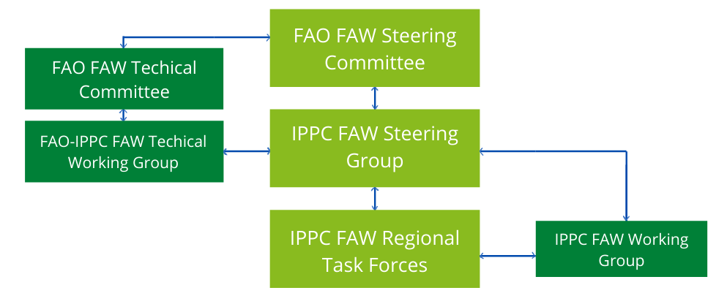++ IPPC FAW Steering Group
- The IPPC FAW Steering Group is chaired by the IPPC Secretary, Mr Jingyuan Xia, and report directly to the FAO Global Steering Committee led by the FAO Director General, Mr Qu Dongyu. The steering group is responsible for the coordination of the IPPC work plan of the Global Action. Other functions include designing, planning, monitoring and evaluation, communication, resources mobilization, and managing relation with stakeholders.
++ FAO-IPPC FAW Technical working group
- The FAO-IPPC FAW Technical Working Group on Phytosanitary and Quarantine in Relation to Trade is responsible for the coordination of all the technical activities related to the prevention of FAW spread to new areas. These activities include developing project plans, conducting scoping studies and reports on FAW prevention as well as providing technical support to the FAO’s FAW Global Action Technical Committee.
++ IPPC FAW Regional Task forces
- Regional task forces will be set up in Europe, Near East and North Africa, and the Pacific to coordinate the implementation of the global action at the regional and national levels. These task forces led by the Regional Pant Protection Organization Directors are composed of pilot countries and report directly to the Steering Group. They provide guidance and coordinate implementation activities in the pilot countries.
++ IPPC FAW Working Group
- This Working Group has been established to serve as a secretariat of the IPPC efforts in relation to the Global Action on prevention. It coordinates and supports the IPPC FAW Steering Group, FAO/IPPC FAW Technical working group, and the IPPC FAW Regional Task Forces’ activities during the implementation phase of the project. It is composed by three focal points from the three regions, and five members of the IPPC Secretariat.

Technical Support
- Preventive measures will be put in place in target countries situated in regions that are not yet affected and new areas where FAW has limited distribution. This outcome will be achieved by implementing key phytosanitary activities, such as the development of guidance on prevention; the implementation of IPPC International Standards for Phytosanitary Measures (ISPMs) for inspection and surveillance; the organization of regional and national training workshops and collaboration on prevention of FAW. In particular, key NPPOs’ functions need to be strengthened through capacity development with trainings on surveillance, inspection and response of pest outbreaks.
Resource Mobilization
- To scale-up the global efforts and tame FAW threat worldwide, the Global Action for Fall Armyworm Control aims to mobilize USD 500 million, most of which will be needed at national level. The global resource mobilization action envisages a financial mechanism composed of contribution of beneficiary and of additional donor-funded projects that will be called upon to contribute to the Global Action. Funds will be mobilized from all relevant sources, national budgets, private sector, development partners, development banks and FAO contributions.
- An estimated budget of over USD 10 million should be mobilized to reduce the risk of further introduction and spread of FAW to new areas. The activities that will be covered by the funds include policy coordination, capacity development for risk assessment, surveillance, and inspection. The IPPC’s resource mobilization action will focus on two main strategies:
- Coordinating with FAO Global resource mobilization action to maximize efforts, avoid duplication and ensure sustainability of the global action;
- Coordinating with the IPPC Community to assist Regional Plant Protection Organization (RPPOs) and National Plant Protection Organizations (NPPOs) in raising funds for regional and national initiatives.

- Additional information on the global resource mobilization action can be found in the Action Framework 2020-2022.
Communications
- Knowledge materials and information for different stakeholders, including RPPOs, NPPOs and the general public, will be developed by the IPPC Secretariat and disseminated through traditional and new media. Regular updates will be provided on the status of FAW in the world and actions being taken on prevention by the IPPC community. Publications and advocacy materials, newsletters and social media materials will be produced and distributed to increase the visibility of the Global Action and raise awareness of the importance of prevention to stop the spread of FAW worldwide. All FAW Global Action documents that relate to the IPPC mandate will be uploaded on this page and be publicly available.

BOX: Other resources
- The Global Action for Fall Armyworm Control: Action framework 2020-2022. Working together to tame the global threat http://www.fao.org/3/ca9252en/ca9252en.pdf
- Implementation plan for the Global Action for Fall Armyworm Control: http://www.fao.org/3/ca9210en/ca9210en.pdf

