ENG

14
2016



Plant Pest Surveillance
CAPACITY DEVELOPMENT

A guide to understand the principal requirements of surveillance programmes for national plant protection organizations

CAPACITY DEVELOPMENT




Plant Pest Surveillance

14
2016
A guide to understand the principal requirements of surveillance programmes for national plant protection organizations

Publication notes:
Version 1.1 published March 2016

Did you read this?
We would appreciate your feedback through a fast and easy two-question survey here: https://www.surveymonkey.com/r/pestsurveillance. This will help the IPPC Secretariat and Capacity Development Committee strengthen this and other training resources.

This guide provides information to support the surveillance activities that national plant protection organizations (NPPOs) need to undertake as part of national phytosanitary systems and as obligations under the International Plant Protection Convention (IPPC). This guide was created as a component of the IPPC National Phytosanitary Capacity Building Strategy, which was adopted by the fifth session of the Commission on Phytosanitary Measures (CPM) (2010) of the IPPC. This work has been developed by Jeffrey Jones, Amanda Hodges, Jennifer Carr and Carla Burkle, among other selected experts, and reviewed by the IPPC Capacity Development Committee (including phytosanitary experts from the seven FAO regions), the technical consultation among regional plant protection organizations (RPPOs) and the IPPC Secretariat. The elaboration of this guide was possible thanks to the financial contribution of the Standards and Trade Development Facility (STDF Project 350).

The designations employed and the presentation of material in this information product do not imply the expression of any opinion whatsoever on the part of the Food and Agriculture Organization of the United Nations (FAO) concerning the legal or development status of any country, territory, city or area or of its authorities, or concerning the delimitation of its frontiers or boundaries. The mention of specific companies or products of manufacturers, whether or not these have been patented, does not imply that these have been endorsed or recommended by FAO in preference to others of a similar nature that are not mentioned.

The views expressed in this information product are those of the author(s) and do not necessarily reflect the views or policies of FAO.

© FAO, 2016

FAO encourages the use, reproduction and dissemination of material in this information product. Except where otherwise indicated, material may be copied, downloaded and printed for private study, research and teaching purposes, or for use in non-commercial products or services, provided that appropriate acknowledgement of FAO as the source and copyright holder is given and that FAO’s endorsement of users’ views, products or services is not implied in any way.

All requests for translation and adaptation rights, and for resale and other commercial use rights should be made via http://www.fao.org/contact- us/licencerequest or addressed to copyright@fao.org.

Text in this document is not an official legal interpretation of the International Plant Protection Convention (IPPC) or its related documents, and is produced for public information only. To translate this material please contact ippc@fao.org for information about a co-publishing agreement.

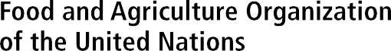

FOREWORD
Surveillance is an essential component in national phytosanitary systems . Article IV of the IPPC prescribes general provisions for the organizational arrangements for national plant protection and specifically states that the responsibilities of an official national plant protection organization shall include “the surveillance of growing plants, including both areas under cultivation and wild flora, and of plants and plant products in storage or in transportation, with the object of reporting the occurrence, outbreak and spread of pests, and of controlling those pests (ISPM 6, 2018).

ISPM 6 (Surveillance) is the International Standard for Phytosanitary Measures relating to plant health surveillance, and describes the requirements for surveillance and the specific requirements and components of a National Surveillance System. ISPM 6 (Surveillance) was adopted by the Thirteenth Session of the Commission on Phytosanitary Measures in April 2018 after three years of consultation and revision, and replaced the original ISPM 6 (Guidelines for surveillance) that was adopted by the 29th FAO Conference in 1997.

Whilst this guide was developed and published in 2016 (during the review and drafting of the ISPM 6 revision), a review by the expert group in 2020 concluded that the guide was still technically valid and aligned with ISPM 6 (Surveillance) adopted in 2018. This guide therefore provides current and appropriate guidance to contracting parties in the requirements for surveillance and the components of National surveillance systems.


Contents
Definitions Used 5
Acronyms and Abbreviations 7
Section 1: Introduction 8
- Organizational Arrangements 9
  - NPPO as a quarantine section within a plant protection department 9
  - Semi-autonomous and autonomous NPPOs 9
  - Integrated institutions 9
- Surveillance Approaches and Application 10
  - General surveillance 10
  - General surveillance approach and application 10
  - Specific surveillance 11
Section 2: Organizational Arrangements 12
- National Legislation 13
- Funding and Sustainability 14
  - Potential sources of funding 14
- Management 16
  - Strategy 16
  - Authority 16
  - Responsibilities 16
  - Planning 17
  - Resources and budget allocation 17
  - Engagement mechanisms 17
  - Performance review 17
  - Monitoring and evaluation 18
- Human Resources 19
  - Training 19
  - Staff retention 19
  - Safety at work 19
- Information Management 20
  - Data flow: structure and presentation 20
- Communication 21
  - Communication strategy 21
  - Stakeholder engagement 21
  - Reporting 22
  - Awareness-raising and advocacy 22
Section 3: Planning and Prioritization 23
- Planning a Surveillance Programme 24
  - Cost–benefit analysis 24
  - Key issues 24
  - Surveillance implementation 25

- Prioritization 26
  - Early detection 26
  - Stakeholder interests 26
  - Responses to outbreaks or incursions 26
- Designing a Specific Plant Pest Surveillance Programme 28
  - Survey design 28
  - Pest-specific surveillance 28
  - Commodity-specific surveillance 28
  - Examples of survey design 28
- Response, Delimiting and Trace-back Surveillance 32
  - Early warning detection surveys 32
  - Investigation plan 32
  - Delimiting surveillance 33
Section 4: Operations 34
- Resource Requirements 35
  - Human resources 35
  - Financial resources 35
  - Physical resources 35
- Methodologies 36
  - General surveillance 36
  - Specific surveys 36
  - Methods 37
  - Inspection 40
  - Sample coding 40
  - Sample collection 40
  - Submission to diagnostic laboratory 41
- Data Collection and Submission 43
- Field Communication and Feedback 44
  - Pre-survey briefing 44
  - Survey (in-field) communications 44
  - Methods of communication 44
- Interaction with Stakeholders 45
- Supervision of Activities 46
Section 5: Bibliography and Additional Resources 47
Bibliography 48
ISPMs Directly Related to Surveillance 51
Internet Resources 52
Appendix A: Surveillance Equipment 5

Area of low pest prevalence
An area, whether all of a country, part of a country, or all or parts of several countries, as identified by the competent authorities, in which a specific pest is present at low levels and which is subject to effective surveillance or control measures [IPPC, 1997; revised CPM, 2015]

Detection survey
Survey conducted in an area to determine if pests are present [FAO, 1990; revised FAO, 1995]

General surveillance
A process whereby information on pests of concern in an area is gathered from various sources. Sources may include national or local government bodies, research institutions, universities, museums, scientific societies (including those of independent specialists), producers, consultants, the general public, scientific and trade journals, unpublished data, and the websites of other NPPOs or international organizations (e.g. the IPPC, regional plant protection organizations, the Convention on Biological Diversity). [ISPM 6, 2018]

Monitoring survey
Ongoing survey to verify the characteristics of a pest population [FAO, 1995]

National plant protection organization
Official service established by a government to discharge the functions specified by the IPPC [FAO, 1990; formerly “plant protection organization (national)”]

Pest
Any species, strain or biotype of plant, animal or pathogenic agent injurious to plants or plant products [FAO, 1990; revised FAO, 1995; IPPC, 1997; revised CPM, 2012]

Pest free area
An area in which a specific pest is absent as dem- onstrated by scientific evidence and in which, where appropriate, this condition is being officially main- tained [FAO, 1995: revised CPM; 2015]

Pest free place of production
Place of production in which a specific pest is ab- sent as demonstrated by scientific evidence and in which, where appropriate, this condition is being of- ficially maintained for a defined period [ISPM 10, 1999 ; revised CPM, 2015]

Pest free production site
A production site in which a specific pest is ab- sent, as demonstrated by scientific evidence, and in which, where appropriate, this condition is being officially maintained for a defined period [ISPM 10, 1999; revised CPM, 2015]

Pest risk analysis (agreed interpretation)
The process of evaluating biological or other scien- tific and economic evidence to determine whether an organism is a pest, whether it should be regu- lated, and the strength of any phytosanitary meas- ures to be taken against it [FAO, 1995; revised IPPC, 1997; ISPM 2, 2007]

Phytosanitary legislation
Basic laws granting legal authority to a national plant protection organization from which phy- tosanitary regulations may be drafted [FAO, 1990; revised FAO, 1995]

Point of entry
Airport, seaport, land border point or any other location officially designated for the importation of consignments, or the entrance of persons [FAO, 1995; revised CPM, 2015]

Quarantine pest
A pest of potential economic importance to the area endangered thereby and not yet present there, or present but not widely distributed and being of- ficially controlled [FAO, 1990; revised FAO, 1995; IPPC, 1997]

Regulated pest
A quarantine pest or a regulated non-quarantine pest [IPPC, 1997]

Specific surveyllance
a process whereby information on pests of concern in an area is obtained by the NPPO over a defined period. NPPOs actively gather specific pest-related data. Specific surveillance includes surveys that are conducted to determine the characteristics of a pest population or to determine which species are present or absent in an area. [ISPM 6, 2018]
Surveillance
An official process which collects and records data on pest presence or absence by survey, monitoring or other procedures [CEPM, 1996; revised CPM, 2015]

Note: IPPC definitions are sourced from the IPPC Glossary of phytosanitary terms (ISPM 5). The glossary is updated annually based on decisions taken by the IPPC Commission on Phytosanitary Measures. The complete and updated glossary is maintained at: http://www.ippc. int/publications/glossary-phytosanitary-terms. The definitions are accurate as of November 2015.

ALPP Area of low pest prevalence
CDC Capacity Development Committee (of the IPPC) CEPM Committee of Experts on Phytosanitary Measures CPM Commission on Phytosanitary Measures
EPPO European and Mediterranean Plant Protection Organization FAO Food and Agriculture Organization of the United Nations GIS Geographic information system
GPS Global positioning system
HLB Huanglongbing disease
IPPC International Plant Protection Convention
ISPM International Standards for Phytosanitary Measures
LoA Letter of agreement
M&E Monitoring and evaluation MoA Memorandum of agreement MoU Memorandum of understanding
NPPO National plant protection organization
PCN Potato cyst nematodes
PFA Pest free area
PFPP Pest free place of production PFPS Pest free production site PRA Pest risk analysis
RPPO Regional plant protection organization
SOP Standard operating procedure
SPS Agreement on the Application of Sanitary and Phytosanitary Measures of the WTO
STDF Standards and Trade Development Facility
WTO World Trade Organization

Section 1: Introduction

International Standards for Phytosanitary Measures (ISPM) no. 6 ( Surveillance) refers to “the requirements for surveillance, including the components of a national surveillance system”. Surveillance is an obligation of a national plant protection organization (NPPO) and underpins other obligations and phytosanitary decision-making. It is a critical part of the national phytosanitary system. Plant pest surveillance thus plays a key role in the overall mandate of the NPPO and is required by Article IV.2(b) of the International Plant Protection Convention (IPPC).
A national plant pest surveillance programme should be conducted in such a way that its results

are accurate, credible and contribute to national goals and priorities. Management support is critical to a strong, sustainable programme. This guide addresses aspects of policy and management, which together should outline the rationale for the establishment of a national plant pest surveillance programme. In order to be successful, a programme needs to be underpinned by legislation, effective coordination, management, communication and training. In some cases, capacity development may be needed to ensure these requirements can be met.
Surveillance activities can be expensive. However, as activities that support national phytosanitary policy, the benefits will invariably outweigh the costs.

8

National organizational arrangements for a functional NPPO differ between contracting parties and discharging their functions may therefore require different systems of management. Plant pest surveillance is one of those functions that may be organized on the basis of the structure and capacity of the NPPO. Here are three examples of different organizational arrangements that would affect how surveillance is managed.

NPPO as a quarantine section within a plant protection department
In countries with limited resources, in particular, there may be a shortage of trained personnel and resources within the NPPO., National legislation or administrative instruments may require that other sectionsof the ministry, or institutions of the country (e.g. research or phytosanitary diagnostic laboratories), carry out surveillance. Some national industry boards and research institutions may also be engaged in surveillance activities. The management challenge for the NPPO becomes one of coordination among the various units involved to ensure accountability, timely implementation, reporting, information sharing and ensuring that protocols are consistent with the IPPC, ISPMs and guidelines.
The NPPO may have limited flexibility to respond to emergencies, to negotiate with partners such as universities or research institutions in the country, and to seek external funding from trading partners. In this case, the NPPO should clearly identify the importance of such partnerships and solicit the government’s full support to put measures in place to engage these institutions and allocate funding for phytosanitary emergencies.
It is essential to prioritize activities to match the level of predictability and availability of funding provided by the government for plant pest surveillance activities. The NPPO and any surveillance committee needs to carefully consider cost–benefit implications for all aspects of the programme in order to optimize the allocation of resources.

Semi-autonomous and autonomous NPPOs
Semi-autonomous and autonomous NPPOs are usually well-defined institutions with competencies and capabilities for fulfilling the functions of the NPPO and are able to manage their surveillance programmes. They are characterized by:
- independence and flexibility to establish necessary systems and policies to effectively implement their functions
- power to choose to contract surveillance to a third party while maintaining responsibility
- budgetary independence and flexibility in allocation of resources
- ability to attract their own funding from stakeholders.
These types of NPPO can therefore establish a national programme based on their government’s priorities, with access to the necessary resources to fund these priorities.

Integrated institutions
Integrated institutions cover a regulatory sanitary and phytosanitary framework (animal health, plant health and food safety); they are sometimes referred to as biosecurity agencies. They are normally characterized by:
- providing technical and managerial support for each programme
- acting as an umbrella agency responsible for procuring funding and other resources
- relationships by and collaboration with external agencies
- having a framework for management of emer- gencies and crises and management of pest incursions or outbreaks.

Surveillance Approaches and Application

ISPM 6 (Surveillance) recognizes two kinds of surveillance: general surveillance and specific surveillance.

General surveillance
General surveillance is defined in ISPM 6 as “a process whereby information on particular pests which are of concern for an area is gathered from many sources, wherever it is available and provided for use by the NPPO”.
General surveillance should:
  - support NPPO declarations of pest status
  - provide information on the early detection of exotic pests
  - report to other organizations, such as other NPPOs, regional plant protection organizations (RPPOs) and the Food and Agriculture Organization of the United Nations (FAO)
  - compile host and commodity pest lists and distribution records.
Outcomes of general surveillance may include:
  - the imposition or lifting of quarantines based on the knowledge gained
  - the design of a specific surveillance activity if more information about a pest is needed within a geographic region.

General surveillance approach and application
According to ISPM 6, a general surveillance approach should include the following.

Sources of information
These may include: NPPOs, other national and local governmentagencies, research institutions, universities, scientific societies (including amateur specialists), producers, consultants, museums, the general public, scientific and trade journals, unpublished data and contemporary observations. In addition, the NPPO may obtain information from international sources, such as FAO, the IPPC, RPPOs, etc.

Collection, storage and retrieval of information
To use data from these sources, it is recommended that NPPOs develop a system for collecting, verifying and compiling pest information.
Components of such a system should include:
- the NPPO or another institution designated by the NPPO acting as the national repository for plant pest records
- a record-keeping and retrieval system
- data verification procedures
- communication channels to transfer information from the sources to the NPPO.
Components of such a system may also include incentives to report, such as:
- legislative obligations (for the general public or specific agencies)
- cooperative agreements (between the NPPO and specific agencies)
- use of contact personnel to enhance communication channels to and from NPPOs
- public education and awareness programmes.

Use of information
Information gathered through such general surveillance will most often be used to:
- support NPPO declarations of pest freedom
- aid in the early detection of new pests
- report to other organizations such as RPPOs and the IPPC Secretariat
- compile host and commodity pest lists and distribution records.
An NPPO should establish a general surveillance activity as part of its regular work programme. This would involve:
- designating staff to compile, screen and analyse comprehensive pest information from diverse sources, as appropriate
- keeping pest status information updated
- establishing and maintaining a system to store, analyse and retrieve data


10

P L A N T P E S T S U R V E IL L A N C E

- ensuring that third parties involved in surveillance are aware of the need to cooperate with the NPPO, particularly for pest reporting – designated staff would ensure that agreements made with such third parties are updated, amended, monitored, issued, reviewed and revoked, as necessary
- establishing a reporting system internal to the NPPO as well as a reporting system for external inputs from third parties
- establishing a system to analyse and validate information compiled through this activity before official reports are made to other contracting parties – this could be done through sector-specific groups, scientific panels, etc.

Specific surveillance
ISPM 6 defines specific surveillance as “ a process whereby information on pests of concern in an area is obtained by the NPPO over a defined period. NPPOs actively gather specific pest-related data. Specific surveillance includes surveys that are conducted to determine the characteristics of a pest population or to determine which species are present or absent in an area”.
Specific surveillance may be focused on a pest or on a host or commodity. Types of specific surveillance include:
- detection
- delimiting
- monitoring.
Specific surveillance outcomes should:
- support NPPO declarations of pest freedom
- aid in the early detection of exotic pests
- assist in reporting to organizations, such as other NPPOs, RPPOs and FAO.

Figure 1: Decision support process for planning pest surveillance

No/Don’t know

Yes

Is the pest present?

Is the pest population distribution known?

Detection survey

Yes

No

Monitoring survey
Delimiting survey

Section 2: Organizational Arrangements

The building blocks for a national plant pest surveillance system
Organizational arrangements for a functional NPPO differ between contracting parties, and discharging these functions may therefore require different systems of management. Surveillance is one of those functions that may be organized on the basis of the structure and capacity of the NPPO. Examples of organizational arrangements are given in the IPPC manual Establishing a national plant protection organization (IPPC, 2015) and may impact on how surveillance is managed.
Regardless of the national institutional structure, an NPPO can establish a national surveil- lance programme on the basis of its government’s priorities, with access to the required resources.
An appropriate management structure needs to be established for a surveillance programme.
Figure 2 is a conceptual plan that may be adapted to suit national institutional structures. It suggests the need for a national pest surveillance manager with an appropriate line of command through regional, state, provincial and field staff. It shows the relationship between manager and administrative and logistic support unit, and the technical support unit. Where appropriate, there may be a relationship established between the NPPO and third party providers and industry where they are required to provide services on behalf of the NPPO. Appointment of a national surveillance committee may also be appropriate in some countries.

Figure 2: Conceptual organization of a management structure for a national surveillance programme
NPPO Surveillance Manager
Field staff
Provincial and district supervisors
Regional manager
Industry and third party providers
- Industry groups
- Universities
- Research institutions
- Laboratories
Administrative and logistic support
- Resources management
- Purchases
- Info management
- Advocacy
- Reporting
Technical support
- Entomologist
- Pathologist
- Nematologist
- Bacteriologist
- Mycologist
National Surveillance Committee

12


National Legislation

Appropriate national phytosanitary legislation and policies or official procedures are basic requirements for supporting activities of a surveillance programme. National legislation should have clear provisions related to assignment of authority, financial resources and responsibilities to appropriate administrative levels.
Legislation, policies or official procedures should ensure the following:.
- It provides legal authority and responsibility to the NPPO and authorized entities for all surveillance activities (e.g. the right to enter premises, inspect, take samples) in support of the IPPC Article IV.2(b), which requires NPPOs to be responsible for the surveillance of plants
- to establishment and maintain diagnostic facilities or provide appropriate access to up-to-date diagnostic services,
- to ensure mandatory domestic reporting to the NPPO on detection or suspected presence of targeted pests as well as pests new to an area, host or pathway to report the occurrence, outbreak and spread of pests. Authority and responsibility should be supported by formal pest exclusion mechanisms to prevent the introduction of pests of phytosanitary concern entering the country, as well as to prevent pest movement into endangered areas such as pest free areas (PFAs), areas of low pest prevalence (ALPPs) and areas that are under official control. Surveillance policies should also cover responsibilities related to administration, finance and governance within the NPPO, including funding for surveillance activities, procedures for surveillance deliverables as well as training and qualification of personnel.
- Provincial or state legislation, where appropriate, is consistent with and supports national legislation to avoid impediments to implementation of surveillance activities.
- Provisions are made for third party institutions and personnel acting on behalf of the NPPO, for example:
- mechanisms of engagement (e.g. letter of agreement (LoA), memorandum of under- standing (MoU), contracts)
- mechanisms for recognizing and dealing with conflicts of interest
- level of accountability to the NPPO
- redress in cases of breach of trust or contract.
- Staff involved in surveillance programmes are legally protected in performing their duties (e.g. against accidents, trespass charges, physical attacks).
- Confidentiality in use of data is maintained.

Funding and Sustainability


The cost of running an effective national plant pest surveillance programme can be very high and funding from government budgets alone may not be sufficient. Collaboration between the government and stakeholders may be needed to ensure that adequate funding is available. Stakeholders such as industry and producers often contribute to surveillance efforts where the benefits to them can be clearly demonstrated.
Sustainability should also be considered, including, for example:
  - adequate resources and a predictable source and level of funding are essential
  - adequately trained and sufficient staff
  - supporting diagnostic institutions are adequately equipped and diagnostic procedures are consistent to ensure accurate identification, verification and storage of specimens
  - appropriate information management systems are current and adequate to allow for data analysis, accessibility and sharing of information
    - the information management system should be supported by a structure that facilitates data collection and collation.

Potential sources of funding

Government-funded national plant pest surveillance programme
A government may absorb the total cost of a national plant pest surveillance programme, particularly when it is seen as a public good. Measures or actions are usually trade driven and directed at a specific commodity. Or they may impact a wider range of plants and their products, so that economic impact is broadly shared. These measures or actions are often implemented as very structured programmes under the responsibility of the NPPO.

Industry funding
Strong and well-established industries (e.g. coffee, tea, banana, rice) may fund plant pest surveillance operations completely if they stand to benefit from such investments through market access or improved food quality. Where market access is the desired outcome, a strong collaboration may be established with the NPPO so that their procedures conform to international standards.

Joint funding between government and industry
- Appropriate arrangements are made between government and industry to address priorities through a cost-sharing platform.
- Partial investment cost is provided as a start-up incentive for specific programmes. This may hold true for cases where the establishment of a PFA or ALPP are the most appropriate pathways for market access.
- Cost-sharing between the government and the stakeholder (e.g. private sector producer): contributions may be financial or in-kind (e.g. related to oversight, supervision or the production and dissemination of guidance materials to industry).

Technical cooperation to facilitate trade
An importing country or potential importing country that has a strong interest in importing a commodity from a country where it is evident that risks cannot be adequately managed without additional measures may choose to fund the cost of specific surveillance in order to help mitigate risks associated with the imported commodity.

Loans or grants
A government or autonomous NPPO may obtain a loan or grant from a donor country, or from national or international lending institutions in cases where very clear surveillance targets can be met and can be seen to result in significant benefits to the country.

    - Technical assistance programmes Institutions involved in capacity building in developing countries generally have technical assistance programmes to respond to specific and urgent requests that meet certain criteria, including opportunities for trade or food security. FAO, the IPPC and the Standards and Trade Development Facility of the World Trade Organization (WTO), for example, have mechanisms to provide technical assistance in support of the enhancement of phytosanitary
capacity that may include national plant pest surveillance. These may require counterpart contributions in kind.

Contingency and other emergency funds
The capability of the NPPO to access extra- budgetary financial resources in order to respond to phytosanitary emergencies (e.g. an introduced quarantine pest to be contained or eradicated, pest outbreaks, and compensating growers whose farms may be quarantined or where crops are subject to destruction or other actions that impact the livelihoods of producers) or emerging issues is very important. It is prudent to establish a contingency fund with substantial resources from extramural sources and from government, industry and other stakeholders to deal with emergencies.

Management


Strategy
The rationale for the establishment of a national plant pest surveillance strategy should relate directly to national priorities regarding trade and protection of plant resources and the environment. The creation of a clear vision provides an NPPO with a tool for encouraging broad support by setting out what is going to happen and what will be achieved. The strategy should ensure the highest level of cooperation, national response and participation. In this regard, pest surveillance is a critical part of a national phytosanitary system that, for example, allows an NPPO to:
  - detect and monitor pest threats in order to prevent their introduction and to manage them if they become present in the country – this can be achieved by using:
    - pest alerts
    - unofficial and official information regarding the occurrence or changing status of a pest for which a pathway has been identified
    - reports in the press
    - scientific but unofficial reports
    - published data
  - maintain and enhance market access and international trade by collecting and providing current surveillance data on the status of pests associated with commodities that are being or will be traded
  - gain the confidence of trading partners by ensuring the availability of current and reliable data on pest status in the country
  - support the preparation and updating of regulated pest lists and technically justifiable import requirements
  - put in place phytosanitary improvement measures in the context of national programmes, including those that relate to the establishment and maintenance of PFAs, pest free places of production (PFPPs), pest free production sites
(PFPSs) and ALPPs where specific conditions must be met in order to support exports
- Enhance food security and protect the environment through effective monitoring of threats to national plant resources.

Authority
The NPPO assumes all responsibilities for the plant pest surveillance programme. Clearly defined lines of command and delegation of different levels of authority must be addressed for a successful programme. In a decentralized system, levels of authority may be delegated to national, state, province, county and district levels so that there is a well-coordinated programme throughout the target areas.
The NPPO may authorize relevant institutions and personnel to work under its authority, but the NPPO in all cases maintains responsibility for all actions taken on its behalf.

Responsibilities
Responsibilities include:
- defining the programme
- selecting and approving partners
- public awareness
- training
- preparation of training materials and protocols
- implementation
- information management and communication.
The NPPO should take overall responsibility for management and coordination and inter alia, may:
- appoint a national surveillance manager and regional or provincial managers where decentralized management and supervision are necessary
- establish a national plant pest surveillance committee that includes key stakeholders but is managed by the NPPO.

Planning
Specific activities to be considered may include procurement and distribution of tools and equipment, trapping, sampling and transport.
- Consistency, credibility and sustainability in approaches should be maintained across all regions and among all actors:
- all supervisors, regional and sub-regional managers and field staff use the same operating procedures
- supervision and auditing are at the same level
- access to the same support services
- vehicles for timely transporting and sampling.
- Procedures and methodologies should be determined and standardized in their use, for example:
- sampling and collection procedures
- trapping densities
- trap servicing
- transporting samples
- preparing samples for identification. The NPPO should:
- establish documented procedures to ensure consistency at all levels of the operations
- ensure that adequate management systems are in place for the efficient and effective storage, retrieval and distribution of information
- ensure that adequate supporting systems, institutions and personnel are identified and engaged for:
- diagnostics
- reference collections
- quality control (standard operating proced- ures, audits, tracking, etc.).

Resources and budget allocation
Resources need to be prudently sourced and applied across plant pest surveillance priorities and activities (see chapter 13). The NPPO should have a clear understanding of:
- the priorities and required activities
- the resource requirements for each priority to effectively launch and sustain the required activities
- the resources that are available
- the resources that are needed
- providers of these resources
- whether the sustainability of these resources is guaranteed.

Engagement mechanisms
The NPPO may:
- establish mechanisms of engagement between the NPPO and stakeholders so that responsibilities can be assigned, honoured and levels of accountability determined (see IPPC, 2015, section 8) – common examples of mechanisms of engagement include LoAs, memoranda of agreement (MoAs), contracts and government–industry agreements
- ensure that all stakeholders are properly informed and cued into the surveillance strategy and that their roles are clearly defined.

Performance review
Plant pest surveillance and the use of surveillance data in international trade and phytosanitary improvement are critical – the consequences of ineffective surveillance and monitoring to ensure accurate results can be devastating. The programme of plant pest surveillance should be technically sound, and include effective supervision of personnel and methods to ensure that all activities are undertaken correctly.
A surveillance programme should be regularly reviewed against its targets, goals and objectives. A formal review process may be established to ensure that:
- the programme is reliable and credible to stakeholders
- quality is assured and maintained throughout the programme
- all aspects of the programme are supported by current technology and procedures, and are appropriate to achieve the stated objectives
- efficiency is gauged against performance standards (auditing where applicable).
The occurrence of incidents that threaten the surveillance programme should be corrected transparently, urgently and effectively.
Internal reviews by a competent review panel may be undertaken periodically on all aspects of

5 . M A N A G E M E N T

the surveillance programme to ensure that quality is being maintained.
External reviews may also be appropriate in cases where a trading partner or potential trading partner needs verification of the quality and effectiveness of a surveillance programme such as PFA, ALPP or eradication.

Monitoring and evaluation
Monitoring and evaluation (M&E) together provide the knowledge required for effective surveillance programme management and reporting, and accountability. Countries that opt to establish an M&E system generally tend to do so at the level of a department, the ministry or, in other cases, at a higher, possibly national, level. Whatever the
case may be, an M&E system developed for plant pest surveillance would need to be adapted to the existing system.
An M&E system is a tool in a project manager’s repertoire that uses methodologies designed to strengthen the ability of people and teams to make management decisions for the successful achievement of stated objectives. An M&E system should help the NPPO to:
- determine whether the surveillance programme is on track, on time and on target
- ensure that funds were used as intended
- determine whether the surveillance programme was implemented as planned
- learn whether the surveillance programme made a difference.


Human Resources

Training
Plant pest surveillance requires different skills and competencies from different groups of people. The NPPO responsible for any given plant pest surveillance programme should strive to maintain the technical integrity of all activities and be responsive to emerging and new pest situations. Specific, task-related training for those involved, as shown in Table 1, will address these issues.

Staff retention
Staff training is a costly but necessary investment, so efforts should be made to support retention of trained staff for the effectiveness and sustainability of the surveillance programme. This may be encouraged by providing, for example:
- salaries commensurate with tasks assigned
- attractive incentives and benefits
- conducive working conditions, such as appropri- ate tools and transport
- awareness of the importance of their tasks to national development.
The NPPO may ensure succession planning to provide for smooth transitions when required.

Safety at work
Safety at work is an important consideration to which management should be committed. Where applicable, management should lead by example. Management should also ensure adequate funding for:
- protective equipment
- personal security gear
- adequate health care and medical coverage
- first aid equipment
- clearly marked or identifiable means of conveyance or transport, where appropriate
- proper identification.

Table 1. The kinds of training that different groups of people involved in a surveillance programme might require
Managers and supervisors | Plant protection and production  personnel involved in surveillance activities | Farmers, producers and industry personnel | Subject specialists from universities and other research institutions
Management and supervision related to  specific tasks | Data collection | Protocols for surveillance of specific pests | Relevant ISPMs
Personnel management | Information on pest biology and ecology | Pest and pest damage recognition | Procedures consistent with the IPPC in surveillance and pest  diagnostics
Procedures for  enforcement and integrity | Surveillance methods | Data collection and recording
Resources management

Information Management


Information systems are required to ensure effective management of information as it moves from the field to record-keeping to reporting.
The NPPO should select hardware and software in terms of short- and long-term programme goals. For example, in order to collect location data more efficiently, the geographic information system (GIS) software package in the office should be able to interact with the global positioning system (GPS) units of field workers. The NPPO should consult with a database administrator and hardware and software solution providers.

Data flow: structure and presentation

Workflow structure
  - It is the responsibility of the surveillance manager to plan a complete data flow cycle in the very early stages of implementation.
  - On the basis of strategic decisions regarding programme goals, a flow chart should be prepared to clarify the appropriate order for the transfer of data.
  - A form, whether paper or computer based, needs to be designed for collecting raw pest data from the field; consistent layout is important.
  - Surveyors need to understand the form, how often the form is transferred to data collectors, and by what means (paper forms will be faxed, computer files sent by e-mail, etc.).
  - A computer-based collection scheme requires choosing a standardized file format.
  - Data collectors must enter the new data, merging these into the growing database. As data are entered they should be validated.
  - Data should be entered in a timely manner depending upon the requirements of the programme.

- The tools used to query the database to extract the required reports must be understood by data analysts (or field personnel if they serve dually as data analysts); data analysis should be relevant to the goals of the surveillance programme.

Record-keeping
ISPM 6 (Surveillance) details a set of minimum records that need to be kept. These are:
- scientific name of the pest and European and Mediterranean Plant Protection Organization (EPPO) code, if available
- family/order
- plant part affected or means of collection (e.g. attractant trap, soil sample, sweep net)
- locality, e.g. location codes, addresses, coord- inates
- date of collection and name of collector
- date of identification and name of identifier
- date of verification and name of verifier
- references, if any
- additional information, e.g. nature of host relationship, infestation status, growth stage of plant affected, or found only in greenhouses.

General guidelines for information management
- Data standards should be considered: they need to be consistent and allow for sharing of data (e.g. between surveillance programmes or between countries) as required.
- The NPPO is responsible for secure data storage and is the final authority for approval of a security protocol. Data should be stored in safe and secure locations and standard operating procedures (SOPs) should be developed for security protocols, data storage and backup.
- The database should be validated and updated as needed.


Communication

Communication helps to ensure that stakeholders and staff understand and support phytosanitary surveillance activities, requirements and systems, and have sufficient information to manage their own related activities. A communication strategy for plant pest surveillance will ensure that communications are handled as effectively as possible.

Communication strategy
A communication strategy should take into consideration:
- information needs of staff, stakeholders and affected parties
- urgency with which decisions need to be made
- extent to which engagement and communica- tion will improve plant pest surveillance and use of information provided by surveillance
- costs of communication and engagement, both to the NPPO and to those engaged.
Coordination of surveillance programmes requires timely and effective means of communica- tion. The NPPO should ensure that communication provisions cover all parties involved, as shown in Table 2.

NPPO internal communication
Internal communications are important to ensure that the surveillance programme is efficient and effective. Topics may include:
- line communication, reporting and feedback
- communication among field officers, for sharing experiences and relevant information, problem- solving, etc.
- communication among NPPO technical managers and supporting administrative staff, regarding budget, procurement and resource distribution, staffing issues, etc.

NPPO external communication
External communications are also necessary to ensure that all parties directly engaged in the

Table 2. Audiences for communications and official reporting

Communication | Reporting to
NPPO internal communication | Concerned trading partners
NPPO and industry groups | RPPOs
NPPO and third party providers | IPPC, FAO
NPPO and surveillance committee
NPPO and general public
NPPO and media

programme are kept informed. NPPOs should be prepared to communicate with:
- industry groups, especially those directly involved in surveillance activities and those directly affected by outcomes, timely and effective communication regarding ongoing issues that may arise from strategies, and procedures and implications of findings
- third party providers acting on behalf of the NPPO regarding progress, implementation issues, ongoing monitoring and review activities
- surveillance committees on strategic issues and outcomes for decision-making
- the general public regarding outreach programmes for effective cooperation, restrictions on movement of plant material, where appropriate, and reporting relevant observations.

Stakeholder engagement
Meaningful engagement of stakeholders requires effective bidirectional communication between the

8 . C O M M UN IC A T IO N

NPPO and all stakeholders regarding their possible and assigned roles in the detection of plant pests.
Stakeholders and their roles may include:
- universities, research institutions and subject specialists to undertake specific surveillance with related activities, such as:
  - provide training in surveillance methodology for specific plant pests or pest groups
  - prepare protocols and data sheets
  - make arrangements for diagnostics
  - provide aerial photos to aid delimit- ing surveys where appropriate (e.g. lethal yellowing disease in areas that are otherwise impossible to reach)
- industry groups (banana, tea, coffee, citrus, etc.):
  - provide information on occurrence or incidence on farms
  - provide data gathered over time on pest occurrence and status
  - provide staff for training and deployment on farm to collect information, set and service traps, sampling and other services, where possible and according to protocols provided by the NPPO
- farmers and producers, plant nurseries:
  - provide alerts on current and past occurrences, service traps
- forestry, parks commissions and similar groups:
  - report incidence of plant pests or pest damage, outbreaks of pests on ornamentals and forestry crops
- consumers, markets and vendors:
  - report unusual or new cases to the NPPO
- press and media:
  - disseminate information
  - educate and raise awareness
  - encourage support for the programme and related activities.

Reporting
The NPPO has a responsibility to report the results of surveillance activities, specifically the occurrence, outbreak and spread of plant pests, and efforts to control them. Information gathered through general surveillance will be used most often for reporting to concerned trading partners, RPPOs and the IPPC (Article IV).
Plant pest surveillance results should be reported in a timely manner to concerned trading partners in a spirit of international cooperation to prevent the spread of pests. Industry groups affected by the results of surveillance should be properly informed.

Awareness-raising and advocacy
It is valuable for key groups and individuals to understand the surveillance programme’s goals, its main operations and what support is needed in order for the programme to function well. The surveillance programme will benefit from having a plan in place to generate awareness and build support among key stakeholders.
An awareness-raising plan should identify the interests of different stakeholders and refine mes- sages and styles of communications to match the interests of the stakeholders, helping them to under- stand why the surveillance programme is important.
The stakeholders may include:
- private sector, who may be concerned about losses both from pests and from control programmes
- high-level government officials, who may not be familiar with the technical issues of phytosani- tary measures but may be very concerned about access to export markets, protection of domes- tic natural resources and jobs, and who may be influential in the policy-setting and budget- planning processes
- the general public, who may be concerned about plant pest surveillance and control programmes as a result of concerns about damage to natural resources and loss of jobs in addition to concerns about consequences to the environment and human health of chemical control of pests
- academia.
An advocacy plan would target these stakeholders differently to address each group’s concerns and help them to understand why a surveillance programme is important and how it will benefit them. The plan can encourage them to ensure that the surveillance programme receives the sustained financial, political and public support needed in order to function effectively and achieve its goals.

Section 3: Planning and Prioritization

Planning, coordination and implementation of a surveillance programme shouldbe based on national priorities such biosecurity, trade and market access, incursion response or pest monitoring. . Planning also ensures the design of a statistically valid surveillance program that complies with NPPO, trading partners and other stakeholders’ expectations. Priorities for surveillance may vary from country to country depending on the needs for surveillance information. Once priorities for surveillance have been established, NPPOs should develop plans for the implementation of surveillance programmes, taking into account phytosanitary legislation and policies.

23

Planning a Surveillance Programme


An NPPO generally plans a surveillance programme on the basis of a need to facilitate trade and protect national plant resources. Such a plan has several components.

Cost–benefit analysis
A cost–benefit analysis must be carefully considered prior to the expenditure of significant resources. For examples of surveillance planning and cost consideration, refer to Pheloung (2005).
Some considerations for a surveillance programme cost–benefit analysis include:
  - level of stakeholder interest in a surveillance programme
  - importance of the agricultural commodity at risk to the local economy
  - potential export economic importance of an agricultural commodity
  - economic importance of an agricultural commodity to an importing country
  - risk of pest introduction, early warning and emergency response
  - estimated economic damage and impact of a pest to an agricultural commodity
  - available field, diagnostic and administrative human resources to implement a surveillance programme
  - available target-specific traps, lures and other tools for pest detection
  - feasibility of the surveillance programme with available monitoring tools.
If the estimated economic cost for conducting a surveillance programme does not outweigh the value of the benefit to a country’s agricultural and natural areas, then an adequate return on investment may be anticipated. Although several possible surveillance programme efforts could result in a significant return on investment, the NPPO must prioritize the most important needs for the country. Refer to chapter 10 for more guidance on pest prioritization.

Key issues
The NPPO will need to consider several key issues in formulating the surveillance plan.

Strategic rationale:
- threat detection and contingency or mitigation
- early warning
- rapid and appropriate response
- preparedness for negative impact to certain pro- ductive sectors or to avert environmental damage.

Feasibility:
- technical capacity to undertake the survey work
- Resource availability-, i.e., human (personnel), financial (for logistics and travel) and physical (field and laboratory equipment).

Stakeholder relations and support:
- an established record of trust and the protec- tion of the country’s agricultural and natural resources is necessary
- the surveillance programme needs to clearly identify its purpose (current or future benefit) and its beneficiaries
- key personnel within the NPPO should be assigned to establish, manage and maintain stakeholder relations.
Stakeholders interested in a surveillance pro- gramme should first consult with their own NPPO and consider the following:
- identity and availability of subject matter specialists – if expert contacts are not available within a given NPPO, consider whether regional or international expertise could provide cooperative project support; other regional governments may also be at risk from newly introduced pest-detection or trade barriers and would mutually benefit from the partnership
- the availability of pest reference collection repositories
- budgetary supply and human resources for monitoring, sample screening, management and general surveillance.

Other considerations
The difficulty of plant pest detection and diagnostics can negatively impact a surveillance programme in terms of rationale, design, operation and cost.
Pest-specific surveys with clear protocols and commercially available traps will be easier to deploy uniformly and monitor regularly.
A surveillance programme needs a communications plan (see chapter 8). Even if stakeholder support is obtained, mismanagement of public communications may end a surveillance programme. A good message for the general public should be simple and appropriate for a broad audience. Producers and other stakeholders who are more directly affected by the surveillance programme will need additional information.

Surveillance implementation
An NPPO should review the procedures and results of other surveillance programmes with similar goals and consider the following questions related to survey programme implementation.
- If surveillance programmes on this pest have been conducted in other regions, what was the outcome?
- How can an improved surveillance programme be implemented, based on lessons learned from other surveillance programmes focused on this pest?
- If surveillance programmes have been conducted on similar pests in your country or other regions, how can you apply the lessons learned to your surveillance programme?
- Has the pest of focus in your surveillance programme been reported on new hosts or within a new ecological niche?
- Has the pest you are surveying been detected outside previously known environmental limits?
A pest’s ability to respond to a new habitat is often unknown; however, some inferences can be deduced from a pest’s invasion history in similar habitats to those in the country of concern. The surveillance results of another NPPO can also assist to guide the development of a pest-specific survey.
A surveillance programme is generally designed either to generate a commodity pest list to facilitate export of a new agricultural commodity or to assist with a regulated pest list. A regulated pest list may include pests of quarantine significance and may affect imports or assist with defining pest risk analysis (PRA) needs. A regulated non-quarantine pest may economically affect plants for planting (see Table 3).
The gathering of information should focus on the needs of and generally relates to both general and specific surveillance programmes. Methods may include the following.
- Horizon scanning: identifying current issues or strategies that may have a significant medium- to long-term future impact on the successful outcome of the survey. An NPPO may also use results from PRA for this purpose.
- Article/data mining: discovering interesting and useful patterns and relationships in large volumes of data.
- In-country sources: information from producers, immigration information, customs data, traders, etc.
- Formal requests to NPPOs of other countries.

Table 3. Definitions associated with categories of pests and lists

Specific terminology | IPPC definition
Commodity pest list | A list of pests present in an area which may be associated with a specific commodity [CEPM, 1996; revised CPM, 2015]
Regulated pest | A quarantine pest or regulated non-quarantine pest [the IPPC, 1997]
Regulated  non-quarantine pest | A non-quarantine pest whose presence in plants for planting affects the intended use of those plants with an economically unacceptable impact and which is therefore regulated within the territory of the importing contracting party [IPPC, 1997; revised CPM, 2013]

Prioritization


Failure to properly assign NPPO resources to the highest risk plant pests may result in:
  - delays in new market access
  - unnecessary or unjustifiable import requirements
  - significant and devastating agricultural crop loss.
PRA can be an important component of the decision process for target pest or commodity- focused surveillance programmes.

Pest risk analysis

The process of evaluating biological or other scientific and economic evidence to determine whether an organism is a pest, whether it should be regulated, and the strength of any phytosanitary measures to be taken against it [FAO, 1995; revised IPPC, 1997; ISPM 2, 2007]

Additional information about PRA can be found in ISPM 11 (Pest risk analysis for quarantine pests) and ISPM 21 (Pest risk analysis for regulated non-quarantine pests).
The NPPO may give high priority to:
  - conducting surveillance to develop a commodity pest list that potential trading partners need in order to enable them to conduct a PRA – some degree of urgency may be necessary as denial of market access for a commodity planned for import may result from failure to produce such information
  - an urgent need to determine which pests currently occur in a country, to facilitate the establishment of justifiable import regulations
  - a demand for updated pest information from an importing country to an exporting country
    - the importing country may have credible information on the status of a new or existing pest that could result in trade restrictions; trade may be stopped if information is not provided.

Early detection
Early detection and rapid pest eradication are often the goals of a regulatory surveillance programme. Available field tools, such as species-specific pheromone-baited traps, can significantly improve field detection efficiency. However, visual scouting remains a relatively low-cost and frequently used method in many cases. Budget plans for trained field scouting personnel need to be considered. The visual scouting process often seeks to detect “hotspots” or concentrated small patches of pest activity.
The NPPO should consider the difficulty of pest detection and overall cost during the development of the surveillance programme. If a pest is difficult to detect and unlikely to be reported early in the invasion phase, the NPPO may choose not to designate resources to the pest even if it is high risk. A pest that is of medium to high priority and easy to detect may receive a higher priority in a surveillance programme because there are more opportunities to detect a successful pest invasion.

Stakeholder interests
Stakeholder input must be considered in prioritization. A lack of stakeholder support will hinder success of the programme. External stakeholders may need pest status information in order to complete a PRA for a commodity. Producers and other individuals employed in agriculture may be the first to detect a pest or symptom of concern. Producers and exporters may also be required to provide information related to market access. Finally, producers will be primarily interested in local and export pest management recommendations.

Responses to outbreaks or incursions
A response to a plant health emergency involves detection, identification, confirmation, assessment, containment, control and management of the plant

pest. A strong network of trained individuals who are prepared to respond is an essential component of an emergency response programme. Although not every pest outbreak will trigger a formal emergency response programme, pest outbreaks often influence prioritization.
Following a new pest outbreak, resource allocations and personnel must be shifted to the new, high-target pest. Response activities from national agencies may include the following:
- rapid detection and delimiting surveys
- technical working groups
- identification and diagnostics
- emergency funding
- emergency response coordination
- mobilization
- unified command
- data management
- regulatory framework
- environmental compliance
- situation reports.
Figure 3 illustrates some of the clear differences between high-priority and low-priority surveillance programmes. However, many pest surveillance programmes may have a range of high- and low-priority factors contributing to the decision process.

Figure 3. Prioritization factors of surveillance programmes
- Quarantine pest
- Easy detection method
- Stakeholder requests
- Pest outbreak
- A high-value agricultural commodity, general surveillance for export

High priority
- Non-quarantine pest
- Difficult detection method
- No stakeholder requests
- No pest outbreak
- A low-value agricultural commodity, general surveillance for export

Low priority

Designing a Specific Plant Pest Surveillance Programme


Survey design
Survey design will depend on the purpose of the survey, whether to look for a pest of unknown status in an area, to gather data about an existing pest population in an area or to determine the boundaries of an infestation.
ISPM 5 (Glossary of phytosanitary terms) defines the following survey designs.
  - Detection survey: “Survey conducted in an area to determine if pests are present”. Detection surveys are appropriate if a pest’s presence in an area is not known.
  - Monitoring survey: “Ongoing survey to verify the characteristics of a pest population”. Monitoring surveys are appropriate to document changes in prevalence of a particular pest population over time and to assist with pest management.
  - Delimiting survey: “Survey conducted to establish the boundaries of an area considered to be infested by or free from a pest”. Delimiting surveys are usually used to define the boundaries of spread for a new, invasive pest. A delimiting survey often precedes the implementation of an eradication programme. Delimiting surveys may also be useful for shipping commodities outside of the pest range for a pest of limited distribution.

Pest-specific surveillance
According to ISPM 6 (Surveillance), a pest-specific surveillance approach should include the following:
  - identification of the target pest(s)
  - identification of scope (e.g. geographic area, production system, season)
  - identification of timing (dates, frequency, duration)
  - in the case of commodity pest lists, the target commodity
  - indication of the statistical basis (e.g. level

of confidence, number of samples, selection and number of sites, frequency of sampling, assumptions)
- description of survey methodology and quality management based on an understanding of the biology of the pest, purpose of the survey and including an explanation of:
  - sampling procedures (e.g. attractant trapping, whole plant sampling, visual inspection, sample collection and laboratory analysis)
  - diagnostic procedures
  - reporting procedures.

Commodity-specific surveillance
Specific pest lists of commodities can be useful in the context of cultural practices or to provide general data in the absence of general surveillance. Commodity-specific surveillance may also be useful to provide information to requesting countries to facilitate their PRAs.
Commodity-specific survey sites should be selected by the following parameters:
- geographic distribution of production areas and their size
- pest management programmes (commercial and non-commercial sites)
- cultivars present
- points of consolidation of the harvested commodity.
Survey methodology will depend on the harvesting time, target commodity pests and associated sampling techniques, and type of commodity.

Examples of survey design

Target pest: pink bollworm
The pink bollworm moth, Pectinophora gossypiella
(Saunders) (Lepidoptera: Gelechiidae), is a globally

important pest of cotton. Prevention, management and yield loss associated with pink bollworm costs cotton producers in the United States of America an estimated US$ 32 million annually. Pink bollworm is capable of long-range migration and so cotton producing regions are at constant risk of infestation and reinfestation. Effective long-term surveillance is necessary to detect incursions and reduce the risk of establishment.

Sampling and collection methods for adults
- At planting, hang delta traps containing rubber septa impregnated with 4 mg of gossyplure pheromone attractant around the perimeter of cotton fields at a rate of one trap per 4 ha.
- Inspect delta traps weekly for adult pink bollworm moths, until harvest or killing freeze. Record presence (and quantity) or absence.

Sampling for larvae
- Select ten non-Bt cotton fields per 4 856–6 070 ha at random and visually inspect the blooms for signs of pink bollworm larvae. If larvae are detected, collect specimens and preserve in 70 percent ethanol to send out for expert identification.
- Start at the bloom stage and continue weekly inspection through cut-out. Record presence (and quantity) or absence.

Information management
- Sampling data may be recorded on paper or by electronic means in the field, but should be permanently stored in a secure electronic database. The NPPO should establish procedures for generating reports from field survey data and disseminating reports to relevant parties.

Occupational safety
Field survey workers will need the following to safely perform their survey activities.
- Basic first aid items, such as antiseptic wash, sterile bandages, pain reliever tablets and antihistamines.
- A field communications plan to keep workers connected to base operations. This may include mobile telephones or radio communications.
- Safe transportation to and from field sites.

Stakeholder engagement
Pink bollworm survey plans are best enacted with the cooperation of producer communities and government regulatory entities. Develop survey plans with cotton growers and create stakeholder buy-in through effective communication with the target audience.

Target pest: Asian citrus psyllid and Huanglongbing disease
The Asian citrus psyllid, Diaphorina citri Kuwayama (Insecta: Hemiptera: Psyllidae), is an important pest of citrus in several countries due to its ability to vector citrus greening or Huanglongbing disease (HLB). HLB is caused by the bacterium Candidatus Liberibacter asiaticus and originates from Asia or India. HLB can kill a citrus tree in as little as five years, and there is no known cure. The only method for protecting citrus trees is to prevent spread of the HLB pathogen through the control of psyllid populations and by the removal and destruction of infected trees.

Sampling and collection methods for adults
- Tap sample: Use a laminated sheet of paper or a smooth white surface such as a clipboard and a 0.3 m piece of half-inch or three-quarter-inch (or equivalent size) PVC (plastic) pipe. Place the sheet or board about 0.3 m below a leafy branch. Hit the branch three times with the pipe. Count and record the number of psyllids that fall onto the sheet. The slippery sheet surface prevents the psyllids from taking flight, but some may fly away before they can be counted if numbers are high.
- Sweep nets: Swing a 15-inch (or equivalent size) diameter sweep net in a 180° arc so that the net rim strikes well into the canopy. After a few sweeps, count and record the number of psyllids captured inside the net.

11 . D E S I G N I N G A S P E C IF I C P L A N T P E S T S U R V E IL L A N C E P R O G R A M M E

- Trees with apparent psyllids or psyllid feeding damage should be preferentially sampled. If trees do not have visible psyllids or psyllid damage, no more than 20 trees should be sampled at a given location. The number of trees sampled may be varied depending upon the needs of the surveillance programme.

Sampling for larvae
- Nymphs and eggs are found only on young flush and must be sampled by direct observation.
— Field personnel should practise recognizing the difference between psyllid and aphid feeding on flush; the presence of the insect is always the best indicator of the actual cause of damage. In general, psyllid feeding results in twisted flush and aphid feeding causes leaf curl.
- The number of psyllids per shoot should be correlated with the percentage of infested shoots.
- Determine for each shoot examined whether psyllid eggs or nymphs are present.
- Ten shoots should be checked at each stop at the same ten locations per block used for the tap sample.
- Determine the amount of flush present and measure shoot density. Keep records of the number of trees needed to locate ten new shoots at each stop and the number of trees examined. No more than 20 trees should be examined at a given location even if ten new shoots are not found.

Sampling and collecting methods for HLB
- Samples should consist of short sections (10– 15 cm or greater) of symptomatic branches with the attached leaves.
- If fruit is present on the branches, the fruit can either be left on or can be trimmed off the tree. If the fruit is removed, leave the fruit stem on the sample (i.e. trim the fruit off as close to the button as possible leaving the stem on the branch).
- If a variety of symptoms are present, the preferred samples (in order of preference) would be:
  - branches with mottled leaves
  - branches that contain shoots that are almost entirely yellow
  - branches that have leaves with yellow veins
  - branches with leaves that have either green islands on a yellow background or yellow islands on a green background
  - branches with nutrient deficiencies that have a “rabbit ear” appearance (small, upright leaves)
  - branches with leaves that show chlorosis and “vein corking”
  - branches with zinc or iron deficiencies that are not related to blight or other known causes.
- Place the leaves and twigs into a sealable (e.g. Ziploc) plastic bag and keep the sample cool and out of sunlight.
- Label the bags “HLB” to expedite their movement in the laboratory.
- Flag the tree or a branch in commercial sites in order to be able to rapidly recognize and revisit the place where a sample was collected. In residential sites flagging could be performed at the discretion of the surveyor.

    - Target pest: potato cyst nematodes Potato cyst nematodes (PCN) (Nematoda: Tylenchida: Heteroderidae) comprise two closely related species
– the pale cyst nematode, Globodera pallida (Stone) and the golden nematode, Globodera rostochiensis (Wollenweber). These microscopic worm-like organisms are quarantine pests and present a serious threat to domestic and international commerce in potatoes and nursery stock. They feed on the roots of the plant and can cause significant loss of yield, and the cysts can survive in the soil for many years, multiplying rapidly when a new crop of host plants is planted. PCN spread primarily by the transport of cysts in soil. Once a field is infested, management includes sanitation, crop rotation, use of resistant varieties and chemicals.

11.4.3.1 Sampling procedures
Field freedom from PCN, based on sampling and testing of soil prior to planting, is a general requirement for seed potatoes and may also be suitable to confirm lot freedom of ware potatoes.
Fields are sampled at a standard rate of 1 500 ml/ha or, if certain conditions are met which reduce the risk of PCN infestation, at a lower rate of 400 ml/ha. These conditions relate to history of
the land, in relation to previous potato crops and the size of the sampled unit. A field is eligible for the lower rate if:
- no potatoes have been grown there for six years prior to the test or
- no PCN have been found in the previous two official tests or
- no PCN or dead cysts have been found in the most recent official test.

Response, Delimiting and Trace-back Surveillance


Early warning detection surveys

    - Pest identification and information Correct plant pest identification is critical to response, delimiting and trace-back surveillance. Information that needs to be prepared about the pest includes:
  - field screening information for further pest surveys
  - pest biology and origin
  - distribution and establishment potential
  - pest significance
  - population dynamics and epidemiology
  - pest vector status
  - potential pathways
  - potential establishment and range
  - eradication, containment and control measures
  - detection methods
  - damage symptoms.

Public education to disseminate information for early warning
Public awareness programmes aimed at reminding the general public and target groups of the potential threats and where to report. Different modern IT tools e.g. mobile applications may be used for this purpose.

Training of principals (field personnel of NPPO and other technical stakeholders) in detection of the target pest
Training of personnel from the NPPO and other concerned stakeholders according to the target pest is essential. This may require time, resources and a certain level of commitment. The NPPO should plan accordingly. This is emphasized in sections 6.1, 6.2, 8.2 and 13.1.

Monitoring system
Where possible and as resources allow, establish a monitoring system using traps or other detection

methods along likely pathways or most vulnerable areas.

Review
Adjust the survey strategy based on updated information.

Investigation plan

Pathway analysis
If a new, exotic invasive species is detected, the likely source of the pest should be analysed and deter- mined. The following steps should be followed in order to determine the spread and origin of the pest.
- Conduct a delimiting survey around the site of initial detection. This will provide information about the spread of the pest. The NPPO may have to conduct interviews with the owners of plants where the pest was detected.
- Assess the degree of damage (insignificant to severe), level of infestation (low to high) and, if possible, duration (old to recent) of the infestation from the time of detection. During the delimitation survey this information should be collected and mapped along with GIS information. This information could assist determination of the likely origin or location (foci) of the infestation.
- Consider the native region and current distribution of the pest. What commodities are currently imported that could be a source of the pest? How were these commodities moved and transported?
- Once the origin has been identified (trace- back), a follow-up of areas that could have also received a pest introduction (trace-forward) also needs to occur.
- An effort to quarantine and eradicate the pest or maintain the pest within a quarantine zone may follow the delimiting survey.

- Host plant and product movement in and out of the area of new pest detection should initially be controlled within the known distribution area and a buffer zone.
- The pest biology will need to be understood in order to officially control the new pest.

Budget and human resources
Budget and human resource considerations for surveillance and sample processing need to be evaluated before implementing an extensive response. All response activities and resource allocations should be priority-based.

    - Data analysis and recommendation Data entry needs to be streamlined for rapid electronic response. If data cannot be evaluated at least weekly, unnecessary resources may be expended. Data analysis also needs to be included in the budget.

Delimiting surveillance
These surveys are usually carried out to determine the boundaries of an infestation or area infected rather than to define an area that is “free from a pest”.
A delimiting survey generally:
- determines the extent and distribution of a pest incursion
- determines whether the pest can be eradicated.

Site selection
For delimiting survey sites:
- initial detection site or target zone – this is usually the starting point for the survey
- extent of survey is determined by the spread of the pest
- target plant hosts (number of and species) should be known
- alternative plant hosts should be known
- sampling and collecting methods specific to the target pest need to be identified and deployed
– some target pests may have species-specific traps or detection methods that may improve collection and hence knowledge of distribution.

Survey preparations
The following information must be prepared for a delimiting survey.
- Define the survey period that can be funded, based on the value of the crop or other relevant prioritization criteria.
- Identify equipment needed and purchase if necessary.
- Designate responsible personnel and agree overall logistical coordination.
- Establish budget availability and parameters.
- Prepare field survey methodology and guides.
- In some instances, an NPPO may choose to designate work to a non-regulatory entity through a cooperative agreement. The non- regulatory entity must understand the regulatory nature of the delimiting survey.
- Data collection and mitigation methods are established by the NPPO. Methods must be clearly described in an SOP and their application monitored by the NPPO.
- Awareness campaigns:
- educational materials need to be prepared for field survey specialists and farmers
- IT aplications and printed materials for the general public also need to be available
- a chain of communication needs to be established for general inquiries and questions – a designated public information officer can assist with awareness questions or concerns. This may be done via special phone number or mobile application
- Data analysis and recommendations.
- Pest status reporting (see ISPM 17).

Section 4: Operations

34


Resource Requirements

Surveillance should be adequately resourced with appropriate human, financial and physical resources. Resources should be planned in advance in order to to ensure that field activities are delivered in a timely and efficient manner. It is the responsibility of NPPO that the staffing, financial and physical resources (equipment, traps and consumables) are in place before starting field activities. Diagnostic services are an essential part of a surveillance program and should be taken into account. The resources may be planned for each pest, or groups of pests or whole surveillance program.

Human resources
Human resources should include the relevant technical skills and training to effectively deliver the surveillance activity. This may also include resourcing additional surveillance officers to provide assistance. The human resources may be calculated, for example – how many inspectors are necessary to carry out the inspections in particular places, how many hours they have to spent for carrying out inspections, how many people need to be involved in identification of pests, hours of work in the laboratory and time for training about methodology. Time for preparation of pest reports and reporting to an international organization should be included into calculation of surveillance costs.

Financial resources
Financial resources should cover all expenses relating to the delivery of the surveillance activities (travel, accommodation, per diems, equipment and supplies, etc.).

Physical resources
Infrastructure resources may include laboratory buildings, offices for staff, storerooms and warehouses, processing areas, communications infrastructure and waste facilities.
Equipment and supply resources may include vehicles, pest traps, lures, personal protective equipmentand consumables (see Appendix A). Most expensive part is vehicles and fuel. The use of vehicles to get to the planned field, plantation, site for the aim to inspect the area. And the costs of fuel – the situation with fuel prices in the country, the necessary of amount of fuel to reach the places, the distance from one place to another – from office to field, from one field to another and how many time in the season. Some extra amount has to be envisaged for purposes, if the traps are broken, stolen or missing. Equipment and reagents for diagnostic purposes may have significant costs.
Data collection resources may include cameras, GPS units, smartphones, tablets, notebooks, computer equipment and stationary (see Appendix A).
Public awareness resource materials refers only to the physical materials used to enhance or gain support for surveillance activities, and may include items such as brochures, posters, postcards and calendars.
Note: These physical resource needs will be dependent on the methodology and equipment needs of the survey plan developed.

Methodologies


Surveillance protocols and methodologies provide consistent instruction on the delivery of a surveillance activity. Surveillance managers and surveillance officers need to be aware of current methods associated with pests of interest and must ensure that the methods meet survey objectives. Methods of plant pest surveillance are further described in Guidelines for surveillance of plant pests in Asia and the Pacific (McMaugh, 2005); chapter 8 focuses on specific case studies.
Surveillance methods may be based on recognized guidelines and international protocols or negotiated equivalents.
In some cases NPPOs may need to derive new methodologies when faced with new and emerging pests.

General surveillance
General surveillance activities provide a useful means for NPPOs to gather pest information beyond specific surveillance. The importance of general surveillance and the central collection of data for national plant biosecurity is discussed in the National Plant Biosecurity Surveillance Strategy 2013–2020 (PHA, 2013). General surveillance also serves the purpose of potentially proving the absence of a pest for trade purposes. Participatory engagement of industry, citizens, growers and academia is a critical component of general surveillance.
General surveillance activities can be delivered in the following ways:
- undertake desktop reviews of scientific journals, publications and databases
- deliver outreach and awareness campaigns to inform the audience about the target pests and ways in which they can assist
- ensure mandatory reporting for agencies and institutions involved in scientific research and publication – in some cases this may involve legislative obligations or cooperative agree- ments to report.

General surveillance must comply with ISPM 8 (Determination of pest status in an area) validation process, and so require adequate screening, validation, data management and analysis to manage data before they are included in information management systems.
Before implementing these general surveil- lance initiatives, it is important to ensure that adequate human and physical resources (computer systems, databases, communication systems, etc.) are available.

Specific surveillance
Specific surveillanceprovide the means for NPPOs to actively gather pest distribution information through structured programmes.
A wide variety of technical methods are available, based on the three fundamental types of surveillance:
- sampling survey: host material, target pests or soil are collected for identification and analysis
- trapping survey: chemical or physical traps used to capture target pests in a given area
- visual examination: host or habitat examined for life stages, signs or symptoms associated with target pests.
These methods may not always be delivered independently and some surveys may include a combination of sampling, trapping and visual inspection.
The three types of surveys on the objectives of the specific surveillance programme recognized by ISPM 6 (Surveillance) are:
- detection surveys: conducted in an area to determine if pests are present
- delimiting surveys: conducted to establish the boundaries of an area considered to be infested by or free from a pest
- monitoring surveys: ongoing survey to verify the characteristics of a pest population.
Table 4 indicates different circumstances under which certain types of survey are deployed.

Table 4. Use of three types of surveys for different pest situations

Specific surveillance | Pest situation
 | Pest present without control | Pest present under suppression | Pest present under eradication | Pest absent under exclusion | Pest transient, eradication of an incursion
Monitoring | Uncontrolled pest subject to monitoring surveys | Pest under suppression subject to monitoring surveys | Pest under eradication subject to monitoring and verification surveys
Detection |  |  |  | No pest; detection surveys including  intensive trapping for exclusion in  a PFA
Delimiting |  |  |  |  | Incursion detected  through ongoing detection surveys, therefore additional implementation of delimiting surveys

Source: derived from IAEA (2003).

Methods

    - Standard operating procedures According to the guidelines for quality management in soil and plant laboratories, produced by the Natural Resource Management and Environment Department (Bashour and Sayegh, 2007), “A Standard Operating Procedure (SOP) is a document which describes the regularly recurring operations relevant to the quality of the investigation. The purpose of a SOP is to carry out the operations correctly and always in the same manner. A SOP should be available at the place where the work is done”.
SOPs should include at least the information identified as a minimum requirement (refer to ISMP 6):
- purpose and scope
- timing and duration
- target pest

- target host
- target areas and site selection
- survey duration
- site selection
- statistical basis
- sample collection
- detailed survey methodology (procedures)
- biosecurity and sanitation considerations
- sample handling and laboratory submission
- equipment and supplies
- reporting.
SOPs may also include:
- legislative authority
- roles, responsibilities and accountabilities
- record-keeping
- reference material (keys, publications, protocols, etc.)
- occupational health and safety.
Note: SOPs must be available and accessible to all staff.

Sampling
Sampling may be:
- random:
  - simple random sampling – unbiased; each unit has equal chance of being selected
  - stratified sampling – a form of random sampling that is based on knowledge of pest distribution and assures collection of pest
- systematic:
  - follows a predetermined pattern, such as X-, W- or Z-shaped transects
  - may involve collection of symptomatic or asymptomatic plants – visible field symptoms are often not immediately expressed at early- stage plant disease or nematode infections; the collection of asymptomatic plant samples provides valuable positive and negative data beyond the known infection range of a given pest.
Methods of sampling for pests are further described in McMaugh (2005): chapter 2 is devoted to designing a specific survey, and section 2.16 focuses on methods of collecting pest specimens.

Trapping
Traps can be used for many purposes, including:
- area pest control of a specific pest or type of pest, such as stink bug traps baited with a species-specific aggregation pheromone
- as part of a specific pest eradication effort
- surveillance (monitoring, delimiting and detection)
- sentinel traps for early detection of a new pest incursion in an area.

Trap types
Semiochemical-based traps use a message-bearing substance from a plant or animal (or a synthetic analogue) to solicit a behavioural response. See Table 5 for advantages and disadvantages.
Examples of semiochemicals include:
- allomones: a signal that benefits the sender, but not the receiving species
- kairomones: a signal that benefits a receiving species, but not the sender
- pheromones: a chemical released by a species for species-specific communication
Table 5. Advantages and disadvantages of semiochemical traps

Advantages | Disadvantages
More selectively attract certain pests depending on the lure | Lure may be too specific or not specific enough to trap target pest
Easy to deploy in the field | Lure may not be available for target pest
Relatively inexpensive | Trap may need a particular field set-up to be effective
Can yield good population data with a minimum effort | Lure may not attract the primary pestiferous life stage of the pest or may not indicate pest distribution

- synomones: a chemical that benefits both the sender and receiver species.
Semiochemical-based trap lures are generally available through a speciality supplier and are relatively inexpensive.
Attractant-based traps often use food or insect-attracting visual clues to selectively trap a particular type of pest. See Table 6 for advantages and disadvantages.
Examples of visual-based attractant traps include
- light traps
- yellow or blue sticky cards.
Attractant-based and semiochemical trap lures are generally easy to set up in the field, but field placement and the time frame for a new attractant or semiochemical lure must be known. The NPPO should establish protocols for monitoring and replenishing traps on the basis of the known life cycle of the target pest.
Physical traps generally take the form of a mechanical or physical barrier that prevents pest movement. For example, a band of folded burlap can be placed around tree trunks that may be potentially infested with the Asian gypsy moth, Lymantria dispar asiatica. Caterpillars will use the burlap as a resting site and can then be destroyed. See Table 7 for advantages and disadvantages.

Table 6. Advantages and disadvantages of attractant traps
Advantages | Disadvantages
Low cost and easy to deploy | Not as specific as semiochemical-based traps
Some selectivity may occur depending upon the available research for the pest | Light traps and sticky cards attract several non-target pests; sorting less target- specific samples may be challenging
May be constructed and designed from local materials | Food-baited attractant traps will require more maintenance and generally degrade more rapidly than semiochemical-based trapping methods
May be used to enhance and improve semiochemical-based trapping methods | May be less specific in terms of trap placement
Species- or genera- specific attraction may occur for some species (e.g. fruit flies within the genus Anastrepha are more attracted to protein-based food lures)

Application method
Trap site selection, mounting and placement will depend upon the target pest and host density. Once a trap has been deployed, GIS coordinates should be recorded. Urban trap locations should also include the full street address. Placement in natural or rural area should include the nearest address and landmarks, in addition to the GIS coordinates.
The following factors need to be considered with trap set-up.
- Concentration of attractants or semiochemicals:
— release rate should be understood for a given geographical area (e.g. fruit fly pheromones have faster release in hot and dry conditions); release rate may also differ with trap type.
- Trap density (monitoring and control):
- should be determined for each geographical region and species or species complex of concern
- plan for appropriate personnel resources for trap services.
- Trapping period should be defined prior to initiating a trapping programme.
- Servicing and replacement:
- instructions on servicing and replacement of commercially available lures should be followed
- spilling liquid lures during trap servicing will reduce overall trap effectiveness.

Sample screening
Traps should be positioned so that specimens can

be easily retrieved.

Table 7. Advantages and disadvantages of physical traps
Advantages | Disadvantages
Not generally harmful to the environment | Often difficult to implement on a larger scale
Effective on small-scale areas of concern | Not as effective as chemical control methods
Relatively easy to deploy | Potentially time intensive for data collection

Protocols for handling samples need to be clearly provided to field survey specialists.
- Field sample screening should include observations on the presence or absence of the suspect target, symptoms of plant damage and other relevant information.
- Field symptoms that should trigger an urgent sample submission should be clearly identified in the protocol.
- Transportation of the sample needs to be defined as:
- hand carry
- standard mail or express delivery.
- Appropriate equipment for labelling and

submitting samples should be provided.
  - Digital images may be used to further support sample collection information
— Digital images are not considered confirmatory for new pest detections or finds.

    - Data collection and reporting Detailed overall trap information should be collected and related to a unique trap code.
Examples of important trap data include:
- date of servicing
- date of trap replacement.
Information specific to the sample of specimen collected may include:
- host plant
- stage of host plant
- collection date
- collector
- GPS coordinates.
Standards for initially reporting data in either paper-based or electronic form need to be clearly articulated in the protocol.
Additional general information, such as weather patterns during sample collection or changes in crop management practices, should be noted.

Quality assurance
The NPPO should routinely conduct staff performance reviews in order to ensure that records are properly maintained and field staff time is managed appropriately.
Routine procedures for auditing equipment, supplies and data quality are recommended. Field personnel can also be periodically evaluated for competence by the assessment of marked specimens.

Inspection
Inspection methods for plants will depend on the target pest and commodity. Examples of target pest survey protocols are included in section 11.4.
Additional details regarding inspection methods are described in McMaugh (2005): chapter 3 includes inspection information.

Sample coding
Each sample should be given a unique identifier (label, number, etc.) to enable tracking and monitoring from the point of collection in the field through to other stages of processing and identification.
Potential coding types:
- permanent marker label (do not use whiteboard marker)
- paper-based labels
- automated barcode labels.
Regardless of the method used, the surveillance officer must ensure that the label integrity is not compromised and that the label remains intact throughout processing.

Sample collection
Specimens must be collected in accordance with the relevant SOP and surveillance protocols to ensure specimen integrity for diagnostic processing.
The field data collection sheet may be electronic or in paper form, and will differ according to the purpose of the survey. Uniform sample collection information should be included on all data sheets used by all users within a given survey. Longitude and latitude coordinates should be recorded, preferably with GPS software. If field surveyors are conducting multiple surveys simultaneously, the data sheet should provide a clear indication of the survey of focus for the data collected. Examples of data that should be associated with a sample from a sample collection perspective (derived from ISPM 6) include:
- scientific name of host and Bayer (EPPO) code, if available and known
- plant part affected by symptoms
- means of collection:
  - attractant trap
  - soil sample
  - sweep net
- locality data:
  - location codes
  - addresses
  - coordinates
- date of collection and name of collector

- additional information relevant to the sample collection may be:
- nature of host relationship
- infestation status
- growth stage of plant affected
- specific details related to the infestation locality, such as:
- found in an agricultural field
- found in greenhouses.

Submission to diagnostic laboratory
Specimens must be handled, packaged and submitted to the diagnostic laboratory in accordance with the relevant SOP and surveillance protocols to ensure specimen integrity, preservation and timeliness for diagnostic processing. Additional details regarding the handling, packaging and submission of samples can be found in McMaugh (2005, section 2.16, Step 14).
Local diagnostic laboratories should be consulted for specific sample submission techniques and to confirm sampling handling capacity prior to submission. Sample submission will depend on the type of organism or type of sample collected. If pests are collected from multiple non-agronomic crop hosts, submission of plant samples to appropriate botanical staff is also recommended.

Packaging
Field personnel should receive training in the proper packaging and submission of samples for the focus pests within a surveillance programme. The NPPO should develop a general protocol for sample sub- mission relevant to its country, and a survey-specific SOP for sample submission may also be needed.
General guidelines within a sample sub- mission protocol may include these instructions on the preferred method of sample delivery:
- hand-delivered
- mail:
- if a sample is suspected as high-risk, express or expedited mail services should be requested, if available
- designated diagnostic labs should be aware of the anticipated sample volume and delivery prior to arrival
- include the sample submission form and data sheet with the sample
- use a crush-proof box or container for sample transport
- do not add water to the sample
- soil samples should be separated from leaf samples – soil on leaves may result in the development of additional plant pathogens on the surface of the leaves during the shipping process
- plant samples with a suspected plant disease should be submitted with multiple plant samples that show a range of symptoms
- a potential plant disease or micro-arthropod can be submitted by placing the plant segment within a dry paper towel and shipping the sample to an approved laboratory.
Sample submission also depends on the sampling technique used during collection. See Table 8 for details.

Sample preparation
Procedures for the specific sampling programme should be followed.
Basic techniques:
- prepare according to relevant SOP
- call laboratory if there are questions about shipping or preserving samples
- most specimens need to be kept cool to prevent degradation.

Insects
Larvae
Place into near-boiling water. Heat about 125 ml (1/2 cup) water (using a gas-burner, microwave oven or kettle) until the first signs of boiling. Add the larvae to this water and let sit for at least 30 s (up to 3 min for large larvae). Remove from water and place into vials with a 70 percent non-denatured ethanol solution. Put a paper label into the vial. The label must include the sample code, survey name and collector (written in pencil, rather than ink, which will dissolve in ethanol). Close the vial firmly and mail it in a well-padded tube or box.

Adult Lepidoptera and other fragile insects
Kill by freezing (two cycles). Submit between layers

Table 8. Sample packaging

Dry | Liquid | Sticky trap
Shipped in vials or glassine envelope | Mites, insect larvae, soft-bodied and hard-bodied adult insects can be transferred to vials of 75–90 percent ethanol or an equivalent, such as isopropyl alcohol | Specimens (Lepidoptera, Diptera, etc.) are fragile and require special handling and shipping techniques
May break during shipment and only recommended for larger insects | Funnel trap samples may have rainwater in them; drain off all the liquid and replace with alcohol to prevent decay of insects | Specimens in traps should not be manipulated or removed for preliminary screening unless expertise is available
If a soft envelope is used, wrap it in shipping bubble sheets; if a rigid cardboard box is used, pack it in such a way that the samples are restricted from moving in the container | Vials used to ship samples should contain samples from a single trap and a printed or hand- written label with the associated collection number using a micron pen or a pencil | Traps can be folded, with Stick Em-glue on the inside, but only without the sticky surfaces  touching, and secured loosely with a rubber band for shipping
Always include sample collection data |  | Inserting a few polystyrene (styrofoam) beads on trap surfaces without insects will cushion and prevent the two sticky surfaces from sticking during shipment to taxonomists
Do not fold traps flat or cover traps with transparent wrap (or other material), because this will damage the specimen
making identification difficult or impossible

of cotton in a labelled container. Place just enough pressure on the specimen to prevent it from moving and damaging scales in transit.

Arachnids, adult insects, molluscs, mites and most nymphs
Place live insects in a vial with 70 percent ethanol solution and a pencil-written label. For true bugs, note colour of live insect in comments section.
Mites smaller than 0.5 mm should be shipped live on host material in a tightly sealed, labelled plastic bag.

Plant tissue:
        - samples should show signs of various stages of disease
        - wrap samples in dry paper towels or newspaper and enclose in plastic bag
        - place in polystyrene shipping container with a few frozen cold packs (wrapped in paper towel) at the bottom.

Nematodes:
        - precautions must be taken to prevent drying, freezing and overheating of samples
        - whole plants or roots with soil should be placed in plastic bags.

It is critical that survey data are collected in a consistent and uniform manner to ensure data integrity through to submission.
NPPOs should develop and implement minimum data standards (refer to ISPM 6) for use across all surveillance programmes.
Survey records should include (but not be limited to) the following data fields:
- scientific name of pest (and Bayer/EPPO code)
- family and order details of pest
- scientific name of host (and Bayer/EPPO code)
- plant part affected
- means of collection
- location details (GPS coordinates, addresses)
- date of collection and name of collector
- date of identification and name of identifier
- date of verification and name of verification
- references
- additional information relating to the data record.
Consistent application of minimum data standards will ensure that surveillance records may be utilized for official phytosanitary purposes.

Negative data
NPPOs should also recognize the importance of capturing and recording negative data in their data collection systems. Negative data are used by NPPOs to support a country’s pest status, PFAs and to support trade and market access.

Field Communication and Feedback


Effective field communications are essential to ensure that field surveillance findings are communicated back to the surveillance manager in a timely and regular manner throughout the delivery of the surveillance activity.
It is recommended that surveillance managers and surveillance officers conduct the following field communication and feedback as part of surveillance activities.

Pre-survey briefing
Surveillance managers and surveillance officers should conduct a pre-survey briefing to ensure that survey preparation, equipment methodologies, communication, data requirements and stakeholder engagement considerations are discussed and agreed prior to undertaking the survey activity. This could be summarized in a checklist review.

Survey (in-field) communications
Surveillance managers and officers should communicate regularly throughout the survey to ensure:
  - communication of surveillance outcomes (significant findings, trapping results)
  - communication of survey delivery issues (health and safety, equipment issues, emergency response, stakeholder concerns).

Post-survey briefing
Surveillance managers and surveillance officers should conduct a post-survey briefing to discuss the findings of the survey, delivery issues, methodology issues, stakeholder feedback and diagnostic considerations.

Methods of communication:
  - face to face
  - mobile phone
  - UHF/HF radios
  - e-mail communication (phone or tablet computer).

Stakeholder interaction and engagement is critical to the successful delivery of surveillance activities.
Stakeholder types (for access considerations) may include:
- commercial (farmers, processing facilities, cooperatives)
- community (homeowners, traditional owners, reservations, interest groups, farmers markets)
- government (military, border, airports, seaports, rail, national parks, protected areas, etc.).
Stakeholder interaction and engagement considerations include:
- be prepared to show government identification and explain purpose of visit
- maintain a proper personal appearance and keep your vehicle clean and tidy
- provide business card or appropriate contact information
- provide pest information and relevant publications, where available
- always ask permission to enter property
- never assume permission will cover repeat visits
– request permission for each visit
- do not try to anticipate consequences of survey results or discuss them with the property owner
- allow property owner or employee to accompany you if they express interest
- avoid damage to crops
- after the survey is completed, inform the property owner whether any samples have been taken and that the results will be forthcoming
- leave all gates, doors, etc., as you find them
- be aware of and comply with any biosecurity and sanitation measures in the location and protocols.
Provide survey result feedback as appropriate (considering programme and notification sensitivities and operational feasibility).

Effective supervision is essential to ensure that field officers deliver survey activities in accordance with relevant SOPs. ISPM 26 (Establishment of pest free areas for fruit flies (Tephritidae)) provides the following specific language in relation to supervision of the establishment of PFAs for fruit flies (Tephritidae).
“The [fruit fly] PFA programme, including regulatory control, surveillance procedures (for example trapping, fruit sampling) and corrective action planning should comply with officially approved procedures. Such procedures should include official delegation of responsibility assigned to key personnel, for example:
  - a person with defined authority and responsibility to ensure that the systems/procedures are implemented and maintained appropriately
  - entomologist(s) with responsibility for the authoritative identification of fruit flies to species level.
The effectiveness of the programme should be monitored periodically by the NPPO of the exporting country, through review of documentation and procedures.” (ISPM 26, section 1.3)
Further explanation and information regarding effective supervision for a fruit fly area- wide programme can be found in the International Atomic Energy Agency guidelines (IAEA, 2003).
Key elements involved in a supervision plan include the following.
- Official independent evaluations should occur periodically to assess the effectiveness of surveillance activities. The timing of evaluations will differ across surveillance programmes, but it is recommended that they be conducted at least twice a year in programmes that run for six months or longer.
- The evaluation should address all aspects related to the ability to detect targeted pests within the time frame required to meet the survey outcomes.
- Aspects of an evaluation should ensure adherence to SOP (see section 14.3.1 for more detail). Aspects that are found to be deficient should be identified and specific recommendations should be made to correct these deficiencies.
- Proper record-keeping is crucial to the successful delivery of a survey. The records for each survey should be inspected to ensure that they are complete and up to date. Field confirmation can then be used to validate the accuracy of the records.
Feedback surveys may be used as an external evaluation tool by relevant stakeholders to assess the effectiveness of a surveillance programme.

Section 5: Bibliography and Additional Resources

47

Bashour, I.I. & Sayegh, A.H. 2007. Methods of analysis for soils of arid and semi-arid regions. Rome, FAO. 119 pp. Available at http://documents.mx/documents/analysis-english.html (last accessed on 23 November 2015).
Clifton, C. nd. Data mining. Encyclopaedia Brittanica. Available at http://www.britannica.com/EBchecked/ topic/1056150/data-mining (last accessed on 23 November 2015).
Coffelt, M.A. & Schultz, P.B. 1993. Host plant suitability of the orangestriped oakworm (Lepidoptera: Saturniidae). J. Environ. Hort., 11(4): 182–186. Available at http://www.hriresearch.org/docs/publications/ JEH/JEH_1993/JEH_1993_11_4/JEH%2011-4-182-186.pdf (last accessed on 23 November 2015).
Dively, G. nd. Integrated pest management overview. University of Maryland. Available at http://www.udel. edu/IPM/cca/ipmoverview.html (last accessed on 23 November 2015).
EDES COLEACP. nd. Surveillance and detection of plant pathogens and pests in the field. Safe Food in ACP Handbook 12.5. Brussels, EDES COLEACP. 26 pp. Available at http://edes.coleacp.org/files/documents/ edes/publications/EDES_fascicule%2012-5_EN_web_0.pdf (last accessed on 23 November 2015).
FAO. 1983. Assessment and collection of data on pre-harvest foodgrain losses due to pests and diseases. FAO Economic and Social Development Paper 28. Rome. 127 pp. Available at http://www.fao.org/ fileadmin/templates/ess/ess_test_folder/World_Census_Agriculture/Publications/FAO_ESDP/ESDP_28_ Assesment_and_collection_of_data_on_pre-harvest_foodgrain_losses.pdf (last accessed on 23 November 2015).
Griessinger, D., Suffert, M., Brunel, S. & Petter, F. 2012. CAPRA: the EPPO computer assisted PRA scheme.
Bulletin OEPP/EPPO Bulletin, 42(1): 42–44.
Kalaris, T., Fieselmann, D., Magarey, R., Colunga-Garcia, M., Roda, A., Hardie, D, Cogger, N, Hammond, N, Martin, P.A.T. & Whittle, P. 2014. The role of surveillance methods and technologies in plant biosecurity. In G. Gordh and S. McKirdy, eds. The handbook of plant biosecurity. Springer, pp. 309–337. Available at http://digitalcommons.unl.edu/cgi/viewcontent.cgi?article=1173&context=zoonoticspub (last accessed on 23 November 2015).
Kamminga, K. & Maguylo, K. 2012. New pest response guidelines: Plum fruit moth (Cydia funebrana). Washington, DC, USDA-APHIS-PPQ. Available at http://www.aphis.usda.gov/import_export/plants/ manuals/emergency/downloads/nprg-cfunebranapra.pdf#M9.9.59762.1Heading.Preparation.Sanitation. and.Cleanup (last accessed on 23 November 2015).
Klass, C. & Eames-Sheavly, M. 1992. Cornell gardening resources, insect traps and barriers. Ecogardening Factsheet 5. Ithaca, NY, Department of Horticulture, Cornell University. http://www.gardening.cornell.edu/ factsheets/ecogardening/insectraps.html (last accessed on 23 November 2015).
IAEA (International Atomic Energy Agency). 2003. Trapping guidelines for area-wide fruit fly programmes. Vienna, IAEA. 47 pp. http://www-pub.iaea.org/MTCD/publications/PDF/TG-FFP_web.pdf (last accessed on 23 November 2015).
IAEA & FAO. 2006. Designing and implementing a geographical information system. A guide for managers of area-wide pest management programmes. Vienna, IAEA, and Rome, FAO. 29 pp. Available at http://www- naweb.iaea.org/nafa/ipc/public/ipc-gismanual-web.pdf (last accessed on 23 November 2015).

P L A N T P E S T S U R V E IL L A N C E

Iowa State University of Science and Technology. 2015. Submitting an insect specimen. Plant and Insect Diagnostic Clinic. Available at http://www.ipm.iastate.edu/ipm/info/submit/insect#Digital_Image_Submission (last accessed on 23 November 2015).
IPPC. 2015. Establishing a national plant protection organization. IPPC Capacity Development 09. Rome, IPPC, FAO. 39 pp. Available at http://www.phytosanitary.info/sites/phytosanitary.info/files/Establishing_a_ NPPO_manual_English_1.1.pdf (last accessed on 24 November 2015).
IPPC Secretariat. 2005. International Standards for Phytosanitary Measures 1 to 24 (2005 edition). Rome, FAO. 291 pp. Available at ftp://ftp.fao.org/docrep/fao/009/a0450e/a0450e.pdf (last accessed on 23 November 2015).Majumdar, A. 2011. Trap crops for managing vegetable insect pests. Timely Information Agriculture & Natural Resources Entomology Series. Alabama Cooperative Extension System. 4 pp. Available at http://www.aces.edu/timelyinfo/entomology/2011/February/feb_14_2011.pdf (last accessed on 23 November 2015).
Mathyam, P. & Yenumula, G. 2012. Pest monitoring and forecasting. In D.P. Abrol and U. Shankar, eds. Integrated pest management, pp. 41–57. Wallingford, UK, CAB International. Available at http://www.researchgate.net/profile/Prabhakar_Mathyam/publication/259240652_Pest_monitoring_ and_forecasting/links/00b7d52a95f2c01516000000.pdf (last accessed on 23 November 2015).
McMaugh, T. 2005. Guidelines for surveillance for plant pests in Asia and the Pacific. ACIAR Monograph No.
119. Bruce, ACT. 192 pp. Available at http://aciar.gov.au/files/node/2311/MN119%20Part%201.pdf (last accessed 30 June 2015).
Meyer, J.R. 2003. Pest control tactics. Department of Entomology, NC State University. Available at http:// accessed on 23 November 2015).
PHA (Plant Health Australia). 2013. National plant biosecurity surveillance strategy 2013–2020. Version 1.0. Deakin, ACT, PHA. 36 pp. Available at http://www.planthealthaustralia.com.au/wp-content/ uploads/2013/04/National-Plant-Biosecurity-Surveillence-Strategy.pdf (last accessed on 23 November 2015).
Pheloung, P. 2005. Contingency planning for plant pest incursions in Australia. In Secretariat of the IPPC, FAO, ed. Identification of risks and management of invasive alien species using the IPPC framework. Proceedings of a workshop, Braunschweig, Germany, 22–26 September 2003, pp. 166–175.
Piñero, J.C. nd. Role of pheromones and plant volatiles in insect pest monitoring and control. PowerPoint presentation. Cooperative Research and Extension, Lincoln University of Missouri. http://extension.missouri. edu/sare/documents/RolePlantVolatilesInsectMonitoringControl.pdf (last accessed on 23 November 2015).
Plant Health Department, BAHA. 2003. Pest risk analysis (PRA): When and why is it done and information that is required from importers for plant health to conduct PRA. Plant Health Department, Belize Agricultural Health Authority. Available at http://pflanzengesundheit.jki.bund.de/dokumente/upload/276cb_bz3- 2006information_for_pest_risk_analysis.pdf (last accessed on 4 December 2015).
Riley, D.G. nd. Economic injury level (EIL) and economic threshold (ET) concepts in pest management. University of Georgia. Available at http://entomology.ifas.ufl.edu/capinera/eny5236/pest1/content/08/9_economic_ injury.pdf (last accessed on 23 November 2015).
Schauff, M.E., ed. nd. Collecting and preserving insects and mites: techniques and tools. Washington, DC, Systematic Entomology Laboratory, USDA. 68 pp. Available at http://www.ars.usda.gov/SP2UserFiles/ad_ hoc/12754100CollectingandPreservingInsectsandMites/collpres.pdf (last accessed on 23 November 2015).
Summers, C.G. 2006. UC pest management guidelines: alfalfa. UC ANR Publication 3430. Available at http://www.ipm.ucdavis.edu/PMG/r1900311.html (last accessed on 23 November 20

Texas A&M AgriLife Extension. 2015. Insects in the city. Diagnostic sample guidelines. http://citybugs. tamu.edu/idhelp/sample-guidelines/ (last accessed on 23 November 2015).
University of Massachusetts Extension. 2015. Integrated pest management. Center for Agriculture, Food and the Environment. Available at https://ag.umass.edu/fruit/general-information/integrated-pest- management-ipm (last accessed on 4 December 2015).
Venter J.H. nd. Pest surveillance. PowerPoint presentation. Department of Agriculture Forestry and Fisheries. Southern African Development Community Secretariat. Available at https://extranet.sadc.int/ files/2213/8563/9294/Pest_Surveillance.pdf (last accessed on 23 November 2015).
Zehnder, G. 2014. Overview of monitoring and identification techniques for insect pests. eXtension Foundation. Available at http://www.extension.org/pages/19198/overview-of-monitoring-and-identification- techniques-for-insect-pests#.VMplii43k40 (last accessed on 23 November 2015).


ISPMs Directly Related to Surveillance

The international standards that are directly concerned with matters relating to surveillance are listed below:

ISPM 1. 2006. Phytosanitary principles for the protection of plants and the application of phytosanitary measures in international trade. Rome, IPPC, FAO.
ISPM 2. 2007. Framework for pest risk analysis. Rome, IPPC, FAO.
ISPM 3. 2003. Guidelines for the export, shipment, import and release of biological control agents and other beneficial organisms. Rome, IPPC, FAO.
ISPM 5. 2012. Glossary of phytosanitary terms. Rome, IPPC, FAO.
ISPM 6. 2018. Surveillance. Rome, IPPC, FAO.
ISPM 7. 2011. Phytosanitary certification system. Rome, IPPC, FAO.
ISPM 8. 1998. Determination of pest status in an area. Rome, IPPC, FAO.
ISPM 10. 1999. Requirements for the establishment of pest free places of production and pest free production sites. Rome, IPPC, FAO.
ISPM 11. 2013. Pest risk analysis for quarantine pests. Rome, IPPC, FAO.
ISPM 17. 2002. Pest reporting. Rome, IPPC, FAO.
ISPM 19. 2003. Guidelines on lists of regulated pests. Rome, IPCC, FAO.
ISPM 21. 2004. Pest risk analysis for regulated non-quarantine pests. Rome, IPCC, FAO.
ISPM 22. 2005. Requirements for the establishment of areas of low pest prevalence. Rome, IPCC, FAO.
ISPM 26. 2015. Establishment of pest free areas for fruit flies (Tephritidae). Rome, IPPC, FAO. ISPM 29. 2007. Recognition of pest free areas and areas of low pest prevalence. Rome, IPPC, FAO. ISPM 31. 2008. Methodologies for sampling of consignments. Rome, IPPC, FAO.
ISPM 32. 2009. Categorization of commodities according to their pest risk. Rome, IPPC, FAO.

Internet Resources
International Plant Protection Convention (IPPC)
www.ippc.int/en/
The IPPC website contains ISPMs and links to other multinational plant protection organizations.

Surveillance
http:// (URL to be added once the page is published)
Each component page under a Phytosanitary System (https://www.ippc.int/en/core-activities/capacity-development/phytosanitary-system/ ) brings together all of the relevant technical resources to help National Plant Protection Organization (NPPO) staff understand and access information related to a subject. Relevant technical resources include: International Standards for Phytosanitary Measures (ISPMs), CPM Recommendations, IPPC Guides and training materials as well as Contributed resources.

IPPC Secretariat. 2019. Guide for Establishing and Maintaining Pest Free Areas. Rome, IPPC, FAO. 128 pp. Available at https://www.ippc.int/en/publications/88508/ (last accessed on 21 September 2020).\

Contributed resources
https://www.ippc.int/en/core-activities/capacity-development/guides-and-training-materials/contributed-resource-list/
Contributed resources are phytosanitary technical resources that were developed by National Plant Protection Organizations (NPPOs), Regional Plant Protection Organizations (RPPOs) and other organizations for their own use and kindly provided the IPPC Secretariat as they are considered useful for other organizations too.

International Symposium for Pest Free Area and Surveillance
https://www.ippc.int/en/core-activities/capacity-development/symposia/symposium-on-pfas-and-surveillance/
The symposium was held in 2019 and the main objectives were to raise awareness of the international phytosanitary framework for Pest Free Areas (PFAs) and Pest Surveillance and the IPPC implementation resources with the emphasis on the PFAs and Pest Surveillance related materials. Presentation slides are available on the website.

Plant Surveillance Network (Australasia and Pacific)
https://plantsurveillancenetwork.net.au/portal/
The Plant Surveillance Network Australasia-Pacific (PSNAP) enables members to communicate about plant pest surveillance and acts as a coordination point for surveillance professionals and practitioners to strengthen surveillance capacity and capability. The network was formed in 2017 as an initiative of the Subcommittee for National Plant Health Surveillance (SNPHS). Improve skills– build capacity and capability in the plant pest surveillance community - facilitate connections– create linkages between surveillance practitioners and those requiring surveillance outcomes - share knowledge– sharing tools and resources developed across the network that will assist increase the efficiency and consistency of plant pest surveillance outcomes

European and Mediterranean Plant Protection Organization (EPPO)
http://www.eppo.int/
This organization is an RPPO and coordinates numerous aspects of plant protection across most European countries. EPPO has produced a number of standards on phytosanitary measures and plant protection products.
North American Plant Protection Organization (NAPPO)
http://www.nappo.org/
This organization is an RPPO and coordinates numerous aspects of plant protection across North American countries. NAPPO has produced a number of standards on phytosanitary measures.

The Plant Protection Committee (COSAVE)
http://www.cosave.org/
This organization is an RPPO and coordinates numerous aspects of plant protection across South American countries. COSAVE has produced a number of standards on phytosanitary measures.

CAB International (CABI)
http://www.cabi.org/
CABI is an international not-for-profit organization that improves people’s lives by providing information and applying scientific expertise to solve problems in agriculture and the environment.

CABI Crop Protection Compendium
http://www.cabi.org/cpc
The compendium contains fact sheets on a wide diversity of pests.

Plantwise
http://www.plantwise.org/
Plantwise is a global programme led by CABI, which works to help farmers lose less of what they grow to plant health problems.

Animal and Plant Health Inspection Service (APHIS) of USDA
http://www.aphis.usda.gov/wps/portal/aphis/ourfocus/planthealth
The website has manuals on a number of invertebrate pest species, with useful information on identification, survey methods and pest control. Pest risk assessments of commodities being considered for import into the United States are available for numerous pests and these can provide readily accessible information about host ranges and surveillance methods, among other useful sections. APHIS also provides useful links to a wide range of pest information databases.

American Phytopathological Society (APS)
http://www.apsnet.org
APSNet contains discussions of plant pathogens through newsletters, and an image collection. It also contains a database of pest lists for different crops and commodities.

Guidelines for surveillance for plant pests in Asia and the Pacific
https://aciar.gov.au/node/8941
This manual will assist plant health scientists to devise surveillance programmes and to transmit specimens to the laboratory for identification and preservation.

Purdue University
CAPS Resource & Collaboration website: http://caps.ceris.purdue.edu/
2020 National Pest Surveillance Guidelines: http://caps.ceris.purdue.edu/pest-surveillanceguidelines/
2020 Priority Pest List: http://caps.ceris.purdue.edu/pest-surveillance-guidelines/2020
Approved Methods for Pest Surveillance: http://caps.ceris.purdue.edu/approved-methods
Survey Manuals: http://caps.ceris.purdue.edu/survey-manuals
Pest Lens: https://pestlens.info/

European Food Safety Authority (EFSA)
28 Pest survey cards
https://efsa.onlinelibrary.wiley.com/doi/toc/10.1002/(ISSN)1831-4732.toolkit-plant-pest-surveillance
10 Story maps https://efsa.maps.arcgis.com/apps/MinimalGallery/index.html?appid=f91d6e95376f4a5da206eb1815ad1489
These materials guide the surveyor in the gathering of the relevant data for the survey design.
Statistical tools (RiBESS + and SAMPELATOR) for the sample size calculation freely available online prior registration at https://shiny-efsa.openanalytics.eu/

The list below is not exhaustive. Surveillance specialists should ensure they have the right equipment for the type of survey to be undertaken. This includes appropriate and reliable means of transport outfitted for the tasks to be undertaken ranging from domesticated draft animals, bicycles, motorcycles, all-terrain vehicles, motor vehicles, water craft, aircraft and other necessary vehicles. Safety equipment should always be carried without exception.

Equipment | Reagents | Supplies | Tools for data collection
Ethanol flame lamp | Ethanol (70–90 percent) | Brightly coloured ribbons | GPS unit
Spade | Calcium chloride chips (desiccant) | Spray paint | Maps
Soil sieves for nematodes | Water | Ice packs | Mobile phone, radio or satellite phone
Sweep net | Ethyl acetate | Camel hair brushes | Diagnostic keys
Pooter or aspirator | Ammonium carbonate | Corrugated cardboard | Random number generator
Collecting vacuum |  | Plastic tubes with snap on caps (assorted sizes) | Digital camera
Mounting boards |  | Tape | Watch
Scissors |  | Clear plastic bags (assorted sizes with zip lock or ties) | Notebook
Plant press |  | Newspaper | Permanent marker pens
Pruning saw |  | Pins for insects | Compass
Water spray |  | Lures | Laptop or personal handheld device
Small combination pick, mattock or trowel |  | Traps | Aerial drones
Field microscope |  | Glassine envelopes for delicate specimens (moths, etc.)
Beating sheets |  | Specimen pots
Hammer |  | Glass vials with screw caps assorted sizes
Chisel |  | Parafilm

Equipment | Reagents | Supplies | Tools for data collection
Strong knife |  | Culture plates
Secateurs |  | Razor blades
Hand lens |  | Scalpels
Binoculars |  | Gloves (gardening type)
Survey bag (backpack type) |  | Surgical gloves (disposable)
Small bucket |  | Absorbent fibre-free paper tissue
Icebox |  | Disinfectant wipes
Power saw |  | Hand towels
Machete |  | Acid-free collectors tags
Penknife |  | Mosquito repellent
Cigarette lighter |  | Sunscreen
Whistle |  | Disposable coveralls with boot covers
Tweezers or forceps
Collecting/killing jars
Hat
Rain gear
Sunglasses
First aid kit with eyewash
Spare clothing

Appendix B: Case studies

Case study 1: Specific Surveillance

O ccurence and distribution of groundnut rosette disease causal agents in western Kenya
- Contact details of a submitter:
MABELE ANTHONY SIMIYU
Tutorial Fellow and PhD Student at Masinde Muliro University of Science and Technology (MMUST), Kakamega, Kenya.
Phone: +254720167714
e-mail: mabeleanthony@gmail.com
- Location and Timeline of the case study:
Western Kenya. Two years (2016-2017)
- Content of the case study:
Groundnut (Arachis hypogaea Linn) is an important legume in western Kenya, but yields are low and declining. Pests and diseases are ranked high among the yield reducing factors. Groundnut rosette disease (GRD) is restricted to sub-Saharan Africa (SSA), and is a major constraint of groundnut production in the region causing up to 100% yield losses in severe epidemics. Rosette disease is transmitted efficiently by the polyphagous groundnut aphid (Aphis craccivora Koch) and inefficiently by Aphis gosypii Glover and Myzus persicae Sulzer found in almost all the groundnut growing regions (Todd et al., 1993), but there is no evidence available for seed transmission (Anitha et al., 2014). The disease is caused by two synergistic viruses; Groundnut rosette assistor virus (GRAV, genus Luteovirus) and Groundnut rosette virus (GRV, genus Umbravirus) associated with a satellite-ribonucleic acid (sat-RNA) (Appiah et al., 2017). Distinct field rosette symptoms of chlorotic, green and mosaic makes it three diseases in one from the phenotypic symptom epiphytology. The complex etiology and lack of sensitive and specific diagnostic tools, are major limitations in understanding the epidemiology of GRD viruses, which are crucial in developing appropriate crop protection management strategies to mitigate its transmission. Simultaneous detection of the causal agents is possible by multiplex RT-PCR but this depends on the availability of specific primers to known causal agents that occur in a specific area. Information on occurrence and distribution of GRD in western Kenya was not documented and limited information is available about the characteristics of associated viruses. This study determined the occurrence and distribution of GRD and characterized GRD associated viruses in western Kenya.
Two surveys were conducted in 2016 and 2017 in the major groundnut growing areas of western Kenya in six counties of Bungoma, Busia, Homabay, Kakamega, Siaya and Vihiga. Purposive sampling of groundnut farms was done by stopping at regular predetermined intervals along motorable roads that traverses each sampling area. The survey was conducted by walking through groundnut fields, and visually inspecting groundnut crops for symptomatic leaves. Depending on the farm size, quadrats were estimated, disease incidence and severity was scored on the disease diagnostic score sheet for each quadrat through random sampling. Disease incidence was calculated according to Reddy (1991) as the proportion of plants showing GRD symptoms. Disease severity was scored using a severity scale of 0 – 3, where: 0 = No disease, 1 = Mild, 2 = Moderate and 3 = Severe. Geographical position system (GPS) coordinates were recorded for each sampled farm to produce a geo-referenced map of GRD occurrence and distribution in western Kenya. Symptomatic and asymptomatic groundnut leaves, some leguminous and solanaceous golden berry (Physalis peruviana) leafy samples were collected in RNAlater® stabilization solution and kept at 4ºC until further laboratory analysis. Total RNA was extracted from the leaf samples using RNeasy Mini Kit (Qiagen) according to the manufacturers’ protocol and used for double stranded cDNA synthesis using the SuperScript II kit. The cDNA was column-purified with the DNA Clean & ConcentratorTM-5 – DNA kit. The samples were then processed with the transposon-based chemistry library preparation kit (Nextera XT, Illumina) following manufacturer’s instructions. The fragment sizes structure of the DNA libraries was assessed using the Agilent 2100 Bioanalyzer. The indexed denatured DNA libraries were sequenced (200-bp paired-end sequencing) on the Illumina MiSeq platform (Illumina). Reads quality check was done using FastQC (version 0.11.5) (Haas et al., 2013). Trimmed reads were used for de novo assembly and contigs aligned to the viral genomes database using CLC Genomics Workbench 10.1.2. The assembled contigs were subjected to a BLASTn search against the GenBank database (Altschul et al., 1990). Phylogenetic analyses and comparisons were performed using the MEGA X software (Kumar et al., 2018). Primers were designed using Primer3Plus from consensus sequences. Biological characterization of GRD was done through sap inoculation on leguminous and solanaceous indicator plants.
The average GRD incidence was 53% and 41% in the short and long rain seasons respectively. Chlorotic rosette (58.6%) was the dominant symptom followed by Green rosette (27.4%) and Mosaic (14.1%). Complete nucleotide sequences of sat-RNA revealed identities of between 88-100% of the western Kenya isolates and those from Malawi, Nigeria and Ghana. Isolate EG16-5 clustered together with M24S, all chlorotic isolates (Z29702.1, Z29703.1) and yellow blotch (Z29710.1, Z29711.1) were the only ones that showed closest identity (97%) with M24S of Malawi (Mukoye et al., 2019). The GRAV coat protein (GRAV-CP) gene sequences revealed 97-100% identity with GeneBank isolates showing very slight variations across SSA (Mukoye & Mabele, 2019). Leguminous hosts showed varied symptoms and tested positive for sat-RNA and GRAV using the designed primers. The variations of GRD symptoms observed on groundnuts was due to the existence of different variants of sat-RNA. The GRD viruses have alternative hosts among the commonly grown legumes, leguminous weeds like the leguminous weed vegetable ‘Oyado’ (Cassia obtusifolia) identified by Okello et al (2017) as a potential alternative host that tested positive for all the GRD agents through RT-PCR, and solanaceous crops/weeds like the golden berry which enhance GRD perpetuation (Mabele et al., 2019). The study recommends an urgent need to curb GRD, possibly through the exploitation of pathogen derived resistance (PDR), rogue volunteer leguminous and solanaceous weeds before planting new crop, conduct surveillance surveys on GRD symptom diversity and pest distribution for appropriate Integrated Pest Management (IPM) crop protection technologies.
- REFERENCES
Altschul, S. F., Gish, W., Miller, W., Myers, E. W. & Lipmon, D. J. (1990). Basic local alignment search tool. Journal of Molecular Biology. 215: 403–410.
Anitha, S., Monyo, E. S. & Okori, P. (2014). Simultaneous detection of groundnut rosette assistor virus (GRAV), groundnut rosette virus (GRV) and satellite RNA (satRNA) in groundnuts using multiplex RT-PCR. Archives of Virology.159: 3059-3062.
Appiah, A. S., Sossah, L. F., Tegg, S. R., Offei, K. S. & Wilson, R. C. (2017). Assessing sequence diversity of goundnut rosette disease agents and the distribution of groundnut rosette assistor virus in major groundnut-producing regions of Ghana. Tropical Plant Pathology. 10: 017-0140.
Haas J. B., Papanicolau, A., Yassour, M., Grabherr, M., Blood, D. P., Bowden, J., Couger, B, M., et al. (2013). Nature Protocols. 8: 1494-1512.
Kumar, S., Stecher, G., Li M., Knyaz, C., & Tamura, K. (2018). MEGA X: Molecular Evolutionary Genetics Analysis across computing platforms. Molecular Biology and Evolution 35: 1547-1549.
Mabele, A. S., Were, H. K., Ndong’a, M. F. O. & Mukoye, B., (2019). Distribution, molecular detection and host range of groundnut rosette assistor virus in western Kenya. Journal of Plant Sciences. 7 (5): 100-105.
Mukoye, B., Mabele, A. S., Ndong’a M. F. O., Mangeni, B.C. & Were, H. K. (2019). Distribution of groundnut rosette disease and sequence diversity of groundnut rosette virus associated satellite RNA (Sat-RNA) in Western Kenya. International Journal of Genetics and Molecular Biology. 12 (1):22-29.
Mukoye, B. & Mabele, A. S. (2019). Genetic diversity of Groundnut rosette disease causal agents towards its management: A review. International Journal of Genetics and Genomics. 7 (1): 12-17.
Okello, D. V., Ugen, M. A., Tukamuhabwa, P., Ochwo-Ssemakula, M., Odong, T. L., Adriko, J., Kiconco, F., Male, A., and Deom, C. M. (2017). Molecular diagnostics of groundnut rosette disease agents in Uganda: Implications on epidemiology and management of groundnut rosette disease. Journal of Plant Breeding and Crop Science. 9: 63-70.
Reddy, D. V. R. (1991). Groundnut viruses and virus diseases; Distribution, identification and control: A review. Plant Pathology. 70: 665-678.
Todd, J. W., Culbreach, A. K. & Demski, J. W. (1993). Insect vectors of groundnut viruses. In: Reddy, D.V.R., McDonald, D. and Moss, J.P. (eds). Working together on groundnut virus diseases. ICRISAT publication. 1994: 81.

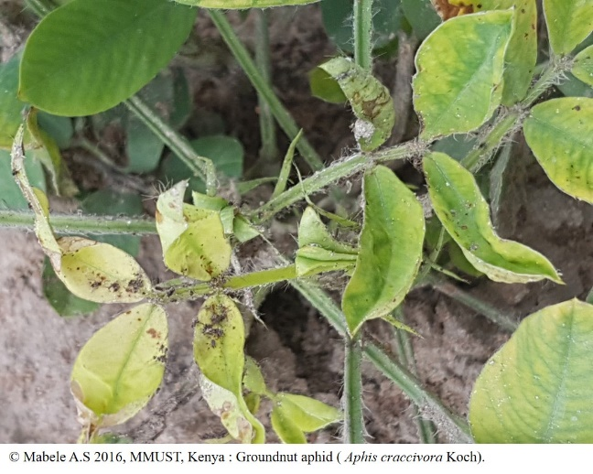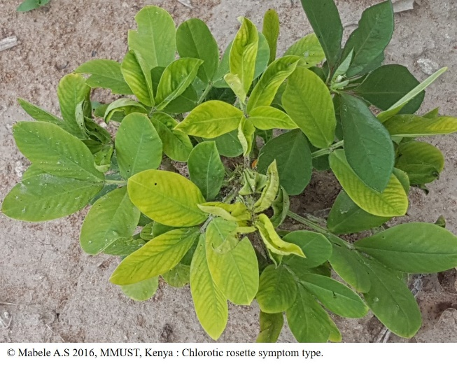
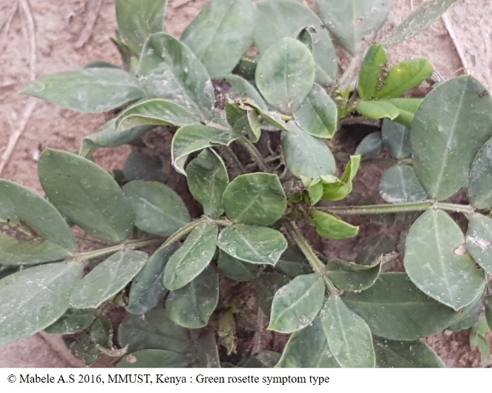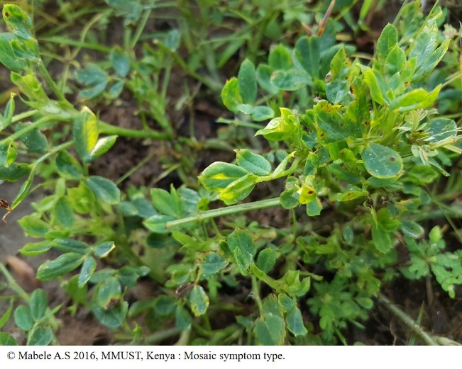
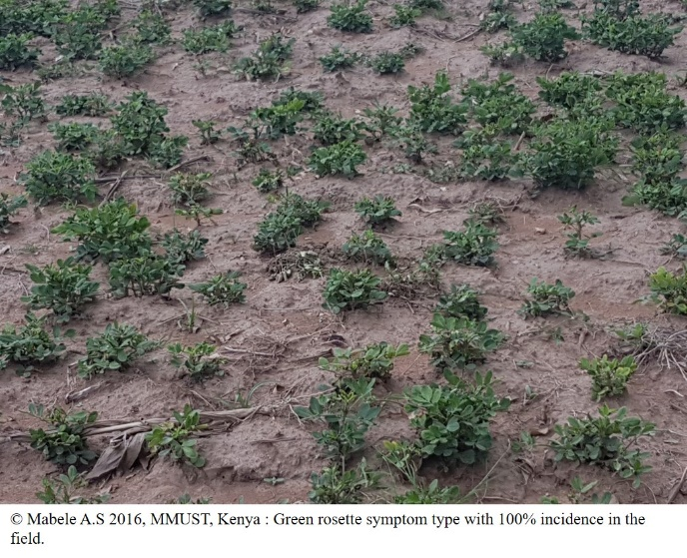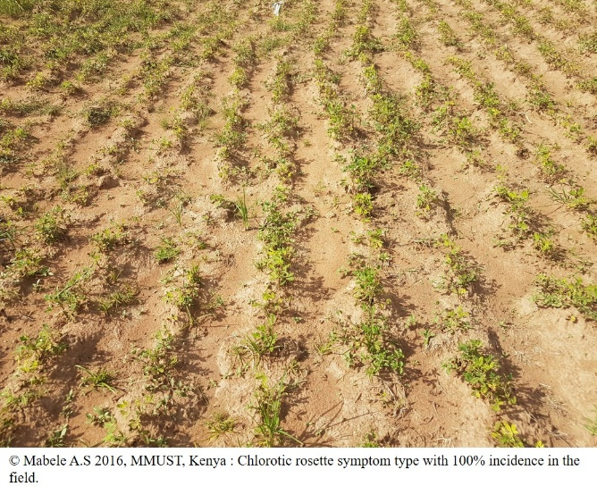
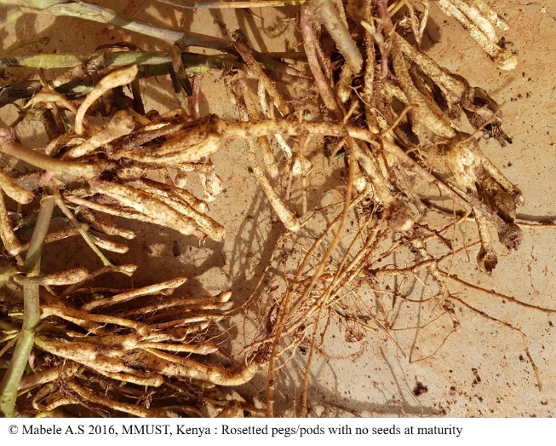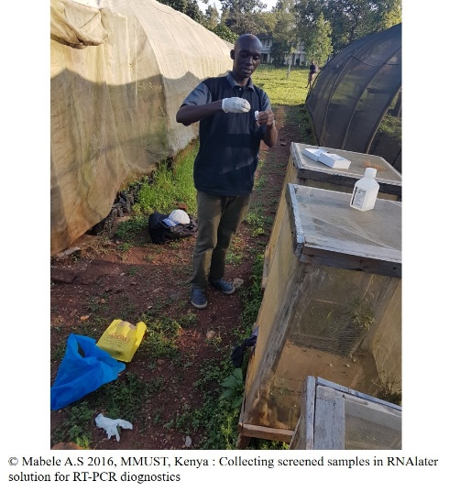

Case study 2: General Surveillance

Surveillance for invasive forest pests: Innovative national trapping and rearing surveys

- Contact details of a submitter:
Mireille Marcotte
National Manager, Plant Health Surveillance Unit, Canadian Food Inspection Agency
Phone: 613-773-5313
E-mail: mireille.marcotte@canada.ca
- Location and Timeline of the case study:
Canada – since 1998
- Content of the case study:

Solid wood packaging material (SWPM) and loose wood dunnage are high-risk pathways for the introduction of invasive wood boring pests. While ISPM 15 has decreased the risks associated with this pathway, there are still interceptions of live wood boring insects at Canadian ports of entry.

To detect these insects as quickly as possible, the Canadian Food Inspection Agency (CFIA) delivers a number of pest specific detection surveys in accordance with ISPM 6 principles, as well as two innovative, early detection general pest surveys called the Invasive Alien Species (IAS) Forest Trapping Survey and the IAS Insect Rearing Survey.

The IAS Forest Trapping Survey has been implemented by the CFIA since the late 1990’s. This is a semiochemical-based survey that uses pheromone and kairomone lures on funnel traps to detect new pests. Based on research done by the Canadian Forest Service (CFS), the CFIA uses different lures every 3 to 5 years in order to target a wide variety of high risk wood borers. Survey sites are selected in wooded or treed sites in industrial and commercial zones or landfills as these are high risk areas for the introduction of pests via international SWPM. Six black, 12 unit funnel traps are set at each site; a rope is suspended about 1.5 m above ground between two trees and the funnel trap is attached at the middle of the rope (Figure 1). Three of the traps are baited with a combination of fuscumol, fuscumol acetate and UHR ethanol (i.e. general longhorn lures) (Figure 2) which attracts longhorned beetles, but also bark/ambrosia beetles and other secondary boring insects (Sweeney et al. 2016). The other 3 traps are baited with monochamol, alpha-pinene, ipsenol and ethanol (i.e. pine sawyer lures) which targets sawyer beetles but also many other wood boring taxa (Ryall et al. 2015).

Since 2011, this survey has resulted in 40 new records, 11 Canadian records and 29 provincial records (Thurston et al., in prep.). Some of these records represent natural distribution of native species, while others appear to be northward extensions of insects native to the United States due to climate change or are the result of introductions of non-actionable species from other countries.

As not all insects respond to the semiochemicals used in the IAS forest trapping survey and as not all high risk industrial sites can be surveyed without trap theft/vandalism or other restrictions, there is a gap in what can be detected with the IAS trapping survey. In order to address this gap, in 2006 the CFIA and the CFS developed the IAS Forest Insect Rearing Survey, where logs are sourced from hazardous municipal street trees that are being removed by the city.

The selected trees, mainly those showing signs/symptoms of insect attack, are cut into short logs. The logs are placed in a mesh cage and are suspended from ceiling racks in 40 foot, steel transport containers which have been modified into a climate-controlled insect rearing facility (Figures 3 and 4).

The CFIA has five insect rearing facilities, located across Canada. This survey has produced 2 provincial and 2 Canadian records. Three of these records are either a range expansion of a native Canadian species or a northward expansion of an insect native to Washington and Oregon. In 2010, adult Trichoferus campestris was reared from bolts from a declining Norway maple tree in Mississauga, Ontario. Although this non-indigenous longhorned beetle was detected in Quebec in 2002, this was the 1st detection in Ontario and was the 1st published North American host record (Bullas-Appleton et al. 2014).

Even though ISPM 15 has been implemented by many countries, non-compliant SWPM still enters Canada and some consignments still include infested SWPM. Therefore, these two general detection survey are important for the CFIA’s ability to quickly detect new incursions of forest IAS as quickly and limit their impacts.
- References
Bullas-Appleton, E., Kimoto, T., and Turgeon, J.J. 2014. Discovery of Trichoferus campestris (Coleoptera: Cerambycidae) in Ontario, Canada and first host record in North America. The Canadian Entomologist, 146: 111-116.

Ryall, K., Silk, P., Webster, R.P., Gutowski, J.M., Meng, Q., Li, Y., Gao, W., Fidgen, J., Kimoto, T., Scarr, T., Mastro, V., and Sweeney, J.D. 2015. Further evidence that monochamol is attractive to Monochamus (Coleoptera: Cerambycidae) species, with attraction synergised by host plant volatiles and bark beetle (Coleoptera: Curculionidae) pheromones. The Canadian Entomologist, 147: 564-579.

Sweeney, J.D., Silk, P., Grebennikov, V., and Mandelshtam, M. 2016. Efficacy of semiochemical-baited traps for detection of Scolytinae species (Coleoptera: Curculionidae) in the Russian Far East. European Journal of Entomology, 113: 84-97.

Thurston, G.S., Kimoto, T., Slater, A., Nei, I. and Roberts, J. New Canadian and provincial records of Coleoptera resulting from routine CFIA surveillance activities. (in preparation)

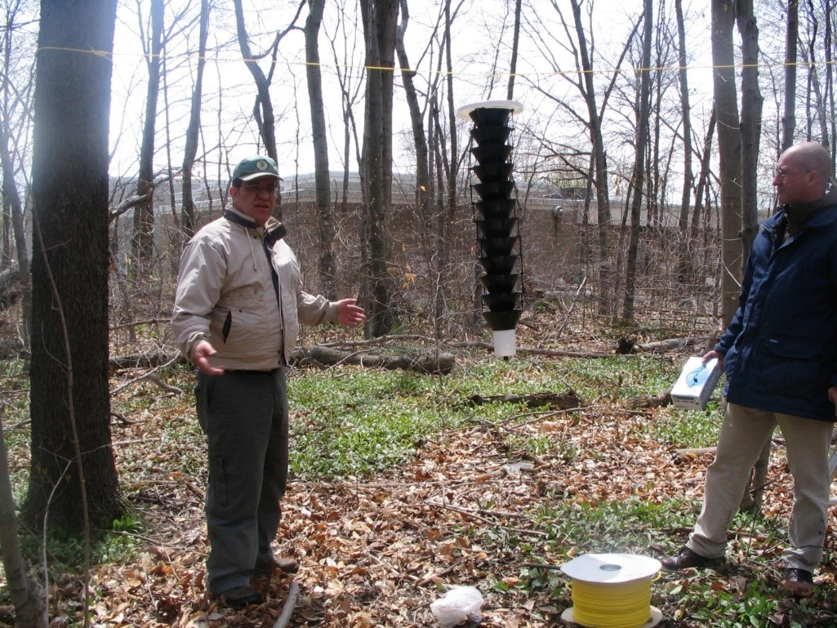
Figure 1. Setting an IAS trap in the field. © Her Majesty the Queen in Right of Canada
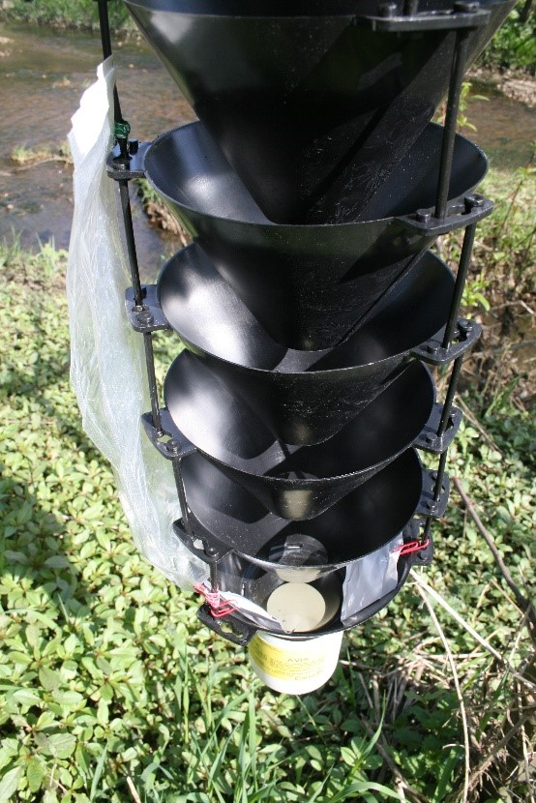
Figure 2. IAS trap baited with General Longhorn lure - UHR ethanol (long sleeve), fuscumol and fuscumol acetate (white pouches). © Her Majesty the Queen in Right of Canada
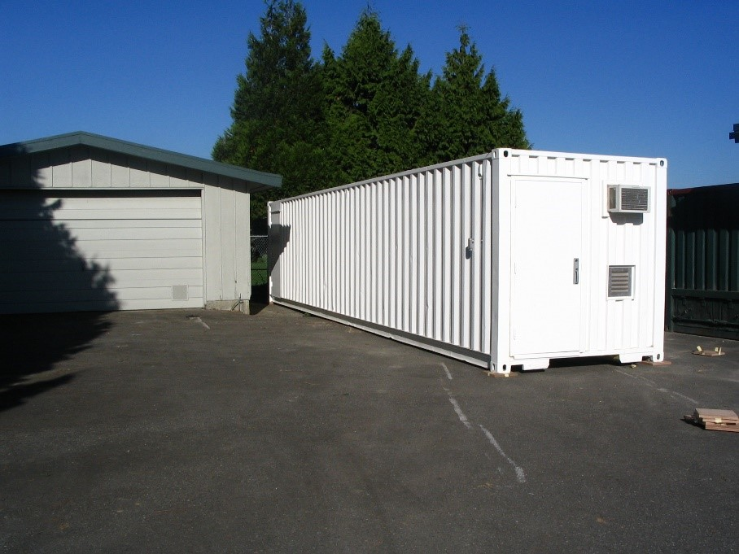
Figure 3. Steel container, modified into a mobile insect rearing facility. © Her Majesty the Queen in Right of Canada
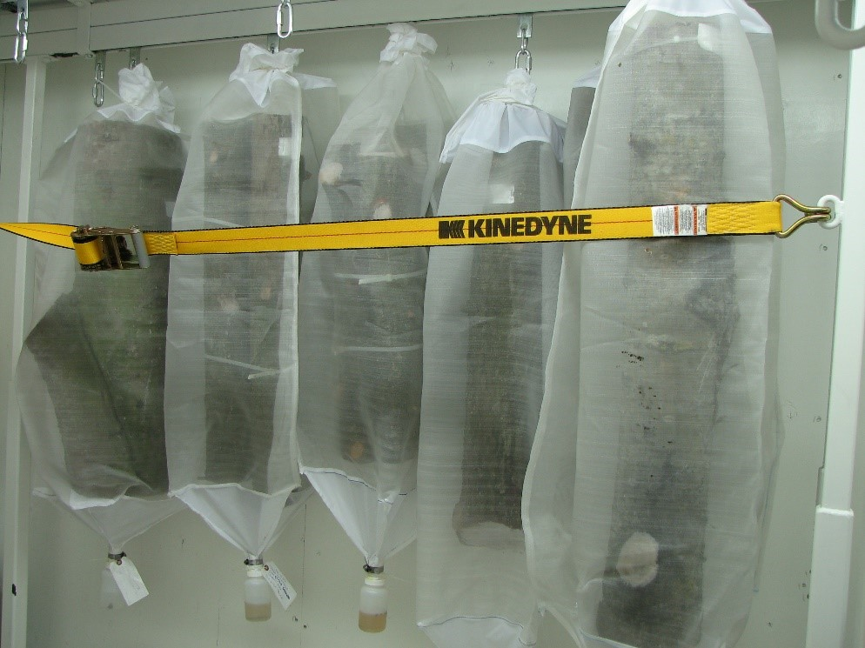
Figure 4. Logs suspended in an IAS insect rearing facility. © Her Majesty the Queen in Right of Canada

Case study 3: General Surveillance

Observatree – an early warning system for tree health using citizen science

- Contact details of a submitter:
Charles Lane
Consultant Plant Pathologist
Fera Science Ltd
Sand Hutton, York, YO41 1LZ, UK
Tel: +44 (0)1904 462326
Email: charles.lane@fera.co.uk
Web: www.fera.co.uk

- Content of the case study:
Context
Observatree is a project aimed at helping to protect the UK’s trees. Where trees have evolved alongside a pest or pathogen, a natural balance has often resulted whereby the tree has developed some level of defence against affecting organisms. However, with increased global movement of trade and people, pests and diseases from around the world have the potential to arrive on our shores faster than by natural movement. Our changing climate is also helping the introduction of alien pests and diseases. When these pests or diseases arrive, our trees are often unable to combat them as they have not had time to evolve defence mechanisms. Many pests and diseases can slow the growth of our trees making them unsightly or unproductive. Others have potential to kill the tree completely. Whilst the loss of any tree species would be tragic, several different species are currently under threat from these new pests or diseases.
What activities were undertaken?

Tree health early warning surveys - a UK network of upto 200 specialist, trained volunteers (Citizen scientists) undertake a range of surveys to assist with spotting new tree pests and diseases. This comprises of three different activities: surveys for the presence of a narrow list (currently 22) of high priority pests and the distribution of some established pests, general health surveillance of trees and monitoring of sentinel trees plots. They also complete surveys to help track the spread of new, established diseases such as Hymenoscyphus fraxineus and assist in research and development projects appropriate to their skills. Volunteers receive annual training to help with identification and surveying techniques.

Triage and verify the most significant reports - the project works with our specialist volunteers to help triage and verify reports of pests and diseases received through an on-line reporting tool called Tree Alert. This may involve visiting sites to carry out further surveillance work following an initial report, including sampling or sending additional photographs or information or verifying the position of a finding.

Share best practice - Observatree connects with other tree health early warning systems in other countries, we learn from their experience and share what we are doing in the UK.
Who was involved?
The project brings together the best skills, knowledge and experience from across the UK to collaborate and share in this single aim. The partnership includes: Forest Research (Project Leaders), Animal and Plant Health Agency, Defra, Forestry Commission, Fera Science Ltd, National Trust, Scottish Forestry, Woodland Trust and the Welsh Government.
The Observatree project has a network of upto 200 volunteers (Citizen scientists) from across the UK who can look out for, and report findings of, pests and diseases. Our volunteers come from all walks of life with a wide-ranging of experience and background, they receive an intensive induction and scientific training programme through online and face-to-face training. We provide pest and disease recognition guides and other extensive online resources, which are also freely available on our website and have become a valuable resource for many stakeholders. The volunteers are requested to attend a face-to-face training session every year, access online training resources and carry out regular surveys throughout the year reporting their findings on a regular basis. There are many other additional training and surveying tasks they can access or offer to support dependent on their availability and skills.
How were the activities initiated and undertaken?
The finding of ash dieback in the natural environment in UK in 2012 led to a review of tree health and biosecurity and publication of the GB Plant Health Strategy. This recognised the importance of engaging with stakeholders and the opportunity to harnesses citizen science for enhanced surveillance. The project was initiated in 2012 as a short feasibility study funded by National Plant Protection Organisation which in turn led to a four-year European LIFE+ Programme project (January 2013 and September 2017), that provided 50% of the costs. The remainder was provided by partner organisations (Forest Research, Forestry Commission, Fera Science Ltd, National Trust and Woodland Trust), supported by APHA, Defra and Natural Resources Wales. Since October 2017, the project is solely funded through the partner organisations listed above.
What ISPMs were successfully implemented?
The project supports the work of the NPPO which is built upon the core principles of many ISPMs -for example, our priority pests and disease list is drawn from the UK plant health risk register which is based upon the principles of pest risk analysis described in ISPM 11 (Pest Risk Analysis of Quarantine Pests). We draw upon the requirements laid out in ISPM 6 (Guidance for Surveillance) which makes specific reference to public education/awareness programs as well as principles such as data verification procedures and good surveillance practice. The results of the surveys help to inform the status of pests in the UK as per ISPM 8. In developing our training concerning plant health and biosecurity we draw upon ISPMs such as ISPM 39 (International Movement of Wood), 41 (International Movement of Used Vehicles, Machinery and Equipment) to illustrate the risk of different pathways of introduction and spread the various pests and pathogens.
Identify any IPPC implementation resources that were used and how they were helpful.
In developing our training programs for our volunteers, we have drawn upon the IPPC implementation capacity development guides and training materials – for example IPPC Factsheets.
Outcomes and impacts
Observatree volunteers have submitted over 10000 tree health reports, of which almost 2500 were of pests or diseases. These reports have included sightings of all priority pests and diseases known to be present within the UK. For example, Oriental chestnut gall wasp, which creates deformed growth on sweet chestnut foliage, was first recorded in the UK in 2015. One of our volunteers made only the second reporting of this tree pest in the UK; it was found in a different area to the previous outbreak, leading to follow-up inspections and intervention to help manage the situation. More recent significant findings have included reports on Chestnut blight and OPM which have also led to follow-up activities by inspectors.
Whilst recording positive results is very important for detecting new outbreaks, unlike many other citizen science projects, Observatree encourages volunteers to submit information on locations where no pests or diseases are found. These ‘negative data’ are very important in helping map rates of spread of any tree pests or diseases. It may identify areas where tree pests or diseases are unable to become established. All mapped results are shared with volunteers, to feedback the outcome of their efforts, and with project partners and stakeholders for information. Over time this will help us to build a comprehensive map of where pests or diseases are causing concern and allow much more targeted responses to them.
Observatree is about more than reported observations of tree pests or diseases. The value of some of these other indicators of success can be more difficult to measure. For example, a significant role of the project is about raising awareness of tree health and the threat these pests and diseases pose to UK trees. We are keen to promote these issues to a wider audience. In addition to providing information and resources to volunteers, our communications team have placed printed and digital advertisements in targeted media, given talks to interested groups and participated in shows and events targeting key audiences. We have provided training for stakeholder groups. Public information boards about the project, featuring local pests and diseases, have been placed in sites where they will be seen by members of the public
Lessons learned and areas for improvement
Collaboration - to raise further awareness of tree health, and to help other citizen science projects by sharing our lessons learned, we have been keen to collaborate with others. Observatree is working with other similar plant health citizen science projects in the UK and beyond to form a network for knowledge exchange and partnership working. We have hosted international conferences and spoken to others about our project, reaching a much wider international audience.
Investing in volunteer management – it should not be underestimated the level of investment required to maintain an engaged and productive volunteer workforce. Although they give their time freely, they have the same needs as professional staff - they need supporting to do their job, developing and maintaining their skills and receiving feedback on the value of their work.
Data management - the success of the project has resulted in considerable interest in the resources that we develop and the volume of data that the volunteers produced. This requires robust and resilient infrastructure and investment to ensure the value of the volunteer surveillance work is made available for national surveillance.
Staying focussed - inevitably with such a talented volunteer workforce, there will be requests to get them involved in a diversity of activities. Good governance of the project has ensured that the views of the volunteers and partners are well balanced and project stays focused on its core mission.
Future plans and activities
The work of the volunteers and the data gathered is now becoming an essential part of tree health surveillance in the UK. We continue to remain focused on our core mission for an early warning system for tree health, but we continue review our priority pests and diseases for surveillance, for example addition of the elm zig-zag sawfly (Aproceros leucopoda), and seek to develop the skills of our volunteers and the network to support them. We work closely with our National Plant Protection Organisation, plant health services and stakeholders to ensure we are meeting their needs; but equally as important, we work with our volunteers to ensure we are also meeting their needs.
- Additional information of the case study:
https://www.observatree.org.uk/
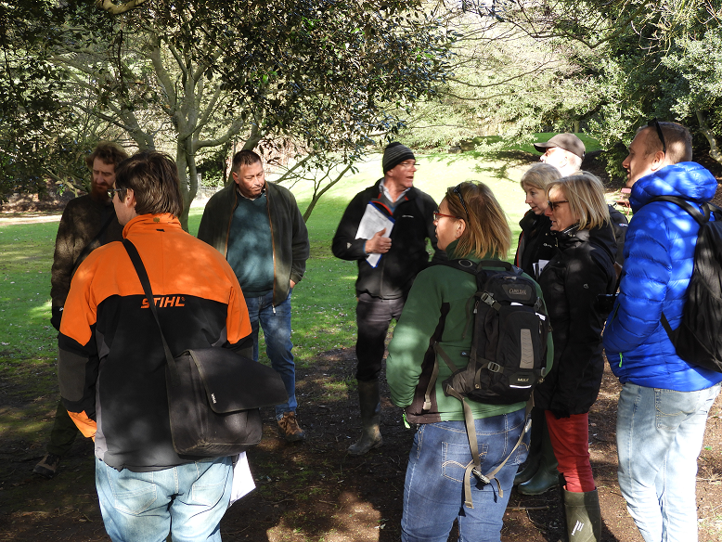
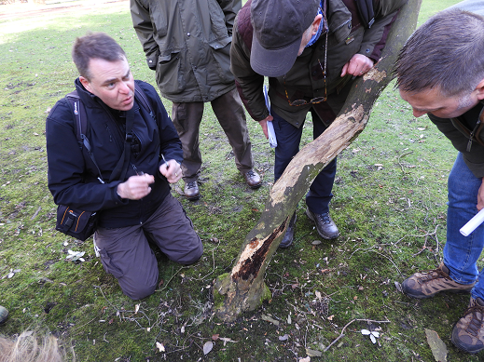
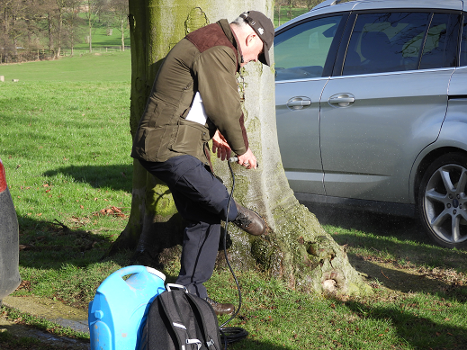

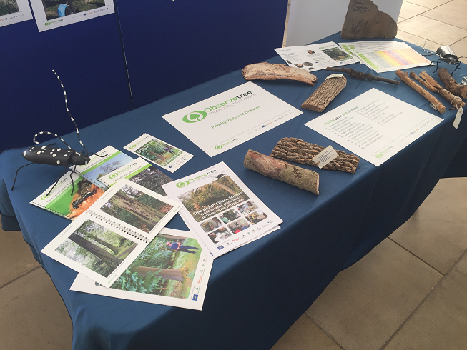
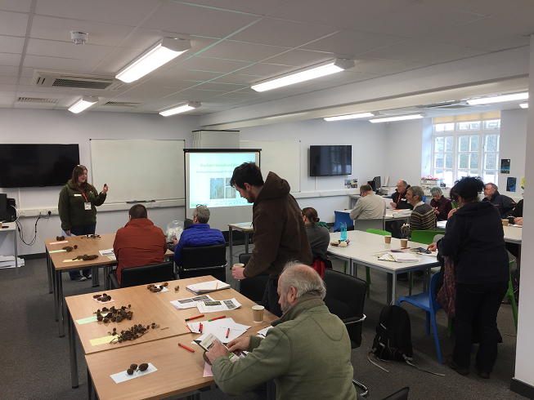

Case study 4: Specific Surveillance
Monitoring of the avocado borer worm (Stenoma catenifer) using pheromones
- Contact details of a submitter:
Verónica Tipán
Director of Phytosanitary Surveillance
Phyto and Zoosanitary Regulation and Control Agency – Agrocalidad, Ecuador
Phone: (+593) 2 3828 860 ext 1062
E-mail: sanidad.vegetal@agrocalidad.gob.ec; vigilancia.fitosanitaria@agrocalidad.gob.ec
- Location and Timeline of the case study:
This case study is carried out in the avocado production sites located in the Provinces of Pichincha, Carchi and Imbabura. The purpose of this study was to identify the presence of the avocado borer insect (Stenoma catenifer), this monitoring network was implemented from May 2019 in the production areas of the indicated provinces with the installation of traps and their respective pheromones.
The monitoring of this pest is currently carried out jointly with the Association CorpoAguacate in which its associates carry out monitoring every 7 days and once a month have the supervision of the Agency's technicians in the territory.
The monitoring information is carried out through a web platform and a free mobile application (Epicollect5) in which the monitoring information of this insect is periodically registered, these data are analyzed by the officials of the Phytosanitary Surveillance Unit of the Agency.
Until now, the presence of this insect has been determined at two production sites, one in the province of Pichincha and the other in Carchi, respectively. Thanks to this activity and the commitment of the producers, the monitoring network for this pest has been strengthened, which is in the process of regulation by the United States for the export of fresh avocado to that country.
- Content of the case study:
Background:
The Phyto and Zoosanitary Regulation and Control Agency has been developing strategies regarding the strengthening of the Phytosanitary Surveillance network. In this sense, the use of pheromones for pest monitoring has been promoted, as is the case of Stenoma catenifer that affects avocado fruits, for that reason, a joint work was established between CorpoAguacate producers who are interested in sending their product to the United States, the country in which this insect is regulated by APHIS.
Therefore, it is necessary to determine the distribution of the pest in order to comply with the requirements established by the United States for the Ecuadorian avocado fruit to enter this country, being one of the main challenges that faces the avocado sector.
The main activities that were carried out were:
a) Use of the free mobile application (Epicollect5).
b) Installation of traps and pheromones.
c) Service time monitoring.
d) International and national regulations (objectives)
e) Informative report.
f) Identification of the pest in the adult state and larvae.
g) Management of pheromones and traps.
In order to strengthen this surveillance network, permanent monitoring has been carried out by the Agency's officials both in the territory and in the verification of the monitoring information carried out by avocado producers at the production zones.
It is necessary to indicate that the Agency's technicians are in charge of taking samples to verify that the insects in the traps correspond to the target pest.
The main purpose of the producers is to provide the Ecuadorian avocado with a seal of origin in order that the Ecuadorian product can reach various markets and be competitive. In addition to the trapping, the producers of the association will start with the implementation of Good Agricultural Practices on their farms and will be supervised by Agency officials.
As the phytosanitary authority of Ecuador, our primary interest is to keep the status of the pest in the country updated in order to be able to carry out the process required by APHIS and negotiate the phytosanitary requirements for the entry of this product to the United States.
The monitoring of the avocado borer worm began with the following activities:
- Socialization and permanent training by the Agency.
- Use of traps and pheromones by producers.
- Implementation of a mobile application to collect monitoring data.
- Commitment of the Agency to take samples and send the results to avocado producers.
The International Standards for Phytosanitary Measures that were successfully implemented were ISPM 6 and ISPM 8 respectively, because the surveillance system is strengthened and there is certainty of the presence of a pest in the country based on what is established in the ISPM 8.
The resources that were taken into consideration for the establishment of monitoring and that are part of the IPPC were:
- The use of regulations related to the phytosanitary surveillance
- The determination of the presence or absence of the pest to avoid non-compliance notifications of the phytosanitary requirements.
- Notification of presence of pests so that the status of the pest in the country is transparent.
Results:
Trapping was implemented in a total of 10 production sites with an average area of 53 hectares. In these sites the presence of the insect was determined only in two farms, one located in the province of Carchi and one in Pichincha.
It is necessary to indicate that the impact that the use of traps and pheromones is high since it has allowed the expansion of pest monitoring areas and especially of nocturnal insects such as the adults of this pest.
In the future, the Agency will promote pest monitoring through the use of pheromones in other crops such as grapes, corn, and sugar cane, to determine the status of the pest in the country and its distribution in the Ecuadorian territory.

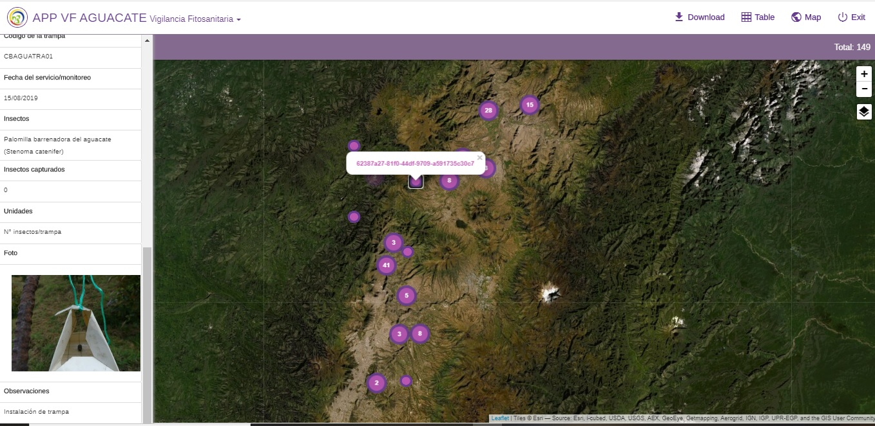

- Map of Stenoma catenifer monitoring sites

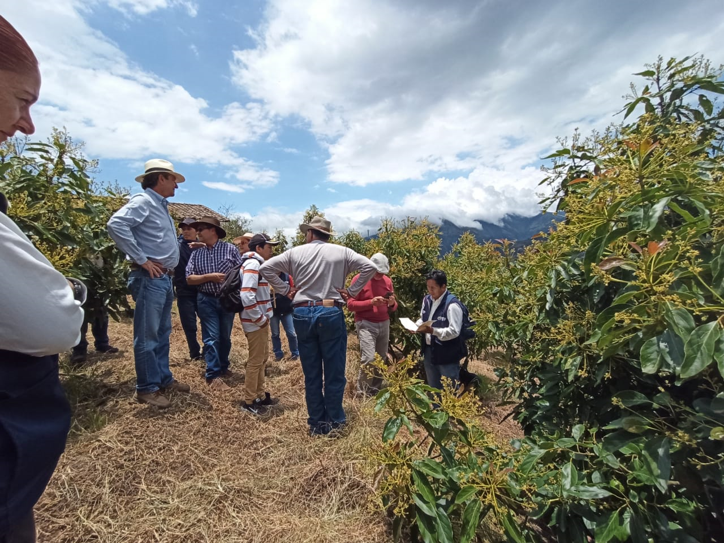
- Training for trapping of Stenoma catenifer
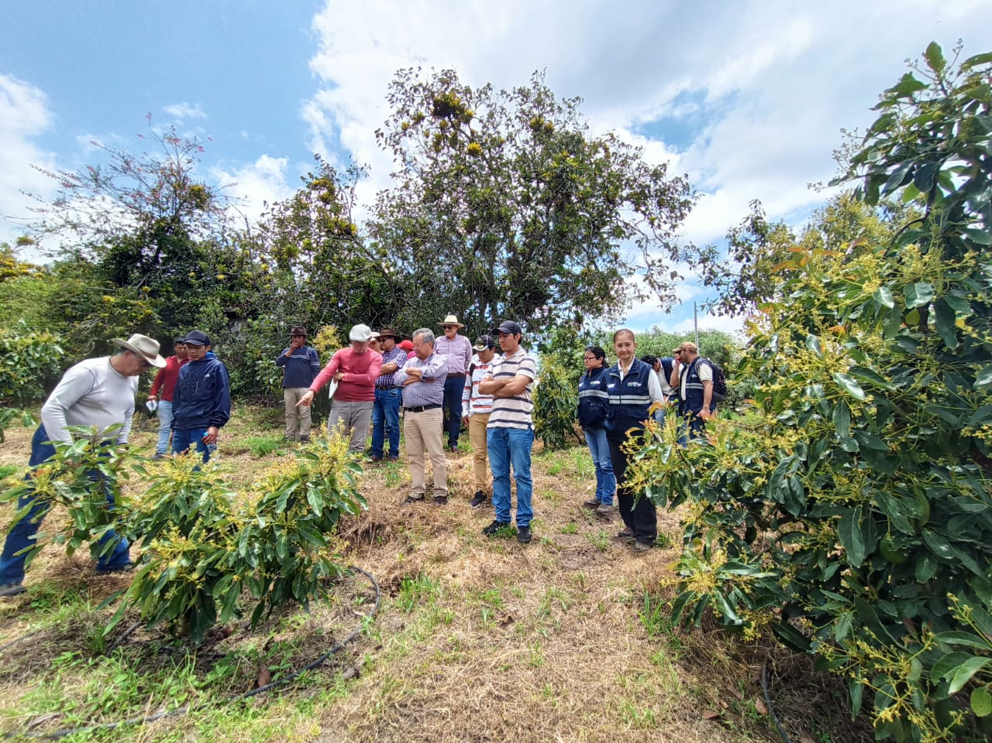
3. Installation of trap and pheromone for Stenoma catenifer

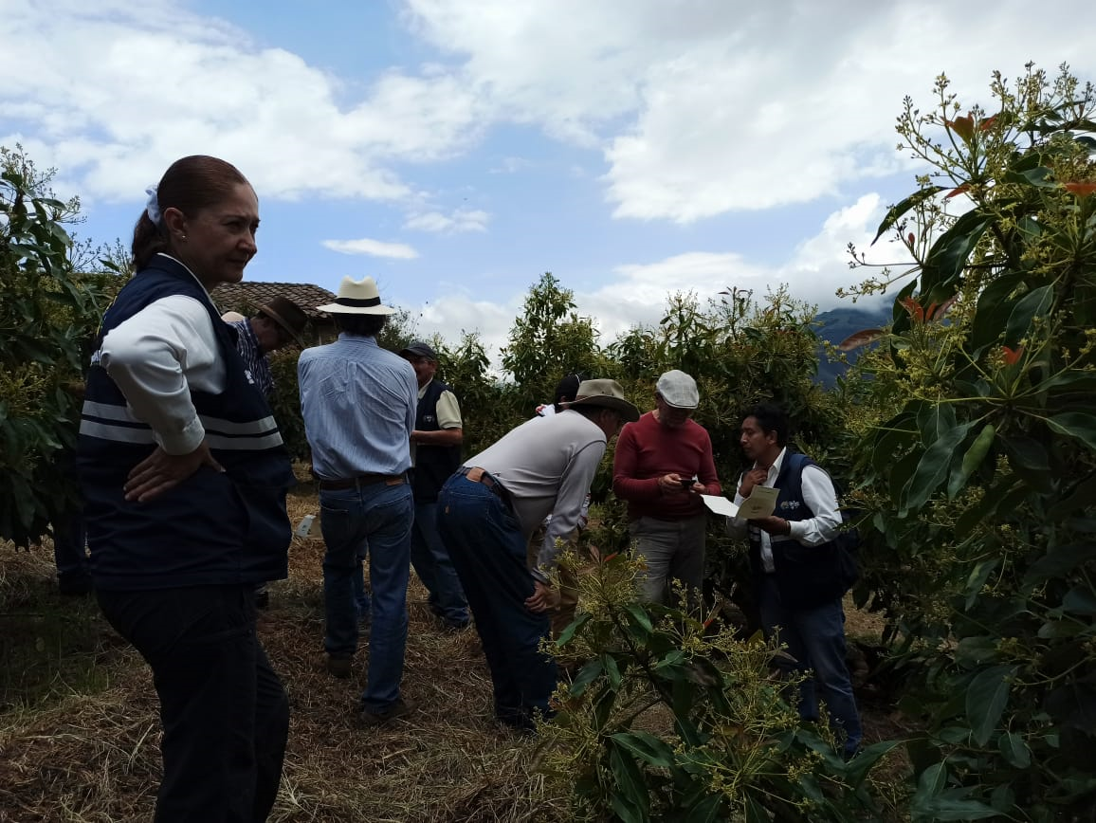

Case study 5: Specific Surveillance
Egypt on phytosanitary measures and Procedures taken to manage the risk of Fall Armyworm
- Contact details of a submitter:
Kamal ElAttar & Nader ElBadry
Head of the Egyptian NPPO & Standard Committee member
The National Plant Protection Organization (NPPO) of EGYPT
Central Administration of Plant Quarantine
Phone: (+202)33351625 - 37608575
E-mail: ippc@capq.gov.eg; ippc.egypt@gmail.com

- Location and Timeline of the case study:
Upper Egypt (1 year since 2019)
- Content of the case study:
The devastating rapid spread of the fall armyworm (FAW) pest (Spodoptera frugiperda), across Africa resulted in a dramatically negative impact on crop production, especially on maize farmers who have been racing to eliminate the destruction of crops. This crisis has enforced governments across Africa to help farmers manage the pest and control its effect on crops.
The pest was first reported in Africa in 2016 (Goergen et al 2016, Cock et al 2017), with subsequent reports across the continent up to 2019 as first reported in Egypt. FAW is reported to attack more than 350 plant species (Cock et al 2017, Day et al 2017). It has caused significant effect in Africa specially on maize (Abrahams et al 2017).

In August 2017, the Regional office for Near East and North Africa (RNE) of FAO, had notified Ministry of Agriculture in Egypt for the detection of FAW in most of the African countries including the neighbouring country Sudan. In compliance with the rules of international organizations and conventions in such cases, the discovery of the insect is reported in some agricultural places in southern Egypt through the Central Department of Quarantine. Notifications had been spread to monitoring and exploration system existing in all governorates of the Republic by field inspection and monitoring of the Pheromone Traps for the speed of detection of the insect in any place and report it to take the necessary through:
- Giving responsibilities to phytosanitary-related specialists who received trainings and have been trained in the relevant research institutes.
- Spreading pheromone traps in all agricultural regions in Egypt under supervision of the Central Pest Control Department.
- Release of campaign (committee) by specialists from the Plant Protection Research Institute (PPRI) and the Central Administration for the Control (CAC) to carry out a delimiting survey for the presence of insects and identify hosts at all Governorates of Egypt by utilizing Traps system, Field inspection and rapid reporting to the Committee to control the pest and take the necessary measurements.

Awareness & Training sessions:

Guidance seminars for the control departments, farmers and all relevant bodies to raise awareness of the devastating pest and its danger, detection methodology, monitoring and identification by phenotype or symptoms of infection.

Taken Action in cooperation with FAO -NRE office
- Several extension workshops and conventions were conducted in governorates of Upper Egypt throughout 2019, these events attended by 587 pest control engineer specialists in addition to academic staff of Agronomy research institute for awareness with Fall Armyworm (FAW), prophylactic measures needed for the pest.
- 100 of Pest control engineer specialists were trained in Upper Egypt for utilizing modern technology for forecasting and detecting FAW by using a mobile application of (famews) in cooperation with FAO (in the period of April-May 2019 in Luxor).
- Publications and flyers illustrating the scientific action procedures for the FAW prevention, this included (Infection symptoms, pest risk, biological hosts in pictures). These publications were distributed to different Agricultural Directorates (Fayoum, Beni Suief, Elminia, Asuit, Qena, Luxor, and Aswan).
- FAW adult insects were detected in Aswan (Kom Ombo, Edfo) using pheromone traps to attract the insect, these insects were further diagnosed at Plant Protection Research Institutes.
- The use of parasite Trickograma in the case of the emergence of any infection related to the fall army worm and to eradicate the hotbeds of infection immediately.
- Chemical control certified program for the fall armyworm sent to all directorates of agriculture provinces of Upper Egypt and others as well as to combat the six pests referred to areas in anticipation of any appearance of the pest at any time during the coming period, which will be applied to the following crops (corn - cotton - vegetables - sugarcane - clover) in case of infection with that worm.

- References
Abrahams, P., Bateman, M., Beale, T., Clottey, V., Cock, M., Colmenarez, Y., Corniani, N., Day, R., Early, R., Godwin, J., Gomez, J., Gonzalez Moreno, P., Murphy, S.T., Oppong Mensah, B., Phiri, N., Pratt, C., Silvestri, S. & Witt, A. (2017). Fall Armyworm: Impacts and Implications for Africa. Evidence Note (2), September 2017. Report to DFID.

Cock, M. J., Beseh, P. K., Buddie, A. G., Cafá, G., & Crozier, J. (2017). Molecular methods to detect Spodoptera frugiperda in Ghana, and implications for monitoring the spread of invasive species in developing countries. Scientific Reports, 7(1), 4103.

Day, R., Abrahams, P., Bateman, M., Beale, T., Clottey, V., Cock, M., Colmenarez, Y., Corniani, N., Early, R., Godwin, J., Gomez, J., Pablo Gonzalez Moreno, P., Murphy, S.T., Oppong-Mensah, B., Phiri, N., Pratt, C., Silvestri, S., and Witt, A. (2017) Fall Armyworm: Impacts and Implications for Africa. Outlooks on Pest Management, DOI: 10.1564/v28_oct_02.

Goergen, G., Kumar, P. L., Sankung, S. B., Togola, A., & Tamò, M. (2016). First report of outbreaks of the fall armyworm Spodoptera frugiperda (JE Smith) (Lepidoptera, Noctuidae), a new alien invasive pest in West and Central Africa. PloS one, 11(10), e0165632.
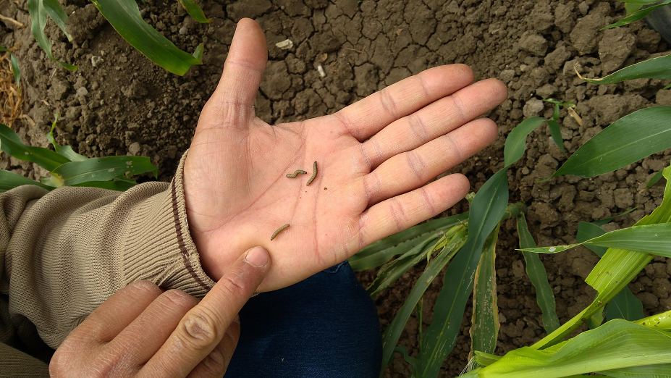
Fall armyworm caterpillars.

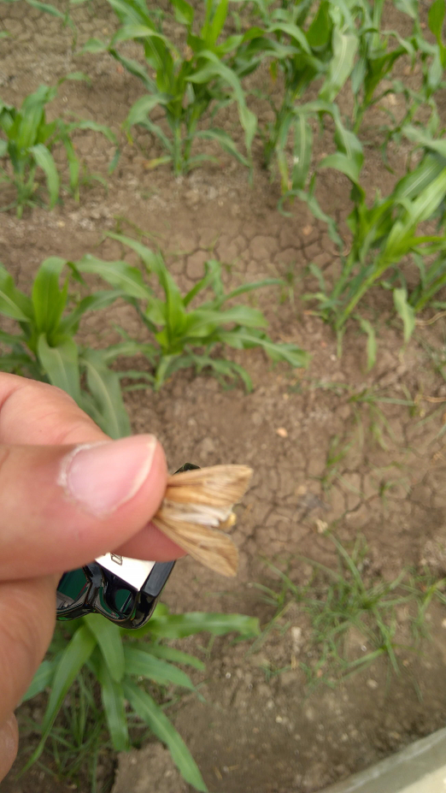
Fall armyworm insect.

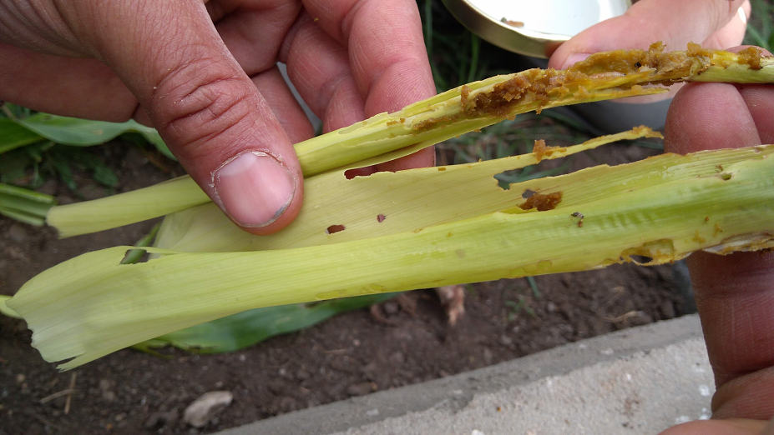
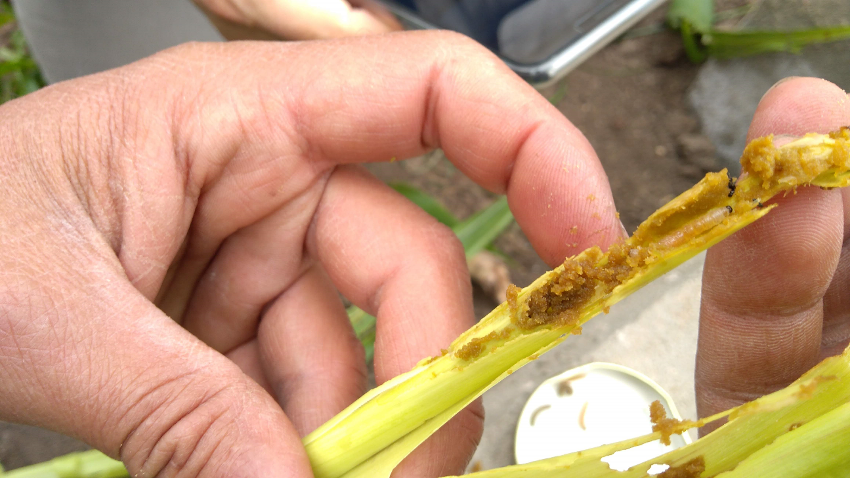
Insect frass.

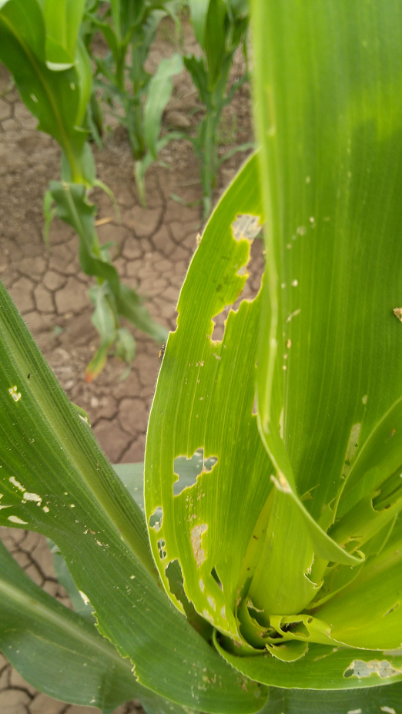
Injured maize leaves.

Case study 6: Specific Surveillance

The International Plant Sentinel Network Spittlebug Hunt
As part of their efforts to protect the UK from Xylella fastidiosa the Department for Environment, Food and Rural Affairs (Defra) drew upon the expertise and resources of the IPSN. The aim was to improve understanding of host plants of spittlebugs in the UK which are known to vector or are potential vectors of the disease.
- Contact details of a submitter:
Katherine O’Donnell
Head of Seed Conservation and Plant Health, Botanic Garden Conservation International
E-mail: katherine.odonnell@bgci.org
- Location and Timeline of the case study:
Botanic gardens in the UK May-June 2017

- Content of the case study:
Spittlebugs and Xylella fastidiosa
There are a number of spittlebugs (also known as froghoppers) that are native to the UK. Nymphs (spittlebug young) develop in foam nests commonly called ‘cuckoo spit’ so finding cuckoo spit can indicate that a plant species is a preferred place for the spittlebugs to develop.
Spittlebugs do not cause significant damage to plants, and many are native to the UK; however they do have the potential to carry Xylella fastidiosa (ISPM 27 Annex 25), a disease causing bacteria, which can kill a wide range of plants including many iconic tree species.
Defra and the UK plant health service are gathering information to ensure that the risks relating to X. fastidiosa are understood, to reduce the risk of the pest arriving in the UK and to be prepared for any outbreaks.
Botanic Gardens Conservation International’s (BGCI) International Plant Sentinel Network (IPSN) is a network of Botanic Gardens and Arboreta working together to provide an early warning for, and vital information on, new and emerging pests and pathogens.

The Department for Environment, Food and Rural Affairs (Defra) drew upon the expertise and resources of the IPSN as part of their efforts to protect the UK from Xylella fastidiosa.
BGCI worked with Fera Science Ltd. and Royal Botanic Gardens, Kew to provide scientific expertise.
Aims and activities
Information was gathered via a public engagement activity. Staff and visitors to botanic gardens were encouraged to look out for the conspicuous ‘cuckoo spit’ produced by the spittlebug nymphs (ISPM 6).
The information requested was purposely designed to be simple and easy to gather - a picture of the ‘cuckoo spit’ on the host, host identity and location. An advantage of the IPSN involvement was that most host plants could easily be identified due to the labelling in botanic gardens and arboreta. This activity aimed to provide valuable information for plant health, but also to offer an opportunity to engage the public. This survey also acted as a pilot project for potential future plant health engagement/citizen science activities.
Several different methods of outreach were employed in order to increase the scope of the project and engage a wide range of stakeholders.
- A poster was created in collaboration with Fera Science Ltd, Royal Botanic Gardens, Kew, BGCI and Defra with information on the Spittlebug Hunt. The poster included images to aid spittlebug identification and information on both the vectors (spittlebugs) and the pathogen (X. fastidiosa). It has links to more information regarding the IPSN and spittlebugs (through the RHS website). The poster also included information on the Twitter campaign (details below) and an alternative reporting mechanism (other than Twitter).

- The survey was run on Twitter using #Spittlebughunt. Participants were invited to include a photo, the location and the plant name (common or Latin) in the tweet.

- A news article was created and published on the IPSN website (http://www.plantsentinel.org/news/1409/).

- Participants could also send information directly to a staff member at Defra plant health policy.
The gardens participating were invited to get involved in the survey by showcasing the poster in their entrance/visitor centre and to involve garden visitors in the activity.
Some suggested ways to do this included;
- Visitors simply reporting to reception
- A table where visitors can fill in the host name and date
- A chalkboard or a white board which can be noted down at the end of a week/day etc.
What ISPMs were successfully implemented?
The project supports the work of the NPPO which is built upon the core principles of many ISPMs - for example, our research on priority pests and disease is drawn from the UK plant health risk register which is based upon the principles of pest risk analysis described in ISPM 11 (Pest Risk Analysis of Quarantine Pests). We draw upon the requirements laid out in ISPM 6 (Guidance for Surveillance) which makes specific reference to public education/awareness programs as well as principles such as data verification procedures and good surveillance practice. The results of the surveys help to inform the status of pests in the UK as per ISPM 8.
Identify any IPPC implementation resources that were used and how they were helpful.
In developing our training programs for our volunteers, we have drawn upon the IPPC implementation capacity development guides and training materials – for example IPPC Factsheets.
Outcomes and impact
The news article on the IPSN website was promoted through the IPSN UK network, PlantNetwork (a UK network of botanic gardens and arboreta) and Cultivate (BGCI’s newsletter). The poster was sent to IPSN Member gardens in the UK. According to Google analytics data the website news item was viewed close to 200 times since it was published.
65 tweets were received between May 26th and June 30th from 20 participants. Tweets were received from Scotland, England, Ireland and Wales. A total of 86 plants were identified as having cuckoo spit on them. The most commonly observed plant was lavender. The tweets were sent in by a combination of plant health officials, botanic garden staff and volunteers.
Emails with information on spittlebug sightings were sent to the staff member at Defra plant health policy. The emails contained data related to 78 sightings of spittlebug. A total of 44 plants were recorded 30 of which were identified to species level. Twelve sightings were sent by email and also tweeted.
In addition 30+ samples of spittlebug nymphs were taken by Defra and Fera Science Ltd. staff and were analysed to confirm their identity.
Conclusions
Research outputs and impact of the campaign
The aim of this campaign was to collect information on current host plants of spittlebugs which are known to vector the disease. The results have expanded the list of potential hosts for the UK, demonstrated the range of managed and unmanaged habitats that spittlebugs can been found in, emphasised the widespread distribution of spittlebugs in the UK and provided information on the time of year when spittlebug larvae are active. This information has been used by plant health scientists to improve their understanding of the host range, frequency and geographical distribution to inform the pest risk analysis. The information will also be helpful as part of the contingency planning process supporting the plant health service in its efforts to prevent the introduction or spread of X. fastidiosa in the UK.
Outreach
The Twitter and email campaign proved an effective form of outreach in creating information related to spittlebug host plants. It represents a successful campaign where volunteers, botanic gardens and plant health officials worked together to gather important plant health data. One nice example of this collaboration can be seen where tweeters found the spittlebug, outside of botanic gardens and were unable to identify the plant species. The botanical experts involved in the campaign used the pictures from the tweets to identify the species that were acting as a host plant to the Spittlebug to ensure that the data captured was useful and of high quality.
Future plans and activities
Surveys have been run in subsequent years by SASA in 2018 and the John Innes Centre in 2020. Campaigns through Twitter can be set up in advance, using a function in Twitter in order to collate data. Data contained in tweets with a specific hash-tag can be automatically recorded to a spreadsheet to reduce amount of time needed to pull the data from individual tweets. Other social media platforms, such as Instagram, could be utilised to carry out future surveys.
- Additional information of the case study:
Further information on X. fastidiosa can be found on the Plant Health Portal factsheet
https://planthealthportal.defra.gov.uk/assets/factsheets/Xf-Plant-Pest-Factsheet-2017v3.pdf

Editing and layout: Green Ink (www.greenink.co.uk)

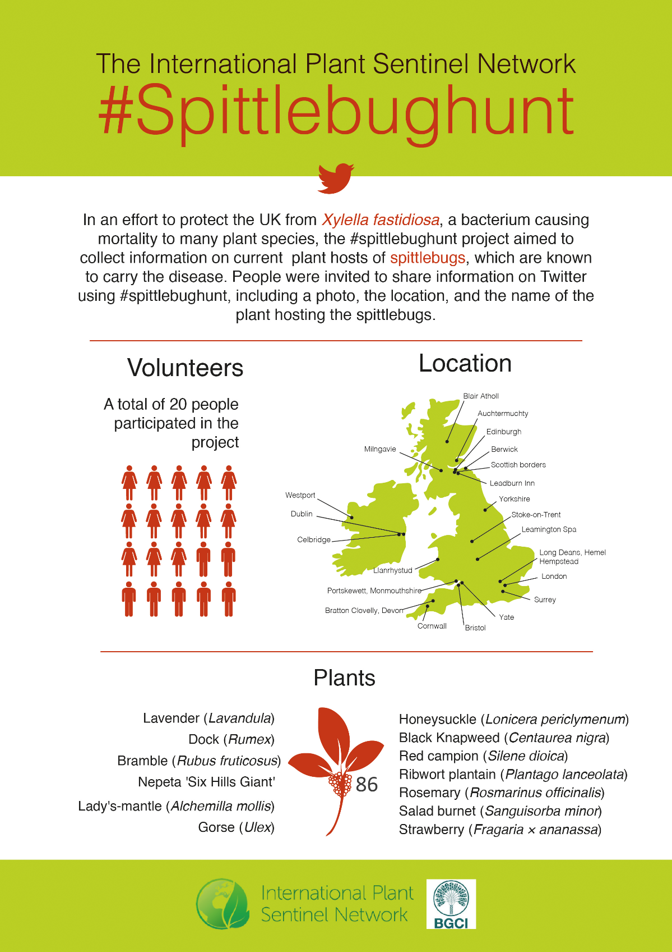
Spittle bug infographic

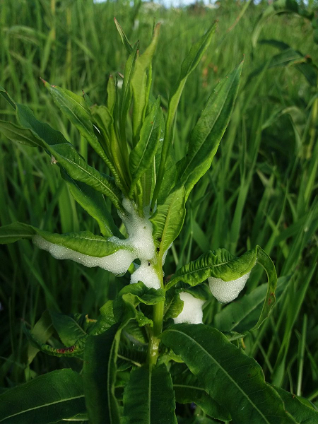
Spittlebug on Fireweed (Chameanerion angustifolium)

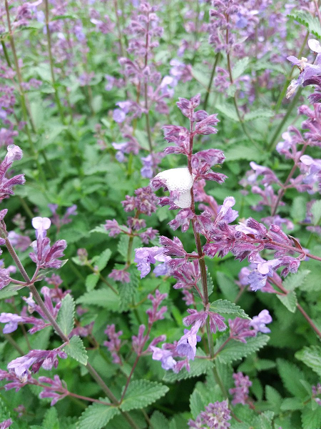
Spittlebug on Nepata Six Hills Giant

Case study 7: General surveillance

Management of an expert network in Argentina

- Contact details of a submitter:
Diego Quiroga
National Director for Plant Protection
National Service for Agri-Food Health and Quality (SENASA)
Phone: (+5411) 4121-5176 / 5495
E-mail: dquiroga@senasa.gov.ar
- Location and Timeline of the case study:
Argentina, 2004-2020
- Content of the case study:
The development of a general plant pest surveillance network within the scope of the NPPO, involves both its personnel from all over the country as well as numerous non-NPPO participants engaged in different ways, according to their role regarding both the crops and the the phytosanitary national system.

Since 2002, when plant pest surveillance system initiated in Argentina, the NPPO contacted different experts in order to gather information related to plant pests status in the country, with the aim to respond to the requirements of third parties during negotiations.

As the system evolved, the need to form a more structured network of experts was noted.

With this objective, a database of experts who are part of this network was organized so that their data were readily available in view of the need to obtain phytosanitary information. Such database is currently accessible online (www.sinavimo.gob.ar-spanishonly).

Likewise, an extensive work was carried out to sensitize the experts so that they could understand the importance of their contribution and the usefulness of the information provided.

This network created in a voluntary participation basis, integrates national experts linked to plant production and protection and belonging to both the public and private spheres. Not only specialists in the scientific-academic field, but also extension agents, producers distinguished for their wide experience and knowledge, are part of it.

Members of the network are regularly consulted regarding the condition of pests and their association with crops at the national level, through personal interviews, online consultations, workshops, etc.

Since 2010 the figure of local surveillance referents was added, being these agents of the NPPO with strategic functions to support plant pest surveillance in their area of concern. The profile of these referents is oriented to responsibility, commitment and technical capacity, but especially to the ability for interpersonal relationships and communication. They act as liaison personnel to strengthen the link with the experts that make up the external network, by maintaining direct contact and promoting understanding, joining, commitment and sustained participation over the time. At the same time, they train local NPPO agents in general surveillance to favor their incorporation into the phytosanitary surveillance system.

The number of experts participating in the surveillance network increased progressively since the beginning of the plant pest surveillance system, currently having more than 700 members. Their active intervention allows integrating the existing dispersed information and incorporating expert judgment into the plant pest surveillance system. Expert opinions can be especially important when reducing uncertainty due to incomplete or contradictory data and determining the validity of pest records. Single or outdated pest records may not represent an established population of the pest in the considered location and their knowledge and experience regarding current situation, can be very helpful to determine pest status.

The following ISPMs were successfully implemented:
• ISPM 6 (Surveillance)
• ISPM 8 (Determination of pest status in an area)
- Additional information of the case study:
www.sinavimo.gov.ar
https://repositorio.iica.int/bitstream/11324/2775/2/BVE17048794i.pdf

IPPC
The International Plant Protection Convention (IPPC) is an international plant health agreement that aims to protect cultivated and wild plants by preventing the introduction and spread of pests. International travel and trade are greater than ever before. As people and commodities move around the world, organisms that present risks to plants travel with them.

Organization
- The number of contracting party signatories to the Convention exceeds 181.
- Each contracting party has a national plant protection organization (NPPO) and an Official IPPC contact point.
- 10 regional plant protection organizations (RPPOs) have been established to coordinate NPPOs in various regions of the world.
- IPPC liaises with relevant international organizations to help build regional and national capacities.
- The Secretariat is provided by the Food and Agriculture Organization of the United Nations (FAO).



International Plant Protection Convention (IPPC)
Viale delle Terme di Caracalla, 00153 Rome, Italy Tel: +39 06 5705 4812 - Fax: +39 06 5705 4819
E-mail: ippc@fao.org - Web: http://www.ippc.int

The IPPC Secretariat is hosted and provided by
