Preliminary outcomes and directions to CPM from the CPM FG on Pest Outbreak Alert and Response Systems
Prepared by the CPM Focus Group on Pest Outbreak Alert and Response Systems

1. Background
- During CPM-14 (2019), the concept of emerging pests and emergency issues was discussed and several countries expressed their concern regarding the situation with Spodoptera frugiperda (Fall Armyworm) and strongly supported exploring how the IPPC Community could develop and/or strengthen global Pest Outbreak Alert and Response Systems.
- In addition, during CPM-14 (2019) session on “Successes and challenges in implementing the IPPC”the RPPO Organismo Internacional Regionalde Sanidad Agropecuaria (OIRSA³) shared its well established emergency alert and response system which had helped to eradicate an incursion of theCentralAmerican flyinglocust (Schistocerca piceifrons piceifrons) within 18 hours of its detection. This outcome occurred because of excellent coordination among high level authorities and established proceduresfor timely communication and actions. OIRSA and FAO have organized simulation exercises to help build the capacities of the NPPOs in the region to respond to pest outbreaks. A video of the simulation highlighting all measures taken by Nicaragua against Fusarium oxysporum f. sp. cubense Tropical Race 4 (TR4) is available on the Instituto de Protección y Sanidad Agropecuaria (IPSA) website⁴. The IPPC Secretariat attended this simulation to better understand how the OIRSA system functions.
- CPM-14 (2019) requested that the Bureau draft an action plan for an IPPC pest emergency system to be submitted to CPM-15 (2020) with input from the SPG. The IPPC Secretariat developed the document and the SPG suggested that this initiative should be aligned with the one of the development agenda items listed in the IPPC Strategic Framework (2020-2030) entitled “Strengthening Pest Outbreak Alert and Response System” in which the concepts of “emerging pests” and “emergency situations” are embedded. It was agreed that the scope would be limited to quarantine or potential quarantine pests.
- A draft action plan has been drafted with input from the FAO Locust and Transboundary Pests, the CPM Bureau (June 2019), the SPG (2020), TC-RPPOs (2020-21) and the Standards Committee (SC), the Implementation and Capacity Development Committee (IC), (2020). In particular, the IC agreed that a project supporting this work was aligned with the IPPC Strategic Objectives outlined in the IPPC Strategic Framework (2020-2030), had strategic value and provides a competitive advantage.
Financial allocations
- There is an estimated budget of USD 630 K to cover activities and staff for the work related to this SF DA item on Strengthening Pest Outbreak Alert and Response Systems for a three-year period (2020 to 2022). This was noted by CPM-14 (2019) and in this document, funds for this budget were flagged from the following sources:
- The Implementation Facilitation Unit regular programme should support activities for up to USD 225 K for 2020-2022.
- A EU project (GCP/GLO/040/EC) has a component related to this DA which will support activities for up to USD 330K for 2020-2022.
- A COMESA trade facilitation programme (project: GCP/INT/387/COM,) has a component related to this DA which will support activities for up to USD 75K for 2020-2022.

- The IPPC Secretariat is on track and following up on the implementation of the above EU and COMESA projects that support this programme.
- Additional funds will be necessary to implement the directions from the focus group. Resource mobilization would need to be undertaken to attract extra budgetary funds.
Activities
Calls to gather experiences and resources on the topic
- CPM-14 (2019) had requested that updates on emerging pest situations be added to the CPM agenda as a standing item. A Call for Pest Outbreak Alerts from contracting Parties had been issued in preparation of CPM-15 (2020). As the CPM in April 2020 was cancelled, the responses received were not presented.
- A Call for phytosanitary technical resources related to Pest Outbreak Alert and Response Systems was made in 2020 and any technical resources received in response to this call were collected.
Linkages with existing FAO initiatives on pests of concern
- Experiences in dealing with Fall Armyworm (Spodoptera frugiperda) have been considered, including how coordination mechanisms and networks can be set at the national, sub-regional, regional and global levels to help ensure appropriate and efficient action is taken. A FAO-IPPC Fall Armyworm Technical Working Group on “Quarantine and Phytosanitary Measures” was established and is managed by the IPPC Secretariat and is part of an overall Fall Armyworm Global Action Plan. Guidelines for the prevention of Fall Armyworm were published and represent one of the components in the toolbox.
- The IPPC Secretariat is also involved in a FAO project aiming to draft a strategy for the whole of Latin America to prevent Fusarium oxysporum f. sp. cubense Tropical Race 4 (TR4) from spreading. An IC Team was established in September 2021 to help respond quickly to this TR4 outbreak.
Activity of the CPM Focus Group on Pest Outbreak Alert and Response Systems
- In July 2020, the CPM Bureau, on behalf of the CPM, established a CPM Focus Group on Pest Outbreak Alert and Response Systems (abbreviated to FG in this document) and requested the IPPC Secretariat to issue a call for experts. In December 2020, the CPM Bureau selected sixteen experts including representatives from the CPM Bureau itself, the SC, the IC, experts from each FAO region (with the exception of the Near-East region as no nominations were submitted), an expert from a regional plant protection organization, and experts from several international organizations (Center for Agriculture and Bioscience International (CABI), Food and Agriculture Organization (FAO), World Animal Health Organization (OIE), and International Atomic Energy Agency (IAEA)), as well as from two networks of researchers: Centre de Coopération International en Recherche Agronomique pour le Développement (CIRAD) and International Society for Plant Pathology (ISPP).
- The Focus Group met virtually each month to complete the twelve tasks defined in its Terms of Reference². Over 20 side meetings were organized to advance on the tasks and presentation sessions were organized to provide content on existing alert and response systems. All meeting reports are available³.
- From January to September 2021, the FG met virtually monthly as well as through more than 15 sub-meetings to address consistently the twelve tasks defined in the ToRs of the Focus Group. For each of the twelve tasks, a Lead volunteered as well as members and met and discussed extensively the topic, in correlation with related other tasks. All decisions were based on the experience of the experts and on knowledge and analysis of existing alert and response systems captured in a related study. Presentation sessions were also organized whereby managers of those existing systems presented them. The following systems were present: FAO Emergency Prevention System (EMPRES), European and Mediterranean Plant Protection Organization (EPPO), European Food Safety Authority (EFSA), European Union Notification System for Plant Health Interceptions (EUROPHYT), the French epidemiological platform, the FAO use of the Epidemic Intelligence from Open Sources (EIOS) for Animal Health, Organismo Internacional Regional de Sanidad Agropecuaria (OIRSA), Centre for Agricultural Bioscience International (CABI), Cropwatch, the Pacific Community (SPC), the Australian system, North America Plant Protection Organization (NAPPO), the USA systems, theWorld Organization for Animal Health (OIE) EIOS, Pest Lens, the Argentinian Network of Experts and the FAO Emergency Management Center for Animal Health and related tools. A study describing all most prominent alert and response systems was drafted and shall be published in 2022, as well as detailed direction for each task formulated by the Focus Group.
- This consistent and progressive work allowed formulation of the below directions which will be modified with input from the SPG and then the FG will report back to the CPM in 2022.
- In light of the work done so far by the FG, the following consierations are made for the development, implementation and maintenance of the Global such system. The FG agreed that the Pest Outbreak Alert and Response System should be renamed to indicate the global nature of the system but the FG could not come to an agreement and this issue should be further considered with the help of a communication expert, understanding that there are many acronyms and that a single word may convey better the message. In the meantime, these systems will be abbreviated as “POARS” in this document.
- The FG as being a combination of people, organizations, information and tools, coordinated by the IPPC Secretariat. Thus the “system” is more than a software or computer system as is sometimes implied.

2. Considerations on definitions
- The FG advises the Standard Committee request the Technical Panel on the Glossary (TPG) to consider the term ‘emerging pest’ and a definition to be included in ISPM 5 (Glossary of Phytosanitary Terms). This term needs to be tailored/aligned with the activities of POARS. The following defintion is proposed:
‘A pest qualifying as a quarantine pest for which the pest risk or impact for an area has recently increased substantially, due to changes in pest-intrinsic factors, hosts, pathways or environment related factors with potential damage reaching epidemic proportions’
- The Standards Committee could support this group in harmonizing terminology related to the planning of prevention, preparedness and rapid response activities, in particular the terms contingency plan, emergency plan, prevention plan, preparedness plan, action plan, response plan.

3. POARS overarching components
- All POARS components were accurately detailed in the full report to be published and are summarized in Figure 1.

Figure 1. Basic components of an alert and response system
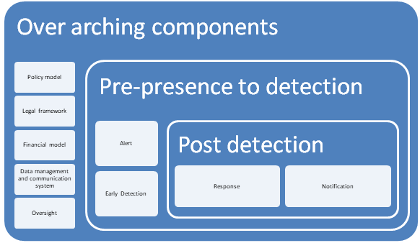

4. Considerations related to relations with other bodies and stakeholders
- The POARS must build synergies and avoid duplication with activities conducted by other organizations. The system must facilitate the interconnection and activities of international, regional, and national organizations and stakeholders and will support activities against emerging pests at global, regional and national levels. The system must be closely interconnected at all levels through clear communication channels. The FG considers the establishment of a global system framework (as described in Figure 2) imperative. The framework presents the participating organizations and stakeholders and shows the interconnections at the global, regional and national levels. The proposed POARS Committee would provide direction and oversight to the POARS.
- The importance of RPPOs in assisting NPPOs and coordinate outbreak responses across their regions is emphasized below.
Figure 2. Proposed framework for the Pest Outbreak Alert and Response System (POARS).
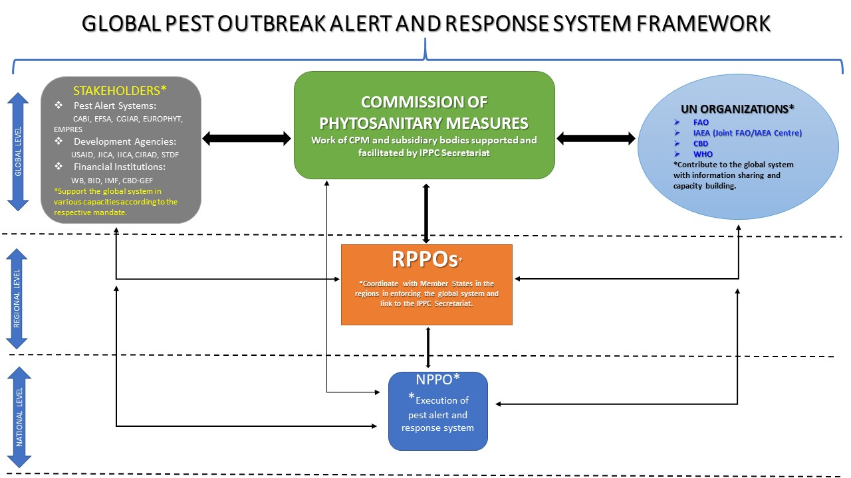

- As happens for parallel systems in animal health, stakeholders’ meetings would be periodically organized to get information on the situation of individual emerging pests. Stakeholders would include FAO offices, donors and countries.

5. Considerations related to the information systems and tools available through the POARS
- A dedicated open access webpage for the POARS (on the IPPC website, www.ippc.int) which would provide different types of information is needed. An associated free mobile application to provide alerts would is also strongly advised. The following advices are made on the information systems and tools:
- A dedicated webpage should be set up and connections should be made between POARS webpage and RPPOs’ websites. The website and access to information should be user-friendly, and available in multiple UN languages.
- The webpage should provide access to a toolbox. The tools could include:
  - automated processes to scan media and scientific sources for information on emerging pests, and distribute it to affected/interested parties (e.g. the EIOS).
  - Data visualization of the geographic distribution of emerging pests, and their progressive spread.
  - Tools for the collection and sharing of surveillance data for emerging pests.
- Tools to facilitate access more readily to expertise on diagnostics, surveillance and eradication tools and procedures (to be considered under the Development agenda “Diagnostic Laboratory Networking”). Access to contingency plans and procedures manuals for emerging pests surveillance and eradication.
- Specific webpages may be created for selected emerging pests (e.g. as per for FAW).
- POARS must include capacity building for NPPOs to improve their ability to detect pests and incentives for NPPOs to report them. Pest reports need to be submitted in a timely and transparent manner and NPPOs need to respond quickly when asked to validate reports.
- The information system must be legally supported (e.g., ensure no liabilities issues for the IPPC Secretariat).

6. Considerations related to the governance of the POARS
- In addressing its tasks laid out in their Terms of Reference, a key consideration of the FG has been how to operationalize a POARS, and what institutional arrangements would be most appropriate. Four questions were examined.
- Should the POARS be operationalized under the auspices of the CPM or through some other mechanisms? Similar systems in human and animal health are not always managed by the internationally recognized standard setting body for the sector, but the FG considers that POARS should be established by and under the auspices of the CPM. The aims of the POARS are very closely aligned to the objectives of the Convention, and as the CPM is mandated to promote the full implementation of the objectives of the Convention (Article XI), and it was the CPM that called for the establishment of the POARS, it is appropriate for CPM to continue to be the responsible body. This does not preclude CPM from deciding at some future date to change this arrangement.
- This arrangement also supports the extensive cooperation that will be necessary for the POARS to be successful. The Convention recognizes the role of Regional Plant Protection Organizations (Article IX), and of International Cooperation (Article XIII).
- Given the major endeavor envisaged for the POARS, the FG recommends to set-up a POARS operational framework composed of government organizations and other organizations at a global, regional and national levels. A POARS Steering Committee would provide direction and oversight to the global system. The Focus Group has examined and laid out in detail the roles for participating organizations including at the global level with FAO and the IPPC Secretariat as well as RPPOs, NPPOs and other organizations in the governance and operationalization of POARS. The roles are presented in the FG document titled “Roles at Global, Regional and National Levels for Strengthening Pest Outbreak Alert and Response Systems” which will be made available at a later stage.
- What body under CPM should be responsible for POARS? The FG considered whether POARS should be established as part of the IC, or whether a new subsidiary body should be established. The FG recommends that a new subsidiary body is established, provisionally titled the Pest Outbreak Alert and Response Systems Committee (POARSC). This POARS Committee should be established to provide general direction to the POARS, ensure overall coordination between stakeholders’ organizations globally, and to drive resource mobilization.
- This Committee could be composed of nine members with relevant skills and experience in Alert and Response Systems, among which there will be at least a RPPO representative:
- Seven members will be representatives from each of the seven FAO regions.
- Two members will be experts in subjects relevant to the work of the POARSC, from academia, donors, international organizations or representatives from the private sector.

- There are several reasons for this consideration:
- The establishment of POARS is envisaged as a major endeavor that will make a significant contribution to the objectives of the Convention. It touches on many aspects of the work of contracting parties, and therefore merits a dedicated subsidiary body.
- From contracting parties’ concerns expressed at recent CPMs, particularly in the light of their experience with several emerging pests such as Fall Armyworm, it is clear that contracting parties want to see improved institutional arrangements and responses for addressing emerging pests. Establishing a new subsidiary body would be a clear and visible way to address these concerns.
- Current work in relation to pest outbreaks and responses is currently under the oversight of the IC. The IC has made major progress since its establishment, but its Terms of Reference are broad and the FG understands that the workload of the IC is already very heavy. Implementing POARS through an IC Sub-group would merely add to the IC’s already heavy workload.
- By establishing the POARS as a subsidiary body, a clear signal is provided that this is recognized as a top priority for contracting parties, and one that therefore needs to be well-resourced. Similar systems in other areas are well supported and it is less likely that the necessary resources would be mobilized if the POARS was established as an IC Sub-group.
- Furthermore, NROs are currently under the oversight of the IC and the FG agreed that the oversight of the pest reporting obligation should be transferred to POARS, while the rest of the NROs would remain under the IC (IC Sub-group on NROs). Pest reporting is very important in identifying emerging problems, and timely reports will facilitate early response to these emerging problems. The good functioning of POARS would rely on swift response, capacity building, networking and cooperation between different actors. Having these activities related to emerging pests under one umbrella structure would ensure faster coordination and better use of resources. In most cases operational procedures are in place and can be used for POARS as well. Some adaptations might be needed though to enable swift actions in case of emergency responses.

- The terms of the FG members could be extended until the creation of the POARS Committee in order to address any needs that may arise.
- The committee could have the following functions:
1. Technical work programme
- Identify resources and keep under review the capability required by contracting parties to implement the IPPC and POARS activities.
- Identify available mechanisms such as technical cooperation projects to support contracting parties implementation of POARSS in the event of a threat or incursion of an emerging pest.
- Identify and propose strategies for contracting parties to enhance implementation of the IPPC and POARSS, including national reporting obligations, taking into account their specific capacities and needs.
- Review contracting parties’ challenges associated with the POARSS.
- Based on an analysis of outputs from the above activities, recommend to CPM priorities to improve the POARSS.
- Identify and recommend new technologies for early detection and response to emerging pest outbreaks which could enhance POARSS.
- Monitor and evaluate actions under the IPPC Strategic Framework, other related strategies, frameworks and work plan(s).

2. Effective and efficient management of the POARSC
- Develop, agree and maintain a list of priorities for Global Pest System activities in alignment with CPM priorities.
- Provide a review function on new projects related to POARS to ensure that they are aligned with the IPPC strategic objectives, have strategic value and a competitive advantage and recommend them to CPM for approval.
- Develop procedures and criteria for the production, oversight and approval of technical resources for alert and response.
- Recommend to the CPM to establish and dissolve POARSC Sub-groups, undertaking specific activities related to POARS and tasks, which composition and tasks will be defined through ToRs.
- Provide oversight to POARSC Sub-groups.
- Establish ad hoc working groups to address specific issues.
- Seek advice and/or input on matters relevant to its work from technical panels (through the IC) and other groups or organizations that assist the IPPC Secretariat.
- Periodically review its functions, procedures and outcomes.
- Monitor and evaluate the effectiveness of its activities and products.
- Develop projects that contribute to achieving the implementation priorities agreed by CPM.

3. Working with the Secretariat
- Provide guidance on alert and response activities for inclusion in the Secretariat’s work plan.
- Assess and prioritize web and technical resources, as appropriate, that are relevant to implement the POARS and the IPPC.
- Promote dispute avoidance as an outcome of effective implementation.
- Oversee the national reporting obligations processes.
- Contribute to the development and maintenance of links with donors, partners and other public and private organizations concerned with alert and response in the phytosanitary area.
- Contribute to the delivery of the IPPC Secretariat’s Communications.
- The Secretariat is responsible for coordinating the work of the POARSC and providing administrative, editorial, operational and technical support. The Secretariat advises the POARSC on the availability and use of financial and staff resources.

- POARSC collaborates with the IC which in turn will coordinate with the Standard Committee to make standard setting and implementation complementary and effective on the basis of aligned priorities for the implementation of the IPPC POARS. This collaboration will take place at a number of levels (e.g. Secretariat, chairs, members, stewards and Sub-groups). The POARSC Chair will be responsible to ensure coordination with the IC and the SC Chairs POARSC, IC and SC collaboration will include:
- Alignment of priorities
- Development of implementation plans related to alert and response systems
- Analysis of responses to calls for topics and issues to be addressed
- Review of the Framework for Standards and Implementation jointly and make recommendations to the CPM for endorsement via the SPG.

- POARS Committee Sub-groups should be established to meet regularly to implement the technical aspects of the POARS, including finalizing the procedure for evaluating species for declaration as emerging pests, and then implementing it.
- For each pest declared as “emerging”, a POARS Committee Team could be formed by the Technical Team, such as those recently set up for FAW or Foc TR4. The organogramme of the POARS Committee as a subsidiary body under the CPM is presented in Figure 3.
- Figure 3: Organigramme of the POARS Committee as a subsidiary body under the CPM
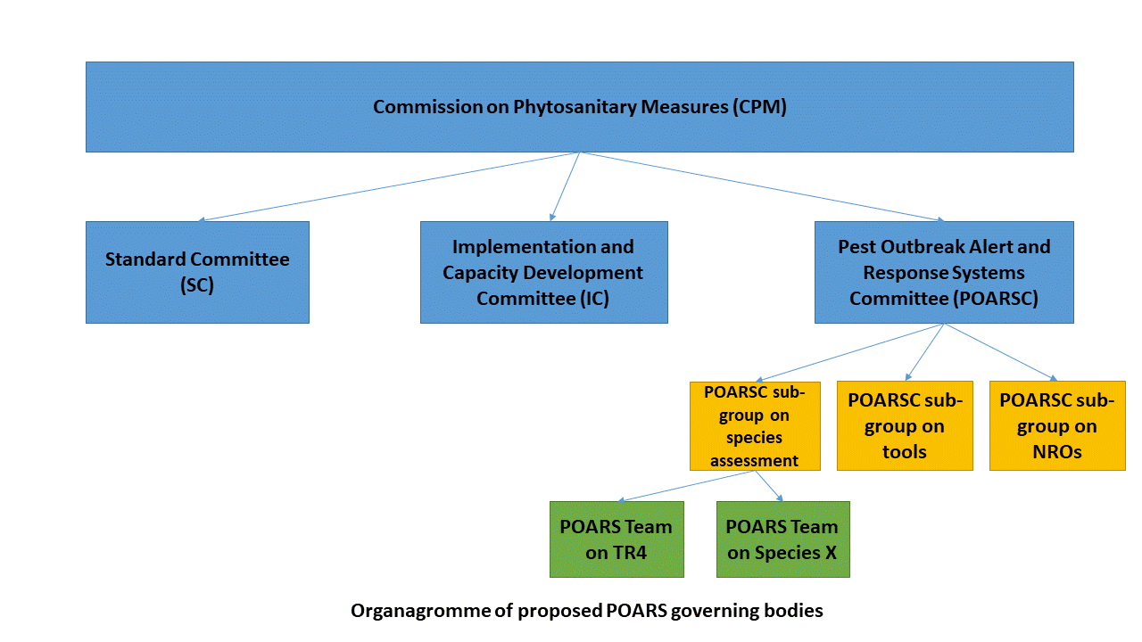

- The POARS Chair should coordinate with the SC and IC to ensure synergies in between the activities of the various CPM Subsidiary bodies. In the teams, appropriate expertise on diagnostic should be ensured and linkage to relevant TPDP discipline lead.
- How should POARS be operationalized? As the POARS is envisaged as a significant development in the implementation of the IPPC, it is recognized that a phased approach is required. The FG therefore recommends that there is an interim phase, during which a number of key tasks will need to be accomplished:
- Clear definition of the relative roles of the POARSC in relation to IC, to ensure synergy rather than overlap.
- Establishment of the governance structures.
- Set-up working groups to address specific tasks including establishing emerging pest criteria and a clear procedure to assess and rank emerging pests, as recommended by the Focus Group.
- Prepare the necessary ToR for specific working groups that will be involved in accomplishing key tasks during the interim phase.
- The FG recommends that this transitory process is overseen by the CPM Bureau. The current FG activity could be maintained in the interim period when necessary, with the members who would commit to spend extra time and effort to this activity. Its tasks would include guiding the development and piloting of the POARS, including establishing the steering committee and technical body for the implementation of POARS. Though, this activity may fall under the IPPC Secretariat mandate.
- What implications are there for the Secretariat? It is envisaged that some reorganization of the IPPC Secretariat will be needed to adapt to the establishment of a new subsidiary body. There will be need for dedicated staff in the secretariat for supporting the POARS and implementing its programme. This activity would be financed from extra-budgetary funds.
- The IPPC Secretariat will need to be well resourced with dedicated staff to facilitate the establishment and operation of POARS. There should be staff retention effort to keep expertise and build on experience gained across the years.
- The FG undertook a detailed review of the most prominent alert and response systems across the world.
- As an example, in terms of costs of maintenance of the national Argentinian network for surveillance, the development and maintenance of software is 30,000 dollars per year (approximately), and there is also a team of professionals 3 equivalent professionals working on the system.
- The organigramme of the Emergency Animal Health Unit within FAO is provided below as an example for animal health alone in Figure 4.
- Exploratory discussions have already begun with the EMC manager to explore the feasibility of working together on a joint programme that could be set to help address emergency activities for both animal and plant health, in order to mutualize resources and to build on experience. This activity is placed under the FAO Emergency unit (OIR) in FAO.

Figure 4: Organigramme of the Emergency Animal Health Unit within FAO.
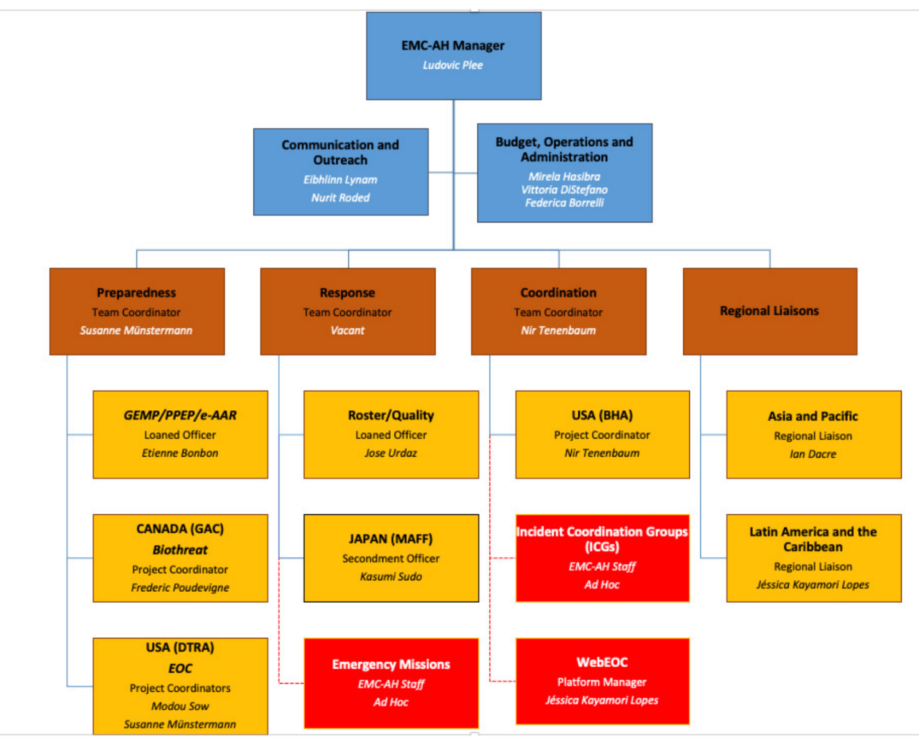

7. Work plan for POARS
- The work plan with main activities as was presented in the Strategic Framework DA implementation for 2020-2024 documented noted by CPM in 2019 remains valid. Table 1 below list these activities and their status.
Activities and tasks | Status of the activity
1. Analysis and report – global state of emerging pest risk scanning and reporting, impediments to reporting | Underway-mostly completed, study to be published early 2022.
2. Definition of organizational structure and user requirements needing to be in place for an enhanced scanning and reporting system | CPM FG POARS developed initial proposals.
3. Development and global adoption of enabling policies to encourage and optimise reporting including IPPC mandate and operating structures | CPM FG POARS to formulate recommendations to the IC Sub-group on NROs.  CPM FG POARS recommends to set on Epidemic Intelligence from Open Sources (EIOS).
4. Establishment of a network of phytosanitary emergency response expertise/tools and making it available to all NPPOs via a global platform | CPM FG POARS to formulate recommendation to the CPM on the way forward.
5. Development, adoption and application of processes for rapidly engaging expertise and response resources | CPM FG POARS to formulate recommendation to the CPM on how to conduct this activity through the POARSC.
6. Establishment of a POARS toolbox | CPM FG POARS to formulate recommendations to the CPM on tools to be developed as well as on the governance to be set to develop these tools.
7. Facilitation of adoption of the POARS globally and advocacy with potential fund providers | Discussions are being held to mutualize activities with the Emergency Animal Health Unit within FAO.
Table 1: POARS activities as defined within the Strategic Framework DA implementation for 2020-2024 documented noted by CPM in 2019 and the status of each activity.

8. Budget to conduct the POARS activities within the IPPC Secretariat
- POARS is a new system, which can be inspired by other similar systems such as the one for animal health, but that should be adapted to the peculiarities of plant health. In its initial phase, its structure needs to be based on a small nucleus of staff fully dedicated and stable over time. As structuring of the system progresses, the system will demand on a greater number of staff to be able to provide effective service to CPs.
- To have a continuous operating capacity, regular budget funds would have to be made available. As a fallback alternative, extrabudgetary funds would be mobilized for this activity through projects and voluntary contributions.
- In a first phase, the human resources dedicated to POARS could be as follows:
- 1 manager
- 1 dedicated IT developer
- Part time administrative person
- 2 scientific officers
- 1 human resources for relations with the regions and the RPPOs, the One Health nexus, WHO and other relevant organizations
- A part time communication expert

- The budget for the staff, including equipment, can be estimated as 800 k/year.
- A further 100 k/year must be made available for the procurement of external services such as translation, IT support and experts meetings.
- The FG considered that cost will be higher on the first year due to all the new development needed. It is expected that the cost for the following years would be lower. On the other hand, if the system works well and that there is demand for support, the cost may also increase.
- The IPPC Secretariat would manage the daily activities of the programme, governed through the POARSC. Preventing pests is very cost effective. A recent synthesis has shown that invasions of insects alone cost a minimum of US$76.0 billion per year globally (InvaCost, a public database of the economic costs of biological invasions worldwide https://www.nature.com/articles/s41597-020-00586-z).
- At minimum, half time of a staff should be dedicated to this activity from the regular budget for the first year. Meetings could be held virtually.

8. Budget for Emergency Response on the ground
- A well-structured global pest alert and response system should provide guidance and information to Member States on available mechanisms for timely response to emerging pest incursions and outbreaks, that would contribute to preventing potential devastating effects to food production and commercialization.
- During CPM 14 (2019), the CPM “called on the IPPC Secretariat to establish an emergency trust fund to support addressing issues related to emerging pests and emergency issues”. A trust fund deposited in a specific account within the IPPC Secretariat (POARS), to support a rapid response to an emerging pest outbreak should be readily available. Mechanisms should be in place for a quick transfer to the requesting NPPOs. The funds should be complementary to the financial resources that the NPPOs (and potentially RPPOs) will have to invest for implementing contingency plans aimed at eradicating outbreaks of an emerging pest.
- In this regard, the FAO Emergency Management Center (EMC) is filling the gap for emerging pests and diseases of concern to animal health. The EMC has an organization structure that includes coordinators at regional level and that it is well staffed and with adequate financial resources from extra budgetary contributions allowing support to Member States in operational matters such as supporting national diagnostic laboratories and field interventions. The EMC has a so-called Incidence Coordination Group (ICG) similar to a Steering Committee, one of the main roles being to define the governance of the participating entities and to engage stakeholders from public and private organizations. It is recommended that a similar setting to the EMC is established for the POARS, possibly under the One-Health-Umbrella initiative.
- In the planning of a fund to support an emerging pest outbreak intervention, it has to be taken into account that early detection of pest incursions will require significantly fewer financial resources to delimit and eradicate an outbreak, compared with the resources required when the pest outbreak is detected late, and the pest has already established and spread beyond the original point of entry. It is expected that the emergency fund will allow an initial rapid response and contribute to partially covering the total costs of the intervention, in particular during the initial stages of the pest delimitation and eradication efforts. The financial resources should be sufficient to support immediate response, including implementation of delimiting surveys and to initiate the enforcement of eradication actions once an outbreak has been confirmed. For example, funds could serve to support activities such as: expert advice in situ to support and train staff on site; procurement of surveillance tools such as specific traps and lures; purchase of equipment including POARS devices and laboratory equipment for the diagnostics laboratories; host removal and disposal, procurement of specific materials such as pesticides (insecticides, fungicides, etc.); procurement of equipment including high pressure pesticide sprayers; all-terrain vehicles and financial resources for contracting services including staff for field operations; diagnostic services and, in some cases, the acquisition and release of beneficial organisms including sterile insects.
- An emergency intervention can be of limited duration (few months), or can extend to few years when necessary. The necessary budget for an intervention may vary depending on the magnitude of the outbreak from few hundred thousand to several million US dollars. Tools to assist in estimating costs of such an intervention are available for some pests including fruit fly quarantine pests. One of these tools is the Cost-Benefit Analysis Model: A tool for Area-Wide Fruit Fly Management (FAO/IAEA 2007).
- Specific criteria would need to be put in place regarding the eligibility of contracting parties expenses for such funding. NPPO should set aside a small percentage (2 to 5%) of its budget annually for a national emergency fund. If no emergencies occur, the fund is used to reinforce activities already underway.
- At the global level, when the POARS identifies emerging pest situations eligible for intervention, the affected contracting parties can directly or through the RPPOs submit a request for funding to the CPM Bureau.
- The SPG is invited to:
- Take note that the full report covering all activities of the CPM Focus Group on Pest Outbreak Alert and Response Systems will be published in early 2022.
- Take note of, and discuss, the considerations made by the CPM Focus Group on Pest Outbreak Alert and Response Systems and
- Provide strategic direction to the CPM Focus Group on Pest Outbreak Alert and Response Systems.

CPM-14 (2019) Five year investment plan of the IPPC Secretariat - in relation to the IPPC Strategic Framework 2020-2030 https://www.ippc.int/fr/publications/86993/
FAO, IPPC (2019) Report of the Fourteen session of the Commission on Phytosanitary Measures. 295 pages. https://assets.ippc.int/static/media/files/publication/en/2019/07/CPM-14_Report_withISPMs-2019-07-31.pdf

