Note from Secretariat: The paragraph numbers and formatting of the document will be adjusted after adoption.

DRAFT ANNEX to ISPM 27: Striga spp. (2008-009)
Status box
This is not an official part of the standard and it will be modified by the IPPC Secretariat after adoption.
Date of this document | 2021-06-22
Document category | Draft annex to ISPM 27 (Diagnostic protocols for regulated pests)
Current document stage | To DP notification period
Origin | Work programme topic: Plants, CPM-2 (2007)  Original subject: Striga spp. (2008-009)
Major stages | 2007-03 CPM-2 added topic (2007-001) to work programme.  2008-04 CPM-3 added subject Striga spp. (2008-009) to work programme, priority 1.  2014-10 Diagnostic protocol (DP) drafting group formed.  2018-02 Technical Panel on Diagnostic Protocols (TPDP) reviewed.  2018-06 DP drafting group revised.  2018-08 TPDP e-forum.  2018-10 DP drafting group revised.  2018-11 Expert consultation.  2019-02 DP drafting group revised.  2019-03 TPDP e-decision to submit to Standards Committee (SC) for approval for first consultation (2019_eTPDP_Feb_01).  2019-03 SC e-decision (2019-eSC_May_13) suspended to allow for editorial review.  2019-05 SC approved for first consultation (2019-eSC_Nov_01).  2019-07 First consultation.  2021-03 Revised by the Leads based on consultation comments.  2021-05 TPDP reviewed and revised, and approved to submit to SC for approval for adoption.  2021-06 SC approved for the DP notification period (e-decision 2021_eSC_May_18).
Discipline leads history | Colette C. JACONO (US, Discipline lead), Liping YIN (CN, Discipline lead)  Géraldine ANTHOINE (FR, Referee)
Consultation on technical level | The first draft of this protocol was written by:  - Lytton John MUSSELMAN (US, Lead author)  - Teresa CORTES (CL, co-author)  - Ruojing WANG (CA, co-author)  - Jayani Nimanthika WATHUKARAGE (LK, co-author)  - Ran-Ling ZUO (CN, co-author)  Comments were provided by Colette JACONO (US) and Liping YIN (CN), both being TPDP members and discipline leads, and Geraldine ANTHOINE, TPDP member and referee.  In addition, the draft has also been subject to expert review and the following international experts submitted comments: Gregory CHANDLER (AU), Chris PARKER (GB), Sathish PUTHIGAE (NZ) and Barbara WATERHOUSE (AU).
Main discussion points during development of the diagnostic protocol | - Subsampling of the working sample for inspection  - Dry sieving vs gravitational separation in water  - Removal of text on Striga biology  - Capsule morphology of important species of Striga  - Descriptive details in seed diagnosis  SEM images  - Table 1 and Table 2: List of host species for Striga spp.
Notes | This is a draft document  2019-04 Edited  2021-03 Edited  2021-06 Edited

CONTENTS
[to be added later]

Adoption
- This diagnostic protocol was adopted by the Standards Committee on behalf of the Commission on Phytosanitary Measures in -- [to be completed after adoption].
- The annex is a prescriptive part of ISPM 27 (Diagnostic protocols for regulated pests).

1. Pest information
- The genus Striga Lour. (witchweeds) comprises approximately 42 species of annual obligate root parasitic plants (Mohamed, Musselman and Riches, 2001; Mohamed and Musselman, 2019). It is mainly distributed in tropical and subtropical regions, and some species are major pests of agricultural crops in these regions. Striga seeds can contaminate seeds or grain by multiple pathways during transportation, storage and trade. Crops parasitized by Striga exhibit reduced growth, with substantial yield losses depending on the level of resistance and tolerance of the specific host genotype (Rodenburg et al., 2005). Symptoms of parasitism include stunted growth and a drought-like appearance of the leaves.
- The greatest damage to crops is caused by three species: Striga asiatica, S. gesnerioides and S. hermonthica (Mohamed, Musselman and Riches, 2001). S. asiatica and S. hermonthica are among the most economically damaging weeds in several regions of the world, especially Africa. In Africa, these two species attack grain crops and cereals, including Zea mays (maize), Cenchrus spp. (= Pennisetum spp.) (pearl millet), Eleusine coracana (finger millet), Panicum spp. (millets), Eragrostis tef (teff) and Sorghum bicolor (sorghum), with some impacts on Saccharum spp. (sugarcane) and Oryza sativa (rice), and can drastically reduce the crop yield value every year (Ejeta, 2007; Csurhes, Markula and Zhou, 2016). S. gesnerioides is the only Striga species that attacks a dicotyledon host and usually infests Fabaceae (especially Vigna unguiculata (cowpea)), Convolvulaceae, Euphorbiaceae and, in the Solanaceae, Nicotiana tabacum (Mohamed and Musselman, 2019).
- S. asiatica is native to Africa, India and China (APHIS, 2011) and may represent a complex of related species (Mohamed, Musselman and Riches, 2001). Its range has expanded to parts of North America and the Asia Pacific region (Nail et al., 2014).
- S. gesnerioides is found throughout much of Africa, the Arabian Peninsula and the Indian subcontinent. This parasite is particularly damaging to V. unguiculata (Musselman and Parker, 1981a). S. gesnerioides is quite variable, with morphotypes associated with different hosts.
- S. hermonthica is native to Africa and the Arabian Peninsula. It grows in savannah ecosystems where wild grasses (Poaceae, such as Andropogon species and Setaria sphacelata) are the hosts. However, S. hermonthica infestation of crops such as Z. mays, S. bicolor, Cenchrus spp. and Panicum spp. can cause devastating yield losses, and the problem is getting worse (Ejeta, 2007).
- The seeds of Striga germinate and infect the host underground, emerging above ground only to flower. The time to flowering among Striga species varies. For example, S. gesnerioides ﬂowers as it emerges from the soil, whereas S. asiatica and S. hermonthica begin flowering about four weeks after emergence (Berner et al., 1996). Most Striga species are self-pollinating, but S. hermonthica and S. aspera are out-crossers, requiring insects for pollination (Aigbokhan, Berner and Musselman, 1998). The temperature response of S. asiatica appears to affect both the relative suitability of a location for growth and its cold tolerance limits. The minimum temperature for development has been found to be 20 °C; the upper limit for growth, 42 °C; and the optimal temperature range for growth, 30–34 °C (Patterson et al., 1982).
- Striga has great reproductive ability, with a maximum fecundity in the order of 200 000 seeds per plant. Striga seeds found in field soils can be as dense as 882 000 seeds per m² (Van Mourik, 2007). Striga seeds are minute and nearly dust-like, can disperse over long distances via wind, water or birds, and can be carried by contaminated soil, tools, vehicles and equipment during transportation or storage. The seeds of Striga are a contaminating pest in agricultural commodities, such as grain, seeds, animal feed or bedding materials, and nursery stocks. The most common seed and grain consignments contaminated with seeds of S. asiatica or S. hermonthica, or with S. gesnerioides, are listed in Table 1 and Table 2, respectively. These tables are based on the field experience of the lead author of this diagnostic protocol and do not necessarily include all hosts from all geographical regions. The geographical origin of the host plant should be considered when selecting which commodities to sample.
Table 1. Common plant hosts of Striga asiatica and Striga hermonthica. This list is not intended to be exhaustive.
Known hosts of Striga asiatica and Striga hermonthica: crops
Cenchrus americanus, pearl millet
Digitaria exilis, fonio
Eragrostis tef, teff
Oryza glaberrima, African rice
Oryza sativa, rice
Saccharum officinarum, sugarcane
Sorghum bicolor, sorghum
Zea mays, maize
Potential hosts of Striga asiatica and Striga hermonthica: grains
Coix lacryma-jobi, adlay millet
Echinochloa esculenta, Japanese millet
Echinochloa frumentacea, Japanese barnyard millet
Eleusine coracana, finger millet
Panicum miliaceum, proso millet
Panicum sumatrense, little millet
Paspalum scrobiculatum, kodo millet
Setaria italica, foxtail millet
Potential hosts of Striga asiatica and Striga hermonthica: seed for lawns, erosion control, or ornamental use
Cenchrus alopecuroides, fountain grass
Eragrostis spp., love grass
Festuca spp., fescue
Lolium spp., ryegrass
Table 2. Common plant hosts of Striga gesnerioides. This list is not intended to be exhaustive.
Known hosts of Striga gesnerioides: crops
Ipomoea batatas, sweet potato
Nicotiana tabacum, tobacco
Vigna subterranea, Bambara bean
Vigna unguiculata, cowpea
Known hosts of Striga gesnerioides: erosion control or mine reclamation
Alysicarpus vaginalis, alyce-clover
Indigofera hirsuta, hairy indigo

2. Taxonomic information
- Name: Striga Lour., 1790
- Synonyms: None
- Taxonomic position: Lamiales, Orobanchaceae
- Common name: witchweed
- Three most economically damaging species of Striga:
- Name: Striga asiatica (L.) Kuntze, 1891
- Common name: red witchweed
- Synonyms: Striga coccinea Benth.,1836
- Striga hirsuta Benth., 1846
- Striga asiatica var. lutea (Lour.) M.R. Almeida, 2001
- Name: Striga gesnerioides (Willd.) Vatke, 1875
- Common name: cowpea witchweed
- Synonyms: Buchnera gesnerioides Willd., 1800
- Buchnera orobanchoides R. Br., 1814
- Striga orobanchoides Benth., 1836
- Name: Striga hermonthica (Delile) Benth., 1836
- Common name: purple witchweed
- Synonyms: Buchnera hermonthica Delile, 1813
- Striga senegalensis Benth., 1836

3. Detection

3.1 Sampling procedures
- A consignment of grain, seeds, or other commodity such as processed grain, flour or non-pelleted animal feed, that is suspected to be contaminated with Striga should be sampled according to ISPM 31 (Methodologies for sampling of consignments). The samples should meet the minimum working sample size stated in section 3.2 and be submitted to a laboratory for analysis.

3.2 Subsampling of the working sample for analysis
- Samples submitted to a laboratory should be drawn from a composite sample, which is a mixture of primary samples. The working sample size is recommended to be no less than 1 kg for large-seeded seeds or grains, such as cereals (e.g. Z. mays, O. sativa, Hordeum vulgare), and 500 g for small-seeded seeds or grains, such as Panicum spp. The minimum size of the working sample may be defined as the weight of 25 000 seeds. When the consignment is less than 1 kg or 500 g, such as for high-value vegetable seeds, the entire consignment should be examined.
- It is noted that the sample sizes specified in the International Seed Testing Association rules (ISTA, 2021), which may differ from the sample sizes given above, are for the determination of germination, disease and moisture in seeds. They do not apply to the detection of seed contamination, such as the contamination of imported consignments of seed and grain with Striga seeds.
- Before submission, samples should be packed and sealed in clean, leakproof bags or containers, clearly labelled with the seed lot, crop species and associated information to allow sample traceability.

3.3 Detection method for seeds of Striga species
- The analysis of the working sample for the presence of Striga seeds is achieved either by washing and filtration (section 3.3.1) or by dry sieving (section 3.3.2).
- After washing or sieving, the filter paper, sieves and screenings should be carefully examined with a stereomicroscope at a magnification of at least 40× (commonly 40× or 60×). A clean, single-use soft brush may be used to transfer the screenings into a suitable container (e.g. Petri dish). To eliminate the risk of contaminating future samples, the brush should be discarded after each use. The brush method has been proven to effectively remove the seeds of Striga, but other cleaning methods may be used as an alternative. Visual examination, under magnification, of the screening devices is required to ensure that they are free of Striga seeds.

3.3.1 Washing and filtration
- The entire working sample is washed in water, the wash water filtered, and the residue collected on either a small gauge mesh sieve or on the surface of a filter paper, which is then analysed. The seed weight-to-water volume ratio should be 1:2; for example, 250 g seed added to 500 mL water containing one or two drops of surfactant. Any type of surfactant may be used. The surfactant type will not affect the detection of Striga.
- An example set-up for a washing and filtration system employs a top sieve with a diameter of 21 cm attached to the top of a funnel installed over a large sink. A smaller sieve, 11 cm in diameter and attached to the bottom of the funnel, catches contaminating Striga seeds as the wash water is filtered through the system. The mesh size of the top sieve varies according to the size of the seed or grain being inspected, although 500 µm is commonly used. The bottom sieve is made of two layers of PVC-coated nylon mesh with a mesh opening of 100 µm to 120 µm. This system avoids the need for filter paper.
- Large submitted samples may require washing in small batches but the whole sample should be analysed.
- For soil samples from field surveys, the soil is first air dried either using a thermostat to control the air temperature or using a dry air cabinet. Once dry, the soil is subjected to the washing method, which allows the seeds to be suspended and then collected, either onto a small mesh screen or onto filter paper, from the surface of the suspension itself or by decanting the suspension through a system of sieves and collecting directly onto the mesh screen or filter paper.

3.3.2 Dry sieving
- The entire working sample or a subsample of the working sample is “dry” sieved using a two-sieve system. A top sieve (e.g. mesh opening of 300 µm) confines the seed or grain sample, a second sieve (150 µm) collects contaminating Striga seeds and a bottom tray catches the dusty debris. The sieve system is shaken by a mechanical shaker (e.g. 40 shakes/second for at least two minutes) or shaken manually. If the shaking is manual, the sample should be shaken vigorously for a longer period until the finer material is fully separated. The working sample may be divided into a few subsamples to ensure that all dust-like materials pass through the sieves. A set of sieves may be used for stepwise removal of impurities, depending on the size of the crop seed; for example, a 400 µm sieve could be used for soybean seeds and the remaining debris then passed through 300 and 150 µm sieves. The same technology could be used for separation of Striga seeds from flour using a sieve with a mesh opening of 70–100 µm. It is expected that the Striga seeds are retained on top of the sieve and the flour particles allowed to go through to the collection tray. Under dry climatic conditions, static electricity can be generated by the sieving process, making it more difficult to separate the coarse and fine fractions of the sample; preventative measures should be considered in these circumstances, such as using anti-static containers and sprays before sieving.

4. Identification

4.1 Identification method
- Classification and identification of Striga species depends largely on floral characters. Inspection, however, usually targets seeds of imported agricultural commodities, such as grain, crop seeds and animal feed, that are suspected to be contaminated with Striga seeds. Morphological identification of Striga plants (including seeds) is based on known reference specimens, literature descriptions and taxonomic keys and descriptions. Considerable data from molecular studies of Striga are available and can be helpful for species determination, but until methods can be simplified and made more uniform, they are of limited value for phytosanitary purposes.

4.2 Identification of seeds
- The capsules of Striga are loculicidal and contain many seeds. However, capsules are usually broken, damaged, or removed in most contaminated commodities during their processing, leaving only the seeds for identification. Seed identification of Striga species is based on seed size, shape, surface texture and colour. The seed shape of Striga can vary including elliptic, ovate, rectangular, D-shaped, trigonous, rhombic or irregular (Figure 1). The seeds are dust-like particles ranging from 0.2 mm to 0.35 mm long, this exceeding the width which can be as narrow as 0.1 mm. The seed surface is strongly patterned with longitudinal ridges that often spiral the seed. The ridges are variably ornamented, with the ornamentation detail being visible under the high magnification of electron microscopy. The seed colour varies from light brown to dark brown, from orange to golden brown, and from grey to light black. The seeds are translucent and tend to glisten under the light of microscopy. The embryo is linear, and a sparse endosperm is present.
- Other dust-like seeds include those of the parasitic genera Orobanche (Figure 2A), Phelipanche and Alectra (Figure 2B). Like Striga, their seed coat (testa) is patterned in a system of longitudinal ridges that often spiral around the seed. In Orobanche and Phelipanche, transverse ridges regularly intersect the longitudinal ridges to create a honeycomb-like pattern of broad interspaces contained by high walls. The spine of the ridge (wall) is smooth. In Striga, secondary ridges may coalesce with the longitudinal ridges, but the interspaces created are both narrower and more elongated and often spiral the seed. While the walls of the interspaces are not as high as in Orobanche and Phelipanche, in Striga the ridge is usually ornamented rather than smooth (Musselman and Parker, 1981b). The angle of the longitudinal ridges around the seed may be variable, even in the same seed sample (Krause and Weber, 1990). The related genus Alectra has a narrow, membranous, and nearly transparent testa enveloping the seed. Patterned with very fine ridges, the testa in Alectra is rectangular to wedge-shaped. At a 100× magnification, the seeds of all three genera can be distinguished from those of Striga.
- In Striga, the patterning of the testa is likewise the key to identification of the three species focused upon in this diagnostic protocol (Global Invasive Species Database: IUCN, 2018), although the distinction between patterns may be difficult to discern (Krause and Weber, 1990). Stereomicroscopic images of seeds of S. asiatica, S. gesnerioides and S. hermonthica are shown in Figure 1A to Figure 1C and their morphological characteristics are summarized in Table 3. Scanning electron micrographs, useful in illustrating the surface patterns described below, are available at the link provided for the Krause and Weber (1990) citation in section 8.

4.2.1 Seed morphology of Striga asiatica
- Seeds of S. asiatica are golden brown and irregularly ovate in shape with a surface featuring longitudinal ridges that spiral around the seed (Figure 1A). The ridges are closely spaced, and each ridge is strikingly ornamented with minute protuberances. Between the ridges, the seed surface may be variably smooth from the near absence of protuberances, while the rim on top of the ridges is narrow and low (Krause and Weber, 1990).

4.2.2 Seed morphology of Striga gesnerioides
- Seeds of S. gesnerioides (Figure 1B) are usually trigonous or D-shaped, or less commonly found in other irregular shapes. The colour varies from grey to light black. The surface is patterned with longitudinal ridges that are closely spaced, and with secondary ridges that form narrow, elongated interspaces between the primary ridges. The ridges are densely ornamented with protuberances, also protuberances may variably frequent the seed surface between the ridges (Krause and Weber, 1990).

4.2.3 Seed morphology of Striga hermonthica
- Seeds of S. hermonthica (Figure 1C) are usually irregularly elliptic or ovate, with their colour varying from light to dark brown. The surface is patterned with longitudinal ridges that often spiral the seed. The ridges are more widely spaced than in S. asiatica or S. gesnerioides and are commonly intercepted by secondary ridges to form broad elongated interspaces with a variable frequency of surface protuberances. The rim on top of the ridges is broad and high (Krause and Weber, 1990).
Table 3. Summary of the main morphological characteristics of seed of the three most economically damaging Striga species
Species | Shape | Surface texture | Colour | Photo
Striga asiatica | Ovate | Longitudinal ridges, closely spaced, spiral the seed | Golden brown | 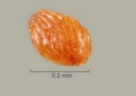
Striga gesnerioides | Usually trigonous or D-shaped | Longitudinal ridges, closely spaced, interspersed with secondary ridges | Varying from grey to light black | 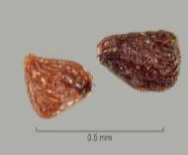
Striga hermonthica | Usually elliptic or ovate | Longitudinal ridges, widely spaced, often spiral the seed, with secondary ridges forming broad elongated interspaces | Varying from light to dark brown | 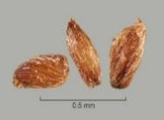

4.3 Identification of mature plants
- The morphological characteristics of mature plants of the three most economically damaging species are listed below and summarized in Table 4. Where capsules are intact, differences in capsule size can also be used for identification: see Table 4.

4.3.1 Striga asiatica
- Annual, 10–30 cm tall, entirely hirsute. Few roots. Stem square, green and sparsely branched. Leaf blade linear to narrowly lanceolate, 5–20 mm × 1–4 mm, not appressed to the stem. Flowers opposite, axillary in leaf-like bracts, racemose. Calyx 4–8 mm long; five-lobed, as long as the tube, subulate. Corolla usually red, rarely yellow, or white; 0.8–1.5 cm long, apically strongly curved; upper lip two-lobed (Figure 3A).

4.3.2 Striga gesnerioides
- Annual or weakly perennial or monocarpic, 11–25 cm tall (rarely up to 100 cm or more), with many adventitious roots from the base. Stems light green or yellow green, succulent; many closely packed stems at the soil surface. Stem square with obtuse angles; leaves very reduced, appressed to the stem, 5–10 mm × 2–3 mm. Leaves and stems puberulent, or almost glabrous. Calyx 0.6–1.0 cm long. Corolla usually purple, rarely pink or yellow. Flowers opposite or alternate, mostly with two flowers for each node, rarely three, no fragrance. Bract and sepal of equal length, 0.8–1.0 cm long; corolla 1.2–1.5 cm long (Figure 3B; Mohamed, Musselman and Riches, 2001).

4.3.3 Striga hermonthica
- Annual, up to 100 cm tall. Stem square, furrowed; usually branched from middle, densely scabrous. Leaves 15–18 mm, opposite, linear or narrowly elliptic, longer than internodes, strigose. Lower floral bracts 12–50 mm long and 2–5 mm wide, longer than calyx; upper bracts lanceolate, equal to or longer than calyx. Flowers opposite, forming a lax raceme denser above middle. Calyx 7–12 mm long; tube 5–10 mm long; sepal with five unequal lobes of 2–4 mm, shorter than corolla tube. Corolla pink or light purple, rarely white (Figure 3C and Figure 3D; Mohamed, Musselman and Riches, 2001).
- S. hermonthica can be confused with S. aspera, which is a widespread species in sub-Saharan Africa that differs by the position of the bend in the corolla (Figure 4). In S. hermonthica, the corolla tube bend is at the tip of the calyx and so most of the corolla tube is enclosed in the calyx (Figure 4B). Striga aspera, on the other hand, has a distinct tube with the bend in the corolla tube near the top of the tube. (Figure 4A). S. aspera has smaller corollas, stems, and leaves and overall is a more delicate plant.
Table 4. Summary of the main morphological characteristics of mature plants of the three most economically damaging Striga species
Species | Plant height (cm) | Stem | Leaf pubescence | Flower colour | Capsule  (L×W in mm)
Striga asiatica | 10–30 | Erect, square; usually branched in agricultural fields, wild plants often unbranched | Strigose | Most commonly scarlet red, rarely yellow or white | 7 × 2
Striga gesnerioides | 11–25 | Many stems arising from a usually bulbous base; numerous adventitious roots | Puberulent | Purple, pink or yellow, depending on host | 10–20 × 3
Striga hermonthica | up to 100 | Usually sparsely branched | Strigose | Pink | 12–15 × 2.0–2.5
L, length; W, width.

5. Records
- Records and evidence should be retained as described in section 2.5 of ISPM 27 (Diagnostic protocols for regulated pests). In cases where other contracting parties may be affected by the results of the diagnosis, the records and evidence and additional material should be kept for at least one year in a manner that ensures traceability.

6. Contact points for further information
Further information on this protocol can be obtained from:
Department of Biological Sciences, Old Dominion University, 110 Mills Godwin Life Sciences Building, Norfolk, VA 23529, United States of America (Lytton John Musselman; email: lmusselm@odu.edu; tel.: (+1) 757 6833597; fax: (+1) 757 6835283).
Saskatoon Laboratory-Seed Science and Technology Section, Canadian Food Inspection Agency (CFIA), 301–421 Downey Road, Saskatoon, Saskatchewan, Canada S7N 4L8 (Ruojing Wang; email: ruojing.wang@canada.ca; tel.: (+1) 306 3854859; fax: (+1) 306 3854944).
National Plant Quarantine Service, Canada Friendship Road, Katunayake, Sri Lanka (Jayani Nimanthika Wathukarage; email: jayaninimanthika@gmail.com; tel.: (+94) 11 2252029).
Huangpu Customs District People’s Republic of China, Chuangye Rd 17, Xiagang Street, Huangpu District 510730, Guangzhou, Guangdong, China (Ran-Ling Zuo; email: zrlspace@163.com; tel.: (+86) 020 82092124).
- A request for a revision to a diagnostic protocol may be submitted by national plant protection organizations (NPPOs), regional plant protection organizations (RPPOs) or Commission on Phytosanitary Measures (CPM) subsidiary bodies through the IPPC Secretariat (ippc@fao.org), who will forward it to the Technical Panel on Diagnostic Protocols (TPDP).

7. Acknowledgements
- The first draft of this protocol was written by Lytton John Musselman (Old Dominion University, United States of America (see preceding section)), Teresa Cortes (Servicio Agrícola y Ganadero (SAG)), Chile), Ruojing Wang (CFIA, Canada (see preceding section)), Jayani Nimanthika Wathukarage (National Plant Quarantine Service, Sri Lanka (see preceding section)) and Ran-Ling Zuo (Huangpu Customs District People’s Republic of China (see preceding section)). The following experts provided comments on earlier versions that improved the quality of the protocol: Gregory Chandler (Department of Agriculture Sydney, Australia), Chris Parker (Bristol, United Kingdom of Great Britain and Northern Ireland), Sathish Puthigae (New Zealand Ministry for Primary Industries, New Zealand) and Barbara Waterhouse (Department of Agriculture, Cairns, Australia). The following TPDP members provided comments on edits on later versions of the protocol to bring it to its final stages: Géraldine Anthoine (TPDP member and Referee for this protocol), Colette Jacono (TPDP member and co-discipline lead for this protocol) and Liping Yin (TPDP member and co-discipline lead for this protocol)

8. References
- The present annex may refer to ISPMs. ISPMs are available on the International Phytosanitary Portal (IPP) at https://www.ippc.int/core-activities/standards-setting/ispms.
- Aigbokhan, E.I., Berner, D.K. & Musselman, L.J. 1998. Reproductive ability of hybrids of Striga aspera and Striga hermonthica. Ecology and Population Biology, 88(6): 563–567.
- APHIS (United States Department of Agriculture, Animal and Plant Health Inspection Service). 2011. Witchweed: A parasitic pest [online]. Plant Protection and Quarantine Factsheet. USA, APHIS. 2 pp. [Cited 11 June 2018]. https://www.aphis.usda.gov/publications/plant_health/2011/witchweed_parasitic_pest.pdf
- Berner, D., Carsky, R., Dashiell, K., Kling, J. & Manyong, V. 1996. A land management based approach to integrated Striga hermonthica control in sub-Saharan Africa. Outlook on Agriculture 25(3): 157–164.
- Csurhes, S., Markula, A. & Zhou, Y. 2016. Invasive plant risk assessment – witchweeds: Striga spp. [online] Queensland, Australia, Department of Agriculture and Fisheries, Biosecurity Queensland. 17 pp. [Cited 11 June 2018]. https://www.daf.qld.gov.au/__data/assets/pdf_file/0009/67644/Witchweed-risk-assessment.pdf
- Ejeta, G. 2007. The Striga scourge in Africa: A growing pandemic. In: G. Ejeta & J. Gressel, eds. Integrating new technologies for Striga control: Towards ending the witch-hunt, pp. 3–16. Singapore, World Scientific Publishing. 356 pp.
- ISTA (International Seed Testing Association). 2021. Sampling. In: International rules for seed testing, Chapter 2 [online], pp. vii + 2-1–2-43. Bassersdorf, Switzerland, ISTA. [Cited 11 June 2021]. https://doi.org/10.15258/istarules.2021.02
- IUCN (International Union for Conservation of Nature). 2018. Species profile Striga asiatica. In: Global Invasive Species Database [online]. [Cited 12 June 2018]. http://www.iucngisd.org/gisd/speciesname/Striga+asiatica
- Krause, D., & Weber, H.C. 1990. SEM observations on seeds of Striga spp. and Buchnera americana (Schrophulariaceae). Plant Systematics and Evolution, 170: 257–263 [online]. [Cited 21 June 2021]. https://doi.org/10.1007/BF00937709.
- Mohamed, K.I. & Musselman, L.J. 2019. Striga. In: Flora of North America Editorial Committee, eds. Flora of North America North of Mexico. Volume 17: Magnoliophyta: Tetrachondraceae to Orobanchaceae, pp. 508–510. New York, United States of America, Oxford University Press.
- Mohamed, K.I., Musselman, L.J. & Riches, C.R. 2001. The genus Striga (Scrophulariaceae) in Africa. Annals of the Missouri Botanical Garden, 88: 60–103.
- Musselman, L.J. & Mann Jr., W.F. 1977. A scanning electron microscopy study of seed surface characteristics of some Scrophulariaceae and Orobanchaceae. Phytomorphology, 26: 359–370.
- Musselman, L.J. & Parker, C. 1981a. Studies on indigo witchweed, the American strain of Striga gesnerioides (Scrophulariaceae). Weed Science 29(5): 594–596.
- Musselman, L.J. & Parker, C. 1981b. Surface features of Striga seeds (Scrophulariaceae). Adansonia, 20: 431–437.
- Nail, K., Kriticos, D.J., Scott, J.K., Yonow, T. & Ota, N. 2014. Striga asiatica (witchweed) [online]. HarvestChoice Pest Geography. International Science & Technology Practice & Policy (InSTePP)–HarvestChoice. 6 pp. [Cited 5 January 2021]. https://citeseerx.ist.psu.edu/viewdoc/download?doi=10.1.1.683.5942&rep=rep1&type=pdf
- Patterson, D.T., Musser, R.L., Flint, E.P. & Eplee, R.E. 1982. Temperature responses and potential for spread of witchweed (Striga lutea) in the United States. Weed Science, 30: 87–93.
- Rodenburg, J., Bastiaans, L., Weltzien, E. & Hess, D.E. 2005. How can selection for Striga resistance and tolerance in sorghum be improved? Field Crops Research, 93(1): 34–50.
- Van Mourik, T.A. 2007. Striga hermonthica seed bank dynamics: process quantification and modelling. Wageningen University, Wageningen, Netherlands. 123 pp. (PhD thesis)

9. Figures
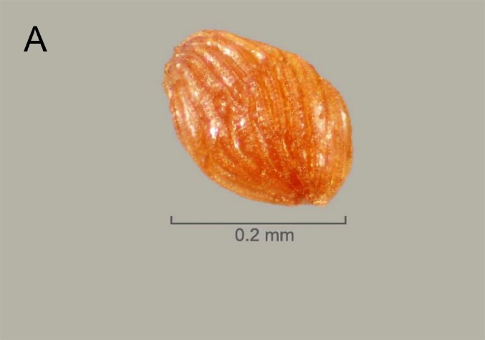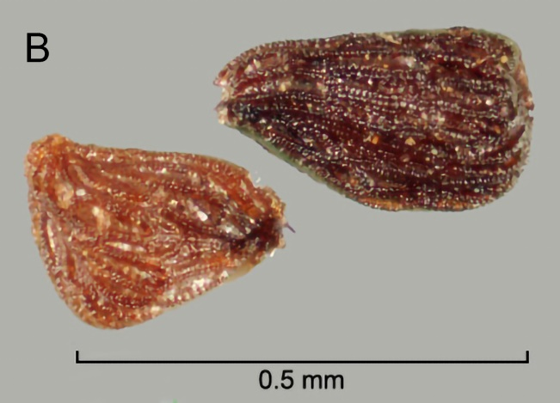
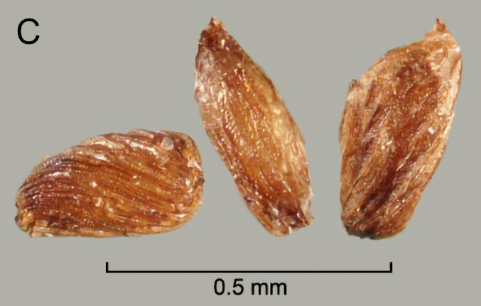
Figure 1. Seeds of Striga: (A) Striga asiatica, (B) Striga gesnerioides, (C) Striga hermonthica. Scale bars: (A) 0.2 mm; (B) and (C) 0.5 mm.
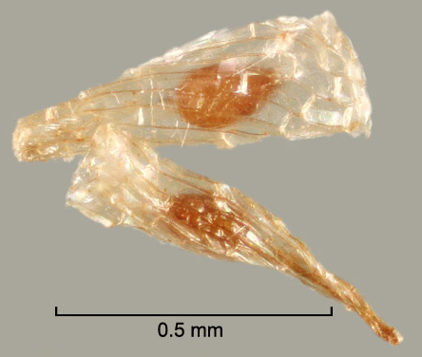
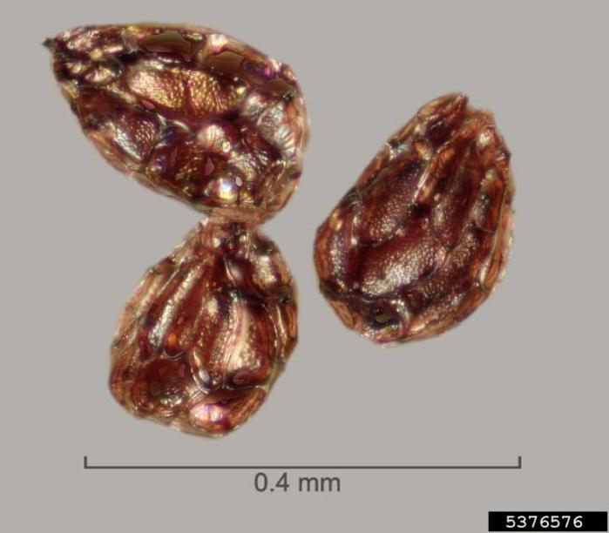
Photos courtesy of Julia Scher, Federal Noxious Weeds Disseminules, United States Department of Agriculture imal and Plant Health Inspection Service Plant Protection and Quarantine, http://idtools.org/id/fnw/index.php.
B
A

Figure 2. Seeds of (A) Orobanche minor and (B) Alectra arvensis. Scale bars: (A) 0.4 mm, (B) 0.5 mm.
Photos courtesy of Julia Scher, Federal Noxious Weeds Disseminules, United States Department of Agriculture Animal and Plant Health Inspection Service Plant Protection and Quarantine, http://idtools.org/id/fnw/index.php.

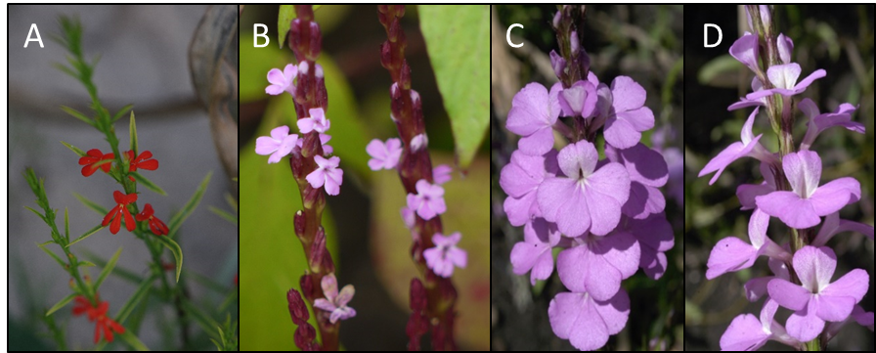
Figure 3. Flowers of Striga species: (A) Striga asiatica; (B) Striga gesnerioides; (C) and (D) Striga hermonthica.
Photos courtesy of (A), (C) and (D) Lytton John Musselman, Old Dominion University, Norfolk, VA, United States of America; (B) Dinesh Valke, Thane, India, https://commons.wikimedia.org/wiki/File:Striga_gesnerioides_(3976973632).jpg.
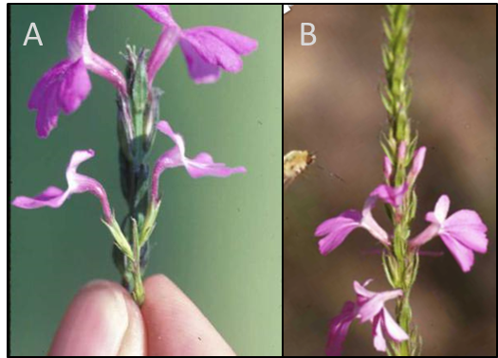
Figure 4. Characteristic bend near the top of the corolla in flowers of Striga aspera (A); absent in Striga hermonthica (B).
Photos courtesy of Lytton John Musselman, Old Dominion University, Norfolk, VA, United States of America.

