IPPC Webinar
Standard setting procedure
31 March 2022
9:00-11:00 (Rome time) or 17:00-19:00 (Rome time)
Interpretation: English; French; Spanish; Arabic; Chinese; Russian

Concept note

Background
- The goal of the International Plant Protection Convention (IPPC) is to prevent and control the introduction and spread of pests of plants. The primary focus of the IPPC is to regulate the movement and international trade of plants and plant products that may act as a pathway or vector for the introduction of plant pests including invasive weed species. One way of doing so is by setting International Standards for Phytosanitary Measures (ISPMs). The IPPC being a multilateral treaty administered by the United Nations – Food and Agriculture Organization (FAO), it provides a neutral forum for members to negotiate such international instruments.
- The development and adoption of standards, CPM recommendations, diagnostic protocols (DPs), and phytosanitary treatments (PTs) are the significant roles of the Commission on Phytosanitary Measures (CPM) and the IPPC Secretariat.
- The WTO Agreement on the Application of Sanitary and Phytosanitary Measures (SPS Agreement) recognizes standards developed under the auspices of the IPPC as the only international standards for plant health. International Standards for Phytosanitary Measures (ISPMs) are adopted by the CPM and countries implement them by establishing aligned requirements within their national system. The standards of the IPPC are recognized as the basis for phytosanitary measures applied in trade by the Members of the WTO.
- The standard setting work of the IPPC is led by the CPM’s Standards Committee (SC). The SC is supported by various expert drafting groups, such as technical panels (TPs) and expert working groups (EWGs). In addition, the Standard Setting Unit (SSU) of the IPPC Secretariat facilitates the development of harmonized international standards through the standard setting procedure, meeting the needs of contracting parties:
- 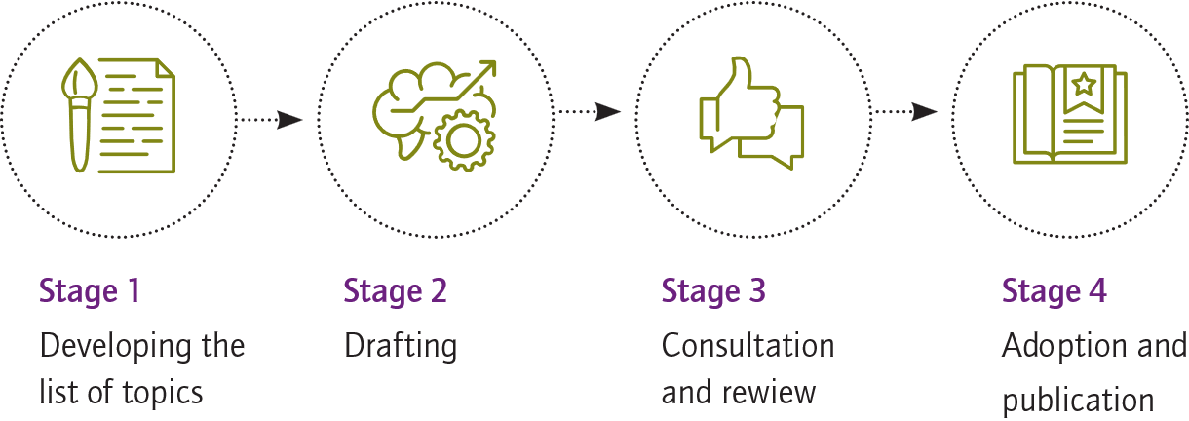

General objectives
- While the development of standards is transparent and inclusive, many stakeholders have difficulty understanding how the procedure works on each type of standard and how to provide input into the standard setting procedure. Hence, the general objectives of the webinar are:
- To enhance understanding of the standard setting procedure.
- To raise awareness on the standard setting procedure.
- To explain how to contribute to the standard setting procedure.

Expected outcomes
- Participants will better understand their roles and options for their involvement in the standard setting procedure and will be able to ask questions during the webinar. The webinar will also allow gaining a better understanding of the following aspects:
- The standard setting procedure and role of international standards for phytosanitary measures.
- Detailed work and activities of the Standards Committee and the Expert Drafting Groups.
- Roles of “stewards”, “assistant stewards”, and the international experts contributing to the drafting and review processes of standards.
- Roles of national plant protection organizations (NPPOs) and regional plant protection organizations (RPPOs) in the standard setting procedure.
- Specifics of the standard setting procedure that draft standards, DPs, PTs, and phytosanitary terms follow.
- Consultation processes that ISPMs go through
- Contribution of new topics and proposals for developing international standards and involvement in the standard setting procedure.

Participants
- NPPO, RPPO staff.
- Other interested stakeholders.

Location and dates
- The webinar will take place virtually on 31 March 2022 (Thursday):
- 9:00-11:00 (2 hours, Rome time, GMT+2); or
- 17:00-19:00 (2 hours, Rome time, GMT+2)

Language
- The webinar will be held in English with simultaneous interpretation into al UN official languages: French, Spanish, Arabic, Chinese, and Russian.

Moderator: Ms Adriana G. Moreira, IPPC Standard Setting Unit Deputy Lead

Preliminary agenda
N | Topic | Presenter
 | Opening | OSAMA EL-LISSY (IPPC Secretary) | 10’
 | The IPPC Standard setting procedure (SSP) at a glance: Introduction and Video launch | ADRIANA MOREIRA (IPPC Standard Setting Unit Deputy Lead) | 10’
 | Main highlights of the IPPC SSP  - Global importance of the ISPMs  - SC and EDGs as leading actors in the standard setting procedure  - Roles of stewards and assistant stewards | EZEQUIEL FERRO (SC Chair) | 15’
 | How to get involved? – experience of NPPOs  - Call for Topics as a gateway to new proposals for ISPMs  - Drafting process  - Country consultation process | EDGAR MUSHEGIAN (IPPC Secretariat)  STEVE COTE (SC member)  JULIET GOLDSMITH (CAHFSA) | 20’
 | Specific SSP for draft standards, DPs, PTs, phytosanitary terms  - Calls  - Process and drafting bodies  - Adoption | JANKA KISS (IPPC Secretariat) | 10’
 | NPPO/RPPO perspective – a life of a standard from submission to adoption  - Overview of the SSP from the NPPO perspective  - Main challenges regarding the standard setting procedure  - Coordination within countries (industry, research, other government bodies) | SOPHIE PETERSON (SC member)  MEKKI CHOUIBANI (NEPPO) | 20’
 | Q&A session | ADRIANA MOREIRA | 30’

