[PleaseReview document review. Review title: 2022 First Consultation: Draft DP: Genus Ceratitis (2016-001). Document title: 2016-001_DP_GenusCeratitis_2022-06-29.docx]
[1]DRAFT ANNEX TO ISPM 27: Genus Ceratitis (2016-001)
[2]Status box (this is not an official part of the standard, and it will be modified after adoption)
[3]Date of this document | [4]2021-05-17
[5]Document category | [6]Draft annex to ISPM 27 (Diagnostic protocols for regulated pests)
[7]Current document stage | [8]To Standards Committee (SC)
[9]Major stages | [10]2016-05 SC added subject Genus Ceratitis (2016-001) to work programme, priority 1.  [11]2020-11 Technical Panel on Diagnostic Protocols (TPDP) agreed to recommend a change in scope of the draft DP to the (SC).  [12]2021-06 SC agreed to reduce scope of DP to diagnosis of the genus and six species.  [13]2021-09 Expert consultation.  [14]2022-04 TPDP recommended draft to SC to be approved for consultation.  [15]2022-05 draft DP to SC to be approved for consultation  [16]2022-06 draft DP approved by the SC for consultation
[17]Discipline leads history | [18]Juliet GOLDSMITH (JM, Discipline lead)  [19]Géraldine ANTHOINE (FR, Referee)
[20]Consultation at the technical level | [21]The first draft of this protocol was written by:  [22]Norman BARR (US, lead author)  [23]Marc DE MEYER (BE)  [24]Massimiliano VIRGILIO (BE)  [25]Gary STECK (US)  [26]In addition, the draft has also been subject to expert review and the following international experts submitted comments: Nader Elbadry (EG), Stephen Gaimari (US) and Angel Ramirez-Suarez (MX).
[27]Main discussion points during the development of the diagnostic protocol | [28]
[29]Notes | [30]This is a draft document.  [31]2022-05 Edited
[32]CONTENTS
[33][to be added later]
[34]Adoption
[35]This diagnostic protocol was adopted by the Standards Committee on behalf of the Commission on Phytosanitary Measures in [Month 20--]. [to be completed after adoption]
[36]The annex is a prescriptive part of ISPM 27 (Diagnostic protocols for regulated pests).

[37]1. Pest information
[38]Fruit flies of the family Tephritidae represent an economically important insect group with a worldwide distribution. The biology of these fruit flies is dependent on the existence of the host plants that can serve as mating locations, oviposition sites for eggs, and nutrient resources for developing larvae. The genus Ceratitis MacLeay consists of 100 described species that are predominantly Afrotropical in distribution (De Meyer et al., 2016). The genus consists of six subgenera: C. (Acropteromma) Bezzi, C. (Ceratalaspis) Hancock, C. (Ceratitis) MacLeay, C. (Hoplolophomyia) Bezzi C. (Pardalaspis) Bezzi, and C. (Pterandrus) Bezzi, (Hancock, 1984; De Meyer and Freidberg, 2005). Two of the subgenera are monotypic (i.e. C. (Hoplolophomyia) and C. (Acropteromma)) and two are not monophyletic lineages (i.e. C. (Ceratalaspis) and C. (Pterandrus)) (De Meyer, 1999; Barr and McPheron, 2006).
[39]The genus includes several fruit pests that damage plants used for commercial and subsistence agriculture. The mated females oviposit eggs into fruit using a structure called an ovipositor. After the eggs hatch, direct damage is caused by larval feeding. Secondary damage is caused by the increased susceptibility to opportunistic fruit pathogens resulting from injuries during oviposition into the fruit and feeding damage. Ceratitis species are either generalists (polyphagous) or a form of specialist that feeds on a particular species (monophagous) or feeds on a lineage of plant species (i.e. stenophagous and oligophagous). The known relationship between Ceratitis species and their host plants is incomplete for many pests. Some host-use records are from field observations that still require confirmation on infested fruits and some Ceratitis species may infest a wider range of hosts than currently reported.
[40]Of the agricultural pests in the genus that exhibit generalist host-use behaviour, six species are included in this diagnostic protocol based on their pest distribution and risk they pose. The most destructive global pest in the genus is the generalist C. (Ceratitis) capitata (Wiedemann). Native to eastern sub-Saharan Africa, C. capitata has successfully invaded other regions of Africa, Hawaii, South America, Central America, Australia and countries of the Mediterranean. This pest can develop on over 400 varieties of plant hosts and survive in tropical, subtropical and temperate environments.
[41]The five additional species included in this protocol are found throughout large regions of sub-Saharan Africa. Ceratitis (Ceratalaspis) cosyra (Walker) is a pest of many fruit hosts such as Annona muricata (soursop), Eriobotrya japonica (loquat), Mangifera indica (mango), Prunus persica (peach), and Psidium guajava (guava). It is found throughout much of sub-Saharan Africa and is reported to be a cryptic species complex (Virgilio et al., 2017). The other four species included in the protocol for species-level identification are C. (Pterandrus) fasciventris (Bezzi), C. (Pterandrus) anonae Graham, C. (Pterandrus) rosa Karsch and C. (Pterandrus) quilicii De Meyer et al. These use a wide range and a large number of commercially grown hosts. The distributions for each of these four species include multiple countries across sub-Saharan Africa; although each species has a different distribution range, these ranges can overlap (De Meyer et al., 2015; De Meyer et al., 2016). The four species are included in a taxonomic species complex called the “FAR complex” because of high morphological and molecular similarity (Barr and McPheron, 2006; Virgilio et al., 2008).

[42]2. Taxonomic information
[43]Name: Ceratitis MacLeay, 1829
[44]Synonyms: none
[45]Taxonomic position: Insecta, Diptera, Tephritidae, Dacinae, Ceratitidini
[46]The genus consists of six subgenera as proposed by Hancock (1984) and revised in several publications (De Meyer, 1996, 1998, 2000; De Meyer and Copeland, 2001; De Meyer and Freidberg, 2005):
[47]Ceratitis (Acropteromma) (Bezzi), 1926
[48]Ceratitis (Ceratalaspis) Hancock, 198
[49]Ceratitis (Ceratitis) MacLeay, 1829
[50]Ceratitis (Hoplolophomyia) Bezzi, 1926
[51]Ceratitis (Pardalaspis) Bezzi, 1918
[52]Ceratitis (Pterandrus) Bezzi, 1918
[53]Acropteromma and Hoplolophomyia are monotypic subgenera (De Meyer, 1999, 2005; De Meyer and Copeland, 2001). Ceratalaspis and Pterandrus are not monophyletic subgenera (De Meyer, 2005; Barr and McPheron, 2006; Barr and Wiegmann, 2009). Pterandrus is divided into two sections (A and B) and is paraphyletic with respect to subgenus Ceratitis (Barr and Wiegmann, 2009). Pterandrus section B and subgenus Ceratitis form a monophyletic clade. The subgenus Pardalaspis is monophyletic.
[54]Common names and synonyms of the fruit fly species included in this protocol are listed in Table 1.
[55]Table 1. Common names and synonyms of fruit fly species of major economic importance belonging to the genus Ceratitis and included in this diagnostic protocol
[56]Species | [57]Common name | [58]Synonyms
[59]Ceratitis (Pterandrus) anonae Graham, 1908 | [60] | [61]Ceratitis pennipes Bezzi, 1908  [62]Pterandrus anonae Bezzi, 1918
[63]Ceratitis (Ceratitis) capitata (Wiedemann, 1824) | [64]Mediterranean fruit fly  [65]medfly | [66]Tephritis capitata Wiedemann, 1824  [67]Ceratitis citriperda MacLeay, 1829  [68]Pardalaspis asparagi Bezzi, 1924
[69]Ceratitis (Ceratalaspis) cosyra (Walker, 1849) | [70]mango fruit fly | [71]Trypeta cosyra Walker, 1849  [72]Ceratitis giffardi Bezzi, 1912  [73]Pardalaspis giffardi var sarcocephali Bezzi, 1924  [74]Pardalaspis parinarii Hering, 1935
[75]Ceratitis (Pterandrus) fasciventris (Bezzi, 1920) | [76] | [77]Pterandrus rosa var fasciventris Bezzi, 1920  [78]Pterandrus flavotibialis Hering, 1935  [79]Pterandrus rosa Munro, 1956  [80]Ceratitis (Pterandrus) rosa Hancock, 1984
[81]Ceratitis (Pterandrus) quilicii De Meyer et al., 2016 | [82] | [83](Ceratitis rosa R2, ‘highland’)*
[84]Ceratitis (Pterandrus) rosa Karsch, 1887 | [85]Natal fruit fly | [86]Pterandrus rosa Bezzi 1918  [87](Ceratitis rosa R1, ‘lowland’)*
[88]Note: * Prior to formal description of Ceratitis quilicii, C. quilicii and C. rosa sensu stricto were referred to under these informal names. See De Meyer et al. (2015).

[89]3. Detection
[90]Fruit flies of the genus Ceratitis are detected mainly by trap for adults or in fruits. Male attractant lures are commonly used for C. capitata adults (Tan et al., 2014) and may be useful for pest species in the subgenera Ceratitis and Pterandrus but are known to be not effective for all species in the genus (De Meyer, 1999). The most commonly used lures are trimedlure (for Ceratitis capitata and representatives of the Ceratitis FAR complex), terpinyl-acetate (for C. cosyra) and enriched ginger oil lure (Mwatawala , 2013; Manrakhan et al., 2017). Other male attractants have been examined, such as methyl eugenol for species in the subgenus Paradalaspis (De Meyer, 1999). In addition, food-based attractants have been reported as being effective for many adult flies (Epsky, Kendra and Schnell, 2014; Manrakhan , 2017). Immature stages of flies, such as eggs and larvae (first, second and third instars), can be found during an inspection of fruits. Larvae usually exit the fruit after feeding, and the immobile pupal stage develops elsewhere (e.g., in leaf litter, soil, or shipping containers).

[91]3.1 Trapping
[92]Guidance on trapping Ceratitis fruit flies, including use of attractants for trapping, such as synthetic food attractants and hydrolysed protein substances, is given in Appendix 1 of ISPM 26 (Establishment of pest-free areas for fruit flies (Tephritidae)).

[93]3.2 Inspection of fruits
[94]Fruits with soft areas, dark stains, dark pin spots, rot, orifices or injuries that might have originated from female oviposition or larval-feeding activities should be targeted for inspection. In order to detect punctures made by female flies during oviposition, fruits should be examined under a microscope by an expert. If larval exit holes are observed, the fruit containers should be inspected for pupae. Third instars may not be present when unripe fruits are collected and packed; however, these fruits might host eggs and first or second instars, which are more difficult to detect. Potentially infested fruits that show typical punctures made by ovipositing female flies should be cut open to search for eggs or larvae inside. The success of detection depends on careful sampling and examination of fruits.
[95]Once detected, larvae may be reared to adults for identification (section 3.3). Rearing of adults is required to accurately identify a fly to species level using morphological techniques. The incubation of infested fruits is a common practice to obtain adult flies, which is necessary to identify species in this protocol. Even if there are no signs of fruit fly infestation, an incubation could be conducted as an oviposition mark is often difficult to recognize.

[96]3.3 Rearing larvae to obtain adults
[97]Larvae can be reared to adults by placing infested fruits in cages containing a pupation medium (e.g., damp vermiculite, sand or sawdust) at the bottom. The cages are covered with cloth or fine mesh. Once the larvae emerge from the fruit, they will move to the pupation medium. Each sample should be observed, and pupae gathered daily. The pupae are placed in containers with the pupation medium, and the containers are covered with a tight lid that enables proper ventilation. Once the adults emerge, they must be kept alive for several days to ensure that the integument and wings acquire the rigidity and characteristic coloration of the species. Flies can be fed with honey (sugar) and water. The adults are then killed by freezing, or by exposure to ethyl acetate or other killing agents appropriate for morphological examination, and then mounted on pins.
[98]Prior to mounting (before they harden), it is useful to gently squeeze the apical part of the preabdomen with forceps, then squeeze the base of the oviscape to expose the aculeus tip for females. Alternatively, this will need to be dissected later in flies. The aedeagus is not commonly used for examination of Ceratitis males.

[99]4. Identification
[100]Identification at the level of species or species complex requires morphological examination of adult flies or molecular analysis. For some species, accurate identification can only be completed for male specimens because the female form has not been described or females lack diagnostic features. In addition to keys developed for species in each subgenus (De Meyer, 1996, 1998, 2000; De Meyer and Freidberg, 2005), an online multi-entry Lucid key to frugivorous flies of Africa is available that can be used to identify Ceratitis species (Virgilio, White and De Meyer, 2014).
[101]It is not reliable to morphologically identify eggs, most larvae or pupae to the species level. There are descriptions of third instars for some species but not all pests in the family. These descriptions of the third instar can be used to discriminate among the described species (White and Elson-Harris, 1992; Steck and Ekesi, 2015) but not to distinguish with reliability one pest from all other pests. This is true of all Ceratitis pests. The descriptions of third instar Ceratitis are usually based on laboratory colony material and might not accurately represent the true diversity of the species (Steck and Ekesi, 2015). The most reliable method for identifying species is rearing larvae to the adult stage or molecular analysis.
[102]A key to identifying economically important genera based on third instars has been published (White and Elson-Harris, 1992), and an online identification tool that includes 81 economically important species of 13 genera is available (Carroll et al. 2004). Ceratitis is the only economically important genus from the tribe Ceratitidini included in the key and the diversity of each genus in the key is based on examination of a limited number of species with larval descriptions available. Steck and Ekesi (2015) reported that a character previously used to distinguish Ceratitis and Bactrocera larvae was based on limited taxon sampling. Morphological examination of a third instar can provide diagnostic information but may not allow an identification to be completed without additional molecular diagnostic information. Host and geographical distribution records are not included in the current protocol as diagnostic features of Ceratitis species because the values are incomplete for many species and subject to change over time. The scope of the protocol is limited to morphological and molecular characters.
[103]Molecular methods for Ceratitis species identification have been reported for several of the most destructive, polyphagous pests: C. capitata (Barr et al., 2006; Huang et al., 2009; Barr et al., 2012; Dhami et al., 2016), C. cosyra (Barr et al., 2006; Virgilio et al., 2017), and the four members of the FAR complex – C. fasciventris, C. anonae, C. rosa and C. quilicii (Virgilio et al., 2019). These studies have considered the molecular phylogeny of the genus (Barr and McPheron, 2006; Barr and Wiegmann, 2009; Erbout et al., 2011) to include species that would have a greater probability of cross-reacting with a target pest or lead to incorrect interpretation of a diagnostic result. Only methods that have the taxonomic sampling needed to demonstrate reliable species identification are included in this diagnostic protocol. These include a real-time polymerase chain reaction (PCR) method for C. capitata (Dhami et al., 2016) and DNA barcoding methods for the identification of C. capitata, C. cosyra and the FAR complex using DNA sequencing of part of the cytochrome c oxidase I (COI) gene (section 4.3).
[104]DNA barcode records for other Ceratitis species are reported in the literature (Barr et al., 2012; Virgilio et al., 2012) and can be accessed using DNA databases. Formal examination of reference data specificity has not been reported for the other pests not included in this protocol. The restriction fragment length polymorphism method of Barr et al. (2006) is also not included in this protocol as it lacks profiles for several important pests in the genus that are represented in DNA barcode studies. Methods to identify insects to the level of genus Ceratitis based on DNA barcodes have not been formally described or published; consequently, methods to identify the genus are not included in this protocol.
[105]Population genetic analysis of C. capitata has revealed several methods for evaluating geographical association (Gasparich et al., 1997; Davies et al., 1999; Bonizzoni et al., 2000, 2004; Meixner et al., 2002; Barr 2009; Ruiz-Arce et al., 2020) or determining the laboratory colony source of a fly (San Andres et al., 2007; Juan-Blasco et al., 2013; Sim et al., 2017; Catalá-Oltra et al., 2020). The accuracy of methods can depend on changing frequencies of genotypes over time and changes in the production or source of laboratory colonies used for the sterile insect technique. These are not, therefore, included in the current protocol.
[106]The destruction of insect tissue for DNA-based identification can preclude morphological examination unless care is taken to retain body parts needed for such examination. The use of a fly leg for DNA extraction is recommended for some species when molecular data are to be collected, but the specimen should be saved for morphological analysis. The presence of characters on fore and mid legs are diagnostically informative in the genus, and at least one row of legs should be retained for morphological examination. When a larva is needed for morphological examination, excision of tissue from the midsection should be performed to collect molecular data. For guidance on preparing a specimen for molecular study, see section 4.3.1.
[107]Molecular methods can be used for all life stages. Morphological identification methods are not available for eggs and pupae, and if these life stages are included in molecular analyses, they do not need to be heat treated.

[108]4.1 Morphological identification of adults
[109]The diagnostic characters required to complete identification to the pest species covered by this protocol and to the genus are provided below. Additional resources on general characters for tephritid fruit fly identification are provided in White and Elson-Harris (1992).

[110]4.1.1 Preparation of adults for identification
[111]Proper preparation of specimens is essential for accurate morphological identification. General instructions on the preparation of adult fruit fly specimens are given by White and Elson-Harris (1992).
[112]Every attempt should be made to preserve all characters on at least one side of the centre line, regardless of the mounting method (Foote et al., 1993).
[113]Characters on the head, wing, leg, thorax and abdomen of a fly can be examined from pinned specimens under magnification using a stereomicroscope at ≥20×. This magnification level is appropriate for observing spot and colour patterns and wing morphology (section 4.1.2).
[114]Wing characters can usually be observed without mounting, so mounting is not recommended as a general practice. It may be necessary for morphometric studies, but it is not necessary to observe the characters used in section 4.1.3. If permanent mounts are made, it is recommended that one of the wings be cut off from its base (the right wing is preferred because it facilitates comparison with images reported in the literature and this diagnostic protocol).
[115]Structures of the ovipositor, such as aculeus shape and length, have not been used consistently as important taxonomic characters at genus or species level of many Ceratitis, except for the aculeus tip which has been used for some groups in the subgenus C. (Ceratalaspis). These structures are not included in the protocol for diagnosis.

[116]4.1.2 Characters to identify adults to the genus Ceratitis
[117]There is no unambiguous character that differentiates all representatives of the genus Ceratitis from any of the other closely related genera within the Dacinae. The combination of the presence of prescutellar setae (Figure 1), presence of basal scutellar setae (Figure 2) and the short appendix of the wing cell bcu (the posterior cubital cell or cup) with a constriction at the base (Figure 3) excludes other dacine genera that consist of pest species (such as Bactrocera Macquart, Dacus Fabricius and Zeugodacus Hendel) as well as any other non-dacine genera.
[118]The following combination of characters differentiates representatives of the genus Ceratitis from other dacine genera with a similar appearance.
[119]Scutellum roundish and swollen (Figure 2) (excludes representatives of the genera Carpophthoromyia Austen and Perilampsis Bezzi, which have a flattened and less rounded scutellum, see Figure 4).
[120]Scutellum with three dark apical markings. These markings can be clearly separated (Figure 2) or partially fused (Figure 5). In some cases, they cover most of the apical and central part of the scutellum (Figure 6), while in some other cases they are reduced to small dark spots (Figure 7). This excludes representatives of the genus Capparimyia Bezzi, which have only two dark apical markings (Figure 8), and several representatives of the genus Trirhithrum Bezzi that have a completely black scutellum (Figure 9). It also excludes some representatives of the genus Neoceratitis Hendel that have a single dark apical marking (Figure 10).
[121]The majority of Ceratitis species have a typical wing banding pattern consisting of an anterior apical band, a discal band, and a subapical band (Figure 3). In some cases, an additional posterior apical band is present (Figure 11). A few Ceratitis species have wing banding that deviates from the normal pattern (i.e. C. divaricata (Munro, 1933), C. flexuosa (Walker, 1853), C. munroanum (Bezzi, 1926), C. taitaensis De Meyer and Copeland, 2016, C. whartoni De Meyer and Copeland, 2009) but none of them is of economic significance. The typical wing banding is also shared by some Trirhithrum and Neoceratitis species. The latter two groups can be separated from Ceratitis by the banding being dark black to black-brown combined with the presence of a posterior apical band (Figure 12) or at least a triangular extension “tooth” attached to the anterior apical band (Figure 13). Ceratitis species usually have a yellow to brown wing banding (Figure 2, Figure 11).
[122]Phylogenetic studies have indicated that at least some Trirhithrum species cluster within the Ceratitis group (see Virgilio et al., 2015). Thus, the generic concept of both Ceratitis and Trirhithrum, and the species to be included in each of these higher taxa, needs revision.

[123]4.1.3 Morphological identification of adults to pest species or complex
[124]For the purposes of this protocol, a number of characters useful for the identification of adult flies have been retrieved from the different published revisions of subgenera (De Meyer 1996, 1998, 2000; De Meyer and Freidberg, 2005) and from the subsequent inclusion in the identification tool developed by Virgilio, White and De Meyer (2014). The diagnostic character states for the six species of economically important Ceratitis species included in this protocol are listed in Table 2, with reference to relevant images illustrating the states.
[125]Table 2. Diagnostic morphological characters of adults of Ceratitis species in this protocol
[126]Character | [127]Species
 | [129]C. anonae | [130]C. capitata | [131]C. cosyra | [132]C. fasciventris | [133]C. quilicii | [134]C. rosa
[135]Both sexes, scutum, postpronotal lobe | [136]Unicolorous (as in Figure 14 & Figure 15) | [137]Pale with black median spot (as in Figure 16 & Figure 17) | [138]Pale with black median spot (as in Figure 16 & Figure 17) | [139]Unicolorous (as in Figure 14 & Figure 15) | [140]Unicolorous (as in Figure 14 & Figure 15) | [141]Unicolorous (as in Figure 14 & Figure 15)
[142]Both sexes, scutellum, apical spots | [143]Three separate spots (as in Figure 18) | [144]One merged spot (as in Figure 19) | [145]Three separate spots (as in Figure 18) | [146]Three separate spots (as in Figure 18) | [147]Three separate spots (as in Figure 18) | [148]Three separate spots (as in Figure 18)
[149]Both sexes, scutum | [150]Greyish to greyish-brown ground colour, with indistinct darker markings (as in Figure 20) | [151]Grey with distinct black markings (as in Figure 21) | [152]Yellow-orange to orange ground colour with distinct black markings (as in Figure 22) (black markings can sometimes be strongly reduced) | [153]Greyish to greyish-brown ground colour, with indistinct darker markings (as in Figure 20) | [154]Greyish to greyish-brown ground colour, with indistinct darker markings (as in Figure 20) | [155]Greyish to greyish-brown ground colour, with indistinct darker markings (as in Figure 20)
[156]Both sexes, wing, anterior apical band | [157]Completely separated from discal band (as in Figure 23 & Figure 24) | [158]Completely separated from discal band (as in Figure 23 & Figure 24) | [159]Connected with discal band (as in Figure 25), at most partially separated (as in Figure 26) | [160]Completely separated from discal band (as in Figure 23 & Figure 24) | [161]Completely separated from discal band (as in Figure 23 & Figure 24) | [162]Completely separated from discal band (as in Figure 23 & Figure 24)
[163]Both sexes, abdomen, tergum 3 | [164]With black-brown transverse band (as in Figure 27) | [165]Without black-brown transverse band (as in Figure 28) | [166]Without black-brown transverse band (as in Figure 28) | [167]With black-brown transverse band (as in Figure 27) | [168]With black-brown transverse band (as in Figure 27) | [169]With black-brown transverse band (as in Figure 27)
[170]Male, head, lower orbital seta | [171]Bristle-like, not modified apically (as in Figure 29 & Figure 30) | [172]Modified, flattened at apex (as in Figure 31 & Figure 32) | [173]Bristle-like, not modified apically (as in Figure 29 & Figure 30) | [174]Bristle-like, not modified apically (as in Figure 29 & Figure 30) | [175]Bristle-like, not modified apically (as in Figure 29 & Figure 30) | [176]Bristle-like, not modified apically (as in Figure 29 & Figure 30)
[177]Male, leg fore femur | [178]Posteriorly with dispersed setae (as in Figure 33 & Figure 34) | [179]Posteriorly with brush of dense setae (as in Figure 35) | [180]Posteriorly with dispersed setae (as in Figure 33 & Figure 34) | [181]Posteriorly with dispersed setae (as in Figure 33 & Figure 34) | [182]Posteriorly with dispersed setae (as in Figure 33 & Figure 34) | [183]Posteriorly with dispersed setae (as in Figure 33 & Figure 34)
[184]Male, leg mid femur | [185]Ventrally with row of long stout setae (“feathering”) (as in Figure 36) | [186]Ventrally with few dispersed long but thin setae (as in Figure 37) | [187]Ventrally with few dispersed long but thin setae (as in Figure 37) | [188]Ventrally with few dispersed long but thin setae (as in Figure 37) | [189]Ventrally with few dispersed long but thin setae (as in Figure 37) | [190]Ventrally with few dispersed long but thin setae (as in Figure 37)
[191]Male, leg mid tibia | [192]Lateral margins with row of long black stout setae (feathering) for more than three-quarters of entire length (as in Figure 38) | [193]Lateral margins with few dispersed short setae (as in Figure 39) | [194]Lateral margins with few dispersed short setae (as in Figure 39) | [195]Lateral margins with row of long stout setae (feathering) for less than half of apical part (as in Figure 40) | [196]Lateral margins with row of long stout setae (feathering) for more than half but less than three-quarters of entire length (as in Figure 41) | [197]Lateral margins with row of long stout setae (feathering) for more than half but less than three-quarters of entire length (as in Figure 42)
[198]Male, leg mid tibia | [199]Pale to brownish coloured over entire length (as in Figure 38) | [200]Pale coloured over entire length (as in Figure 39) | [201]Pale coloured over entire length (as in Figure 39) | [202]Usually pale coloured, at most area between feathering partially darker yellow to brownish coloured (as in Figure 40) | [203]Pale except area between feathering where darker coloured; dark colour not reaching lateral margins in upper part (red arrow in Figure 41) | [204]Pale except area between feathering where darker coloured; dark colour reaching lateral margins in upper part (red arrow in Figure 42)
[205]Female, anepisternum | [206]With partly dark pilosity in lower half (as in Figure 44) | [207]Whole pale pilosity (as in Figure 43) | [208]Whole pale pilosity (as in Figure 43) | [209]Whole pale pilosity (as in Figure 43) | [210]Whole pale pilosity (as in Figure 43) | [211]Whole pale pilosity (as in Figure 43)
[212]Female, leg fore femur | [213]Posteriorly with few dark hairs between posterior and posterodorsal row of setae (as in Figure 33) | [214]Posteriorly without dark hairs between posterior and posterodorsal setae (as in Figure 34) | [215]Posteriorly without dark hairs between posterior and posterodorsal setae (as in Figure 34) | [216]Posteriorly without dark hairs between posterior and posterodorsal setae (as in Figure 34) | [217]Posteriorly without dark hairs between posterior and posterodorsal setae (as in Figure 34) | [218]Posteriorly without dark hairs between posterior and posterodorsal setae (as in Figure 34)

[219]4.2 Morphological identification of third instars
[220]As explained earlier in section 4, identification of flies based on examination of the third-instar life stage is not sufficient to complete accurate species identification under all circumstances. Larval descriptions are not available for all species that could be confused for a pest, and descriptions are based on laboratory-reared colonies that might not represent the true variation of the species (Steck and Ekesi, 2015). However, a diagnosis to the genus or species that is based solely on larval morphology could be appropriate when screening for a pest where its presence is expected based on prior information and closely related species that could be mistaken for the pest are absent. Molecular analysis (section 4.3) should be performed to complete the identification of a larva when the diagnosis is intended to confirm a new record of pest presence.
[221]Morphological characters of third instars are published for several Ceratitis species. These descriptions can be used to discriminate among species that have been studied. These descriptions can also be used to provide additional support to an identification of one of those studied species if the identification is based on other methods. In this protocol, a description of third instars for the genus Ceratitis is provided that has been extrapolated from published species descriptions: this may be of value in supporting identifications.
[222]When a larva is detected in fruit, identification of the instar stage is not always certain. The fully developed second instar and newly moulted third instar of a fly species can be the same length: the third-instar Ceratitis, for example, can be as small as 3.2 mm in length for some species (Steck and Ekesi, 2015). Typical relative sizes of the egg and three instars are shown in Figure 45. The best characters to separate instars in all species are the absolute sizes of the cephaloskeleton and spiracles: they never overlap between instars. However, these data are not published for second or first instars of most species. Another differentiating feature between third and second instars is the relative size of the mouthhook subapical tooth: in the third instar the subapical tooth is very small compared to the apical tooth (Figure 46), but in the second instar it is subequal (Figure 47).
[223]Larvae can be examined using a dissecting stereomicroscope, compound optical microscope and scanning electron microscope (SEM). General examination for initial screening can be accomplished using the stereomicroscope, but slide-mounted specimens under a compound microscope or SEM are needed to complete genus and species diagnoses. The most detailed images and illustrations reported in the literature are from SEM examination of specimens. Therefore, diagnoses based on optical microscopy require photographed images that provide evidence of structures observed in SEM images.

[224]4.2.1 Preparation of third-instar larvae for identification
[225]Larvae can be prepared for morphological examination by first killing them in very hot or boiling water and then storing them in 70% ethanol. Rinsing larvae in cool, distilled water with a drop of mild dishwashing detergent before killing in hot water helps clean specimens for subsequent examination. The live larvae are then placed in water at >65 °C for at least two minutes, cooled to room temperature and then preserved in 70% ethanol. If larvae turn partially or completely black after one day, the hot water treatment was inadequate, and the water temperature or treatment time should be increased. The larval cuticle may split open on one side near the head, but this is inconsequential for identification purposes. Splitting is minimized if the larvae are run through a graduated alcohol series of 35%–50%–70% ethanol for two hours each, with an additional change to fresh 70% alcohol. It is advisable to include a label in the storage vial with all sampling information. These samples are ready for examination under a stereomicroscope or subsequent preparation for slide mounting or examining under an SEM.
[226]Larvae that are to be used for morphological analysis alone can be saved in 70% ethanol after boiling. Those larvae that are to be used for both morphological and molecular analysis can have tissue excised (section 4.3.1) and saved in ≥95% ethanol in a freezer (≤-20 °C) until DNA is extracted and the remaining anterior and posterior sections saved in 70% ethanol.
[227]4.2.1.1 Preparing larvae for stereomicroscope examination
[228]Morphological examination of larvae can be performed on unmounted specimens using a stereomicroscope. After intact larvae are removed from alcohol and blotted dry, their external features such as oral ridges, anterior and posterior spiracles, and anal lobes can be examined. Counts of oral ridges and lobes of the anterior spiracle can be made, as well as observations of characters such as shapes of spiracles and anal lobes, orientation and length and width measurements of posterior spiracular slits, and presence or absence of dorsal spinules and caudal ridges. Specimens should be re-wetted with alcohol as needed to prevent shrivelling.
[229]4.2.1.2 Preparing larvae for slide mounting and examination using a compound microscope
[230]Morphological examination can be performed on slide-mounted larvae using a compound microscope with objective 20×, 40× or higher. These slide-mounted larvae can be examined for external morphology (e.g. anterior and posterior spiracles, oral ridges) as well as internal structures such as the cephaloskeleton. However, slide mounting larvae can preclude subsequent higher resolution analysis of morphological characters observable using SEM. It is therefore not recommended to slide mount all specimens representing a sample or the only larva available for diagnosis; unmounted larvae should be kept for future analysis.
[231]To prepare specimens for slide mounting, it is necessary to remove (clear) all the internal tissues to allow observation of the cuticle, oral opening, cephaloskeleton, anterior and posterior spiracles, and anal lobes. First, two incisions are made in the larva: one laterally through the thoracic segments, and one between the posterior spiracles and anus. Then the incised larva is immersed in hot 10% NaOH or 10% KOH solution for 10–15 min or until most internal tissues are visibly digested. After digestion, the remaining internal debris is carefully removed using forceps and the specimen flushed with distilled water under a stereomicroscope. The cephaloskeleton is extracted through the lateral incision on the thorax.
[232]Cleared specimens can be placed in glycerin on a glass depression slide with a cover slip for examination or imaging and recording of measurement data under a compound microscope (Figure 48). Afterwards, specimens can be retained as vouchers by returning them to alcohol in a labelled vial, or permanent slide mounts can be made using Canada balsam or Euparal following standard methods. For permanent mounts, care must be taken to position and stabilize the specimen in the proper orientation before adding the cover slip, otherwise it may be impossible to get realistic images or accurate measurements after the specimen dries in place. Slides must be allowed to dry for several days or weeks (the time can be reduced by using an oven), but they can be examined under the microscope at low magnification immediately after mounting. Slides should be labelled.
[233]4.2.1.3 Preparing larvae for SEM examination
[234]For observation using an SEM, the specimens (stored in alcohol) should first be completely dehydrated by running through a series of ethanol rinses – 70%, 80%, 95%, and two or three changes of absolute ethanol – followed by one or two rinses in ethyl acetate and air-dried (or critical-point dried after the alcohol dehydration series), then coated with gold–palladium and mounted on a stub (Carroll and Wharton, 1989). If the larval specimen has not been cut or punctured before the ethanol rinses, then two to three lateral punctures should be made with a minuten pin to allow alcohol to permeate the tissues. The duration of each ethanol rinse for a larva with punctures should be at least two hours. If the midsection of the larval specimen has been excised and removed (section 4.3.1), then alcohol permeates the tissue more quickly and each rinse step should have a duration of 15 minutes. Similar techniques can be found elsewhere (e.g. Frías et al., 2006; Frías, Selivon and Hernández-Ortiz, 2008; Frías Lassere, Hernández Ortiz and López Muñoz, 2009).

[235]4.2.2 Characters to identify third-instar larvae of genus Ceratitis
[236]Diagnosis: dorsolateral pair of sensilla parallel to maxillary palp; preoral lobes elongate and petal-like, preoral organ ringed with petal-like lobes; preoral teeth absent; mouthhook apical tooth ventrally grooved, secondary conical, subapical tooth present, mouthhook basally elongate, dental sclerite present; oral ridges with scalloped edges, accessory plates present in single series; anterior spiracle tubules in a single sinuous row, flat to convex centrally; rimae of posterior spiracles approximately 2.5–3.5 times longer than wide; caudal ridge present; thin, dark, sclerotized line on caudal segment absent; live, mature third instars display skipping (jumping) behaviour. Important exceptions are noted below under the individual species notes.
[237]Fruit fly larval descriptive terminology has evolved over the years. Useful references include Teskey (1981), Steck and Wharton (1988), White and Elson-Harris (1992), White et al. (1999), Carroll et al. (2004), Rodriguez et al. (2021) and Steck et al. (forthcoming). The figures in this protocol illustrate the usage employed here and the diagnostic and key features listed above and below.
[238]A generalized fruit fly larval habitus (Figure 49) shows the anatomical disposition of the pseudocephalon, thoracic segments and abdominal segments, together with the locations of important key features such as the mouthhooks, spinules, anterior and posterior spiracles, and anal lobes.
[239]The pseudocephalon (head) of a fruit fly larva has two prominent protuberances (cephalic lobes), each bearing an antennal sensory organ, a dorsolateral pair of sensilla, and a maxillary palpus. The pair of dorsolateral sensilla are arranged parallel to the maxillary palpus in Ceratitis and other Dacinae, which differs from the perpendicular arrangement seen in Anastrepha (Figure 50, Figure 51, Figure 52). They can be observed using either an SEM or a compound microscope.
[240]The preoral lobes are present just anterior to the mouth opening, and laterally adjacent to them are the preoral organ and associated lobes. In Ceratitis larvae, the preoral organ is a small cylindrical lobe bearing sensilla that is ringed by several petal-like lobes, referred to as the preoral lobes, that extend medially (Figure 53). They differ from Dacus and Zeugodacus (Figure 54), in which the preoral lobes are elongated with toothed margins identical to the oral ridges, and from those of Anastrepha (Figure 55), in which the sensilla of the preoral organ are on the lateral ends of an elongate, undifferentiated preoral lobe. These features can be observed in detail under an SEM and sometimes crudely under a dissecting or compound microscope.
[241]Preoral teeth are absent in Dacinae. They occur in one tribe of the Trypetinae – the Carpomyini (Rhagoletis, Carpomya) – and consist of one to several stout sclerotized teeth on the posterior surface of the preoral organ. They can be observed using either an SEM or a light microscope (Figure 56, Figure 57).
[242]Most of the cephaloskeleton is internal and not visible until the specimen is cleared. Only part of the mouthhook is visible externally. In Ceratitis species, the mouthhook has a large apical tooth and a small secondary tooth. However, the secondary tooth may be imperceptibly small (visible only under an SEM) or entirely absent in some specimens of C. capitata and C. rosa. The secondary tooth is always absent in Anastrepha and pest species of Bactrocera (except B. (Notodacus) xanthodes) (Figure 58, Figure 59). The ventral shape of the apical tooth can easily be seen under an SEM, but it is not apparent under a light microscope. It is ventrally grooved in Ceratitis but tusk-like in Dacus and some Zeugodacus spp. (Figure 58, Figure 59, Figure 60). The posterior part of the mouthhook is extended into an elongate neck beyond the ventral protuberance in Ceratitis and other Dacinae but is truncate posteriorly in Trypetinae (Anastrepha, Rhagoletis). A dental sclerite is present in Ceratitis and other Dacinae but there is no dental sclerite in Trypetinae (Anastrepha, Rhagoletis). The neck and dental sclerite can be observed under a compound microscope (Figure 61, Figure 62).
[243]A lateral lip of the oral opening, apparently a single structure but usually deeply invaginated to give the appearance of being two adjacent lips (inner and outer), is present in SEM images of nearly all tephritid larvae described to date but varies in extent (Figure 63, Figure 64). Lateral to the outer lateral lip is a series of elongate ridges called the oral ridges, which may funnel liquids into the mouth during feeding. Oral ridges occur in larvae of all fruit-infesting tephritids, but they vary in number and their edges may be smooth, serrate, scalloped or fringed (Figure 65, Figure 66, Figure 67). Details of these features are best observed with an SEM as they may be damaged during preparation for slide mounting or difficult to get into a good viewing position on a slide.
[244]A single series of accessory plates at the lateral margins of the oral ridges is present in most species of Ceratitis. Accessory plates are also present in Bactrocera, Dacus and Anastrepha, although their specific shapes, numbers and positions vary among genera (Figure 65, Figure 66, Figure 67). Accessory plates are absent in Rhagoletis. Details are best observed with an SEM.
[245]Anterior spiracles are located dorsolaterally on the first thoracic segment. They have an internal trunk that flares apically to expose one or more external rows of tubules that are short with a rounded top bearing a thin slit to allow passage of air. Individual tubules are very similar among all fruit fly larvae. However, the number of tubules, their arrangement and the overall dimensions of the spiracles may be useful in diagnosing some fruit fly species. The apical row of tubules in Ceratitis and other Dacinae are typically fan-shaped with a flat or convex top, compared with Anastrepha in which the row or rows of tubules are distinctly bilobed. The anterior spiracles should be observed on cleared specimens on slides under a light microscope (Figure 68, Figure 69).
[246]The last larval abdominal segment has a pair of posterior spiracles located posterodorsally (Figure 70) and anal lobes located ventrally. In the Dacinae (including Ceratitis), a caudal ridge is present in the area between the posterior spiracles and anal lobe. Presence of a caudal ridge can be used to separate the subfamily Dacinae from Trypetinae, in which it is absent (Figure 71, Figure 72). The caudal ridge is usually apparent in dorsal, caudal and lateral views, although it may be easier to see from some angles than others. The caudal ridge can be observed using either a dissecting microscope or an SEM.
[247]Some Dacinae have a thin, dark, sclerotized line below the caudal ridge that is visible under a dissecting microscope, but not under an SEM. It is known to occur in numerous Zeugodacus species (Figure 73). It has not been observed in any Ceratitis larvae described to date.
[248]Live, mature third instars of Dacinae display skipping (jumping) behaviour. The larva curls into a ring shape and attaches its mouthhooks to its caudal segment. When it flexes the body muscles and releases the attachment of the mouthhooks, the larva springs several centimetres into the air. This behaviour presumably is a method to escape predators. Trypetine larvae do not display this behaviour.

[249]4.2.3 Characters to identify third instars of Ceratitis capitata
[250]Useful diagnostic features given in Steck and Ekesi (2015) and Steck et al. (forthcoming) are included in Table 3. If all of the character states in Table 3 are observed, the insect is consistent with a diagnosis as Ceratitis capitata, but molecular analysis should be performed to confirm that identification (section 4.3.5). Steck and Ekesi (2015) stated that “C. capitata larvae can be separated from most individuals of the FAR complex by the absence of oral ridge accessory plates and the presence of dorsal spinules on T3” (see Figure 65 for oral ridge). Also, the subapical tooth of the mouthhook is absent or minute when present and usually not apparent with a light microscope, and the single, wide lateral lip seen in C. capitata (Figure 64) has not been observed in larvae of any other Ceratitis species described to date.

[251]4.2.4 Characters to identify third instars of Ceratitis cosyra
[252]The diagnostic features included in Table 3 for Ceratitis cosyra derive from Kandybina (1977). If all of the character states in Table 3 are observed, the insect is consistent with a diagnosis as Ceratitis cosyra, but molecular analysis should be performed to confirm that identification (section 4.3.6).

[253]4.2.5 Characters to identify third instars of the FAR complex
[254]The diagnostic features outlined in Steck and Ekesi (2015) are included in Table 3. If all of the character states in Table 3 are observed, the insect is consistent with a diagnosis as Ceratitis FAR complex, but molecular analysis should be performed to confirm that identification (section 4.3.7). It is generally not possible to distinguish the four species in the FAR complex using third-instar larvae. Steck and Ekesi (2015) reported that, in comparison to the other three species, C. fasciventris specimens tend to have “smaller dimensions of the cephaloskeleton and anterior spiracle apical width, and lower counts of spiracular processes and narrowness of their bases”.
[256]Table 3. Diagnostic morphological characters of third instars of Ceratitis species
[257]Character | [258]Species
 | [260]C. anonae | [261]C. capitata | [262]C. cosyra | [263]C. fasciventris | [264]C. quilicii (rosa R2) | [265]C. rosa (R1)
[266]Dorsolateral sensilla orientation to maxillary palp | [267]Parallel | [268]Parallel | [269]Parallel | [270]Parallel | [271]Parallel | [272]Parallel
[273]Preoral organ and lobes | [274]Petal-like | [275]Petal-like | [276]Petal-like | [277]Petal-like | [278]Petal-like | [279]Petal-like
[280]Mouthhook Secondary tooth | [281]Present | [282]Present or absent | [283]Present | [284]Present | [285]Present or absent | [286]Present
[287]Cephaloskeleton total length | [288]1.16–1.23 mm | [289]1.06–1.11 mm | [290]n/a | [291]0.89–1.14 mm | [292]1.14–1.34 mm | [293]0.99–1.26 mm
[294]Lateral lips | [295]2, narrow | [296]1, wide | [297]2, narrow | [298]2, narrow | [299]2, narrow | [300]2, narrow
[301]Oral ridges | [302]10–11 | [303]8–12 | [304]10–12 | [305]9–10 | [306]8–12 | [307]8–12
[308]Oral ridge margins | [309]Scalloped | [310]Scalloped (rarely entire) | [311]Scalloped | [312]Scalloped | [313]Scalloped | [314]Scalloped
[315]Accessory plates | [316]8–12, well-developed, some scalloped | [317]Absent | [318]9–13 short linear and irregular nubs, not scalloped | [319]3–8, small or nubs | [320]Geographically variable: absent or nubs to 4–7 well-developed, some scalloped | [321]7–11, well-developed, some scalloped
[322]Dorsal spinules | [323]Present on T1–T2 | [324]Present on T1–T3 (rarely A1) | [325]Present on T1-T3 | [326]Present on T1–T2 | [327]Present on T1–T2 | [328]Present on T1–T2
[329]Number of anterior spiracle tubules | [330]10–13 | [331]9–12 | [332]11–12 | [333]9–12 | [334]10–13 | [335] 8–15
[336]Anterior spiracle apical width | [337]0.19–0.24 mm | [338]0.16–0.19 mm | [339]n/a | [340]0.14–0.17 mm | [341]0.18–0.24 mm | [342]0.16–0.21 mm
[343]Caudal ridge | [344]Present | [345]Present | [346]Present | [347]Present | [348]Present | [349]Present
[350]Notes: n/a, data not yet available; T1, T2, T3, first, second and third thoracic segments.

[351]4.3 Molecular identification of Ceratitis specimens
[352]Methods for molecular identification have been published for several Ceratitis species (Barr et al., 2006; Barr et al., 2012; Virgilio et al., 2017). Additional studies have investigated the population genetics of C. capitata (section 4) and the molecular evolution of the group (Barr and McPheron, 2006; Virgilio et al., 2008; Barr and Wiegmann, 2009; Erbout et al., 2011). The current protocol includes those molecular methods that have been applied to specimen identification of specific pests for which diagnostic sensitivity and specificity has been measured. Additional molecular datasets such as DNA sequence records from phylogenetic studies could be valuable in supporting information for identifications but are not yet described as diagnostic test methods.
[353]Specimen identification based on comparison of DNA sequences of a fragment of the COI gene of animals is commonly referred to as DNA barcoding (Hebert et al., 2003; Floyd et al., 2010). This diagnostic technique has been applied to tephritid fruit flies in several studies to demonstrate the general performance of the technology (Armstrong and Ball, 2005; Virgilio et al., 2010; Jiang et al., 2014). Development of DNA barcode data into an identification method for specific pests has been examined formally for C. capitata (Barr et al., 2012) and C. cosyra (Virgilio et al., 2017). The DNA barcoding method is not sufficient to complete species-level identifications for C. anonae, C. fasciventris, C. rosa and C. quilicii (Virgilio et al., 2019).
[354]In the case of C. capitata, the method does not separate C. capitata from its sister species, C. caetrata. As a result, identification of a specimen as C. capitata using DNA barcoding is dependent on considering a reduced taxonomic scope in the diagnosis process. This reduced scope is achieved by excluding C. caetrata as a possible outcome in the diagnosis, where possible, on the basis of its restricted host range, which includes indigenous wild fruits but not commercially grown fruits, and its limited geographical distribution: C. caetrata has not been detected outside of Kenya (De Meyer, 2001; De Meyer et al., 2002, 2004). The inability to separate C. capitata and C. caetrata is also true of the real-time PCR method developed for diagnosis of C. capitata based on COI gene sequence differences (described in section 4.3.5.2).
[355]If confirmatory analysis is required to identify C. capitata collected in regions where it co-occurs with C. caetrata, then it is possible to compare amplicon lengths of a ribosomal (r)RNA target as reported by Barr et al. (2006). In that study, a 26 base pair (bp) size difference was observed between C. capitata and C. caetrata because of the internal transcribed spacer 1 (ITS-1) of the rRNA array (section 4.3.5.3).
[356]Analyses of C. cosyra specimens using microsatellite DNA (Virgilio et al., 2015) and mitochondrial DNA (Barr et al., 2012; Frey et al., 2013; Virgilio et al., 2017) support the hypothesis of cryptic species under the name C. cosyra. Virgilio et al. (2017) distinguished at least two lineages named C. cosyra group 1 and C. cosyra group 2. These two groups do not form one monophyletic lineage based on analysis of the COI gene. Of the C. cosyra specimens included in molecular studies, group 1 is the dominant lineage because it is reported from a greater number of specimens and from collections over a wider geographical distribution range. The DNA barcoding method can identify a fly to species C. cosyra group 1 or to C. cosyra group 2 based on high DNA sequence similarity (Virgilio et al., 2017).
[357]Phylogenetic analysis of C. cosyra COI DNA sequences has identified additional specimens that do not cluster into group 1 or group 2. These sequences were from specimens that either could not be confirmed to be C. cosyra using morphology or had pseudogene copies of the COI gene that preclude diagnostic analysis of the data (Barr et al., 2012; Virgilio et al., 2017). As summarized by Virgilio et al. (2017), the species limits of C. cosyra and potential cryptic species that look like C. cosyra are not yet known. Insufficient information is available to conclude that a fly is not C. cosyra based on dissimilarity to records reported from either group 1 or group 2. Presence of two or more dissimilar copies of COI in a C. cosyra specimen has been reported (Barr et al., 2012) and when sequenced could generate results that do not match the DNA barcoding sequence records for groups 1 and 2.
[358]The pests C. rosa, C. anonae, C. fasciventris and C. quilicii are closely related species that together comprise the FAR species complex (Barr and McPheron, 2006; Virgilio et al., 2008, 2013, 2019). These four species cannot be separated from each other using the DNA barcoding method (Virgilio et al., 2010; Barr et al., 2012; Virgilio et al., 2012). The COI records for these four species form a monophyletic clade in phylogenetic trees indicating that identification of the FAR complex is possible using the DNA barcode data (Barr and McPheron, 2006; Virgilio et al., 2008, 2019), but there are limitations to using tree-based identification methods for the data (Meier et al., 2006; DeSalle and Goldstein, 2019). Reliable identification of flies to the level of the FAR complex based on percentage divergence between COI sequences has not been demonstrated. This is because the observed genetic distances separating FAR complex DNA barcode records can be high and similar to the minimum distances separating FAR specimens from other species (Barr et al., 2012). The application of conservative genetic distance estimates can be used to support a tree-based analysis for the identification of specimens in the FAR complex.
[359]Once a fly is identified as a member of the FAR complex based on morphology or DNA barcode data, additional analysis using 16 microsatellite DNA markers can distinguish the four species (Delatte et al., 2014; Virgilio et al., 2013, 2019). The microsatellite DNA technique requires comparison of PCR-amplified alleles to alleles of reference material to correctly score the size of the allele fragments and complete computational analysis of admixture coefficients to determine the fly’s identity. Reference material of these species is not readily available, and the method has not been replicated in multiple laboratories yet. Consequently, this method is not provided in detail in the current protocol.

[360]4.3.1 DNA extraction for molecular tests
[361]Boykin et al. (2014) and Ball and Armstrong (2008) provide protocols for DNA extraction using commercial kits that are useful because small amounts of starting material such as one fruit fly leg can give enough DNA yield and quality for PCR. The methods used to preserve fruit flies for morphological and molecular examination are not the same. Ethanol is a common preservative for fruit fly DNA. Although fruit fly specimens can be preserved in ≥95% ethanol at −20 °C or colder for long-term storage, percentages of ethanol above 70% can make larvae more difficult to dissect. Preparation of larvae for morphological examination includes a boiling step (section 4.2.1) before storage. This boiling step is compatible with molecular study but not required to process larvae in molecular analyses. The boiling step is recommended if a voucher of the specimen is to be retained for morphological examination. It is possible to soak larvae in DNA extraction lysis buffers overnight to isolate nucleic acids from specimens, and then use the larvae in slide mounting. These buffer-soaked larvae, however, are not appropriate for SEM examination.
[362]In cases where molecular and morphological methods are to be used, it is therefore recommended that a portion of the larva (such as abdominal segment 4 or 5) be excised for the extraction, or a hind leg be removed and stored in ethanol for DNA extraction. The remaining specimen can be prepared for morphological work. It is important to ensure that the legs of adults are available for examination as the characters present on the legs are used to identify Ceratitis species. Further examples of methods are provided by Plant Health Australia (2016).

[363]4.3.2 Controls for molecular tests
[364]For the test result to be considered reliable, appropriate controls should be considered for each series of nucleic acid extractions and PCR amplifications of the target pest. As a minimum, a positive nucleic acid control, a negative amplification control (no template control), and a negative extraction control should be used for a COI PCR test used to conduct DNA barcoding or for a real-time PCR test.
[365]Positive nucleic acid control. This control is used to monitor the efficiency of the test method (apart from the extraction). Pre-prepared (stored) genomic target DNA may be used.
[366]Negative amplification control (no template control). This control is necessary to rule out false positives resulting from contamination with other genetic material during the preparation of the reaction mixture. PCR-grade water that was used to prepare the reaction mixture is added in place of template DNA.
[367]Negative extraction control. This control is used to monitor contamination during nucleic acid extraction. This requires extraction blanks to be processed alongside the samples to be tested.

[368]4.3.3 PCR amplification for DNA barcoding flies in the genus Ceratitis
[369]DNA barcoding methods for Ceratitis species have been reported by Barr et al. (2012) and Virgilio et al. (2010, 2012). The Barr et al. (2012) study specifically addressed the use of the method for identification of C. capitata. In that study, primer selection impacted amplification of alternate copies of the target for several species, including specimens of C. capitata. The Folmer et al. (1994) and Simon et al. (1994) primer pairs used by Barr et al. (2012) are included here to provide two options for completing DNA barcoding of the pest. Amplification can be accomplished using the reagents and conditions presented in Table 4.
[370]The oligonucleotide primers used from Folmer et al. (1994) are:
[371]LCO-1490 (forward) (5′-GGT CAA CAA ATC ATA AAG ATA TTG G-3′)
[372]HCO-2198 (reverse) (5′-TAA ACT TCA GGG TGA CCA AAA AAT CA-3′)
[373]The oligonucleotide primers used from Simon et al. (1994) are:
[374]TY-J-1460 (forward) (5′- TAC AAT TTA TCG CCT AAA CTT CAG CC-3′)
[375]C1-N-2191 (reverse) (5′- CCC GGT AAA ATT AAA ATA TAA ACT TC-3′)
[376]Table 4. Master mix composition, cycling parameters and amplicons for PCR to amplify COI barcode from Ceratitis capitata
[377]Reagents | [378]Final concentration
[379]PCR-grade water | [380]–†
[381]PCR buffer | [382]1×
[383]MgCl₂ | [384]2.5 mM
[385]dNTPs | [386]200 µM of each
[387]Primer (forward) | [388]0.2 µM
[389]Primer (reverse) | [390]0.2 µM
[391]DNA polymerase | [392]0.025 U/µL
[393]DNA sample | [394]1 µL
[395]Cycling parameters | [396]
[397]Initial denaturation | [398]94 °C for 3 min
[399]Number of cycles | [400]35
- [401]Denaturation | [402]94 °C for 20 s
- [403]Annealing | [404]50 °C for 20 s
- [405]Elongation | [406]72 °C for 30 s
[407]Final elongation | [408]72 °C for 5 min
[409]Expected amplicons | [410]
[411]Size | [412]c. 709 bp (Folmer et al. primer set)  [413]c. 775 bp (Simon et al. primer set)
[414]Notes: † For a final reaction volume of 25 µL or 50 µL.
[415]bp, base pairs; PCR, polymerase chain reaction.
[416]If the negative controls generate amplicons, then the results are not valid. If the positive control fails to generate the expected product, the results are not valid. Only sequences of PCR products from good test runs are considered for the diagnosis.

[417]4.3.4 DNA sequence editing and quality control for DNA barcoding data
[418]The DNA sequencing of PCR products should be carried out using each PCR primer to generate two DNA sequence reads in alternate directions. In addition to the output of base sequence data reported as text, the chromatogram and Phred scores used to determine base calls should also be examined during the editing process and stored with records. The two sequences should be aligned to create a consensus sequence and then visually examined to identify conflicting information. Chromatograms should be edited to resolve conflicting signals using visual examination. Sites that are not corroborated by data in both sequences because of differences in lengths should be removed or assigned as an ambiguous base (i.e., N = A, C, T or G). If multiple peaks are observed at a nucleotide site in both the forward-primed and reverse-primed sequences, then the site should be assigned as an ambiguous base (i.e., N) in the consensus sequence. If conflict is the result of ambiguity at a site because of two sequences and each has a high Phred score (>30), then the site should be assigned as an ambiguous base (i.e., N). Diagnosis should only be performed on edited sequences having less than 0.5% ambiguous bases. The final sequence length of the query sequence should be at least 500 bp in length for data interpretation. Additional information on data-editing processes is available in EPPO (2016).
[419]Once a consensus sequence has been generated, the data should be queried against records of the International Nucleotide Sequence Database Collaboration, which comprises the DNA DataBank of Japan, the European Nucleotide Archive, and GenBank at the National Center for Biotechnology Information (NCBI). The query can be performed using the default setting for blastn searches in the Basic Local Alignment Search Tool (BLAST) of NCBI: https://blast.ncbi.nlm.nih.gov/Blast.cgi. The best sequence match between the query consensus and the database (i.e., the match with the highest Max Score) should be a species in the genus Ceratitis. If the query is a best match to a Ceratitis record, then the consensus sequence is appropriate for further DNA barcode comparison and interpretation in the protocol (sections 4.3.5.1, 4.3.6.1, and 4.3.7.1). If the query is not a best match to a Ceratitis record, then the consensus sequence is not appropriate for further DNA barcode comparison because it could be a contaminant, a pseudogene, a Ceratitis species not previously reported, or a species outside the scope of the protocol.
[420]DNA barcode analysis should be performed using copies of the COI gene that are orthologous. Paralogous copies of COI and other mitochondrial genes have been reported for Ceratitis species, including C. capitata and C. cosyra (Barr et al., 2006, 2012). Evidence of pseudogenes in a specimen or the presence of multiple, paralogous COI copies in a specimen can make it more difficult to interpret results (Blacket, Semeraro and Malipatil, 2012). It is possible for paralogous copies of a mitochondrial gene to be preferentially amplified instead of the orthologous copy during PCR (Barr et al., 2006, Barr and McPheron 2006). Virgilio et al. (2012) included a record for C. capitata (DQ011888) that is inconsistent with estimated intraspecific variation for the species and is possibly a misidentified specimen or a paralogous copy of the COI gene.
[421]Before completing a diagnosis, the query nucleotide sequence should be translated into an amino acid sequence and compared to the amino acid translation of Ceratitis records (sections 4.3.5, 4.3.6 or 4.3.7) to detect evidence of premature stop codons and reading-frame shifts (frameshifts) that suggest a pseudogene has been amplified and sequenced. Paralogous copies of COI such as pseudogenes should not be interpreted using the DNA barcoding methods included in this protocol. It can be difficult to detect pseudogenes and other paralogs of the COI gene because DNA barcode records can lack evidence of insertions or deletion in the nucleotide alignment and disruptions to amino acid translation codes (Buhay, 2009). In addition to detecting frameshift mutations, the protocol includes steps to assist in paralogous copy recognition based on high rates of ambiguous calls (i.e., conflicting calls of multiple peaks) and high mutation rates for a specimen observed as a long branch in the clade of a phylogenetic tree.

[422]4.3.5 Molecular tests for Ceratitis capitata
[423]Species identification can be completed for C. capitata using DNA barcoding (section 4.3.5.1), assuming C. caetrata can be excluded as a possible identification based on its host use and limited distribution. If it is possible that C. caetrata is present in the same trap, host or pathway as C. capitata, then an additional test for amplicon size of a ribosomal (r)DNA PCR target can be performed to distinguish the two species (section 4.3.5.3). A real-time PCR test (section 4.3.5.2) may identify C. capitata in pathways and areas where its presence is expected, but DNA barcoding should be used to confirm new records if based on molecular data.
[424]4.3.5.1 DNA barcoding to identify Ceratitis capitata
[425]The Barr et al. (2012) study demonstrated that an uncorrected p-distance measure of 2% was appropriate to capture intraspecific variation and that a barcode gap existed between C. capitata and the close relative C. pinax. After exclusion of an atypical sequence (DQ011888), analysis by Virgilio et al. (2012) also reported an expected divergence of 2% using p-distance or Kimura 2-parameter distance. In both studies, the next most similar species (C. catoirii, C. malgassa and C. pinax) were greater than 5% distant from the C. capitata and C. caetrata DNA records. The Barr et al. (2012) study also examined the dataset using DNA characters states and determined that a clade including C. capitata and C. caetrata can be diagnosed from other species. The DNA barcoding method described in this protocol to identify C. capitata is based on these studies and describes one reliable approach to diagnose C. capitata without reliance on databases that can change over time. The PCR method for amplification of the COI target is provided in section 4.3.3.
[426]Before analysis and interpretation, the quality of the query DNA sequence data should be confirmed using the recommendations of section 4.3.4 regarding the number of ambiguous bases, overall data quality, and the need to confirm a match to a Ceratitis record on a public server.
[427]If quality conditions are met, the consensus sequence of the query should be aligned to the COI records reported in Barr et al. (2012) and available from GenBank as PopSet407912263. This can be accomplished using an algorithm such as CLUSTAL and visual examination of alignment. The alignment should be visually examined for insertion and deletion events caused by the query sequence. The alignment should be translated into amino acids using genetic code for insect mitochondria and examined for evidence of frameshifts or premature stops. If either is observed, the query sequence is treated as a pseudogene. If there is no evidence that the consensus sequence is a pseudogene, then the query sequence can be diagnosed based on agreement of two analyses: a tree-based visualization and a separate genetic-distance measure.
[428]The alignment can be used to generate a maximum parsimony (MP) tree or, if multiple MP trees are determined to be equally parsimonious in a search, a strict consensus tree of all MP trees. This provides an assessment of character-based similarities between the query and the records in the alignment. The query sequence is interpreted to be a C. capitata sequence if the query sequence is in a clade that consists exclusively of C. capitata and C. caetrata sequences. If the query sequence does not form a clade including any C. capitata and C. caetrata sequences in the MP tree, this is evidence in support of the sequence being a species other than C. capitata or C. caetrata. It is possible for paralogous copies of COI to form a clade with reference sequences and complicate interpretation. A comparison of the query records to reported genetic-distance values between orthologous copies of the pest can assist in detecting possible pseudogenes or confirming the MP-based interpretation.
[429]Next, to confirm a positive identification in the MP tree result, the edited sequence should be aligned to three reference sequences: accessions GQ154188 (C. capitata), GQ154186 (C. caetrata) and GQ154194 (C. catoirii) from reference specimens at the Royal Museum for Central Africa. The pairwise, uncorrected percent differences among the four sequences should be computed and the results used to determine if the follow conditions are true:
- [430]The distance between the query sequence and GQ154188 (C. capitata) record is less than 2%.
- [431]The distance between the query sequence and GQ154186 (C. caetrata) record is less than 2%.
[432]The distance between the query sequence and GQ154194 (C. catoirii) record is greater than 5%.
[433]If these three conditions are true for genetic-distance measures, and the query sequence forms a clade that consists exclusively of C. capitata and C. caetrata sequences in the MP tree, then the query is identified as C. capitata.
[434]If the query sequence is greater than 5% divergent from the C. capitata and C. caetrata reference records, and the query sequence does not form a clade including any C. capitata and C. caetrata sequences in the MP tree, then the query specimen is not consistent with C. capitata. Identification as C. cosyra (section 4.3.6) or a FAR complex species (section 4.3.7) can be examined using this protocol.
[435]If the results do not match either of these two outcomes, then the query fly cannot be identified. In this situation, the genetic results are inconsistent with genetic-distance estimates from prior datasets. It is possible that the sequence is an alternate, paralogous copy of the COI gene.
[436]4.3.5.2 Real-time PCR to identify Ceratitis capitata
[437]This real-time PCR, developed by Dhami et al. (2016), is designed to amplify a 97 bp fragment of the COI gene from C. capitata based on in silico comparison of 314 barcode records. The method uses TaqMan probe chemistry and was developed and validated using a single commercial real-time PCR reagent mixture. Validation measurements reported in Dhami et al. (2016) are for analytical sensitivity, repeatability and reproducibility. In addition to the in silico comparisons, diagnostic sensitivity was assessed experimentally using 20 C. capitata specimens and diagnostic specificity was assessed using 90 flies in other genera (Bactrocera, Dacus and Zeugodacus) and 5 Ceratitis flies: 3 C. caetrata, 1 C. cosyra and 1 C. rosa. The C. caetrata specimens did cross-react in the real-time method, but the other species assessed did not cross-react.
[438]Dhami et al. (2016) reported that a TaqMan 18S internal control may be used with this method to demonstrate that failure to amplify the C. capitata target is not the result of poor sample quality.
[439]Diagnosis of flies based on a real-time PCR is not sufficient to complete accurate species identification under all circumstances. Diagnostic specificity within the genus Ceratitis has been demonstrated using in silico comparisons, but real-time PCR to check for cross-reaction under laboratory conditions against all Ceratitis pest species has not been performed. However, a diagnosis to C. capitata that is based solely on real-time PCR result could be appropriate when screening for the pest where its presence is expected and where other Ceratitis species that could be mistaken for the pest are absent. Morphological identification of an adult or DNA barcoding analysis of a larva should be performed to complete the identification of a fly when the diagnosis is intended to confirm a new record of pest presence.
[440]The oligonucleotide primers and probes used are:
[441]Ccap2F (forward primer): 5′-GCT GTA AAT TTT ATC ACA ACA-3′
[442]Ccap3R (reverse primer): 5′-GTG CAG TAA GAA CTA CTG-3′
[443]Ccap2P (hydrolysis probe): 5′-(Quasar 670/Cal Red)-CGG AAT TTC ATT CGA CCG AAT ACC T–(BHQ-1)-3′
[444]The master mix and amplification conditions are described in Table 5.
[445]Table 5. Master mix composition, cycling parameters and amplicons for real-time PCR to identify C. capitata
[446]Reagents | [447]Final concentration
[448]PCR-grade water | [449]–†
[450]master mix* | [451]1×
[452]BSA (10mg/ml) | [453]0.05 µg/µL
[454]Primer (forward) | [455]0.5 µM
[456]Primer (reverse) | [457]0.5 µM
[458]Probe | [459]0.2 µM
[460]DNA polymerase | [461](in master mix)
[462]DNA sample | [463]1–20 ng
[464]Cycling parameters | [465]
[466]Initial denaturation | [467]95 °C for 2 min
[468]Number of cycles | [469]35
[470]Denaturation | [471]95 °C for 10 s
[472]Annealing | [473]58 °C for 60 s
[474]Expected amplicons | [475]
[476]Size | [477]97 bp
[478]Notes: * Master mix containing dNTPs, polymerase, MgCl₂, buffer or stabilizers, normalization dyes.
[479]† For a final reaction volume of 10 µL.
[480]bp, base pairs; BSA, bovine serum albumin; PCR, polymerase chain reaction.
[481]If the negative controls generate amplicons, then the results are not valid. If the positive control fails to generate the expected product within the 35 cycles, then the results are not valid. The product of the positive control must generate a sigmoidal growth curve to be interpreted as a positive result. The experimental specimens are identified as C. capitata (or C. caetrata) only when a product is generated within the 35 cycles and has a sigmoidal growth curve.
[482]Failure to generate a real-time PCR product consistent with the C. capitata target is not sufficient to determine that the specimen is not C. capitata, as it is possible that the nucleic acid sample of the specimen was not appropriate for real-time PCR. In these circumstances, an additional PCR-based test of the extracted DNA, such as the conventional PCR to amplify COI described in section 4.3.3, must therefore also be performed to confirm that nucleic acid quality and quantity did not impact the result. Dhami et al. (2016) demonstrated that commercially available eukaryotic 18S real-time PCR control kits can also be used to confirm suitability of the extraction for diagnosis of C. capitata. The COI conventional PCR and 18S real-time PCR options must also include positive and negative controls. The positive controls and experimental samples for the 18S real-time PCR are only positive if they generate a product within 35 cycles and have a sigmoidal shaped growth curve. The relative sensitivity of the COI conventional PCR and the COI and 18S real-time PCR have not been reported.
[483]4.3.5.3 PCR of rDNA to distinguish Ceratitis capitata and Ceratitis caetrata
[484]Barr et al. (2006) demonstrated a size difference for the ITS-1 rDNA located in the rRNA gene array between C. capitata and C. caetrata. Using the primers report by Douglas and Haymer (2001), the ITS-1 locus was amplified from five species: C. anonae C. caetrata, C. capitata, C. fasciventris, and C. rosa. The specimens of C. capitata and C. caetrata generated distinct sizes that differed by 26 bases. The amplicon sizes predicted in silico were 1 028 bp for C. caetrata (AY782168.1) and 1 002 for C. capitata (AF307848.1). Repeating the procedure on a series of specimens for each species generated consistent band size differences in species (Barr et al., 2006). This method provides diagnostic information to separate C. capitata and C. caetrata, but additional information from morphology or DNA analysis is required to determine whether the query fly is one of the two species. Subsequent work by Virgilio et al. (2008) re-examined ITS-1 from a larger collection of C. anonae C. fasciventris, and C. rosa specimens and reported sharing of size variants among those species.
[485]The oligonucleotide primers used by Douglas and Haymer (2001) are:
[486]ITS1-F5 (forward) (5′- CAC GGT TGT TTC GCA AAA GTT -3′)
[487]ITS1-B9 (reverse) (5′- TGC AGT TCA CAC GAT GAC GCA C -3′)
[488]The master mix and amplification conditions are described in Table 6.
[489]Table 6. Master mix composition, cycling parameters and amplicons for PCR to amplify ITS-1 from Ceratitis capitata
[490]Reagents | [491]Final concentration
[492]PCR-grade water | [493]–†
[494]PCR buffer | [495]1×
[496]MgCl₂ | [497]2.5 mM
[498]dNTPs | [499]200 µM of each
[500]Primer (forward) | [501]0.05 µM
[502]Primer (reverse) | [503]0.05 µM
[504]DNA polymerase | [505]0.025 U/µL
[506]DNA sample | [507]1 µL
[508]Cycling parameters | [509]
[510]Initial denaturation | [511]94 °C for 3 min
[512]Number of cycles (round 1) | [513]10
[514]Denaturation | [515]94 °C for 60 s
[516]Annealing | [517]60 °C for 60 s
[518]Elongation | [519]72 °C for 60 s
[520]Number of cycles (round t 2) | [521]10
[522]Denaturation | [523]94 °C for 60 s
[524]Annealing | [525]58 °C for 60 s
[526]Elongation | [527]72 °C for 60 s
[528]Number of cycles (round 3) | [529]10
[530]Denaturation | [531]94 °C for 60 s
[532]Annealing | [533]57 °C for 60 s
[534]Elongation | [535]72 °C for 60 s
[536]Final elongation | [537]72 °C for 10 min
[538]Expected amplicons | [539]
[540]Size | [541]1 002 bp or 1 028 bp
[542]Notes: † For a final reaction volume of 25 µL or 50 µL.
[543]bp, base pairs; PCR, polymerase chain reaction.
[544]If the negative controls generate amplicons, then the results are not valid. If the positive control fails to generate the expected product, then the results are not valid. Amplicon size differences can be scored on 1.4% agarose gels. The results for the query fly should be compared to those of a known C. capitata and C. caetrata to compare amplicon size or to one of the species and a molecular ladder that can discriminate the band sizes in the range.

[545]4.3.6 Molecular tests for Ceratitis cosyra
[546]The name C. cosyra currently includes multiple cryptic species (Virgilio et al., 2017). Molecular identification can be completed for two lineages within the species referred to as C. cosyra group 1 and C. cosyra group 2 using DNA barcoding (section 4.3.6.1).
[547]4.3.6.1 DNA barcoding for Ceratitis cosyra
[548]DNA barcoding methods for C. cosyra have been reported by Barr et al. (2012) and Virgilio et al. (2017). In the Barr et al. (2012) study, pseudogene copies were reported in the species. The Virgilio et al. (2017) study demonstrated that using either an uncorrected p-distance or Kimura two-parameter distance of 2% for similarity match was successful in identifying specimens to the C. cosyra group 1 and C. cosyra group 2 clades. The Barr et al. (2012) study included group 1 specimens and generated similar distance measures of genetic diversity within the species. The Barr et al. (2012) study did not include group 2 specimens.
[549]Identification to either C. cosyra group is based on a high similarity match between COI barcode sequences. It is not possible to conclude that a query fly is not C. cosyra based on high dissimilarity between the query and C. cosyra COI sequences. This is because the cryptic species limits are unknown and highly divergent copies of COI have been reported from C. cosyra specimens. The PCR method for amplification of the COI target is provided in section 4.3.3.
[550]Before analysis and interpretation, the quality of the query DNA sequence data should be confirmed using the recommendations of section 4.3.4 regarding number of ambiguous bases, overall data quality, and the need to confirm a match to a Ceratitis record on a public server.
[551]If quality conditions are met, the consensus sequence of the query should be aligned to the COI records reported by Virgilio et al. (2017) and available at this link: dx.doi.org/10.5883/DS-COSYRA. The dataset and the query sequence can be aligned using an algorithm such as CLUSTAL and visual examination of alignment. The alignment should be visually examined for insertion and deletion events caused by the query sequence. The alignment should be translated into amino acids using genetic code for insect mitochondria and examined for evidence of frameshifts or premature stops. If either is observed, the query sequence is treated as a pseudogene. If there is no evidence that the consensus sequence is a pseudogene, then the query sequence can be diagnosed based on agreement of two analyses: a tree-based visualization and a separate genetic-distance measure.
[552]The alignment can be used to generate an MP tree or, if multiple MP trees are determined to be equally parsimonious in a search, a strict consensus tree of all MP trees. This provides an assessment of character-based similarities between the query and the records in the alignment. The query sequence is interpreted to be a C. cosyra sequence if the query sequence is in a clade that consists exclusively of C. cosyra sequences. If the query sequence does not form a clade including any C. cosyra sequences in the MP tree, this should not be interpreted as evidence that the sequence is not C. cosyra, because the species appears to form polyphyletic lineages in trees and might be a cryptic species (Virgilio et al., 2017). It is also possible for paralogous copies of COI to form a clade with reference sequences and complicate interpretation. A comparison of the query records to reported genetic-distance values between orthologous copies of the pest can assist in detecting possible pseudogenes or confirming the MP-based interpretation.
[553]Next, to confirm a positive identification in the MP tree result, the edited sequence should be aligned to a C. cosyra group 1 record (GQ154202) and C. cosyra group 2 record (GQ154204) from reference specimens at the Royal Museum for Central Africa. The pairwise, uncorrected percent differences among the three sequences should be computed and the results used to determine the identification.
[554]If the distance between the query sequence and the GQ154202 (C. cosyra group 1) record is less than 2%, and the query sequence forms a clade that consists exclusively of C. cosyra sequences in the MP tree, then the query fly is identified as C. cosyra group 1.
[555]If the distance between the query sequence and the GQ154204 (C. cosyra group 2) record is less than 2%, and the query sequence forms a clade that consists exclusively of C. cosyra sequences in the MP tree, then the query fly is identified as C. cosyra group 2.
[556]If the results do not match either of these two outcomes, then the query fly cannot be identified. In this situation, the genetic results are inconsistent with genetic-distance estimates from prior datasets. It is possible that the sequence is an alternate, paralogous copy of the COI gene. Identification of the query fly as C. capitata (section 4.3.5) or a FAR complex species (section 4.3.7) can be examined using this protocol.

[557]4.3.7 Molecular tests for the FAR complex
[558]Molecular methods can diagnose a query fly to the level of the FAR complex using DNA barcoding (section 4.3.7.1). As explained in section 4.3, molecular identification of FAR complex specimens to the level of species (i.e., C. anonae, C. fasciventris, C. rosa and C. quilicii) require microsatellite DNA examination but details for that procedure are not provided in this protocol. Identification of a fly to the FAR complex is a prerequisite for subsequent microsatellite DNA diagnosis.
[559]4.3.7.1 DNA barcoding the FAR complex
[560]The species C. anonae, C. fasciventris, C. rosa and C. quilicii form a monophyletic clade in phylogenetic trees constructed using COI data, but the species are polyphyletic within the clade (Barr and McPheron, 2006; Virgilio et al., 2008, 2019). The COI genetic-distance estimates between two FAR complex specimens and between a FAR complex specimen and a non-FAR complex Ceratitis specimen can be similar and near 2.5% for some comparisons (Barr et al., 2012). A threshold value for identification of the FAR complex based on genetic distances has not been reported for diagnostic application. Molecular identification to the FAR complex level using DNA barcoding depends on a comparison of the query sequence in a tree-based identification and analysis of genetic-distance measures performed to confirm diversity is within expected levels. The PCR method for amplifying the COI target is provided in section 4.3.3.
[561]Before analysis and interpretation, the quality of the query DNA sequence data should be confirmed using the recommendations of section 4.3.4 regarding the number of ambiguous bases, overall data quality, and the need to confirm a match to a Ceratitis record on a public server.
[562]If quality conditions are met, the consensus sequence of the query should be aligned to the COI records reported in both Barr et al. (2012) and Virgilio et al. (2010). These are stored in GenBank as PopSet407912263 and PopSet339262093, respectively. The two datasets and the query sequence can be aligned using an algorithm such as CLUSTAL and visual examination of alignment. The alignment should be visually examined for insertion and deletion events caused by the query sequence. The alignment should be translated into amino acids using genetic code for insect mitochondria and examined for evidence of frameshifts or premature stops. If either is observed, the query sequence is treated as a pseudogene. If there is no evidence that the consensus sequence is a pseudogene, then the query sequence can be diagnosed based on agreement of two analyses: a tree-based visualization and a separate genetic distance measure.
[563]The alignment can be used to generate an MP tree or, if multiple MP trees are determined to be equally parsimonious in a search, a strict consensus tree of all MP trees. This provides an assessment of character-based similarities between the query and the records in the alignment. The query sequence is interpreted to be a FAR complex sequence if the query sequence is in a clade that consists exclusively of sequences of FAR complex species. If the query sequence does not form a clade including any FAR complex sequences in the MP tree, this is evidence in support of the sequence being a species other than those in the FAR complex. It is also possible for paralogous copies of COI to form a clade with reference sequences and complicate interpretation. A comparison of the query records to reported genetic-distance values between orthologous copies of the pest can assist in detecting possible pseudogenes or confirming the MP-based interpretation.
[564]To confirm that genetic distances between the query and the FAR complex sequences are consistent with prior estimates of genetic variation, the query sequence should be aligned to the following two FAR complex records from reference specimens at the Royal Museum for Central Africa: C. anonae (GQ154176) and C. rosa (GQ154252). The pairwise, uncorrected percent difference between the query and the two FAR complex records should be computed and the results used to determine the identification.
[565]If the distance between the query sequence and C. anonae (GQ154176) is less than 2% and distance between the query sequence and C. rosa (GQ154252) is less than 2%, then the query fly is identified as FAR complex.
[566]If the MP tree results and genetic distance do not match the expected outcomes for the FAR complex, then the query fly cannot be identified. In this situation, the genetic results are inconsistent with genetic-distance estimates from prior datasets. It is possible that the sequence is an alternate, paralogous copy of the COI gene.

[567]5. Records
[568]Records and evidence should be retained as described in section 2.5 of ISPM 27 (Diagnostic protocols for regulated pests).
[569]In cases where other contracting parties may be adversely affected by the diagnosis, records and evidence (in particular, preserved or slide-mounted specimens, photographs of distinctive taxonomic structures, DNA extracts and photographs of gels, DNA sequence files with chromatograms, aligned DNA sequences, as appropriate) should be kept for at least one year in a manner that ensures traceability.

[570]6. Contact points for further information
[571]Further information on this protocol can be obtained from:
[572]USDA-APHIS, Moore Air Base, Bldg. S-6414, 22675 N. Moorefield Rd., Edinburg, TX 78541, United States of America (Norman Benjamin Barr; email: Norman.B.Barr@aphis.usda.gov).
[573]Florida Dept of Agriculture and Consumer Services, Division of Plant Industry, 1911 SW 34th Street, Gainesville, FL 32608, United States of America (Gary Steck; email: Gary.Steck@FDACS.gov).
[574]Royal Museum for Central Africa, Entomology Section, Leuvensesteenweg 13, B-3080 Tervuren, Belgium (Marc De Meyer; email: demeyer@africamuseum.be; and Massimiliano Virgilio; email: massimiliano.virgilio@africamuseum.be).
[575]A request for a revision to a diagnostic protocol may be submitted by national plant protection organizations (NPPOs), regional plant protection organizations (RPPOs) or Commission on Phytosanitary Measures (CPM) subsidiary bodies through the IPPC Secretariat (ippc@fao.org), who will forward it to the Technical Panel on Diagnostic Protocols (TPDP).

[576]7. Acknowledgements
[577]The first draft of this protocol was written by Marc De Meyer (Royal Museum for Central Africa, Belgium (see preceding section)), Massimiliano Virgilio (Royal Museum for Central Africa, Belgium (see preceding section)), Norman Barr (USDA-APHIS (see preceding section)) and Gary Steck (Florida Department of Agriculture and Consumer Services, United States of America (see preceding section)).

[578]8. References
[579]The present annex may refer to ISPMs. ISPMs are available on the International Phytosanitary Portal (IPP) at www.ippc.int/core-activities/standards-setting/ispms.
[580]Armstrong, K.F. & Ball, S.L. 2005. DNA barcodes for biosecurity: invasive species identification. Philosophical Transactions of the Royal Society B, 360: 1813–1823.
[581]Ball, S.L. & Armstrong, K.F. 2008. Rapid, one-step DNA extraction for insect pest identification by using DNA barcodes. Journal of Economic Entomology, 101: 523–532.
[582]Barr, N.B. 2009. Pathway analysis of Ceratitis capitata (Diptera: Tephritidae) using mitochondrial DNA. Journal of Economic Entomology, 102: 401-411.
[583]Barr, N.B., Copeland, R.S., De Meyer, M., Masiga, D., Kibogo, H.G., Billah, M.K., Osir, E., Wharton, R.A. & McPheron, B.A. 2006. Molecular diagnostics of economically important Ceratitis fruit fly species (Diptera: Tephritidae) in Africa using PCR and RFLP analyses. Bulletin Entomological Research, 96: 505–521.
[584]Barr, N.B., Islam, M.S., De Meyer, M. & McPheron, B.A. 2012. Molecular identification of Ceratitis capitata (Diptera: Tephritidae) using DNA sequences of the COI barcode region. Annals of the Entomological Society of America, 105: 339–350.
[585]Barr, N.B. & McPheron, B.A. 2006. Molecular phylogenetics of the genus Ceratitis (Diptera: Tephritidae). Molecular Phylogenetics and Evolution, 38: 216–230.
[586]Barr, N.B. & Wiegmann, B.M. 2009. Phylogenetic relationships of Ceratitis fruit flies inferred from nuclear CAD and tango/ARNT gene fragments: testing monophyly of the subgenera Ceratitis (Ceratitis) and C. (Pterandrus). Molecular Phylogenetics and Evolution, 53: 412–424.
[587]Blacket, M.J., Semeraro, L. & Malipatil, M.B. 2012. Barcoding Queensland fruit flies (Bactrocera tryoni): impediments and improvements. Molecular Ecology Research, 12: 428–436.
[588]Bonizzoni, M., Guglielmino, C.R., Smallridge, C.J., Gomulski, M., Malacrida, A.R. & Gasperi, G. 2004. On the origins of medfly invasion and expansion in Australia. Molecular Ecology, 13: 3845–3855.
[589]Bonizzoni, M., Malacrida, A.R., Guglielmino, C.R., Gomuslki, L.M., Gasperi, G. & Zheng, L. 2000. Microsatellite polymorphism in the Mediterranean fruit fly, Ceratitis capitata. Insect Molecular Biology, 9: 251–261.
[590]Boykin, L.M., Schutze, M.K., Krosch, M.N., Chomic, A., Chapman, T.A., Englezou, A., Armstrong, K.F. et al. 2014. Multi-gene phylogenetic analysis of the south-east Asian pest members of the Bactrocera dorsalis species complex (Diptera: Tephritidae) does not support current taxonomy. Journal of Applied Entomology, 138: 235–253.
[591]Buhay, J. 2009. “COI-like” sequences are becoming problematic in molecular systematic and DNA barcoding studies. Journal of Crustacean Biology, 29: 96–110.
[592]Carroll, L.E. 1998. Description of the third instar larva of Ceratitis rosa Karsch (Diptera: Tephritidae). Proceedings of the Entomological Society of Washington, 100: 88–94.
[593]Carroll, L.E., Norrbom, A.L., Dallwitz, M.J. & Thompson, F.C. 2004. Pest fruit flies of the world: larvae. Version: 8 December 2006. Cited 18 March 2015. www.delta-intkey.com/ffl/ident.htm
[594]Carroll, L.E. & Wharton, R.A. 1989. Morphology of the immature stages of Anastrepha ludens (Diptera: Tephritidae). Annals of the Entomological Society of America, 82: 201–214.
[595]Catalá-Oltra, M., Llácer, E., Urbaneja, A. & Pérez-Hedo, M. 2020. Development and validation of real-time PCR method to estimate stored sperm in the spermathecae of Ceratitis capitata (Diptera: Tephritidae). Journal of Economic Entomology, 113: 1471–1478.
[596]Davies, N., Villablanca, F.X. & Roderick, G.K. 1999. Bioinvasions of the medfly Ceratitis capitata: source estimation using DNA sequences at multiple intron loci. Genetics, 153: 351–360.
[597]Delatte, H., Virgilio, M., Simiand, C., Quilici, S., Nzogella, Y.B. & Meyer, M. 2014. Isolation and characterisation of sixteen microsatellite markers amplifying an African agricultural pest, Ceratitis rosa (Walker) (Diptera: Tephritidae). Conservation Genetics Resources, 6: 9–11.
[598]De Meyer, M. 1996. Revision of the subgenus Ceratitis (Pardalaspis) Bezzi, 1918 (Diptera: Tephritidae: Ceratitini). Systematic Entomology, 21: 15–26.
[599]De Meyer, M. 1998. Revision of the subgenus Ceratitis (Ceratalaspis) Hancock (Diptera: Tephritidae). Bulletin of Entomological Research, 88: 257–290.
[600]De Meyer, M. 1999. Phylogeny of the genus Ceratitis (Dacinae: Ceratitidini). In: M. Aluja & A.L. Norrbom, eds. Fruit flies (Tephritidae) – Phylogeny and evolution of behavior, pp. 409–428. Boca Raton, USA, CRC Press. 944 pp.
[601]De Meyer, M. 2000. Systematic revision of the subgenus Ceratitis MacLeay s.s. (Diptera: Tephritidae). Zoological Journal of the Linnean Society, 128: 439–467.
[602]De Meyer, M. 2001. Distribution patterns and host–plant relationships within the genus Ceratitis MacLeay (Diptera: Tephritidae) in Africa. Cimbebasia, 17: 219– 228.
[603]De Meyer, M. 2005. Phylogenetic relationships within the fruit fly genus Ceratitis MacLeay (Diptera: Tephritidae), derived from morphological and host plant evidence. Insect Systematics and Evolution, 36: 459–479.
[604]De Meyer, M., Clarke, A.R., Vera T.M. & Hendrichs, J. 2015. Resolution of cryptic species complexes of tephritid pests to enhance SIT application and facilitate international trade – Editorial. ZooKeys, 540: 1–3.
[605]De Meyer, M. & Copeland, R.S. 2001. Taxonomic notes on the Afrotropical subgenera Ceratitis (Acropteromma) Bezzi and C. (Hoplolophomyia) Bezzi (Diptera: Tephritidae). Cimbebasia, 17: 77–84.
[606]De Meyer, M., Copeland, R.S., Lux, S.A., Mansell, M., Quilici, S., Wharton, R., White, I.M. & Zenz, N.J. 2002. Annotated check list of host plants for Afrotropical fruit flies (Diptera: Tephritidae) of the genus Ceratitis. Documentations Zoologiques, Musée Royal de l’Afrique Centrale, 27: 1–91.
[607]De Meyer, M., Copeland, R.S., Wharton, R.A. & McPheron, B.A. 2004. On the geographic origin of the medfly, Ceratitis capitata (Wiedemann) (Diptera: Tephritidae). In: B.N. Barnes, ed. Proceedings of the 6th International Symposium on Fruit Flies of Economic Importance, 6–10 May 2002, Stellebosch, South Africa, pp. 45–53. Irene, South Africa, Isteg Scientific Publications.
[608]De Meyer, M. & Freidberg, A. 2005. Revision of the subgenus Ceratitis (Pterandrus) Bezzi (Diptera: Tephritidae). Israel Journal of Entomology, 35–36: 197–315.
[609]De Meyer, M., Mwatawala, M., Copeland, R.S. & Virgilio, M. 2016. Description of new Ceratitis species (Diptera: Tephritidae) from Africa, or how morphological and DNA data are complementary in discovering unknown species and matching sexes. European Journal of Taxonomy, 233: 1–23. http://dx.doi.org/10.5852/ejt.2016.233
[610]DeSalle, R. & Goldstein, P. 2019. Review and interpretation on trends in DNA barcoding. Frontiers in Ecology and Evolution, 7: 302. https://doi.org/10.3389/fevo.2019.00302
[611]Dhami, M.K., Gunawardana, D.N., Voice, D. & Kumarasinghe, L. 2016. A real-time PCR toolbox for accurate identification of invasive fruit fly species. Journal of Applied Entomology, 140: 536–552.
[612]Douglas, L.J. & Haymer, D.S. 2001. Ribosomal ITS1 polymorphisms in Ceratitis capitata and Ceratitis rosa (Diptera: Tephritidae). Annals of the Entomological Society of America, 94: 726–731.
[613]EPPO (European and Mediterranean Plant Protection Organization). 2016. DNA barcoding as an identification tool for a number of regulated pests. PM 7/129 (1). EPPO Bulletin, 46: 501–537.
[614]Epsky, N.D., Kendra, P.E. & Schnell, E.Q. 2014. History and development of food-based attractants. In: T.E. Shelly, N.D. Epsky, E.B. Jang, J. Reyes-Flores & R. Vargas, eds. Trapping and the detection, control and regulation of tephritid fruit flies – Lures, area-wide programs, and trade implications, pp. 75–118. Dordrecht, the Netherlands, Springer.
[615]Erbout, N., Virgilio, M., Lens, L., Barr, N. & De Meyer, M. 2011. Discrepancies between subgeneric classification and molecular phylogeny of Ceratitis (Diptera: Tephritidae), can the evolution of host use provide some clues? Molecular Phylogenetics and Evolution, 60: 259–264.
[616]Floyd, R., Lima, J., deWaard, J., Humble, L. & Hanner, R. 2010. Common goals: policy implications of DNA barcoding as a protocol for identification of arthropod pests. Biological Invasions, 12: 2947–2954.
[617]Folmer, O., Black, M., Hoeh, W., Lutz, R. & Vrijenhoek, R. 1994. DNA primers for amplification of mitochondrial cytochrome c oxidase subunit I from diverse metazoan invertebrates. Molecular Marine Biology and Biotechnology, 3: 294–299.
[618]Foote, R.H., Blanc, F.L. & Norrbom, A.L. 1993. Handbook of the fruit flies (Diptera: Tephritidae) of America north of Mexico. Ithaca, USA, Comstock Publishing Associates (Cornell University Press). 571 pp.
[619]Frey, J.E., Guillíen, L., Frey, B., Samietz, J., Rull, J. & Aluja, M. 2013. Developing diagnostic SNP panels for the identification of true fruit flies (Diptera: Tephritidae) within the limits of COI-based species delimitation. BMC Evolutionary Biology, 13: 106. www.biomedcentral.com/1471-2148/13/106
[620]Frías Lasserre, D., Hernández Ortiz, V. & López Muñoz, L. 2009. Description of the third-instar of Anastrepha leptozona Hendel (Diptera: Tephritidae). Neotropical Entomology, 38(4): 491–496.
[621]Frías, D., Hernández-Ortiz, V., Vaccaro, N.C., Bartolucci, A.F. & Salles, L.A. 2006. Comparative morphology of immature stages in some frugivorous species of fruit flies (Diptera: Tephritidae). In: A. Freidberg, ed. Biotaxonomy of the Tephritoidea, Israel Journal of Entomology, 35–36: 423–457.
[622]Frías, D., Selivon, D. & Hernández-Ortiz, V. 2008. Taxonomy of immature stages: new morphological characters for Tephritidae larvae identification. In: A. Malavasi, R. Sugayama, R. Zucchi & J. Sivinski, eds. Fruit flies of economic importance – From basic to applied knowledge. Proceedings of the 7th International Symposium on Fruit Flies of Economic Importance, Salvador, Brazil, 10–15 September 2006, pp. 29–44.
[623]Gasparich, G.E., Silva, J.G., H-Y. Han, H-Y., McPheron, B.A., Steck, G.J. & Sheppard, W.S. 1997. Population genetic structure of Mediterranean fruit fly (Diptera: Tephritidae) and implications for worldwide colonization patterns. Annals of the Entomological Society of America, 90: 790–797.
[624]Hancock, D.L. 1984. Ceratitinae (Diptera: Tephritidae) from the Malagasy subregion. Journal of the Entomological Society of Southern Africa, 47: 277–301.
[625]Hebert, P.D.N., Cywinska, A., Ball, S.L. & deWaard, J.R. 2003. Biological identifications through DNA barcodes. Proceedings of the Royal Society B, 270: 313–321.
[626]Huang, C.-G., Hsu, J.-C., Haymer, D.S., Lin, G.-C. & Wu, W.-J. 2009. Rapid identification of the Mediterranean fruit fly (Diptera: Tephritidae) by loop-mediated isothermal amplification. Journal of Economic Entomology, 102: 1239–1246.
[627]Jiang, F., Jin, Q., Liang, L., Zhang, A.B. & Li, Z.H. 2014. Existence of species complex largely reduced barcoding success for invasive species of Tephritidae: a case study in Bactrocera spp. Molecular Ecology Resources, 14: 1114–1128.
[628]Juan-Blasco, M., Urbaneja, A., San Andrés, V., Castañera, P. & Sabater-Muñoz, B. 2013. Improving the sterile sperm identification method for its implementation in the area-wide sterile insect technique program against Ceratitis capitata (Diptera: Tephritidae) in Spain. Journal of Economic Entomology, 106: 2541–2547.
[629]Kandybina, M. N. 1977. Lichinki plodovykh mukh-pestrokrylok (Diptera, Tephritidae). [Larvae of fruit-infesting fruit flies (Diptera, Tephritidae)]. Opred. Faune SSSR No. 114: 1-210. [In Russian; unpublished English translation, 1987, produced by National Agricultural Library, Beltsville, Maryland, U.S.A.]
[630]Manrakhan, A., Daneel, J.-H., Beck, R., Virgilio, M., Meganck, K. & De Meyer, M. 2017. Efficacy of trapping systems for monitoring of Afrotropical fruit flies. Journal of Applied Entomology, 141: 825–840.
[631]Meier, R., Shiyang, K., Vaidya, G. & Ng, P.K.L. 2006. DNA barcoding and taxonomy in Diptera: a tale of high intraspecific variability and low identification success. Systematic Biology, 55(5): 715–728.
[632]Meixner, M.D., McPheron, B.A., Silva, J.G., Gasparich, G.E. & Sheppard, W.S. 2002. The Mediterranean fruit fly in California: evidence for multiple introductions and persistent populations based on microsatellite and mitochondrial DNA variability. Molecular Ecology, 11: 891–899.
[633]Mwatawala, M.W., Virgilio, M., Quilici, S., Dominic, M. & De Meyer, M. 2013. Field evaluation of the relative attractiveness of enriched ginger root oil (EGO) lure and trimedlure for African Ceratitis species (Diptera: Tephritidae). Journal of Applied Entomology, 137: 392–397.
[634]Plant Health Australia. 2016. The Australian handbook for the identification of fruit flies, version 2.1. Canberra, Plant Health Australia. 314 pp.
[635]Rodriguez, E.J., Steck, G.J., Moore, M.R., Norrbom, A.L., Sutton, B.D. & Branham, M.A. 2021. Description of larvae of Anastrepha amplidentata and Anastrepha durantae with review of larval morphology of the fraterculus group (Diptera: Tephritidae). Proceedings of the Entomological Society of Washington, 123(1): 169–189.
[636]Ruiz-Arce, R., Todd, T.N., Deleon, R., Barr, N.B., Virgilio, M., De Meyer, M. & McPheron, B.A. 2020. Worldwide phylogeography of Ceratitis capitata (Diptera: Tephritidae) using mitochondrial DNA. Journal of Economic Entomology, 113: 1455–1470.
[637]San Andrés, V., Urbaneja, A., Sabater-Muñoz, B. & Castañera, P. 2007. A novel molecular approach to assess mating success of sterile Ceratitis capitata (Diptera: Tephritidae) males in sterile insect technique programs. Journal of Economic Entomology, 100: 1444–1449.
[638]Sim, S.B., Ruiz-Arce, R., Barr, N.B. & Geib, S.M. 2017. A new diagnostic resource for Ceratitis capitata strain identification based on QTL mapping. G3: Genes|Genomes|Genetics, 7: 3637–3647.
[639]Simon, C., Frati, F., Beckenbach, A., Crespi, B., Liu, H. & Flook, P. 1994. Evolution, weighting, and phylogenetic utility of mitochondrial gene sequences and a compilation of conserved polymerase chain reaction primers. Annals of the Entomological Society of America, 87: 651–701.
[640]Steck, G.J. & Ekesi, S. 2015. Description of third-instar larvae of Ceratitis fasciventris, C. anonae, C. rosa (FAR complex) and C. capitata (Diptera, Tephritidae). ZooKeys, 540: 443–466.
[641]Steck, G.J., Ndlela, S., Somma, L.A., Diaz, J., Moore, M.J. & Awad, J. (forthcoming). Description of immature stages of Dacus bivittatus (Diptera: Tephritidae). Proceedings of the Entomological Society of Washington.
[642]Steck, G.J. & Wharton, R.A. 1988. Description of immature stages of Anastrepha interrupta, A. limae, and A. grandis (Diptera: Tephritidae). Annals of the Entomological Society of America, 81: 994–1003.
[643]Tan, K.H., Nishida, R., Jang, E.B. & Shelly, T.E. 2014. Pheromones, male lures, and trapping of tephritid fruit flies. In: T. Shelly, N. Epsky, E.B. Jang, J. Reyes-Flores & R. Vargas, eds. Trapping and the detection, control, and regulation of tephritid fruit flies – Lures, area-wide programs and trade implications, pp. 15–74. Dordrecht, the Netherlands, Springer.
[644]Teskey, H.J. 1981. Morphology and terminology: larvae. In: J.R. McAlpine, B.V. Peterson, G.E. Shewell, H.J. Teskey, J.R. Vockeroth & D.M. Wood, eds. Manual of Nearctic Diptera, Volume 1. Research Branch Agriculture Canada, Monograph 27: 65–88.
[645]Virgilio, M., Backeljau, T., Barr, N. & De Meyer, M. 2008. Molecular evaluation of nominal species in the Ceratitis fasciventris, C. anonae, C. rosa complex (Diptera: Tephritidae). Molecular Phylogenetics and Evolution, 48: 270–280.
[646]Virgilio, M., Backeljau, T., Nevado, B. & De Meyer, M. 2010. Comparative performances of DNA barcoding across insect orders. BMC Bioinformatics, 11: 206. https://doi.org/10.1186/1471-2105-11-206
[647]Virgilio, M., Daneel, J.-H., Manrakhan, A., Delatte, H., Meganck, K. & De Meyer, M. 2019. An integrated diagnostic setup for the morphological and molecular identification of the Ceratitis FAR complex (C. anonae, C. fasciventris, C. rosa, C. quilicii, Diptera, Tephritidae). Bulletin of Entomological Research, 109: 376–382.
[648]Virgilio, M., Delatte, H., Nzogela, Y.B., Simiand, C., Quilici, S., De Meyer, M. & Mwatawala, M. 2015. Population structure and cryptic genetic variation in the mango fruit fly, Ceratitis cosyra (Diptera, Tephritidae). ZooKeys, 540: 525–538.
[649]Virgilio, M., Delatte, H., Quilici, S., Backeljau, T. & De Meyer, M. 2013. Cryptic diversity and gene flow among three African agricultural pests: Ceratitis rosa, Ceratitis fasciventris and Ceratitis anonae (Diptera, Tephritidae). Molecular Ecology, 22: 2526–2539.
[650]Virgilio, M., Jordaens, K., Breman, F.C., Backeljau, T. & De Meyer, M. 2012. Identifying insects with incomplete DNA barcode libraries, African fruit flies (Diptera: Tephritidae) as a test case. PLoS ONE, 7: e31581. https://doi.org/10.1371/journal.pone.0031581
[651]Virgilio, M., Manrakhan, A., Delatte, H., Daneel, J-H., Mwatawala, M.W., Meganck, K., Barr, N.B. & De Meyer, M. 2017. The complex case of Ceratitis cosyra (Diptera, Tephritidae) and relatives. A DNA barcoding perspective. Journal of Applied Entomology, 141: 788–797.
[652]Virgilio, M., White, I. & De Meyer, M. 2014. A set of multi-entry identification keys to African frugivorous flies (Diptera, Tephritidae). ZooKeys, 428: 97–108.
[653]White, I.M. & Elson-Harris, M.M. 1992. Fruit flies of economic significance: their identification and bionomics. Wallingford, UK, CABI. 601 pp.
[654]White, I.M., Headrick, D.H., Norrbom, A.L. & Carroll, L.E. 1999. Glossary. In: M. Aluja & A.L. Norrbom, eds. Fruit flies (Tephritidae) – Phylogeny and evolution of behavior, pp. 881–924. Boca Raton, USA, CRC Press. 944 pp.

[655]9. Figures
[656]Figure 1. Scutum Ceratitis quinaria: prescutellar setae present.
[657]Figure 2. Scutellum Ceratitis rosa: basal scutellar setae present; swollen, apically with three separated markings.
[658]Figure 3. Wing Ceratitis capitata. Abbreviations: AAB, anterior apical band; bcu = wing cell bcu indicating location of constriction at base; DB, discal band; SAB, subapical band.
[659]Figure 4. Scutellum Perilampsis tetradactyla: flat.
[660]Figure 5. Scutellum Ceratitis capitata: apical markings fused.
[661]Figure 6. Scutellum Ceratitis gravinotata: apical markings covering most of scutellar dorsal surface.
[662]Figure 7. Scutellum Ceratitis quinaria: apical markings reduced to small dark spots.
[663]Figure 8. Scutellum Capparimyia savastani: with two dark markings.
[664]Figure 9. Scutellum Trirhithrum obscurum: largely to completely black dorsal surface.
[665]Figure 10. Scutellum Neoceratitis cyanescens: apically with single dark marking.
[666]Figure 11. Wing Ceratitis rubivora: posterior apical band (PAB) present.
[667]Figure 12. Wing Trirhithrum nitidum: wing posterior apical band (PAB) present.
[668]Figure 13. Wing Trirhithrum occipitale: wing posterior apical band reduced to toothlike appendage.
[669]Figure 14. Postpronotal lobe (lateral view, indicated by circle) Ceratitis rosa: unicolorous.
[670]Figure 15. Postpronotal lobe (dorsal view, indicated by circle) Ceratitis quinaria: unicolorous.
[671]Figure 16. Postpronotal lobe (lateral view, indicated by circle) Ceratitis capitata: pale with black median spot.
[672]Figure 17. Postpronotal lobe (dorsal view, indicated by circle) Ceratitis caetrata: pale with black median spot.
[673]Figure 18. Scutellum Ceratitis rosa: apically with three separate dark spots.
[674]Figure 19. Scutellum Ceratitis capitata: apical spots merged into one marking.
[675]Figure 20. Scutum Ceratitis rosa: greyish to greyish-brown with indistinct darker markings.
[676]Figure 21. Scutum Ceratitis capitata: grey with distinct black markings.
[677]Figure 22. Scutum Ceratitis cosyra: yellow-orange to orange ground colour with distinct black markings.
[678]Figure 23. Wing Ceratitis edwardsi: anterior apical band connected with discal band.
[679]Figure 24. Wing Ceratitis cuthbertsoni: anterior apical band partially separated from discal band.
[680]Figure 25. Wing Ceratitis capitata: anterior apical band completely separated from discal band.
[681]Figure 26. Wing Ceratitis rubivora: anterior apical band completely separated from discal band.
[682]Figure 27. Abdomen Ceratitis colae: third tergum with black-brown transverse band.
[683]Figure 28. Abdomen Ceratitis argenteobrunnea: third tergum without black-brown transverse band.
[684]Figure 29. Male head Ceratitis rosa (lateral view): lower orbital seta bristle-like, not modified apically (indicated by arrow).
[685]Figure 30. Male head Ceratitis cosyra (dorsal view): lower orbital seta bristle-like, not modified apically (indicated by arrow).
[686]Figure 31. Male head Ceratitis capitata (lateral view): lower orbital seta modified, flattened at apex (indicated by arrow).
[687]Figure 32. Male head Ceratitis capitata (dorsal view): lower orbital seta modified, flattened at apex (indicated by arrow).
[688]Figure 33. Leg fore femur Ceratitis rosa: posteriorly with dispersed setae and with few dark hairs between posterior and posterodorsal row of setae.
[689]Figure 34. Leg fore femur Ceratitis quinaria: posteriorly with dispersed setae but without dark hairs between posterior and posterodorsal setae.
[690]Figure 35. Leg fore femur Ceratitis malgassa: posteriorly with bush of dense setae.
[691]Figure 36. Male leg mid femur Ceratitis anonae: ventrally with row of long stout setae (“feathering”).
[692]Figure 37. Male leg mid femur Ceratitis quilicii: ventrally with few dispersed long but thin setae.
[693]Figure 38. Male leg mid tibia Ceratitis rubivora: row of long black stout setae (feathering) along lateral margins for more than three-quarters of entire length, and pale to brownish coloured over entire length.
[694]Figure 39. Male leg mid tibia Ceratitis argenteobrunnea: few dispersed short setae along lateral margins and pale coloured over entire length.
[695]Figure 40. Male leg mid tibia Ceratitis fasciventris: row of long stout setae (feathering) along lateral margins for less than half of apical part and usually pale coloured, at most area between feathering partially darker yellow to brownish coloured.
[696]Figure 41. Male leg mid tibia Ceratitis quilicii: row of long stout setae (feathering) along lateral margins for more than half but less than three-quarters of entire length and pale except area between feathering where darker coloured; dark colour not reaching lateral margins in upper part (indicated by arrow).
[697]Figure 42. Male leg mid tibia Ceratitis rosa: row of long stout setae (feathering) along lateral margins for more than half but less than three-quarters of entire length and pale except area between feathering where darker coloured; dark colour reaching lateral margins in upper part (indicated by arrow).
[698]Figure 43. Female anepisternum Ceratitis rosa: ventral margin without dark hairs along it, pilosity completely yellow.
[699]Figure 44. Female anepisternum Ceratitis anonae: ventral margin with few dark hairs along it.
[700]Figure 45. From top to bottom: egg, first instar, second instar and third instar of Ceratitis capitata, showing differences in sizes.
[701]Figure 46. Cephaloskeleton of Ceratitis fasciventris, third instar: subapical tooth on mouthhook much smaller than apical tooth. Dental sclerite indicated by arrow; total length of cephaloskeleton indicated by bar.
[702]Figure 47. Cephaloskeleton of Ceratitis fasciventris, second instar: subapical tooth on mouthhook is subequal in size to apical tooth.
[703]Figure 48. Slide-mounted, cleared cuticle with cephaloskeleton removed.
[704]Figure 49. Habitus of fruit fly larva showing location of major anatomical features. Abbreviations: A1–A8, first to eighth abdominal segments; ASp, anterior spiracle; MH, mouthhook; PC, pseudocephalon; PSp, posterior spiracles; sp, spinules; T1–T3, first to third thoracic segments.
[705]Figure 50. Maxillary palpus, dorsolateral pair of sensilla (circled) and antenna of Ceratitis capitata (scanning electron micrograph).
[706]Figure 51. Maxillary palpus, dorsolateral pair of sensilla (circled) and antenna of Ceratitis capitata (light micrograph).
[707]Figure 52. Maxillary palpus, dorsolateral pair of sensilla (circled) and antenna of Anastrepha ludens (scanning electron micrograph).
[708]Figure 53. Preoral organ (arrow) and preoral lobes (bar) of Ceratitis cosyra.
[709]Figure 54. Preoral organ (arrow) and preoral lobes (bar) of Zeugodacus cucurbitae.
[710]Figure 55. Preoral organ (arrow) and preoral lobes (bar) of Anastrepha ludens.
[711]Figure 56. Preoral teeth (circled) of Rhagoletis pomonella.
[712]Figure 57. Preoral teeth (circled) of Rhagoletis pomonella (scanning electron micrograph).
[713]Figure 58. Mouthhooks of Ceratitis rosa: with grooved ventral surface and small subapical teeth (circled).
[714]Figure 59. Mouthhooks of Ceratitis capitata: with grooved ventral surface and no subapical teeth.
[715]Figure 60. Mouthhook of Dacus bivittatus: tusk-shaped with large subapical tooth.
[716]Figure 61. Mouthhook of Ceratitis capitata: with elongate posterior neck (arrow).
[717]Figure 62. Mouthhook of Anastrepha ludens: with truncate posterior end.
[718]Figure 63. Facial mask of Ceratitis anonae: lateral lip divided into inner and outer lips (arrows).
[719]Figure 64. Facial mask of Ceratitis capitata: lateral lip wide and undivided (arrow).
[720]Figure 65. Oral ridges of Ceratitis capitata: with entire margins and no accessory plates.
[721]Figure 66. Oral ridges of Ceratitis cosyra: with scalloped margins and one series of accessory plates (arrows).
[722]Figure 67. Oral ridges of Anastrepha curvicauda: with entire margins and three series of accessory plates (arrows).
[723]Figure 68. Anterior spiracle of Ceratitis rosa: flat topped. Apical width indicated by bar.
[724]Figure 69. Anterior spiracle of Anastrepha ludens: bilobed.
[725]Figure 70. Posterior spiracles of Ceratitis anonae. Length and width of spiracular openings indicated by bars.
[726]Figure 71. Caudal segment of Ceratitis capitata: caudal ridges present (arrows).
[727]Figure 72. Caudal segment of Anastrepha distincta: caudal ridges absent.
[728]Figure 73. Caudal segment of Zeugodacus cucurbitae: with black line (arrow) below caudal ridges.
[729]Figures 1–44, Source: Jonathan Brecko and Annelies. Kayenbergh, © Royal Museum for Central Africa, Belgium.
[730]Figures 45–73, Source: Gary Steck, Louis A. Somma and Jessica Diaz, Florida Department of Agriculture and Consumer Services, United States of America.
[731]9. Figures
[732]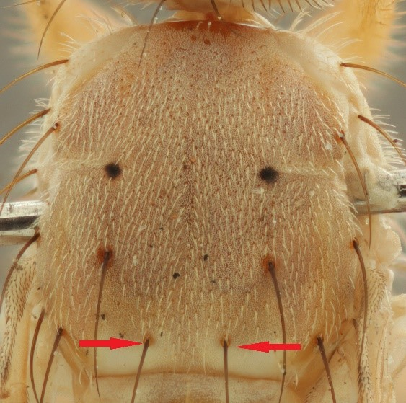 |  |  |  | [733]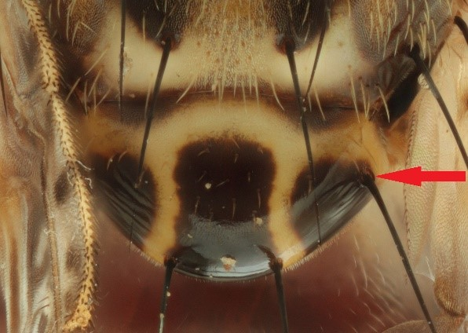
[734]Figure 1. Scutum Ceratitis quinaria; prescutellar setae present (indicated by arrows). |  |  |  | [735]Figure 2. Scutellum Ceratitis rosa; basal scutellar setae present (indicated by arrow); swollen, apically with three separated marking.
[736]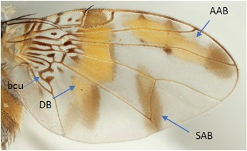 |  |  |  |  |  |  |  |  |  |  |  |  |  |  |  |  |  |  |  |  |  |  |  |  |  |  | [737]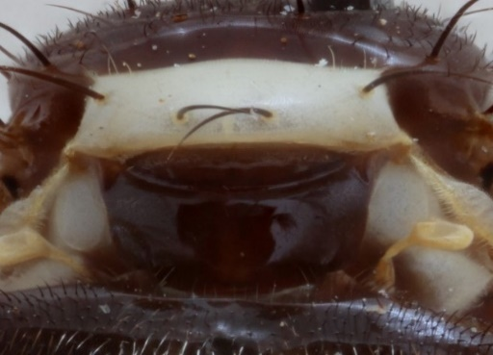
[738]Figure 3. Wing Ceratitis capitata. Abbreviations: AAB=anterior apical band, bcu = wing cell bcu indicating location of constriction at base; DB=discal band, SAB=subapical band. |  |  |  |  |  |  |  |  |  |  |  |  |  |  |  |  |  |  |  |  |  |  |  |  |  |  | [739]Figure 4. Scutellum Perilampsis tetradactyla; flat.
[740]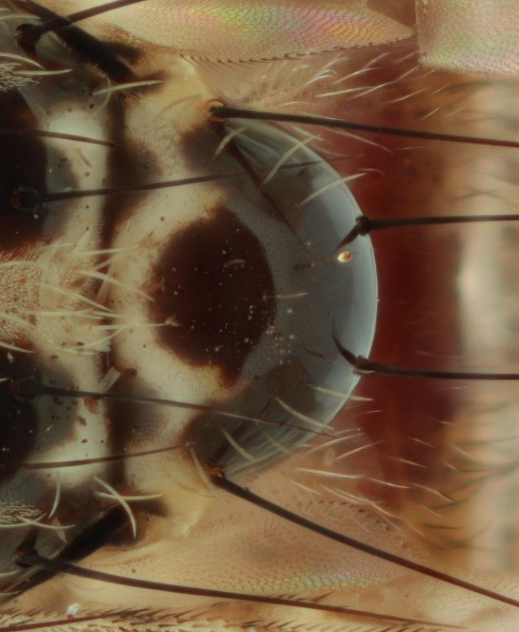 |  |  |  |  |  |  |  |  |  |  |  |  |  |  |  |  |  |  |  |  |  |  |  |  |  | [741]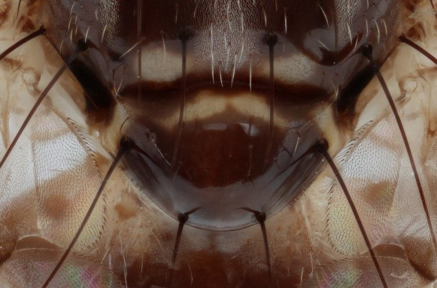
[742]Figure 5. Scutellum Ceratitis capitata; apical markings fused. |  |  |  |  |  |  |  |  |  |  |  |  |  |  |  |  |  |  |  |  |  |  |  |  |  | [743]Figure 6. Scutellum Ceratitis gravinotata; apical markings covering most of scutellar dorsal surface.
[744]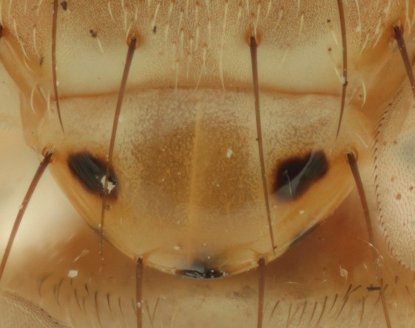 |  | [745]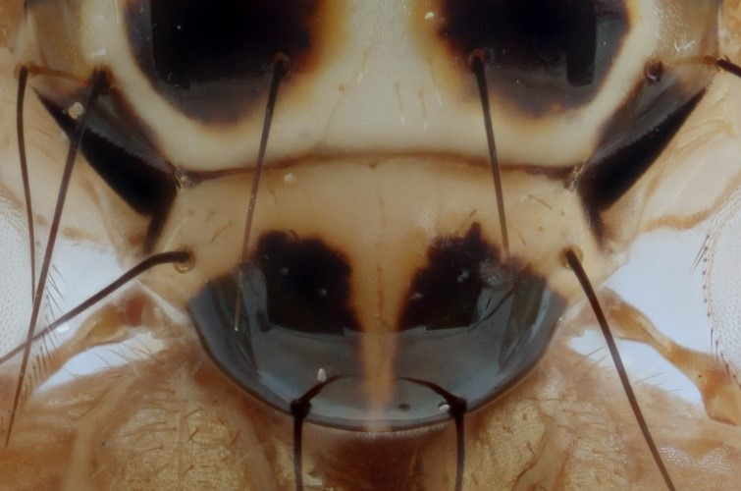
[746]Figure 7. Scutellum Ceratitis quinaria; apical markings reduced to small dark spots. |  | [747]Figure 8. Scutellum Capparimyia savastani; with two dark markings.
[748]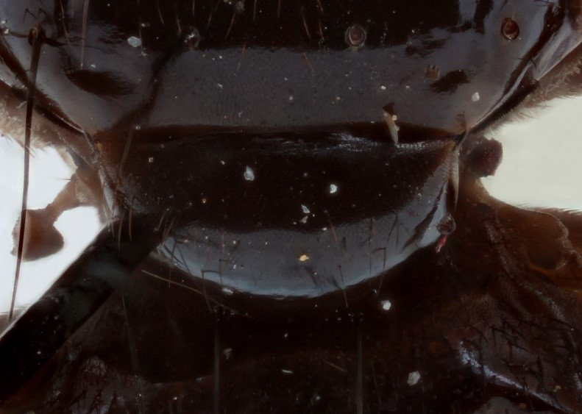 |  |  |  |  |  |  |  |  |  |  |  |  |  |  |  |  |  |  |  |  |  |  |  |  |  |  |  | [749]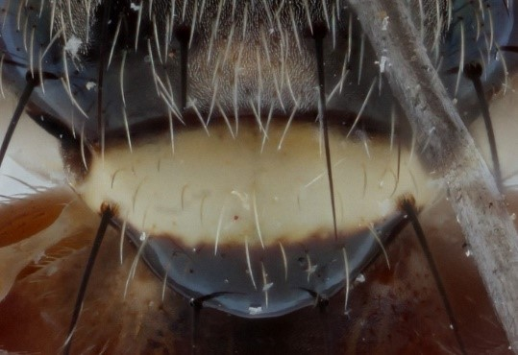
[750]Figure 9. Scutellum Trirhithrum obscurum; largely to completely black dorsal surface. |  |  |  |  |  |  |  |  |  |  |  |  |  |  |  |  |  |  |  |  |  |  |  |  |  |  |  | [751]Figure 10. Scutellum Neoceratitis cyanescens; apically with single dark marking.
[752]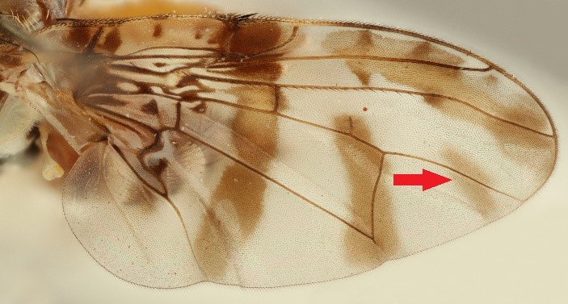 |  |  |  |  |  |  |  |  |  |  |  |  |  |  |  |  |  |  |  |  |  |  |  | [753]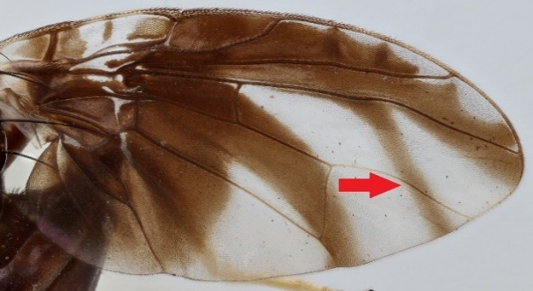
[754]Figure 11. Wing Ceratitis rubivora; posterior apical band (PAB, indicated by arrow present. |  |  |  |  |  |  |  |  |  |  |  |  |  |  |  |  |  |  |  |  |  |  |  | [755]Figure 12. Wing Trirhithrum nitidum; wing posterior apical band (PAB, indicated by arrow) present.
[756]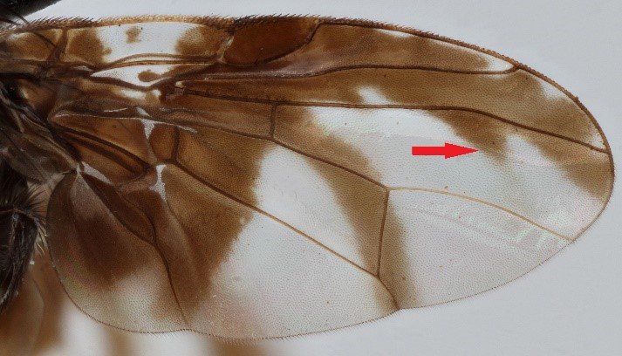 |  |  |  |  |  |  |  |  |  |  |  |  |  |  |  |  |  |  |  |  |  |  |  |  |  |  |  |  | [757]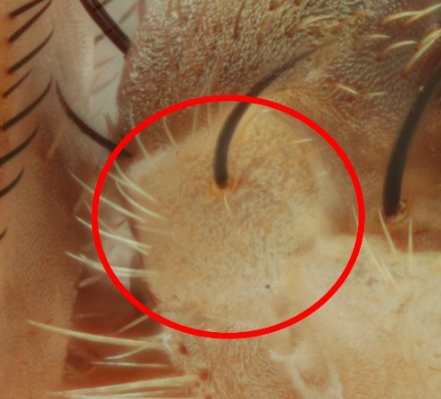
[758]Figure 13. Wing Trirhithrum occipitale; wing posterior apical band reduced to toothlike appendage (indicated by arrow). |  |  |  |  |  |  |  |  |  |  |  |  |  |  |  |  |  |  |  |  |  |  |  |  |  |  |  |  | [759]Figure 14. Postpronotal lobe (lateral view, indicated by circle) Ceratitis rosa unicolorous.
[760]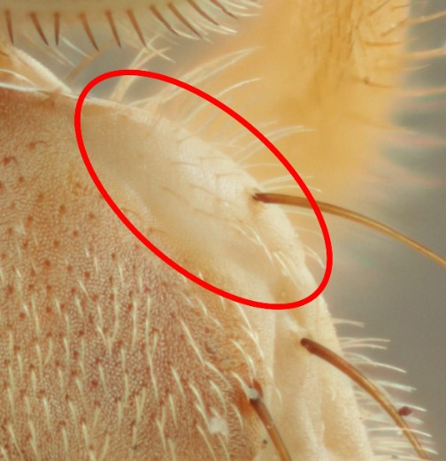 |  |  |  |  |  |  |  |  |  |  |  |  |  |  |  |  |  |  |  |  |  |  |  |  | [761]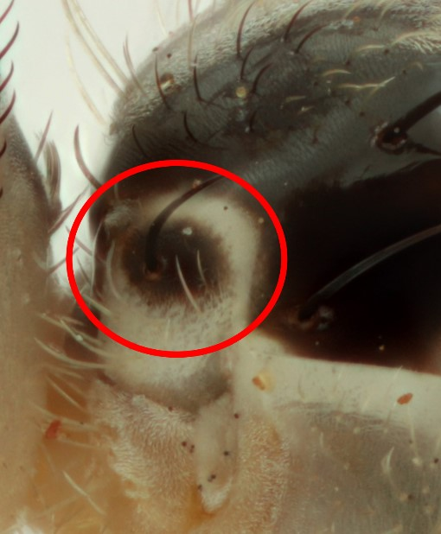
[762]Figure 15. Postpronotal lobe (dorsal view, indicated by circle) Ceratitis quinaria unicolorous. |  |  |  |  |  |  |  |  |  |  |  |  |  |  |  |  |  |  |  |  |  |  |  |  | [763]Figure 16. Postpronotal lobe (lateral view, indicated by circle) Ceratitis capitata pale with black median spot.
[764]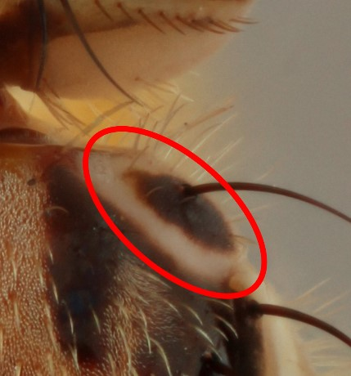 | [765]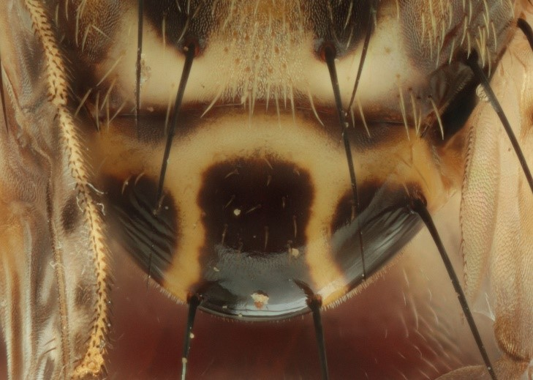
[766]Figure 17. Postpronotal lobe (dorsal view, indicated by circle) Ceratitis caetrata pale with black median spot. | [767]Figure 18. Scutellum Ceratitis rosa; apically with three separate dark spots.  [768]
[769]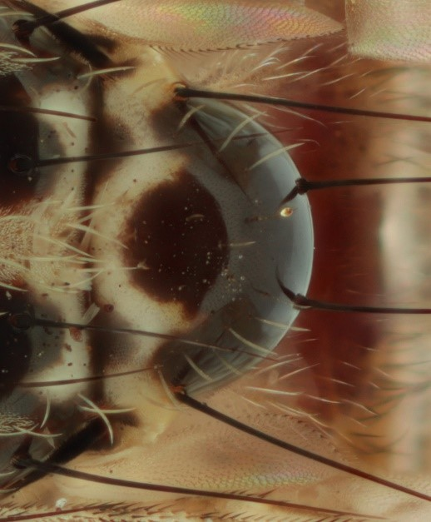 |  |  |  |  |  |  |  |  |  |  |  |  |  |  |  |  |  |  |  |  |  | [770]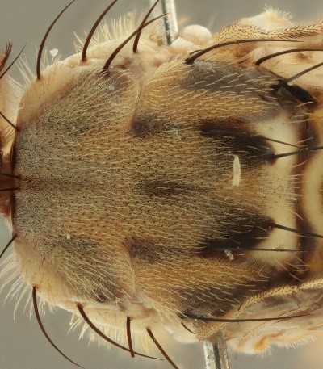
[771]Figure 19. Scutellum Ceratitis capitata; apical spots merged into one marking. |  |  |  |  |  |  |  |  |  |  |  |  |  |  |  |  |  |  |  |  |  | [772]Figure 20. Scutum Ceratitis rosa; greyish to greyish brown with indistinct darker markings.
[773]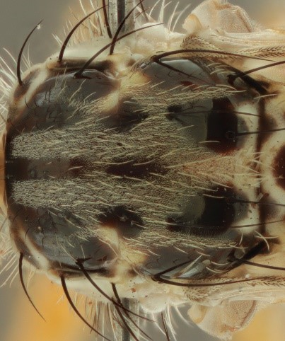 |  |  |  |  |  | [774]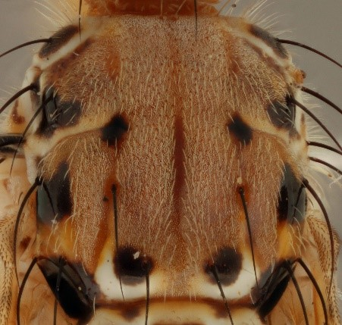
[775]Figure 21. Scutum Ceratitis capitata; grey with distinct black markings. |  |  |  |  |  | [776]Figure 22. Scutum Ceratitis cosyra; yellow-orange to orange ground colour with distinct black markings.
[777]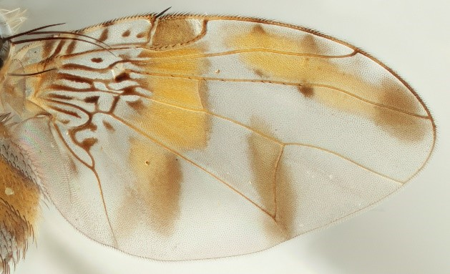 |  |  |  |  |  |  |  |  |  |  |  |  |  |  |  |  |  |  |  |  |  | [778]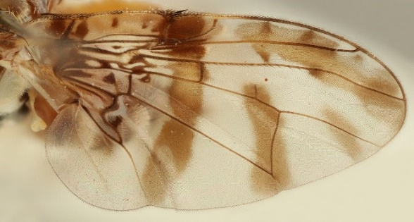
[779]Figure 23. Wing Ceratitis capitata; anterior apical band completely separated from discal band. |  |  |  |  |  |  |  |  |  |  |  |  |  |  |  |  |  |  |  |  |  | [780]Figure 24. Wing Ceratitis rubivora; anterior apical band completely separated from discal band.
[781]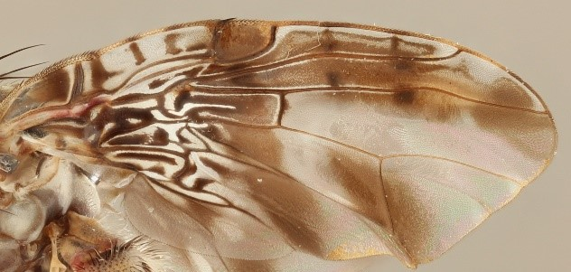 |  |  |  |  |  |  |  |  |  |  |  |  | [782]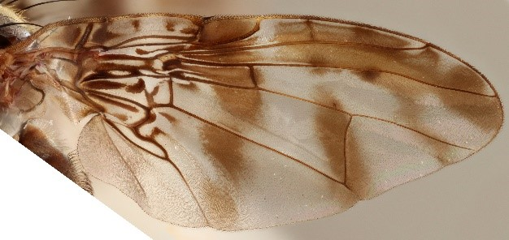
[783]Figure 25. Wing Ceratitis edwardsi; anterior apical band connected with discal band. |  |  |  |  |  |  |  |  |  |  |  |  | [784]Figure 26. Wing Ceratitis cuthbertsoni; anterior apical band partially separated from discal band.
[785]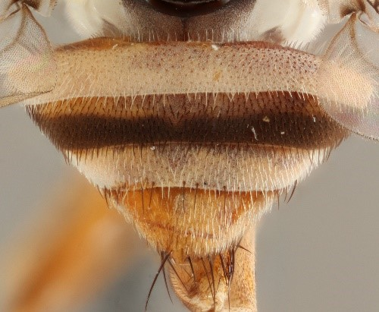 |  |  |  |  |  |  |  |  |  |  |  |  |  |  |  |  |  |  |  |  |  |  |  |  |  | [786]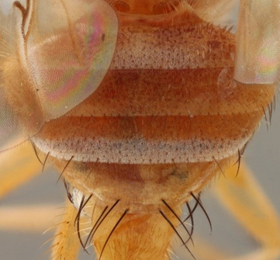
[787]Figure 27. Abdomen Ceratitis colae; third tergum with black-brown transverse band. |  |  |  |  |  |  |  |  |  |  |  |  |  |  |  |  |  |  |  |  |  |  |  |  |  | [788]Figure 28. Abdomen Ceratitis argenteobrunnea; third tergum without black-brown transverse band.
[789]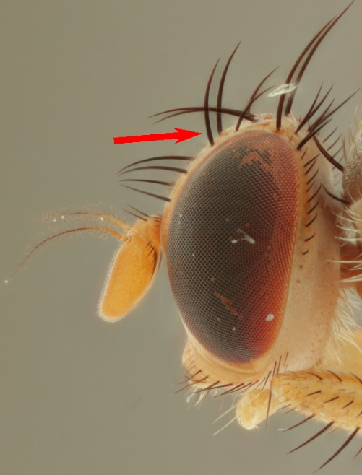 |  |  |  |  |  |  |  |  |  |  |  |  |  |  |  |  |  |  |  |  |  |  | [790]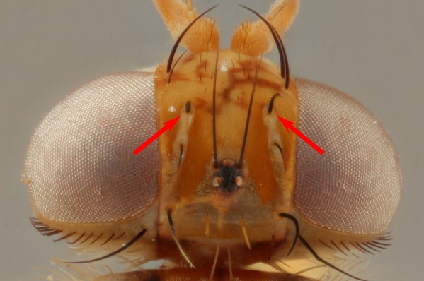
[791]Figure 29. Male head Ceratitis rosa (lateral view); lower orbital seta bristle like, not modified apically (indicated by arrow). |  |  |  |  |  |  |  |  |  |  |  |  |  |  |  |  |  |  |  |  |  |  | [792]Figure 30. Male head Ceratitis cosyra (dorsal view); lower orbital seta bristle like, not modified apically (indicated by arrow).
[793]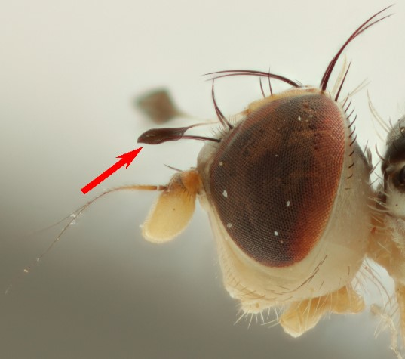 |  |  |  |  |  |  |  |  | [794]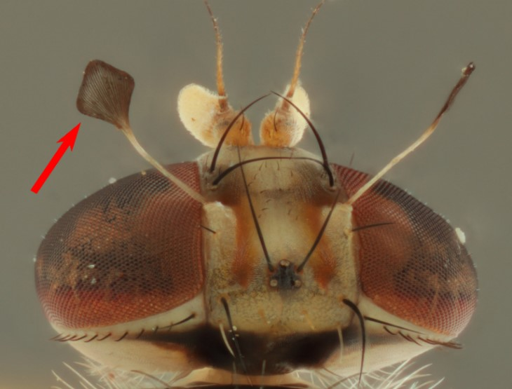
[795]Figure 31. Male head Ceratitis capitata (lateral view); lower orbital seta modified, flattened at apex (indicated by arrow). |  |  |  |  |  |  |  |  | [796]Figure 32. Male head Ceratitis capitata (dorsal view); lower orbital seta modified, flattened at apex (indicated by arrow).
[797]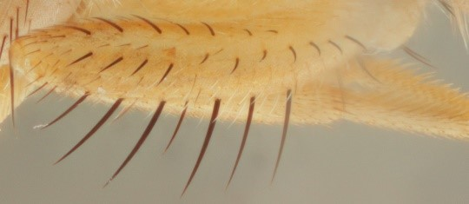 |  |  |  |  |  |  |  |  |  |  |  |  |  |  |  |  |  |  |  | [798]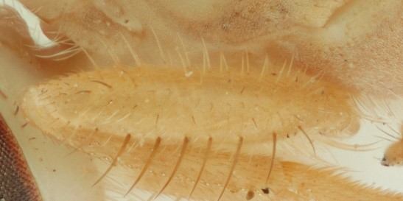
[799]Figure 33. Leg fore femur Ceratitis rosa; posteriorly with dispersed setae and with few dark hairs between posterior and posterodorsal row of setae. |  |  |  |  |  |  |  |  |  |  |  |  |  |  |  |  |  |  |  | [800]Figure 34. Leg fore femur Ceratitis quinaria; posteriorly with dispersed setae but without dark hairs between posterior and posterodorsal setae.
[801]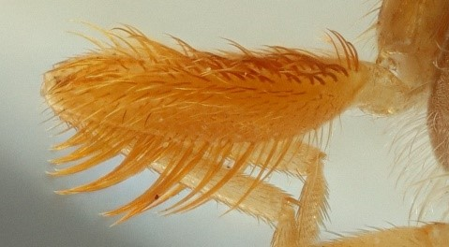 |  |  |  |  |  |  |  |  |  |  |  |  |  |  |  |  |  | [802]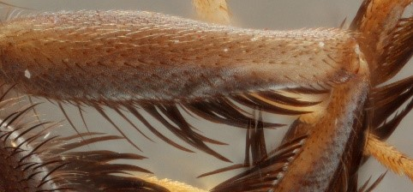
[803]Figure 35. Leg fore femur Ceratitis malgassa; posteriorly with bush of dense setae. |  |  |  |  |  |  |  |  |  |  |  |  |  |  |  |  |  | [804]Figure 36. Male leg mid femur Ceratitis anonae, ventrally with row of long stout setae ('feathering').
[805]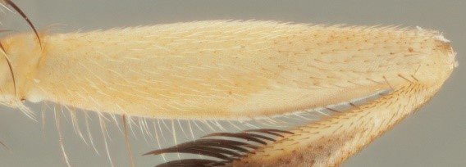 |  |  |  |  | [806]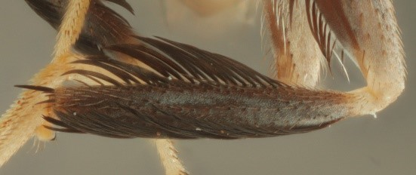
[807]Figure 37. Male leg mid femur Ceratitis quilicii, ventrally with few dispersed long but thin setae. |  |  |  |  | [808]Figure 38. Male leg mid tibia Ceratitis rubivora, along lateral margins with row of long black stout setae (feathering) for more than 3/4 of entire length, and pale to brownish coloured over entire length.
[809]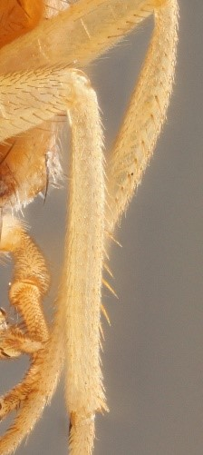 |  |  |  |  | [810]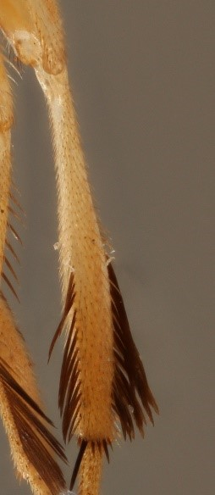
[811]Figure 39. Male leg, mid tibia Ceratitis argenteobrunnea, along lateral margins with few dispersed short setae and pale coloured over entire length |  |  |  |  | [812]Figure 40. Male leg, mid tibia Ceratitis fasciventris, along lateral margins with row of long stout setae (feathering) for less than half of apical part and usually pale coloured, at most area between feathering partially darker yellow to brownish coloured.
[813]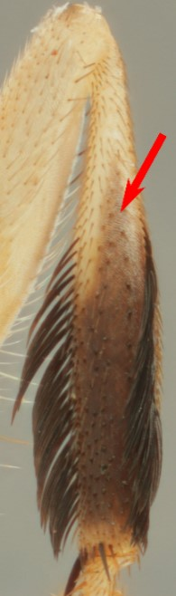 |  |  |  |  | [814]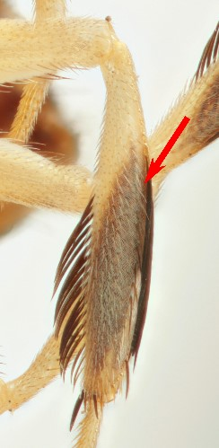
[815]Figure 41. Male leg, mid tibia Ceratitis quilicii, along lateral margins with row of long stout setae (feathering) for more than half but less than 3/4 of entire length and pale except area between feathering where darker coloured; dark colour not reaching lateral margins in upper part (indicated by arrow). |  |  |  |  | [816]Figure 42. Male leg, mid tibia Ceratitis rosa, along lateral margins with row of long stout setae (feathering) for more than half but less than 3/4 of entire length and pale except area between feathering where darker coloured; dark colour reaching lateral margins in upper part (indicated by arrow).
[817]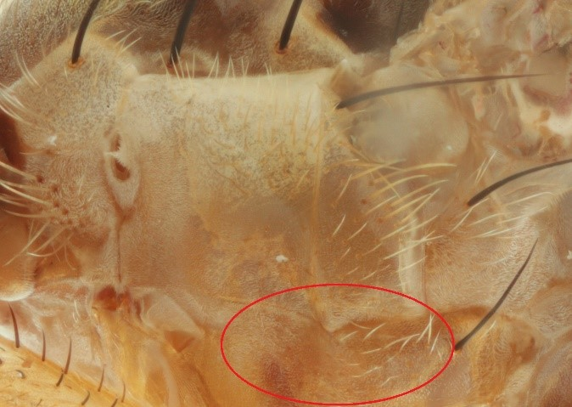 |  |  |  |  |  |  |  |  |  |  |  |  |  |  |  | [818]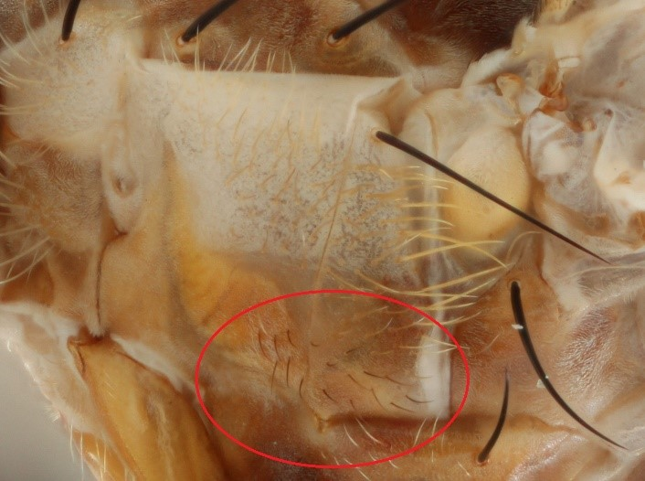
[819]Figure 43. Female anepisternum Ceratitis rosa, along ventral margin without dark hairs, pilosity completely yellow (indicated by circle). |  |  |  |  |  |  |  |  |  |  |  |  |  |  |  | [820]Figure 44. Female anepisternum Ceratitis anonae, along ventral margin with few dark hairs (indicated by circle).
[821]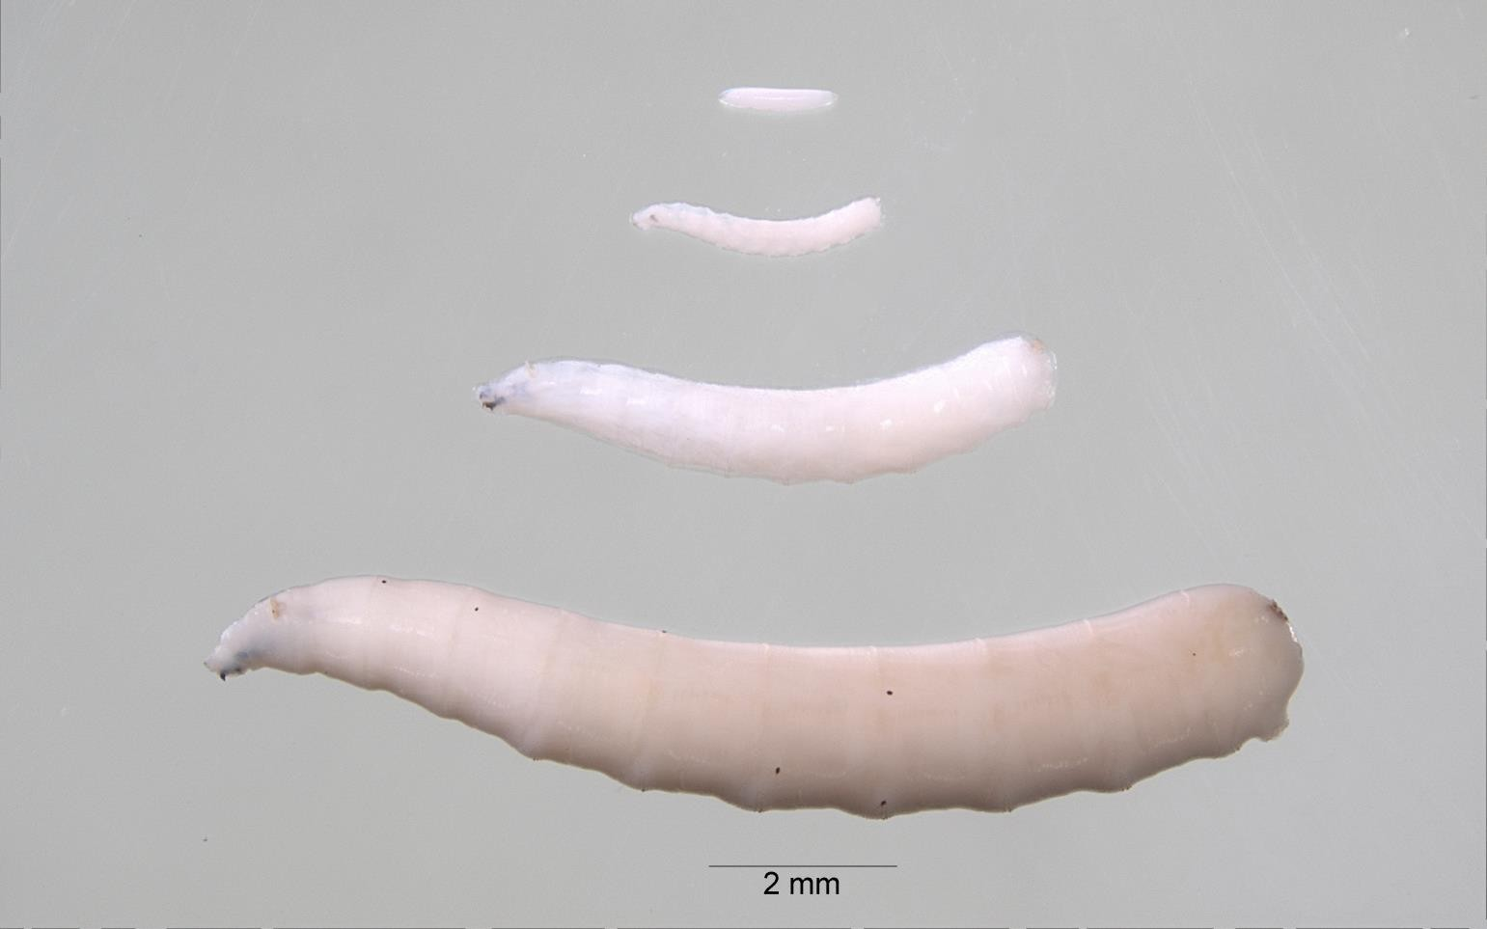
[822]Figure 45. Egg, first, second, and third instars of [Dacus bivittatus] showing differences in sizes.
[823]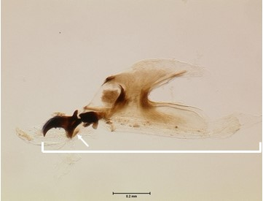 |  |  |  |  |  |  | [824]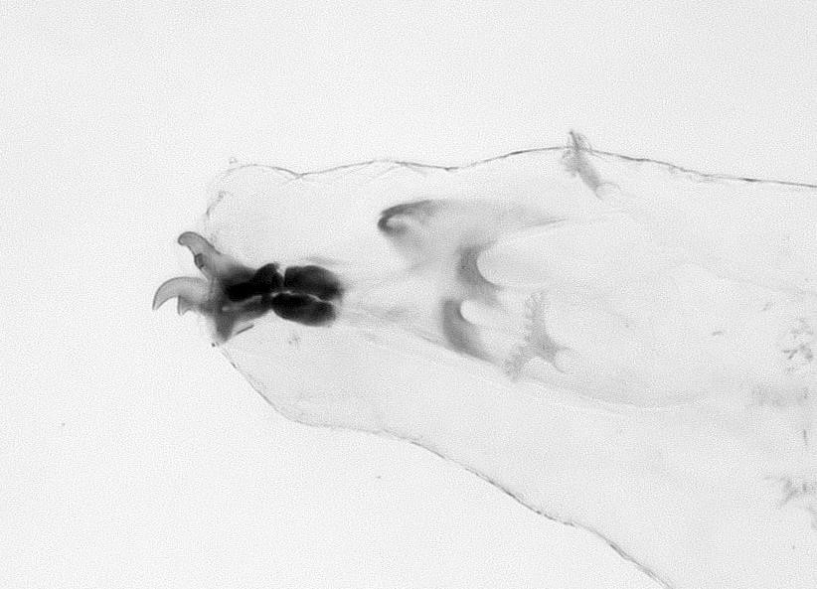
[825]Figure 46. Cephaloskeleton of Ceratitis fasciventris, third instar. Subapical tooth on mouthhook is much smaller than apical tooth. Dental sclerite present (arrow). Bar = length of cephaloskeleton. |  |  |  |  |  |  | [826]Figure 47. Cephaloskeleton of Ceratitis fasciventris, second instar. Subapical tooth on mouthhook is subequal in size to apical tooth.
[827]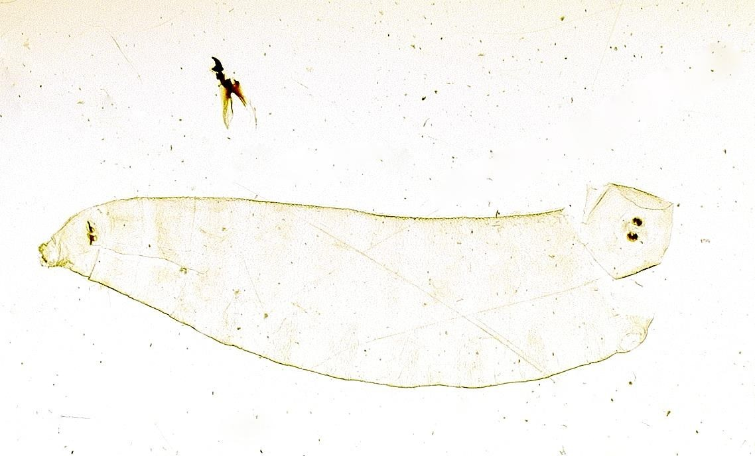
[828]Figure 48. Slide-mounted, cleared cuticle with cephaloskeleton removed.
[829]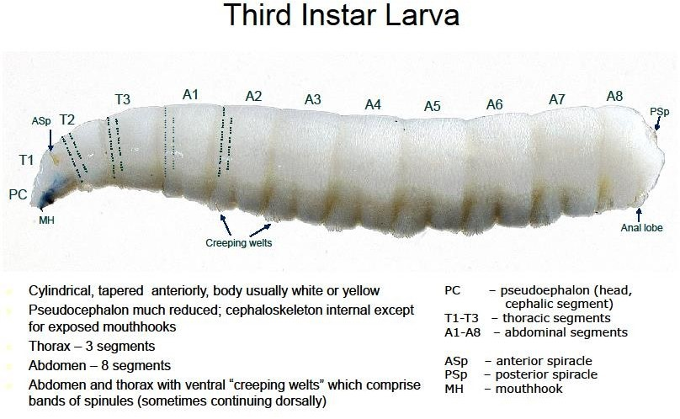
[830]Figure 49. Habitus of fruit fly larva showing location of major anatomical features.
[831]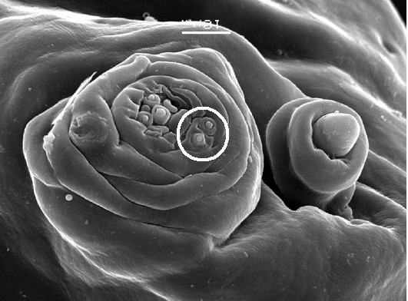 |  |  |  |  |  |  |  |  |  |  |  |  |  |  |  |  |  |  |  |  | [832]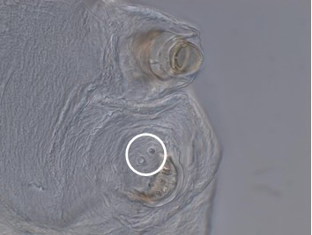
[833]Figure 50. Maxillary palpus, dorsolateral pair of sensilla (circle), and antenna of Ceratitis capitata, SEM. |  |  |  |  |  |  |  |  |  |  |  |  |  |  |  |  |  |  |  |  | [834]Figure 51. Maxillary palpus, dorsolateral pair of sensilla (circle), and antenna of [Dacus bivittatus], light photomicrograph.
[835]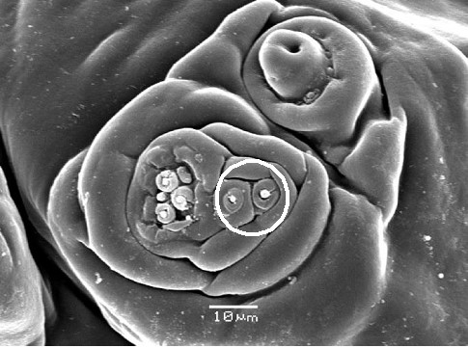 |  |  |  |  |  |  |  |  |  |  |  |  |  |  |  |  |  |  | [836]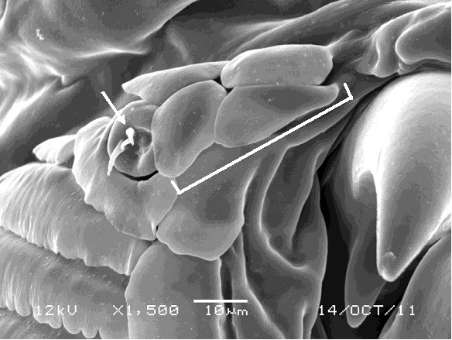
[837]Figure 52. Maxillary palpus, dorsolateral pair of sensilla (circle), and antenna of Anastrepha ludens, SEM. |  |  |  |  |  |  |  |  |  |  |  |  |  |  |  |  |  |  | [838]Figure 53. Preoral organ (arrow) and preoral lobes of Ceratitis cosyra (bar).
[839]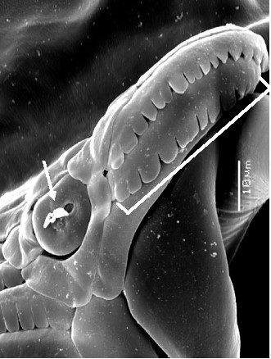 |  |  | [840]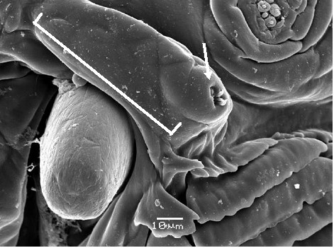
[841]Figure 54. Preoral organ (arrow) and preoral lobes of Zeugodacus cucurbitae (bar). |  |  | [842]Figure 55. Preoral organ (arrow) and preoral lobes of Anastrepha ludens (bar).
[843]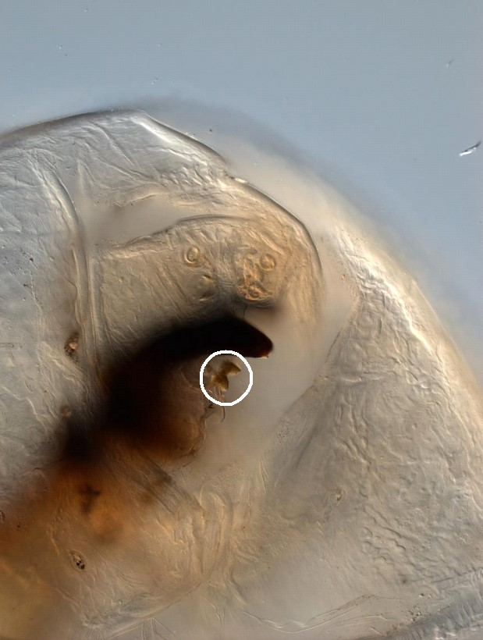 |  |  |  |  |  |  |  |  |  | [844]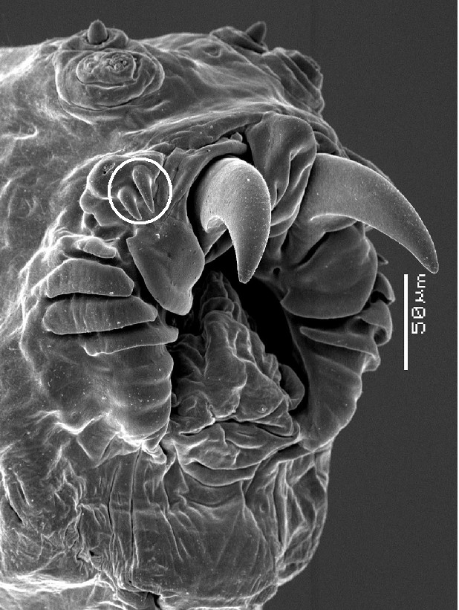
[845]Figure 56. Preoral teeth (circle) of Rhagoletis pomonella. |  |  |  |  |  |  |  |  |  | [846]Figure 57. Preoral teeth circle) of Rhagoletis  [847]pomonella, SEM
[848]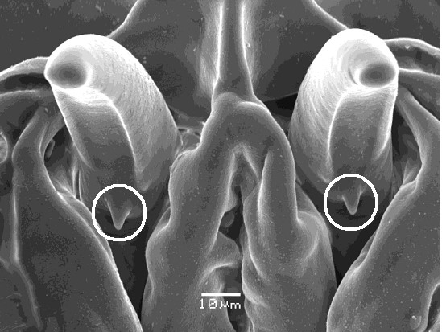 |  |  |  |  |  |  |  |  |  |  |  |  |  |  |  |  | [849]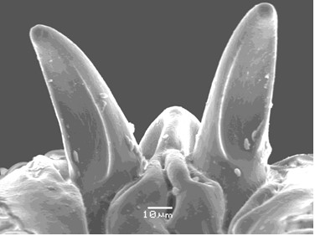
[850]Figure 58. Mouthhooks of Ceratitis rosa, with grooved ventral surface and small subapical teeth (circles). |  |  |  |  |  |  |  |  |  |  |  |  |  |  |  |  | [851]Figure 59. Mouthhooks of Ceratitis capitata, with grooved ventral surface, no teeth.
[852]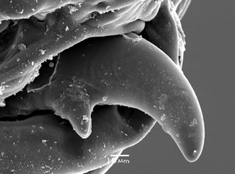 |  |  |  |  |  |  |  | [853]
[854]Figure 60. Mouthhook of Dacus bivittatus, tusk-shaped with large subapical tooth. |  |  |  |  |  |  |  | [855]
[856]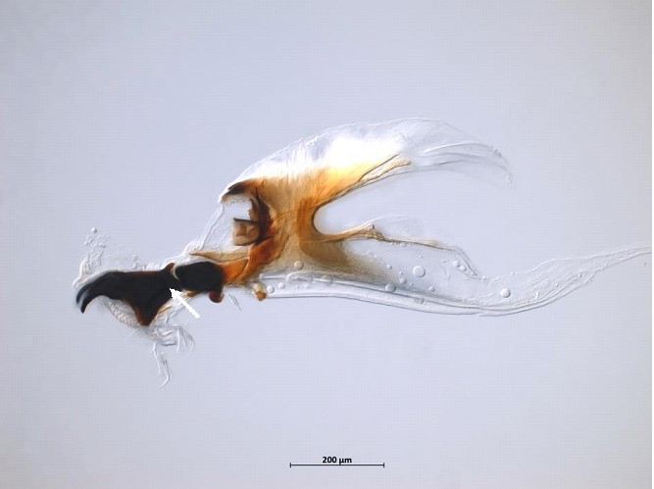 |  |  |  |  |  |  |  |  |  |  |  |  |  | [857]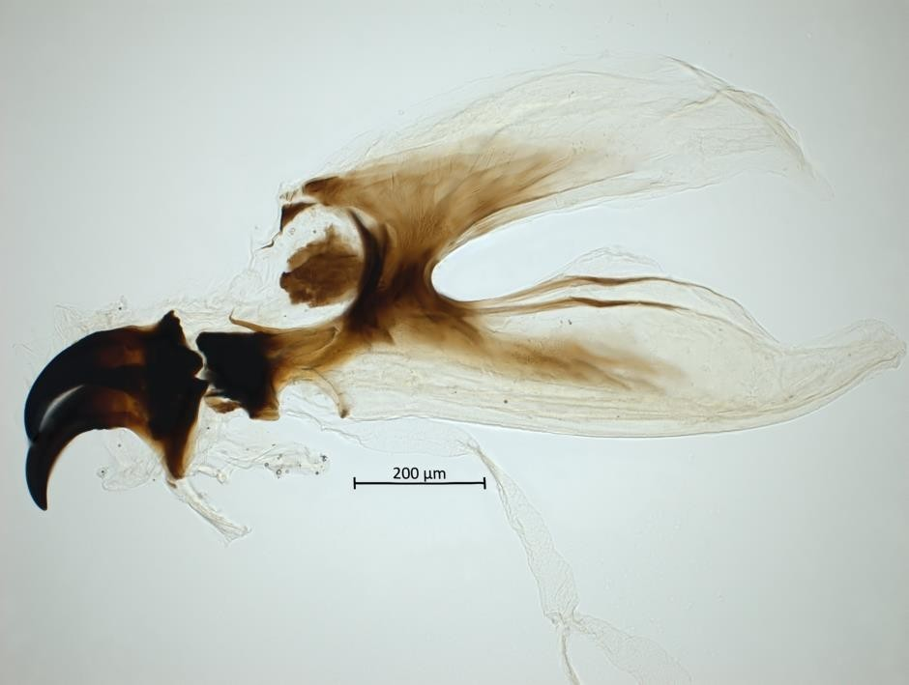
[858]Figure 61. Mouthhook of Ceratitis capitata with elongate posterior neck (arrow). |  |  |  |  |  |  |  |  |  |  |  |  |  | [859]Figure 62. Mouthhook of Anastrepha ludens with truncate posterior end.
[860]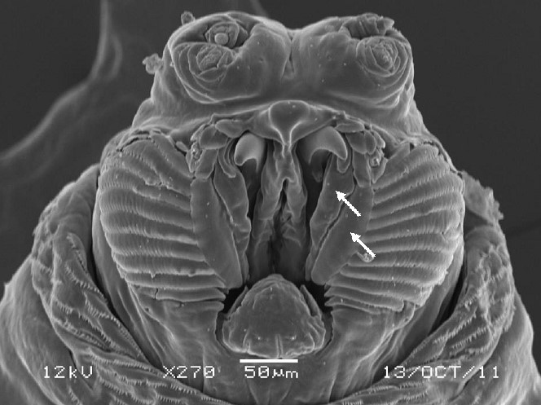 |  |  |  |  |  |  |  |  |  | [861]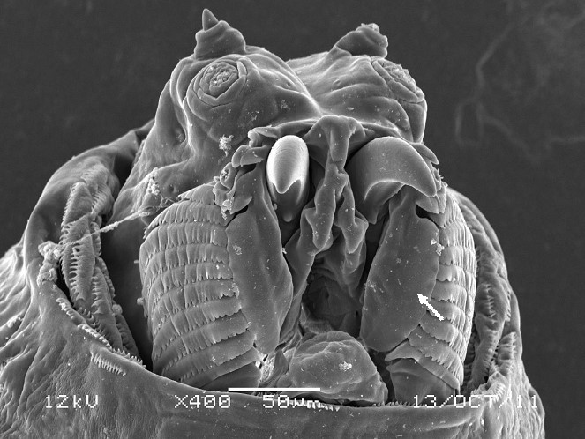
[862]Figure 63. Facial mask of Ceratitis anonae. Lateral lip is divided into narrow inner and outer lips (arrows). |  |  |  |  |  |  |  |  |  | [863]Figure 64. Facial mask of Ceratitis capitata. Lateral lip is wide, undivided (arrow).
[864]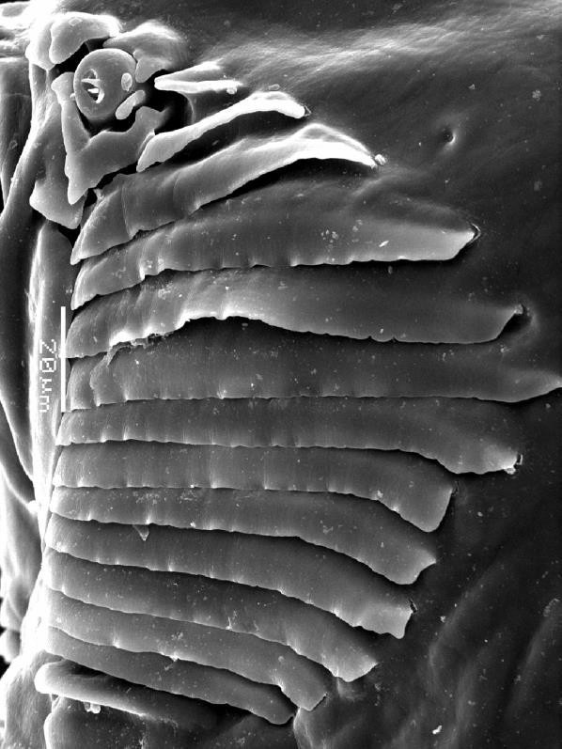 |  |  |  |  |  |  |  |  |  |  |  |  |  |  | [865]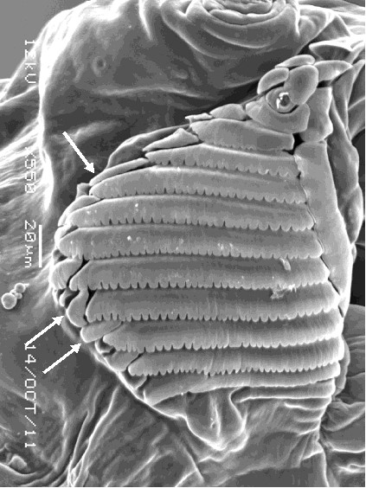
[866]Figure 65. Oral ridges of Ceratitis capitata with entire margins, no accessory plates. |  |  |  |  |  |  |  |  |  |  |  |  |  |  | [867]Figure 66. Oral ridges of Ceratitis cosyra with scalloped margins, one series of accessory plates (arrows).
[868]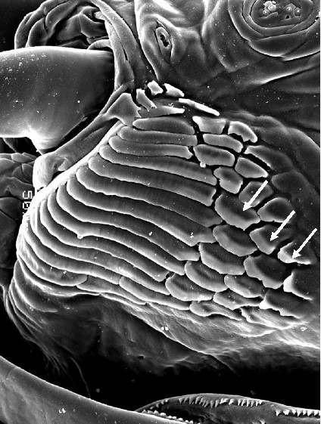 |  |  |  |  |  |  |  |  |  |  | [869]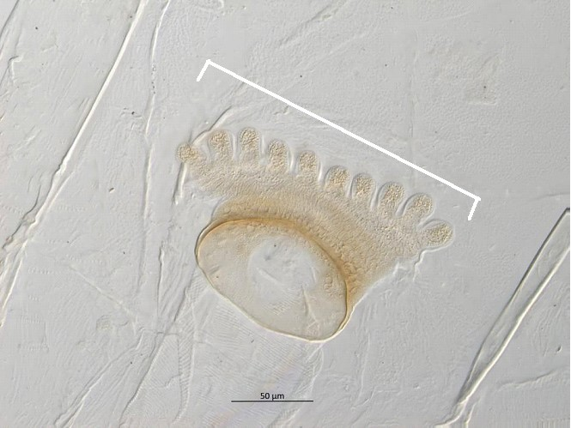
[870]Figure 67. Oral ridges of Anastrepha curvicauda with entire margins, three series of accessory plates (arrows). |  |  |  |  |  |  |  |  |  |  | [871]Figure 68. Anterior spiracle of Ceratitis rosa, flat topped. Bar = apical width.
[872]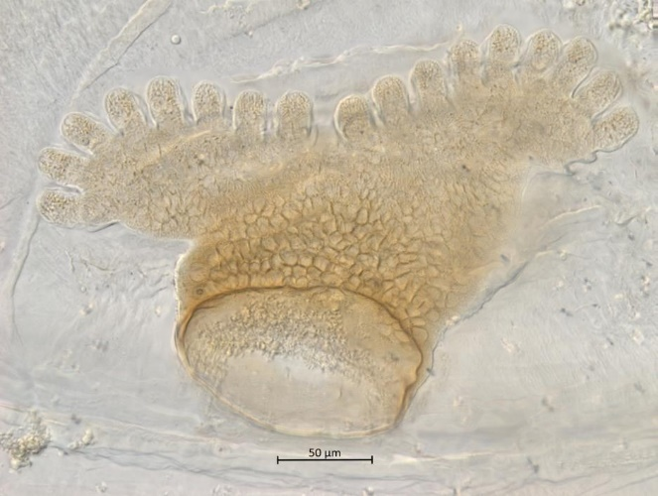 |  |  |  |  |  |  |  |  |  |  |  | [873]
[874]Figure 69. Anterior spiracle of Anastrepha ludens, bilobed. |  |  |  |  |  |  |  |  |  |  |  | [875]
[876]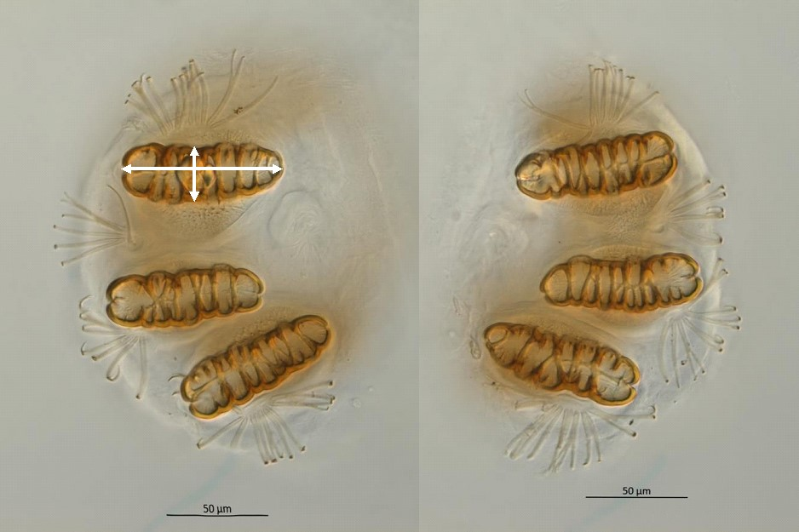
[877]Figure 70. Posterior spiracles of Ceratitis anonae. Arrows = length/width measurements.
[878]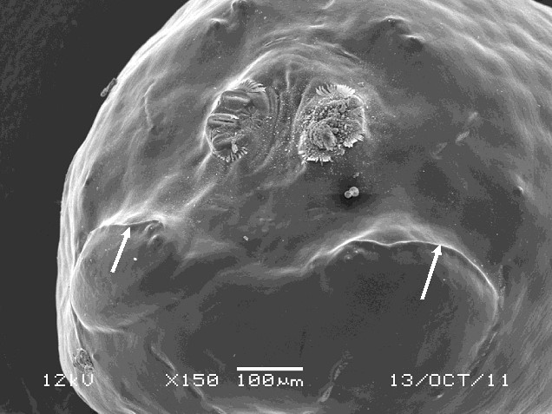 |  |  |  |  |  |  |  |  | [879]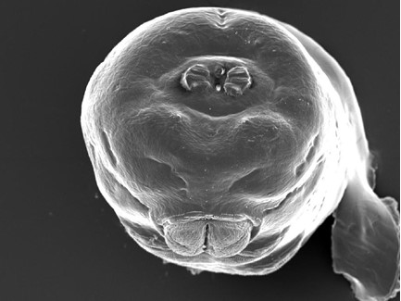
[880]Figure 71. Caudal segment of Ceratitis capitata, caudal  [881]ridges present (arrows). |  |  |  |  |  |  |  |  | [882]Figure 72. Caudal segment of Anastrepha distincta, caudal ridges absent.
[883]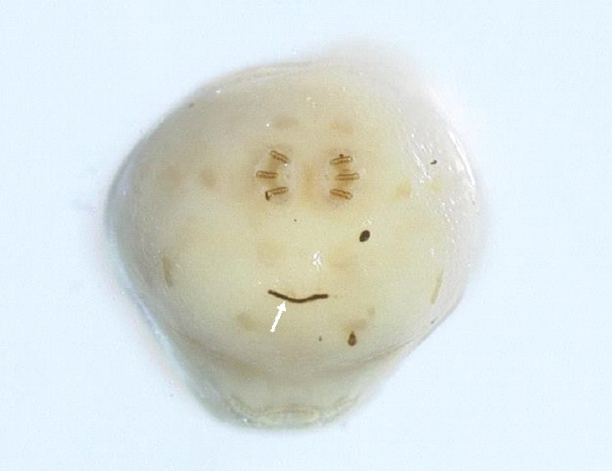
[884]Figure 73. Caudal segment of Zeugodacus cucurbitae with black line (arrow) below caudal ridges.
[885]

