Abstract

Recommendations for the CPM for implementation timeline, budgetary considerations, and monitoring of the eight development agenda items of the strategic framework.

IPPC Strategic Framework 2020-2030 Developmental agenda Items Implementation plan

August 2022

**Outline for Report on Overarching Integrated Plan for Implementation of SFDAIs**

This would be a stand-alone report. When presented to CPM it would have a coversheet with brief background and requesting CPM note the report and agree to a list of recommendations that have been explained in the report.

# Exec Summary

A 1- or 2-page summary of the report – To be completed after SPG.

Table of Contents

Exec Summary 1

Background and Introduction 3

Developing the Implementation Plan 6

Sequencing the Development Agenda Items 7

Financial and Resource Plan 8

Monitoring & Evaluation Framework 10

Governance 10

Review 12

Monitoring and evaluation 13

Plan Summaries for SFDAIs 15

Harmonization of electronic data exchange 15

Commodity-specific ISPMs 15

Management of e-commerce and postal and courier pathways 17

Developing guidance on the use of third-party entities 18

Strengthening pest outbreak alert and response systems (POARS) 19

Assessment and management of climate change impacts on plant health 21

Global phytosanitary research coordination 22

Diagnostic laboratory networking 22

Investment Prospectus 23

Conclusions 23

APPENDIX A - Agenda Item #1 - Harmonization of electronic data exchange 24

APPENDIX B - Agenda Item #2 - Commodity and pathway specific ISPMs 24

APPENDIX C - Agenda Item #3 - Management of e-commerce and postal courier pathways 25

APPENDIX D - Agenda Item #4 - Developing guidance on the use of third-party entities 28

APPENDIX E - Agenda Item #5 - Strengthening pest outbreak alert and response systems 28

APPENDIX F - Agenda Item #6 - Assessment and management of climate change impacts on plant health 30

APPENDIX G - Agenda Item #7 - Global phytosanitary research coordination 32

APPENDIX H - Agenda Item #8 - Diagnostic laboratory networking 32

APPENDIX I – SFDAI reporting template 33

APPENDIX J – CPM Focus Group membership 33

# Background and Introduction

Non-native plant pests threaten the health of the world’s plants. Some of these, such as *Spodoptera frugiperda* (fall armyworm) and tomato brown rugose fruit virus, impact food security and economic prosperity, while others, such as *Agrilus planipennis* (emerald ash borer) and *Anoplophora glabripennis* (Asian longhorn beetle), impact the productivity and biodiversity of forests and the wild flora of the natural environment. The likelihood of these pests being introduced into new countries has increased with the globalisation of trade, as the volume and diversity of plants, plant products and other objects moving around the world has grown. The risk has also increased with climate change, as the climate of parts of the world have become more suitable for the establishment and spread of non-native species, and new trade pathways have opened up due to global changes in plant distribution and production.

It is therefore more important than ever that we tackle this issue with a coordinated global effort. This is recognised in the Strategic Framework for the International Plant Protection Convention (IPPC) 2020-2030, which sets out the following mission, vision, goal and strategic objectives:

**Mission** – Protect global plant resources and facilitate safe trade

**Vision** – The spread of plant pests is minimized and their impacts within countries are effectively managed

**Goal** – All countries have the capacity to implement harmonized measures to prevent pest introductions and spread, and minimize the impacts of pests on food security, trade, economic growth, and the environment.

**Strategic Objectives –**

1. Enhance global food security & increase sustainable agricultural productivity.
2. Protect forests and the environment from the impacts of plant pests.
3. Facilitate safe trade & economic growth.

These will be achieved in part through the core activities of the IPPC, including:

* development of international standards recognized by the WTO-SPS agreement as providing technically justified and harmonized phytosanitary measures for trade to manage the pest and disease risks to plants;
* implementation of standards and capacity development by contracting parties, through the use of the phytosanitary capacity development tool, production of guidance materials and coordination of training; and
* communication of the IPPC’s principles and the importance of protecting plants from plant pests.

The strategic framework also outlines eight new development agenda items (or work programmes) aligned to the mission, vision, goal and strategic objectives. These have been identified based on the anticipated changes to the operational environment of national, regional, and global plant protection organizations, and the associated opportunities and challenges. They are designed to deliver tangible benefits to implementing countries. In brief, these eight development agenda items are:

1. **Harmonization of electronic data exchange** – A global system for production and exchange of electronic phytosanitary certificate information.
2. **Commodity- and pathway-specific ISPMs** – The adoption and implementation of international standards for specific commodities and pathways, with accompanying diagnostic protocols and phytosanitary treatments to support implementation.
3. **Management of e-commerce and postal and courier pathways** – A coordinated international effort to substantially reduce the spread of pests and pest host material sold through e-commerce and distributed through mail and courier pathways.
4. **Developing guidance on the use of third-party entities** – The implementation of ISPM 45 Requirements for national plant protection organizations using third party entities to perform phytosanitary actions.
5. **Strengthening pest outbreak alert and response systems** - A system to evaluate and communicate timely information on emerging pest risks and assist countries to secure funds, expertise, and resources to respond quickly and effectively to an outbreak.
6. **Assessment and management of climate change impacts on plant health** – To raise awareness of climate change impacts on plant health; enhance how these impacts are evaluated and managed in plant health; and raise the profile of these impacts in the international climate change debate.
7. **Global phytosanitary research coordination** – An analysis of international phytosanitary research structures and policies to explore how improved international coordination of plant health research could help countries to avoid overlap in research activities and to utilize research resources in the most efficient and effective manner.
8. **Diagnostic laboratory networking** – Establishing a network of diagnostic laboratory services and diagnostic protocols to help countries identify pests in a more reliable and timely manner.

These development agenda items are ambitious, complex, and will require significant funding and resources to complete. All have the potential to significantly advance IPPC Strategic Objectives, as visualized in Figure 1. Some may be more complex or difficult to implement than others. In Figure 1, complexity of implementation is referring to how challenging it will be for the IPPC to establish the necessary policies, standards, and other mechanisms to develop and implement the initiative. However, for some individual countries implementation may be much more challenging or much less challenging, e.g. for countries already using the ephyto solution implementation may now be quite straightforward while for others it may be a major challenge. Each country may be able to create their own illustration of impact, complexity, and resourcing required, for implementation in their own country.

This document sets out how each of these agenda items will be achieved as part of an overarching implementation plan. The plan includes clear milestones and activities with realistic timeframes for each item, and the funding and resources needed for completion. Given the competing demands of the IPPC Secretariat and contracting parties, these development agenda items cannot be carried out simultaneously, so this plan also describes how they will be sequenced out until 2030.

This plan should be accompanied by an investment prospectus, which would outline each of the development agenda items with timelines, deliverables, impacts and resource needs. This publication could be used with donor organizations to attract resources for individual projects and the overall programme of work.

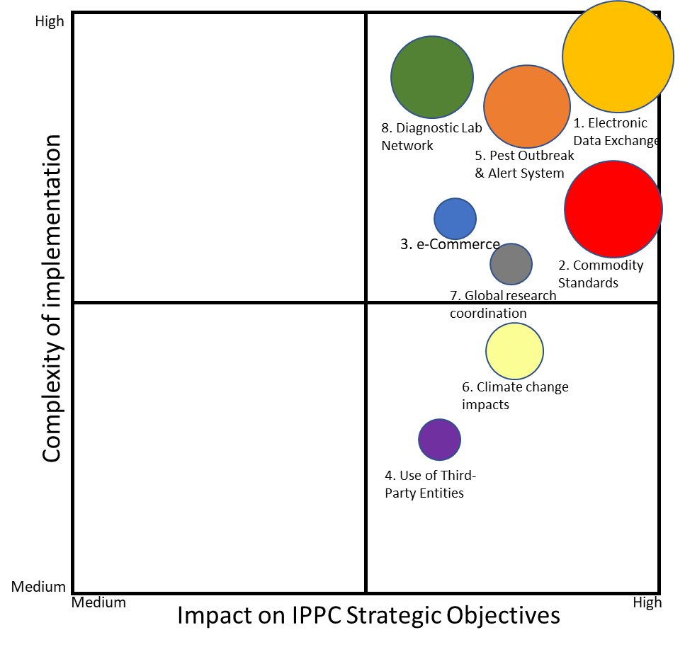

**Figure 1.** IPPC Strategic Framework Development Agenda Item: Illustrative degree of complexity vs. impact on IPPC strategic objectives. The size of the circle illustrates the relative amount of resource required to deliver the project.

# Developing the Implementation Plan

The development agenda items in the Strategic Framework for the International Plant Protection Convention (IPPC) 2020-2030 present great opportunities to progress the mission of the IPPC and to deliver tangible benefits to implementing countries. However, work on these development agenda items is dependent on adequate funding and resources being secured. Without significant cuts in the existing core work programme of the IPPC, regular programme funds are inadequate to deliver the strategic initiatives within reasonable timeframes. Additional funds must be sourced from either: the FAO, member country voluntary contributions, donor organisations (e.g. STDF, World Bank), or new funding arrangements (e.g. a new mechanism to reimburse the cost of delivering the ePhyto solution). Contracting party resourcing is also an issue, as often capacity and capability of contracting parties to engage with IPPC activities is limited when balanced against other priorities within their countries. This often means the bulk of the work rests with the IPPC Secretariat and a small number of countries.

When the Strategic Framework was presented to CPM-14 in 2019, a paper proposing a high-level five-year budget for the IPPC Secretariat was presented, but this was only noted by the CPM and not taken further. However, some contracting parties did recommend during the session of the CPM that a detailed and costed operational plan should be developed for the implementation of the entire Strategic Framework 2020 - 2030.

The Strategic Planning Group (SPG) in 2020 also highlighted the need to sequence out and carefully plan the implementation of the development agenda items. CPM 15 in 2021 therefore, agreed to establish a CPM Focus Group to develop an overarching implementation plan, with clear development agenda item start dates, milestones, timelines, monitoring and evaluation frameworks, and estimations of required budget and resources.

The CPM Focus Group was established in September 2021 and included representatives from NPPOs of the FAO regions, one representative from the ten RPPOs, one representative from the CPM Bureau, one representative from the Standards Committee, and one representative from the Implementation and Capacity Development Committee (see Appendix J). Members of the IPPC Secretariat also provided support to the group.

Some agenda items were well advanced and others had not yet started. Some had funding and short-term plans in place while others had yet to begin. No agenda items had clear goals, deliverables, or budgets over the long-term. Typically planning did not extend beyond a two-year horizon. The CPM Focus Group worked with the IPPC Secretariat, subsidiary bodies, other focus groups and steering committees to develop more detailed long-term plans for each of the development agenda items. This involved the following stages:

1. The IPPC Secretariat prepared a summary of the current state of development agenda items
2. The CPM Focus Group brainstormed milestones and activities for the development agenda items to inform planning
3. The CPM Focus Group developed two templates to capture planning information for the development agenda items: a high-level planning template, which included information on the delivery groups, stage of implementation, outcomes, issues and risks; and a milestones and resources template, which included information on the milestones, activities, funding and resources
4. The CPM Focus Group worked with the IPPC Secretariat and other relevant bodies to fill in the templates
5. The CPM Focus Group and IPPC Secretariat used the information in these templates to plan out the development agenda items to 2030, including estimations of funding and resources

The development of long-term plans for each of the development agenda items allowed the CPM Focus Group to sequence the various activities and ensure that the IPPC Secretariat and other bodies do not become overwhelmed over the course of the Strategic Framework. The monitoring and evaluation framework for the overarching implementation plan was developed in parallel.

# Sequencing the Development Agenda Items

Implementation of some agenda items commenced while the Strategic Framework was being drafted. Others commenced as soon as CPM endorsed the draft Strategic Framework in 2019. This urgency to deliver provides evidence of the value contracting parties see in the new development agenda items. However, pressure on IPPC Secretariat and contracting party resources, both time and funding, mean that it is difficult to work on all the development agenda items simultaneously. Sequencing therefore needs consideration.

Five phases are used to describe the work to implement the development agenda items.

|  |  |
| --- | --- |
| **Not Started:** | Work has not yet commenced. Initial resources need to be allocated prior to moving into Scope and Plan phase. |
| **Scope and Plan**: | Work is underway to understand the opportunity, needs, and scope of work required and to establish a plan that will deliver an effective programme of work. A focus group or steering group supported by the IPPC Secretariat usually leads this phase. At the end of the planning stage, CPM or Bureau approval is typically granted before delivery starts. |
| **Delivery**: | The approved plan is being implemented, milestones are being achieved, and benefits are being delivered. The work is delivered using project management disciplines. It is not yet a core or ‘business as usual’ part of the Secretariat work programme. |
| **Transition**: | In this phase, the major change components of the work are completed, and benefits are starting to be realized. Planning is required to move from project-based work to a more ‘business as usual’ approach to delivery. As part of the transition, CPM will establish clear resource allocations, expectations, and monitoring and reporting requirements for the IPPC Secretariat’s ongoing delivery of the work. |
| **Ongoing core activity**: | A regular rhythm of work within scope of the development agenda item is being delivered, commonly led by the IPPC Secretariat but may still be guided by a steering group or subsidiary body. The work has become ‘business as usual’ for the Secretariat. Contracting parties carry out implementation efforts in their own countries are being supported by Secretariat advice and resources developed during earlier stages. The Secretariat monitors and reports on delivery of the work and benefits. |

It should be noted that these phases reference work at the level of the CPM and not work that may be done by contracting parties to implement the development agenda item within their countries. For example, implementing *DAI 4:* *Developing guidance on the use of third-party entities* may enter the delivery phase in 2027 for the work programme of the CPM, while some individual contracting parties may have already implemented the use of third-parties consistent with ISPM 45, and other contracting parties may never consider the use of third-parties in their countries.

Having examined the state of the work under each of the development agenda items, there are limited opportunities or benefits from substantially resequencing the development agenda items. The first six development agenda items are already in Delivery phase and should continue. Three of the six are important but relatively small and low complexity topics. The current phase for each development agenda item and the proposed timing of phases out to 2030 are illustrated in Figure 2.



**Figure 2.** Proposed Sequencing of development agenda items and approximate programme phasing.

Note that for some projects the FG SFDAI there may be value in delivering what is already planned, then conducting a new Scope & Plan phase to consider whether more activity would add additional value. The status, long-term plans and sequencing recommendations for each development agenda item are discussed in the section ‘Plan Summaries for SFDAIs’. For further detail on each development agenda item, see Appendix A-H.

# Financial and Resource Plan

Budgets have been developed for each SFDAI. They have been built bottom-up by estimating the resources required to deliver the milestones. Budgets include secretariat resources, contract costs, publication costs etc. Budgets do not include provision for the time and direct costs incurred by contracting parties as they engage in the CPM work programme to deliver these SFDAI’s.

The budgets also do not include country-specific capacity building projects organised by contracting parties to implement SFDAIs in their own countries.

The Secretariat staff costs identified are additional to existing staff costs except where specified. Proposed budgets for additional Secretariat staff use current standardized FAO costings. It is recognised some people deployed to the work may be lower cost contractors or in-kind staff provided by contracting parties. However, at this stage we are unable to predict for each component of the work whether it should be performed by a permanent member of staff, a contractor, or an ‘in-kind’ person provided from a contracting party.

For some SFDAIs, funding from sources other than the regular programme budget have been identified in the early stages of the work. Typically, this is funding or in-kind staff have already been committed to the programme. Beyond this the FG SFDAI has not attempted to determine which budget components should be funded from regular programme verses trust funds or other sources (an exception is for harmonisation of electronic data exchange where it is assumed no funding is coming from regular programme). Some flexibility exists around where regular programme resources are allocated. The Secretariat with the CPM Bureau Finance Committee is best placed to under-take analysis of the budgets developed and propose how regular programme funds are allocated. The remainder of the budget will need to be provided from other sources.

Although not agreed by CPM, a request was made during CPM-16 (2022) for the FG SFDAI to develop two funding scenarios, one optimal and the other minimal. Only one scenario has been developed. It is simply the best estimate of the logical steps required to implement each SFDAI at a pace we think the CPM could support. For most SFDAIs the proposed steps represent the minimum requirements for successful implementation. The level of resources required to support implementation could be examined further, but this would best be done by the Bureau finance committee working with the Secretariat. The FG SFDAI is mindful that unless the SFDAIs are properly resourced, either the Secretariat will be put under increased pressure and core programmes could suffer or, implementation at the IPPC level will be poor and contracting parties will find it more difficult to implement in their countries.

Note that budget estimates for SFDAIs that are less advanced, e.g. not started, are less detailed and likely to be less accurate than for projects in advanced stages of delivery.

Total cost of the SFDAI programme is approximately $24.5 million over 8 years (including 2022). Half the budget cost is for the ePhyto Solution for which a sustainable funding mechanism is being developed.

Annually the cost of the programme ranges from $1.0 – 1.8 million per annum (excluding the ePhyto Solution).

It CPM chooses to proceed with implementation at the pace proposed, additional resources will need to be mobilized. Resource mobilization planning for each SFDAI should be part of the Scope & Plan phase. Projects should not proceed to Delivery phase until sufficient resources have been secured to support delivery.



**Figure 3:** Summary of proposed implementation budget

# Monitoring & Evaluation Framework

## Governance

Ownership of the overarching implementation plan for the Strategic Framework development agenda items rests with the Commission of Phytosanitary Measures (CPM).

As the CPM’s executive body, between CPM meetings, the CPM Bureau will provide oversight and strategic direction for the overarching implementation plan.

The Standards Committee (SC) and the Implementation and Capacity Development Committee (IC) will report to the CPM Bureau on the development agenda items and will help to coordinate their activities. The SC will be responsible for commodity and pathway specific ISPMs and the IC will be responsible for e-commerce, third party entities, pest outbreak alert and response system, climate change, global phytosanitary research coordination and diagnostic networking. The CPM Bureau will be responsible for e-phyto.

Each development agenda item will have its own implementation group as follows:

1. **Harmonization of electronic data exchange** – the E-phyto Steering Group, which provides guidance and advice on IPPC efforts to facilitate the international exchange of electronic phytosanitary information among contracting parties.
2. **Commodity- and pathway-specific ISPMS** – the Technical Panel on Commodity Standards (TPCS), which develops and updates commodity standards within the framework of the concept standard and develops guidance on related aspects.
3. **Management of e-commerce and postal and courier pathways –** The IC team on e-commerce, which helps to guide the work on e-commerce.
4. **Developing guidance on the use of third-party entities** – the IC team on developing guidance on the use of third-party entities.
5. **Strengthening pest outbreak alert and response systems** – the POARS Steering Group, which will provide coordination, guidance and advice on IPPC actions to develop and implement a Global Pest Outbreak Alert and Response System, avoiding duplication and building synergies with other systems.
6. **Assessment and management of climate change impacts on plant health** - The CPM Focus Group on Climate Change and Phytosanitary Issues, which will coordinate the development and support the implementation of the IPPC’s action plan on climate change to 1) raise awareness of the impacts of climate change on plant health; 2) enhance evaluation and management of risks of climate change to plant health and 3) enhance the adequate recognition of phytosanitary matters in the international climate change debate.
7. **Global phytosanitary research coordination** – a CPM Focus Group on Global Phytosanitary Research Coordination (yet to be established).
8. **Diagnostic laboratory networking** – a CPM Focus Group on Diagnostic Laboratory Networking (yet to be established).

Each of these groups will be led by a member of a contracting party and will be supported by one or more members of the IPPC Secretariat. The groups will be responsible for developing monitoring and evaluation plans for their respective development agenda items. The IPPC Secretariat will be responsible for coordinating development of monitoring and evaluation plans and reporting results to CPM.

See Figure 4 for reporting lines.

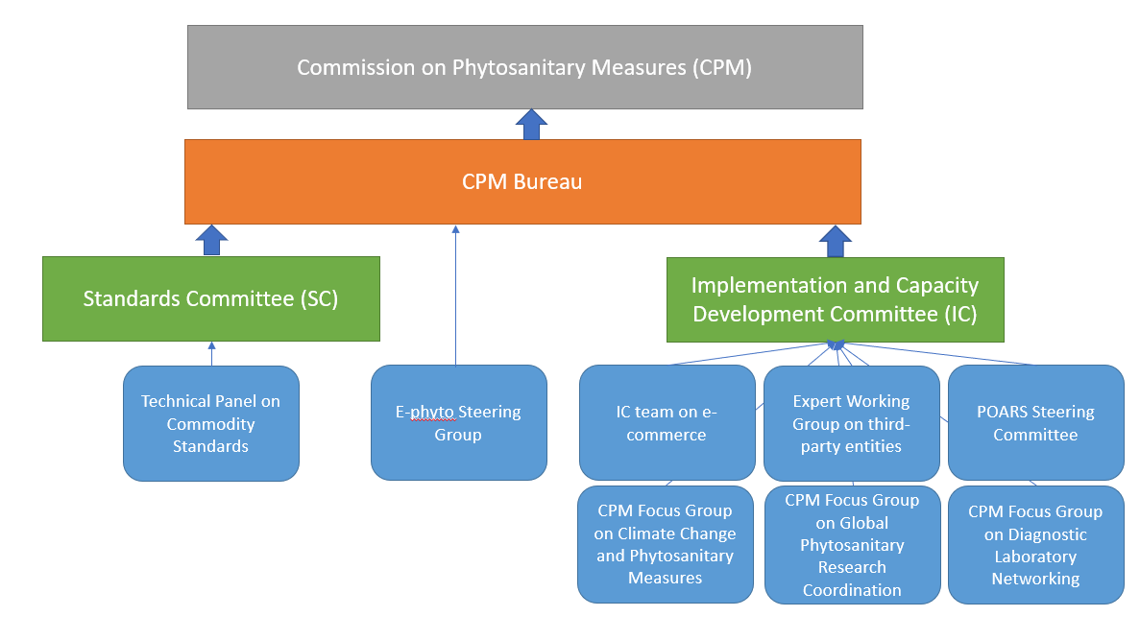

**Figure 4:** Governance structure and reporting lines for the overarching implementation plan for the Strategic Framework development agenda items.

## Review

To ensure the overarching implementation plan is progressing well and remains fit for purpose, the plan will be reviewed on a regular basis. These reviews should include plan refreshes prior to the start of each FAO biennium and a more substantial review half-way through the Strategic Framework period.

The plan refreshes should be carried out for each development agenda item by the respective implementation group. These refreshes will allow the progress of the development agenda items to be tracked and will provide the opportunity to develop more detailed short- and medium-term plans for subsequent years. By holding these refreshes prior to each FAO biennia, it will allow for any changes in funding and resources to be considered prior to the finalisation of the budget. The FAO biennia for the period of the implementation plan are 2022-23, 24-25, 26-27, 28-29 and 30-31. Any significant changes to funding and resources identified by an implementation group should be raised with the responsible group (SC or IC) and CPM Bureau as appropriate.

The more substantive review carried out half-way through the Strategic Framework period will be carried out by the CPM Bureau in 2025. In addition to assessing the progress of the development agenda items, this review will consider all development agenda items together and will identify where further sequencing of activities is required and whether there are areas of interest that should be included as development agenda items. The results of the review should be tested with the SPG and agreed by the CPM in 2026. If considered necessary, a CPM Focus Group could be established to carry out this review.

## Monitoring and evaluation

For reviews to be carried out as in the previous section, monitoring and evaluation plans should be developed for each development agenda item and for the overarching implementation plan as a whole.

Monitoring and evaluation plans for each development agenda item should be developed by the respective implementation group. These plans should be developed as soon as possible after the start of the development agenda item work programme or, if the work programme has already started, as soon as possible following April 2023.

Progress of the development agenda items should be monitored against Key Performance Indicators (KPIs), which will be focussed on milestones and deliverables. The following essential milestones and deliverables should be considered as KPIs for the development agenda items:

1. **Harmonization of electronic data exchange** 
   1. Translation of GENS into Arabic, Spanish and Russian by December 2023
   2. Approval of sustainable funding mechanism by December 2024
   3. Second international ePhyto solution conference by 2027
   4. 112 countries exchanging in production by 2030
2. **Commodity- and pathway-specific ISPMS**
   1. Prioritisation of commodity-specific annexes by April 2024
   2. Adoption of first ISPM commodity-specific annex by April 2025
   3. Study to evaluate the economic, trade and food security benefits from implementation of commodity standards initiated by 2027 by April 2027
   4. Adoption of diagnostic protocols and phytosanitary treatments for commodity-specific annexes by April 2027
   5. Study to evaluate extent of and barriers to NPPO adoption of commodity specific annexes starts by December 2028
3. **Management of e-commerce and postal and courier pathways**
   1. Completion of communications plan for e-commerce by December 2023
   2. Completion of IPPC Observatory study on e-commerce (phase 1) by December 2023
   3. Long-term planning based on recommendations from the IPPC Observatory study by December 2024
   4. Completion of IPPC Observatory study on e-commerce (phase 2) by December 2027
4. **Developing guidance on the use of third-party entities**
   1. Development of training materials by April 2023
   2. Increase in confidence in the use of third-party entities by April 2024
   3. Scope and plan whether further actions are required by April 2026
   4. Subject to CPM decision, start delivery of additional actions from 2027
5. **Strengthening pest outbreak alert and response systems**
   1. Establishment of POARS steering group and operational working groups by April 2023
   2. Establishment of POARS information system and toolbox by April 2027
   3. Establishment of POARS emergency response facility by April 2027
6. **Assessment and management of climate change impacts on plant health**
   1. Implementation of climate change action plan by December 2025
   2. Scope and plan next steps for CPM proposal by April 2026
   3. Subject to CPM decision, start delivery of deliver second tranche of initiatives to support managing climate change impacts on plant health by 2027
7. **Global phytosanitary research coordination**
   1. Investigation of existing networks by December 2025
   2. Develop proposal for research coordination by April 2026
   3. Subject to CPM decision, establish global phytosanitary research coordination by December 2027
8. **Diagnostic laboratory networking**
   1. Investigation of existing networks by June 2023
   2. Establishment of CPM Focus Group and development of proposal by April 2024
   3. Development of implementation plan by April 2026
   4. Subject to CPM decision, development of roster of service organisations/experts, administrative arrangements, and template MOUs by December 2027
   5. Piloting of a first diagnostic laboratory network by December 2028
   6. Launch the initial networks by December 2030

These milestones and deliverables should be monitored regularly by the implementation groups and could be supported by the maintenance of activity logs, with Red-Amber-Green ratings, and risk logs. Where possible, the current benchmark level of performance for a KPI (or the level prior to the project starting) should be established to help demonstrate impact.

Reports on progress against milestones and deliverables should be completed at least every 6 months using the template in annex I. Following the completion of a development agenda item or transition to business-as-usual arrangements, a final report should be written, detailing the outcomes and lessons learned from the work. All reports should be provided to the responsible group (SC or IC) and to the CPM Bureau.

In addition to monitoring and evaluation plans for each development agenda item, a plan should also be developed for the overarching implementation plan, covering all development agenda items together. This plan will be held by the CPM Bureau and will monitor progress against key milestones to allow decision making on sequencing and re-allocation of funding and resources. Reports from the individual development agenda items will form the basis of the overarching monitoring and evaluation plan.

# Plan Summaries for SFDAIs

## Harmonization of electronic data exchange

**Status:** CPM-10 (2014) confirmed support for developing an ePhyto solution. Since then, the ePhyto Solution has been built, 44 countries have deployed the GeNS system and 112 countries have ePhyto Hub connections, with 70 countries actively exchanging certificate information through the Hub. Over 2.5 million live exchanges have been made since going live in 2017 with a steep increase in usage since early 2020. The functionality of the ePhyto solution continues to grow. Substantial effort is still required within countries to implement electronic exchange.

**Long-term plan: TBC**

**Financial plan:** To carry out the activities of the work programme, the following funding will be required:

|  |  |  |  |  |  |  |  |  |
| --- | --- | --- | --- | --- | --- | --- | --- | --- |
| 2023  ($’000) | 2024  ($’000) | 2025  ($’000) | 2026  ($’000) | 2027  ($’000) | 2028  ($’000) | 2029  ($’000) | 2030  ($’000) | Total  ($’000) |
| $1,071 | $1,147 | $1,330 | $1,410 | $1,498 | $1,498 | $1,498 | $1,498 | $11,926 |

Resources will include IPPC Secretariat staff and members of the ePhyto Steering Group.

**Sequencing recommendation:** FG SFDAI recommends that this should continue in Delivery phase until sustainable funding arrangements are in place, then transition to ongoing core activity. During or prior to transition, there should be consideration of the following: to have a permanent staff position to lead the Secretariat ePhyto work programme; future governance arrangements; change control and approval processes; standardized regular reporting.

**Monitoring & Evaluation KPIs:** The following KPIs are anticipated.

1. Translation of GENS into Arabic, Spanish and Russian by December 2023
2. Approval of sustainable funding mechanism by December 2024
3. Second international ePhyto solution conference by 2027
4. 112 countries exchanging in production by 2030

## Commodity-specific ISPMs

**Status:** ISPM 46 Commodity-specific standards for phytosanitary measures has been developed and adopted. The Technical Panel for Commodity Standards (TPCS) has been established. There is one topic in the TPCS work programme - International movement of mango (*Mangifera indica*).

**Long-term plan:** The TPCS will begin to develop the first commodity-specific standard on mango fruit, along with accompanying diagnostic protocols and phytosanitary treatments as appropriate. The aim will be to adopt this standard by 2025. While this standard is being developed, other commodities proposed for a standard will be prioritised, with new standards adopted by 2027 and beyond. To ensure that the TPCS can continue to function and develop commodity-specific standards, a long-term sustainable funding mechanism will be scoped out and adopted.

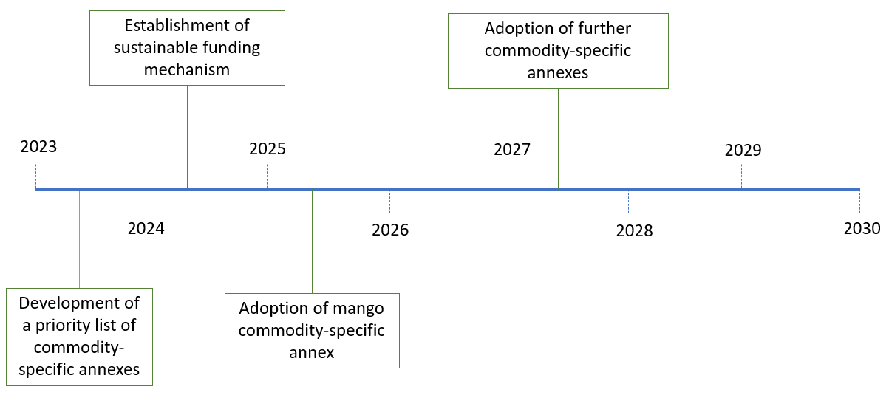

**Figure 4.** Timeline of activities for the commodity specific ISPMs development agenda item.

To encourage implementation of the commodity-specific standards and to assess their use, communication and advocacy material will be developed for contracting parties and an evaluation of the economic, food security, trade and environmental benefits of implementing the commodity-specific standards, as well as an evaluation of the barriers to implementation, will be carried out. The results of these evaluations will identify where support is needed.

**Financial plan:** To carry out the activities of the work programme, the following funding will be required:

|  |  |  |  |  |  |  |  |  |
| --- | --- | --- | --- | --- | --- | --- | --- | --- |
| 2023  ($’000) | 2024  ($’000) | 2025  ($’000) | 2026  ($’000) | 2027  ($’000) | 2028  ($’000) | 2029  ($’000) | 2030  ($’000) | Total  ($’000) |
| 254 | 324 | 324 | 254 | 324 | 309 | 239 | 239 | 2,531 |

Resources will include IPPC Secretariat staff and members of the TPCS, SC, SC-7, diagnostic panels and treatment panels.

**Sequencing recommendation:** FG SFDAI recommends that this should continue in Delivery phase until at least two ISPM 46 annexes have been adopted by CPM. This will enable lessons to be learnt and the standard setting process to be adjusted, if necessary, to support prioritization of commodity-specific topics and development of commodity-specific annexes to ISPM 46. During transition, a study to evaluate the benefits from implementation of commodity-specific standards is encouraged.

**Monitoring & Evaluation KPIs:** The following KPIs are anticipated.

1. Prioritization of commodity-specific annexes by April 2024
2. Adoption of first ISPM commodity-specific annex by April 2025
3. Study to evaluate the economic, trade and food security benefits from implementation of commodity standards initiated by 2027 by April 2027
4. Study to evaluate extent of and barriers to NPPO adoption of commodity specific annexes starts by December 2028

## Management of e-commerce and postal and courier pathways

**Status:** This is an important but relatively small development agenda item work programme that commenced following the adoption of CPM *Recommendation on Internet trade (e-commerce) in plants and other regulated articles.* This development agenda item includes a joint work programme with the World Customs Organisation (WCO), the Universal Postal Union (UPU) and International Seed Federation (ISF) to manage phytosanitary risks associated with e-commerce and the associated postal and courier pathways. Technical resources are made available on the IPP and a new e-commerce guide has been published. An informal network of e-Commerce experts from contracting parties facilitates information exchange and solutions to e-Commerce challenges.

**Long-term plan:** The e-commerce guide will be supported by general awareness raising materials targeting NPPOs and national stakeholders in the e-commerce supply chain. More specific awareness raising materials will be developed in collaboration with the World Customs Association, the Universal Postal Union, International Seed Federation, Global Express Association, and other industry groups, targeting their members. A webinar and/or workshop will also be given to promote the work on e-commerce.

Following this work, an IPPC Observatory study to characterize the phytosanitary risks associated with e-commerce trade and assess how these risks have changed since 2012 will be carried out in 2023. This study will also describe the extent to which NPPOs and RPPOs have implemented the CPM recommendation on internet trade in plants and other regulated articles, and it will establish a baseline for measuring key e-commerce outcomes. It is expected that the study will provide recommendations that will lead to a longer-term plan.

Given the pace at which technologies associated with e-commerce are advancing, a further IPPC Observatory study is planned for 2027 to monitor changes and measure outcomes. As with the IPPC Observatory study in 2023, several recommendations are expected that will lead to further work.

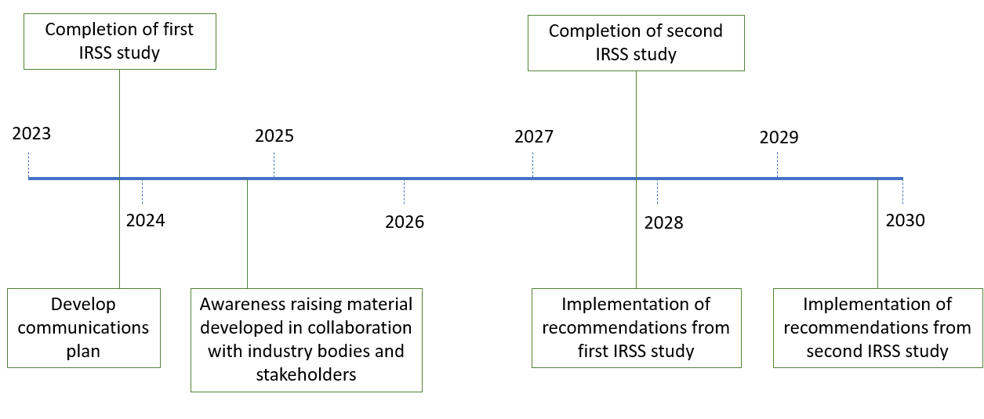

**Figure 5.** Timeline of activities for the e-commerce development agenda item.

**Financial plan:** To carry out the activities of the work programme, the following funding will be required:

|  |  |  |  |  |  |  |  |  |
| --- | --- | --- | --- | --- | --- | --- | --- | --- |
| 2023  ($’000) | 2024  ($’000) | 2025  ($’000) | 2026  ($’000) | 2027  ($’000) | 2028  ($’000) | 2029  ($’000) | 2030  ($’000) | Total  ($’000) |
| 112 | 147 | 77 | 63 | 53 | 46 | 33 | 33 | 701 |

Resources will be provided by in-kind staff contribution from Canada until April 2023. Further staff resources will be required afterwards, with the level of resource determined by the findings of the IPPC Observatory study. A CPM Focus Group or informal network may be required to guide the work.

**Sequencing recommendation:** FG SFDAI recommends this should continue in Delivery phase until an IPPC Observatory-type study has been completed and findings have been implemented into the programme. Following the IPPC Observatory study in 2023, it would also be a good opportunity to review the informal network of e-Commerce experts, and share information via webinars and other channels.

**Monitoring & Evaluation KPIs:** The following KPIs are anticipated.

1. Completion of communications plan for e-commerce by December 2023
2. Completion of IPPC Observatory study on e-commerce (phase 1) by December 2023
3. Long-term planning based on recommendations from the IPPC Observatory study by December 2024
4. Completion of IPPC Observatory study on e-commerce (phase 2) by December 2027

## Developing guidance on the use of third-party entities

**Status:** Since the 2021 adoption of ISPM 45 *Requirements for national plant protection organizations if authorizing entities to perform phytosanitary actions*, a webinar has been held to raise awareness of the ISPM among contracting parties. Scoping and planning for an implementation work programme has not yet occurred. Contracting parties can use ISPM 45 now, but there is an opportunity to delay an implementation work programme.

**Long-term plan: TBC**

**Financial plan:** To carry out the activities of the work programme, the following funding will be required:

|  |  |  |  |  |  |  |  |  |
| --- | --- | --- | --- | --- | --- | --- | --- | --- |
| 2023  ($’000) | 2024  ($’000) | 2025  ($’000) | 2026  ($’000) | 2027  ($’000) | 2028  ($’000) | 2029  ($’000) | 2030  ($’000) | Total  ($’000) |
|  |  |  | 161 | 211 | 201 | 111 | 151 | 845 |

Resources will include IPPC Secretariat staff and members of the IC.

**Sequencing recommendation:** FG SFDAI recommends not starting the Scope and Plan phase until 2026. At this point, IPPC Secretariat resource will need to be assigned to work with the IC to develop a plan. The sequencing of this development agenda item does not reflect on its importance, but having not started, there is simply an opportunity to delay starting the work to allow the IPPC Secretariat and contracting parties time to focus on development agenda items that are already being progressed. Some high-level planning has been completed by the FG SFAI to make budget provision in later years.

**Monitoring & Evaluation KPIs:** The following KPIs are anticipated.

1. Development of training materials by April 2023
2. Increase in confidence in the use of third-party entities by April 2024
3. Scope and plan whether further actions are required by April 2026
4. Subject to CPM decision, start delivery of additional actions from 2027

## Strengthening pest outbreak alert and response systems (POARS)

**Status:** A substantial amount of work has been done to Scope and Plan this development agenda item. In 2022 CPM 16 considered a draft action plan and agreed to establish a POARS Steering Group to further develop the plan to implement this development agenda item. Because a plan has not yet been approved this development agenda item is considered to still be in the Scope and Plan phase. However, it is noted that in parallel with planning, the IPPC Secretariat, supported by technical working groups, has been delivering strong emerging pest programmes for fall armyworm (*Spodoptera frugiperda*) and Fusarium banana wilt TR4.

**Long-term plan:** Following the establishment of the POARS steering group and the development of a workplan, work will begin across three main areas:

1. Evaluating and ranking emerging plant pests. To inform the evaluation and ranking of emerging plant pests, the definition of “emerging pest” will be considered by the Technical Panel of the Glossary.
2. Developing surveillance and response tools. This will first involve the collation of existing tools, before developing tools for the gaps that have been identified.
3. Developing national pest reporting. This will include the development of a website on the International Phytosanitary Portal to provide access to reporting, the design of a horizon scanning system for collecting information on emerging pests, and establishing a system of communicating alerts on these pests.

To ensure that NPPOs are well supported when responding to outbreaks of plant pests, an emergency trust fund will be set up with a mechanism allowing for the quick transfer of funds to NPPOs. Further support will be provided by establishing a roster of expertise and resources that NPPOs can access rapidly, including access to diagnostics.

When carrying out the work for POARS, it will be important for the steering group to build an operational network of organisations and stakeholders at global, regional and national levels, and to mutualise activities with the Emergency Animal Health Unit of the FAO.

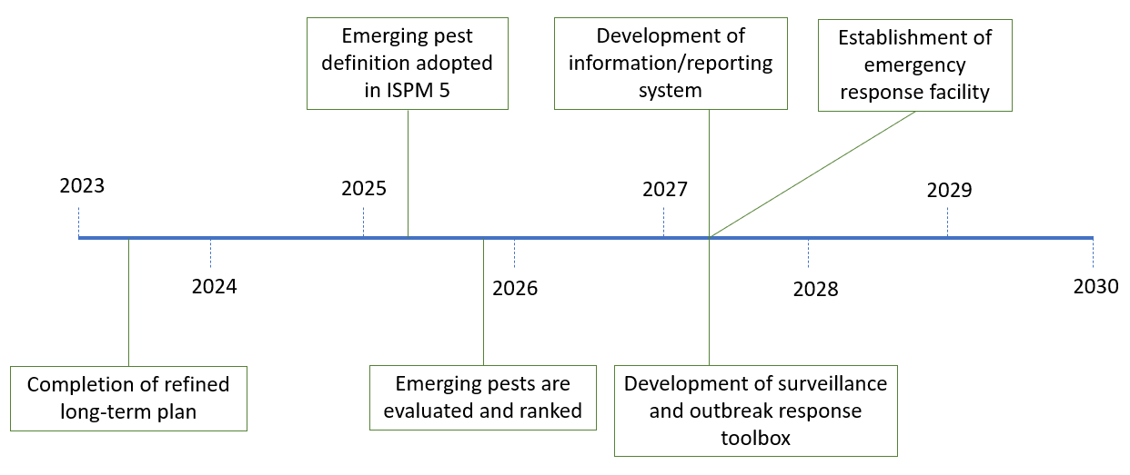

**Figure 6.** Timeline of activities for the strengthening pest outbreak alert and response system development agenda item.

**Financial plan:** To carry out the activities of the work programme, the following funding will be required:

|  |  |  |  |  |  |  |  |  |
| --- | --- | --- | --- | --- | --- | --- | --- | --- |
| 2023  ($’000) | 2024  ($’000) | 2025  ($’000) | 2026  ($’000) | 2027  ($’000) | 2028  ($’000) | 2029  ($’000) | 2030  ($’000) | Total  ($’000) |
| 265 | 425 | 425 | 425 | 425 | 425 | 425 | 425 | 3,240 |

This budget assumes funding at the level indicated in paper CPM 2022/36, paragraphs 54-55 ($325k staff, $100k contracts). Resources will include IPPC Secretariat staff and members of the IC, the POARS Steering Group.

**Sequencing recommendation:** FG SFDAI anticipates CPM approval of a revised POARS plan at CPM-17 (2023) at which point this development agenda item should immediately enter Delivery phase. This is expected to be a large and complex programme in an area where IPPC has not ventured until recently. Establishing well-functioning, and repeatable mechanisms to deliver an effective POARS system is expected to take up to four years. With experience of the programme, CPM will be able to determine the right size and structure for the programme. When satisfied the programme is functioning well it could transition to Ongoing core activity. Considerations during transition will need to include suitable governance or steering arrangements, whether sustainable funding for the programme is in place, and how well the programme is complementing other bodies involved in pest outbreak alert and response.

**Monitoring & Evaluation KPIs:** The following KPIs are anticipated.

1. Establishment of POARS steering group and operational working groups by April 2023
2. Establishment of POARS information system and toolbox by April 2027
3. Establishment of POARS emergency response facility by April 2027

## Assessment and management of climate change impacts on plant health

**Status:** CPM-15 (2021) established the Focus Group on Climate Change and Phytosanitary Issues (FG-CCPI). The FG worked rapidly to propose a four-year programme of work with a suite of actions prioritized for the first two years. This development agenda item is now in Delivery phase.

**Long-term plan:** Following the agreement of the climate change action plan at CPM-16, the Focus Group on Climate Change and Phytosanitary Issues will begin work across three main areas:

1. Raising awareness of the impacts of climate change on plant health. This will be achieved through convening and participating in meetings and side events related to the impact of climate change on plant health; raising awareness through cultural and social media and developing a webpage; facilitating discussions within IPPC subsidiary bodies, regional workshops as well as other IPPC technical groups and CPM; and assisting NPPOs to meet their national reporting obligations (NRO) established by IPPC.
2. Enhancing the evaluation and management of climate change risks to plant health. This will be achieved through supporting countries to collect, analyse and use climate change impact-related information in decision-making and supporting countries in building capacity on the impacts of climate change on plant health.
3. Enhancing the recognition of phytosanitary matters in the international climate change debate. This will be achieved through strengthening collaboration with relevant organisations, such as the Intergovernmental Panel on Climate Change (IPCC) and the Secretariat of the Convention of Biological Diversity, and facilitating, promoting and supporting phytosanitary issues-related policy dialogue at the global level through mainstreaming phytosanitary policies into the climate change debate.

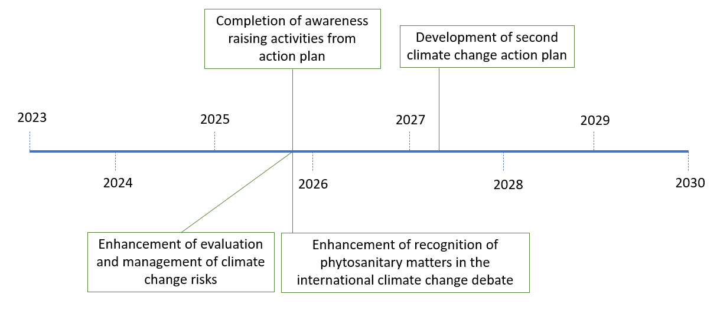

**Figure 7.** Timeline of activities for the climate change development agenda item.

**Financial plan:** To carry out the activities of the work programme, the following funding will be required:

|  |  |  |  |  |  |  |  |  |
| --- | --- | --- | --- | --- | --- | --- | --- | --- |
| 2023  ($’000) | 2024  ($’000) | 2025  ($’000) | 2026  ($’000) | 2027  ($’000) | 2028  ($’000) | 2029  ($’000) | 2030  ($’000) | Total  ($’000) |
| 60 | 322 | 322 | 322 | 322 | 322 | 322 | 322 | 2,626 |

Resources will include IPPC Secretariat staff and members of the FG on Climate Change and Phytosanitary Issues.

**Sequencing Recommendations:** FG SFDAI recommends this should continue in Delivery phase. FG SFDAI anticipates once the 2022-2025 action plan has been delivered, CPM will want to build off the work done and will request a new action plan. At that point, the development agenda item will re-enter the Scope and Plan phase until a new plan is approved.

**Monitoring & Evaluation KPIs:** The following KPIs are anticipated.

1. Implementation of climate change action plan by December 2025
2. Scope and plan next steps for CPM proposal by April 2026
3. Subject to CPM decision, start delivery of deliver second tranche of initiatives to support managing climate change impacts on plant health by 2027

## Global phytosanitary research coordination

**Status:** No work has been started on this SFDAI.

**Long-term plan: TBC**

**Financial plan:** To carry out the activities of the work programme, the following funding will be required:

|  |  |  |  |  |  |  |  |  |
| --- | --- | --- | --- | --- | --- | --- | --- | --- |
| 2023  ($’000) | 2024  ($’000) | 2025  ($’000) | 2026  ($’000) | 2027  ($’000) | 2028  ($’000) | 2029  ($’000) | 2030  ($’000) | Total  ($’000) |
|  |  | 47 | 95 | 230 | 230 | 245 | 230 | 1,077 |

Resources will include IPPC Secretariat staff and a Focus Group yet to be established to assess the value of this SFDAI and then scope and plan if CPM agrees to proceed.

**Sequencing Recommendations:** The FG SFDAI recommends not starting this development agenda item until 2025 at the earliest. During the Scope and Plan phase, a study should be conducted to build an understanding of the coordination mechanisms that already exist and what gaps exist that the IPPC could fill. A work programme proposal should then be developed to implement a suitable response to the gaps or build on existing networks.

## Diagnostic laboratory networking

**Status:** To date a small amount of work has been commissioned to examine the current state of diagnostic capability in NPPOs and to confirm whether there is a need for a diagnostic laboratory network. No other scoping or planning has been done other than by the FG SFDAI in order to make an approximate budget provision.

**Long-term plan: TBC**

**Financial plan:** To carry out the activities of the work programme, the following funding will be required:

|  |  |  |  |  |  |  |  |  |
| --- | --- | --- | --- | --- | --- | --- | --- | --- |
| 2023  ($’000) | 2024  ($’000) | 2025  ($’000) | 2026  ($’000) | 2027  ($’000) | 2028  ($’000) | 2029  ($’000) | 2030  ($’000) | Total  ($’000) |
| 54 | 54 | 125 | 165 | 285 | 245 | 265 | 285 | 1,503 |

Resources will include IPPC Secretariat staff and a Focus Group yet to be established.

**Sequencing recommendations:** Implementation of this development agenda item has the potential to be a very large and complex programme. FG SFDAI recommends the Scope and Plan phase should commence soon (2024) with the establishment of a focus group to work with the IPPC Secretariat. We expect this to take two years before a viable proposal with enough detail is presented to CPM for approval. As with some other large development agenda items, the CPM may need more than one year to make a final decision on how to proceed.

**Monitoring & Evaluation KPIs:** The following KPIs are anticipated.

1. Investigation of existing networks by December 2025
2. Develop proposal for research coordination by April 2026
3. Subject to CPM decision, establish global phytosanitary research coordination by December 2027

# Investment Prospectus

The overarching implementation plan could be accompanied by an investment prospectus. This would have two purposes. The first is to raise awareness of the overarching implementation plan to contracting parties, RPPOs and other relevant international bodies, and the second is to be used as information material for donor organisations, including funding decision-makers in contracting parties, to attract funding for the development agenda items.

# Conclusions

To be completed after SPG

Some concluding remarks to wrap the report up.

Highlight key findings

Highlight the benefits on an integrated overarching plan

Highlight any issues that will need particular attention

Summarise next steps / actions from this point forward.

Recommendations from the FG

# APPENDIX A - Agenda Item #1 - Harmonization of electronic data exchange

TBC

**Benefit statement**

**Delivery**

**Milestones and activities**

**Funding and resources**



**Monitoring and evaluation**

**Communication**

**Issues and risks**

# APPENDIX B - Agenda Item #2 - Commodity and pathway specific ISPMs

**Benefit statement**

As described in the Strategic Framework, new ISPMs will be adopted and implemented for specific commodities and pathways, with accompanying diagnostic protocols and phytosanitary treatments to support implementation. They will provide NPPOs with harmonized phytosanitary measures, which they may use to support their pest risk analysis activities and import regulatory systems, or to establish export-oriented production systems. This will simplify trade and expedite market access negotiations.

**Delivery**

At CPM-16 in 2022, the ISPM ‘Commodity-specific standards for phytosanitary measures’ was adopted. This is an overarching concept standard and provides guidance on the purpose, use, content, publication, and review of commodity-specific standards. These standards will form annexes under the overarching concept standard.

Following inclusion in the list of standard topics, the commodity-specific standards will be developed either directly by the Technical Panel on Commodity Standards (TPCS) or by expert drafting groups established by the Standards Committee (SC). The TPCS will also be responsible for reviewing commodity-specific standards, recommending revisions and topics, and developing guidance on aspects related to the standards.

**Milestones and activities**

Following the adoption of the concept standard and the establishment of the TPCS, the TPCS will begin to develop the first commodity-specific standard on mango fruit, along with accompanying diagnostic protocols and phytosanitary treatments as appropriate. The aim will be to adopt this standard by 2025. While this standard is being developed, other commodities proposed for a standard will be prioritised, with new standards adopted by 2027 and beyond. To ensure that the TPCS can continue to function and develop commodity-specific standards, a long-term sustainable funding mechanism will be scoped out and adopted.

To encourage implementation of the commodity-specific standards and to assess their use, communication and advocacy material will be developed for contracting parties and an evaluation of the economic, food security, trade and environmental benefits of implementing the commodity-specific standards, as well as an evaluation of the barriers to implementation, will be carried out. The results of these evaluations will identify where support is needed.

**Funding and resources**

To carry out the activities of the work programme, the following funding will be required:



Resources will include IPPC Secretariat staff and members of the TPCS, SC, SC-7, diagnostic panels and treatment panels.

**Monitoring and evaluation**

A specific monitoring and evaluation plan will not be developed for this SFDAI, but the SFDAI will be monitored through the general monitoring and evaluation plan outlined in the overarching SF implementation plan.

**Communication**

A specific communication plan will not be developed for this SFDAI, but the SFDAI will be communicated through the general communication plan developed by the CPM Communications Focus Group.

**Issues and risks**

One issue is that there is not an existing system for the prioritisation of commodity-specific standards, but this can be addressed by the TPCS in the coming year prior to the next call for topics.

Future risks include not receiving sufficient topics for commodity-specific standards, a lack of funding to develop standards and support implementation, and limited information on the cost-effectiveness of the commodity-specific standards.

# APPENDIX C - Agenda Item #3 - Management of e-commerce and postal courier pathways

**Benefit statement**

The desired 2030 outcome in the Strategic Framework has been amended to give the following key outcomes:

* NPPOs will be aware of the phytosanitary risks posed by business-to-consumer (B2C) and person-to-person (P2P) e-Commerce transactions.
* Contracting Parties will update their legislation and authorities to address e-Commerce challenges, considering digital innovations, available technologies and new business models.
* NPPOs will comply with ISPM 20 (specifically section 4.1). Lists of regulated articles will be prepared and maintained, and will be available to all relevant e-commerce stakeholders, including other government departments and stakeholders in other countries.
* NPPOs will establish public awareness raising, communication, education, and outreach programmes to make consumers, the public and other stakeholders aware of the regulatory requirements, risks and responsibilities associated with cross-border e-commerce.
* Contracting Parties will apply risk management measures to identify and intercept e-commerce consignments that present a phytosanitary risk, while facilitating legitimate e-commerce trade (e.g., advanced electronic data, screening methods and non-intrusive inspection methods).
* NPPOs will share information, cooperate, and collaborate with other national border agencies and national postal operators to address pest risks associated with e-commerce trade. (e.g., Memorandum of Understanding between NPPO and their national customs administration)
* NPPOs will gather data and monitor non-compliances, inspections and regulatory activities and will be able to demonstrate a measurable reduction in non-compliances associated with the mail and courier pathways.

**Delivery**

The SFDAI will be led by the Implementation and Facilitation Unit within the IPPC Secretariat and will be delivered by the team on e-commerce, which is composed of four members (IC lead, IC RPPO representative, SC representative and the IPPC Secretariat lead on e-commerce). The IC will provide oversight of this work with input from the SC.

**Milestones and activities**

In 2022 and 2023, work will be completed on an e-commerce guide on plants, plant products and other regulated articles, and this will be translated from English into the five other FAO languages. The guide will be supported by general awareness raising materials targeting NPPOs and national stakeholders in the e-commerce supply chain. More specific awareness raising materials will be developed in collaboration with the World Customs Association, the Universal Postal Union, International Seed Federation, Global Express Association, and other industry groups, targeting their members. A webinar and/or workshop will also be given to promote the work on e-commerce.

Following this work, an IPPC Observatory study to characterize the phytosanitary risks associated with e-commerce trade and assess how these risks have changed since 2012 will be carried out in 2023. This study will also describe the extent to which NPPOs and RPPOs have implemented the CPM recommendation on internet trade in plants and other regulated articles, and it will establish a baseline for measuring key e-commerce outcomes. It is expected that the study will provide recommendations that will lead to a longer-term plan.

Given the pace at which technologies associated with e-commerce are advancing, a further IPPC Observatory study is planned for 2027 to monitor changes and measure outcomes. As with the IPPC Observatory study in 2023, several recommendations are expected that will lead to further work.

**Funding and resources**

To carry out the activities of the work programme, the following funding will be required:



Resources will be provided by in-kind staff contribution from Canada until April 2023. Further staff resources will be required afterwards, with the level of resource determined by the findings of the IPPC Observatory study.

**Monitoring and evaluation**

Monitoring and evaluation for this activity will principally be achieved using the IPPC Observatory studies described in the milestones and activities section. However, the SFDAI will also be monitored through the general monitoring and evaluation plan outlined in the overarching SF implementation plan.

**Communication**

A communication plan will be developed in 2022 or 2023, depending on securing/allocating funds to hire a communications specialist. The SFDAI will also be communicated through the general communication plan developed by the CPM Communications Focus Group.

**Issues and risks**

A significant issue is that e-commerce is very dynamic; the number of cross-border shipments continue to grow, new players continue to engage in e-commerce as both consumers and vendors, and digital technologies and business models are constantly changing. And unfortunately, the number of phytosanitary experts working on the leading edge of e-commerce globally is not growing at the same pace and the expertise seems to be concentrated in a few regions. Any future calls for resources, experts and case studies may therefore receive a poor response.

Participation in the informal e-commerce network is poor. At this point, the network is used as a mechanism for communicating information from the IPPC Secretariat to key industry stakeholders (e.g., announcements, calls, relevant news items). However, the webinar and/or workshop could be used to encourage more active engagement and launch a more dynamic forum for discussions.

A risk is that some regions are underrepresented in this work. Organizing a webinar and/or workshop on e-commerce will help to raise the visibility of this topic and hopefully encourage broader engagement.

A further risk is that funding will not be secured for coordination of e-commerce activities and for the development of a communication plan.

# APPENDIX D - Agenda Item #4 - Developing guidance on the use of third-party entities

TBC

**Benefit statement**

**Delivery**

**Milestones and activities**

**Funding and resources**



**Monitoring and evaluation**

**Communication**

**Issues and risks**

# APPENDIX E - Agenda Item #5 - Strengthening pest outbreak alert and response systems

**Benefit statement**

As described in the Strategic Framework, a global pest alert system with mechanisms to evaluate and communicate emerging pest risks will be developed, providing regular information to NPPOs on changes in pest status around the world. NPPOs will use this to quickly adapt their phytosanitary systems to reduce the risk of introduction and spread. In the case of outbreaks, strengthened pest outbreak response systems and tools will help countries take much more timely action, especially against new incursions. NPPOs, RPPOs and the FAO will collaborate to develop and roll out a comprehensive but easy to use toolbox to help countries respond quickly and effectively. RPPOs will play an active role in assisting NPPOs and coordinating outbreak responses across their regions.

**Delivery**

The SFDAI will be led by the Implementation and Facilitation Unit within the IPPC Secretariat and will initially be delivered by the POARS steering group. The steering group will first redefine the focus of the work and establish the POARS capability, before operationalising the POARS.

**Milestones and activities**

Following the establishment of the POARS steering group and the development of a workplan, work will begin across three main areas:

1. Evaluating and ranking emerging plant pests. To inform the evaluation and ranking of emerging plant pests, the definition of “emerging pest” will be considered by the Technical Panel of the Glossary.
2. Developing surveillance and response tools. This will first involve the collation of existing tools, before developing tools for the gaps that have been identified.
3. Developing national pest reporting. This will include the development of a website on the International Phytosanitary Portal to provide access to reporting, the design of a horizon scanning system for collecting information on emerging pests, and establishing a system of communicating alerts on these pests.

To ensure that NPPOs are well supported when responding to outbreaks of plant pests, an emergency trust fund will be set up with a mechanism allowing for the quick transfer of funds to NPPOs. Further support will be provided by establishing a roster of expertise and resources that NPPOs can access rapidly, including access to diagnostics.

When carrying out the work for POARS, it will be important for the steering group to build an operational network of organisations and stakeholders at global, regional and national levels, and to mutualise activities with the Emergency Animal Health Unit of the FAO.

**Funding and resources**

To carry out the activities of the work programme, the following funding will be required:



Resources required to establish the POARS:

* One manager
* One dedicated IT developer
* One part time administrative person
* Two scientific officers
* One human resource for relations with the regions, RPPOs, the One Health Nexus, WHO, and other organisations
* One communications expert

Resources will also include IPPC Secretariat staff and members of the POARS steering group.

**Monitoring and evaluation**

Upon establishing the POARS steering group, a monitoring and evaluation plan will be developed. The SFDAI will also be monitored through the general monitoring and evaluation plan outlined in the overarching SF implementation plan.

**Communication**

As with the monitoring and evaluation plan, a communication plan will be developed soon after the establishment of the POARS steering group. This will focus on communication within the POARS networks, as well as communication about POARS to wider stakeholders to ensure awareness and buy-in. The SFDAI will also be communicated through the general communication plan developed by the CPM Communications Focus Group.

**Issues and risks**

There is a risk that the workplan developed by the POARS steering group is not accepted by the CPM, but the steering group will look to redefine the work based on feedback at CPM-16.

On the reporting system itself, there is an ongoing concern that NPPOs will not share data on pest findings. As with other SFDAIs, there is also a concern over having sufficient funding to take forward the work. The steering group will be looking to address these concerns over 2022 and 2023.

# APPENDIX F - Agenda Item #6 - Assessment and management of climate change impacts on plant health

**Benefit statement**

The key outcomes include, but are not limited to:

* Raising awareness of the impacts of climate change on plant health
* Enhancing the evaluation and management of risks of climate change to plant health
* Enhancing the recognition of phytosanitary matters in the international climate change debate

**Delivery**

At CPM-16 in 2022, the 2022-2025 action plan for the implementation of the SFDAI was adopted. The action plan will be led by the Integration and Support team within the IPPC Secretariat and will be delivered by the CPM Focus Group on Climate Change and Phytosanitary Issues. To ensure that delivery is effective, NPPOs, RPPOs, relevant international organisations, and major donors are expected to be called, to actively contribute to the resourcing, planning and implementation of the action plan. Coordination and alignment of this work with that of the other relevant international organizations, as well as collaboration with other relevant public and private sector institutions and organizations will also be critical.

**Milestones and activities**

To raise awareness of the impacts of climate change on plant health, the following activities will be undertaken:

* Convening and participating in meetings and side events related to the impact of climate change on plant health. This will include holding global and regional webinars and giving presentations at the International Plant Health Conference and UN Climate Change Conference Forums.
* Raising awareness through cultural and social media (e.g., radio talk shows, social media, poster and flyers, digital platforms, etc.), developing a climate change webpage on the International Plant Portal as a repository of information, and engaging with stakeholders through surveys and by other means to gather information on the topic.
* Facilitating discussions within IPPC subsidiary bodies, regional workshops as well as other IPPC technical groups and CPM. This will include the IC, SC and Bureau; the fall armyworm and *Fusarium* tropical race 4 meetings; the communications focus group meetings; RPPO meetings and conferences; and side events of CPM.
* Assisting NPPOs to meet their national reporting obligations (NRO) established by IPPC. The national reporting system could be enhanced to further share information on changes to pest distributions, host range, and adaptability of pests and host plants.

To enhance the evaluation and management of climate change risks to plant health, the following will be carried out:

* Supporting countries to collect, analyse and use climate change impact-related information in decision-making.
  + Reviewing existing use of climate change assessments in pest risk analysis and surveillance, providing advice on climate change models, providing advice on assessment and tools, and developing guidance on incorporating climate change assessments in pest risk analysis, surveillance and risk management.
  + Creating Regional climate hubs e.g., USDA Climate Hubs that provide science-based information to agricultural and natural resource managers to help address the effects of climate change.
  + Incorporating ‘climate change impacts on plant health’ criteria (similar to the ‘potential implementation issues’ criteria) into the template for draft ‘standard’ specifications, draft guidance material specifications, and into the assessment criteria for the upcoming IPPC Call for topics.
  + Reviewing linkages to the safe provision of food aid
* Supporting countries in building capacity on the impacts of climate change on plant health
  + Developing, reviewing and promoting tools to enhance the preparedness and response of Agricultural Extension Agents, farmers and other relevant stakeholders on the impacts of climate change on plant health
  + Incorporating climate change references and technical resources into IPPC guidance materials
  + Developing an IPPC guide to assist in identifying cultural and social impacts of climate change on plant health, including island communities under threat of sea level rise

To enhance the recognition of phytosanitary matters in the international climate change debate, the following will be carried out:

* Strengthening collaboration with relevant organisations, such as the Intergovernmental Panel on Climate Change (IPCC) and the Secretariat of the Convention of Biological Diversity.
* Facilitating, promoting and supporting phytosanitary issues-related policy dialogue at the global level through mainstreaming phytosanitary policies into the climate change debate

**Funding and resources**

To carry out the activities of the work programme, the following funding will be required:



Contd…



Resources will be provided by IPPC Secretariat staff and members of the CPM Focus Group on Climate Change and Phytosanitary Issues.

**Monitoring and evaluation**

A monitoring and evaluation plan has not been developed for this SFDAI yet, but the intention is for it to be monitored against its key performance indicators and deliverables through IPPC monitoring and evaluation processes. The SFDAI will also be monitored through the general monitoring and evaluation plan outlined in the overarching SF implementation plan.

**Communication**

A communication plan will be developed by the Focus Group on Climate Change and Phytosanitary Issues. The SFDAI will also be communicated through the general communication plan developed by the CPM Communications Focus Group.

**Issues and risks**

Funding and resources to support the development of guidance materials, webpages, communication resources, workshop initiatives and other activities need to be mobilised in order to deliver the action plan in its entirety.

# APPENDIX G - Agenda Item #7 - Global phytosanitary research coordination

TBC

**Benefit statement**

**Delivery**

**Milestones and activities**

**Funding and resources**



**Monitoring and evaluation**

**Communication**

**Issues and risks**

# APPENDIX H - Agenda Item #8 - Diagnostic laboratory networking

TBC

**Benefit statement**

**Delivery**

**Milestones and activities**

**Funding and resources**



**Monitoring and evaluation**

**Communication**

**Issues and risks**

# APPENDIX I – SFDAI reporting template

|  |  |
| --- | --- |
| **SFDAI Reporting template** | |
| **SFDAI** |  |
| **Implementation group** |  |
| **Report writer** |  |
| **Date** |  |
| **Summary of progress** | |
| **Next steps** | |
| **Assessment against M&E targets** | |
| **Issues and risks** | |
| **Support required** | |

# APPENDIX J – CPM Focus Group membership

**Table 2.** CPM Focus Group membership.

|  |  |
| --- | --- |
| Region/body represented | Name and organization |
| Africa | Vacant |
| Asia | **Teppei Shigemi**  Ministry of Agriculture, Forestry and Fisheries (MAFF), Japan |
| Europe | **Matthew Everatt**  Department for Environment, Food and Rural Affairs (Defra), UK |
| North America | **Katherine Hough**  United States Department of Agriculture-Animal Plant Health Inspection Service-Plant Protection and Quarantine (USDA-APHIS) |
| Latin America and Caribbean | **Diego Quiroga**  SENASA, Argentina |
| South-West Pacific | **Glenn Dulla**  Guam Department of Agriculture, Biosecurity Division |
| Near East | Vacant |
| IC | **Kyu-Ock Yim**  Animal and Quarantine Agency, Republic of Korea |
| CPM Bureau | **Peter Thomson**  Biosecurity New Zealand, Ministry for Primary Industries |
| SC | **André Felipe C. P. da Silva**  Quarantine Division Ministry of Agriculture, Livestock and Food Supply, Brazil |
| RPPO | **Nico Horn**  Director-General/Directeur Général European and Mediterranean Plant Protection Organization |