DRAFT REVISION OF DP 09: GENUS ANASTREPHA SCHINER (2021-002)

Status box (this is not an official part of the standard, and it will be modified after adoption)
Date of this document | 2021-09-21
Document category | REVISION of adopted DP for annex to ISPM 27:2006 (Diagnostic protocols for regulated pests)
Current document stage | To TPDP for review
Major stages | 2014-03: CPM-1 (2006) added topic to work programme  (Genus Anastrepha, 2004-015).  2015-08: SC adopted DP09 on behalf of CPM (with no formal  objections received).  2020-12: Request for revision to DP09 submitted to TPDP  2021-04: Request for revision to DP09 submitted to SC  2021-06: SC added topic to work programme (revision Genus Anastrepha Schiner, 2021-002)  2021-09: Selected drafting team notified of work and commenced revision  2022-09: First draft submitted for TPDP review prior to EC
Discipline leads history | Norman BARR (USA, Discipline lead)  Juliet GOLDSMITH (JM, REFEREE)
Consultation at the technical level | The first draft of this protocol was written by:  Mr Raul RUIZ-ARCE (USA) (lead author)  Mr Allen NORRBOM (USA)  Mr Ignacio DUMOIS (Argentina)  Ms Thoa KIM-HOANG (Viet Nam)  Mr. Gary STECK (USA)
Main discussion points during the development of the diagnostic protocol | Comment:  The number of species treated for species diagnosis is increased to eight in the DP because the genus Toxotrypana was revised and is considered part of Anastrepha. The pest Anastrepha curvicauda (= T. curvicauda) is included in protocol.  The original drafting team requested inclusion of Mr. Gary Steck as a team member to provide significant additions to diagnosis of larvae and the IPPC formally reviewed and approved the addition.
Notes | 1. This is a draft document. The original protocol was topic 2006-015 and it was adopted in 2015. Adopted protocol did not include molecular methods for diagnosis but advances in methods were reported after adoption. The revision addresses new abilities for diagnosis.  2. The DP might require advice on inclusion of unpublished information.  3. The taxonomy section (Table 1) includes combinations in addition to formal synonyms. The authors recommended this addition.

- CONTENTS
- [to be added later]
- Adoption
- The revision of this diagnostic protocol was adopted by the Standards Committee on behalf of the Commission on Phytosanitary Measures in [Month 20--]. [to be completed after adoption]
- The annex is a prescriptive part of ISPM 27 (Diagnostic protocols for regulated pests).
1. Pest Information
- The family Tephritidae comprises over 5000 species in 500 or so genera (Norrbom et al., 1999a, 1999b; Norrbom, 2004b, and unpublished data). The Tephritidae are distributed worldwide in temperate, tropical and subtropical regions. Anastrepha Schiner (Tephritidae: Toxotrypanini) is the largest genus of Tephritidae in the Americas and is represented by more than 300 species that occur from the southern United States (Texas and Florida) to northern Argentina (Hernández-Ortiz, 1992; Foote et al., 1993; Hernández-Ortiz and Aluja, 1993; Norrbom, 2004b; Norrbom et al., 2012, 2015, 2018, 2021). These include the species formerly placed in Toxotrypana Gerstaecker, now considered a synonym of Anastrepha (Norrbom et al., 2018). At least eight species of Anastrepha are considered major economic pests because of the great importance of the cultivated fruits they attack (e.g., mango and citrus) and/or their wide host range. These eight species are: A. curvicauda (Gerstaecker); A. fraterculus (Wiedemann); A. grandis (Macquart); A. ludens (Loew); A. obliqua (Macquart); A. serpentina (Wiedemann); A. striata Schiner; and A. suspensa (Loew). Anastrepha fraterculus has been recognized as a cryptic species complex (Hernández-Ortiz et al., 2004, 2012, 2015; Selivon et al., 2004, 2005; Vera et al., 2006, Cáceres et al., 2009, Sutton et al., 2015). This diagnostic protocol for Anastrepha covers identification of the genus and the species of major economic importance. For further general information about species of Tephritidae, see White and Elson-Harris (1992) and Norrbom (2010).
- The length of the tephritid life cycle varies according to each species as well as environmental and climatic conditions (Basso, 2003). Female Anastrepha deposit their eggs inside fruits. The number of eggs deposited per fruit is variable and depends mainly on features of the host fruit such as size and conditions. Restricting the host list to natural infestations, hosts are known for 129 (39.3%) of the currently recognized 328 Anastrepha species (Liquido et al., 2022). Published host records for major pests are available at USDA Compendium of Fruit Fly Host Information. (https://coffhi.cphst.org/.)
- The introduction of cultivated exotic species such as Mangifera indica and Citrus spp. have allowed some pest species of Anastrepha to expand their original areas of distribution and enhance their reproductive potential. However, they still have marked preferences for certain native hosts, which is probably indicative of their original host relationships. In this regard, the species A. suspensa, A. fraterculus and A. striata breed mainly in hosts belonging to the family Myrtaceae, A. ludens in the Rutaceae, A. obliqua in the Anacardiaceae, A. serpentina in the Sapotaceae, and A. grandis in the Cucurbitaceae (Norrbom, 2004a).
- Among native hosts in the American tropics, there seems to be an ancestral association with plants that produce latex and particularly the family Sapotaceae. Sapotaceous fruits are frequent hosts for the dentata, leptozona, serpentina, daciformis, robusta and cryptostrepha species groups. Myrtaceous fruits are also very important hosts. At least 26 Anastrepha species, most belonging to the A. fraterculus species group, have been reported feeding on plants of this family (Norrbom and Kim, 1988; Norrbom et al., 1999c).
2. Taxonomic Information
- Name: Anastrepha Schiner, 1868
- Synonyms: Toxotrypana Gerstaecker, 1860; Acrotoxa Loew, 1873; Pseudodacus Hendel, 1914; Phobema Aldrich, 1925; Lucumaphila Stone, 1939
- Taxonomic position: Insecta: Diptera: Tephritidae, Trypetinae, Toxotrypanini
- Common names: See Table 1.

Table 1. Common names and synonyms of fruit fly species of major economic importance belonging to the genus Anastrepha.
Common name | Anastrepha species | Synonyms and other combinations
Papaya fruit fly | Anastrepha curvicauda (Gerstaecker, 1860) | Toxotrypana curvicauda Gerstaecker, 1860
 |  | Mikimyia furcifera Bigot, 1884
 |  | Toxotrypana fairbatesi Munro, 1984
South American fruit fly | Anastrepha fraterculus (Wiedemann, 1830) species complex | Dacus fraterculus Wiedemann, 1830
 |  | Tephritis mellea Walker, 1836
 |  | Trypeta unicolor Loew, 1862
 |  | Anastrepha unicolor: Schiner 1868
 |  | Trypeta fraterculus: Loew, 1873
 |  | Acrotoxa fraterculus: Loew, 1873
 |  | Anthomyia frutalis Weyenbergh, 1874
 |  | Anastrepha fraterculus var. soluta Bezzi, 1909
 |  | Anastrepha peruviana Townsend, 1913
 |  | Anastrepha braziliensis Greene, 1934
 |  | Anastrepha costarukmanii Capoor, 1954
 |  | Anastrepha scholae Capoor, 1955
 |  | Anastrepha pseudofraterculus Capoor, 1955
 |  | Anastrepha lambayecae Korytkowski and Ojeda, 1968
South American cucurbit fruit fly | Anastrepha grandis (Macquart, 1846) | Anastrepha schineri Hendel, 1914
 |  | Anastrepha latifasciata Hering, 1935
 |  | Tephritis grandis Macquart, 1846
 |  | Trypeta grandis: Loew, 1873
Mexican fruit fly | Anastrepha ludens (Loew, 1873) | Anastrepha lathana Stone, 1942
 |  | Trypeta ludens Loew, 1873
 |  | Acrotoxa ludens: Loew, 1873
West Indian fruit fly | Anastrepha obliqua (Macquart, 1835) | Tephritis obliqua Macquart, 1835
 |  | Trypeta obliqua: Osten Sacken, 1868
 |  | Acrotoxa obliqua: Loew, 1873
 |  | Anastrepha fraterculus var. mombinpraeoptans Seín, 1933
 |  | Anastrepha fraterculus var. ligata Lima, 1934
 |  | Anastrepha trinidadensis Greene, 1934
 |  | Anastrepha mombinpraeoptans: Stone, 1942
Sapote fruit fly | Anastrepha serpentina (Wiedemann, 1830) | Dacus serpentinus Wiedemann, 1830
 |  | Leptoxys serpentina: Macquart, 1843
 |  | Trypeta serpentina: Loew, 1873
 |  | Acrotoxa serpentina: Loew, 1873
 |  | Urophora vittithorax Macquart, 1851
American guava fruit fly | Anastrepha striata Schiner, 1868 | Dictya cancellaria Fabricius, 1805
 |  | Trypeta cancellaria: Wiedemann, 1830
Caribbean fruit fly | Anastrepha suspensa (Loew, 1862) | Trypeta suspensa Loew, 1862
 |  | Acrotoxa suspensa: Loew, 1873
 |  | Anastrepha unipuncta Sein, 1933
 |  | Anastrepha longimacula Greene, 1934

3. Detection
- Fruit flies can be detected as larvae by inspection inside fruits and as pupae in leaf litter, soil, or the containers in which the fruits are being transported, or they can be captured outdoors as adults by means of traps.
3.1 Inspection of fruits.
- Infested fruits can be found in imported or exported shipments, in baggage, and even on aeroplanes or terrestrial transportation vehicles. Fruits with soft areas, dark stains, rot, orifices or injuries that might have originated from female oviposition or larval feeding activities are targeted for inspection. In order to detect punctures made by female flies during oviposition, the visual examination should be done under a microscope by an expert. If larval exit holes are observed, the fruit containers should be inspected for pupae. Second and third instar larvae and pupae are not likely to occur when unripe fruits are collected and packed; however, these fruits might host eggs and first instar larvae, which are more difficult to detect. Potentially infested fruits that show typical punctures made by ovipositing female flies should be cut open to search for eggs or larvae inside. The success of detection depends on careful sampling and examination of fruits.
3.2 Inspection of traps.
- Guidance on trapping Anastrepha fruit flies is given in Appendix 1 of ISPM 26 (Establishment of pest free areas for fruit flies (Tephritidae). In general, monitoring systems established for the detection of fruit fly adults in trees, either in fruit-growing regions or in areas at high risk of introduction, require the utilization of McPhail or multilure traps baited with food attractants or synthetic lures. The baits, often with rich sources of ammonium, should be recognized and approved internationally (e.g., ISPM 26). The specific methods of trap deployment and time of service of the traps must be in agreement with the national phytosanitary regulations.
4. Identification
- The taxonomy of the genus Anastrepha is based mainly on adult external morphology and characters of the female terminalia (Stone, 1942; Hernández-Ortiz, 1992; Zucchi, 2000; Norrbom et al., 2012). Because morphological characters of immature stages are not well documented for most Anastrepha species, these characters have a more limited utility in species recognition (White and Elson-Harris, 1992; Steck et al., 2019) in comparison with adult morphology. However, some information on egg structures and third instar larvae is available in the scientific literature and has diagnostic utility for certain species (Steck and Wharton, 1988; Steck et al., 1990; Frías et al., 2006, 2008, 2009; Dutra et al., 2011a, 2011b, 2012, 2013, 2018a,b; Figueiredo et al., 2011; Rodriguez et al., 2021). Identification keys for the larvae of the eight species of Anastrepha known to be of major economic importance (Table 1) are available (Steck et al., 1990; Carroll et al., 2004) but should be used with consideration of their limits.
- Although the third instar larvae of some Anastrepha species can be discriminated in keys (Steck and Wharton, 1988; Carroll and Wharton, 1989; Steck et al., 1990; White and Elson-Harris, 1992; Carroll et al., 2004; Frías et al., 2006; Hernández-Ortiz et al., 2010), the available data are based on very limited sampling for most species. Studies of additional closely related species that have not yet been characterized may also reduce the reliability of the method. The most reliable method for identification is rearing larvae to the adult stage. Molecular methods of identification have also been reported for some of the major pest species and are included in the protocol (section 4.5).
- Several pest species of Anastrepha are believed to comprise multiple (yet to be described) cryptic species that are morphologically indistinguishable or require morphometric analysis for their recognition (Hernández-Ortiz et al., 2004, 2012, 2015). The Anastrepha fraterculus species complex (Table 1) is included in the protocol, but it is identified to the level of complex because revision of its taxonomy and associated molecular diagnosis are not yet fully resolved (Sutton et al., 2015, Prezotto et al., 2019).
4.1 Preparation of adults for identification
4.1.1 Rearing larvae to obtain adults
- Infested fruits are placed in cages covered with cloth or fine mesh and that have a sterile pupation medium (e.g. damp vermiculite, sand or sawdust) at the bottom. Once the larvae emerge from the fruit, they will move to the substratum for pupation. It is recommended to incubate each fruit separately. Each sample must be observed and pupae gathered daily. The pupae are placed in containers with the pupation medium, and the containers are covered with a tight lid that enables proper ventilation. Once the adults emerge, they must be kept alive for 48–72 h to ensure that the tegument and wings acquire the rigidity and characteristic coloration of the species. The adults are then killed and preserved by placing them in 95% ethanol or they are killed with ethyl acetate or another agent and then mounted on pins. For female flies, immediately after killing them (before they harden) it is useful to gently squeeze the apical part of the preabdomen with forceps, then squeeze the base and apex of the oviscape to expose the aculeus tip (so that it does not need to be dissected later).
4.1.2 Preparation of adults for microscopic examination
- For species recognition of adult stages, the entire specimen should be preserved – either dry (pinned) or in 70% ethanol. Examination of the wings and the aculeus is particularly important. Examination of the aculeus must be done at about 400× magnification. The wing and aculeus of each specimen can be mounted under two separate coverslips on the same slide. Dissection and mounting should be done only by someone with experience. Dissecting the female terminalia in Anastrepha is difficult and it is easy to damage useful parts.
4.1.2.1 Aculeus
- It is preferable to cut off the whole abdomen from a female to dissect the oviscape (syntergosternite 7) (Figure 1), the eversible membrane and the aculeus. For preserved dry (pinned) specimens, fine dissection scissors are recommended to remove the abdomen. The abdomen needs to be cleared. This can be accomplished by placing it in a 10% sodium hydroxide (NaOH) or 10% potassium hydroxide (KOH) solution and heating it in a boiling water bath for 10–15 min, washing the structure with distilled water, and then removing internal contents under a stereomicroscope with the help of dissection forceps. The aculeus and the eversible membrane should be exposed. At this step it is possible to examine the aculeus directly in one or two drops of glycerine under a microscope. Afterwards, the structure can be transferred to a microvial with glycerine and pinned under the mounted dry specimen. For permanent slides, proceed as described in section 4.1.2. Mounting the aculeus permanently in the ventral position prevents the observation of some characters better seen in lateral view. For this reason, preservation in glycerine in a microvial is often preferable.
4.1.2.2 Wings
- Wing characters can usually be observed without mounting, so mounting is not recommended as a general practice. It may be necessary for morphometric studies, but it is not necessary for observation of the characters used in the key in section 4.3.2. If permanent mounts are made, it is recommended to cut off one of the wings from its base (the right wing is preferred because it facilitates comparison with images reported in the literature and this diagnostic protocol).
4.2 Preparation of larvae for morphological identification
- As noted in section 4, observation of adult characters may be necessary to corroborate a morphological identification based on larvae. If immature stages are found, it is recommended to preserve some larvae for morphological examination by treating them in hot water and then storing them in 70% ethanol, and rearing the remaining larvae and pupae to obtain adult specimens for identification (section 4.1.1).
- Larval preparation can be accomplished by washing live larvae in a mild detergent solution (one drop of liquid dishwashing detergent in a beaker of water). Deionized (or distilled) water is recommended, if possible. Kill by dropping live larvae into a 70°C water bath for 2-4 minutes. Allow water and larvae to cool to room temperature. Place larvae in 70% ethanol solution. Label and store until ready for study.
- To prepare specimens for slide mounting, it is necessary to remove (clear) all the internal contents to allow observation of the cuticle, cephaloskeleton, anterior and posterior spiracles, and anal lobes. This can be accomplished by cutting the larva longitudinally on one side from the cephalic segment to the caudal segment. Most of the internal tissues can be removed manually and preserved in 95% ethanol for separate DNA extraction and amplification. The remaining tissues can be cleared from the larva by immersing it in hot 10% NaOH or 10% KOH solution in a test tube in a boiling water bath for 10–15 min or in a Petri dish on a coffee cup warmer for 30-60 min. Stray undigested internal contents can then be carefully removed from the specimen using forceps and distilled water under a stereomicroscope (10× magnification or greater).
- Placing the cleared cuticle, cephaloskeleton and spiracles in a drop of glycerin on a glass slide allows for observation under a compound microscope. The specimen can be easily positioned for imaging or taking measurements as needed. After observation, the specimen can be returned to a vial with 70% ethanol for permanent storage and/or later re-examination if desired. Alternatively, permanent slide mounts can be made using Canada balsam or Euparal. First, the cleared specimen must be dehydrated for 25 min in each of 50%, 75% and 100% ethanol. For mounting with Canada balsam, the specimen should be transferred to lavender oil for 15 min to clear it and then immediately mounted on a slide with one or two drops of Canada balsam. When Euparal is used as the mounting medium, the specimen should be transferred from 100% ethanol to clove oil for about 30 min to clear it before mounting. In both cases, slides must be allowed to dry for several days (the time can be reduced by using an oven), but they can be examined under the microscope at low magnification immediately after mounting. Slides should be fully labeled. The disadvantage of permanent slides is that important structures can no longer be repositioned for optimal imaging or measuring.
- Morphological examination of larvae can be performed on unmounted larvae (Figure 2) using a stereomicroscope, on slide-mounted larvae using a compound microscope, or on critical-point dried larvae using a scanning electron microscope (SEM). With a stereomicroscope it is possible to count oral ridges, accessory plates, and tubules on the anterior spiracles; observe the shape of anterior spiracles and anal lobes, and presence of dorsal spinules on various body segments; measure apical width of anterior spiracles and length of posterior spiracles. On slide-mounted, cleared larvae it is possible to reexamine many of the same external features and obtain more accurate measurements under a compound microscope. The oral ridge margins and accessory plates also may be seen, although it may be difficult to prepare a specimen properly to view them. The external posterior spiracles and their hair-like processes and the internal cephaloskeleton are readily visible on cleared specimens under a compound microscope using an objective of 20×, 40× or higher (Figure 2-C). Detailed, high resolution observation of the external morphology of larvae, especially of the facial mask including oral ridges, accessory plates, preoral lobes, and sensory organs is best achieved using an SEM (Figure 2-D). The ventral surface of the mouth hook is only visible under SEM. It is therefore not recommended to slide mount all specimens representing a sample or the only larva available for diagnosis; unmounted larvae should be kept for future analysis.
- For observation using an SEM, the specimen is dehydrated by running through a series of ethanol baths: 70%, 80%, 95%, and three changes of absolute ethanol (15 min each bath). Specimens should then be critical-point dried before mounting on stubs. Alternatively, specimens can be placed in two additional baths of ethyl acetate, air dried and mounted on a stub for sputter coating. See Carroll and Wharton (1989), Frías et al. (2006, 2008, 2009), and Rodriguez et al. (2021) for further details and variations.
4.3 Morphological identification of adults
4.3.1 Identification of the genus Anastrepha
- Adult flies can be diagnosed to genus using a combination of characters. Body usually predominantly yellow to orange, occasionally mostly brown (Figures 2 and 4). Head (Figure 5-A): Usually yellow with two to eight frontal and one or two orbital setae, sometimes posterior orbital seta absent; ocellar seta usually very weak or indistinct; postocellar, medial and lateral vertical setae present. Thorax (Figure 5): Macrosetae of thorax usually black, red–brown or orange, rarely golden yellow; scutum usually yellow to orange, occasionally mostly dark brown or sometimes with dark brown or black stripes or spots, always with two to five white to pale yellow stripes; mesonotum with the following setae, except in the curvicauda group, where they are reduced or absent: one postpronotal, two notopleurals, one presutural supra-alar, one postsutural supra-alar, one postalar, one intra-alar, one dorsocentral, one acrostichal (rarely absent) and two scutellars.
- Wings (Figures 6 and 7): Subcostal break present; crossvein r-m placed distal to mid-length of discal cell (dm); basal cubital cell (cua) with a well-developed posteroapical extension; vein M₁ usually conspicuously curved forwards apically (strongly so in all major pest species, except A. curvicauda) and not meeting costa at a 90° angle. Wing pattern with orange to brown coloured bands usually forming a typical pattern as follows: costal or C-band on basal costal margin extending to apex of vein R₁and including all of basal costal and costal cells, the pterostigma and at least the part of cell r₁ posterior to it; S-band, extending from the apex of cell cua across cell dm and crossvein r-m, reaching costal margin, and continuing to apex of wing; and V-band forming an inverted V shape, comprising the proximal arm (subapical band) along vein dm-m and the distal arm (posterior apical band) arising from the apical part of cell m₁, converging and often connected in cell r₄₊₅; the distal arm of the V-band is frequently incomplete or absent. The typical wing pattern is modified in some economically important species (see key to species in Section 4.3.2). Some species, including A. curvicauda, have a wasp-mimic pattern consisting of a broad, uninterrupted costal band and a diffuse cubital streak, and a few non-pest species have entirely different wing patterns.
- Male terminalia (Figure 6-B): Epandrium broad in lateral view with lateral surstylus short or elongated; medial surstylus shorter than lateral surstylus with two stout blackish prensisetae apically; proctiger membranous, weakly sclerotized at least laterally and ventrally; phallus elongated, usually longer than length of oviscape of female; glans weakly sclerotized with an apical T-shaped sclerite, glans sometimes absent in non-pest species.
- Female terminalia (Figures 1 and 6): Oviscape tube-like, variable in length, basally with flange-like lateral lobes; eversible membrane (usually inverted inside oviscape) basally with dorsal group of hook-like sclerotized denticles (sometimes referred to as the rasper); aculeus (usually inverted inside eversible membrane and oviscape) well sclerotized, tip sometimes serrated on lateral margins.
4.3.2 Key to adults of major economically important species of Anastrepha
- Key adapted from Hernández-Ortiz et al. (2010); should be used with care as minor pests or non-economic species that are not included could be misidentified. To complete a conclusive identification of the major pest species using the protocol, each specimen diagnosed using the key must also be examined for all diagnostic morphological characters in Tables 2 and 3. For species not included in the protocol and additional information on morphological structures and other Anastrepha species, see Norrbom et al. (2012).
- 1. Wing (Figure 7-A) with only broad, uninterrupted costal band filling all of wing anterior to vein R₄₊₅, and more diffuse band covering cell cua and base of cell m₄; most setae, including postpronotal, presutural supra-alar, dorsocentral, intra-alar and scutellar setae, absent or small and weak, much shorter than scutellum length; abdomen petiolate; body predominantly yellow with conspicuous brown markings (Figure 3); anatergite at most with dark dorsal and ventrolateral spots; scutellum with at most base and lateral third of apical margin brown; scutum with dark posterior mark broader than long and separate from dark submedial stripes and dark sublateral stripes, the latter strongly laterally curved posteriorly (Figure 3-B); oviscape elongate, usually longer than thorax and abdomen combined, and strongly curved (Figure 3-A). (Larvae infest papaya, other Caricaceae, and Apocynaceae) Anastrepha curvicauda (Gerstaecker)
- – Wing (Figure 7(B-H)) usually with typical C-, S- and V-bands. Setae, including postpronotal, presutural supra-alar, dorsocentral, intra-alar and scutellar setae, well developed, longer than scutellum length; abdomen not petiolate; body color variable, but usually predominantly yellow to orange or brown (Figures 3 and 4); oviscape length variable, but usually straight or nearly so. ...............................................................................................2
- 2. Wing (Figure 7(C-H)) with C-band interrupted at end of vein R₁ by a well-delimited hyaline mark in cell r₁; anterior and posterior orbital setae present; distal arm of V-band usually present at least partially, but if absent, wing pattern dark brown to black. 3
- – Wing (Figure 7-B) with C-band uninterrupted from wing base to apex, sometimes diffuse in cell r₁; posterior orbital seta often absent; distal arm of V-band absent. All following characters must be present: basal half of S-band continuous from apex of cell cua through crossvein r-m and connecting with C-band anteriorly; cell r₂₊₃ entirely infuscated; vein R₂₊₃ almost straight in entire length; cell br broadly hyaline between crossveins bm-m and r-m; abdominal tergites yellow to orange; scutum (Figure 4-A) with narrow, dark brown dorsocentral stripes; aculeus of female relatively long (5.3–6.2 mm) and usually greater than 0.10 mm wide, aculeus tip (Figure 8-B) with V-shaped ridges, lateral margins non-serrate; phallus of male greater than 6 mm long, glans present. (Larvae infest melons and other Cucurbitaceae). .Anastrepha grandis (Macquart)
- 3. Scutum predominantly brown (Figure 3-C) or with broad, brown to black U-shaped mark (Figure 3-D) 4
- – Scutum (Figures 4(B-D)) mostly yellow or orange, without dark brown markings except sometimes along scuto-scutellar suture ….................................................................................................................................................5
- 4. Wing pattern (Figure 7-C) mostly dark brown; distal arm of V-band completely absent; abdominal tergites (Figure 3-C) mostly dark brown with T-shaped medial white mark; thoracic pleuron mostly brown, strongly contrasting with yellow markings; female aculeus 2.6–3.8 mm long, tip (Figure 8-C) 0.37–0.46 mm long, 0.14–0.17 mm wide, lateral margins finely serrate on distal 0.5–0.7. (Larvae predominantly infest Sapotaceae) Anastrepha serpentina (Wiedemann)
- – Wing pattern (Figure 7-D) mostly orange and moderate brown; distal arm of V-band often present; abdominal tergites and pleuron yellow to orange; scutum (Figure 3-D) with two broad dorsocentral stripes connected on posterior margin to form U-shaped mark, without setulae on small area along transverse suture, with nonmicrotrichose stripe along dorsocentral line contrasting with dense white microtrichia elsewhere on scutum; female aculeus 1.95–2.30 mm long, tip (Figure 8-D) broad, 0.24–0.31 mm long, 0.17–0.20 mm wide. (Larvae predominantly infest guavas and other Myrtaceae)
……………. Anastrepha striata Schiner
- 5. Wing (Figures 7(F-H)) with distal section of S-band narrow to moderately broad, never reaching apex of vein M₁; V-band with arms separated anteriorly or if joined, with large hyaline mark between them and vein M₁; scuto-scutellar suture with or without brown spot medially; aculeus variable …… 6
- – Wing (Figure 7-E) with distal section of S-band extremely broad, reaching apex of vein M₁; V-band broad and complete, with arms widely connected anteriorly, hyaline mark between them and vein M₁ small or absent; scuto-scutellar suture usually with large rounded brown spot medially; female aculeus 1.4–1.6 mm long, tip (Figure 8-E) 0.19–0.23 mm long, 0.10–0.13 mm wide, lateral margins serrate on distal 0.50–0.65. (Generalist pest, but larvae predominantly infest guavas and other Myrtaceae) Anastrepha suspensa (Loew)
- 6. Female oviscape less than 2.2 mm long, 0.50-0.75 times as long as thorax (Figures 4(C-D)); aculeus less than 2.0 mm long, tip (Figures 8(G-H)) relatively short and broad with large teeth on sides; male phallus 2.3–3.45 mm long, 0.7–1.1 times as long as thorax; other characters variable 7
- – Female oviscape more than 3.0 mm (usually more than 3.5 mm) long, 1.1–1.55 times as long as thorax (Figure 4-B); aculeus more than 2.9 mm long (usually 3.3–5.8 mm); aculeus tip (Figure 8-F) 0.28–0.42 mm long, with moderate constriction near mid-length; lateral margins non-serrate or finely serrate on distal 0.55 or less; male phallus 5.0–6.3 mm long, 1.45–1.85 times as long as thorax; subscutellum (Figure 5(C-2)) always with brown lateral markings, sometimes extended onto mediotergite; wing pattern as in Figure 7-F. (Larvae commonly infest citrus and mango) Anastrepha ludens (Loew)
- 7. Subscutellum (Figure 5(C-3)) entirely yellow, mediotergite usually with brown lateral markings; scuto-scutellar suture without medial brown spot (Figure 4-C); aculeus tip (Figure 8-G) 0.16–0.20 mm long, with lateral serrations on distal two-thirds or four-fifths; wing pattern variable (Figure 7-G). (Larvae commonly infest mango and Spondias) Anastrepha obliqua (Macquart)
- – Both mediotergite and subscutellum (Figure 5(C-1)) with broad dark brown to black lateral markings; scuto-scutellar suture usually with medial brown spot (as in Figure 4 (B and D); aculeus 1.4–1.9 mm long, aculeus tip 0.20–0.28 mm long, lateral margins with 8 to 14 teeth on distal two-fifths to three-fifths (Figure 8-H); wing pattern variable (Figure 7-H) (Generalist pest) Anastrepha fraterculus (Wiedemann) species complex
4.4 Morphological identification of third instar larvae
- When a larva is detected in fruit, identification of the instar stage is not always certain. A newly molted third instar may be smaller than some fully developed second instars and less than half its potential fully developed size (Steck et al. 2022). Typical relative sizes of the second and third instars are shown in Figure 9-A. The best characters to separate second and third instars in all species are absolute sizes of the cephaloskeleton and spiracles: they never overlap between instars. However, these data are not published for second or first instars of most species. Another differentiating feature between second and third instars of Anastrepha is the presence or absence of a subapical tooth on the mouthhook: it is present in the second instar and subequal in size to the apical tooth (Figure 9-B) vs. absent in the third instar (Figure 9-C). Third instars of many Dacinae also have a subapical tooth, but usually it is much smaller than the apical tooth, not subequal in size (Figure 9-D).
4.4.1 Key to third instar larvae of major economically important fruit-infesting genera of Tephritidae
- Key adapted from White and Elson-Harris (1992), Carroll et al. (2004) and Frías et al. (2006, 2008).
- 1. Posterior spiracles prominently raised from body surface; or most body segments with conspicuous setae or processes; or posterior spiracular openings sinuous. Not Tephritidae
- – Posterior spiracles nearly flush with body surface; tubercles, if present, on caudal segment only; with 3 posterior spiracular slits, elongate or oval, usually subparallel (Figures 2-A and 10-A) Tephritidae … 2
- 2. Caudal ridge present (Figure 10-A). Mouthhook with elongate posterior neck, with or without subapical tooth (Figure 11-A). Dental sclerite present. Dorsolateral sensilla parallel to maxillary palpus (Figure 12 (A and B)) (Dacinae) .... Ceratitis, Bactrocera, Dacus, Zeugodacus
- – Caudal ridge absent (Figure 10-B). Mouthhook posteriorly truncate, without subapical tooth. Dental sclerite absent (Figure 11-B). Dorsolateral sensilla perpendicular to or at oblique angle to maxillary palpus (Figure 12-C) (Trypetinae) ….. 3
- 3. Preoral teeth present posterior to preoral organ (Figures 13 (A and B)). Oral ridges few (≤7) and short, accessory plates usually absent (Figure 13-B). Anterior spiracle variously shaped, not bilobed, usually with tubules in at least two rows (Figures 14 (A and B)). Caudal tubercles prominently developed (Figure 15 (A and B)) … Carpomya, Rhagoletis, Zonosemata
- – Preoral teeth absent (Figure 13-C). Oral ridges numerous (≥7) and long, accessory plates present (Figure 13-C). Anterior spiracle usually bilobed, tubules usually in single row (Figure 14(C and D)). Caudal tubercles weakly developed (Figures 2-A and 9-A)… Anastrepha
4.4.2 Key to third instar larvae of major economically important species of Anastrepha
- This key is adapted from Steck et al. (1990), Carroll et al. (2004), Rodriguez et al. (2021), Rodriguez (2022), and Martinez Alava (2022). See Table 4 for diagnostic morphological characters of third instar larvae of major Anastrepha pest species. Geographic distribution and hosts are quoted only as additional information of the common source of origin for the species. Note that larvae of members of the Anastrepha fraterculus species group (i.e., A. fraterculus, A. ludens, A. obliqua, and A. suspensa in the protocol) generally overlap in all key character states and many individual specimens cannot reliably be distinguished based on morphology alone. The key only includes character states that represent the common features for each species (i.e., states present in 95% of specimens examined for a species but not fixed to a species). The key does not include numerous additional couplets to accommodate those specimens which displayed extreme character state values. In view of the difficulties, a determination based on a single specimen should be treated as supportive information in a diagnosis but not a final identification. When several specimens of a collection are examined, the likelihood of a correct determination is greatly increased.
- 1. Anterior spiracle (Figures 2-B, 14) with ≥22 tubules (Figure 19(A,C))... 2
- – Anterior spiracle (Figures 2-B, 14) with ≤22 tubules (Figure 19(B, D-H))... 3
- 2. Anterior spiracle with 22–30 tubules; caudal tubercles strongly reduced; posterior spiracular processes reduced (SP-1 and SP-IV with 2–7 trunks, basal width ca. 1/10 length spiracular slits, and processes short) (Main hosts: papaya (Carica рaрaya); distribution: tropical Americas and USA: Florida.) (Figures 16-A, 17-A, 18-A, 19-A, 20-A, 21-A) ... Anastrepha curvicauda
- – Anterior spiracles with 28-37 tubules; caudal sensilla normally developed; posterior spiracular processes normally developed (SP-1 and SP-IV with 11-22 trunks, basal width ca. 1/4–1/3 length of spiracular slits, and processes long) (Main hosts: Cucurbitaceae; distribution: Panama to Argentina.) (Figures 16-C, 17-C, 18-C, 19-C, 20-C, 21-C, 22(A and B)) ... Anastrepha grandis
- 3. Dorsal spinules (Figure 23) present on one or more abdominal segments … 4
- – Dorsal spinules not present on abdominal segments … 5
- 4. Oral ridges 6–10; preoral organ with 4 or more sensilla; dorsal posterior spiracular processes (SP-I) 13–22 with medium to wide bases. (Main hosts: fruits of Myrtaceae; distribution: tropical Americas.) (Figures 16-G, 17-G, 18-G, 19-G, 20-G, 21-G 64) … Anastrepha striata
- – Oral ridges 11–17; preoral organ with 3 sensilla; dorsal posterior spiracular processes (SP-I) 5–15 with narrow bases. (Main hosts: Citrus spp. (Rutaceae) or Mangifera indica; distribution: USA: southern Texas to Panama.) (Figures 11-B, 12-C, 14(C and D), 23-B, 16-D, 17-D, 18-D, 19-D, 20-D, 21-D) … Anastrepha ludens (in part)
- 5. Ventral surface of mouthhook rough (SEM required to observe) (Main hosts: Sapotaceae; distribution: tropical Americas.) (Figures 16-F, 17-F, 18-F, 19-F, 20-F, 21-F) … Anastrepha serpentina
- – Ventral surface of mouthhook smooth … 6
- 6. Accessory plates ≥7 (Polyphagous pests, widely distributed (A. fraterculus complex, A. obliqua) or Mexico/Central America (A. ludens)) ... Anastrepha fraterculus complex (in part) (Figures 16-B, 17-B, 18-B, 19-B, 20-B, 21-B, 22-C), Anastrepha obliqua (Figures 13-C, 16-E, 17-E, 18-E, 19-E, 20-E, 21-E, 22-D), Anastrepha ludens (in part)
- – Accessory plates ≤6 (Polyphagous pests; widely distributed but not Greater Antilles (A. fraterculus complex) or Greater Antilles, USA (Florida) (A. suspensa); Figures 9(A and C), 16-H, 17-H, 18-H, 19-H, 20-H, 21-H, 23-A) ... Anastrepha fraterculus complex (in part), Anastrepha suspensa.

Table 2. Diagnostic morphological characters of the genus Anastrepha used in the keys of this protocol
Biological stage | Structure | Description
Larva | Dorsolateral sensilla | Perpendicular to or at oblique angle to maxillary palpus
 | Preoral teeth | Absent
 | Oral ridges and accessory plates | Numerous, elongate; accessory plates present
 | Mouthhook | Posterior region truncate, without distinct neck; preapical tooth absent; dental sclerite absent
 | Anterior spiracle | Usually bilobed, tubules in a single or double row
 | Caudal ridge | Absent
 | Posterior spiracles | Spiracular slits elongate, dorsal and medial slits parallel, posterior slit at oblique angle
Adult | Head chaetotaxy | Two to eight frontal and one or two orbital setae; ocellar setae very weak or indistinct; postocular setae unicolorous
 | Mesonotum chaetotaxy | One postpronotal, two notopleural, one presutural supra-alar, one postsutural supra-alar, one postalar, one intra-alar, one dorsocentral, one acrostichal (rarely absent) and two scutellar setae (except in curvicauda group, where these setae are small and some may be absent)
 | Wings | Veins: Vein M usually conspicuously curved forwards apically (strongly so in all pest species) and meeting costa without 90º angle; crossvein r-m placed distal to mid-length of discal cell (dm); basal cubital cell (bcu) with well-developed posteroapical extension
 |  | Wing pattern: C-band on basal costal margin; S-band (from apex of cell bcu across cell dm and crossvein r-m); V-band forming an inverted V shape comprising the proximal arm (subapical band) on dm-cu and distal arm (posterior apical band) arising from cell m, both convergent in cell R₄₊₅
 | Male genitalia | Lateral surstylus short or moderately elongate; medial surstylus shorter than lateral surstylus, with two prensisetae apically; proctiger weakly sclerotized laterally and ventrally; glans weakly sclerotized with an apical T-shaped sclerite, glans sometimes absent in non-pest species
 | Female genitalia | Oviscape tube-like, variable in length; eversible membrane basally with dorsal hook-like sclerotized teeth usually in triangular or suboval pattern; aculeus well sclerotized, length variable, tip sometimes serrated on lateral margins

Table 3. Diagnostic morphological characters of adults of Anastrepha species
Species | Structure | Description
curvicauda | Chaetotaxy | Most setae, including postpronotal, presutural supra-alar, dorsocentral, intra-alar and scutellar setae, absent or small and weak, much shorter than scutellum length (Figure 3(A and B))
 | Thorax | Yellow with extensive dark brown markings; scutum with submedial brown stripes separate from brown mark on posterior margin, which is wider than long; anatergite at most with dark dorsal and ventrolateral spots; subscutellum and mediotergite with brown markings (Figure 3(A and B))
 | Wings | With only broad, uninterrupted costal band (C-band + apical part of S-band) filling all of wing anterior to vein R₄₊₅, and more diffuse band covering cell cua and base of cell m₄; vein R₂₊₃ with strong bends and often spur veins (Figure 7-A)
 | Abdomen | Petiolate; yellow to orange with dark brown bands (Figure 3-A)
 | Female genitalia | Oviscape elongate, 11–20 mm long, usually longer than thorax and abdomen combined, and strongly dorsally arched (Figure 3-A); aculeus (Figure 8-A)
fraterculus species complex | Chaetotaxy | Setae generally well developed; posterior orbital seta present (similar to Figure 4(C and D))
 | Thorax | Mostly yellow to orange; scutum without brown stripes (similar to Figure 4(C and D)); both mediotergite and subscutellum with lateral brown markings (Figure 5(C-1)); scuto-scutellar suture usually with medial brown spot (similar to Figure 4-D)
 | Wings | Distal part of S-band normally developed, never reaching apex of vein M; V-band connected to or separated from S-band anteriorly (Figure 7-H)
 | Abdomen | Not petiolate; entirely yellow to orange (similar to Figures 4(C and D))
 | Female genitalia | Oviscape yellow to orange, straight; 1.65–2.12 mm long, 0.55–0.75 times as long as mesonotum; aculeus 1.4–2.0 mm long; aculeus tip 0.20–0.30 mm long, 0.12–0.15 mm wide; lateral margins with 8 to 14 teeth occupying distal two-fifths to two-thirds (Figure 8-H)
grandis | Chaetotaxy | Setae generally well developed; posterior orbital seta usually absent (Figure 4-A)
 | Thorax | Mostly yellow to orange; scutum with narrow dark brown dorsocentral stripes (Figure 4-A)
 | Wings | C-band uninterrupted along costal vein; basal half of S-band (on discal cell) continuous from apex of cell bcu through crossvein R-M and connecting with C-band above; cell r₂₊₃ completely pigmented in entire length; vein R₂₊₃ almost straight; cell br broadly hyaline between veins bm-cu and r-m (Figure 7-B)
 | Abdomen | Not petiolate; entirely yellow to orange (Figure 4-A)
 | Female genitalia | Oviscape orange, straight; 4.99–6.28 mm long, 1.40–1.59 times as long as mesonotum (Figure 12); aculeus 5.25–6.18 mm long; aculeus tip 0.58–0.66 mm long, 0.16–0.18 mm wide, with V-shaped ridges, lateral margins non-serrate (Figure 8-B)
ludens | Chaetotaxy | Setae generally well developed; posterior orbital seta present (Figure 4-B)
 | Thorax | Mostly yellow to orange; scutum without brown stripes (Figure 4-B); subscutellum always with brown marks laterally, often extending onto mediotergite (Figure 5(C-2))
 | Wings | V-band usually not connected to S-band, and with arms usually separated anteriorly (Figure 7-F)
 | Abdomen | Not petiolate; entirely yellow to orange (Figure 4-B)
 | Female genitalia | Oviscape yellow to orange, straight; 3.5–6.3 mm long, 1.10–1.55 times as long as mesonotum (Figure 4-B); aculeus usually 3.3–5.8 mm long; aculeus tip 0.28–0.42 mm long, 0.12–0.14 mm wide, with a moderate constriction near mid-length; lateral margins non-serrate or finely serrate on distal 0.55 or less (Figure 8-F)
obliqua | Chaetotaxy | Setae generally well developed; posterior orbital seta present (Figure 4-C)
 | Thorax | Mostly yellow to orange; scutum without brown stripes (Figure 4-C); subscutellum entirely yellow, mediotergite usually with lateral brown markings (Figure 5(C-3)); scuto-scutellar suture without medial brown spot (Figure 4-C)
 | Wings | Distal part of S-band normally developed, never reaching apex of vein M; V-band usually connected anteriorly to S-band (Figure 7-G)
 | Abdomen | Not petiolate; entirely yellow to orange (Figure 4-C)
 | Female genitalia | Oviscape yellow to orange, straight; 1.5–1.9 mm long, 0.52–0.61 times as long as mesonotum (Figure 4-C); aculeus 1.30-1.75 mm long; aculeus tip 0.16–0.20 mm long, 0.08–0.12 mm wide, with lateral serrations on distal two-thirds to four-fifths (Figure 8-G)
serpentina | Chaetotaxy | Setae generally well developed; posterior orbital seta present (Figure 3-C)
 | Thorax | Mostly brown or red–brown contrasting with yellow markings; scutum mostly brown with three yellow stripes (Figure 3-C)
 | Wings | Wing pattern mostly dark brown; distal arm of V-band completely absent (Figure 7-C)
 | Abdomen | Not petiolate; mostly brown, with white to yellow medial T-shaped mark (Figure 3-C)
 | Female genitalia | Oviscape orange to brown, straight; 2.58–3.91 mm long, 0.79–1.02 times as long as mesonotum (Figure 3-C); aculeus 2.58–3.83 mm long; aculeus tip 0.37–0.46 mm long, 0.14–0.17 mm wide, lateral margins finely serrated on distal 0.5–0.7 (Figure 8-C)
striata | Chaetotaxy | Setae generally well developed; posterior orbital seta present (Figure 3-D)
 | Thorax | Mostly yellow to orange; scutum with two broad dorsocentral stripes connected on posterior margin forming a U-shaped mark, without setulae in a small area along transverse suture (Figure 3-D)
 | Wings | Wing pattern mostly orange and brown; distal arm of V-band present or absent (Figure 7-D)
 | Abdomen | Not petiolate; entirely yellow to orange (Figure 3-D)
 | Female genitalia | Oviscape yellow to dark orange, straight; 2.32–2.66 mm long, 0.74–0.86 times as long as mesonotum (Figure 3-D); aculeus 1.95–2.30 mm long; aculeus tip broad, 0.24–0.31 mm long, 0.17–0.20 mm wide, lateral margins non-serrate or at most with a few weak apical serrations (Figure 8-D)
suspensa | Chaetotaxy | Setae generally well developed; posterior orbital seta present (Figure 4-D)
 | Thorax | Mostly yellow to orange; scutum without brown stripes; scuto-scutellar suture usually with large rounded brown spot medially (Figure 4-D); subscutellum and mediotergite with or without lateral brown marks
 | Wings | Distal part of S-band extremely broad, reaching apex of vein M₁; V-band broad and complete, with arms widely connected anteriorly (Figure 7-E)
 | Abdomen | Not petiolate; entirely yellow to orange (Figure 4-D)
 | Female genitalia | Oviscape yellow to orange, straight; 1.45–1.95 mm long, 0.6–0.8 times as long as mesonotum (Figure 4-D); aculeus 1.4–1.6 mm long; aculeus tip 0.19–0.23 mm long, 0.10–0.13 mm wide, lateral margins serrate on distal 0.50–0.65 (Figure 8-E)

Table 4. Key morphological characters of third instars of Anastrepha species. Data taken from Steck et al. (1992), Carroll et al. (2004), Hernandez et al. (2019), Rodriguez (2022) and Martinez Alava (2022).
Species | Maximum length (mm) | Dorsal spinules present | No. oral ridges, margin shape | Accessory plates | Preoral organ sensilla | Mouthhook, length b (tip to ventral apodeme) (mm) | Mouthhook, ventral surface
curvicauda | 15 | T1–T3 (–A1 or beyond in Colombia) | 13–19, margins entire | 16-34, in 1–3 series | 1 (2 extra but much smaller sensilla may be visible at high magnification) | 0.20–0.25 | weakly papillate
fraterculus species complex | 10 | T1–T2 or T3 | 7–11, margins emarginate to scalloped | 4–11, in single series | 2 or 3 | 0.20–0.27 | smooth
grandis | 17 | T1– A4 or A5 | 8–13, margins weakly emarginate | 13-24, in 2–4 series | 3 | 0.30–0.37 | densely papillate
ludens | 12 | T1–T3 or A1 | 11–17, margins entire, rarely scalloped | 9-15, in 1–2 series | 3 | 0.26–0.31 | nearly smooth
obliqua | 11 | T1–T2 or T3 | 6–11, margins emarginate to scalloped | 3-7, in single series | 3 or 4 | 0.24–0.31 | smooth
serpentina | 10 | T1–T2 or T3 | 10–17, margins entire to serrate, emarginate or scalloped | 8–15, in 1–2 series | 2 | 0.24–0.30 | rough
striata | 11 | T1–A3 or more | 6–10, margins entire to serrate | 4–12, in 1–2 series | 4 or more | 0.26–0.37 | rough
suspensa | 9 | T1, or T1–T2 or T3 | 8–13, margins emarginate to scalloped | 2–6, in single series | 2 | 0.22–0.29 | smooth

Table 4. Continued.
Species | No. anterior spiracles lobes | Anterior spiracle apical width (mm) | Posterior spiracle slit length (mm) | Posterior spiracle length/width | Posterior spiracle processes: number (dorsal and ventral), base | Anal lobes (Figure 22)
curvicauda | 22–30 | 0.35–0.49 | 0.09-0.16 | 3–5 | 2–7, very short, narrow | entire
fraterculus species complex | 9–13 | 0.16–0.24 | 0.07–0.10 | 2.7–3.8 | 9–18, narrow-medium | entire, grooved, bilobed
grandis | 28–37 in 2–3 rows | 0.43–0.61 | 0.12–0.16 | 3.0–5.3 | 11–22, narrow | bilobed
ludens | 12–22 | 0.26–0.35 | 0.08–0.13 | 2.9–4.9 | 5–15, narrow | bilobed
obliqua | 9–18 | 0.20–0.27 | 0.08–0.12 | 3.0–4.9 | 8–17,narrow-medium | entire
serpentina | 13–19 | 0.21–0.29 | 0.07–0.10 | 2.3–3.6 | 5–12, narrow | entire, grooved, bilobed
striata | 11–18 | 0.20–0.35 | 0.10–0.15 | 3.3–5.8 | 13–22, medium-wide | entire, grooved, bilobed
suspensa | 9–14 | 0.16–0.24 | 0.07–0.10 | 2.3–3.7 | 8–16, narrow-medium | entire, grooved
4.5 Molecular identification of economically important species of Anastrepha
- Molecular diagnostic methods allow for the identification of the Anastrepha pest species A. grandis, A. ludens, A. obliqua, A. serpentina, A. striata, and A. suspensa (Barr et al., 2017, 2018). The procedures described in these publications target DNAs using the polymerase chain reaction (PCR) and conventional sequencing. The protocols mentioned in these studies provide guidance for sequencing the amplification of the barcoding cytochrome oxidase subunit I (COI) gene region (Folmer 1994) and the internal transcribed spacer 2 (ITS2) region (Ji et al. 2003). The outcomes described in these methods yield sequences that are unique to those previously mentioned species and will allow diagnosticians to make accurate determinations. In addition to geographic and taxonomic sampling of the pests used to confirm diagnostic specificity in these diagnostic methods, the genus Anastrepha has been the subject of several molecular studies that support the methods through estimates of pest genetic diversity (Boykin et al., 2010; Ruiz-Arce et al. 2012, 2015, 2019; Barr et al., 2017, 2018; Bartolini et al., 2020) and systematic relationships (McPheron et al., 1999; Smith-Caldas et al., 2001; Barr 2005; Silva and Barr 2006 Mengual et al. 2017; Moore et al., 2022).
4.5.1 DNA extraction methods
- The successful diagnoses of specimens belonging to Anastrepha require proper preservation and effective isolation of high-quality DNAs of sufficient quantities to analyze with PCR methods. These considerations should be taken early on, prior to gathering individuals if possible. Specimens should be stored in 70-100% ethanol (Vink et al., 2005) immediately after collecting and maintained in >95% ethanol and/or kept at -20ºC or cooler temperatures to minimize the degradation of nucleic acids. Published methods for isolating DNAs have relied on use of commercial kits and effective protocols for isolating DNA. The DNA isolation process removes unwanted agents that may inhibit some molecular methods and yields a more refined product. Armstrong (2005) and Boykin et al. (2014) provide protocols that have successfully isolated sufficient quantities of DNA from a single leg for PCR. Removal of a leg from an adult specimen for DNA extraction is recommended so that a voucher is retained for morphological examination. For larvae (prepared according to section 4.2), the mid-section of the body can be removed, leaving the head and caudal areas intact. This approach is minimally invasive and recommended because the remaining specimen can be used for future studies including morphological identifications (Barr et al., 2006).
4.5.2 Controls for molecular tests
- For the test result to be considered reliable, appropriate controls – which will depend on the type of test used and the level of certainty required – should be considered for each series of nucleic acid isolations and amplification of the target pest or target nucleic acid. As a minimum, a positive nucleic acid control, a negative amplification control (no template control), and a negative extraction control should be used for a PCR test used to conduct DNA sequencing analysis.
- Positive nucleic acid control. This control is used to monitor the efficiency of the test method (apart from the extraction). Pre-prepared (stored) genomic target DNA may be used. A positive control may consist of a previously analyzed sample belonging to an individual of known identity and condition of DNA.
- Negative amplification control (no template control). This control is necessary to rule out false positives resulting from contamination with other genetic material during the preparation of the reaction mixture. PCR-grade water that was used to prepare the reaction mixture is added in place of template DNA
- Negative extraction control. This control is used to monitor contamination during nucleic acid extraction. This requires extraction blanks to be processed alongside the samples to be tested.
4.5.3 COI PCR amplification methods for Anastrepha species
- The methods for amplifying COI in Anastrepha DNAs were reported in Barr et al. (2018). Two primer sets were used in the study and resulted in trimmed amplified fragments of 650-750 base pairs. These two sets provide comparable results with those individual species mentioned in their publication. Diagnosing A. grandis, A. ludens, A. serpentina, and A. striata can be reliably accomplished using these methods.
- Table 5 provides the PCR master mix components and their respective concentrations and volumes and PCR amplification when using these two primer sets.
- The COI oligonucleotide primers used from Folmer et al. (1994):
- LCO-1490 (5′-GGTCAACAAATCATAAAGATATTGG-3′)
- HCO-2198 (5′-TAAACTTCAGGGTGACCAAAAAATCA-3′)
- The COI oligonucleotide primers used from Simon et al. (1994):
- TY-J-1460 (5′- TACAATTTATCGCCTAAACTTCAGCC-3′)
- C1-N-2191 (5′- CCCGGTAAAATTAAAATATAAACTTC-3′)
Table 5. List of master mix ingredients and PCR cycling parameters for COI.
Reagents | Final concentration
PCR-grade water | –†
PCR buffer | 1×
MgCl₂ | 2.5 mM
dNTPs | 200 µM of each
Primer (forward) | 0.2 µM
Primer (reverse) | 0.2 µM
DNA polymerase | 0.025 U/µL
DNA sample | 1 µL
Cycling parameters
Initial denaturation | 94 °C for 3 min
Number of cycles | 39
- Denaturation | 94 °C for 20 s
- Annealing | 52 °C for 20 s
- Elongation | 72 °C for 20 s
Final elongation | 72 °C for 5 min
Expected amplicons
Size | c. 709 bp (Folmer et al. primer set)  c. 775 bp (Simon et al. primer set)
4.5.4 ITS2 PCR amplification methods for Anastrepha species
- The methods for amplifying ITS2 in Anastrepha DNAs were reported in Barr et al. (2017). The primer set used in the study results in PCR products of variable length. The fragment size of the amplicons is not used to diagnose the species, but once aligned, the sequence data include nucleotide differences that are used to diagnose several species. The edited alignment is 220 base pairs. Fixed differences in the alignment caused by substitutions and insertions are used to diagnose three species in the study: A. ludens, A. obliqua, and A. suspensa. The taxonomic representation in the ITS2 data is not as comprehensive as the COI sequence resource. Consequently, use of COI for identification of A. ludens is recommended for molecular confirmation of that species. The COI sequence data are insufficient to diagnose A. obliqua and A. suspensa. The ITS2 data are used in addition to COI data to complete a confirmed identification of A. obliqua, and A. suspensa. Table 6 provides a modified version of the Barr et al. (2017) PCR master mix components and their respective concentrations and volumes and PCR amplification when using these two primer sets.
- The ITS2 oligonucleotide primers used from Ji et al. (2003) and Barr et al. (2017):
- CAS5p8Ft (5'-TGAACATCGACATTTYGAACGCATAT) Ji et al. (2003)
- AsusR1 (5'-TTTTCATTTCATTTTATTTGAGAGG) Barr et al. (2017)
Table 6. List of master mix ingredients and PCR cycling parameters for ITS2.
Reagents | Final concentration
PCR-grade water | –†
PCR buffer | 1×
MgCl₂ | 2 mM
dNTPs | 200 µM of each
Primer (forward) | 0.4 µM
Primer (reverse) | 0.4 µM
DNA polymerase | 0.025 U/µL
DNA sample | 2 µL
Cycling parameters
Initial denaturation | 94 °C for 3 min
Number of cycles | 39
- Denaturation | 94 °C for 20 s
- Annealing | 50 °C for 40 s
- Elongation | 72 °C for 30 s
Final elongation | 72 °C for 5 min
Expected amplicons
Size | c. 230-290 bp
4.5.5 DNA sequence editing
- Using a bi-directional sequencing approach of PCR products is required to confirm sequencing and will yield two DNA sequence reads in alternate directions. This provides two pieces of data for the same DNA target. The instrument output will provide the user with sequence data reported as text, the instrument trace signal (chromatogram), and quality scores (Phred). This information will help in determining nucleotide base calls that will provide a more accurate read during the editing process. Using software or manual alignment methods, the forward and reverse sequences for the same DNA sample should then be aligned to create a consensus sequence. The consensus sequence must be visually inspected for accurate calls. Sites that are not corroborated by data in both sequences because of differences in lengths should be not be considered as accurate and assigned as an ambiguous base (i.e., N = A, C, T or G). If multiple peaks are observed at a nucleotide site in both the forward-primed and reverse-primed sequences, or both show high quality scores (>30) but are conflicting calls then the site should be assigned as an ambiguous base (i.e., N) in the consensus sequence. Diagnosis should only be performed on edited sequences having less than 0.5% ambiguous bases. The final sequence length of the query sequence should be approximately 600 base pairs (bp) in length for COI. Additional information on data editing processes is available in the EPPO Bulletin (2016).
Once a consensus sequence is generated, the query for either COI or ITS2 can be performed using default setting for blastn search of Basic Local Alignment Search Tool (BLAST) of NCBI: https://blast.ncbi.nlm.nih.gov/Blast.cgi. The best sequence match between the consensus and the database as measured with the highest Max Score should be a species in the genus Anastrepha. If the consensus is a best match to an Anastrepha record, then the consensus sequence is appropriate for further comparison and interpretation in the protocol for each species (sections below). If the consensus is a best match to DNA other than a Anastrepha record, then the consensus sequence likely represents DNA from a contaminant or an Anastrepha species not previously reported. Both studies reported that there were no pseudogenes or intra-individual copies occurring in the species examined with COI (Barr et al., 2018) and ITS2 (Barr et al., 2017). Nevertheless, the consensus sequence of the COI gene should be translated into an amino acid sequence and compared to amino acid translation of Anastrepha records to detect evidence of premature stop codons and reading frame shifts that suggest a pseudogene has been amplified and sequenced.
4.5.6 Methods for identifying Anastrepha species with COI
- Verifying the quality conditions prior to continuing analyses is recommended. The consensus sequence can then be compared to reference sequences for COI found in the Barcode of Life Data system (BOLD) and Barr et al. (2017) reference sequences GenBank (KU511143-KU511157, MF695132-MF695457, MF695459-MF695586, MF838771-MF838840), and for ITS2 in Genbank (PopSet 1046760793: KU510999-KU511142). The alignment of query and reference sequences can be accomplished using an algorithm such as CLUSTAL W (Thompson et al., 2003) found in software such as Mega (Kumar et al., 2012). The COI alignment provides another opportunity to perform quality control measures on the consensus sequence. One can visually examine insertion and deletion events seen as gaps in the alignment and translation into amino acids allows for revealing evidence of pseudogenes. If there is no evidence of a pseudogene, then the consensus can be examined using genetic distance methods in order to make species determinations. The ITS2 alignment includes insertion and deletion events and these events are included as characters in the diagnosis.
- The alignment can then be used to calculate the uncorrected pairwise p-distance estimates and arrive at the identity of an individual. The divergence may vary among species for these comparisons. Those recommended estimates are listed below for species determinations. Based on these methods, the barcode gap can be used to effectively diagnose query sequences belonging to A. grandis, A. ludens, A. serpentina, and A. striata. For the other major pest species discussed in this document, there is no barcode gap in COI (A. fraterculus complex, A. obliqua, A. suspensa) or there is insufficient data to evaluate (A. curvicauda).
4.5.6.1 COI sequencing methods for identifying Anastrepha grandis
- Sequences from the 32 A. grandis specimens revealed in the Barr et al. (2017) study can be accessed within BOLD (BIN: BOLD:AAE5912) or by using the reference data alignment from Section 4.5.6. Computed pairwise p-distance estimates can be used to make an accurate determination to this species. The query specimen is diagnosed as A. grandis if the pair-wise p-distances between the query sequence and all A. grandis reference sequences are ≤0.014. Alternatively, a phylogenetic tree using Maximum Likelihood or other character-based tree searching method can be used to confirm species diagnosis. Identification to A. grandis using tree topology requires two conditions be supported: (1) the query specimen is in a monophyletic clade comprised of only A. grandis reference sequences and (2) the query cannot be the sister taxon to a clade comprising all A. grandis reference sequences.
- If the results do not meet the expected distance measure or the tree-based criteria, then the query fly cannot be identified as A. grandis. In this situation, the genetic results are inconsistent with genetic distance estimates from prior data sets. It is possible that the sequence is a paralogous copy of the COI gene and additional taxonomic and or molecular diagnoses need to be conducted.
4.5.6.2 COI sequencing methods for identifying Anastrepha ludens
- Sequences from the 81 A. ludens specimens revealed in the Barr et al. (2017) study can be accessed in GenBank or BOLD (BIN: BOLD:AAJ2068). Comparisons to other Anastrepha records in BOLD (BOLD:AAC0699) can be made in order to accurately determine the identity of the query sequence. The query sequence when compared to sequences belonging to A. ludens via the computed pairwise p-distance estimates can provide the end user with an accurate determination. Arriving at a determination of A. ludens is correct if the pair-wise p-distances between the query and all A. ludens reference sequences are ≤0.024. Alternatively, phylogenetic tree analysis can be performed as described in Section 4.5.6.1 to confirm identity of query fly as A. ludens based on monophyletic topology.
- If the results do not meet the expected distance measure or the tree-based criteria, then the query fly cannot be identified as A. ludens. In this situation, the genetic results are inconsistent with genetic distance estimates from prior data sets. It is possible that the sequence is a paralogous copy of the COI gene and additional taxonomic and or molecular diagnoses need to be conducted.
4.5.6.3 COI sequencing methods for identifying Anastrepha serpentina
- Queried sequences can be compared to those catalogued reference sequence for this species in BOLD (BIN BOLD:AAF3739) and GenBank (Barr et al. 2017). Additional sequences from other species within the serpentina group are also found allowing for comparisons with other closely related individuals. When comparing the query to these reference sequences, the query sequence is diagnosed as A. serpentina if pair-wise p-distance estimates between the query and all A. serpentina reference sequences are seen to be ≤0.015. Alternatively, phylogenetic tree analysis can be performed as described in Section 4.5.6.1 to confirm identity of query fly as A. serpentina based on monophyletic topology.
- If the results do not meet the expected distance measure or the tree-based criteria, then the query fly cannot be identified as A. serpentina. In this situation, the genetic results are inconsistent with genetic distance estimates from prior data sets. It is possible that the sequence is a paralogous copy of the COI gene and additional taxonomic and or molecular diagnoses need to be conducted.
4.5.6.4 COI sequencing methods for identifying Anastrepha striata
- The reference sequences in BOLD and GenBank can be referenced and compared against a query. Using the methods described above, the user can determine the identity as A. striata if the p-distance estimates are ≤0.011 between the query and all A. striata reference sequences. Alternatively, phylogenetic tree analysis can be performed as described in Section 4.5.6.1 to confirm identity of query fly as A. ludens based on monophyletic topology.
- If the results do not meet the expected distance measure or the tree-based criteria, then the query fly cannot be identified as A. striata. In this situation, the genetic results are inconsistent with genetic distance estimates from prior data sets. It is possible that the sequence is a paralogous copy of the COI gene and additional taxonomic and or molecular diagnoses need to be conducted.
4.5.7 Methods for identifying Anastrepha species with ITS2
- Once editing has been completed, the query sequence can then be compared to ITS2 reference sequences found in GenBank (KU510999–KU511142). The software applications capable of global alignment such as Mega (Kumar et al., 2016), employing CLUSTAL W (Thompson et al., 2003) can be used to align the query and reference sequences. The ITS2 alignment will include insertion and deletion events and these events are included as characters in the diagnosis. Only three species can be diagnosed with these methods - A. ludens, A. obliqua, and A. suspensa. In order to make an accurate diagnosis, the exact match of query to reference must be made. The ITS2 method is appropriate for diagnosing these three flies during screening of the pests where it is known to be present.
5. Records
- Records and evidence, including voucher specimens, should be retained as described in section 2.5 of ISPM 27 (Diagnostic protocols for regulated pests).
- In cases where other contracting parties may be affected by the diagnosis, the records and evidence (in particular, preserved or slide-mounted specimens and photographs of distinctive taxonomic structures, as appropriate) should be deposited in a museum or another permanent collection.
6. Contact Points for Further Information
- Further information on this protocol can be obtained from:
- Instituto de Ecología A.C., Red de Interacciones Multitróficas, Xalapa, Veracruz, México (Vicente Hernández-Ortiz; e-mail: vicente.hernandez@inecol.mx).
- Systematic Entomology Laboratory, United States Department of Agriculture (USDA), Washington, DC, United States (Allen L. Norrbom; e-mail: anorrbom@sel.barc.usda.gov).
- Escola Superior de Agricultura Luiz de Queiroz (ESALQ)/Universidade de São Paulo (USP) – Departmaneto de Entomologia, Piracicaba, Brazil (Roberto A. Zucchi; e-mail: razucchi@usp.br; Marcoandre Savaris; e-mail: savaris@usp.br).
- Universidad Metropolitana de Ciencias de la Educación, Instituto de Entomología, Santiago, Chile (Daniel Frías; e-mail: daniel.frias@umce.cl).
- Florida Department of Agriculture and Consumer Services, Division of Plant Industry, Gainesville, FL, United States (Gary Steck; e-mail: gary.steck@fdacs.gov).
- Universidad de Buenos Aires, Facultad de Agronomía, Buenos Aires, Argentina (Alicia Basso; e-mail: bassoalicia@yahoo.com).
- APHIS, United States Department of Agriculture (USDA), Plant Protection and Quarantine, Insect Management and Molecular Diagnostics Laboratory, TX, United States (Norman B. Barr; e-mail: Norman.B.Barr@aphis.usda.gov).
- Ministerio de Ganadería, Agricultura y Pesca, Dirección General de Servicios Agrícolas, Departamento Laboratorios Biológicos, Montevideo, Uruguay (Andrea Listre; e-mail: allbme@gmail.com).
- Servicio Nacional de Sanidad y Calidad Agroalimentaria (SENASA), Dirección de Laboratorio Vegetal, Departamento de Entomología y Acarología, Buenos Aires, Argentina (Ignacio Dumois; e-mail: idumois@senasa.gob.ar).
- Ministry of Agriculture and Rural Development (MARD), Plant Protection Department (PPD), Plant Quarantine Diagnostic Centre (PQDC), Vietnam; Hoang Kim Thoa; email: thoahk.bvtv@mard.gov.vn or kimthoappd@gmail.com).
- A request for a revision to a diagnostic protocol may be submitted by national plant protection organizations (NPPOs), regional plant protection organizations (RPPOs) or Commission on Phytosanitary Measures (CPM) subsidiary bodies through the IPPC Secretariat (ippc@fao.org), which will in turn forward it to the Technical Panel on Diagnostic Protocols (TPDP).
7. Acknowledgements
- The revision of this protocol was performed by Raul Ruiz-Arce (APHIS, United States Department of Agriculture (USDA), United States), Allen Norrbom (Systematic Entomology Laboratory, Agricultural Research Service, United States Department of Agriculture (USDA), United States), Ignacio Dumois (Servicio Nacional de Sanidad y Calidad Agroalimentaria, Argentina), Thoa Kim-Hoang (Plant Quarantine Diagnostic Centre, Ministry of Agriculture and Rural Development (MARD), Vietnam), and Gary Steck (Division of Plant Industry, Florida Department of Agriculture and Consumer Services, United States). The first adopted version of the protocol was written by V. Hernández-Ortiz (Instituto de Ecología A.C., Red de Interacciones Multitróficas, México (see preceding section)) with the collaboration of N. Vaccaro (Instituto Nacional de Tecnología Agropecuaria, Estación Experimental Concordia, Argentina) and A. Basso (Universidad de Buenos Aires, Facultad de Agronomía, Argentina (see preceding section)).
- In addition, the following experts were significantly involved in the development of this protocol:
- R.A. Zucchi (Escola Superior de Agricultura Luiz de Queiroz, Universidade de São Paulo, Brazil (see preceding section))
- D. Frías (Universidad Metropolitana de Ciencias de la Educación, Chile (see preceding section))
- N.B. Barr (APHIS, United States Department of Agriculture (USDA), United States (see preceding section))
- A.L. Terra, (Ministerio de Ganadería, Agricultura y Pesca, Dirección General de Servicios Agrícolas, Uruguay)
- A. Listre (Ministerio de Ganadería, Agricultura y Pesca, Dirección General de Servicios Agrícolas, Uruguay)
- O. Volonterio (Ministerio de Ganadería, Agricultura y Pesca, Dirección General de Servicios Agrícolas, Uruguay)
- M. Malipatil (La Trobe University, Bioprotection, Biosciences Research Division, Department of Environment and Primary Industries (Victoria), Australia)
- V. Balmès (Anses, Laboratoire de la santé des végétaux, Unité entomologie et plantes invasives, France).
8. References
- The present standard refers to International Standards for Phytosanitary Measures (ISPMs). ISPMs are available on the International Phytosanitary Portal (IPP) at https://www.ippc.int/core-activities/standards-setting/ispms.
- Armstrong, K. F., & Ball, S. L. 2005. DNA barcodes for biosecurity: invasive species identification. Philosophical Transactions of the Royal Society B: Biological Sciences, 360(1462), 1813-1823.
- Barr, N. B., & McPheron, B. A. 2006. Molecular phylogenetics of the genus Ceratitis (Diptera: Tephritidae). Molecular phylogenetics and evolution, 38(1), 216-230.
- Barr, N. B., Cui, L., & McPheron, B. A. 2005. Molecular systematics of nuclear gene period in genus Anastrepha (Tephritidae). Annals of the Entomological Society of America, 98(2), 173-180.
- Barr, N. B., Ruiz-Arce, R., Farris, R. E., Silva, J. G., Lima, K. M., Dutra, V. S., ... & Thomas, D. B. 2018. Identifying Anastrepha (Diptera; Tephritidae) Species Using DNA Barcodes. Journal of economic entomology, 111(1), 405-421.
- Barr, N., Ruiz-Arce, R., Obregón, O., Shatters, R., Norrbom, A. L., Nolazco, N., & Thomas, D. 2017. Diagnostic characters within ITS2 DNA support molecular identification of Anastrepha suspensa (Diptera: Tephritidae). Florida Entomologist, 100(1), 182-185.
- Bartolini, I., Rivera, J., Nolazco, N., & Olórtegui, A. 2020. Towards the implementation of a DNA barcode library for the identification of Peruvian species of Anastrepha (Diptera: Tephritidae). Plos one, 15(1), e0228136.
- Basso, A., Sonvico, A., Quesada-Allue, L. A., & Manso, F. 2003. Karyotypic and molecular identification of laboratory stocks of the South American fruit fly Anastrepha fraterculus (Wied)(Diptera: Tephritidae). Journal of Economic Entomology, 96(4), 1237-1244.
- Boykin, L. M., Schutze, M. K., Krosch, M. N., Chomič, A., Chapman, T. A., Englezou, A., ... & Cameron, S. L. 2014. Multi‐gene phylogenetic analysis of south‐east Asian pest members of the Bactrocera dorsalis species complex (Diptera: Tephritidae) does not support current taxonomy. Journal of Applied Entomology, 138(4), 235-253.
- Boykin, L. M., Shatters Jr, R. G., Hall, D. G., Dean, D., & Beerli, P. 2010. Genetic variation of Anastrepha suspensa (Diptera: Tephritidae) in Florida and the Caribbean using microsatellite DNA markers. Journal of economic entomology, 103(6), 2214-2222.
- Cáceres, C., Segura, D.F., Vera, M.T., Wornoayporn, V., Cladera, J.L., Teal, P., Sapountzis, P., Bourtzis, P., Zacharopoulou, A. & Robinson, A.S. 2009. Incipient speciation revealed in Anastrepha fraterculus (Diptera; Tephritidae) by studies on mating compatibility, sex pheromones, hybridization, and cytology. Biological Journal of the Linnean Society, 97: 152–165.
- Carroll, L.E. & Wharton, R.A. 1989. Morphology of the immature stages of Anastrepha ludens (Diptera: Tephritidae). Annals of the Entomological Society of America, 82: 201–214.
- Carroll, L.E., Norrbom, A.L., Dallwitz, M.J. & Thompson, F.C. 2004. Pest fruit flies of the world: Larvae. Version: 8 December 2006. Available at http://delta-intkey.com/ffl/ (last accessed 18 March 2015).
- Dutra, V. S., B. Ronchi-Teles, G. J. Steck, E. L. Araujo, M. F. Souza-Filho, A. Raga & J. G. Silva. 2018a. Description of larvae of three Anastrepha species in the fraterculus species group (Diptera: Tephritidae). Proceedings of the Entomological Society of Washington, 120: 708-724.
- Dutra, V. S., B. Ronchi-Teles, G. J. Steck, E. J. Rodriguez, A. L. Norrbom, B. D. Sutton & J. G. Silva. 2018b. Description of the larvae of Anastrepha curitis, Anastrepha pickeli and Anastrepha pulchra (Diptera: Tephritidae). Proceedings of the Entomological Society of Washington, 120: 9-24.
- Dutra, V.S., Ronchi-Teles, B., Steck, G.J. & Gomes Silva, J. 2011a. Description of eggs of Anastrepha spp. (Diptera: Tephritidae) in the spatulata group using scanning electron microscopy. Annals of the Entomological Society of America, 104(5): 857–862.
- Dutra, V.S., Ronchi-Teles, B., Steck, G.J. & Gomes Silva, J. 2011b. Egg morphology of Anastrepha spp. (Diptera: Tephritidae) in the fraterculus group using scanning electron microscopy. Annals of the Entomological Society of America, 104(1): 16–24.
- Dutra, V.S., Ronchi-Teles, B., Steck, G.J. & Gomes Silva, J. 2012. Description of larvae of Anastrepha spp. (Diptera: Tephritidae) in the fraterculus group. Annals of the Entomological Society of America, 105(4): 529–538.
- Dutra, V.S., Ronchi-Teles, B., Steck, G.J. & Gomes Silva, J. 2013. Description of eggs of Anastrepha curitis and Anastrepha leptozona (Diptera: Tephritidae) using SEM. Annals of the Entomological Society of America, 106(1): 13–17.
- EPPO (European and Mediterranean Plant Protection Organization). 2016. EPPO Standard PM 7/129(1) DNA barcoding as an identification tool for a number of regulated pests. EPPO Bulletin, 46, 501–537.
- Folmer, O., Black, M., Hoeh, W., Lutz, R., & Vrijenhoek, R. 1994. DNA primers for amplification of mitochondrial cytochrome c oxidase subunit I from diverse metazoan invertebrates Mol Mar Biol Biotechnol. 3: 294–9.
- Foote, R.H., Blanc, F.L. & Norrbom, A.L. 1993. Handbook of the fruit flies (Diptera: Tephritidae) of America North of Mexico. Ithaca, NY, Comstock Publishing Associates, Cornell University Press. 571 pp.
- Frías, D., Hernández-Ortiz, V. & López Muñoz, L. 2009. Description of the third-instar of Anastrepha leptozona Hendel (Diptera: Tephritidae). Neotropical Entomology, 38(4): 491–496.
- Frías, D., Hernández-Ortiz, V., Vaccaro, N., Bartolucci, A. & Salles, L. 2006. Comparative morphology of immature stages in some frugivorous species of fruit flies (Diptera: Tephritidae). In A. Freidberg, ed. Biotaxonomy of the Tephritoidea, Israel Journal of Entomology, 35–36: 423–457.
- Frias, D., Selivon, D. & Hernández-Ortiz, V. 2008. Taxonomy of immature stages: New morphological characters for Tephritidae larvae identification. In A. Malavasi, R. Sugayama, R. Zucchi & J. Sivinski, eds. Fruit flies of economic importance: From basic to applied knowledge. Proceedings of the International Symposium on Fruit Flies of Economic Importance, Salvador, Brazil, 10–15 September 2006, pp. 29–44.
- Hernández-Ortiz, V. & Aluja, M. 1993. Listado de especies del género neotropical Anastrepha (Diptera: Tephritidae) con notas sobre su distribución y plantas hospederas. Folia Entomológica Mexicana, 88: 89–105.
- Hernández-Ortiz, V. 1992. El género Anastrepha Schiner en México. Taxonomía, distribución y sus plantas huéspedes. Publicación #33. Xalapa, México, Instituto de Ecología. 167 pp.
- Hernández-Ortiz, V., Bartolucci A.F., Morales-Valles, P., Frías, D. & Selivon, D. 2012. Cryptic species of the Anastrepha fraterculus complex: A multivariate approach for the recognition of South American morphotypes. Annals of the Entomological Society of America, 105(2): 305–318.
- Hernández-Ortiz, V., Canal, N.A., Tigrero Salas, J.O., Ruíz-Hurtado, F.M. & Dzul-Cauich, J. F. 2015. Taxonomy and phenotypic relationships of the Anastrepha fraterculus complex in the Mesoamerican and Pacific Neotropical dominions (Diptera, Tephritidae). ZooKeys, 540: 95–124.
- Hernández-Ortiz, V., Gómez-Anaya, J.A., Sánchez, A., McPheron, B.A. & Aluja, M. 2004. Morphometric analysis of Mexican and South American populations of the Anastrepha fraterculus complex (Diptera: Tephritidae) and recognition of a distinct Mexican morphotype. Bulletin of Entomological Research, 94: 487–499.
- Hernández-Ortiz, V., Guillén-Aguilar, J. & López, L. 2010. Taxonomía e identificación de moscas de la fruta de Importancia Económica en América. In P. Montoya, J. Toledo & E. Hernández, eds. Moscas de la Fruta: Fundamentos y Procedimientos para su Manejo, pp. 49–80. México, D.F., S y G Editores.
- Ji, Y. J., Zhang, D. X., & He, L. J. 2003. Evolutionary conservation and versatility of a new set of primers for amplifying the ribosomal internal transcribed spacer regions in insects and other invertebrates. Molecular Ecology Notes, 3(4), 581-585.
- Kumar, S., Stecher, G., & Tamura, K. 2016. MEGA7: molecular evolutionary genetics analysis version 7.0 for bigger datasets. Molecular Biology and Evolution, 33(7), 1870-1874.
- Liquido, N. J., McQuate, G. T., Suiter, K. A., Norrbom, A. L., Yee, W. L. & Chang, C. L. 2022. The USDA compendium of Fruit Fly Host Information. 2022. Edition 5.0. https://coffhi.cphst.org/. Accessed on January 19, 2022.
- Martinez Alava, J. O. 2022. Morfología y taxonomía de las formas inmaduras del género Anastrepha Schiner (Diptera: Tephritidae) para Colombia. PhD dissertation. Universidad Nacional de Colombia, Bogotá D.C.
- McPheron, B. A., Han, H. Y., Silva, J. G., & Norrbom, A. L. 1999. Phylogeny of the genera Anastrepha and Toxotrypana (Trypetinae: Toxotrypanini) based upon 16S rRNA mitochondrial DNA sequences. In Fruit Flies (Tephritidae) (pp. 361-380). CRC Press.
- Mengual, X., Kerr, P., Norrbom, A. L., Barr, N. B., Lewis, M. L., Stapelfeldt, A. M., ... & Gaimari, S. 2017. Phylogenetic relationships of the tribe Toxotrypanini (Diptera: Tephritidae) based on molecular characters. Molecular Phylogenetics and Evolution, 113, 84-112.
- Moore, M. et al. (In-publication). A COI DNA Barcode Library for Anastrepha Schiner (Diptera: Tephritidae). PONE-D-21-36803R1.
- Norrbom, A. L., A. Muller, A. Gangadin, B. D. Sutton, E. J. Rodriguez, M. Savaris, S. Lampert, P. A. Rodriguez Clavijo, G. J. Steck, M. R. Moore, N. Nolazco, H. Troya, C. B. Keil, A. Padilla, B. M. Wiegmann, B. Cassel, M. Branham & R. Ruiz-Arce. 2021. New species and host plants of Anastrepha (Diptera: Tephritidae) primarily from Suriname and Pará, Brazil. Zootaxa, 5044 (1): 1–74.
- Norrbom, A. L., N. B. Barr, P. Kerr, X. Mengual, N. Nolazco, E. J. Rodriguez, G. J. Steck, B. D. Sutton, K. Uramoto & R. A. Zucchi. 2018. Synonymy of Toxotrypana Gerstaecker with Anastrepha Schiner (Diptera: Tephritidae). Proceedings of the Entomological Society of Washington, 120: 834-841.
- Norrbom, A. L. 2010. Tephritidae (fruit flies, moscas de frutas). Manual of Central American Diptera, 2, 909-954.
- Norrbom, A. L., E. J. Rodriguez, G. J. Steck, B. A. Sutton, and N. Nolazco. 2015. New species and host plants of Anastrepha (Diptera: Tephritidae) primarily from Peru and Bolivia. Zootaxa. 4041: 1–94.
- Norrbom, A.L. & Kim, K.C. 1988. A list of the reported host plants of the species of Anastrepha (Diptera: Tephritidae). United States Department of Agriculture, APHIS 81–52, 114 pp.
- Norrbom, A.L. 2004a. Host plant database for Anastrepha and Toxotrypana (Diptera: Tephritidae: Toxotrypanini). Diptera Data Dissemination Disk (CD-ROM) 2.
- Norrbom, A.L. 2004b. Updates to Biosystematic Database of World Diptera for Tephritidae through 1999. Diptera Data Dissemination Disk (CD-ROM) 2.
- Norrbom, A.L., Carroll, L.E. & Freidberg, A. 1999a. Status of knowledge. In F.C. Thompson, ed. Fruit fly expert identification system and systematic information database, pp. 9–47. Myia (1998) 9, vii + 524 pp. and Diptera Data Dissemination Disk (CD-ROM) (1998) 1.
- Norrbom, A.L., Carroll, L.E., Thompson, F.C., White, I.M. & Freidberg, A. 1999b. Systematic database of names. In F.C. Thompson, ed. Fruit fly expert identification system and systematic information database, pp. 65–251. Myia (1998) 9, vii + 524 pp. and Diptera Data Dissemination Disk (CD-ROM) (1998) 1.
- Norrbom, A.L., Korytkowski, C.A., Zucchi, R.A., Uramoto, K., Venable, G.L., McCormick, J. & Dallwitz, M.J. 2012. Anastrepha and Toxotrypana: Descriptions, illustrations, and interactive keys. Version: 31 August 2012. Available at http://delta-intkey.com (last accessed 18 March 2015).
- Norrbom, A.L., Zucchi, R.A. & Hernández-Ortiz, V. 1999c. Phylogeny of the genera Anastrepha and Toxotrypana (Trypetinae: Toxotrypanini) based on morphology. In M. Aluja & A.L. Norrbom, eds. Fruit flies (Tephritidae): Phylogeny and evolution of behavior, pp. 299–342. Boca Raton, FL, CRC Press.
- Prezotto, L. F., Perondini, A. L., Hernández-Ortiz, V., Frías, D., & Selivon, D. 2019. What can integrated analysis of morphological and genetic data still reveal about the Anastrepha fraterculus (Diptera: Tephritidae) cryptic species complex?. Insects, 10(11), 408.
- Rodriguez, E.J. 2022. Comparative morphology and integrative taxonomy to enhance accuracy of identification of fruit fly larvae in the genus Anastrepha (Diptera: Tephritidae). PhD dissertation. University of Florida, Gainesville.
- Rodriguez, E. J., G. J. Steck, M. R. Moore, A. L. Norrbom, B. D. Sutton & M. A. Branham. 2021. Description of larvae of Anastrepha amplidentata and Anastrepha durantae with review of larval morphology of the fraterculus group. Proceedings of the Entomological Society of Washington, 123 (1): 169–189.
- Ruiz–Arce, R., Barr, N. B., Owen, C. L., Thomas, D. B., & McPheron, B. A. 2012. Phylogeography of Anastrepha obliqua inferred with mtDNA sequencing. Journal of economic entomology, 105(6), 2147-2160.
- Ruiz-Arce, R., Islam, M. S., Aluja, M., & McPheron, B. A. 2019. Genetic variation in Anastrepha obliqua (Diptera: Tephritidae) in a highly diverse tropical environment in the Mexican state of Veracruz. Journal of economic entomology, 112(6), 2952-2965.
- Ruiz-Arce, R., Owen, C. L., Thomas, D. B., Barr, N. B., & McPheron, B. A. 2015. Phylogeographic structure in Anastrepha ludens (Diptera: Tephritidae) populations inferred with mtDNA sequencing. Journal of Economic Entomology, 108(3), 1324-1336.
- Selivon, D., Perondini, A.L.P., Morgante, J.S. 2005. A genetic-morphological characterization of two cryptic species of the Anastrepha fraterculus complex (Diptera: Tephritidae). Annals of the Entomological Society of America, 98: 367–381.
- Selivon, D., Vretos, C., Fontes, L. & Perondini, A.L.P. 2004. New variant forms in the Anastrepha fraterculus complex (Diptera, Tephritidae). In B.N. Barnes, ed. Proceedings of the 6th International Symposium on Fruit Flies of Economic Importance, Stellenbosch, South Africa, 2004, pp. 253–258. Stellenbosch, South Africa, Isteg Scientific Publications.
- Silva, J. G., & Barr, N. B. 2006. Recent advances in molecular systematics of Anastrepha Schiner. In R. L. Sugayama, R. A. Zucchi, S. M. Ovruski & J. Sivinski, eds., Fruit Flies of Economic Importance: From Basic to Applied Knowledge. Proceedings of the 7th International Symposium on Fruit Flies of Economic Importance, 10-15 September 2006, Salvador, Brazil. (pp. 13-28).
- Smith-Caldas, M. R., McPheron, B. A., Silva, J. G., & Zucchi, R. A. 2001. Phylogenetic relationships among species of the fraterculus group (Anastrepha: Diptera: Tephritidae) inferred from DNA sequences of mitochondrial cytochrome oxidase I. Neotropical Entomology, 30, 565-573.
- Steck, G. J., E. J. Rodriguez, A. L. Norrbom, V. S. Dutra, B. Ronchi-Teles & J. G. Silva. 2019. Review of Anastrepha (Diptera: Tephritidae) immature stage taxonomy, p. 57-88. In: D. Pérez-Staples, F. Díaz-Fleischer, P. Montoya & M. T. Vera (eds.), Area-wide management of fruit fly pests. CRC Press, Boca Raton, i-xxviii + 412 p.
- Steck, G.J. & Wharton, R.A. 1988. Description of immature stages of Anastrepha interrupta, A. limae, and A. grandis (Diptera: Tephritidae). Annals of the Entomological Society of America, 81: 994–1003.
- Steck, G.J., Carroll, L.E., Celedonio-Hurtado, H. & Guillén-Aguilar, J. 1990. Methods for identification of Anastrepha larvae (Diptera: Tephritidae), and key to 13 species. Proceedings of the Entomological Society of Washington, 92: 333–346.
- Steck, G.J., Ndlela, S., Somma, L.A., Diaz, J., Moore, M.R. & Awad, J. 2022. Description of the immature stages of Dacus bivittatus (Diptera: Tephritidae), the greater pumpkin fruit fly. Proceedings of the Entomological Society of Washington (In press).
- Stone, A. 1942. The fruit flies of the genus Anastrepha. United States Department of Agriculture Miscellaneous Publication, 439: 112 p.
- Sutton, B. D., G. J. Steck, A. L. Norrbom, E. J. Rodriguez, P. Srivastava, N. Nolazco Alvarado, F. Colque, E. Yábar Landa, J. J. Lagrava Sánchez, E. Quisberth, E. Arévalo Peñaranda, P. A. Rodriguez Clavijo, J. K. Alvarez-Baca, T. Guevara Zapata & P. Ponce. 2015. Nuclear ribosomal internal transcribed spacer 1 (ITS1) variation in the Anastrepha fraterculus cryptic species complex (Diptera, Tephritidae) of the Andean region. ZooKeys, 540: 175–191.
- Silva, J. G., & Barr, N. B. 2006, September. Recent advances in molecular systematics of Anastrepha Schiffner. In Seventh international symposium on fruit flies of economic importance, Salvador, Brazil (pp. 13-18).
- Thompson, J.D., Gibson, T.J. and Higgins, D.G. 2003. Multiple sequence alignment using ClustalW and ClustalX. Current protocols in bioinformatics, (1), pp.2-3.
- Vera, M.T., Cáceres, C., Wornoayporn, V., Islam, A., Robinson, A.S., De La Vega, M.H., Hendrichs, J. & Cayol, J.P. 2006. Mating incompatibility among populations of the South American fruit fly Anastrepha fraterculus (Diptera: Tephritidae). Annals of the Entomological Society of America, 99: 387–397.
- Vink, C. J., Thomas, S. M., Paquin, P., Hayashi, C. Y., & Hedin, M. 2005. The effects of preservatives and temperatures on arachnid DNA. Invertebrate systematics, 19(2), 99-104.
- White, I.M. & Elson-Harris, M.M. 1992. Fruit flies of economic significance: Their identification and bionomics. Wallingford, UK, CABI. 601 pp.
- Zucchi, R.A. 2000. Taxonomia. In A. Malavasi & R.A. Zucchi, eds. Moscas-das-frutas de importância econômica no Brasil. Conhecimento básico e aplicado, pp. 13–24. Riberao Preto, Brasil, Holos Editora.

9. Figures
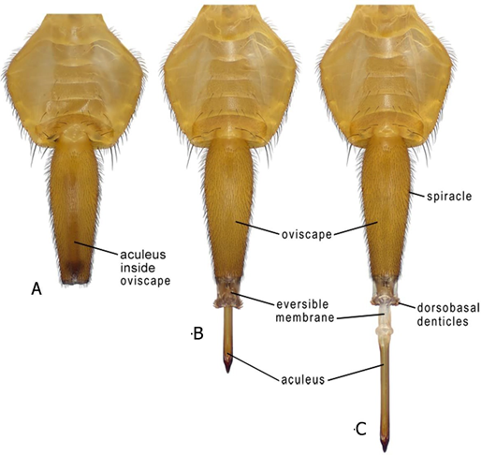

Figure 1. Ovipositor of adult female of Anastrepha striata in ventral view: (A) Aculeus and eversible membrane retracted inside oviscape; (B) Aculeus and eversible membrane partially everted; (C) Aculeus and eversible membrane completely everted.
Source: Figures adapted from Norrbom et al. (2012).

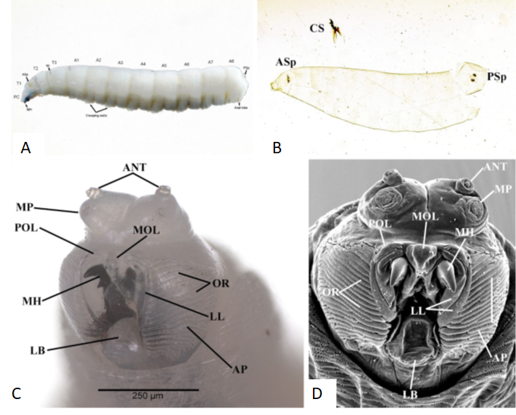
Figure 2. Third instars: (A) Habitus showing location of major anatomical features; (B) pseudocephalon, ventrolateral view; (C) Slide-mounted larva, cleared cuticle with cephaloskeleton removed; (D) pseudocephalon, ventral view, SEM. A1-A8, first to eighth abdominal segments; ANT, antenna; AP, accessory plates; ASp, anterior spiracle; CP, cephaloskeleton; MH, mouthhook; MP, maxillary palp; PC, pseudocephalon; OR, oral ridges; POL, preoral lobes; PSp, posterior spiracles; sp, spinules; T1-T3, first to third thoracic segments.
Source: Figures 2A-B courtesy of J. Diaz and G. J. Steck; Figures 2C-D from Steck et al. 2022.

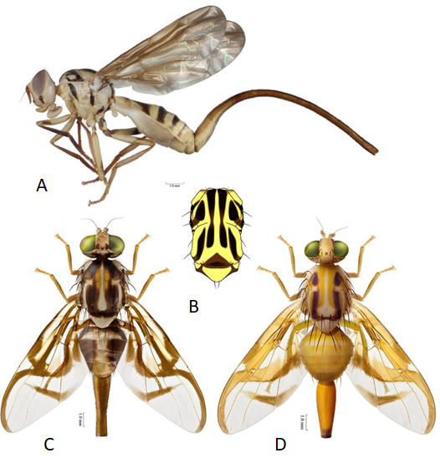
Figure 3. (A) Habitus of adult female of Anastrepha curvicauda in lateral view. (B) Thorax of adult female of Anastrepha curvicauda in dorsal view. (C) Habitus of adult female of Anastrepha serpentina in dorsal view. (D) Habitus of adult female of Anastrepha striata in dorsal view.
Source: Figures adapted from Norrbom et al. (2012).

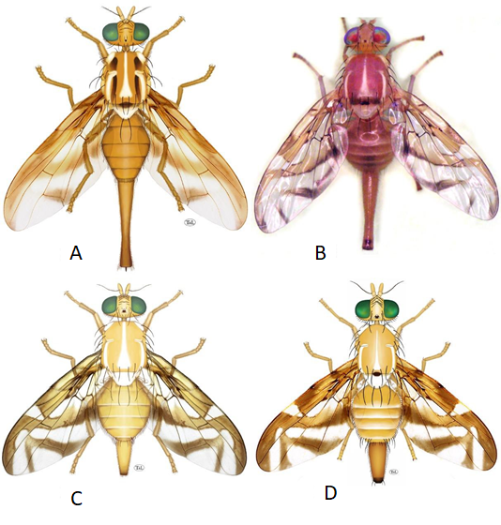
Figure 4. Habitus of adult female in dorsal view: (A) Anastrepha grandis; (B) Anastrepha ludens (Mexican fruit fly); (C) Anastrepha obliqua (West Indian fruit fly); (D) Anastrepha suspensa (Caribbean fruit fly).
Source: Figures 4-A, C, D adapted from Norrbom et al. (2012); Figure 4-B micrograph courtesy V. Hernández-Ortiz.

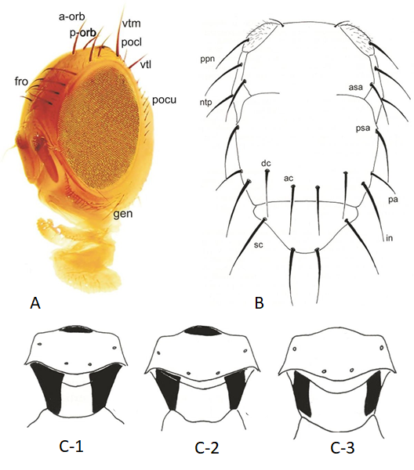
Figure 5. (A) Morphology of head of Anastrepha species in fronto-lateral view. a-orb, anterior orbital setae; fro, frontal setae; gen, gena; pocl, postocellar setae; pocu, postocular setae; p-orb, posterior orbital seta; vtl, lateral vertical seta; vtm, medial vertical seta. (B) Thorax in dorsal view, showing chaetotaxy. ac, acrostichal seta; asa, presutural supra-alar seta; dc, dorsocentral seta; in, intra-alar seta; ntp, notopleural setae; pa, postalar seta; ppn, postpronotal seta; psa, postsutural supra-alar seta; sc, scutellar setae. (C) Mediotergite and subscutellum, posterior view: (C-1) A. fraterculus; (C-2) A. ludens; and (C-3) A. obliqua.
Source: Figure 4-A adapted from Hernández-Ortiz et al. (2010); Figures 4-B, C adapted from Hernández-Ortiz (1992).

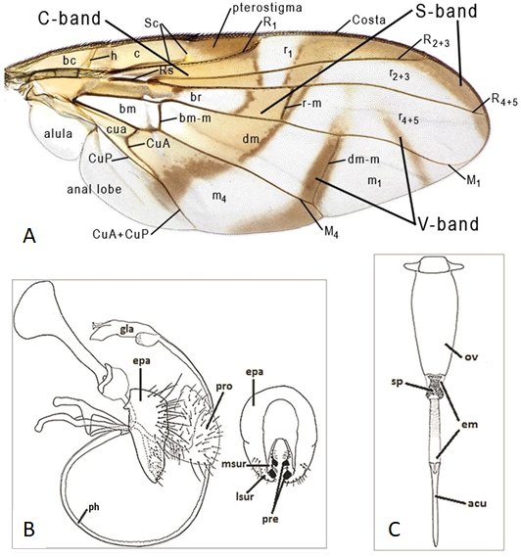
Figure 6. (A) Wing in dorsal view showing general Anastrepha pattern and nomenclature of veins and cells. (B) Male terminalia in Anastrepha species. epa, epandrium; gla, glans; lsur, lateral surstylus; msur, medial surstylus; ph, phallus; pre, prensisetae; pro, proctiger. (C) Female terminalia in Anastrepha species. em, eversible membrane; ov, oviscape; sp, sclerotized plates.
Source: Figure 6-A adapted from Hernández-Ortiz et al. (2010); Figures 6-B, C adapted from Norrbom et al. (2012).

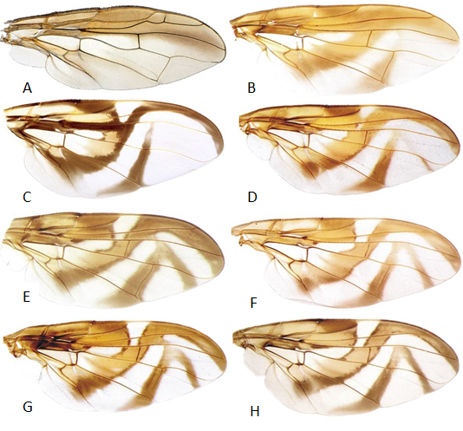
Figure 7. Wing pattern of Anastrepha species: (A) A. curvicauda; (B) A. grandis; (C) A. serpentina; (D) A. striata; (E) A. suspensa; (F) A. ludens; (G) A. obliqua; and (H) A. fraterculus (Brazil).
Source: Figures adapted from Hernández-Ortiz et al. (2010) and Norrbom et al. (2012).

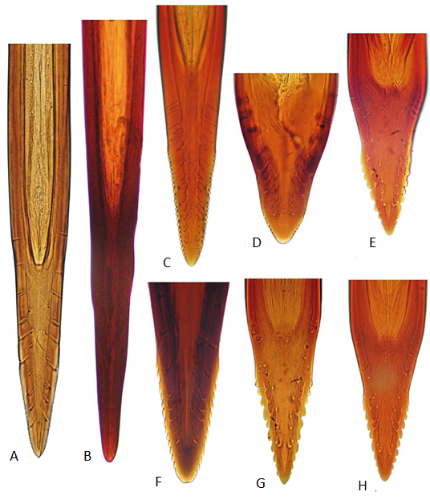
Figure 8. Morphology of the aculeus tip in ventral view of Anastrepha species of major economic importance: (A) A. curvicauda; (B) A. grandis; (C) A. serpentina; (D) A. striata; (E) A. suspensa; (F) A. ludens; (G) A. obliqua; and (H) A. fraterculus (Brazil).
Source: Figure 8-A courtesy of A.L. Norrbom; figures 8-B-H adapted from Hernández-Ortiz et al. (2010).

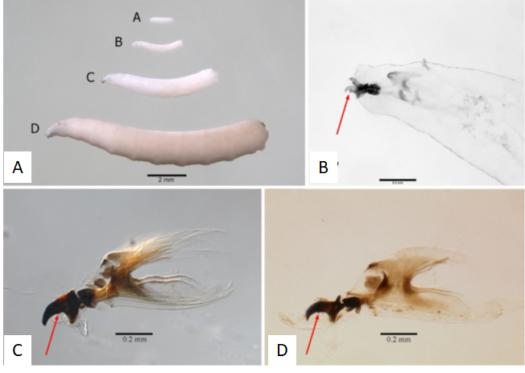
Figure 9. (A) Lateral habitus: (A-A), second instar; (A-B), small third instar; (A-C), large third instar of Anastrepha suspensa showing differences in sizes (A-D); (B) Cephaloskeleton of Anastrepha suspensa, second instar; arrow indicates subapical tooth on mouthhook that is subequal in size to apical tooth; (C) Cephaloskeleton of Anastrepha suspensa, third instar; arrow indicates lack of subapical tooth on mouthhook; (D) Cephaloskeleton of Ceratitis fasciventris, third instar; arrow indicates subapical tooth on mouthhook that is much smaller than apical tooth.
Source: Figures 9-A, B courtesy of D. R. Traficante and G. J. Steck; Figure 9-C courtesy of J. Diaz and G. J. Steck; Figure 9-D courtesy of G. J. Steck.

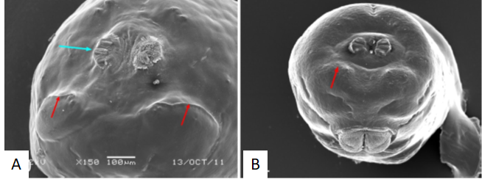
Figure 10. Caudal segment: (A), Ceratitis capitata, caudal ridges present (red arrows), posterior spiracle (blue arrow); (B), Anastrepha distincta, caudal ridges absent (arrow).
Source: Figure 10-A courtesy of G. J. Steck; Figure 10-B courtesy of L. A. Somma and G. J. Steck.

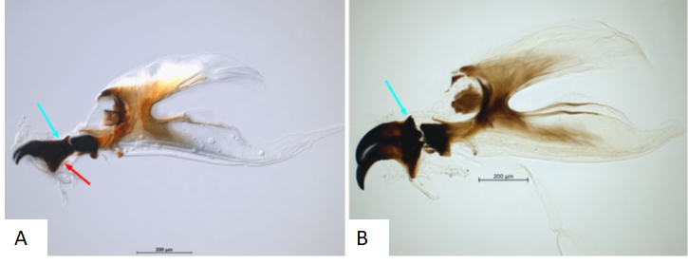
Figure 11. Cephaloskeleton: (A), mouthhook of Ceratitis capitata with elongate posterior neck (blue arrow) and dental sclerite (red arrow); (B), mouthhook of Anastrepha ludens with truncate posterior end and no dental sclerite.
Source: Figures courtesy of J. Diaz and G. J. Steck.

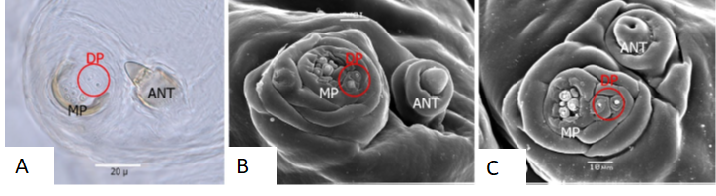
Figure 12. Pseudocephalon sensory structures: antenna, maxillary palpus, dorsolateral pair: (A), dorsolateral pair of sensilla (circled) perpendicular to maxillary palpus, Anastrepha suspensa; (B), dorsolateral pair of sensilla (circled) perpendicular to maxillary palpus, Anastrepha suspensa, SEM; (C), dorsolateral pair of sensilla (circled), parallel to maxillary palpus, Ceratitis capitata, SEM. ANT, antenna; DP, dorsolateral pair; MP, maxillary palpus.
Source: Figure 12-A courtesy of D. R. Traficante and G. J. Steck; Figures 12-B, C courtesy of L. A. Somma and G. J. Steck.

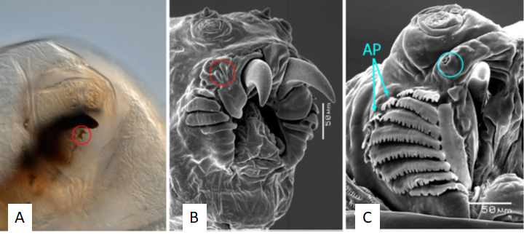
Figure 13. (A) Preoral teeth (circled), Rhagoletis pomonella; (B) Preoral teeth (circled), Rhagoletis pomonella, few oral ridges, no accessory plates, SEM; (C) Preoral organ lacks preoral teeth (circle), numerous oral ridges and accessory plates, Anastrepha obliqua, SEM. AP, accessory plates.
Source: Figure 13-A courtesy of G. J. Steck; Figures 13-B, C courtesy of L. A. Somma and G. J. Steck.

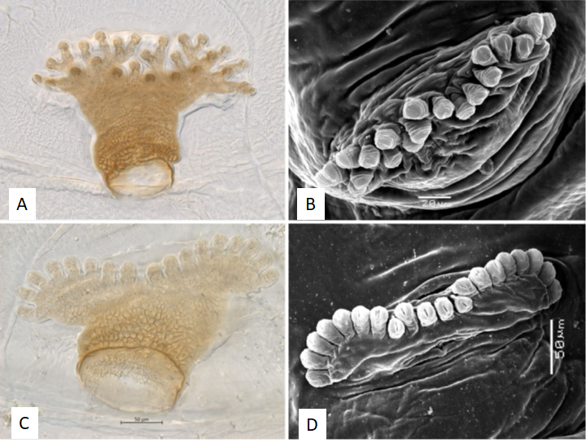
Figure 14. Anterior spiracle: (A) Rhagoletis cingulata; (B) Rhagoletis cingulata, SEM; (C) Anastrepha ludens; (D) Anastrepha ludens, SEM.
Source: Figures 14-A, C courtesy of J. Diaz and G. J. Steck; Figures 14-B, D courtesy of L. A. Somma and G. J. Steck.

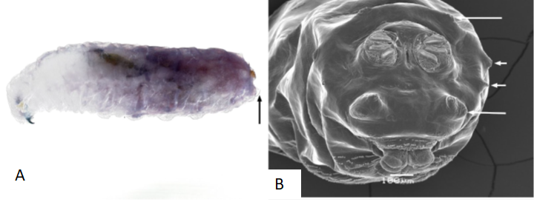
Figure 15. Rhagoletis cingulata; (A) lateral habitus, arrow indicates prominent tubercles on caudal segment; (B) caudal segment, arrows indicate prominent tubercles, SEM.
Source: Figure 15-A courtesy of G. J. Steck; Figure 15-B courtesy of L. A. Somma and G. J. Steck.

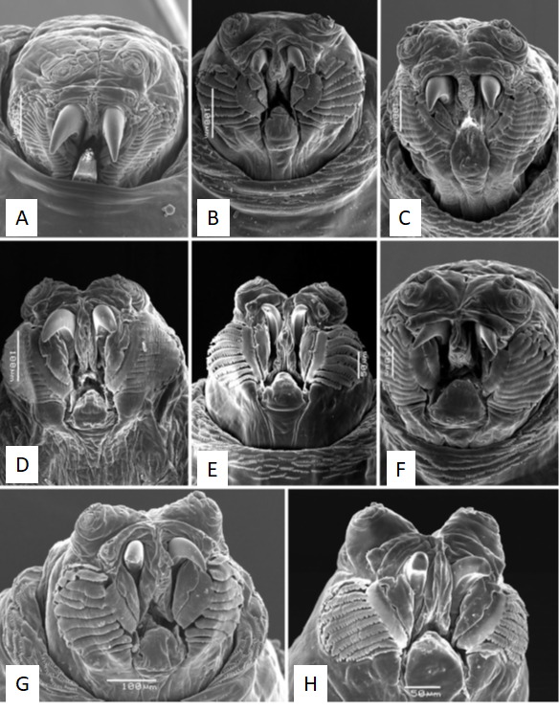
Figure 16. Facial mask: (A) Anastrepha curvicauda; (B) Anastrepha fraterculus; (C) Anastrepha grandis; (D) Anastrepha ludens; (E) Anastrepha obliqua; (F) Anastrepha serpentina; (G) Anastrepha striata; (65) Anastrepha suspensa.
Source: Figures 16-A, C–H courtesy of L. A. Somma and G. J. Steck; Figure 16-B courtesy of G. J. Steck.

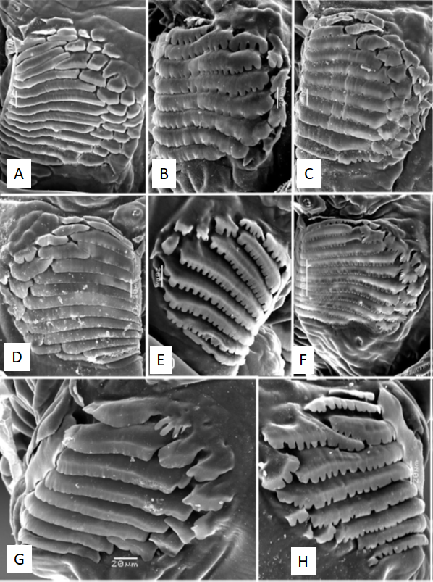
Figure 17. Oral ridges and accessory plates: (A) Anastrepha curvicauda; (B) Anastrepha fraterculus; (C) Anastrepha grandis; (D) Anastrepha ludens; (E) Anastrepha obliqua; (F) Anastrepha serpentina; (G) Anastrepha striata; (H) Anastrepha suspensa. Source: Figures courtesy of L. A. Somma and G. J. Steck.

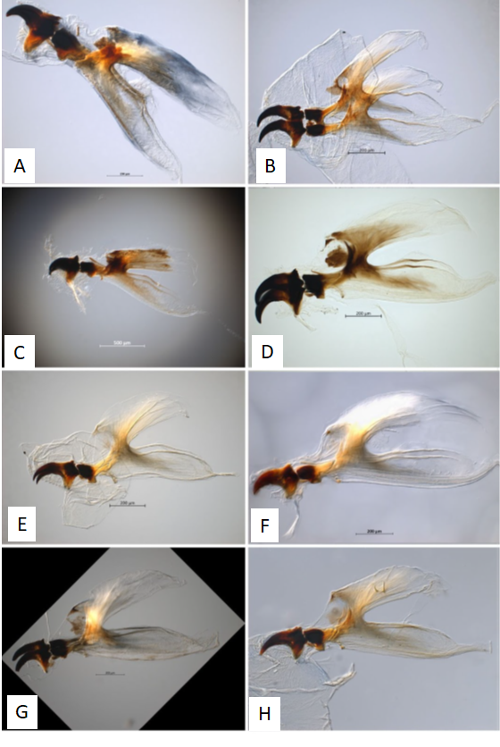
Figure 18. Cephaloskeleton: (A) Anastrepha curvicauda; (B) Anastrepha fraterculus; (C) Anastrepha grandis; (D) Anastrepha ludens; (E) Anastrepha obliqua; (F) Anastrepha serpentina; (G) Anastrepha striata; (H) Anastrepha suspensa.
Source: Figures 18-A, G courtesy of D. R. Traficante and G. J. Steck; Figures 18-B-F, H courtesy of J. Diaz and G. J. Steck.

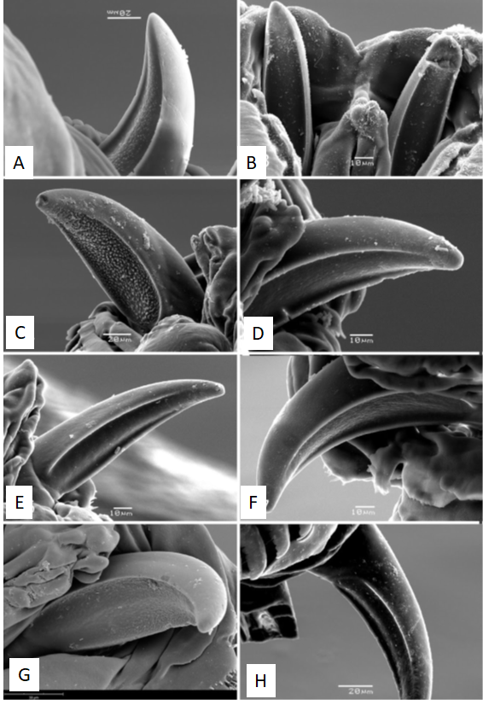
Figure 19. Mouthhook ventral surface: (A) Anastrepha curvicauda; (B) Anastrepha fraterculus; (C) Anastrepha grandis; (D) Anastrepha ludens; (E) Anastrepha obliqua; (F) Anastrepha serpentina; (G) Anastrepha striata; (H) Anastrepha suspensa.
Source: Figures courtesy of L. A. Somma and G. J. Steck.

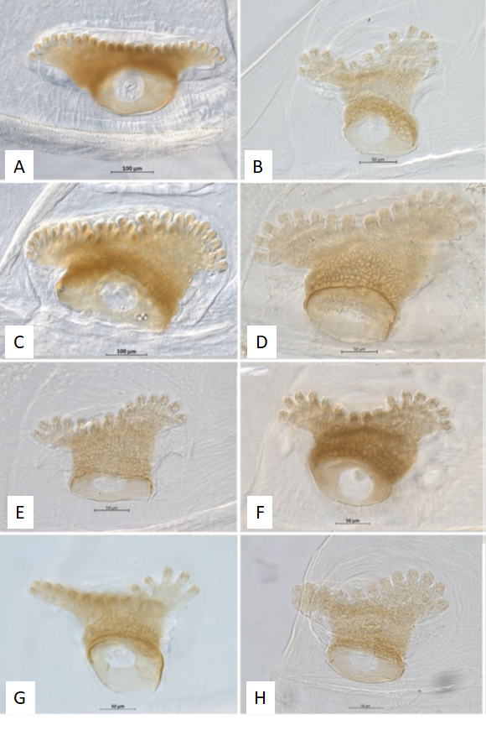
Figure 20. Anterior spiracle: (A) Anastrepha curvicauda; (B) Anastrepha fraterculus; (C) Anastrepha grandis; (D) Anastrepha ludens; (E) Anastrepha obliqua; (F) Anastrepha serpentina; (G) Anastrepha striata; (H) Anastrepha suspensa.
Source: Figures courtesy of J. Diaz and G. J. Steck.

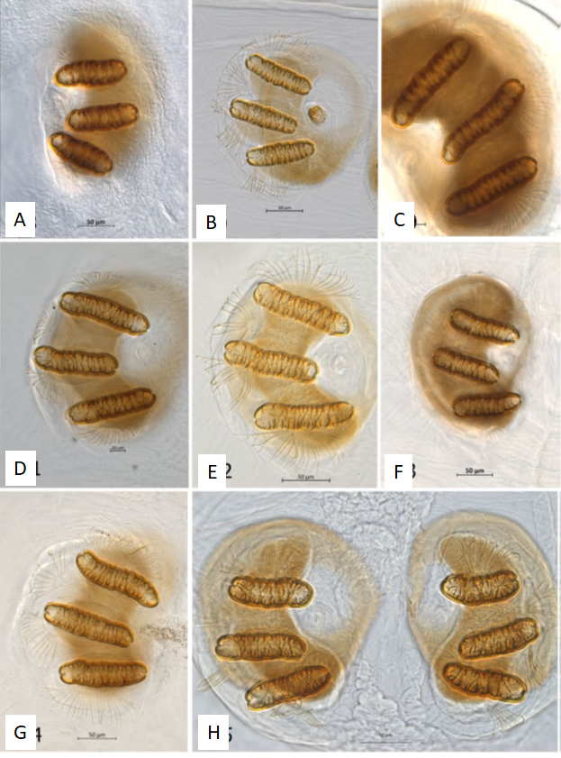
Figure 21. Posterior spiracle: (A) Anastrepha curvicauda; (B) Anastrepha fraterculus; (C) Anastrepha grandis; (D) Anastrepha ludens; (E) Anastrepha obliqua; (F) Anastrepha serpentina; (G) Anastrepha striata; (H) Anastrepha suspensa.
Source: Figures courtesy of J. Diaz and G. J. Steck.

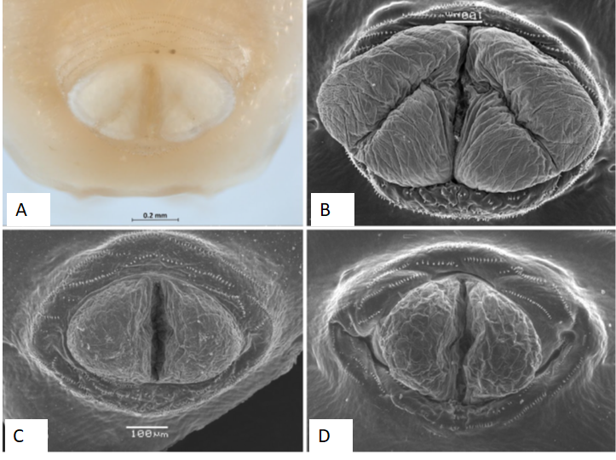
Figure 22. Anal lobes: (A) grooved, unequal lobes, Anastrepha grandis; (B) grooved, unequal lobes, Anastrepha grandis, SEM; (C) entire, Anastrepha fraterculus, SEM; (D) entire, Anastrepha obliqua, SEM.
Source: Figure 22-A courtesy of J. Diaz and G. J. Steck; Figures 22-B-D courtesy of L. A. Somma and G. J. Steck.

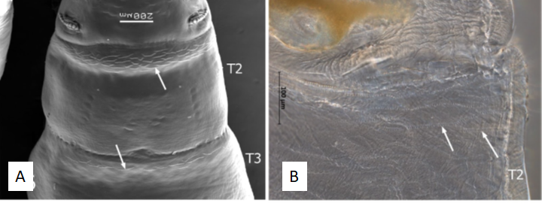
Figure 23. Dorsal spinules (arrows): (A) present on T2 and T3, Anastrepha suspensa, SEM; (B) as seen under compound microscope, Anastrepha ludens. Source: Figure 23-A courtesy of L. A. Somma and G. J. Steck; Figure 23-B courtesy of J. Diaz and G. J. Steck

