[1]DRAFT ANNEX to ISPM 27: ‘Candidatus Liberibacter’ spp. on Citrus spp. (2004-010)
[2]Status box
[3]This is not an official part of the standard and it will be modified by the IPPC Secretariat after adoption.
[4]Date of this document | [5]2021-12-08
[6]Document category | [7]Draft new annex to ISPM 27 (Diagnostic protocols for regulated pests)
[8]Current document stage | [9]To Standards Committee (SC)
[10]Major stages | [11]2004-11 SC added subject under work programme topic: Bacteria (2006-005).  [12]2016-05 Expert consultation.  [13]2016-06 DP drafting group revised the draft.  [14]2016-07 Technical Panel on Diagnostic Protocols (TPDP) revised and approved to submit to SC for consultation.  2021-06 SC approved for first consultation (2021_eSC_MAY_1).  2021-07 First consultation.  2021-11 TPDP revised and approved to submit to SC for approval for adoption.
[15]Discipline leads history | [16]Brendan RODONI (AU, Discipline Lead)  [17]Robert TAYLOR (NZ, Referee)
[18]Consultation on technical level | [19]The first draft of this protocol was written by:  - [20]María M. López (Instituto Valenciano de Investigaciones Agrarias, Moncada, Valencia, ES)  - [21]Solke De Boer (Charlottetown Laboratory, Canadian Food Inspection Agency, Charlottetown, CA)  - [22]John HARTUNG (Molecular Plant Pathology Laboratory, Agricultural Research Service, United States Department of Agriculture, US)  - [23]Rita Lanfranchi (Laboratory of Plant Pest and Disease. National Agrifood Health and Quality Service (SENASA), AR)  - [24]Takayuki Matsuura (Ministry of Agriculture, Forestry and Fisheries, Yokohama Plant Protection Station, Yokohama, JP)  - [25]Jacek Plazinski (Office of the Chief Plant Protection Officer, Division of Product Integrity, Animal and Plant Health, Canberra, AU)  - [26]Changyong Zhou (Citrus Research Institute, Chinese Academy of Agricultural Sciences/Southwest University, Chonging, CN)  [27]  [28]In addition, the draft has also been subject to expert review and the following international experts submitted comments:  - [29]Robert Taylor (Plant Health & Environment Laboratory, Biosecurity New Zealand, NZ).  [30]
[31]Main discussion points during development of the diagnostic protocol | [32]
[33]Notes | [34]This is a draft document.  [35]2021-04 Edited  2021-12 Edited
[36]
[37]CONTENTS
[38][to be added later]
[39]Adoption
[40]This diagnostic protocol was adopted by the Standards Committee on behalf of the Commission on Phytosanitary Measures in [Month 20--]. [to be completed after adoption]
[41]The annex is a prescriptive part of ISPM 27 (Diagnostic protocols for regulated pests).

[42]1. Pest information
[43]Huanglongbing (HLB), caused by ‘Candidatus Liberibacter’ species and also known as citrus greening, is one of the most destructive and widespread diseases of citrus in Asia, Africa and the Americas, affecting mainly Citrus species, cultivars and hybrids and, to a lesser extent, some other hosts within the Rutaceae (CABI, 2021; EPPO, 2021). The ‘Ca. Liberibacter’ species associated with the disease are transmitted by the psyllids Diaphorina citri (EPPO, 2005), Trioza erytreae and Cacopsylla citrisuga (Cen et al., 2012); ‘Candidatus Liberibacter asiaticus’ has also been detected in Diaphorina communis identified in Bhutan (Donovan et al., 2012).
[45]Huanglongbing-like symptoms were described for the first time in 1919 in China and then in 1921 in the Philippines (Bové, 2006). However, farmers in southern China had observed yellowing of their citrus trees since the late 1800s and in India the “citrus dieback” syndrome has been reported since the eighteenth century. In South Africa, the first symptoms of HLB were recorded in 1828/29 (Da Graça, 2010). Subsequently, HLB has extended its distribution into many of the major citrus-producing areas of the world.
[46]The causal agents of HLB are fastidious Gram-negative bacteria in the ‘Ca. Liberibacter’ genus (Garnier, Danel and Bové, 1984). ‘Ca. Liberibacter’ species are restricted to the sieve tubes within the phloem tissues and are unevenly distributed within the host plant (Jagoueix, Bové and Garnier, 1994). The pathogenic ‘Ca. Liberibacter’ species were discovered by electron microscopy in citrus trees with HLB symptoms. Three species of ‘Ca. Liberibacter’ have been associated with HLB and are differentiated based on the nucleotide sequence in the 16S ribosomal gene operon (Jagoueix, Bové and Garnier, 1994). Bacterium titres in the phloem vary depending on ‘Ca. Liberibacter’ or plant species, plant organ, and the climatic or environmental conditions to which plants are exposed (Tatineneni et al., 2008; Lopes et al., 2009a; Lopes et al., 2017; Cifuentes Arenas et al., 2019). ‘Ca. Liberibacter’ spp. can be transported both upward and downward throughout the tree, but the distribution of the bacterium is highly patchy (Li, Levy and Hartung, 2009). The highest concentrations can be found in the stem and midribs of flush (a flush being a newly developing cluster of very young leaves on the expanding terminal end of a shoot) (Chiyaka et al., 2012). The three species are as follows:
- [48]‘Candidatus Liberibacter africanus’ (CLaf) is transmitted by Trioza erytreae, is heat-sensitive and causes symptoms between 22 °C and 24 °C (Jagoueix, Bové and Garnier, 1994), with no symptoms appearing at 27–30 °C (da Graça, 1991). It is present in Asia and Africa (Bové, 2006; da Graça, 2010; CABI, 2021).
- [49]‘Candidatus Liberibacter americanus’ (CLam) was described as a new species when it was first found in 2004 in São Paulo, Brazil (Teixeira et al., 2005a, 2005b, 2005c; Bové, 2006). It is transmitted by Diaphorina citri (Yamamoto et al., 2006). CLam is heat sensitive, with cell multiplication in plant tissues partially affected at 32 °C and highly affected at 35 °C and 38 °C (Lopes et al., 2009b). Similarly, Gasparoto et al. (2012) found that CLam did not infect plants maintained at night/day temperature conditions of 27/32 °C, but infection by CLas occurred at all the studied temperatures (17/22, 22/27 or 27/32 °C).
- Candidatus Liberibacter asiaticus’ (CLas), transmitted by Diaphorina citri, is heat tolerant and induces symptoms in warm climates at optimal temperatures in the range 27–32 °C (Jagoueix, Bové and Garnier, 1996). Cell multiplication in plant tissues is partially limited at 38 °C (Lopes et al., 2009b). It is present in Asia, Africa, Oceania and North and South America (Bové, 2006; da Graça, 2010; CABI, 2021).
[50]Huanglongbing is a disease that affects Citrus and a few other genera of Rutaceae. The disease is present in C. aurantiifolia (lime), C. ×aurantium (sour orange), C. limettioides (Palestinian sweet lime), C. limon L. (lemon), C. limonia Osbeck (Rangpur lime), C. japonica (syn. Fortunella japonica (kumquat), C. medica (citron), C. paradisi (grapefruit), C. paradisi × C. reticulata (tangelo), C. reticulata (mandarin), C. sinensis (L.) Osbeck (sweet orange) and Poncirus trifoliata (trifoliate orange) (da Graça, 1991). The rutaceous trees Calodendrum capense (Cape chestnut), Murraya paniculata (Garnier et al., 2000; Lopes et al., 2010, Cifuentes Arenas et al., 2019) and Atalantia (syn. Severinia) buxifolia (Deng et al., 2008) may harbour ‘Ca. Liberibacter’ species but at lower titres than in citrus plants, and support populations of Trioza erytreae and Diaphorina citri (Garnier et al., 2000; Jagoueix, Bové and Garnier, 1996). Other hosts may be viewed at https://gd.eppo.int/taxon/LIBEAS/hosts, https://gd.eppo.int/taxon/LIBEAF/hosts, and https://gd.eppo.int/taxon/LIBEAM/hosts.
The incubation period for HLB within citrus trees ranges from a few months to one or more years (Gottwald, 2010). At about three months after inoculation, Folimonova and Achor (2010) detected CLas in 70% of inoculated C. sinensis and C. paradisi seedlings, with severe asymmetrical yellowing of leaves clearly observed five to six months after grafting. In a similar study (Coletta-Filho et al., 2010), CLas was detected in 60% of C. sinensis ‘Valencia’ trees one month after inoculation, and typical HLB symptoms (chlorosis of leaves) were observed six to eight months after inoculation. Quantification of the bacterium using quantitative polymerase chain reaction (qPCR) has shown the presence of CLas in different parts of the infected plant, but with an uneven distribution (Tatineni et al., 2008). Consequently, when sampling a citrus tree or other species, the sample should be as representative as possible of the total leaf area of the plant to increase the probability of detecting and identifying the causative agent of HLB in each laboratory analysis.
[51]The psyllids reported as being the vectors of HLB persist and multiply on other rutaceous plants including A. buxifolia, Atalantia missionis, Citrus inodora, Citrus ×virgata Mabb ‘Sydney Hybrid’, Citropsis gabunensis, Citropsis schweinfurthii, Clausena anisum-olens, Limonia acidissima, Naringi crenulata (Barkley and Beattie, 2008), Swinglea glutinosa (Garnier and Bové, 1993) and Vepris lanceolata (Gottwald, Graça and Bassanezi, 2007). More information on insect vectors is available from Table 2 and Table 3 of the following pest risk analysis on HLB: https://www.anses.fr/fr/system/files/SANTVEG2016SA0235Ra.pdf.
[52]To date, psyllids are the only group of insects known to transmit ‘Ca. Liberibacter’ spp. (Cen et al., 2012). The bacterium can multiply in the body of the insect vectors (Aubert, 1987; Jagoueix, Bové and Garnier, 1997). Pelz-Stelinsky et al. (2010) reported that transmission of CLas from parent to offspring (transovarial) occurred at a rate of 2–6% as opposed to the absence of transovarial transmission reported by Hung et al. (2004).

[53]2. Taxonomic information
[54]Name: ‘Candidatus Liberibacter africanus’ Garnier, 2000
[55]Synonym: ‘Candidatus Liberobacter africanum’ Jagoueix et al., 1994
[56]Name: ‘Candidatus Liberibacter americanus’ Texeira et al., 2005
[57]Name: ‘Candidatus Liberibacter asiaticus’ Garnier, 2000
[58]Synonym: ‘Candidatus Liberobacter asiaticum’ Jagoueix et al., 1994
[59]Taxonomic position: Bacteria, Proteobacteria, Alpha-Proteobacteria, Rhizobiales, Phyllobacteriaceae
[60]Disease names: huanglongbing (HLB), also known as citrus greening or yellow shoot disease (the common name “huanglongbing” being currently widely adopted in the scientific literature (CABI, 2021))
[61]In 1994, the International Committee for Systematic Bacteriology recommended that, as proposed by Murray and Schleifer (1994), a ‘Candidatus’ designation be used as an interim taxonomic status, to provide a proper allocation of sequence-based potential new taxa at the genus and species level (Murray and Schleifer, 1994; Murray and Stackebrandt, 1995). Jagoueix, Bové and Garnier (1994) proposed that this new group in the alpha subdivision of the Proteobacteria should be referred to by the name “Liberobacter” (from the Latin liber [bark] and bacter [bacteria]). Subsequently, two “Candidatus species”, Liberobacter asiaticum and Liberobacter africanum, were recognized based on polymorphism in the 16S ribosomal (r)DNA nucleotide sequences. Later, the spelling was corrected to ‘Liberibacter’, to conform to the Latin convention of using the connecting vowel “i” rather than “o”, and the species asiaticum and africanum changed to asiaticus and africanus (Garnier et al., 2000). In 2004, a new species, ‘Ca. Liberibacter americanus’, was discovered in Brazil (Teixeira et al., 2005c).

[62]3. Detection
Plants infected with ‘Ca. Liberibacter’ spp. may exhibit symptoms that may be similar to those associated with other phloem-limited bacteria, physiological disorders or other diseases. Specific methods are therefore required for the detection and identification of ‘Ca. Liberibacter’ species in Citrus.
[63] Huanglongbing was diagnosed in the late twentieth century by electron microscopic examination and by bioassays on indicator plants. In vitro cultivation of the ‘Ca. Liberibacter’ species associated with HLB is not yet sufficiently well established to allow their diagnosis through methods involving culturing. Historically, ‘Ca. Liberibacter’ species were considered non-culturable bacteria, but although four reports have referred to the cultivation of HLB-related ‘Ca. Liberibacter’ species (Davis et al., 2008; Sechler et al., 2009; Ha et al., 2019; Mandadi et al., 2020), confirmation is needed. However, methods based on the polymerase chain reaction (PCR) amplification of sequences from genes, such as the 16S ribosomal (r)RNA gene (Li, Hartung and Levy, 2006) and the rplKAJL-rpoBC gene cluster (Hocquellet et al., 1999; Teixera et al., 2005a), are efficient and sensitive for the detection of liberibacters in HLB-infected plant tissue and in psyllids.
[64]The use of PCR to detect ‘Ca. Liberibacter’ spp. in a vector is very useful for surveillance because it allows detection of the pathogen in the insect before appearance of the symptoms in trees. Nguyen, Le and Nguyen (2003) showed that HLB-infected psyllids may contain a higher titre of the bacterium than HLB-infected plant tissue. Molecular detection is the method that may detect the bacterium in a single adult or in the third, fourth and fifth instars of the psyllid (Manjunath et al., 2008).
[65]Loop-mediated isothermal amplification (LAMP) has been adapted for the sensitive detection of CLas (Okuda et al., 2005; Rigano et al., 2014; Keremane et al., 2015; Choi et al., 2018). Such LAMP-based methods are performed at a constant temperature, can be used on crude DNA extractions, and have shown promise for on-site diagnostics. However, these methods have not yet been well validated for routine diagnosis of CLas and hence are not included in this diagnostic protocol.
[66]In this diagnostic protocol, methods (including reference to brand names) are described as published, as these define the original level of sensitivity, specificity and reproducibility achieved. Laboratory procedures presented in the protocols may be adjusted to the standards of individual laboratories, provided that they are adequately validated.

[67]3.1 Symptoms
[68]Inspection is important for detection in symptomatic plants and is a routine method for the surveillance of HLB. Yellow shoots and blotchy mottle symptoms on leaves are typical symptoms on HLB-infected trees and can be used on site as part of an initial diagnosis. However, symptoms can be confused with nutritional disorders (zinc, iron or manganese deficiencies) or with other diseases (e.g. Australian citrus dieback (caused by ‘Candidatus Phytoplasma’ sp.), citrus blight, gummosis (cause by Phytophthora spp.), stubborn disease of citrus (cause by Spiroplasma citri), and tristeza (caused by Citrus tristeza virus)). ‘Ca. Liberibacter’ spp. can be unevenly distributed in the host plant and at a very low concentration, resulting in sparse symptoms that are easy to miss.
[69]Symptoms of HLB develop slowly. Infected trees gradually decline in vigour and yield and remain stunted or eventually die (Figure 1). The disease develops irregularly, so individual trees may show a mixture of normal and diseased sectors (Figures 2, 3, and Figure 4). This mixture within the same tree is a diagnostic characteristic (see https://iocv.ucr.edu/sites/g/files/rcwecm4696/files/huanglongbing-011.jpg).
Symptoms first appear as leaf yellowing (Figure 5), followed by mottling and chlorosis in one shoot or sector of the tree. Later, leaf symptoms resemble nutritional deficiencies (zinc, copper or nitrogen). Discoloration of the leaves starts along the main and secondary veins and then spreads away from the veins, with the leaves turning pale to light yellow with unevenly distributed dark green patches. The larger leaves on the base of branches become a “blotchy mottle”, with the two halves of the leaf being asymmetrical in terms of the pattern of yellow and green. This is the most characteristic foliar symptom (see https://iocv.ucr.edu/sites/g/files/rcwecm4696/files/huanglongbing-041.jpg). [71]Leaves on weak terminal twigs are small, upright and show a variety of chlorotic patterns.
Infected fruits have a bitter and salty taste and a reduced Brix acid ratio, are smaller and of poor quality, often fail to develop normal fruit colour, and often fall prematurely (see https://iocv.ucr.edu/sites/g/files/rcwecm4696/files/huanglongbing-085.jpg). A ripening colour inversion can occur where the stylar end remains green and the peduncle end colours prematurely (Figure 6). Another diagnostic feature is the “silver thumb print”: a greyish-white imprint on the rind that is left if pressure is exerted on the fruit with a finger (CABI, 2021). Small, brownish-black aborted seeds can be observed when fruits are cut in half, but this symptom can also be present in fruits affected by citrus stubborn disease. In addition, the vascular bundles within the fruit axis at the peduncular end have a strong brownish stain (EPPO, 2021).
[72]The columella is curved, causing the fruit to be distorted and lopsided (see https://iocv.ucr.edu/sites/g/files/rcwecm4696/files/huanglongbing-092.jpg). Seeds in the affected fruit are usually aborted.
[73]Images of HLB symptoms and distinctive characteristics may be viewed at the European and Mediterranean Plant Protection Organization (EPPO) Global Database (https://gd.eppo.int/taxon/LIBEAS/photos) or at https://iocv.ucr.edu/citrus-diseases/huanglongbing.

[74]3.2 Sampling and sample preparation
[75]Huanglongbing is a systemic disease of citrus. ‘Ca. L. asiaticus’ has been detected in bark tissue, leaf midrib, roots, and different floral and fruit parts of infected citrus trees (Tatineni et al., 2008; Teixeira et al., 2008; Li, Levy and Hartung, 2009; Louzada et al., 2016). Sample selection is critical for ‘Ca. Liberibacter’ spp. detection. Each tree should be sectioned into quadrants; each quadrant should be sampled to give a total of ~15 leaves per tree to obtain at least ~1 g of petiole and midribs from symptomatic or symptomless trees (EPPO, 2021).

[76]3.2.1 Symptomatic material
[77]An appropriate sample from a symptomatic tree consists of approximately fifteen leaves (NAPPO, 2012). Sampling should target collection of leaves with typical symptoms. Tissue prints of the petioles or the basal part of the leaves on membranes can also be used, as described by Bertolini et al. (2014) and Siverio et al. (2017) (see section 3.4.1). The leaf samples are placed in a labelled plastic bag (one bag per tree), stored in a cool box while in the field, and refrigerated at approximately 4 °C as soon as possible. Leaves can be processed at any time up to three weeks after collection if kept in sealed plastic bags or other sealed containers at 4 °C and if no decay has occurred. The petiole and midribs of collected leaves are excised and processed for DNA extraction because the leaf midribs are enriched in phloem vessels and cover two-thirds of the leaf: they consequently have a higher titre of ‘Ca. Liberibacter’ cells (da Graça, 1991; Wang et al., 2006). Older leaves and longer infected plants also yield a higher titre of Liberibacter DNA (Nguyen, Le and Nguyen, 2003).

[78]3.2.2 Asymptomatic material
[79]An appropriate sample from a symptomless tree consists of at least fifteen mature leaves collected from around the canopy of the tree (EPPO, 2021). For small trees (e.g. in a nursery), three to twelve leaves per tree are collected (NAPPO, 2012). The sampled leaves are placed in a labelled plastic bag (one bag per tree), stored in a cool box while in the field, and refrigerated as soon as possible. Leaves should be kept in sealed plastic bags or sealed containers at approximately 4 °C and processed as soon as possible.

[80]3.2.3 Psyllids
[81]The preparation of the specimen or specimens consists of placing the adults or nymphs in a labelled vial and then either processing them for DNA extraction immediately or preserving them in 70% ethanol. The insects may also be squashed onto membranes (see section 3.4.2).

[82]3.3 Biological detection (graft transmission)
[83]Biological indexing can be used for ‘Ca. Liberibacter’ species detection despite the low rate of graft transmission and is suitable as a screening method for use by diagnosticians who have experience with symptom observation. The indicators used commonly are C. sinensis or Citrus ×tangelo (Orlando tangelo) for CLaf, C. sinensis or C. reticulata × C. sinensis (Murcott tangor) for CLam (Lopes and Frare, 2008; NAPPO, 2012), and C. sinensis (sweet orange) or C. reticulata (mandarin) for CLas. Catharanthus roseus (periwinkle) may also be used: in this host, ‘Ca. Liberibacter’ spp. can multiply after transmission by Cuscuta campestris (dodder) and be present at a higher titre than in citrus plants (Garnier and Bové, 1983), with the symptoms developing after three months at 25 °C (Nguyen, Le and Nguyen, 2003; Bové, 2006).
[84]There are several recommendations for selecting plant material for grafting onto indicator plants. According to Lopes et al. (2009), the best inoculum is from symptomatic branches (particularly those showing symptoms within the previous 12 months) that are suspected to be infected by any ‘Ca. Liberibacter’ species. The selected branch piece is cut into segments, each 3–5 cm long, and the segments are grafted onto the stem of the indicator potted plant. After inoculation, the graft is protected with polyethylene tape and the plants are maintained in a greenhouse. The grafted indicator plants are then inspected regularly. The first symptoms usually appear three to four months after inoculation with a light yellowing of the mature apical leaf and progress to blotchy mottling (diffuse and asymmetrical chlorosis) and eventually thickening of the vein after 6 to 12 months (Lopes and Frare, 2008; EPPO, 2021).
[85]Leaf grafting is performed using a 3 mm × 12 mm section of the midrib part of the leaf, placed into a T-cut in the bark of an indicator seedling (Roistacher, 1991). The grafted plants are kept at at 25–32 °C for CLas and 20–25 °C for CLaf (EPPO, 2021). It has been demonstrated that CLas is transmitted more efficiently than CLam and reaches a higher titre in the infected plant (Lopes et al., 2009a; Hall et al., 2013).

[86]3.4 Molecular detection
[87]Conventional PCR is relatively sensitive and specific, particularly when used on symptomatic samples. It can lead to false negative results when the concentration of the bacterium is too low to detect, for instance in newly infected trees with a low concentration and uneven distribution of the pathogen (Bové, 2006). Consequently, conventional PCR should only be used on plants exhibiting symptoms and is not reliable for the detection of ‘Ca. Liberibacter’ spp. in symptomless plants. However, real-time PCR may be useful in programmes for the production of certified citrus nursery trees and in post-entry quarantine. Li, Hartung and Levy (2006), Teixeira et al. (2008) and Bertolini et al. (2014) have reported that real-time PCR can detect ‘Ca. Liberibacter’ spp. in symptomless samples of infected plants and is more convenient for early detection than conventional PCR.

[88]3.4.1 Nucleic acid extraction from plant material
[89]Based on experience from several countries, the following methods may be used to extract DNA from plant tissue, although other DNA extraction kits can also give good DNA quality.
NaOH extraction. For rapid extraction, plant tissue samples (1 g midribs and petioles) are ground in 2% (w/v) NaOH (5 mL). The debris is pelleted using a bench top centrifuge for 5 s. The supernatant is collected and diluted 1:50 and can be used directly for molecular amplificiation (EPPO, 2021).
[90]CTAB extraction. Plant tissue samples (500 mg midribs) are homogenized in cetyl trimethyl ammonium bromide (CTAB) buffer (3 mL) containing 0.2% β-mercaptoethanol. The β-mercaptoethanol should be freshly prepared and added to the CTAB buffer immediately before use. Homogenization of plant tissue can be done either by using commercially available equipment (a Fastprep (MP Biomedicals) instrument or a Mini-Beadbeater (BioSpec)2 instrument) or by manually grinding with a mortar and pestle or crushing the tissue in a plastic bag. After this, 2 mL homogenate is transferred to a microtube and incubated for at least 15 min at 65°C with regular mixing (e.g. by a thermomixer or inversion). The resulting extract is centrifugated at 3 000 g for 5 min in a microcentrifuge and 800 µL supernatant is then put in a 2 mL microtube with 800 µL chloroform-isoamyl alcohol solution (24:1 v/v), mixed and centrifuged at 14 000 g for 5 min. The aqueous phase is transferred to a new microtube, mixed with 0.6 volume of cold isopropanol and kept at −20 °C for 30 min before being centrifuged at 14 000 g for 20 min. The supernatant is discarded and the pellet washed twice with 70% ethanol and resuspended in 100 µL sterile distilled water. The resulting extracts can be stored at −20°C until use.
[91]Commercial kit. After using any of the disruption methods described above in relation to CTAB extraction, DNA extraction is carried out using the DNeasy Plant Mini Kit (Qiagen)2 according to the manufacturer’s instructions.
[92]Plant tissue print. The plant tissue print method is a rapid, direct method of sample preparation (Bertolini et al., 2008) that can be done under field conditions and has demonstrated its efficiency when combined with the real-time PCR detection(Bertolini et al. 2014). The tissue print method is performed by pressing five to ten fresh, manually detached, citrus leaf petioles onto an area (0.5 cm²) of a positively charged nylon or 3MM filter paper membrane (Bertolini et al., 2008). The tissue printed membrane is cut out and inserted, with tweezers, into a microcentrifuge tube containing either 100 µL distilled water, 0.5% Triton X-100 or glycine buffer (0.1 M glycine, 0.05 M NaCl, 1 mM ethylenediaminetetraacetic acid (EDTA)). Samples are then incubated at 100 °C or room temperature for 10 min as described by Bertolini et al. (2014), vortexed and placed on ice until use.

[93]3.4.2 Nucleic acid extraction from the psyllid vectors
[94]Manjunath et al. (2008). In this method, the psyllids (up to 50) are air-dried for 10 min, transferred to a 1.5 mL microtube containing 300 µL extraction buffer (10 mM Tris, pH 8.0, 100 mM NaCl, 1 mM EDTA, 2% sodium dodecyl sulphate) and 20 units of Proteinase K (New England Biolabs)2, ground finely and incubated either at 50°C for 3 h or 37 °C overnight. An equal volume of phenol-chloroform-isoamyl alcohol (25:24:1) is added, vortexed and the aqueous phase transferred to a second tube containing 300 µL chloroform-isoamyl alcohol (24:1) and the extraction procedure is repeated. The aqueous phase is ethanol precipitated and the resulting DNA pellet is dissolved in 20–50 µL sterile water and stored at −20 °C.
[95]Bertolini et al. (2014). In this method, individual psyllids are inmobilized and squashed on nylon or paper membranes with the bottom end of a microcentrifuge tube. Pieces of membrane harbouring the squashed samples are inserted into microtubes containing 100 µL distilled water, 0.5% Triton X-100 or glycine buffer (0.1 M glycine, 0.05 M NaCl, 1 mM EDTA). Samples are then incubated at room temperature for 10 min, vortexed and placed on ice until used for real-time PCR (EPPO, 2021).
[96]NAPPO (2012). In this method, one to five adult psyllids are placed into a microfuge tube and homogenized in the tube with a micropestle. DNA extraction is then carried out using the commercial kit Qiagen DNeasy Blood and Tissue Kit2 according to the manufacturer’s instructions.

[97]3.4.3 Conventional PCR
[98]Conventional PCR has proven to be a reliable, specific and sensitive technique for detecting ‘Ca. Liberibacter’ spp. in HLB-infected symptomatic trees. Li, Hartung and Levy (2007) determined that there were no significant differences in sensitivity among the conventional PCR methods listed below. All conventional PCR methods can detect ‘Ca. Liberibacter’ spp. in 10⁻² dilutions of DNA extracts obtained from 200 mg of midribs from infected plants.
[99]3.4.3.1 Conventional PCR using the primers of Jagoueix, Bové and Garnier (1996)
[100]Jagoueix, Bové and Garnier (1996) used three primers in the same PCR mixture: OI1, OA1 and OI2c. The primer sequences, which are based on the 16S rDNA sequences, are as follows:
[101]OI1 (forward): 5′-GCG CGT ATG CGA ATA CGA GCG GCA-3′
[102]OA1 (forward): 5′-GCG CGT ATT TTA TAC GAG CGG CA-3′
[103]OI2c (reverse): 5′-GCC TCG CGA CTT CGC AAC CCA T-3′
[104]The primer pair OI1/OI2c amplifies the DNA of CLaf and CLas; the primer pair OA1/OI2c preferentially amplifies the DNA of CLaf.
[105]Although Jagoueix, Bové and Garnier (1996) determined that the primer pair OI1/OI2c detects CLaf and CLas, this primer pair does not detect CLam (Li, Hartung and Levy, 2007). The specificity of the primers has been demonstrated by screening the following non-target species: Acinetobacter lwoffi, Agrobacterium tumefaciens, Citrus tristeza virus, Escherichia coli, ‘Candidatus Phytoplasma aurantifolia’ (lime witches’ broom phytoplasma), ‘Candidatus Phytoplasma solani’ (stolbur phytoplasma), Spiroplasma citri, Xanthomonas campestris and Xylella fastidiosa. The sensitivity of the method was not quantified, but although amplifications were obtained from 20 mg of infected midribs, they were not obtained when lesser amounts of infected midribs were mixed with 1 g of healthy midrib tissue.
[106]The master mix used for this PCR, developed by Jagoueix, Bové and Garnier (1996), is described in Table 1.
[107]Table 1. Master mix composition, cycling parameters and amplicons for conventional PCR using the primers of Jagoueix, Bové and Garnier (1996)
[108]Reagents | [109]Final concentration
[110]PCR-grade water | [111]– ^{i}
[112]PCR buffer | [113]1×
[114]dNTPs | [115]200 µM
[116]MgCl₂ | [117]2.0 mM
[118]Primer OI1 (forward) | [119]0.5 µM
[120]Primer OA1 (forward) | [121]0.5 µM
[122]Primer OI2c (reverse) | [123]0.5 µM
[124]Taq DNA polymerase | [125]1.5 U
[126]DNA volume | [127]1 µL DNA extract of plant tissue or insect vector
[128]Cycling parameters | [129]
[130]Initial denaturation | [131]94°C for 2 min
[132]Number of cycles | [133]35
- [134]Denaturation | [135]92°C for 60 s
- [136]Annealing and elongation | [137]72°C for 90 s
[138]Final elongation | [139]72°C for 10 min
[140]Expected amplicons | [141]
[142]Size | [143]1160 bp
[144]i For a final reaction volume of 50 µL.
[145]bp, base pairs; PCR, polymerase chain reaction.
[146]3.4.3.2 Conventional PCR using the primers of Hocquellet et al. (1999)
[147]Hocquellet et al. (1999) designed the primers A2 and J5 specifically to detect CLaf and CLas. Species specificity has been demonstrated against A. tumefaciens, A. lwoffi, E. coli, Xanthomonas citri pv. citri, X. fastidiosa, S. citri, ‘Ca. P. aurantifolia’ and ‘Ca. P. solani’. These primers do not detect CLam (Li, Hartung and Levy, 2007). Polymerase chain reaction conditions have also been optimized to allow these primers to be used in duplex PCR with the GB1 and GB3 primers of Teixeira et al. (2005a); for further information on method description and validation, see Cellier et al. (2020) and EPPO (2021).
[148]The primer sequences, which are based on the DNA sequences of the ß- operon, are as follows:
[149]A2 (forward): 5′-TAT AAA GGT TGA CCT TTC GAG TTT-3′
[150]J5 (reverse): 5′-ACA AAA GCA GAA ATA GCA CGA ACA A-3′
[151]The master mix used for this PCR, developed by Hocquellet et al. (1999), is described in Table 2.
[152]Table 2. Master mix composition, cycling parameters and amplicons for conventional PCR using the primers of Hocquellet et al. (1999)
[153]Reagents | [154]Final concentration
[155]PCR-grade water | [156]– ^{i}
[157]PCR buffer | [158]1×
[159]dNTPs | [160]200 µM
[161]MgCl₂ | [162]2.0 mM
[163]Primer A2 (forward) | [164]1.0 µM
[165]Primer J5 (reverse) | [166]1.0 µM
[167]Taq DNA polymerase | [168]1.0 U
[169]DNA volume | [170]2 µL DNA extract of plant tissue
[171]Cycling parameters | [172]
[173]Initial denaturation | [174]94°C for 2 min
[175]Number of cycles | [176]35
- [177]Denaturation | [178]92°C for 20 s
- [179]Annealing | [180]62°C for 20 s
- [181]Elongation | [182]72°C for 45 s
[183]Final elongation | [184]72°C for 10 min
[185]Expected amplicons | [186]
[187]Size | [188]669 bp for CLaf
[189] | [190]703 bp for CLas
[191]i For a final reaction volume of 50 µL.
[192]bp, base pairs; CLas, ‘Candidatus Liberibacter asiaticus’; CLaf, ‘Candidatus Liberibacter africanus’;PCR, polymerase chain reaction.
[193]3.4.3.3 Conventional PCR using the primers of Teixeira et al. (2005a)
[194]Teixeira et al. (2005a) designed the primers GB1 and GB3 specifically for PCR amplification of the 16S rDNA of CLam. The primer sequences are as follows:
[195]GB1 (forward): 5′-AAG TCG AGC GAG TAC GCA AGT ACT-3′
[196]GB3 (reverse): 5′-CCA ACT TAA TGA TGG CAA ATA TAG-3′
[197]The primer pair GB1/GB3 detects only CLam and not CLaf or CLas (Teixeira et al., 2005a). Species specificity has been demonstrated against Phytophthora citricola, Phytophthora citrophthora, X. citri pv. citri strain A and X. fastidiosa (Li, et al., 2007).
[198]The master mix used for this PCR, developed by Teixeira et al. (2005b), is described in Table 3.
[199]Table 3. Master mix composition, cycling parameters and amplicons for conventional PCR using the primers of Teixeira et al. (2005a)
[200]Reagents | [201]Final concentration
[202]PCR-grade water | [203]– ^{i}
[204]PCR buffer | [205]1×
[206]dNTPs | [207]200 µM
[208]MgCl₂ | [209]2.0 mM
[210]Primer GB1 (forward) | [211]1.0 µM
[212]Primer GB3 (reverse) | [213]1.0 µM
[214]Taq DNA polymerase | [215]1.5 U
[216]DNA volume | [217]1 µL DNA extract of plant or insect vector tissue
[218]Cycling parameters | [219]
[220]Initial denaturation | [221]94°C for 2 min
[222]Number of cycles | [223]35
- [224]Denaturation | [225]94°C for 45 s
- [226]Annealing | [227]64°C for 45 s
- [228]Elongation | [229]72°C for 60 s
[230]Final elongation | [231]72°C for 10 min
[232]Expected amplicons | [233]
[234]Size | [235]1027 bp
[236]i For a final reaction volume of 40 µL.
[237]bp, base pairs; PCR, polymerase chain reaction.

[238]3.4.4 Real-time PCR
[239]Real-time PCR is an efficient technique for early detection of ‘Ca. Liberibacter’ spp. in both symptomatic and asymptomatic trees (Li, Hartung and Levy, 2006).
[240]Li, Hartung and Levy (2007) reported that real-time PCR could detect down to 10⁻⁵ dilutions of DNA extracts obtained from 200 mg of midribs from infected plants. The real-time PCR method of Li, Hartung and Levy (2006) showed similar sensitivity for ‘Ca. Liberibacter’ spp. detection.
[241]3.4.4.1 Real-time PCR using the primers and probes of Li, Hartung and Levy (2006)
[242]This real-time PCR method allows the detection of each of the three ‘Ca. Liberibacter’ species in plant tissue and in psyllids. It is based on combinations of three species-specific forward primers, a reverse primer common to all three ‘Ca. Liberibacter’ species and a TaqMan probe that anneals to the amplicon of each of the three species associated with HLB. The method can be multiplexed with internal controls for plant and psyllid tissue. Li, Hartung and Levy (2006) observed no substantial differences in cycle threshold (Ct) values when internal and target primers and probes were multiplexed for the detection of ‘Ca. Liberibacter’ spp.
[243]Li, Hartung and Levy (2006) determined that the primer–probe set HLBaspr (HLBas/HLBp/HLBr) detects CLas, and the primer–probe set HLBafpr (HLBaf/HLBp/HLBr) detects CLaf. The primer–probe set HLBampr (HLBam/HLBp/HLBr) detects CLam but not CLaf or CLas. Species specificity has been demonstrated against Citrus tristeza virus, Curtobacterium flaccumfaciens strain ER1/6, ‘Candidatus Liberibacter solanacerum’, P. citricola I 22F3, P. citrophthora I 1E4, X. citri pv. citri strain A and X. fastidiosa (Li, Hartung and Levy, 2006; EPPO, 2021).
[244]This real-time PCR was further validated in a comparative study of the performance of five real-time PCR methods by Cellier et al. (2020) and was shown to be the best method for CLas and CLaf detection. The sensitivity of the method (the analytical sensitivity) is such that it can detect down to 10^{₋5} dilutions of DNA extracts obtained from infected Citrus plants (Li, Hartung and Levy, 2006).
[245]The sequences of the four primers and the TaqMan probe, which are based on the 16S rDNA sequences of the three ‘Ca. Liberibacter’ species, are as follows (including the addition of a missing G nucleotide in the sequence of the forward primer HLBas, based on the genome information for CLas obtained by Duan et al. (2009)):
[246
[248]Specific to ‘Ca. Liberibacter americanus’:
[249]HLBam (forward primer): 5′-GAG CGA GTA CGC AAG TAC TAG-3′
[250]Specific to ‘Ca. Liberibacter africanus’:
[251]HLBaf (forward primer): 5′-CGA GCG CGT ATT TTA TAC GAG CG-3′
[252]Specific to ‘Ca. Liberibacter asiaticus’:
[247]HLBas (forward primer): 5′-TCG AGC GCG TAT GCG AAT ACG-3′
Used for all three species:
[253]HLBr (reverse primer): 5′-GCG TTA TCC CGT AGA AAA AGG TAG-3′
[254]HLBp (hydrolysis probe): 5′-FAM-AGA CGG GTG AGT AAC GCG-BHQ1-3′
The missing G nucleotide in the HLBas (forward primer) was noted by Bao et al. (2020), who found that although the missing G did not affect the sensitivity of the method in detecting CLas at high bacterial titres, it did result in less sensitivity for samples with low titres. Bao et al. (2020) recommended using a modified forward primer, CLas-4G (5′-AGT CGA GCG CGT ATG CGA AT-3′), instead of the HLBas forward primer to further enhance low titre detection of CLas.
[255]The internal control primers and probe to target plant tissue, based on sequences of conserved plant cytochrome oxidase (COX) gene from Citrus (Li, Hartung and Levy, 2006), are as follows:
[256]COXf (forward primer): 5′-GTA TGC CAC GTC GCA TTC CAG A-3′
[257]COXr (reverse primer): 5′-GCC AAA ACT GCT AAG GGC ATT C-3′
[258]COXp probe: 5′-TET-CAG ATG CTT ACG CTG-BHQ1-3′
[259]The internal control primers and probe to target psyllid tissue, based on sequences of a nuclear gene that codes for a glycoprotein (Manjunath et al., 2008), are as follows:
[260]DCF (forward primer): 5′-TGG TGT AGA TGG TTG TGA TCT GAT GTG-3′
[261]DCR (reverse primer): 5′-ACC GTT CCA CGA CGG TGA-3′
[262]DCP (hydrolysis probe): 5′-HEX-TGT GGG CGA GGC TAC AGA AC-BHQ1-3′
[263]According to Ammar et al. (2011), an internal control based on the D. citri ribosomal S20 psyllid gene may also be used. The primer and probe sequences are as follows:
[264]Dci-S20-L (forward primer): 5′-GCC CAA GGG CCC AATCA-3′
[265]Dci-S20-R (reverse primer): 5′-GGA GTC TTA CGG GTG GTT ATT CTG-3′
[266]Internal control probe: 5′-FAM-AAT GCC CAC CAA AGT T-BHQ1-3′
In another method based on Li et al. (2008), an internal control based on the D. citri wingless gene (WG) may also be used. The primer and probe sequences are as follows:
WGf (forward primer): 5′-GCT CTC AAA GAT CGG TTT GAC GG -3′
WGr (reverse primer): 5′-GCT GCC ACG AAC GTT ACC TTC-3′
WGp internal control probe: 5′-TET-TTA CTG ACC ATC ACT CTG GAC GC-BHQ2-3′
[267]Other real-time PCR cycling parameters and master mixes have been optimized and shown to work with this method: for example the Go Taq Probe qPCR master mix (Promega)2 (Cellier et al., 2020; EPPO, 2021).
[268]The master mix for the primers and probes of Li, Hartung and Levy (2006) is described in Table 4.

[269]Table 4. Master mix composition and cycling parameters for real-time PCR using the primers and probes of Li, Hartung and Levy (2006)
[270]Reagents | [271]Final concentration
[272]PCR-grade water | [273]– ^{i}
[274]PCR buffer | [275]1×
[276]dNTPs | [277]250 µM
[278]MgCl₂ | [279]6 mM
[280]Primer HLBas (forward) | [281]0.25 µM
[282]Primer HLBam (forward) | [283]0.25 µM
[284]Primer HLBaf (forward) | [285]0.25 µM
[286]Primer HLBr (reverse) | [287]0.25 µM
[288]Probe HLBp | [289]0.15 µM
[290]Internal primer COXf (forward) | [291]0.30 µM
[292]Internal primer COXr (reverse) | [293]0.30 µM
[294]Probe COXp | [295]0.15 µM
[296]Taq DNA polymerase | [297]1 U
[298]DNA volume | [299]2 µL DNA extract of plant or insect vector tissue
[300]Cycling parameters | [301]
[302]Initial denaturation | [303]95°C for 10 min
[304]Number of cycles | [305]40
- [306]Denaturation | [307]95°C for 20 s^{ii}
- [308]Annealing and elongation | [309]58°C for 40 s
[310]i For a final reaction volume of 25 µL.
[311]
ii Some laboratories have found that denaturation times can be decreased depending on which real-time PCR instrument is used.
[312]PCR, polymerase chain reaction.
3.4.4.2 Real-time PCR using the primers and probes of Zeng et al. (2016)
This real-time PCR method was developed for the identification of CLas and uses primers targeted at the nrdB gene that encodes the β-subunit of ribonucleotide reductase (RNR). A feature of the RNR target is its higher five-copy number in the genome of CLas, making this method more sensitive than PCR methods that target the three-copy 16S rDNA gene. This method has been validated against 262 samples extracted from CLas-infected plants and psyllids in seven provinces in China and three states in the United States of America (Zheng et al., 2016).
The primers and probes used are:
RNRf (forward primer): 5′-CAT GCT CCA TGA AGC TAC CC-3′
RNRr (reverse primer): 5′-GGA GCA TTT AAC CCC ACG AA-3′
RNRp probe: 5’- FAM-CCT CGA AAT CGC CTA TGC AC-BHQ – 3’
The master mix for the Zeng et al. (2016) primers and probes is described in Table 5.

Table 5. Master mix composition and cycling parameters for real-time PCR using the primers and probes of Zeng et al. (2016)
Reagents | Final concentration
PCR-grade water | – ^{i}
PCR buffer | 1×
dNTPs | 250 µM
MgCl₂ | 6 mM
Primer RNRf (forward) | 0.25 µM
Primer RNRf (reverse) | 0.25 µM
Probe RNRp | 0.15 µM
Taq DNA polymerase | 1 U
DNA volume | 2 µL DNA extract of plant or insect vector tissue
Cycling parameters
Initial denaturation | 95°C for 10 min
Number of cycles | 40
- Denaturation | 95°C for 20 s
- Annealing and elongation | 60°C for 30 s
i For a final reaction volume of 25 µL.
[313]
[320]
[321]
[351]3.4.4.3 Real-time PCR using the primers and probes of Morgan et al. (2012)
[352]This real-time PCR method was developed for the identification of CLas and uses primers based on the internal 100 base pair (bp) region of the 132 bp full repeat shared by the high copy hyvI and hyvII genes. Other real-time PCR cycling parameters and master mixes have been optimized and shown to work with this method (EPPO, 2021). This includes a SYBR Green2 qPCR version which has been validated and found to be as efficient as the TaqMan version (Cellier et al., 2020; EPPO, 2021).
[353]The primers and probes used are:
[354]LJ900f_{f} (forward primer): 5′-GCC GTT TTA ACA CAA AAG ATG AAT ATC-3′
[355]LJ900f_{r} (reverse primer): 5′-ATA AAT CAA TTT GTT CTA GTT TAC GAC-3′
[356]Probe LJ900p_{p}: FAM-ACA TCT TTC GTT TGA GTA GCT AGA TCA TTG A-Iowa Black FQ
[357]The master mix for the Morgan et al. (2012) primers and probes is described in Table 6.
[358]Table 6. Master mix composition and cycling parameters for real-time PCR using the primers and probes of Morgan et al. (2012)
[359]Reagents | [360]Final concentration
[361]PCR-grade water | [362]– ^{i}
[363]PCR mix (Fast Universal PCR master mix)^{ii} | [364]1×
[365]Primer LJ900f_{f} (forward) | [366]0.6 µM
[367]Primer LJ900f_{r} (reverse) | [368]0.9 µM
[369]Probe LJ900p_{p} | [370]0.5 µM
[371]DNA volume | [372]2 µL DNA extract of plant tissue
[373]Cycling parameters | [374]
[375]Initial denaturation | [376]95°C for 3 min
[377]Number of cycles | [378]40
- [379]Denaturation | [380]95°C for 3 s
- [381]Annealing and elongation | [382]62°C for 30 s
[383] ^{i} For a final reaction volume of 15 µL.
[384] ^{ii} See page footnote 2.
[385]PCR, polymerase chain reaction.
[386]3.4.4.4 A combined nested PCR and real-time PCR using the primers and probes of Lin et al. (2010)
[387]This TaqMan method was developed for detection of CLas. It combines nested PCR and TaqMan PCR in a single tube. The procedure involves two PCR steps using species-specific outer and inner primer pairs with different annealing temperatures, allowing both the first and the second rounds of PCR to be performed sequentially in the same closed tube. The primer–probe sets are as follows:
[391]Outer primers:
[392]Las-O-F (forward): 5′-CGG TGA ATG TAT TAAG CTG AGG CGT TCC-3′
[393]Las-O-R (reverse): 5′-TAC CCA CAA CAA AAT GAG ATA CAC CAA CAA CTT C-3′
[]Inner primers:
[]Las-I-F (forward): 5′-CGA TTG GTG TTC TTG TAG CG-3′
[]Las-I-R (reverse): 5′-AAC AATA GA AGG ATCA AGC ATC T-3′
[394]TaqMan probe:
[395]Las-P: 5′-FAM-AAT CAC CGA AGG AGA AGC CAG CAT TAC A-MGB-3′
[396]Lin et al. (2010) evaluated the specificity (analytical specificity) of the method with over 70 strains of CLas from six different countries and against several non-target pathogens of citrus including CLam, CLaf and ‘Ca. Liberibacter solanacearum’, S. citri, Xanthomonas citri pv. citri and X. fastidiosa. Only CLas was detected. The sensitivity was estimated as 10³ copies of target DNA. No other performance data are available.
[397]The master mix for the Lin et al. (2010) primers and probes is described in Table 7.
[398]Table 7. Master mix composition and cycling parameters for combined nested PCR and real-time PCR
[399]Reagents | [400]Final concentration
[401]PCR-grade water | [402]– ^{i}
[403]PCR mix (TaqMan master mix) | [404]1×
[409]Outer primer Las-O-F (forward) | [410]0.05 µM
[411]Outer primer Las-O-R (reverse) | [412]0.05 µM
[405]Inner primer Las-I-F (forward) | [406]2.0 µM
[407]Inner primer I-R (reverse) | [408]2.0 µM
[413]Probe Las-P | [414]1.0 µM
[415]DNA volume | [416]2 µL DNA extract of plant tissue
[417]Cycling parameters | [418]
[419]Preincubation | [420]50°C for 2 min
[421]Initial denaturation | [422]95°C for 10 min
[423]Number of cycles (1st round) | [424]20
- [425]Denaturation | [426]95°C for 30 s
- [427]Annealing | [428]67°C for 45 s
- [429]Elongation | [430]72°C for 45 s
[431]Number of cycles (2nd round) | [432]35
- [433]Denaturation | [434]95°C for 30 s
- [435]Annealing | [436]57°C for 45 s
- [437]Elongation | [438]72°C for 45 s
[439]i For a final reaction volume of 20 µL.
[440]
[441]PCR, polymerase chain reaction.

[442]3.4.5 Controls for molecular testing
[443]For the test result obtained to be considered reliable, appropriate controls – which will depend on the type of test used and the level of certainty required – should be considered for each series of nucleic acid isolations and amplifications of the target nucleic acid. For PCR, a positive nucleic acid control (consisting of the target ‘Ca. Liberibacter’ species, e.g. CLas) and a negative amplification control (no template control) are the minimum controls that should be used. Additional controls may be used for PCR as described below.
[444]Positive nucleic acid control. This control is used to monitor the efficiency of PCR amplification. Preprepared (stored) nucleic acid, whole genomic DNA or a synthetic control (e.g. cloned PCR product) may be used.
[445]Internal control. For conventional and real-time PCR, a plant housekeeping gene such as COX (Weller et al., 2000; Li, Hartung and Levy, 2006) should be used as an internal control to eliminate the possibility of PCR false negatives resulting either from nucleic acid extraction failure or degradation or from the presence of PCR inhibitors. For an internal control for vectors, a primer–probe set based on the glycoprotein gene in psyllids may be used (Manjunath et al., 2008).
[446]Negative amplification control (no template control). This control is necessary for conventional and real-time PCR to rule out false positives resulting from contamination with the target DNA during preparation of the reaction mixture. PCR-grade water that was used to prepare the reaction mixture, or sterile phosphate-buffered saline, is added at the amplification stage.
[447]Positive extraction control. This control is used to ensure that the nucleic acid from the target is of sufficient quantity and quality for PCR amplification. Nucleic acid is extracted from known infected host tissue or HLB-positive psyllid DNA.
[448]For PCR, care needs to be taken to avoid cross-contamination resulting from aerosols from the positive control or from positive samples. If required, the positive control used in the laboratory should be sequenced so that this sequence can be readily compared with sequences obtained from PCR amplicons of the correct size. Alternatively, synthetic positive controls may be made with a known sequence that, again, can be compared with PCR amplicons of the correct size.
[449]Negative extraction control. This control is used to monitor both contamination during nucleic acid extraction and cross-reaction with the host tissue. The control comprises nucleic acid that is extracted from healthy host plants of the same species but where not available other hosts can be used, such as C. roseus or C. sinensis plants grown from seed or healthy psyllids reared on healthy plants.

[450]3.4.6 Interpretation of results
[451]3.4.6.1 Conventional PCR
[452]A pathogen-specific PCR will be considered valid only if both of the following criteria are met:
- [453]the positive control produces the correct size amplicon;
- [454]no amplicons of the correct size for the bacterium are produced in the negative extraction control or the negative amplification control.
If the internal control primers are also used, each of the test samples must produce an amplicon of the correct size. Failure of the samples to amplify with the internal control primers suggests, for example, that the DNA extraction has failed, the nucleic acid has not been included in the reaction mixture, compounds inhibitory to PCR are present in the DNA extract, or the DNA has degraded.
[455]A sample will be considered positive if it produces an amplicon of the correct size. The sample is considered negative when there is no amplification or when a band of the expected size is not produced.
[456]3.4.6.2 Real-time PCR
[457]A real-time PCR will be considered valid only if both of the following criteria are met:
- [458]the positive control produces an exponential amplification curve with the pathogen-specific primers and probe;
- [459]no amplification curve is seen (i.e. Ct value is 40 or, if a cut-off value has been defined, Ct value is > cut-off value) either with the negative extraction control or the negative amplification control.
[460]If the COX internal control primers are also used, then the negative control (if used), the positive control, and each of the test samples must produce an amplification curve for the test to be considered valid. Failure of the samples to produce an amplification curve with the internal control primers suggests, for example, that the DNA extraction has failed, the DNA has not been included in the reaction mixture, compounds inhibitory to PCR are present in the DNA extract, or the DNA has degraded.
[461]A sample will be considered positive if it produces an exponential amplification curve. The cycle cut-off value needs to be verified in each laboratory when implementing the method for the first time. Guidance on how to determine the cycle cut-off value can be found in Chandelier, Planchon and Oger (2010).

[462]4. Identification
[463]The minimal identification requirements are two positive PCR amplifications (from PCR methods described in sections 3.4.3 and 3.4.4) based on sequences of different genes specific for ‘Ca. Liberibacter’ spp. or specific for CLaf, CLam or CLas.
[464]If the outcome is critical (e.g. post-entry quarantine sample, new record), conventional PCRs that amplify the 16S rDNA gene (section 3.4.3) should be performed and the PCR products sequenced. The primers developed by Jagoueix, Bové and Garnier (1996) will amplify a 1160 bp product from or CLaf or CLas, and primers developed by Teixeira et al. (2005b) will amplify a 1027 bp product from CLam. Sanger sequencing of these PCR products should be carried out using each primer to generate two independent DNA sequence reads in alternate directions. These sequences should be aligned to identify conflicting information. Chromatograms should be edited to resolve conflicting signals. If multiple peaks at a nucleotide are observed in the sequences generated using both the forward and reverse primers, then the site should be assigned as an ambiguous base (i.e. N = A, C, T or G). The final edited sequence should be at least 900 bp in length for data interpretation. Sequence data can be analysed using the Basic Local Alignment Search Tool (BLASTN), available at the National Center for Biotechnology Information (http://www.ncbi.nlm.nih.gov/). For species identification, the sequence should be at least a 99% match to published reference sequences (e.g. CLas, GenBank accession number L22532; CLam, GenBank accession number AY742824; CLaf, GenBank accession number L22533). Other DNA sequence-based methods can also be used for species identification: for example multilocus sequence analysis (Morris et al., 2017) or a genome sequence approach (Kwak et al., 2021).

[465]5. Records
[466]Records and evidence should be retained as described in section 2.5 of ISPM 27 (Diagnostic protocols for regulated pests).
[467]In cases where other contracting parties may be affected by the results of the diagnosis, in particular in cases of non-compliance (ISPM 13 Guidelines for the notification of non-compliance and emergency action) and where CLaf, CLam or CLas is found in an area for the first time, the following records and evidence and additional material should be kept for at least one year in a manner that ensures traceability:
- [468]The original sample should be kept frozen at −80 °C, or freeze-dried, or dried over calcium chloride and kept at 4°C.
- [469]If relevant, DNA extractions should be kept at −20 °C or at −80 °C, and plant extracts spotted on membranes should be kept at room temperature.
- [470]If relevant, PCR amplification products should be kept at −20 °C or at −80 °C.

[471]6. Contact points for further information
[472]Further information on this protocol can be obtained from:
[473]Laboratory of Plant Pest and Disease, National Agrifood Health and Quality Service (SENASA), Av. Paseo Colón 367, ACD1063, Argentina (Rita Lanfranchi; email: ritalanfranchi@hotmail.com).
[474]Instituto Valenciano de Investigaciones Agrarias, Carretera de Moncada-Náquera Km 4.5, 46113 Moncada, Valencia, Spain (Ester Marco; email: emarco@ivia.es).
Yokohama Plant Protection Station, Ministry of Agriculture, Forestry and Fisheries, 1-16-10 Shinyamashita, Naka-ku, Yokohama, Kanagawa, Japan (Tayayuki Matsuura; email: matsuurat@pps.maff.go.jp).
National Citrus Engineering Research Center, Citrus Research Institute, Southwest University, Chongqing, China (Changyong Zhou; email: zhoucy@cric.cn).
[475]A request for a revision to a diagnostic protocol may be submitted by national plant protection organizations (NPPOs), regional plant protection organizations (RPPOs) or Commission on Phytosanitary Measures (CPM) subsidiary bodies to the IPPC Secretariat (ippc@fao.org), who will forward it to the Technical Panel on Diagnostic Protocols (TPDP).

[476]7. Acknowledgements
[477]The first draft of this protocol was written by María M. López (Instituto Valenciano de Investigaciones Agrarias, Valencia, Spain), Solke De Boer (Charlottetown Laboratory, Canadian Food Inspection Agency, Canada), John Hartung (Molecular Plant Pathology Laboratory, Agricultural Research Service, United States Department of Agriculture, United States of America), Rita Lanfranchi (Laboratory of Plant Pest and Disease, SENASA, Argentina (see preceding section)), Takayuki Matsuura (Ministry of Agriculture, Forestry and Fisheries, Japan (see preceding section)), Jacek Plazinski (Office of the Chief Plant Protection Officer, Division of Product Integrity, Animal and Plant Health, Australia) and Changyong Zhou (Citrus Research Institute, Chinese Academy of Agricultural Sciences/Southwest University, Chonging, China (see preceding section)).
[478 Robert Taylor (TPDP member and Referee for this protocol) provided comments and edits to later versions of the protocol to bring it to its final stages.

[479]8. References
The present annex may refer to ISPMs. ISPMs are available on the International Phytosanitary Portal (IPP) at https://www.ippc.int/core-activities/standards-setting/ispms.
[480]Ammar, E.-D., Shatters Jr., R.G., Lynch, C. & Hall, D.G. 2011. Detection and relative titer of ‘Candidatus Liberibacter asiaticus’ in the salivary glands and alimentary canal of Diaphorina citri (Hemiptera: Psyllidae) vector of citrus huanglongbing disease. Annals of the Entomological Society of America, 104(3): 526–533.
[481]Aubert, B. 1987. Trioza erytreae Del Guercio and Diaphorina citri Kuwayama (Homoptera: Psylloidea) the two vectors of citrus greening disease: Biological aspects and possible control strategies. Fruits, 42(3): 149–162.
[482]Barkley, P.B. & Beattie, G.A.C. 2008. Contingency plans for HLB (huanglongbing) and his vectors in Australia. In Proceedings of the First International Workshop on Citrus Huanglongbing, 2008, Mexico.
Bao, M., Zheng, Z., Sun, X., Chen, J. & Deng, X. 2020. Enhancing PCR capacity to detect ‘Candidatus Liberibacter asiaticus’ utilizing whole genome sequence information. Plant Disease, 104: 527–532.
[483]Bertolini, E., Felipe, R.T.A., Sauer, A.V., Lopes, S.A., Arilla, A., Vidal, E., Mourão Filho, F.A.A. et al. 2014. Tissue‐print and squash real‐time PCR for direct detection of ‘Candidatus Liberibacter’ species in citrus plants and psyllid vectors. Plant Pathology, 63: 1149–1158.
[484]Bertolini, E., Moreno, A., Capote, N., Olmos, A., de Luis, A., Vidal, E., Pérez-Panades, J. & Cambra, M. 2008. Quantitative detection of Citrus tristeza virus in plant tissues and single aphids by real-time RT-PCR. European Journal of Plant Pathology, 120: 177–188.
[485]Bové, J.M. 2006. Huanglongbing: A destructive, newly-emerging, century-old disease of citrus. Journal of Plant Pathology, 88: 7–37.
[486]CABI. 2021. Citrus huanglongbing (greening) disease (citrus greening). Datasheet. In: Invasive Species Compendium [online]. Wallingford, UK, CABI. [Cited 15 April 2021]. www.cabi.org/isc/datasheet/16567
[487]Cellier, G., Redondo, C., Cubero, J., Roselló, M., de Andrade, E., Cruz, L., Ince, E. et al. 2020. Comparison of the performance of the main real-time and conventional PCR detection tests for ‘Candidatus Liberibacter’ spp., plant pathogenic bacteria causing the huanglongbing disease in Citrus spp. European Journal of Plant Pathology, 157: 919–941.
[488]Cen, Y., Gao, J., Deng, X., Xia, Y., Chen, J., Zhang, L., Guo, J. et al. 2012. A new insect vector of ‘Candidatus Liberibacter asiaticus’, Cacopsylla (Psylla) citrisuga (Hemiptera: Psyllidae). In Book of Abstracts of the XII International Citrus Congress, p. 194. Valencia, Spain.
[489]Cen, Y., Zhang, L., Xia, Y, Guo, J., Deng, X., Zhou, W., Sequeira, R. et al. 2012. Detection of ‘Candidatus Liberibacter asiaticus’ in Cacopsylla (Psylla) citrisuga (Hemiptera: Psyllidae). Florida Entomologist, 95: 304–311.
[490]Chandelier, A., Planchon, V. & Oger, R. 2010. Determination of cycle cut off in real‐time PCR for the detection of regulated plant pathogens. EPPO Bulletin, 40: 52–58.
Chiyaka, C, Singer, B.H., Halbert, S.E., Morris, J.G. & van Bruggen, A.H.C. 2012. Modeling huanglongbing transmission within a citrus tree. Proceedings of the National Academy of Sciences of the United States of America, 109: 12213–12218.
[491]Choi, C.W., Hyun, J.W., Hwang, R.Y. & Powell, C.A. 2018. Loop-mediated isothermal amplification assay for detection of ‘Candidatus Liberibacter asiaticus’, a causal agent of citrus huanglongbing. The Plant Pathology Journal, 34: 499–505.
Cifuentes-Arenas, J.C., Beattie, G.A.C, Peña, L. & Lopes, S.A. 2019. Murraya paniculata and Swinglea glutinosa as short-term transient hosts of ‘Candidatus Liberibacter asiaticus’ and implications for the spread of huanglongbing. Phytopathology, 109: 2064–2073.
Coletta-Filho, H.D., Carlos, E.F., Alves, K.C.S., Pereira, M.A.R., Boscariol-Camargo, R.L., de Souza, A.A. & Machado, M.A. 2010. In planta multiplication and graft transmission of ‘Candidatus Liberibacter asiaticus’ revealed by real-time PCR. European Journal of Plant Pathology, 126: 53–60.
[492]Da Graça, J. 1991. Citrus greening disease. Annual Review of Phytopathology, 29: 109–136.
[493]Da Graça, J.V. 2010. Etiology, history and world situation of citrus huanglongbing. In Proceedings of the Second International Workshop on Citrus Huanglongbing and the Asian Citrus Psyllid. Mérida, Yucatán, Mexico.
Davis, M.J., Mondal, S.N., Chen, H., Rogers, M.E. & Brlansky R.H. 2008. Co-cultivation of ‘Candidatus Liberibacter asiaticus’ with actinobacteria from citrus with Huanglongbing. Plant Disease, 92: 1547–1550.
[494]Deng, X., Lou, Z., Feng, Z., Li, H., Chen, J. & Civerolo, E.L. 2008. First report of ‘Candidatus Liberibacter asiaticus’ from Atalantia buxifolia in Guangdong, China. Plant Disease, 92: 314.
[495]Donovan, N.J., Beattie, G.A.C., Chambers, G.A., Holford, P., Englezou, A., Hardy, S., Dorjee, Phuntsho Wangdi, Thinlay & Namgay Om. 2012. First report of ‘Candidatus Liberibacter asiaticus’ in Diaphorina communis. Australasian Plant Disease Notes, 7: 1–4.
Duan, Y., Zhou, L., Hall, D.G., Li, W., Doddapaneni, H., Lin, H., Liu, L. et al. 2009. Complete genome sequence of citrus huanglongbing bacterium, ‘Candidatus Liberibacter asiaticus’ obtained through metagenomics. Molecular Plant-Microbe Interactions, 22: 1011–1020.
[496]EPPO (European and Mediterranean Plant Protection Organization). 2005. Diaphorina citri. PM 7/52. EPPO Bulletin, 35: 331–333.
[497]EPPO (European and Mediterranean Plant Protection Organization). 2021. ‘Candidatus Liberibacter africanus’, ‘Candidatus Liberibacter americanus’ and ‘Candidatus Liberibacter asiaticus’. PM 7/121(2). EPPO Bulletin, 51: 267–281.
Folimonova, S.Y. & Achor D.S. 2010. Early events of citrus greening (huanglongbing) disease development at the ultrastructural level. Phytopathology 100: 949–958.
[498]Garnier, M. & Bové, J.M. 1983. Transmission of the organisms associated with citrus greening disease from sweet orange to periwinkle by dodder. Phytopathology, 73: 1358–1363.
[499]Garnier, M. & Bové, J.-M. 1993. Citrus greening disease and the greening bacterium. In Proceedings of the Twelfth Conference of the International Organization of Citrus Virologists (IOCV), pp. 212–219. Riverside, USA, IOCV.
[500]Garnier, M., Danel, N. & Bové, J.M. 1984. The greening organism is a Gram negative bacterium. In Proceedings of the Ninth Conference of the International Organization of Citrus Virologists (IOCV), pp. 115–124. Riverside, USA, IOCV.
[501]Garnier, M., Jagoueix-Eveillard, S., Cronje, P.R. Le Roux, H.F. & Bové, J.M. 2000. Genomic characterization of a liberibacter present in an ornamental rutaceous tree, Calodendrum capense, in the Western Cape province of South Africa. Proposal of ‘Candidatus Liberibacter africanus subsp. capensis’. International Journal of Systematic and Evolutionary Microbiology, 50: 2119–2125.
[502]Gasparoto, M.C.G., Coletta-Filho, H.D., Bassanezi, R.B., Lopes, S.A., Lourenço, S.A. & Amorim, L. 2012. Influence of temperature on infection and establishment of ‘Candidatus Liberibacter americanus’ and ‘Candidatus Liberibacter asiaticus’ in citrus plants. Plant Pathology, 61: 658–664.
Gottwald, T.R. 2010. Current epidemiological understanding of citrus huanglongbing. Annual review of phytopathology, 48:119-139.
[503]Gottwald, T.R., Graça, J.V.D. & Bassanezi, R.B. 2007. Citrus huanglongbing: The pathogen and its impact. Plant Health Progress, 8 [online]. [Cited 15 April 2021]. https://doi.org/10.1094/PHP-2007-0906-01-RV
Ha, P.T., He, R., Killiny, N., Brown, J.K., Omsland, A., Gang, D.R. and Beyenal, H. 2019. Host-free biofilm culture of “Candidatus Liberibacter asiaticus,” the bacterium associated with Huanglongbing. Biofilm, 1, p.100005.
[504]Hall, D.G., Richardson, M.L., Ammar, E.-D. & Halbet, S.E. 2013. Asian citrus psyllid, Diaphorina citri, vector of citrus huanglongbing disease. Entomologia Experimentalis et Applicata, 146: 207–223.
[505]Hocquellet, A., Toorawa, P., Bové, J.-M. & Garnier, M. 1999. Detection and identification of the two ‘Candidatus Liberobacter’ species associated with citrus huanglongbing by PCR amplification of ribosomal protein genes of the ß operon. Molecular and Cellular Probes, 13: 373–379.
Hung, T.-H., Hung, S.-C., Chen, C.-N., Hsu, M.-H. & Su, H.-J. 2004. Detection by PCR of ‘Candidatus Liberibacter asiaticus’, the bacterium causing citrus huanglongbing in vector psyllids: Application to the study of vector–pathogen relationships. Plant Pathology, 53: 96–102.
[506]Jagoueix, S., Bové, J.M. & Garnier, M. 1994. The phloem-limited bacterium of greening disease of citrus is a member of the α subdivision of the Proteobacteria. International Journal of Systematic Bacteriology, 44: 379–386.
[507]Jagoueix, S., Bové, J.M. & Garnier, M. 1996. PCR detection of the two ‘Candidatus Liberobacter’ species associated with greening disease of citrus. Molecular and Cellular Probes, 10: 43–50.
[508]Jagoueix, S., Bové, J.M. & Garnier, M. 1997. Comparison of 16S/23S ribosomal intergenic regions of ‘Candidatus Liberobacter asiaticum’ and ‘Candidatus Liberobacter africanum’, the two species associated with citrus huanglongbing (greening) disease. International Journal of Systematic Bacteriology, 47: 224–227.
[509]Keremane, M.L., Ramadugu, C., Rodriguez, E., Kubota, R., Shibata, S., Hall, D.G., Roose, M.L., Jenkins, D. & Lee, R.F. 2015. A rapid field detection system for citrus huanglongbing associated ‘Candidatus Liberibacter asiaticus’ from the psyllid vector, Diaphorina citri Kuwayama and its implications in disease management. Crop Protection, 68: 41–48.
Kwak, Y., Sun, P., Meduri, V.R., Percy, D.M., Mauck, K.E. & Hansen, A.K. 2021. Uncovering symbionts across the psyllid tree of life and the discovery of a new Liberibacter species, ‘Candidatus Liberibacter capsica’. Frontiers in Microbiology, 12: 739763 [online]. [Cited 3 December 2021]. https://doi.org/10.3389/fmicb.2021.739763
Li, W., Duan, Y., Brlansky, R.H., Twieg, E. & Levy, L. 2008. Incidence and population of ‘Candidatus Liberibacter asiaticus’ in Asian citrus psyllids (Diaphorina citri) on citrus plants affected by huanglongbing in Florida. In T.R. Gottwald & J.H. Graham, eds. Reaching beyond boundaries. Proceedings of the International Research Conference on Huanglongbing, 1–5 December 2008, Orlando, United States of America, pp. 261–264. United States of America, Plant Management Network / American Phytopathological Society. 480 pp.
[510]Li, W., Hartung, J. & Levy, L. 2006. Quantitative real-time PCR for detection and identification of ‘Candidatus Liberibacter’ species associated with citrus huanglongbing. Journal of Microbiological Methods, 66: 104–115.
[511]Li, W., Hartung, J. & Levy, L. 2007. Evaluation of DNA amplification methods for improved detection of ‘Candidatus Liberibacter species’ associated with citrus huanglongbing. Plant Disease, 91, 51–58.
Li, W., Levy, L. & Hartung, J.S. 2009. Quantitative distribution of ‘Candidatus Liberibacter asiaticus’ in citrus plants with citrus huanglongbing. Phytopathology, 99: 139–144.
[512]Lin, H., Chen, C., Doddapaneni, H., Duan, Y., Civerolo, E.L., Bai, X. & Zhao, X. 2010. A new diagnostic system for ultra-sensitive and specific detection and quantification of ‘Candidatus Liberibacter asiaticus’, the bacterium associated with citrus huanglongbing. Journal of Microbiological Methods, 81: 17–25.
[513]Lopes, S.A., Bertolini, E., Frare, G.F., Martins, E.C., Wulff, N.A., Teixeira, D.C., Fernandes, N.G. & Cambra, M. 2009a. Graft transmission efficiencies and multiplication of ‘Candidatus Liberibacter americanus’ and ‘Ca. Liberibacter asiaticus’ in citrus plants. Phytopathology, 99: 301–306.
[514]Lopes, S.A. & Frare, G.F. 2008. Graft transmission and cultivar reaction of citrus to ‘Candidatus Liberibacter americanus’. Plant Disease, 92:121–124.
Lopes, S.A., Frare, G.F., Bertolini, E., Cambra, M., Fernandes, N.G., Ayres, A.J., Marin, D.R. & Bové, J.M. 2009b. Liberibacters associated with citrus huanglongbing in Brazil: ‘Candidatus Liberibacter asiaticus’ is heat tolerant, ‘Ca. L. americanus’ is heat sensitive. Plant Disease, 93: 257–262.
[515]Lopes, S.A., Frare, G.F., Camargo, L.E.A., Wulff, N.A., Teixeira, D.C., Bassanezi, R.B., Beattie, G.A.C. & Ayres, A.J. 2010. Liberibacters associated with orange jasmine in Brazil: Incidence in urban areas and relatedness to citrus liberibacters. Plant Pathology, 59: 1044–1053.
Lopes, S.A., Luiz, F.Q.B.F., Oliveira, H.T., Cifuentes-Arenas, J.C. & Raiol-Junior, L.L. 2017. Seasonal variation of ‘Candidatus Liberibacter asiaticus’ titers in new shoots of citrus in distinct environments. Plant Disease, 101: 583–590.
Louzada, E.S., Vazquez, O.E., Braswell, W.E., Yanev, G., Devanaboina, M. & Kunta, M. 2016. Distribution of ‘Candidatus Liberibacter asiaticus’ above and below ground in Texas citrus. Phytopathology, 106: 702–709.
Mandadi K & Ancona V (2020) Hairy root matrix used to culture CLas to rapidly screen antimicrobials for improved HLB management. https://berke ley.app.box.com/s/w2vhu 19aet of2f3 zazkm hdzs0vjwu6ec.
[516]Manjunath, K.L., Halbert, S.E., Ramadugu, C., Webb, S. & Lee, R.F. 2008. Detection of ‘Candidatus Liberibacter asiaticus’ in Diaphorina citri and its importance in the management of citrus huanglongbing in Florida. Phytopathology, 98: 387–396.
[517]Morgan, J.K., Zhou, L., Li, W., Shatters, R.G., Keremane, M. & Duan, Y.-P. 2012. Improved real-time PCR detection of ‘Candidatus Liberibacter asiaticus’ from citrus and psyllid hosts by targeting the intragenic tandem-repeats of its prophage genes. Molecular and Cellular Probes, 26: 90–98.
Morris, J., Shiller, J., Mann, R., Smith, G., Yen, A. & Rodoni, B. 2017. Novel ‘Candidatus Liberibacter’ species identified in the Australian eggplant psyllid, Acizzia solanicola. Microbial Biotechnology, 10: 833–844.
[518]Murray, R.G.E. & Schleifer, K.H. 1994. Taxonomic notes: A proposal for recording the properties of putative taxa of procaryotes. International Journal of Systematic Bacteriology, 44: 174–176.
[519]Murray, R.G.E. & Stackebrandt, E. 1995. Taxonomic Note: Implementation of the provisional status for incompletely described procaryotes. International Journal of Systematic Bacteriology, 45: 186–187.
[520]Nguyen, T.N.T. & Le, T.H. & Nguyen, T.N. 2003. Preliminary quantification of DNA of citrus huanglongbing pathogen in the Mekong delta. Research topics of fruit production in 2003, No. 5. Longdinh, Chauthanh, Tiengiang, Viet Nam, Southern Fruit Research Institute.
[521]NAPPO (North American Plant Protection Organization). 2012. Citrus huanglongbing [online]. Diagnostic Protocol (DP) 02. Ottawa, NAPPO. 10 pp. [Cited 15 April 2021]. https://www.nappo.org/application/files/6515/8322/7229/NAPPO_HLB_DP_2_2012-04-10-e.pdf
[522]Okuda, M., Matsumoto, M., Tanaka, Y., Subandiyah, S. & Iwanami, T. 2005 Characterization of the tufB-secE-nusG-rplKAJL-rpoB gene cluster of the citrus greening organism and detection by loop-mediated isothermal amplification. Plant Disease, 89: 705–711.
[523]Pelz-Stelinsky, K.S., Brlansky, R.H., Ebert, T.A. & Roger, M.E. 2010. Transmission parameters for ‘Candidatus Liberibacter asiaticus’ by Asian citrus psyllid (Hemiptera: Psyllidae). Journal of Economical Entomology, 103: 1531–1541.
[524]Rigano, L.A., Malamud, F., Orce, I.G., Filippone, M.P., Marano, M.R., do Amaral, A.M., Castagnaro, A.P. & Vojnov, A.A. 2014. Rapid and sensitive detection of ‘Candidatus Liberibacter asiaticus’ by loop mediated isothermal amplification combined with a lateral flow dipstick. BMC Microbiology, 14: 86 [online]. [Cited 3 December 2021]. https://doi.org/10.1186/1471-2180-14-86
[525]Roistacher, C.N. 1991. Techniques for biological detection of specific citrus graft-transmissible diseases. In C.N. Roistacher. Graft-transmissible diseases of citrus: Handbook for detection and diagnosis of graft-transmissable diseases of citrus, Chapter 7, pp. 35–45. Rome, International Organization of Citrus Virologists and FAO.
Sechler, A., Schuenzel, E.L., Cooke, P., Donnua, S.I., Thaveechai, N.I., Postnikova, E., Stone, A.L., Schneider, W.L., Damsteegt, V.D. and Schaad, N.W. 2009. Cultivation of ‘Candidatus Liberibacter asiaticus’,‘Ca. L. africanus’, and ‘Ca. L. americanus’ associated with huanglongbing. Phytopathology 99: 480-486.
[526]Siverio, F., Marco-Noales, E., Bertolini, E., Teresani, R.G., Peñalver, J., Mansilla, P., Aguín, O. et al. 2017. Survey of huanglongbing associated with ‘Candidatus Liberibacter’ species in Spain: Analyses of citrus plants and Trioza erytreae. Phytopathologia Mediterranea, 56: 98–110.
[527]Tatineni, S., Sagaram, U.S., Gowda, S., Robertson, C.J., Dawson, W.O., Iwanami, T. & Wang, N. 2008. In planta distribution of ‘Candidatus Liberibacter asiaticus’ as revealed by polymerase chain reaction (PCR) and real-time PCR. Phytopathology, 98: 592–599.
[528]Teixeira, D.C., Danet, J.L., Eveillard, S., Martins, E.C., de Jesus Junior, W.C., Yamamoto, P.T., Lopes, S.A. et al. 2005a. Citrus huanglongbing in São Paulo State, Brazil: PCR detection of the ‘Candidatus Liberibacter’ species associated with the disease. Molecular and Cellular Probes, 19: 173–179.
[529]Teixeira, D.C., Lopes, S.A., Yamamoto, P.T., Eveillard, S., Martins, E.C., de Jesus Junior, W.C., Bassanezi, R.B. et al. 2005b. PCR detection of the two Liberibacter associated with citrus huanglongbing in São Paulo State, Brazil. In Proceedings of the Sixteenth Conference of the International Organization of Citrus Virologists (IOCV), pp 432–438. Monterrey, Mexico, IOCV.
Teixeira, D.C., Saillard, C., Couture, C., Martins, E., Wulff, N.A., Eveillard-Jagoueix, S., Yamamoto, P.T., Ayres, A.J. & Bové, JM. 2008. Distribution and quantification of ‘Candidatus Liberibacter americanus’, agent of huanglongbing disease of citrus in São Paulo State, Brasil, in leaves of an affected sweet orange tree as determined by PCR. Molecular and Cellular Probes, 22: 139–150.
[530]Teixeira, D.C., Saillard, C., Eveillard, S, Danet, J.L., da Costa, P.I., Ayres, A.J. & Bove, J. 2005c. ‘Candidatus Liberibacter americanus’, associated with citrus huanglongbing (greening disease) in São Paulo State, Brazil. International Journal of Systematic and Evolutionary Microbiology, 55: 1857–1862.
[531]Wang Z., Yin, Y., Hu, H., Yuan, Q., Peng, G. & Xia, Y. 2006. Development and application of molecular based diagnosis for ‘Candidatus Liberibacter asiaticus’, the causal pathogen of citrus huanglongbing. Plant Pathology, 55: 630–638.
[532]Weller, S.A., Elphinstone, J.G., Smith, N.C., Boonham, N. & Stead, D.E. 2000. Detection of Ralstonia solanacearum strains with a quantitative, multiplex, real-time, fluorogenic PCR (TaqMan) assay. Applied and Environmental Microbiology, 66: 2853–2858.
[533]Yamamoto, P.T., Felippe, M.R., Garbim, L.F., Coelho, J.H.C., Martins, E.C. & Leite, A.P.R. 2006. Diaphorina citri (Kuwayama) (Hemiptera: Psyllydae): Vector of the bacterium ‘Candidatus Liberibacter americanus’. In Proceedings of the Huanglongbing-Greening International Workshop. Fundecitrus, Araraquara, p. 96. Ribeirão Preto, Brazil.
Zheng, Z., Xu, M., Bao, M., Wu, F., Chen, J. & Deng, X. 2016. Unusual five copies and dual forms of nrdB in ‘Candidatus Liberibacter asiaticus’: Biological implications and PCR detection application. Scientific reports, 6: 39020 [online]. [Cited 3 December 2021]. https://doi.org/10.1038/srep39020

[534]9. Figures
[535]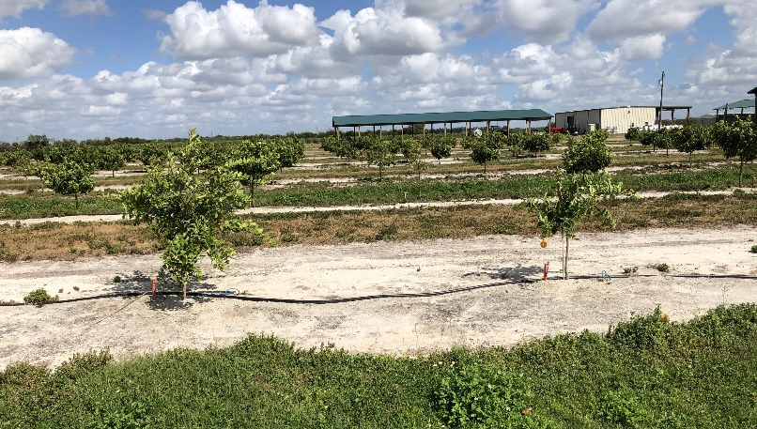
[536]Figure 1. Citrus sinensis (orange) tree on the left not infected with ‘Candidatus Liberibacter asiaticus’, compared with tree on the right that is infected with first signs of stunting, approximately one year after planting.
Photo courtesy of Greg McCollum, Agricultural Research Service, United States Department of Agriculture, United States of America.
[537]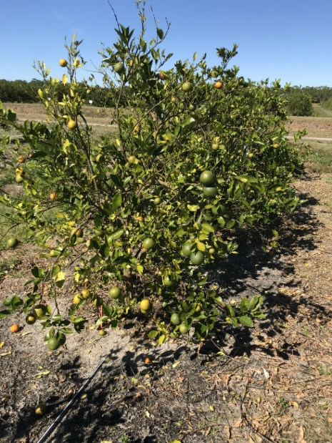
[538]Figure 2. Four-year-old Citrus sinensis (orange) tree declining from huanglonbing. Small upright leaves near shoot tips (where transmission takes place), canopy thinning resulting from leaf drop, and dieback.
Photo courtesy of Greg McCollum, Agricultural Research Service, United States Department of Agriculture, United States of America.
[539]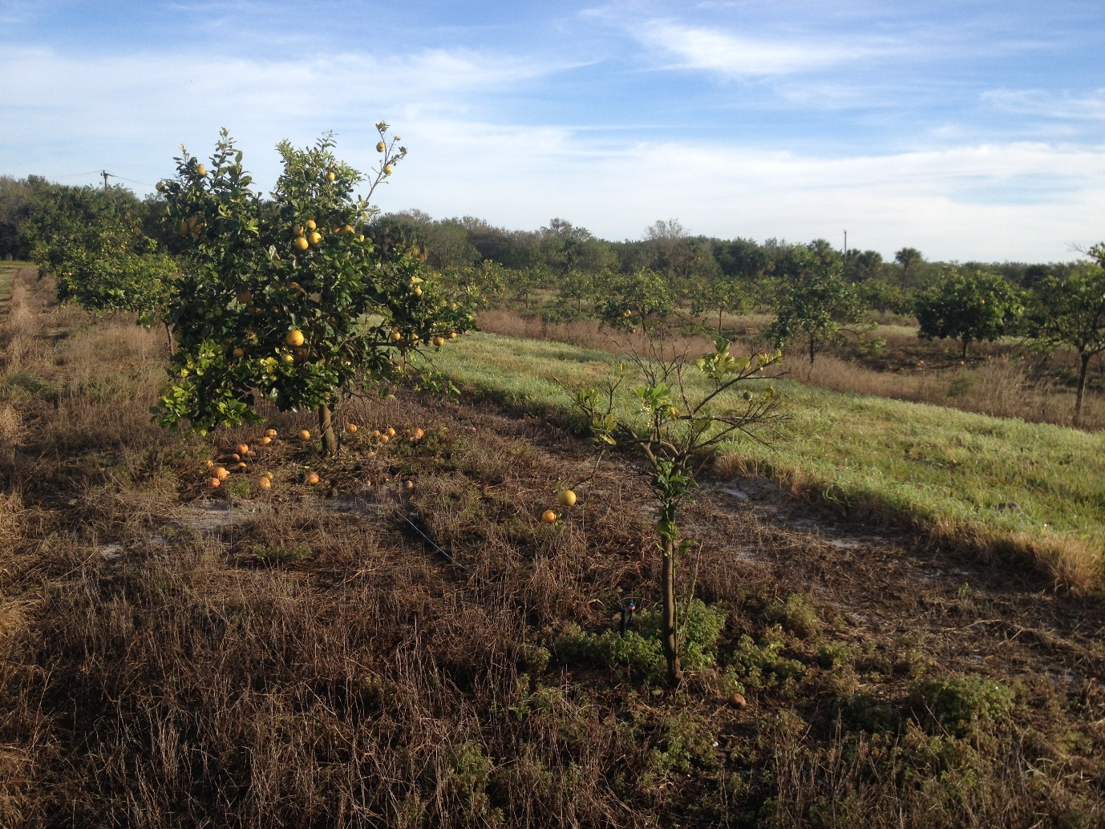
[540]Figure 3. Two adjacent Citrus sinensis (orange) trees infected with ‘Candidatus Liberibacter asiaticus’ at different stages of huanglongbing progression.
Photo courtesy of Greg McCollum, Agricultural Research Service, United States Department of Agriculture, United States of America.

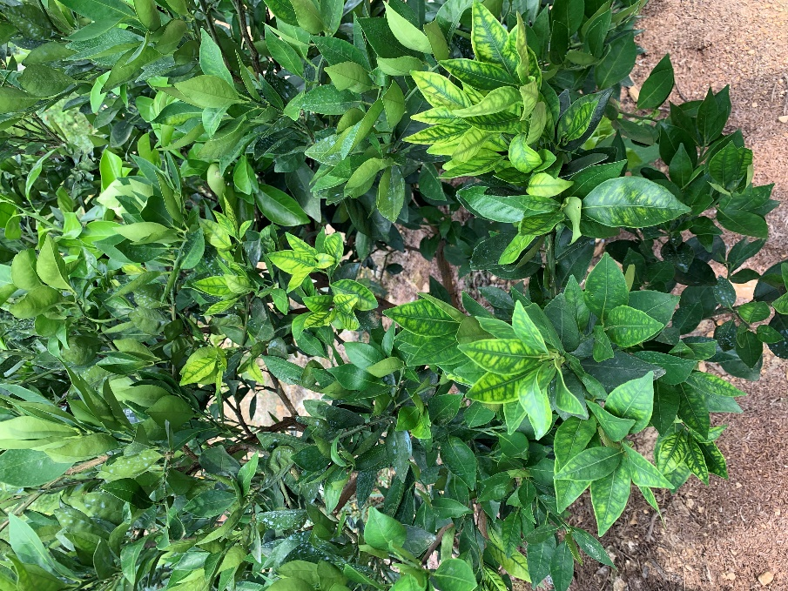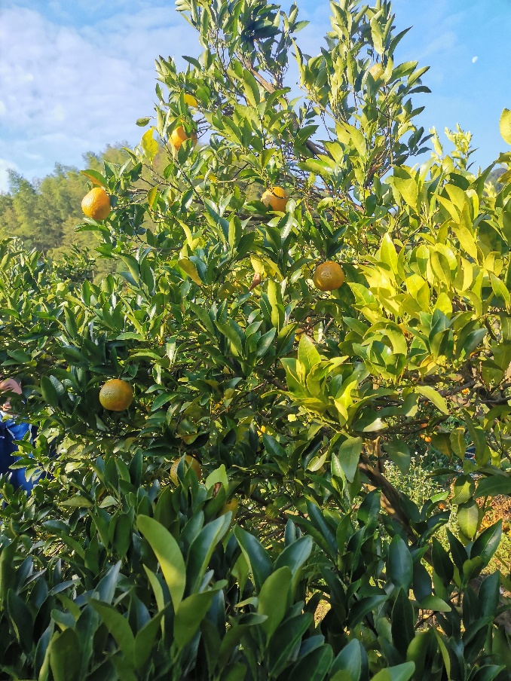

Figure 4. Citrus sinensis (orange) tree infected with ‘Candidatus Liberibacter asiaticus’ at the beginning stages of huanglongbing progression and the more advanced stage.
Photo courtesy of National Agro-tech Extention and Service Centre Ministry of Agriculture and Rural Affairs, P.R.China.

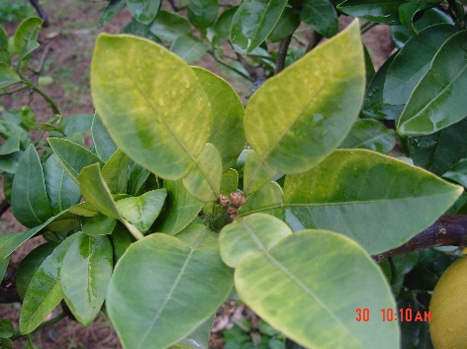

Figure 5. Leaf yellowing symptoms on Citrus sinensis (orange) infected with ‘Candidatus Liberibacter asiaticus’.
Photo courtesy of National Agro-tech Extention and Service Centre Ministry of Agriculture and Rural Affairs, P.R.China.

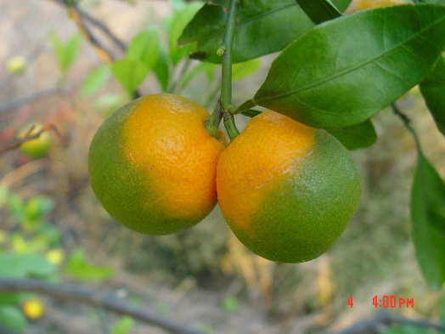

Figure 6. Ripening colour inversion symptom observed on Citrus sinensis (orange) fruit’.
Photo courtesy of National Agro-tech Extention and Service Centre Ministry of Agriculture and Rural Affairs, P.R.China.

[44] Citrus species, cultivars and hybrids are named according to the International Plant Names Index: https://www.ipni.org
The use of names of reagents, chemicals or equipment in these diagnostic protocols implies no approval of them to the exclusion of others that may also be suitable.

