[1]DRAFT ANNEX TO ISPM 27: Mononychellus tanajoa (2018-006)
[2]Status box
[3]This is not an official part of the standard, and it will be modified by the IPPC Secretariat after adoption.
[4]Date of this document | [5]2023-05-05
[6]Document category | [7]Draft annex to ISPM 27 (Diagnostic protocols for regulated pests)
[8]Current document stage | [9]To Standards Committee (SC) for adoption
[10]Origin | [11]Original subject: Mononychellus tanajoa (2018-006)
[12]Major stages | [13]2018-11 SC added subject Mononychellus tanajoa (2018-006) to work programme, priority 1.  [14]2021-03 Expert consultation.  [15]2022-04 Technical Panel on Diagnostic Protocols (TPDP) recommended draft to SC to be approved for consultation.  [16]  [17]2022-06 SC approved draft DP for consultation.  2022-07 Consultation.  2022-10 TPDP revised.  2023-02 DP drafting group revised.  2023-03 TPDP revised and recommended to SC for adoption.
[18]Discipline leads history | [19]2019-08 Juliet GOLDSMITH (JM)
[20]Referee | [21]2019-08 Norman BARR (US)
[22]Consultation on technical level | [23]The first draft of this protocol was written by:  [24]Qing Hai FAN (NZ, Lead author)  [25]Denise NAVIA (BR, Co-author)  [26]Rachid HANNA (US, Co-author)  [27]In addition, the draft has also been subject to expert review and the following international experts submitted comments: Frederic Beaulieu (CA), Jurgen Otto (AU) , Hasan Rahmani (AgriBio, the Centre for AgriBioscience, Australia) and Karen Mclachlan-Hamilton (entomology–diagnostic biologist, Canada).
[28]Main discussion points during the development of the diagnostic protocol | [29]
[30]Notes | [31]This is a draft document  [32]2022-05 Edited  2023-05 Edited
[33]CONTENTS
[34][to be added later]
[35]Adoption
[36]This diagnostic protocol was adopted by the Standards Committee on behalf of the Commission on Phytosanitary Measures in [Month 20--]. [to be completed after adoption]
[37]The annex is a prescriptive part of ISPM 27 (Diagnostic protocols for regulated pests).
- [38]Pest information
[39]The cassava green mite, Mononychellus tanajoa (Bondar) (Acari: Tetranychidae), is one of the major pests of cassava Manihot esculenta (Euphorbiaceae) (Byrne et al., 1982; Byrne, Belloti and Guerrero, 1983; Veiga, 1985) – a staple crop for more than 11 percent of the world’s population (FAO, 2013). It prefers to feed on the underside of young leaves of growing shoots of the cassava plant. Immature and adult mites feed by piercing plant tissues and sucking out the contents of cells, leading to leaf distortion and chlorotic mottling (Figure 1A to Figure 1C). Severe mite damage can lead to defoliation of the upper parts of shoots, producing a “candlestick” appearance (Figure 1D) and resulting in 50–80% storage-root yield loss (Shukla, 1976; Byrne et al., 1982; Byrne, Belloti and Guerrero, 1983; Veiga, 1985; CABI, 2020).
[42]Mononychellus tanajoa (Figure 2A) is a tropical and subtropical species. It was first described on Manihot spp. in Brazil in 1938 and is now widely distributed in South and Central America (Machi et al., 2014; Vásquez-Ordóñez and Parsa, 2014; CABI, 2023; EPPO, 2022; Migeon and Dorkeld, 2021). In Africa, M. tanajoa was first reported in Uganda in 1971 (Lyon, 1973). From there, it rapidly expanded its distributed throughout the cassava-growing regions of the continent and is now established in over 30 countries (Byrne, Belloti and Guerrero, 1983; Gutierrez et al., 1988; Yaninek, 1988; Yaninek, Moraes and Markham, 1989; Bolland, Gutierrez and Flechtmann, 1998; Vásquez-Ordóñez and Parsa, 2014; CABI, 2023; EPPO, 2022; Migeon and Dorkeld, 2021).
[43]This mite is mainly a pest of cultivated M. esculenta, although it has been recorded on other Manihot species (Bondar, 1938; Flechtmann and Baker, 1970). It also occurs on several species in other plant families, including Erythrina sp., Gliricidia maculata, Gliricidia sepium, Phaseolus vulgaris and Senna occidentalis (Fabaceae) (Rossi Simons, 1961; Baker and Pritchard, 1962; Estebanes-Gonzalez and Baker, 1968; Andrews and Poe, 1980; Mendonça et al., 2011); Passiflora cincinnata and Passiflora edulis (Passifloraceae) (Moraes, Moreira and Delalibera, 1995; Mendonça et al., 2011); and Typha domingensis (Typhaceae) (Moraes, Moreira and Delalibera, 1995; Aguilar and Murillo, 2008; Migeon and Dorkeld, 2021).
[44]The life cycle of M. tanajoa consists of the egg and four active stages: six-legged larva, eight-legged protonymph, deutonymph and adult. An inactive (quiescent) stage is present between the active stages, during which moulting occurs. This species overwinters as eggs or adult females. It completes a generation in 24.7 days on M. esculenta at 24 ± 2 °C, 65 ± 10% relative humidity (Moraes, Moreira and Delalibera, 1995). The developmental time can decrease substantially with increasing temperature; M. tanajoa needs only eight days to develop from egg to adult at 31 °C. An adult female can lay about 58 eggs during her lifetime (Yaninek, Moraes and Markham, 1989). The highest population density of M. tanajoa occurs during the first half of the dry season (Yaninek, Moraes and Markham, 1989). In Brazil, severe damage is only observed in the dry areas of the northeast region, although the mite is widely distributed in the country (Moraes and Flechtmann, 2008).
[45]Mites in the family Phytoseiidae (Figure 2B) are the main natural enemies of spider mites (Tetranychidae). Among the natural enemies of M. tanajoa, more than 30 species of Phytoseiidae are found on Manihot spp. (Zannou et al., 2005; Mutisya et al., 2017; Demite et al., 2021). Apart from the phytoseiid mites, the acaropathogenic fungus Neozygites tanajoae (Entomophthorales: Neozygitaceae) (Figure 2C) is a widespread host-specific pathogen of M. tanajoa in Brazil (Delalibera, Hajek and Humber, 2004). It was introduced into Benin in West Africa, where it is now widespread (Agboton, Hanna and von Tiedmann, 2011) alongside the much less virulent Neozygites floridana, which has a much broader host range among tetranychid mites (Lopes Ribeiro et al., 2009).
- [46]Taxonomic information
[47]Name: Mononychellus tanajoa (Bondar, 1938)
[48]Synonyms and other scientific names:
[49]Tetranychus tanajoa Bondar, 1938
[50]Mononychus tanajoa (Bondar, 1938)
Eotetranychus estradai Baker and Pritchard, 1962
[51]Taxonomic position: Acari, Trombidiformes, Prostigmata, Tetranychidae
[52]Common names: cassava green mite, cassava mite
- [53]Detection
[54]Mononychellus tanajoa may be first found on the underside of young leaves of the upper third of the cassava canopy (Yaninek, Moraes and Markham, 1989). With continuous feeding by a growing population of M. tanajoa, damage to the leaf expands to impact all interveinal leaf surfaces. Heavily damaged leaves eventually become desiccated and fall. As the mite prefers to feed on young leaves in the upper part of the cassava plant, severe damage can lead to shoot defoliation, giving the appearance of a “candlestick” (Figure 1D).
[55]In addition to being found on plant foliage, M. tanajoa may also be found on cassava stem cuttings, packaging, farm machinery, vehicles and tools, farm waste, workers’ clothing, soil, and nearby plants that are in contact with the host. Because of the small size of M. tanajoa, it is extremely difficult to detect during the early stages of an infestation.
[56]While host symptoms are seen with the naked eye, all life stages of M. tanajoa require magnification with a hand lens or stereomicroscope. The uppermost, recently unfolded, mature leaves are the best to look at for detecting and monitoring M. tanajoa infestations. A hand (or head) lens of a minimum of 5× magnification (preferably 10×) allows detection of M. tanajoa on leaf surfaces. Sampling programmes based on actual counts, classes of densities and binomial (presence/absence) sequential sampling have been developed (Yaninek, Moraes and Markham, 1989; Nachman et al., 1993; Onzo et al., 2005).
[57]Other mites co-infest cassava in the Americas (principally several species in the Mononychellus genus) and in Africa (principally Oligonychus gossypii and rarely Tetranychus urticae). In Africa, O. gossypii is easily distinguishable from M. tanajoa by its larger size, reddish appearance – hence the common name “red spider mite” – and colonization of older leaves.
Various techniques can be used to collect spider mites from plants. The collected mites can be prepared immediately for microscopic examination (see section 4.1) or stored in small tubes containing 70% ethanol or Oudemans’ fluid (5 parts glycerine, 87 parts 70% ethanol, 8 parts glacial acetic acid) . A concentration of 95%–100% ethanol is needed for mites intended for molecular analyses (Walter and Krantz, 2009). Both female and male adults are needed for identification with dichotomous keys (Flechtmann and de Queiroz, 2015).
[58]Mites can be collected individually from leaves. using a forceps or fine brush (size 0) and with the aid of a hand lens (Walter and Krantz, 2009)
[59]Beating the host plant is one of the most effective methods for collecting spider mites. A stick is used to vigorously beat the leaves and branches over a white tray from which the mites are picked up with a fine brush.
[60]The washing and sieving method can also be used to collect spider mites. First, leaves or branches are dipped in 0.2–0.3% household detergent or 50–70% ethanol in a large container and stirred for a few minutes to dislodge the mites. Next, the suspension is poured into a stack of three stainless-steel sieves: 1 680 μm, 600 μm and 44 μm aperture for the top, middle and bottom sieves, respectively (modified from de Lillo, 2009). Finally, mites on the bottom sieve are backwashed with 70% ethanol into a Petri dish and picked up with a fine brush. An alternative method is to immerse plant material in 50–70% ethanol, allowing the mites to sink to the bottom of the container, from where they can be collected with a pipette.
[61]In this diagnostic protocol, methods (including reference to brand names) are described as published, as these define the original level of sensitivity, specificity and reproducibility achieved. Laboratory procedures presented in the protocols may be adjusted to the standards of individual laboratories, provided that they are adequately validated.
- [62]Identification
[63]Identification of spider mites in the Mononychellus genus has traditionally been based on microscopic morphological characters. Adult female and male specimens must be mounted on slides and examined using a high-power microscope (e.g. ×400–1000). Morphological characters are best observed with a compound microscope using either differential interference contrast or phase contrast. Features of the adult body are illustrated and labelled in Figure 3 to Figure 8. Keys for the morphological species identification of immature stages of Mononychellus are not available.
[64]DNA sequencing of a barcoding fragment of the cytochrome c oxidase subunit I (COI) can support identification but cannot provide confirmatory diagnosis, as only limited sequences of M. tanajoa and of some closely related cassava Mononychellus species (M. caribbeanae, M. progresivus and M. mcgregori) are available in the GenBank public database (a National Center for Biotechnology Information database) (Ovalle et al., 2020).

[65]4.1 Preparation of specimens for microscopic examination
[66]Mites need to be properly prepared for morphological examination. Maceration dissolves internal tissues, increasing transparency and softening the cuticle. This clearing can be achieved by submerging the specimen in 60–95% lactic acid (suitable for recently collected specimens) or Nesbitt’s fluid (chloral hydrate 40 g, concentrated HCl (12 M) 2.5 mL, distilled water 25 mL, suitable for old alcohol-preserved specimens). The clearing process varies from specimen to specimen. It is advisable to check occasionally until the specimens become translucent. Gentle heating in an oven or hot plate at 45 °C can accelerate maceration. Specimens are mounted in Hoyer’s medium (chloral hydrate 200 g, crystalline gum arabic 30 g, glycerol 20 mL, distilled water 50 mL) or in Heinze-PVA medium (chloral hydrate 100 g, glycerol 10 mL, polyvinyl alcohol 10 g, distilled water 60 mL, 85–92% lactic acid 35 mL). Adult females are mounted dorsoventrally, but adult males should be mounted laterally to display the taxonomically informative characters of the aedeagus (male genitalia). The male specimens can be mounted as described by Henderson (2001) or repositioned laterally by gently pushing the coverslip to one side. Slides are labelled with the collection data (i.e. an accession number, locality, host, collector and collection date) and then put on a hot plate at 70 °C for 20 minutes before identification. If immersion objectives are to be used, a longer heating time (24 h) on the hot plate is required to ensure the slides are completely stable. If the specimens are to be retained following identification (see section 5), the identified specimens are placed in an oven at 45–50 °C for a few weeks until the medium is dry. For long-term storage, specimens mounted in Hoyer’s medium on microscope slides should be sealed with a sealant (e.g. Glyptal® electrical insulating sealant or Euparol) to prevent water from entering or leaving the mount. Nail polish can be used for short-term storage but is susceptible to cracking and may dissolve in substances used to clean slides. Detailed methods for mite specimen preparation and mounting are available in Walter and Krantz (2009).

[68]4.2 Morphological characters of the family Tetranychidae
[69]The spider mite family Tetranychidae includes more than 1 300 species in 86 genera (Migeon and Dorkeld, 2021). Various keys to separate Tetranychidae from other families are available in general acarological references (e.g. Walter et al., 2009). Species of this family share the following characteristics:
- [70]dorsal propodosoma without bothridia (Figure 3A);
- [71]hysterosoma with four or fewer pairs of setae in the c series (Figure 3A);
- [72]chelicerae basally fused, forming a retractable stylophore (Figure 3A);
- [73]stylophore without a ribbed collar basally (Figure 3A, Figure 4 and Figure 5A);
- [74]movable cheliceral digits greatly elongate, whip-like (Figure 4A and Figure 4C);
- [75]palp with a thumb-claw structure (Figure 5B);
- [76]tarsi I and II usually with one to two sets of duplex setae (Figure 6A and Figure 6B);
- [77]solenidia on tarsi I and II setiform (Figure 6A and Figure 6B); and
- [78]tarsal claws usually with tenent hairs (Figure 7).

[79]4.3 Dichotomous key to genera of Tetranychidae on Manihot spp.
[80]In addition to M. tanajoa, 56 species in 12 genera of Tetranychidae have been recorded on M. esculenta and other Manihot species so far (Migeon and Dorkeld, 2021): Allonychus (3 species), Aponychus (1 species), Atrichoproctus (1 species), Eotetranychus (1 species), Eutetranychus (5 species), Mononychellus (7 species), Neotetranychus (1 species), Oligonychus (8 species), Panonychus (1 species), Petrobia (1 species), Schizotetranychus (1 species) and Tetranychus (26 species). These genera can be distinguished by morphological traits.
[81]This key can be used to distinguish the Tetranychidae genera encountered on Manihot spp. (modified from Meyer (1987) and Bolland, Gutierrez and Flechtmann (1998)).
[82]1. Empodium absent or without tenent hairs (Figure 7B to Figure 7I); female with one or two pairs of pseudanal (ps) setae (Figure 3B); male with four pairs of setae (g and ps) on genito-anal valves (Figure 8A) 2
[83]– Empodium with tenent hairs (Figure 7A); female with three pairs of pseudanal setae; male with five pairs of setae on genito-anal valves Petrobia Murray
[84]2. Tarsus I without duplex setae or with one set of duplex setae; empodia I–IV in female and III–IV in male absent (Figure 7B) or vestigial .3
[85]– Tarsus I with two sets of duplex setae (Figure 6A); empodia I–IV in female and III–IV in male uncinate (claw-like) (Figure 7C) or split into three pairs of proximoventral hairs (Figure 7D) 4
[86]3. Female with one pair of pseudanal setae; hysterosomal setae f₁ inserted in marginal area, lateral to dorsocentral setae c₁, d₁ and e₁ (Figure 8C) Aponychus Rimando
[87]– Female with two pairs of pseudanal setae; hysterosomal setae f₁ inserted in median area, approximately aligned with dorsocentral setae c₁, d₁ and e₁ (Figure 8D) Eutetranychus Banks
[88]4. Female with two pairs of h setae (h₁ missing) and one or two pairs of pseudanal setae 5
[89]– Female with three pairs of h setae and two pairs of pseudanal setae (Figure 3B) 7
[90]5. Female with two pairs of pseudanal setae; tarsal duplex setae close to each other in the distal half of segment, or well separated from each other with one in the distal half and the other in the basal half; empodium variable 6
[91]– Female with one pair of pseudanal setae; tarsal duplex setae close to each other in distal half of segment; empodium uncinate Atrichoproctus Flechtmann
[92]6. Duplex setae on tarsus I close to each other, in distal half; empodium claw-like, strong, not shorter than proximoventral hairs (Figure 7E); male with claw I bifid Oligonychus Berlese
[93]– Duplex setae on tarsus I relatively distant from each other, one in distal half and other in basal half of segment; empodium variable (Figure 7D), if claw-like, much shorter than proximoventral hairs; male with claw I not bifid Tetranychus Dufour
[94]7. Empodium claw-like (Figure 7C and Figure 7F) 8
[95]– Empodium not claw-like, ending in a tuft of hairs (Figure 7D) 10
[96]8. Empodial claw ending in a single tip (Figure 7C and Figure 7E) 9
[97]– Empodial claw bifurcate distally (Figure 7F) Schizotetranychus Trägårdh
[98]9. Dorsal idiosomal setae not on tubercles; empodial claw shorter than proximoventral hairs (Figure 7I) Allonychus Pritchard and Baker
[99]– Dorsal idiosomal setae on strong tubercles; empodial claw longer than or as long as proximoventral hairs (Figure 7E) Panonychus Yokoyama
[100]10. Hysterosomal striae forming a basket-weave pattern (Figure 8B) or varying from longitudinal to irregular between the two e₁ setae; dorsal idiosomal setae usually on tubercles (Figure 8B) 11
[101]– Hysterosomal striae transverse; dorsal idiosomal setae not on tubercles Eotetranychus Oudemans
[102]11. Hysterosomal striae not forming a basket-weave (grouped granulation) pattern (Figure 3) Mononychellus Wainstein
[103]– Hysterosomal striae forming a basket-weave pattern (Figure 8B) Neotetranychus Trägårdh

[104]4.4 Morphological characters of the genus Mononychellus Wainstein
[105]The genus includes 31 species worldwide, which can be recognized by the following characteristics.
[106]For adult females, the characteristics are:
- [107]prodorsum mostly striated (Figure 3A, Figure 9A, Figure 9B, Figure 9D and Figure 9F) or medially finely reticulate and dotted (Figure 9C and Figure 9E);
- [108]dorsal idiosomal setae linear or slightly expanded apically or proximately, usually on tubercles (Figure 10C to Figure 10E) (with exceptions, e.g. in M. tanajoa);
- [109]three pairs of h setae and two pairs of pseudanal (ps) setae present (Figure 3B);
- [110]striae between the two e₁ setae variable, from oblique to longitudinal (Figure 10);
- [111]pregenital striae varying from procurved to transverse (Figure 11)
- [112]palpal terminal eupathidium (spinneret) varying from as long as wide to 2.5× as long as wide (Figure 5B and Figure 12);
- [113]tarsus I with two sets of distal duplex setae adjacent to each other in the distal part of the segment, and four (rarely five) tactile setae and one solenidion (rarely none or three) in proximal part (Figure 6A);
- [114]tibia I with eight or nine (rarely 12) tactile setae and one solenidion (rarely four) (Figure 6A);
- [115]tarsus II with three tactile setae and one solenidion in proximal part (Figure 6B); and
- [116]tibia II with seven (rarely six) tactile setae (Figure 6B).
[117]For adult males, the characteristics are:
- [118]genito-anal valves with four pairs of setae (g and ps) (Figure 8A);
- [119]aedeagus with shaft mostly straight, slender, bending upward or downward apically, forming a narrow neck, with a small, usually subtriangular knob (Figure 13 and Figure 14);
- [120]palp with terminal eupathidium slightly tapered;
- [121]tarsus I with three or four tactile setae and two to four solenidia in proximal part;
- [122]tibia I with eight or nine (rarely 12) tactile setae and three or four solenidia;
- [123]tarsus II with three tactile setae and one solenidion in proximal part; and
- [124]tibia II with seven tactile setae.

[125]4.5 Dichotomous key to species of Mononychellus on Manihot spp. based on females
[126]Eight species of Mononychellus have been recorded from Manihot spp. (Flechtmann and de Queiroz, 2015; Migeon and Dorkeld, 2021) and can be differentiated by using the following key.
[127]1. Prodorsum finely reticulate medially (Figure 9C and Figure 9E); most hysterosomal setae (c₁, c₂, d₁, d₂, e₁, e₂, f₁, f₂, h₁) with a finely reticulated area around the setal base (Figure 10C and Figure 10E) 2
[128]– Prodorsum mostly striated (Figure 9A, Figure 9B, Figure 9D and Figure 9F); area surrounding the base of each hysterosomal seta merely striated, not reticulate (Figure 10A, Figure 10B, Figure 10D and Figure 10F) 3
[129]2. Tarsus I with three solenidia and four tactile setae in proximal part; seta d₁ not reaching base of e₁ (Figure 10C); reticulated area around the hysterosomal setae small, well isolated from each other s (Figure 10C) M. chemosetosus (Paschoal, 1970)
[130]– Tarsus I with one solenidion and four tactile setae in proximal part; seta d₁ extending beyond base of e₁ (Figure 10E); reticulated area around the hysterosomal setae large, close to each other (Figure 10E) M. planki (McGregor, 1950)
[131]3. Hysterosomal setae c₁, d₁ and e₁ oblanceolate and obviously shorter than distances between their bases (Figure 10B and Figure 10F); sc₁ shorter than or nearly as long as distance sc₁–sc₂ (Figure 3A and Figure 15C); c₂ shorter than c₃ (Figure 3A) 4
[132]– Hysterosomal setae c₁, d₁ and e₁ linear or only slightly expanded apically, at least one of them longer than or nearly as long as distances between their bases (Figure 10A and Figure 10D); sc₁ longer than distance sc₁–sc₂; c₂ longer than c₃ 5
[133]4. Area posterior to f₂ reticulated (Figure 10B); f₁ less than 1.5× as long as c₁ or d₁ (Figure 10B); palp with terminal eupathidium more than twice as long as wide (Figure 12B)
M. caribbeanae (McGregor, 1950)
[134]– Area posterior to f₂ simply striated (Figure 3B); f₁ more than twice as long as c₁ or d₁ (Figure 3A and Figure 10F); palp with terminal eupathidium no more than 1.5× as long as wide (Figure 12F) M. tanajoa (Bondar, 1938)
[135]5. Hysterosomal setae c₁, d₁ and e₁ extending beyond or almost reaching bases of setae in next row (Figure 10A); c₁, d₁ and e₁ longer than distances c₁–c₁, d₁–d₁ and e₁–e₁, respectively (Figure 10A) 6
[136]– Hysterosomal setae c₁, d₁ and e₁ far from reaching bases of setae in next row; c_{1,} d₁ and e₁ much shorter than distances c₁–c₁, d₁–d₁ and e₁–e₁, respectively M. progresivus Doreste, 1981
[137]6. Seta sc₁ no more than 1.3× as long as sc₂; c₁ and d₁ as long as or slightly shorter than c₂ and d₂, respectively 7
[138]– Seta sc₁ about twice as long as sc₂; c₁ and d₁ obviously longer than c₂ and d₂, respectively M. mcgregori (Flechtmann and Baker, 1970)
[139]7. Palp with terminal eupathidium about as long as wide; aedeagal knob about 3× as wide as neck; tarsus I with four (rarely five) tactile setae and one solenidion (rarely none) in proximal part
M. manihoti Doreste, 1981
[140]– Palp with terminal eupathidium about 1.5× as long as wide (Figure 12A); aedeagal knob about twice as wide as neck; tarsus I with five tactile setae and one solenidion in proximal part
M. bondari (Paschoal, 1970)

[141]4.6 Identification of Mononychellus tanajoa

[142]4.6.1 Morphological identification
[143]Adult female
[144]Idiosoma: oval, 330–480 µm long and 187–217 µm wide, from greenish to yellowish in colour when alive (Figure 2A). Dorsal idiosomal setae stout, oblanceolate (Figure 3A and Figure 15); lobes of dorsal striae strong and rounded; prodorsum striated (Figure 3A, Figure 15A, Figure 15B and Figure 15C); seta sc₁ not reaching base of sc₂; hysterosomal setae c₁, d₁ and e₁ short, not reaching half of the distances to bases of setae in next row (Figure 3A and Figure 10F); c₁ shorter than half the distance between the two c₁ setae, d₁ about one-third the distance between the two d₁ setae, e₁ shorter than half the distance between the two e₁ setae; marginal setae c₂, d₂ and e₂ about 1.4–1.8× as long as c₁, d₁ and e₁, respectively; f₁ more than twice as long as c₁ or d₁ (Figure 3A and Figure 10F); striae between e₁ and e₁ varying from oblique to longitudinal (Figure 15D, Figure 15E and Figure 15F), area posterior to f₂ simply striated (Figure 3,
[145]Gnathosoma: palp with terminal eupathidium about 1.5× as long as wide (Figure 5B and Figure 12F). Peritreme usually distally straight, ending in a small bulb or sometimes a tiny hook (Figure 4F and Figure 5A).
[146]Legs: tarsus I (Figure 6A) with five tactile setae and one solenidion in proximal part; tibia I with nine tactile setae and one solenidion; tarsus II (Figure 6B) with three tactile setae and one solenidion in proximal part; tibia II with seven tactile setae; tarsi III (Figure 6C) and IV (Figure 6D) each with ten tactile setae and one solenidion; tibiae III and IV each with six tactile setae.
[147]Adult male
[148]Idiosoma: tapered posteriorly (Figure 3A), 275–308 µm long and 167–178 µm wide, paler than adult female when alive. Aedeagus (Figure 13) with main shaft nearly straight, slightly curving ventrally, progressively tapering and forming a narrow neck before reaching aedeagal knob; knob with two sharp projections (Figure 13).
[149]Gnathosoma: palp with terminal eupathidium apically tapered, slightly longer than wide.
[150]Legs: tarsus I with five tactile setae and three solenidia in proximal part; tibia I with nine tactile setae and three solenidia; tarsus II with three tactile setae and one solenidion in proximal part; tibia II with seven tactile setae.

[151]4.6.2 Molecular identification
[152]Mitochondrial DNA sequencing of the COI gene can be used to support identification of M. tanajoa, irrespective of the developmental stage.
[154]4.6.2.1 Extraction of nucleic acid
[155]Genomic DNA should be extracted from a single specimen of any developmental stage, since infestation by more than one species on the same host plant (mixed infestation) is typical for spider mites. There are many different methods available for DNA extraction, such as the modified cetyltrimethylammonium bromide method (potassium acetate 2.5 M, pH 5.5) (Ovalle et al., 2020), the DNeasy ® Blood and Tissue Kit (QIAGEN ™) (de Mendonça et al., 2011; Li et al., 2015) and the PrepMan Ultra Sample Preparation Reagent (Thermo Fisher Scientific) (Matsuda et al., 2013).1
[157]4.6.2.2 Conventional PCR and sequencing
[158]The DNA extracted can be used for polymerase chain reaction (PCR) amplification of the DNA barcoding region as chosen by the Consortium for the Barcode of Life with the following primers presented by Folmer et al. (1994):
[159]LCO1490 (forward): 5′-GGT CAA CAA ATC ATA AAG ATA TTG G-3′
[160]HCO2198 (reverse): 5′-TAA ACT TCA GGG TGA CCA AAA AAT CA-3′
[164]Ovalle et al. (2020) provide an example of the master mix composition and cycling parameters for the amplification of COI using the primers presented by Folmer et al. (1994) (Table 1).
[165]Table 1. Master mix composition, cycling parameters and amplicons for PCR to distinguish Mononychellus tanajoa from Mononychellus caribbeanae, Mononychellus mcgregori and Tetranychus urticae
[166]Reagents | [167]Final concentration
[168]PCR-grade water | [169]–†
[170]PCR buffer | [171]1×
[172]MgCl2 | [173]2.5 mM
[174]dNTPs | [175]2.5 mM of each
[176]Primer (forward) | [177]5 µM
[178]Primer (reverse) | [179]5 µM
[180]DNA polymerase | [181]0.25 U
[182]DNA sample | [183]20 ng
[184]Cycling parameters | [185]
[186]Number of cycles | [187]5
[188]- Denaturation | [189]94 °C for 40 s
[190]- Annealing | [191]45 °C for 40 s
[192]- Elongation | [193]72 °C for 60 s
[194]Number of cycles | [195]35
[196]- Denaturation | [197]94 °C for 40 s
[198]- Annealing | [199]51 °C for 40 s
[200]- Elongation | [201]72 °C for 60 s
[202]Final elongation | [203]72 °C for 10 min
[204]Expected amplicons | [205]
[206]Size | [207]709 bp  [208](the amplicon size varies for species and individuals)
[209]Notes:† For a final reaction volume of 20 µL.
[210]bp, base pairs; PCR, polymerase chain reaction.
Source: Ovalle, T.M., Vásquez-Ordóñez, A.A., Jimenez, J., Parsa, S., Cuellar, W.J. & Lopez-Lavalle, L.A.B. 2020. A simple PCR-based method for the rapid and accurate identification of spider mites (Tetranychidae) on cassava. Scientific Reports, 10: 19496. https://doi.org/10.1038/s41598-020-75743-w
[211]4.6.2.3 Controls for molecular tests
[212]For the test result to be considered reliable, appropriate controls – which will depend on the type of test used and the level of certainty required – should be considered for each series of nucleic acid extractions and PCR amplifications of the target pest. As a minimum, a positive nucleic acid control and a negative amplification control (no template control) should be used.
[213]Positive nucleic acid control. This control is used to monitor the efficiency of the method used for the test (apart from the extraction). Pre-prepared (stored) genomic DNA may be used.
[214]Negative amplification control (no template control). This control is necessary to rule out false positives resulting from contamination with other genetic material during the preparation of the reaction mixture. PCR-grade water that was used to prepare the reaction mixture is added in place of template DNA.
[215]Negative extraction control. This control is used to monitor contamination during nucleic acid extraction. This requires extraction blanks to be processed alongside the samples to be tested.
[216]4.6.2.4 Sequence editing and analysis
[217]The sequences are edited using specific software (e.g. open-source Staden Package, BioEdit). The quality of the sequences should be checked. A consensus sequence should be obtained using the sequence-editing software by overlapping the DNA template’s forward and reverse sequences. The edited sequences are compared with those available in the public DNA database GenBank using the Basic Local Alignment Search Tool (BLAST), available at the National Center for Biotechnology Information (www.ncbi.nlm.nih.gov). Further guidance on sequence editing and analysis may be found in Appendices 7 and 8 of EPPO (2021). An identity with M. tanajoa equal to or higher than 99% based on a query cover higher than 90% is required support species-level identification (Smith, Fisher and Hebert, 2005; Porter and Hajibabaei, 2020). One sequence of a 597 bp of the COI fragment is available in GenBank for an M. tanajoa haplotype (accession number MN913384.1) and for the closely related species M. mcgregori (MN913383) and M. caribbeanae (MN913382.1).
[218]Additional work on the diagnostics of mites in the family Tetranychidae (Navajas et al., 1992, 1998, 2000; Ros and Breeuwer, 2007; de Mendonça, et al., 2011; Matsuda et al., 2013; Li et al., 2015; Zélé, Weill and Magalhães, 2018) has not yet been adapted to the identification of M. tanajoa and consequently not included in this protocol.
- [219]Records
[220]Records and evidence should be retained as described in section 2.5 of ISPM 27 (Diagnostic protocols for regulated pests).
[221]In cases where other contracting parties may be adversely affected by the diagnosis, the records and evidence of the results of the diagnosis (in particular, preserved or slide-mounted specimens, photographs of distinctive taxonomic structures, DNA extracts and photographs of gels, as appropriate) should be kept for at least one year in a manner that ensures traceability.
- [222]Contact points for further information
Further information on this protocol can be obtained from:
[223]Plant Health & Environment Laboratory, Biosecurity New Zealand, Ministry for Primary Industries, P.O. Box 2095, Auckland 1072, New Zealand (Qing-Hai Fan; email: qinghai.fan@mpi.govt.nz).
[224]Institut National de Recherche pour l’Agriculture, l’Alimentation et l’Environnement (INRAE), Centre de Biologie pour la Gestion des Populations (UMR CBGP), CS 30016, 34988 Montferrier-sur-Lez cedex, France (Denise Navia; email: denise.navia@inrae.fr).
[225]Center for Tropical Research, Institute of the Environment and Sustainability, University of California, Los Angeles, 90095, CA, United States of America (Rachid Hanna; email: rahanna@ucla.edu or rachidhanna01@gmail.com).
A request for a revision to a diagnostic protocol may be submitted by national plant protection organizations (NPPOs), regional plant protection organizations (RPPOs) or Commission on Phytosanitary Measures (CPM) subsidiary bodies through the IPPC Secretariat (ippc@fao.org), who will forward it to the Technical Panel on Diagnostic Protocols (TPDP).
- [226]Acknowledgements
[227]The first draft of this protocol was written by Qing-Hai Fan (Plant Health & Environment Laboratory, New Zealand (see preceding section)), Denise Navia (Institut National de Recherche pour l’Agriculture, l’Alimentation et l’Environnement, France (see preceding section)) and Rachid Hanna (Centre for Tropical Research, United States of America (see preceding section)).
[228]In addition, the following experts were significantly involved in the development of this protocol: Frederic Beaulieu (Agriculture & Agri-Food Canada), Jurgen Otto (Department of Agriculture, Fisheries and Forestry, Australia), Hasan Rahmani (AgriBio, the Centre for AgriBioscience, Australia) and Karen Mclachlan-Hamilton (entomology–diagnostic biologist, Canada).
[229]The following experts provided some references and specimens: Carlos Holger Wenzel Flechtmann, Gilberto José de Moraes and Raphael de Campos Castilho (Departamento de Entolomogia e Acarologia, Universidade de São Paulo, Brazil), and Renata Santos de Mendonça (Universidade de Brasília, Federal District, Brazil). Mite reference collections used for this protocol include those of the Department of Entomology and Acarology, Escola Superior de Agricultura Luiz de Queiroz/Universidade de São Paulo (ESALQ/USP), Piracicaba, São Paulo, Brazil and Embrapa Recursos Genéticos e Biotecnologia, Brasilia, Federal District, Brazil.
- [230]References
[231]The present annex may refer to ISPMs. ISPMs are available on the International Phytosanitary Portal (IPP) at www.ippc.int/core-activities/standards-setting/ispms.
[232]Agboton, B.V., Hanna, R. & von Tiedemann, A. 2011. Molecular detection of establishment and geographical distribution of Brazilian isolates of Neozygites tanajoae, a fungus pathogenic to cassava green mite, in Benin (West Africa). Experimental and Applied Acarology, 53: 235–244. https://doi.org/10.1007/s10493-010-9395-3
[233]Aguilar, H. & Murillo, P. 2008. New hosts and records of plant feeding mites for Costa Rica: interval 2002–2008. Agronomia Costarricense, 32: 7–28.
[234]Andrews, K.L. & Poe, S.L. 1980. Spider mites of El Salvador, Central America (Acari: Tetranychidae). Florida Entomologist, 63: 502–505. https://journals.flvc.org/flaent/article/view/57526
[235]Baker, E.W. & Pritchard, A.E. 1962. Arañas rojas de América Central (Acarina: Tetranychidae). Revista de la Sociedad Mexicana de Historia Natural, 23: 309–340.
[236]Bolland, H.R., Gutierrez, J. & Flechtmann, C.H.W. 1998. World catalogue of the spider mite family (Acari: Tetranychidae). Leiden, Netherlands, K. Brill. 392 pp.
[237]Bondar, G. 1938. Notas entomologicas da bahia III. Revista Entomologica do Brasil, 9: 441–445.
[238]Byrne, D.H., Belloti, A.C. & Guerrero, J.M. 1983. The cassava mites. Tropical Pest Management, 29(4): 378–394. https://doi.org/10.1080/09670878309370833
[239]Byrne, D.H., Guerrero, J.M., Belloti, A.C. & Gracen, V.E. 1982. Yield and plant growth responses of Mononychellus mite resistant and susceptible cassava cultivars under protected vs. infested conditions. Crop Science, 22(3): 486–490. https://doi.org/10.2135/cropsci1982.0011183X002200030011x
[240]CABI. 2023. Mononychellus tanajoa (cassava green mite). In: CABI compendium. Wallingford, UK. [Cited 16 May 2023]. https://doi.org/10.1079/cabicompendium.34767
[241]de Lillo, E. 2009. A modified method for eriophyoid mite extraction (Acari: Eriophyoidea). International Journal of Acarology, 27(1): 67–70. https://doi.org/10.1080/01647950108684228
[242]Delalibera Jr, I., Hajek, A.E. & Humber, R.A. 2004. Neozygites tanajoae sp. nov., a pathogen of the cassava green mite. Mycologia, 96(5): 1002–1009. https://doi.org/10.1080/
15572536.2005.11832900
[243]de Mendonça, R.S., Navia, D., Diniz, I.R., Auger, P. & Navajas, M. 2011. A critical review on some closely related species of Tetranychus sensu stricto (Acari: Tetranychidae) in the public DNA sequences databases. Experimental and Applied Acarology, 55: 1–23. https://doi.org/10.1007/s10493-011-9453-5
[244]Demite, P.R., de Moraes, G.J., McMurtry, J.A., Denmark, H.A. & Castilho, R.C. 2021. Phytoseiidae database. [Cited 12 February 2021]. www.lea.esalq.usp.br/phytoseiidae
EPPO (European and Mediterranean Plant Protection Organization). 2021. DNA barcoding as an identification tool for a number of regulated pests. PM 7/129 (2). EPPO Bulletin, 51: 100–143. https://doi.org/10.1111/epp.12724
[247]EPPO. 2022. Mononychellus tanajoa (MONNTA). In: EPPO global database. Paris. [Cited July 2022]. https://gd.eppo.int/taxon/MONNTA
[248]Estebanes-Gonzalez, M.L. & Baker, E.W. 1968. Arañas rojas de Mexico (Acarina: Tetranychidae). Anales de la Escuela Nacional de Ciencias Biologicas, 15: 61–133.
[249]FAO. 2013. Save and grow: cassava – A guide to sustainable production intensification. Rome. 129 pp. www.fao.org/3/i3278e/i3278e.pdf
[250]Flechtmann, C.H.W. & Baker, E.W. 1970. A preliminary report on the Tetranychidae (Acarina) of Brazil. Annals of the Entomological Society of America, 63: 156–163. https://doi.org/10.1093/aesa/63.1.156
[251]Flechtmann, C.H.W. & de Queiroz, D.L. 2015. Mononychellus Wainstein, 1971 (Acari, Prostigmata, Tetranychidae): description of a new species from Brazil and key to species. Systematic & Applied Acarology, 20(7): 831–838. https://doi.org/10.11158/saa.20.7.10
[252]Folmer, O., Black, M., Hoeh, W., Lutz, R. & Vrijenhoek, R. 1994. DNA primers for amplification of mitochondrial cytochrome c oxidase subunit I from diverse metazoan invertebrates. Molecular Marine Biology and Biotechnology, 3(5): 294–299.
[253]Gutierrez, A.P., Yaninek, J.S., Wermelinger, B., Herren, H.R. & Ellis, C.K. 1988. Analysis of biological control of cassava pests in Africa, III: cassava green mite Mononychellus tanajoa. Journal of Applied Ecology, 25(3): 941–950.
[254]Henderson, R.C. 2001. Technique for positional slide-mounting of Acari. Systematic and Applied Acarology Special Publications, 7: 1–4. https://doi.org/10.11158/saasp.7.1.1
[255]Li, D., Fan, Q.-H. Waite, D.W., Gunawardana, D., George, S. & Kumarasinghe, L. 2015. Development and validation of real-time PCR assay for rapid detection of two-spotted spider mite, Tetranychus urticae (Acari: Tetranychidae). PLoS ONE, 10(7): e0131887. https://doi.org/10.1371/journal.pone.0131887
[256]Lopes Ribeiro, A.E., Corrêa Gondim Jr, M.G., Calderan, E. & Delalibera Jr, I. 2009. Host range of Neozygites floridana isolates (Zygomycetes: Entomophthorales) to spider mites. Journal of Invertebrate Pathology, 102(3): 196–202. https://doi.org/10.1016/j.jip.2009.08.012
[257]Lyon, W.F. 1973. A plant-feeding mite Mononychellus tanajoa (Bondar) (Acarina:Tetranychidae) new to the African continent threatens cassava (Manihot esculenta Crantz) in Uganda, East Africa. PANS Pest Articles & News Summaries, 19(1): 36–37.
[258]Machi, A.R., de Cássia Neves Esteca, F., Arthur, P.B., Gava, M.A. & Arthur, V. 2014. A review on Mononychellus tanajoa (Bondar, 1938) pest of cassava in Brazil. Australian Journal of Basic and Applied Sciences, 8(3): 342–348. www.ajbasweb.com/old/ajbas/2014/March/342-348.pdf
[259]Matsuda, T., Fukumoto, C., Hinomoto, N. & Gotoh, T. 2013. DNA-based identification of spider mites: molecular evidence for cryptic species of the genus Tetranychus (Acari: Tetranychidae). Journal of Economic Entomology, 106(1): 463–472. https://doi.org/10.1603/EC12328
[260]Mendonça, R.S., Navia, D., Diniz, I.R. & Flechtmann, C.H.W. 2011. South American spider mites: new hosts and localities. Journal of Insect Science, 11: 121. https://doi.org/10.1673/031.011.12101
[261]Meyer, M.K.P.S. 1987. African Tetranychidae (Acari: Prostigmata): with reference to the world genera. Pretoria, South Africa, Department of Agriculture and Water Supply. Entomology Memoir No. 69. 175 pp.
[262]Migeon, A. & Dorkeld, F. 2021. Spider mites web: a comprehensive database for the Tetranychidae. Montpellier, France, Center for Biology for Population Management (CBGP). [Cited 12 February 2021]. www1.montpellier.inra.fr/CBGP/spmweb
[245]Moraes, G.J. & Flechtmann, C.H.W. 2008. Manual de Acarologia, Acarologia Básica e Ácaros de Plantas Cultivadas no Brasil. Ribeirão Preto, Brazil, Holos Editora. 308 pp.
[246]Moraes, G.J., Moreira, A.N. & Delalibera Jr, I. 1995. Growth of the mite Mononychellus tanajoa (Acari: Tetranychidae) on alternative plant hosts in northeastern Brazil. Florida Entomologist, 78: 350–354. https://journals.flvc.org/flaent/article/view/59134
[263]Mutisya, D.L., El-Banhawy, E.S.M., Vicente dos Santos, V., Kariuki, C.W., Khamala, C.P.M. & Tixier, M.-S. 2017. Predatory phytoseiid mites associated with cassava in Kenya, identification key and molecular diagnosis (Acari: Phytoseiidae). Acarologia, 5: 541–554. https://doi.org/10.24349/acarologia/20174172
[264]Nachman, G, Skovgård, H., Tomkiewicz, J., Münster-Swendsen, M. & Pedersen, O.C. 1993. Sampling strategies for assessing the overall density of the cassava green mite (Mononychellus tanajoa). Experimental and Applied Acarology, 17: 5–28. https://link.springer.com/article/10.1007/BF00156941
[265]Navajas, M., Cotton, D., Kreiter, S. & Gutierrez, J. 1992. Molecular approach in spider mites (Acari: Tetranychidae): preliminary data on ribosomal DNA sequences. Experimental & Applied Acarology, 15: 211–218. https://doi.org/10.1007/BF01246563
[266]Navajas, M., Lagnel, J., Gutierrez, J. & Boursot, P. 1998. Species-wide homogeneity of nuclear ribosomal ITS2 sequences in the spider mite Tetranychus urticae contrasts with extensive mitochondrial COI polymorphism. Heredity, 80: 742–752. https://doi.org/10.1046/j.1365-2540.1998.00349.x
[267]Navajas, M., Tsagkarakou, A., Lagnel, J. & Perrot-Minnot, M.-J. 2000. Genetic differentiation in Tetranychus urticae (Acari: Tetranychidae): polymorphism, host races or sibling species? Experimental & Applied Acarology, 24: 365–376. https://doi.org/10.1023/A:1006432604611
[268]Onzo, A., Hanna, R., Sabelis, M.W. & Yaninek, J.S. 2005. Temporal and spatial dynamics of an exotic predatory mite and its herbivorous mite prey on cassava in Benin, West Africa. Environmental Entomology, 34(4): 866–874. https://doi.org/10.1603/0046-225X-34.4.866
[269]Ovalle, T.M., Vásquez-Ordóñez, A.A., Jimenez, J., Parsa, S., Cuellar, W.J. & Lopez-Lavalle, L.A.B. 2020. A simple PCR-based method for the rapid and accurate identification of spider mites (Tetranychidae) on cassava. Scientific Reports, 10: 19496. https://doi.org/10.1038/s41598-020-75743-w
[270]Porter, T.M. & Hajibabaei, M. 2020. Putting COI metabarcoding in context: the utility of exact sequence variants (ESVs) in biodiversity analysis. Frontiers in Ecology and Evolution, 8: 248. https://doi.org/10.3389/fevo.2020.00248
[271]Ros, V.I.D. & Breeuwer, J.A.J. 2007. Spider mite (Acari: Tetranychidae) mitochondrial COI phylogeny reviewed: host plant relationships, phylogeography, reproductive parasites and barcoding. Experimental and Applied Acarology, 42(4): 239–262. https://doi.org/10.1007/s10493-007-9092-z
[272]Rossi Simons, N.H. 1961. Lista de las especies de Tetranychidae (Acari) de la República Argentina. Idia, 163: 9–13.
[273]Shukla, P.T. 1976. Preliminary report on the green mite (Mononychellus tanajoa, Bonder) resistance in Tanzanian local cassava varieties. East African Agricultural and Forestry Journal, 42(1): 55–59.
[274]Smith, M.A., Fisher, B.L. & Hebert, P.D.N. 2005. DNA barcoding for effective biodiversity assessment of a hyperdiverse arthropod group: the ants of Madagascar. Philosophical Transactions of the Royal Society B, 360: 1825–1834. https://doi.org/10.1098/rstb.2005.1714
[275]Vásquez-Ordóñez, A.A. & Parsa, S. 2014. A geographic distribution database of Mononychellus mites (Acari, Tetranychidae) on cassava (Manihot esculenta). ZooKeys, 407: 1–8. https://doi.org/10.3897/zookeys.407.7564
[276]Veiga, A.F.S.L. 1985. Aspectos bioecológicos e alternativas de controle do ácaro verde da mandioca Mononychellus tanajoa (Bondar, 1938) (Acarina: Tetranychidae) no Estado de Pernambuco. Escola Superior de Agricultura Luiz de Queiroz/Universidade de São Paulo (ESALQ/USP), Piracicaba, São Paulo, Brazil. PhD thesis. 137 pp.
[277]Walter, D.E. & Krantz, G.W. 2009. Collection, rearing, and preparing specimens. In: G.W. Krantz & D.E. Walter, eds. A manual of acarology, 3rd edition, pp. 83–96. Lubbock, USA, Texas Tech University Press.
[278]Walter, D.E., Lindquist, E.E., Smith, I.M., Cook, D.R. & Krantz, G.W. 2009. Order Trombidiformes. In: G.W. Krantz & D.E. Walter, eds. A manual of acarology, 3rd edition, pp. 233–420. Lubbock, USA, Texas Tech University Press.
[279]Yaninek, J.S. 1988. Continental dispersal of the cassava green mite, an exotic pest in Africa, and implications for biological control. Experimental and Applied Acarology, 4: 211–224. https://doi.org/10.1007/BF01196187
[280]Yaninek, J.S., de Moraes, G.J. & Markham, R.H. 1989. Handbook on the cassava green mite (Mononychellus tanajoa) in Africa. Ibadan, Nigeria, International Institute of Tropical Agriculture (IITA). 140 pp.
[282]Zannou, I.D., Hanna, R., de Moraes, G.J., Kreiter, S., Phiri, G. & Jone, A. 2005. Mites of cassava (Manihot esculenta Crantz) habitats in Southern Africa. International Journal of Acarology, 31(2): 149–164. https://doi.org/10.1080/01647950508683667
[283]Zélé, F., Weill, M. & Magalhães, S. 2018. Identification of spider-mite species and their endosymbionts using multiplex PCR. Experimental and Applied Acarology, 74(2): 123–138. https://doi.org/10.1007/s10493-018-0224-4

9. Figures
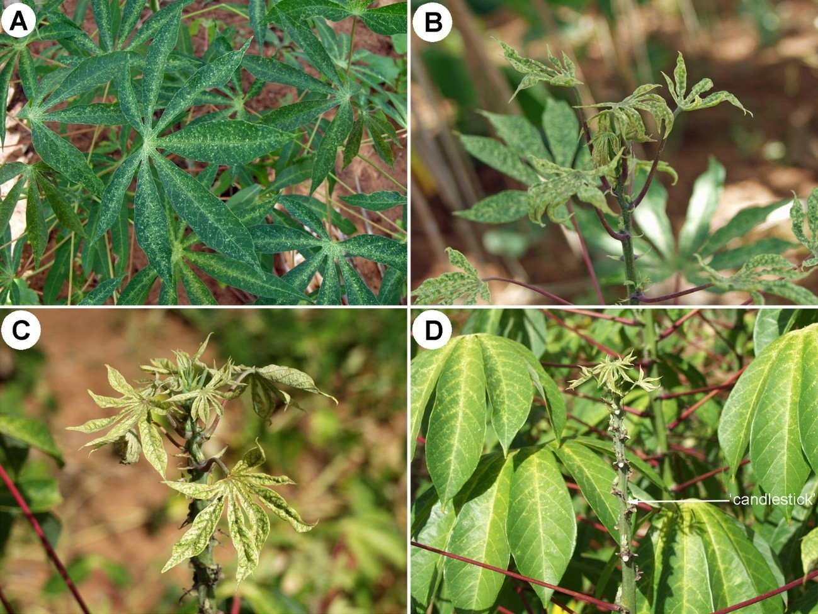
Figure 1. Progression of Mononychellus tanajoa damage to cassava plant: (A) stippled leaves; (B) distorted leaves; (C) chlorotic, mottled leaves with considerable reduction in leaf size; (D) death and fall of upper shoot leaves giving a “candlestick” appearance.
[318]Source: R. Hanna, Center for Tropical Research, University of California, Los Angeles, United States of America.

[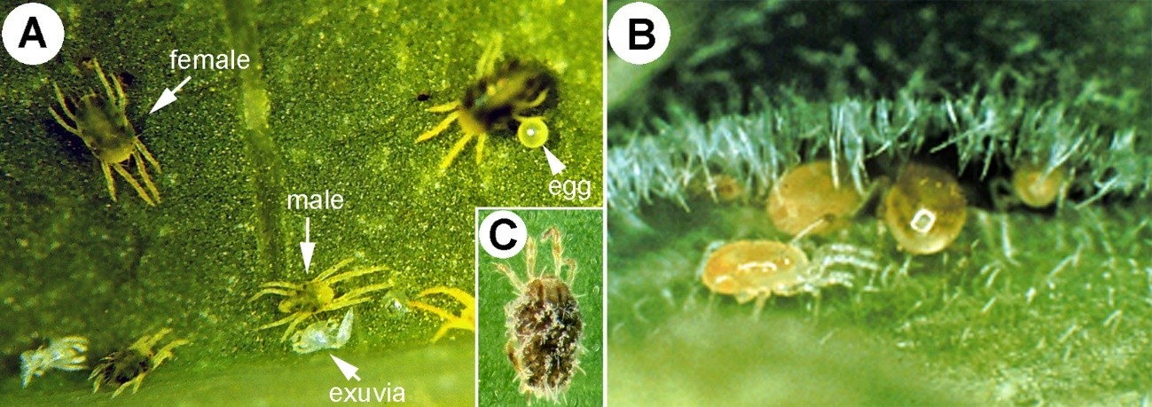
[320]Figure 2. Mononychellus tanajoa and its principal biocontrol agents: (A) adult and immature stages of M. tanajoa; (B) predatory mite Typhlodromalus aripo; (C) Neozygites tanajaoe infected M. tanajoa.
[321]Source: (A) J.S. Yaninek, (B & C) G. Goergen, International Institute of Tropical Agriculture, Nigeria.
[322]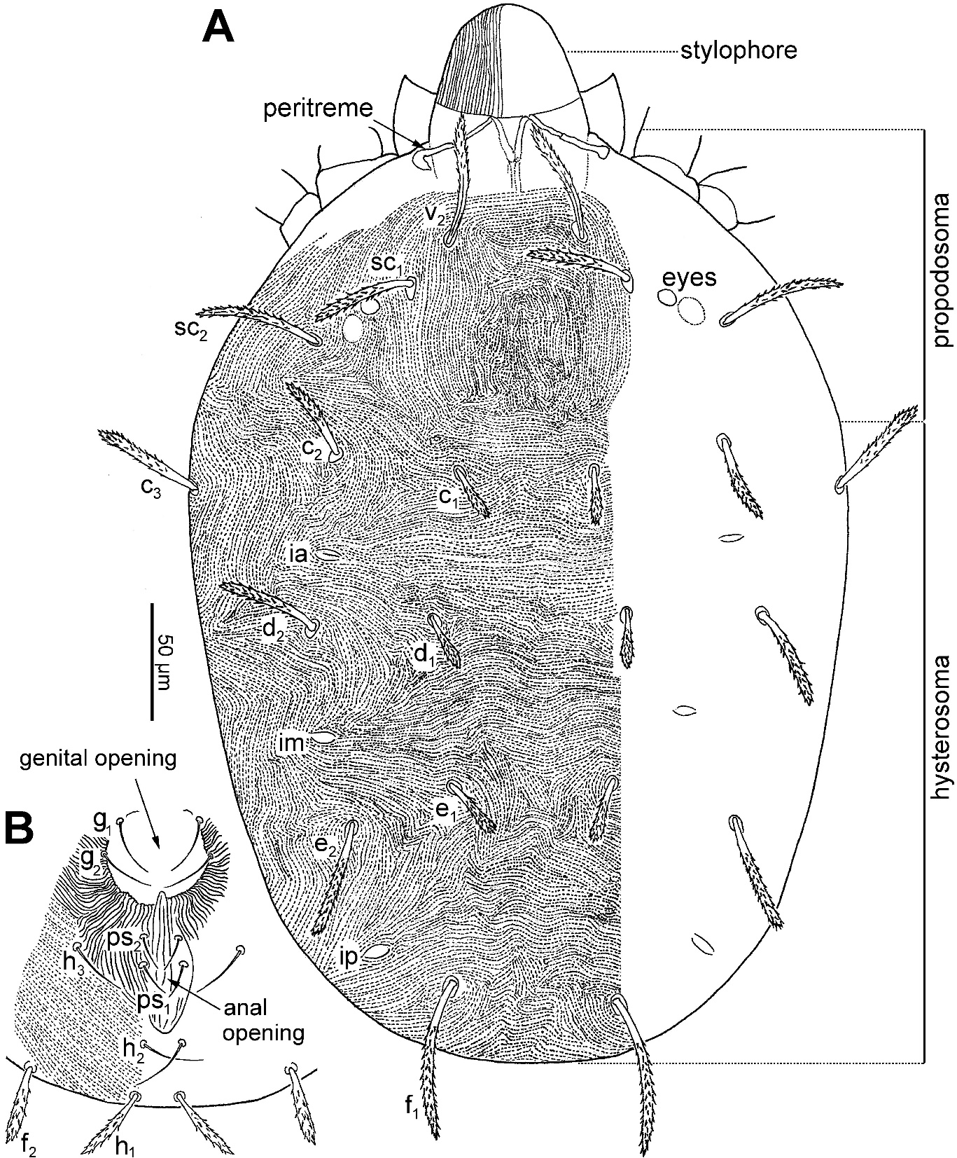
323]Figure 3. Mononychellus tanajoa, adult female: (A) dorsal view of idiosoma; (B) genital and anal region.
Note: For notation of structures, see Lindquist, E.E. 1985. Chapter 1.1 Anatomy, phylogeny and systematics. 1.1.1 External anatomy. In: W. Helle & M.W. Sabelis, eds. Spider mites – Their biology, natural enemies and control, Volume 1A, pp. 3–28. Amsterdam, Elsevier.
[324]Source: Q.-H. Fan, Plant Health & Environment Laboratory, Biosecurity New Zealand, Ministry for Primary Industries, New Zealand and D. Navia, Institut National de Recherche pour l’Agriculture, l’Alimentation et l’Environnement, France.

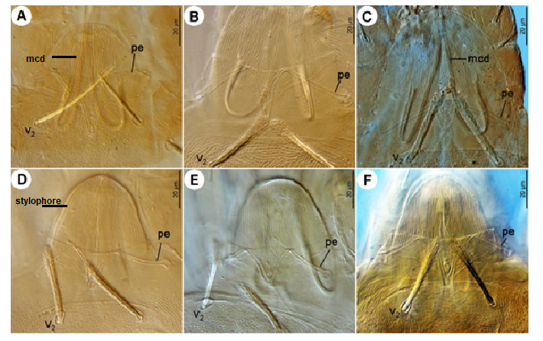

Figure 4. Stylophores and peritremes of adult females of Mononychellus spp. (A) M. bondari; (B) M. caribbeanae; (C) M. chemosetosus; (D) M. mcgregori; (E) M. planki; (F) M. tanajoa.
Notes: mcd, movable cheliceral digit; pe, peritremes.
Source: D. Navia, Institut National de Recherche pour l’Agriculture, l’Alimentation et l’Environnement, France and Q.-H. Fan, Plant Health & Environment Laboratory, Biosecurity New Zealand, Ministry for Primary Industries, New Zealand.
[333]Figure 5. Mononychellus tanajoa, adult female: (A) dorsal view of stylophore and peritremes; (B) infracapitulum and palp.
Notes: For notation of structures, see Lindquist, E.E. 1985. Chapter 1.1 Anatomy, phylogeny and systematics. 1.1.1 External anatomy. In: W. Helle, W. & M.W. Sabelis, eds. Spider Mites –. Their Biology, Natural Enemies and Control, Volume 1A, pp. 3–28. Amsterdam, Elsevier; v₂, seta.
[334]Source: D. Navia, Institut National de Recherche pour l’Agriculture, l’Alimentation et l’Environnement, France and Q.-H. Fan, Plant Health & Environment Laboratory, Biosecurity New Zealand, Ministry for Primary Industries, New Zealand.
.

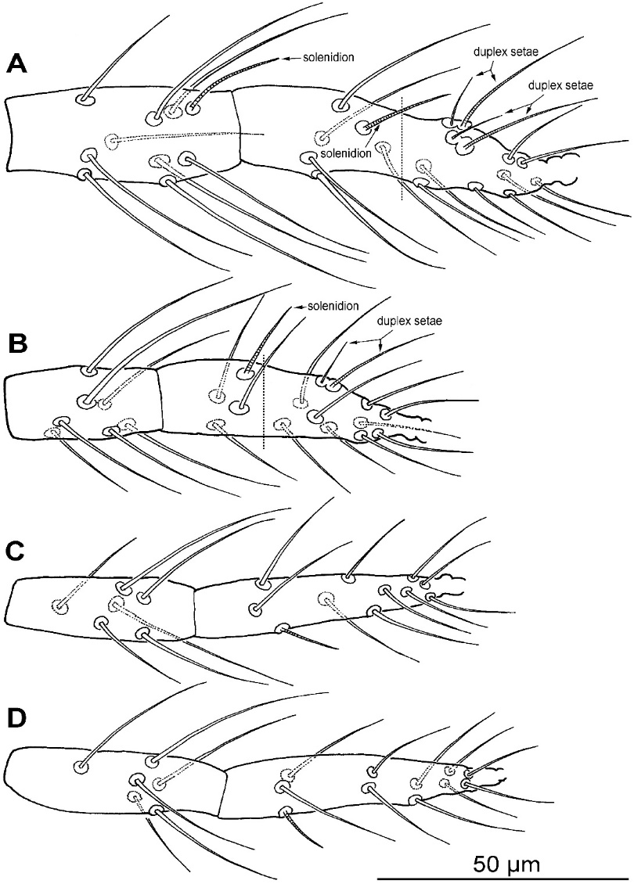

336]Figure 6. Mononychellus tanajoa, adult female: (A) tibia and tarsus I; (B) tibia and tarsus II; (C) tibia and tarsus III; (D) tibia and tarsus IV.
Note: Vertical dotted line in (A) and (B) marks the division between the proximal and distal parts of the tarsus.
[337]Source: Q.-H. Fan, Plant Health & Environment Laboratory, Biosecurity New Zealand, Ministry for Primary Industries, New Zealand and D. Navia, Institut National de Recherche pour l’Agriculture, l’Alimentation et l’Environnement, France.

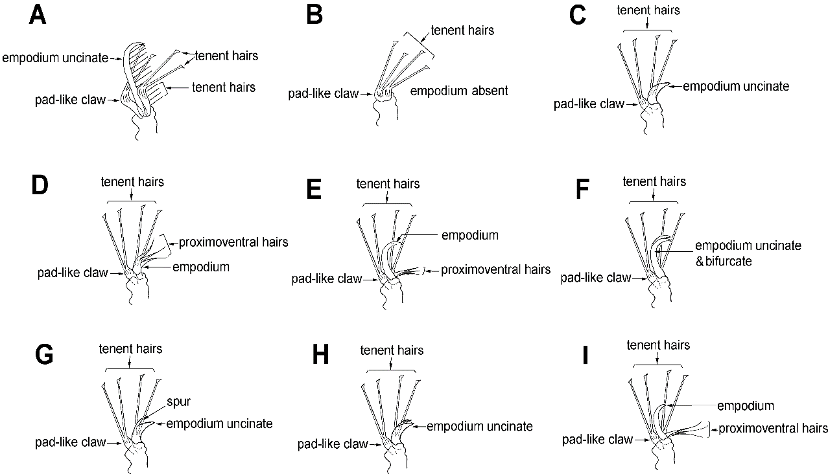

Figure 7. Types of pretarsi (II) in Tetranychidae on Manihot spp.: (
[343]Source: Q.-H. Fan, Plant Health & Environment Laboratory, Biosecurity New Zealand, Ministry for Primary Industries, New Zealand and D. Navia, Institut National de Recherche pour l’Agriculture, l’Alimentation et l’Environnement, France.

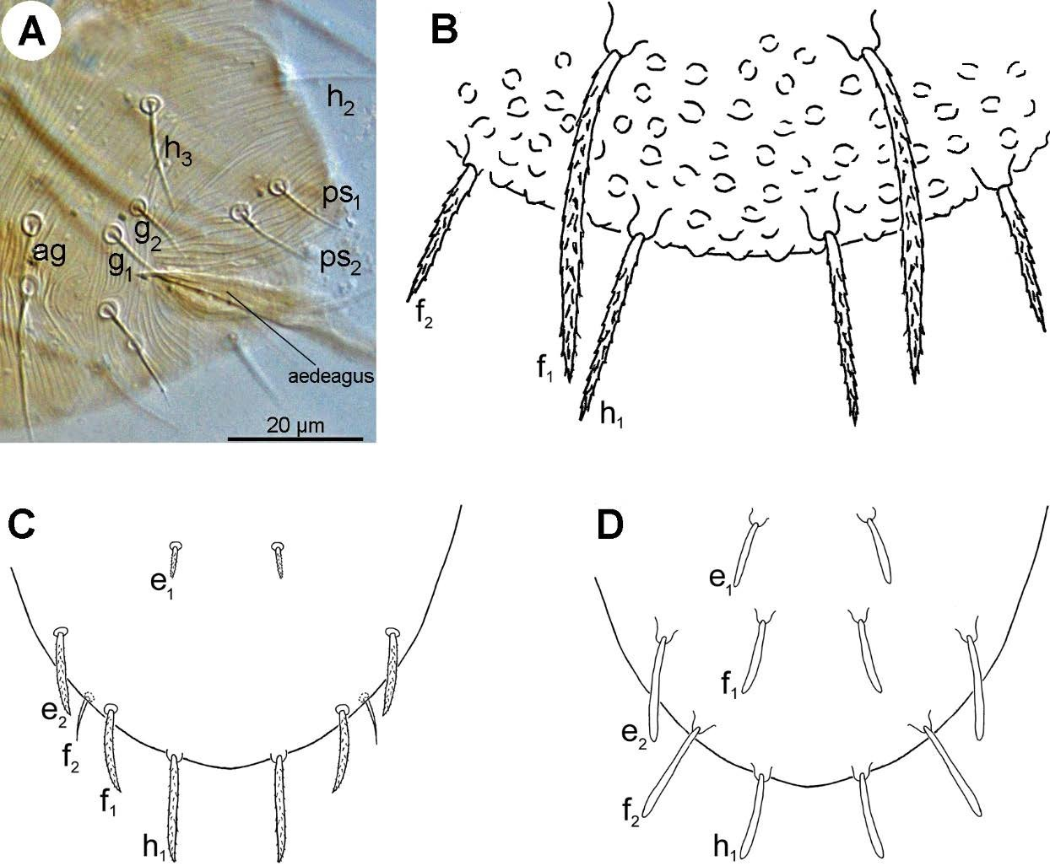

[325]
[326]Figure 8. Hysterosoma: (A) male Mononychellus; (B) female Neotetranychus; (C) female Aponychus;
[327](D) female Eutetranychus.
[328]Source: Q.-H. Fan, Plant Health & Environment Laboratory, Biosecurity New Zealand, Ministry for Primary Industries, New Zealand and D. Navia, Institut National de Recherche pour l’Agriculture, l’Alimentation et l’Environnement, France.
[329] 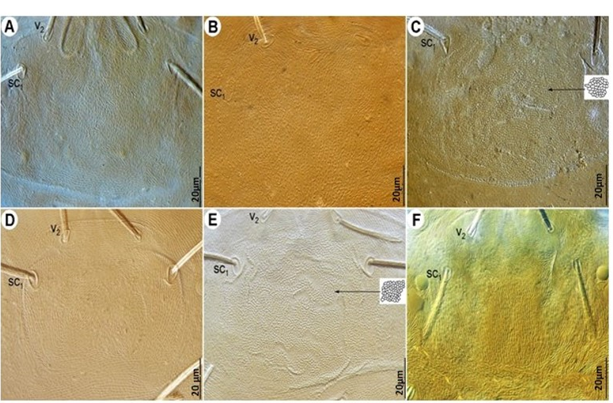

Figure 9. Prodorsum of adult females of Mononychellus spp.: (A) M. bondari; (B) M. caribbeanae; [346](C) M. chemosetosus; (D) M. mcgregori; (E) M. planki; (F) M. tanajoa.
[347]Source: D. Navia, Institut National de Recherche pour l’Agriculture, l’Alimentation et l’Environnement, France and Q.-H. Fan, Plant Health & Environment Laboratory, Biosecurity New Zealand, Ministry for Primary Industries, New Zealand.

[349][350]Figure 10. Hysterosoma of adult females of Mononychellus spp.: (A) M. bondari; (B) M. caribbeanae; (C) M. chemosetosus; (D) M. mcgregori; (E) M. planki; (F) M. tanajoa.
Source: D. Navia, Institut National de Recherche pour l’Agriculture, l’Alimentation et l’Environnement, France and Q.-H. Fan, Plant Health & Environment Laboratory, Biosecurity New Zealand, Ministry for Primary Industries, New Zealand.

Figure 11. Genital and anal regions of adult females of Mononychellus spp.: (A) M. bondari; (B) M. caribbeanae; (C) M. chemosetosus; (D) M. mcgregori; (E) M. planki; (F) M. tanajoa.
[354]Source: D. Navia, Institut National de Recherche pour l’Agriculture, l’Alimentation et l’Environnement, France and Q.-H. Fan, Plant Health & Environment Laboratory, Biosecurity New Zealand, Ministry for Primary Industries, New Zealand.

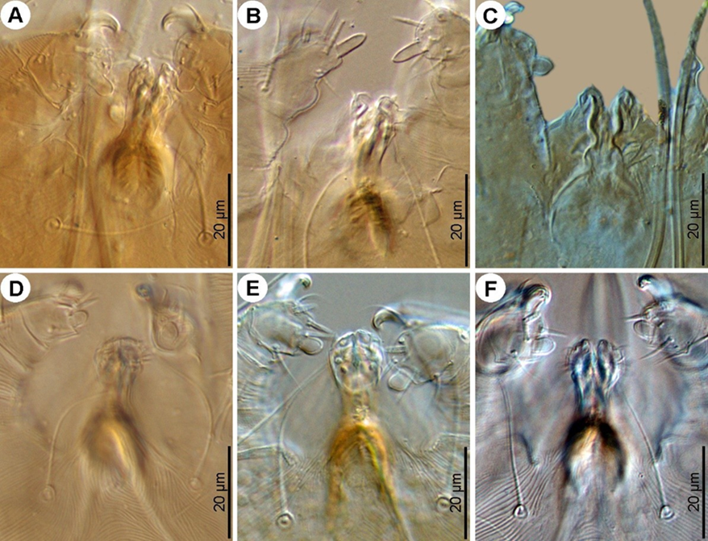

Figure 12. Infracapitulum and palps of adult females of Mononychellus spp.: (A) M. bondari; (B) M. caribbeanae; (C) M. chemosetosus; (D) M. mcgregori; (E) M. planki; (F) M. tanajoa.
[357]Source: D. Navia, Institut National de Recherche pour l’Agriculture, l’Alimentation et l’Environnement, France and Q.-H. Fan, Plant Health & Environment Laboratory, Biosecurity New Zealand, Ministry for Primary Industries, New Zealand.

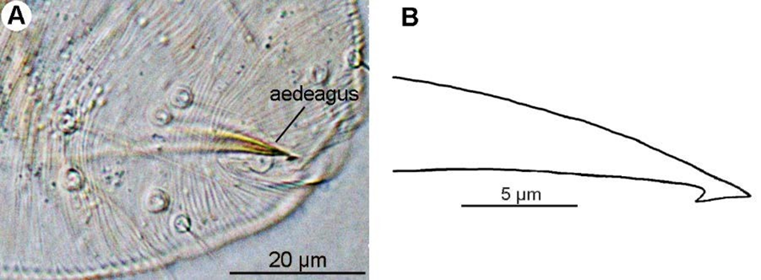

[339]Figure 13. Mononychellus tanajoa, lateral view of aedeagus: (A) photograph; (B) line drawing.
[340]Source: D. Navia, Institut National de Recherche pour l’Agriculture, l’Alimentation et l’Environnement, France and Q.-H. Fan, Plant Health & Environment Laboratory, Biosecurity New Zealand, Ministry for Primary Industries, New Zealand.
[341]

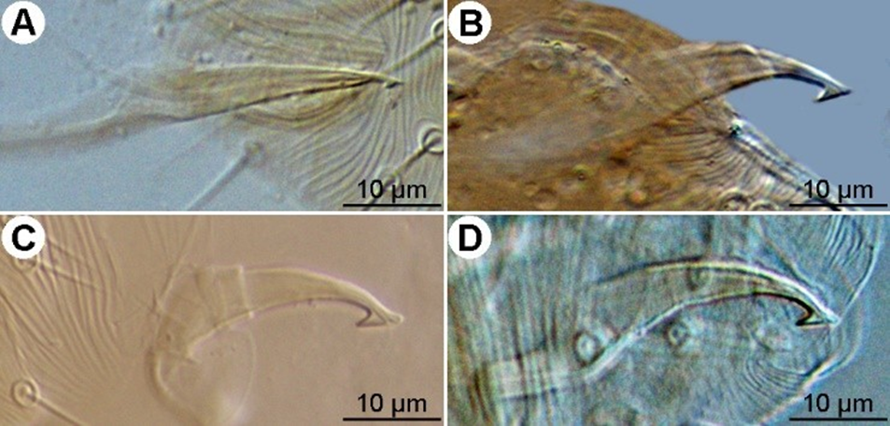

[359]Figure 14. Aedeagi of adult males of Mononychellus spp. (A) M. bondari; (B) M. chemosetosus; (C) M. mcgregori; (D) M. planki.
[360]Source: D. Navia, Institut National de Recherche pour l’Agriculture, l’Alimentation et l’Environnement, France and Q.-H. Fan, Plant Health & Environment Laboratory, Biosecurity New Zealand, Ministry for Primary Industries, New Zealand.

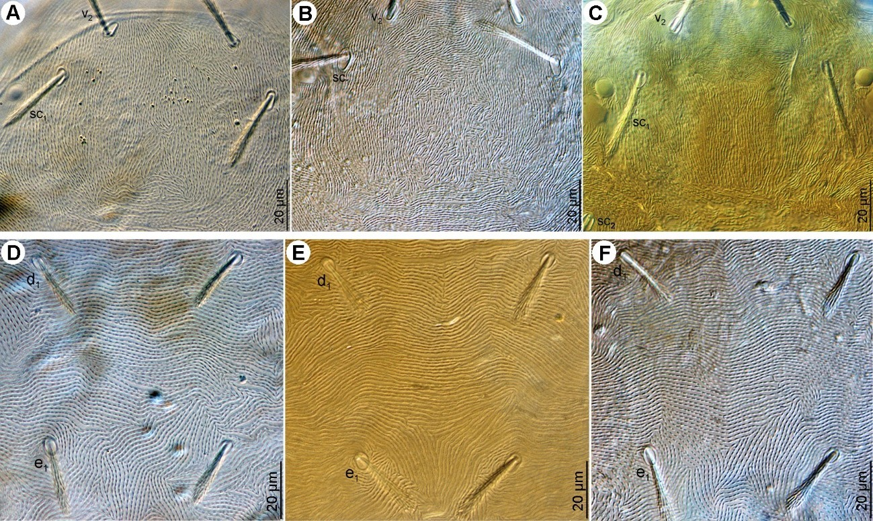

[330]Figure 15. Mononychellus tanajoa: (A–C) variation of prodorsal striation in adult female; (D–F) hysterosoma.
[331]Source: D. Navia, Institut National de Recherche pour l’Agriculture, l’Alimentation et l’Environnement, France and Q.-H. Fan, Plant Health & Environment Laboratory, Biosecurity New Zealand, Ministry for Primary Industries, New Zealand.

[156] The use of names of reagents, chemicals or equipment in these diagnostic protocols implies no approval of them to the exclusion of others that may also be suitable.

