[PleaseReview document review. Review title: 2023 First consultation: Draft annex to ISPM 27: Revision of DP 09 - Genus Anastrepha Schiner (2021-002). Document title: 2021-002_Revision_DP9_Anastrepha_2023-06-29_For_Consultation.docx]
[1]DRAFT REVISION OF DP 9: Genus Anastrepha (2021-002)
[2]Status box (this is not an official part of the standard, and it will be modified after adoption)
[3]Date of this document | [4]2023-06-02
[5]Document category | [6]Revision of annex to ISPM 27 (Diagnostic protocols for regulated pests)
[7]Current document stage | [8]To consultation period
[9]Major stages | [10]2020-12 Request for revision to DP 9 submitted to Technical Panel of Diagnostic Protocols (TPDP).  [11]2021-01 Request for revision to DP 9 submitted to Standards Committee (SC).  [12]2021-06 SC added topic to work programme (revision Genus Anastrepha, 2021-002), priority 2.  [13]2021-09 Drafting group commenced revision.  [14]2022-10 TPDP revision.  [15]2023-03 TPDP reviewed.  [16]2023-03 Expert consultation.  [17]2023-04 Drafting group revision.  [18]2023-06 Standards Committee (SC) approved for consultation via e-decision (2023_eSC_Nov_06)
[19]Discipline leads history | [20]2021-04 Norman BARR (US, Discipline lead)  [21]2021-04 Juliet GOLDSMITH (JM, Referee)
[22]Consultation at the technical level | [23]The first draft of this protocol was written by:  [24]Ignacio DUMOIS (AR)  [25]Allen NORRBOM (US)  [26]Raul RUIZ-ARCE (US) (lead author)  [27]Gary STECK (US)  [28]Kim Hoang THOA (VN)  [29]
[30]Main discussion points during the development of the diagnostic protocol | [31]Comment:  [32]The number of species treated for species diagnosis is increased to eight in the DP because the genus Toxotrypana is now considered part of Anastrepha. The pest Anastrepha curvicauda (formerly Toxotrypana curvicauda) is included in this protocol.  [33]  [34]The original drafting team requested inclusion of Gary Steck as a team member to provide significant additions to diagnosis of larvae and the IPPC formally reviewed and approved the addition.  [35]
[36]Notes | - [37]This is a draft document. The original protocol was topic 2006-015 and it was adopted in 2015 (it is still in force).  - [38]Adopted protocol did not include molecular methods for diagnosis but advances in methods were reported after adoption. The revision addresses new abilities for diagnosis and includes an additional species based on taxonomic revision.  - [39]The draft DP might require advice on inclusion of unpublished information.  - [40]The taxonomy section (Table 1) includes combinations in addition to formal synonyms. The authors recommended this addition.  [41]Edited 2023-04
[42]
[43]CONTENTS
[44][to be added later]

[45]Adoption
[46]The revision of this diagnostic protocol was adopted by the Standards Committee on behalf of the Commission on Phytosanitary Measures in [Month 20--]. [to be completed after adoption]
[47]The annex is a prescriptive part of ISPM 27 (Diagnostic protocols for regulated pests).

[48]
1. Pest information
[49]The family Tephritidae comprises over 5 000 species in approximately 500 genera (Norrbom, Carroll and Freidberg, 1999; Norrbom et al., 1999; Norrbom, 2004b, 2022). The Tephritidae are distributed worldwide in temperate, tropical and subtropical regions. Anastrepha Schiner (Tephritidae: Toxotrypanini) is the largest genus of Tephritidae in the Americas: it is represented by more than 300 species, divided into 27 species groups (Norrbom et al. 1999; Mengual et al. 2017; Norrbom et al. 2018; Steck et al. 2019) that occur from the southern United States of America (Texas and Florida) to northern Argentina (Hernández-Ortiz, 1992; Foote, Blanc and Norrbom, 1993; Hernández-Ortiz and Aluja, 1993; Norrbom, 2004b; Norrbom et al., 2012, 2015, 2018, 2021). These species include those formerly placed in Toxotrypana Gerstaecker, now considered a synonym of Anastrepha (Norrbom et al., 2018). At least eight species of Anastrepha are considered pests of major economic importance because of the commercial value of the cultivated fruits they attack (e.g. mango and citrus) or their wide host range. These eight species are: A. curvicauda (Gerstaecker); A. fraterculus (Wiedemann); A. grandis (Macquart); A. ludens (Loew); A. obliqua (Macquart); A. serpentina (Wiedemann); A. striata Schiner; and A. suspensa (Loew). A. fraterculus has been recognized as a cryptic species complex (Hernández-Ortiz et al., 2004, 2012, 2015; Selivon et al., 2004; Selivon, Perondini and Morgante, 2005; Vera et al., 2006, Cáceres et al., 2009; Sutton et al., 2015). This diagnostic protocol for Anastrepha covers identification of the genus and the species of major economic importance. For further general information about species of Tephritidae, see White and Elson-Harris (1992), Aluja and Norrbom (1999) and Norrbom (2010).
[50]The length of the tephritid life cycle varies according to each species as well as environmental and climatic conditions (Basso, 2003). Female Anastrepha deposit their eggs inside fruits, except for A. manihoti Lima which develops in stems. The number of eggs deposited per fruit is variable and depends on both intrinsic and extrinsic factors; some species (e.g. A. obliqua) always lay single eggs, others (e.g. A. bezzii, A. grandis) have large clutch sizes, and others (e.g. A. ludens) vary the clutch size based on host fruit size (Aluja et al., 1999). A total of 494 natural host plant species (see ISPM 37 (Determination of host status of fruit to fruit flies (Tephritidae)) are known for 148 (43%) of the 328 currently recognized Anastrepha species and nine unnamed species (Norrbom, 2022; Rodriguez et al., forthcoming). Published host records for major pests are available at the United States Department of Agriculture Compendium of Fruit Fly Host Information (https://coffhi.cphst.org).
[51]The introduction of cultivated exotic species such as Mangifera indica and Citrus spp. has allowed some pest species of Anastrepha to expand their original geographical distribution. However, they still have marked preferences for certain indigenous hosts, which is probably indicative of their original host relationships. In this regard, the species A. suspensa, A. fraterculus and A. striata breed mainly in hosts belonging to the family Myrtaceae, A. ludens in the Rutaceae, A. obliqua in the Anacardiaceae, A. serpentina in the Sapotaceae, and A. grandis in the Cucurbitaceae (Norrbom, 2004a).
[52]Among indigenous hosts in the American tropics, there seems to be an ancestral association with plants that produce latex and particularly the families Apocynaceae, Moraceae and Sapotaceae. Sapotaceous fruits are frequent hosts for the benjamini, daciformis, dentata, gigantea, leptozona, panamensis, robusta, serpentina and speciosa species groups. Myrtaceous fruits are also very important hosts. At least 26 Anastrepha species, most of which belong to the fraterculus or striata species groups, have been reported feeding on plants of this family (Norrbom and Kim, 1988; Norrbom, Zucchi and Hernández-Ortiz, 1999; Rodriguez et al., forthcoming).

[53]2. Taxonomic information
[54]Name: Anastrepha Schiner, 1868
[55]Synonyms: Toxotrypana Gerstaecker, 1860; Acrotoxa Loew, 1873; Pseudodacus Hendel, 1914; Phobema Aldrich, 1925; Lucumaphila Stone, 1939
[56]Taxonomic position: Insecta, Diptera, Tephritidae, Trypetinae, Toxotrypanini
[57]Common names: see Table 1
[58]Table 1. Common names, synonyms and other names of Anastrepha species of major economic importance included in this protocol
[59]Common name | [60]Anastrepha species | [61]Synonyms and other names
[62]Papaya fruit fly | [63]Anastrepha curvicauda (Gerstaecker, 1860) | [64]Toxotrypana curvicauda Gerstaecker, 1860
 |  | [67]Mikimyia furcifera Bigot, 1884
 |  | [70]Toxotrypana fairbatesi Munro, 1984
[71]South American fruit fly | [72]Anastrepha fraterculus (Wiedemann, 1830) species complex | [73]Dacus fraterculus Wiedemann, 1830
 |  | [76]Tephritis mellea Walker, 1836
 |  | [79]Trypeta unicolor Loew, 1862
 |  | [82]Anastrepha unicolor Schiner 1868
 |  | [85]Trypeta fraterculus Loew, 1873
 |  | [88]Acrotoxa fraterculus Loew, 1873
 |  | [91]Anthomyia frutalis Weyenbergh, 1874
 |  | [94]Anastrepha fraterculus var. soluta Bezzi, 1909
 |  | [97]Anastrepha peruviana Townsend, 1913
 |  | [100]Anastrepha braziliensis Greene, 1934
 |  | [103]Anastrepha costarukmanii Capoor, 1954
 |  | [106]Anastrepha scholae Capoor, 1955
 |  | [109]Anastrepha pseudofraterculus Capoor, 1955
 |  | [112]Anastrepha lambayecae Korytkowski and Ojeda, 1968
[113]South American cucurbit fruit fly | [114]Anastrepha grandis (Macquart, 1846) | [115]Anastrepha schineri Hendel, 1914
 |  | [118]Anastrepha latifasciata Hering, 1935
 |  | [121]Tephritis grandis Macquart, 1846
 |  | [124]Trypeta grandis Loew, 1873
[125]Mexican fruit fly | [126]Anastrepha ludens (Loew, 1873) | [127]Anastrepha lathana Stone, 1942
 |  | [136]Trypeta ludens Loew, 1873
 |  | [139]Acrotoxa ludens: Loew, 1873
[140]West Indian fruit fly | [141]Anastrepha obliqua (Macquart, 1835) | [142]Tephritis obliqua Macquart, 1835
 |  | [145]Trypeta obliqua Osten Sacken, 1868
 |  | [148]Acrotoxa obliqua Loew, 1873
 |  | [151]Anastrepha fraterculus var. mombinpraeoptans Seín, 1933
 |  | [154]Anastrepha fraterculus var. ligata Lima, 1934
 |  | [157]Anastrepha trinidadensis Greene, 1934
 |  | [160]Anastrepha mombinpraeoptans Stone, 1942
[161]Sapote fruit fly | [162]Anastrepha serpentina (Wiedemann, 1830) | [163]Dacus serpentinus Wiedemann, 1830
 |  | [166]Leptoxys serpentina Macquart, 1843
 |  | [169]Trypeta serpentina Loew, 1873
 |  | [172]Acrotoxa serpentina Loew, 1873
 |  | [175]Urophora vittithorax Macquart, 1851
[182]American guava fruit fly | [183]Anastrepha striata Schiner, 1868 | [184]Dictya cancellaria Fabricius, 1805
 |  | [187]Trypeta cancellaria Wiedemann, 1830
[188]Caribbean fruit fly | [189]Anastrepha suspensa (Loew, 1862) | [190]Trypeta suspensa Loew, 1862
 |  | [193]Acrotoxa suspensa: Loew, 1873
 |  | [196]Anastrepha unipuncta Seín, 1933
 |  | [199]Anastrepha longimacula Greene, 1934
[200]

[201]3. Detection
[202]Fruit flies of the genus Anastrepha are detected mainly by trapping adults or by finding eggs and larvae in fruits. Immature stages (eggs and first-, second- and third-instar larvae) can be found during inspection of fruits. After completing development, larvae exit the fruit, and the immobile pupal stage develops elsewhere (e.g. in leaf litter, soil or the packaging of containers).

[203]3.1 Trapping
[204]Guidance on trapping Anastrepha fruit flies is given in Appendix 1 of ISPM 26 (Establishment of pest free areas for fruit flies (Tephritidae)).

[205]3.2 Inspecting fruits
[206]Signs of fruit fly infestation are the presence of soft areas, dark stains, dark pin spots, rot, holes or injuries that might be caused by oviposition or larval feeding activities. To detect punctures made by female flies during oviposition, fruits can be examined under a stereomicroscope by an expert. If larval exit holes are observed, puparia may be detected in the packaging of the fruit. Third instars may not be present when unripe fruit is collected and packed; however, this fruit might host eggs or first or second instars, which are more difficult to detect. On potentially infested fruit showing typical punctures made by ovipositing female flies, eggs and larvae may be seen when cutting the fruit open.
[207]Once detected, larvae may be reared to adults (section 4.1.1), which is required to accurately identify a fly to species level with morphological techniques. The incubation of infested fruits is a common practice to obtain adult flies. As oviposition marks are often difficult to recognize, fruits can be held to check for potential larval development even if there are no signs of fruit fly infestation.

[208]4. Identification
[209]The taxonomy of the genus Anastrepha is based mainly on adult external morphology and characters of the female terminalia (Stone, 1942; Hernández-Ortiz, 1992; Zucchi, 2000; Norrbom et al., 2012). Because morphological characters of immature stages are not well documented for most Anastrepha species, these characters have a more limited utility in species recognition (White and Elson-Harris, 1992; Steck et al., 2019) in comparison with adult morphology. However, some information on egg structures and third-instar larvae is available in the scientific literature and has diagnostic utility for certain species (Steck and Wharton, 1988; Steck et al., 1990; Frías et al., 2006; Frías, Selivon and Hernández-Ortiz, 2008; Frías Lasserre, Hernández-Ortiz and López Muñoz, 2009; Dutra et al., 2011a, 2011b, 2012, 2013, 2018a, 2018b; Figueiredo et al., 2013; Rodriguez et al., 2021). Identification keys for the larvae of the eight species of Anastrepha known to be of major economic importance (Table 1) are available (Steck et al., 1990; Carroll et al., 2004) but should be used with consideration of their limitations.
[210]Although the third-instar larvae of some Anastrepha species can be discriminated in keys (Steck and Wharton, 1988; Carroll and Wharton, 1989; Steck et al., 1990; White and Elson-Harris, 1992; Carroll et al., 2004; Frías et al., 2006; Hernández-Ortiz, Guillén-Aguilar and López, 2010), the available data are based on very limited sampling for most species. The reliability of these keys cannot, therefore, be guaranteed until further studies are conducted, including studies of additional, closely related species that have not yet been characterized. The most reliable method for identification is rearing larvae to the adult stage. Molecular methods of identification have also been reported for some of the major pest species and are included in this diagnostic protocol (section 4.5).
[211]Several pest species of Anastrepha are believed to comprise multiple (yet to be described) cryptic species that are morphologically indistinguishable or require morphometric analysis for their recognition (Hernández-Ortiz et al., 2004, 2012, 2015). The A. fraterculus species complex (Table 1) is included in the protocol, but it is identified to the level of complex because revision of its taxonomy and associated molecular diagnosis are not yet fully resolved (Sutton et al., 2015, Prezotto et al., 2019).
[212]4.1 Preparation of adults for identification

[213]4.1.1 Rearing larvae to obtain adults
[214]Larvae can be reared to adults by placing infested fruits in containers containing a sterile pupation medium (e.g. damp vermiculite, sand or sawdust) on the bottom. The containers are covered with cloth or fine mesh. Once the larvae emerge from the fruit, they will move to the pupation medium for pupation. It is recommended that each fruit sample is incubated separately. Each sample must be observed, and pupae gathered daily. The pupae are placed in containers with the pupation medium, and the containers are covered with a tight lid that enables proper ventilation. Once the adults emerge, they must be kept alive for 48–72 h to ensure that the integument and wings acquire the rigidity and characteristic coloration of the species. Adults can be fed with honey and water or a mix of sugar, yeast, wheatgerm and water. The adults are then killed and preserved by placing them in 70–95% ethanol, or they are killed with ethyl acetate or another agent and then mounted on pins. For female flies, immediately after killing them (before they harden) it is useful to gently squeeze the apical part of the preabdomen with forceps, then squeeze the base and apex of the oviscape to expose the aculeus tip (so that it does not need to be dissected later).

[215]4.1.2 Preparation of adults for microscopic examination
[216]For species recognition of adult stages, the entire specimen should be preserved – either dry (pinned) or in 70% ethanol. Examination of the wings and the aculeus is particularly important. Examination of the aculeus must be done at about 400× magnification. The wing and aculeus of each specimen can be mounted under two separate coverslips on the same slide. Dissection and mounting should be done only by someone with experience. Dissecting the female terminalia in Anastrepha is difficult and it is easy to damage useful parts.
[217]4.1.2.1 Aculeus
[218]It is preferable to cut off the whole abdomen from a female to dissect the oviscape (syntergosternite 7) (Figure 1), the eversible membrane and the aculeus. For preserved dry (pinned) specimens, fine dissection scissors are recommended to remove the abdomen. The abdomen needs to be cleared. This can be accomplished by placing it in a 10% sodium hydroxide (NaOH) or 10% potassium hydroxide (KOH) solution and heating it in a boiling water bath for 10–15 min, washing the structure with distilled water, and then removing internal contents under a stereomicroscope with the help of dissection forceps. This should reveal the aculeus and the eversible membrane. At this step it is possible to examine the aculeus directly in one or two drops of glycerine under a microscope. Afterwards, the structure can be transferred to a microvial with glycerine and pinned under the mounted dry specimen. For permanent slides, proceed as described in the introductory text of section 4.1.2. Mounting the aculeus permanently in the ventral position prevents the observation of some characters better seen in lateral view. For this reason, preservation in glycerine in a microvial is often preferable.
[219]4.1.2.2 Wings
[220]Wing characters can usually be observed without mounting, so mounting is not recommended as a general practice. It may be necessary for morphometric studies or photography, but it is not necessary for observation of the characters used in the key in section 4.3.2. If permanent mounts are made, it is recommended that one of the wings be cut off from its base (the right wing is preferred because it facilitates comparison with images reported in the literature and this diagnostic protocol).

[221]4.2 Preparation of larvae for morphological identification
[222]As noted in the introductory text of section 4, observation of adult characters may be necessary to corroborate a morphological identification based on larvae. If immature stages are found, it is recommended that some larvae be preserved for morphological examination by treating them in hot or boiling water, cooling to room temperature, and then storing them in 70% ethanol, and rearing the remaining larvae and pupae to obtain adult specimens for identification (section 4.1.1). Larvae that are to be used for morphological analysis alone can be saved in 70% ethanol after boiling. Larvae that are to be used for both morphological and molecular analysis can have tissue excised (section 4.5.1) and saved in ≥95% ethanol in a freezer (≤−20 °C) until DNA is extracted and the remaining anterior and posterior sections saved in 70% ethanol.
[223]For the hot water treatment, live larvae are killed by placing in water at 65–100 °C for at least two minutes, cooled to room temperature and then preserved in 70% ethanol. If larvae turn partially or completely black after one day in 70% ethanol, the hot water treatment was inadequate, and the water temperature or treatment time should be increased. The larval cuticle may split open on one side near the head, but this is inconsequential for identification purposes. Splitting is minimized if the larvae are run through a graduated alcohol series of 35%–50%–70% ethanol for two hours each, with an additional change to fresh 70% alcohol. It is advisable to include a label in the storage vial with all sampling information. These samples are ready for examination under a stereomicroscope or subsequent preparation for slide mounting or examining under a scanning electron microscope (SEM).
[224]To prepare specimens for slide mounting, it is necessary to remove (clear) all the internal tissues to allow observation of the cuticle, oral opening, cephaloskeleton, anterior and posterior spiracles, and anal lobes. First, two incisions are made in the larva: one laterally through the thoracic segments, and one between the posterior spiracles and anus. Then the incised larva is immersed in hot 10% NaOH or 10% KOH solution for 10–15 min or until most internal tissues are visibly digested. After digestion, the remaining internal debris is carefully removed using forceps and the specimen flushed with distilled water under a stereomicroscope. The cephaloskeleton is extracted through the lateral incision on the thorax.
[225]Cleared specimens can be placed in glycerine on a glass depression slide with a cover slip for examination or imaging and recording of measurement data under a compound microscope. Afterwards, specimens can be retained as vouchers by returning them to alcohol in a labelled vial, or permanent slide mounts can be made using Canada balsam or Euparal following standard methods. First, the cleared specimen must be dehydrated for 25 min in each of 50%, 75% and 100% ethanol. For mounting with Canada balsam, the specimen should be transferred to lavender oil for 15 min to clear it and then immediately mounted on a slide with one or two drops of Canada balsam. When Euparal is used as the mounting medium, the specimen should be transferred from 100% ethanol to clove oil for about 30 min to clear it before mounting. For permanent mounts, care must be taken to position and stabilize the specimen in the proper orientation before adding the cover slip, otherwise it may be impossible to get realistic images or accurate measurements after the specimen dries in place. Slides must be allowed to dry for several days or weeks (the time can be reduced by using an oven), but they can be examined under the microscope at low magnification immediately after mounting. Slides should be labelled.
[226]Morphological examination of larvae can be performed on unmounted larvae (Figures 2A,C) using a stereomicroscope, on slide-mounted larvae (Figure 2B) using a compound microscope, or on critical-point dried larvae using an SEM (Figure 2D).
[227]With a stereomicroscope it is possible to count oral ridges, accessory plates, and tubules on the anterior spiracles; observe the shape of anterior spiracles and anal lobes, and the presence of dorsal spinules on various body segments; and measure the apical width of anterior spiracles and the length of posterior spiracles. Fine details of the facial mask (preoral lobes, oral ridges and their edges, accessory plates) of an unmounted larva can be observed by using a transmitted-light compound microscope. A clean, dry larva is placed on a piece of facial tissue on a glass slide and the head is observed at 100× magnification. Specimens should be re-wetted with alcohol as needed to prevent shrivelling during examination.
[228]On slide-mounted, cleared larvae it is possible to re-examine many of the same external features observed on unmounted specimens and obtain more accurate measurements under a compound microscope. The oral-ridge margins and accessory plates may also be seen, although it may be difficult to prepare a specimen properly to view them. The external posterior spiracles, their hair-like processes and the internal cephaloskeleton are readily visible on cleared specimens under a compound microscope using an objective of 20×, 40× or higher (Figure 2C). Detailed, high-resolution observation of the external morphology of larvae, especially of the facial mask including oral ridges, accessory plates, preoral lobes and sensory organs, is best achieved using an SEM (Figure 2D). The ventral surface of the mouth hook is only visible under SEM. It is therefore recommended that slide-mounting does not include all specimens representing a sample or the only larva available for diagnosis; unmounted larvae should be kept for future analysis.
[229]For observation using an SEM, the specimen is dehydrated by running through a series of ethanol baths: 70%, 80%, 95% and three changes of absolute ethanol (15 min each bath). Specimens should then be critical-point dried before mounting on stubs. Alternatively, specimens can be placed in two additional baths of ethyl acetate, air-dried and mounted on a stub for sputter coating. See Carroll and Wharton (1989), Frías et al. (2006), Frías, Selivon and Hernández-Ortiz (2008), Frías Lasserre, Hernández-Ortiz and López Muñoz (2009) and Rodriguez et al. (2021) for further details and variations.

[230]4.3 Morphological identification of adults

[231]4.3.1 Identification of the genus Anastrepha
[232]Adult flies can be diagnosed to genus using a combination of characters.
[233]Body: usually predominantly yellow to orange, occasionally mostly brown (Figure 3 and Figure 4). Head (Figure 5A): usually yellow with two to eight frontal and one or two orbital setae, sometimes posterior orbital seta absent; ocellar seta usually very weak or indistinct; postocellar, medial and lateral vertical setae present. Thorax (Figure 5B): macrosetae of thorax usually black, red–brown or orange, rarely golden yellow; scutum usually yellow to orange, occasionally mostly dark brown or sometimes with dark-brown or black stripes or spots, always with two to five white to pale yellow stripes; mesonotum with the following setae, except in the curvicauda group, where they are reduced or absent – one postpronotal, two notopleurals, one presutural supra-alar, one postsutural supra-alar, one postalar, one intra-alar, one dorsocentral, one acrostichal (rarely absent) and two scutellars.
[234]Wings (Figure 6A and Figure 7): subcostal break present; crossvein r-m placed distal to mid-length of discal cell (dm); anterior cubital cell (cua; by some authors termed cell bcu, the basal cubital cell, or cell cup, the posterior cubital cell) with a well-developed posteroapical extension; vein M₁ usually conspicuously curved forwards apically (strongly so in all major pest species, except A. curvicauda) and not meeting costa at a 90° angle. Wing pattern with orange to brown coloured bands usually forming a typical pattern as follows: costal or C-band on basal costal margin extending to apex of vein R₁ and including all of basal costal and costal cells, the pterostigma and at least the part of cell r₁ posterior to it; S-band, extending from the apex of cell cua across cell dm and crossvein r-m, reaching costal margin, and continuing to apex of wing; V-band forming an inverted V shape, comprising the proximal arm (subapical band) along vein dm-m and the distal arm (posterior apical band) arising from the apical part of cell m₁, the arms converging and often connected in cell r₄₊₅; and the distal arm of the V-band frequently incomplete or absent. The typical wing pattern is modified in some economically important species (see key to species in section 4.3.2). Some species, including A. curvicauda, have a wasp-mimic pattern consisting of a broad, uninterrupted costal band and a diffuse cubital streak, and a few non-pest species have entirely different wing patterns.
[235]Male terminalia (Figure 6B): epandrium broad in lateral view with lateral surstylus short or elongated; medial surstylus shorter than lateral surstylus with two stout blackish prensisetae apically; proctiger membranous, weakly sclerotized at least laterally and ventrally; phallus elongated, usually longer than length of oviscape of female; glans weakly sclerotized with an apical T-shaped sclerite, glans sometimes absent in non-pest species.
[236]Female terminalia (Figure 1 and Figure 6C): oviscape tube-like, variable in length, basally with flange-like lateral lobes; eversible membrane (usually inverted inside oviscape) basally with dorsal group of hook-like sclerotized denticles (sometimes referred to as the rasper); aculeus (usually inverted inside eversible membrane and oviscape) well sclerotized, tip (Figure 8) sometimes serrated on lateral margins.

[237]4.3.2 Key to adults of major economically important species of Anastrepha
[238]The following key is adapted from Hernández-Ortiz, Guillén-Aguilar and López (2010). It should be used with care, as minor pests or non-economically important species that are not included in this diagnostic protocol could be misidentified as one of the species in the key. To complete a conclusive identification of the major pest species using this protocol, each specimen diagnosed using the key must also be examined for all diagnostic morphological characters in Table 2 and Table 3. For species not included in the protocol and additional information on morphological structures and other Anastrepha species, see Norrbom et al. (2012).
[239]1. Wing (Figure 7A) with only broad, uninterrupted costal band filling all of wing anterior to vein R₄₊₅, and more diffuse band covering cell cua and base of cell m₄; most setae, including postpronotal, presutural supra-alar, dorsocentral, intra-alar and scutellar setae, absent or small and weak, much shorter than scutellum length; abdomen petiolate; body predominantly yellow with conspicuous brown markings (Figure 3A and Figure 3B); anatergite at most with dark dorsal and ventrolateral spots; scutellum with at most base and lateral third of apical margin brown; scutum with dark posterior mark broader than long and separate from dark submedial stripes and dark sublateral stripes, the latter strongly laterally curved posteriorly (Figure 3B); oviscape elongate, usually longer than thorax and abdomen combined, and strongly curved (Figure 3A). (Larvae infest papaya, other Caricaceae, and Apocynaceae.) Anastrepha curvicauda (Gerstaecker)
[240]– Wing (Figure 7B to Figure 7H) usually with typical C-, S- and V-bands; setae, including postpronotal, presutural supra-alar, dorsocentral, intra-alar and scutellar setae, well developed, longer than scutellum length; abdomen not petiolate; body colour variable, but usually predominantly yellow to orange or brown (Figure 3C, Figure 3D and Figure 4); oviscape length variable, but usually straight or nearly so. 2
[241]2. Wing (Figure 7C to Figure 7H) with C-band interrupted at end of vein R₁ by a well-delimited hyaline mark in cell r₁; anterior and posterior orbital setae present; distal arm of V-band usually present at least partially, but if absent, wing pattern dark brown to black. 3
[242]– Wing (Figure 7B) with C-band uninterrupted from wing base to apex, sometimes diffuse in cell r₁; posterior orbital seta often absent; distal arm of V-band absent. All following characters must be present: basal half of S-band continuous from apex of cell cua through crossvein r-m and connecting with C-band anteriorly; cell r₂₊₃ entirely infuscated; vein R₂₊₃ almost straight for its entire length; cell br broadly hyaline between crossveins bm-m and r-m; abdominal tergites yellow to orange; scutum (Figure 4A) with narrow dark-brown dorsocentral stripes; aculeus of female relatively long (5.3–6.2 mm) and usually greater than 0.10 mm wide, aculeus tip (Figure 8B) with V-shaped ridges, lateral margins non-serrate; phallus of male greater than 6 mm long, glans present. (Larvae infest melons and other Cucurbitaceae.) Anastrepha grandis (Macquart)
[243]3. Scutum predominantly brown (Figure 3C) or with broad, brown to black, U-shaped mark (Figure 3D). 4
[244]– Scutum (Figure 4B to Figure 4D) mostly yellow or orange, without dark brown markings except sometimes along scuto-scutellar suture. 5
[245]4. Wing pattern (Figure 7C) mostly dark brown; distal arm of V-band completely absent; abdominal tergites (Figure 3C) mostly dark brown with T-shaped medial white mark; thoracic pleuron mostly brown, strongly contrasting with yellow markings; female aculeus 2.6–3.8 mm long, tip (Figure 8C) 0.37–0.46 mm long, 0.14–0.17 mm wide, lateral margins finely serrate on distal 50–70%. (Larvae predominantly infest Sapotaceae.) Anastrepha serpentina (Wiedemann)
[246]– Wing pattern (Figure 7D) mostly orange and moderate brown; distal arm of V-band often present; abdominal tergites and pleuron yellow to orange; scutum (Figure 3D) with two broad dorsocentral stripes connected on posterior margin to form U-shaped mark, without setulae on small area along transverse suture, with non-microtrichose stripe along dorsocentral line contrasting with dense white microtrichia elsewhere on scutum; female aculeus 1.95–2.30 mm long, tip (Figure 8D) broad, 0.24–0.31 mm long, 0.17–0.20 mm wide. (Larvae predominantly infest guavas and other Myrtaceae.)
Anastrepha striata Schiner
[247]5. Wing (Figure 7F to Figure 7H) with distal section of S-band narrow to moderately broad, never reaching apex of vein M₁; V-band with arms separated anteriorly or, if joined, with large hyaline mark between them and vein M₁; scuto-scutellar suture with or without brown spot medially; aculeus variable.
6
[248]– Wing (Figure 7E) with distal section of S-band extremely broad, reaching apex of vein M₁; V-band broad and complete, with arms widely connected anteriorly, hyaline mark between them and vein M₁ small or absent; scuto-scutellar suture usually with large, rounded brown spot medially; female aculeus 1.4–1.6 mm long, tip (Figure 8E) 0.19–0.23 mm long, 0.10–0.13 mm wide, lateral margins serrate on distal 50–65%. (Generalist pest, but larvae predominantly infest guavas and other Myrtaceae.) Anastrepha suspensa (Loew)
[249]6. Female oviscape less than 2.2 mm long, 0.50–0.75 times as long as thorax (Figure 4C and Figure 4D); aculeus less than 2.0 mm long, tip (Figure 8G and Figure 8H) relatively short and broad with large teeth on sides; male phallus 2.3–3.45 mm long, 0.7–1.1 times as long as thorax; other characters variable. 7
[250]– Female oviscape more than 3.0 mm (usually more than 3.5 mm) long, 1.1–1.55 times as long as thorax (Figure 4B); aculeus more than 2.9 mm long (usually 3.3–5.8 mm); aculeus tip (Figure 8F) 0.28–0.42 mm long, with moderate constriction near mid-length; lateral margins non-serrate or finely serrate on distal 55% or less; male phallus 5.0–6.3 mm long, 1.45–1.85 times as long as thorax; subscutellum (Figure 5D) always with brown lateral markings, sometimes extended onto mediotergite; wing pattern as in Figure 7F. (Larvae commonly infest citrus and mango.) Anastrepha ludens (Loew)
[251]7. Subscutellum (Figure 5E) entirely yellow, mediotergite usually with brown lateral markings; scuto-scutellar suture without medial brown spot (Figure 4C); aculeus tip (Figure 8G) 0.16–0.20 mm long, with lateral serrations on distal two-thirds or four-fifths; wing pattern variable (Figure 7G). (Larvae commonly infest mango and Spondias.) Anastrepha obliqua (Macquart)
[252]– Both mediotergite and subscutellum (Figure 5C) with broad, dark-brown to black, lateral markings; scuto-scutellar suture usually with medial brown spot (as in Figure 4B and Figure 4D); aculeus 1.4–1.9 mm long, aculeus tip 0.20–0.28 mm long, lateral margins with 8 to 14 teeth on distal two-fifths to three-fifths (Figure 8H); wing pattern variable (Figure 7H). (Generalist pest.) Anastrepha fraterculus (Wiedemann) species complex

[253]4.4 Morphological identification of third-instar larvae
[254]When a larva is detected in fruit, identification of the instar stage is not always certain. A newly molted third instar may be smaller than some fully developed second instars and less than half its potential fully developed size (Steck et al., 2022). Typical relative sizes of the egg and three larval instars are shown in Figure 9A. The best characters to separate instars in all species are absolute sizes of the cephaloskeleton and spiracles: they never overlap between instars. However, these data are not published for second or first instars of most species. Another differentiating feature between second and third instars of Anastrepha is the presence or absence of a subapical tooth on the mouthhook: it is present in the second instar and subequal in size to the apical tooth (Figure 9B) but absent in the third instar (Figure 9C). Third instars of many Dacinae also have a subapical tooth, but usually it is much smaller than the apical tooth and not subequal in size (Figure 9D).

[255]4.4.1 Key to third-instar larvae of major economically important fruit-infesting genera of Tephritidae
[256]The following key is adapted from White and Elson-Harris (1992), Carroll et al. (2004), Frías et al. (2006) and Frias, Selivon and Hernández-Ortiz (2008).
[257]1. Posterior spiracles prominently raised from body surface; or most body segments with conspicuous setae or processes; or posterior spiracular openings sinuous. not Tephritidae
[258]– Posterior spiracles nearly flush with body surface; tubercles, if present, on caudal segment only; with three posterior spiracular slits, elongate or oval, usually subparallel (Figure 2A and Figure 10A).
(Tephritidae) 2
[259]2. Caudal ridge present (Figure 10A); mouthhook with elongate posterior neck, with or without subapical tooth (Figure 11A); dental sclerite present; dorsolateral sensilla parallel to maxillary palpus (Figure 12C). (Dacinae) Ceratitis, Bactrocera, Dacus, Zeugodacus
[260]– Caudal ridge absent (Figure 10B); mouthhook posteriorly truncate, without subapical tooth; dental sclerite absent (Figure 11B); dorsolateral sensilla perpendicular to or at oblique angle to maxillary palpus (Figure 12A and Figure 12B). (Trypetinae) 3
[261]3. Preoral teeth present posterior to preoral organ (Figure 13A and Figure 13B); oral ridges few (≤7) and short, accessory plates usually absent (Figure 13B); anterior spiracle variously shaped, not bilobed, usually with tubules in at least two rows (Figure 14A and Figure 14B); caudal tubercles prominently developed (Figure 15). Carpomya, Rhagoletis, Zonosemata
[262]– Preoral teeth absent (Figure 13C); oral ridges numerous (≥7) and long, accessory plates present (Figure 13C); anterior spiracle usually bilobed, tubules usually in single row (Figure 14C and Figure 14D); caudal tubercles weakly developed (Figure 2A and Figure 9A). Anastrepha

[263]4.4.2 Key to third-instar larvae of major economically important species of Anastrepha
[264]The following key is adapted from Steck et al. (1990), Carroll et al. (2004), Rodriguez et al. (2021), Martinez Alava (2022) and Rodriguez (2022). See Table 4(a) and Table 4(b) for diagnostic morphological characters of third-instar larvae of major Anastrepha pest species. Geographical distribution and hosts are quoted only as additional information on the most common sources of origin for the species. Note that larvae of members of the fraterculus species group (i.e. A. fraterculus, A. ludens, A. obliqua and A. suspensa in this diagnostic protocol) generally overlap in all key character states and many individual specimens cannot reliably be distinguished based on morphology alone. The key only includes character states that represent the common features for each species (i.e. states present in 95% of specimens examined for a species but not fixed to a species). The key does not include couplets to accommodate those specimens displaying extreme character-state values. In view of the difficulties, a determination based on a single specimen should be treated as supportive information in a diagnosis but not a final identification. When several specimens of a collection are examined, the likelihood of a correct determination is greatly increased.
[265]1. Anterior spiracle (Figure 2B and Figure 14) with ≥22 tubules (Figure 16A and Figure 16C). 2
[266]– Anterior spiracle (Figure 2B and Figure 14) with ≤22 tubules (Figure 16B, Figure 16D to Figure 16H). 3
[267]2. Anterior spiracle with 22–30 tubules; caudal tubercles strongly reduced; posterior spiracular processes reduced (SP-I and SP-IV with 2–7 trunks, basal width ca. one-tenth the length of spiracular slits, and processes short). (Main hosts: papaya (Carica рaрaya); distribution: tropical Americas and United States of America (Florida).) (Figure 16A and Figure 21A.) Anastrepha curvicauda
[268]– Anterior spiracles with 28–37 tubules; caudal sensilla normally developed; posterior spiracular processes normally developed (SP-I and SP-IV with 11–22 trunks, basal width ca. a quarter to a third the length of spiracular slits, and processes long). (Main hosts: Cucurbitaceae; distribution: Panama to Argentina.) (Figure 16C and Figure 21C) Anastrepha grandis
[269]3. Dorsal spinules (Figure 23) present on one or more abdominal segments. 4
[270]– Dorsal spinules not present on abdominal segments. 5
[271]4. Oral ridges 6–10; preoral organ with four or more sensilla; dorsal posterior spiracular processes (SP-I) 13–22 with medium to wide bases. (Main hosts: fruits of Myrtaceae; distribution: tropical Americas.) (Figure 17G, Figure 18G, Figure 19G, Figure 20G, Figure 16G and Figure 21G.)
Anastrepha striata
[272]– Oral ridges 11–17; preoral organ with three sensilla; dorsal posterior spiracular processes (SP-I) 5–15 with narrow bases. (Main hosts: Citrus spp. (Rutaceae) or Mangifera indica; distribution: United States of America (southern Texas) to Panama.) (Figure 11B, Figure 12A, Figure 12B, Figure 14C, Figure 14D, Figure 23B, Figure 16D, Figure 17D, Figure 18D, Figure 19D, Figure 20D and Figure 21D.)
Anastrepha ludens (some)
[273]5. Ventral surface of mouthhook rough (SEM required to observe). (Main hosts: Sapotaceae; distribution: tropical Americas.) (Figure 16F, Figure 17F, Figure 18F, Figure 19F, Figure 20F and Figure 21F.) Anastrepha serpentina
[274]– Ventral surface of mouthhook smooth 6
[275]6. Accessory plates ≥7. (Polyphagous pests, widely distributed (A. fraterculus complex, A. obliqua) or Mexico and Central America (A. ludens).)
Anastrepha fraterculus complex (some) (Figure 16B, Figure 17B, Figure 18B, Figure 19B, Figure 20B, Figure 21B and Figure 22C), Anastrepha obliqua (Figure 13C, Figure 16E, Figure 17E, Figure 18E, Figure 19E, Figure 20E, Figure 21E and Figure 22D), Anastrepha ludens (some)
[276]– Accessory plates ≤6. (Polyphagous pests; widely distributed but not Greater Antilles (A. fraterculus complex) or Greater Antilles and United States of America (Florida) (A. suspensa).) ( A, Figure 9C, Figure 16H, Figure 17H, Figure 18H, Figure 19H, Figure 20H, Figure 21H and Figure 23A.) Anastrepha fraterculus complex (some), Anastrepha suspensa
[277]
[278]Table 2. Diagnostic morphological characters of the genus Anastrepha used in the keys of this protocol
[279]Biological stage | [280]Structure | [281]Description
[282]Larva | [283]Dorsolateral sensilla | [284]Perpendicular to or at oblique angle to maxillary palpus
 | [286]Preoral teeth | [287]Absent
 | [289]Oral ridges and accessory plates | [290]Numerous, elongate; accessory plates present
 | [292]Mouthhook | [293]Posterior region truncate, without distinct neck; preapical tooth absent; dental sclerite absent
 | [295]Anterior spiracle | [296]Usually bilobed, tubules in a single or double row
 | [298]Caudal ridge | [299]Absent
 | [301]Posterior spiracles | [302]Spiracular slits elongate, dorsal and medial slits parallel, posterior slit at oblique angle
[303]Adult | [304]Head chaetotaxy | [305]Two to eight frontal and one or two orbital setae; ocellar setae very weak or indistinct; postocular setae unicolorous
 | [307]Mesonotum chaetotaxy | [308]One postpronotal, two notopleural, one presutural supra-alar, one postsutural supra-alar, one postalar, one intra-alar, one dorsocentral, one acrostichal (rarely absent) and two scutellar setae (except in curvicauda group, where these setae are small and some may be absent)
 | [310]Wings | [311]Veins: Vein M₁ usually conspicuously curved forwards apically (strongly so in all pest species) and meeting costa without 90° angle; crossvein r-m placed distal to mid-length of discal cell (dm); anterior cubital cell (cua) with well-developed posteroapical extension
 |  | [314]Wing pattern: C-band on basal costal margin; S-band (from apex of cell cua across cell dm and crossvein r-m); V-band forming an inverted V shape comprising the proximal arm (subapical band) on dm-m and distal arm (posterior apical band) arising from cell m₁, both convergent in cell r₄₊₅
 | [316]Male genitalia | [317]Lateral surstylus short or moderately elongate; medial surstylus shorter than lateral surstylus, with two prensisetae apically; proctiger weakly sclerotized laterally and ventrally; glans weakly sclerotized with an apical T-shaped sclerite, glans sometimes absent in non-pest species
 | [319]Female genitalia | [320]Oviscape tube-like, variable in length; eversible membrane basally with dorsal hook-like sclerotized teeth usually in triangular or suboval pattern; aculeus well sclerotized, length variable, tip sometimes serrated on lateral margins
[321]
[322]Table 3. Diagnostic morphological characters of adults of Anastrepha species
[323]Species | [324]Structure | [325]Description
[326]curvicauda | [327]Chaetotaxy | [328]Most setae, including postpronotal, presutural supra-alar, dorsocentral, intra-alar and scutellar setae, absent or small and weak, much shorter than scutellum length (Figure 3A and Figure 3B)
 | [330]Thorax | [331]Yellow with extensive dark-brown markings; scutum with submedial brown stripes separate from brown mark on posterior margin, which is wider than long; anatergite at most with dark dorsal and ventrolateral spots; subscutellum and mediotergite with brown markings (Figure 3A and Figure 3B)
 | [333]Wings | [334]With only broad, uninterrupted costal band (C-band + apical part of S-band) filling all of wing anterior to vein R₄₊₅, and more diffuse band covering cell cua and base of cell m₄; vein R₂₊₃ with strong bends and often spur veins (Figure 7A)
 | [336]Abdomen | [337]Petiolate; yellow to orange with dark-brown bands (Figure 3A)
 | [339]Female genitalia | [340]Oviscape elongate, 11–20 mm long, usually longer than thorax and abdomen combined, and strongly dorsally arched (Figure 3A); aculeus tip very finely serrate (Figure 8A)
[341]fraterculus species complex | [342]Chaetotaxy | [343]Setae generally well developed (similar to Figure 4C, Figure 4D and Figure 5B); posterior orbital seta present (similar to Figure 5A)
 | [345]Thorax | [346]Mostly yellow to orange; scutum without brown stripes (similar to Figure 4C and Figure 4D); both mediotergite and subscutellum with lateral brown markings (Figure 5C); scuto-scutellar suture usually with medial brown spot (similar to Figure 4D)
 | [348]Wings | [349]Distal part of S-band normally developed, never reaching apex of vein M₁; V-band connected to or separated from S-band anteriorly (Figure 7H)
 | [351]Abdomen | [352]Not petiolate; entirely yellow to orange (similar to Figure 4C and Figure 4D)
 | [354]Female genitalia | [355]Oviscape yellow to orange, straight; 1.65–2.12 mm long, 0.55–0.75 times as long as mesonotum; aculeus 1.4–2.0 mm long; aculeus tip 0.20–0.30 mm long, 0.12–0.15 mm wide; lateral margins with 8 to 14 teeth occupying distal two-fifths to two-thirds (Figure 8H)
[356]grandis | [357]Chaetotaxy | [358]Setae generally well developed; posterior orbital seta usually absent (Figure 4A)
 | [360]Thorax | [361]Mostly yellow to orange; scutum with narrow dark-brown dorsocentral stripes (Figure 4A)
 | [363]Wings | [364]C-band uninterrupted along costal vein; basal half of S-band (on discal cell) continuous from apex of cell cua through crossvein r-m and connecting with C-band above; cell r₂₊₃ completely pigmented over its entire length; vein R₂₊₃ almost straight; cell br mostly hyaline between veins bm-m and r-m (Figure 7B)
 | [366]Abdomen | [367]Not petiolate; entirely yellow to orange (Figure 4A)
 | [369]Female genitalia | [370]Oviscape orange, straight; 4.99–6.28 mm long, 1.40–1.59 times as long as mesonotum (Figure 4A; aculeus 5.25–6.18 mm long; aculeus tip 0.58–0.66 mm long, 0.16–0.18 mm wide, with V-shaped ridges, lateral margins non-serrate (Figure 8B)
[371]ludens | [372]Chaetotaxy | [373]Setae generally well developed (Figure 4B); posterior orbital seta present (similar to Figure 5A)
 | [375]Thorax | [376]Mostly yellow to orange; scutum without brown stripes (Figure 4B); subscutellum always with brown marks laterally, often extending onto mediotergite (Figure 5D)
 | [378]Wings | [379]V-band usually not connected to S-band, and with arms usually separated anteriorly (Figure 7F)
 | [381]Abdomen | [382]Not petiolate; entirely yellow to orange (Figure 4B)
 | [384]Female genitalia | [385]Oviscape yellow to orange, straight; 3.5–6.3 mm long, 1.10–1.55 times as long as mesonotum (Figure 4B); aculeus usually 3.3–5.8 mm long; aculeus tip 0.28–0.42 mm long, 0.12–0.14 mm wide, with a moderate constriction near mid-length; lateral margins non-serrate or finely serrate on distal 55% or less (Figure 8F)
[386]obliqua | [387]Chaetotaxy | [388]Setae generally well developed (Figure 4C); posterior orbital seta present (similar to Figure 5A)
 | [390]Thorax | [391]Mostly yellow to orange; scutum without brown stripes (Figure 4C); subscutellum entirely yellow, mediotergite usually with lateral brown markings (Figure 5E); scuto-scutellar suture without medial brown spot (Figure 4C)
 | [393]Wings | [394]Distal part of S-band normally developed, never reaching apex of vein M₁; V-band usually connected anteriorly to S-band (Figure 7G)
 | [396]Abdomen | [397]Not petiolate; entirely yellow to orange (Figure 4C)
 | [399]Female genitalia | [400]Oviscape yellow to orange, straight; 1.5–1.9 mm long, 0.52–0.61 times as long as mesonotum (Figure 4C); aculeus 1.30–1.75 mm long; aculeus tip 0.16–0.20 mm long, 0.08–0.12 mm wide, with lateral serrations on distal two-thirds to four-fifths (Figure 8G)
[401]serpentina | [402]Chaetotaxy | [403]Setae generally well developed (Figure 3C); posterior orbital seta usually present (similar to Figure 5A)
 | [405]Thorax | [406]Mostly brown or red–brown contrasting with yellow markings; scutum mostly brown with three white or yellow stripes (Figure 3C)
 | [408]Wings | [409]Wing pattern mostly dark brown; distal arm of V-band completely absent (Figure 7C)
 | [411]Abdomen | [412]Not petiolate; mostly brown, with white to yellow medial T-shaped mark (Figure 3C)
 | [414]Female genitalia | [415]Oviscape orange to brown, straight; 2.58–3.91 mm long, 0.79–1.02 times as long as mesonotum (Figure 3C); aculeus 2.58–3.83 mm long; aculeus tip 0.37–0.46 mm long, 0.14–0.17 mm wide, lateral margins finely serrated on distal 50–70% (Figure 8C)
[416]striata | [417]Chaetotaxy | [418]Setae generally well developed (Figure 3D); posterior orbital seta present (similar to Figure 5A)
 | [420]Thorax | [421]Mostly yellow to orange; scutum with two broad dorsocentral stripes connected on posterior margin forming a U-shaped mark, without setulae in a small area along transverse suture (Figure 3D)
 | [423]Wings | [424]Wing pattern mostly orange and brown; distal arm of V-band present or absent (Figure 7D)
 | [426]Abdomen | [427]Not petiolate; entirely yellow to orange (Figure 3D)
 | [429]Female genitalia | [430]Oviscape yellow to dark orange, straight; 2.32–2.66 mm long, 0.74–0.86 times as long as mesonotum (Figure 3D); aculeus 1.95–2.30 mm long; aculeus tip broad, 0.24–0.31 mm long, 0.17–0.20 mm wide, lateral margins non-serrate or at most with a few weak apical serrations (Figure 8D)
[431]suspensa | [432]Chaetotaxy | [433]Setae generally well developed (Figure 4D); posterior orbital seta present (similar to Figure 5A)
 | [435]Thorax | [436]Mostly yellow to orange; scutum without brown stripes; scuto-scutellar suture usually with large, rounded brown spot medially (Figure 4D); subscutellum and mediotergite with or without lateral brown marks
 | [438]Wings | [439]Distal part of S-band extremely broad, reaching apex of vein M₁; V-band broad and complete, with arms widely connected anteriorly (Figure 7E)
 | [441]Abdomen | [442]Not petiolate; entirely yellow to orange (Figure 4D)
 | [444]Female genitalia | [445]Oviscape yellow to orange, straight; 1.45–1.95 mm long, 0.6–0.8 times as long as mesonotum (Figure 4D); aculeus 1.4–1.6 mm long; aculeus tip 0.19–0.23 mm long, 0.10–0.13 mm wide, lateral margins serrate on distal 50–65% (Figure 8E)
[446]
[447]
[448]Table 4(a). Morphological characters of third instars of Anastrepha species: body length, spinules, facial mask, and mouthhooks
[449]Species | [450]Maximum length (mm) | [451]Dorsal spinules present | [452]No. oral ridges, margin shape | [453]Accessory plates | [454]Preoral organ sensilla | [455]Mouthhook, length from tip to ventral apodeme (mm) | [456]Mouthhook, ventral surface
[457]curvicauda | [458]15 | [459]T1–T3  (–A1 or beyond in Colombia) | [460]13–19, margins entire | [461]16-34, in 1–3 series | [462]1 (2 extra but much smaller sensilla may be visible at high magnification) | [463]0.20–0.25 | [464]weakly papillate
[465]fraterculus species complex | [466]10 | [467]T1–T2 or T3 | [468]7–11, margins emarginate to scalloped | [469]4–11, in single series | [470]2 or 3 | [471]0.20–0.27 | [472]smooth
[473]grandis | [474]17 | [475]T1–A4 or A5 | [476]8–13, margins weakly emarginate | [477]13–24, in 2–4 series | [478]3 | [479]0.30–0.37 | [480]densely papillate
[481]ludens | [482]12 | [483]T1–T3 or A1 | [484]11–17, margins entire, rarely scalloped | [485]9-15, in 1–2 series | [486]3 | [487]0.26–0.31 | [488]nearly smooth
[489]obliqua | [490]11 | [491]T1–T2 or T3 | [492]6–11, margins emarginate to scalloped | [493]3-7, in single series | [494]3 or 4 | [495]0.24–0.31 | [496]smooth
[497]serpentina | [498]10 | [499]T1–T2 or T3 | [500]10–17, margins entire to serrate, emarginate or scalloped | [501]8–15, in 1–2 series | [502]2 | [503]0.24–0.30 | [504] rough
[505]striata | [506]11 | [507]T1–A3 or more | [508]6–10, margins entire to serrate | [509]4–12, in 1–2 series | [510]4 or more | [511]0.26–0.37 | [512]rough
[513]suspensa | [514]9 | [515]T1, or T1–T2 or T3 | [516]8–13, margins emarginate to scalloped | [517]2–6, in single series | [518]2 | [519]0.22–0.29 | [520]smooth
[521]Notes: A1, A3, A4, A5, first, third, fourth and fifth abdominal segments; T1, T2, T3, first, second and third thoracic segments.
[522]Sources: See Table 4(b).
[523]
[524]Table 4(b). Morphological characters of third instars of Anastrepha species: anterior and posterior spiracles and anal lobes
[525]Species | [526]No. anterior spiracles lobes | [527]Anterior spiracle apical width (mm) | [528]Posterior spiracle slit length (mm) | [529]Posterior spiracle length and width ratio | [530]Posterior spiracle processes: number (dorsal and ventral), base | [531]Anal lobes (Figure 22)
[532]curvicauda | [533]22–30 | [534]0.35–0.49 | [535]0.09–0.16 | [536]3–5 | [537]2–7, very short, narrow | [538]entire
[539]fraterculus species complex | [540]9–13 | [541]0.16–0.24 | [542]0.07–0.10 | [543]2.7–3.8 | [544]9–18, narrow–medium | [545]entire, grooved, bilobed
[546]grandis | [547]28–37 in 2–3 rows | [548]0.43–0.61 | [549]0.12–0.16 | [550]3.0–5.3 | [551]11–22, narrow | [552]bilobed
[553]ludens | [554]12–22 | [555]0.26–0.35 | [556]0.08–0.13 | [557]2.9–4.9 | [558]5–15, narrow | [559]bilobed
[560]obliqua | [561]9–18 | [562]0.20–0.27 | [563]0.08–0.12 | [564]3.0–4.9 | [565]8–17, narrow–medium | [566]entire
[567]serpentina | [568]13–19 | [569]0.21–0.29 | [570]0.07–0.10 | [571]2.3–3.6 | [572]5–12, narrow | [573]entire, grooved, bilobed
[574]striata | [575]11–18 | [576]0.20–0.35 | [577]0.10–0.15 | [578]3.3–5.8 | [579]13–22, medium–wide | [580]entire, grooved, bilobed
[581]suspensa | [582]9–14 | [583]0.16–0.24 | [584]0.07–0.10 | [585]2.3–3.7 | [586]8–16, narrow–medium | [587]entire, grooved
[588]Sources:
[589]Carroll, L.E., Norrbom, A.L., Dallwitz, M.J. & Thompson, F.C. 2004 onwards. Pest fruit flies of the world – larvae. Version: 9th April 2019. https://www.delta-intkey.com/ffl/index.htm
[590]Hernández-Ortiz, V., Barradas-Juanz, N. and Díaz-Castelazo, C. 2019. A review of the natural host plants of the Anastrepha fraterculus complex in the Americas. Area-wide management of fruit fly pests, pp.89-122. Martinez Alava, J.O. 2022. Morfología y taxonomía de las formas inmaduras del género Anastrepha Schiner (DipteraTephritidae) para Colombia. Bogotá D.C., Colombia, Universidad Nacional de Colombia. PhD dissertation. https://repositorio.unal.edu.co/handle/unal/82507
[591]Rodriguez, E.J. 2022. Integrative taxonomy to enhance accuracy of identification of fruit fly larvae in the genus Anastrepha (Diptera: Tephritidae). University of Florida, Gainesville, USA. PhD dissertation. 324 pp.

[592]Steck, G.J., Carroll, L.E., Celedonio, H. & Guillen, J.C. 1990. Methods for identification of Anastrepha larvae (DipteraΧTephritidae), and key to 13 species. Proceedings of the Entomological Society of Washington 92, 333–346.
4.5 Molecular identification of economically important species of Anastrepha
[593]Molecular diagnostic methods allow for the identification of the Anastrepha pest species A. grandis, A. ludens, A. obliqua, A. serpentina, A. striata and A. suspensa. The procedures described in Barr et al. (2017, 2018) target DNA using the polymerase chain reaction (PCR) and conventional sequencing. Guidance for sequencing the cytochrome oxidase subunit I (COI) gene is provided in Folmer et al. (1994) and Barr et al. (2018) and for the internal transcribed spacer 2 (ITS2) region in Ji, Zhang and He (2003) and Barr et al. (2017). These methods yield sequences that will allow diagnosticians to make accurate identifications. The analytical specificity of the sequence datasets was supported by sampling of the pests across a broad geographical and taxonomic range. Specificity is also supported by several molecular studies of pest genetic diversity in the genus Anastrepha (Boykin et al., 2010; Ruiz-Arce et al., 2012, 2015, 2019; Barr et al., 2017, 2018; Bartolini et al., 2020) and systematic relationships (McPheron et al., 1999; Smith-Caldas et al., 2001; Barr et al., 2005; Silva and Barr 2008; Mengual et al. 2017).

[594]4.5.1 DNA extraction methods
[595]Specimens should be stored in 70–100% ethanol (Vink et al., 2005) immediately after collecting and then either maintained in >95% ethanol or kept at −20 °C or lower temperatures with or without >95% ethanol to minimize the degradation of nucleic acids. Commercial kits are effective for isolating DNA. In addition, Armstrong and Ball (2005) and Boykin et al. (2014) provide procedures that have been shown to successfully isolate sufficient quantities of DNA from a single leg for PCR.
[596]In cases where molecular and morphological methods are to be used, it is recommended that a portion of the larva (such as abdominal segment 4 or 5) be excised, or a hind leg be removed, and stored in ethanol for DNA extraction. The remaining specimen can be prepared for morphological work.
[597]For larvae (prepared according to section 4.2), the mid-section of the body can be removed, leaving the head and caudal areas intact. This approach is minimally invasive and recommended because the remaining specimen can be used for future studies including morphological identifications (Barr and McPheron, 2006). Preparation of larvae for morphological examination includes a boiling step before storage. This boiling step is compatible with molecular study but not required to process larvae in molecular analyses. The boiling step is recommended if a voucher of the specimen is to be retained for morphological examination. It is possible to soak larvae in DNA extraction lysis buffers overnight to isolate nucleic acids from specimens, and then use the larvae in slide mounting. These buffer-soaked larvae, however, are not appropriate for SEM examination.

[598]4.5.2 PCR amplification for DNA barcoding flies in the genus Anastrepha
[599]Methods of DNA barcoding for Anastrepha species have been reported by Barr et al. (2018). The amplification of the COI DNA barcoding fragment can be accomplished using the reagents and cycling parameters presented in Table 5.
[600]The COI oligonucleotide primers used from Folmer et al. (1994) are:
[601]LCO-1490 (forward): 5′-GGT CAA CAA ATC ATA AAG ATA TTG G-3′
[602]HCO-2198 (reverse): 5′-TAA ACT TCA GGG TGA CCA AAA AAT CA-3′
[603]Table 5. Master mix composition, cycling parameters and amplicons for PCR amplification of COI
[604]Reagents | [605]Final concentration
[606]PCR-grade water | [607]–†
[608]PCR buffer | [609]1×
[610]MgCl₂ | [611]2.5 mM
[612]dNTPs | [613]200 µM of each
[614]Primer (forward) | [615]0.2 µM
[616]Primer (reverse) | [617]0.2 µM
[618]DNA polymerase | [619]0.025 U/µL
[620]DNA sample | [621]1 µL
[622]Cycling parameters | [623]
[624]Initial denaturation | [625]94 °C for 3 min
[626]Number of cycles | [627]39
[628]Denaturation | [629]94 °C for 20 s
[630]Annealing | [631]52 °C for 20 s
[632]Elongation | [633]72 °C for 20 s
[634]Final elongation | [635]72 °C for 5 min
[636]Expected amplicons | [637]
[638]Size | [639]ca. 709 bp
[640]Notes: Data from Barr et al. (2018). Primer set is that of Folmer et al. (1994).
[641]† For a final volume of 25 µL.
[642]bp, base pairs; PCR, polymerase chain reaction.
[643]Barr, N.B., Ruiz-Arce, R., Farris, R.E., Silva, J.G., Lima, K.M., Dutra, V.S., Ronchi-Telles, B. et al. 2018. Identifying Anastrepha (Diptera; Tephritidae) species using DNA barcodes. Journal of Economic Entomology, 111(1): 405–421. https://doi.org/10.1093/jee/tox300
[644]Folmer, O., Black, M., Hoeh, W., Lutz, R. & Vrijenhoek, R. 1994. DNA primers for amplification of mitochondrial cytochrome c oxidase subunit I from diverse metazoan invertebrates. Molecular Marine Biology and Biotechnology, 3: 294–9.

[645]4.5.3 PCR amplification of ITS2 for flies in the genus Anastrepha
[646]A method for amplifying ITS2 in Anastrepha DNA was reported in Barr et al. (2017). The primer set used in the study results in PCR products of variable length (230–290 bp). The fragment size of the amplicons is not used to diagnose the species. Fixed differences between species caused by nucleotide substitutions and insertions were used to diagnose three species in the study: A. ludens, A. obliqua and A. suspensa. Table 6 provides a version of the Barr et al. (2017) PCR master mix composition and the primers used, with cycling parameters modified for PCR amplification.
[647]The ITS2 oligonucleotide primers used are as follows, the forward primer being from Ji et al. (2003) and the reverse primer from Barr et al. (2017):
[648]CAS5p8Ft (forward): 5′-TGA ACA TCG ACA TTT YGA ACG CAT AT-3′
[649]AsusR1 (reverse): 5′-TTT TCA TTT CAT TTT ATT TGA GAG G-3′
[650]Table 6. Master mix composition, cycling parameters and amplicons for PCR amplification of ITS2
[651]Reagents | [652]Final concentration
[653]PCR-grade water | [654]–†
[655]PCR buffer | [656]1×
[657]MgCl₂ | [658]2 mM
[659]dNTPs | [660]200 µM of each
[661]Primer (forward) | [662]0.4 µM
[663]Primer (reverse) | [664]0.4 µM
[665]DNA polymerase | [666]0.025 U/µL
[667]DNA sample | [668]2 µL
[669]Cycling parameters | [670]
[671]Initial denaturation | [672]94 °C for 3 min
[673]Number of cycles | [674]39
[675]Denaturation | [676]94 °C for 20 s
[677]Annealing | [678]50 °C for 40 s
[679]Elongation | [680]72 °C for 30 s
[681]Final elongation | [682]72 °C for 5 min
[683]Expected amplicons | [684]
[685]Size | [686]ca. 230–290 bp
[687]Notes: † For a final volume of 25 µL.
[688]bp, base pairs; PCR, polymerase chain reaction.
[689]Source: Modified from:
[690]Barr, N., Ruiz-Arce, R., Obregón, O., Shatters, R., Norrbom, A.L., Nolazco, N. & Thomas, D. 2017. Diagnostic characters within ITS2 DNA support molecular identification of Anastrepha suspensa (Diptera: Tephritidae). Florida Entomologist, 100(1): 182–185. https://journals.flvc.org/flaent/article/view/88122/89311

[691]4.5.4 Controls for molecular tests
[692]For the test result to be considered reliable, appropriate controls should be considered for each series of nucleic acid isolations and amplification of the target pest or target nucleic acid. As a minimum, a positive nucleic acid control, a negative amplification control (no template control), and a negative extraction control should be used for a PCR test used to conduct DNA sequencing analysis.
[693]Positive nucleic acid control. This control is used to monitor the efficiency of the method used for the test (apart from the extraction). A positive control may consist of a previously analysed sample. A synthetic control can be used if known genomic DNA is not available.
[694]Negative amplification control (no template control). This control is necessary to rule out false positives resulting from contamination with other genetic material during the preparation of the reaction mixture. PCR-grade water that was used to prepare the reaction mixture is added in place of template DNA.
[695]Negative extraction control. This control is used to monitor contamination during nucleic acid extraction. This requires extraction blanks to be processed alongside the samples to be tested.

[696]4.5.5 DNA sequence editing and analysis
[697]The use of a bidirectional sequencing approach to PCR products will yield two DNA sequence reads for the same DNA target but in opposite directions. The instrument output will provide the user with sequence data reported as text, the instrument trace signal (chromatogram) and quality scores (Phred). This information will help in the determination of nucleotide base calls (the assignment of bases from the chromatogram) that will provide a more accurate read during the editing process. Using software or manual alignment methods, the forward and reverse sequences for the same DNA sample should then be aligned to create a consensus sequence. The consensus sequence must be visually inspected for accurate calls. Sites that are not corroborated by data in both sequences should not be considered as accurate and should be assigned as an ambiguous base (i.e. N = A, C, T or G). If multiple peaks are observed at a nucleotide site in both the forward-primed and reverse-primed sequences, or both show high quality scores (>30) but are conflicting calls, then the site should be assigned as an ambiguous base (i.e. N) in the consensus sequence. Diagnosis should only be performed on edited sequences having less than 0.5% ambiguous bases. The final length of the query sequence should be approximately 600 base pairs (bp) for COI. The final length of the edited ITS2 sequence after primers are removed ranges from 179 to 239 bp. Additional information on data editing processes is available in EPPO (2021).
[698]Once a consensus sequence is generated, the query for either COI or ITS2 can be performed using the default setting of the Basic Local Alignment Search Tool for nucleotides (BLASTN) of National Center for Biology Information: https://blast.ncbi.nlm.nih.gov/Blast.cgi. The best sequence match between the consensus and the database as measured with the highest Max Score is considered to be a species in the genus Anastrepha. If the consensus is a best match to an Anastrepha record, then the consensus sequence is appropriate for further comparison and interpretation in this diagnostic protocol for each species (section 4.5.6 and section 4.5.7). If the consensus is a best match to DNA other than a Anastrepha record, then the consensus sequence probably represents DNA from a contaminant or an Anastrepha species not previously reported. No pseudogenes or intra-individual copies were found to occur in the species examined with COI by Barr et al. (2018) and with ITS2 by Barr et al. (2017). Nevertheless, the consensus sequence of the COI gene should be translated into an amino acid sequence and compared to the amino acid translation of Anastrepha records to detect evidence of premature stop codons and reading-frame shifts that suggest a pseudogene has been amplified and sequenced. The taxonomic representation in the ITS2 data is not as comprehensive as the COI sequence resource. Consequently, although use of COI is recommended for molecular confirmation of A. ludens, the COI sequence data are insufficient to diagnose A. obliqua and A. suspensa. For complete identification of A. obliqua and A. suspensa, both ITS2 data and COI data are used.

[699]4.5.6 Identification of A. grandis, A. ludens, A. serpentina and A. striata using COI
[700]To identify a specimen using COI, the consensus COI sequence can be compared to reference sequences reported in Barr et al. (2017): GenBank KU511143–KU511157, MF695132–MF695457, MF695459–MF695586 and MF838771–MF838840. The edited consensus sequence and GenBank reference sequences can be aligned using CLUSTAL W (Thompson, Gibson and Higgins, 2003) and the alignment used to calculate uncorrected, pairwise p-distance estimates in Molecular Evolutionary Genetic Analysis (MEGA) software (Kumar, Stecher and Tamura, 2016). Barr et al. (2017) demonstrated that a barcode gap exists for the species A. grandis, A. ludens, A. serpentina and A. striata, and that p-distance estimates can be used to diagnose these species. Phylogenetic analysis of COI can also be used to diagnose these four species. The COI data are not sufficient to diagnose A. fraterculus, A. obliqua or A. suspensa and there are insufficient data to diagnose A. curvicauda.
[701]To diagnose A. grandis, A. ludens, A. serpentina or A. striata using COI genetic p-distances, the consensus sequence (after editing and analysis as described in section 4.5.5) must fulfil one of the conditions below:
- [702]To diagnose A. grandis, the pairwise distances between the consensus sequence and all A. grandis reference sequences are ≤0.014.
- [703]To diagnose A. ludens, the pairwise distances between the consensus sequence and all A. ludens reference sequences are ≤0.012.
- [704]To diagnose A. serpentina, the pairwise distances between the consensus sequence and all A. serpentina reference sequences are ≤0.015.
- [705]To diagnose A. striata, the pairwise distances between the consensus sequence and all A. striata reference sequences are ≤0.009.
[706]Alternatively, to diagnose A. grandis, A. ludens, A. serpentina or A. striata using COI phylogenetic tree analysis, the alignment including all the reference sequences of Barr et al. (2017) and the edited consensus sequence can be analysed in a character-based tree search (e.g. maximum likelihood or maximum parsimony). Identification as one of the four species requires two conditions to be observed in the tree topology using the revised criteria for tree-based identification of Meier et al. (2006):
- [707]Condition 1: The consensus sequence is included in a clade that is exclusive to conspecific reference sequences (i.e. all records in the clade are either A. grandis, A. ludens, A. serpentina or A. striata).
- [708]Condition 2: The consensus sequence is at least one node into the clade in condition 1 (i.e. the consensus sequence is not the sister taxon to all of the conspecific reference sequences in the clade).
[709]If the results do not agree with the expected distance measures or tree-based topology conditions for one of the four species, then the specimen cannot be identified using the COI consensus sequence data alone.

[710]4.5.7 Identification of A. obliqua and A. suspensa using COI and ITS2
[711]To identify a specimen as A. obliqua or A. suspensa, both the COI and ITS2 sequences must be analysed. First, a phylogenetic tree-based analysis as described in section 4.5.6 using the COI consensus sequence should be completed. In addition, the edited ITS2 consensus sequence should be compared to each of the ITS2 reference sequences found in GenBank (KU510999–KU511142; PopSet 1046760793) using p-distance pairwise comparisons.
[712]To diagnose A. obliqua, the following two conditions must be observed:
- [713]Condition 1: The consensus COI sequence is included in a clade that is inclusive of at least one A. obliqua record and additional species in the fraterculus species group (e.g. A. fraterculus, A. suspensa) but excludes records of the species A. grandis, A. ludens, A. serpentina or A. striata.
- [714]Condition 2: The consensus ITS2 sequence is identical to an ITS2 record of A. obliqua (i.e. no base-substitution differences and no inserts or deletions between the two sequences).
[715]To diagnose A. suspensa, the following two conditions must be observed:
- [716]Condition 1: The consensus COI sequence is included in a clade consisting of only A. suspensa and A. fraterculus COI records.
- [717]Condition 2: The consensus ITS2 sequence is identical to an ITS2 record of A. suspensa (i.e. no base-substitution differences and no inserts or deletions between the two sequences).
[718]If the results do not agree with both the expected COI tree-based topology conditions and the ITS2 identical-match conditions, then the specimen cannot be identified using the COI and ITS2 data.
[719]5. Records
[720]Records and evidence, including voucher specimens, should be retained as described in section 2.5 of ISPM 27 (Diagnostic protocols for regulated pests).
[721]In cases where other contracting parties may be affected by the results of the diagnosis, the records and evidence (in particular, preserved or slide-mounted specimens and photographs of distinctive taxonomic structures, as appropriate) should be kept for at least one year in a manner that ensures traceability.

[722]6. Contact points for further information
[723]Further information on this protocol can be obtained from:
[724]Animal Plant Health and Inspection Service (APHIS), United States Department of Agriculture (USDA), Plant Protection and Quarantine, Insect Management and Molecular Diagnostics Laboratory, TX, United States of America (Norman B. Barr; email: Norman.B.Barr@aphis.usda.gov).
[725]Universidad de Buenos Aires, Facultad de Agronomía, Buenos Aires, Argentina (Alicia Basso; email: bassoalicia@yahoo.com).
[726]Universidad Metropolitana de Ciencias de la Educación, Instituto de Entomología, Santiago, Chile (Daniel Frías; email: daniel.frias@umce.cl).
[727]Instituto de Ecología A.C., Red de Interacciones Multitróficas, Xalapa, Veracruz, México (Vicente Hernández-Ortiz; email: vicente.hernandez@inecol.mx).
[728]Servicio Nacional de Sanidad y Calidad Agroalimentaria (SENASA), Dirección de Laboratorio Vegetal, Departamento de Entomología y Acarología, Buenos Aires, Argentina (Ignacio Dumois; email: idumois@senasa.gob.ar).
[729]Ministerio de Ganadería, Agricultura y Pesca, Dirección General de Servicios Agrícolas, Departamento Laboratorios Biológicos, Montevideo, Uruguay (Andrea Listre; email: allbme@gmail.com).
[730]Systematic Entomology Laboratory, Agricultural Research Service, United States Department of Agriculture (USDA), Washington, DC, United States of America (Allen L. Norrbom; e-mail: allen.norrbom@usda.gov).
[731]Escola Superior de Agricultura Luiz de Queiroz (ESALQ)/Universidade de São Paulo (USP), Departmaneto de Entomologia, Piracicaba, Brazil (Roberto A. Zucchi; email: razucchi@usp.br; Marcoandre Savaris; email: savaris@usp.br).
[732]Florida Department of Agriculture and Consumer Services, Division of Plant Industry, Gainesville, FL, United States of America (Gary Steck; email: gary.steck@fdacs.gov).
[733]Ministry of Agriculture and Rural Development (MARD), Plant Protection Department (PPD), Plant Quarantine Diagnostic Centre (PQDC), Viet Nam; Hoang Kim Thoa; email: thoahk.bvtv@mard.gov.vn or kimthoappd@gmail.com).
[734]A request for a revision to a diagnostic protocol may be submitted by national plant protection organizations (NPPOs), regional plant protection organizations (RPPOs) or Commission on Phytosanitary Measures (CPM) subsidiary bodies through the IPPC Secretariat (ippc@fao.org), who will forward it to the Technical Panel on Diagnostic Protocols (TPDP).

[735]7. Acknowledgements
[736]This protocol was revised by Ignacio Dumois (SENASA, Argentina (see preceding section)), Thoa Kim-Hoang (PQDC, MARD, Viet Nam (see preceding section)) Allen Norrbom (Systematic Entomology Laboratory, USDA, United States of America (see preceding section)), Raul Ruiz-Arce (APHIS, USDA, United States of America), and Gary Steck (Division of Plant Industry, Florida Department of Agriculture and Consumer Services, United States of America (see preceding section)). The first adopted version of the protocol was written by A. Basso (Universidad de Buenos Aires, Facultad de Agronomía, Argentina (see preceding section)), and V. Hernández-Ortiz (Instituto de Ecología A.C., Red de Interacciones Multitróficas, México (see preceding section)) with the collaboration of N. Vaccaro (Instituto Nacional de Tecnología Agropecuaria, Estación Experimental Concordia, Argentina).
[737]In addition, the following experts were significantly involved in the development of this protocol: V. Balmès (Anses, Laboratoire de la santé des végétaux, Unité entomologie et plantes invasives, France). N.B. Barr (APHIS, USDA, United States of America (see preceding section)), D. Frías (Universidad Metropolitana de Ciencias de la Educación, Chile (see preceding section)), A. Listre (Ministerio de Ganadería, Agricultura y Pesca, Dirección General de Servicios Agrícolas, Uruguay), M. Malipatil (La Trobe University, Bioprotection, Biosciences Research Division, Department of Environment and Primary Industries (Victoria), Australia),A.L. Terra (Ministerio de Ganadería, Agricultura y Pesca, Dirección General de Servicios Agrícolas, Uruguay), O. Volonterio (Ministerio de Ganadería, Agricultura y Pesca, Dirección General de Servicios Agrícolas, Uruguay), and R.A. Zucchi (Escola Superior de Agricultura Luiz de Queiroz, Universidade de São Paulo, Brazil (see preceding section)).

[738]8. References
[739]The present standard refers to International Standards for Phytosanitary Measures (ISPMs). ISPMs are available on the International Phytosanitary Portal (IPP) at www.ippc.int/core-activities/standards-setting/ispms.
[740]Aluja, M. & Norrbom, A.L., eds. 1999. Fruit flies (Tephritidae) – Phylogeny and evolution of behavior. Boca Raton, USA, CRC Press. xvi + 944 pp.
[741]Aluja, M., Piñero, J., Jácome, I., Díaz-Fleischer, F. & Sivinski, J. 1999. Behavior of flies in the genus Anastrepha (Trypetinae: Toxotrypanini). In: M. Aluja & A.L. Norrbom, eds. Fruit flies (Tephritidae) – Phylogeny and evolution of behavior, pp. 375–406. Boca Raton, USA, CRC Press. xvi + 944 pp.
[742]Armstrong, K.F. & Ball, S.L. 2005. DNA barcodes for biosecurity: invasive species identification. Philosophical Transactions of the Royal Society B, 360(1462): 1813–1823. https://doi.org/10.1098/rstb.2005.1713
[743]Barr, N.B. & McPheron, B.A. 2006. Molecular phylogenetics of the genus Ceratitis (Diptera: Tephritidae). Molecular Phylogenetics and Evolution, 38(1), 216–230. https://doi.org/10.1016/j.ympev.2005.10.013
[744]Barr, N.B., Cui, L. & McPheron, B.A. 2005. Molecular systematics of nuclear gene period in genus Anastrepha (Tephritidae). Annals of the Entomological Society of America, 98(2): 173–180. https://doi.org/10.1603/0013-8746(2005)098[0173:MSONGP]2.0.CO;2
[745]Barr, N.B., Ruiz-Arce, R., Farris, R.E., Silva, J.G., Lima, K.M., Dutra, V.S., Ronchi-Telles, B. et al. 2018. Identifying Anastrepha (Diptera; Tephritidae) species using DNA barcodes. Journal of Economic Entomology, 111(1): 405–421. https://doi.org/10.1093/jee/tox300
[746]Barr, N., Ruiz-Arce, R., Obregón, O., Shatters, R., Norrbom, A.L., Nolazco, N. & Thomas, D. 2017. Diagnostic characters within ITS2 DNA support molecular identification of Anastrepha suspensa (Diptera: Tephritidae). Florida Entomologist, 100(1): 182–185. https://journals.flvc.org/flaent/article/view/88122/89311
[747]Bartolini, I., Rivera, J., Nolazco, N. & Olórtegui, A. 2020. Towards the implementation of a DNA barcode library for the identification of Peruvian species of Anastrepha (Diptera: Tephritidae). PLoS ONE, 15(1): e0228136. https://doi.org/10.1371/journal.pone.0228136
[748]Basso, A., Sonvico, A., Quesada-Allue, L.A. & Manso, F. 2003. Karyotypic and molecular identification of laboratory stocks of the South American fruit fly Anastrepha fraterculus (Wied) (Diptera: Tephritidae). Journal of Economic Entomology, 96(4), 1237–1244. https://doi.org/10.1093/jee/96.4.1237
[749]Boykin, L.M., Schutze, M.K., Krosch, M.N., Chomič, A., Chapman, T.A., Englezou, A., Armstrong, K.F., Clarke, A.R., Hailstones, D. & Cameron, S.L. 2014. Multi‐gene phylogenetic analysis of south‐east Asian pest members of the Bactrocera dorsalis species complex (Diptera: Tephritidae) does not support current taxonomy. Journal of Applied Entomology, 138(4): 235–253. https://doi.org/10.1111/jen.12047
[750]Boykin, L.M., Shatters Jr, R.G., Hall, D.G., Dean, D. & Beerli, P. 2010. Genetic variation of Anastrepha suspensa (Diptera: Tephritidae) in Florida and the Caribbean using microsatellite DNA markers. Journal of Economic Entomology, 103(6): 2214–2222. https://doi.org/10.1603/EC10128
[751]Cáceres, C., Segura, D.F., Vera, M.T., Wornoayporn, V., Cladera, J.L., Teal, P., Sapountzis, P., Bourtzis, K., Zacharopoulou, A. & Robinson, A.S. 2009. Incipient speciation revealed in Anastrepha fraterculus (Diptera; Tephritidae) by studies on mating compatibility, sex pheromones, hybridization, and cytology. Biological Journal of the Linnean Society, 97: 152–165. https://doi.org/10.1111/j.1095-8312.2008.01193.x
[752]Carroll, L.E., Norrbom, A.L., Dallwitz, M.J. & Thompson, F.C. 2004 onwards. Pest fruit flies of the world – larvae. Version: 9th April 2019.http://delta-intkey.com/ffl
[753]Carroll, L.E. & Wharton, R.A. 1989. Morphology of the immature stages of Anastrepha ludens (Diptera: Tephritidae). Annals of the Entomological Society of America, 82: 201–214.
[754]Dutra, V.S., Ronchi-Teles, B., Steck, G.J., Araujo, E.L., Souza-Filho, M.F., Raga, A. & Silva, J.G. 2018a. Description of larvae of three Anastrepha species in the fraterculus species group (Diptera: Tephritidae). Proceedings of the Entomological Society of Washington, 120: 708–724. https://doi.org/10.4289/0013-8797.120.4.708
[755]Dutra, V.S., Ronchi-Teles, B., Steck, G.J. & Gomes Silva, J. 2011a. Description of eggs of Anastrepha spp. (Diptera: Tephritidae) in the spatulata group using scanning electron microscopy. Annals of the Entomological Society of America, 104(5): 857–862. https://doi.org/10.1603/AN11059
[756]Dutra, V.S., Ronchi-Teles, B., Steck, G.J. & Gomes Silva, J. 2011b. Egg morphology of Anastrepha spp. (Diptera: Tephritidae) in the fraterculus group using scanning electron microscopy. Annals of the Entomological Society of America, 104(1): 16–24. https://doi.org/10.1603/AN10105
[757]Dutra, V.S., Ronchi-Teles, B., Steck, G.J. & Gomes Silva, J. 2012. Description of larvae of Anastrepha spp. (Diptera: Tephritidae) in the fraterculus group. Annals of the Entomological Society of America, 105(4): 529–538. https://doi.org/10.1603/AN11180
[758]Dutra, V.S., Ronchi-Teles, B., Steck, G.J. & Gomes Silva, J. 2013. Description of eggs of Anastrepha curitis and Anastrepha leptozona (Diptera: Tephritidae) using SEM. Annals of the Entomological Society of America, 106(1): 13–17. https://doi.org/10.1603/AN12054
[759]Dutra, V.S., Ronchi-Teles, B., Steck, G.J., Rodriguez, E.J., Norrbom, A.L., Sutton, B.D. & Silva, J. G. 2018b. Description of the larvae of Anastrepha curitis, Anastrepha pickeli and Anastrepha pulchra (Diptera: Tephritidae). Proceedings of the Entomological Society of Washington, 120: 9–24. https://doi.org/10.4289/0013-8797.120.1.9
[760]EPPO (European and Mediterranean Plant Protection Organization). 2021. DNA barcoding as an identification tool for a number of regulated pests. EPPO Standard PM 7/129(2). EPPO Bulletin, 46: 501–537. https://doi.org/10.1111/epp.12724
[761]Figueiredo, J.V.A., Perondini, A.L.P., Ruggiro, E.M., Prezotto, L.F. & Selivon, D. 2013. External eggshell morphology of Anastrepha fruit flies (Diptera: Tephritidae). Acta Zoologica, 94: 125–133. https://doi.org/10.1111/j.1463-6395.2011.00533.x
[762]Folmer, O., Black, M., Hoeh, W., Lutz, R. & Vrijenhoek, R. 1994. DNA primers for amplification of mitochondrial cytochrome c oxidase subunit I from diverse metazoan invertebrates. Molecular Marine Biology and Biotechnology, 3: 294–9.
[763]Foote, R.H., Blanc, F.L. & Norrbom, A.L. 1993. Handbook of the fruit flies (Diptera: Tephritidae) of America north of Mexico. Ithaca, NY, Comstock Publishing Associates, Cornell University Press. 571 pp.
[764]Frías Lasserre, D., Hernández-Ortiz, V. & López Muñoz, L. 2009. Description of the third-instar of Anastrepha leptozona Hendel (Diptera: Tephritidae). Neotropical Entomology, 38(4): 491–496.
[765]Frías, D., Hernández-Ortiz, V., Vaccaro, N., Bartolucci, A. & Salles, L. 2006. Comparative morphology of immature stages in some frugivorous species of fruit flies (Diptera: Tephritidae). In: A. Freidberg, ed. Biotaxonomy of the Tephritoidea, Israel Journal of Entomology, 35–36: 423–457.
[766]Frias, D., Selivon, D. & Hernández-Ortiz, V. 2008. Taxonomy of immature stages: new morphological characters for Tephritidae larvae identification. In: A. Malavasi, R. Sugayama, R. Zucchi & J. Sivinski, eds. Fruit flies of economic importance – From basic to applied knowledge. Proceedings of the 7th International Symposium on Fruit Flies of Economic Importance, 10–15 September 2006, Salvador, Brazil, pp. 29–44.
[767]Hernández-Ortiz, V. 1992. El género Anastrepha Schiner en México – Taxonomía, distribución y sus plantas huéspedes. Publicación 33. Xalapa, México, Instituto de Ecología. 167 pp.
[768]Hernández-Ortiz, V. & Aluja, M. 1993. Listado de especies del género neotropical Anastrepha (Diptera: Tephritidae) con notas sobre su distribución y plantas hospederas. Folia Entomológica Mexicana, 88: 89–105.
[769]Hernández-Ortiz, V., Bartolucci A.F., Morales-Valles, P., Frías, D. & Selivon, D. 2012. Cryptic species of the Anastrepha fraterculus complex: a multivariate approach for the recognition of South American morphotypes. Annals of the Entomological Society of America, 105(2): 305–318. https://doi.org/10.1603/AN11123
[770]Hernández-Ortiz, V., Canal, N.A., Tigrero Salas, J.O., Ruíz-Hurtado, F.M. & Dzul-Cauich, J.F. 2015. Taxonomy and phenotypic relationships of the Anastrepha fraterculus complex in the Mesoamerican and Pacific Neotropical dominions (Diptera, Tephritidae). ZooKeys, 540: 95–124. https://doi.org/10.3897/zookeys.540.6027
[771]Hernández-Ortiz, V., Gómez-Anaya, J.A., Sánchez, A., McPheron, B.A. & Aluja, M. 2004. Morphometric analysis of Mexican and South American populations of the Anastrepha fraterculus complex (Diptera: Tephritidae) and recognition of a distinct Mexican morphotype. Bulletin of Entomological Research, 94: 487–499. https://doi.org/10.1079/BER2004325
[772]Hernández-Ortiz, V., Guillén-Aguilar, J. & López, L. 2010. Taxonomía e identificación de moscas de la fruta de importancia económica en América. In: P. Montoya, J. Toledo & E. Hernández, eds. Moscas de la fruta – Fundamentos y procedimientos para su manejo, pp. 49–80. México, D.F., S y G Editores.
[773]Ji, Y.-J., Zhang, D.-X. & He, L.-J. 2003. Evolutionary conservation and versatility of a new set of primers for amplifying the ribosomal internal transcribed spacer regions in insects and other invertebrates. Molecular Ecology Notes, 3(4): 581–585. https://doi.org/10.1046/j.1471-8286.2003.00519.x
[774]Kumar, S., Stecher, G. & Tamura, K. 2016. MEGA7: molecular evolutionary genetics analysis version 7.0 for bigger datasets. Molecular Biology and Evolution, 33(7): 1870–1874. https://doi.org/10.1093/molbev/msw054
[775]Martinez Alava, J.O. 2022. Morfología y taxonomía de las formas inmaduras del género Anastrepha Schiner (Diptera: Tephritidae) para Colombia. Bogotá D.C., Colombia, Universidad Nacional de Colombia. PhD dissertation. https://repositorio.unal.edu.co/handle/unal/82507
[776]McPheron, B.A., Han, H.-Y., Silva, J.G. & Norrbom, A.L. 1999. Phylogeny of the genera Anastrepha and Toxotrypana (Trypetinae: Toxotrypanini) based upon 16S rRNA mitochondrial DNA sequences. In: M. Aluja & A.L. Norrbom, eds. Fruit flies (Tephritidae) – Phylogeny and evolution of behavior, pp. 361–380. Boca Raton, USA, CRC Press.
[777]Meier, R., Shiyang, K., Vaidya, G. & Ng, P.K.L. 2006. DNA barcoding and taxonomy in Diptera: a tale of high intraspecific variability and low identification success. Systematic Biology, 55: 715–728. https://doi.org/10.1080/10635150600969864
[778]Mengual, X., Kerr, P., Norrbom, A.L., Barr, N.B., Lewis, M.L., Stapelfeldt, A.M., Scheffer, S.J. et al. 2017. Phylogenetic relationships of the tribe Toxotrypanini (Diptera: Tephritidae) based on molecular characters. Molecular Phylogenetics and Evolution, 113: 84–112. https://doi.org/10.1016/j.ympev.2017.05.011
[779]Norrbom, A.L. 2004a. Host plant database for Anastrepha and Toxotrypana (Diptera: Tephritidae: Toxotrypanini). Diptera Data Dissemination Disk (CD-ROM) 2.
[780]Norrbom, A.L. 2004b. Updates to Biosystematic Database of World Diptera for Tephritidae through 1999. Diptera Data Dissemination Disk (CD-ROM) 2.
[781]Norrbom, A.L. 2010. Tephritidae (fruit flies, moscas de frutas). In: B.V. Brown, A. Borkent, J.M. Cumming, D.M. Wood, N.E. Woodley & M.A. Zumbado, eds. Manual of Central American Diptera, Volume 2, pp. 909–954. Ottawa, NRC Research Press.
[782]Norrbom, A.L. 2022. Tephritidae databases. In: N.J. Liquido, A.L. Norrbom, G.T. McQuate, K.A. Suiter, W.L. Yee & C.L. Chang. USDA compendium of fruit fly host information (CoFFHI). Edition 5.0. United States Department of Agriculture. [Cited 19 January 2022]. (https://coffhi.cphst.org).
[783]Norrbom, A.L., Barr, N.B., Kerr, P., Mengual, X., Nolazco, N., Rodriguez, E.J., Steck, G.J., Sutton, B.D., Uramoto, K. & Zucchi, R.A. 2018. Synonymy of Toxotrypana Gerstaecker with Anastrepha Schiner (Diptera: Tephritidae). Proceedings of the Entomological Society of Washington, 120: 834–841. https://doi.org/10.4289/0013-8797.120.4.834
[784]Norrbom, A.L., Carroll, L.E. & Freidberg, A. 1999. Status of knowledge. In: F.C. Thompson, ed. Fruit fly expert identification system and systematic information database, pp. 9–47. Myia (1998) 9, vii + 524 pp. and Diptera Data Dissemination Disk (CD-ROM) (1998) 1.
[785]Norrbom, A.L., Carroll, L.E., Thompson, F.C., White, I.M. & Freidberg, A. 1999. Systematic database of names. In: F.C. Thompson, ed. Fruit fly expert identification system and systematic information database, pp. 65–251. Myia (1998) 9, vii + 524 pp. and Diptera Data Dissemination Disk (CD-ROM) (1998) 1.
[786]Norrbom, A.L. & Kim, K.C. 1988. A list of the reported host plants of the species of Anastrepha (Diptera: Tephritidae). United States Department of Agriculture, Animal and Plant Health Inspection Service, Publ. 81–52. 114 pp.
[787]Norrbom, A.L., Korytkowski, C.A., Zucchi, R.A., Uramoto, K., Venable, G.L., McCormick, J. & Dallwitz, M.J. 2012 onwards. Anastrepha and Toxotrypana – Descriptions, illustrations, and interactive keys. Version: 9th April 2019. Delta-intkey.com. Available at https://www.delta-intkey.com/anatox/index.htm
[788]Norrbom, A.L., Muller, A., Gangadin, A., Sutton, B.D., Rodriguez, E.J., Savaris, M., Lampert, S. et al. 2021. New species and host plants of Anastrepha (Diptera: Tephritidae) primarily from Suriname and Pará, Brazil. Zootaxa, 5044 (1): 1–74. https://doi.org/10.11646/zootaxa.5044.1.1
[789]Norrbom, A.L., Rodriguez, E.J., Steck, G.J., Sutton, B.A. & Nolazco, N. 2015. New species and host plants of Anastrepha (Diptera: Tephritidae) primarily from Peru and Bolivia. Zootaxa, 4041: 1–94. https://doi.org/10.11646/zootaxa.4041.1.1
[790]Norrbom, A.L., Zucchi, R.A. & Hernández-Ortiz, V. 1999c. Phylogeny of the genera Anastrepha and Toxotrypana (Trypetinae: Toxotrypanini) based on morphology. In: M. Aluja & A.L. Norrbom, eds. Fruit flies (Tephritidae) – Phylogeny and evolution of behavior, pp. 299–342. Boca Raton, USA, CRC Press.
[791]Prezotto, L.F., Perondini, A.L.P., Hernández-Ortiz, V., Frías, D. & Selivon, D. 2019. What can integrated analysis of morphological and genetic data still reveal about the Anastrepha fraterculus (Diptera: Tephritidae) cryptic species complex? Insects, 10(11): 408. 23 pp. https://doi.org/10.3390/insects10110408
[792]Rodriguez, E.J. 2022. Integrative taxonomy to enhance accuracy of identification of fruit fly larvae in the genus Anastrepha (Diptera: Tephritidae). University of Florida, Gainesville, USA. PhD dissertation. 324 pp.
[793]Rodriguez, E.J., Norrbom, A.L., Steck, G.J., Sutton, B.D., Ruiz-Arce, R., Wiegmann, B.M., Nolazco, N. et al. (forthcoming). New host plant and distribution records of Anastrepha species (Diptera: Tephritidae) primarily from the western Amazon. Proceedings of the Entomological Society of Washington.
[794]Rodriguez, E.J., Steck, G.J., Moore, M.R., Norrbom, A.L., Sutton, B.D. & Branham, M.A. 2021. Description of larvae of Anastrepha amplidentata and Anastrepha durantae with review of larval morphology of the fraterculus group (Diptera: Tephritidae). Proceedings of the Entomological Society of Washington, 123 (1): 169–189. https://doi.org/10.4289/0013-8797.123.1.169
[795]Ruiz–Arce, R., Barr, N.B., Owen, C.L., Thomas, D.B. & McPheron, B.A. 2012. Phylogeography of Anastrepha obliqua inferred with mtDNA sequencing. Journal of Economic Entomology, 105(6): 2147–2160. https://doi.org/10.1603/EC12211
[796]Ruiz-Arce, R., Islam, M.S., Aluja, M. & McPheron, B.A. 2019. Genetic variation in Anastrepha obliqua (Diptera: Tephritidae) in a highly diverse tropical environment in the Mexican state of Veracruz. Journal of Economic Entomology, 112(6): 2952–2965. https://doi.org/10.1093/jee/toz223
[797]Ruiz-Arce, R., Owen, C.L., Thomas, D.B., Barr, N.B. & McPheron, B.A. 2015. Phylogeographic structure in Anastrepha ludens (Diptera: Tephritidae) populations inferred with mtDNA sequencing. Journal of Economic Entomology, 108(3): 1324–1336. https://doi.org/10.1093/jee/tov082
[798]Selivon, D., Perondini, A.L.P. & Morgante, J.S. 2005. A genetic–morphological characterization of two cryptic species of the Anastrepha fraterculus complex (Diptera: Tephritidae). Annals of the Entomological Society of America, 98: 367–381. https://doi.org/10.1603/0013-8746(2005)098[0367:AGCOTC]2.0.CO;2
[799]Selivon, D., Vretos, C., Fontes, L. & Perondini, A.L.P. 2004. New variant forms in the Anastrepha fraterculus complex (Diptera, Tephritidae). In: B.N. Barnes, ed. Proceedings of the 6th International Symposium on Fruit Flies of Economic Importance, 6–10 May 2004, Stellenbosch, South Africa, pp. 253–258. Stellenbosch, South Africa, Isteg Scientific Publications.
[800]Silva, J.G., & Barr, N.B. 2008. Recent advances in molecular systematics of Anastrepha Schiner. In: R.L. Sugayama, R.A. Zucchi, S.M. Ovruski & J. Sivinski, eds. Fruit flies of economic importance – From basic to applied knowledge. Proceedings of the 7th International Symposium on Fruit Flies of Economic Importance, 10–15 September 2006, Salvador, Brazil, pp. 13–28.
[801]Smith-Caldas, M.R.B., McPheron, B.A., Silva, J.G. & Zucchi, R.A. 2001. Phylogenetic relationships among species of the fraterculus group (Anastrepha: Diptera: Tephritidae) inferred from DNA sequences of mitochondrial cytochrome oxidase I. Neotropical Entomology, 30: 565–573.
[802]Steck, G.J., Carroll, L.E., Celedonio-Hurtado, H. & Guillén-Aguilar, J. 1990. Methods for identification of Anastrepha larvae (Diptera: Tephritidae), and key to 13 species. Proceedings of the Entomological Society of Washington, 92: 333–346.
[803]Steck, G.J., Ndlela, S., Somma, L.A., Diaz, J., Moore, M.R. & Awad, J. 2022. Description of the immature stages of Dacus bivittatus (Diptera: Tephritidae), the greater pumpkin fruit fly. Proceedings of the Entomological Society of Washington, 124: 661–682. https://doi.org/10.4289/0013-8797.124.3.661
[804]Steck, G.J., Rodriguez, E.J., Norrbom, A.L., Dutra, V.S., Ronchi-Teles, B. & Silva, J.G. 2019. Review of Anastrepha (Diptera: Tephritidae) immature stage taxonomy. In: D. Pérez-Staples, F. Díaz-Fleischer, P. Montoya & M.T. Vera, eds. Area-wide management of fruit fly pests, pp. 57–88. Boca Raton, USA, CRC Press. i-xxviii + 412 pp.
[805]Steck, G.J. & Wharton, R.A. 1988. Description of immature stages of Anastrepha interrupta, A. limae, and A. grandis (Diptera: Tephritidae). Annals of the Entomological Society of America, 81: 994–1003. https://doi.org/10.1093/aesa/81.6.994
[806]Stone, A. 1942. The fruit flies of the genus Anastrepha. United States Department of Agriculture Miscellaneous Publication No. 439. 112 pp.
[807]Sutton, B.D., G.J. Steck, A.L. Norrbom, E.J. Rodriguez, P. Srivastava, N. Nolazco Alvarado, F. Colque, E. et al. 2015. Nuclear ribosomal internal transcribed spacer 1 (ITS1) variation in the Anastrepha fraterculus cryptic species complex (Diptera, Tephritidae) of the Andean region. ZooKeys, 540: 175–191. https://doi.org/10.3897/zookeys.540.6147
[808]Thompson, J.D., Gibson, T.J. & Higgins, D.G. 2003. Multiple sequence alignment using ClustalW and ClustalX. Current Protocols in Bioinformatics, 1: 2–3. https://doi.org/10.1002/0471250953.bi0203s00
[809]Vera, M.T., Cáceres, C., Wornoayporn, V., Islam, A., Robinson, A.S., De La Vega, M.H., Hendrichs, J. & Cayol, J.P. 2006. Mating incompatibility among populations of the South American fruit fly Anastrepha fraterculus (Diptera: Tephritidae). Annals of the Entomological Society of America, 99: 387–397. https://doi.org/10.1603/0013-8746(2006)099[0387:MIAPOT]2.0.CO;2
[810]Vink, C.J., Thomas, S.M., Paquin, P., Hayashi, C.Y., & Hedin, M. 2005. The effects of preservatives and temperatures on arachnid DNA. Invertebrate Systematics, 19(2), 99–104. https://doi.org/10.1071/IS04039
[811]White, I.M. & Elson-Harris, M.M. 1992. Fruit flies of economic significance – Their identification and bionomics. Wallingford, UK, CABI. 601 pp.
[812]Zucchi, R.A. 2000. Taxonomia. In: A. Malavasi & R.A. Zucchi, eds. Moscas-das-frutas de importância econômica no Brasil – Conhecimento básico e aplicado, pp. 13–24. Riberão Preto, Brasil, Holos Editora.
[813]9. Figures
[814]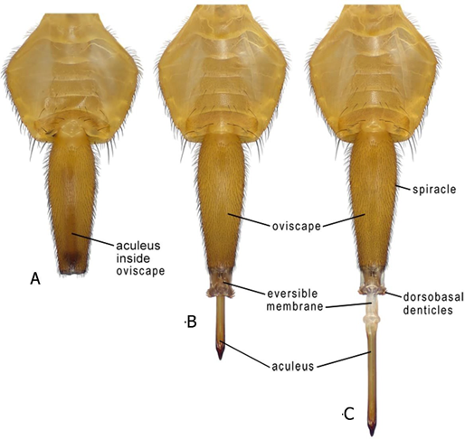
[815]
[816]Figure 1. Ovipositor of adult female of Anastrepha striata in ventral view: (A) aculeus and eversible membrane retracted inside oviscape; (B) aculeus and eversible membrane partially everted; (C) aculeus and eversible membrane completely everted.
[817]Source: Adapted from:
[818]Norrbom, A.L., Korytkowski, C.A., Zucchi, R.A., Uramoto, K., Venable, G.L., McCormick, J. & Dallwitz, M.J. 2012 onwards. Anastrepha and Toxotrypana – Descriptions, illustrations, and interactive keys. Version: 9th April 2019. Delta-intkey.com. Available at https://www.delta-intkey.com/anatox/index.htm
[819]
[820]
[821]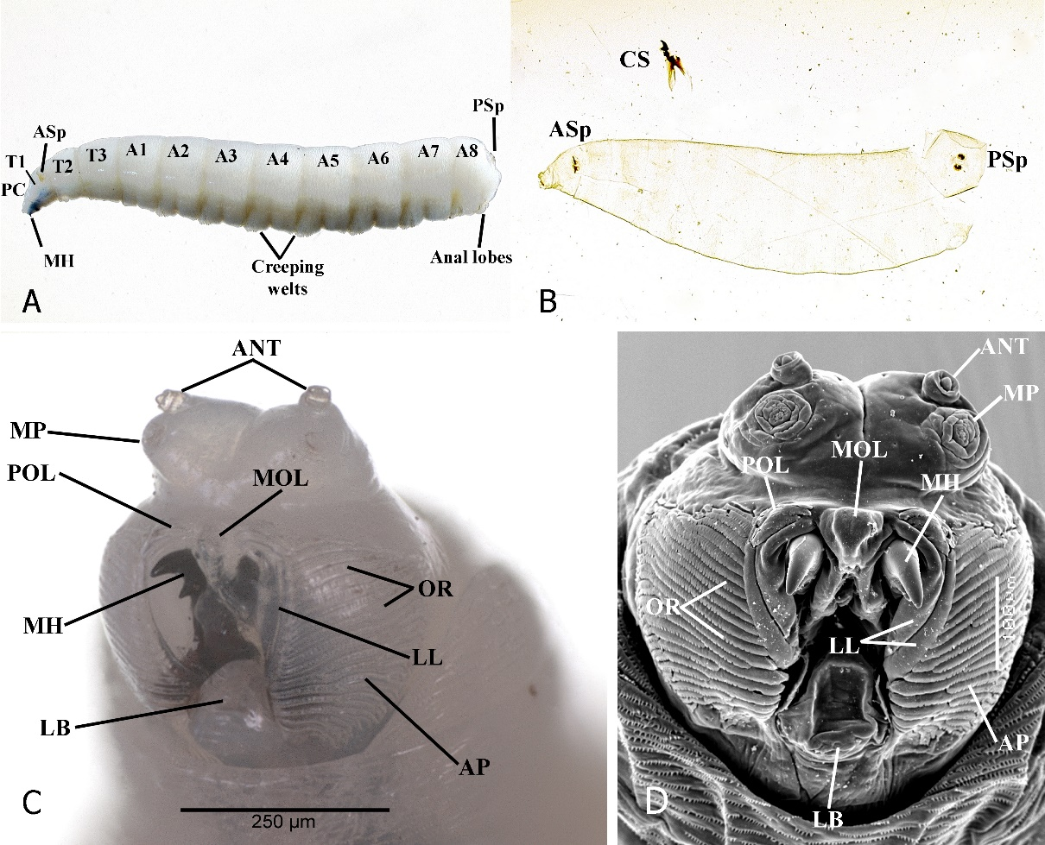
[822]Figure 2. Third instars: (A) habitus showing location of major anatomical features; (B) pseudocephalon, ventrolateral view; (C) slide-mounted larva, cleared cuticle with cephaloskeleton removed; (D) pseudocephalon, ventral view, scanning electron micrograph.
[823]Notes: A1–A8, first to eighth abdominal segments; ANT, antenna; AP, accessory plates; ASp, anterior spiracle; CS, cephaloskeleton; LB, llabium; LL, lateral lips; MH, mouthhook; MP, maxillary palp; PC, pseudocephalon; OR, oral ridges; POL, preoral lobes; PSp, posterior spiracles; sp, spinules; T1–T3, first to third thoracic segments.
[824]Sources: (A–B) J. Diaz and G.J. Steck; (C–D) Steck et al. (2022).
[825]Steck, G.J., Ndlela, S., Somma, L.A., Diaz, J., Moore, M.R. & Awad, J. 2022. Description of the immature stages of Dacus bivittatus (Diptera: Tephritidae), the greater pumpkin fruit fly. Proceedings of the Entomological Society of Washington, 124: 661–682. https://doi.org/10.4289/0013-8797.124.3.661
[826]
[827]
[828]
[829]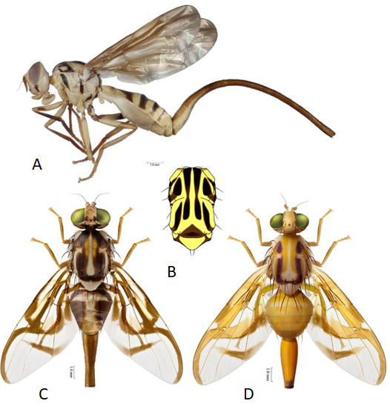
[830]Figure 3. (A) Habitus of adult female of Anastrepha curvicauda (papaya fruit fly) in lateral view. (B) Thorax of adult female of Anastrepha curvicauda in dorsal view. (C) Habitus of adult female of Anastrepha serpentina (sapote fruit fly) in dorsal view. (D) Habitus of adult female of Anastrepha striata (American guava fruit fly) in dorsal view. Note: scale bar 1,0mm.
[831]Source: Adapted from:
[832]Norrbom, A.L., Korytkowski, C.A., Zucchi, R.A., Uramoto, K., Venable, G.L., McCormick, J. & Dallwitz, M.J. 2012 onwards. Anastrepha and Toxotrypana – Descriptions, illustrations, and interactive keys. Version: 9th April 2019. Delta-intkey.com. Available at https://www.delta-intkey.com/anatox/index.htm
[833]
[834]
[835]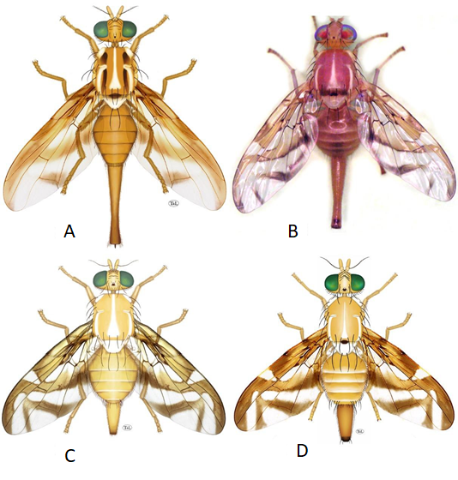
[836]Figure 4. Habitus of adult female in dorsal view: (A) Anastrepha grandis (South American cucurbit fruit fly); (B) Anastrepha ludens (Mexican fruit fly); (C) Anastrepha obliqua (West Indian fruit fly); (D) Anastrepha suspensa (Caribbean fruit fly).
[837]Sources: (A, C, D) adapted from Norrbom et al. (2012); (B) V. Hernández-Ortiz.
[838]Norrbom, A.L., Korytkowski, C.A., Zucchi, R.A., Uramoto, K., Venable, G.L., McCormick, J. & Dallwitz, M.J. 2012 onwards. Anastrepha and Toxotrypana – Descriptions, illustrations, and interactive keys. Version: 9th April 2019. Delta-intkey.com. Available at https://www.delta-intkey.com/anatox/index.htm
[839] 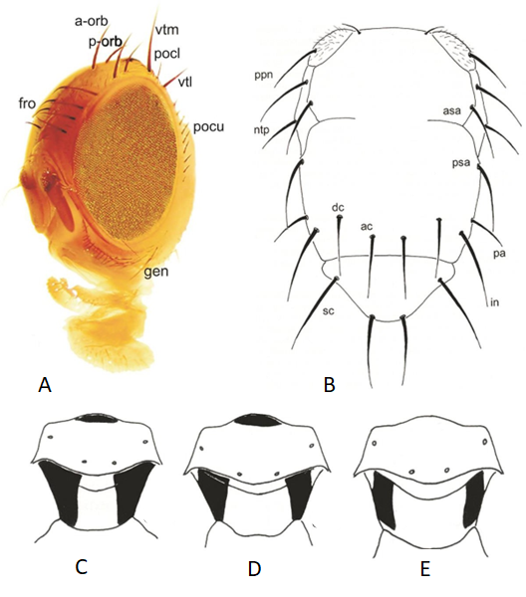
[840]Figure 5. (A) Morphology of head of Anastrepha species in fronto-lateral view. (B) Thorax in dorsal view, showing chaetotaxy. (C–E) Mediotergite and subscutellum, posterior view: (C) A. fraterculus; (D) A. ludens; (E) A. obliqua.
[841]Notes: (A) a-orb, anterior orbital setae; fro, frontal setae; gen, gena; pocl, postocellar setae; pocu, postocular setae; p-orb, posterior orbital seta; vtl, lateral vertical seta; vtm, medial vertical seta. (B) ac, acrostichal seta; asa, presutural supra-alar seta; dc, dorsocentral seta; in, intra-alar seta; ntp, notopleural setae; pa, postalar seta; ppn, postpronotal seta; psa, postsutural supra-alar seta; sc, scutellar setae.
[842]Sources: (A) adapted from Hernández-Ortiz, Guillén-Aguilar and López (2010); (B–E) adapted from Hernández-Ortiz (1992).
[843]Hernández-Ortiz, V. 1992. El género Anastrepha Schiner en México – Taxonomía, distribución y sus plantas huéspedes. Publicación 33. Xalapa, México, Instituto de Ecología. 167 pp.
[844]Hernández-Ortiz, V., Guillén-Aguilar, J. & López, L. 2010. Taxonomía e identificación de moscas de la fruta de importancia económica en América. In: P. Montoya, J. Toledo & E. Hernández, eds. Moscas de la fruta – Fundamentos y procedimientos para su manejo, pp. 49–80. México, D.F., S y G Editores.
[845]
[846]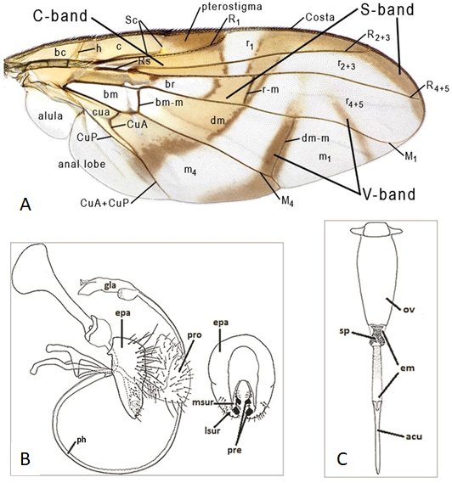
[847]Figure 6. (A) Wing in dorsal view showing general Anastrepha pattern and nomenclature of veins and cells. (B) Male terminalia in Anastrepha species. (C) Female terminalia in Anastrepha species.
[848]Notes: (B) epa, epandrium; gla, glans; lsur, lateral surstylus; msur, medial surstylus; ph, phallus; pre, prensisetae; pro, proctiger. (C) acu, aculeus; em, eversible membrane; ov, oviscape; sp, sclerotized plates.
[849]Sources: (A) adapted from Hernández-Ortiz, Guillén-Aguilar and López (2010); (B–C) adapted from Norrbom et al. (2012).
[850]Hernández-Ortiz, V., Guillén-Aguilar, J. & López, L. 2010. Taxonomía e identificación de moscas de la fruta de importancia económica en América. In: P. Montoya, J. Toledo & E. Hernández, eds. Moscas de la fruta – Fundamentos y procedimientos para su manejo, pp. 49–80. México, D.F., S y G Editores.
[851]Norrbom, A.L., Korytkowski, C.A., Zucchi, R.A., Uramoto, K., Venable, G.L., McCormick, J. & Dallwitz, M.J. 2012 onwards. Anastrepha and Toxotrypana – Descriptions, illustrations, and interactive keys. Version: 9th April 2019. Delta-intkey.com. Available at https://www.delta-intkey.com/anatox/index.htm
[852]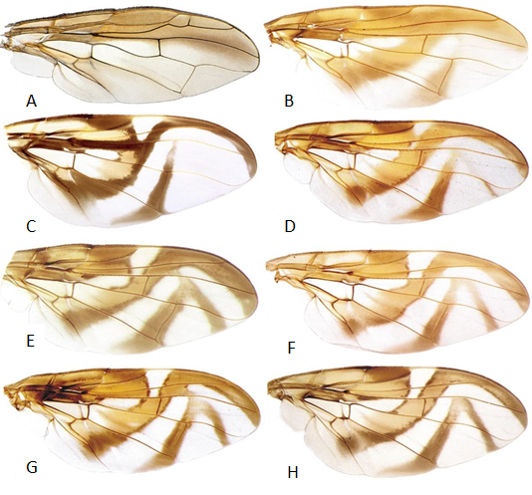
[853]Figure 7. Wing pattern of Anastrepha species: (A) A. curvicauda; (B) A. grandis; (C) A. serpentina; (D) A. striata; (E) A. suspensa; (F) A. ludens; (G) A. obliqua; (H) A. fraterculus (Brazil).
[854]Sources: Adapted from:
[855]Hernández-Ortiz, V., Guillén-Aguilar, J. & López, L. 2010. Taxonomía e identificación de moscas de la fruta de importancia económica en América. In: P. Montoya, J. Toledo & E. Hernández, eds. Moscas de la fruta – Fundamentos y procedimientos para su manejo, pp. 49–80. México, D.F., S y G Editores.
[856]Norrbom, A.L., Korytkowski, C.A., Zucchi, R.A., Uramoto, K., Venable, G.L., McCormick, J. & Dallwitz, M.J. 2012 onwards. Anastrepha and Toxotrypana – Descriptions, illustrations, and interactive keys. Version: 9th April 2019. Delta-intkey.com. Available at https://www.delta-intkey.com/anatox/index.htm
[857]
[858]
[859]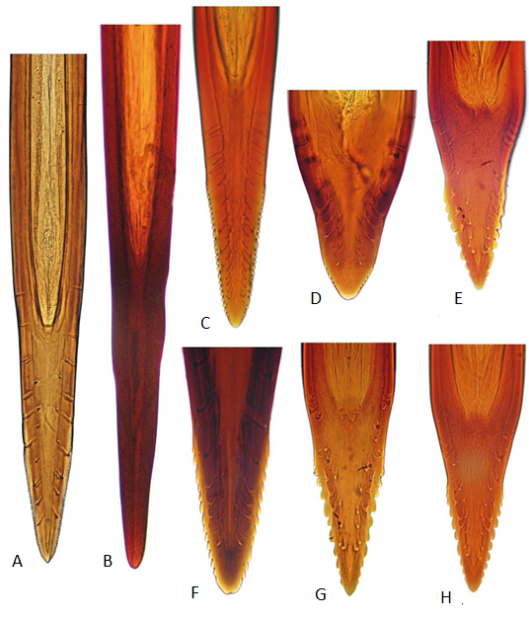
[860]Figure 8. Morphology of the aculeus tip in ventral view of Anastrepha species of major economic importance: (A) A. curvicauda; (B) A. grandis; (C) A. serpentina; (D) A. striata; (E) A. suspensa; (F) A. ludens; (G) A. obliqua; (H) A. fraterculus (Brazil).
[861]Sources: (A) A.L. Norrbom; (B–H) adapted from Hernández-Ortiz, Guillén-Aguilar and López (2010).
[862]Hernández-Ortiz, V., Guillén-Aguilar, J. & López, L. 2010. Taxonomía e identificación de moscas de la fruta de importancia económica en América. In: P. Montoya, J. Toledo & E. Hernández, eds. Moscas de la fruta – Fundamentos y procedimientos para su manejo, pp. 49–80. México, D.F., S y G Editores.
[863]
[864]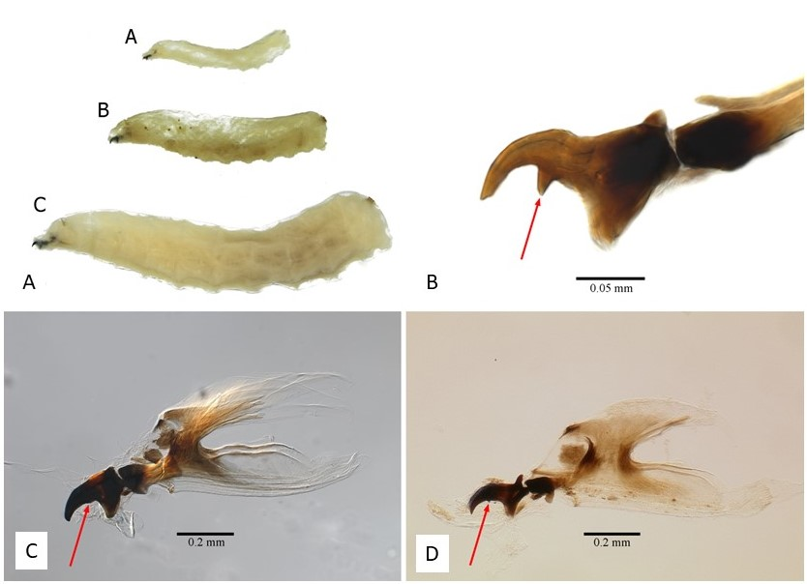
[865]Figure 9. (A) Lateral habitus: (A-A), instar; (A-B), instar; (A-C), instar; of Anastrepha suspensa, showing differences in sizes. (B) Cephaloskeleton of Anastrepha suspensa, second instar; arrow indicates subapical tooth on mouthhook that is subequal in size to apical tooth. (C) Cephaloskeleton of Anastrepha suspensa, third instar; arrow indicates lack of subapical tooth on mouthhook. (D) Cephaloskeleton of Ceratitis fasciventris, third instar; arrow indicates subapical tooth on mouthhook that is much smaller than apical tooth.
[866]Sources: (A–B) D. R. Traficante and G. J. Steck; (C) J. Diaz and G. J. Steck; (D) G.J. Steck.
[867]
[868]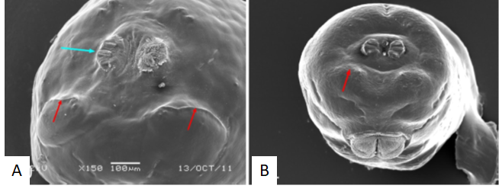
[869]Figure 10. Caudal segment: (A) Ceratitis capitata, caudal ridges present (red arrows), posterior spiracle (blue arrow); (B) Anastrepha distincta, caudal ridges absent (arrow).
[870]Sources: (A) G.J. Steck; (B) L.A. Somma and G.J. Steck.
[871]
[872]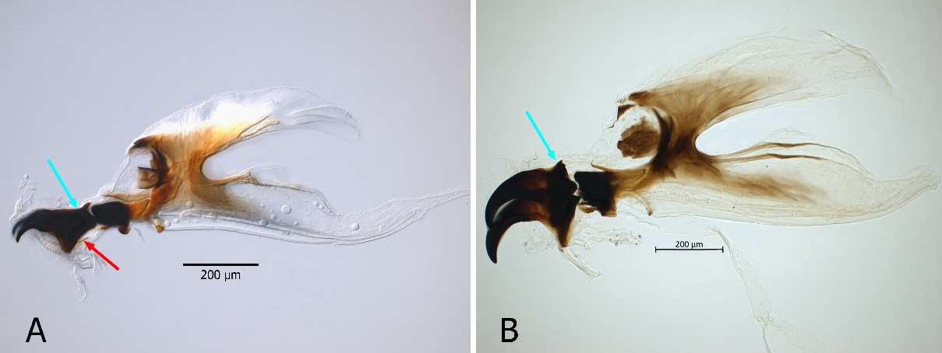
[873]Figure 11. Cephaloskeleton: (A) mouthhook of Ceratitis capitata with elongate posterior neck (blue arrow) and dental sclerite (red arrow); (B) mouthhook of Anastrepha ludens with truncate posterior end and no dental sclerite.
[874]Source: J. Diaz and G.J. Steck.
[875]
[876]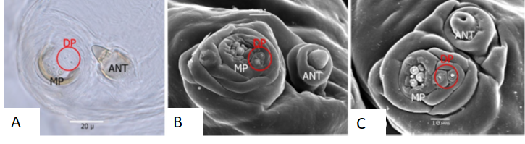
[877]Figure 12. Pseudocephalon sensory structures – antenna, maxillary palpus, dorsolateral pair: (A) dorsolateral pair of sensilla (circled) perpendicular to maxillary palpus, Anastrepha suspensa; (B) dorsolateral pair of sensilla (circled) perpendicular to maxillary palpus, Anastrepha suspensa, SEM; (C) dorsolateral pair of sensilla (circled), parallel to maxillary palpus, Ceratitis capitata, SEM.
[878]Notes: ANT, antenna; DP, dorsolateral pair; MP, maxillary palpus; SEM, scanning electron micrograph.
[879]Sources: (A) D.R. Traficante and G.J. Steck; (B–C) L.A. Somma and G.J. Steck.
[880]
[881]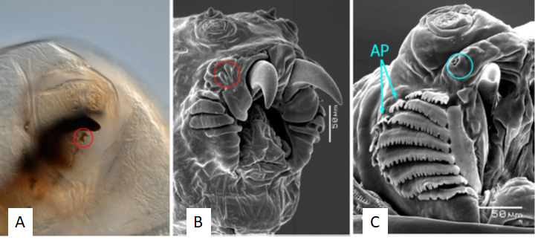
[882]Figure 13. (A) Preoral teeth (circled), Rhagoletis pomonella; (B) preoral teeth (circled), Rhagoletis pomonella, few oral ridges, no accessory plates, SEM; (C) preoral organ lacks preoral teeth (circle), numerous oral ridges and accessory plates, Anastrepha obliqua, SEM.
[883]Notes: AP, accessory plates; SEM, scanning electron micrograph.
[884]Sources: (A) G.J. Steck; (B–C) L.A. Somma and G.J. Steck.
[885]
[886]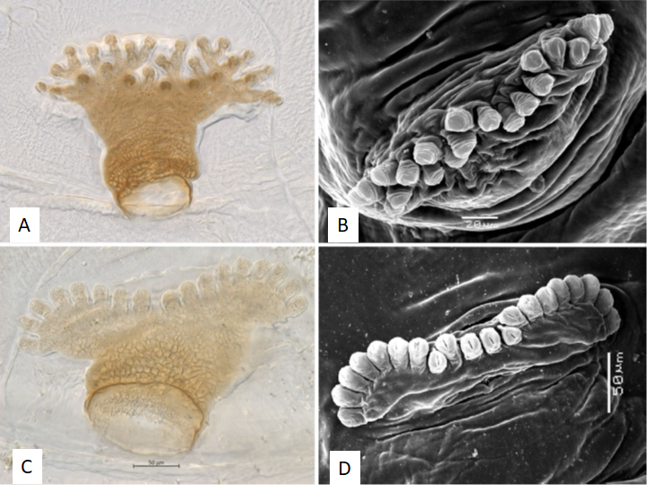
[887]Figure 14. Anterior spiracle: (A) Rhagoletis cingulata; (B) Rhagoletis cingulata, SEM; (C) Anastrepha ludens; (D) Anastrepha ludens, SEM.
[888]Note: SEM, scanning electron micrograph.
[889]Sources: (A, C) J. Diaz and G.J. Steck; (B, D) L.A. Somma and G.J. Steck.
[890]
[891]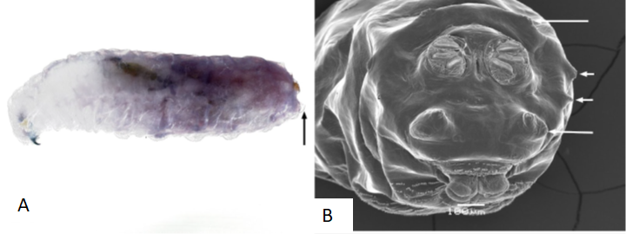
[892]Figure 15. Rhagoletis cingulata: (A) lateral habitus, arrow indicates prominent tubercles on caudal segment; (B) caudal segment, arrows indicate prominent tubercles, scanning electron micrograph.
[893]Sources: (A) G.J. Steck; (B) L.A. Somma and G.J. Steck.
[894]
[895]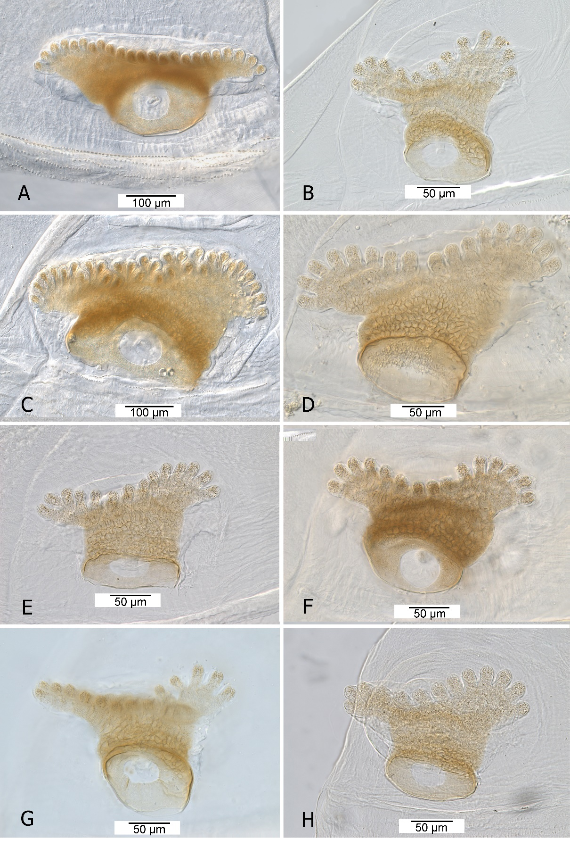
[896]Figure 16. Anterior spiracle: (A) Anastrepha curvicauda; (B) Anastrepha fraterculus; (C) Anastrepha grandis; (D) Anastrepha ludens; (E) Anastrepha obliqua; (F) Anastrepha serpentina; (G) Anastrepha striata; (H) Anastrepha suspensa.
[897]Source: J. Diaz and G.J. Steck.
[898]
[899]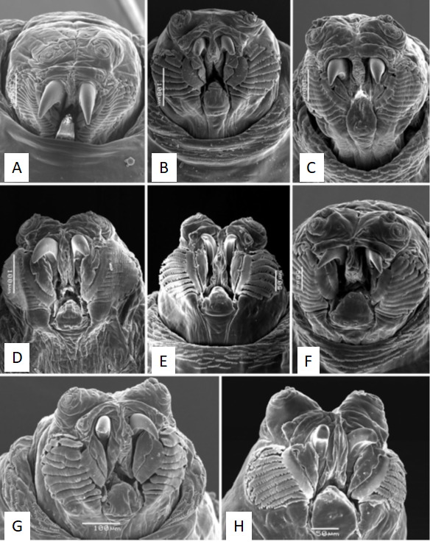
[900]Figure 17. Facial mask: (A) Anastrepha curvicauda; (B) Anastrepha fraterculus; (C) Anastrepha grandis; (D) Anastrepha ludens; (E) Anastrepha obliqua; (F) Anastrepha serpentina; (G) Anastrepha striata; (H) Anastrepha suspensa.
[901]Sources: (A, C–H) L.A. Somma and G.J. Steck; (B) G.J. Steck.
[902]
[903]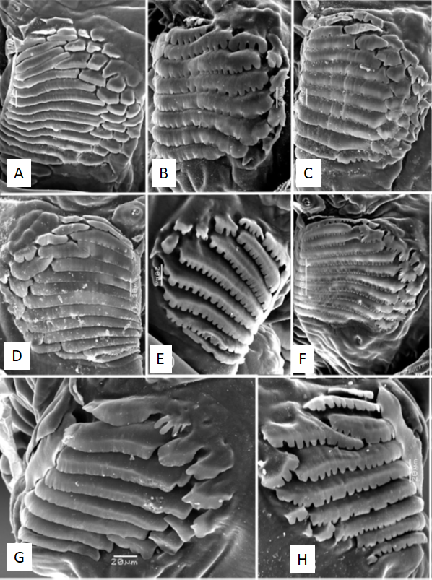
[904]Figure 18. Oral ridges and accessory plates: (A) Anastrepha curvicauda; (B) Anastrepha fraterculus; (C) Anastrepha grandis; (D) Anastrepha ludens; (E) Anastrepha obliqua; (F) Anastrepha serpentina; (G) Anastrepha striata; (H) Anastrepha suspensa.
[905]Source: L.A. Somma and G.J. Steck.
[906]
[907]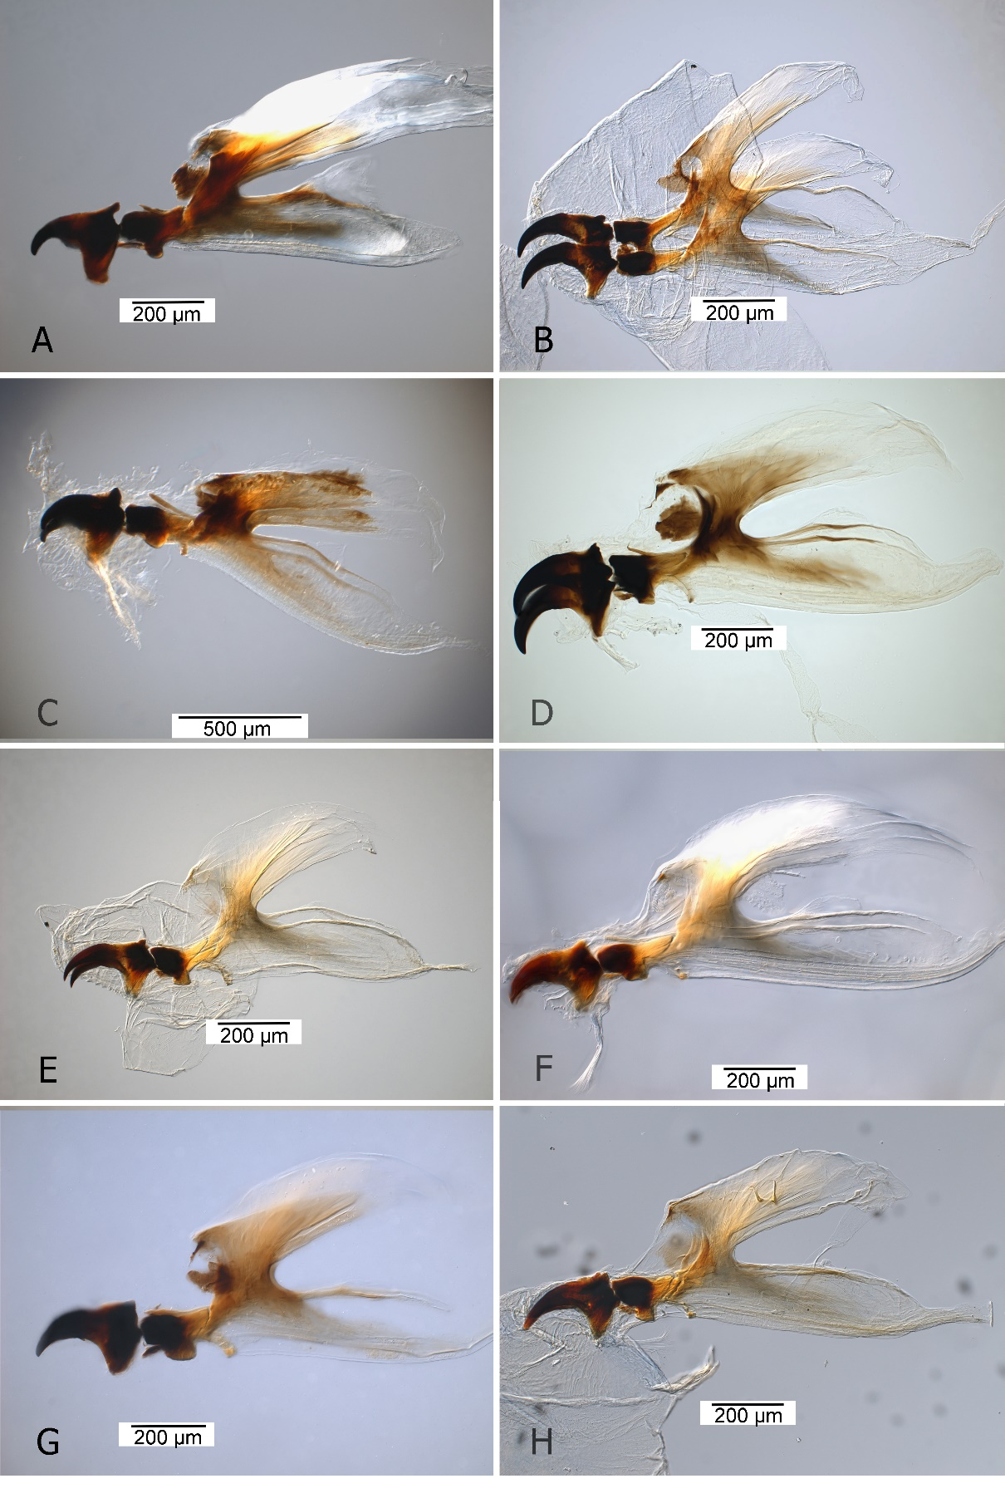
[908]Figure 19. Cephaloskeleton: (A) Anastrepha curvicauda; (B) Anastrepha fraterculus; (C) Anastrepha grandis; (D) Anastrepha ludens; (E) Anastrepha obliqua; (F) Anastrepha serpentina; (G) Anastrepha striata; (H) Anastrepha suspensa.
[909]Sources: (A, G) D.R. Traficante and G.J. Steck; (B–F, H) J. Diaz and G.J. Steck.
[910]
[911]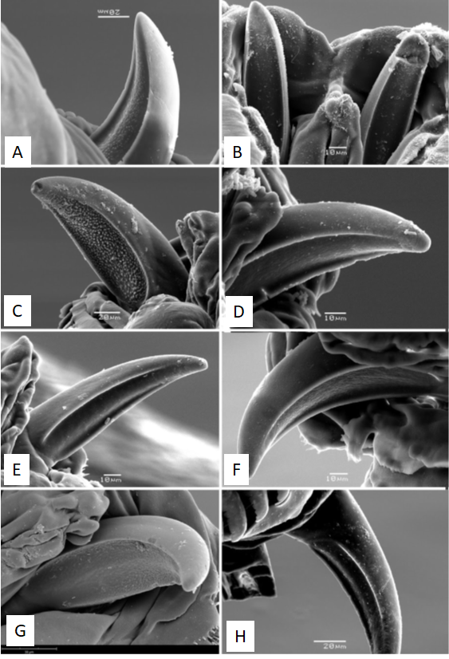
[912]Figure 20. Mouthhook ventral surface: (A) Anastrepha curvicauda; (B) Anastrepha fraterculus; (C) Anastrepha grandis; (D) Anastrepha ludens; (E) Anastrepha obliqua; (F) Anastrepha serpentina; (G) Anastrepha striata; (H) Anastrepha suspensa.
[913]Source: L.A. Somma and G.J. Steck.
[914]
[915]
[916]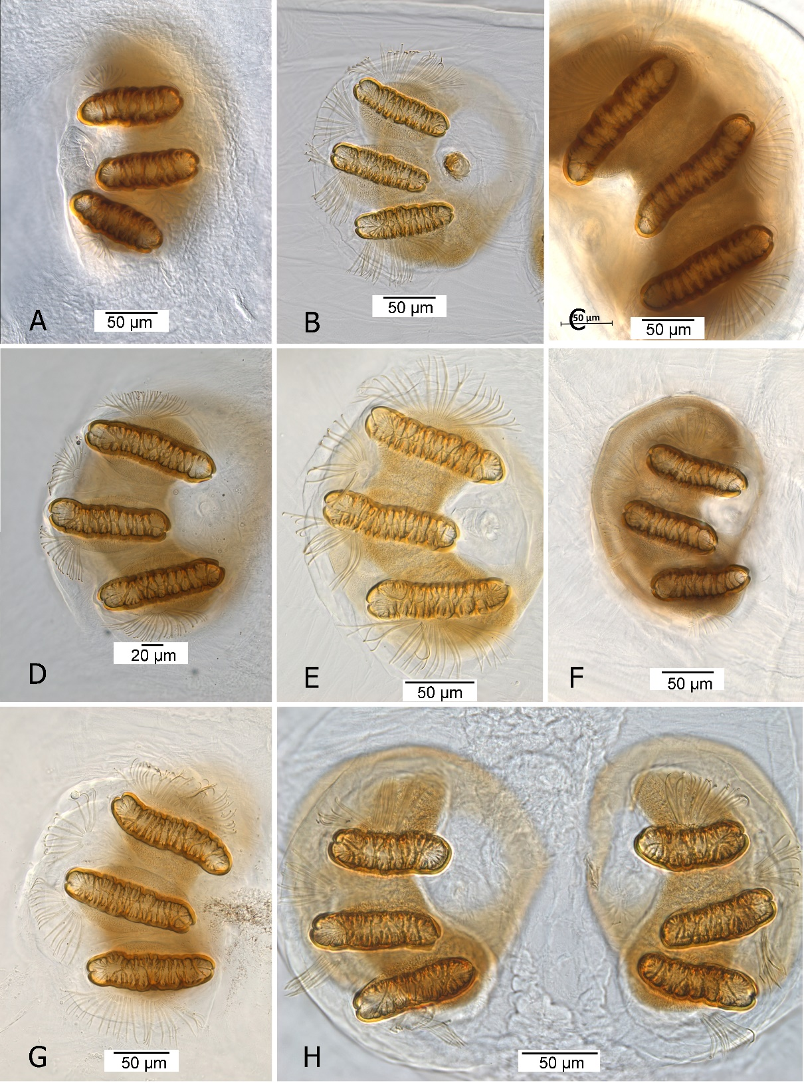
[917]Figure 21. Posterior spiracle: (A) Anastrepha curvicauda; (B) Anastrepha fraterculus; (C) Anastrepha grandis; (D) Anastrepha ludens; (E) Anastrepha obliqua; (F) Anastrepha serpentina; 50VAnastrepha striata; (H) Anastrepha suspensa.
[918]Source: J. Diaz and G.J. Steck.
[919]
[920]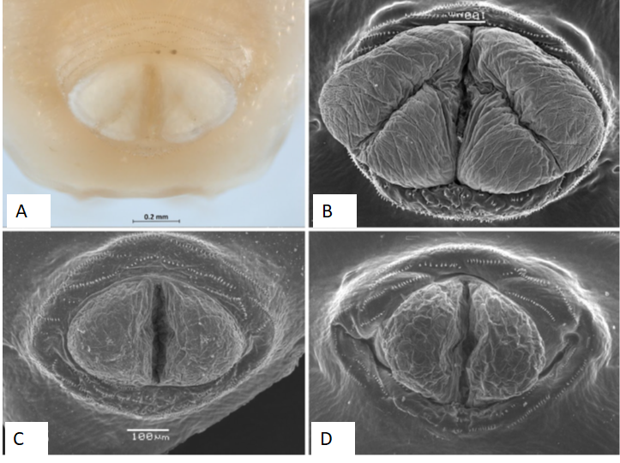
[921]Figure 22. Anal lobes: (A) grooved, unequal lobes, Anastrepha grandis; (B) grooved, unequal lobes, Anastrepha grandis, SEM; (C) entire, Anastrepha fraterculus, SEM; (D) entire, Anastrepha obliqua, SEM.
[922]Note: SEM, scanning electron micrograph.
[923]Sources: (A) J. Diaz and G.J. Steck; (B–D) L.A. Somma and G.J. Steck.
[924]
[925]
[926]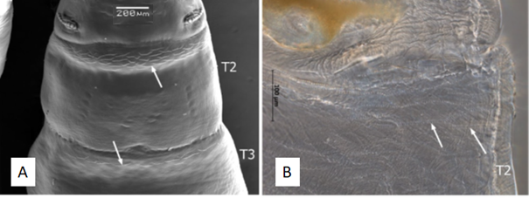
[927]Figure 23. Dorsal spinules (arrows): (A) present on T2 and T3, Anastrepha suspensa, scanning electron micrograph; (B) as seen under compound microscope, Anastrepha ludens.
[928]Sources: (A) L.A. Somma and G.J. Steck; (B) J. Diaz and G.J. Steck.
[929]
[930]
[931]
[932]
[933]Potential implementation issues
[934]This section is not part of the standard. The Standards Committee in May 2016 requested the Secretariat to gather information on any potential implementation issues related to this draft. Please provide details and proposals on how to address these potential implementation issues.
[935]

