[PleaseReview document review. Review title: 2023 First consultation: Draft CPM Recommendation: CPM Recommendation on sea containers . Document title: CPM_Recommendation_Sea_Containers_En.docx]

[1]Draft CPM Recommendation on minimizing pest risk associated with sea container pathway

[2]Status box
[3]This is not an official part of the CPM recommendation and it will be modified by the IPPC Secretariat after adoption.
[4]Date of this document | [5]2023-01-12
[6]Document category | [7]Draft revision of CPM Recommendation R-06
[8]Current document stage | [9]To CPM-17 (2023) for approval for consultation
[10]Major stages | [11]2022-04 CPM-16 (2022) requested the CPM Recommendation on Sea containers (R-06), originally adopted in 2017, should be retained and revised, either as an interim approach prior to the development of an ISPM, or as a final approach.  [12]2022 CPM Focus Group on Sea Containers revised the CPM Recommendation R-06
[13]Notes | [14]Due to extensive revisions to CPM Recommendation R-06, this draft is not presented in track changes.  [15]This is a draft document
[16]

[17]PURPOSE
[18]It is evident that the international movement of contaminated sea containers is a factor in the spread of pests. Therefore, the contamination of all containers whether empty or packed should be avoided.

[19]INTENT OF THIS RECOMMENDATION
[20]This recommendation is provided in order to:
- [21]Communicate the plant health risks related to the movement of sea containers and their cargoes
- [22]Confirm the IPPC CPM’s intent to develop long term guidance on this matter and to recommend related activities during the interim period
- [23]Describe the types of contamination of concern to stakeholders and the IPPC community and common methods for their removal
- [24]Encourage the wide spread use of containers with steel floors to replace those that have wooden floors which provide an environment conducive to certain types of contamination and makes it difficult to detect and remove them
- [25]Seek input from the IPPC community and other stakeholders on effective measures to reduce contamination and risks presented by the sea container pathway, and related information
- [26]Communicate the next steps for IPPC community activities on sea containers to stakeholders

[27]BACKGROUND: RISKS AND IMPLICATIONS FOR THE INTERNATIONAL SEA CONTAINER PATHWAY
[28]As this CPM Recommendation is expected to serve as interim guidance, and since the related work on developing longer-term guidance continues to evolve, it was felt important to include contextual information to accompany the key recommendations. Therefore, this CPM Recommendation includes contextual information regarding the background to plant health risks and the international sea container pathway, identification of shared responsibilities for stakeholders, a description of the types of risk presented by sea containers moving in international trade and related contamination of concern, the need for collaboration with the World Organization for Animal Health, and information on planned next steps for work on sea containers being conducted under the direction of the CPM.
[29]There is international consensus among competent authorities that the international movement of sea containers and their cargoes can potentially facilitate the introduction and spread of pests that can pose a serious risk to agriculture, forestry and natural resources.
[33]Plant health risks presented by the sea container pathway currently represent a significant challenge for the International Plant Protection Convention (IPPC) community. At the same time, the performance of the global economy, and all national economies, depend on the efficient movement of containers to ensure the predictable and effective functioning of supply chains. In addition, the number and range of stakeholders involved is extremely diverse, and the pathway itself is mostly a non-plant pathway, thus involving other responsible authorities in addition to the NPPOs. In this context, the IPPC’s CPM is working to develop guidance to reduce the plant health risks related to containers and their cargoes with associated decisions expected to be taken in 2023 and 2024.
[34]Container logistics operations are extremely complex, sensitive to impediments to movements, and positioning of containers. Even small delays in their movement can result in broader and potentially costly ramifications for international supply chains. The balance between the necessity for phytosanitary actions and minimizing impact on supply chains must be carefully respected when developing approaches to reduce pest risks associated with the sea container pathway.
[35]Given this situation, the IPPC community and stakeholders should support implementation of aligned science- and risk-based measures.
[36]It should also be recognised that complete elimination of the risks posed by the sea container pathway is not feasible; therefore, risk reduction should be the objective of recommended activities and guidance.
[37]The scope of the IPPC covers measures for the control of plant pests (and related regulated articles/pathways) only, and plant pests are therefore the focus of this recommendation. However, it is recognized that actions that improve container and cargo cleanliness that are effective against plant pests may also contribute to reducing the risk of contamination by other organisms and contaminants that are not of phytosanitary concern. Therefore, the IPPC’s work on the sea container pathway may be of interest to other standard-setting bodies.

[38]SHARED RESPONSIBILITIES
[39]The IPPC community, and other government and industry stakeholders, have a role to play in reducing the risks of pest contamination of sea containers and their cargoes. However, it is noted that the legal basis for managing plant health risks through sea containers pathway will vary among different countries and NPPOs.
[40]All parties involved in international container supply chains should employ practices to reduce the risk of pest contamination while the container is in their control. This recommendation provides a set of practices, that, when implemented, may reduce the presence of contamination in containers and their cargoes. Any such practices should be conducted in accordance with the parties’ roles and responsibilities in the supply chain and should take into consideration all relevant safety and operational constraints.

[41]RISKS RELATED TO EMPTY CONTAINERS
[42]Empty containers are frequently exported and can also be contaminated by pests. A main contributor to such contamination is incomplete unpacking and cleaning. Therefore, it is necessary that consignees completely unpack and clean containers prior to next usage or vessel loading. Container depots also have a particularly important role as they often act as the start and end points for empty containers. Inspection and, when required, cleaning of any contamination of an empty container done at a container depot may cause the least interruption of container logistics.

[43]RISKS INFLUENCED BY TYPE OF CARGO
[44]The nature of the cargo transported in sea containers can contribute to the pest risks. In addition, the handling and storage of commodities prior to and during packing can result in contamination of sea containers. Packing is the most likely stage for contamination of sea containers. Essentially, risks related to cargo should be considered up to and including the packing stage. This includes the time spent in the area where packing occurs. This is because all types of cargoes, irrespective of whether they are plant or non-plant products (e.g. car parts, pipes, tires,), or their method of handling and storage, may be a source of potential pest contamination (e.g. weed seeds, plant parts, soil, insects, standing water) of containers.

[45]DESCRIPTION OF PEST CONTAMINATION
[46]Since this recommendation is intended for all parties involved in container supply chains, the recommendation makes reference to terms familiar both to the IPPC community and all stakeholders.
[47]Contamination is described in the International Standard for Phytosanitary Measures (ISPM) 5, Glossary of phytosanitary terms, as: Presence of a contaminating pest or unintended presence of a regulated article in or on a commodity, packaging, conveyance, container or storage place [CEPM, 1997; revised ICPM, 1999; CPM, 2018].
[48]Contamination is described in the Cargo Transport Unit (CTU) code as: Visible forms of animals, insects or other invertebrates (alive or dead, in any lifecycle stage, including egg casings or rafts), or any organic material of animal origin (including blood, bones, hair, flesh, secretions, excretions); viable or non-viable plants or plant products (including fruit, seeds, leaves, twigs, roots, bark); or other organic material, including fungi; or soil, or water; where such products are not the manifested cargo within the CTU.
[50]The CTU code also describes a clean CTU including containers as follows: A CTU free from:
- [51]Any previous cargo residues;
- [52]Any securing materials used from previous consignments;
- [53]Any marks, placards or signs associated with previous consignments;
- [54]Any detritus (waste) that may have accumulated in the CTU;
- [55]Visible pests and other living or dead organisms, including any part, gametes, seeds, eggs or propagules of such species that may survive and subsequently reproduce; soil; organic matter;
- [56]All other items covered by contamination, infestation and invasive alien species that can be discovered upon visible inspection.
[57]As the IPPC definition of a pest covers “any species, strain or biotype of plant, animal or pathogenic agent injurious to plants or plant products”, the definition of contamination in the CTU code thus has a broader meaning while it is focused inside the container and misses the “in or on” component of the ISPM 5 definition that points to internal and external cleanliness. However, an approach aimed at cleanliness will provide an effective level of risk reduction towards all visible contamination, irrespective of its exact nature.

[58]RECOMMENDATION: REDUCING THE RISK OF CONTAMINATION OF SEA CONTAINERS AND THEIR CARGOES
[59]The IPPC encourages all parties involved in the container supply chains to ensure that they exercise due diligence when executing their custodial responsibility to verify that containers are free of visible pest contamination before they are transferred into the custody of the next responsible party in the chain.
[60]Parties having custodial responsibilities include but are not limited to: container depots, consignors, shippers, packers, transportation service providers, consignees, and terminals.
[61]All parties involved in container supply chains should ensure that appropriate steps are taken to prevent contamination of containers and their cargoes. This may involve actions such as handling, locating and storing containers and cargoes in accordance with any available best practices to avoid contamination from pest habitats or pest populations (the distance will depend on the pest). Such best practices may include:
- [62]storage in areas free of risks from contamination by vegetation, soil and free standing water.(e.g. the use of fully paved/sealed storage and handling areas; and,
- [63]storage in areas away from contaminated containers and cargoes. Other measures might be applied in specific situations to reduce the attraction of pests (such as when using artificial lights), or during seasonal periods of pest presence and in case of ongoing pest outbreaks.

[65]RECOMMENDATION: VISUAL EXAMINATION FOR CONTAMINATION OF SEA CONTAINERS AND THEIR CARGOES
[66]Where accessible, the interior and exterior of all six sides of sea containers, i.e. the roof, underside, side walls and end walls, including doors), and their cargoes should be visually examined by all relevant parties as described in the IPPC Sea Containers Surveys Guidelines for National Plant Protection Organizations (NPPOs). for potential contamination. The exterior and interior of empty containers should also be inspected for contamination before dispatch, before packing and after unpacking.(see also appendix 1 of this recommendation) In addition, for refrigerated containers, the ventilation inlet grilles and floor drain holes should be inspected.
[68]More detailed information on areas where contamination may often be found as well as guidance on how to undertake sea container inspections in a safe manner, including of the underside and roof of the sea container, is provided in the aforementioned IPPC Sea Containers Surveys Guidelines for National Plant Protection Organizations (NPPOs).

[69]RECOMMENDATION: METHODS TO REMOVE CONTAMINATION
[70]If contamination is found, methods to remove debris and contaminants such as soil, plant parts or organisms may include:
- [71]Sweeping or vacuum cleaning the interior of the sea container
- [72]Use of leaf blowers
- [73]Washing, scraping or other physical means to clean the interior or exterior of the sea container
- [74]Using high pressure washers
- [75]Removal of contaminants from ventilation inlet grilles and floor drain holes
[76]Consideration should be given to the safe and secure disposal of contaminant material to prevent further distribution of the contaminants. For example when using leaf blowers and pressure washers care should be taken in order not to distribute any contaminants throughout the area or distribute environmental hazards in water supplies, etc.
[77]Under certain circumstance, treatments may be necessary to neutralize contamination. NPPOs or other authorities may have requirements and guidance in place on the use of treatments.
[78]Recipients of sea containers and their cargoes that have moved internationally should seek guidance on appropriate risk management actions and disposal of contamination, including wash water, from their respective National Plant Protection Organization if contamination is detected on or in imported containers, including empty containers.
[79]Methods for the safe disposal of contamination should be sufficient to prevent spread of pests and may include:
- [80]bagging
- [81]incineration
- [82]deep burial
- [83]containment
- [84]freezing

[85]RECOMMENDATION: CONTAINER STRUCTURE
[86]It is acknowledged that the introduction of modifications to the existing container design across the global container fleet may take significant time. However, evidence shows eliminating the use of wooden flooring in containers reduces the risk of contamination. The IPPC’s CPM therefore encourages the container industry in cooperation with container manufacturers to consider ways to facilitate the more widespread usage of steel floors, including introducing sea containers with metal floors as part of the normal container lifecycle and replacement timeframes/frequency.
[87]Consideration of other modifications to existing container design, e.g., the undercarriage and vents, may contribute further to risk reduction. More research into these possibilities is encouraged and would be facilitated by the availability of information from the NPPOs regarding areas of containers where contamination are most commonly found.
[88]Currently, existing container coatings cannot be easily modified in order for them to reduce pest contamination. More research in this area is also encouraged, as is consideration of replacing current bitumastic undercarriage coating to reduce the “stickiness” and thus adhesion of pests and contaminants.

[89]RECOMMENDATION: INPUT FOR EFFECTIVE MEASURES AND BEST PRACTICES
[90]CPM 18 in 2024 is expected to take key decisions on longer-term guidance on minimizing the risks associated with the international sea container pathway and the Focus Group on Sea Containers is working in the interim to develop recommendations for such prospective guidance. As such, proposals for industry- or government-led solutions that would contribute to risk management, and suggestions for practicable measures and activities that may be effective if widely adopted, would be welcomed by the Focus Group on Sea Containers. In addition, information on emerging technologies that may assist with pest risk management would be of value for the Focus Group’s considerations.
[91]NPPOs should work with relevant stakeholders and to continue to gather information on pest presence and their risks of movement via the sea container pathway and to provide this information to the IPPC Secretariat. An important tool for such data collection is the usage of the template in the IPPC guidelines for sea containers survey.
[93]Any information on these points should be submitted to the IPPC Secretariat [e-mail address ippc@fao.org and/or website: www.ippc.int].

[94]RECOMMENDATION: RAISING AWARENESS
[95]NPPOs should inform relevant stakeholders of any plant health import requirements that may apply to containers that move internationally.
[96]NPPOs should:
- [97]promote practices that prevent contamination of sea containers and their cargoes and manage related risks;
- [98]communicate information about the risk of pest movement associated with the sea container pathway to all parties involved in the operation of container supply chains regarding risks; and
- [99]promote and support inclusion of appropriate procedures for cleaning of the interior and exterior of sea containers in relevant industry guidelines by incorporating the IPPC guidelines on container cleanliness.

[100]RECOMMENDATION: COLLABORATION WITH WORLD ORGANIZATION FOR ANIMAL HEALTH
[101]Recognizing that pest contamination via the sea container pathway may convey risks to both plant and animal health, and in the interest of avoiding the development of duplicating or conflicting measures, the IPPC Secretariat is requested to engage with World Organization for Animal Health (WOAH) to ensure coordination of related work in both organizations.
[102]

[103]Next steps for the development of IPPC guidance on sea containers and their cargoes (Note that this section will not appear in the finally adopted recommendation but is presented to accompany the draft only, during consultations)
[104]The Focus Group on Sea Containers is working to develop guidance to deliver to the 18h Commission on Phytosanitary Measures (CPM-18) in 2024. It is expected that CPM-18 will take key decisions on the potential development of long-term IPPC guidance on sea containers at that meeting.
[105]In order to prepare the Focus Group’s proposals for CPM-18, the Focus Group will hold meetings throughout the remainder of 2023 and will consider all information gathered further to the above recommendations.
[106]An important part of developing robust proposals for CPM-18 will be engagement with public and private sector stakeholders in order to further communicate and consult on the risks and needs to mitigate these by involvement of stakeholders and the practicability of any proposals. This will ensure that they will be effective in reducing plant health risks related to the movement of sea containers while minimizing any negative impacts on related logistics operations and supply chains. With these objectives in mind, it is expected that a three- day sea containers workshop will be held in Brisbane, Australia in July 2023. All stakeholders are encouraged to participate in this workshop.
[107]
[108]
[113]Appendix 1 - (in English only)
[114]
[115]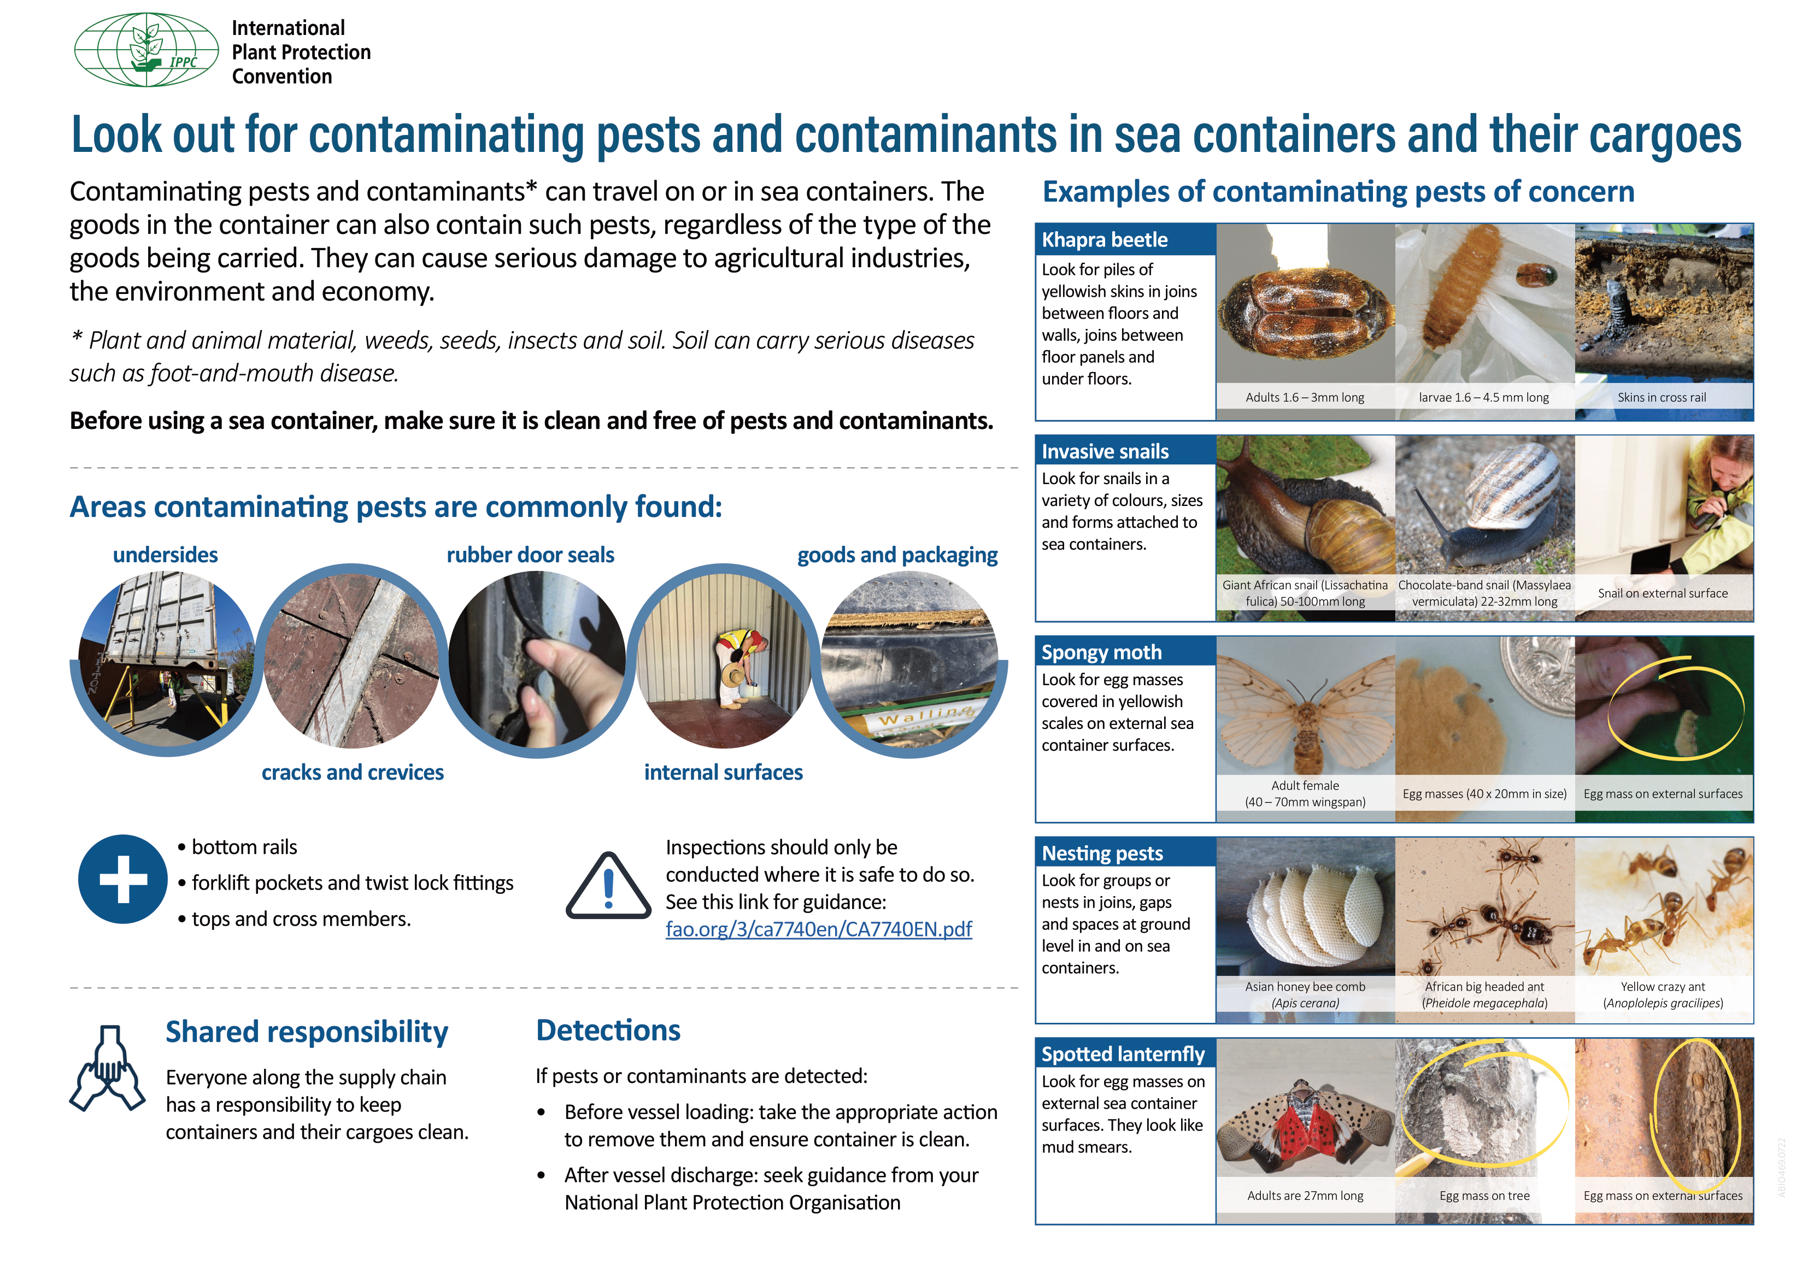

[30] The term “sea containers” means multimodal steel containers as defined in the CTU Code (which in turn aligns with the definition in the International Maritime Dangerous Goods (IMDG) Code): [31]“An article of transport equipment that is of a permanent character and accordingly strong enough to be suitable for repeated use; specially designed to facilitate the transport of goods, by one or other modes of transport, without intermediate reloading: designed to be secured and/or readily handled, having fittings for these purposes, and approved in accordance with the International Convention for Safe Containers (CSC), 1972, as amended.” [32]The term “sea container” does not include the carrying vehicles, carrying conveyances or packaging. It includes, however, all containers transported internationally by sea, road and rail. The term includes empty and packed containers.
[49] The CTU Code and related material may be accessed at: IMO/ILO/UNECE Code of Practice for Packing of Cargo Transport Units (CTU Code)
[64]IPPC best practice guide on measures to minimize pest contamination entitled "Sea Container Supply Chains and Cleanliness": https://www.fao.org/documents/card/en/c/ca7963en
[67] https://www.fao.org/3/ca7740en/CA7740EN.pdf
[92] https://www.ippc.int/en/publications/87069/

