[PleaseReview document review. Review title: DRAFT ANNEX TO ISPM 27: Heterobasidion annosum sensu lato (2021-015). Document title: 2021-015_DP_Heterobasidion.docx]
[1]DRAFT ANNEX TO ISPM 27: Heterobasidion annosum sensu lato (2021-015)
[2]
[3]Status box
[4]This is not an official part of the standard and will be modified after adoption.
[5]Date of this document | [6]2024-01-26
[7]Document category | [8]Draft new annex to ISPM 27 (Diagnostic protocols for regulated pests)
[9]Current document stage | [10]To consultation
[11]Origin | [12]Work programme topic: Fungi and fungus-like organisms (2006-006)  [13]Original subject: Heterobasidion annosum sensu lato (2021-015)
[14]Major stages | [15]2021-08 Subject proposed during 2021 IPPC call for topics.  [16]2021-11 Standards Committee (SC) added subject Heterobasidion annosum (2021-015) to work programme, priority 3.  [17]2023-04 Expert consultation.  [18]2023-11 Technical Panel on Diagnostic Protocols revised and approved for consultation.  [19]2024-01 SC approved for consultation via e-decision (2024_eSC_May_02)
[20]Discipline leads history | [21]2022-04 Yazmin RIVERA (US, Discipline Lead)  [22]2022-04 Robert TAYLOR (NZ, Referee)
[23]Consultation on technical level | [24]The first draft of this diagnostic protocol was prepared by:  - [25]Luana GIORDANO (IT, lead author)  - [26]Eeva J. VAINIO (FI)
[27]Main discussion points during development of the diagnostic protocol  [28][to be updated throughout DP development] | [29]2023-04 Title amended by drafting group to add “sensu lato”.  [30]
[31]Notes | [32]This is a draft document.  [33]Edited 2023-06  [34]Edited 2023-12
[35]
[36]Contents
[37][to be added later]
[38]Adoption
[39]This diagnostic protocol was adopted by the Standards Committee on behalf of the Commission on Phytosanitary Measures in ----. [to be completed after adoption].
[40]The annex is a prescriptive part of ISPM 27 (Diagnostic protocols for regulated pests).
[41]

[42]
1. Pest information
[43]Heterobasidion annosum sensu lato (s.l.) (Fr.) Bref., 1888 is a complex of species (also referred to as the H. annosum complex) that includes the most common and destructive fungal pathogens of conifers causing root and butt rots. They are widely distributed in the coniferous forests of the northern hemisphere (Korhonen et al., 1998; Dai et al., 2003; Worrall et al., 2010). H. annosum s.l. is a major concern especially in intensively managed forests, where the decrease in wood production and the reduction in wood quality caused by the pathogens can result in high economic losses.
[44]The fungus had long been regarded as a single species until mating experiments revealed the occurrence of intersterile groups within H. annosum s.l. (Korhonen, 1978; Chase and Ullrich, 1988; Capretti et al., 1990). A formal description was published for each intersterile group, with the species being named according to their host preferences. Five phytopathogenic species are therefore currently included within H. annosum s.l.: H. abietinum Niemelä & Korhonen, 1998, H. annosum (Fr.) Bref., 1888 sensu stricto (s.s.), H. irregulare Garbel. & Otrosina, 2010, H. occidentale Otrosina & Garbel., 2010 and H. parviporum Niemelä & Korhonen, 1998. They are characterized based on their geographical origin, host preference, morphology, and biochemical, phylogenetic and genomic traits (Otrosina et al., 1993; Linzer et al., 2008; Dalman, Olson and Stenlid, 2010; Garbelotto and Gonthier, 2013; Chen et al., 2015; Sillo et al., 2015; Yuan et al., 2021). An additional species, H. subparviporum Y.C. Dai, Jia J. Chen & Yuan Yuan, 2021, seems to be a saprotroph (Yuan et al., 2021).
[45]Three of the phytopathogenic species – H. abietinum, H. annosum s.s. and H. parviporum (Niemelä and Korhonen, 1998) – occur in some countries in Europe and Asia, mainly associated with Abies alba, Pinus spp., and Picea abies, respectively (Garbelotto and Gonthier, 2013). Depending on tree species composition and structure, these three species of Heterobasidion can coexist in the same conifer stand (e.g. Gonthier, Garbelotto and Nicolotti, 2003). The remaining two species occur in North America: H. occidentale (Otrosina and Garbelotto, 2010), associated with Picea spp., Tsuga spp., Pseudotsuga spp. and Sequoiadendron spp., and H. irregulare, mainly associated with Pinus spp., Juniperus spp., Calocedrus decurrens and Abies spp. A table describing the susceptibility of some tree species to H. annosum s.l. species and the main host tissue colonized is available in Garbelotto and Gonthier (2013).
[46]One exception to the geographical distribution described above is that the current distribution of H. irregulare also includes approximately 100 km of land along the Tyrrhenian coast around Rome (Italy). This is a relatively recently discovered example of a biological invasion that occurred after the accidental introduction of this North American species into central Italy during the Second World War (Gonthier et al., 2004). H. irregulare is now associated with significant mortality of Pinus pinea, in monocultural pine stands, in mixed oak–pine natural forests and in urban parks (Gonthier et al., 2007, 2014). In September 2015, H. irregulare was included in the A2 list of pests recommended for regulation by the European and Mediterranean Plant Protection Organization (EPPO). More information about H. irregulare is available in the EPPO Global Database (EPPO, n.d.(a)).
[47]Although Heterobasidion species are characterized by partial interfertility in laboratory experiments, hybrids between the two sympatric North American species, H. irregulare and H. occidentale, have rarely been found in North America (Garbelotto et al., 1996; Lockman et al., 2014). Nevertheless, high hybridization rates have been observed between the two naturally allopatric species, H. annosum s.s. and H. irregulare, in Italian coastal pine woodlands (Gonthier et al., 2007).
[48]Species of H. annosum s.l. have a varied infection biology (Rishbeth, 1950, 1951a, 1951b). Airborne propagules (mostly basidiospores) infect freshly exposed wood surfaces, such as stump tops or stem and root wounds (primary infection). Once established, the fungus may spread vegetatively via root contacts and grafts (secondary infection) (Stenlid and Redfern, 1998).
[49]H. annosum s.l. commonly develops fruiting bodies producing basidiospores at ground level, at the base of stumps or dead trees, or inside the internal cavities of old decayed stumps. H. annosum s.l. also produces conidia developing from conidiophores; however, they play an active role only in short-distance dispersal of the fungus (Redfern and Stenlid, 1998) or when accidentally carried by root-feeding insects (Kadlec, Starý and Zumr, 1992). The asexual stage (also referred to as the anamorph) of H. annosum s.l. was formerly referred to as Spiniger meineckellus.
[50]For more general information about H. annosum s.l. (Heterobasidion root rot), see the CABI Compendium (CABI, n.d.). Information on its distribution, updated regularly, is available in the EPPO Global Database (EPPO, n.d.(b)).

[51]2. Taxonomic information
[52]The species complex H. annosum s.l. comprises five phytopathogenic species (Chen et al., 2015; Yuan et al., 2021) responsible for severe economic and environmental losses (Garbelotto and Gonthier, 2013): H. abietinum, H. annosum s.s., H. irregulare, H. occidentale and H. parviporum. H. subparviporum seems to be a saprotroph (Yuan et al., 2021).
[53]From a phytosanitary point of view, diagnostic protocols are available only for the five phytopathogenic species. Therefore, the following taxonomic information, and the whole of this diagnostic protocol, refers exclusively to the phytopathogenic members of the H. annosum s.l. species complex.
[54]Name: Heterobasidion annosum sensu lato (Fr.) Bref., 1888
[55]Synonyms: Polyporus annosus Fr., 1821
[56] Fomes annosus (Fr.) Cooke, 1885
[57] Spiniger meineckellus (A.J. Olson) Stalpers, 1974 (anamorph or asexual stage)
[58]Taxonomic position: Fungi, Basidiomycota, Russulales, Bondarzewiaceae, Heterobasidion
[59]Common names: annosum root rot, annosus root rot, butt rot of conifers, heart rot of conifers, Heterobasidion root rot, root rot of conifers
[60]MycoBank: MB#17745

[61]3. Detection
[62]The detection of H. annosum s.l. species in the field is based on the examination of symptoms and the finding of fruiting bodies (Greig, 1998; Gonthier and Thor, 2013). Detection should be complemented by the collection of samples in the field and their subsequent analysis with molecular methods. Molecular methods provide the most reliable way to accurately identify different species, and the only way of distinguishing closely related species of the pathogen. Detection of these pathogens can be achieved by biological (isolation and culture) and molecular methods.
[63]This diagnostic protocol describes well-established methods for the detection and identification of different species within the complex H. annosum s.l. It is not a comprehensive review of all methods available for the diagnosis of H. annosum s.l.
[64]In this diagnostic protocol, methods (including reference to brand names) are described as published, as these define the original level of sensitivity, specificity and reproducibility achieved. Laboratory procedures presented in the protocols may be adjusted to the standards of individual laboratories, provided that they are adequately validated.

[65]3.1 Symptoms
[66]Two different kinds of symptoms may be observed, depending on tree species and age: root rot and heart rot. Stumps and dead trees should also be examined for the presence of fruiting bodies. Symptoms and fruiting bodies are described below and are illustrated in Figure 1 to Figure 6.

[67]3.1.1 Root rot
[68]Tree species characterized by a resinous heartwood (e.g. Pinus spp., Juniperus spp.) are susceptible to a white root rot and may be killed (Figure 1). In young trees, mortality occurs within a short period of time (i.e. one season); in older trees, mortality proceeds more slowly. Disease symptoms may include the yellowing or browning of foliage, the decline of annual shoot growth, the shedding of old needles (also called the “lion-tailing phenomenon”; Figure 2) and crown transparency. Up to two-thirds of a root system may be killed by the pathogen before symptoms appear in the crown (Greig, 1998).
[69]Heterobasidion symptoms may not be easily distinguished from those of other root-rot agents such as Armillaria spp. Pine-infecting H. annosum s.l. produces sheets of a white, paper-thin mycelium beneath the bark of infected roots or at the tree collar (Greig, 1998). Although this cannot be regarded as a reliable diagnostic feature of the disease, it is generally sufficient to discriminate between Heterobasidion root rots and Armillaria root rots, whose signs consist of a thicker mycelium or the presence of rhizomorphs (Figure 3; Guillaumin and Legrand, 2013).

[70]3.1.2 Heart rot
[71]Species characterized by a non-resinous heartwood (e.g. Picea spp., Abies spp.) are susceptible to an extensive heart rot in the roots, the butt (bole) and the stem (Figure 4). Often the decay is confined to the butt. However, in Picea abies, decay columns may extend several metres into the stem. When heart rot develops, in some cases resulting in cavities (Figure 4), external symptoms are rarely visible and mortality does not occur. However, symptoms may include resin flow, bulging of the lower stem and crown deterioration. Mortality has been observed in saplings and in very young trees. Foliage yellowing can be observed in cases of advanced decay (Greig, 1998).
[72]In Picea abies, Armillaria borealis Marxm. & Korhonen, 1982 causes a dark brown rot leading to hollowing of the tree earlier than if infected by H. parviporum. However, in contrast to Armillaria spp., the Heterobasidion decayed wood has a characteristic appearance of “pocket rot” and stays rather light in colour for a long time, and fresh heart rot is often surrounded by a violet-coloured ring.

[73]3.1.3 Fruiting bodies
[74]Fruiting bodies of H. annosum s.l. most commonly develop at ground level, at the base of stumps or dead trees, or inside the internal cavities of old decayed stumps; they may envelop litter debris (Figure 5). Fruiting bodies may be produced more intensively in the rainy and humid periods of the year. Unfortunately, identifications in the field may be erroneous because morphological traits partially overlap between species and small differences occur. In general, fruiting bodies are perennial, pileate, resupinate or effused-reflexed (partly pileate, partly resupinate), rubbery in texture, and 1–40 cm across. The top surface is reddish or dark brown in colour (Figure 6) and becomes darker with age. The margin is distinct and white. The lower surface is white or cream coloured and is characterized by numerous small pores. Incipient fruiting bodies may form under the bark. These are smaller in size (0.5–1 cm in diameter) and are referred to as “popcorn” because of their appearance (Otrosina and Garbelotto, 2010; Figure 6).

[75]3.2 Sampling and sample preparation
[76]Different techniques for sampling and sample preparation as described below are recommended depending on the material being tested. With the exception of passive spore traps, samples should be kept cool and sent to the laboratory in closed plastic or paper bags or containers for isolation the following day. However, in sealed self-closing plastic bags, excessive moisture can hasten tissue degradation and saprophytic activity. Storage at low temperatures (2–8 °C) is highly recommended to prolong sample life.

[77]3.2.1 Fruiting bodies
[78]Fruiting bodies and incipient fruiting bodies (“popcorn”) of H. annosum s.l. should be placed in a sealed container or in closed plastic or paper bags and stored at 2–8 °C until laboratory analyses.
[79]For the subsequent isolation of H. annosum s.l. from fruiting bodies, see section 3.3.1.

[80]3.2.2 Wood samples from symptomatic or suspected trees
[81]Wood samples (at least 10 × 10 × 5 mm) from living trees that are symptomatic or suspected of being infected should be collected with a hammer and a chisel from the outer sapwood of roots or the tree collar or from stumps or logs. The chisel must be disinfected with 95% ethanol (v⁄v) after every sampling. Wood samples should be placed in a sealed container or in closed plastic or paper bags and stored at 2–8 °C until laboratory analyses. Subsequently, they should be incubated at room temperature (18–24 °C) under moist conditions for 7–15 days.
[82]Wood samples can be also collected from living trees by extracting wood cores by means of an increment borer. The increment borer must be disinfected with 95% ethanol (v⁄v) after every drilling. Wood cores may be incubated in sterile plastic bottles in the dark at room temperature (18–24 °C) for up to one month.
[83]Sampling of symptomatic or suspected trees may be performed at any time of the year.
[84]For the subsequent isolation of H. annosum s.l. from wood samples, see section 3.3.2.

[85]3.2.3 Wood sawdust from drillings of symptomatic (or suspected) and asymptomatic trees
[86]Wood sawdust should be taken from drillings conducted at the base of symptomatic, suspected and asymptomatic trees, with a drill long enough to reach the heartwood in order to obtain wood decayed by Heterobasidion sp. (e.g. with a 4-mm-diameter, 43-cm-long drill bit). Four holes at 90° from one another should be drilled at the base of the trunk (approximately 5 cm above ground) (Guglielmo et al., 2010). Two samples should be obtained by combining opposite drillings in 9-cm-diameter plastic Petri dishes (Figure 7) or in tubes and used for the molecular detection of the pathogen; alternatively, all the wood sawdust generated (from the four drillings) can be pooled together in one sample (Guglielmo et al., 2010). After each sampling, the drill bit must be disinfected with 0.5% (w⁄v) sodium hypochlorite (NaClO) solution, rinsed with sterile distilled water, and wiped with 70% or 95% ethanol (v⁄v).
[87]The diagnostic efficiency is higher in smaller trees (diameter at breast height 1.30 m above ground (DBH) <80 cm) than in larger ones (DBH >80 cm) (Guglielmo et al., 2010). In the latter case, or in the presence of monumental specimens, it may be useful to increase the number of drillings and to analyse the sawdust from each drilling separately to maximize the diagnostic efficiency. However, the choice of the most appropriate sampling method may vary depending on considerations such as tree diameter, acceptable injury levels, cost and the diagnostic sensitivity that is needed (Guglielmo et al., 2010).
[88]Samples should be stored at –20 °C until laboratory analyses.
[89]Sampling of symptomatic, suspected and asymptomatic trees may be performed at any time of the year. Drilling may also be used to sample timber or wood in service.

[90]3.2.4 Passive spore traps
[91]Spores of H. annosum s.l. can be trapped using the modified version of the wood-disc exposure method (Rishbeth, 1959; James and Cobb, 1984; Gonthier et al., 2007). Freshly cut wood discs, approximately 11–13 cm in diameter, 0.5–1.5 cm in thickness and without bark, cut the day before their exposure in the forest from living and healthy Picea abies or Pinus spp., should be sprayed with 65% ethanol (v/v) and exposed for 24 hours in the field. Discs should be placed singly in open, 15-cm diameter, plastic Petri dishes containing sterile pieces of filter paper dampened with 3.5 mL of sterile distilled water (Figure 7) to prevent drying during exposure. Discs in closed Petri dishes should also be included as controls to check for possible contamination with either H. annosum s.l. already present in the wood discs used as traps or airborne spores that landed on the wood during trap preparation. After field exposure, the filter papers on which the wood discs are placed should be replaced by new filter papers dampened with sterile distilled water in the laboratory. The wood discs are then incubated at room temperature (18–24 °C) for 7–15 days. The discs should be regularly checked for possible H. annosum s.l. colonies after a week in case such colonies subsequently become overgrown by other fungi (e.g. Ophiostoma spp., Penicillium spp., Trichoderma spp.).
[92]For the subsequent isolation of H. annosum s.l. from passive spore traps, see section 3.3.2.

[93]3.3 Isolation and culture
[94]Isolation of H. annosum s.l. may be performed directly from fresh fruiting bodies or from infected wood samples or passive spore traps incubated in moist conditions as described above (see sections 3.2.2 and 3.2.4, respectively). Isolation of H. annosum s.l. is not feasible from wood sawdust.

[95]3.3.1 Isolation from fruiting bodies
[96]Pieces of tissue approximately 2 × 2 × 5 mm in size should be excised using a sterile scalpel from the context of fruiting bodies, surface-disinfected in a 30% (w⁄v) hydrogen peroxide (H₂O₂) solution or in a 5% (w⁄v) sodium hypochlorite (NaOCl) solution for eight seconds and rinsed three times in sterile distilled water for approximately ten seconds (Giordano et al., 2009). Then, they are transferred onto plastic Petri dishes filled with pentachloronitrobenzene (PCNB)-based selective culture medium for H. annosum s.l. (Table 1; Kuhlman and Hendrix, 1962) or with the semi-selective culture medium modified from Legrand and Guillaumin (1993) by Bendel et al. (2006) (Table 2). Petri dishes are incubated at room temperature (18–24 °C) for at least 4–5 days in the light.
[97]Cultures can also be obtained from spore prints. To accomplish this, the lid of a Petri dish is propped at an angle over the Petri dish, with the fruiting body wedged between the lid and the edge of the Petri dish (but without touching the agar medium). This assembly is then incubated until spores are released on the agar surface.
[98]Subcultures can be maintained on generic agar-based media (e.g. malt extract agar, potato dextrose agar). Despite a lower success rate because of the more abundant presence of contaminant colonies (e.g. Penicillium spp., Trichoderma spp.), isolation of H. annosum s.l. can also be performed on these generic agar-based media.
[99]Table 1. PCNB-based selective culture medium
[100]Reagents and autoclaving parameters | [101]Quantity
[102]Initial mixture: | [103]
- [104]Bacto peptone | [105]5 g
- [106]Agar | [107]20 g
- [108]MgSO₄ | [109]250 mg
- [110]KH₂PO₄ | [111]500 mg
- [112]Streptomycin | [113]100 mg
- [114]Pentachloronitrobenzene (PCNB) | [115]190 ppm
- [116]Distilled water to a final volume of 978 mL | [117]
[118]Autoclave for 20 min at 121°C | [119]
[120]After sterilization, add: | [121]
- [122]Ethanol (95%) | [123]20 mL
- [124]Lactic acid (50%) | [125]2 mL
[126]Note: Store at approximately 4 °C in the dark for not more than 15 days.
[127]Source: Kuhlman, E.G. & Hendrix Jr, F.F. 1962. A selective medium for the isolation of Fomes annosus. Phytopathology, 52: 1310–1312.
[128]Table 2. Semi-selective culture medium
[129]Reagents and autoclaving parameters | [130]Quantity
[131]Initial mixture: | [132]
- [133]Malt extract | [134]20 g
- [135]Agar | [136]15 g
- [137]Distilled water to a final volume of 1 L | [138]
[139]Autoclave for 20 min at 121°C | [140]
[141]After sterilization, add: | [142]
- [143]Thiabendazole† | [144]230 mg
- [145]Streptomycin | [146]100 mg
- [147]Polymyxin sulphate | [148]50 mg
- [149]Sodic benzylpenicillin | [150]100 mg
[151]Notes: †Added in 1 mL concentrated lactic acid, 85–90%.
[152]Store at approximately 4 °C in the dark for not more than 15 days.
[153]Source: Adapted from Legrand and Guillaumin (1993) by Bendel et al. (2006):
[154]Bendel, M., Kienast, F., Bugmann, H. & Rigling, D. 2006. Incidence and distribution of Heterobasidion and Armillaria and their influence on canopy gap formation in unmanaged mountain pine forests in the Swiss Alps. European Journal of Plant Pathology, 116: 85–93. https://doi.org/10.1007/s10658-006-9028-1.
[155]Legrand, P. & Guillaumin, J.J. 1993. Armillaria species in the forest ecosystems of the Auvergne (Central France). Acta Oecologica, 14: 389–403.

[156]3.3.2 Isolation from wood samples and passive spore traps
[157]For isolation from wood samples and passive spore traps, individual colonies can be identified under a dissecting microscope (65–160× magnification) based on the presence of conidiophores of the anamorphic stage of the fungus. The conidiophores appear as a mass of whitish “pinheads” on stalks (Figure 7). Hyphae and conidiophores should be directly transferred onto plastic Petri dishes filled with either the selective or semi-selective culture medium described above (see section 3.3.1). In the case of passive spore traps, when Heterobasidion spp. colonies are present, 3–5 colonies per disc should be isolated. Petri dishes are incubated at room temperature (18–24 °C) for at least 4–5 days in the light. Subcultures can be maintained on generic agar-based media as described above (see section 3.3.1).
[158]In the case of wood samples, isolation without the prior incubation described in section 3.2.2 may be attempted, but experience shows that this is less successful. The procedure for such isolation is the same as described for fruiting bodies (see section 3.3.1).

[159]3.4 Detection by molecular methods
[160]Molecular methods have been developed to detect pathogenic species or groups of species in H. annosum s.l. using conventional polymerase chain reaction (PCR), real-time PCR, multiplex real-time PCR or loop-mediated isothermal amplification (LAMP) (Table 3).
[162]For this diagnostic protocol, six methods (or sets of methods) have been selected based on laboratories’ experience of using them and the availability of validation data: one method for the detection of H. annosum s.l. (species complex) and five species-specific methods (or sets of methods) to detect different Heterobasidion species. These methods are described below.
[163]For practical purposes, Bahnweg et al. (2002) developed specific PCR primers for H. annosum s.l. allowing simultaneous detection of Armillaria spp. in multiplex PCR. This method can be applied to detect these two pathogens causing tree root rot, particularly in the early stages of infection in which symptoms are not yet clearly expressed (see sections 3.1.1 and 3.1.2). Both H. annosum s.l. and Armillaria spp. are economically-important pathogens of conifers that can coexist in the same stand and sometimes double infection is possible. In the absence of signs of these two pathogens (e.g. fruiting bodies, rhizomorphs for Armillaria spp.), Heterobasidion symptoms may not be easily distinguished from those of Armillaria spp. or of other root-rot agents.
[164]Methods based on PCR targeting mitochondrial DNA have been developed to discriminate the species H. abietinum, H. annosum s.s. and H. parviporum (Gonthier et al., 2001; Gonthier, Garbelotto and Nicolotti, 2003). A duplex PCR-based method targeting nuclear and mitochondrial DNA has also been developed to distinguish between H. annosum s.s. and H. irregulare (Gonthier et al., 2007) and to detect hybrids between these two species. In addition, real-time PCR methods have been developed. The internal transcribed spacer (ITS) region was selected by Lamarche et al. (2017) to design a set of real-time PCR methods using hydrolysis probes with different levels of specificity to detect the species of H. annosum s.l. occurring in North America, H. irregulare and H. occidentale, and H. annosum s.s. Ioos et al. (2019) developed multiplex real-time PCR methods for the detection and identification of Heterobasidion species infecting conifers in Europe (H. abietinum, H. annosum s.s., H. irregulare and H. parviporum), which can be used simultaneously or individually thanks to probes labelled with species-specific fluorescent dyes. Sillo, Giordano and Gonthier (2018) focused on H. irregulare and developed a LAMP method that targets a specific region (cytochrome P450 monooxygenase with haem-binding activity) identified through comparative genomics.1
[165]The above methods can be used for typing isolates and fruiting bodies, as well as environmental (wood) samples. The molecular detection directly from environmental materials represents a powerful tool for a rapid and reliable monitoring of these pathogenic species.
[166]As previously indicated, this diagnostic protocol does not provide a comprehensive review of all molecular methods available for the diagnosis of H. annosum s.l. Other molecular tests are available in the literature and other equipment, kits or reagents may be used provided that a verification is carried out.
[167]Table 3. Molecular methods for detection of pathogenic species or groups of species in Heterobasidion annosum sensu lato
[168]Section | [169]Method ^{(source)} | [170]Species targeted |  |  |  |  |  | [171]Other
 |  | [174]H. annosum s.l. | [175]H. abietinum | [176]H. annosum s.s. | [177]H. irregulare | [178]H. occidentale | [179]H. parviporum
[181]3.4.3.1 | [182]cPCR¹ | [183]+ | [184]- | [185]- | [186]- | [187]- | [188]- | [189]+
[190]3.4.3.2 | [191]cPCR^{2, 3} | [192]- | [193]+ | [194]+ | [195]- | [196]- | [197]+ | [198]-
[199]3.4.3.3 | [200]cPCR⁴ | [201]+ | [202]- | [203]+ | [204]+ | [205]- | [206]- | [207]-
[208]3.4.4.1 | [209]real-time PCR⁵ | [210]+ | [211]- | [212]+ | [213]+ | [214]+ | [215]- | [216]-
[217]3.4.4.2 | [218]real-time PCR⁶ | [219]- | [220]+ | [221]+ | [222]+ | [223]- | [224]+ | [225]-
[226]3.4.4.3 | [227]LAMP*^{, 7} | [228]- | [229]- | [230]- | [231]+ | [232]- | [233]- | [234]-
[235]Notes: * See page footnote 1.
[236]cPCR, conventional PCR; LAMP, loop-mediated isothermal amplification; PCR, polymerase chain reaction.
[237]Sources: ¹Bahnweg, G., Möller, E.M., Anegg, S., Langebartels, C., Wienhaus, O. & Sandermann Jr, H. 2002. Detection of Heterobasidion annosum s.l. [(Fr.) Bref.] in Norway spruce by polymerase chain reaction. Journal of Phytopathology, 150: 382–389. https://doi.org/10.1046/j.1439-0434.2002.00772.x
[238]²Gonthier, P., Garbelotto, M., Varese, G.C. & Nicolotti, G. 2001. Relative abundance and potential dispersal range of intersterility groups of Heterobasidion annosum in pure and mixed forests. Canadian Journal of Botany, 79: 1057–1065. https://doi.org/10.1139/b01-090
[239]³Gonthier, P., Garbelotto, M. & Nicolotti, G. 2003. Swiss stone pine trees and spruce stumps represent an important habitat for Heterobasidion spp. in subalpine forests. Forest Pathology, 33: 191–203. https://doi.org/10.1046/j.1439-0329.2003.00323.x
[240]⁴Gonthier, P., Nicolotti, G., Linzer, R., Guglielmo, F. & Garbelotto, M. 2007. Invasion of European pine stands by a North American forest pathogen and its hybridization with a native interfertile taxon. Molecular Ecology, 16: 1389–1400. https://doi.org/10.1111/j.1365-294X.2007.03250.x
[241]⁵Lamarche J., Potvin, A., Stewart, D., Blais, M., Pelletier, G., Shamoun, S.F., Hamelin, R.C. & Tanguay, P. 2017. Real-time PCR assays for the detection of Heterobasidion irregulare, H. occidentale, H. annosum sensu stricto and the Heterobasidion annosum complex. Forest Pathology, 47: e12321. https://doi.org/10.1111/efp.12321
[242]⁶Ioos, R., Chrétien, P., Perrault, J., Jeandel, C., Dutech, C., Gonthier, P., Sillo, F., Hietala, A.M., Solheim, H. & Hubert, J. 2019. Multiplex real-time PCR assays for the detection and identification of Heterobasidion species attacking conifers in Europe. Plant Pathology, 68: 1493–1507. https://doi.org/10.1111/ppa.13071
[243]⁷Sillo, F., Giordano, L. & Gonthier, P. 2018. Fast and specific detection of the invasive forest pathogen Heterobasidion irregulare through a loop-mediated isothermal amplification (LAMP) assay. Forest Pathology, 48(2): e12396. https://doi.org/10.1111/efp.12396

[244]3.4.1 Preparation of material
[245]Depending on the tissue source (wood samples, wood sawdust from drillings, fruiting bodies, mycelium from cultures), different methods may be used for homogenization or disruption of the tissue.
[246]About 100 mg of wood tissue (including sawdust) or fruiting bodies may be disrupted by a tissue pulverizer; various grinding methods can be used, providing they produce a homogenously ground sample (e.g. FastPrep FP120 Cell Disrupter (Qbiogene), TissueLyser (QIAGEN)). Freeze-drying overnight (lyophilization), or pre-freezing in liquid nitrogen or at −80 °C (overnight), can be beneficial for disruption.
[248]Extraction of DNA from fungal cultures (obtained by isolation from wood samples, fruiting bodies or passive spore traps: see section 3.3), can be optimized by culturing isolates in flasks containing a liquid medium (e.g. 2% malt extract (w/v)) at room temperature (18–24 °C) for at least one week. The fungal mycelium is separated from the culture medium (supernatant) by vacuum filtration to dryness on a filter paper, freeze-dried overnight, and subsequently ground in a FastPrep FP120 Cell Disrupter (Qbiogene) or TissueLyser (QIAGEN).² DNA can also be extracted from fungal cultures grown on agar Petri dishes. The agar plates can be supplemented with cellophane membranes to facilitate the collection of mycelia.

[249]3.4.2 DNA extraction
[250]Extraction of DNA from wood tissue (including sawdust), fruiting bodies or fungal cultures grown in a liquid medium or on agar plates (see section 3.4.1) can be performed using different commercial kits (e.g. DNeasy Plant Mini Kit (QIAGEN), EZNA Stool DNA Kit (Omega Bio-Tek)), following the manufacturers’ instructions.²
[251]The DNA from fungal cultures grown on agar Petri dishes can be directly extracted by the “hyphal tip isolation” method (Schweigkofler, O’Donnell and Garbelotto, 2004), modified as described here. Briefly, the fungal mycelium is collected with the tip of a micropipette and suspended in 100 µL of sterile distilled water, frozen in liquid nitrogen for three minutes, thawed at 75 °C, vortexed for one minute, and finally centrifuged for five minutes at 19 000 g. The freezing and thawing are repeated three times, with the last thaw extended to 15 minutes. Samples are then centrifuged for five minutes at 19 000 g and the supernatant is used as template DNA for PCR.
[252]The LAMP method of Sillo, Giordano and Gonthier (2018) targeting H. irregulare can be coupled with a rapid DNA extraction method for mycelia collected from woody spore traps, based on the use of alkaline polyethylene glycol (PEG) (Chomczynski and Rymaszewski, 2006).1 Briefly, the samples (adhesive tape pieces) are homogenized into a crude macerate using a 10-mm stainless-steel bead in 5 mL plastic tubes containing 2 mL alkaline PEG lysis buffer (Table 4). Tubes are shaken by hand for two minutes, and 1 µL of the ten-fold dilution of the crude macerate is used in the LAMP method (Sillo, Giordano and Gonthier, 2018; EPPO, 2020a).
[253]Table 4. Alkaline polyethylene glycol (PEG) buffer
[254]Reagents |  | [255]Quantity
[256]Polyethylene glycol average Mn 4 600 |  | [257]2.5 g
[258]KOH 2 M |  | [259]0.93 mL
[260]Distilled water |  | [261]39 mL
[262]Adjust pH to 13.0−13.5 with KOH 0.5 M | [263]
[264]Note: Store at room temperature.
[265]Source: Chomczynski, P. & Rymaszewski, M. 2006. Alkaline polyethylene glycol-based method for direct PCR from bacteria, eukaryotic tissue samples, and whole blood. BioTechniques, 40: 454–458. https://doi.org/10.2144/000112149
[266]For all extraction methods, DNA should be stored at −20 °C until use; subsequently, any remaining DNA (i.e. DNA not used for PCR) can be stored at −80 °C or −20 °C.

[267]3.4.3 Detection by conventional PCR
[268]There are several conventional taxon-specific PCR methods for the detection of Heterobasidion species. Two of these methods (or sets of methods) are described below. For practical purposes, an additional multiplex PCR method targeting H. annosum s.l. and Armillaria spp. (Bahnweg et al., 2002) is also described.
[269]3.4.3.1 Multiplex PCR of Bahnweg et al. (2002) targeting Heterobasidion annosum s.l. and Armillaria spp.
[270]The Heterobasidion-specific primers HET-7a and HET-8a were developed by Bahnweg et al. (2002) and combined in a multiplex PCR with the Armillaria-specific primers ARM-1 and ARM-2 (Schulze et al., 1997) for the simultaneous detection of these two economically-important pathogens of conifers. Both HET-7a and HET-8a were derived from ITS sequences. The primers are considered genus-specific because differences in ITS sequences between species within H. annosum s.l. are very small (Kasuga et al., 1993). The specificity of the method was cross-checked against a wide panel of pure cultures from target (Armillaria spp. and Heterobasidion spp.) and non-target species, including other root- and butt-rot fungi (e.g. Ilyonectria destructans (Zinssm.) Rossman, L. Lombard & Crous, 2015), wood decomposers (e.g. Pholiota squarrosa (Vahl) P. Kumm., 1871, Stereum sanguinolentum (Alb. & Schwein.) Fr., 1838, Trichaptum abietinum (Pers. ex J.F. Gmel.) Ryvarden, 1972, Tyromyces spp.), ectomycorrhizal fungi (e.g. Hebeloma mesophaeum (Pers.) Quél., 1872, Russula ochroleuca Fr., 1838) and parasitic Peronosporales (e.g. Phytophthora spp., Pythium spp.) that may occur in the same environment. The PCR method was verified on environmental wood samples. As little as 1 pg of Armillaria DNA in a mixture with 100 ng of Heterobasidion DNA still yielded a visible amplicon (Bahnweg et al., 2002).
[271]The master mix and cycling parameters for the PCR are described in Table 5 and the primers are as follows:
[272]HET-7a (forward): 5′-GCT GCT TCT CAC AAA CTC TTC G-3′ (Bahnweg et al., 2002)
[273]HET-8a (reverse): 5′-AAG CAG GTC CCC CAC AAT CG-3′ (Bahnweg et al., 2002)
[274]ARM-1 (forward): 5′-AGG GTA TGT GCA CGT TCG AC-3′ (Schulze et al., 1997)
[275]ARM-2 (reverse): 5′-GGA AAG CTA AGC TCG CGC TA-3′ (Schulze et al., 1997)
[276]Table 5. Master mix composition, cycling parameters and amplicons for multiplex PCR targeting Heterobasidion annosum s.l. and Armillaria spp.
[277]Reagents | [278]Final concentration
[279]PCR-grade water | [280]†
[281]PCR buffer | [282]1×
[283]MgCl₂ | [284]2.0 mM
[285]dNTPs | [286]0.1 mM
[287]Primer HET-7a (forward) | [288]0.2 µM
[289]Primer HET-8a (reverse) | [290]0.2 µM
[291]Primer ARM-1 (forward) | [292]0.2 µM
[293]Primer ARM-2 (reverse) | [294]0.2 µM
[295]Bovine serum albumin | [296]0.4 mg
[297]DNA polymerase | [298]1 U
[299]DNA (volume) | [300]1 µL
[301]Cycling parameters
[302]Initial denaturation | [303]94 °C for 3 min
[304]Annealing | [305]68 °C for 1 min
[306]Elongation | [307]72 °C for 2 min
[308]Number of cycles | [309]30
- [310]Denaturation | [311]94 °C for 30 s
- [312]Annealing | [313]68 °C for 1 min
- [314]Elongation | [315]72 °C for 2 min
[316]Final elongation | [317]72 °C for 5 min
[318]Expected amplicons
[319]Heterobasidion annosum sensu lato | [320]400 bp
[321]Armillaria spp. | [322]660 bp
[323]Notes: † For a final reaction volume of 25 µL.
[324]bp, base pairs; PCR, polymerase chain reaction.
[325]Sources: Bahnweg, G., Möller, E.M., Anegg, S., Langebartels, C., Wienhaus, O. & Sandermann Jr, H. 2002. Detection of Heterobasidion annosum s.l. [(Fr.) Bref.] in Norway spruce by polymerase chain reaction. Journal of Phytopathology, 150: 382–389. https://doi.org/10.1046/j.1439-0434.2002.00772.x
[326]Schulze, S., Bahnweg, G., Möller, E.M. & Sandermann Jr, H. 1997. Identification of the genus Armillaria by specific amplification of an rDNA-ITS fragment and evaluation of genetic variation within A. ostoyae by rDNA-RFLP and RAPD analysis. European Journal of Forest Pathology, 27: 225–239. https://doi.org/10.1111/j.1439-0329.1997.tb00865.x
[327]The PCR products can be visualized by standard agarose gel electrophoresis.
[328]3.4.3.2 Conventional PCR of Gonthier et al. (2001) and Gonthier, Garbelotto and Nicolotti (2003) targeting Heterobasidion abietinum, H. annosum s.s. and H. parviporum
[329]A taxon-specific, competitive-priming PCR (Garbelotto et al., 1996, 1998), combined with a PCR-mediated detection of species-specific DNA insertions in the ML5–ML6 DNA region of the mitochondrial large ribosomal RNA gene (Gonthier et al., 2001), was modified by Gonthier, Garbelotto and Nicolotti (2003) to target three species, H. abietinum, H. annosum s.s. and H. parviporum, by a single PCR amplification and gel electrophoresis. The specificity of the method was verified with a wide panel of pure fungal cultures from all three target species and was also verified on environmental samples including both fruiting bodies and naturally infected wood samples. Samples were collected in two subalpine stands of natural mixed spruce (Picea abies), larch (Larix spp.) and Swiss stone pine (Pinus cembra L., 1753) in the western Italian Alps where all three target species can coexist.
[330]The master mix and cycling parameters for the PCR are described in Table 6 and the primers are as follows:
[331]MLS (forward): 5′-AAA TTA GCC ATA TTT TAA AAG-3′ (Garbelotto et al., 1998)
[332]Mito 5 (reverse): 5′-TAA GAC CGC TAT A(T/A)A CCA GAC-3′ (Garbelotto et al., 1998)
[333]MLF (forward): 5′-TAA AAA TTT AAA TTG CCT AA-3′ (Garbelotto et al., 1998)
[334]Mito 7 (reverse): 5′-GCC AAT TTA TTT TGC TAC C-3′ (Gonthier et al., 2001)
[335]Table 6. Master mix composition, cycling parameters and amplicons for conventional PCR targeting Heterobasidion abietinum, H. annosum sensu stricto and H. parviporum
[336]Reagents | [337]Final concentration
[338]PCR-grade water | [339]†
[340]PCR buffer | [341]1×
[342]MgCl₂ | [343]1.5 mM
[344]dNTPs | [345]0.2 mM
[346]Primer MLS (forward) | [347]0.5 µM
[348]Primer Mito 5 (reverse) | [349]0.5 µM
[350]Primer MLF (forward) | [351]0.5 µM
[352]Primer Mito 7 (reverse) | [353]0.5 µM
[354]DNA polymerase | [355]0.625 U
[356]DNA (volume) | [357]6.25 µL
[358]Cycling parameters
[359]Initial denaturation | [360]94 °C for 1.5 min
[361]Numbers of cycles | [362]35
- [363]Denaturation | [364]92 °C for 1 min
- [365]Annealing | [366]53 °C for 1 min
- [367]Elongation | [368]72 °C for 3 min
[369]Final elongation | [370]72 °C for 10 min
[371]Expected amplicons
[372]Heterobasidion abietinum | [373]195 bp
[374]Heterobasidion annosum sensu stricto | [375]230 bp
[376]Heterobasidion parviporum | [377]185 bp
[378]Notes: † For a final reaction volume of 25 µL.
[379]bp, base pairs; PCR, polymerase chain reaction.
[380]Sources: Garbelotto, M., Otrosina, W.J., Cobb, F.W. & Bruns, T.D. 1998. The European S and F intersterility groups of Heterobasidion annosum may represent sympatric protospecies. Canadian Journal of Botany, 76: 397–409. https://doi.org/10.1139/b97-185
[381]Garbelotto, M., Ratcliff, A., Bruns, T.D., Cobb, F.W. & Otrosina, W.J. 1996. Use of taxon-specific competitive-priming PCR to study host specificity, hybridization, and intergroup gene flow in intersterility groups of Heterobasidion annosum. Phytopathology, 86: 543–551. https://doi.org/10.1094/Phyto-86-543
[382]Gonthier, P., Garbelotto, M. & Nicolotti, G. 2003. Swiss stone pine trees and spruce stumps represent an important habitat for Heterobasidion spp. in subalpine forests. Forest Pathology, 33: 191–203. https://doi.org/10.1046/j.1439-0329.2003.00323.x
[383]Gonthier, P., Garbelotto, M., Varese, G.C. & Nicolotti, G. 2001. Relative abundance and potential dispersal range of intersterility groups of Heterobasidion annosum in pure and mixed forests. Canadian Journal of Botany, 79: 1057–1065. https://doi.org/10.1139/b01-090
[384]The PCR products can be visualized by standard agarose gel electrophoresis.
[385]3.4.3.3 Conventional PCR of Gonthier et al. (2007) targeting Heterobasidion annosum s.l., H. annosum s.s. and H. irregulare
[386]A taxon-specific conventional PCR was developed by Gonthier et al. (2007) targeting H. annosum s.s. and H. irregulare; this PCR can also be used to detect hybrids between H. annosum s.s. and H. irregulare. The DNA was characterized by three sets of PCR primers specifically designed to target one nuclear locus (two sets) and one mitochondrial locus in Heterobasidion (Gonthier et al., 2001). The primers EFaNAPFor and EFaEuPFor were designed on the nuclear elongation factor 1-α (EFA) to exclusively amplify either H. irregulare or H. annosum s.s., respectively, when each of them is used in combination with the two H. annosum universal primers EFaHaFor and EFaHaRev. The use of both EFa primer sets allows the results obtained by each primer set to be confirmed. The primers Mito 5, Mito 7 and Mito 8 amplify a 121 bp amplicon in the mitochondrial ribosomal operon for H. irregulare and one of 158 bp for H. annosum s.s. The specificity of the two resulting PCR methods (one targeting the nuclear locus and the other targeting the mitochondrial locus) was verified on 490 isolates of H. irregulare, 86 isolates of H. annosum s.s. and 6 hybrid isolates between the two species. Hybrid isolates are typed as EU (H. annosum s.s.) at the mitochondrial locus and as NA (H. irregulare) at the nuclear locus, or vice versa as NA at the mitochondrial locus and as EU at the nuclear locus (see section 1 for hybridization between H. annosum s.s. and H. irregulare). The methods are 100% specific to the target species; no cross-reaction between species was noted (Gonthier et al., 2007).
[387]The master mix and cycling parameters for the two PCR methods are described in Table 7 and Table 8, and the primers are as follows:
[388]Mito 8 (forward): 5′-GCG GTG TAA TAA AAT CGG-3′ (Gonthier et al., 2001)
[389]Mito 5 (reverse): 5′-TAA GAC CGC TAT A(T/A)A CCA GAC-3′ (Garbelotto et al., 1998)
[390]Mito 7 (reverse): 5′-GCC AAT TTA TTT TGC TAC C-3′ (Gonthier et al., 2001)
[391]EFaHaFor (forward): 5′-CTA TGT CGC GGT ACA GCT TG-3′ (Gonthier et al., 2007)
[392]EFaNAPFor (forward): 5′-GTA CAT GGT CAC TGT ACG TAG ATG C-3′ (Gonthier et al., 2007)
[393]EFaEuPFor (forward): 5′-ATG GTC ACT GTA CGT AGA TCA TGC-3′ (Gonthier et al., 2007)
[394]EFaHaRev (reverse): 5′-GCG AGG A(T/C)A AGA AGT AAT CAG CA-3′ (Gonthier et al., 2007)
[395]Table 7. Master mix composition, cycling parameters and amplicons for conventional PCR to target the nuclear locus of Heterobasidion annosum sensu lato, H. annosum sensu stricto and H. irregulare
[396]Reagents | [397]Final concentration
[398]PCR-grade water | [399]†
[400]PCR buffer | [401]1×
[402]MgCl₂ | [403]1.5 mM
[404]dNTPs | [405]0.2 mM
[406]Primer EFaHaFor (forward) | [407]0.5 µM
[408]Primer EFaNAPFor or EFaEuPFor (forward) | [409]0.5 µM
[410]Primer EFaHaRev (reverse) | [411]0.5 µM
[412]DNA polymerase | [413]0.625 U
[414]DNA (volume) | [415]2 µL
[416]Cycling parameters
[417]Initial denaturation | [418]94 °C for 5 min
[419]Numbers of cycles | [420]35
- [421]Denaturation | [422]95 °C for 45 s
- [423]Annealing | [424]62 °C for 45 s
- [425]Elongation | [426]72 °C for 45 s
[427]Final elongation | [428]72 °C for 7 min
[429]Expected amplicons
[430]Heterobasidion annosum sensu lato | [431]169 bp
[432]Heterobasidion annosum sensu stricto | [433]69 bp
[434]Heterobasidion irregulare | [435]71 bp
[436]Notes: † For a final reaction volume of 25 µL.
[437]bp, base pairs; PCR, polymerase chain reaction.
[438]Source: Gonthier, P., Nicolotti, G., Linzer, R., Guglielmo, F. & Garbelotto, M. 2007. Invasion of European pine stands by a North American forest pathogen and its hybridization with a native interfertile taxon. Molecular Ecology, 16: 1389–1400. https://doi.org/10.1111/j.1365-294X.2007.03250.x
[439]Table 8. Master mix composition, cycling parameters and amplicons for conventional PCR to target the mitochondrial locus of Heterobasidion annosum sensu lato, H. annosum sensu stricto and H. irregulare
[440]Reagents | [441]Final concentration
[442]PCR-grade water | [443]†
[444]PCR buffer | [445]1×
[446]MgCl₂ | [447]1.5 mM
[448]dNTPs | [449]0.2 mM
[450]Primer Mito 8 (forward) | [451]0.5 µM
[452]Primer Mito 5 (reverse) | [453]0.5 µM
[454]Primer Mito 7 (reverse) | [455]0.5 µM
[456]DNA polymerase | [457]0.625 U
[458]DNA (volume) | [459]6.25 µL
[460]Cycling parameters
[461]Initial denaturation | [462]94 °C for 1.5 min
[463]Numbers of cycles | [464]35
- [465]Denaturation | [466]92 °C for 1 min
- [467]Annealing | [468]53 °C for 1 min
- [469]Elongation | [470]72 °C for 3 min
[471]Final elongation | [472]72 °C for 10 min
[473]Expected amplicons
[474]Heterobasidion annosum sensu stricto | [475]158 bp
[476]Heterobasidion irregulare | [477]121 bp
[478]Notes: † For a final reaction volume of 25 µL.
[479]bp, base pairs; PCR, polymerase chain reaction.
[480]Source: Gonthier, P., Garbelotto, M., Varese, G.C. & Nicolotti, G. 2001. Relative abundance and potential dispersal range of intersterility groups of Heterobasidion annosum in pure and mixed forests. Canadian Journal of Botany, 79: 1057–1065. https://doi.org/10.1139/b01-090
[481]The PCR products can be visualized by standard agarose gel electrophoresis.

[482]3.4.4 Detection by real-time PCR
[483]There are several Heterobasidion-specific real-time PCR methods available in the literature. Some of these are described in sections 3.4.4.1 to 3.4.4.3.
[484]3.4.4.1 Real-time PCR of Lamarche et al. (2017) targeting Heterobasidion annosum s.l., H. annosum s.s., H. irregulare and H. occidentale
[485]Lamarche et al. (2017) developed four real-time PCR primer–probe sets for the detection of H. annosum s.l., H. annosum s.s., H. irregulare and H. occidentale. The primer–probe sets were all designed to work with the same chemistry under a unique, standardized set of thermocycling parameters. Therefore, they can be used in microwell plates arrayed in any machine format to suit individual users’ needs and to increase throughput. Reactions for multiple samples, targeting multiple pathogens can be performed in a single real-time PCR run.
[486]Lamarche et al. (2017) assessed the performance of the real-time PCR methods using these primer–probe sets. The specificity of the methods was verified with a wide panel of pure fungal cultures from target and phylogenetically closely related species of Heterobasidion: H. abietinum (7 isolates); H. annosum s.s. (14); H. araucariae P.K. Buchanan, 1988 (1); H. ecrustosum Tokuda, T. Hatt. & Y.C. Dai, 2009 (5); H. insulare (Murrill) Ryvarden, 1972 (1); H. irregulare (17 isolates of different origins and hosts); H. occidentale (8); H. orientale Tokuda, T. Hatt. & Y.C. Dai, 2009 (5); and H. parviporum (9) (Tokuda et al., 2009; Jang et al., 2014; EPPO 2020a). All four methods developed are 100% specific to their target species; no cross-reaction was observed. Sensitivity, evaluated by assessing the limit of detection (with a threshold of 95% of positive results), was found to be between 1 and 100 copies of the ITS region of the target DNA, corresponding to one binucleate spore per µL. The methods showed a high degree of repeatability; the coefficient of variation for each method, using the mean Ct value and the standard deviation, ranged from 1.2% for the H. occidentale method to 5.2% for the H. annosum s.s. method (DNA samples containing 5 000 copies of the target gene region were used). The real-time PCR methods were also verified on environmental samples collected through a trial examining the aerial density of Heterobasidion spores in a forest nursery.
[487]The master mix and cycling parameters for the multiplex real-time PCR are described in Table 9. The primers and probes (Lamarche et al., 2017) are as follows:
[488]For Heterobasidion annosum s.l.:
[489]Hannosum_sl_F388 (forward primer): 5′-GAG ATC CAT TGT TGA AAG TTG TAT A-3′
[490]Hannosum_sl_R591 (reverse primer): 5′-GAA TAT CGT GCR RGG TTG AA-3′
[491]Hannosum_sl_T512RC (probe): 6FAM-5′-CCA TCT CAC/ZEN/ACC TGT GCA CAC TC-3′-3IABkFQ
[492]For Heterobasidion annosum s.s.:
[493]Hannosum_ss_4A/T_F435 (forward primer): 5′-CCA TTC TAA AGA CAT ACG ATG AG-3′
[494]Hannosum_ss_R501 (reverse primer): 5′-GTC GGG TTC TTT TGA C-3′
[495]Hannosum_ss_irregulare_T464RC (probe): 6FAM-5′- TTC CGA GCC/ZEN/GCG TCT TCT-3′-3IABkFQ
[496]For Heterobasidion irregulare:
[497]Hirregulare_4A/G_F435 (forward primer): 5′-CAT TCT GAA GAC ATA CGA GGG A-3′
[498]Hirregulare_R500 (reverse primer): 5′-GGT CGG GTT CTT TTG AT-3′
[499]Hannosum_ss_irregulare_T464RC (probe): 6FAM-5′-TTC CGA GCC/ZEN/GCG TCT TCT-3′-3IABkFQ
[500]For Heterobasidion occidentale:
[501]Hoccidentale_2C/T_F60 (forward primer): 5′-TCT TTC GAC GGT TGG AAG TG-3′
[502]Hoccidentale_3C/G_R195 (reverse primer): 5′-GAG GCT TTG CTG GTC GTT-3′
[503]Hoccidentale_T96RC (probe): 6FAM-5′-CGT GGG+T+A+C GCC-3′-3IABkFQ
[504]Table 9. Master mix composition and cycling parameters for multiplex real-time PCR targeting Heterobasidion annosum sensu lato, H. annosum sensu stricto, H. irregulare and H. occidentale
[505]Reagents | [506]Final concentration
[507]PCR-grade water | [508]†
[509]QuantiTect Multiplex PCR NoROX master mix (QIAGEN)‡ | [510]1×
[511]Forward primer | [512]0.6 µM
[513]Reverse primer | [514]0.6 µM
[515]Probe | [516]1 µM
[517]DNA (volume) | [518]1 µL
[519]Cycling parameters
[520]Initial denaturation | [521]95 °C for 15 min
[522]Numbers of cycles | [523]50
- [524]Denaturation | [525]95 °C for 15 s
- [526]Annealing and elongation | [527]60 °C for 90 s
[528]Notes: † For a final reaction volume of 10 µL.
[529]‡ See page footnote 2.
[530]PCR, polymerase chain reaction.
[531]Source: Lamarche J., Potvin, A., Stewart, D., Blais, M., Pelletier, G., Shamoun, S.F., Hamelin, R.C. & Tanguay, P. 2017. Real-time PCR assays for the detection of Heterobasidion irregulare, H. occidentale, H. annosum sensu stricto and the Heterobasidion annosum complex. Forest Pathology, 47: e12321. https://doi.org/10.1111/efp.12321
[532]3.4.4.2 Multiplex real-time PCR of Ioos et al. (2019) targeting Heterobasidion abietinum, H. annosum s.s., H. irregulare and H. parviporum
[533]Ioos et al. (2019) developed real-time PCR detection methods for H. abietinum, H. annosum s.s., H. irregulare and H. parviporum, which can be used individually or simultaneously by using probes labelled with species-specific fluorescent dyes. The primers and probes target a specific region of the DNA replication licensing factor (Mcm7) for H. abietinum, H. annosum s.s. and H. irregulare, and the RNA polymerase II large subunit (RPB1) for H. parviporum. Preliminary attempts to use all four primer–probe sets in a single PCR tube (quadruplex PCR) showed an unacceptable loss of sensitivity. However, it was found that a triplex real-time PCR, using primers and probes for H. irregulare and H. parviporum plus the FungiQuant primer–probe set of Liu et al. (2012) targeting the 18S rDNA of a broad range of fungal species, together with a duplex real-time PCR for H. abietinum and H. annosum s.s., could be successfully achieved without compromising the sensitivity of each method.
[534]Ioos et al. (2019) assessed the performance of the real-time PCR methods in triplex for H. irregulare, H. parviporum and FungiQuant and in duplex for H. abietinum and H. annosum s.s. The limit of detection with genomic DNA from target species was estimated at 1 pg, 10 pg, 1 pg and 1 pg for H. abietinum, H. annosum s.s., H. irregulare and H. parviporum, respectively. The specificity of the methods was verified with a wide panel of pure fungal cultures from target and non-target species; in addition to other non-target Heterobasidion species (e.g. H. araucariae, H. insulare, H. occidentale), non-target species included Armillaria ostoyae (Romagn.) Herink, 1973, Coniferiporia sulphurascens (Pilát) L.W. Zhou & Y.C. Dai, 2016, Echinodontium tinctorium (Ellis & Everh.) Ellis & Everh., 1900, Fomitopsis pinicola (Sw.) P. Karst., 1881, Fuscoporia torulosa (Pers.) T. Wagner & M. Fisch., 2001, Onnia tomentosa (Fr.) P. Karst., 1889, Phaeolus schweinitzii (Fr.) Pat., 1900, Porodaedalea pini (Brot.) Murrill, 1905 and Stereum sanguinolentum (Ioos et al., 2019).
[535]These methods can also be used to detect heterokaryotic hybrids between species, because they can simultaneously detect DNA from different species of H. annosum s.l. Ioos et al. (2019) obtained positive results with the DNA from two artificial H. annosum s.s. × H. irregulare hybrids generated by Giordano et al. (2018): both the H. annosum s.s. and H. irregulare real-time PCR methods yielded positive results.
[536]The real-time PCR methods were verified on environmental samples, including both fruiting bodies and artificially inoculated or naturally infected wood samples (Ioos et al., 2019).
[537]The master mix and cycling parameters for the multiplex real-time PCR are described in Table 10. The primers and probes are as follows:
[538]For Heterobasidion abietinum:
[539]Habi For 4 (forward primer): 5′-TCG TTT CAG CCC TTT CCA A-3′ (Ioos et al., 2019)
[540]Habi Rev 14 (reverse primer): 5′-TTG ATG AAT ATA GTG CGC CTC G-3′ (Ioos et al., 2019)
[541]Habi P 7 (probe): Cy5-5′-GGT GCG TCG TCG CCT TCA TTA TTT T-3′-BHQ2 (Ioos et al., 2019)
[542]For Heterobasidion annosum s.s.:
[543]Hann For 14 (forward primer): 5′-CGT CGC CTT AAT GAT TTC ATA AG-3′ (Ioos et al., 2019)
[544]Hann Rev 10 (reverse primer): 5′-TGT CAC TGT ACT GTT TCT TTA GC-3′ (Ioos et al., 2019)
[545]Hann P 11 (probe): FAM-5′-ACC ATA CAY GTT GGC GGG AAC CTC-3′ BHQ1 (Ioos et al., 2019)
[546]For Heterobasidion irregulare:
[547]Hirr For 1 (forward primer): 5′-CGT CGT CTC CAT GAT CTC AA-3′ (Ioos et al., 2019)
[548]Hirr Rev 5 (reverse primer): 5′-TTG ATG AAT ATA GTG CGC TTC A-3′ (Ioos et al., 2019)
[549]Hirr P 5 (probe): JOE-5′-CCA TWC ACG TTG GCG GGA ACC TT-3′-BHQ1 (Ioos et al., 2019)
[550]For Heterobasidion parviporum:
[551]Hpar For 4 (forward primer): 5′-CAA TCG TAT GGG GTC ATT GTA A-3′ (Ioos et al., 2019)
[552]Hpar Rev 6 (reverse primer): 5′-CAC ATC CGC CAT GTC CC-3′ (Ioos et al., 2019)
[553]Hpar P 8 (probe): ROX-5′-GAT CTG CGA GCC CGA CGA ACC G-3′-BHQ2 (Ioos et al., 2019)
[554]For 18S rDNA (internal positive control):
[555]FungiQuant-F (forward primer): 5′-GGR AAA CTC ACC AGG TCC AG-3′ (Liu et al., 2012)
[556]FungiQuant-R (reverse primer): 5′-GSW CTA TCC CCA KCA CGA-3′ (Liu et al., 2012)
[557]FungiQuant-Prb (probe): FAM-5′-TGG TGC ATG GCC GTT-3′-BHQ1 (Liu et al., 2012)
[558]Table 10. Master mix composition and cycling parameters for multiplex real-time PCR targeting Heterobasidion abietinum, H. annosum sensu stricto, H. irregulare and H. parviporum
[559]Reagents | [560]Final concentration
[561]PCR-grade water | [562]†
[563]PCR buffer | [564]1×
[565]MgCl₂ | [566]5.0 mM
[567]dNTPs | [568]0.2 mM
[569]Primer (forward) | [570]0.3 µM
[571]Primer (reverse) | [572]0.3 µM
[573]Probe | [574]0.1 µM
[575]HotGold Star DNA polymerase (Eurogentec)‡ | [576]0.025 U
[577]DNA (volume) | [578]2 µL
[579]Cycling parameters
[580]Initial denaturation | [581]95 °C for 10 min
[582]Numbers of cycles | [583]40
- [584]Denaturation | [585]95 °C for 15 s
- [586]Annealing and elongation | [587]65 °C for 55 s
[588]Notes: † For a final reaction volume of 20 µL.
[589]‡ See page footnote 2.
[590]PCR, polymerase chain reaction.
[591]Source: Ioos, R., Chrétien, P., Perrault, J., Jeandel, C., Dutech, C., Gonthier, P., Sillo, F., Hietala, A.M., Solheim, H. & Hubert, J. 2019. Multiplex real-time PCR assays for the detection and identification of Heterobasidion species attacking conifers in Europe. Plant Pathology, 68: 1493–1507. https://doi.org/10.1111/ppa.13071
[592]3.4.4.3 LAMP1 of Sillo, Giordano and Gonthier (2018) targeting Heterobasidion irregulare
[593]Sillo, Giordano and Gonthier (2018) developed a LAMP1 method for the early detection of H. irregulare. The targeted gene is the gene for a cytochrome P450 monooxygenase with haem-binding activity in the genome of H. irregulare strain TC 32-1 (Olson et al., 2012).
[594]Sillo, Giordano and Gonthier (2018) assessed the performance of the method, reporting the limit of detection to be about 20 pg of target DNA per reaction, and the time taken to achieve a detection result to be less than 40 minutes. No cross-reactivity was observed with 12 isolates of non-target phylogenetically closely related species, including H. abietinum, H. annosum s.s. and H. parviporum, or with 14 isolates of seven other wood-decay hymenomycetes found in pine trees (Echinodontium tinctorium, Fomitopsis pinicola, Fuscoporia torulosa, Onnia spp., Phaeolus schweinitzii, Porodaedalea pini and Stereum spp.). Nine isolates of H. irregulare of different origins were also used.
[595]The master mix and incubation conditions for the LAMP¹ method are described in Table 11 and the primers (Sillo, Giordano and Gonthier, 2018) are as follows:
[596] HirrSC3_F3 (forward external primer): 5′-GCC ACC AAA ACT GGT TGT-3′
[597] HirrSC3_B3 (reverse external primer): 5′-TGA AGA TGT CAA TGG AGG T-3′
[598]HirrSC3_FIP (forward internal primer): 5′-TCA CTA GAA CCG ATT TCA TGG GTA AAG GTG CTA GAG CAT AGC-3′
[599]HirrSC3_BIP (reverse internal primer): 5′-AGT GGA GAA TCG TTG TTA CAG TCC ACT GTC GAC ATA AGT GCA-3′
[600]HirrSC3_FL (forward loop primer): 5′-ACA TGG CGT ACG TAT GCT TG-3′
[601]HirrSC3_BL (reverse loop primer): 5′-GAG GTT GAA GAC AAA AAC TTA CGT G-3′
[602]Table 11. Master mix composition and incubation conditions for LAMP method targeting Heterobasidion irregulare*
[603]Reagents | [604]Final concentration
[605]PCR-grade water | [606]†
[607]Isothermal Mastermix ISO-001 (OptiGene)‡ | [608]0.975×
[609]HirrSC3_F3 (forward primer) | [610]0.25 µM
[611]HirrSC3_B3 (reverse primer) | [612]0.25 µM
[613]HirrSC3_FIP (forward primer) | [614]0.5 µM
[615]HirrSC3_BIP (reverse primer) | [616]0.5 µM
[617]HirrSC3_FL (forward primer) | [618]0.5 µM
[619]HirrSC3_BL (reverse primer) | [620]0.5 µM
[621]DNA (volume) | [622]1 µL
[623]Incubation conditions
[624]Isothermal amplification | [625]65 °C for 40 min
- [626]Fluorescence detection | [627]Every minute
[628]Melting curve | [629]From 65 °C to 95 °C
- [630]Temperature increment | [631]0.1 °C
- [632]Fluorescence detection | [633]Every 10 s
[634]Notes: * See page footnote 1.
[635]† For a final reaction volume of 20 µL.
[636]‡ See page footnote 2.
[637]LAMP, loop-mediated isothermal amplification; PCR, polymerase chain reaction.
[638]Source: Sillo, F., Giordano, L. & Gonthier, P. 2018. Fast and specific detection of the invasive forest pathogen Heterobasidion irregulare through a loop-mediated isothermal Amplification (LAMP) assay. Forest Pathology, 48(2): e12396. https://doi.org/10.1111/efp.12396
[639]The LAMP reactions are performed using an instrument equipped with a fluorophore (FAM) reading channel and melt curve analysis. Depending on the equipment, the peak value may vary and should be verified for each laboratory.

[640]3.4.5 Controls for molecular tests
[641]For the test result obtained to be considered reliable, appropriate controls – which will depend on the type of method used and the level of certainty required – should be considered for each series of nucleic acid extractions and amplification of the target pests or target nucleic acid. For PCR-based methods (conventional PCR and real-time PCR) and LAMP,¹ a positive nucleic acid control, a negative amplification control and either an internal positive control or positive extraction control, are the minimum controls to be used.
[642]Positive nucleic acid control. This control is used to monitor the efficiency of the amplification of nucleic acid of the target pest. This can include amplification of nucleic acid extracted from the target organism, total nucleic acid extracted from infected host tissue, a whole genome or a synthetic control. For reactions not performed on isolated pests, the positive nucleic acid control should preferably be near to the limit of detection.
[643]Negative amplification control (no template control). This control is necessary to rule out false positives resulting from contamination (e.g. with the target DNA) during preparation of the reaction mixture. PCR-grade water that was used to prepare the reaction mixture is added at the amplification stage.
[644]Negative extraction control. This control is used to monitor both contamination during nucleic acid extraction and cross-reaction with the host tissue. The control comprises nucleic acid that is extracted from uninfected host tissue and subsequently amplified.
[645]Alternatively, extraction blanks (e.g. sterile water, clean extraction buffer) can be processed with the samples to be tested if sufficient uninfected host tissue is not available. This will allow contamination of extraction reagents and cross-contamination between samples to be identified. It is recommended that multiple controls be included when large numbers of positives are expected.
[646]Positive extraction control. This control is used to ensure that the target nucleic acid extracted is of sufficient quantity and quality and that the target is detected. Nucleic acid is extracted from infected host tissue or, if suitable infected material is not available, healthy plant tissue that has been spiked with the target pest.
[647]Internal positive control. As an alternative (or in addition) to the external positive controls (positive extraction control and positive nucleic acid control), an internal positive control can be used to monitor each individual sample separately and to check for potential PCR inhibitors. Internal positive controls can be genes either present in the matrix DNA or added to the DNA solution.
[648]When using the method of Sillo, Giordano and Gonthier (2018) on plant samples, the test should be combined with the cytochrome oxidase (COX) LAMP method developed by Tomlinson, Dickinson and Boonham (2010) in order to confirm successful DNA extraction.1 The primers (Tomlinson, Dickinson and Boonham, 2010) are as follows:
[649]COX-F3 (forward primer) 5′-TAT GGG AGC CGT TTT TGC-3′
[650]COX-B3 (reverse primer): 5′-AAC TGC TAA GRG CAT TCC-3′
[651]COX-FIP (forward primer): 5′-ATG GAT TTG RCC TAA AGT TTC AGG GCA GGA TTT CAC TAT TGG GT-3′
[652]COX-BIP (reverse primer): 5′-TGC ATT TCT TAG GGC TTT CGG ATC CRG CGT AAG CAT CTG-3′
[653]COX-FL (forward primer): 5′-ATG TCC GAC CAA AGA TTT TAC C-3′
[654]COX-BL (reverse primer): 5′-GTA TGC CAC GTC GCA TTC C-3′
[655]In Lamarche et al. (2017) and Gonthier et al. (2007), internal positive controls can include specific amplicons or co-amplification of endogenous nucleic acid, using conserved primers that amplify conserved non-organism target nucleic acid that is also present in the sample (e.g. plant COX gene or eukaryotic 18S rDNA).

[656]3.4.6 Interpretation of results
[657]3.4.6.1 Interpretation of conventional PCR results
[658]A conventional PCR will be considered valid only if the controls produce the expected results:
- [659]the negative amplification control produces no band corresponding to the expected amplicon size; and
- [660]the positive nucleic acid control, the positive extraction control (if used), and the internal positive control (if used), produce bands that correspond to the expected amplicon size.
[661]When these conditions are met:
- [662]a sample will be considered negative if it produces no band or if it produces a band that corresponds to an amplicon size that is different than expected; and
- [663]a sample will be considered positive if it produces a band corresponding to the expected amplicon size.
[664]3.4.6.2 Interpretation of real-time PCR results
[665]A real-time PCR will be considered valid only if the controls produce the expected results:
- [666]the negative amplification control produces no amplification curve; and
- [667]the positive nucleic acid control, the positive extraction control (if used), and the internal positive control (if used), produce an exponential amplification curve.
[668]When these conditions are met:
- [669]a sample will be considered negative if it produces no exponential amplification curve or if it produces a curve that is not exponential; and
- [670]a sample will be considered positive if it produces an exponential amplification curve.
[671]A Ct cut-off value may be applied according to laboratory validation data.
[672]3.4.6.3 Interpretation of LAMP results
[673]The LAMP reaction will be considered valid only if the controls produce the expected results:
  - [674]the negative amplification control produces no amplification curve; and
- [675]the positive nucleic acid control, the positive extraction control (if used) and the internal positive control (if used), produce an exponential amplification curve (i.e. an exponential fluorescence signal) and a melting curve with a peak at 85.50 °C ± 0.5 °C (Sillo, Giordano and Gonthier, 2018).
[676]When these conditions are met:
- [677]a sample will be considered negative if it produces no amplification curve or if it produces a curve that has a melting temperature different from that expected (85.50 °C ± 0.5 °C); and
- [678]a sample will be considered positive if it produces an exponential amplification curve and a melting curve with a peak at 85.50 °C ± 0.5 °C as defined for positive controls.
[679]Comparison of melting curves between samples and positive controls should be carried out to exclude false-positive signals. Depending on the equipment, the peak value may vary and should be verified for each laboratory.

[680]4. Identification
[681]Heterobasidion annosum s.l. can be identified by the macro- and micromorphological characteristics of its fruiting bodies, or by its growth characteristics and morphology in pure culture, but experience with the identification of Heterobasidion species is required. Even with experience, however, the slight differences and the partial overlapping of morphological traits between H. annosum s.l. species often lead to erroneous identifications. Molecular methods therefore provide the most reliable way to accurately identify the pathogen at species level. In some cases, the traditional method using mating experiments with confirmed homokaryotic strains for each species (Korhonen, 1978; Stenlid, 1985; Mitchelson and Korhonen, 1998) can be used as an alternative to molecular methods, but it requires expertise in the interpretation of the results and more time. The conventional PCR and real-time PCR methods described in sections 3.4.3 and 3.4.4 are species specific and are used for detection of the pathogen in infected material, passive spore traps or in pure fungal cultures. DNA sequencing (see section 4.2) can also be performed to confirm the identity of pure fungal cultures of the pathogen.

[682]4.1 Morphological identification of fruiting bodies
[683]The fruiting bodies of H. annosum s.l. are 1–40 cm across, perennial, very irregular in shape, pileate, resupinate or effused-reflexed, and rubbery in texture (Figure 5, Figure 6 and Figure 8). The top surface (when present) is reddish or dark brown in colour and becomes darker with age. The margin is distinct, thin and white. The context is 0.2−1 cm thick, whitish, and corky to woody. The hyphal system is dimitic and non-agglutinated, with generative hyphae and skeletal hyphae. The lower surface (hymenophore) is labyrinthine or daedaleoid, white or cream coloured, with numerous small irregular pores; the pores are (1–)2–3 per mm and 150–500(–1000) µm in diameter (Figure 8). Tubes are unevenly or distinctly stratified and are 2–10 mm long in each layer. Basidia are 9−13 × 5−7 µm, clavate, four-spored, and without a basal clamp. Cystidia are absent. Basidiospores are 3.5−5.5 × 3−4 µm, ovoid to broadly ellipsoid, hyaline, thin-walled and slightly asperulate, with a few guttules (CABI, n.d.).
[684]Slight differences between H. annosum s.l. species occur in the macromorphology and micromorphology of fruiting bodies, especially in the size of pores, the length of brown hairs on the upper margin and, to a lesser extent, the size of spores (Mitchelson and Korhonen, 1998; Otrosina and Garbelotto, 2010). Unfortunately, differences are small and morphological traits partially overlap between species, which often leads to erroneous identifications in the field. Some diagnostic differences between species occurring in Europe and Asia (H. abietinum, H. annosum s.s. and H. parviporum) and species occurring in North America (H. irregulare and H. occidentale) that may be of use in the field where fruiting bodies are found are available in Table 12 (modified from Otrosina and Garbelotto, 2010).
[685]Isolation of H. annosum s.l. may be performed directly from fresh fruiting bodies (see section 3.3.1).
[686]Table 12. Some diagnostic differences between species of Heterobasidion annosum sensu lato occurring in Europe and Asia, and those occurring in North America, that may be of use in the field where fruiting bodies are found
[687]Species | [688]Location of fruiting bodies | [689]Length of fruiting bodies  [690](cm) | [691]Mean pore density in mm² (SD) and % of irregular pores
[692]H. abietinum | [693]Root collar, along roots, and in decay pockets | [694]In colder areas (central-eastern Europe) up to 30 cm, in mesic warm areas up to 40–45 cm | [695]12.5 (0.3) (no % data available)
[696]H. annosum s.s. | [697]Root collar and primary roots of infected or dead trees | [698]Up to 30 cm | [699]8 (0.3) (no % data available)
[700]H. irregulare | [701]Root collar (eastern North America, Italy), under bark of buttress and under intact stump surface (western United States of America) | [702]Up to 30 cm in North America  [703]In central Italy, sporocarps can be 30–40 cm, and larger than those of H. annosum | [704]7.3 (0.12) 11%
[705]H. occidentale | [706]Decay pockets in stumps and fallen trees, under intact surface of pine stumps | [707]Up to 40 cm | [708]8.6 (0.07) 6%
[709]H. parviporum | [710]Root collar, along roots and decay pockets within the butt | [711]Up to 30 cm  [712]Gaitnieks et al. (2021) observed larger fruiting bodies than earlier studies: the largest one had a total area of 1 784 cm² and a length of 97 cm | [713]13.4 (0.4) (no % data available)
[714]Notes: SD, standard deviation.
[715]Gaitnieks, T., Bruna, L., Zaluma, A., Burnevica, N., Klavina, D., Legzdina, L., Jansons, J. & Piri, T. 2021. Development of Heterobasidion spp. fruit bodies on decayed Piecea abies. Forest Ecology and Management, 482: 118835. https://doi.org/10.1016/j.foreco.2020.118835
[716]Source: Adapted from Otrosina, W.J. & Garbelotto, M. 2010. Heterobasidion occidentale sp. nov. and Heterobasidion irregulare nom. nov.: a disposition of North American Heterobasidion biological species. Fungal Biology, 114: 16–25. https://doi.org/10.1016/j.mycres.2009.09.001

[717]4.1.1 Cultural characteristics and morphology
[718]In culture, H. annosum s.l. can be easily distinguished from other fungi based on its club-like conidiophores with conidiogeneous vesicles 7.5–18(–22) µm diameter (Figure 9; Stalpers, 1978). Asexual spores (conidia), 4–8(–10) × 2.5–5(–6) µm in size, are subglobose to ovoid or lacrymoid, smooth, hyaline, non-septate, thick-walled and without vacuoles (Stalpers, 1978). Colonies grow rapidly on generic agar-based media, reaching 6–8 cm in 7 days; they are white or cream to light buff, ivory yellow or honey yellow, and are sometimes pulverulent because of conidial production (Figure 10). Marginal and aerial hyphae are 1.5–5.5(–8) µm, with clamp connections typically present but rare (Figure 10; Stalpers, 1978). Mycelia originating from germination of single basidiospores are haploid and lack clamp connections.
[719]Macromorphological and micromorphological characters of colonies of H. annosum s.l. are not sufficiently divergent to allow a reliable identification of species within the complex (Mitchelson and Korhonen, 1998). Instead, the identification of species within H. annosum s.l. was traditionally based on the use of mating experiments (i.e. sexual compatibility experiments), through which an unknown isolate is paired on agar medium with confirmed homokaryotic strains of the different species. Details on how to perform mating experiments are provided by Korhonen (1978), Stenlid (1985) and Mitchelson and Korhonen (1998). However, the partial in vitro interfertility among species may occasionally lead to an ambiguous diagnosis.
[720]Cultures of H. annosum s.l. can be stored on malt extract agar or potato dextrose agar slopes at 5 °C. DNA can be stored at −80 °C or −20 °C.
[721]As previously indicated, molecular methods (including DNA sequencing, see section 4.2) provide the only reliable way to accurately identify the pathogen at species level.

[722]4.2 Molecular identification
[723]The conventional PCR and real-time PCR methods described in sections 3.4.3 and 3.4.4 are species specific and can be used for identification of the pathogen in infected material, passive spore traps or in pure fungal cultures. For Heterobasidion isolated in pure culture, sequence analysis of the ITS and EFA regions (see section 4.2.1) is an alternative that can be used for sequence-based, species-level identification.

[724]4.2.1 ITS and EFA sequencing for species-level identification
[725]Heterobasidion spp. isolated in pure culture can be identified by the amplification and sequencing of the ITS DNA region (including ITS1, 5.8S and ITS2) with two different primer pairs: ITS1-F and ITS4 or ITS1-F and ITS4-B (White et al., 1990; Gardes and Bruns, 1993). The first primer pair, which includes the fungal-selective primer ITS1-F, efficiently amplifies the DNA of ascomycetes and basidiomycetes; the second one, which also includes the phylum-selective (basidiomycetes) primer ITS4-B, efficiently amplifies the DNA of basidiomycetes but results in either no product or an extremely faint product for the DNA of ascomycetes (Gardes and Bruns, 1993). The EFA region (Johannesson and Stenlid, 2003) can be used to further confirm the identification of close species, such as when distinguishing between H. abietinum and H. parviporum. These primer pairs can be used to generate amplification products for sequencing from all species of Heterobasidion. The expected amplicon produced using these primers can be generated only from DNA extracted from a pure fungal culture (for the preparation of material and DNA extraction, see sections 3.4.1 and 3.4.2).
[726]The master mix and cycling parameters for the PCR are described in Table 13 and the primers are as follows:
[727]ITS1-F (forward primer): 5′-CTT GGT CAT TTA GAG GAA GTA A-3′ (Gardes and Bruns, 1993)
[728]ITS4 (reverse primer): 5′-TCC TCC GCT TAT TGA TAT GC-3′ (White et al., 1990)
[729]ITS4-B (reverse primer): 5′-CAG GAG ACT TGT ACA CGG TCC AG-3′ (Gardes and Bruns, 1993)
[730]EFA-F (forward primer): 5′-TCA ACG TGG TCG GTG AGC AGG TA-3′ (Johannesson and Stenlid, 2003)
[731]EFA-R (reverse primer): 5′-AAG TCA CGA TGT CCA GGA GCA TC-3′ (Johannesson and Stenlid, 2003)
[732]Table 13. Master mix composition, cycling parameters and amplicons for ITS and EFA sequencing
[733]Reagents | [734]Final concentration
[735]PCR-grade water | [736]†
[737]PCR buffer | [738]1×
[739]MgCl₂ | [740]1.5 mM
[741]dNTPs | [742]0.2 mM
[743]Primers: | [744]
- [745]ITS1-F (forward) | [746]0.5 µM
- [747]ITS4 or ITS4-B (reverse) | [748]0.5 µM
[749]or | [750]
- [751]EFA-F (forward) | [752]0.5 µM
- [753]EFA-R (reverse) | [754]0.5 µM
[755]DNA polymerase | [756]0.025 U
[757]DNA (volume) | [758]6.25 µL
[759]Cycling parameters
[760]Initial denaturation | [761]95 °C for 5 min
[762]Numbers of cycles | [763]35
- [764]Denaturation | [765]95 °C for 30 s
- [766]Annealing | [767]55 °C for 30 s
- [768]Elongation | [769]72 °C for 1 min
[770]Final elongation | [771]72 °C for 10 min
[772]Expected amplicons
[773]ITS  [774]EFA | [775]600 bp  [776]400 bp
[777]Notes: † For a final reaction volume of 25 µL.
[778]bp, base pairs; EFA, elongation factor 1-α; ITS, internal transcribed spacer; PCR, polymerase chain reaction.
[779]Sources: Gardes, M. & Bruns, T.D. 1993. ITS primers with enhanced specificity for basidiomycetes: application to the identification of mycorrhizae and rusts. Molecular Ecology, 2: 113–118. https://doi.org/10.1111/j.1365-294X.1993.tb00005.x
[780]Johannesson, H. & Stenlid, J. 2003. Molecular markers reveal genetic isolation and phylogeography of the S and F intersterility groups of the wood-decay fungus Heterobasidion annosum. Molecular Phylogenetics and Evolution, 29: 94–101. https://doi.org/10.1016/S1055-7903(03)00087-3
[781]White, T.J., Bruns, T.D., Lee, S.B. & Taylor, J.W. 1990. Amplification and direct sequencing of fungal ribosomal RNA genes for phylogenetics. In: N. Innis, D.H. Gelfand, J.J. Sninsky & T.J. White, eds. PCR protocols – A guide to methods and applications, pp. 315–322. Academic Press, San Diego, USA. 482 pp.
[782]The PCR products can be visualized by standard agarose gel electrophoresis. The remaining amplification product can be purified using a suitable PCR purification kit following the manufacturer’s instructions and the purified amplicon can be bidirectionally sequenced with ITS1-F and ITS4, ITS1-F and ITS4-B, or EFA-F and EFA-R primer pairs.

[783]4.2.2 Controls for molecular tests
[784]The minimum controls for a sequence-based identification are a negative amplification control and a positive nucleic acid control for the PCR. See section 3.4.5 for more details on controls for molecular tests.

[785]4.2.3 Interpretation of results
[786]A test is considered valid if the negative amplification control does not produce a band corresponding to the expected amplicon size (see 3.4.6.1) and the positive nucleic acid control does produce a band that corresponds to the expected amplicon size.
[787]After sequencing, the quality of the resulting sequence should be checked by visual assessment of the electropherograms. Consensus sequences may be built from the forward and reverse reads. The final edited sequence should cover at least 99% of the expected length for data interpretation and should be compared with published sequences using the Basic Local Alignment Search Tool (BLAST), available at the National Center for Biotechnology Information, United States of America (https://blast.ncbi.nlm.nih.gov/Blast.cgi).
[788]There are three additional, useful databases for sequence comparison:
- [789]Barcode of Life Data System (BOLD): the BOLD Identification System for ITS is a default identification tool for fungal barcodes (www.boldsystems.org).
- [790]UNITE: this is a database and sequence management environment centred on the eukaryotic nuclear ribosomal ITS region (https://unite.ut.ee).
- [791]MycoBank: this is an online database documenting mycological nomenclatural novelties and providing pairwise sequence alignments and polyphasic identifications of fungi and yeasts against curated reference databases (https://www.mycobank.org/).
[792]For species identification, the sequence should be at least a 99% match to published reference sequences (preferably from type specimens, if available). Dalman et al. (2010) provide GenBank accession numbers for reliable specimens of all Heterobasidion species: GenBank accession numbers from FJ627520 to FJ627596 for ITS and FJ627434 to FJ627364 for EFA. Examples are: H. abietinum isolate Faf4-2, GenBank accession number FJ627561.1 for ITS and FJ627400.1 for EFA; H. annosum s.s. isolate W15, GenBank accession number FJ627596.1 for ITS and FJ627434.1 for EFA; H. irregulare isolate MON 111, GenBank accession number FJ627580.1 for ITS and FJ627418.1 for EFA; H. occidentale isolate MON 108, GenBank accession number FJ627578.1 for ITS and FJ627416.1 for EFA; and H. parviporum isolate Fas1, GenBank accession number FJ627567.1 for ITS and FJ627406.1 for EFA.

[793]5. Records
[794]Records and evidence should be retained as described in section 2.5 of ISPM 27 (Diagnostic protocols for regulated pests).
[795]In cases where other contracting parties may be adversely affected by the results of the diagnosis, records and evidence of the results (e.g. cultures, slides, photos of fungal structures, photos of symptoms and signs, photos of separation gels) should be retained for at least one year in a manner that ensures traceability.

[796]6. Contact points for further information
[797]Further information on this protocol can be obtained from:
[798]Plant Protection Service Lombardy Region, Viale Raimondi 54, 22070 Vertemate con Minoprio, Como, Italy (Luana Giordano; email: luana_giordano_cnt@regione.lombardia.it; tel.: (+39) 031 320583).
[799]Natural Resources Institute Finland, Latokartanonkaari 9, FI-00790 Helsinki, Finland (Eeva J. Vainio; email: eeva.vainio@luke.fi; tel.: (+358) 29 5325410).
[800]A request for a revision to a diagnostic protocol may be submitted by national plant protection organizations (NPPOs), regional plant protection organizations (RPPOs) or Commission on Phytosanitary Measures (CPM) subsidiary bodies through the IPPC Secretariat (ippc@fao.org), who will forward it to the Technical Panel on Diagnostic Protocols (TPDP).

[801]7. Acknowledgements
[802]The first draft of this protocol was written by Luana Giordano (Plant Protection Service Lombardy Region, Italy (see preceding section)) and Eeva J. Vainio (Natural Resources Institute Finland (see preceding section)).
[803]This protocol is partially adapted, with permission, from EPPO (2020a, 2020b).

[804]8. References
[805]The present annex may refer to ISPMs. ISPMs are available on the International Phytosanitary Portal (IPP) at www.ippc.int/core-activities/standards-setting/ispms.
[806]Bahnweg, G., Möller, E.M., Anegg, S., Langebartels, C., Wienhaus, O. & Sandermann Jr, H. 2002. Detection of Heterobasidion annosum s.l. [(Fr.) Bref.] in Norway spruce by polymerase chain reaction. Journal of Phytopathology, 150: 382–389. https://doi.org/10.1046/j.1439-0434.2002.00772.x
[807]Bendel, M., Kienast, F., Bugmann, H. & Rigling, D. 2006. Incidence and distribution of Heterobasidion and Armillaria and their influence on canopy gap formation in unmanaged mountain pine forests in the Swiss Alps. European Journal of Plant Pathology, 116: 85–93. https://doi.org/10.1007/s10658-006-9028-1
[808]CABI. n.d. Heterobasidion annosum sensu lato (Heterobasidion root rot). In: CABI compendium. Wallingford, UK. [Cited 3 November 2022]. https://doi.org/10.1079/cabicompendium.27044
[809]Capretti, P., Korhonen, K., Mugnai, L. & Romagnoli, C. 1990. An intersterility group of Heterobasidion annosum specialized to Abies alba. European Journal of Forest Pathology, 20: 231–240. https://doi.org/10.1111/j.1439-0329.1990.tb01134.x
[810]Chase, T.E. & Ullrich, R.C. 1988. Heterobasidion annosum, root- and butt-rot of trees. Advances in Plant Pathology, 6: 501–510. https://doi.org/10.1016/B978-0-12-033706-4.50037-2
[811]Chen, J.-J., Cui, B.-K., Zhou, L.-W., Korhonen, K. & Dai, Y.-C. 2015. Phylogeny, divergence time estimation, and biogeography of the genus Heterobasidion (Basidiomycota, Russulales). Fungal Diversity, 71: 185–200. https://doi.org/10.1007/s13225-014-0317-2
[812]Chomczynski, P. & Rymaszewski, M. 2006. Alkaline polyethylene glycol-based method for direct PCR from bacteria, eukaryotic tissue samples, and whole blood. BioTechniques, 40: 454–458. https://doi.org/10.2144/000112149
[813]Dai, Y.-C., Vainio, E.J., Hantula, J., Niemelä, T. & Korhonen, K. 2003. Investigations on Heterobasidion annosum s. lat. in central and eastern Asia with the aid of mating tests and DNA fingerprinting. Forest Pathology, 33: 269–286. https://doi.org/10.1046/j.1439-0329.2003.00328.x
[814]Dalman, K., Olson, Å. & Stenlid, J. 2010. Evolutionary history of the conifer root rot fungus Heterobasidion annosum sensu lato. Molecular Ecology, 19: 4979–4993. https://doi.org/10.1111/j.1365-294X.2010.04873.x
[815]EPPO (European and Mediterranean Plant Protection Organization). 2020a. Heterobasidion irregulare. PM 7/140(1). EPPO Bulletin, 50(1): 19–31. https://doi.org/10.1111/epp.12618
[816]EPPO. 2020b. Heterobasidion irregulare: procedures for official control. PM 9/28(1). EPPO Bulletin, 50(1): 142–147. https://doi.org/10.1111/epp.12620
[817]EPPO. n.d.(a). Heterobasidion irregulare. In: EPPO global database. Paris. [Cited 3 November 2022]. https://gd.eppo.int/taxon/HETEIR
[818]EPPO. n.d.(b). Heterobasidion annosum. In: EPPO global database. Paris. [Cited 3 November 2022]. https://gd.eppo.int/taxon/HETEAN
[819]Garbelotto, M. & Gonthier, P. 2013. Biology, epidemiology, and control of Heterobasidion species worldwide. Annual Review of Phytopathology, 51: 39–59. https://doi.org/10.1146/annurev-phyto-082712-102225
[820]Garbelotto, M., Otrosina, W.J., Cobb, F.W. & Bruns, T.D. 1998. The European S and F intersterility groups of Heterobasidion annosum may represent sympatric protospecies. Canadian Journal of Botany, 76: 397–409. https://doi.org/10.1139/b97-185
[821]Garbelotto, M., Ratcliff, A., Bruns, T.D., Cobb, F.W. & Otrosina, W.J. 1996. Use of taxon-specific competitive-priming PCR to study host specificity, hybridization, and intergroup gene flow in intersterility groups of Heterobasidion annosum. Phytopathology, 86: 543–551. https://doi.org/10.1094/Phyto-86-543
[822]Gardes, M. & Bruns, T.D. 1993. ITS primers with enhanced specificity for basidiomycetes: application to the identification of mycorrhizae and rusts. Molecular Ecology, 2: 113–118. https://doi.org/10.1111/j.1365-294X.1993.tb00005.x
[823]Giordano, L., Gonthier, P., Varese, G.C., Miserere, L. & Nicolotti, G. 2009. Mycobiota inhabiting sapwood of healthy and declining Scots pine (Pinus sylvestris L.) trees in the Alps. Fungal Diversity, 38: 69–83. www.fungaldiversity.org/fdp/sfdp/FD38-4.pdf
[824]Giordano, L., Sillo, F., Garbelotto, M. & Gonthier, P. 2018. Mitonuclear interactions may contribute to fitness of fungal hybrids. Scientific Reports, 8: 1706. https://doi.org/10.1038/s41598-018-19922-w
[825]Gonthier, P., Anselmi, N., Capretti, P., Bussotti, F., Feducci, M., Giordano, L., Honorati, T. et al. 2014. An integrated approach to control the introduced forest pathogen Heterobasidion irregulare in Europe. Forestry, 87: 471–481. https://doi.org/10.1093/forestry/cpu015
[826]Gonthier, P., Garbelotto, M. & Nicolotti, G. 2003. Swiss stone pine trees and spruce stumps represent an important habitat for Heterobasidion spp. in subalpine forests. Forest Pathology, 33: 191–203. https://doi.org/10.1046/j.1439-0329.2003.00323.x
[827]Gonthier, P., Garbelotto, M., Varese, G.C. & Nicolotti, G. 2001. Relative abundance and potential dispersal range of intersterility groups of Heterobasidion annosum in pure and mixed forests. Canadian Journal of Botany, 79: 1057–1065. https://doi.org/10.1139/b01-090
[828]Gonthier, P., Nicolotti, G., Linzer, R., Guglielmo, F. & Garbelotto, M. 2007. Invasion of European pine stands by a North American forest pathogen and its hybridization with a native interfertile taxon. Molecular Ecology, 16: 1389–1400. https://doi.org/10.1111/j.1365-294X.2007.03250.x
[829]Gonthier, P. & Thor, M. 2013. Annosus root and butt rots. In: P. Gonthier & G. Nicolotti, eds. Infectious forest diseases, pp. 128–158. Wallingford, UK, CABI. 641 pp. https://doi.org/10.1079/9781780640402.0128
[830]Gonthier, P., Warner, R., Nicolotti, G., Mazzaglia, A. & Garbelotto, M.M. 2004. Pathogen introduction as a collateral effect of military activity. Mycological Research, 108: 468–470. https://doi.org/10.1017/S0953756204240369
[831]Greig, B.J.W. 1998. Field recognition and diagnosis of Heterobasidion annosum. In: S. Woodward, J. Stenlid, R. Karjalainen & A. Hüttermann, eds. Heterobasidion annosum – Biology, ecology, impact and control, pp. 35–41. Wallingford, UK, CABI. 589 pp.
[832]Guglielmo, F., Gonthier, P., Garbelotto, M. & Nicolotti, G. 2010. Optimization of sampling procedures for DNA-based diagnosis of wood decay fungi in standing trees. Letters in Applied Microbiology, 51: 90–97. https://doi.org/10.1111/j.1472-765X.2010.02860.x
[833]Guillaumin, J.J., & Legrand, P. 2013. Armillaria root rots. In: P. Gonthier & G. Nicolotti, eds. Infectious forest diseases, pp. 159–177. Wallingford, UK, CABI. 641 pp. https://doi.org/10.1079/9781780640402.0128
[834]Ioos, R., Chrétien, P., Perrault, J., Jeandel, C., Dutech, C., Gonthier, P., Sillo, F., Hietala, A.M., Solheim, H. & Hubert, J. 2019. Multiplex real-time PCR assays for the detection and identification of Heterobasidion species attacking conifers in Europe. Plant Pathology, 68: 1493–1507. https://doi.org/10.1111/ppa.13071
[835]James, R.L. & Cobb, F.W. 1984. Spore deposition by Heterobasidion annosum in forests of California. Plant Disease, 68: 246–248. https://doi.org/10.1094/PD-68-246
[836]Jang, Y., Jang, S., Lim, Y.W., Kim, C. & Kim, J.-J. 2014. Taxonomy and phylogeny of Heterobasidion in South Korea. Mycotaxon, 129: 47–56. https://doi.org/10.5248/129.47
[837]Johannesson, H. & Stenlid, J. 2003. Molecular markers reveal genetic isolation and phylogeography of the S and F intersterility groups of the wood-decay fungus Heterobasidion annosum. Molecular Phylogenetics and Evolution, 29: 94–101. https://doi.org/10.1016/S1055-7903(03)00087-3
[838]Kadlec, Z., Starý, P. & Zumr, V. 1992. Field evidence for the large pine weevil, Hylobius abietis as a vector of Heterobasidion annosum. European Journal of Forest Pathology, 22: 316–318. https://doi.org/10.1111/j.1439-0329.1992.tb00799.x
[839]Kasuga, T., Woods, C., Woodward, S. & Mitchelson, K. 1993. Heterobasidion annosum 5.8S ribosomal DNA and internal transcribed spacer sequence: rapid identification of European intersterility groups by ribosomal DNA restriction polymorphism. Current Genetics, 24: 433–436. https://doi.org/10.1007/BF00351853
[840]Korhonen, K. 1978. Intersterility groups of Heterobasidion annosum. Communicationes Instituti Forestalis Fenniae, 94: 1–25.
[841]Korhonen, K., Capretti, P., Karjalainen, R. & Stenlid, J. 1998. Distribution of Heterobasidion annosum intersterility groups in Europe. In: S. Woodward, J. Stenlid, R. Karjalainen & A. Hüttermann, eds. Heterobasidion annosum – Biology, ecology, impact and control, pp. 93–104. Wallingford, UK, CABI. 589 pp.
[842]Kuhlman, E.G. & Hendrix Jr, F.F. 1962. A selective medium for the isolation of Fomes annosus. Phytopathology, 52: 1310–1312.
[843]Lamarche J., Potvin, A., Stewart, D., Blais, M., Pelletier, G., Shamoun, S.F., Hamelin, R.C. & Tanguay, P. 2017. Real-time PCR assays for the detection of Heterobasidion irregulare, H. occidentale, H. annosum sensu stricto and the Heterobasidion annosum complex. Forest Pathology, 47: e12321. https://doi.org/10.1111/efp.12321
[844]Legrand, P. & Guillaumin, J.J. 1993. Armillaria species in the forest ecosystems of the Auvergne (Central France). Acta Oecologica, 14: 389–403.
[845]Linzer, R.E., Otrosina, W.J., Gonthier, P., Bruhn, J., Laflamme, G., Bussières, G. & Garbelotto, M. 2008. Inferences on the phylogeography of the fungal pathogen Heterobasidion annosum, including evidence of interspecific horizontal genetic transfer and of human-mediated, long-range dispersal. Molecular Phylogenetics and Evolution, 46: 844–862. https://doi.org/10.1016/j.ympev.2007.12.010
[846]Liu, C.M., Kachur, S., Dwan, M.G., Abraham, A.G., Aziz, M., Hsueh, P.-R., Huang, Y.-T. et al. 2012. FungiQuant: a broadcoverage fungal quantitative real-time PCR assay. BMC Microbiology, 12: 255. https://doi.org/10.1186/1471-2180-12-255
[847]Lockman, I.B., Mascheretti, S., Schechter, S. & Garbelotto, M. 2014. A first generation hybrid discovered in Larix lyalli in Montana. Plant Disease, 98: 1003. https://doi.org/10.1094/PDIS-12-13-1211-PDN
[848]Mitchelson, K. & Korhonen, K. 1998. Diagnosis and differentiation of intersterility groups. In: S. Woodward, J. Stenlid, R. Karjalainen & A. Hüttermann, eds. Heterobasidion annosum – Biology, ecology, impact and control, pp. 71–92. Wallingford, UK, CABI. 589 pp.
[849]Niemelä, T. & Korhonen, K. 1998. Taxonomy of the genus Heterobasidion. In: S. Woodward, J. Stenlid, R. Karjalainen & A. Hüttermann, eds. Heterobasidion annosum – Biology, ecology, impact and control, pp. 27–33. Wallingford, UK, CABI. 589 pp.
[850]Olson, Å., Aerts, A., Asiegbu, F. Belbahri, L., Bouzid, O., Broberg, A., Canbäck, B. et al. 2012. Insight into trade-off between wood decay and parasitism from the genome of a fungal forest pathogen. New Phytologist, 194: 1001–1013. https://doi.org/10.1111/j.1469-8137.2012.04128.x
[851]Otrosina, W.J., Chase, T.E., Cobb Jr, F.W. & Korhonen, K. 1993. Population structure of Heterobasidion annosum from North America and Europe. Canadian Journal of Botany, 71: 1064–1071. https://doi.org/10.1139/b93-123
[852]Otrosina, W.J. & Garbelotto, M. 2010. Heterobasidion occidentale sp. nov. and Heterobasidion irregulare nom. nov.: a disposition of North American Heterobasidion biological species. Fungal Biology, 114: 16–25. https://doi.org/10.1016/j.mycres.2009.09.001
[853]Redfern, D.B. & Stenlid, J. 1998. Spore dispersal and infection. In: S. Woodward, J. Stenlid, R. Karjalainen & A. Hüttermann, eds. Heterobasidion annosum – Biology, ecology, impact and control, pp. 105–124. Wallingford, UK, CABI. 589 pp.
[854]Rishbeth, J. 1950. Observations on the biology of Fomes annosus, with particular reference to East Anglian pine plantations – I. The outbreaks of disease and ecological state of the fungus. Annals of Botany, 14: 365–383. https://doi.org/10.1093/oxfordjournals.aob.a083252
[855]Rishbeth, J. 1951a. Observations on the biology of Fomes annosus with particular reference to East Anglian pine plantations – II. Spore production, stump infection, and saprophytic activity in stumps. Annals of Botany, 15: 1–22. https://doi.org/10.1093/oxfordjournals.aob.a083264
[856]Rishbeth, J. 1951b. Observations on the biology of Fomes annosus with particular reference to East Anglian pine plantations – III. Natural and experimental infection of pines, and some factors affecting severity of the disease. Annals of Botany, 15: 221–246. https://doi.org/10.1093/oxfordjournals.aob.a083278
[857]Rishbeth, J. 1959. Dispersal of Fomes annosus Fr. and Peniophora gigantea (Fr.) Massee. Transactions of the British Mycological Society, 42: 243–260. https://doi.org/10.1016/S0007-1536(59)80034-6
[858]Schulze, S., Bahnweg, G., Möller, E.M. & Sandermann Jr, H. 1997. Identification of the genus Armillaria by specific amplification of an rDNA-ITS fragment and evaluation of genetic variation within A. ostoyae by rDNA-RFLP and RAPD analysis. European Journal of Forest Pathology, 27: 225–239. https://doi.org/10.1111/j.1439-0329.1997.tb00865.x
[859]Schweigkofler, W., O’ Donnell, K. & Garbelotto, M. 2004. Detection and quantification of airborne conidia of Fusarium circinatum, the causal agent of pine pitch canker, from two California sites by using a real-time PCR approach combined with a simple spore trapping method. Applied and Environmental Microbiology, 70: 3512–3520. https://doi.org/10.1128/AEM.70.6.3512-3520.2004
[860]Sillo, F., Garbelotto M., Friedman, M. & Gonthier, P. 2015. Comparative genomics of sibling fungal pathogenic taxa identifies adaptive evolution without divergence in pathogenicity genes or genomic structure. Genome Biology and Evolution, 7: 3190–3206. https://doi.org/10.1093/gbe/evv209
[861]Sillo, F., Giordano, L. & Gonthier, P. 2018. Fast and specific detection of the invasive forest pathogen Heterobasidion irregulare through a loop-mediated isothermal amplification (LAMP) assay. Forest Pathology, 48(2): e12396. https://doi.org/10.1111/efp.12396
[862]Stalpers, J.A. 1978. Identification of wood-inhabiting Aphyllophorales in pure culture. Studies in Mycology No. 16. Baarn, Kingdom of the Netherlands, Centraalbureau voor Schimmelcultures. 248 pp. www.studiesinmycology.org/index.php/issue/18-studies-in-mycology-no-16
[863]Stenlid, J. 1985. Population structure of Heterobasidion annosum as determined by somatic incompatibility, sexual incompatibility and isoenzyme patterns. Canadian Journal of Botany, 63: 2268–2273. https://doi.org/10.1139/b85-322
[864]Stenlid, J. & Redfern, D.B. 1998. Spread within the tree and stand. In: S. Woodward, J. Stenlid, R. Karjalainen & A. Hüttermann, eds. Heterobasidion annosum – Biology, ecology, impact and control, pp. 125–141. Wallingford, UK, CABI. 589 pp.
[865]Tokuda, S., Hattori, T., Dai, Y.-C., Ota, Y. & Buchanan, P.K. 2009. Three species of Heterobasidion (Basidiomycota, Hericiales), H. parviporum, H. orientale sp. nov. and H. ecrustosum sp. nov. from East Asia. Mycoscience, 50: 190–202. https://doi.org/10.1007/S10267-008-0476-7
[866]Tomlinson, J.A., Dickinson, M.J. & Boonham, N. 2010. Rapid detection of Phytophthora ramorum and P. kernoviae by two-minute DNA extraction followed by isothermal amplification and amplicon detection by generic lateral flow device. Phytopathology, 100(2): 143–149. https://doi.org/10.1094/PHYTO-100-2-0143
[867]White, T.J., Bruns, T.D., Lee, S.B. & Taylor, J.W. 1990. Amplification and direct sequencing of fungal ribosomal RNA genes for phylogenetics. In: N. Innis, D.H. Gelfand, J.J. Sninsky & T.J. White, eds. PCR protocols – A guide to methods and applications, pp. 315–322. Academic Press, San Diego, USA. 482 pp.
[868]Worrall, J.J., Harrington, T.C., Blodgett, J.T., Conklin, D.A. & Fairweather, M.L. 2010. Heterobasidion annosum and H. parviporum in the southern Rocky Mountains and adjoining states. Plant Disease, 94: 115–118. https://doi.org/10.1094/PDIS-94-1-0115
[869]Yuan, Y., Chen, J.-J., Korhonen, K., Martin, F. & Dai, Y.-C. 2021. An updated global species diversity and phylogeny in the forest pathogenic genus Heterobasidion (Basidiomycota, Russulales). Frontiers in Microbiology, 11: 596393. https://doi.org/10.3389/fmicb.2020.596393
[870]

[871]9. Figures
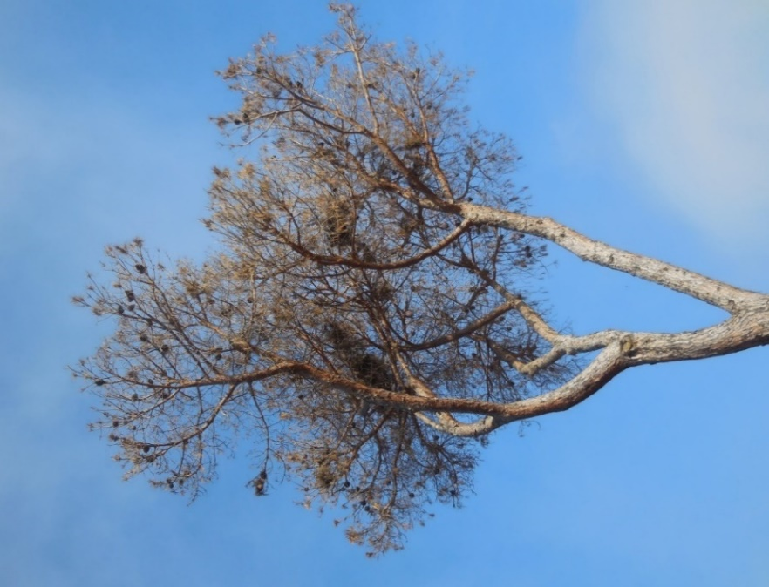
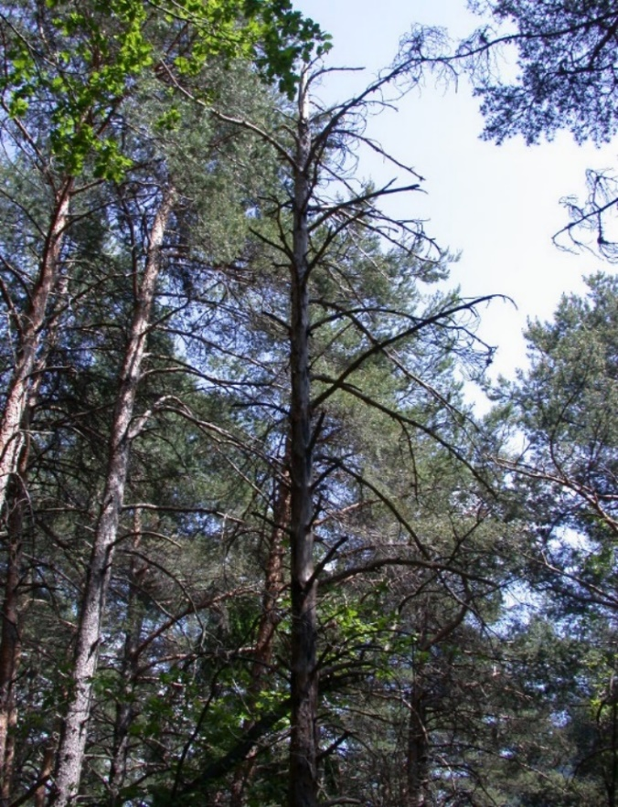
[872]
[873]Figure 1. Mortality of Pinus sylvestris (left) and Pinus pinea (right) caused by Heterobasidion annosum sensu stricto and Heterobasidion irregulare, respectively.
[874]Source: L. Giordano, Plant Protection Service Lombardy Region, Italy.
[875]
[876]
[877]
[878]
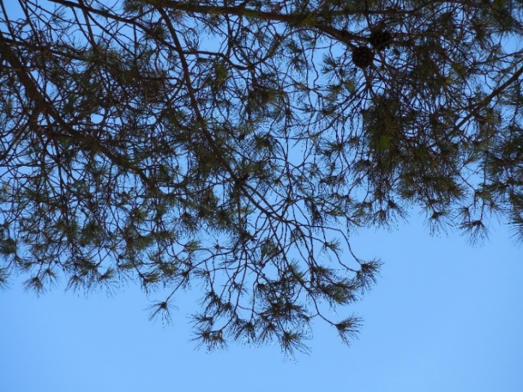
[879]
[880]Figure 2. The lion-tailing phenomenon of Pinus pinea caused by Heterobasidion irregulare.
[881]Source: L. Giordano, Plant Protection Service Lombardy Region, Italy.
[882]
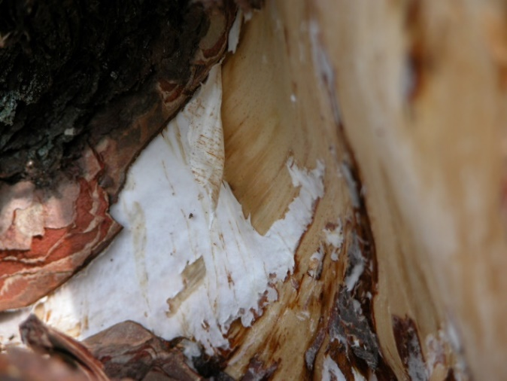
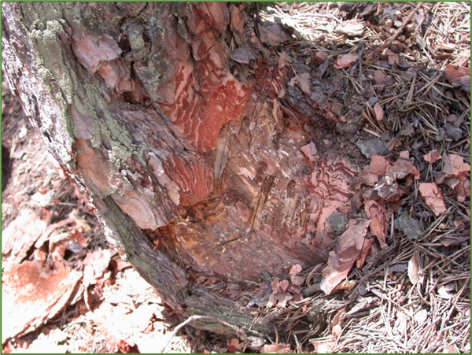
[883]
[884]Figure 3. Paper-thin mycelium of Heterobasidion sp. and cambium necrosis beneath the bark at the tree collar of Pinus sylvestris (left). Thicker white mycelium of Armillaria sp. beneath the bark at the tree collar of Pinus sylvestris (right).
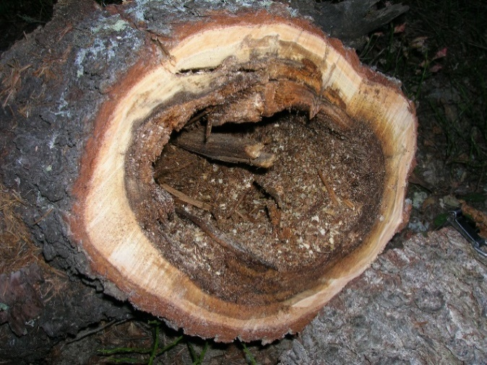
[885]Source: L. Giordano, Plant Protection Service Lombardy Region, Italy.
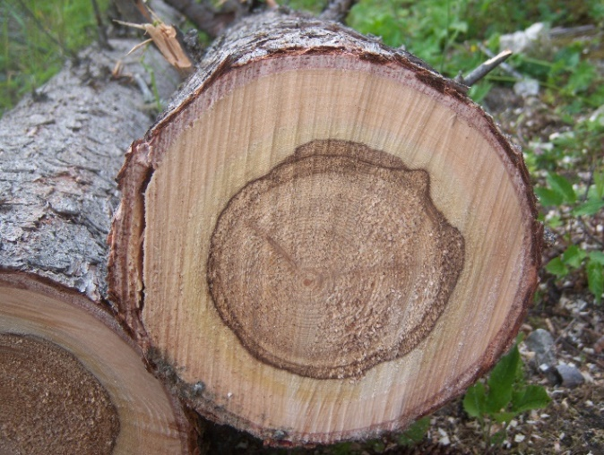
[886]
[887]Figure 4. Heart rot of Picea abies caused by Heterobasidion parviporum. When heart rot develops, it can result in cavities (right).
[888]Source: L. Giordano, Plant Protection Service Lombardy Region, Italy.
[889]
[890]
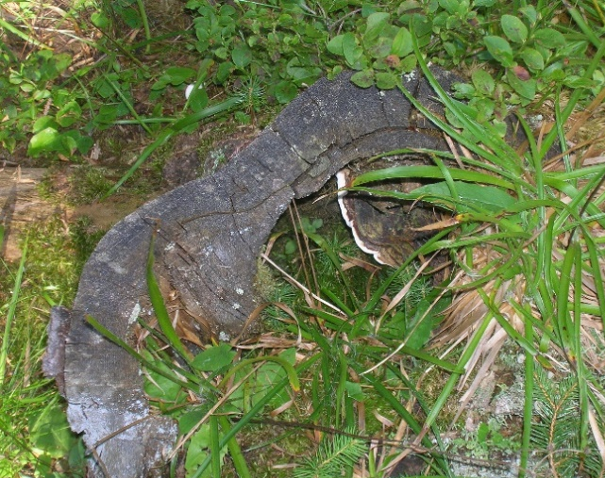
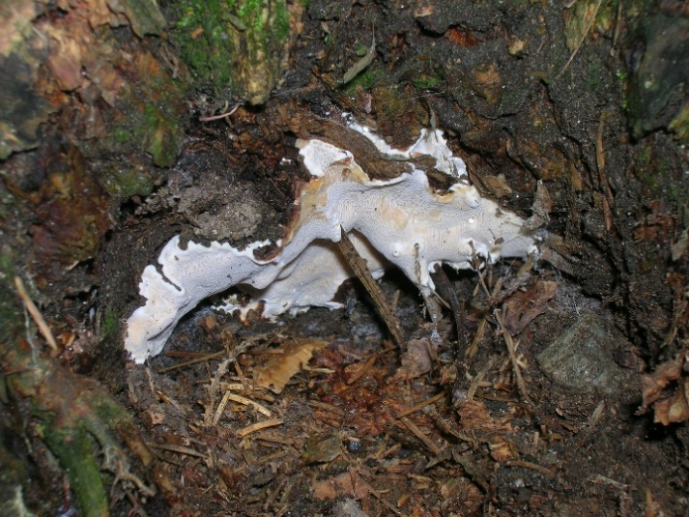
[891]
[892]Figure 5. Examples of Heterobasidion annosum sensu lato fruiting bodies. They may envelop litter debris (left) and develop inside the internal cavities of old decayed stumps (right).
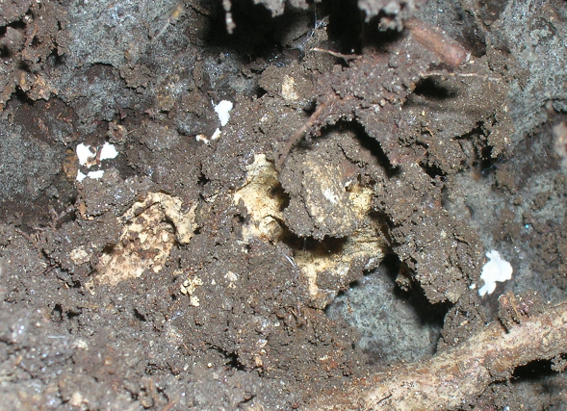
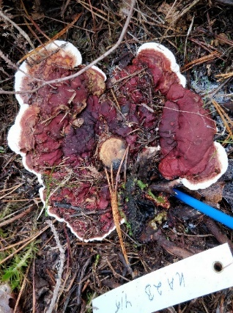
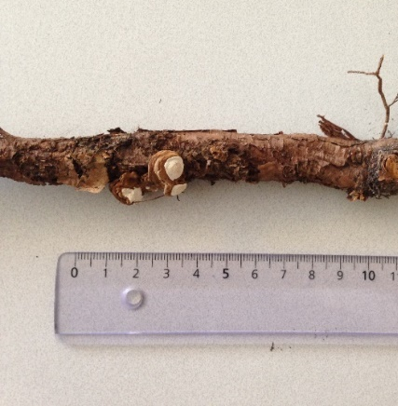
[893]Source: L. Giordano, Plant Protection Service Lombardy Region, Italy.
[894]
[895]Figure 6 Incipient fruiting bodies of Heterobasidion annosum sensu lato, referred to as “popcorn” because of their appearance in pine roots (left, centre). Large fruiting body surrounding a stump of a very small Scots pine seedling that has been cut after being killed by H. annosum sensu stricto (right): the reddish-brown top surface of the fruiting body is visible.
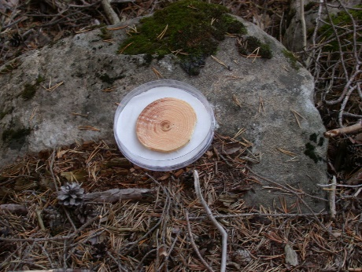
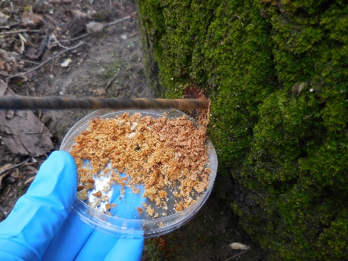
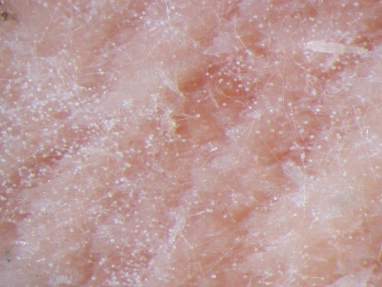
[896]Sources: E.J. Vainio, Natural Resources Institute Finland (left and right); L. Giordano, Plant Protection Service Lombardy Region, Italy (centre).
[897]
[898]Figure 7. Conidiophores of the anamorphic stage of Heterobasidion annosum sensu lato that appear as a mass of whitish “pinheads” on stalks (left). Wood sawdust from drilling at the base of a tree (centre). Passive spore trap exposed in the field inside an open, 15-cm diameter, plastic Petri dish containing a sterile piece of filter paper dampened with sterile distilled water (right).
[899]Source: L. Giordano, Plant Protection Service Lombardy Region, Italy.
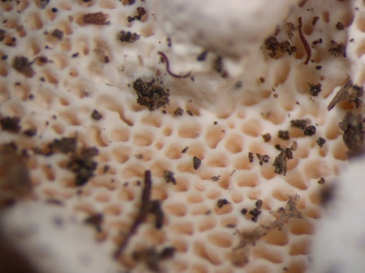
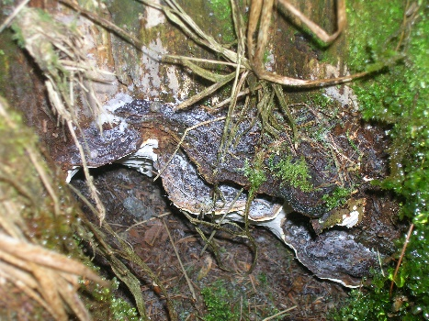
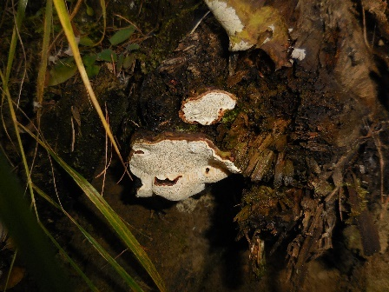
[900]
[901]
[902]Figure 8. Fruiting bodies of Heterobasidion annosum sensu lato (top left, top right); pores of the lower surface of fruiting bodies (bottom).
[903]Source: L. Giordano, Plant Protection Service Lombardy Region, Italy.
[904]
[905]Figure 9. Conidiophores and conidia of the asexual stage of Heterobasidion annosum sensu lato (40× magnification).
[906]Source: L. Giordano, Plant Protection Service Lombardy Region, Italy.
[907]
[908]
[909]
[910]
[911]
[912]
[913]
[914]
[915]
[916]
[917]
[918]
[919]
[920]
[921]
[922]
[923]
[924]Figure 10. White-cream colony of Heterobasidion annosum sensu lato (left) and clamp connection (right) (40× magnification).
[925]Source: L. Giordano, Plant Protection Service Lombardy Region, Italy.

[161] When using LAMP on a regular basis in an area which has a patent system such as Japan (Patent Nos. 3,313,358, 3,974,441 and 4,139,424), the United States of America (US6,410,278, US6,974,670 and US7,494,790), the European Union (Nos. 1,020,534, 1,873,260, 2,045,337 and 2,287,338), China (ZL008818262), the Republic of Korea (Patent No, 10-0612551), Australia (No. 779160), and the Russian Federation (No. 2,252,964), it is necessary for users to receive a licence from Eiken Chemical Co., Ltd. before use.
[247] The use of names of reagents, chemicals or equipment in these diagnostic protocols implies no approval of them to the exclusion of others that may also be suitable.

