DRAFT ISPM: [Title (Topic no.)]

This template shows what a draft ISPM should include.
[Bracketed text] is text that must be retained but amended for the ISPM being drafted.
A clear structure and content, paragraph numbering, and simple but coherent formatting are imperative (i.e. apply only the minimum amount of formatting necessary but make sure the heading levels are correct to ensure that the structure of the document is understood by contracting parties).
Use manual paragraph numbering following initial drafting and before in-session changes.

Status box
This is not an official part of the standard and it will be modified by the IPPC Secretariat after adoption.
Date of this document | [2023-04-21]
Document category | For example:  Draft appendix to ISPM XX
Current document stage | The stage where the document is going to in the standard setting process. For example:  To first consultation
Major stages | All the major stages of the standard setting process that the draft has gone through, including:  The relevant publication history of the specification for the draft ISPM  EWG meeting  SC meetings  Small SC working group discussions  TP meetings (virtual and face-to-face)  SC e-decisions  When the draft was submitted for adoption by CPM  Formal objections (if any)  The major stages for drafts can be: deferred (no changes were made during the meeting); commented (no revision was made, but comments were added); revised (the text was modified); or reviewed (the text was not modified but recommendations were provided). For example:  2010-03 CPM-XX added topic Title (topic no.).  2011-11 Technical Panel for the Glossary reviewed.  2012-05 Standards Committee (SC) deferred.  2013-05 SC revised.  2013-07 Consultation.  2014-11 SC recommended for adoption.  2015-03 CPM-XX adopted the standard.  Note that abbreviations and acronyms describing IPPC meetings and document stages should be spelled out in full upon first use in the status box (except for CPM, IPPC and ISPM, which may be used without definition).
Steward history | Names and countries of lead and assistant stewards assigned to the draft, with the date and meeting of nomination, name, country code (ISO 3166-1 alpha-2), and role (“Lead Steward” or “Assistant Steward”). Names are listed in reverse chronological order, with the current role holders listed first (lead steward above assistant steward). For example:  2008-11 SC Dwi SETIAWAN (ID, Lead Steward)  2012-04 SC Julie ALIAGA (US, Assistant Steward)
Notes | This section includes all the information that the IPPC Secretariat needs to record and is not included in the major stages (e.g. editing, formatting, email discussions).  This section will remain on the drafts going for consultation but deleted before adoption. For example:  2023-04 Edited

Adoption
- Text to this paragraph will be added following adoption.

Introduction

Scope
- A short statement that delineates what is covered by the standard.

References
- References that are cited in the text of the standard (except for ISPMs, to which a general reference is given) are added here. Follow the IPPC style guide, in conjunction with FAOSTYLE, for bibliographic style.
- If a bibliography of useful information is included (i.e. references that are not cited in the main text), this must be attached to the document as an appendix.
- The following standard paragraph is added for reference to ISPMs. It may be changed to the singular when only ISPM 5 (Glossary of phytosanitary terms) is referenced:
- [The present standard refers to ISPMs. ISPMs are available on the International Phytosanitary Portal (IPP) at www.ippc.int/core-activities/standards-setting/ispms.]

Definitions
- Normally, only the following standard paragraph is required:
- [Definitions of phytosanitary terms used in this standard can be found in ISPM 5 (Glossary of phytosanitary terms).]
- If there are terms or definitions that are not in ISPM 5 and are defined only for the purpose of the specific ISPM, the following additional text should be included:
- [In addition to the definitions in ISPM 5, in this standard the following definition(s) apply(applies).]
- New terms defined by the expert drafting group or terms that have been revised from their approved version in ISPM 5 should be included in this section. A new term included in the definitions section may be a specialized term that is used in the standard but one that will not be added to ISPM 5; the definition must be precise and comprehensive:
Term | Definition (terms used in the definition that are defined in ISPM 5 are bolded).

Outline of requirements
- A summary of the substance of the standard (analogous to the abstract of a scientific paper).

Background
- Explains why the standard was drafted (i.e. its objectives) and includes other information that may help contracting parties to understand the history of the development of the standard. When a standard is being revised, the background section should include relevant information on the reasons for and scope of the revision.

IMPACTS ON BIODIVERSITY AND THE ENVIRONMENT
- Explains how the standard may affect biodiversity and the environment by providing a means to prevent the entry, into new areas, of organisms that may otherwise have a negative impact on biodiversity (invasive alien species), human health or animal health, or by specifying requirements that directly or indirectly affect organisms other than pests or the biophysical environment upon which they depend.

Requirements
- The requirements section may be subdivided into general requirements and specific requirements or other blocks appropriate to the subject, as needed.
- Below are examples of headings to illustrate the hierarchy of heading levels that should be used to structure the ISPM into sections. Experts can hereby copy the heading styles they need.

general requirements

1. Operational plans
- Example of a first level heading under the “general requirements” section heading where the general requirements for the standard are set out.

2. Documentation and record-keeping
- See the IPPC style guide for guidance on requirements for documentation and record-keeping.

specific requirements

3. Establishment of the pest free area
- Example of a first level heading where the specific requirements will be described.

4. Phytosanitary procedures
- Example of a first level heading where the specific requirements will be described in overall terms.

4.1 Surveillance activities
- Example of a second level heading. In this section, the detailed specific requirements will be described.
- Tables and figures are often placed in an appendix or annex, depending on their purpose. The following are examples of how to set up tables, and of the necessary information to be added to figures.
- Table 1. [Title]
Insects |  | Fungi and nematodes
Pest group | Examples within the pest group | Pest group | Examples within the pest group
Bark beetles | Scolytinae, Molytinae | Rust fungi | Cronartiaceae, Pucciniaceae
Wood flies | Pantophthalmidae | Pathogenic decay fungi | Heterobasidion spp.

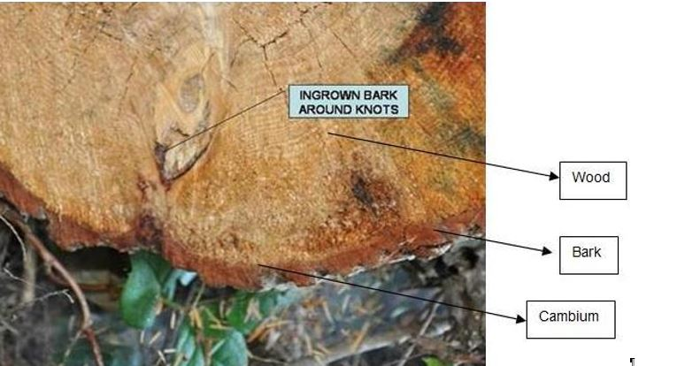
- Figure 1. [Description.]
- Source: [Name, Institution, Country].

This supplement is a prescriptive part of the standard.

SUPPLEMENT 1: [Title of the supplement]
1. Heading example
- Supplements add conceptual information that is supplemental to a standard and that provides additional text without changing existing text.
- In ISPM 5, supplements are used to clarify and explain complex phytosanitary terms and definitions that cannot be understood from a normal concise definition.
- If a supplement is revised or a new one added to an existing ISPM, the date of adoption by the Commission on Phytosanitary Measures (CPM) should be included with the prescriptive status statement above the title.
1.1 Heading example

This annex is a prescriptive part of the standard.

ANNEX 1: [Title of the annex]
1. Heading example
An annex adds technical information to the standard. It is referred to in the main text of the standard. An annex does not normally include conceptual information of relevance to the standard. An annex should only contain highly specific information that may need to be changed over time and that does not affect the principles incorporated in the main text of the standard. For example, annexes may:
- provide technical guidelines for phytosanitary treatments or procedures, including treatments, treatment schedules and diagnostic protocols;
- include tables and figures; or
- contain information that may need to be amended or revised to ensure that the specific information provided is consistent with and reflects current scientific knowledge and other relevant information.
Amendment or revision of annexes may be made without modifying the main text of the standard and may for instance be necessary under the following circumstances:
- the approval of new guidelines, treatments or procedures;
- a change in existing methods; or
- as a result of experiences with implementation of a particular standard.
- If an annex is revised or a new one added to an existing ISPM, the date of adoption by the CPM should be included with the prescriptive status statement above the title.
1.1 Heading example

This appendix is for reference purposes only and is not a prescriptive part of the standard.

APPENDIX 1: [Title of the appendix]
1. Heading example
- Appendices provide references or further information relevant to the standard. If an appendix is revised or a new one added to an existing ISPM, the date of adoption by the CPM should be included with the non-prescriptive status statement above the title.
1.1 Heading example

