[1]DRAFT REVISION OF DP 27: Ips spp. (2021-004)
[2]Status box
[3]This is not an official part of the standard and will be modified after adoption
[4]Date of this document | [5]2024-04-10
[6]Document category | [7]Draft revision of annex to ISPM 27 (Diagnostic protocols for regulated pests)
[8]Current document stage | [9]To for approval for adoption
[10]Origin | [11]Original subject: Ips spp.
[12]Major stages | [13]2021-02 Standards Committee (SC) added Revision of DP 27 (Ips spp.) to the Technical Panel on Diagnostic Protocols (TPDP) work programme, priority 1.  [14]2022-08 Expert consultation.  [15]2022-10 Diagnostic protocol (DP) drafting group revised.  [16]2022-10/11 TPDP revised and recommended draft DP to SC for consultation.  [17]2023-06 SC approved for consultation (2023_eSC_Nov_02).  2023-07 Consultation.  2023-11 TPDP reviewed and revised draft and consultation comments.  2024-02 TPDP approved responses to consultation comments and recommended the draft DP to the SC for approval for adoption  2024-06 SC approved for adoption.
[18]Discipline leads history | [19]2021-04 Norman BARR (US, Discipline Lead)  [20]2021-04 Juliet GOLDSMITH (JM, Referee)
[21]Consultation on technical level | [22]The revised draft of this protocol was written by (lead author and DP drafting group):  [23]Hume DOUGLAS (CA, lead author)  [25] HOANG Kim Thoa (VN, co-author)  [24]Alfayo OMBUYA (KE, co-author)  [26]  [27]In addition, the draft has also been subject to expert review and the following international expert submitted comments: Dimitrios Avtzis (Forest Research Institute - Hellenic Agricultural Organization Demeter, Greece).
[28]Main discussion points during development of the diagnostic protocol | [29]  [30]  [31]
[32]Notes | [33]This is a draft document to revise the adopted DP because the initial version did not capture the full variability of Ips hauseri and required improvement to the key to avoid incorrect identifications.  [34]Original DP adopted and published in 2018  [35]2023-03 Edited  2024-04 Edited
[36]
[37]CONTENTS
[38][to be added later]
[39]Adoption [to be completed after adoption]
[40]This diagnostic protocol was first adopted by the Standards Committee on behalf of the Commission on Phytosanitary Measures in August 2018.
[41]The first revision of this diagnostic protocol was adopted by the Standards Committee on behalf of the Commission on Phytosanitary Measures in [Month 20--].
[42]The annex is a prescriptive part of ISPM 27 (Diagnostic protocols for regulated pests).
[43]

[44]1. Pest information
[45]Ips bark beetles (Coleoptera: Curculionidae: Scolytinae: Ipini) are subcortical phloem feeders in Pinaceae (conifer trees), especially Pinus (pine), Picea (spruce) and Larix (larch or tamarack) species (Cognato, 2015). In non-outbreak times, Ips beetles mainly inhabit weak or dead trees (Cognato, 2015). Adults and larvae kill healthy trees during outbreaks (Cognato, 2015) by destroying the phloem and cambium in tree trunks and limbs when feeding and tunnelling (Furniss and Carolin, 1977). Outbreaks can destroy thousands of hectares of healthy trees (Cognato, 2015). Certain climatic conditions may promote Ips outbreaks (Wermelinger, 2004; Breshears et al., 2005; Marini et al., 2017). These climatic events include high temperatures, drought, high winds, and heavy ice and snowstorms. Ips bark beetles can also transmit pathogenic fungi (Krokene and Solheim, 1998; Meng et al., 2015), in particular blue stain fungi (including several species in the genera Grosmannia and Ceratocystis (Ascomycota: Sordariomycetes), Ramanenka, Ugwu and Ivashchanka, 2021; Figure 1). Ceratocystis fungi from Ips beetles also interfere with the biological control of the conifer pest Sirex noctilio Fabricius (Hymenoptera: Siricidae) (Yousuf et al., 2014).
[46]Indigenous Ips species are present in North America and Eurasia, in all countries where Pinus and Picea occur naturally (Cognato, 2015). Five Ips species (I. apache, I. calligraphus, I. grandicollis, I. subelongatus and I. typographus) also occur as non-indigenous species, especially where Picea and Pinus are introduced (Knižek, 2011; Cognato, 2015) and where Pinus has been planted. Some Ips species use Larix as the principal host genus in their native range (Table 1). A few species use Abies (fir) and Cedrus (true cedar) as hosts during outbreaks (Wood and Bright, 1992). Ips species are not limited to the principal host genera provided in Table 1, as other conifers can be attacked when a principal host is not available.
[47]There are 37 valid Ips species worldwide (Table 1), distinguished mainly by the number and the shapes of spines on the elytral declivity (the apical, downward sloping part of the elytra). Phylogenetic analyses of the Ipini prompted transfer of several species to the genera Pseudips (Cognato, 2000) and Orthotomicus (Cognato and Vogler, 2001). Cognato (2015) reviewed the phylogeny, taxonomy, diagnosis and biology of all Ips species. This IPPC diagnostic protocol is focused on the diagnosis of 14 Ips species (Table 2), included on the basis of their known pest status according to CABI and EPPO (1997). These 14 are treated as target species in the protocol. Other Ips species in the protocol are referred to as non-target (NT) species in the identification keys, but these species could also cause tree mortality, especially if introduced outside their native ranges.
[48]Table 1. Worldwide list of Ips species with distribution and principal host genera
[49]Species | [50]Authority | [51]Indigenous range* | [52]Principal host genera
[53]Ips acuminatus | [54](Gyllenhal, 1827) | [55]Eurasia | [56]Pinus
[57]Ips amitinus | [58](Eichhoff, 1872) | [59]Eurasia (west) | [60]Picea, Pinus
[61]Ips apache | [62]Lanier, 1991 | [63]North America (south) | [64]Pinus
[65]Ips avulsus | [66](Eichhoff, 1868) | [67]North America (east) | [68]Pinus
[69]Ips bonanseai | [70](Hopkins, 1906) | [71]North America (south) | [72]Pinus
[73]Ips borealis | [74]Swaine, 1911 | [75]North America (north) | [76]Picea
[77]Ips calligraphus | [78](Germar, 1823) | [79]North America, Caribbean | [80]Pinus
[81]Ips cembrae | [82](Heer, 1836) | [83]Eurasia (widespread) | [84]Larix
[85]Ips chinensis | [86]Kurenzov and Kononov, 1966 | [87]Eurasia (southeast) | [88]Pinus
[89]Ips confusus | [90](LeConte, 1876) | [91]North America (west) | [92]Pinus
[93]Ips cribricollis | [94](Eichhoff, 1869) | [95]North America (south), Central America, Caribbean | [96]Pinus
[97]Ips duplicatus | [98](Sahlberg, 1836) | [99]Eurasia (widespread) | [100]Picea
[101]Ips emarginatus | [102](LeConte, 1876) | [103]North America (west) | [104]Pinus
[105]Ips grandicollis | [106](Eichhoff, 1868) | [107]North America (east, south) | [108]Pinus
[109]Ips hauseri | [110]Reitter, 1895 | [111]Eurasia (central) | [112]Picea
[113]Ips hoppingi | [114]Lanier, 1970 | [115]North America (southwest) | [116]Pinus
[117]Ips hunteri | [118]Swaine, 1917 | [119]North America (west) | [120]Picea
[121]Ips integer | [122](Eichhoff, 1869) | [123]North America (west, south) | [124]Pinus
[125]Ips knausi | [126]Swaine, 1915 | [127]North America (west) | [128]Pinus
[129]Ips lecontei | [130]Swaine, 1924 | [131]North America (south) | [132]Pinus
[133]Ips longifolia | [134](Stebbing, 1909) | [135]Eurasia (central) | [136]Pinus
[137]Ips montanus | [138](Eichhoff, 1881) | [139]North America (west) | [140]Pinus
[141]Ips nitidus | [142]Eggers, 1933 | [143]China | [144]Picea
[145]Ips paraconfusus | [146]Lanier, 1970 | [147]North America (west) | [148]Pinus
[149]Ips perroti | [150]Swaine, 1915 | [151]North America (north) | [152]Pinus
[153]Ips perturbatus | [154](Eichhoff, 1869) | [155]North America (north) | [156]Picea
[157]Ips pilifrons | [158]Swaine, 1912 | [159]North America (west) | [160]Picea
[161]Ips pini | [162](Say, 1826) | [163]North America (widespread) | [164]Pinus
[165]Ips plastographus | [166](LeConte, 1869) | [167]North America (west) | [168]Pinus
[169]Ips schmutzenhoferi | [170]Holzschuh, 1988 | [171]Asia (Himalayas) | [172]Larix, Picea, Pinus
[173]Ips sexdentatus | [174](Boerner, 1767) | [175]Eurasia (widespread) | [176]Pinus, Picea
[177]Ips shangrila | [178]Cognato and Sun, 2007 | [179]Asia (east) | [180]Picea
[181]Ips stebbingi | [182]Strohmeyer, 1908 | [183]Eurasia (central) | [184]Picea, Pinus
[185]Ips subelongatus | [186](Motschulsky, 1860) | [187]Eurasia (east) | [188]Larix
[189]Ips tridens | [190](Mannerheim, 1852) | [191]North America (west) | [192]Picea
[193]Ips typographus | [194](Linnaeus, 1758) | [195]Eurasia (north and west) | [196]Picea
[197]Ips woodi | [198]Thatcher, 1965 | [199]North America (west) | [200]Pinus
[201]Notes: Principal host genera refer to hosts from which Ips species are most commonly collected in their indigenous range. Species targeted by this protocol are underlined.
[202]* South = tropical and subtropical parts of North America. North America refers to the North American continent including countries north of Colombia. Widespread may not include all countries in the continent.
[203]Source: Cognato, A.I. 2015. Biology, systematics, and evolution of Ips. In: F.E. Vega & R.W. Hofstetter, eds. Bark beetles – Biology and ecology of native and invasive species, pp. 351–370. San Diego, USA, Academic Press. 620 pp. https://doi.org/10.1016/B978-0-12-417156-5.00009-5
[204]Most attacks are initiated by male beetles, who create a nuptial chamber under the bark and release aggregation pheromones to attract males and females to colonize the same tree. The polygynous males attract up to eight females to the nuptial chamber (diameter: 7–15 mm). Females mate with the resident male and then create radiating egg galleries along the inner bark where they each lay around 20–30 eggs in niches along the gallery walls (Chararas, 1962). These eggs will hatch after about seven days (Cognato, 2015; Figure 2 and Figure 3). Newly formed larval galleries then radiate from the oviposition galleries bored by the females (Figure 2 and Figure 3). Each larval gallery can extend along the bark for 10–30 cm. Larval development requires as little as six weeks in warm areas, allowing up to five generations per year. In cooler areas, development can require up to two years (Furniss and Carolin, 1977). Pupation occurs within larval galleries. Adult beetles overwinter within parental breeding galleries, in forest litter, or in living wood tissue (Chansler, 1964; Lanier, 1967).
[205]Direct flight distances of 50 km for Ips sexdentatus (Jactel and Gaillard, 1991) and 18 or more km for I. typographus (Forsse and Solbreck (1985) have been reported for adults. These estimates do not include the impact of wind on movement during flight. In some cases, the international trade of wood may result in the introduction of Ips to new areas (Haack, 2001). Life stages of Ips can be dispersed through host plants or raw wood used for solid wood packaging material and wood products, when present underneath the bark or in the phloem.

[206]2. Taxonomic information
[207]Name: Ips DeGeer, 1775
[208]Synonyms: Cumatotomicus Ferrari, 1867
[209] Cyrtotomicus Ferrari, 1867
[210]Taxonomic position: Insecta, Coleoptera, Curculionidae, Scolytinae, Ipini
[211]
[212]Table 2. Common names and synonyms of target Ips species, sorted by subgenera
[213]Subgenus | [214]Ips species | [215]Common name | [216]Synonyms and other names
[217]Bonips Cognato, 2001 | [218]Ips pini (Say, 1826) | [219]pine engraver beetle | [221]Bostrichus dentatus Sturm, 1826  [222]Bostrichus pallipes Sturm, 1826  [220]Bostrichus pini Say, 1826  [223]Ips dentatus (Sturm, 1826)  [224]Ips praefrictus (Eichhoff, 1868)  [225]Tomicus praefrictus Eichhoff, 1868  [226]Ips oregonis (Eichhoff, 1869)  [227]Tomicus oregonis Eichhoff, 1869  [228]Ips rectus (LeConte, 1876)  [229]Tomicus rectus LeConte, 1876  [230]Ips laticollis Swaine, 1918  [231]Ips oregoni Swaine, 1918 (misspelling of oregonis by Eichhoff, 1869)  [232]
[233] | [234]Ips plastographus (LeConte, 1869)* | [235]California pine engraver | [236]Tomicus plastographus LeConte, 1869
[237]Cumatotomicus Ferrari, 1867 | [238]Ips sexdentatus (Boerner, 1767) | [239]six-toothed bark beetle | [240]Dermestes sexdentatus Boerner, 1767  [241]Ips pinastri Bechstein, 1818  [242]Ips stenographus Duftschmid, 1825  [243]Ips junnanicus Sokanovskiy, 1959
[244]Granips Cognato, 2001 | [245]Ips calligraphus (Germar, 1823) | [246]six-spined Ips, coarsewriting engraver | [247]Tomicus calligraphus Germar, 1823  [248]Bostrichus exesus Say, 1826  [249]  [250]Ips praemorusus (Eichhoff, 1868)  [251]Tomicus praemorusus Eichhoff, 1868  [252]Ips interstitialis Eichhoff, 1869  [253]Tomicus interstitialis Eichhoff, 1869  [254]Ips ponderosae Swaine, 1925
[255] | [256]Ips confusus (LeConte, 1876) | [257]piñon Ips | [258]Tomicus confusus LeConte, 1876
[259] | [260]Ips grandicollis (Eichhoff, 1868) | [261]southern pine engraver | [263]Tomicus grandicollis Eichhoff, 1868  [262]Ips cacographus (LeConte, 1869)  [264]Tomicus cacographus LeConte, 1869  [265]Ips chagnoni Swaine, 1916  [266]Ips cloudcrofti Swaine, 1924  [267]
[268] | [269]Ips lecontei Swaine, 1924 | [270]Arizona fivespined Ips | [271]none
[272] | [273]Ips paraconfusus Lanier, 1970 | [274]California fivespined Ips | [275]none
[276]Ips de Geer, 1775 | [277]Ips amitinus (Eichhoff, 1872) | [278]small spruce bark beetle, eight-toothed spruce bark beetle | [279]Tomicus amitinus Eichhoff, 1872  [280]Ips amitinus var. montanus Fuchs, 1913
[281] | [282]Ips cembrae (Heer, 1836) | [283]large larch bark beetle | [284]Bostrichus cembrae Heer, 1836  [285]Ips cembrae var. engadinensis Fuchs, 1913  [286]Ips fallax Eggers, 1915  [287]Ips shinanoensis Yano, 1924
[288] | [289]Ips duplicatus (Sahlberg, 1836) | [290]northern bark beetle | [291]Bostrichus duplicatus Sahlberg, 1836  [292]Tomicus rectangulus Ferrari, 1867  [293]Tomicus judeichii Kirsch, 1871  [294]Tomicus infucatus Eichhoff, 1877  [295]Tomicus infucatus Eichhoff, 1878
[296] | [297]Ips subelongatus (Motschulsky, 1860) | [298]larch bark beetle, oblong bark beetle | [299]Tomicus subelongatus Motschulsky, 1860
[300] | [301]Ips typographus (Linnaeus, 1758) | [302]eight-toothed spruce bark beetle | [303]Dermestes typographus Linnaeus, 1758  [304]Bostrichus octodentatus Paykull, 1800  [305]Ips japonicus Niisima, 1909
[306]No subgenus (Incertae sedis) | [307]Ips hauseri Reitter, 1895 | [308]Kyrgyz mountain engraver, Hauser’s engraver | [309]Ips ussuriensis Reitter, 1913
[310]Notes: Synonymy follows Knižek, M. 2011. Subfamily Scolytinae Latreille, 1804. In: I. Löbl & A. Smetana, eds. Catalogue of palaearctic Coleoptera 7: Curculionoidea I, pp. 204–250. Stenstrup, Denmark, Apollo Books. 373 pp.
[311]*Ips plastographus has two subspecies, I. p. plastographus (LeConte) and I. p. maritimus Lanier.
[312]

[313]3. Detection
[314]Ips bark beetles can be found in boles and branches of the tree genera Pinus, Picea, Larix and Cedrus. Pinus and Picea wood are of primary economic importance to the world timber trade. If bark is present, round wood, handicrafts, dunnage, crates or pallets suspected of originating from these tree genera could harbour Ips. Flying adult beetles are collected using a well-developed system of semiochemical lure-based traps (Fettig and Hilszczański, 2015).
[315]Adults, larvae and pupae (Figure 4) are found in the host plant or wood products immediately underneath the bark or in the phloem, and not deeper in the wood or xylem (although some overwintering adults tunnel into the xylem (Lanier, 1967)). Trees can be examined by removing the bark to see if galleries are present or by viewing externally for symptoms of infestation (circular holes, 1–4 mm in diameter, and red-brown boring dust, Figure 5).
[316]3.1 Symptoms of infestation in living trees
[317]Four general symptoms indicating possible attack in living Pinaceae trees are as follows:
- [318]Yellowing, dying needles on the crown, a branch or the entire tree.
- [319]Appearance of red-brown or yellow-brown boring dust on the bark or near the tree (Figure 5). Ips beetles often cause resin leakage but rarely cause the appearance of resinous pitch tubes on the surface of the bark as in Dendroctonus colonization.
- [320]Presence of intersecting maternal galleries up to 30 cm long, with lateral larval galleries, under the bark (Figure 2 and Figure 3).
- [321]Appearance of many small holes on the bark (e.g. ten or more 1–4 mm diameter holes in a 10 cm × 10 cm area). This is consistent with the postemergence stage of Ips infestation. At this time the progeny have emerged from the tree to find unexploited bark tissue in which to establish new galleries.
[322]Several months or more after successful colonization, the attacked tree may change leaf (needle) colour to yellow-green or red as the tree dies. Ips beetles sometimes kill healthy trees when beetle populations are high, although some trees recover even after the beetles have successfully reproduced in their tissues.
[323]3.2 Collecting specimens from plants and wood products
[324]Bark can be removed from affected trees or wood products using a sharp, strong knife or a small axe. The wood underneath the bark layer and the inner bark can be inspected for galleries (examples are shown in Figure 2 and Figure 3). A magnifying lens (≥40×) can be used to inspect galleries for adults, larvae and eggs. If gallery engravings are present, some of the bark or affected material should be collected and photographed. Infested materials can be transported using a sealed bag or container. Double bagging of samples is useful for preventing escape.
[325]Detected adults, larvae, pupae or eggs can be removed using flexible forceps with narrow tips (for eggs and small larvae) or broad tips (for large larvae and adults). Live larvae, or larvae recently killed in ethanol, can be placed for 30 to 60 seconds in near-boiling water (90 °C to 100 °C) for long-term preservation. Specimens should then be stored in a glass vial containing 70% to 80% ethanol. Adults can be killed in ethanol or by placement into a dry tube and then a freezer at either −20 °C for at least 24 h or −80 °C for at least 6 h before card- or point-mounting on a pin. If specimens are to be saved for DNA analysis, it is recommended that they be stored in a preservative such as a high percentage (>95%) of ethanol or propylene glycol.
[326]It is necessary to collect any adults present because adults have important diagnostic morphological characters. It is not possible to identify juveniles to genus or species level based on morphology. In the laboratory, adult specimens should be mounted for examination while larvae, pupae or eggs should be examined in ethanol. See section 4.1 and section 4.2 for details on preparation of specimens for identification.

[327]4. Identification
[328]Member of the genus Ips can be identified to species level by adult external morphology (Douglas et al., 2019). Adult structures are illustrated in Figure 6. Descriptions and regional keys to the species of Ips based on morphology are available (Balachowsky, 1949; Kurenzov and Kononov, 1966; Grüne, 1979; Schedl, 1981; Wood, 1982; Holzschuh, 1988; Lanier, Teale and Pajares, 1991; Pfeffer, 1995; Cognato and Sun, 2007). A generic key to the Scolytinae larvae of eastern Canada is available (Thomas, 1957) but juvenile stages cannot be used for reliable identification of the genera on a global scale. Although Ips species have been discovered and identified using DNA sequence data (Cognato and Sun, 2007), validated protocols for universal DNA identification of Ips species have not yet been developed (Chang et al., 2012). Additional work is needed to demonstrate that DNA sequence data provide accurate identification of the target species and to determine how to interpret DNA similarity between target and non-target species.

[329]4.1 Morphological identification of beetle adults

[330]4.1.1 Preparation of adults for morphological examination
[331]Ethanol-preserved specimens (section 3.2) are transferred to a dish filled with 70% to 80% ethanol to remove dirt, debris and frass. Specimens can be cleaned by gently brushing with a fine-hair artist’s paint brush. The integument must be clean to show the surface texture and setal punctures. Before mounting, adult specimens preserved in ethanol should first be dried by removing the specimen from the ethanol, blotting it with paper towel and allowing it to air-dry for 2–5 min. Specimens removed from −20 or −80 °C freezers should be placed on blotting paper and thawed for 10–20 min or until any visible condensation has evaporated from the specimen. A triangular point mount can be used for mounting, attaching the beetle to the point along the right side of its thorax. Specimens may, alternatively, be glued ventrally to the middle of an 11 × 4.5 mm mounting card. Ideally the left lateral, dorsal and ventral views should be free and visible for examination. Once adults are pinned, they may be examined under a dissecting microscope capable of 40× magnification or higher (a higher magnification may be preferable). Strong, diffuse lighting is important for examination of adult bark beetles to see the surface sculpturing. Because adult bark beetles are shiny, light reflected from specimens may make it difficult to see surface structures. The sheen can be reduced by placing tracing paper or translucent drafting film between the light source and the specimen.

[332]4.1.2 Identification of adults in the subfamily Scolytinae
[333]Wood (1986) provides a key to the world genera of Scolytinae. Rabaglia (2002) provides an updated key to the North American genera of Scolytinae. Adult Scolytinae can be identified by the following morphological characters (Hulcr et al., 2015):
- [334]Body cylindrical (nearly circular in cross-section).
- [335]Head width in dorsal view at least half of pronotal width.
- [336]Legs and antennae (Figure 6, Figure 7, and Figure 8(a) to Figure 8(e)) short (shorter than maximum body width in most, hind legs up to two-thirds of body length in a few Xyleborini), and flattened in cross-section in most.
- [337]Tarsi of legs with four visible tarsomeres (tiny fourth tarsomere is hidden between the third and fifth).
- [338]Antennae (Figure 7, and Figure 8(a) to Figure 8(c)) geniculate (bent or elbowed) with: a long basal segment (the scape); an angled junction with a series of one to seven bead-like antennomeres (the funicle); and a compressed three-segmented apical club (intersegmental sutures visible or not).
- [339]The head anterior to the eyes is not elongated into a snout (Figure 6 and Figure 7). A snout or rostrum is present in most other Curculionidae (weevils).
[340]Additional confirmatory characters for use in diagnosing damaged specimens are as follows:
- [341]Eyes flush (level) with surface of head (Figure 9(a) to Figure 9(h)). Eyes of many similar-shaped Bostrichidae protrude.
- [342]Ventrally, the pregular sclerite (= submentum) is visible with a pregular suture present.
- [343]Anterior legs of Ips and most other Scolytinae have socketed denticles on their apical and posterior edges (Figure 8(d), arrows). Such socketed denticles, which appear as spine-like hairs are also present in three other weevil subfamilies. Magnification greater than 100× is required to separate socketed denticles from nearby non-socketed spines.

[344]4.1.3 Identifying adults of the tribe Ipini Bedel, 1888
[345]Ips belongs to the tribe Ipini and can be distinguished from most other Scolytinae by the concave elytral declivity surrounded by large spines. The following tribal-level diagnostic characters are modified from Wood (1986):
- [346]Compound eye (Figure 9(a) to Figure 9(d)) sinuate (narrowed at mid-height), ventral half narrower than dorsal part.
- [347]Antennal scape (basal segment) slender elongate, funicle five-segmented, club either obliquely truncate or with sutures on posterior face strongly displaced toward apex (Figure 8(a) to Figure 8(c)).
- [348]Pronotum (Figure 6) with anterior half strongly declivous, with large asperities (broad spines). Posterior half without asperities and approximately horizontal.
- [349]Procoxae contiguous in ventral view, intercoxal piece deeply notched or absent.
- [350]Protibia with three or four socketed denticles (Figure 8(d), arrows).
- [351]Scutellum visible in dorsal view (Figure 10(a)).
- [352]Elytral declivity moderately to strongly excavated, sides with tubercles or spines in most of the species (Figure 7 and Figure 11).
- [353]Vestiture hair-like (not scale-like or wider at mid-length than at base).
- [354]Frons sexually dimorphic in most species.

[355]4.1.4 Identification of Ips adults
[356]Ips can be separated from other members of the tribe Ipini by features of the antennal club and elytral declivity, combined. The following diagnostic characters are as modified from Wood (1986) by Cognato (2000) and Cognato and Vogler (2001):
- [357]Body length 2.1–8.0 mm (most are larger than 3 mm). Other Ipini are 1.0–4.3 mm long.
- [358]Antennal club flattened (thickness less than one-third maximum width) and marked by sutures (Figure 8(a) to Figure 8(c)). Sutures nearly straight to strongly bisinuate (not procurved).
- [359]Elytral declivity broadly and deeply excavated, with sides acutely elevated and armed by three or more pairs of spines (Figure 7, Figure 11, Figure 12 and Figure 13). Apices of spines aligned with edge of declivity. Second spine (beginning from dorsal-most part of sloping declivity) acute in lateral profile (acute shape visible in spine next to “elytral declivity” label in Figure 6). Lower edge of concavity with an acutely elevated, explanate transverse ridge separating declivital excavation from apical edge (Figure 12(c)). Apex of declivity is not visible in the dorsal view.
[360]Ips is most similar in appearance to two other Ipini genera that also inhabit Pinaceae: Orthotomicus Ferrari, 1867 and Pseudips Cognato, 2000. Ips can be distinguished from Orthotomicus by the pointed second spine of its elytral declivity (right-angled in many Orthotomicus) and the broader explanate edge of its elytral declivity (Figure 12(c) vs Figure 12(e)). Ips can be distinguished from Pseudips by its straight, bisinuate or acutely angulate antennal club sutures (Figure 8(a) to Figure 8(c)). These sutures are broadly procurved (curved away from the antennal base at the midline of the club) in Pseudips, and also in the tropical, angiosperm feeding Acanthotomicus Blandford, 1894 and the warm-climate, ambrosia feeding Premnobius Eichhoff, 1878. Pityogenes Bedel, 1888 and Pityokteines Fuchs, 1911 are conifer-feeding Ipini, identified by their small size (1.8–3.7 mm) and the rounded edges of their elytral declivity. The tropical, ambrosia-fungus-feeding Premnophilus Brown, 1962 lacks visible antennal sutures.
[361]Most Ips species are grouped into subgenera, based on phylogenetic results by Cognato and Vogler (2001) and Cognato and Sun (2007). Diagnostic characteristics (external morphology only) of subgenera are as follows: Cumatotomicus Ferrari, body length >5 mm, spines on first and second elytral interstriae on declivity; Bonips Cognato, elytral declivity with four spines per side, elytral disc without punctures on interstriae; Granips Cognato, elytral declivity with five to six spines per side; Ips DeGeer, elytral declivity with four spines per side, elytral disc with punctures on interstriae; Incertae sedis, several Ips species outside any named subgenus. It is not necessary to identify to subgenus level to identify Ips species.

[362]4.1.5 Key to distinguish Ips adults from other Scolytinae
[363]The following key is modified from Wood (1986).
[364]1. Anterior edge of elytra procurved or armed with spines or asperities (Figure 10(b)) not Ips
[365]– Anterior edge of elytra straight or transverse, without asperities (Figure 10(a)) 2
[366]2. Apex of protibiae and dorsal (outer) ridge with only a single spine (Figure 8(e), circled part), or mesotibiae wider at mid-length than apex not Ips
[367]– Apex of protibiae with multiple spines and denticles (Figure 8(d)), and mesotibiae widest near apex (as in Figure 8(d) and Figure 8(e)) 3
[368]3. Eye sharply, deeply emarginate, lower half usually almost equal in width to upper half; elytral declivity flattened to convex, unarmed by spines or large tubercles not Ips
[369]– Eye shallowly sinuate (Figure 9(a)), its lower half distinctly narrower than above; elytral declivity elaborately excavated, with lateral edges armed by three to six pairs of spines (Figure 7, Figure 11 to Figure 13) 4
[370]4. Elytral declivity narrowly bisulcate, sides broadly elevated, rounded, and armed by three or fewer pairs of spines; posterior margin of declivity rounded; (most shorter than 3 mm) not Ips
[371]– Elytral declivity broadly, deeply excavated, sides acutely elevated and armed by three or more pairs of spines (Figure 7, Figure 11 and Figure 13), posterior edge of declivity with an acutely elevated (Figure 12(c) and Figure 12(e), circled), transverse ridge separating declivital excavation from elytral apex; (most longer than 3 mm) 5
[372]5. With one or more of the following characteristics: sutures of antennal club absent or procurved; elytral declivity with spines between the edge of the declivity and the elytral suture; declivital spine 2 obtuse or right-angled in lateral profile, or explanate apex of declivity absent or narrower than length of declivital spine 2 (Figure 12(e)). Body length 1.4–4.3 mm not Ips
[373]– Sutures of antennal club weakly to strongly bisinuate (Figure 8(a) to Figure 8(c)); elytral declivity with all spines in line with edge of declivity (Figure 7, Figure 11 to Figure 13), declivital spine 2 acute in lateral profile; explanate apex of declivity wider than length of declivital spine 2 (Figure 12(c) and Figure 13(f)). Body length 2.1–8.0 mm Ips

[374]4.1.6 Species identification of Ips adults
[375]Diagnostic characters of Ips spp. adults described in this protocol are based on key characters and diagnostic notes in Cognato (2015). If possible, both males and females from the same gallery should be examined because some diagnostic characters may occur in only one sex. Males and females from the same gallery are most likely to be conspecific. The closely related (Cognato and Sun, 2007) Ips species I. confusus and I. paraconfusus, and also I. cembrae and I. subelongatus, are not fully distinguished from each other in the key to species provided in section 4.1.7. This may be important, as these species may differ in their biology and distribution and in whether they are a regulated pest or not (Stauffer et al., 2001). Additional examination by Ips specialists with appropriate reference collections is required to identify these beetles to species level using morphology (Cognato, 2015). DNA studies have been published to support identification of I. confusus and I. paraconfusus (Cognato, Rogers and Teale, 1995; Cognato and Sun, 2007), I. cembrae and I. subelongatus (Stauffer et al., 2001; Cognato and Sun, 2007), and I. typographus and Ips duplicatus (Becker, König and Hoppe, 2021), but these studies have not yet been developed into identification methods. In this protocol, 14 species are treated as target species (section 4.1.8) based on their known pest status according to CABI and EPPO (1997). However, other Ips can also cause tree mortality, especially if introduced outside their native ranges.
[376]Ips species are distinguished primarily by characters of the elytra and frons. Experts usually begin identifications by counting declivital spines. Here the following characters are useful: the number of spines on the declivity (not including small denticles on the first elytral interstria); the distance from the first spine to the elytral suture relative to its height or to its distance from the second spine (Figure 13(a) and Figure 13(b)); and the shininess of the declivity compared to the elytral dorsal surface (Figure 11(d) vs Figure 11(e)). Several characters come from the third declivital spine (Figure 14): its pointedness (acute, right-angled, and obtuse or rounded) and its profile (simple (triangular); straight-sided with acute apex; petiolate (narrower near base than near apex); hooked (with second point on ventral side); and double-pointed (appearing like two basally fused spines)). On the elytral disc (the horizontal part of the elytra), the presence or absence of punctures on the interstriae (elevated smooth surfaces between striae) are important (Figure 15(a) and Figure 15(b)), especially on the second and third interstriae midway between the anterior edge of the elytra and the declivity.
[377]On the frons (Figure 9(a) to Figure 9(h)), the presence or absence of the following characters are used: a median tubercle; a median carina (between median tubercle and labrum if both present); a median fossa or pit (above median tubercle if present); scattered circular tubercles; setae; dense setal brushes obscuring integument; or setal punctures. A few species pairs can only be distinguished by the number of ridges on the pars stridens (Lanier, Teale and Pajares, 1991), a stridulatory organ at the posterior of the head capsule. However, this technique is not included in this protocol because it is only required for a few localized non-target species and because it requires removal of the head.

[378]4.1.7 Key to diagnose adults of target Ips species
[379]Measurements: elytral disc punctures are measured across the steepest part of the puncture walls on the flatter, anteromesal part of the elytra; interstriae (also on disc) are bounded by the steepest parts of adjacent strial punctures (Figure 15(e)). NT = non-target species.
[380]1. Elytral declivity with three spines (Figure 11(f)); or frons with dense setae hiding part of integument; or frons protruding near epistoma; or frons without tubercles above level of eyes
non-target species: I. acuminatus (Gyllenhal), males; I. borealis Swaine, some; I. chinensis Kurenzov and Kononov; I. emarginatus (LeConte), some; I. pilifrons Swaine, some females; I. shangrila Cognato and Sun, some; I. tridens (Mannerheim), some
[381]– Elytral declivity with four to six spines (Figure 11(a), Figure 11(b) and Figure 11(j)); frons not protruding on ventral half, not partly hidden by dense setae, and with tubercles above level of eyes (Figure 9(c)) 2
[382]2. Elytral declivity with six spines per side (Figure 11b; counts do not include small spines on the first interstria) 3
[383]– Elytral declivity with four to five spines per side (Figure 11(a) and Figure 11(j)) 5
[384]3. Elytral disc without punctures between striae (Figure 15(a), on second and third interstriae between basal third and apical third); elytral declivity with spine 4 largest (Figure 12(a)); and frons with transverse carina (Figure 9(g)) I. sexdentatus (Boerner)
[385]– Elytral disc with punctures between striae (Figure 15(b), as restricted above); elytral declivity with spine 3 largest in most (Figure 11(b), although spine 4 is largest in some female I. calligraphus); frons without transverse carina 4
[386]4. Pronotal width 1.7 mm or less I. apache Lanier, NT
[387]– Pronotal width 2.0 mm or more I. calligraphus (Germar)
[388]5. First suture of antennal club nearly straight (Figure 8(a)) 6
[389]– First and second sutures of antennal club sinuate or acutely angulate (Figure 8(b) and Figure 8(c)) 8
[390]6. Elytral declivity with spine 3 tapered (Figure 14(a)) or straight-sided with tapered apex (Figure 14(b)) I. borealis Swaine, some, NT
[391]– Elytral declivity with spine 3 petiolate (capitate) (Figure 14(c)) 7
[392]7. Frons with median tubercle (Figure 9(a)); body length 3.5–4.8 mm (Palaearctic)
I. amitinus (Eichhoff)
[393]– Frons without median tubercle (Figure 9(h)); body length 2.7–3.5 mm (Nearctic) I. perroti Swaine, NT
[394]8. Sutures of antennal club acutely angulate (Figure 8(c)); elytral declivity with five spines in most (Figure 11(g) and Figure 11(j)) 9
[395]– Sutures of antennal club sinuate (Figure 8(b)); elytral declivity with four (Figure 13(e) and Figure 13(f)) or five spines 22
[396]9. Elytral declivity with four spines (Figure 13(e) and Figure 13(f)) 10
[397]– Elytral declivity with five spines (Figure 11(g) and Figure 11(j)) 11
[398]10. Frons with median epistomal tubercle connected to frontal tubercle by a vertical carina (Figure 9(b), requires magnification >50× and diffuse light) I. integer (Eichhoff), NT
[399]– Median epistomal tubercle not connected to frontal tubercle (Figure 9(a)) I. plastographus (LeConte)
[400]11. Frons with median tubercle split (Figure 9(d)), or with transverse pair of tubercles
I. lecontei Swaine, males
[401]– Frons with median tubercle entire (Figure 9(a)) or absent 12
[402]12. Frons without median tubercle (females only) 13
[403]– Frons with median tubercle (Figure 9(a)) (males & females) 16
[404]13. Elytra with declivital spine 1 closer to suture than to spine 2 (Figure 13(a)) 14
[405]– Elytra with declivital spine 1 closer to spine 2 than to suture (or equidistant) (Figure 13(b)) 15
[406]14. Pronotum 1.1–1.2 times longer than wide; elytral interstrial punctures 0.4–0.5 times diameter of adjacent strial punctures, interstriae 2 (rarely 3) times wider than adjacent strial punctures (Figure 15(d)) I. grandicollis (Eichhoff), some
[407]– Pronotum 1.0–1.1 times longer than wide; elytral interstrial punctures 0.5–0.6 times diameter of adjacent strial punctures (Figure 15(c)), interstriae 3–5 times wider than adjacent strial punctures (Figure 15(c)) I. lecontei Swaine, some
[408]15. Elytral interstriae 5–6 times wider than adjacent strial punctures (Figure 15(e))
I. confusus (LeConte); I. paraconfusus Lanier
[409]– Elytral interstriae 2–5 times wider than adjacent strial punctures (Figure 15(b))
non-target species: I. hoppingi Lanier, some; I. montanus (Eichhoff), some
[410]16. Elytra with declivital spine 1 closer to suture than to spine 2 (Figure 13(a)) 17
[411]– Elytra with declivital spine 1 closer to spine 2 than to suture (or equidistant) (Figure 13(b)) 19
[412]17. Elytral interstriae on disc with punctures 0.6–0.7 times diameter of adjacent strial punctures, interstriae 4–6 times wider than striae (Figure 15(e)); declivital spine 3 right-angled to acute I. paraconfusus Lanier, some males
[413]– Elytral interstriae on disc with punctures 0.3–0.5 times diameter of adjacent strial punctures, interstriae 2–3 times wider than striae (Figure 15(d)); declivital spine 3 rounded, obtuse or right-angled… 18
[414]18. Frons median fovea (concavity above median tubercle) present (Figure 9(c), arrow); elytral interstriae on disc with punctures 0.4–0.5 times diameter of adjacent strial punctures
I. grandicollis (Eichhoff), some
[415]– Frons median fovea absent (Figure 9(a) and Figure 9(b)); elytral interstriae on disc with punctures 0.3 times diameter of adjacent strial punctures I. cribricollis (Eichhoff), NT
[416]19. Frons with median fovea weak (shallow concavity above median tubercle) or absent
non-target species: I. hoppingi Lanier, males; I. montanus (Eichhoff), some
[417]– Frons with median fovea impressed (Figure 9(c), arrow) 20 (diagnostically difficult species)
[418]20. Elytral declivity with spine 3 pointed (Figure 14(a) and Figure 14(c), acute or right-angled) 21
[419]– Elytral declivity with spine 3 rounded (Figure 11(d) and Figure 14(e), not at arrow)
… I. confusus (LeConte), males
[420]21. Frons with median tubercle separated from epistoma by no more than its own diameter (Figure 9(f)); elytra with interstriae 4–6 times wider than striae (Figure 15(e))
I. paraconfusus Lanier, some males
[421]– Frons with median tubercle separated from epistoma by 1–5 times its diameter (Figure 9(e)); elytra with interstriae 2–3 times wider than striae (Figure 15(d))
.................................................................................................. I. montanus (Eichhoff), some, NT
[422]22. Elytral declivity with five spines (Figure 11(g) and Figure 11(j)) 23
[423]– Elytral declivity with four spines (Figure 13(e) and Figure 13(f)) 24
[424]23. Elytra with apical half of declivital spine 3 symmetrical in lateral profile, apex acute to right-angled I. knausi Swaine, females
[425]– Declivital spine 3 asymmetrical (Figure 14(e)), apex obtuse to rounded
I. grandicollis (Eichhoff), some
[426]24. Frons median tubercle absent (Figure 9(h)) 25
[427]– Frons median tubercle present (Figure 9(a)) 46
[428]25. Elytral disc without setose punctures between striae (between interstriae 2–3 at middle third of length of disc) (Figure 15(a)); if punctures present, then associated setae shorter than width of scutellar shield 26
[429]– Elytral disc with setose punctures between striae (Figure 15(b)); setae longer than width of scutellar shield, setae worn off in some specimens 30
[430]26. Length 2.0–2.8 mm; elytral interstriae on disc are 1–2 times width of adjacent striae (Figure 15(d)) (eastern United States of America) I. avulsus (Eichhoff), some, NT
[431]– Length 2.9–5.7 mm; elytral interstriae on disc are 3 or more times wider than adjacent striae (Figure 15(c)) 27
[432]27. Frons with median fovea impressed (Figure 9(c), arrow)…………………………… non-target species: I. nitidus Eggers, some; I. bonanseai (Hopkins), some; I. perturbatus (Eichhoff), some; I. schmutzenhoferi Holzschuh
[433]– Frons with median fovea absent (Figure 9(h)) 28
[434]28. Elytral declivital spines 1–4 not aligned in posterior view (Figure 13(c)) 29
[435]– Elytral declivital spines 1–4 nearly aligned in posterior view (Figure 13(d))
… non-target species: I. bonanseai (Hopkins), some females; I. perturbatus (Eichhoff), some
[436]29. Pronotal punctures on posteromedial area smaller and less dense than in posterolateral areas (Figure 8(f)) I. pini (Say), some females
[437]– Pronotal punctures on posteromedial area similar in size and density to those in posterolateral areas (Figure 8(g)) I. bonanseai (Hopkins), some males, NT
[438]30. Elytral declivity with spine 3 emarginate (Figure 14(d)); elytral declivity with matt surface (Figure 12(d)) I. knausi Swaine, some
[439]– Elytral declivity with spine 3 not emarginate (Figure 14(a) to Figure 14(c)); elytral declivity with shiny surface in most (Figure 12(e)) 31
[440]31. Elytral declivity with spine 3 petiolate (capitate) (Figure 14(c)) 32
[441]– Elytral declivity with spine 3 evenly tapered (Figure 14(a)) or nearly parallel-sided with tapered apex (Figure 14(b)) 43
[442]32. Elytral declivity with spines 2 and 3 projecting from shared tumescence (Figure 13(e)), area between spines largely impunctate in lateral view 33
[443]– Elytral declivity with spines 2 and 3 not projecting from shared tumescence (Figure 13(f)), area between spines punctate in lateral view 38
[444]33. Head with row of circular epistomal tubercles present and interrupted medially by gap or elongate tubercle (Figure 9(a) to Figure 9(g)) 34
[445]– Head with row of circular epistomal tubercles absent (Figure 9(h)) or, if present, then not interrupted medially 36
[446]34. Elytral interstrial punctures 0.3–0.4 times diameter of adjacent strial punctures
non-target species: I. perturbatus (Eichhoff), some; I. stebbingi Strohmeyer, some; I. tridens (Mannerheim), some
[447]– Elytral interstrial punctures 0.5–0.7 times diameter of adjacent strial punctures 35
[448]35. Elytra with declivital spine 1 closer to spine 2 than to suture (Figure 13(b)), or equidistant; frons without transverse carina I. cembrae (Heer), some
[449]– Elytra with declivital spine 1 closer to suture than to spine 2 (Figure 13(a)); frons with or without transverse carina
non-target species: I. longifolia (Stebbing), some; I. perturbatus (Eichhoff), some; I. pilifrons Swaine, some; I. woodi Thatcher
[450]36. Elytral disc with interstriae 1–2 times wider than striae (Figure 15(d)), and declivital spine 1 closer to suture than to spine 2 (Figure 13(a)) I. woodi Thatcher, NT
[451]– Elytra with interstriae 2–5 times wider than striae (Figure 15(c)); if interstriae only twice diameter of striae, then elytra with declivital spine 1 closer to spine 2 than to suture (Figure 13(b)) 37
[452]37. Elytra with declivital spine 1 closer to spine 2 than to suture (Figure 13(b))
I. cembrae (Heer), some
[453]– Elytra with declivital spine 1 closer to suture than to spine 2 (Figure 12(c) and Figure 13(a))
… I. tridens (Mannerheim), males and some females, NT
[454]38. Elytra with punctures on interstriae 0.3–0.4 times diameter of adjacent strial punctures, interstriae 2–3 times width of adjacent striae (Figure 15(d)); declivity with apical half of spine 3 nearly symmetrical I. stebbingi Strohmeyer, some females, NT
[455]– Elytra with punctures on interstriae 0.3–0.7 times diameter of adjacent strial punctures, interstriae 3–5 times width of adjacent striae (Figure 15(c)); declivity with apical half of spine 3 asymmetrical (Figure 14(c)) 39
[456]39. Frons without median carina above epistoma; elytral declivity with spines 1–4 nearly aligned in posterior view (Figure 13(d)); length 3.3–4.5 mm I. hunteri Swaine, NT
[457]– Frons with (Figure 9(b)) or without median carina (I. subelongatus) above epistoma; elytral declivity with spines 1–4 not aligned in posterior view (Figure 13(c)); length 3.7–6.5 mm 40
[458]40. Frons with median carina above epistoma (carina is weakly raised smooth midline between densely tuberculate lateral areas) (Figure 9(b)); elytra with punctures on interstriae 0.3–0.5 times diameter of adjacent strial punctures (Figure 15(c))
… I. cembrae (Heer), some; I. subelongatus (Motschulsky), NT
[459]– Frons with or without median carina above epistoma (and lateral areas less densely tuberculate); elytra with punctures on interstriae 0.5–0.9 times diameter of adjacent strial punctures (Figure 15(e)) 41
[460]41. Frons with median fovea present (Figure 9(c)); elytra with interstriae 4–5 times width of striae (Figure 15(e)) I. nitidus Eggers, some
[461]– Frons without median fovea; or median fovea present and elytra with interstriae 3 times width of striae (Figure 15(c)) 42
[462]42. Elytra with declivital spine 1 closer to spine 2 than to suture (Figure 13(b))
……… I. cembrae (Heer), some
[463]– Elytra with declivital spine 1 closer to suture than to spine 2 (Figure 13(a))
I. pilifrons Swaine, males
[464]43. Elytral declivity with spines 1–4 not aligned in posterior view (Figure 13(c))
non-target species: I. nitidus Eggers, some; I. stebbingi Strohmeyer, some; I. tridens (Mannerheim), some
[465]– Elytral declivity with spines 1–4 nearly aligned in posterior view (Figure 13(d)) 44
[466]44. Elytra with interstriae 5 times wider (rarely 4 or 6 times) than adjacent striae (Figure 15(e)), declivity with spine 3 parallel-sided with tapered apex (Figure 14(b)) I. perturbatus (Eichhoff), some
[467]– If elytra with interstriae 5 times wider than adjacent striae, then declivity with spine 3 evenly tapered (Figure 14(a)) … 45
[468]45. Body 2.3–2.5 times longer than wide; elytra with punctures on interstriae 0.5–0.7 times diameter of adjacent strial punctures (Figure 15(c))
… I. duplicatus (Sahlberg), some females; I. borealis Swaine, some males
[469]– Body 2.4–2.8 times longer than wide; elytra with punctures on interstriae 0.3–0.5 times diameter of adjacent strial punctures (Figure 15(e)) I. borealis Swaine, some males
[470]46. Elytral disc without punctures between striae (Figure 15(a) on second and third interstriae between basal third and apical third); if punctures present, then setae shorter than scutellar shield width (unreliable where setae are worn off) 47
[471]– Elytral disc with punctures on interstriae (Figure 15(b), as restricted above), associated setae longer than scutellar shield width 55
[472]47. Elytral declivity with spine 3 evenly tapered (Figure 14(a)) or emarginate (Figure 14(d)) at apex 48
[473]– Elytral declivity with spine 3 petiolate (capitate) (Figure 14(c)) or nearly parallel-sided with tapered apex (Figure 14(b)) 51
[474]48. Elytral declivity with spine 3 emarginate at apex (Figure 14(d))
I. emarginatus (LeConte), some, NT
[475]– Elytral declivity with spine 3 evenly tapered (Figure 14(a)) and not emarginate 49
[476]49. Length 2.1–2.8 mm; elytra with interstriae 1–2 times wider than adjacent striae (Figure 15(d)) I. avulsus (Eichhoff), some, NT
[477]– Length 2.9–4.3 mm; elytra with interstriae 3–5 times wider than adjacent striae (Figure 15(c)) 50
[478]50. Elytral declivity with spines 1–4 nearly aligned in posterior view (Figure 13(d))
I. bonanseai (Hopkins), some females, NT
[479]– Elytral declivity with spines 1–4 not aligned in posterior view (Figure 13(c))
I. pini (Say), some females
[480]51. Length 2.9–3.8 mm; elytral declivity with spines 1–4 nearly aligned in posterior view (Figure 13(d)), declivity surface shiny (Figure 12(c) and Figure 12(e))
I. bonanseai (Hopkins), some males, NT
[481]– Length 3.3–5.8 mm; elytral declivity with spines 1–4 aligned or not in posterior view (Figure 13(c)); if spines aligned, then elytral declivity with matt surface in most (Figure 12(d)) 52
[482]52. Elytral declivity with matt surface (Figure 12(d)) I. typographus (Linnaeus), most
[483]– Elytral declivity with a shiny surface (Figure 12(c) and Figure 12(e)) 53
[484]53. Elytral declivity with spines 2 and 3 projecting from shared tumescence (Figure 13(e)), area between spines largely impunctate in lateral view I. pini (Say), some
[485]– Elytral declivity with spines 2 and 3 not projecting from shared tumescence (Figure 13(f)), area between spines punctate in lateral view 54
[486]54. Elytral declivity with spines 1–4 not aligned in posterior view (Figure 13(c)); elytral interstrial punctures 0.5–1.0 times diameter of adjacent strial punctures (Figure 15(e))
I. nitidus Eggers, some, NT
[487]– Elytral declivity with spines 1–-4 nearly aligned in posterior view (Figure 13(d)); elytral interstrial punctures 0.3–0.4 times diameter of adjacent strial punctures
I. typographus (Linnaeus), rare individuals
[488]55. Elytral declivity with matt surface (Figure 12(d)) 56
[489]– Elytral declivity is shiny (Figure 12(c) and Figure 12(e)) 57
[490]56. Elytra with declivital spine 3 emarginate (two apices) (Figure 14(d))
I. knausi Swaine, some, NT
[491]– Elytra with declivital spine 3 not emarginate (one apex) (Figure 14(b) and Figure 14(c))
[492] I. typographus (Linnaeus), some
[493]57. Elytra with declivital spine 3 evenly tapered (Figure 14(a)) 58
[494]– Elytra with declivital spine 3 petiolate (capitate) (Figure 14(c)) or nearly parallel-sided with tapered apex (Figure 14(b)) 60
[495]58. Elytral declivity with spines 1–4 not aligned in posterior view (Figure 13(c)), distance between spines 1 and 2 nearly equals distance between spines 2 and 3 I. hauseri Reitter, females
[496]– Elytral declivity with spines 1–4 nearly aligned in posterior view (Figure 13(d)), spine 2 more than 1.5 times farther from spine 1 than from spine 3 (except in some I. duplicatus) 59
[497]59. Elytral declivity with spine 3 tapered to acute apex (Figure 14(a)); elytral interstrial punctures 0.5–0.7 times diameter of adjacent strial punctures
I. duplicatus (Sahlberg), some females; I. borealis Swaine, some males, NT; I. shangrila Cognato and Sun, some, NT
[498]– Elytral declivity with spine 3 tapered or nearly parallel-sided with tapered apex, apex acute to rounded (Figure (14 (b)); elytral interstrial punctures 0.3–0.7 times diameter of adjacent strial punctures I. borealis Swaine, some males, NT; I. shangrila Cognato and Sun, some, NT
[499]60. Elytra with declivital spine 3 petiolate (capitate) (Figure 14(c)) 61
[500]– Elytra with declivital spine 3 nearly parallel-sided with tapered apex (Figure 14(b)) 62
[501]61. Elytral declivity with spines 2 and 3 projecting from shared tumescence (Figure 11(e) and Figure 13(e)), area between spines largely impunctate in lateral view
I. duplicatus (Sahlberg), some males
[502]– Elytral declivity with spines 2 and 3 not projecting from shared tumescence (Figure 13(f)), area between spines punctate in lateral view 54
[503]62. Elytral declivity with spines 2 and 3 projecting from shared tumescence (Figure 13(e)), area between spines largely impunctate in lateral view 63
[504]– Elytral declivity with spines 2 and 3 not projecting from shared tumescence (Figure 13(f)), area between spines punctate in lateral view 65
[505]63. Body 2.6–2.8 times longer than wide; elytral declivity with spines 1–4 not aligned in posterior view (Figure 13(c)) I. hauseri Reitter, males
[506]– Body 2.3–2.6 times longer than wide; elytral declivity with spines 1–4 nearly aligned in posterior view (Figure 13(d)) 64
[507]64. Body 2.5–2.6 times longer than wide; elytral interstrial punctures 0.3–0.5 times diameter of adjacent strial punctures, interstriae 2–3 times width of adjacent striae (Figure 15(d))
I. borealis Swaine, some males, NT
[508]– Body 2.3–2.5 times longer than wide; elytral interstrial punctures 0.5–0.7 times diameter of adjacent strial punctures, interstriae 3–5 times width of adjacent striae (Figure 15(c))
I. duplicatus (Sahlberg), some males
[509]65. Length 2.6–4.1 mm; elytral interstrial punctures 0.3–0.5 times diameter of adjacent strial punctures; declivity with spine 3 acute to rounded I. borealis Swaine, some males, NT
[510]– Length 3.7–5.8 mm; elytral interstrial punctures 0.3–0.9 times diameter of adjacent strial punctures; declivity with spine 3 acute to right-angled 54
[511]

[512]4.1.8 Diagnostic notes on target species (modified from Cognato, 2015)
[513]Notes on diagnosis, distributions and hosts are provided below to supplement information presented in the species key. Body lengths are rounded to the nearest 0.5 mm (except for I. avulsus, I. bonanseai and I. montanus). Text on distinguishing morphologically similar non-target species is included in indented notes below the respective paragraphs on target species.
[514]Subgenus Bonips
[515]I. pini (Say, 1826) (Figure 7 and Figure 13(e)). Principal hosts: Pinus spp. Diagnosis: I. pini has four spines on the elytral declivity and lacks punctures on the second and third elytral interstriae near the mid-length of the disc. Body length: 3.0–4.5 mm. I. pini should be diagnosed using the key or a full description that includes interspecific variation and sexual dimorphism. This species differs from the related species I. avulsus and I. bonanseai as follows:
- [516]I. avulsus (Eichhoff, 1868). Principal hosts: Pinus spp. Differs from I. pini in the non-petiolate profile of the third spine of the male declivity, the short expansion of the declivital apex, and its smaller size, 2.1–2.8 mm (Wood, 1982).
- [517]I. bonanseai (Hopkins, 1906). Principal hosts: Pinus spp. Differs from I. pini in that the median frontal tubercle is connected to the epistomal tubercle, and in its smaller size, 2.9–3.4 mm.
[518]I. plastographus (LeConte, 1869) (I. p. plastographus (LeConte) and I. p. maritimus Lanier), (Figure 9(a) and Figure 11(l)). Principal hosts: Pinus contorta and Pinus muricata. Diagnosis: This species has four spines on the elytral declivity and is similar to I. pini (Figure 7). Body length: 3.5–6.5 mm. I. plastographus lacks a frontal carinate elevation on the head and differs from the related species I. integer as follows:
- [519]I. integer (Eichhoff, 1869). Principal hosts: Pinus spp. Sibling species to I. plastographus, diagnosable by the connection of the median epistomal and frontal tubercles of the head by a carinate elevation or by molecular phylogenetics (Cognato and Sun, 2007). These species are potentially sympatric in northwestern North America. However, I. plastographus is mostly restricted to two hosts, P. contorta and P. muricata.
[520]Subgenus Cumatotomicus
[521]I. sexdentatus (Boerner, 1767) (and Figure 9(g) and Figure 12(a)). Principal hosts: Pinus spp. and Picea spp. Diagnosis: I. sexdentatus has six spines on the elytral declivity. This species differs from all other Ips spp. in having the largest spine in the fourth position (Figure 12(a)). Body length: 4.5–8.0 mm. This Palaearctic species is not closely related to the North American six-spined species I. calligraphus (Figure 11(b)) or I. apache, which both have the largest spine in the third position.
[522]Subgenus Granips
[523]I. calligraphus (Germar, 1823) (Figure 11(b)). Principal hosts: Pinus spp. Diagnosis: I. calligraphus has six spines on the elytral declivity (Figure 11(b)) and its general appearance is like I. apache. Body length: 3.5–7.0 mm. This species differs from I. sexdentatus in that the third declivital spine of I. calligraphus is the largest. It is distinguished from other Ips spp. by the presence of three spines beyond the third declivital spine. It differs from I. apache (Lanier, Teale and Pajares, 1991) in the distance between the ridges of the pars stridens and in being a larger size, with a pronotal width of 2.0–2.1 mm (1.6 mm in I. apache).
[524]I. confusus (LeConte, 1876) (Figure 6 and Figure 11(d)). Principal hosts: Pinus edulis and Pinus monophylla. Diagnosis: I. confusus has five spines on the elytral declivity. Body length: 3.0–5.5 mm. This protocol does not reliably distinguish I. confusus from I. paraconfusus. I. confusus differs from I. paraconfusus in the distance between the ridges of the pars stridens. It differs from the related species I. hoppingi and I. montanus as follows:
- [525]I. hoppingi Lanier, 1970. Principal hosts: Pinyon pines including Pinus cembroides and Pinus discolor. Sibling species to I. confusus, from which it is diagnosed by the distance between the ridges of the pars stridens (Lanier, 1970) or by molecular phylogenetics (Cognato and Sun, 2007).
- [526]I. montanus (Eichhoff, 1881) (Figure 9(e), Figure 11(j) and Figure 15(b)). Differs from I. confusus and I. paraconfusus in the absence of the frontal fovea; the male major median frontal tubercle displaced from the epistoma; and some specimens are larger than the smallest I. confusus specimens, 4.6–5.4 mm.
[527]I. paraconfusus Lanier, 1970 (Figure 9(f)). Principal hosts: Pinus attenuata, Pinus coulteri, Pinus jeffreyi, Pinus lambertiana and Pinus ponderosa. Diagnosis: Body length: 3.5–5.0 mm. This species has five spines on the elytral declivity and is most like I. confusus (Figure 11(d)). The Ips species that are most similar to I. paraconfusus differ from it as follows: I. confusus differs in characters of the pars stridens (not presented here); I. montanus has more and larger frontal punctures, lacks a median frontal fovea, the male major median frontal tubercle is displaced from the epistoma, and some specimens are larger, 4.6−5.4 mm; and I. hoppingi is only partly distinguishable from I. paraconfusus by the methods presented here.
[528]I. grandicollis (Eichhoff, 1868) (Figure 4, Figure 8(c), Figure 9(c) and Figure 11(g)). Principal hosts: Pinus spp. Diagnosis: Body length: 2.5–5.0 mm. There are five spines on the elytral declivity and its general appearance is like I. confusus (Figure 11(d)). This species differs from I. confusus in that the first declivital spine is closer to the second spine than to the suture, and from I. cribricollis in the width of the female pars stridens and the presence of a median fovea on the male frons in I. grandicollis (Lanier, 1987).
[529]I. lecontei Swaine, 1924 (Figure 9(d), Figure 11(i) and Figure 15(c)). Principal hosts: Pinus ponderosa and Pinus pseudostrobus. Diagnosis: Body length: 3.5–5.0 mm. This species has five spines on the elytral declivity and is most like I. confusus (Figure 11(d)). This species differs from all other species with five declivital spines in having a split tubercle or pair of median frontal tubercles on the epistoma (Figure 9(d)).
[530]Subgenus Ips
[531]I. amitinus (Eichhoff, 1872) (Figure 11(a)). Principal hosts: Picea spp. and Pinus spp. Diagnosis: I. amitinus has four spines on the elytral declivity. Body length: 3.5–5.0 mm. This species differs from all other Eurasian Ips spp. in that the antennal club sutures are nearly straight (as in Figure 8(a)). Body length: 3.5–5.0 mm. It differs from the morphologically similar North American I. perroti (2.5–3.5 mm) in its larger size.
[532]I. cembrae (Heer, 1836) (Figure 11(c)). Principal hosts: Larix spp. Diagnosis: Body length: 4.0–6.5 mm. I. cembrae has four spines on the elytral declivity and is most like I. typographus (Figure 12(d)). This species differs from I. typographus in having a shiny elytral declivity and interstrial punctures on the elytral disc. It differs from the morphologically similar North American Picea-feeding species and I. woodi in the space between the first and second declivital spines, which is less than the length of the first spine in I. cembrae. It differs from its sister species I. subelongatus in its less setose elytral declivity, and DNA data may also be helpful in distinguishing these two species (Stauffer et al., 2001; Cognato and Sun, 2007) in some cases. However, there remains a need for further research to compare additional DNA sequences from both species.
[533]I. subelongatus (Motschulsky, 1860) (Figure 12(b)). Principal hosts: Larix spp. Diagnosis: There are four spines on the elytral declivity. Body length: 4.0–6.5 mm. This species differs from I. typographus (Figure 12(d)) in having a shiny elytral declivity and interstrial punctures on the elytral disc. This species differs morphologically from I. cembrae only slightly, in having a more densely setose elytral declivity. DNA data have been reported that can be helpful in distinguishing between these two species (Stauffer et al., 2001; Cognato and Sun, 2007). It differs from the morphologically similar North American Picea-feeding species and I. woodi in the space between the first and second spines, which is less than the length of the first spine in I. subelongatus.
[534]I. duplicatus (Sahlberg, 1836) (Figure 11(e) and Figure 13(d)). Principal hosts: Picea spp. Diagnosis: I. duplicatus has four spines on the elytral declivity. Body length: 2.5–4.5 mm. This species differs from many other Ips spp. in the position of the first spine of the elytral declivity, which is closer to the elytral suture than to the second spine. It differs from the morphologically similar Himalayan species, North American Picea-feeding species and I. woodi, in having a sparsely granulate frons. This species differs from the similar I. hauseri (Figure 11(h)) in the close proximity of the bases of the second and third spines in I. duplicatus (less than the distance between the first and second spines).
[535]I. typographus (Linnaeus, 1758) (Figure 12(d)). Principal hosts: Picea spp., but has been found in Pinus sylvestris in Europe. Diagnosis: I. typographus has four spines on the elytral declivity. Body length: 3.5–5.5 mm. This species differs from most other species in its dull elytral declivity (in most specimens) and impunctate interstriae on the basal half of the elytral disc. I. nitidus can be distinguished from most I. typographus specimens by its shiny declivity, and all specimens can be distinguished morphologically by examining the alignment of the spines of the elytral declivity and the relative size of elytral interstrial punctures (section 4.1.7 couplet 54). It differs from the morphologically similar Himalayan species, North American Picea-feeding species and I. woodi in having a major median frontal tubercle.
[536]No subgenus: Incertae sedis
[537]I. hauseri Reitter, 1895 (Figure 11(h) and Figure 13(c)). Principal hosts: Picea spp. Diagnosis: Body length: 3.5–5.5 mm. There are four spines on the elytral declivity and its general appearance is like I. duplicatus (Figure 11(e)). This species differs from all other European Ips spp. in the position of the first spine of the elytral declivity, which is closer to the elytral suture than to the second spine. It differs from morphologically similar Himalayan species, North American Picea-feeding species and I. woodi in having a sparsely granulate frons. This species differs from its sister species I. duplicatus in the distance between the bases of the second and third spines (nearly equal to the distance between the first and second spines in I. hauseri).

[538]4.2 Morphological identification of larvae in the subfamily Scolytinae
[539]While adult specimens are needed to confirm the genus-level identification of Ips species, it is useful to examine larvae if no adults are available. However, they may be confused with other similar Scolytinae larvae.
[540]Ips larvae are indistinguishable from some species in other genera. Morphological examination of larvae will not allow positive identification but may allow elimination of some candidate genera. Methods are provided to indicate whether a larva is either not Ips or suspected to be Ips.

[541]4.2.1 Preparation of larvae for morphological examination
[542]The ethanol-preserved specimens can be transferred to a small Petri dish filled with 70% ethanol for morphological examination. Specimens should be clean of debris and frass before examination (especially the head). Specimens can be cleaned by gently brushing with a fine camel-hair brush. They may be examined under a dissecting microscope capable of 40× magnification or higher (higher magnification is better).

[543]4.2.2 Identifying larvae in the subfamily Scolytinae
[544]Mature larvae are 2–6 mm long. Larvae of this subfamily have no legs (Figure 4, right). The body is soft with three thoracic segments and ten abdominal segments. The mouthparts and head capsule are sclerotized, and are pale brown in most specimens. The head capsule is globular and not retracted into the first thoracic segment; the antennae have one segment; and the cranium has a “Y”-shaped ecdysial suture. The thorax has three pairs of pedal lobes (where legs would be), each with two to four setae. Each abdominal segment has two or three tergal (dorsal) folds. The prothorax and the first eight abdominal segments bear spiracles (Bright, 1991).
[545]Ips larvae are difficult to distinguish from the larvae of other Curculionoidea. They are mainly recognizable as Scolytinae because of their presence in complex gallery systems with multiple larvae. Other non-Scolytinae beetle larvae that may co-occur in such galleries have thoracic legs allowing them to actively colonize bark beetle galleries.

[546]4.2.3 Key to distinguish final instar Ips larvae from some other Scolytinae
[547]Ips larvae in their final instar stage may be distinguished from some other Nearctic and Palaearctic conifer-feeding genera. The key below is based on work by Thomas (1957), with only 15 genera examined from mostly North American fauna. This key may help determine that some larvae are not Ips, but it should not be used for positive identification of Ips. Ips larvae cannot be identified to species level using morphology.
[548]1. Posterior part of the premental sclerite of the labium rectangular, lightly pigmented (Figure 16(c)) not Ips
[549]– Posterior part of the premental sclerite of the labium acute, and dark at midline (Figure 16(a) and Figure 16(b)) 2
[550]2. The three postlabial setae (ventral side of head capsule) arranged in a triangle (middle pair most distant from each other) (Figure 16(b)), or posterior pair not the most distant from each other across midline of head not Ips
[551]– The three postlabial setae arranged in a line (Figure 16(a)), and posterior pair furthest apart 3
[552]3. Six or more dorsal epicranial setae on head capsule not Ips
[553]– Five or fewer dorsal epicranial setae on head capsule 4
[554]4. Labial palps unsegmented, or appearing unsegmented not Ips
[555]– Labial palps two-segmented (Figure 16(a), near midline) 5
[556]5. Epipharynx with three pairs of median setae not Ips
[557]– Epipharynx with more than three pairs of median setae 6
[558]6. Labium with two anteromedian setae not Ips
[559]– Labium with four anteromedian setae, outer pair smaller Ips (and some other genera)

[560]5. Records
[561]Records and evidence should be retained as described in section 2.5 of ISPM 27 (Diagnostic protocols for regulated pests).
[562]In cases where other contracting parties may be affected by the results of the diagnosis, the following records and evidence and additional material should be kept for at least one year in a manner that ensures traceability: preserved pinned or slide-mounted specimens and photographs of distinctive taxonomic structures.

[563]6. Contact points for further information
[564]Further information on this protocol can be obtained from:
[565]Michigan State University, 288 Farm Lane, Room 243 Natural Science Building, East Lansing, MI 48824, United States of America (Anthony I. Cognato; email: cognato@msu.edu; tel.: (+1) 517 4322369).
[566]Netherlands Food and Consumer Product Safety Authority (NVWA), Netherlands Institute for Vectors Invasive Plants and Plants Health (NIVIP), Geertjesweg 15, 6706 EA, Wageningen, Kingdom of the Netherlands (Bas van de Meulengraaf; tel: (+31) 8 82232402).
[567]Canadian National Collection of Insects, Arachnids and Nematodes, Agriculture and Agri-Food Canada, K.W. Neatby Building, 960 Carling Avenue, Ottawa, Ontario, K1A0C6, Canada (Hume Douglas; email: hume.douglas@agr.gc.ca; tel.: (+1) 613 7597128).
[568]Norwegian Institute of Bioeconomy Research, Division of Biotechnology and Plant Health, Box 115, N-1431 Ås, Norway (Torstein Kvamme; email: Torstein.Kvamme@nibio.no; tel.: (+47) 900 85153; and Karl Thunes; email: karl.thunes@nibio.no; tel.: (+47) 456 00856).
[569]Ministry of Agriculture and Rural Development (MARD), Plant Protection Department (PPD), Plant Quarantine Diagnostic Centre (PQDC), Viet Nam (Hoang Kim Thoa; email: thoahk.bvtv@mard.gov.vn or kimthoappd@gmail.com).
[570]
[571]A request for a revision to a diagnostic protocol may be submitted by national plant protection organizations (NPPOs), regional plant protection organizations (RPPOs) or Commission on Phytosanitary Measures (CPM) subsidiary bodies through the IPPC Secretariat (ippc@fao.org), who will forward it to the Technical Panel on Diagnostic Protocols (TPDP).

[572]7. Acknowledgements
[573]This protocol was revised by Hume Douglas (Agriculture and Agri-Food Canada, Canada (see preceding section)), Alfayo Ombuya (Kenya Plant Health Inspectorate Service, Kenya), and Hoang Kim Thoa (Ministry of Agriculture and Rural Development, Viet Nam (see preceding section)). The first draft of this protocol was written by Hume Douglas (Agriculture and Agri-Food Canada, Canada), with content from Anthony I. Cognato (Michigan State University, United States of America (see preceding section)) and editing by Brigitta Wessels-Berk (NVWA, Kingdom of the Netherlands) and Norman Barr (United States Department of Agriculture, Animal and Plant Health Inspection Service, United States of America). K. Savard (Agriculture and Agri-Food Canada, Canada) and K. Bolte (Canadian Food Inspection Agency, Canada) provided additional images.
[574]Thanks are also extended to the reviewers of the originally adopted protocol, including: Bjørn Økland (Norwegian Institute of Bioeconomy Research, Norway), Torstein Kvamme (Norwegian Institute of Bioeconomy Research (see preceding section)), Hiroaki Shirato (Ministry of Agriculture, Forestry and Fisheries, Yokohama Plant Protection Station, Japan) and Graham S. Thurston (Canadian Food Inspection Agency, Canada).

[575]8. References
[576]The present annex may refer to ISPMs. ISPMs are available on the International Phytosanitary Portal (IPP) at https://www.ippc.int/core-activities/standards-setting/ispms.
[577]Balachowsky, A. 1949. Coléoptères Scolytides. Faune de France, 50. Paris, Lechevalier. 320 pp.
Becker, M., König, S. & Hoppe B. 2021. A simple PCR-based approach for rapid detection of Ips typographus and Ips duplicatus in the presence of (associated) symbionts and parasites. Journal of Plant Diseases and Protection, 128: 527–534. https://doi.org/10.1007/s41348-020-00388-w
[578]Breshears, D.D., Cobb, N.S., Rich, P.M., Price, K.P., Allen, C.D., Balice, R.G., Romme, W.H. et al. 2005. Regional vegetation die-off in response to global-change-type drought. Proceedings of the National Academy of Sciences of the United States of America, 102: 15144–15148. https://doi.org/10.1073/pnas.0505734102
[579]Bright, D.E. 1991. Scolytidae (Curculionoidea). In: F.W. Stehr, ed. Immature insects, Volume 2, pp. 613–616. Iowa, Kendall/Hunt Publishing Company. 975 pp.
[581]CABI & EPPO (European & Mediterranean Plant Protection Organization) (I.M. Smith, D.G. McNamara, P.R. Scott & M. Holderness, eds). 1997. Quarantine pests for Europe, 2nd edn. Wallingford, UK, CABI. 1425 pp.
[582]Chang, H., Hao, D.-J., Xiao, R.-T., Liu, Y., Qian, L., An, Y.-L. & Yang, X.-J. 2012. DNA barcoding based on the mitochondrial CO I gene sequences for Ips species (Coleoptera: Scolytidae). Acta Entomologica Sinica, 55: 1075–1081. http://www.insect.org.cn/EN/Y2012/V55/I9/1075
[583]Chansler, J.F. 1964. Overwintering habits of Ips lecontei Sw. and Ips confusus (Lec.) in Arizona and New Mexico. United States Department of Agriculture, Forest Service Research Note RM-27. Fort Collins, USA, Rocky Mountain Forest and Range Experiment Station. 4 pp.
[584]Chararas, C. 1962. Etude biologique des scolytides des conifères. Encyclopédie Entomologique, Series A, No. 38. Paris, Paul Lechevalier. 556 pp.
[586]Cognato, A.I. 2015. Biology, systematics, and evolution of Ips. In: F.E. Vega & R.W. Hofstetter, eds. Bark beetles – Biology and ecology of native and invasive species, pp. 351–370. San Diego, USA, Academic Press. 620 pp. https://doi.org/10.1016/B978-0-12-417156-5.00009-5
[585]Cognato, A.I. 2000. Phylogenetic analysis reveals new genus of Ipini bark beetle (Scolytidae). Annals of the Entomological Society of America, 93: 362–366. https://doi.org/10.1603/0013-8746(2000)093[0362:PARNGO]2.0.CO;2
[587]Cognato, A.I., Rogers, S.O. & Teale, S.A. 1995. Species diagnosis and phylogeny of the Ips grandicollis group (Coleoptera: Scolytidae) using random amplified polymorphic DNA. Annals of the Entomological Society of America, 88: 397–405. https://doi.org/10.1093/aesa/88.4.397
[588]Cognato, A.I. & Sun, J.H. 2007. DNA based cladograms augment the discovery of a new Ips species from China (Coleoptera: Curculionidae: Scolytinae). Cladistics, 23: 539–551. https://doi.org/10.1111/j.1096-0031.2007.00159.x
[589]Cognato, A.I. & Vogler, A.P. 2001. Exploring data interaction and nucleotide alignment in a multiple gene analysis of Ips (Coleoptera: Scolytinae). Systematic Biology, 50: 758–780. https://doi.org/10.1080/106351501753462803
[590]Douglas, H.B., Cognato, A.I., Grebennikov, V. & Savard, K. 2019. Dichotomous and matrix-based keys to the Ips bark beetles of the world (Coleoptera: Curculionidae: Scolytinae). Canadian Journal of Arthropod Identification, 38: 234pp. https://doi:10.3752/cjai.2019.38
[591]Fettig, C.J. & Hilszczański, J. 2015. Management strategies for bark beetles in conifer forests. In: F.E. Vega & R.W. Hofstetter, eds. Bark beetles – Biology and ecology of native and invasive species, pp. 555–584. San Diego, USA, Academic Press. 620 pp. https://doi.org/10.1016/B978-0-12-417156-5.00014-9
[592]Forsse, E. & Solbreck, C. 1985. Migration in the bark beetle Ips typographus L.: duration, timing and height of flight. Zeitschrift für Angewandte Entomologie, 100: 47–57. https://doi.org/10.1111/j.1439-0418.1985.tb02756.x
[593]Furniss, R.L. & Carolin, V.M. 1977. Western forest insects. United States Department of Agriculture (USDA) Forest Service, Miscellaneous Publication No. 1339. Washington, DC, USDA. 654 pp.
[594]Grüne, S. 1979. Brief illustrated key to European bark beetles. Hannover, Germany, M. & H. Schaper. 182 pp.
Haack, R.A. 2001. Intercepted Scolytidae (Coleoptera) at U.S. ports of entry: 1985–2000. Integrated Pest Management Reviews, 6: 253–282. https://doi.org/10.1023/A:1025715200538
[595]Holzschuh, C. 1988. Eine neue Art der Gattung Ips aus Bhutan (Coleoptera: Scolytidae). Entomologica Basiliensia, 12: 481–485.
[596]Hulcr, J., Atkinson, T.H., Cognato, A.I., Jordal, B.H. & McKenna, D.D. 2015. Morphology, taxonomy and phylogenetics of bark beetles. In: F.E. Vega & R.W. Hofstetter, eds. Bark beetles – Biology and ecology of native and invasive species, pp. 41–84. Amsterdam, Academic Press. 620 pp. https://doi.org/10.1016/B978-0-12-417156-5.00002-2
Jactel, H. & Gaillard, J. 1991. A preliminary study of the dispersal potential of Ips sexdentatus (Boern) (Col., Scolytidae) with an automatically recording flight mill. Journal of Applied Entomology, 112: 138–145. https://doi.org/10.1111/j.1439-0418.1991.tb01039.x
[597]Knižek, M. 2011. Subfamily Scolytinae Latreille, 1804. In: I. Löbl & A. Smetana, eds. Catalogue of palaearctic Coleoptera 7: Curculionoidea I, pp. 204–250. Stenstrup, Denmark, Apollo Books. 373 pp.
[598]Krokene, P. & Solheim, H. 1998. Pathogenicity of four blue-stain fungi associated with aggressive and nonaggressive bark beetles. Phytopathology, 88: 39–44. https://doi.org/10.1094/PHYTO.1998.88.1.39
[599]Kurenzov, A.I. & Kononov, D.G. 1966. [A new species of bark beetles (Ipidae Coleoptera).] In: A.I. Cherepanow, ed. [New species of fauna of Siberia and adjoining regions], pp. 29–33. Novosibirsk, the Russian Federation, Institute of Biology, Academy of Sciences of the USSR, Siberian Branch (in Russian).
[600]Lanier, G.N. 1967. Ips plastographus (Coleoptera: Scolytidae) tunneling in sapwood in lodgepole pine in California. The Canadian Entomologist, 99: 1334–1335. https://doi.org/10.4039/Ent991334-12
[601]Lanier, G.N. 1970. Biosystematics of North American Ips (Coleoptera: Scolytidae): Hopping’s group IX. The Canadian Entomologist, 102: 1139–1163. https://doi.org/10.4039/Ent1021139-9
[602]Lanier, G.N. 1987. The validity of Ips cribricollis (Eich.) (Coleoptera: Scolytidae) as distinct from I. grandicollis (Eich.) and the occurrence of both species in Central America. The Canadian Entomologist, 119: 179–187. https://doi.org/10.4039/Ent119179-2
[603]Lanier, G.N., Teale, S.A. & Pajares, J.A. 1991. Biosystematics of the genus Ips (Coleoptera: Scolytidae) in North America: Review of the Ips calligraphus group. The Canadian Entomologist, 123: 1103–1124. https://doi.org/doi:10.4039/Ent1231103-5
[604]Marini, L., Økland, B., Jönsson, A.M., Bentz, B., Carroll, A., Forster, B., Grégoire, J.-C. et al. 2017. Climate drivers of bark beetle outbreak dynamics in Norway spruce forests. Ecography, 40: 1–10. https://doi.org/10.1111/ecog.02769
[605]Meng, X.J., Lu, Q., Liu, X.W., Jiao, X.J., Liang, J. & Zhang, X.Y. 2015. The species specific associations between Ips subelongatus and ophiostomatoid fungi. Acta Ecologica Sinica, 35: 313–323 (in Chinese with English abstract). https://doi.org/10.5846/stxb201304010576
[606]Pfeffer, A. 1995. Zentral- und westpaläarktische Borken- und Kernkäfer (Coleoptera: Scolytidae, Platypodidae). Basel, Switzerland, Pro Entomologia, Naturhistorisches Museum. 310 pp.
[607]Rabaglia, R.J. 2002. XVII. Scolytinae Latrielle 1807. In: R.H. Arnett, Jr., M.C. Thomas, P.E. Skelley & J.H. Frank, eds. American beetles. Vol. 2. Polyphaga: Scarabaeoidea through Curculionoidea, pp. 792–805. Boca Raton, USA, CRC Press. xiv + 861 pp.
Ramanenka, M.O., Ugwu, J.A. & Ivashchanka, L.O. 2021. Mycobiota of bark beetles of the genus Ips DeGeer, 1775 (Coleoptera, Curculionidae: Scolytinae: Ipini) and its economic impact. Entomological Review, 101: 1113–1125. https://doi.org/10.1134/S0013873821080078
[608]Schedl, K.E. 1981. Familie: Scolytidae (Borken- und Ambrosiakäfer). In: H. Freude, K.W. Harde & G.A. Lohse, eds. Die Käfer Mitteleuropas, Bd. 10: Bruchidae, Anthribidae, Scolytidae, Platypodidae, Curculionidae I, pp. 34–99. Krefeld, Germany, Goecke & Evers. 310 pp.
[609]Stauffer, C., Kirisits, T., Nussbaumer, C., Pavlin, R. & Wingfield, M.J. 2001. Phylogenetic relationships between the European and Asian eight spined larch bark beetle populations (Coleoptera, Scolytidae) inferred from DNA sequences and fungal associates. European Journal of Entomology, 98: 99–105. https://doi.org/10.14411/eje.2001.014
[610]Thomas, J.B. 1957. The use of larval anatomy in the study of bark beetles (Coleoptera: Scolytidae). The Memoirs of the Entomological Society of Canada, 89(S5): 3–45. https://doi.org/10.4039/entm8905fv
[611]Wermelinger, B. 2004. Ecology and management of the spruce bark beetle Ips typographus: a review of recent research. Forest Ecology and Management, 202: 67–82. https://doi.org/10.1016/j.foreco.2004.07.01
[612]Wood, S.L. 1982. The bark and ambrosia beetles of North and Central America (Coleoptera: Scolytidae), a taxonomic monograph. Great Basin Naturalist Memoirs, 6: 1–1359.
[613]Wood, S.L. 1986. A reclassification of the genera of Scolytidae (Coleoptera). Great Basin Naturalist Memoirs, 10: 1–126.
[614]Wood, S.L. & Bright, D.E. 1992. A catalog of Scolytidae and Platypodidae (Coleoptera), Part 2: taxonomic index. Great Basin Naturalist Memoirs, 13: 1–1553.
[615]Yousuf, F., Gur, G.M., Carnegie, A.J., Bedding, R.A., Bashford, R., Gitau, C.W. & Nicol, H.I. 2014. The bark beetle, Ips grandicollis, disrupts biological control of the woodwasp, Sirex noctilio, via fungal symbiont interactions. FEMS Microbial Ecology, 88: 38–47. https://doi.org/10.1111/1574-6941.12267

[616]9. Figures
[617] 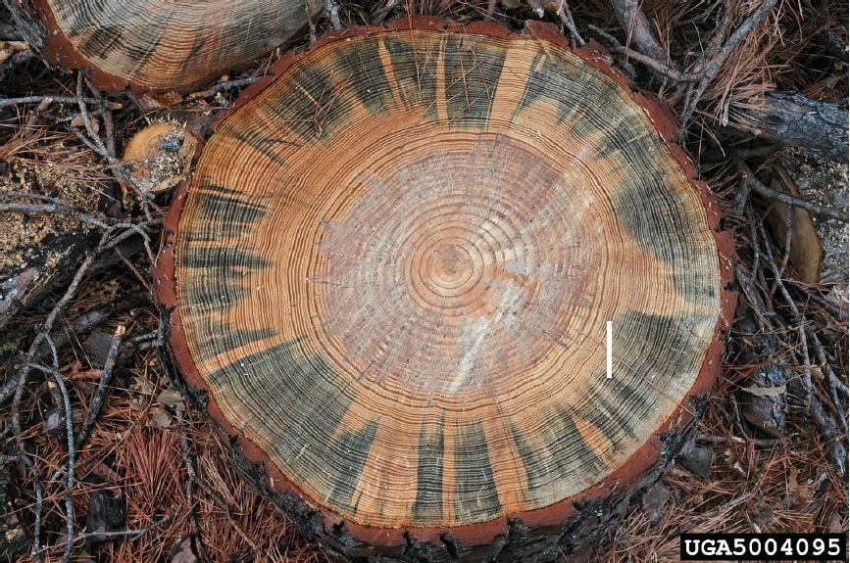
[618]Figure 1. Blue stain fungus (Ceratocystis sp.) affecting wood of Pinus sp.
[619]Note: Scale bar: 5 cm.
[620]Source: Ronald F. Billings, Texas Forest Service, United States of America, Bugwood.org.
[621]
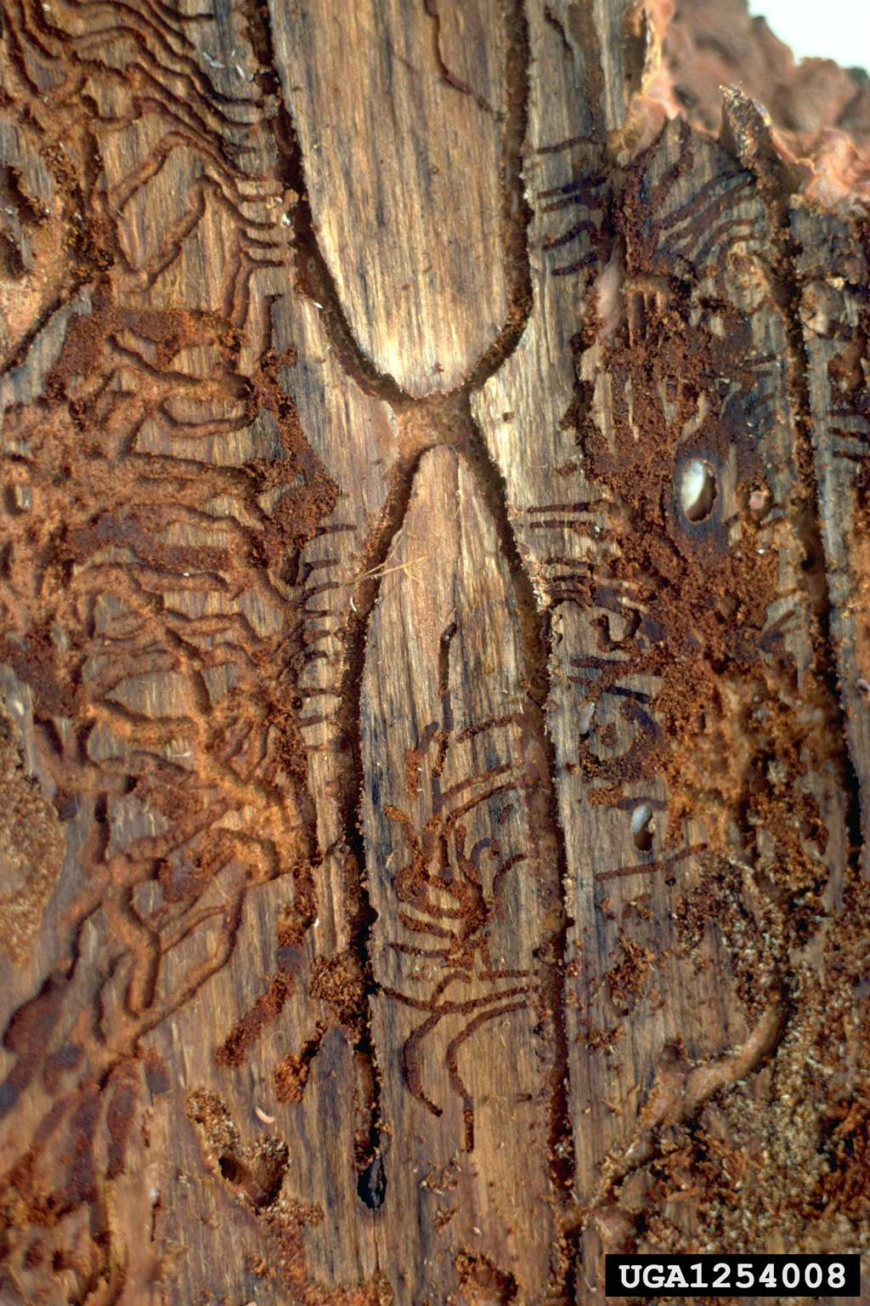
[622]
[623]Figure 2. Partial Ips calligraphus maternal galleries in Pinus wood with radiating and intersecting larval galleries. The central “H”-shaped gallery was built by one male and four females. One adult female (black) and two pupae (white) are shown with arrows.
[624]Note: Scale bar: 5 cm.
[625]Source: William M. Ciesla, Forest Health Management International, Bugwood.org.
[626] 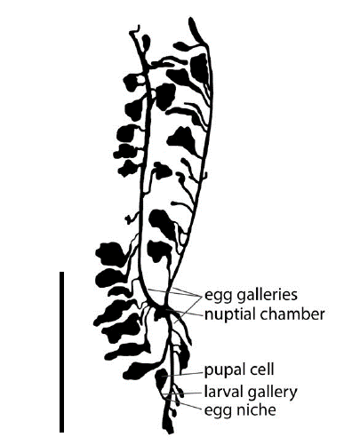
[627]Figure 3. Partial Ips pini gallery system. The central “Y”-shaped gallery was built by one male and three females.
[628]Note: Scale bar: 5 cm.
[629]Source: K. Savard, Agriculture and Agri-Food Canada, Ottawa, Canada.
[630]
[631]
[632]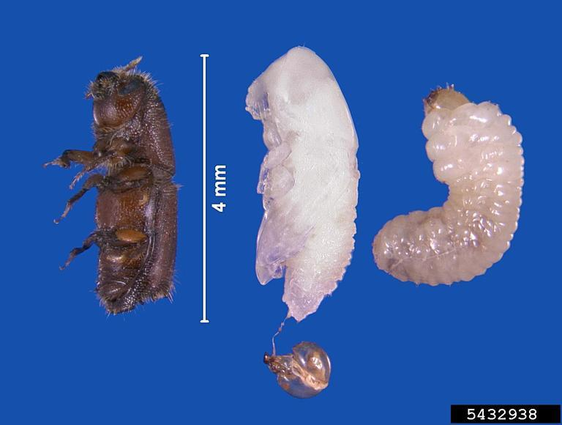
[633]Figure 4. Ips grandicollis: from left to right, adult, pupa (with larval head capsule attached) and larva.
[634]Source: Erich G. Vallery, USDA Forest Service - SRS-4552, Bugwood.org.
[635]
[636]
[637] 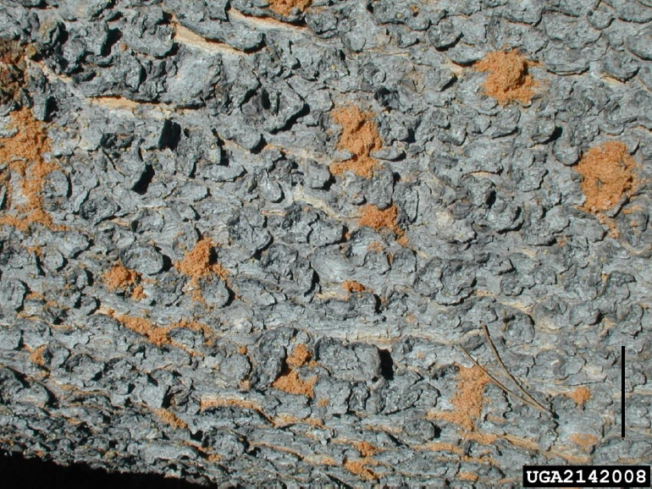
[638]Figure 5. Bark of fallen Pinus sp. tree with boring dust from dense population of Ips pini.
[639]Note: Scale bar: 5 cm.
[640]Source: Brytten Steed, United States Department of Agriculture Forest Service, Bugwood.org.
[641]
[642] 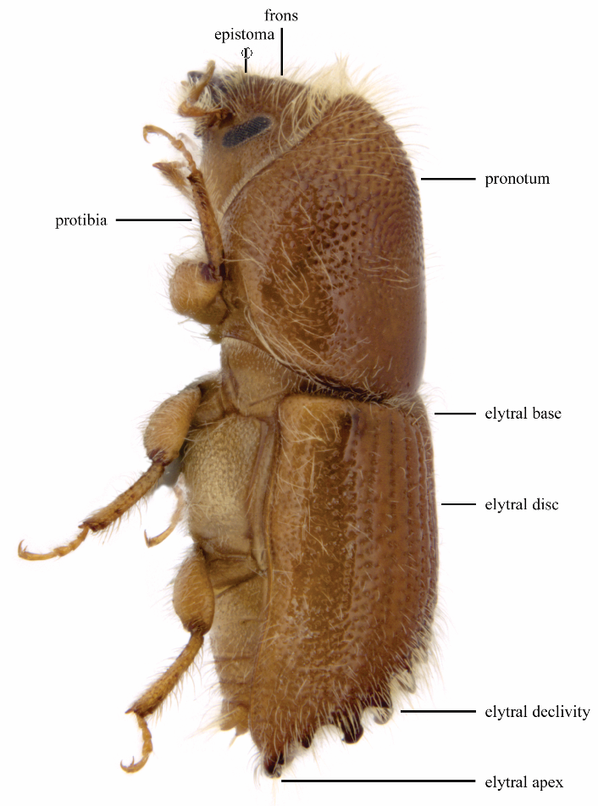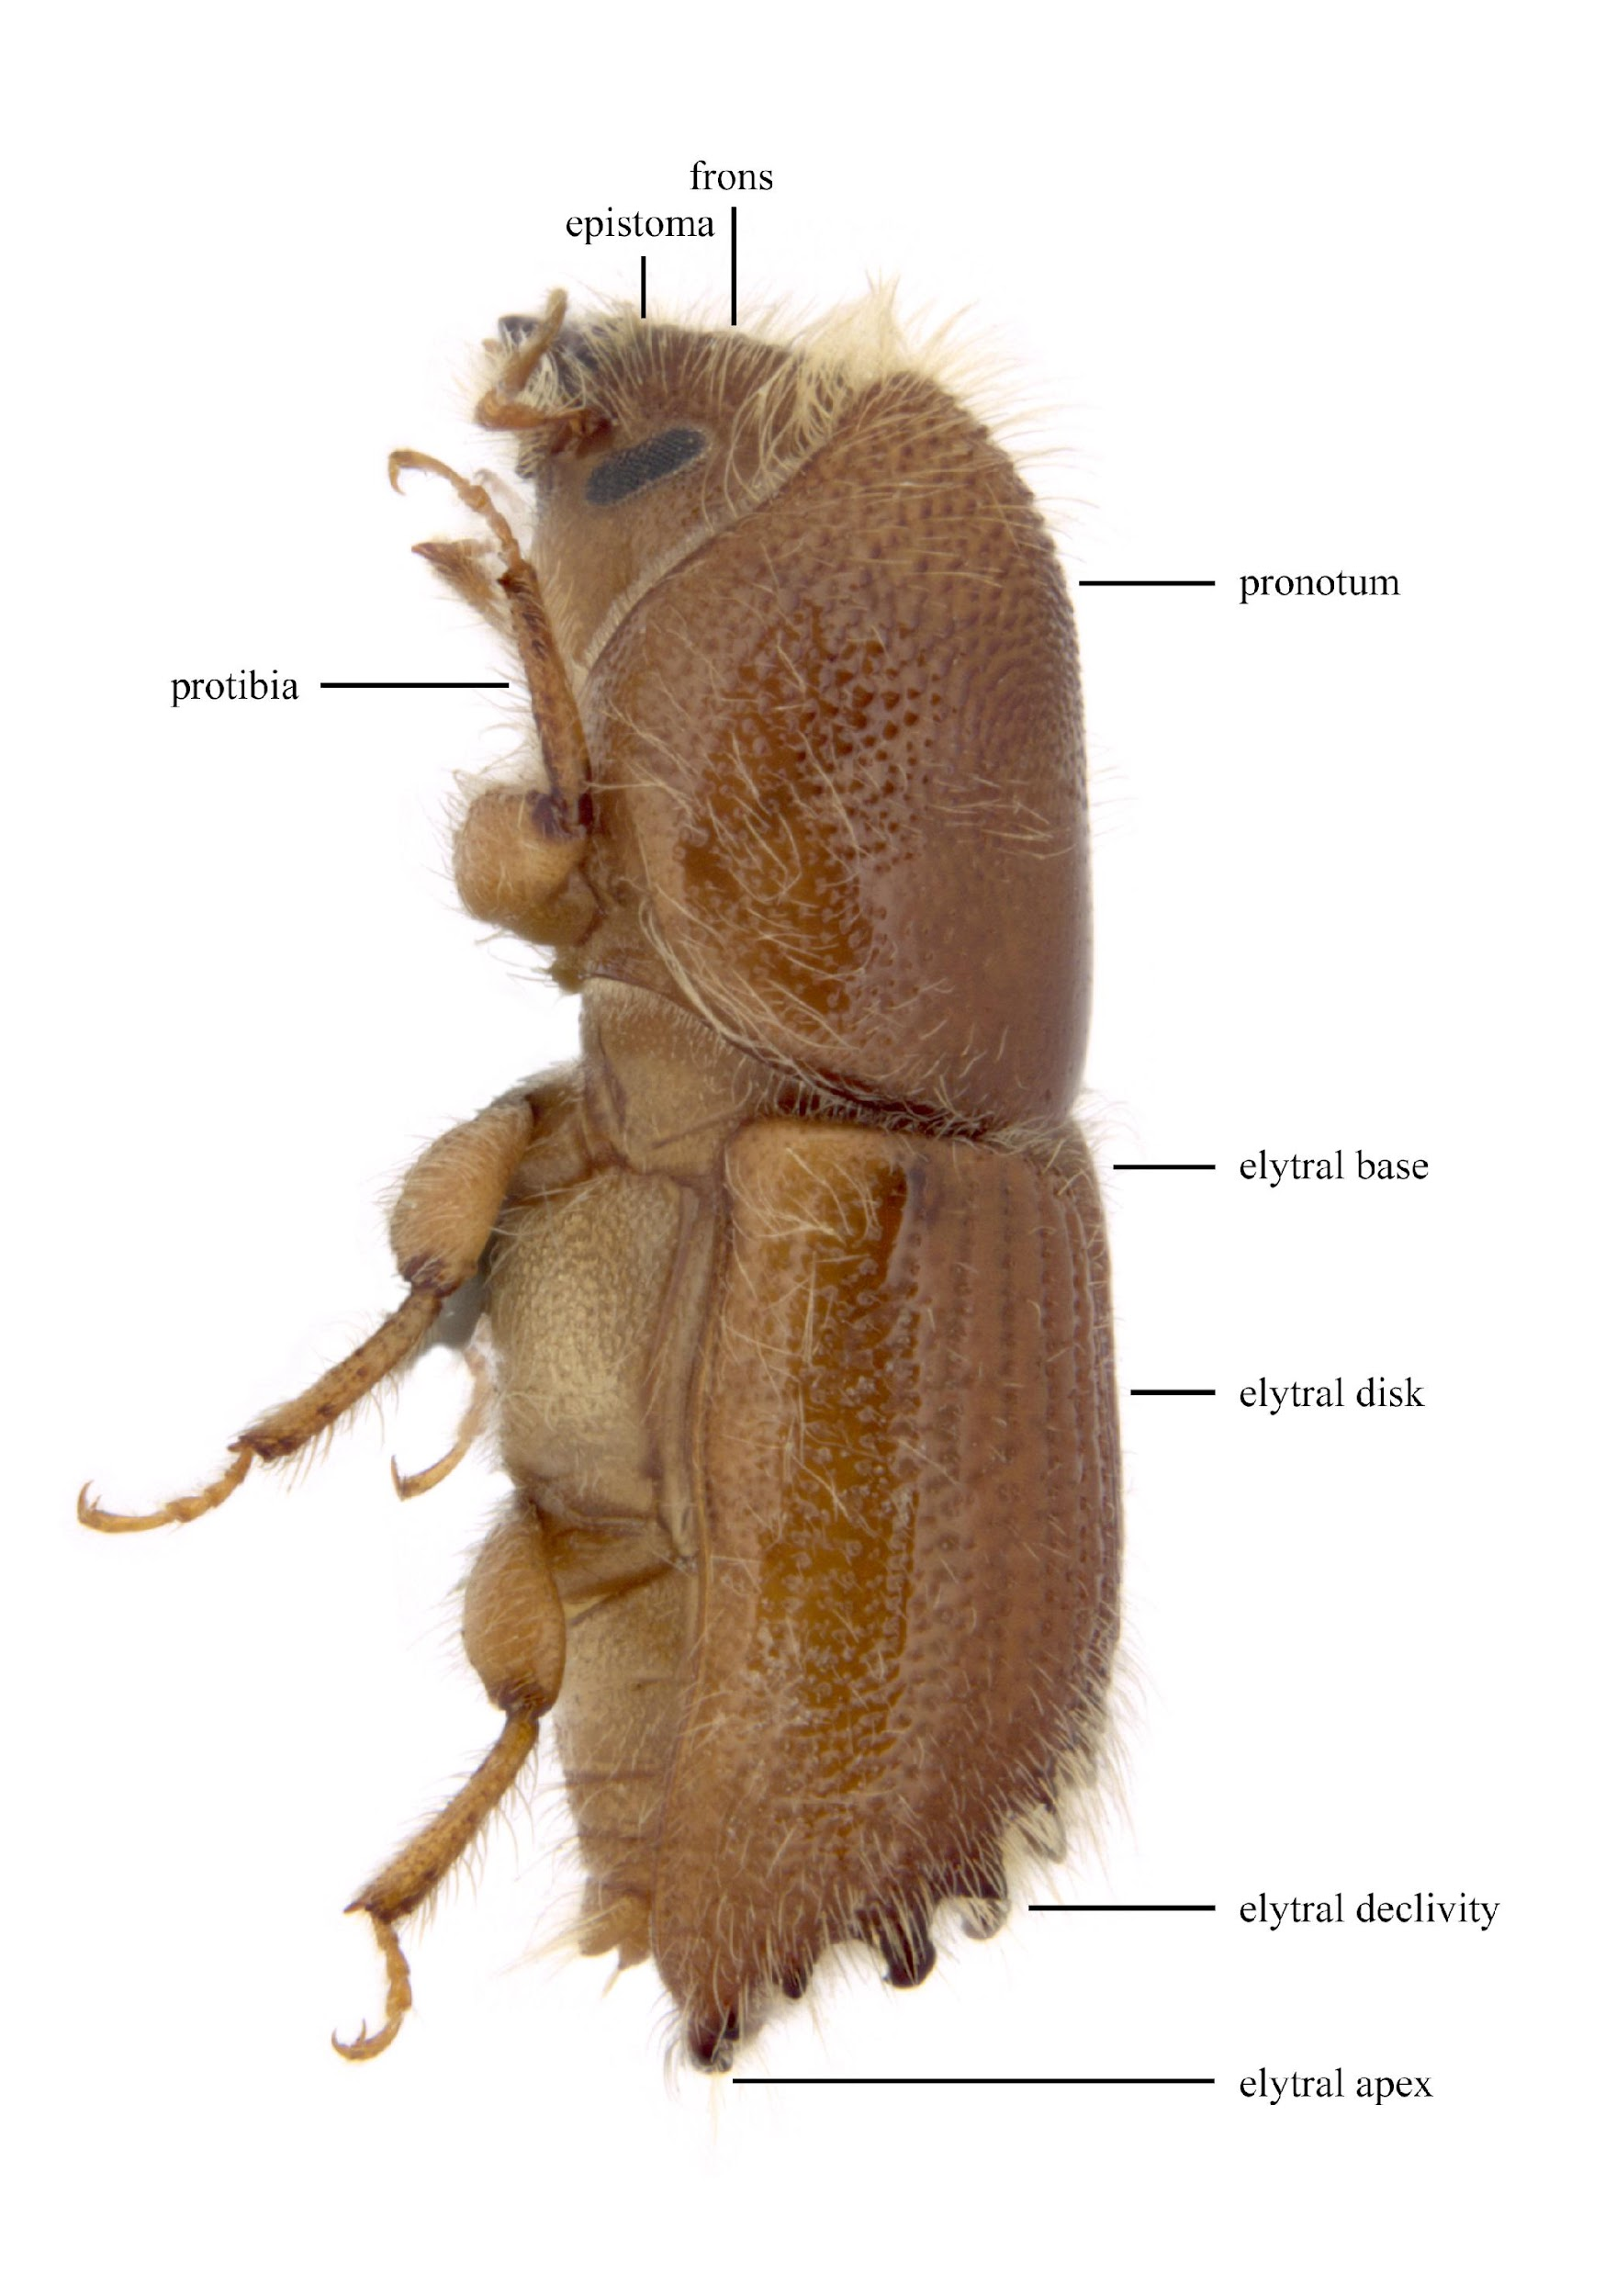Figure 6. Morphology of an adult bark beetle (Ips confusus) in lateral view.
[643]Source: K. Savard, Agriculture and Agri-Food Canada, Ottawa, Canada.
[644]
[645]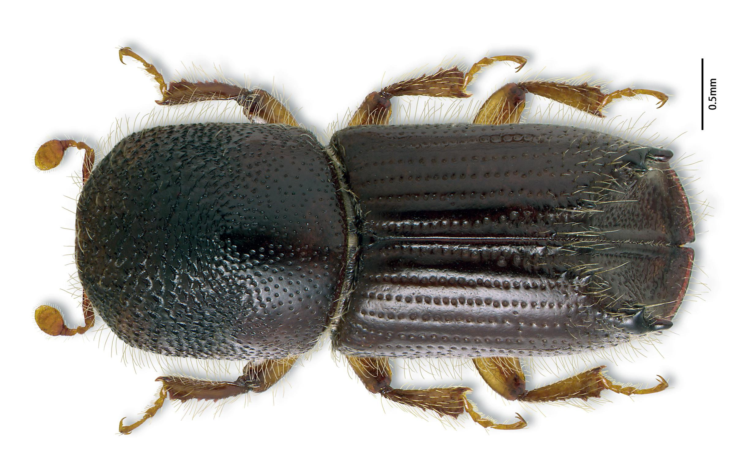Figure 7. Ips pini: dorsal habitus of adult.
[646]Source: K. Bolte, Canadian Forest Service, Ottawa, Canada.
[647]
[648]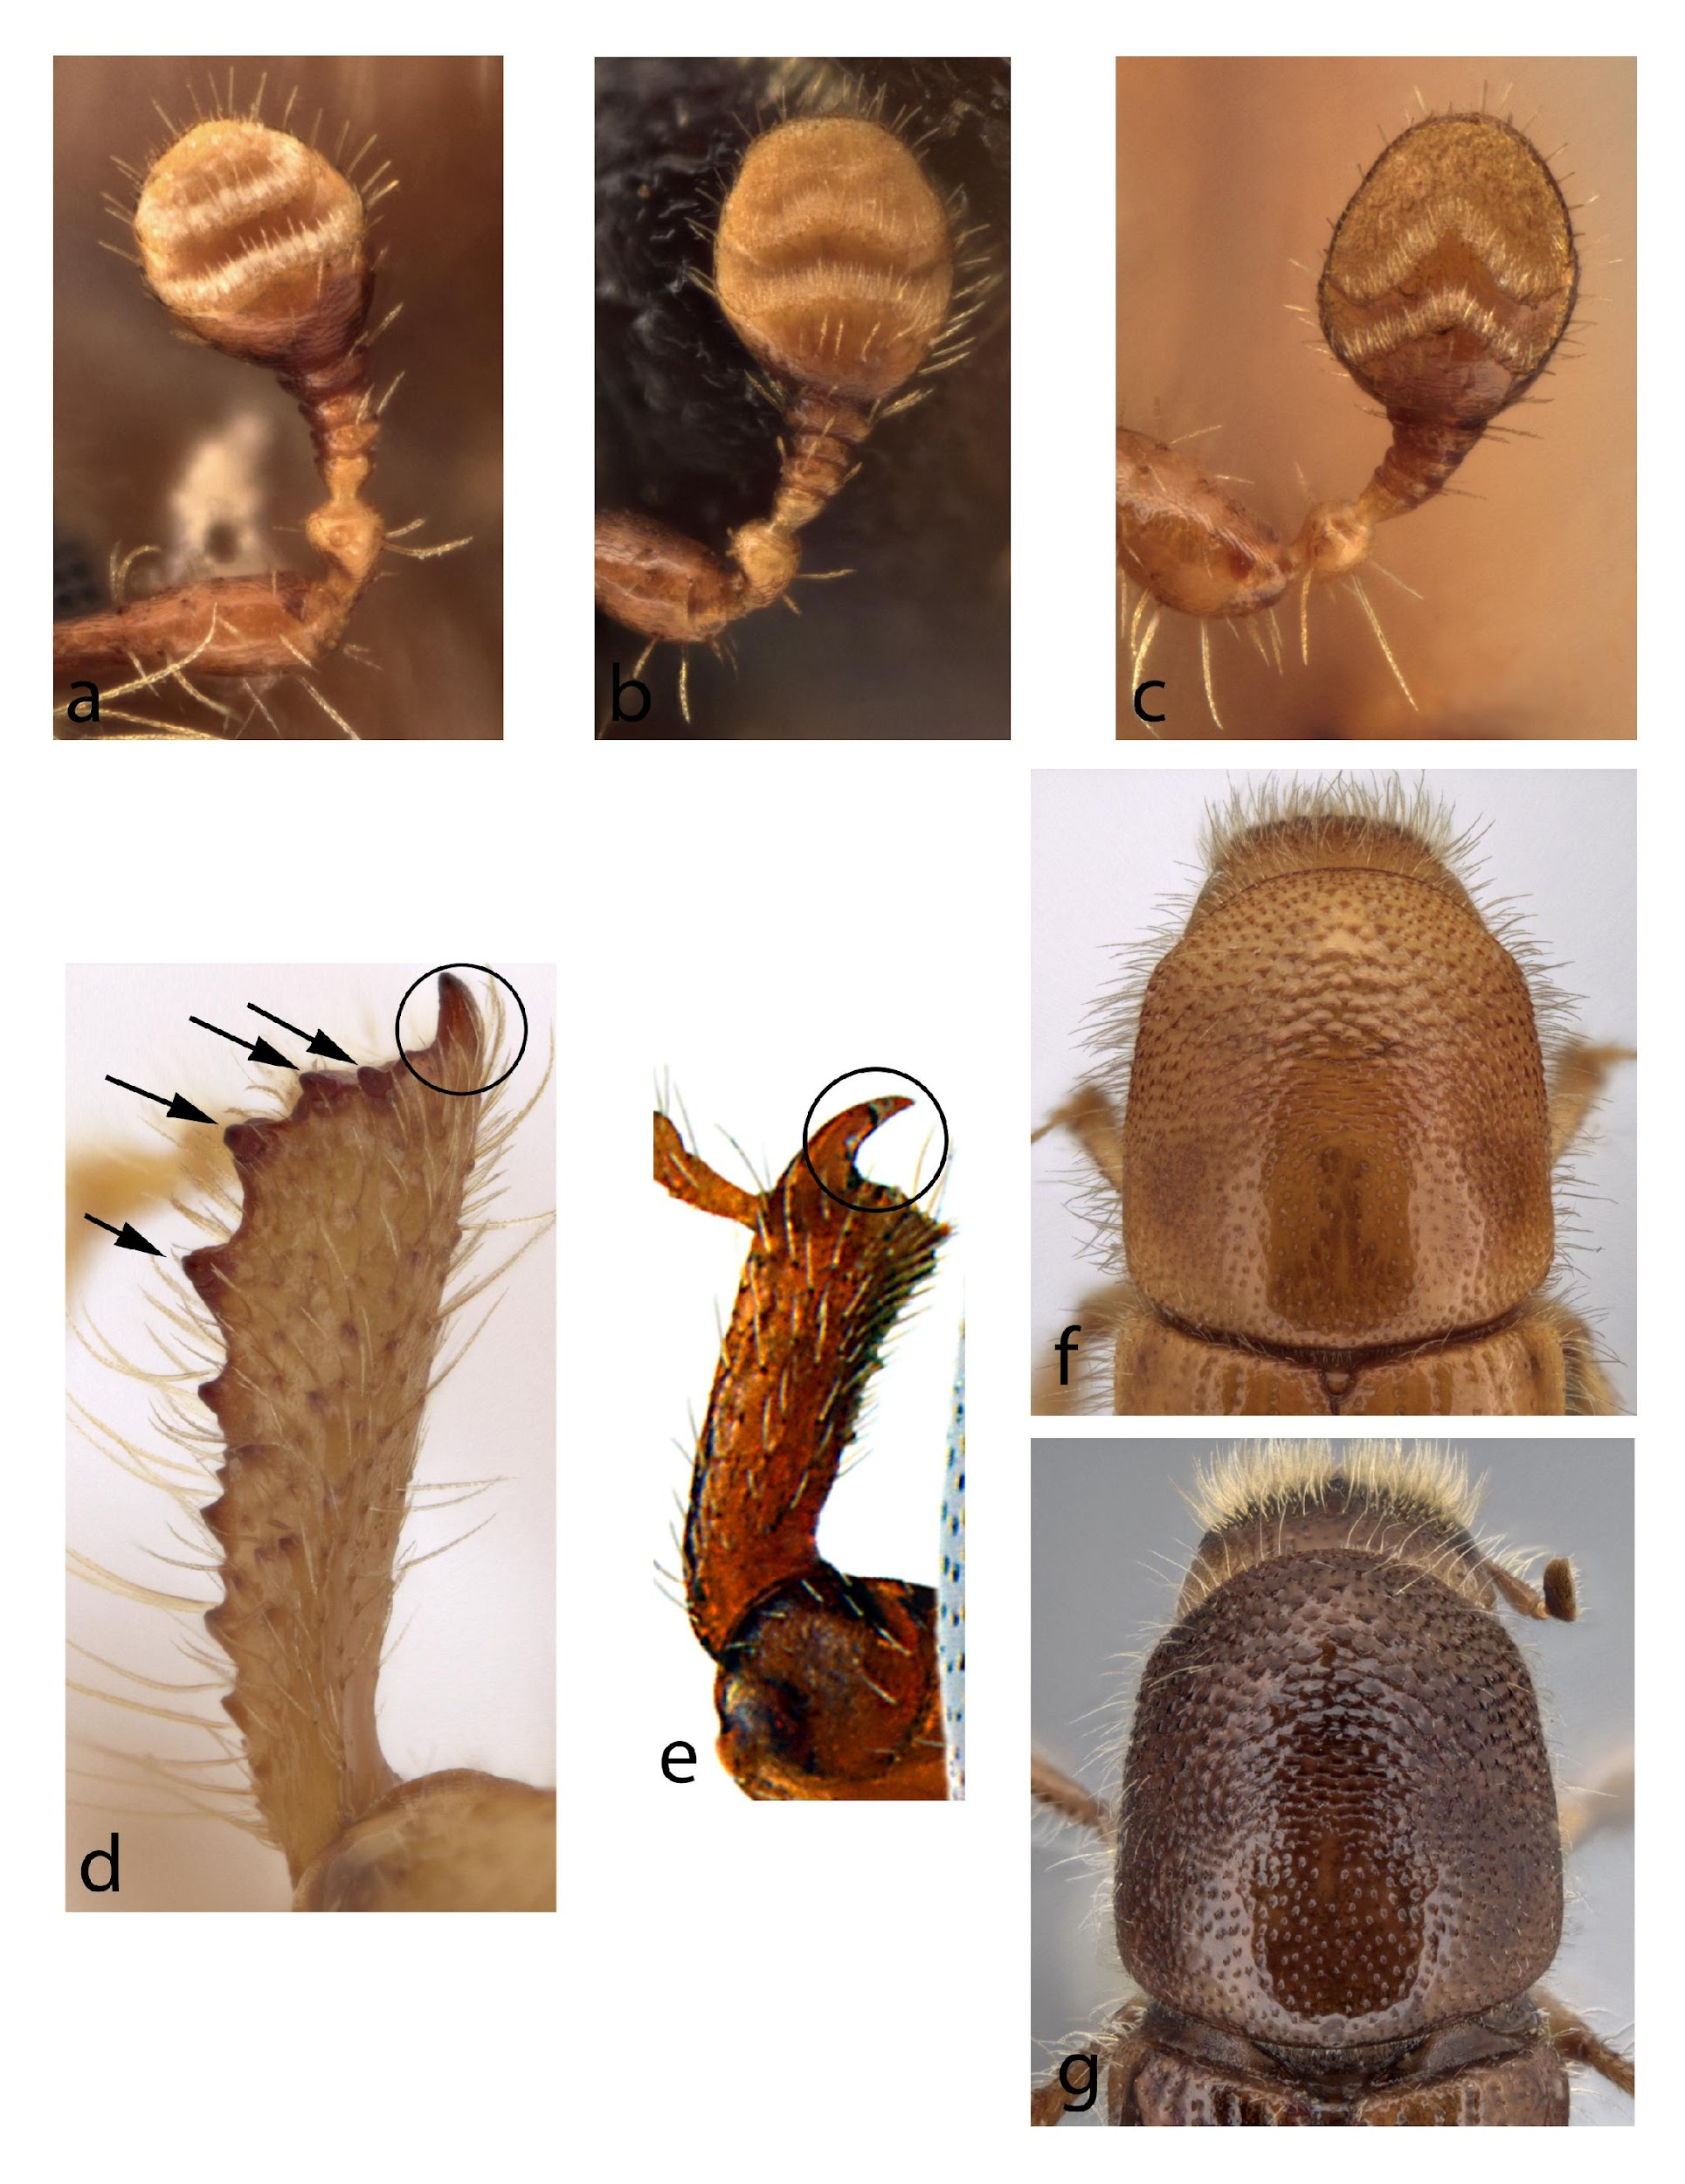
[649]Figure 8. (a)–(c) Antenna of Ips spp.: (a) I. perroti (straight sutures); (b) I. tridens (bisinuate sutures); (c) I. grandicollis (angulate sutures). (d) and (e) Front tibia of Scolytinae spp.: (d) Ips sexdentatus; (e) Scolytus multistriatus. Arrows indicate socketed denticles (teeth); circle surrounds apical non-socketed spine. (f) and (g) Pronotum of Ips spp.: (f) I. pini; (g) I. bonanseai.
[650]Sources: (a)–(d), (f) and (g) K. Savard, Agriculture and Agri-Food Canada, Ottawa, Canada; (e) K. Bolte, Canadian Forest Service, Ottawa, Canada.
[651]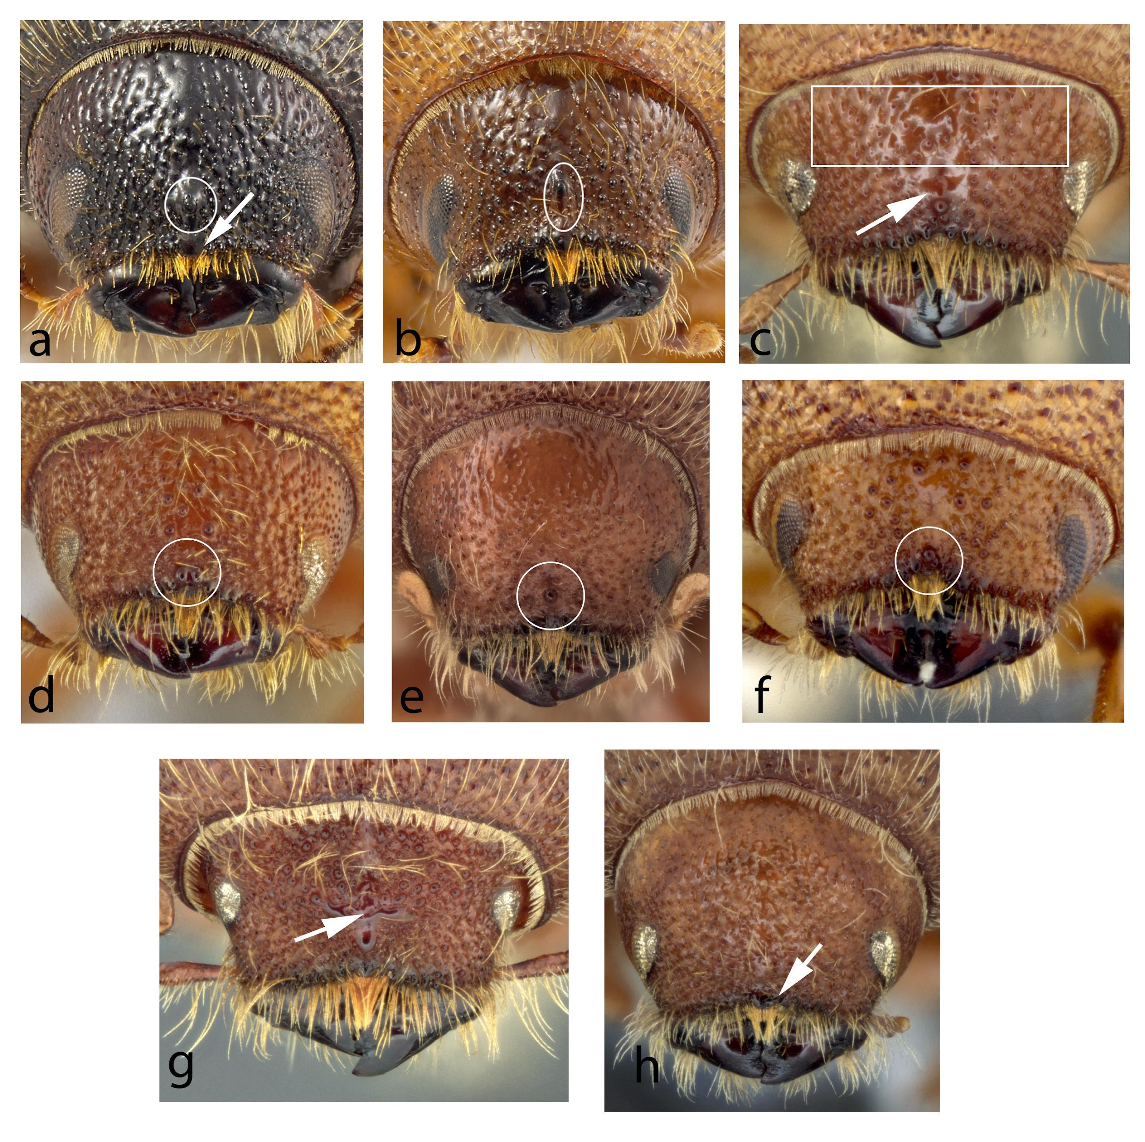
[652]Figure 9. Head of Ips spp.: (a) I. plastographus with round median tubercle (circled) and epistoma marked with an arrow; (b) I. integer with elongate frontal tubercle (in vertical white oval); (c) I. grandicollis with tubercles on frons above eyes highlighted and median fovea marked with arrow; (d) I. lecontei with split frontal tubercle; (e) I. montanus with round central tubercle (circled); (f) I. paraconfusus with tubercle (circled); (g) I. sexdentatus with transverse carina marked with arrow; and (h) I. woodi with epistoma marked with an arrow.
[653]Sources: (a) and (b) K. Bolte, for Canadian Food Inspection Agency; (c)–(h) K. Savard, Agriculture and Agri-Food Canada, Ottawa, Canada.
[654]
[655]
[656]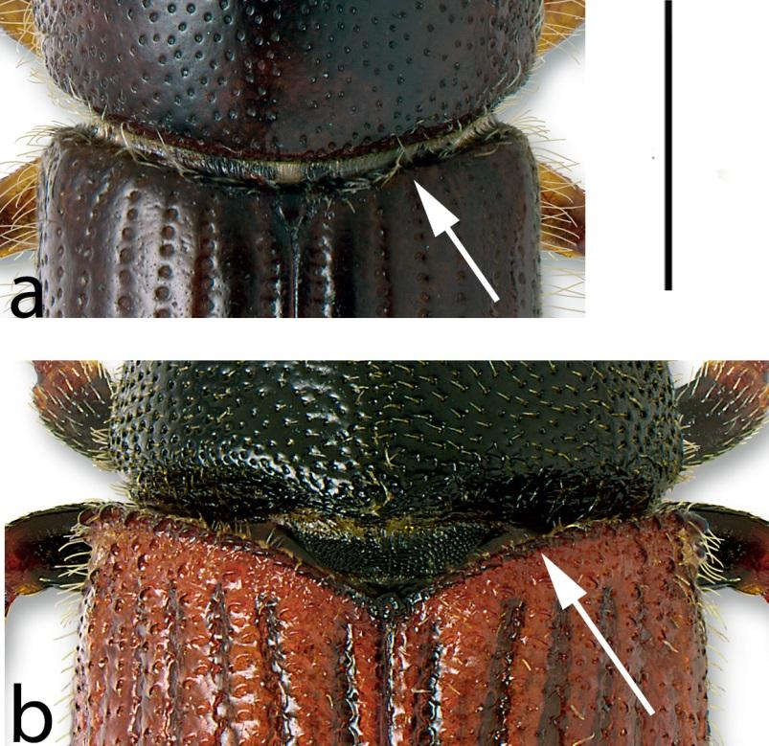
[657]
[658]Figure 10. Anterior edge of elytra (arrow): (a) smooth and not procurved, Ips pini; and (b) asperate (with spines) and procurved, Phloeosinus punctatus.
[659]Note: Scale bar: approximately 1 mm.
[660]Source: K. Bolte, Canadian Forest Service, Ottawa, Canada.
[661]
[662]
[663]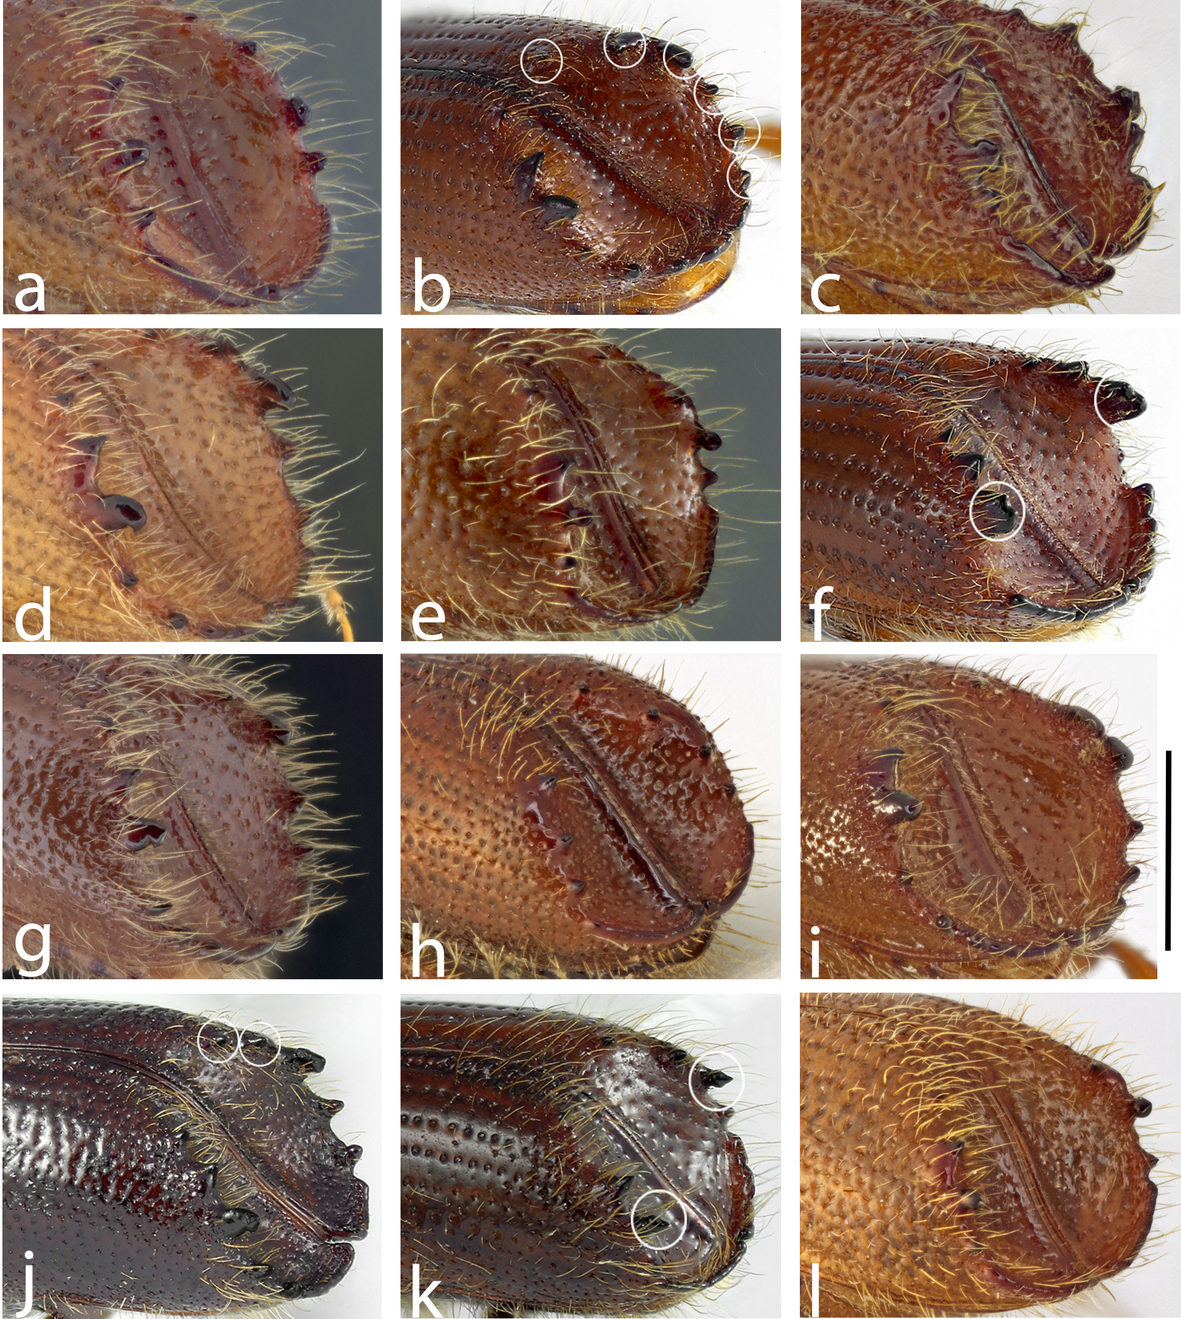
[664]Figure 11. Elytral declivity of Ips spp.: (a) Ips amitinus; (b) Ips calligraphus (six spines); (c) Ips cembrae (third spine petiolate and subacute); (d) Ips confusus; (e) Ips duplicatus; (f) Ips emarginatus (emarginate third spine); (g) Ips grandicollis (five spines); (h) Ips hauseri (third spine tapered and acute); (i) Ips lecontei (third spine hooked and obtuse); (j) Ips montanus (five spines); (k) Ips perturbatus (third spine petiolate and acute); and (l) Ips plastographus (third spine petiolate and subacute).
[665]Note: Scale bar: 1 mm.
[666]Sources: (a), (c), (d), (e), (g)–(i) and (l) K. Savard, Agriculture and Agri-Food Canada, Ottawa, Canada; (b), (f), (j) and (k) K. Bolte, for Canadian Food Inspection Agency, Ottawa, Canada.
[667]
[668]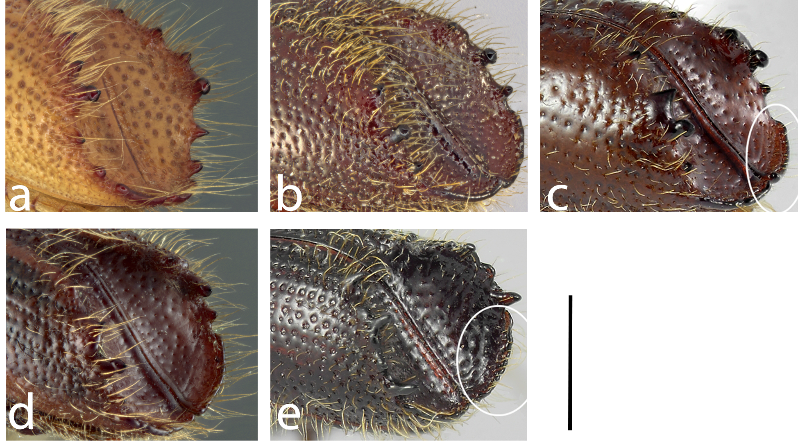
[669]
[670]Figure 12. Elytral declivity of Ipini spp.: (a) Ips sexdentatus; (b) Ips subelongatus (third spine petiolate and subacute); (c) Ips tridens (explanate apex of declivity); (d) Ips typographus; and (e) Orthotomicus latidens (smaller explanation of apex of declivity).
[671]Note: Scale bar: 1 mm.
[672]Sources: (a, b and d) K. Savard, Agriculture and Agri-Food Canada, Ottawa, Canada; (c and e) K. Bolte, for Canadian Food Inspection Agency, Ottawa, Canada.
[673]
[674]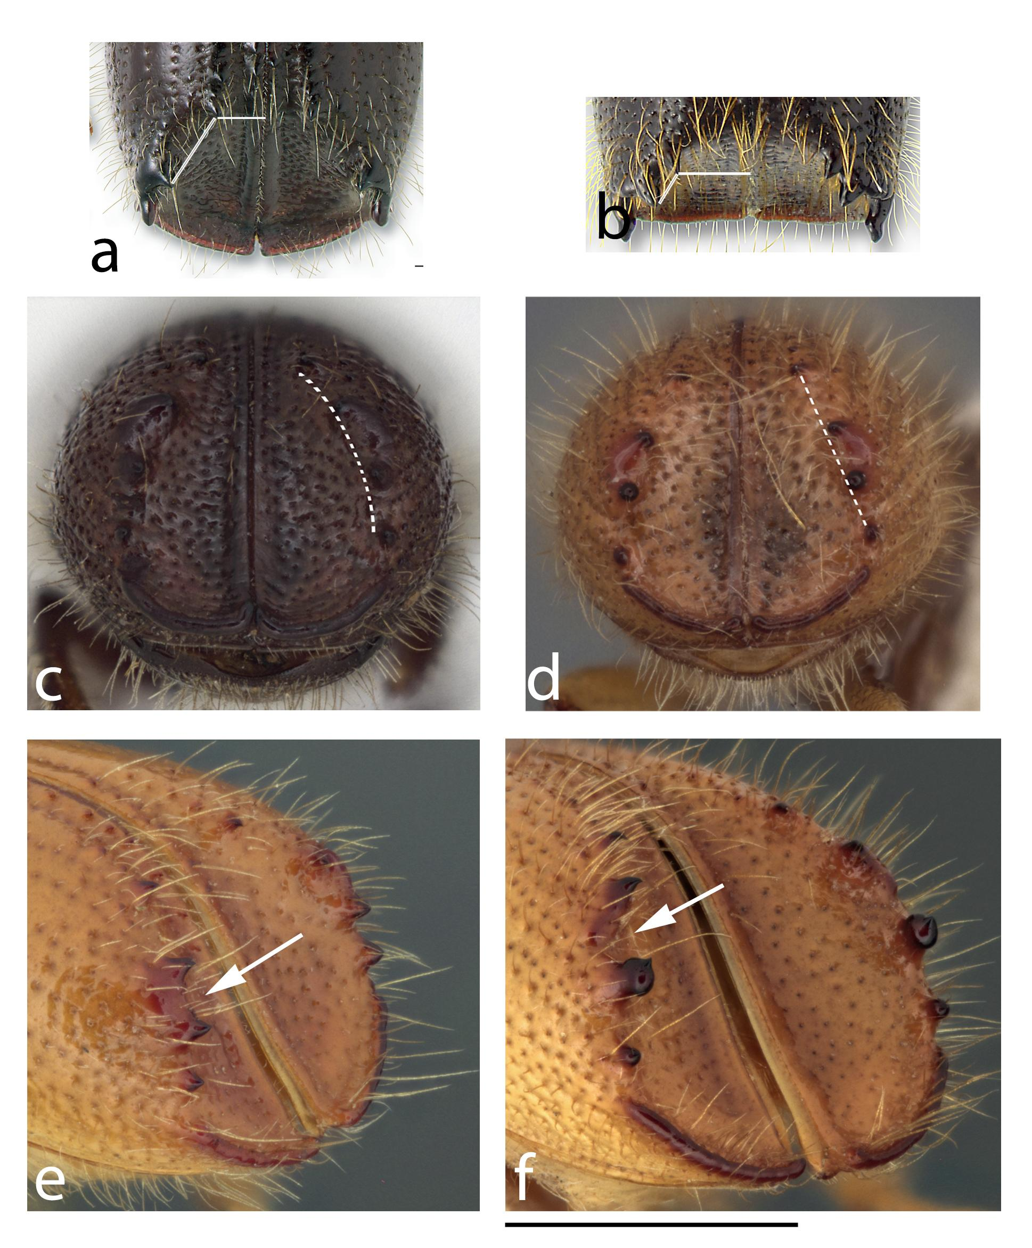
[675]Figure 13. (a) and (b) Elytral declivity of Ipini spp., showing relative distances between first spine and suture vs first and second spines: (a) Ips pini (first spine closer to suture); (b) Pseudips mexicanus (first spine closer to second spine). (c) and (d) Elytral declivity of Ips spp., showing curvature of spine rows: (c) Ips hauseri; (d) Ips duplicatus. (e) and (f) Elytral declivity, showing tumescence: (e) Ips pini with spines 2 and 3 arising from shared tumescence; (f) Ips nitidus with spines 2 and 3 not arising from shared tumescence.
[676]Note: Scale bar: (c) and (d) 1 mm; (e) and (f) 0.75 mm.
[677]Sources: (a) and (b) K. Bolte, for Canadian Food Inspection Agency, Ottawa, Canada; (c)–(f) K. Savard, Agriculture and Agri-Food Canada, Ottawa, Canada.
[684]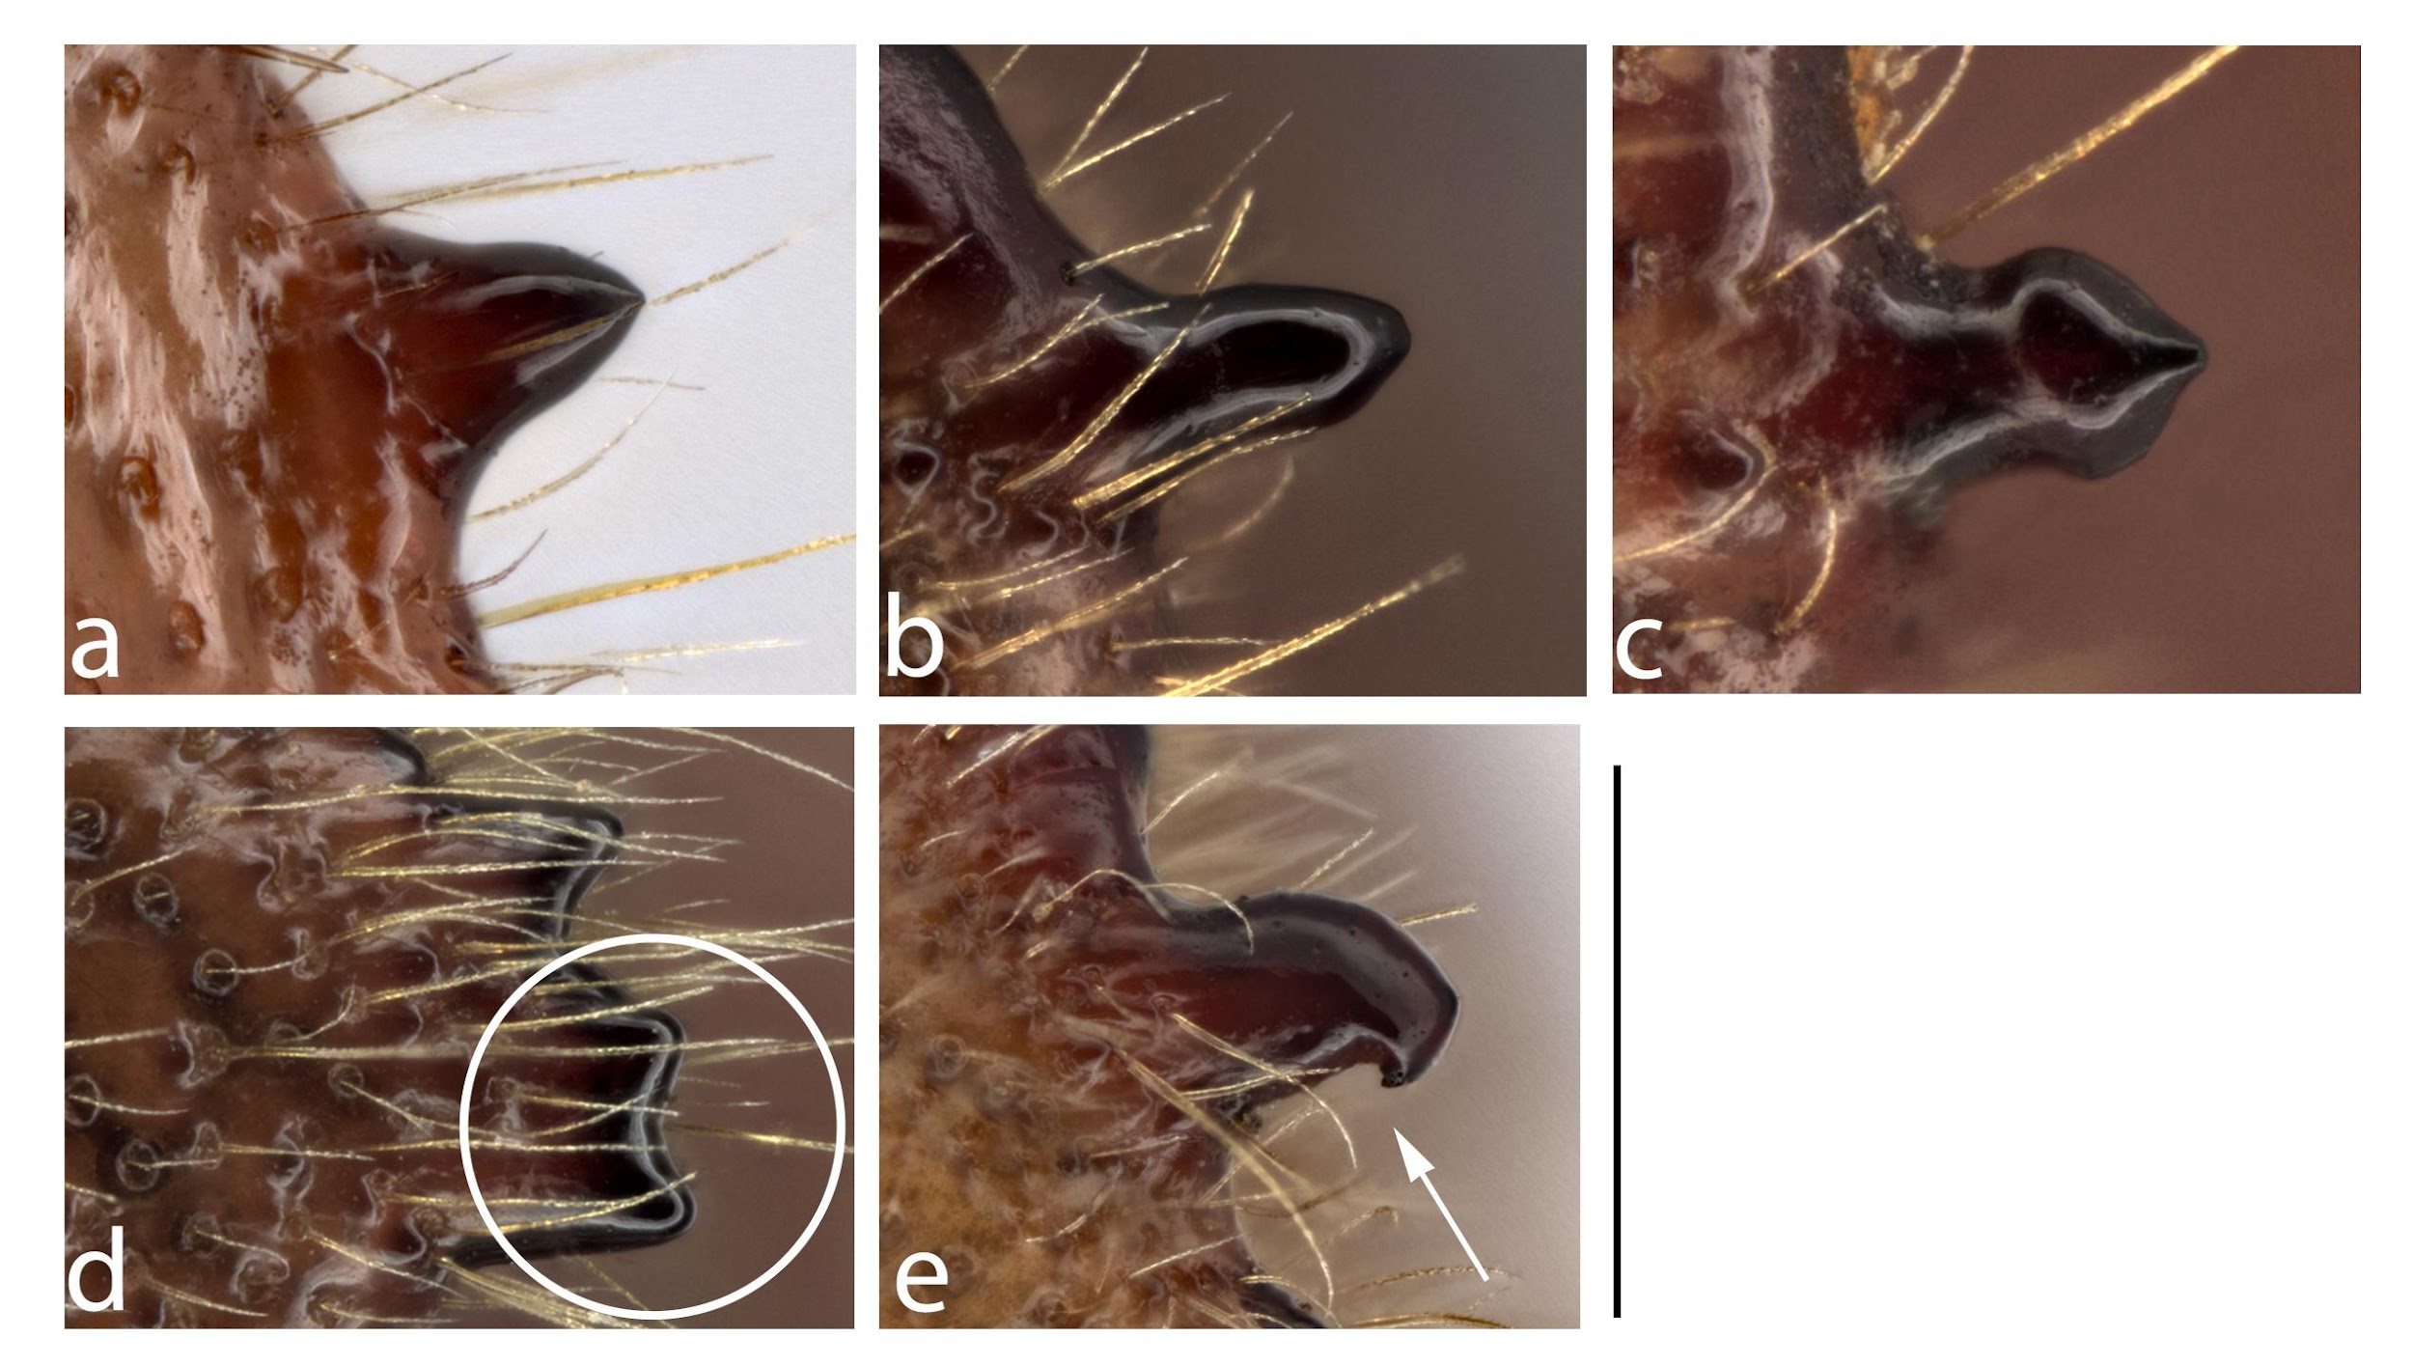
[685]Figure 14. Shape of spines of elytral declivity of Ips spp.: (a) tapered; (b) straight-sided with tapered apex; (c) petiolate (narrowed near base); (d) emarginate (two apices); and (e) hooked (point on posterior edge shown with arrow).
[686]Note: Scale bar: 0.5 mm.
[687]Source: K. Bolte, for Canadian Food Inspection Agency, Ottawa, Canada.
[688]
[678]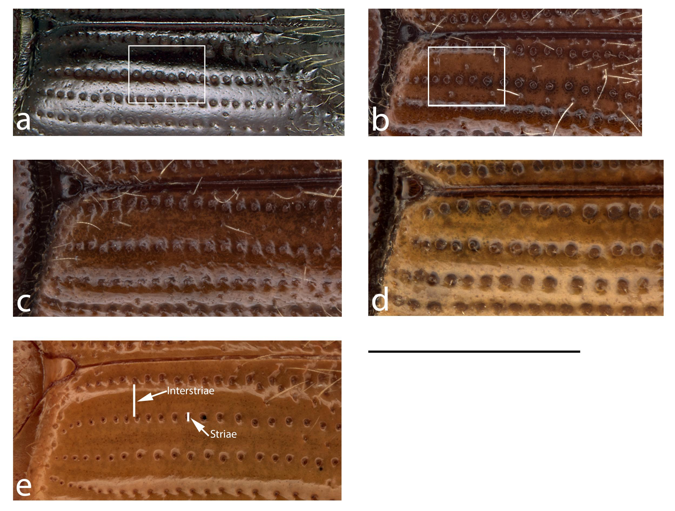
[679]Figure 15. Elytral disc of Ips spp., showing punctation of elytral intervals (between major strial rows of punctures): (a) Ips pini (without punctures); (b) Ips montanus (punctate); (c) Ips lecontei; (d) Ips avulsus; and (e) Ips nitidus.
[680]Note: Scale bar: 1.5 mm.
[681]Sources: (a) K. Bolte, for Canadian Food Inspection Agency, Ottawa, Canada; (b–e) K. Savard, Agriculture and Agri-Food Canada, Ottawa, Canada.
[682]
[683]
[689]
[690]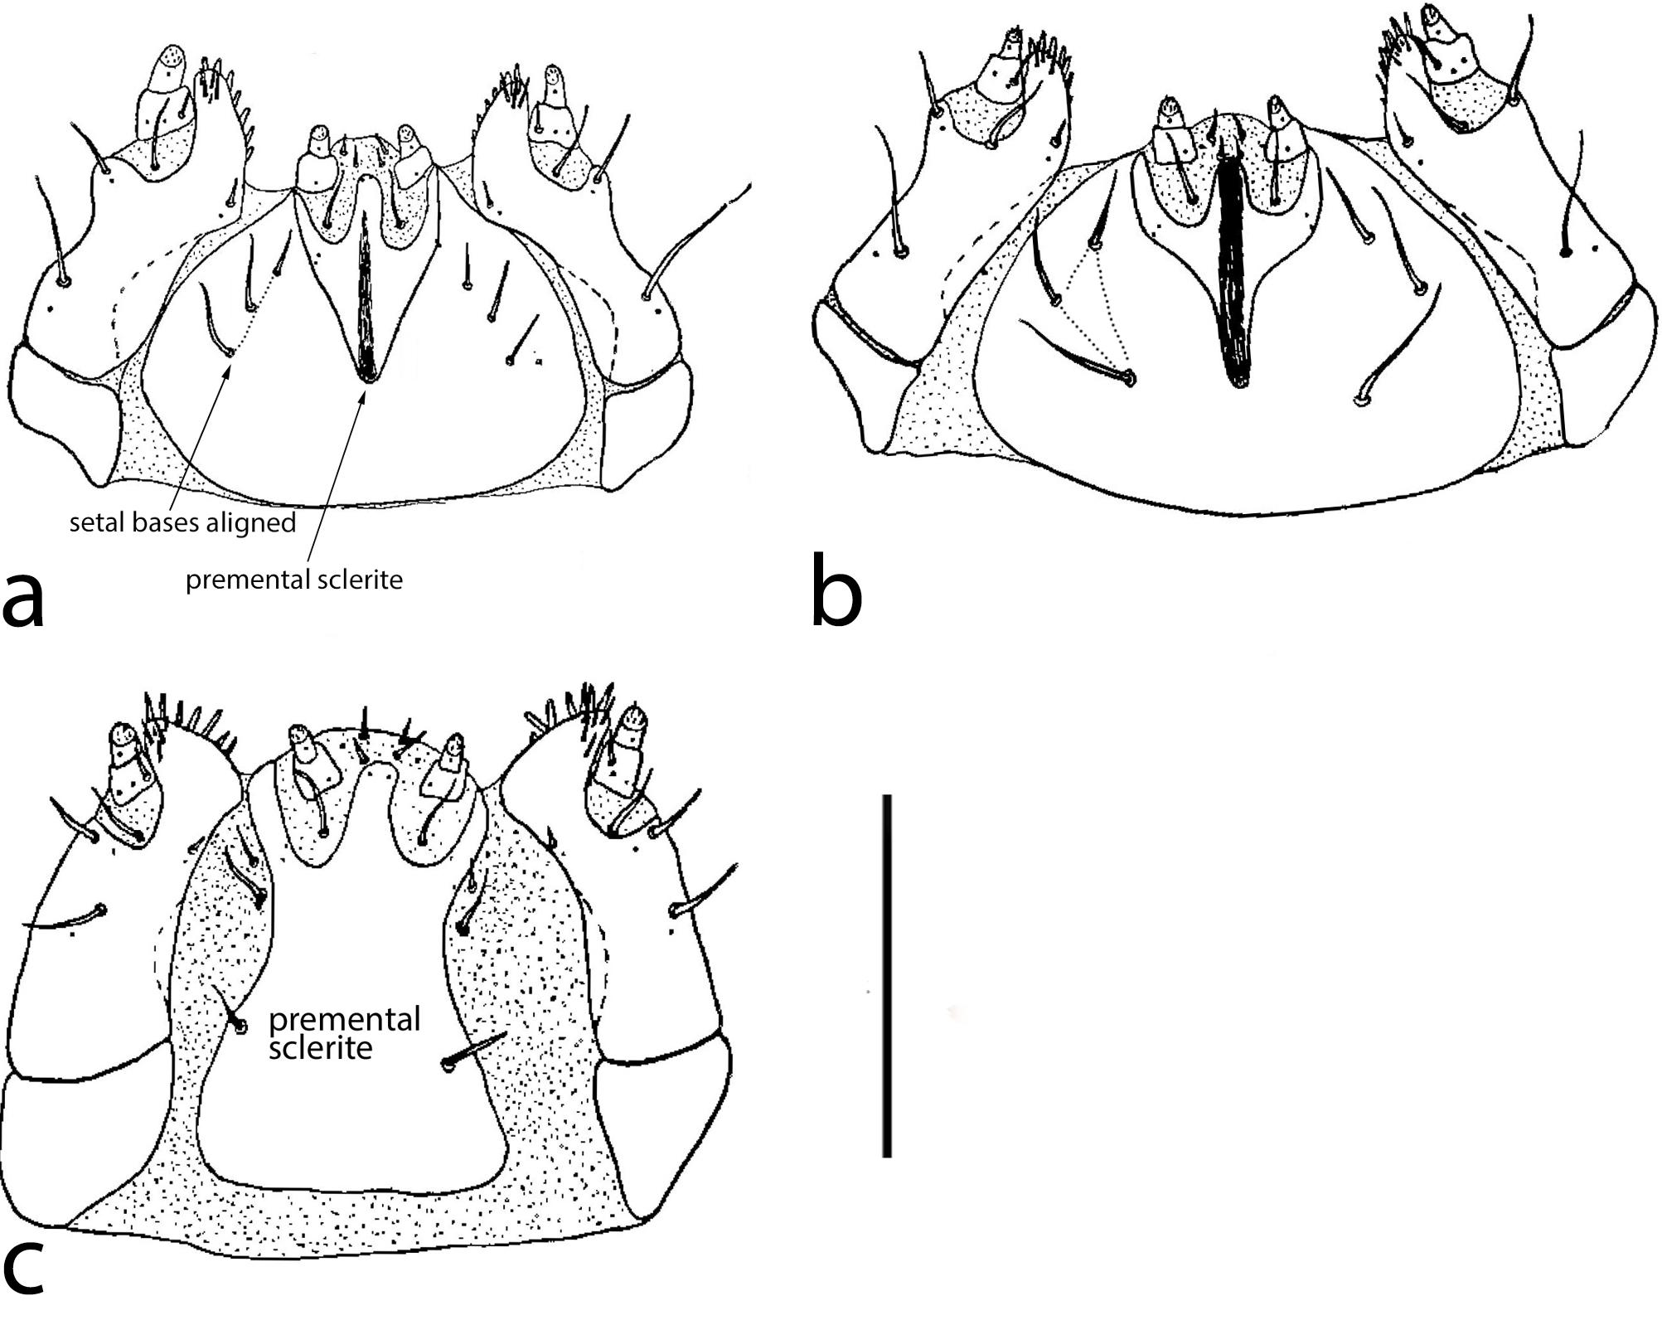
[691]Figure 16. Scolytinae larvae, ventral view of mouthparts: (a) Ips pini, showing triangular premental sclerite and aligned postlabial setal bases; (b) Polygraphus rufipennis with postlabial setal bases arranged in a triangle; and (c) Trypodendron lineatum with premental sclerite rectangular.
[692]Note: Scale bar: 0.5 mm.
[693]Source: Thomas, J.B. 1957. The use of larval anatomy in the study of bark beetles (Coleoptera: Scolytidae). The Memoirs of the Entomological Society of Canada, 89(S5): 3–45.
[694]
[695]
[696]
[697]
[698]
[699]

