[PleaseReview document review. Review title: 2024 consultation: Draft annex to ISPM 27: Meloidogyne mali. (2018-019). Document title: 2018-019_DP_M_mali.docx]

[1]DRAFT ANNEX TO ISPM 27: Meloidogyne mali (2018-019)
[2]Status box
[3]This is not an official part of the standard and will be modified after adoption.
[4]Date of this document | [5]2024-06-10
[6]Document category | [7]Draft new annex to ISPM 27 (Diagnostic protocols for regulated pests)
[8]Current document stage | [9]To consultation
[10]Origin | [11]Work programme topic: Nematodes (2006-008)  [12]Original subject: Meloidogyne mali (2018-019)
[13]Major stages | [14]2018-11 Subject proposed during 2018 IPPC call for topics.  [15]2018-11 SC added Meloidognye mali (2018-009) to work programme, priority 3.  [16]2022-04 Expert consultation.  [17]2023-11 Technical Panel on Diagnostic Protocols (TPDP) reviewed  [18]2024-06 TPDP recommended the draft DP for approval for consultation  [19]20204-06 SC approved the draft DP for consultation
[20]Discipline leads history | [21]2019-08 Géraldine ANTHOINE (FR, Discipline lead)  [22]2019-08 Norman BARR (US, Referee)
[23]Consultation on technical level | [24]The first draft of this diagnostic protocol was prepared by:  - [25]Thomas PRIOR (GB) (lead author)  - [26]Jianfeng GU (CN)  - [27]Gerrit KARSSEN (NL)  - [28]Fengcheng SUN (CA)  - [29]Trinh Thi Thu THUY (VN)  [30]In addition, the draft has also been subject to expert review and the following international experts submitted comments:  - [31]Evelyn van Heese (NIVIP, Kingdom of the Netherlands)  - [32]Dr Aphorio Silva de Oliveira (NVWA, Kingdom of the Netherlands)  - [33]Yiwu Fang (Technical Center of Ningbo Customs, China)
[34]Main discussion points during development of the diagnostic protocol  [35][to be updated throughout DP development] | [36][to be completed later]  [37] (Note: Especially after experts have been consulted at early stages of development, the cover note should indicate substantial comments that were not incorporated in the draft. Include as bullet points.)
[38]Notes | [39]This is a draft document.  [40]2023-06 Edited  [41]2024-05 Edited
[42]Contents
[43][to be added later]
[44]Adoption
[45]This diagnostic protocol was adopted by the Standards Committee on behalf of the Commission on Phytosanitary Measures in ----. [to be completed after adoption].
[46]The annex is a prescriptive part of ISPM 27 (Diagnostic protocols for regulated pests).

[47]1. Pest information
[48]The root-knot nematode genus Meloidogyne comprises at present more than 100 formally described species. All species are endoparasitic and some are well known for their negative impact on crops worldwide (Karssen, Wesemael and Moens, 2013).
[49]A relatively small number of the described species are known to parasitize trees and shrubs (Jepson, 1987). One such species is Meloidogyne mali Itoh, Ohshima and Ichinohe, 1969 – a species described from Malus domestica (apple) in Japan (Itoh, Ohshima and Ichinohe, 1969). M. mali is a polyphagous and economically important pest species that induces large root galls on host plants, affecting the ability of the plant to take up water and nutrients from the soil. It was added to the European and Mediterranean Plant Protection Organization’s List of pests recommended for regulation as quarantine pests (EPPO A2 List: EPPO, n.d.(a)) in 2017.
[50]M. mali is widely distributed in Japan, where the stunting and severe decline of infected trees in orchards has been reported (Nyczepir and Halbrendt, 1993). It has been recorded parasitizing a large number of host trees, shrubs and herbaceous plants, as listed in the EPPO (2017) pest risk analysis for M. mali. To date, very little information is available on yield losses in cultivated plants. As this is an emerging pest on many tree and ornamental plant hosts, the economic impacts of the loss of these hosts in natural environments have also not yet been established.. The following examples, however, may provide an indication of the impact:
- [51]Morus sp. (mulberry): In a pot trial, up to 50% crop loss was shown in young trees, depending on the level of infestation (Toida, 1991).
- [52]Malus domestica (apple): M. mali is described as one of the most damaging nematodes for apples in northern Japan, causing the stunting and severe decline of trees in orchards (Itoh, Ohshima and Ichinohe, 1969; Nyczepir and Halbrendt, 1993). M. mali reduces apple tree growth by 15–43% and fruit yield is reduced on heavily infested trees (Nyczepir and Halbrendt, 1993).
[53]This species is considered to have been introduced into the Kingdom of the Netherlands, during which time a large amount of Ulmus sp. (elm) material (seeds, cuttings and occasionally rooted material) was imported. In 1992, rooted elm seedlings were sent to several other European countries (Heybroek, 1993). The nematode was reported from elm trees in Italy by Palmisano and Ambrogioni (2000) as a new species Meloidogyne ulmi, which was later synonymized to M. mali (Ahmed et al., 2013). To date, in addition to Japan, M. mali has been reported locally in Europe, the Republic of Korea and the United States of America (EPPO, n.d.(b)). Based on a pest risk analysis, M. mali is regulated in many countries (EPPO, n.d.(b)).
[54]M. mali has sedentary endoparasitic habits. Males are common, as M. mali is a sexually reproducing nematode (Janssen et al., 2017). In Japan, the life cycle of M. mali on Maluspumila has been observed to last 18–22 weeks, with one generation per year (Sakurai et al., 1973; Inagaki, 1978). The development from egg masses to second-stage (J2) juveniles in those egg masses takes approximately two weeks. Further generations in the growing season may develop, depending on the temperature and the presence of perennial host plants; this is also reported for the related species M. ardenensis. Egg-laying females of M. mali (and M. ardenensis) have been observed in the Kingdom of the Netherlands in early March, which may indicate that overwintering of young females is possible (G. Karssen, personal communication, 2024). It has also been suspected that M. mali overwinters within the roots of infested plants, although the developmental stage at which this occurs is not yet known (Ahmed et al., 2013).
[55]M. mali shares geographical areas and hosts with five species of Meloidogyne for which it could be confused on the basis of its morphology: M. ardenensis in Europe (on Quercus robur (Subbotin, Palomares-Rius and Castillo, 2021)), M. camelliae in Japan and Thailand (on Solanum lycopersicum (Subbotin, Palomares-Rius and Castillo, 2021)), M. paramali in Japan (on Acer palmatum (Gu et al., 2023)), M. suginamiensis in Japan (on Acer sp., Morus sp., Prunus sp., Ulmus sp. (Toida and Yaegashi, 1984; Brown, Dalmasso and Trudgill, 1993; Subbotin, Palomares-Rius and Castillo, 2021)) and M. vitis in Japan (on Vitis vinifera (Yang et al., 2021)).

[56]2. Taxonomic information
[57]Name: Meloidogyne mali Itoh, Ohshima & Ichinohe, 1969
[58]Synonym: Meloidogyne ulmi Palmisano & Ambrogioni, 2000
[59]Taxonomic position: Nematoda, Tylenchida, Meloidogynidae
[60]Common name: apple root-knot nematode (other common names in various languages are listed in CABI (n.d.))

[61]3. Detection

[62]3.1 Hosts and symptoms
[63]M. mali induces galls up to 0.5 cm in diameter on young roots (Figure 1); however, on older roots these galls become larger (1–2 cm in diameter; Figure 2). These large galls are typical for M. mali (see also the original description of M. mali in Itoh, Ohshima and Ichinohe (1969) and Palmisano and Ambrogioni (2000)).
[64]Above-ground symptoms in trees are only visible when the trees become heavily infested. Then, they will show early leaf fall and reduced growth. In the Kingdom of the Netherlands, several cases have been reported of heavily infested elms being uprooted during (or following) storms (EPPO, 2017, 2018).
[65]The principal hosts of M. mali are Malus spp. (ornamental apple species), Ulmus spp. (elms) and Morus spp. (mulberry). It has also been recorded parasitizing a wide range of other plants, including trees, shrubs and herbaceous plants, such as Acer spp. (Japanese maple), Apium graveolens (celery), Arctium lappa (greater burdock), Castanea crenata (Japanese chestnut), Cucumis sativus (cucumber) and Euonymus fortunei (wintercreeper) and Lagerstroemia indica (Indian crape myrtle) (EPPO, 2017, n.d.(b)).

[66]3.2 Extraction
[67]Above-ground symptoms of heavily infested plants include stunting and yellowing, while below ground typical root galls are found (Figure 1 and Figure 2). Laboratory analysis is performed from a sample of 0.5–1 kg soil or growing media mixed with the roots from 3–5 host plants. To detect the presence of nematodes, it is necessary to extract nematodes from roots (all life stages possibly recovered), soil or growing media (only motile males and J2 juveniles recovered). For all type of samples a modified Baermann funnel method (e.g. a Whitehead tray), can be used for nematode extraction (EPPO, 2013). Root galls, if present, are analysed using a dissecting microscope. These galls may have associated egg masses. If galls with egg masses are observed, mature swollen females, males and J2 juveniles can be obtained. Mature females can be isolated from the roots by dissecting the root tissue under a dissecting microscope with transmitted light. They should be transferred using a pipette, fine forceps (or tweezers) or a fine paint brush to a 0.9% NaCl solution in order to avoid possible osmotic disruption in tap water. Alternatively, enzymatic digestion of roots with cellulase and pectinase can be used for the recovery of sedentary stages (females and third- (J3) and fourth- (J4) stage juveniles) and eggs (Araya and Caswell-Chen, 1993). Males and J2 juveniles can be obtained from plant tissues or soil by suitable extraction techniques (see, for example, EPPO (2013)).
[68]Specimens suspected of belonging to the genus Meloidogyne may be distinguished based on their morphology. Second-stage juveniles of M. mali (and other Meloidogyne spp.) are relatively small in length and differ from other plant-parasitic nematodes by having a delicate stylet with distinct basal knobs, the lip region being slightly set off from the body, and the metacorpus and plates being relatively large, distinct and oval-shaped. The tail is typically conoid and slim, with a prominent hyaline region. The body of adult males is vermiform and much longer than the J2 juveniles, with a sclerotized cephalic framework set off from the body, a large and distinct stylet and a pair of spicules near to the terminus.

[69]4. Identification
[70]M. mali can be identified solely based on morphology; however, a combination of morphological, biochemical and molecular methods would further support diagnosis.

[71]4.1 Preparation of material
[72]As with other species of plant-parasitic nematodes, morphological observation should be carried out on as many adult and juvenile specimens as possible, with a recommended minimum of at least one female and ten J2 juveniles to confirm diagnosis. There are numerous published methods for fixing and processing nematode specimens for study, summarized in Manzanilla-López and Marbán-Mendoza (2012). Processing of nematodes in anhydrous glycerol is recommended, as important taxonomic features can be obscured if specimens are not cleared sufficiently.
[73]Temporary microscope slide preparations can be made quickly for instant examination, but such slides may only remain usable for a few weeks. If possible, permanent slides should be prepared for future reference and deposited in nematode reference collections. Methods of preparing permanent slide-mounts of nematodes are described in detail in EPPO (2021).

[74]4.1.1 Temporary preparations
[75]Vermiform juveniles and males
[76]A small drop of water is placed on a glass slide or cavity slide (enough to fill the well in the case of the latter). Nematode specimens are transferred to the water and the slide placed on a hotplate set at 65 °C. It is vital that the heating is only just sufficient to kill the nematodes, as prolonged heating will result in distortion and deterioration of the specimens. In practice, 5–10 seconds on a hotplate will be sufficient time for most specimens. A small drop of single-strength triethanolamine and formalin (TAF) fixative (7 mL formalin (40% formaldehyde), 2 mL triethanolamine, 91 mL distilled water) or another appropriate fixative is placed in the centre of a dust-free glass slide, and an appropriate amount of paraffin wax shavings or a paraffin wax ring (sufficient to help support a coverslip and seal it to the slide) is positioned around the drop. The nematode specimens are transferred from the first glass slide or cavity slide to the TAF fixative. A clean coverslip is placed upon the wax and the slide is heated until the wax has just melted; gently tapping the slide may remove air that may be lodged under the coverslip. There should be a clear area of TAF fixative containing the nematodes in the centre and a complete ring of wax to seal the slide. Should the seal be broken, or the nematodes become embedded in the wax, the slide can be reheated, the coverslip removed, and the recovered nematodes remounted on a new slide. The coverslip is sealed with a ring of clear nail varnish or another sealing compound.
[77]Alternatively, nematodes may be immobilized by exposing a suspension of specimens to a low temperature (2–8 °C) until the suspension has also reached that temperature. A temporary water-mounted slide can then be prepared for identification.
[78]Females
[79]The following method is adapted and summarized from Jepson (1987). Dissection is performed using water to allow to use dissected portions for molecular diagnosis, if required (i.e. if only a single female specimen has been recovered). The dissection and mounting of a nematode female’s perineal pattern is easier when specimens have been previously fixed, stained, dissected in a drop of glycerol or transferred to a 0.9% NaCl solution in order to avoid possible osmotic disruption in tap water.
[80]A small drop of water is placed on a glass slide or cavity slide, enough to fill the well. A female nematode specimen is transferred to the water. The dorsal perineal pattern is located and the tip of a sterile hypodermic needle is used to puncture the mid-body of the female to release turgor pressure. The nematode female is cut in half transversely at the mid-body, ensuring that the perineal pattern is undamaged (the anterior region can be placed into a suitable microtube for molecular analysis if desired or mounted along with the posterior for morphological assessment). The body contents adhered to the perineal pattern are removed, and the edges of the perineal pattern are trimmed until the tissue lays flat on the slide. A small drop of single-strength TAF fixative (composition as above) or another appropriate fixative is placed in the centre of a dust-free glass slide, and an appropriate amount of paraffin wax shavings or a paraffin wax ring (sufficient to help support the coverslip and seal it to the slide) is positioned around the drop. The perineal pattern (and anterior region if desired) is transferred from the glass slide or cavity slide to the TAF fixative and positioned so that it is dorsal side up under the surface of the fixative drop. A clean coverslip is placed upon the wax and the slide is heated until the wax has just melted; gently tapping the slide may remove air that may be lodged under the coverslip. There should be a clear area of TAF fixative containing the nematode tissue in the centre and a complete ring of wax to seal the slide. Should the seal be broken, or the specimens become embedded in the wax, the slide can be reheated, the coverslip removed, and the recovered tissue remounted on a new slide. The coverslip is sealed with a ring of clear nail varnish or another sealing compound.

[81]4.2 Identification using morphological characteristics
[82]Differential interference contrast is recommended for observing and identifying specimens mounted (in fixative) on microscope slides. A complete key has been published on the genus Meloidogyne by Jepson (1987) and updated by Subbotin, Palomares-Rius and Castillo (2021). This protocol presents the main morphological and morphometric characteristics to assist with discrimination between similar species, but, as noted above, identification to species level should be confirmed by molecular or biochemical methods (EPPO, 2018).

[83]4.2.1 Morphological characteristics of Meloidogyne spp.
[84]Sedentary females are annulated, pearly white and globular to pear-shaped, 400–1300 µm long and 300–700 µm wide. The stylet is dorsally curved, 10–25 µm long, with rounded to ovoid stylet knobs set off to sloping posteriorly. The males are vermiform, annulated, slightly tapering anteriorly, bluntly rounded posteriorly, 700–2000 µm long and 25–45 µm wide. The stylet is 13–30 µm long, with stylet knobs that are variable in shape. The J2 juveniles are vermiform, annulated, tapering at both ends, 250–700 µm long and 12–18 µm wide, with the tail length 15–100 µm and the hyaline tail part 5–30 µm in length. Both males and J2 juveniles have lateral fields with four incisures (EPPO, 2018).

[85]4.2.2 Morphology and morphometrics of Meloidogyne mali
[86]The following descriptions have been amended from Itoh, Ohshima and Ichinohe (1969), Palmisano and Ambrogioni (2000), Gu, Fang and Liu (2020) and Ahmed et al. (2013) (cited in EPPO, 2018).
[87]Females
[88]Characteristics of the stylet and the perineal pattern are particularly useful for identification. The stylet, composed of a dorsally curved cone, straight shaft and stylet knobs, ranges in length between 11 and 17 µm and has rounded to pear-shaped knobs, usually slightly posteriorly sloping. The perineal pattern has an oval shape, with a low, rounded to square-shaped dorsal arch; phasmids are distinct, and the lateral field is indistinct or marked by breaks or folds in the striae (Figure 3, Figure 4 and Figure 5) (EPPO, 2018).
[89]Males
[90]The head shape and the stylet morphology are the most useful characters for identification. The straight stylet has rounded, posteriorly sloping knobs. The head is weakly offset and the head cap is low and slightly narrower than the postlabial region. No postlabial incisures are present. The distance from the stylet knobs to the dorsal gland orifice is relatively long: 6–13 µm (Figure 5 and Figure 6) (EPPO, 2018).
[91]Second-stage juveniles
[92]Body length is reported to typically range from 390 to 450 µm (but with certain populations reported to have a range of 362–507 μm (Gu, Fang and Liu, 2020)). This species has a short tail (23–39 µm) and short hyaline tail part (4–12 µm). The stylet knobs are small and rounded and slope slightly posteriorly. The hemizonid is positioned posterior to the excretory pore in contrast to the condition in males. The tail is conical and usually ends in a finely pointed tip. The hyaline tail part is clearly delimited anteriorly with a few cuticular constrictions typically present (Figure 3 and Figure 7) (EPPO, 2018).
[93]Differential diagnosis of morphologically similar species
[94]M. mali is morphologically close to five other species of Meloidogyne that share some hosts and areas of distribution (section 1): M. ardenensis, M. camelliae, M. paramali, M. suginamiensis and M. vitis. It differs from these species by having a finely pointed tail terminus in J2 juveniles, while the tail tips are broadly rounded in M. ardenensis, M. camelliae and M. suginamiensis (Figure 7 ), the tail in M. paramali J2 juveniles has a finely rounded to broadly pointed (never sharply pointed) terminus and a shorter hyaline region, and the tail in M. vitis J2 juveniles is longer with a variable terminus (Figure 8) (EPPO, 2018; Yang et al., 2021; Gu et al., 2023). In addition, J2 juveniles of M. camelliae have a longer body length and an anterior position of the hemizonid in relation to the excretory pore.
[95]The star-shaped perineal pattern of M. camelliae allows an easy separation from M. mali, M. ardenensis, M. paramali, M. suginamiensis and M. vitis (Figure 9). The female perineal pattern of M. vitis differs from M. mali in that there is typically a moderately high dorsal arch, and there are no lateral lines in the lateral field (Yang et al., 2021). M. paramali has a similar perineal pattern to M. mali and can be distinguished from the latter by the distinct lateral fields (Figure 9) (Gu et al., 2023).
[96]Some of the morphological and morphometric characters that can be used to differentiate the females, males (Figure 10) and J2 juveniles of M. mali, M. ardenensis, M. camelliae, M. paramali, M. suginamiensis and M. vitis are summarized in Table 1.
[97]Table 1. Morphological and morphometrical characters of Meloidogyne mali and five other Meloidogyne species with which it may be confused: M. ardenensis, M. camelliae, M. paramali, M. suginamiensis and M. vitis
[98]Character | [99]M. mali | [100]M. ardenensis | [101]M. camelliae | [102]M. paramali | [103]M. suginamiensis | [104]M. vitis
[105]♀ Stylet length | [106]13–17 (15) | [107]15–19 (17) | [108]17–18 (17.5) | [109]12.5–16.9 (14.5) | [110]12–17 (14) | [111]8.1–26.6 (15.7)
[112]♂ Stylet length | [113]18–22 (20) | [114]17–24 (22) | [115]21–24 (22) | [116]18.9–20.1 (19.5) | [117]17–21 (20) | [118]17.0–21.4 (19.3)
[119]♂ Dorsal gland orifice* | [120]6–13 (8) | [121]3–4 (4) | [122]4–7 (5.3) | [123]6.5–7.0 (6.75) | [124]4–8 (5.4) | [125]2.4–3.9 (3.3)
[126]♂ Stylet knob shape† | [127]Rounded (Figure 5, Figure 6 & Figure 10) | [128]Pear-shaped (Figure 10) | [129]Pear-shaped (Figure 10) | [130]Rounded (Figure 10) | [131]Rounded (Figure 10) | [132]Rounded (Figure 10)
[133]♂ Stylet knob position | [134]Sloping posteriorly (Figure 5, Figure 6 & Figure 10) | [135]Sloping posteriorly (Figure 10) | [136]Sloping posteriorly (Figure 10) | [137]Offset to sloping posteriorly (Figure 10) | [138]Sloping posteriorly (Figure 10) | [139]Offset to sloping posteriorly (Figure 10)
[140]J2 body length | [141]390–450 (418) | [142]372–453 (417) | [143]443–576 (501) | [144]402–555 (433) | [145]370–490 (420) | [146]353.4–425.8 (396.9)
[147]J2 tail length | [148]23–39 (31) | [149]32–45 (39) | [150]40–56 (47) | [151]24.0–36.8 (32.2) | [152]24–33 (28) | [153]47.0–63.8 (57.4)
[154]J2 hyaline tail part | [155]4–12 (8) | [156]10–13 (12) | [157]4–9 (6) | [158]3.0–4.9 (4.3) | [159]3–5 (4) | [160]9.7–15.7 (12.2)
[161]J2 hemizonid position‡ | [162]Posterior (Figure 3 & Figure 7) | [163]Posterior | [164]Anterior | [165]Posterior | [166]Posterior | [167]Not recorded
[168]J2 tail tip | [169]Pointed (Figure 3, Figure 7 & Figure 8) | [170]Broadly rounded (Figure 8) | [171]Broadly rounded (Figure 8) | [172]Finely rounded to broadly pointed (Figure 8) | [173]Broadly rounded (Figure 8) | [174]Variable (Figure 8)
[175]Notes: Length in µm; mean length in parentheses.
[176]* Length of dorsal gland orifice to base of stylet. † Partly after Jepson (1987). ‡ Hemizonid position in relation to the excretory pore.
[177]J2, second-stage juvenile.
[178]Jepson, S.B. 1987. Identification of root-knot nematodes (Meloidogyne species). Farnham Royal, UK, Commonwealth Agricultural Bureaux. 265 pp.
[179]Sources:
[180]M. mali: Itoh, Y., Ohshima, Y. & Ichinohe, M. 1969. A root-knot nematode, Meloidogyne mali n. sp. on apple-tree from Japan (Tylenchida: Heteroderidae). Applied Entomology and Zoology, 4: 194–202. https://doi.org/10.1303/aez.4.194
[181]M. ardenensis: de A. Santos, M.S.N. 1968. Meloidogyne ardenensis n. sp. (Nematoda: Heteroderidae), a new British species of root-knot nematode. Nematologica (1967), 13: 593–598. https://doi.org/10.1163/187529267X00418
[182]M. camelliae: Golden, A.M. 1979. Description of Meloidogyne camelliae n. sp. and M. querciana n. sp. (Nematoda: Meloidogynidae) with SEM and host-range observations. Journal of Nematology, 11: 175–189. https://journals.flvc.org/jon/article/view/65150
[183]M. paramali: Gu, J., Fang, Y., Ma, X., Shao, B. & Zhuo, K. 2023. Meloidogyne paramali n. sp. (Nematoda: Meloidogyninae) and first report of M. marylandi in maple and yacca tree from Japan. Journal of Nematology, 55(1). https://doi.org/10.2478/jofnem-2022-0036
[184]M. suginamiensis: Toida, Y. & Yaegashi, T. 1984. Description of Meloidogyne suginamiensis n. sp. (Nematoda: Meloidogynidae) from mulberry in Japan. Japanese Journal of Nematology, 12: 49–57.
[185]M. vitis: Yang, Y., Hu, X., Liu, P., Chen, L., Peng, H., Wang, Q. & Zhang, Q. 2021. A new root-knot nematode, Meloidogyne vitis sp. nov. (Nematoda: Meloidogynidae), parasitizing grape in Yunnan. PLoS ONE, 16(2): e0245201. https://doi.org/10.1371/journal.pone.0245201

[186]4.3 Identification using molecular methods
[187]This section provides information regarding molecular methods that enable the identification of M. mali from isolated nematodes at any life stage. M. mali cannot be identified solely on the basis of molecular or biochemical methods.
[188]Several methods are available for the identification of M. mali. The molecular methods described hereafter are those recommended at the time of drafting of this protocol. Other methods may be available. Extraction of DNA is the first step for any molecular method (section 4.3.1). DNA barcoding (section 4.3.2) is recommended to identify M. mali from other species with which it may be confused, including M. paramali.
[189]In this diagnostic protocol, methods (including reference to brand names) are described as published, as these define the original level of sensitivity, specificity and reproducibility achieved. Laboratory procedures presented in the protocols may be adjusted to the standards of individual laboratories, provided that they are adequately validated.

[190]4.3.1 DNA extraction
[191]Method 1 (Gu et al., 2021). Extraction should be performed on 3–5 individual nematodes. A single nematode is placed into a 200 µL polymerase chain reaction (PCR) microtube that has been preprepared to contain 8 µL ddH₂O and 1 µL 10× PCR buffer (Mg²⁺free). The PCR microtube containing the nematode specimen is placed in an ultra-low-temperature refrigerator (−70 °C) for a minimum of 20 min. After this, the PCR microtube is heated at 85 °C for 2 min, then 1 µL proteinase K (1 mg/mL) is added and the tube is heated at 56 °C for 15 min, followed by heating at 95 °C for 10 min. The DNA obtained is ready for direct PCR amplification or can be stored at −20 °C until required.
[192]Method 2 (Heydari & Pedram, 2020). Extraction should be performed on 3–5 individual nematodes. A 15 μL drop of TE buffer (10 mM Tris-Cl; 0.5 mM ethylenediaminetetraacetic acid (EDTA); pH 9.0) is placed on a clean slide. A single nematode is placed in the drop of buffer and either directly squashed with the tip of a suction pipette or cut into pieces with a sterile hypodermic needle. This solution is then pipetted into a 200 µL PCR tube. The DNA obtained is ready for direct PCR amplification or can be stored at −20 °C until required.
[193]Other methods. Methods 1 and 2 may be adjusted to the standards of individual laboratories, provided that they are adequately validated. Commercial kits, such as the DNeasy Blood and Tissue Kit (QIAGEN), the QIAamp DNA Micro Kit (QIAGEN) or the Nematode DNA extraction kit (ClearDetections), may also be used: such kits should be used according to the manufacturer’s instructions or may be adapted following in-house validation.

[195]4.3.2 DNA barcoding
[196]Ribosomal (r)RNA-based molecular barcoding remains a powerful tool for M. mali delimitation (Gu, Fang and Liu, 2020). Several genomic regions have been directly sequenced from isolated nematodes for the purpose of species identification of M. mali and differentiation of different Meloidogyne species (EPPO, 2016). These regions include the 18S small subunit (SSU), internal transcribed spacers (ITS), the 28S large subunit (LSU) of ribosomal DNA, and the cytochrome c oxidase I (COI) mitochondrial DNA region (Holterman et al., 2009; Ahmed et al., 2013). In M. mali, COI sequences are more homogeneous than rRNA sequences; COI gene sequencing is also the most efficient method for DNA barcoding. A single gene can be used for DNA barcoding, but several genes used together give a more reliable identification. The targeted region is amplified by PCR and the amplicons are sequenced either directly or after they are cloned. A protocol for DNA barcoding based on COI, SSU and LSU is described in Appendix 5 of EPPO (2016) and can be used to support the identification of M. mali.
[197]Reference to reliable, curated databases for DNA sequencing, such as EPPO-Q-bank (https://qbank.eppo.int/nematodes), should be made (Bonants, Edema and Robert, 2013; EPPO, 2018). Other sources of reference sequences may be used, such as GenBank (https://www.ncbi.nlm.nih.gov/genbank/: sequence MT406757 for the LSU barcode of M. mali).
[198]Sequence data can then be analysed using the Basic Local Alignment Search Tool (BLAST) available at the National Center for Biotechnology Information (NCBI) (www.ncbi.nlm.nih.gov) and compared with Meloidogyne sequences available in the NCBI database.
[199]For the SSU, ITS or LSU, the following criteria apply:
- [200]18S SSU gene. If the sample’s pairwise sequence divergence compared with known M. mali sequences is less than 2% but more than 2% compared with all other species, it is identified as M. mali.
- [201]Internal transcribed spacer gene. If the sample’s pairwise sequence divergence compared with known M. mali sequences is less than 5% but more than 5% compared with all other species, it is identified as M. mali.
- [202]28S LSU gene. If the sample’s pairwise sequence divergence compared with known M. mali sequences is less than 5% but more than 5% compared with all other species, it is identified as M. mali.
- [203]Any other results should be further investigated.
[204]Compared with rRNA, COI sequences in M. mali are more homogeneous. If the sample’s COI pairwise sequence divergence compared with known M. mali sequences is less than 1% but more than 1% compared with all other species, it is identified as M. mali.
[205]Controls for barcoding
[206]For the test result to be considered reliable, appropriate controls – which will depend on the type of method used for the test and the level of certainty required – should be considered for each series of nucleic acid isolations and amplifications of the target pest or target nucleic acid.
[207]The minimum controls are described below, as well as additional controls that may be used for barcoding.
[208]Positive nucleic acid control. This control is used to monitor the efficiency of PCR amplification. Preprepared (stored) nucleic acid, whole genomic DNA or a synthetic control (e.g. cloned PCR product) may be used.
[209]Negative amplification control (no template control). This control is necessary for conventional and real-time PCR to rule out false positives resulting from contamination during preparation of the reaction mixture. PCR-grade water that was used to prepare the reaction mixture is added at the amplification stage.
[210]Negative extraction control. This control is used to monitor contamination during nucleic acid extraction. Extraction buffer can be used as a negative extraction control. It is recommended that multiple controls be included when large numbers of positive samples are processed.
[211]Interpretation of results from PCR
[212]The PCR will be considered valid only if these criteria are met:
- [213]the positive control produces amplicons of the expected size for the target nematode;
- [214]the negative controls produce no amplicons of the expected size for the target nematode.

[215]4.4 Identification using a biochemical method: isozyme electrophoresis
[216]Isozymes are very useful for the identification of root-knot nematodes and are therefore usually included in the descriptions of new Meloidogyne species. In particular, the isozymes esterase (EST; EC 3.1.1.1) and malate dehydrogenase (MDH; EC 1.1.1.37) are commonly used for the identification of young egg-laying Meloidogyne females. This life stage is used because it has the highest protein content. The advantages of the isozyme electrophoresis method are that it is relatively simple, cheap and fast (within four hours, a complete run can be performed, including preparation and staining). It can also detect species mixtures easily when individual females are used. For most described Meloidogyne species, the isozymes patterns are available (see Subbotin, Palomares-Rius and Castillo, 2021). The disadvantage of this method is the need for young egg-laying females; this stage is not always available. It can be overcome by first culturing a particular Meloidogyne species, but this is time-consuming (taking 6 to 12 weeks).
[217]The recommended method is from Esbenshade and Triantaphyllou (1985). This is a native polyacrylamide thin-slab gel electrophoresis method in a discontinuous buffer system. Several useful polyacrylamide electrophoresis systems are available, including systems with prefabricated gels and mini gel tanks. Note that the PhastSystem, a partly automated micro gel electrophoresis apparatus, is no longer available (Karssen et al., 1995).
[218]For staining gels, it is recommended that one gel be stained for EST activity and another for MDH, with staining solutions prepared according to Table 2. Staining solutions are added to each gel and the gel then incubated at 37 °C in the dark. The total staining times for EST and MDH are 60 min and 5 min, respectively.
[219]The species-specific phenotype of Meloidogyne javanica, with relative mobility (Rm) values of 1.0, 1.25 and 1.4 (Figure 11), should be used as a standard control in each gel. The EST and MDH isozyme pattern for M. mali can be compared with the isozyme data of Carneiro et al. (2000), Esbenshade and Triantaphyllou (1985) and Subbotin, Palomares-Rius and Castillo (2021). M. mali has a weak single EST band, the VS1 type, as in Figure 11A (see Esbenshade and Triantaphyllou (1985) for the isozyme notations or types)), while the MDH N1 type (Figure 11B) is most common. N1a and N3 types have also been observed within M. mali (Ahmed et al., 2013; Figure 11B, lanes 10 and 11, respectively). Some variation in isozyme types is common in sexually reproducing organisms.
[220]Table 2. Esterase and malate dehydrogenase staining solutions
[221]Esterase
[222]0.1 M phosphate buffer, pH 7.3 | [223]100 mL
[224]Fast blue RR salt | [225]0.06 g
[226]EDTA | [227]0.03 g
[228]Alpha-naphthyl acetate (dissolved in 2 mL acetone) | [229]0.04 g
[230]Malate dehydrogenase
[231]Beta-NAD | [232]0.05 g
[233]Nitro blue tetrazolium | [234]0.03 g
[235]Phenazine methosulphate | [236]0.002 g
[237]0.5 M Tris buffer, pH 7.1 | [238]5 mL
[239]Stock† | [240]7.5 mL
[241]Reagent-grade water | [242]70 mL
[243]Notes: †10.6 g Na₂CO₃ + 1.34 g L-malic acid in 100 mL water.
[244]EDTA, ethylenediaminetetraacetic acid.
[245]Source: European and Mediterranean Plant Protection Organization. 2018. Meloidogyne mali. PM 7/136(1). EPPO Bulletin, 48(3): 438–445. https://doi.org/10.1111/epp.12544

[246]5. Records
[247]Records and evidence should be retained as described in section 2.5 of ISPM 27 (Diagnostic protocols for regulated pests). In cases where other contracting parties may be affected by the results of the diagnosis, in particular in cases of non-compliance (ISPM 13 (Guidelines for the notification of non-compliance and emergency action)) and where M. mali is found in an area for the first time, records and evidence (including preserved biological material or permanent slides) should be kept for at least one year in a manner that ensures traceability. As isolated nematodes will deteriorate in water, as many specimens as possible should be preserved in an appropriate medium for future examination. For morphological evidence, critical features as outlined in the diagnostic keys should be drawn, photographed or filmed on video while fresh material is available, and relevant measurements should be included. For molecular analysis, DNA should also be preserved. DNA extracts and PCR amplification products should be kept at −20 °C. For biochemical analysis, pictures of gels should be kept.

[248]6. Contact points for further information
[249]Further information on this protocol can be obtained from:
[250]Ningbo Inspection and Quarantine Science Technology Academy/Ningbo Customs Technology Center, No. 8, Huikang Road, Yinzhou District, Ningbo, Zhejiang, China (Jianfeng Gu; email: jeffgu00@qq.com; tel.: (+86) 0574 89095059).
[251]National Plant Protection Organization (NPPO), Geertjesweg 15, 6706 EA Wageningen, Kingdom of the Netherlands (Gerrit Karssen; email: g.karssen@nvwa.nl).
[252]Fera Science Ltd., Sand Hutton, York, YO1 1LZ, United Kingdom (Thomas Prior; email: thomas.prior@fera.co.uk; tel.: (+44) 1904 462206).
[253]Nematology Dept., Canadian Food Inspection Agency, 3851 Fallowfield Road, Ottawa, ON K2H 8P9, Canada (Fengcheng Sun; email: fengcheng.sun@inspection.gc.ca; tel.: (+1) 613 8683438).
[254]Plant Quarantine Diagnosis Center Plant Protection Department, Ministry of Agriculture and Rural Development (MARD), 149 Ho Dac Di, Dong Da, Hanoi, Viet Nam (Trinh Thi Thu Thuy; email: thuytt74@gmail.com; tel.: (+84) 43 8571064).
[255]A request for a revision to a diagnostic protocol may be submitted by national plant protection organizations (NPPOs), regional plant protection organizations (RPPOs) or Commission on Phytosanitary Measures (CPM) subsidiary bodies through the IPPC Secretariat (ippc@fao.org), who will forward it to the Technical Panel on Diagnostic Protocols (TPDP).

[256]7. Acknowledgements
[257]This diagnostic protocol is adapted with permission from the peer-reviewed diagnostic protocol for M. mali developed by EPPO (EPPO, 2018).
[258]The first draft of this protocol was written by Jianfeng Gu (Ningbo Inspection and Quarantine Science Technology Academy/Ningbo Customs Technology Center, China (see preceding section)), Gerrit Karssen (NPPO, Kingdom of the Netherlands (see preceding section)), Thomas Prior (Fera Science Ltd., United Kingdom of Great Britain and Northern Ireland (see preceding section)), Fengcheng Sun (Canadian Food Inspection Agency, Canada (see preceding section)) and Trinh Thi Thu Thuy (MARD, Viet Nam (see preceding section)). The following experts provided comments that improved the quality of the protocol: Evelyn van Heese (Netherlands Institute for Vectors, Invasive plants and Plant health (NIVIP), Kingdom of the Netherlands), Aphorio Silva de Oliveira (Netherlands Food and Consumer Product Safety Authority (NVWA), Kingdom of the Netherlands) and Yiwu Fang (Technical Center of Ningbo Customs, China).

[259]8. References
[260]The present annex refers to ISPMs. ISPMs are available on the International Phytosanitary Portal (IPP) at www.ippc.int/en/core-activities/standards-setting/ispms.
[261]Ahmed, M., van de Vossenberg, B.T.L.H., Cornelisse, C. & Karssen, G. 2013. On the species status of the root-knot nematode Meloidogyne ulmi Palmisano & Ambrogioni, 2000 (Nematoda, Meloidogynidae). ZooKeys, 362: 1–27. https://doi.org/10.3897/zookeys.362.6352
[262]Araya, M. & Caswell-Chen, E.P. 1993. Enzymatic digestion of roots for the recovery of root-knot nematode developmental stages. Journal of Nematology, 25: 590–595. https://journals.flvc.org/jon/article/view/66547
[263]Bonants, P., Edema, M. & Robert, V. 2013. Q-bank, a database with information for identification of plant quarantine plant pest and diseases. EPPO Bulletin, 43: 211–215. https://doi.org/10.1111/epp.12030
[264]Brown, D.J.F., Dalmasso, A. & Trudgill, D.L. 1993. Nematode pests of deciduous soft fruits and vines. In: K. Evans, D.L. Trudgill, J.M. Webster, eds. Plant parasitic nematodes in temperate agriculture, pp. 427–462. Wallingford, UK, CABI.
[265]CABI. n.d. Meloidogyne mali. In: CABI compendium. Wallingford, UK. [Cited February 2023.] https://doi.org/10.1079/cabicompendium.33247
[266]Carneiro, R.M.D.G., Almeida, M.R.A. & Quénéhervé, P. 2000. Enzyme phenotypes of Meloidogyne spp. populations. Nematology, 2: 645–654. https://doi.org/10.1163/156854100509510
[267]EPPO (European and Mediterranean Plant Protection Organization). 2013. Nematode extraction. PM 7/119(1). EPPO Bulletin, 43: 471–495. https://doi.org/10.1111/epp.12077
[268]EPPO. 2016. DNA barcoding as an identification tool for a number of regulated pests. PM 7/129(1). EPPO Bulletin, 46: 501–537. https://doi.org/10.1111/epp.12344
[269]EPPO. 2017. Pest risk analysis for Meloidogyne mali (Tylenchida: Meloidogynidae), apple root-knot nematode. In: EPPO global database. Paris. https://gd.eppo.int/taxon/MELGMA/documents (Express PRA for Meloidogyne mali.)
[270]EPPO. 2018. Meloidogyne mali. PM 7/136(1). EPPO Bulletin, 48(3): 438–445. https://doi.org/10.1111/epp.12544
[271]EPPO. 2021. Guidelines for the management of nematode collections used for the production and maintenance of reference material. PM 7/148(1). EPPO Bulletin, 51(3): 507–548. https://doi.org/10.1111/epp.12798
[272]EPPO. n.d.(a). EPPO A2 list of pests recommended for regulation as quarantine pests. In: EPPO. Paris. [Cited 2 May 2024]. https://www.eppo.int/ACTIVITIES/plant_quarantine/A2_list
[273]EPPO. n.d.(b). Meloidogyne mali. In: EPPO global database. Paris. [Cited 28 February 2023]. https://gd.eppo.int/taxon/MELGMA
[274]Esbenshade, P. & Triantaphyllou, A. 1985. Use of enzyme phenotypes for identification of Meloidogyne species. Journal of Nematology, 17: 6–20. https://journals.flvc.org/jon/article/view/65610
[275]Gu, J.F., Fang, Y. & Liu, L. 2020. Morphological and molecular analysis of a Meloidogyne mali population with high intragenomic rRNA polymorphism. Journal of Nematology, 52: e2020-105. https://doi.org/10.21307/jofnem-2020-105
[276]Gu, J., Fang, Y., Ma, X., Shao, B. & Zhuo, K. 2023. Meloidogyne paramali n. sp. (Nematoda: Meloidogyninae) and first report of M. marylandi in maple and yacca tree from Japan. Journal of Nematology, 55(1). https://doi.org/10.2478/jofnem-2022-0036
[277]Gu, J., Fang, Y., Schönfeld, U., Ma, X.X. & Xiaoling, Lü. 2021. Bursaphelenchus parayongensis n. sp. (Tylenchina: Aphelenchoididae) found in packaging wood from China. Nematology, 23(9): 1039–1051. https://doi.org/10.1163/15685411-bja10093
[278]Heybroek, H.M. 1993. The Dutch elm breeding program. In: M.B. Sticklen & J.L. Sherald, eds. Dutch elm disease research – Cellular and molecular approaches, pp. 16–25. New York, USA, Springer–Verlag. xii + 344 pp. https://doi.org/10.1007/978-1-4615-6872-8_3
[279]Heydari, F. & Pedram, M. 2020. Morphological and molecular characterization of Ektaphelenchoides pini (Massey, 1966) Baujard, 1984 (Aphelenchoididae; Ektaphelenchinae) from Iran, with morphological and taxonomic observations on some species. Journal of Nematology, 52: 1–12 pp. https://doi.org/10.21307/jofnem-2020-052
[280]Holterman, M., Karssen, G., van den Elsen, S., van Megen, H., Bakker, J. & Helder, J. 2009. Small subunit rDNA-based phylogeny of the Tylenchida sheds light on relationships among some high-impact plant-parasitic nematodes and the evolution of plant feeding. Phytopathology, 99: 227–235. https://doi.org/10.1094/PHYTO-99-3-0227
[281]Inagaki, H. 1978. Apple root–knot nematode Meloidogyne mali, its taxonomy, ecology, damage and control. Second Asian Regional Conference on root–knot nematodes, Thailand Kasetsart Journal, 12, 25–30.
[282]Itoh, Y., Ohshima, Y. & Ichinohe, M. 1969. A root-knot nematode, Meloidogyne mali n. sp. on apple-tree from Japan (Tylenchida: Heteroderidae). Applied Entomology and Zoology, 4: 194–202. https://doi.org/10.1303/aez.4.194
[283]Janssen, T., Karssen, G., Topalović, O., Coyne, D. & Bert, W. 2017. Integrative taxonomy of root-knot nematodes reveals multiple independent origins of mitotic parthenogenesis. PLoS ONE, 12: e0172190. https://doi.org/10.1371/journal.pone.0172190
[284]Jepson, S.B. 1987. Identification of root-knot nematodes (Meloidogyne species). Farnham Royal, UK, Commonwealth Agricultural Bureaux. 265 pp.
[285]Karssen, G., van Hoenselaar, T., Verkerk-Bakker, B. & Janssen, R. 1995. Species identification of cyst and root-knot nematodes from potato by electrophoresis of individual females. Electrophoresis, 16: 105–109. https://doi.org/10.1002/elps.1150160119
[286]Karssen, G., Wesemael, W. & Moens, M. 2013. Root-knot nematodes. In: R.N. Perry & M. Moens, eds. Plant nematology, 2nd edn, pp. 73–108. Wallingford, UK, CABI. https://doi.org/10.1079/9781780641515.0073
[287]Manzanilla-López, R.H. & Marbán-Mendoza, N., eds. 2012. Practical plant nematology. Mexico, Biblioteca Básica de Agricultura, Grupo Mundi-Prensa, pp. 121–123. 883 pp.
[288]Nyczepir, A.P. & Halbrendt, J.M. 1993. Nematode pests of deciduous fruit and nut trees. In: K. Evans, D.L. Trudgill & J.M. Webster, eds. Plant parasitic nematodes in temperate agriculture, pp. 381–425. Wallingford, UK, CABI.
[289]Palmisano, A. & Ambrogioni, L. 2000. Meloidogyne ulmi sp. n., a root-knot nematode from elm. Nematologia Mediterranea, 28: 279–293. https://journals.flvc.org/nemamedi/article/view/63531
[290]Sakurai K, Inagaki H, Yuhara I, Tsutsumi M. 1973. Damage and control of the apple root-knot nematode Meloidogyne mali Itoh, Ohshima and Ichinoe, 1969 on apple trees. Res. Bull. Hokkaido Natl. Agric. Exp. Stn., no. 105.
[291]Subbotin, S.A., Palomares-Rius, J.A. & Castillo, P. 2021. Systematics of root-knot nematodes (Nematoda: Meloidogynidae). Leiden, Kingdom of the Netherlands, Brill. 857 pp.
[292]Toida, Y. 1991. Mulberry damages caused by a root-knot nematode, Meloidogyne mali indigenous to Japan. Japan Agricultural Research Quarterly, 24: 300–305. https://www.jircas.go.jp/en/publication/jarq/24/4/300
[293]Toida, Y. & Yaegashi, T. 1984. Description of Meloidogyne suginamiensis n. sp. (Nematoda: Meloidogynidae) from mulberry in Japan. Japanese Journal of Nematology, 14: 49–57. https://doi.org/10.14855/jjn1972.14.49
[294]Yang, Y., Hu, X., Liu, P., Chen, L., Peng, H., Wang, Q. & Zhang, Q. 2021. A new root-knot nematode, Meloidogyne vitis sp. nov. (Nematoda: Meloidogynidae), parasitizing grape in Yunnan. PLoS ONE, 16(2): e0245201. https://doi.org/10.1371/journal.pone.0245201

[295]9. Figures
[296]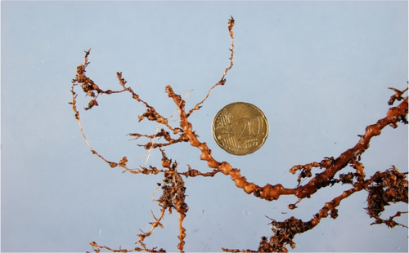
[297]Figure 1. Young elm root infested with Meloidogyne mali.
[298]Source: National Plant Protection Organization, Kingdom of the Netherlands.
[299]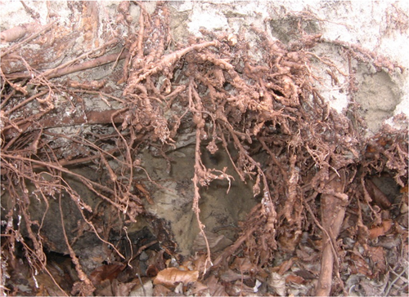
[300]Figure 2. Older elm roots heavily infested with Meloidogyne mali.
[301]Source: Bas Steenks, Kingdom of the Netherlands.
[302]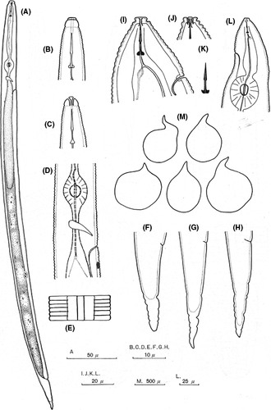
[303]
[304]Figure 3. Meloidogyne mali. (A)–(H) Second-stage (J2) juveniles: (A) body; (B) and (C) anterior region (lateral and dorsal, respectively); (D) metacorpus region; (E) lateral field; and (F–H) tails (lateral). (I–M) Females: (I), (J) and (L) anterior region; (K) stylet; and (M) body shape.
[305]Source: Itoh, Y., Ohshima, Y. & Ichinohe, M. 1969. A root-knot nematode, Meloidogyne mali n. sp. on apple-tree from Japan (Tylenchida: Heteroderidae). Applied Entomology and Zoology, 4: 194–202. https://doi.org/10.1303/aez.4.194
[306]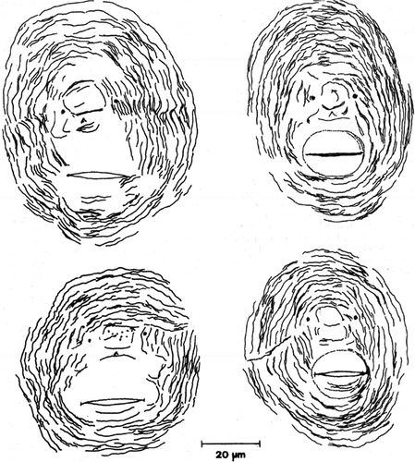
[307]
[308]Figure 4. Meloidogyne mali perineal patterns.
[309]Source: Palmisano, A. & Ambrogioni, L. 2000. Meloidogyne ulmi sp. n., a root-knot nematode from elm. Nematologia Mediterranea, 28: 279–293. https://journals.flvc.org/nemamedi/article/view/63531
[310]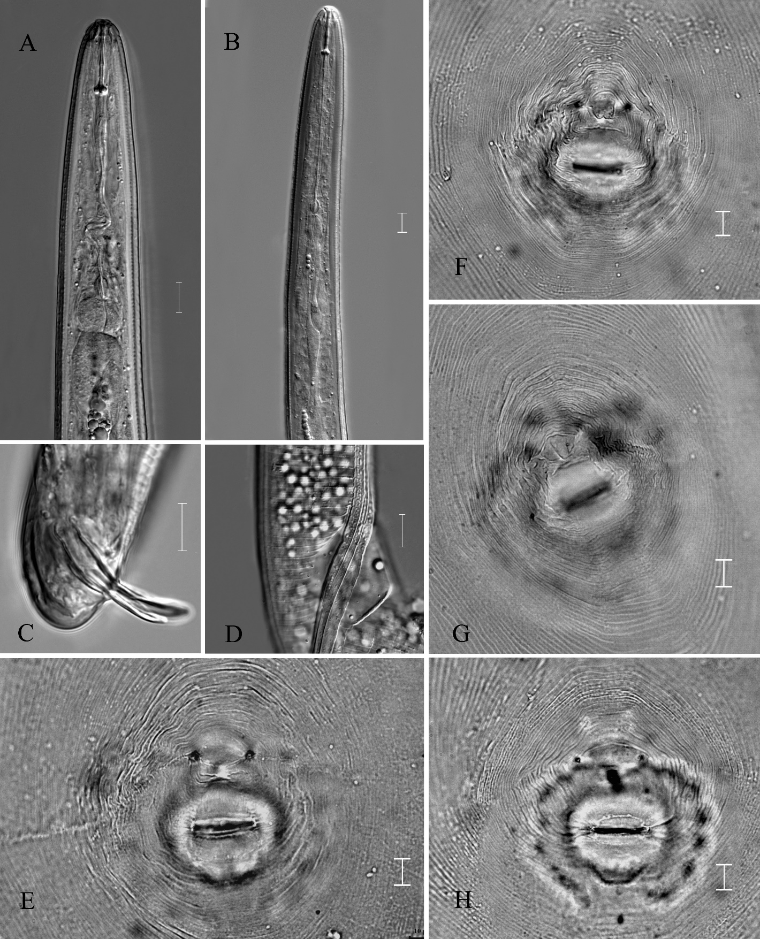
[311]Figure 5. Light photomicrographs of Meloidogyne mali male and female perineal patterns: (A) and (B) male anterior; (C) posterior region of male; (D) lateral field of male; and (E–H) perineal patterns of females.
[312]Note: Scale bars = 10 µm.
[313]Source: Jiangfeng Gu, China.
[314]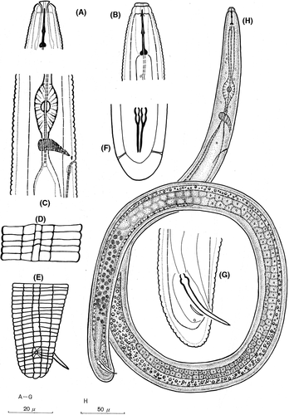
[315]
[316]Figure 6. Meloidogyne mali males: (A) and (B) anterior region (lateral and dorsoventral, respectively); (C) region of metacorpus; (D) lateral field; (E–G) tail regions (lateral, ventral, lateral, respectively); and (H) body.
[317]Source: Itoh, Y., Ohshima, Y. & Ichinohe, M. 1969. A root-knot nematode, Meloidogyne mali n. sp. on apple-tree from Japan (Tylenchida: Heteroderidae). Applied Entomology and Zoology, 4: 194–202. https://doi.org/10.1303/aez.4.194
[318]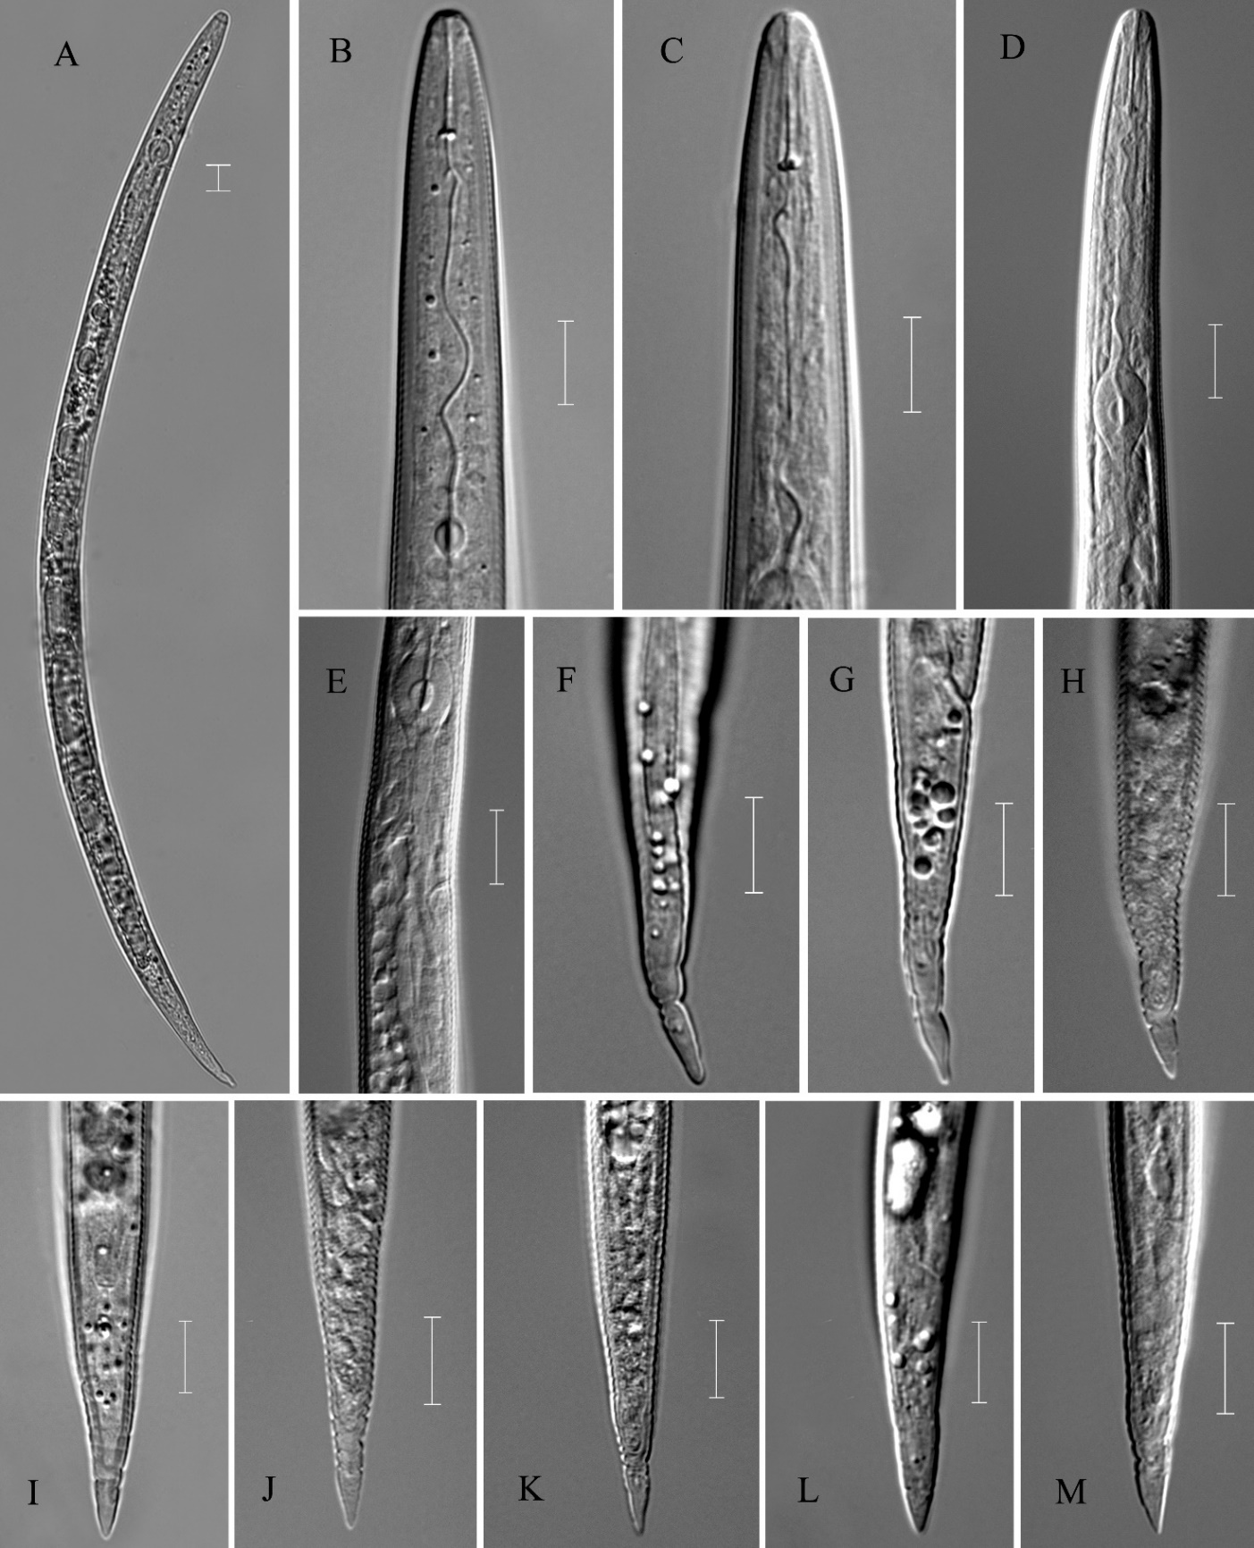
[319]Figure 7. Light photomicrographs of Meloidogyne mali second-stage juveniles: (A) habitus following heat relaxation; (B–D) anterior region; (E) metacorpus region; and (F–M) tail region.
[320]Note: Scale bars = 10 µm.
[321]Source: Jianfeng Gu, China.
[322]
[323]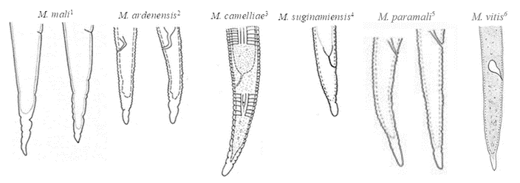
[324]Figure 8. Second-stage juvenile tails of Meloidogyne mali, Meloidogyne ardenensis, Meloidogyne camelliae, Meloidogyne paramali, Meloidogyne suginamiensis and Meloidogyne vitis.
[325]Note: Drawings in lateral view, not to scale.
[326]Sources:
[327](1) Itoh, Y., Ohshima, Y. & Ichinohe, M. 1969. A root-knot nematode, Meloidogyne mali n. sp. on apple-tree from Japan (Tylenchida: Heteroderidae). Applied Entomology and Zoology, 4: 194–202. https://doi.org/10.1303/aez.4.194
[328](2) de A. Santos, M.S.N. 1968. Meloidogyne ardenensis n. sp. (Nematoda: Heteroderidae), a new British species of root-knot nematode. Nematologica (1967) 13: 593–598. https://doi.org/10.1163/187529267X00418
[329](3) Golden, A.M. 1979. Description of Meloidogyne camelliae n. sp. and M. querciana n. sp. (Nematoda: Meloidogynidae) with SEM and host-range observations. Journal of Nematology, 11: 175–189. https://journals.flvc.org/jon/article/view/65150
[330](4) Toida, Y. & Yaegashi, T. 1984. Description of Meloidogyne suginamiensis n. sp. (Nematoda: Meloidogynidae) from mulberry in Japan. Japanese Journal of Nematology, 12: 49–57.
[331](5) Gu, J., Fang, Y., Ma, X., Shao, B. & Zhuo, K. 2023. Meloidogyne paramali n. sp. (Nematoda: Meloidogyninae) and first report of M. marylandi in maple and yacca tree from Japan. Journal of Nematology, 55(1). https://doi.org/10.2478/jofnem-2022-0036
[332](6) Yang, Y., Hu, X., Liu, P., Chen, L., Peng, H., Wang, Q. & Zhang, Q. 2021. A new root-knot nematode, Meloidogyne vitis sp. nov. (Nematoda: Meloidogynidae), parasitizing grape in Yunnan. PLoS ONE, 16(2): e0245201. https://doi.org/10.1371/journal.pone.0245201
[333]
[334]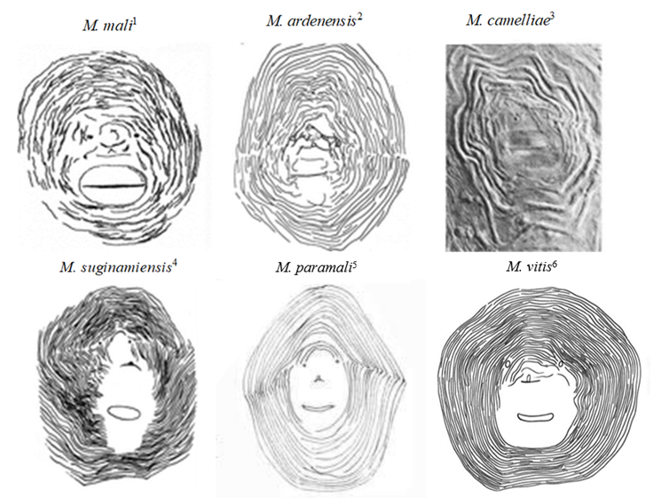
[335]Figure 9. Perineal patterns of Meloidogyne mali, Meloidogyne ardensis, Meloidogyne camelliae, Meloidogyne paramali, Meloidogyne suginamiensis and Meloidogyne vitis.
[336]Note: Drawings 1, 2, 4 and 5 are not to the same scale as photo 3.
[337]Sources:
[338](1) Itoh, Y., Ohshima, Y. & Ichinohe, M. 1969. A root-knot nematode, Meloidogyne mali n. sp. on apple-tree from Japan (Tylenchida: Heteroderidae). Applied Entomology and Zoology, 4: 194–202. https://doi.org/10.1303/aez.4.194
[339](2) de A. Santos, M.S.N. 1968. Meloidogyne ardenensis n. sp. (Nematoda: Heteroderidae), a new British species of root-knot nematode. Nematologica (1967) 13: 593–598. https://doi.org/10.1163/187529267X00418
[340](3) Golden, A.M. 1979. Description of Meloidogyne camelliae n. sp. and M. querciana n. sp. (Nematoda: Meloidogynidae) with SEM and host-range observations. Journal of Nematology, 11: 175–189. https://journals.flvc.org/jon/article/view/65150
[341](4) Toida, Y. & Yaegashi, T. 1984. Description of Meloidogyne suginamiensis n. sp. (Nematoda: Meloidogynidae) from mulberry in Japan. Japanese Journal of Nematology, 12: 49–57.
[342](5) Gu, J., Fang, Y., Ma, X., Shao, B. & Zhuo, K. 2023. Meloidogyne paramali n. sp. (Nematoda: Meloidogyninae) and first report of M. marylandi in maple and yacca tree from Japan. Journal of Nematology, 55(1). https://doi.org/10.2478/jofnem-2022-0036
[343](6) Yang, Y., Hu, X., Liu, P., Chen, L., Peng, H., Wang, Q. & Zhang, Q. 2021. A new root-knot nematode, Meloidogyne vitis sp. nov. (Nematoda: Meloidogynidae), parasitizing grape in Yunnan. PLoS ONE, 16(2): e0245201. https://doi.org/10.1371/journal.pone.0245201
[344]
[345]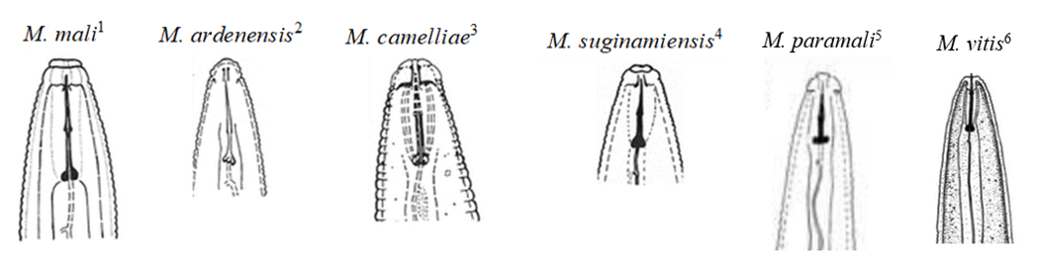
[346]
[347]Figure 10. Male head regions of Meloidogyne mali, Meloidogyne ardenensis, Meloidogyne camelliae, Meloidogyne paramali, Meloidogyne suginamiensis and Meloidogyne vitis.
[348]Notes: Drawings in dorsoventral view (1), lateral view (2, 3, 5, 6) and dorsal (4) view; not to scale.
[349]Sources:
[350](1) Itoh, Y., Ohshima, Y. & Ichinohe, M. 1969. A root-knot nematode, Meloidogyne mali n. sp. on apple-tree from Japan (Tylenchida: Heteroderidae). Applied Entomology and Zoology, 4: 194–202. https://doi.org/10.1303/aez.4.194
[351](2) de A. Santos, M.S.N. 1968. Meloidogyne ardenensis n. sp. (Nematoda: Heteroderidae), a new British species of root-knot nematode. Nematologica (1967) 13: 593–598. https://doi.org/10.1163/187529267X00418
[352](3) Golden, A.M. 1979. Description of Meloidogyne camelliae n. sp. and M. querciana n. sp. (Nematoda: Meloidogynidae) with SEM and host-range observations. Journal of Nematology, 11: 175–189. https://journals.flvc.org/jon/article/view/65150
[353](4) Toida, Y. & Yaegashi, T. 1984. Description of Meloidogyne suginamiensis n. sp. (Nematoda: Meloidogynidae) from mulberry in Japan. Japanese Journal of Nematology, 12: 49–57.
[354](5) Gu, J., Fang, Y., Ma, X., Shao, B. & Zhuo, K. 2023. Meloidogyne paramali n. sp. (Nematoda: Meloidogyninae) and first report of M. marylandi in maple and yacca tree from Japan. Journal of Nematology, 55(1). https://doi.org/10.2478/jofnem-2022-0036
[355](6) Yang, Y., Hu, X., Liu, P., Chen, L., Peng, H., Wang, Q. & Zhang, Q. 2021. A new root-knot nematode, Meloidogyne vitis sp. nov. (Nematoda: Meloidogynidae), parasitizing grape in Yunnan. PLoS ONE, 16(2): e0245201. https://doi.org/10.1371/journal.pone.0245201
[356]
[357]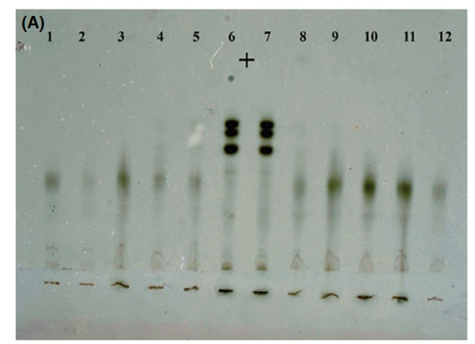 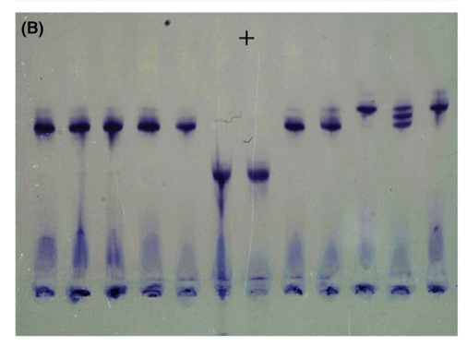
[358]Figure 11. Esterase (A) and malate dehydrogenase (B) isozyme profiles of Meloidogyne mali (1–5 and 8–12) and the reference Meloidogyne javanica (6 and 7).
[359]Source: Ahmed, M., van de Vossenberg, B.T.L.H., Cornelisse, C. & Karssen, G. 2013. On the species status of the root-knot nematode Meloidogyne ulmi Palmisano & Ambrogioni, 2000 (Nematoda, Meloidogynidae). ZooKeys, 362: 1–27. https://doi.org/10.3897/zookeys.362.6352
[360]

[194] The use of names of reagents, chemicals or equipment in these diagnostic protocols implies no approval of them to the exclusion of others that may also be suitable.

