[PleaseReview document review. Review title: 2025 First Consultation: 2023-023-Draft annex International movement of fresh Colocasia esculenta corms to ISPM 46. Document title: 2023-023_DraftAnnex_ISPM46_IntMovTaro_eng.docx]

***[1]*****DRAFT ANNEX TO ISPM 46: International movement of fresh** ***Colocasia esculenta* corms (2023-023)**

***[2]*Status box**

|  |  |
| --- | --- |
| ***[3]***This is not an official part of the standard and it will be modified by the IPPC Secretariat after adoption. | |
| ***[4]*Date of this document** | ***[5]***2025-05-23 |
| ***[6]*Document category** | ***[7]***Draft annex to ISPM 46 |
| ***[8]*Current document stage** | ***[9]****To* first consultation |
| ***[10]*Major stages** | ***[11]***2024-04 CPM-18 added topic Annex *International movement of fresh taro (Colocasia esculenta)* *corm for consumption* (2023-023) to ISPM 46 (*Commodity-specific standards for phytosanitary measures*) to the work programme, priority 1.  ***[12]***2024-12 Technical Panel on Commodity Standards (TPCS) drafted.  ***[13]***2025-01 TPCS revised and recommended to Standards Committee (SC) for approval for consultation.  ***[14]***2025-05 SC revised and approved for first consultation. |
| ***[15]*Steward history** | ***[16]***2024-05 SC Sophie PETERSON (AU, Lead Steward)  ***[17]***2024-12 TPCS Douglas KERRUISH (AU, Assistant Steward) |
| ***[18]*Notes** | ***[19]***2024-12 TPCS approved title amended by steward, *International movement of fresh* Colocasia esculenta *corms*  ***[20]***2025-03 Edited  ***[21]***2025-05 Edited |

***[22]***Adoption

***[23]***[Text to this paragraph will be added following adoption.]

***[24]***1. Scope

***[25]***This commodity standard provides guidance for national plant protection organizations (NPPOs) on pests associated with the fresh corms of *Colocasia esculenta* (taro) (Alisamatales: Araceae) and options for phytosanitary measures for the international movement of fresh *C. esculenta* corms for consumption or processing.

***[26]***2. Description of the commodity and its intended use

***[27]***This commodity standard applies to fresh *C. esculenta* corms, without leaves and lateral buds (see Appendix 1). The standard applies to corms that have been produced for international trade and are intended for consumption or processing in an importing country. It does not apply to corms that have already been processed (e.g. canned, cooked, dried, frozen, peeled).

***[28]***3. Pests associated with fresh *Colocasia esculenta*

***[29]***The pests included in Table 1 are considered to be associated with fresh *C. esculenta* corms and are regulated in international trade by at least one contracting party based on technical justification. The list of pests is not exhaustive, nor country specific.

***[30]***The list of pests does not consider factors that may influence pest infestation of corms in the country of origin (e.g. cultivar or variety; geographical and ecological factors).

***[31]***Inclusion of a pest in Table 1 does not constitute technical justification for its regulation by importing countries using this standard. When determining whether to regulate a pest listed in this commodity standard, the NPPO of the importing country should base its decision on technical justification using either a pest risk analysis or, where applicable, another comparable examination and evaluation of available scientific information.

***[32]*****Table 1.** Pests considered to be associated with fresh *Colocasia esculenta* corms*

|  |  |  |
| --- | --- | --- |
| ***[33]*Pest group** | ***[34]*Family** | ***[35]*Species (scientific name and authority)†** |
| ***[36]***Beetles (Coleoptera) | ***[37]***Scarabaeidae | ***[38]****Papuana biroi* (Endrödi, 1969) |
| ***[39]*** | ***[40]*** | ***[41]****Papuana cheesmanae* Arrow, 1941 |
| ***[42]*** | ***[43]*** | ***[44]****Papuana hubneri* (Fairmaire, 1879) |
| ***[45]*** | ***[46]*** | ***[47]****Papuana inermis* Prell, 1912 |
| ***[48]*** | ***[49]*** | ***[50]****Papuana japenensis* Arrow, 1941 |
| ***[51]*** | ***[52]*** | ***[53]****Papuana laevipennis* Arrow, 1911 |
| ***[54]*** | ***[55]*** | ***[56]****Papuana semistriata* Arrow, 1911 |
| ***[57]*** | ***[58]*** | ***[59]****Papuana szentivanyi* Endrödi, 1971 |
| ***[60]*** | ***[61]*** | ***[62]****Papuana trinodosa* Prell, 1912 |
| ***[63]*** | ***[64]*** | ***[65]****Papuana uninodis* Prell, 1912 |
| ***[66]***Planthoppers (Hemiptera) | ***[67]***Delphacidae | ***[68]****Tarophagus proserpina* (Kirkaldy, 1907) |
| ***[69]***Nematodes (Tylenchida) | ***[70]***Pratylenchidae | ***[71]****Radopholus similis* (Cobb, 1893) Thorne, 1949 |
| ***[72]***Oomycetes (Peronsporales) | ***[73]***Peronosporaceae | ***[74]****Phytophthora colocasiae* Racib., 1900 |
| ***[75]*Pest group** | ***[76]*Family** | ***[77]*Virus (virus name, acronym and species name)†** |
| ***[78]***Viruses | ***[79]***Potyviridae | ***[80]***dasheen mosaic virus (DsMV; species *Potyvirus dasheenis*) |
| ***[81]*** | ***[82]***Rhabdoviridae | ***[83]***colocasia bobone disease virus (CBDV; *Cytorhabdovirus colocasiae*) |
| ***[84]*** | ***[85]*** | ***[86]***taro vein chlorosis virus (TaVCV; species *Alphanucleorhabdovirus colocasiae*) |
| ***[87]*** | ***[88]***Tospoviridae | ***[89]***tomato zonate spot virus (TZSV; species *Orthotospovirus tomatozonae*) |

***[90]****Notes:* * Information used to compile this list was supplied by at least one contracting party and may be provided by the IPPC Secretariat upon request.

***[91]***† Scientific names used in this table, and names provided for viruses, are based on the submissions by contracting parties.

***[92]***4. Options for phytosanitary measures

***[93]***This section provides options for phytosanitary measures that may be relevant for the pests listed in Table 1. The options presented are not exhaustive and contracting parties may consider other options as phytosanitary measures.

***[94]***Table 2 provides general options for phytosanitary measures that may be relevant to pests listed in Table 1.

***[95]***Table 3 lists some specific options to manage the pest risk of pests listed in Table 1, with further details in Table 4 and Table 5. Abbreviations used for options for phytosanitary measures are listed in Box 1, as well as below in relevant tables.

***[96]***Importing-country NPPOs should decide whether the options listed in Table 3 are effective at managing the pest risk to an acceptable level before selecting them as phytosanitary measures. Importing-country NPPOs should also consider whether a measure for one pest will effectively manage the pest risk of other regulated pests of *C. esculenta* corms. In addition, when applying these options as phytosanitary measures, NPPOs should consider the procedures for successful application.

***[97]***When considering the use of methyl bromide (Table 4), NPPOs should refer to the Commission on Phytosanitary Measures recommendation on the *Replacement or reduction of the use of methyl bromide as a phytosanitary measure* (R-03). Where possible, alternative options to methyl bromide fumigation that are effective and more environmentally friendly should be selected and applied by NPPOs.

***[98]***Options for phytosanitary measures included in this commodity standard may be effective at managing pest risk when used alone or when integrated with other measures in a systems approach as described in ISPM 14 (*The use of integrated measures in a systems approach for pest risk management*).

***[99]***The surface of taro corms is pitted and rough with crevices, holes and dead leaf stems. It can harbour pests (e.g. beetles, mites, nematodes), and soil residues containing soil-borne pests may stick to the surface. To reduce the risk of such pests remaining on the corms, measures such as thorough cleaning of the corms should be considered when assessing options for phytosanitary measures for this commodity.

***[100]*****Table 2.** General options for phytosanitary measures

| ***[101]*Options for phytosanitary measures** | ***[102]*References** |
| --- | --- |
| ***[103]***Pest free areas | ***[104]***ISPM 4 (*Requirements for the establishment of pest free areas*) |
| ***[105]***Systems approaches | ***[106]***ISPM 14 (*The use of integrated measures in a systems approach for pest risk management*) |
| ***[107]***Phytosanitary treatments | ***[108]***ISPM 28 (*Phytosanitary treatments for regulated pests*) |
| ***[109]***Inspection | ***[110]***ISPM 23 (*Guidelines for inspection*)  ***[111]***ISPM 31(*Methodologies for sampling of consignments*) |
| ***[112]***Testing and pest identification | ***[113]***ISPM 27 (*Diagnostic protocols for regulated pests*) |
| ***[114]***Phytosanitary certification | ***[115]***ISPM 7 (*Phytosanitary certification system*)  ***[116]***ISPM 12 (*Phytosanitary certificates*) |
| ***[117]***Post-harvest operations (cleaning to be free from soil, e.g. brushing, washing) | ***[118]***ISPM 14  ***[119]***ISPM 32 (*Categorization of commodities according to their pest risk*) |

***[120]****Sources:* See References section.

***[121]*****Box 1.** Abbreviations used in this commodity standard for options for phytosanitary measures

|  |  |
| --- | --- |
| ***[122]***MB | ***[123]***methyl bromide fumigation |
| ***[124]***PFA | ***[125]***pest free area |
| ***[126]***SA | ***[127]***systems approach |

***[128]*Table 3.** Pest-specific options for phytosanitary measures

| ***[129]*Pest** | ***[130]*Options for phytosanitary measures** |
| --- | --- |
| ***[131]*Beetles** | ***[132]*** |
| ***[133]****Papuana* spp. | ***[134]***MB 1; PFA |
| ***[135]*Planthoppers** | ***[136]*** |
| ***[137]****Tarophagus proserpina* | ***[138]***Removal of petiole base |
| ***[139]*Nematodes** | ***[140]*** |
| ***[141]****Radopholus similis* | ***[142]***Pre-harvest sampling of corms with laboratory testing† |
| ***[143]*Oomycetes** | ***[144]*** |
| ***[145]****Phytophthora colocasiae* | ***[146]***PFA; SA 1 |
| ***[147]*Viruses** | ***[148]*** |
| ***[149]***dasheen mosaic virus | ***[150]***Removal of petiole base |
| ***[151]***colocasia bobone disease virus | ***[152]***Removal of petiole base |
| ***[153]***taro vein chlorosis virus | ***[154]***Removal of petiole base |
| ***[155]***tomato zonate spot virus | ***[156]***Removal of petiole base |

***[157]****Notes:* † Pre-harvest sampling of corms with laboratory testing targeting the pest of concern. If the pest is detected, the corms from that field are excluded from export.

***[158]***MB, methyl bromide fumigation (see Table 4); PFA, pest free area; SA, systems approach (see Table 5).

***[159]*****Table 4.** Options for methyl bromide fumigation (MB) (applied under normal atmospheric pressure)

|  |  |  |  |  |
| --- | --- | --- | --- | --- |
| ***[160]*Measure number** | ***[161]*Minimum temperature (°C)** | ***[162]*Minimum dose (g/m3)** | ***[163]*Minimum time (hours)** | ***[164]*Reference** |
| ***[165]***MB 1 | ***[166]***5–10  ***[167]***11–15  ***[168]***16–20  ***[169]***21–25  ***[170]***31 and above | ***[171]***56  ***[172]***48  ***[173]***40  ***[174]***32  ***[175]***16 | ***[176]***2  ***[177]***2  ***[178]***2  ***[179]***2  ***[180]***2 | ***[181]***MAFF (1998) |

***[182]****Note:* National plant protection organizations should also refer to ISPM 43 (*Requirements for the use of fumigation as a phytosanitary measure*) and the Commission on Phytosanitary Measures recommendation on *Replacement or reduction of the use of methyl bromide as a phytosanitary measure* (R-03).

***[183]****Source:* See References section.

***[184]*****Table 5.** Options for systems approaches (SAs)

|  |  |  |
| --- | --- | --- |
| ***[185]*Systems approach number** | ***[186]*Independent measures** | ***[187]*References** |
| ***[188]***SA 1 | ***[189]****Planting measures* (e.g. use of resistant varieties)  ***[190]****Pre-harvest measures* (e.g. in-field pest control measures to reduce inoculum levels)  ***[191]****Post-harvest measures* (e.g. hot water dipping, topping of corms) | ***[192]***Biosecurity Australia (2011)  ***[193]***DAFF (2020) |

***[194]****Note:* National plant protection organizations should also refer to ISPM 14 (*The use of integrated measures in a systems approach for pest risk management*).

***[195]****Sources:* See References section.

***[196]***5. References

***[197]***The present annex refers to ISPMs. ISPMs are available on the International Phytosanitary Portal (IPP) at <https://www.ippc.int/core-activities/standards-setting/ispms>.

***[198]***5.1 Main text

***[199]*CPM R-03**. 2017. *Replacement or reduction of the use of methyl bromide as a phytosanitary measure*. CPM Recommendation. IPPC Secretariat. Rome, FAO. Adopted 2008. <https://www.ippc.int/en/publications/84230>

***[200]***5.2 Tables

***[201]*Biosecurity Australia**. 2011. *Draft review of import conditions for fresh taro corms*. Canberra. 200 pp. <https://www.agriculture.gov.au/sites/default/files/sitecollectiondocuments/ba/plant/2011/Draft_Review_of_Import_Conditions_for_Fresh_Taro_Corms_Final.pdf>

***[202]*DAFF (Department of Agriculture, Fisheries and Forestry)**. 2020. *Review of risk management measures for* Phytophthora colocasiae *in fresh taro from Samoa*. Canberra. Unpublished.

***[203]*Ministry of Agriculture, Forestry and Fisheries (MAFF) Japan** – Database for importing conditions - [Database for importing conditions](https://www.pps.maff.go.jp/eximlist/Pages/exp/resultPlantCountryE.xhtml?faces-redirect=true) https://www.maff.go.jp/j/syouan/keneki/kikaku/attach/pdf/pra_table2_2-67.pdf

***[204]*MAFF (Ministry of Agriculture, Food and Forests - Kingdom of Tonga)**.1998. *Quarantine and quality management division operational manual*. Nuku’alofa, Tonga.

***[205]***Potential implementation issues

***[206]***This section is not part of the standard. The Standards Committee in May 2016 requested the secretariat to gather information on any potential implementation issues related to this draft. Please provide details and proposals on how to address these potential implementation issues.

***[207]***APPENDIX 1: A typical, large, dasheen-type taro corm

***[208]***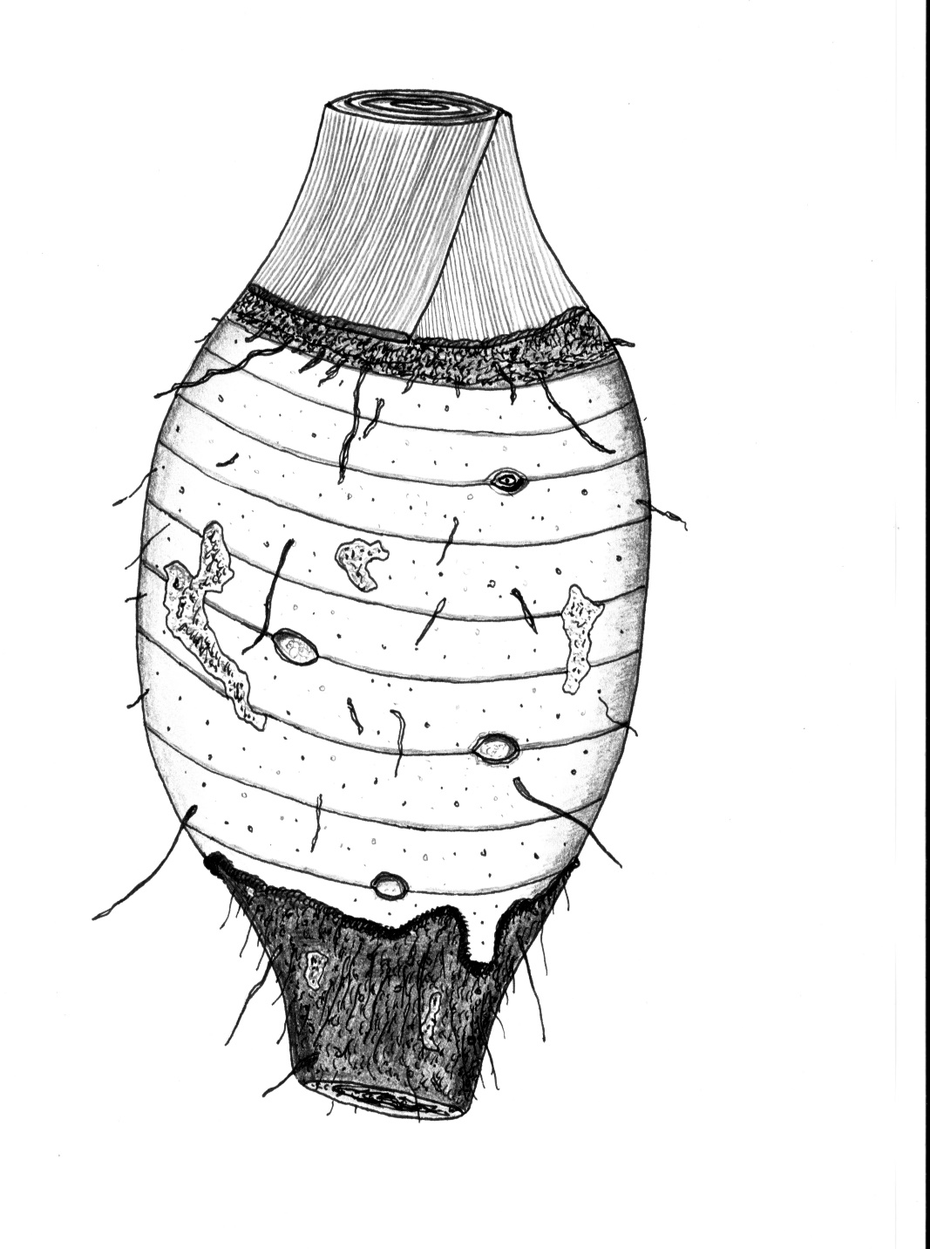

***[209]***Petiole base and leaf stems

***[210]***Emerging lateral bud

***[211]***Wound where lateral cormel was removed

***[212]***Fine roots

***[213]***Remnant scar from the base of the cormel originally used as planting material

***[214]*1 cm**

***[215]*BASE**

***[216]*APEX**

***[217]****Source:* Biosecurity Australia. 2011. *Draft review of import conditions for fresh taro corms*. Canberra. 200 pp. <https://www.agriculture.gov.au/sites/default/files/sitecollectiondocuments/ba/plant/2011/Draft_Review_of_Import_Conditionsfor_Fresh_Taro_Corms_Final.pdf>. Reproduced with permission.