Commission on Phytosanitary Measures

STRATEGIC PLANNING GROUP

UPDATE ON THE IPPC PLANT HEALTH CAMPUS AND THE WAY FORWARD
(Prepared by New Zealand)

1. Background
- The IPPC Plant Health Campus is a comprehensive online platform offering free access to 15 eLearning courses and over 20 practical guides on various plant health topics and phytosanitary technical information. The Campus is hosted by and developed in collaboration with the FAO eLearning Academy.
- Funded by the European Union, the Campus is designed to strengthen national phytosanitary capacity, targeting a wide audience including national plant protection organizations (NPPOs) and their staff, Phytosanitary Capacity Evaluation (PCE) facilitators, plant health stakeholders, partners and university students.
- Since its official launch at CPM-19 in 2025, the IPPC Secretariat has actively promoted the Campus at major events such as the International Day of Plant Health, IPPC Regional Workshops, the EU Plant Health Heads Meeting, Africa Phytosanitary Programme training sessions, the Standards and Trade Facilitation (STDF) Working Group, the World Food Forum hosted by FAO and various international conferences.
- In June, the secretariat organized a webinar where the Campus was officially launched in French, enhancing awareness about this online hub and increasing global access to the various technical resources.
- Promotional efforts also include a five-minute introductory video developed together with the FAO eLearning Academy and testimonial videos of NPPO and RPPO staff and trainers sharing their user experiences.

2. Continued need for maintenance, development and translations
- The IPPC Plant Health Campus has the potential to become the premier learning hub on key plant health topics for professionals, significantly strengthening phytosanitary capacity and systems globally. Its sustainability is therefore paramount in ensuring access and knowledge sharing.
- Thanks to ongoing promotional efforts, the Campus has seen strong global engagement, with courses taken over 13 000 times and more than 4 700 certificates issued over the span of one year. The most popular courses include the introductory module “Working with a NPPO”, as well as “Surveillance” and “Export Certification”, available in both English and French.
- The highest number of learners is from Africa (48 percent), followed by Asia (29 percent), demonstrating the Campus’ global relevance and reach. However, language remains a key barrier to broader access (see Figure 1). To address this, the IPPC Secretariat intends to make the Campus available in Spanish by early 2026, significantly expanding accessibility in Latin America and other Spanish-speaking regions.
- Discussions are also ongoing with a number of contracting parties and partners, to secure in-kind support to translate the Campus and some of the resources into Arabic, Chinese and Russian.
- A dedicated communication plan is currently being developed for the IPPC Plant Health Campus, with input from SPG participants through a Mentimeter survey to capture ideas and suggestions for broader engagement.
- Figure 1: IPPC Plant Health Campus number of learners by region
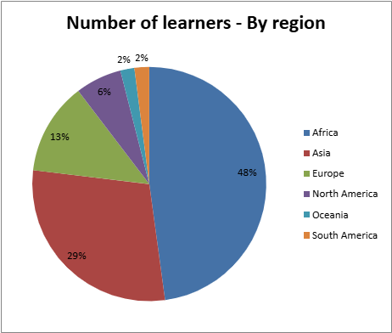

3. Engagement with learners and on-going promotion

- So far, two main target audiences have actively engaged with the Campus:
- National Plant Protection Organizations (NPPOs) are using the Campus to meet internal training needs by aligning courses with staff development objectives. A notable example is the NPPO of Egypt, which organized a training session based on the Wood Packaging Material in International Trade course, with over 70 inspectors completing the training.
- Universities in Europe have begun integrating courses on the Campus into their academic curricula, recognizing their European Credit Transfer and Accumulation System (ECTS) value for Master’s degrees. The University of Louvain in Belgium has incorporated these courses and is promoting them to other academic institutions. Similarly, CIHEAM Bari is also using the courses in its training programmes and the secretariat is discussing with the Institut National Supérieur d'Agronomie and Biotechnologies at the Université des Sciences et Techniques de Masuku in Gabon, which intends to highlight some of the courses in its Master of Science programme. Furthermore, the NPPO of Korea will present the Campus during the Korean Society of Plant Pathology to include some courses in graduate schools.
- This academic collaboration supports the long-term vision of building the next generation of plant health officers, ultimately easing the burden on NPPOs and strengthening global plant health systems.
- In collaboration with the FAO Office for Youth and Women, the IPPC Secretariat intends to host an awareness session with a network of academicians, to further promote integration of the elearning courses into existing degree and non-degree courses.
- The Strategic Planning Group (SPG) is invited to:
Contribute in-kind support to translation of eLearning courses and guides into Arabic, Russian and Chinese, while noting that additional funding will be required to process and integrate these materials into the platform;
- Share suggestions for the maintenance, improvement and promotion of the Campus via the Mentimeter survey during the SPG meeting.

