[PleaseReview document review. Review title: 2025 First Consultation: 2023-023-Draft annex International movement of fresh Colocasia esculenta corms to ISPM 46. Document title: 2023-023_DraftAnnex_ISPM46_IntMovTaro_eng.docx]
[1]DRAFT ANNEX TO ISPM 46: International movement of fresh Colocasia esculenta corms (2023-023)
[2]Status box
[3]This is not an official part of the standard and it will be modified by the International Plant Protection Convention (IPPC) IPPC Secretariat after adoption.
[4]Date of this document | [5]2025-05-23
[6]Document category | [7]Draft annex to International Standard on Phytosanitary Measures ISPM 46
[8]Current document stage | [9]To first consultation
[10]Major stages | [11]2024-04 Commission on Phytosanitary Measures (CPM) CPM-18 added topic Annex International movement of fresh taro (Colocasia esculenta) corm for consumption (2023-023) to ISPM 46 (Commodity-specific standards for phytosanitary measures) to the work programme, priority 1.  [12]2024-12 Technical Panel on Commodity Standards (TPCS) drafted.  [13]2025-01 TPCS revised and recommended to Standards Committee (SC) for approval for consultation.  [14]2025-05 SC revised and approved for first consultation.
[15]Steward history | [16]2024-05 SC Sophie PETERSON (AU, Lead Steward)  [17]2024-12 TPCS Douglas KERRUISH (AU, Assistant Steward)
[18]Notes | [19]2024-12 TPCS approved title amended by steward, International movement of fresh Colocasia esculenta corms  [20]2025-03 Edited  [21]2025-05 Edited
[22]Adoption
[23][Text to this paragraph will be added following adoption.]

[24]1. Scope
[25]This standard provides guidance on national plant protection organizations (NPPOs) on pests associated with fresh taro and options for phytosanitary measures to manage these pests in international trade.

[26]

[28]3. Pests associated with fresh Colocasia esculenta corms
[29]
[30]The list of pests does not consider factors that may influence pest infestation of corms in the country of origin (e.g. cultivar or variety; geographical and ecological factors, agricultural and production practices).
[31]Inclusion of a pest in Table 1 does not constitute technical justification for its regulation by importing countries using this standard. The NPPO of the importing country should decide whether to regulate a on technical justification supported by a pest risk analysis or by another similar scientific evaluation.

[33]Pest group | [34]Family | [35]Species (scientific name and authority)†
[36] | [37] | [38]Papuana biroi Endrödi, 1969
[39] | [40] | [41]
[42] | [43] | [44]
[45] | [46] | [47]
[48] | [49] | [50]
[51] | [52] | [53]
[54] | [55] | [56]Papuana Woodlarkiana Woodlarkiana (Montrouzier, 1855)
[57] | [58] | [59]
[60] | [61] | [62]
[63] | [64] | [65]
[66]
[69] | [70] | [71]
[72] | [73] | [74]
 | [76]
[78] | [79] | [80]the French Polynesian strain of viruss (FP-DsMV; species Potyvirus dasheenis) dasheen mosaic
[81] | [82] | [83]
[84] | [85]
[87] | [88] | [89]
[90]Notes: * Information used to compile this list was supplied by at least one contracting party and may be provided by the IPPC Secretariat upon request.
[91]† Scientific names used in this table are based on the submissions by contracting parties, modified where more than one name was submitted to the more recent scientific name or aligned with ISPM 27 (Diagnostic protocols for regulated pests) or ISPM 28 (Phytosanitary treatments for regulated pests).

[92]4. Options for phytosanitary measures
[93]This section provides options for phytosanitary measures that may be relevant for the pests listed in Table 1. The options presented are not exhaustive and contracting parties may consider other options as phytosanitary measures.
[94]Table 2 provides general options for phytosanitary measures that may be relevant to pests listed in Table 1.
[95]Table 3 lists some pest-specific options to manage the pest risk of pests listed in Table 1, with further details in Table 4 and Table 5.
[96]The NPPO of importing country should decide whether the options listed in Table 3 are effective at managing the pest risk to an acceptable level before selecting them as phytosanitary measures. The NPPO of importing country should also consider whether a measure for one pest will effectively manage the pest risk of other regulated pests of C. esculenta corms. In addition, when applying these options as phytosanitary measures, NPPOs should consider the procedures for successful application.
[97]When considering the use of methyl bromide (Table 4), NPPOs should refer to the Commission on Phytosanitary Measures recommendation on the Replacement or reduction of the use of methyl bromide as a phytosanitary measure (R-03). Where possible, alternative options to methyl bromide fumigation that are effective and more environmentally friendly should be selected and applied by NPPOs.
[98]Options for phytosanitary measures included in this commodity standard may be effective at managing pest risk when used alone or when integrated with other measures in a systems approach as described in ISPM 14 (The use of integrated measures in a systems approach for pest risk management).
[99]It has a rough texture with cavities, cracks and remains of leaf stems when harvested. It can harbour pests (e.g. ants, beetles, nematodes), and soil residues containing soil-borne pests may stick to the surface. To reduce the risk of such pests remaining on the corms (e.g. washing and scraping) and storage of corms at hygienic packing and storage facilities measures such as thorough cleaning of the corms to remove soil residues and dead leaves from the crevices and holes should be considered when assessing options for phytosanitary measures for this commodity.
[100]
[101]Options for phytosanitary measures | [102]References
[103]Pest free areas (PFA) | [104]ISPM 4 (Requirements for the establishment of pest free areas)  ISPM 10 (Requirements for the establishment of pest free places of production and pest free production sites)
[105]Systems approaches (SA) | [106]ISPM 14 (The use of integrated measures in a systems approach for pest risk management)
[107]Phytosanitary treatments | [108]ISPM 28 (Phytosanitary treatments for regulated pests)
[109]Phytosanitary Inspection | [110]ISPM 23 (Guidelines for inspection)  [111]ISPM 31 (Methodologies for sampling of consignments)  ISPM 20 (Guidelines for a phytosanitary import regulatory system)
[112]Testing and pest identification | [113]ISPM 27 (Diagnostic protocols for regulated pests)
[114]Phytosanitary certification | [115]ISPM 7 (Phytosanitary certification system)  [116]
[117]Post-harvest operations (cleaning to be free from soil, e.g. brushing, washing) | [118]ISPM 14 (The use of integrated measures in a systems approach for pest risk management)  [119]
[120]Sources: See References section.
[121]
[122] | [123]
 | [127]
[128]
[129]pour les tableaux il faut harmoniser par rapport à la présentation | [130]Options for phytosanitary measures
[131]Beetles | [132]
[133]Papuana spp. | [134]
 | [136]
[137] | [138]
[139] | [140]
[141] | [142]
 | [144]
 | [146]
[147] | [148]
[149] | [150]
[151]
[153] | [154]
[155]
[157]Notes: † Pre-harvest sampling of corms with laboratory testing targeting the pest of concern. If the pest is detected, the corms from that field are excluded from export.
[158]
[159]
[160]Measure number | [161]Minimum temperature (°C) | [162]Minimum dose (g/m³) | [163]Minimum time (hours) | [164]Reference
[165] | [166]5–10  [167]11–15  [168]16–20  [169]21–25  [170]31 and above | [171]56  [172]48  [173]40  [174]32  [175]16 | [176]2  [177]2  [178]2  [179]2  [180]2 | [181]MAFF (1998)
[182]
[183]
[184]
[185]Systems approach number | [186]Independent measures | [187]References
[188] | [189]Planting measures (e.g. use of resistant varieties, pest free place of production)  [190]Pre-harvest measures (e.g. in-field pest control measures)  [191] | [192]  [193]DAFF (2020)
[194]
[195]Sources: See References section.

[196]5. References
[197]The present annex refers to ISPMs. ISPMs are available on the International Phytosanitary Portal (IPP) at https://www.ippc.int/core-activities/standards-setting/ispms.

[198]5.1 Main text
[199]CPM R-03. 2017. Replacement or reduction of the use of methyl bromide as a phytosanitary measure. CPM Recommendation. IPPC Secretariat. Rome, FAO. Adopted 2008. https://www.ippc.int/en/publications/84230

[200]5.2 Tables
[201]Biosecurity Australia. 2011. Review of import conditions for fresh taro corms. Canberra. 213 pp. https://www.agriculture.gov.au/sites/default/files/sitecollectiondocuments/ba/plant/2011/taro/Review_of_Import_Conditions_for_Fresh_Taro_Corms_clean.pdf
[202]DAFF (Department of Agriculture, Fisheries and Forestry). 2020. Review of risk management measures for Phytophthora colocasiae in fresh taro from Samoa. Canberra. Unpublished.
[203]
[204]MAFF (Ministry of Agriculture, Food and Forests - Kingdom of Tonga).1998. Quarantine and quality management division operational manual. Nuku’alofa, Tonga.

[205]Potential implementation issues
[206]This section is not part of the standard. The Standards Committee in May 2016 requested the secretariat to gather information on any potential implementation issues related to this draft. Please provide details and proposals on how to address these potential implementation issues.

[207]APPENDIX 1: A typical, large, dasheen-type taro corm
[208]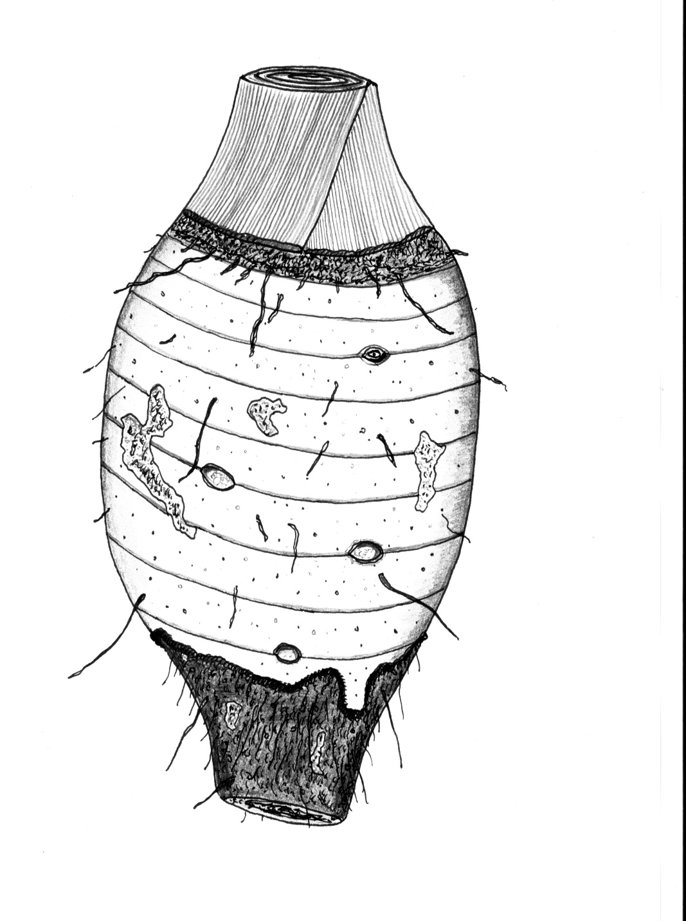
[209]Petiole base and leaf stems
[210]Emerging lateral bud
[211]Wound where lateral cormel was removed
[212]Fine roots
[213]Remnant scar from the base of the cormel originally used as planting material
[214]1 cm
[215]BASE
[216]APEX
[217]Source: Biosecurity Australia. 2011. Review of import conditions for fresh taro corms. Canberra. 213 pp. https://www.agriculture.gov.au/sites/default/files/sitecollectiondocuments/ba/plant/2011/taro/Review_of_Import_Conditions_for_Fresh_Taro_Corms_clean.pdf. Reproduced with permission.

