Commission on Phytosanitary Measures

twentieth SESSION

UPDATE ON THE PEST OUTBREAK ALERT AND RESPONSE SYSTEM (POARS) AGENDA ITEM 13.5

(Prepared by the IPPC Secretariat)

Introduction
- This paper provides an update to the Commission on Phytosanitary Measures (CPM) on progress achieved in implementing the Pest Outbreak Alert and Response System (POARS) since the update presented to CPM-19 (2025). The POARS initiative continues to advance as part of the IPPC Strategic Framework 2020–2030.

Governance
- With the current POARS Steering Group’s mandate concluding in February 2026, ensuring a seamless transition to the new steering group approved by CPM 19 (2025) is a priority. The CPM Bureau reviewed the governance arrangements at its October and December 2025 meetings and approved the Terms of Reference (ToR). The new steering group will be managed by the IPPC Secretariat’s Implementation and Facilitation Unit and report to the bureau. A call for experts was launched on 19 December 2025. The bureau will review nominations and decide on the composition of the steering group.

Outcomes of the Call for Nominations of potential Emerging Pests
- The identification and prioritization of emerging pests marks a significant milestone in moving POARS from pilot testing into an operational system. In response to the call for nominations, the original steering group evaluated 27 submissions for potential emerging pests of global concern using the agreed upon three-step criteria, which were tested at the Strategic Planning Group (SPG) meeting in 2024 and shared with CPM-19 (2025).
- As illustrated in Figure 1, the steering group applied a structured three-step assessment to evaluate nominated pests:
- Step 1 – Distribution and spread: determination of whether there is evidence of recent geographical spread beyond the pest’s historical range and whether the pest is not yet widespread in areas at risk;
- Step 2 – Current impact: assessment of demonstrated economic and/or environmental impacts in affected or newly invaded areas; and
- Step 3 – Risk evidence: evaluation of the likelihood of further international spread, the potential scale of impacts in new areas, and the feasibility and limitations of available risk management measures.
- Only pests that met the relevant criteria across all three steps were designated Emerging Pests of Global Concern. Pests partially meeting the criteria, or where evidence remained limited or uncertain, were placed on a watch list. Pests that did not meet the criteria were not considered for further global action at this stage, while acknowledging that they may be of regional or national significance.
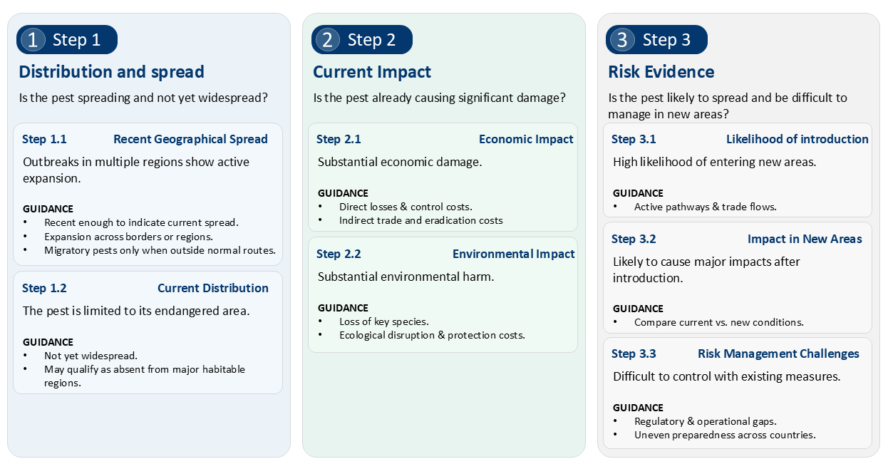
Figure 1. POARS three-step criteria for emerging pest identification
- The results are as follows:
- Emerging pests of global concern (7):
Bactrocera dorsalis (Diptera: Tephritidae)
Fusarium oxysporum f. sp. cubense TR4 (Hypocreales: Nectriaceae)
Lycorma delicatula (Hemiptera: Fulgoridae)
Orobanche cumana (Lamiales: Orobanchaceae)
Rhizoctonia theobromae (Cantharellales: Ceratobasidiaceae)
Rhynchophorus ferrugineus (Coleoptera: Curculionidae)
Xylella fastidiosa (Xanthomonadales: Xanthomonadaceae)
- Pests placed on the Watch List (6):
Banana bunchy top virus (BBTV) (Bunyavirales: Nanoviridae)
Candidatus Liberibacter asiaticus (Rhizobiales: Rhizobiaceae)
Candidatus Liberibacter solanacearum (Rhizobiales: Rhizobiaceae)
Clavibacter nebraskensis (Micrococcales: Microbacteriaceae)
Euwallacea fornicatus (Coleoptera: Curculionidae)
Sri Lanka cassava mosaic virus (SLCMV) (Geminiviridae: Begomovirus)
- The order of pests presented above is alphabetical and does not indicate priority or relative level of concern.
- For emerging pests such as Lycorma delicatula, Orobanche cumana, and Rhizoctonia theobromae, a gap analysis is expected to help identify where additional global guidance or operational tools may be needed. This work aims to support the development of harmonized technical approaches and promote more aligned preparedness measures across countries, contributing to greater consistency in early detection and response.
- The bureau has already approved the establishment of an expert working group for Rhizoctonia theobromae as recommended by the steering group.
- For emerging pests such as Bactrocera dorsalis, Xylella fastidiosa, Fusarium oxysporum f. sp. cubense TR4, and Rhynchophorus ferrugineus, where significant research, guidance, and response efforts already exist, POARS will act as a consolidated hub. Rather than duplicating ongoing efforts, POARS will collate and structure existing information into accessible pest-specific toolboxes hosted on the International Phytosanitary Portal (IPP).
- The complete list of nominated pests, the criteria, and a summary of the assessments are publicly available in the POARS section of the International Phytosanitary Portal.

Operationalization of Alerts and Information
- Following completion of the pilot assessment phase, POARS has entered its first cycle of operational implementation.
- One of the first tangible outputs is the publication of Global Pest Alerts, which marks the transition from concept to active use of the alert system for emerging pests. To complement this, the secretariat has also initiated the release of IPPC Monthly Pest Reporting Summaries, shared via email with national plant protection organizations and regional plant protection organizations. These summaries consolidate key official pest reports submitted by contracting parties (CPs) through the International Phytosanitary Portal as well as notifications from national or regional reporting systems used by CPs to fulfil their national reporting obligations.
- The secretariat has also initiated horizon-scanning collaboration with Centre for Agriculture and Bioscience International (CABI), with technical support from the European Food Safety Authority (EFSA), using the Epidemic Intelligence from Open Sources (EIOS) platform to monitor pests included on the POARS lists. A dedicated POARS dashboard has been created, and regular monitoring outputs are now supporting situational awareness and informing early warning activities. In parallel, the secretariat actively engages with the broader EIOSplant health community through established community meetings. Further refinement and integration of this work is planned as POARS matures.

Strategic Collaboration and Outreach
- Plant health innovation fair at CPM-20: The bureau has endorsed the POARS Steering Group proposal for the organization of a plant health innovation fair at CPM-20 (2026) to showcase the linkages between the Climate Change Focus Group and the Smart Plant Health initiative, emphasizing their shared strategic objectives.
- Synergies with the Africa Phytosanitary Programme (APP): Recognizing the strong synergies, collaboration has already commenced. The POARS Steering Group presented its framework and criteria for assessing emerging pests during the APP Training-of-Trainers session in South Africal 2025, outlining initial areas for joint work. Strategic recommendations were subsequently shared with the bureau, the SPG and the Implementation and Capacity Development Committee, focusing on governance alignment, integration of POARS emerging pests into national surveillance, strengthened reporting and communication, coordinated development of technical tools, and enhanced use of data for early warning and preparedness for emerging pests.

Recommendations
The CPM is invited to:
- note the progress achieved in implementing POARS since CPM-19.
- note the conclusion of the mandate of the current POARS Steering Group and the initiation of the governance transition towards the establishment of the new steering group, in accordance with the ToR approved by the CPM Bureau, as requested by CPM-19.
- acknowledge the initiation of horizon-scanning activities and strengthened collaboration with strategic partners, including CABI, EFSA and the APP.

The designations employed and the presentation of material in this document do not imply the expression of any opinion whatsoever on the part of the Food and Agriculture Organization of the United Nations (FAO) concerning the legal or development status of any country, territory, city or area or of its authorities, or concerning the delimitation of its frontiers or boundaries.

During its October meeting, the Bureau provided feedback and requested that the Terms of Reference (ToRs) be streamlined to focus solely on governance. Operational details will be moved to a separate procedures document. As of November 2025, the Bureau is further refining the ToRs for the upcoming POARS Steering Group (SG), which will be discussed at the December meeting. Once the Bureau approves the ToRs, a call for experts and approval of membership by the Bureau are expected in early 2026. Updates on the outcomes and progress regarding this matter will be provided verbally to CPM-20.
In early 2025, the IPPC Secretariat launched a call for the nomination of potential emerging pests of global concern. The call, which ran from January 31 to March 3, 2025, invited NPPOs and RPPOs to submit potential emerging pests for assessment. Call for Nominations of Potential Emerging Pests of Global Concern - International Plant Protection Convention
The Watch List is dynamic; a pest’s category is reviewed if significant new information emerges. Following a reassessment, a pest may be upgraded to "Emerging Pest of Global Concern," activating POARS activities, or downgraded and removed from the list if the threat has diminished, ensuring the system remains focused on the most significant global risks.

