International Plant Protection Convention (IPPC)

Integration and support team (ist) STAFF
Updated 2026-04-30

TECHNICAL STAFF – Regular Programme posts
 | Adriana G. MOREIRA  - Officer in Charge (OiC) of the IPPC Integration and Support Team (IST): 85%  - Standard Setting Officer and Deputy Lead to the SSU: 15%  Based in: Rome (HQ)  Room: B708  Tel.: + 39 06 570 55 809  E-mail: Adriana.Moreira@fao.org | OiC to the Integration and Support Team: Leads and manages the Implementation and Support Team (IST) on an interim basis, overseeing the team that provides operational and cross-cutting support to the IPPC Secretariat. Responsibilities include overseeing IPPC governance body logistics (CPM, Bureau, SPG), coordinating strategic communications, overseeing the management of digital platforms, and  international cooperation. Also oversees the Focus Group on Research Coordination and the TC-RPPOs as partnership.  Standard setting: Support to the overall of standard setting activities. Secretariat coordinator and lead for the IPPC Technical Panel on Diagnostic Protocols (TPDP) and on Commodity Standards (TPCS), CPM Focus Group on Safe Provision of Food and other Humanitarian Aid and Laboratory Diagnostic Networking. IPPC coordinator for CPM Recommendations process, support to the Standards Committee (SC), and several other SSU topics and working groups. Input into IPPC Governance and outreach material.  IPPC Secretariat gender focal point to the FAO NSP gender group.
ADMINISTRATIVE STAFF – Regular Programme posts
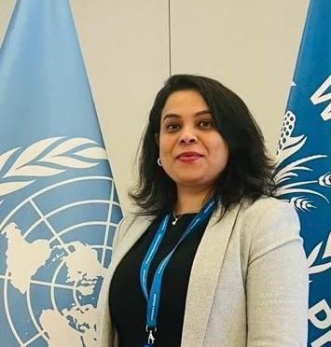 | Lucy George – Integration and support Team Assistant: Overall admin support to IST (80%) + 20% IPPC Secretariat  Based in: Rome (HQ)  Room:B758BIS  E-mail: Lucy.George@fao.org | Integration and Support Team and Administration:  Providing administrative and operational support to the group, ensuring effective implementation of its activities. Drafting and proofreading correspondence and documentation, and coordinating logistics for meetings, workshops, and technical consultations. Supporting recruitment processes, including documentation, interview scheduling, and ePPR initiation. managing travel arrangements for staff and consultants, assisting with procurement procedures, and ensuring timely submission of requets system. Supporting financial management through budget revisions and funding reallocations, ensuring efficient delivery of administrative and logistical services.  Secretary Hub:  Performing procurement activities and handling related administrative procedures for the IPPC Secretary. Organizing and managing the Secretary’s travel arrangements, including the preparation and follow-up of all associated administrative and financial documentation, ensuring compliance with organizational policies and timely execution of all processes.
CONSULTANTS – Trust funds or regular programme budget
 | Paola SENTINELLI  IPPC knowledge management specialist and Deputy Lead to the IST 100%  Based in: Rome (HQ)  Room: B766  E-mail: paola.sentinelli@fao.org | Integration and Support Team: Support to the overall coordination of IPPC Integration and Support Team (IST) activities, including IPPC governing bodies, communication, and knowledge management functions. Responsible for managing and maintaining IPPC knowledge systems, including the International Phytosanitary Portal (IPP), the APPPC platform, and other online tools, ensuring their effectiveness, user-friendliness, and technical accuracy. Lead for the development and integration of IPPC tools and data across platforms such as the EPPO pest identity database and UNEP’s InforMEA. Coordinator for the technical aspects of the Phytosanitary Capacity Evaluation (PCE) tool, National Reporting Obligations (NROs) data management, and analytical reporting. Provide technical support to initiatives such as the Africa Phytosanitary Programme (APP) and the ePhyto Solution. Responsible for posting and maintaining online content, and supporting communication and outreach activities.
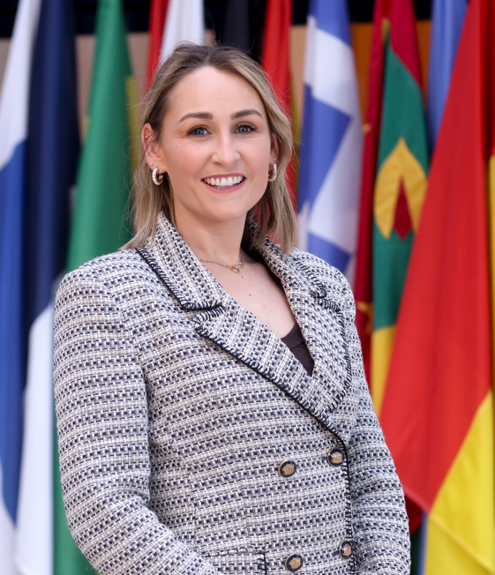 | Aoife Cassin  IPPC Programme Specialist: 100%  Based in: Rome (home-based)  e-mail: aoife.cassin@fao.org | Integration and Support Team:  Coordinates and organizes IPPC governance meetings including the annual meeting of the Commission on Phytosanitary Measures (CPM), CPM Bureau and the IPPC Strategic Planning Group. Responsible for coordinating and preparing the discussion papers, processing and reviewing documents and implementation of follow-up actions. Programme, scheduling and logistical support for the 2025 IPPC global workshop on systems approaches.
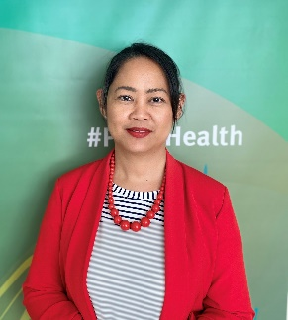 | Mutya Frio  Strategic Communications Specialist: 100%  Based in: Rome (HQ)  Room: B766  E-mail: mutya.frio@fao.org | Integration and Support Team: Coordinates the overall IPPC secretariat strategic communications and the communications team; serves as focal point for campaigns on CPM annual sessions and the International Day of Plant Health; coordinates NSP and OCC communication requests and activities; writes news, features, blogs, video scripts, press releases and, speeches; drafts discussion papers on communications for IPPC governing body meetings; and coordinates the establishment of the IPPC Regional Communications Networks,  Implementation and Facilitation Unit:  Develops and implements a communications plan on the IPPC ePhyto Solution.
 | Anita TIBASAAGA  Writer and communication specialist:50% APP, 20% IFU, 30%IST  Based in: Rome (HQ)  Room: B758BIS  E-mail: anita.tibasaaga@fao.org | Integration and Support Team: Communication coordination for the implementation of the Africa Phytosanitary Programme (APP) e.g. updating the webpage, producing videos, brochures, publishing protocols, news and features etc. Writing content e.g. IPPC website, news, feature stories, newsletter, speeches, announcements and other website copy. Support to organising events e.g. CPM and IDPH, oversee development and production of communication and visibility materials, compiles monthly IPPC Chronicle of events, coordinates writing SOPs, monitors publication of IPPC documents through FAO’s Publication Workflow System.  Handles photo requirements and requests.  Implementation and facilitation  Supports communication activities of the Implementation Facilitation Unit , particularly Pest Outbreak Alert Response System and the IPPC Plant Health Campus.
 | Mariam ALMASRI  Communication Specialist: 50% SSU, 50% IST  Based in: Rome (HQ)  Room: B758BIS  E-mail: Mariam.Almasri@fao.org | Standard Setting: Communication support to the overall standard setting activities, such as the Standards Committee (SC) and Technical Panels, through the development of strategic communication and advocacy materials. Liaison with the videographer and graphic designer to produce standard setting communication products. Contribution to visibility of IPPC standard setting processes and outcomes across web and social media channels. Input into IPPC outreach materials related to standard setting.  Integration and Support Team: Management of the IPPC official social media accounts, including content creation, campaign implementation, and oversight of multimedia production in coordination with OCC. Monitoring and evaluation of communication performance through analytics and monthly reporting on social media and website trends. Contribution to the organization and communication coverage of IPPC events and webinars, including the CPM Annual Sessions, International Day of Phytosanitary Health (IDPH), and CPM Bureau meetings. Development of web content to support knowledge management and enhance visibility of IPPC activities. Coordination of communication networks, including the IPPC Community of Practice and the IPPC Regional Communications Network. Support to the coordination of technical consultations among regional plant protection organizations (TC-RPPOs) and IPPC Regional Workshops.
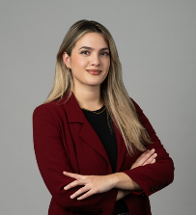 | Elettra COCCA: Intern 100% IST  Based in: Rome (home-based)  E-mail: elettra.cocca@fao.org | Integration and Support Team:  Support for IDPH, and other events. Overall communication support
 | Olivetta Caravita di Toritto: Intern 100% IST  Based in: Rome (home-based)  E-mail: olivetta.caravitaditoritto@fao.org | Integration and Support Team:  Support to the IPPC social media and communications campaigns
 | Alessandro MANNOCCHI  Graphic designer:100%  Based in: Rome (home-based)  E-mail: alessandro.mannocchi@fao.org | Integration and Support Team:  Graphic designer and art director develops and implements visual identities for programs and events through the creation of online elements, traditional media and conference design
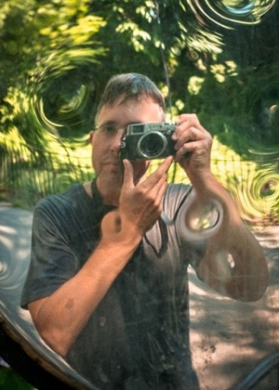 | Simon GRIFFEE  Graphic designer:80%  Based in: US (home-based)  E-mail: simongriffee@gmail.com | Integration and Support Team: Design for print and screens to support IPPC’s work on and off the field. Illustration, typesetting, layout, HTML, CSS, occasional photography.

