Report of the Second Meeting of the Expert Working Group
on
“The Use of Integrated Measures in a Systems Approach for Pest Risk Management”

The Working Group (WG) nominated Ms Ines Ares as chairperson for the meeting and Ms. Ares (Chairperson) welcomed delegates (see Annex I) to Argentina. On the second day of the EWG it was agreed Mr Ribeiro de Silva continue as chairperson to allow Ms Ares to participate more fully in the EWG discussions. The IPPC Secretariat was nominated as rapporteur for the meeting.

The meeting noted that in a number of cases it is desirable that the SC Stewart also act as chairperson for the EWG to allow individual experts more freedom to participate and express their opinions. However, it is important to note this does not preclude the chairperson from participating in discussions and providing expert opinion, with the understanding their primary goal is to ensure the meeting moves forward and consensus is developed on technical issues.

The report of the First Meeting was accepted without changes. It was noted a definition for infection could be used as the IPPC Glossary Working Group needed to develop one for ISPM No. 20 (Guidelines for Export Regulatory Systems) to deal with latent infection.

The revision of Specification #15 was considered but all agreed that the changes did not change the objectives and work already undertaken by this EWG. However, it was noted that the drafting of the anticipated citrus canker surveillance standard will take place immediately after the “The Use of Integrated Measures in a Systems Approach for Pest Risk Management” draft is complete. The members of the surveillance e-mail working group need to be re-confirmed. The delegates first worked through the supporting documents for this WG to ensure a common understanding of the issues was obtained based on the last documents developed at the last meeting.

- Risk assessment

To ensure the scientific basis for the draft ISPM on “Uses of Integrated measures in a Systems Approach for Xanthomons axonopodis pv. citri Risk Management in Fruit” is correct, the WG reviewed the proposed risk assessment for citrus canker fruit (Annex I).

Mr Pruvost started the discussions by presenting an update to the PRA for citrus canker on fruit agreed at the previous EWG. A summary of specific points are:

- Taxonomy: Of the 3 pathovars currently known to infect citrus, X. axonopodis pv. aurantifolli and X. axonopodis pv. citrumelo have been proposed as separate genetic groups from Xanthomonas axonopodis. It was agreed by the WG that only Xa pv. citri is the causal organism of Asiatic Citrus Canker and to the inclusion of strain variants from Florida and Western Asia (specifically related to variation based on host range studies).

- Pathogenicity: ALL Xa pv. citri isolates are pathogenic i.e. no avirulent isolates, but it is possible to isolate non-pathogenic isolates of Xanthomonas from citrus plants.

- Distribution: Added Bolivia and the recent outbreak in Australia. The disease is not known to occur in Morocco, although listed by CABI. Distribution data from Africa, Central America and Caribbean, and Pacific distribution listed by CABI is suspect, as there appear to be some countries missing that are known to have the disease and others are present when the disease has never been confirmed despite efforts to confirm the bacterium’s presence. It is noted that it is VERY important to use more than one source of information to verify information from a single sources e.g. CABI data. This is particularly important with respect to non-English language publications.

- Temperatures: referenced a new publication that verified earlier data published on temperature parameters for Citrus Canker.

- Non-Rutaceae hosts: Florida has been unable to confirm non-Rutaceae host susceptibility.

- Survival: added for the ability of Xac to survive in citrus in arid regions subject to irrigation.

- Dispersal: the ability of Xac to move long distances by wind driven rain.

It was noted that the additional data did not alter the risk assessment conclusions and recommendations developed in 2003.

- Risk Management

The EWG concluded the new updates to the PRA did not affect the content or outcome of the Risk Management paper. The meeting agreed on the table for risk management options. The information listed in section 2.2 was placed in an agreed table to improve clarity, consistency and understanding according to a proposal presented by Uruguay.

In relation to 3 of the 4 papers presented by Uruguay and Argentina immediately before the meeting, the EWG agreed that there was not complete information in the papers to allow a complete understanding of the information. The EWG spent a lot of time getting clarification of the data and concluded that the data provided was not adequate to confidently agree with the conclusions presented in the papers. It was understood that additional data could be gleaned from the raw data that may further support the conclusions of the papers, but this would have to be done in the immediate future.

Paper on evaluation: The EWG concluded that the trend indicated that the incidence on the fruit is less than the incidence on the trees. The EWG also concluded that the raw data was necessary to conduct further statistical analysis – Ares undertook to provide this to Brown on her return to Uruguay. The meeting also noted that this work would be repeated in subsequent seasons and that when reporting it it was necessary to report the incidence of fruit in a separate table from the incidence of trees. This would allow more definitive conclusions to be drawn.

Papers on the packing house process: Evaluation of the sorting process (Uruguay) and Proposal for monitoring citrus farms according to packing plants ability to remove fruits with quarantine diseases symptoms (Argentina): Documentation of the packing house process in Uruguay shows a professional and well thought out process for culling fruit. The EWG concluded that a citrus packing house process can remove a significant quantity of the Xac infected fruit, but could not agree on how much based on the data presented. The data presented by Argentina required substantial clarification (primarily Table 2) and the EWG noted the good work and the trends indicated in the paper were that the packing house and inspection processes could reduce fruits with citrus canker significantly. Based on the data as presented, the EWG was not able to conclude the culling in the packing house would completely eliminate all fruit with symptoms with any great degree of confidence. However, it was noted that the data needed to be developed / analysed further and this may improve support for the conclusions of this paper. In addition, it was noted that further information would also be collected and made available by Argentina.

After extensive discussions based on the above papers, the EWG concluded that the draft ISPM should allow a minimal rate (it was agreed that absolute zero is not possible) of infected Xac fruit for delivery to the packinghouse – the exact acceptable level of risk would need to be developed through bilateral negotiations. Such a range cannot be determined at present due to the unknown false negative rate during processing in the packing house – this can be determined in future once the appropriate data is available and analysed statistically and then be attached to the ISPM as an Annex. It is also difficult to determine because epidemiological context in different regions can be markedly different. All EWG members were requested to provide appropriate data to allow this analysis to take place.

- Draft ISPM

The EWG agreed risk assessment and risk management documents were the scientific basis on which the draft ISPM was prepared. Although these documents will not be referenced in this draft ISPM or provided during country consultation, it was felt important (as they are the first proposal for a draft ISPM dealing with a systems approach for a specific pest) that they should become part of the WG report, and be made available to other groups working on other draft system approach ISPMs.

Substantial debate occurred on the fact that there is no historical evidence that infected fruit can result in the introduction of this pest into a disease free area. However, the argument that absence of proof is not scientific proof that this does not happen was presented. Therefore, it had to be assumed that such a risk still exists (even if minimal) until scientific proof is provided that this is not the case.

It was noted the purpose of developing a systems approach ISPM for Xac is to provide an alternative to such phytosanitary measures as PFA, pest free places and sites of production, and prohibition i.e. this draft ISPM is to develop a phytosanitary process that is equivalent in efficacy to such measures. The meeting agreed that this draft ISPM deals with a situation where Xac is determined present by the NPPO.

It was accepted that more detail on management practices were added to the document, and it was noted sanitation practices should not take place after flowering has been initiated (i.e. this would usually take place during the “dry season”). This is to avoid masking of symptoms on fruit and hence incomplete sanitation being applied.

The draft ISPM includes a threshold level (determined bilaterally) in the system approach (see annexes of the draft ISPM) in pre-harvest. As a result of extensive discussions, there are now 2 versions of the draft ISPM:
- version of the draft that was not accepted due to problem with incubation after harvest (version 1); and
- last version that includes sampling of fruit for incubation before harvest (version 2).
There is also a further intermediate version that has been saved as a working document for reference, if needed in future. These are all available on the IPP at https://www.ippc.int/id/43443 (password protected area).

The EWG agreed to re-discuss the previously agreed steps for surveys on Thursday afternoon, with the understanding that this could impact negatively on the delivering of a completed draft ISPM by the end of the week. This discussion was based on the proposal that a final “phytosanitary test” would be conducted on fruit sampled on exit from the packinghouse process (version 1). However, discussion soon revolved around the possibility of latent infection in symptomless fruit that may pose a risk to an importing country. During discussions on the “phytosanitary test” considerable discussion revolved around possible latent infection in symptomless fruit. In this context the meeting agreed that countries in the COSAVE region do not export fruit at a susceptible stage.

COSAVE Secretariat noted the test being requested is in addition to anything requested before during export of fruit and she was not aware of any existing evidence that shows latent infection on fruit, under field conditions can lead to symptom expression after harvest and during shipment of commercial fruit. Inoculation experiments conducted so far have used inoculum concentrations far higher than those that occur in nature and are not considered valid for simulation of field conditions. In addition, stated that during black spot induction tests (high humidity and temperatures) of symptomless fruit, citrus canker symptoms have never being observed. This would lead to the conclusion that there are many unknowns parameters to accept the concept of citrus canker latent infection at present, as an important biological fact in the pathway of commercial citrus fruit consider in the PRA.

Brown, Pruvost and Poliakoff noted that uncertainty exists in determining an appropriate level of protection for an importing country. The uncertainty arises from the inability to determine the true approach rate for infected fruit on importation i.e. one method is the ability to detect infected fruit that has not show symptoms before export. For instance with Ya Li pears infected with Alternaria spp. has a significant latency period and requires modification of phytosanitary measures to achieve an appropriate level of protection. This is possible with citrus canker and importing countries do not wish to be the “test bed” for fruit that has not been diagnosed correctly that allows such uncertainty. It was also noted that the fruit exported from the COSAVE region is no longer in the susceptible stage it could still be infected. Infection can occur prior to the non-susceptible stage and the length of the period before symptoms appear has not been established.

The EWG agreed that research on the significance of latent infection needs to be addressed before it is included in an ISPM.

It was noted that the ISPM should however allow an importing country to establish an appropriate protection because of unknown factors that may pose a risk. It was also noted that the proposed final symptom test was far less restrictive than existing measures in place. Additionally, it was noted that it is completely impractical to have to store (cold storage) all processed fruit for the required period before the results of the tests are obtained to allow shipping. For these reasons, it was “agreed” that the use of this test was not possible to complete after the packing house process because of operational conditions and practical feasibility.

As a result of this disagreement on the inclusion of a “phytosanitary test”, some members of the EWG proposed to revert to the previously agreed surveys i.e. 3 separate surveys as originally agreed in 2003. Another proposal (version 2) was presented on Friday morning and it is this version that will be discussed / developed further via e-mail. The EWG concluded that if agreement could be reached on the new “Induction of Symptoms” protocol for samples (version 2) taken 15-20 days before harvest, then the whole document needs to be revised to ensure consistency with other measures e.g. number of surveys. The EWG agreed to continue working on both versions of the draft ISPM until agreement can be reached on the appropriate phytosanitary measures.

  - General comments

The Secretariat was requested to check definitions and consistency of terms in the draft ISPM, once the draft has been finalised.

For the “The Use of Integrated Measures in a Systems Approach for Pest Risk Management”, it was decided to only use the unit citrus production site as the basic unit for determination of pest incidence and status.

  - Follow-up needed

The ËWG will continue working on this document through e-mail until finalised, with the objective of submission to the SC in April 2006. The objective would be to finalise this document by 1 October 2005. Until all WG members agree on the content, it will not be considered finalised. Currently there will be no additional meeting to assist with drafting this standard due to work programme and time constraints. However, should it not be possible to reach agreement on the Annex for the incubation protocol by 1 October 2005, alternate options such as an additional meeting may be necessary to strongly justify.

Ribeiro e Silva to:
- develop the scope for the document and outline after the finalization of the draft ISPM.

Brown to:
- analyse data from Ares on incidence on trees and fruit;
- analyse data from Cortese on packing house and establishment of false negative rate;
- provide draft for Annex I by 1 June 2005; and
- provide drafts for Annex II, III and V by 1 June 2005 (to work with Cortese)

Ares to provide:
- data on incidence on trees and fruit to Brown for further analysis; and
- draft for Annex IV by 1 June 2005.

Pruvost to provide:
- the exact period for incubation of fruit (based on Japanese publication) and protocol Annex VI for incubation of fruit by 15 May 2005 for circulation.

Cortese to provide:
- data on packing house to Brown for further analysis; and
- drafts for Annex II, III and V by 1 June 2005 (to work with Brown)

Nowell to:
- edit draft ISPM into IPPC format (once the draft has been finalised);
- provide all draft documents via the International Phytosanitary Portal (IPP) by “close of business” Tuesday 8 March 2005;
- finalise report and distribute to WG members via the IPP before the end of April 2005; and
- provide linkage for any e-mail discussions that may be necessary for finalization of the draft ISPM.

  - Phytosanitary terms

An IPPC definition for infection has been developed as the definition of infestation is scientifically not correct and unacceptable for members of the EWG. This definition is also needed for ISPM 20 where the term latent infections is used, but not defined.

New terms that need to be considered by the IPPC Glossary Group:
- Citrus place of production: consists of a number of defined citrus sites of production which are under official control
- Citrus site of production: consists of a single production unit with a single cultivar that is under official control
- Incidence survey (Asian citrus canker): A survey conducted in a citrus production site at post bloom stage, based on a sampling protocol, to determine incidence on trees – will depend on final version of the document
- Qualification survey (Asian citrus canker): A survey conducted in a citrus production site shortly before harvest, based on a sampling protocol, to determine incidence on trees – will depend on final version of the document
- Infection: the act of an organism entering and establishing a pathogenic or potentially beneficial relationship with a host.
- Traceability (of a commodity): Ability to trace commodity records of observation, data and information (including origin and movement) which result from carrying out phytosanitary measures and which indicate whether specified process parameters are achieved in order to establish and audit trail.
- false negative rate
- check final draft ISPM for new definitions...........

Recommendations for other systems approach or pest specific ISPMs:
- essential to have pest information (datasheet) and/or scientific publications;
- essential to develop general pest risk assessment and management reports to be agreed during the first part of the EWG meeting;
- availability of other PRA documents related to the specific pest;
- provide the scientific and statistical basis to all WG members for all the proposed measures for the systems approach;
- all the above information should be made available as early as possible before the meeting (at least 30 days before the WG meets), otherwise they cannot be considered during the WG;
- no new significant information should be presented during the meeting that will require substantial additional analysis and discussion;
- avoid re-addressing previously agreed text, particularly if more than one meeting of the EWG is convened in developing the same draft IPSM;
- previous communication by the WG by e-mail to obtain a basic understanding of the issues involved before the meeting and to be supervised by the steward;
- necessary to have good secretariat support for the WG; and
- all documents developed to facilitate the development of a draft ISPM are considered support documents and have no official status under the IPPC.

- Miscellaneous

  - Draft ISPM on Surveillance for citrus cancer

The IPPC Secretariat, in consultation with some members of the SC, had decided not to proceed with the surveillance WG (including as an e-mail discussion group) as initially planned. It was believed details of the current draft ISPM should be finalised first so that appropriate surveillance methodologies could be determined. Brown is still willing to fulfil role of Stewart for this WG. The EWG believes sufficient information now exists to develop this new ISPM.

Annex I

PARTICIPANTS LIST

Mr Odilson Ribeiro e Silva (SC Stewart and Chairperson)  Address: Esplanada dos Ministérios,  Bloco D, Sala 344  Brasília,DF 70043-900,Brasil.  Tel: 005561.2182308; 2182731  Fax: 005561. 2243995  Email: odilson@agricultura.gov.br | Ms Françoise Poliakoff (France)  Address: DRAF PAYS DE LA LOIRE  LNPV Unité Bactériologie  7, rue jean Dixméras  F-49044-ANGERS , France, Cedex 01  Tél. : (0033)-(0)2 41 72 32 43  Fax : (0033)-(0)2 41 48 22 85  francoise.poliakoff@agriculture.gouv.fr
Ms Ana Peralta  Address: COSAVE Coordination Secretary  Esplanada dos Ministeros, MAPA Predio Principal, Sala 32  Brasilia, Brazil  Tel.: (5561) 218 2982-86  Fax.: (5561) 218 2980  E-mail.: cosave@cosave.org; anaperalta@agricultura.gov.br | Mr Olivier Pruvost (France)  Address: CIRAD  Pôle de Protection des Plantes,  Station de Ligne Paradis,  7, chemin de l'IRAT,  97410 Saint Pierre Cedex,  Reunion, France  Tel: (262) 262499220  Fax: (262) 262499293  E-mail: olivier.pruvost@cirad.fr
Mr Lawrence G. Brown (USA)  Address: Centre for Plant Health Science and Technology  US Department of Agriculture, Plant Protection and Quarantine  1730 Varsity Dr. #300  Raleigh  North Carolina  27608, USA  Phone: (001) 919-855-7503  Fax: (001)919-855-9597  E-mail: lawrence.g.brown@usda.gov | Mr Pablo Cortese (Argentina)  Address: SENASA  Paseo Colón 367, Piso 7.  (1063) Buenos Aires, Argentina  Tel: (54 11) 4331 60 41 (1713/1726)  Fax: (54 11) 4331 60 41  E-mail: pacortese@sinavimo.gov.ar
Ms Maria Inés Ares (Uruguay)  Address: Servicio de Protección Agricola  Ministerio de Granaderia, Agricultura y Pesca  Millan 4703  Montevideo  Uruguay  Phone (office): 598 2 3083094  Fax (office): 598 2 3092219  E-mail: mares@mgap.gub.uy | Mr David Nowell (FAO)  Address: IPPC Secretariat  Plant Protection Service (AGPP)  Plant Production and Protection Division  Viale delle Terme di Caracalla  00100, Rome, Italy  Tel: (0039) 0657052034  Fax: (0039) 0657054819  E-mail: dave.nowell@fao.org
Annex II

Specification No. 15 (1st Revision)

Title: The use of integrated measures in a systems approach for pest risk management of citrus fruit for citrus canker (Xanthomonas axonopodis pv. citri)

Reason for the standard:
ISPM No. 14 (The use of integrated measures in a systems approach for pest risk management) provides general guidelines related to pest risk management by the application of integrated measures in a systems approach, as an alternative to the application of a single phytosanitary measure or restrictive phytosanitary measures, with the objective of satisfying phytosanitary requirements.

The Fourth Session of the Interim Commission on Phytosanitary Measures recommended that a specific standard on risk management of citrus canker (Xanthomonas axonopodis pv. citri) for citrus fruit be developed.

Based on the biological characteristics of the pest, it is possible to offer different phytosanitary measures, integrated in a systems approach for the risk management of pest entry and establishment, that could be employed by importing countries with the aim to facilitate citrus fruit trade.

Scope and purpose: This standard provides specific guidelines on options for risk management of citrus canker by applying integrated phytosanitary measures in a systems approach to facilitate the movement of citrus fruit.

Tasks:
The Expert Working Group (EWG) should:
1. consider existing standards, such as ISPMs No. 4, 6, 8, 9 and 10;
2. consider citrus canker dissemination in relation to citrus fruit;
3. incorporate relevant concepts of systems approach (ISPM No. 14), including consideration of items such as:
- inspections (field and packaging)
- laboratory diagnostics
- treatments
- relationship between infested areas and pest free areas
- general aspects of surveillance (keeping in mind that the technical aspects of surveillance are to be contained in a future standard on surveillance for citrus canker).

Provision of resources: Funding for meetings will be provided by the COSAVE region.

Steward: Odilson Ribeiro e Silva.

Collaborators: NPPOs from COSAVE region - Argentina, Brazil, Paraguay and Uruguay.

Expertise of EWG: 6-8 phytosanitary experts having familiarity with phytosanitary systems, ISPMs, systems approaches and citrus canker expertise.

Participants: Pablo Cortese (Argentina), Françoise Poliakoff (France), José Adalberto Zuniga Reyes (Honduras), Olivier Pruvost (Réunion), Lawrence Brown (U.S.), Maria Inés Ares (Uruguay), Ana Peralta (COSAVE).

Approval: Specification developed by the SC-7 in May 2003, and approved by the SC by email in 2003. First revision reviewed by the extraordinary working group of the Standards Committee meeting in July 2004, and approved by the SC in November 2004.

References:
IPPC 1997; WTO-SPS Agreement, ISPM No. 4 (Requirements for the establishment of pest free areas); ISPM No. 6 (Guidelines for surveillance); ISPM No. 8 (Determination of pest status in an area); ISPM No. 9 (Guidelines for pest eradication programmes); ISPM No. 10 (Requirements for the establishment of pest free places of production and pest free production sites); ISPM No. 14 (The use of integrated measures in a systems approach for pest risk management); draft standard on citrus canker.

Annex III

RISK ASSESSMENT REPORT FOR Xanthomonas axonopodis pv citri ON CITRUS FRUITS

Agreed in the Second Meeting of the EWG on Systems Approach for Citrus Canker.
Buenos Aires, Argentina
March 2005

INDEX

STAGE I. INITIATION

  - Reasons for the PRA initiation
  - Taxonomic position of the pest

STAGE II. PROBABILITY OF INTRODUCTION

2.1 Probability of entry

2.1.1 Geographical distribution at world level
2.1.2 Situation of the area under PRA
2.1.3 Main hosts
2.1.4 Probable pathways of entry

2.2 Probability of establishment

2.2.1 Hosts at risk in the PRA area
2.2.2 Weather similarities between the area of origin and the area of destination
2.2.3 Brief description of the pest biology
2.2.4 Conditions of survival during handling, transportation and storing
2.2.5 Possibility of transference to an appropriate host

2.3 Economic Impact Assessment

2.3.1 Description of the damage to potential hosts in the PRA area
2.3.2 Economic impacts where the pest is present
2.3.3 Potential economic impact in the PRA area

2.4 Conclusion

2.4.1 Estimate of probabilities of introduction and establishment
2.4.2 Identified Level of Risk

MENTIONED BIBLIOGRAPHY
RISK ASSESSMENT REPORT FOR Xanthomonas axonopodis pv. citri (Xac) IN CITRUS FRUIT.

STAGE I. INITIATION

1.1 Reasons for the PRA initiation.

At the COSAVE Region, with the exception of Chile, the other countries (Argentina, Brazil Paraguay and Uruguay) have areas affected by citrus canker, and among them, the main citrus fruit exporting countries at the South Cone can be found.
Due to this reason, official institutions and their technical teams have an experience of almost 30 years in the different technical aspects of the management and control of the disease, and in export phytosanitary certification systems. Additionally, this experience is complementary to relevant information developed by USA, at domestic level or with countries belonging to the COSAVE Region.
The objective of this assessment is to contribute with elements for the risk management of the pest, in the citrus fruit trade, to facilitate the reassessment of the phytosanitary measures required by those importing countries in which the pest is of quarantine concern.

1.2- Taxonomic position of the pest

Identity:

Name: Xanthomonas axonopodis pv. citri (Hasse) Vauterin, et.al. 1995.

Synonyms: Xanthomonas campestris (Pammel) Dowson pv. citri (Hasse).
Pseudomonas citri Hasse.
Xanthomonas citri (Hasse) Dowson
Xanthomonas citri (Hasse) Dowson f.dp. aurantifolia Namekata & Oliveira.
Xanthomonas campestris (Pammel) Dowson pv. aurantifolii Gabriel, et al. 1989.

Taxonomic Position: Bacterium: Gracilicutes.

Common names: Cancrosis de los cítricos (all strains), Cancrosis Asiática (Tipo A), Cancrosis de la lima ácida y Cancrosis del limonero gallego (Tipo C), Citrus canker, Bacterial canker of Citrus, Citrus bacterial canker, Asiatic canker, canker A, canker B, canker C, canker D, Citrus bacteriosis, Chancre bacterien des agrumes.

Notes about taxonomy: Several changes on the taxonomic status of X. campestris pv. citri have been proposed (8). This includes the reassignment of some strains of pv. citri at species level, such as X. citri and X. campestris pv. aurantifolli. Up to now, these overviews have not been universally adopted and strains A, B, C and D are still classified as X. campestris pv. citri. More recently, Vauterin et al. (30) have proposed new classifications within the Xanthomonas genera. The new name X. axonopodis pv. citri (Xac) has been accepted for strain A.The names X. axonopodis pv. aurantifolli and X.axonopodis pv. citrumelo have been proposed for strains B/C/D and E, respectively, but not officially adopted by the ISPP taxonomy committee. In 1990 all the regulations regarding citrus bacterial spot or strain E of X. campestris pv. citri (X. campestris pv. citrumelo) have been withdrawn, based on scientific evidence and experience in Florida which indicated that none of the strain types cause a harmful disease for citrus or other fruit plants, Graham and Gottwald (10). The infrasubspecific division of xanthomonads associated with Rutaceae into three pathovars has been further justified by rep-PCR and AFLP analysis (20). Based on this study, all strains pathogenic to citrus belong to three different genomic groups within the axonopodis species.

STAGE II – PROBABILITY OF INTRODUCTION

2.1 Probability of entry.

2.1.1 Geographical Distribution at world level.

Citrus canker has probably originated in the Asian southeast and it was subsequently spread throughout Asia and then Africa, Oceania and the Americas. The disease has been reported in the Indian Ocean Islands in Middle East. Strains causing a moderate type of disease, with a minor host range have been reported in South America (Canker B, Canker C). They have not been isolated from naturally infected trees since the 80´s.

ASIA: Afghanistan, Andaman Islands, Bangladesh, Cambodia, People’s Republic of China, Hong Kong, India, Indonesia, Iran, Japan (including Okinawa) Kampuchea, Democratic People’s Republic of Korea, Laos, Malaysia, Maldives, Miasma (Burma), Nepal, Oman, Pakistan, Philippines, Ryuku Islands, Saudi Arabia, Singapore, Sri Lanka, Taiwan, Thailand, United Arab Emirates, Vietnam, Yemen.

AFRICA: Comoro Islands, People’s Republic of Congo, Cote d’Ivoire, Gabon, Madagascar, Mauritius, Mozambique (reported as eradicated), Reunion Island, Rodríguez Island, Seychelles Islands, South Africa (Reported as Eradicated) and Zaire (status in Africa must be reviewed).

NORTH AMERICA: Mexico (Only strain D, reported as eradicated), United States of America.

SOUTH AMERICA: Argentina (Strain A, B eradicated), Brazil (Strain A, C), Paraguay (Strain A, B and C), Uruguay (Strain A, B eradicated), Bolivia.

OCEANIA: Carolinas Islands, Christmas Islands, Cocos Islands, Fiji Islands, Guam, Marianas Islands, Micronesia, Papua New Guinea, Thursday Island (Eradicated in 1991), Reported as eradicated from the Australia and New Zealand commercial citrus areas, nevertheless, there are still occasional outbreaks in Australia.

2.1.2 Situation of the area under PRA.

The situation of the pest in the area under PRA is of quarantine importance.

    - Main hosts:

Known hosts are those of the Rutaceae family. Nevertheless, plants of Citrus genera are the hosts with higher economic importance. Natural infections are known to happen only in species, hybrids and cultivars of Citrus spp., Poncirus trifoliata, Fortunella spp. (F. japonica and F. margarita), Severinia buxifolia and Swienglea glutinosa. Nevertheless, other rutaceous members, including members of the Subfamilies Aurantiodeae, Rutoideae and Toddalioideae. A non rutaceous host, Lansium domesticum (Meliaceae) has been reported but this information was not confirmed. Canker B strains have a host range similar to Canker A strains, but affect certain hosts less severely (24). Canker C and D strains only affect Mexican lime (C. aurantifolia). The potential host range may include any wild or cultivated Rutaceae plant developed in tropical and subtropical areas where the weather is appropriate for infection and development of the disease.

Host susceptibility

Only species of Citrus and Poncirus genera are susceptible under natural conditions as to be important in the Citrus canker epidemic development. Among Citrus varieties, Citrus canker is more severe on grapefruits, some orange varieties such as Hamlin, Pineapple and Navel, Mexican limes and lemons (15). However some varieties of mandarins, oranges and limes are less susceptible and can be commertialy produced in areas where Citrus canker is endemic (15). Among these varieties are: Dancy, Ponkan, Tankan and Satsuma mandarins; Valencia, Pera, Folha, Murcha, Jaffa, Salustiana, Shamouti and Cadenera oranges, and Tahiti lime (15, 16).Variants of Xac, designed as type A* and A^{w} have a host range restricited to few citrus species, including Mexican lime (C. aurantifolia) and/or alemow (C. macrophylla) (27, 32).

2.1.4 Probable pathways of entry: This assessment only analyzes citrus fruits to be traded.

2.2 Probability of establishment.

2.2.1 Hosts in risk in the PRA Area: Species of the Citrus, Poncirus and Fortunella genera.

2.2.2 Weather similarities between the area of origin and the area of destination.

As this analysis is carried out for different free areas in which the weather details are not known, weather conditions favorable for the disease are analyzed.

According to Canteros (4) and Leite (15), weather conditions favorable for the disease are copious and persistent rains during growing season, specially in spring and summer and strong winds (wind speed higher than 8 m/s) when raining and high temperatures, but generally not above 35°C (15). Citrus canker takes place since ancient times and reaches high intensity in zones of the world where the rain season happens together with the more intense growing season. Even in favorable zones the disease may vary widely when environmental conditions change. For example, in Japan the higher infections are produced at the same time as typhoons, which lashes planted areas in some seasons.

Weather factors which promote the different stages of the disease are temperature from 20 to 35°C and humidity with regards to bacteria multiplication in already produced lesions, humidity, rains and simultaneous winds for spreading and invasion, high humidity for establishment and temperatures of 20 to 35°C for the development of a new lesion. Optimum temperature for Citrus canker development is 30º C (15)

Adverse effects for this phase are: temperatures above 35º C or under 13º C and low humidity for multiplication in old canker lesions, dryness for dispersion and invasion, low humidity for establishment and low temperature for young lesion development

These results were confirmed by Verniere et al. (31). In this study, areas under disease progress curves (AUDPC) were strongly related to the number of days during the two weeks after infection with temperatures lower than 14°C and higher than 28°C.

According to Peltier & Frederick (18), the disease is more severe in regions where temperature and humidity (rains) monthly averages increase and decrease during the year. On the contrary, the disease is less severe where high temperatures come together with low rains.

According to Serizawa et. al. (23) and Graham et al. (11), free water is a dispersion factor for the bacteria. If the wind speed is higher than 8m/sec. the disease will be more severe, as it will have the necessary pressure for penetration of the bacteria through the stomata. When wind-driven rains occur, Xac is detectable at high population sizes (10⁵-10⁷ cfu/ml)after short rain durations (a few minutes) (2,19). Later on, population sizes detected in rain water decrease substantially. The relationship between Xac population sizes and distance from the inoculum source is best described by power law models (2). Thus, Xac is readily dispersed in wind-driven rain and is dispersed in large quantities immediately after the stimulus occurs, upon which wind-driven splash can disperse inoculum over a prolonged period and over a substantial distance.

Koizumi (13), has analyzed the behavior of canker in 10 varieties of citrus and verified that the period of incubation of the bacteria decreased with the increasing of temperature. This author also verified that optimal temperatures for canker development in field conditions are between 25 and 30°C.

Stall et al. (25), in studies carried out in Argentina, verified that the internal population of Xac in canker lesions are between 10⁶ and 10⁷ cfu/ml. in the seasons in which the higher temperatures comes together with rains, while during winter months bacteria population decreased from 10² to 10⁴ cfu/ml. Even the age of the lesions does not significantly affect the bacterial population during the warmer months.

On the other side, using a rainfall simulation device, Pruvost et al. (19), verified that in Mexican Lime canker leaf lesions, submitted to tropical environment, populations of Xac did not strongly decrease in old lesions (6-10 months).

The establishment of A and A* strains in arid areas (with supplementary irrigation) of western Asia (32) may be, however, indicative of an adaptation of some genotypes to dryer climatic conditions.

2.2.3 Brief description of the pest biology.

The sources of primary inoculum for spring infections are lesions in branches and leaves as a consequence of the previous autumn infections and in which the pathogen survives during winter. The bacteria survive in lesions in leaves, branches and fruits developed during spring. Seasonal lesions are the source of bacteria for secondary infections.

In spring and at the beginning of the summer, with humid and warm weather and in the presence of free water, the bacteria that survived winter, exude from lesions. The bacteria infect leaves and young branches in actively growing tissue. The infection takes place through natural openings (stomatic pores and lenticels) and injuries. The bacteria multiplies in intercellular spaces, while the host cells divide producing abnormal proliferation of cells to cause canker type lesions.

Citrus leaves are susceptible to the canker infection for a period of only 14 to 21 days approximately near the moment they reach their maximum expansion. Fruits may be susceptible for a period of 60 to 90 days after petal drop. Lesions do not affect the internal quality of the fruit.

Rainwater collected from the foliage with lesions have between 10⁵ and 10⁸ cfu/ml. Thus rain with wind is the main way of spreading of the bacteria and winds above 8 m/s help the penetration of the agent through stomata or injuries caused by storms and insects.

Among the last ones, the citrus leaf miner (Phyllocnistis citrella) may be highlighted as it produces galleries on the leaves and when it breaks the cuticle it exposes the mesophyll to the infection caused by the bacteria, even in the more resistant varieties. Jesus et al. (12) has verified that the damages caused by the miner larvae on the leaves facilitate infection in a period of 0 to 4 days. On the other hand, with mechanical injuries, this period was of 0 to 2 days (possibly due to a quicker leaf healing).

2.2.4 Conditions of survival during handling, transportation and storing.

The bacteria survive for variable periods of time, associated to citrus symptomatic leaves, more than one year, in debris of affected plant tissues, a few months and in the soil for a few days or weeks, depending on soil and weather conditions (temperature and relative humidity). Gottwald, Graham and Shubert (9)

In addition to this, it can survive on undergrowth of weed foliage during short periods.

Timmer, Gottwald and Zitko (28) verified that the bacteria do not multiply on the asymptomatic leaves surface and the number of live bacteria on the surface of this leaves decrease very quickly, even when they had favorable conditions for their development. Culturable populations of 50.000 cfu/ml decrease to 5 cfu/ml in 50 hours on the surface of the leaves of Pineapple orange.

Populations of Xac in leaves and fruits without symptoms are generally low, even in highly infected lots and almost always undetectable in farms with low disease intensity. Rybak and Canteros (22), Timmer, Gottwald and Zitko (29) have found evidences that Xac can not remain on host plants or non host in absence of symptoms for long periods of time. This verifies the fact that the Xac residual epiphytic populations d not contribute to the leaf infection. Bacteria remaining on the leaves after rain can only survive some days, but they cannot multiply on the foliage surface and the number of live bacteria quickly decreases (15, 16). As Xac does not multiply on leaf surfaces, it is considered as a casual epiphyte instead of resident, and, therefore, it is not an important source of inoculum.

For the analysis of this point there is a division between Xac survival in lesions and in epiphytic form.

- Survival of Xac in lesions:

According to Gottwald, Graham and Shubert (9), the bacteria survives from one growing season to the following in lesions formed, mainly, during its last stage. The bacteria remain viable because there are host live cells near it. Lesions in branches can keep the bacteria alive for several years. Living bacteria have been isolated in lesions of 5 to 7 years of age form Mexican lime trunks affected by Wellington strains in Florida.

- Survival of Xac in epiphyte form:

All studies listed below refer to culturable populations of Xac, however a recent report by Cubero & Graham (7), establishes that xanthomonads associated with Citrus can enter a viable but non culturable state. The biological significance of this state is presently unknown.

On inert surfaces (metals, plastics, clothes and processed woods, among others) it was verified that Xac dies between 24 and 72 hours Gottwald et al. (9), depending on the environmental conditions, mainly humidity: when the surfaces are dried the bacteria dye.

In non host plants it may survive for several weeks in natural conditions and, according to the information of Japan and Brazil, the survival of Xac was verified up to 8 months at root zones of some weeds located under diseased trees that had been eradicated (there are no other quotations that may confirm these results). Gottwald et al (9). More recent studies showed that Xac can not survive on crop residues, weeds or soil for long periods (15). This quick decrease of Xac population is due to the fact that the bacteria has not the capacity to survive out of citrus canker lesions (15).

Koizumi and Kuhara (14) indicated that fruits are susceptible for long periods, from green (small) to maturation. Mature fruits can be infected, but their lesions do not develop.

On fruits without symptoms, Belasque and Rodriguez Neto (1) externally sprayed with a suspension of bacteria (10⁶ cfu/ml) and preserved them at room temperature at the laboratory. It was verified that the bacteria population decreased from 10 x 5 cells/ml in time zero to 10² cfu/ml in 24 hours and 10¹ cfu/ml at the third day. There was no possibility of recovering inoculated bacteria after five days.

It is useful to mention that several studies that refer to this point, such as Obata et al. (17), Stapleton, J.J. (26), Canteros et al. (5), analyze the efficiency of disinfections treatments for fruits without symptoms and their results are directly linked to the possibility of spreading of the disease and its establishment in a free zone.

Verdier et. al. in recent studies non publish yet, evaluating post harvest treatments in symptomless fruit, artificially inoculated and naturally exposed, found that average bacterial population from inoculated fruit was 2 x 10³ cfu/ml, being 4 cfu/ml after post harvest treatments. In naturally exposed fruit the bacterial population was 40 cfu/ml, being 0,054 cfu/ml after post harvest treatments.

2.2.5 Possibility of transference to an appropriate host.

Pest long distance dissemination mainly takes place through movement of infected plant propagative material, such as buds, rootstocks or nursery plants. There are no confirmed proof of spreading through seeds. Although it is proved that the pest can move over long distances with infected fruits, there is no proof of an infection started as a consequence of the introduction of affected fruit to the market.

As from the last information of Xac detection in the world, and of reinfections in countries with the disease eradicated or in areas considered as free it is mentioned that:

Infections in several Arab countries (Yemen, Saudi Arabia, Iran, United Arab Emirates, etc) are related to the introduction of infected plants from India and Pakistan, countries where the disease is endemic.

In countries such as Australia which have shown some reinfection events, they have not been related to the introduction of affected fruit. The same has happened in Florida State (USA) even when this country has an important database of interceptions of symptomatic fruits in airports and ports.

2.3 Economic Impact Assessment.

2.3.1 Description of the damage to potential hosts in the PRA area.

Primary symptoms of Xac are spots on leaves and branches and damage in the fruit skin. Under favorable infection conditions in susceptible hosts there is a defoliation and premature fall of the fruits.

Dead of terminal branches in highly susceptible hosts may happen in highly favorable conditions for the development of the disease. The internal quality of the infected fruit, which ripens on the trees, is not affected. However, the market value of the fruit with lesions is reduced.

In general, and depending on the varieties, grapefruits, limes and Poncirus trifoliata are highly susceptible; sour orange, lemon and sweet orange are moderately susceptible. Mandarins are moderately resistant. But some mandarins and hybrids mandarins are high susceptible to citrus canker, such as Fremont, Kara and Umatilla (13)

    - Economic impacts where the pest is present.

When citrus canker is severe on very susceptible varieties, under highly favorable conditions for the development of the disease (without an adequate phytosanitary management) defoliation and fall of the fruit are mentioned. There is a lost in commercial quality due to changes in the external aspect of the affected fruit.
The most important economic loss happens because of quarantine restrictions imposed to citrus fruit international trade, for fruits coming from areas where the disease occurs.

    - Potential economic impact in the PRA area.

If the pest is effectively established in citrus commercial production areas the economic impact will depend on the phytosanitary measures implemented at the beginning of the epidemic and on their success. The presence of the citrus leaf miner, and the occurrence of favorable environmental conditions are important factors which may affect the effectiveness of the first control actions.
If an endemic situation is reached, impacts will be the same as those mentioned above.

2.4 Conclusion

2.4.1 Estimate of probabilities of introduction and establishment.

For the analysis of this estimate several statistical procedures which may allow to achieve an estimated value of introduction and establishment, all of them based on the probability calculation where each stage is considered independently may be used.

This document uses information based on the Citrus Canker Risk Analysis carried out by a possible importer country for a country of the region and the risk assessment for Erwinia amylovora in commercialization of apple fruit carried out by Roberts et al. (21), due to the fact that it is a bacteria with possible transmission by fruit, subject to international trade.

If the before mentioned citrus canker risk analysis assessment is considered, the assessment will be carried out through:

- Estimate probability of entry.

The number of symptomatic and asymptomatic harvested fruit in one season was considered, taking into account export volumes with two definite probabilities:

- If the bacterium survives in the infected fruit after post harvest treatment.
- If the bacterium is capable of living after transport from the port to the destination.

- Estimate probability of establishment.

The number of symptomatic and asymptomatic fruit, which may enter into the destination country during a year, was considered, calculating the following probabilities:

- If the exported fruit enters into a citrus growing region in the country of destination.
- The possibility of the viable bacteria getting in contact with a Citrus tree.
- If the host is receptive at the contact moment.
- If environmental conditions are favorable for infection development.
- If it is possible that as from the moment of contact between the bacterium and the host, an infection is produced.

For this study, the results obtained with regard to the possibility of entrance vary between 0 and 2000 fruits/year with a media of near 20 fruits.
Regarding the possibility of establishment, it is concluded that it may happen 1 outbreak in 3.000 years.

In the study carried out by Roberts, a model taking into account the number of exported fruits per year was used, based on the following probabilities:

- If the exported fruit is infected or contaminated.
- If the bacteria survives to storing, transportation and culling.
- If the fruit may be in touch with the host.
- If the host is in a receptive state
- If the bacteria is transferred to the hosts and the infection is produced.

The results, according to the assessed scenarios, were the following:

Scenario 1: It takes into account the restrictions imposed by Japan to New Zealand and USA, and the average obtained is 1 outbreak every 38,462 years.

Scenario 2: Considers some of the requirements of the previous scenario, and in the places of production there may happen a 1 % or less of trees affected by the disease and the media obtained is 1 outbreak every 35,971 years.

Scenario 3: Without any phytosanitary measures and the obtained average is 1 outbreak every 11,364 years.

2.4.2 Identified Level of Risk.

According to what has been analyzed with regard to the information of this risk assessment, the conclusion is that the level of risk of this pest in the citrus fruit trade is very low.

Canteros (3) says that the probable risk of spreading of this disease through a fruit without symptoms, exported for final consumption, is practically non existent.

Civerolo (5) mentions that:

- Up to the date it has not been proved that Xac latent populations may produce symptoms in harvested fruits.
- There is no report proving the beginning of an epidemic due to asymptomatic commercial fruit.
- An effective management of the citrus canker may mitigate the risk of spreading of Xac through commercial fruit.
- Citrus fruit commercially produced through an integrated measure system has a very low risk of spreading of citrus canker.

Although there is a very low risk for introduction of citrus canker through fruit transportation pathway, from places that are not free from the pest, it is important to establish risk management options to meet the appropriate level of protection of importing countries where Xac is considered a quarantine pest. This is based on the lack of evidence that an epidemics can be initiated through the movement of Citrus fresh fruit from countries where the disease occur or by the introduction of symptomatic or asymtomatic fruits from infected areas.
MENTIONED BIBLIOGRAPHY

1. BELASQUE Jr.J., and RODRIGUEZ NETO, J. Sobrevivencia da bactéria causadora do cancro cítrico (Xanthomonas axonopodis pv. citri) em frutos de laranja nao infectados com a doença. Summa Phytopathologica, 26 (1): 128 (Resumo 153).

2. BOCK, C.H., PARKER, P.E., and GOTTWALD, T.R. 2005. Effect of simulated wind-driven rain on duration and distance of dispersal of Xanthomonas axonopodis pv. citri from canker-infected citrus trees. Plant Dis. 89:71-80.

3. BROWN, W.G., and SCHUBERT, T.S. 1987. Use of Xanthomonas campestris pv. citri to evaluate surface disinfectants for canker quarantine treatment of citrus fruit. Plant Disease. 71: 319-323.

4. CANTEROS, B. I. 1997. Justificación del Sistema de Lotes de Sanidad Controlada para la Producción de Fruta en Argentina con Riesgo Mínimo para la infección de Cancrosis de los Países Citrícolas de la Unión Europea. Curso de Actualización para profesionales. EEA INTA Bella Vista. 2002, pg. 211-213

5. CANTEROS, B.I. NARANJO, M., and RYBAK, M. 2000. Production of Fruits Free of Xanthomonas axonopodis pv.citri in Selected Plots, in Areas of Endemic Canker in Argentina. Proceedings International Society Citriculture. Orlando. Florida. USA. 2000.

6. CIVEROLO, E. 1997. XXI NAPPO Annual Meeting en Seattle, Washington, USA.

7. CUBERO, J., and GRAHAM, J.H. 2002. Does the viable but non-culturable state have implications for eradication of citrus canker bacterium ? Phytopathology 92:S17.

8. GABRIEL, D.W., KINGSLEY, M.T., HUNTER, J.E., and GOTTWALD, T. 1989. Reinstatement of Xanthomonas citri (ex Hasse) and X. phaseoli (ex Smith) to species and reclassification of all X. campestris pv. citri strains. Int. J. Syst. Bacteriol. 39:14-22.

9. GOTTWALD, T.R., GRAHAM, J.M. and SCHUBERT, T.S. 2002. Citrus Canker: The pathogen and Its Impact.

10. GRAHAM, J.H. and GOTTWALD, T.R., 1991. Research Perspectives on Eradication of Citrus Bacterial Disease in Florida. Plan Disease 12 1991, 1193-1200 pp.

11. GRAHAM, J.H., GOTTWALD, T.R., RILEY, T.D., and ACHOR, D. 1992. Penetration through stomata and growth of strains of Xanthomonas campestris in citrus cultivars varying in susceptibility to bacterial diseases. Phytopathology, 82: 1319-1325, 1992.

12. JESUS Jr., W. C., BERGAMIN FILHO, A., BELASQUE JR., J.C., CHRISTIANO, R.S.C., AMORIN, l, and RODIGUES NETO, J. 2003. Age of mechanical and leaf miner wounds on incidence and severity of citrus canker. 8th.Int.Congr. Pl. Pathol., Christchurch, NZ, 2-7 feb/2003 (Abstr. 2.5).

13. KOIZUMI, M. 1976. The incubation period of citrus canker in relation to temperature. Bull Fruit Trees Res. Sta., series B, 3:33-46.

14. KOIZUMI, M., and KUHARA, S.1982. Evaluation of citrus plants for resistance to bacterial canker disease in relation to the lesion extension. Bull. Fruit. Tree. Res., Sta., series D, Okitsu, 4: 73-92.

15. LEITE JR, R. P. 1990. Cancro cítrico: prevençao e controle no Paraná. IAPAR. Circular 61. Londrina, PR, Brazil.

16. LEITE JR, R. P. 2000. Surviving with citrus canker in Brazil. Proc. Intl. Soc. Citricult. IX Congr. 2000, 2: 890-896.

17. OBATA, T., TSUBOI, F., and WAKIMOTO, S. 1969. Studies on the detection of Xanthomonas citri by phage technique and the surface sterilization of Unshu Orange for export to the United States. Res. Bull. Plant Prot. Serv., Yokohama, 44(2): 26-37.

18. PELTIER, G.L., and FREDERICH, W.J. 1926. Effects of weather on the world distribution and prevalence of citrus canker and citrus scab. J. Agric. Res., 32: 147-164.

19. PRUVOST, O., BOHER, B., BROCHERIEUX, C., NICOLE, M., and CHIROLEU, F. 2002. Survival of Xanthomonas axonopodis pv. citri in leaf lesions under tropical environmental conditions and simulated splash dispersal of inoculum. Phytopathology, 92: 336-346.

20. RADEMAKER, J.L.W., HOSTE, B., LOUWS, F.J., KERSTERS, K., SWINGS, J., VAUTERIN, L., VAUTERIN, P., and DE BRUIJN, F.J. 2000. Comparison of AFLP and rep-PCR genomic fingerprinting with DNA-DNA homology studies: Xanthomonas as a model system. Int. J. Syst. Evol. Microbiol. 50:665-677.

21. ROBERTS, R.G., HALE, C.N., VAN DER ZWET, T., MILLER, C.E., and REDIN, S.C. 1998. The potential for spread of Erwinia amylovora and fire blight via commercial apple fruit; a critical review and risk assessment. Crop Prot. 17:19-28.

22. RYBAK, M., and CANTEROS, B.I. 2000. Populations of Xanthomonas axonopodis pv. citri in endemic areas. En S.H. De Boer (ed). Plant Pathogenic bacteria, 362-370.

23. SERIZAWA, S., INOUE, K., and GOTO, M. 1959. Studies on citrus canker disease. I. Dispersal of the citrus canker organism. Bull. Fac. Agric. Shizuoka Univ., 8:81-85.

24. STALL, R.E., and CIVEROLO, E.L. 1991. Research relating to the recent outbreak of citrus canker in Florida. Annu. Rev. Phytopathol. 29:399-420.

25. STALL, R.E., MILLER, J.W., and ECHENIQUE, B.I.C. 1980.Population dynamics of Xanthomonas citri causing cancrosis of citrus in Argentina. Proc. Fla. St. Hortic. Soc., 93:10-14.

26. STAPLETON, J.J. 1986. Effects of postharvest clorine and wax treatments on surface microflora of lime fruit in relation to citrus bacteriosis disease. Plant Dis. 70:1046-1048.

27. SUN, X.A., STALL, R.E., JONES, J.B., CUBERO, J., GOTTWALD, T.R., GRAHAM, J.H., DIXON, W.N., SCHUBERT, T.S., CHALOUX, P.H., STROMBERG, V.K., LACY, G.H., and SUTTON, B.D. 2004. Detection and characterization of a new strain of citrus canker bacteria from key Mexican lime and Alemow in South Florida. Plant Dis. 88:1179-1188.

28. TIMMER, L.W., GOTTWALD, T.R. and ZITKO, S.E. 1991. Bacterial exudation from lesions of Asiatic citrus canker and citrus bacterial spot. Plant. Dis. 75: 192-195.

29. TIMMER, L.W., GOTTWALD, T.R. AND ZITKO, S.E. 1996. Populations dynamics of Xanthomonas campestris pv. citri on symptomatic and asymptomatic citrus leaves under various environmental conditions Proceedings. ISC.

30. VAUTERIN, L., HOSTE, B., KERSTERS, K., and SWINGS, J. 1995. Reclassification of Xanthomonas. Int. J. Syst. Bacteriol. 45:472-489.

31. VERNIERE, C., GOTTWALD, T.R., and PRUVOST, O. 2003. Disease development and symptom expression of Xanthomonas axonopodis pv. citri in various citrus plant tissues. Phytopathology 93:832-843.

32. VERNIERE, C., HARTUNG, J.S., PRUVOST, O.P., CIVEROLO, E.L., ALVAREZ, A.M., MAESTRI, P., and LUISETTI, J. 1998. Characterization of phenotypically distinct strains of Xanthomonas axonopodis pv. citri from Southwest Asia. Eur. J. Plant Pathol. 104:477-487.

Annex IV

RISK MANAGEMENT REPORT FOR Xanthomonas axonopodis pv citri ON CITRUS FRUITS

Agreed in the Second Meeting of the EWG on Systems Approach for Citrus Canker.
Buenos Aires, Argentina
March 2005

INTRODUCTION

Pest risk management is the process through which options and intensity of measures to be applied are identified, to reach the adequate level of phytosanitary protection, taking into account the uncertainty analyzed in the risk assessment step and the probability of introduction,

RISK LEVEL

The conclusion of the risk evaluation step for Xac is that the level of risk of introduction and the establishment of this pest as a product of the international trade of fruits is very low.

PATHWAY IDENTIFICATION

In this case, risk management is analyzed, identificating a single pathway; import of citrus fruit.

IDENTIFICATION OF POSSIBLE MEASURES TO MEET THE REQUIREMENTS OF THE IMPORTING COUNTRIES

1. - Measures related to the crop.

- Pest free area, based on ISPM Nº 4.
- Pest free places of production and production sites, based on ISPM Nº10.

MEASURE CATHEGORY | PATHWAY: FRUIT
Importation under pest free area certification
System to establish pest free area | Yes
Phytosanitary measures to maintain a pest free area | Yes
Surveys to verify that the area has been maintained free of the pest | Yes
Traceability | Yes
Buffer zone requirement | No
Importation from places of production and production sites declared free of the pest.
System to establish a pest free place of production or production site | Yes
System to maintain them free of the pest | Yes
Verification that the pest free status has been obtained or maintained | Yes
Traceability | Yes
Phytosanitary certification system | Yes
Buffer zone requirement | Possible

2.- Measures related to the consignment.

- Free consignment, based on ISPM Nº 14.

2.1 Identification of possible measures to be performed by the exporting countries.

MEASURE CATHEGORY | PATHWAY: FRUIT

Importation under an integrated measures system

Preharvest
1. Eradication Procedures | Possible
2. Crop management measures to reduce the bacterial population and the number of infections. | Yes
3.Surveys | Yes
4. Importation conditioned to plant age or growing stage, or harvest season. | No
5. Traceability | Yes

Postharvest
1.Packing house inspection | Yes
2. Postharvest treatment | Yes
3. Box inspection | Yes
4. Importation under special permits and specific restrictions. | No
5. Traceability | Yes

2.2 Identification of possible measures to be performed by the importing countries.

MEASURE CATHEGORY | PATHWAY: FRUIT
1. Inspection at entry points | Yes
2.Test of suspected samples by analytical techniques agreed between trading partners | Yes
3. Specific actions for non compliance | Yes
4. System auditing by the importing country | Possible
5. Review and revise agreed measures between trading partners in order to consider alternative/ additional risk management options. | Possible

Annex V

INTERNATIONAL STANDARD

FOR
PHYTOSANITARY MEASURES

(2005 DRAFT v3)

USE OF INTEGRATED MEASURES IN A SYSTEMS APPROACH
FOR
Xanthomonas axonopodis pv. citri (Hasse) Vauterin et al, 1995
RISK MANAGEMENT IN
CITRUS FRUIT

CONTENTS

Endorsement …………………………………………………………………………………………. 3
Application……………………………………………………………………………………………. 3
Review and amendment ………………………………………………………………………………. 3
Distribution……………………………………………………………………………………………. 3

INTRODUCTION ………………………………………………………...............…………...…….. 4

SCOPE ……………………………………………………………………………..................……… 4

REFERENCES ……………….……………………………………………………………………... 4

DEFINITIONS AND ABBREVIATIONS …………….…………………………………………… 4

OUTLINE OF REQUIREMENTS ……………………………..………….………………………. 7

REQUIREMENTS ………………………………………………………………………………….. 7

1. Purpose ………………………………………………………………………………...…………. 8

2.Identification of the phytosanitary measures that should be applied in the systems approach .............…………………………………………………………………………………………...…… 8
2.1Pre-harvest …………...………………………………………………………………….. 8
2.2 Post-harvest....... ………………………………………………………………………… 8
3. Independent and dependent measures ……………………..……………………………………..9

4. Efficacy of measures …………………………………………………………..…………………....9

4.1 Pre-harvest …...…………………………………………………………………………...9
4.2 Post-harvest ……………………………………………………………….…………... .10
5. Control points …………………………………………………………………………………… 11

6. Phytosanitary Certification System …………………………………………………………… 12
Endorsement
International Standards for Phytosanitary Measures (ISPMs) are prepared by the Secretariat of the International Plant Protection Convention as part of the Food and Agriculture Organization of the United Nations´s global programme of policy and technical assistance in plant quarantine. This programme makes available to FAO Members and other interested parties these standards, guidelines, and recommendations to achieve international harmonization of phytosanitary measures, with the aim to facilitate trade and avoid the use of unjustifiable measures as barriers to trade.

This standard was endorsed by the Interim Commission on Phytosanitary Measures in …………

Application

International Standards for Phytosanitary Measures (ISPMs) are adopted by contracting parties to the IPPC, and by FAO Members that are not contracting parties, through the Interim Commission on Phytosanitary Measures. ISPMs are the standards, guidelines and recommendations recognized as the basis for phytosanitary measures applied by Members of the World Trade Organization under the Agreement on the Application of Sanitary and Phytosanitary Measures. Non-contracting parties to the IPPC are encouraged to observe these standards.

Review and amendment

International Standards for Phytosanitary Measures are subject to periodic review and amendment. The next review date for this standard is …………., or such other date as may be agreed upon by the Commission on Phytosanitary Measures.

Standards will be updated and republished as necessary. Standard holders should ensure that the current edition of this standard is being used.

Distribution

International Standards for Phytosanitary Measures are distributed by the Secretariat of the International Plant Protection Convention to all FAO Members, plus the Executive/Technical Secretariats of the Regional Plant Protection Organizations:

- Asia and Pacific Plant Protection Commission
- Caribbean Plant Protection Commission
- Comité Regional de Sanidad Vegetal para el Cono Sur
- Comunidad Andina
- Inter-African Phytosanitary Council
- Organismo Internacional Regional de Sanidad Agropecuaria
- Pacific Plant Protection Organization
- European and Mediterranean Plant Protection Organization
- North American Plant Protection Organization.

INTRODUCTION

SCOPE

This standard assesses the integrated measures in a systems approach as an option for risk management of Xanthomonas axonopodis pv citri (Xac) which causes Asiatic Citrus Canker (ACC), according to relevant international standards, specifically ISPMs Nº 11 and Nº 14, which have been developed to meet phytosanitary requirements regarding import of citrus fruits originating from areas in which the pest is present, in order to facilitate safe international trade of citrus fruit.

REFERENCES

Agreement on the Application of Sanitary and Phytosanitary Measures, 1994. World Trade Organization, Geneva.
Determination of pest status in an area , 1998, ISPM Nº 8, FAO , Rome.
Export certification system, 1997, ISPM Nº 7, FAO, Rome
Guidelines for pest risk analysis, 1996. ISPM Pub. N° 2, FAO, Rome.
Glossary of phytosanitary terms, 2002. ISPM Pub. N° 5, FAO, Rome.
Guidelines for phytosanitary certificates, 2001, ISPM Nº 12, FAO, Rome.
Guidelines for pest eradication programs, 1998, ISPM Nº 9, FAO, Rome.
Guidelines for surveillance, 1997, ISPM Nº6, FAO, Rome.
International Plant Protection Convention, 1997. FAO, Rome.
Pest risk analysis for quarantine pests including analysis on environmental risks, 2001. ISPM Pub. N° 11 rev.1, FAO, Rome.
Principles of plant quarantine as related to international trade, 1995. ISPM Pub. N° 1, FAO, Rome.
Requirements for the establishment of pest free places of production and pest free production sites, 1999, ISPM Nº 10, FAO, Rome.
The use of integrated measures in a systems approach for pest risk management. 2002. ISPM Pub. N° 14. FAO, Rome.

DEFINITIONS AND ABBREVIATIONS

Area | An officially defined country, part of a country or all or parts of several countries [FAO, 1990; revised FAO, 1995; CEPM, 1999; based on the World Trade Organization Agreement on the Application of Sanitary and Phytosanitary Measures]
Citrus place of production* | Consists of a number of defined citrus sites of production which are under official control
Citrus site of production* | Consists of a single production unit with a single cultivar under official control
Commodity | A type of plant, plant product, or other article being moved for trade or other purpose [FAO, 1990; revised ICPM, 2001]
Consignment | A quantity of plants, plant products and/or other articles being moved from one country to another and covered, when required, by a single phytosanitary certificate (a consignment may be composed of one or more commodities or lots) [FAO, 1990; revised ICPM, 2001]
Control point | A step in a system where specific procedures can be applied to achieve a defined effect and can be measured, monitored, controlled and corrected [ISPM Pub. N° 14, 2002]
Country of origin (of a consignment of plants) | Country where the plants were grown [FAO, 1990, revised CEPM, 1996; CEPM, 1999]
Detection survey | Survey conducted in an area to determine if pests are present [FAO, 1990, revised FAO, 1995]
Entry (of a pest) | Movement of a pest into an area where it is not yet present, or present by not widely distributed and being officially controlled [FAO, 1995]
Establishment | Perpetuation, for the foreseeable future, of a pest within an area after entry [FAO, 1990; revised FAO, 1995; IPPC, 1997; formerly established]
Incidence survey (Asiatic citrus canker)* | A survey conducted in a citrus production site at post bloom stage, based on a sampling protocol, to determine incidence on trees
Infection* | The act of an organism entering and establishing a pathogenic or potentially beneficial relationship with a host.
Introduction | The entry of a pest resulting in its establishment [FAO, 1990; revised FAO, 1995; IPPC, 1997]
Inspection | Official visual examination of plants, plant products or other regulated articles to determine if pests are present and /or to determine compliance with phytosanitary regulations [FAO, 1990; revised FAO 1995; formerly inspect]
IPPC | International Plant Protection Convention, as deposited in 1951 with FAO in Rome and as subsequently amended [FAO, 1990; revised ICPM, 2001]
Lot | A number of units of a single commodity, identifiable by its homogeneity of composition, origin etc., forming part of a consignment [FAO, 1990]
National Plant Protection Organization | Official service established by a government to discharge the functions specified by the IPPC [FAO, 1990; formerly Plant Protection  Organization (National)]
NPPO | National Plant Protection Organization [FAO, 1990; ICPM, 2001]
Official | Established, authorized or performed by a National Plant Protection Organization [FAO, 1990]
Pathway | Any means that allows the entry or spread of a pest [FAO, 1990; revised FAO, 1995]
Pest | Any species, strain or biotype of plant, animal or pathogenic agent injurious to plants or plant products [FAO, 1990; revised FAO, 1995; IPPC, 1997]
Pest Risk Analysis | The process of evaluating biological or other scientific and economic evidence to determine whether a pest should be regulated and the strength of any phytosanitary measures to be taken against it [FAO, 1995; revised ISPM, 1997]
Pest risk assessment (for quarantine pests) | Evaluation of the probability of the introduction and spread of a pest and of the associated potential economic consequences [FAO, 1995; revised ISPM Pub. N° 11, 2001]
Pest risk management (for quarantine pests) | Evaluation and selection of options to reduce the risk of introduction and spread of a pest [FAO, 1995; revised ISPM Pub. N° 11, 2001]
Phytosanitary measure (agreed interpretation) | Any legislation, regulation or official procedure having the purpose to prevent the introduction and/or spread of quarantine pests, or to limit the economic impact of regulated non-quarantine pests [FAO, 1995; revised IPPC, 1997; ISC 2001] The agreed interpretation of the term phytosanitary measure accounts for the relationship of phytosanitary measures to regulated non-quarantine pests. This relationship is not adequately reflected in the definition found in Article II of  the IPPC (1997).
Phytosanitary procedure | Any officially prescribed method for implementing phytosanitary regulations including the performance of inspections, tests, surveillance or treatments in connection with regulated pests [FAO, 1990; revised FAO, 1995; CEPM, 1999; ICPM, 2001]
Phytosanitary regulation | Official rule to prevent the introduction and/or spread of quarantine pests, or to limit the economic impact of regulated non-quarantine pests, including establishment of procedures for phytosanitary certification [FAO, 1990; revised FAO, 1995;CEPM, 1999; ICPM 2001]
PRA Area | Area in relation to which a Pest Risk Analysis is conducted [FAO, 1995]
PRA | Pest Risk Analysis [FAO, 1995; revised ICPM, 2001]
Qualification survey (Asiatic citrus canker)* | A survey conducted in a citrus production site shortly before harvest, based on a sampling protocol, to determine incidence on trees
Quarantine pest | A pest of potential economic importance to the area endangered thereby and not yet present there, or present but not widely distributed and being officially controlled [FAO, 1990; revised FAO, 1995; IPPC 1997]
Spread | Expansion of the geographical distribution of a pest within an area [FAO, 1995]
Survey | An official procedure conducted over a defined period of time, to determine the characteristics of a pest population or to determine which species occur in an area. ( FAO, 1990, revised CEPM, 1996)
Systems approach(es) | The integration of different pest risk management measures, at least two of which act independently, and which cumulatively achieve the appropriate level of phytosanitary protection [ISPM Pub. N° 14, 2002]
Test | Official examination other than visual, to determine if pests are present or to identify pests [FAO, 1990]
Traceability ( of a commodity)* | Ability to trace commodity records of observation, data and information (including origin and movement) which result from carrying out phytosanitary measures and which indicate whether specified process parameters are achieved in order to establish an audit trail.
Treatment | Officially authorized procedure for the killing or removal of pests or rendering pests infertile [FAO, 1990; revised FAO 1995; ISPM Pub. N° 15, 2002]

(*) New term.

OUTLINE OF REQUIREMENTS

Based on the international standards, the result of a pest risk analysis (PRA) can conclude that it is necessary to manage the identified phytosanitary risk. An option for pest risk management is the systems approach. The identified risks related to the presence of Xac on citrus fruits, may lead to the proposal of risk management measures based on control points in citrus export system to reduce and control the risk of its introduction. The systems approach should be less restrictive to safe trade than a single phytosanitary measure, which may or may not be feasible.

REQUIREMENTS

The systems approach for Asiatic citrus canker is established and maintained by the exporting contracting parties through the NPPOs.

- Purpose

The purpose is to establish a systems approach combining phytosanitary measures for risk management of Xac, in order to meet the level of phytosanitary protection required by the importing party for whom this pest is of quarantine importance.

This system is intended to achieve the safe trans-boundary movement of citrus fruit from citrus sites of production where the pest is present below an agreed threshold and the results of the surveys indicate that the pest was not detectable, based on the survey parameters proposed in this standard.

The systems approach considers pre-harvest and post-harvest procedures, which contribute to the efficacy of the pest risk management.

- Identification of the phytosanitary measures that should be applied in the systems approach

Only contracting parties that could comply with ISPM Nº 6 for Asiatic citrus canker would be eligible for the application of this system approach.

The following are identified phytosanitary measures for pest risk management for the pathway commercial fruit. Additional phytosanitary measures could be applied when technically justified.

Measures to be performed by the exporting countries.

Preharvest
1. Eradication Procedures | If necessary
2. Crop management measures to reduce the bacterial population and the number of infections. | Yes
3.Surveys | Yes
4. Traceability | Yes

Postharvest
1.Packing house inspection | Yes
2. Postharvest treatment | Yes
3. Box inspection | Yes
4. Traceability | Yes

Measures to be performed by the importing countries.

1. Inspection at entry points | Yes
2.Test of suspected samples by analytical techniques agreed between trading partners | Yes
3. Specific actions for non compliance | Yes
4. System auditing by the importing country | If necessary
5. Review and revise agreed measures between trading partners in order to consider alternative/ additional risk management options. | If necessary

3. Independent and dependent phytosanitary measures

A systems approach can be composed of independent and dependent phytosanitary measures, including at least two independent phytosanitary measures. The relationships between those proposed measures, specific for Xac are indicated in the table below.

Phytosanitary Measure | 1 | 2 | 3 | 4 | 5 | 6 | Add later
1.Accepted practices for citrus canker management
2. Detection survey | I | D
3. Incidence survey
4. Qualification survey
5. Inspection of the process of fruit packaging during turn over, at the export line. | I | I
6. Post-harvest treatment | I | I |  |  | I
7. Inspection of boxes | I | I |  |  | I | I

Note: Sections of the document will be included into the last column by the Secretariat.
I : independent phytosanitary measure

D : dependent phytosanitary measure

4.Efficacy of phytosanitary measures

The systems approach may be developed or evaluated either in a quantitative or qualitative manner or a combination of both. In this case, the efficacy of phytosanitary measures is assessed in pre and post harvest.

4.1 Pre-harvest

4.1.1 Crop management measures to reduce bacterial population and the number of infections.

Use of crop management practices to reduce Xac population and the number of infections includes measures that could be implemented by the exporting country, until fruit harvest.

Based on the information obtained from surveillance programs, which provide information on the pest status in the Citrus site of production and taking into account the climatic conditions during the phenological stages more favorable for disease occurrence, the management measures more appropriate for each situation are determined, that could be the following or a selection of them:

Selection of less susceptible varieties:
There are cultivars that have demonstrated to be significantly less susceptible to Xac, both in foliage and fruit, allowing having through them a better phytosanitary condition of the crop.

Sanitation measures for affected trees:
Measures like pruning, defoliation or tree removal are applicable according to the pest situation in a site of production, in order to reduce the available inoculum. Sanitation measures should be carried out prior to bloom stage.

Preventive crop chemical treatments:
These treatments may be carried out through spray with appropriate phytosanitary products to protect the new flushes of the plants and fruits from Xac infection.

Integrated management of leaf miners of Citrus .
The integrated management of the leaf miner is carried out through chemical and biological control to lower the number of its lesions, to avoid the entry of Xac through these lesions.

Cultural measures:
Measures such as windbreaks, pruning, irrigation, appropriate fertilization to avoid a large number of flushes, inter row management, disinfection measures (grove entrance, personnel, tools, equipments, etc) are applicable in order to give the less favorable conditions for Xac infection development.

The NPPO of the exporting country should evaluate through a survey if the efficacy of the applied phytosanitary measures allows the fruits of the site of production to be qualified for delivery to the packing house.

4.1.2 Surveys

Surveys allow NPPOs to determine which citrus sites of production are eligible for packinghouse processing.

Two kinds of surveys could be applied in the site of production in the framework of the application of a systems approach for Xac to determine eligibility to harvest fruit for export. These are detection and incidence survey and qualification survey.

4.1.2.1 Detection survey.

For the purposes of this systems approach, detection survey should be performed. This survey verifies the absence or presence of the pest in the citrus site of production included in an infested area

It is based on a sampling protocol (see annex 1), which will allow determination, with a confidence interval, of the presence or absence of the pest.

      - Incidence survey

This survey, based on a sampling protocol, should be performed after bloom stage, to verify the incidence of Citrus canker on trees. It should be expressed in quantitative terms with a confidence interval as described in annex 2.

In case citrus sites of production was not found free of Citrus canker symptoms at that stage, incidence should be determined on trees and if it is higher than the one that was agreed between trading partners, then the citrus site of production is not suitable for export under the system approach

4.1.2.3 Qualification survey

2003 Version

This survey, based on a sampling protocol (see annex), should be performed within three weeks of harvest to verify whether the citrus site of production has no detectable lesions on trees. It should be expressed in quantitative terms with a confidence interval NEED VALUES HERE.

Fruit from citrus sites of production found free of Xac at that stage would be suitable for harvest and delivery to the citrus packing house.

2005 Discussion

All Citrus sites of production for export require the qualification survey before they would be elegible for harvest.

This survey, based on a sampling protocol, should be performed within three weeks before harvest to verify the incidence of Citrus canker on trees and fruits. It should be expressed in quantitative terms with a confidence interval as described in annex 3.

Fruit from citrus sites of production found free of Citrus canker symptoms at that stage, would be suitable for harvest and delivery to the citrus packing house.

In case fruit from citrus sites of production was not found free of Citrus canker symptoms at that stage, incidence should be determined and if it is higher than the one that was agreed between trading partners, then the citrus site of production is not suitable for export under the system approach.

Note : Agreement was not reached in the group about the text for this item

4.1.3. Traceability pre harvest

To trace back Citrus fruit for export, the following documentation should be produced as a minimum and made available through the NPPO:

- Register of all pertinent information about the site of production.
- Records of any field inspections and surveys undertaken.
- Authorization to harvest.

Records of crop management practices should be made available by the grower to the NPPO.

4.2 Post-harvest

4.2.1.Packing house inspection

Annex 4 contains the inspection procedures to be performed by trained staff during inspection through the whole process of the fruit in the packing house and specially:

- in the sorting points
- at packaging

4.2.2. Post harvest treatment

Post harvest treatments for Xac should be performed, based on authorized products, such as the following ones:

- Immersion with Sodium Hypochlorite at 200 ppm, pH 7.0, for two minutes.
or
- Immersion in non saponaceous SOPP at 2% during 1 minute
or
- 45 seconds washing with a SOPP saponaceous formula.

Register of performed treatments should be maintained for the NPPO.

4.2.3. Box inspection

Inspection of boxes or bins for export should be a simple random sample of 3000 fruits from each defined population (see Annex 5).
Information made available by the traceability systems defines the population.

When at least one lesion of citrus canker is detected, then the current defined population is not eligible for export. All Citrus sites of production composing the defined population should undergo a further pre harvest qualification survey, in order to maintain their eligibility for export.

4.2.4 Traceability post harvest

To trace back Citrus fruit for export, the following documentation should be produced as a minimum and made available through the NPPO:

- Identification of the harvest containers.
- Transport documentations from orchard to packing house and from the packing house to the point of exit to the importing country.
- Identification of box/pallets/bins

4.2.5. Induction of symptoms

Note: No agreement has been reached on this item.

Incubation should not be initiated BEFORE 30 DAYS PRIOR TO HARVEST.
A simple random sample of 3000 fruits from the site of production should be incubated in a Citrus canker conducive environment, to induce symptoms development under a protocol defined in annex 6. Period of induction should be 15 to 20 days. The respective NPPO should carry out the inspection of the incubated fruit after this period. If a fruit with symptoms of Citrus canker is found in the incubated sample, then either the site of production is not eligible for export.

Note: figures in blue mean that they must be reviewed based in bibliographic information.

5. Critical Control Points

The NPPO is responsible for the relevant inspections at specified control points with the aim to verify compliance with the above phytosanitary measures.
For this systems approach control points are identified at the citrus site of production and the packing house.

6. Export Certification System

The export certification system should comply with ISPM Nº 7 and 12 and is based on the use of traceability as a tool to identify the origin of the fruit to be commercialized, allowing to know whether the different production process stages comply with the phytosanitary requirements of the importing countries.

The following is the sequence of the system components:

- Registry of producers, citrus sites of production.
- Pre-harvest inspections to verify compliance of the incidence level required to approve the harvest (see paragraph …..).
- Harvest approval.
- Identification of the harvest containers
- National Transport Documentation
- Register of packinghouses
- Inspections at packinghouses and certification of post-harvest treatment.
- Identification of pallets or bins
- Verification of the consignment and issuance of the Phytosanitary Certificate.

Note: Check consistency of the text.

7. Measures in the importing country

The importing country may wish to consider the following measures.
- Inspection at entry points
- Test of suspected samples by analytical techniques agreed between trading partners
- Specific actions for non compliance
- System auditing by the importing country
- Review and revise agreed measures between trading partners in order to consider alternative/ additional risk management options.

LIST OF ANNEXES

The following Annexes need to be developed

Annex 1 : Detection survey

- Statistical basis for the sampling protocol
- Survey protocol parameters.(L. Brown provides document till June 1st )

Annex 2 : Incidence survey

- Sampling protocol (L. Brown and Pablo Cortese provide document till June 1st )

Annex 3 : Qualification survey

- Sampling protocol (L. Brown and Pablo Cortese provide document till June 1st )

Annex 4 : Inspections at packing house

- Inspection procedures during packing ( Ines Ares provides document till June 1st)

Annex 5 : Inspection of boxes and bins

- Statistical basis for the simple random sampling for boxes and bins (L. Brown and Pablo Cortese provide document till June 1st )

Annex 6 : Incubation protocol

- Detailed Incubation Protocol ( Olivier Pruvost provides document till May 15th)

Annex VI

MINISTRY OF LIVESTOCK, AGRICULTURE AND FISHERIES OF URUGUAY

GENERAL DIRECTION OF AGRICULTURAL SERVICES

PLANT PROTECTION DIVISION

Evaluation of the incidence of citrus canker on fruit

Exploratory follow-up

Introduction

The Uruguayan citriculture can be defined as an agro-industrial complex designed to produce citrus whose main destination is the export of fresh fruit. This citrus production takes place in two large areas which have their own special characteristics.The Northern area mainly covers the Departments of Salto, Paysandú, Río Negro and Rivera, and the Southern area covers the Departments of Montevideo, Canelones, San José, Colonia and Maldonado.

Uruguay has approximately 20,862 hectares of citrus plantations with a total number of plants in the order of 6 millions and a production of 340,000 tons of fruit.

In the Northern area and basically in the area of Salto and North of Paysandú, the geographical distribution of citrus plantations is very heterogeneous. It comprises large companies and small-and-medium-sized producers with different objectives regarding the commercial destination of their production. Big companies production is destined to export, while the production of the other producers is destined to the domestic market and some varieties of commercial interest are destined to export.
The disease caused by Xanthomonas axonopodis pv. citri is one of the main phytosanitary problems of citriculture in this area, principally due to the quarantine restrictions of international markets.

Since 1977, citrus canker is under official control. During all these years, different phytosanitary measures were implemented according to the different epidemiological situations. Nevertheless, considering always citrus canker as the key pest to certify. As from 1997, with the introduction of the citrus leaf miner (Phyllocnistis citrella) and El Niño phenomenon, the appearance of an important epidemic impact determined an increase in the incidence of the disease. On the other hand, according to the data obtained in field studies, differences in the incidence on fruit were observed. There were no bibliographical information about the relationship between the incidence on fruits and on plants.
Given the importance of citriculture for the area in the Departments of Salto and Paysandú and according to the limited information regarding the different incidence of citrus canker on foliage and fruit, a follow-up was carried out during 2003 to evaluate this relationship.

Specific objective: To evaluate the relationship between the incidence of Xanthomonas axonopodis pv citri on fruit in commercial places of production.

Materials and Methods

Sixty eight blocks of citrus commercial production of the Salto area and the Northern part of the Department of Paysandú were selected at random.

In accordance with the information available, obtained from the annual prospecting of the Places of Production, blocks from 27 Places of Production were selected to be evaluated.
Prior to the 2003 harvest, an inspection was carried out in the blocks covering 100% of the plants. The selected blocks were grouped by variety, while the evaluation was done for all the varieties. The variety groups considered were Satsuma Mandarins, Navel and Valencia Oranges, Mandarins and Hybrids, Grapefruits and Lemons.

All plants were observed in each production block. In each of them, the presence or absence of visible symptoms of citrus canker (Xac) was determined in leaves and fruits. The number of fruits with Xac symptoms were counted and the total number of fruits in each tree was estimated.

The evaluated parameters were the following:

Incidence of citrus canker on plants (IP): Number of plants with Xac symptoms /Total number of plants in block. It is expressed by a percentage.
Incidence of citrus canker on plants with fruits with Xac symptoms (IPF): Number of plants with fruits with Xac symptoms /Total number of plants in block. It is expressed by a percentage.
Incidence on fruit (IF): Total number of fruits with Xac symptoms /Total number of fruits. It is expressed by a percentage.

For the purpose of the analysis, the results obtained were grouped according 4 ranges: incidence of 0-1%, 1.1-5%, 5.1-10% and more than 10%. Furthermore, the maximum incidence of each evaluated parameter was related to the relationship between the maximum incidence on plants (%) and the corresponding maximum incidence on fruits (%) in the evaluated blocks.

Results and Discussion

The obtained results are shown in the following table:

Table 1: Number and percentage of blocks according to incidence ranges of the evaluated parameters.
Parameter | 0 – 1%  # and % of blocks |  | 1 – 1.5%  # and % of blocks |  | 5.1 –10%  # and % of blocks |  | 10  # and % of blocks |  | Total number of blocks
IP | 17 | 25 | 7 | 10 | 7 | 10 | 37 | 55 | 68
IPF | 29 | 43 | 9 | 13 | 7 | 10 | 23 | 34 | 68
IF | 60 | 88 | 8 | 12 | 0 |  | 0 |  | 68

The 25% of the commercial blocks evaluated has an incidence on plants equal or lower than 1%, which was evaluated through the presence of Xac symptoms in leaves. The 55% of the observed blocks had an incidence on plants higher than10%.

The incidence of plants with fruit with Xac symptoms is different with respect to the incidence of plants with symptoms only in leaves, as it can be observed in Table 1, with 43% of blocks with an incidence on plants with symptoms in fruits equal or lower than 1%.

The incidence on fruits in plants is even lower, 88% of the evaluated blocks presented a value equal or lower that 1% on their fruits with Xac symptoms.

The relationship between the maximum incidence of plants with symptoms in leaves and the maximum incidence of fruits with symptoms is analysed In the following figure. The relationship between both variables for all Places of Production was positive, with a coefficient of determination of 52%. It can be observed that the production blocks with incidence on plants lower that 35% presented incidence on fruits with symptoms lower than 0.5%.
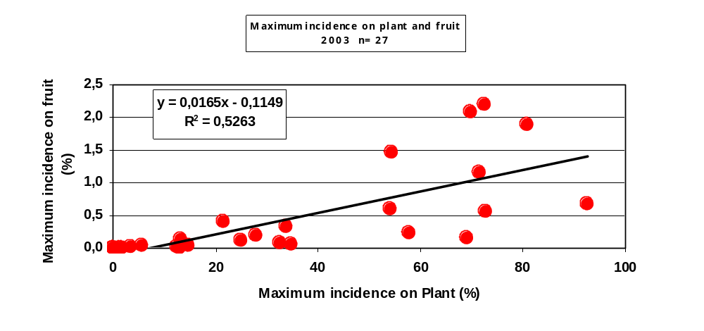

Annex VII

EVALUATION OF THE SORTING PROCESS OF CITRUS FRUIT FOR EXPORT IN PACKINGHOUSES RELATED WITH THE EFFICACY OF ONE OF THE MEASURES PROPOSED FOR RISK MANAGEMENT OF Xanthomonas axonopodis pv. citri FOR EXPORT TO THE EUROPEAN UNION.

MINISTRY OF LIVESTOCK, AGRICULTURE AND FISHERIES OF URUGUAY, GENERAL DIRECTION OF AGRICULTURAL SERVICES

PLANT PROTECTION DIVISION

On the basis of the risk management and assessment reports for Xanthomonas axonopodis pv. citri and Guignardia citricarpa issued by COSAVE [Southern Cone Committee for Vegetal Health], the NPPO of MERCOSUR countries submitted an Alternative Proposal of equivalent phytosanitary measures for the risk management of these pests in citrus fruits, based on ISPM 14 “The use of integrated measures in a systems approach for pest risk management”.

The aim consists in setting a systems approach which combines X. axonopodis pv. citri and Guignardia citricarpa risk management measures to meet the appropriate level of phytosanitary protection of an importing country for which this pest is of quarantine importance. The systems approach offers an alternative to the use of only one procedure or it replaces more restrictive measures. The system considers pre-harvest and post-harvest procedures which contribute to the efficacy of pest risk management.

One of the measures established in pre-harvest is the Authorization to harvest the site of production. This measure consists in an inspection of the crop to establish the incidence of fruit with symptoms of the mentioned pests. On the basis of this inspection, harvest of the fruit in the inspected site will be authorised with an incidence lower or equal than 1%.

The proposal of this measure is based on the efficacy in the sorting task performed in packing houses, mainly to comply with the export agreements regarding fruit quality and different categories. Based on this, for culling of fruit with symptoms of the mentioned pests, it is possible to select them to comply with one of post-harvest defined measures, Sorting of infected fruit.

In this paper, we analyse the possibility and efficacy of the proposed measure based on packing house data where two processes take place. First the fruit goes through a pre-grading process and then goes through the processing line ending with fruit packaging. Although in Uruguay, such as in Argentina and Brazil, not all packing houses perform the pre-grading process and the fruit directly goes to the packing line, we chose this type of packing house to analyse both processes.

The analysis was made based on the available data during all the process in the packing house located in Salto, Uruguay. Differences in the process for the different species (Mandarins, Oranges, Lemons and Grapefruits) were analysed in order to show the efficacy of the fruit sorting for export evaluating the proposed maximum limit of 1% incidence of fruit with symptoms in pre-harvest.

Description of the citrus fruit process flow in the packing house

Pre-grading

Degreening

Processing line

Packaging

1. Process description

Pre-grading process

Electronic sorting of fruit by size, weight and colour. Manual removal of fruit which does not comply due to cosmetic or phytosanitary problems. At this stage, fruit is dipped in a sodium hypochlorite solution (200 to 250 ppm of free chlorine). Eventually Post- harvest fungicides are also added.

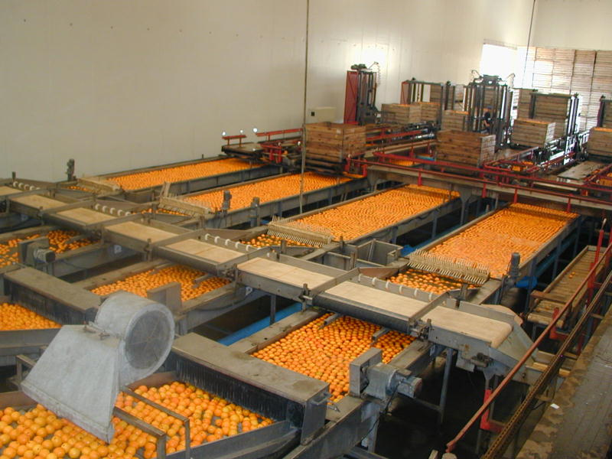 Pre-grading machine

An standard pre-grading machine has 4 sorting lines. In each one work 6 to 8 operators divided in both sides of the line depending on fruit quality at reception.

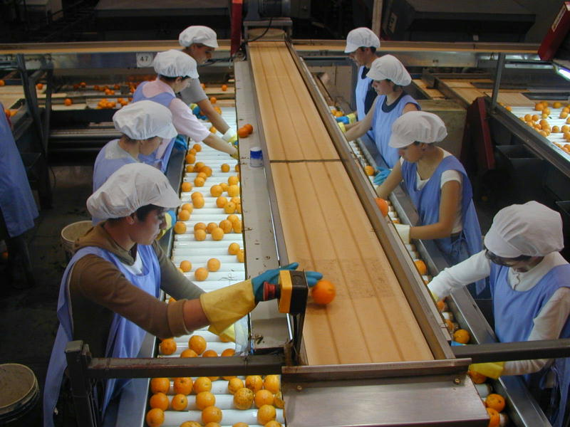 Sorting line. Pre-grading machine.

Fruit dumped per hour depends among other factors on fruit size. For instance the values go from 40,000 kg/hour in oranges to 25,000 kg/hour for small mandarins. The average in the case of lemons is 30,000 kg per hour and 35,000 kg per hour in the case of grapefruits. Table 1 shows the quantity of fruit observed by operators along the sorting lines.

Table 1: Fruit processed per hour, per sorting line, per minute.

SPECIES | KG/HOUR | KG/HOUR/LINE | KG/LINE/MIN. | FRUITS/LINE/MIN.
Orange | 40,000 | 10,000 | 167 | 835
Grapefruit | 35,000 | 8,750 | 146 | 730
Mandarin | 22,000 | 6,250 | 104 | 1,248
Lemon | 30,000 | 7,500 | 125 | 1,250

Each line has a width and velocity according to human visual capability. In this case width is 1.20 m, length 4 m and fruit velocity 4 m/minute.

Fruit sorting evaluation for quality problems

In the case of lemons, where a maximum of 1,250 fruits are analysed per minute, considering a velocity of 4 m/min and 8 people in the sorting line, the number of fruits observed per minute is 156. According to the size evaluated, 260 fruits can be included per square meter, leaving small spaces among fruits (this number was directly evaluated on the line).
It is important to mention the skill of the packing house operators to perform the fruit sorting, which is the result of training and experience.

Evaluation of lemon sorting, with Xac symptoms: The number of fruits observed per minute and the number of fruits with symptoms that should be removed to be discarded are shown in Table 2, considering three levels of incidence: 5%, 3% and 1% of fruits with symptoms.

Table 2: Fruits / minute, Fruits with symptoms according to incidence and fruit with symptoms to be removed per person per line.

Incidence | Fruits/Minute | Fruits With Symptoms | Fruits/Person/Min.  To Be Removed.
5% | 1,250 | 63 | 8
3% | 1,250 | 38 | 5
1% | 1,250 | 13 | 2

Although these calculations are theoretical, figures show that 2 fruits per person per minute per sorting line must be removed. It must be also taken into account that four lines are used during this process and the operators experience and training. Special training in detection of symptoms is performed annually.

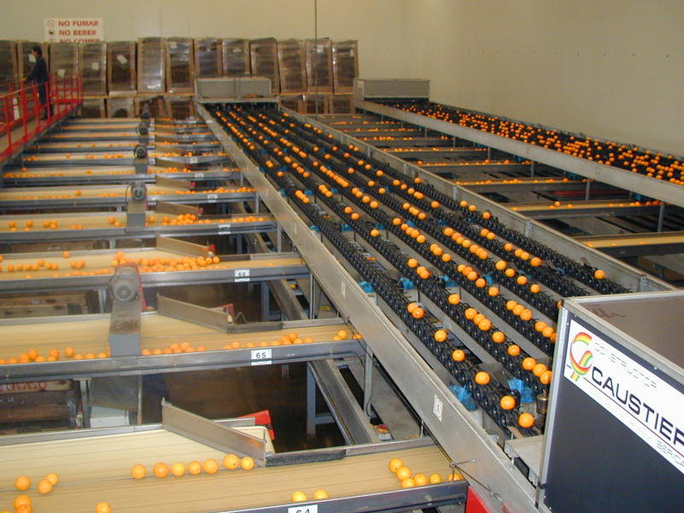 Electronic grading machine.

1.2 Processing line

As mentioned above, packing houses may have the two processes, such as in this case. In other packing houses fruit goes directly to the processing line. For this reason calculations are now shown for this process independently.

Through this line, fruit is washed and sanitized again, with the addition of fungicides and waxes. Along the line a similar process mentioned in the pre-grading process is performed. In this case lines are narrower (velocity is the same), and the same fruit goes along three different lines, where four operators work in each one (2 on each side).

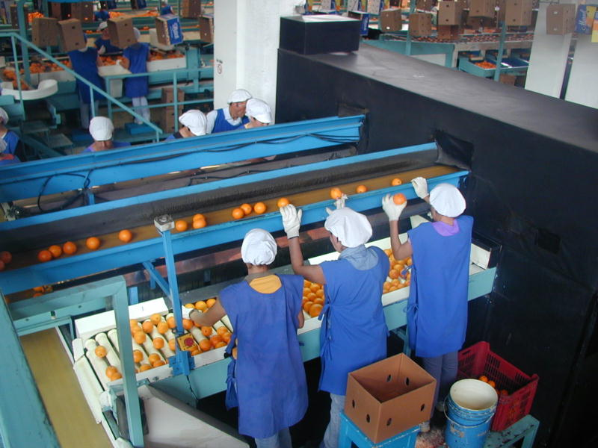Packing house. Sorting line.

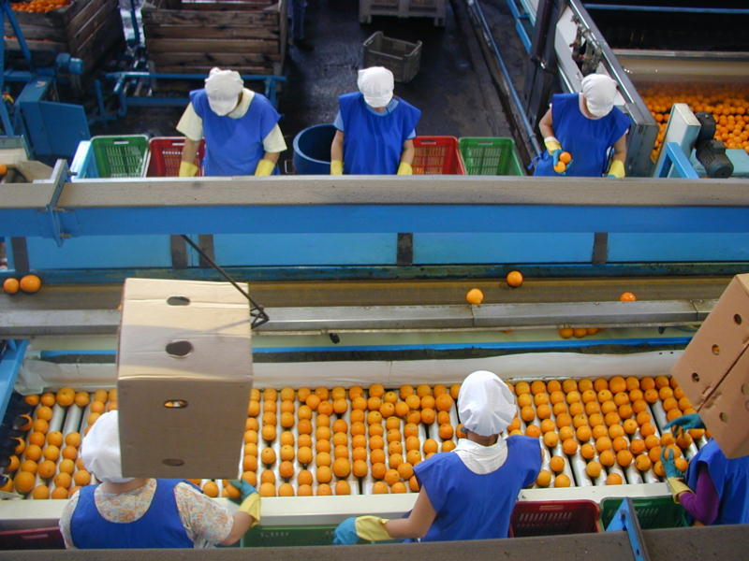 Packing house. Sorting line.

Table 3 shows the number of fruits observed per minute, considering 3 lines and 4 people per line, according to the volume of processed fruit per hour, for three citrus species.
Table 3: Fruits / minute, by species and processed volume.

Species | Kg/Hour | Kg/Min. | Fruits/Min.
Orange | 15,000 | 250 | 1,250
Mandarin | 11,000 | 183 | 2,200
Lemon | 10,000 | 167 | 1,670

Fruit sorting evaluation by specie with Xac symptoms

Table 4 shows the number of fruits with symptoms which must be removed, by minute, by operator based on the reception of 1% of fruit with symptoms.

Table 4: Symptomatic fruit/ person/minute to be removed by line, considering a maximum incidence of 1%.

Species | Fruits/  Minute | Fruits W/ Symptoms  ( 1%) | Fruits W / Symptoms / Minute / Line | Fruits W / Symptoms Person. / Min. To Be Removed.
Orange | 1,250 | 13 | 5 | 1-2
Mandarin | 2,200 | 22 | 7-8 | 1-2
Lemon | 1,670 | 17 | 6 | 1-2

There are three sorting lines in this processing line; between 1 and 2 symptomatic fruits should be removed per minute/ person /line. This removal is also performed in the other sorting lines.

Fruit sorting evaluation by quality.

In order to show the capability of fruit sorting through both processes an example of evaluation of a lemon lot with 43% of culled fruit is presented. Fruit was culled according to different reasons and is expressed as percentage.

Results showed: Botrytis 8%, scarring 14%, Septoria leaf spot, 7%, scab 4%, green cheeks 4 %; deformities 3%, gold-yellow colour 2%, scissors cut 1%.

1.3 Packaging

Packaging in MERCOSUR region is made manually, so operators are trained to remove fruits which could present any type of biotic or abiotic problem previously specified.

Average packaging performance at this stage of the process is 12 pallets/hour for Oranges and Grapefruits, which is equivalent to 840 boxes/hour (15 kg/box). For Mandarins 9 pallets/hour equivalent to 900 boxes/hour (10 kg/box) and for Lemons 8 pallets/hour, equivalent to 560 boxes/hour (15 kg/box).

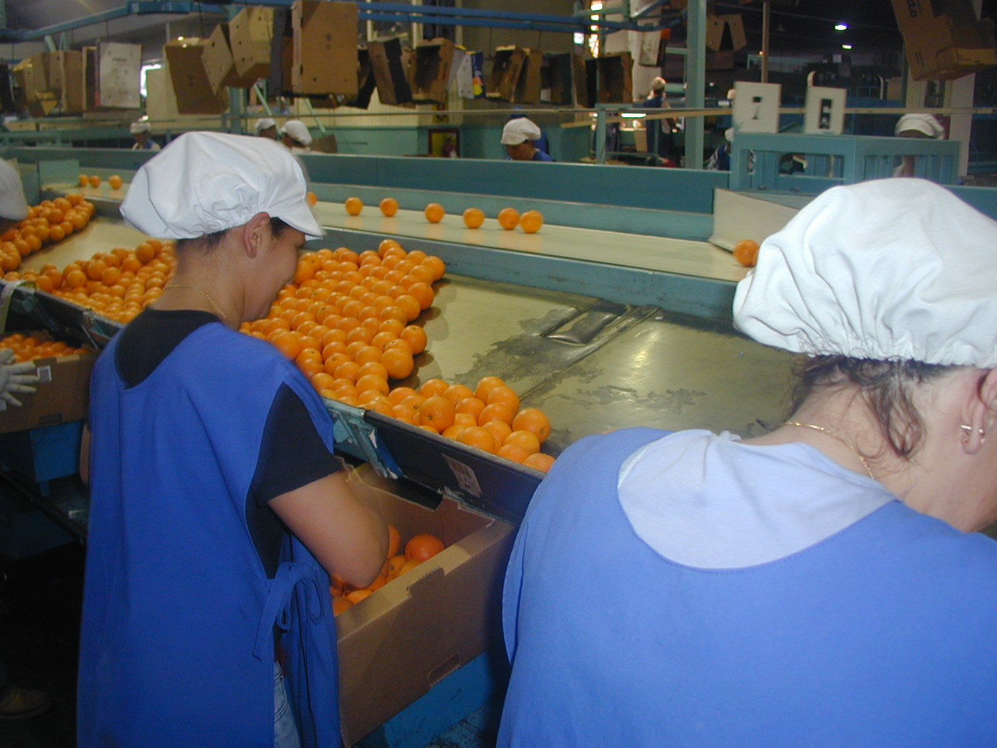 Packaging.

1.4 Quality control along the process

In order to achieve the required quality, personnel specially trained perform a continuous quality control along the line, including pre-grading and processing line. Additionally continuous sampling is carried out on finished boxes, with a sampling rate of 0.1 to 0.2%. Thus 1 to 2 boxes/hour is inspected.

Other type of control are also performed such as culling sampling, quality verification of processed fruit and packaging.

Conclusions.

This paper describes the processes of a packing house authorized for export. The data shows the capability of removal of fruit not complying export requirements, which applies to fruit with citrus canker symptoms.

Data shows the real capability to achieve the objective of symptomless fruit in finished boxes for export.

In order to achieve this objective in the example given during the pre-sorting process with lemons with a field incidence up to 1% of fruit with symptoms, each operator should remove 2 symptomatic fruit per minute. Additionally in the processing line each operator should remove 1 to 2 symptomatic fruits.

Finally each packing house has a staff of trained personnel who perform quality control along the process and the final product. Additionally the NPPO performs the official control during all the process complemented with a final inspection of packed boxes.

Acknowledgments

We want to thank Mr. Andrés Puppo, Agriculturist of Citricota Salteña S.A. Company, for all his co-operation and information given to write this paper.

Annex VIII

TECHNICAL REPORT

Proposal for monitoring citrus farms according to packing plants ability to remove fruits with quarantine diseases symptoms.

L. Daniel Ploper, C. Jacqueline Ramallo ad Gabriela M. Fogliata
Phytopathology section. Agro-industrial Experimental Station “Obispo Colombres” (EEAOC)
(4101) Las Talitas, Tucumán, Argentina. dt@eeaoc.org.ar

Introduction

On July 2004 the Technical Meeting between the European Union - MERCOSUR on Phytosanitary Aspects of Citrus Fresh Fruit was held in Brussels, Belgium. The goals of the meeting were: a) analyse the international scientific evidence in relation to black spot and citrus canker risk analysis and b) analyse and discuss equivalent protection measures. It is important to highlight that an additional new option was intended to be submitted. It is not a substitute of the ones established by Guideline 29/2000 of the EU, and it required supplementary scientific information.

The available information to support the proposal of equivalent protection measures was submitted in said meeting. However, the European scientists and officials pointed out that additional scientific papers were necessary to offer a greater support to the various proposals submitted. Some of these papers had already been started; therefore, at that moment it was mentioned that results were going to be released as they were completed.

In this paper, supplementary scientific information is provided in order to support the proposal submitted (both for the case of black spot and canker) regarding the tolerance levels of fruit with symptoms in production lots. In the proposal submitted in Brussels this was mentioned as follows:

“An inspection prior to the harvest will be carried out in order to determine the incidence of affected fruit in the production site. The incidence index is determined by the quantity of affected fruit over the total quantity of fruit considered. With an incidence of affected fruit lower or equal to 1%, the harvest is authorised to be processed in the packing plants registered for exports”.

”Alternative proposal of equivalent phytosanitary measure for Xanthomonas axonopodis pv. citri risk management in citrus fruit”. Document made by P. Cortese (Argentina), J.G. Baldini (Brazil), Ernesto Galliani and M.I. Ares (Uruguay). Presented in Brussels in July 2004.

This study was based on a citrus canker evaluation performed in a packing plant of the Province of Tucumán, during the 2004 campaign with fruits whose destination was NOT the European Union (EU).

Background

The requirements imposed by the EU for the export of citrus are detailed in Guideline 29/2000 (currently only in force in Paraguay and Uruguay) and in Decision 416/2004 (in force since May 2004 for Argentina and Brazil).

The requirements of Decision 416/2004 are more demanding. We can highlight the case of citrus canker, where it is established that there must not be symptoms in the “place of production” from the beginning of the vegetative cycle. (“place of production” considered by FAO as a “group of fields where the same technical criterion is applied”). The Decision also sets forth that the harvested fruits must be asymptomatic and be free from bacteria, and besides, they must be subjected to an appropriate treatment for disinfections. Furthermore, it establishes that there must be a complete and thorough record of all the chain, including the place of production, the packing facilities and the exporters, etc.

In the case of black spot, it is also set forth that symptoms must not be registered since the beginning of the last vegetative cycle and the fruits must be free from symptoms. As for the case of canker, a complete and thorough record of all the chain is required.

Objective
Considering the high level currently required for the citrus fresh fruit exports bound for the European Union, it was consider proper to quantify the capacity of the packing plants to discard fruits with quarantine disease symptoms which could enter said plants. In this way, we intend to offer data which contribute to measure, in their actual magnitude, the risks that would be assumed if presence of symptoms is allowed in the lots for export.

Furthermore, the levels of incidence which could be tolerated in the lots for exports tried to be determined with the information of the levels of fruit with symptoms which are capable of be totally removed by the packing plants.

It is important to highlight that the documents on Risk Analysis, Proposal for Risk Management and Alternative Proposals of Equivalent Phytosanitary Measure for Risk Management submitted by MERCOSUR in Brussels tend to ensure that asymptomatic fruit will be consigned. That is to say, we try to guarantee the consignment of free batches (fruits without symptoms) from regions affected with the disease and lots with low incidence.

Materials and Methods

To carry out this study, we work with fruit whose destination was OTHER than the European Union (No EU) in order to be able to admit a level of disease different to cero in the packing plant. Various weeks of packing work were considered from week number 25 to 31, corresponding to the months of June and July, 2004.

Fruit of different origins chosen at random and from farms located at different agro-ecological areas of the province were considered. This gave the sampling the character of being random, which was important at the time of validating the results.

The following steps took place during packing: the fruit was processed conventionally and a strict record of fruits with citrus canker symptoms was kept at the different points were the necessary quantifications were made. In the packing line, the proper number of workers were placed whose specific function was the removal of fruit with symptoms. A diagram of the packing process and the points were the initial sampling and the visual inspections were perform is shown in Figure 1.

- Dump Sampling

- Scale insect wash (brush)

- Soda tank

- Soda rinsing
1st visual inspection
- Disinfectant application

- Disinfectant rinsing

- Drying
2nd visual inspection
- Waxing
Last visual inspection
- Bench

Figure 1: Post-harvest process and treatment performed during packing where this study was made. Tucumán, 2004.

Quantifications were made at a guess and the minimum detection threshold was canker of approximately 1 to 2 mm.

Results

The results below were obtained after evaluating about 2.5 million of trays, representing more than 330 millions of fruits. The evaluated trays and the total number of fruits with canker detected after the last visual inspection (prior to the final control in the bench) are registered in Chart 1.
Chart 1. Quantity of canker detected in the packing line in different quantities of dumped trays in the relevant weeks, Tucumán, June / July 2004.

Weeks
Dumped trays
# of fruits
Total canker
%
25
244,202
33,699,876
12,262
0.0364
26
297,540
41,060,520
6,973
0.0170
27
341,560
47,135,280
7,678
28
48,842,340
4,435
0.0091
29
388,870
53,664,060
898
0.0017
30
425,626
58,736,388
2,757
0.0047
31
53,222,460
8,146
0.0153
Total
2

,437,398
336,360,924
43,149
0.1005

0.0163
353,930

385,670

According to this chart, the maximum level of canker observed after the last visual inspection was 0.036% (12,262 fruits with canker) out of a total of 33,699,876 dumped fruits. This happened during week 25. The total percentage of fruits with canker which were detected during the 7 weeks of sampling was 0.0128%.

Detailed data of the moment at which the detection of fruits with canker was achieved, for sampling on different days are shown in Chart 2.

Chart 2. Detail of the position and percentage of discarded fruit in the packing line. Tucumán, June / July 2004.
Date
Entry of fruit
Sampling
1st
inspection
2nd
inspection
Inspection
Line
Bench
Boxes
Fruits
173,880
6,694
412
164
19
2
0
%
3.85
0.23
0.009
0.001
0.0001
0
Fruits
331,200
11,228
194
78
4
2
0
%
3.39
0.058
0.023
0.001
0.0001
0
Fruits
162,840
2,182
76
30
0
0
0
%
1.34
0.0047
0.018
0
0
0
Fruits
165,600
1,623
233
47
6
0
0
%
0.98
0.14
0.028
0.0036
0
0
Fruits
160,080
912
15
6
0
0
0
%
0.57
0.0093
0.003
0
0
0
Fruits
364,320
1,894
328
175
8
1
0
%
0.52
0.09
0.048
0.0021
0.0001
0
Fruits
314,640
787
177
77
2
0
0
%
0.25
0.056
0.024
0.0006
0
0
Fruits
380,880
647
122
55
0
0
0
%
0.17
0.032
0.014
0
0
0
06/16/2004
06/16/2004
06/21/2004
07/30/2004
06/17/2004
06/30/2004
08/07/2004
06/10/2004

This chart is of the utmost importance as it shows that with levels of fruits entering the packing plant of about 1%, they arrive at the bench with values almost reaching 0 (zero) and at the box with no symptoms. Even when values close or superior to 3% of fruit with symptoms were detected during the dump, it was possible to obtain boxes with level 0 (zero) of fruit with symptoms.

Afterwards and with the purpose of specifying the places where the greater percentage of discarded fruit was achieved, a record of what happened in each of them was taken. Figure 2 shows the different sectors and percentages of discarded fruit at them.

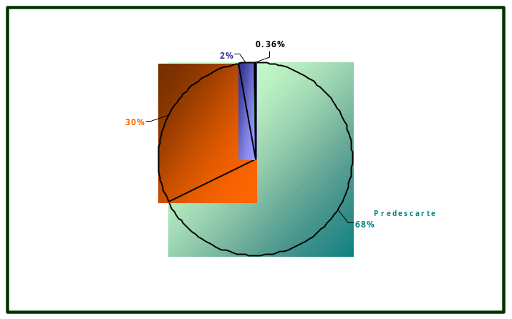
Figure 2: Percentage of discarded fruit registered in different sampling packing points. Tucumán, June / July 2004.

We can observed through this figure that the greater percentage of discarded fruit took place during the dump process and as the fruit went into the packing circuit the presence of fruit with canker notably diminished until reaching levels inferior to one, even to 0 (zero) in many cases, in the bench.

Proposal to Monitor Land
This capacity of cleaning or discarding which was shown numerically and was made in real conditions of commercial packing in the province of Tucumán, where the values of the disease incidence even higher than 3% can be reduced to 0 (zero) in finished boxes, invite us to go back to the process of land inspection in order to determine what levels of disease could be admitted in the lots bound for export.

For this reason, an additional exercise with mathematical calculations on updated and real values of production in the province was performed. In the first place, lots were classified according to productivity, considering the number of trays/ plant (tray of 20 kg = 135 fruits).

Starting from this supposition, we determined what number of affected fruits per tree represented levels of disease of 5%, 3% and 1%. This information is given in Chart 3.

Chart 3. Average number of affected fruits per plant which represent 5%; 3% and 1% if the 100% of fruits in each plant is inspected.

Trays/pl.
# of fr./pl.
5%
3%
1%
Up to 2
203
10.1
6.1
2
3 to 4
472
23.6
14.1
4,4
5 to 6
742
37.1
22.3
7.4
7 to 8
1012
50.6
30.4
10.1
9 to 10
1282
64.1
38.5
12.8
Productivity
Average # of

affected fruit
representing
5.0%;
2.5%
and
1.0%
of
lot
infection
monitoring
100%
of the fruits in the tree

the

This chart shows that according to the potential productivity of the tree; that is to say, on the basis of the quantity of trays of fruit which produces, an estimation of the number of fruits which should be detected with symptoms in accordance with the required level can be made.

For example, if we consider a tree which produces 5 to 6 trays of fruit, the total quantity of fruit of that tree would be approximately 742. A level of canker of 1% would imply that 7 fruits of that tree have symptoms. If the required level were lower and a 2.5% of canker could be admitted in the lot, the quantity of fruit with canker per tree would be 18. If the required level were even lower, for example, 5%, the number of admitted affected fruit would be 37. These values are considered only if the total quantity of fruits in a tree is evaluated.

However, it is not possible to monitor the totality (100%) of the fruits in a tree. Therefore, the following considerations were taken into account to estimate the percentage of fruits per plant which could be evaluated:

1. Distribution of fruits in the tree:
- In the upper third (2.67 m to 4.00 m from the ground) we find the 25% of the total fruits of the tree.
- In the central part (1.34 m to 2.66 m from the ground) we find the 35% of the total fruits of the tree.
- In the lower third (0.00 m a 1.33 m from the ground) we find the 40% of the total fruits of the tree.

2. The upper third cannot be efficiently observed by the monitor.

3. If we consider that the average height of a person performing the control could be 1.73 m, the eyes will be located at 1.45 m from the ground. Consequently, considering a field of vision of 0.60 m wide, the monitor should observe the range located between 1.25 m and 1.85 m, all around the plant. Considering trees of 4 m, in this range we would find the 30% of the fruit in the tree.

4. Therefore, a monitor will be able to efficiently control up to 300 fruits per tree, only if the they were below an average height of 1.85 m.

On the basis of these considerations, it was estimated that a monitor would only be able to efficiently revise the 30% of the fruits in a plant. In this way, the number of affected fruits per tree represented levels of disease of 5%, 3% and 1% when evaluating the 30% of the fruits in each tree was determined (Chart 4).

Chart 4. Average number of affected fruits per tree representing 5%; 3% and 1% if the 30% of the fruits in each tree is controlled.

It is to say that, for the case of the same tree which had a productivity of 5 to 6 trays of fruit, 1% of disease would mean the presence of 2 fruits with canker per tree when the 30% of the fruit is controlled (a total of 223 fruits per tree). In the same way, 7 fruits with canker per tree would represent the 3% and 11 fruits with symptoms per tree would indicate a 5%.

Conclusions

In accordance with the results of this study, a packing plant with the characteristics of the one evaluated here, has the capacity to efficiently discard the total quantity of fruits with citrus canker symptoms when processing batches with values close to 4% of affected fruits.

If it is accepted that packing plants have this capacity of removing said levels of fruits with symptoms, reaching levels of 0 (zero) in finished boxes, it is reasonable to think that in the lot of origin, levels of disease such as the ones in the packing plant can be admitted.

A level of incidence (considering incidence as the quantity of affected fruit over the estimated total quantity of fruit in the lot) between 1% and 5% implies the presence in each tree of 2 to 11 fruits with symptoms if the productivity of that tree is included between 5 and 6 trays and of 3 to 15 fruits with symptoms if the productivity is of 7 to 8 trays.

As it can be concluded from this paper, the proposal to admit an incidence of affected fruit at the production site which is lower or equal to 1% would imply a tolerance of a number of fruits with symptoms per tree which, according to the information given in this paper, could be removed through the high efficient process implemented in packing plants.

Errata
- In Chart 1, % Total of canker is 0.0128% instead of 0.1005 (cell at the bottom on the right side)

- In Chart 3, in the cell at the top on the right, where it is written: “Average number of affected fruits per plant representing 5%; 2.5% and 1%...”, instead of 2.5% should be consider 3%.
Annex IX

SHORT REPORT

Xanthomonas axonopodis pv. citri survival in Citrus fruit submitted to post harvest treatment using detecting by semi-selective culture media and bioassay.

VERDIER, E., ZEFFERINO,E and MÉNDEZ,S. Ministerio de Ganadería, Agricultura y Pesca, Dirección General de Servicios Agrícolas, Av. Millán 4703, CP 12900, Montevideo, Uruguay.

It has been proved that Citrus Canker disease, caused by Xanthomonas axonopodis pv. citri (Hasse) Vauterin 1995 (Xac) is disseminated by the use of infected propagative material, but here is no technical conclusive evidence about the importance of fruit destined to export as a pathway for bacterial dispersal.

This paper addresses the assessment of the possibility that Citrus Canker could be transmitted through Citrus fruit for export submitted to post harvest routine treatment in Uruguayan packing plants. Such kind of treatments include between other management practices, treatments with sodium hypoclorite (NaClO) and sodium ortofenilfenate (SOPP).

Xac detection is particularly difficult in asymptomatic samples, which can harbour very low bacterial populations. Other experiments developed in the Dirección General de Servicios Agrícolas (DGSA) leaded to the adjustment of different procedures to capture and identify minimal Xac bacterial populations through selective and semi-selective media on Citrus leaves and fruits.

The bacterial population remaining on fruit naturally or artificially infested was assessed using semi selective XOS media and “in vitro” bioassay on Citrus leaf discs by inoculation of fruit washing solutions, after receiving the usual post harvest treatment.

The assessment was performed through a three years period, to get a reasonable number of naturally infested fruits and therefore, to determine quantitatively the bacterial population remaining after post harvest treatment.

Fruits infested with asymptomatic populations, coming from Citrus plantations.

141 asymptomatic fruits were processed, from which Xac was recuperated in 67% of the check fruits (with no post harvest treatment) and in only 3% of the treated fruits.

To calculate the media survival of the bacterial population, the number of colonies present in three repetitions for each dilution was read (6 Petri dishes), obtaining an individual media for each fruit, used to calculate the general media for the trial.

Usual post harvest treatment reduced the number of naturally infested fruits tested as positive in the before mentioned tests, from 67% to 3% and the media bacterial population from 39,4 cfu/ml to 0.06 cfu/ml.

Table 1: Nº of asymptomatic naturally infested fruits, with positive detection into the total number of assessed fruits and Xac media population after post harvest treatment.

Nº of Positive Fruits / Xac Population ( Cfu/ml)
Total Assessed Fruits
Trials Check Treated Check Treated

1 9/10 0/10 34 0
2 5/10 0/10 25 0
3 8/10 0/10 94 0
4 10/20 2/22 10 0.3
5 14/19 0/20 34 0

Total 46/69 2/72
Media 39.4 0.06
Percentage 67% 3%

Fruit artificially infested.

From 185 asymptomatic artificially infested processed fruits, Xac was recuperated in 79% of the check fruits (with no post harvest treatment) and in 12% of the treated fruits. The media bacterial population in check fruits was of 1.7 x 10³ cfu/ml and 8 cfu/ml for treated fruits.

The number of artificially infested fruits that were positive in the tests, dropped from 79% to 12% and the media bacterial population was reduced from 1.7 x 10³ cfu/ml to 8 cfu/ml.

Table 2: Nº of asymptomatic artificially infested fruits, with positive detection into the total number of assessed fruits and Xac media population after post harvest treatment.

Nº of Positive Fruits/ Xac Population ( cfu/ml)
Total Assessed Fruits

Trials Check Treated Check Treated

1 5/5 4/15 2.7 x 10³ 3
2 4/5 2/15 2.6 x 10³ 5
3 8/10 5/29 0.5 x 10³ 4
4 3/5 4/43 2.2 x 10³ 18
5 5/5 0/24 1.2 x 10³ 0
6 6/9 3/20 1.0 x 10³ 16

Total 31/39 18/146
Media 1.7 x 10³ 8
Percentage 79% 12%

Conclusions

The type of processing method and the previous adjustment of detection techniques, as well as their specificity and sensitivity, indicate that these results are highly reliable.

Additionally, bacterial population used for fruit artificial inoculation are extremely high in terms of cfu/ml, and then never found in natural conditions for fruit infestation.

Bacterial populations remaining on artificially infested check fruits were of 1,7 x 10³ cfu/ml, compared with 39 cfu/ml on naturally infested ones. But in both cases after post harvest treatment, the bacterial population was practically eliminated and figures arrived to 8 and 0.06 cfu/ml respectively. The last one is a mathematical expression with no biological meaning because of being lower than 1 cfu/ml.

Also it is important to consider that further management practices, like cold storage and transport, will help to decrease bacterial population after post harvest treatment.

The assessment performed clearly support the fact that Citrus fruit post harvest treatment routinely used in packing plants in Uruguay is very effective to eliminate Xac populations (decrease of 99.8% of the naturally infesting population and 99.5% in the case of artificially inoculated one).

The conclusion is that, based on the results obtained, chemical post harvest treatment usually performed to fruit for export in Uruguay is a very effective phytosanitary measure to mitigate transmission risks of the pest through this pathway.

