WORKSHOP REPORT

Information Exchange – International Phytosanitary Portal (IPP) 2nd Training Workshop for the Asia Region,
Kuala Lumpur, Malaysia, 13 – 17 November 2006

Venue:
Melia Hotel
Kuala Lumpur
Malaysia

1. INTRODUCTION

1.1 Background

An Information Exchange – International Phytosanitary Portal (IPP) Training Workshop for the Asia Region, was held in Kuala Lumpur, Malaysia from 13 – 17 November, 2006. This workshop was jointly organized by the Department of Agriculture under the Ministry of Agriculture and Agro-Based Industries Malaysia in collaboration with the Secretariats of the International Plant Protection Convention (IPPC) and the Asia and Pacific Plant Protection Commission (APPPC). The workshop covered primarily APPC member countries in the Asia Region and was funded by the Food and Agriculture Organization (FAO).

This workshop was intended for participants responsible for information exchange in their respective National Plant Protection Organization (NPPO) and more specifically those tasked with entering the relevant information in the International Phytosanitary Portal (IPP). This portal is an internet-based information system designed to hold official phytosanitary information published in accordance with the Convention, and decisions by the Commission on Phytosanitary Measures (CPM).

The IPP has recently been upgraded following the recommendations of the system Support Group (SG), with improved features, to allow IPPC contracting parties to use the system to meet their national information exchange obligations under the IPPC.

The system can now accommodate the following obligatory information:

- Pest reports [Articles IV 2(b) & VIII 1(a) of the IPPC New Revised Text];
- Description of the NPPOs [Article IV 4];
- Phytosanitary restrictions, requirements and prohibitions [Article VII 2(b)];
- Points of entry with specific restrictions [Article VII 2(d)];
- Lists of regulated pests [Article VII 2(i)];
- Emergency actions [Article VII 6]; and
- Official contact point details [Article VIII 2]

The IPP is also able to display any other IPPC related information countries may wish to enter. It is also the primary tool that is used by the IPPC Secretariat to manage the IPPC work program.

The primary objective of the IPP is to provide contracting parties with a single, freely-accessible portal to meet their obligations to publish official phytosanitary information. However, in cases where a country already publishes information relevant to a particular reporting obligation, the IPP can incorporate links to the relevant authoritative official website.

Data can be entered to the IPP by the Official IPPC contact point, or by the officially-nominated (only by the IPPC Contact Point) responsible (information) officer. Individual countries should liaise with the IPP manager regarding the password-protected user accounts required in order to meet their data entry needs.

To support contracting parties, the IPPC Secretariat arranged a series of regional and sub-regional workshops from 2005 to 2006. The purpose of these events was to explain national phytosanitary information exchange obligations, and to provide basic training to Official contact points (and/or nominated information officers) on how to use the IPP to meet these obligations.

1.2 Objectives for the Regional Workshop.

1.2.1 The overall objective of these workshops is to increase national capacity through training for nominated ‘information’ officers and/or official contact points in the use of the IPP in the exchange of official information, and on how to access official information for use in the phytosanitary decision making process.

    - Ensure that every CPM Member has equal access to essential official phytosanitary information, the capability to exchange official information electronically (if allowed by the government), and to meet their obligations under the IPPC and to facilitate phytosanitary decision-making by providing and facilitating access to up-to-date phytosanitary information on:

- NPPOs,
- national requirements,
- CPM,
- IPPC
- other RPPOs,
- pests of potential phytosanitary importance, and
- NPPO contact points

via Internet;

- training in the exchange of official phytosanitary information, and information management for phytosanitary decision-making;
- providing access to basic technical phytosanitary information in support of the above processes; and
- providing information on the access to the FAO Biosecurity Portal (IPFSAPH).

1.3 Participation

Participants consisted of senior plant protection officers responsible for information exchange in the respective NPPO who already have a background in the management of phytosanitary information. 12 participants from 7 countries attended this workshop, namely Australia, Bhutan, China, Democratic Peoples’ Republic of Korea, Malaysia, Peoples’ Republic of Korea and Zambia (refer to Appendix 1). Participants from Bangladesh and Pakistan were invited, but were unable to confirm their participation. Also in attendance were FAO Facilitators, Mr. David C. Nowell, and Mr. Yongfan Piao. Ms Wan Normah Wan Ismail, as Project Coordinator led the workshop from Malaysia, supported by 8 officers from the Crop Protection and Plant Quarantine Division, Department of Agriculture as members of the workshop secretariat.

1.4 Workshop Program – as in Appendix 2.

2. OPENING SESSION

2.1 Opening Remarks

The opening remarks were delivered by Ms. Wan Normah Wan Ismail, Acting Director of the Crop Protection and Plant Quarantine Division, Department of Agriculture Malaysia, who welcomed the participants to Malaysia. She thanked the FAO for choosing this venue for the workshop, and hoped that more countries could be accommodated in the future.

Also acting as the Project Coordinator, she mentioned that this workshop was ideal for the sharing of information, and would work as a platform for participating countries to realize the responsibilities associated with this process. She ended the address by wishing the participants a successful workshop, and hoped that the goals would be realized.

  - Welcoming Address

Mr. Yongfan Piao, FAO Representative, Bangkok, welcomed the participants on behalf of the APPPC. Mr. Piao felt that this was an appropriate time for the workshop, as the participating countries were ready to make their commitments towards the success of the IPP. He noted that as to date, more than 20 countries from the Asia-Pacific Region have participated and benefited from these types of workshops. He also thanked Malaysia, and especially the Crop Protection and Plant Quarantine Division, Department of Agriculture, for their support, and hoped that the participants would actively contribute to, and enhance the capacity of the IPP. He reiterated that the IPP is a useful platform for communication and the sharing of information among countries.

During the workshop, Mr. Piao hoped that participants can find their position, and if possible, the gaps that exists, and ways to close these gaps. In closing, Mr. Piao pointed out the usefulness of the IPP which can ensure the continuity of information exchange, even as the people responsible for SPS have come and gone.

2.3 Keynote Address

Mr. David C. Nowell from the IPPC secretariat welcomed participants and announced that this workshop was part of a series of worldwide IPP workshops. To date, this program has already been conducted in Africa (2), Latin America (1), the Caribbean (1), Europe (3), the Pacific (1), and Asia (2). The only region not covered to date was the Middle East, and this would be done in 2007. This workshop included information exchange implications of the New Revised Text of the IPPC. Although obligations of the countries remain the same, the emphasis has changed, and the primary responsibility on information sharing now lies with each individual country member. Within the work program of the governing body, three main areas of focus were mentioned. They are:

- Standard setting
- Technical assistance
- Information exchange

The IPPC Secretariat then outlined the expectations of the workshops, and reiterated his role to teach the contracting parties on the processes involved in the IPP. Plans have already been made to have follow-up workshops in the future, where participants would qualify after logging more than 12 months on the IPP, to obtain feedback to improve the features of the system.

In closing, he thanked the Malaysian Secretariat for their support, which had made organizing the event from his headquarters very much easier.

3. WORKSHOP PRESENTATION.

Several papers were presented during the workshop:

- Presentation of the workshop program
- Workshop objectives and expected outputs
- Introduction to information exchange under the IPPC
- Country Presentations on National Information Exchanges Processes
- Role of IPPC official contact points & NPPO information exchange obligations
- Official versus scientific information
- How does the SPS-notification system fit into this?
- Introduction to- and Demonstration of the IPP

Details of the papers are found in Appendix 3.

4. IPP HANDS-ON (from day 2)

A demonstration on the use of the IPP was conducted by the facilitators, and the portal was extensively tested by the participants.

4.1 Objective

The purpose of the hands-on session was to train participants in the use of the IPP. The first part was to train the participants on the basic functions and navigation of the IPP, and the second part was data entry.

4.2 Navigation/browsing

Exercises:
Participants were required to browse the IPP based on the following Practical Navigation Exercises:

- Find your own country’s Contact Point Information and check if the data are correct...

- Who is the official contact point for South Africa and how can I contact this person?

- What is the name of the ‘nominated’ person for information exchange under the NPPO for Thailand?

- Find the details of THIS workshop in the IPP! -> including all handouts...

- How many IPPC contracting- and non-contracting parties are there?

- Your country wants to submit their letter of adherence to the IPPC – which Model Instrument for Adherence to the IPPC can be used for this official notification?

- Find the newest ‘statistics’ about the various data-inputs done by all NPPOs.

- Find the French-language ‘Nomination’ form to nominate a responsible officer to edit information on behalf of the respective NPPO (IPP Editor Notification form).

- How many nominated IPP Editors are listed in the IPP?

- IPP introduction letter sent to all NPPO contact points about ‘Information Exchange activities in 2005/06’.

- a. Find the latest up-date of the ‘Directory of NPPOs and RPPOs’.
b. Find the form for notification & submission of NPPO contact point details.

- Electronic copy of the “Guide” to the IPPC.

- Find all the details of IPPC Secretariat staff (e.g. Dave Nowell...)

- What was the major objective of the revision of the IPPC (1997) which lead to the New Revised Text (NRT)...

- Provide a colleague a hand-out in Spanish language explaining the ‘Standard-setting-process’ under the IPPC.

- Find the 2005-Country comments for the (draft) ISPM: “Guidelines for Consignments in Transit” from Turkey.

- Find the Draft ISPM: “Phytosanitary treatments for regulated pests”.

- Your country is not a party of the convention, but wants to submit its instruments of Adherence to the IPPC – What can you do to assist your government to submit their ‘Instrument for Adherence to the IPPC’.

- In preparation for the 2nd Session of the Commission for Phytosanitary Measures (CPM) / 2nd CPM held in FAO/Rome, your official IPPC contact point asked you to prepare a full set of meeting documents...

- You received a typical request regarding issues related to ISPM #15:
...we are a U.K. based company and joint owners of a factory in Malaysia...., where we manufacture wood products and import the goods into the U.K. ... Our pallets are classified as Dunnage...

...What is the official definition of ‘dunnage’, and do we need to treat it according to ISPM #15?

...When does this standard become compulsory and what are the implementation dates for Malaysia?

How does the Certification mark look like?

- You want to read all ‘Convention-Articles’ relevant for instance for the ‘Reporting Obligations’ under the IPPC...

- What is ‘Phytosanitary Capacity Evaluation’ (PCE) – find relevant background information in the IPP...

- What is the WTO Agreement on the Application of Sanitary and Phytosanitary Measures?

- Where can I find information about the last ‘meeting of the Parties to the Cartagena Protocol on Biosafety’?

- Which are the ‘Subsidiary bodies’ under the convention...?

- What is the difference between “emergency action” and “emergency measure”?

- What is the difference between “regulated”- and “non-regulated” pests?

- How to prepare ‘lists of regulated pests’?

- What are the official websites of Australia’s Quarantine service?

- How is Indonesia’s NPPO organized / structured?

- Need to contact the Phytosanitary Inspection Unit of “Ljubljana” in the Republic of Slovenia...

- What are Vietnam’s listed ‘Quarantine Pests’?

- Does the ‘Oriental Thrips’ (Thrips palmi) occur in Serbia?

- Which Pest status categories shall be considered when reporting under the IPPC?

- You want to publish incidents of ‘non-compliance’ relevant to your NPPO. Which documents should you refer to, and where in the IPP can you find them?

- What are the Specifications (‘terms of reference’) for the Expert Working Group for ‘Pest free areas for fruit flies’?

- Can you find ISPMs in other than the UN-official languages?

4.3 Data entry

Participants were required to enter data into the IPP Training Portal using information available. On the final day of the workshop, the facilitator examined the web pages put up by the participants and generally commented on their content.

5. WORKSHOP DISCUSSION

5.1 Availability Of IPP Information In Other Languages
To a question raised concerning the limited availability of information in other languages, the facilitator explained that the primary objective of posting information on the IPP is to meet national obligations. The contents submitted in their national language by the individual countries will be represented in the IPP, but will not be translated into all the FAO languages by the IPPC Secretariat.

5.2 Progress Of The Development Of The IPP
The workshop wanted to know the progress of the IPP since its inception. The facilitator stated that the IPP has so far focused on data entry and now the emphasis is changing to data extraction. IPP workshops have been held all over the world, and the portal has accumulated a significant amount of information. The portal has already been extensively used by some countries. In a few areas, there is a problem with participation, and there are also limitations with the acquisition of official information.

Users of the IPP were noted to be very diverse, ranging from people who have hardly any knowledge of computer usage, to experts. The IPP has to draw a balance in the contents and features to cater for this diversity. The expansion of the IPP is more dependant on the users themselves, rather than the secretariat. Future changes to the portal may be slow, as the core program is shared by 18 other groups, which would have an influence on the collective usage.

5.3 Enquiry On China Website
The contents of the China website <http://www.agri.gov.cn> are entirely in the Chinese language, and there are no immediate plans for an English version

5.4 Enquiry On Regulation Of Information In Country Website
The representative from Australia gave a brief mention on the process of information regulation of the website <http://www.aqis.gov.au>. Reports of pests made to the authorities are used as a basis for the information to be made available on the portal. Other sources would include checks with SPS notification.

5.5 Development Of IPP Web Forum
The facilitator explained that there were no plans to include a web forum facility on the IPP because of the implications that may be related to liability and trade issues. However, there may be a web forum for discussions on technical matters on a planned related website, and this may be limited to non-profit organizations and country participation. It is in an early development phase.

5.6 IPP And Dispute Settlement
The IPPC Secretariat will not participate in discussions on legal issues to avoid liability. The facilitator advised that other mechanisms such as the IPPC dispute settlement system which does not have to be formal, can be used to resolve the matter.

5.7 Future Direction For Expansion
The FAO Representative, Bangkok put forward the view that development of the IPP is very dependant on contributions from the user countries in this region. He advised that management of information within each country is the key to proper documentation and submission of information to make the IPP successful.

5.8 Status Of Information & Communication Technology (ICT) Personnel And The IPP
The representative from the Republic of Korea suggested that steps should be taken to ensure the availability of sufficiently trained personnel to handle the running of the ICT hardware

5.9 Permission For Information Access On The IPP
The facilitator explained that information published by a country on the IPP is public information.

5.10 Status Of Editors In The IPP
The facilitator explained that there are several levels of editors within the IPP. A national editor is given authority to enter and edit information from their own countries. A regional Plant Protection Organization editor may enter and edit information for their RPPO. The Secretariat editors only edited Secretariat information. The webmaster has overall control of the contents of the entire IPP.

5.11 Updating Of Contact Point In The IPP
The representative of Bhutan enquired on the updating process for contact point of countries. The facilitator explained that the contact point stated on the IPP would be changed/updated upon nomination by a recognized authority from that country. Contact points may be further categorized as:

- Official contact point – as authorized by the country
- Unofficial contact point – a person notified to the IPP but not through established channels, or awaiting confirmation from recognized national authorities
- Information point – a person who provides information to the IPP, but the participating country is not yet a contracting party to the IPPC.

The number of contact points and editors vary from country to country. The IPPC Secretariat prefers a small number of people involved in the process.

5.12 E-Mail Link Function
To a question regarding the function of E-mail links, the facilitator explained that the link found in the individual NPPO sites in the IPP is a powerful tool for anyone who wants to send any query or information directly to the Contact Person of the NPPO.

5.13 Older Version of the Information
Any information replaced by a newer version of information will be archived and be classified as an older version that can be viewed in the future. Any information posted to the IPP will not be deleted and the person who is responsible in making changes to the contents will be recorded and can be displayed upon request. Mr. Nowell advised all NPPOs to be very careful with the information that they intend to upload to the IPP to make sure that it is the correct version and also to avoid any complication arising from the information displayed.

- PRESENTATION OF WORKSHOP EXERCISES

The participants were given an opportunity to present their exercises to the workshop. Relevant information was then uploaded from the Training Site to the Production Site. The facilitator expressed overall satisfaction with the grasp of the participants in the handling of the Training Site, and hoped that more information could be put into the Production Site. The participant from the Democratic Peoples’ Republic of Korea could not put any information into the portal because of the lack of internet facilities from that country. The IPPC Secretariat undertook to mail a complete copy of all IPPC standards and the IPPC to the DPRK, and will investigate the option of providing a CD-ROM version of the IPP.

One of the difficulties faced by the participants was that there was insufficient space for the placement of short descriptions when uploading website information. The workshop recommended that the space for the short description be increased to at least 250 words.

Another difficulty was the inability to sort pest lists if they were found on multiple pages.

It was also suggested that the website put up some sort of guide as to assist editors to place information into the correct categories.

Logos should be about 2 cm square, and flags should be proportionate

- CONCLUSION AND ACKNOWLEDGEMENTS

Generally, the workshop was carried out in accordance to the scheduled program, and the overall objectives were met. Participants generally benefited from the training, and were ready to contribute to the IPP upon return to the home countries.

The workshop also noted the above strengths, weaknesses and recommendations put forward by the participants. These will be discussed with the authorities at the Headquarters where decisions will be made for future improvement.

The facilitator thanked participants for their enthusiasm and persistence, and also thanked the hosts for the excellent hospitality and resources made available for the running of the workshop. The participants also thanked the organizers for making the workshop successful.
Appendix 1: List of FAO Consultants, Project Coordinator, Participants and Secretariat

FAO Consultant
Mr. David C. Nowell
IPPC Secretariat
FAO-AGPP
Food and Agriculture Organization of United Nations
Viale delle Terme di Caracalla,
00153 Rome, Italy
Tel: 00 39 06 570 52034
Fax: 00 39 06 570 54819
Email: Dave.Nowell@fao.org

FAO Representative, Bangkok
Mr. Yongfan Piao
Plant Protection Officer (FAORAP)
Executive Secretary, APPPC
FAO Regional Office for Asia and the Pacific
39 Phra Atit Rd.
Bangkok 10200, Thailand
Tel: (+66)-2-6974268
Fax: (+66)-2-697 4445
Email: Yongfan.Piao@fao.org

Project Coordinator
Ms. Wan Normah Wan Ismail
Deputy Director
Crop Protection & Plant Quarantine Division
Gallagher Road
50632 Kuala Lumpur, Malaysia
Tel: (603) 26977160
Fax: (603) 26977164
Email: wannis@doa.gov.my
wann54@yahoo.com

Participants

Australia
Ms. Julia Rymer
Australian Government Department of Agriculture Fisheries & Forestry
GPO Box 858, Canberra ACT 2601
Australia
Tel: 61 2 6272 4837
Fax: 61 2 6272 5838
Email: Julia.rymer@daff.gov.au

Bhutan
Mr. Thuji Tshering
Chief Regulatory and Quarantine Officer
Ministry of Agriculture
Bhutan Agriculture and Food Regulatory Authority (BAFRA)
MoA, PO Box # 1071
Thimphu, Bhutan
Tel: +975 2 327031 (off), +975 17608432 (mobile)
Fax: +975 2 327032
Email: t_tshering@moa.gov.bt
thujitshering@yahoo.com

China
Dr. Xingfu Jiang
Associate Professor
Plant Protection and Plant Quarantine Division
Crop Production Department
Ministry of Agriculture
No.11 Nongzhanguan Nanli
Beijing 100026, China
Tel: (+86) 10 6419 2804
Fax : (+86) 10 6419 3376
E-mail : jxf54@163.com
PPQ@agri.gov.cn

DPR Korea
Mr. Kim Chun San
Director
Central Plant Protection Station
Jang Hun dong, Mangyong dae District
Pyongyang, Democratic People's Republic of Korea
Tel: 850 2 756 1706
Fax: 850 2 381 4427
Eamil: c/o Mr. Kim Myong Hyok:
MyongHyok.Kim@wfp.org;
michael.stapleton@undp.org;
fao.myonghyok.kim@undp.org

Mr. Son Gyong Man
Officer
Central Plant Protection Centre
Jang Hun dong, Mangyong dae District
Pyongyang, Democratic People's Republic of Korea
Tel: 850 2 756 1706
Fax: 850 2 381 4427
Eamil: c/o Mr. Kim Myong Hyok:
fao.myongyhok.kim@undp.org &
Myongyhok.Kim@wfp.org,

Malaysia
Ms. Rozziah Bujang Masli
Agriculture Officer
Import and Export Section
Crop Protection and Plant Quarantine Division
Gallagher Road
50632 Kuala Lumpur, Malaysia
Tel: 6 03 2697 7182
Fax: 6 03 2697 7179
Email: bm_rozi@bluebottle.com

Mr. Mohd Nizam Bin Ibrahim
Assistant Agriculture Officer
Crop Pest Management Section
Crop Protection and Plant Quarantine Division
Gallagher Road
50632 Kuala Lumpur, Malaysia
Tel: 6 03 2697 7145
Fax: 6 03 2697 7205
Email: nizam@doa.gov.my

Mr. Yip Kin San
Principal Assistant Director
Enforcement and Crop Protection Section
Department of Agriculture Sabah
Aras 1, Wisma Pertanian Sabah
88632 Kota Kinabalu, Sabah,
Malaysia
Tel: 6 088 283264
Fax: 6 088 239046
Email: KinSan.Yip@sabah.gov.my

Mr. Abang Yusuf Abang Hassan
Principal Assistant Director
Crop Protection and Plant Quarantine Branch
Department of Agriculture Sarawak
12 – 17 Floor Menara Pelita, Tun Abdul Rahaman Yakub Road,
Petrajaya, 93050 Kuching, Sarawak
Malaysia
Tel: 082-233600 / 082 441000
Fax: 082-413163 / 082 447821
Email: yusufh1@sarawaknet.gov.my

South Korea
Mr. Hwang, Jin-Won
Assistant Director
National Plant Quarantine Service,
Ministry of Agriculture and Forestry
Republic of Korea
433-1, Anyang 6-Dong, Manan-Gu,
Anyang-Si, Gyeonggi-Do,
Republic of Korea
Tel : +82-31-446-1926
Fax : + 82-31-445-6934
E mail : jwhwang@npqs.go.kr

Mr. Shim, Dong-Wook
Assistant Director
National Plant Quarantine Service,
Ministry of Agriculture and Forestry
Republic of Korea
433-1, Anyang 6-Dong, Manan-Gu,
Anyang-Si, Gyeonggi-Do,
Republic of Korea
Tel : +82-31-469-2669
Fax : + 82-31-448-6429
E mail : shim@npqs.go.kr

Zambia
Mr. Justine Kabala
Agricultural Research Officer
Zambia Agriculture research Institute
Mount Makulu Central Research Station
Private Bag 7, Chilanga,
Zambia
Tel: 260 1 278141/130/380
Fax: 260 1 278141/130
Email: pqpsmt@zamtel.zm or mtmakulu@zamnet.zm
or Kalabajustine@yahoo.co.uk

Secretariat
Mr. Ho Haw Leng
Principal Assistant Director
Crop Protection & Plant Quarantine Division
Department of Agriculture
Gallagher Road
50632 Kuala Lumpur, Malaysia
Tel. : 60-3-2697-7170
Fax : 60-3-2697-7164
hawlengho@doa.gov.my
hawlengho@yahoo.com

Mr. Chan Yeng Wai
Principal Assistant Director
Crop Protection & Plant Quarantine Division
Department of Agriculture
Gallagher Road
50632 Kuala Lumpur, Malaysia
Tel. : 60-3-2697-7191
Fax : 60-3-2697-7205
E-mail : yengwai@doa.gov.my
yengwai@yahoo.com

Ms. Wong Wan Cheng
Assistant Director
Crop Pest Management Section
Crop Protection & Plant Quarantine Division
Department of Agriculture
Gallagher Road
50632 Kuala Lumpur, Malaysia
Tel. : 60-3-2697-7141
Fax : 60-3-2697-7205
E-mail : wancheng@doa.gov.my
wong5494@yahoo.com

Mr. Arizal Arshad
Assistant Director
Import and Export Section
Crop Protection & Plant Quarantine Division
Department of Agriculture
Gallagher Road
50632 Kuala Lumpur, Malaysia
Tel. : 60-3-2697-7184
Fax : 60-3-2697-7189
E-mail : arizal@doa.gov.my

Ms. Noraini Ahmad
Assistant Agriculture Officer
Enforcement Section
Crop Protection & Plant Quarantine Division
Department of Agriculture
Gallagher Road
50632 Kuala Lumpur, Malaysia
Tel. : 60-3-2697-7163
Fax : 60-3-2697-7205
E-mail : noraini@doa.gov.my

Pn. Kiftiah Utoh
Assistant Agriculture Officer
Import and Export Section
Crop Protection & Plant Quarantine Division
Department of Agriculture
Gallagher Road
50632 Kuala Lumpur, Malaysia
Tel. : 60-3-2697-7184
Fax : 60-3-2697-7189
E-mail: kiftiah56@yahoo.com

Mr. Mohd Nor Daud
Agriculture Assistant
Information & Communication Technology Section
Planning & Information Management Division
Department of Agriculture
Wisma Tani, Putrajaya,
Malaysia
Tel. : 60-3-88703113
Fax : 60-3-88703118
E-mail: monda01@gmail.com

Appendix 2 – Workshop Program

2nd Information Exchange – International Phytosanitary Portal (IPP) Training Workshop for the Asia Region, Kuala Lumpur, Malaysia, 14 - 17 November 2006

14 November 2006 Tuesday

Session I: Opening
Chair: Host institution - Crop Protection and Plant Quarantine Division, Department of Agriculture -- Ms. Wan Normah Wan Ismail
09.00 Registration
09:30 Welcoming Remarks -- Host institution - Director of Crop Protection and Plant Quarantine Division, Department of Agriculture Malaysia-- Ms. Wan Normah Wan Ismail
10:00 Welcoming Address: RPPO (APPPC) – Mr. Yongfan Piao
10:10 Key Note Address: FAO / IPPC – Mr. David C. Nowell
10:20 Organizational announcements,
Nomination of a WS Rapporteur, Chair for Sessions IV+V
10.30 Refreshment

Session II: Introduction to Workshop Programme on Information Exchange Capacity Building
Chair: Host institution

10:45 Introduction of Participants ( incl. brief summary of experience with using the IPP )
11:15 Presentation of the workshop programme ( IPPC ) – Adoption of Agenda
11:30 Workshop Objectives and expected Outputs ( IPPC )
11:45 Introduction to information exchange under the IPPC
12:30 Lunch

Session III: Country Reports on National Information Exchange processes within the IPPC Framework
Chair: IPPC Secretariat

14:00-17:00 Country Presentations on National Information Exchange Processes
including pros and cons about using the IPP in each workshop participating country

15 November 2006 Wednesday

Session IV: Reporting obligations under the IPPC
Chair: IPPC Secretariat

09:00 Role of IPPC official contact points ( IPPC Secretariat ) & NPPO information exchange obligations (IPPC Secretariat & RPPO),
-> Using the IPP to meet Reporting Obligations
10:00 Official versus Scientific information
10:30 Refreshment
10:45 How does the SPS-notification system fit into this?
11:20 Introduction to- and Demonstration of the IPP ( IPPC Secretariat )
Introduction to the IPP--- Background information on the IPP
12:00 Lunch

Session V: Introduction to the IPP
Chair: IPPC Secretariat

13:45
- Purpose of the IPP
- Layout of the IPP
- Retrieving information
- Data entry

Session VI: Practical Sessions ( I )
Chair: IPPC Secretariat

14:15
- IPP Navigation & Practical exercises
- NPPO contact points
- NPPO information
- Standards ISPMs
- News online, IPP User Manual
- Events online, IPP User Manual
- RPPO information RPPO lists
- Meeting papers/reports online, IPP User Manual
- Search online, IPP User Manual
- Advanced search

17:00 Conclusion: reflection on key learning points from Day 2

16 November 2005 Thursday

Session VII: Practical Sessions ( II )
Chair: IPPC Secretariat

09:00 Summary on retrieving information -
Questions-answers
10:00 Data entry – Preparation of information for entry into the IPP using templates
12:30 Lunch

14:00
- Data entry
- Reporting Obligations (for NPPOs):
- Pest reports (Articles IV 2(b) & VIII 1(a));
- Description of the NPPOs (Article IV 4);
- Phytosanitary restrictions, requirements and prohibitions (Article VII 2(b));
- Points of entry with specific restrictions (Article VII 2(d));
- List of regulated pest (Article VII 2(i));
- Emergency actions (Article VII 6);
- Official contact points (Article VIII 2)

17:00 Conclusion: reflection on key learning points from Day 3

17 November 2005 Friday

Session VIII: Practical Sessions continued ( III )
Chair: IPPC Secretariat

09:00 Data entry and navigation
Summary on data entry - Questions-answers – discussion &
presentations of data added by each country to their NPPO site in the IPP
Open discussion: Questions-answers etc. & Workshop Evaluation Form
12:30 Lunch

Session IX: Closing
Chair: Host institution

14:00 Workshop evaluation
15:00 Adoption of the report
17.00 Closing remarks --
IPPC representative
RPPO representative
Appendix 3 – Workshop Presentations

  - Presentation of the workshop program

The facilitator presented to the participants a general overview of the workshop program, detailing the role and responsibilities of the participants throughout the four-day program. The workshop proceeded upon consensus of the participants.

3.2 IPP Workshop Objectives and Expected Outputs

A summary of the presentation as follows:

Awareness
- Make countries aware of their national IPPC information exchange obligations
- Provide background on the exchange of information within the IPPC framework
- Explain the CPM work programme on information exchange (IPPC SD #2)
- Role and functions of an IPPC contact point
- Role and function of the IPPC Secretariat

Use of the IPP
- Purpose
- Layout / structure
- Data retrieval
- Data entry

Expected Outputs
- Understand:
  - information exchange under the IPPC
  - national IPPC information exchange obligations
  - role of IPPC contact point
  - the IPP
  - role of the IPP editor
Ability of participants to:
- retrieve data from the IPP
- enter data into the IPP
Identification of:
- improvements in the workshop
  - structure
  - content
- changes necessary to the IPPC information exchange work programme
- suggested changes to the IPP
- general capacity building needs
  - national
  - sub-regional

Format of Workshop
- Structured but informal
  - information session
  - “hands on” learning
  - data entry
- Questions and discussion
- Evaluation

3.3 Introduction to Information Exchange under the IPPC

What is the IPPC?
- A multilateral treaty for international cooperation in plant protection
- The global instrument for the harmonization of phytosanitary measures
- The phytosanitary standard-setting organization named in the WTO-SPS Agreement

Purpose of the IPPC
- to secure common and effective action to prevent the spread and introduction of pests of plants and plant products, and to promote appropriate measures for their control.

Membership
- November 2006: 159 Contracting Parties (to the 1979 text)
- Includes most major trading partners (since Oct. 2005 including China and the European Community!)
- Regional plant protection organizations are not members, but governments can belong to RPPOs without being contracting parties to the IPPC

Scope of the IPPC
- International cooperation in the protection of plants and plant products from harmful pests
- plants include forests and wild flora
- pests include diseases and weeds
- harm includes indirect effects such as those from weeds
- not limited to trade
- Extends to storage places, conveyances, and containers
- Includes biological control organisms
- Provision for research or other purposes
- Other objects or materials capable of harbouring or spreading pests

History of IPPC
- 1952 Original IPPC came into force, superseding all international plant protection agreements
- 1979 IPPC (Revised Text of the IPPC)
- Countries provided information to FAO
- e.g. pest reports, legislation, regulations
- FAO disseminated
- published
- PPB
- PQ DB
- Dissemination

Challenges
- Countries
- Lack of commitment
- Consistency
- Accuracy
- Source
- FAO resources
- Essentially a failure

Revision of the IPPC
Modernize IPPC
- trade
Needed consistency with WTO-SPS Agreement
- standard setting
Institutionalization (1992: formalizes Secretariat and standard-setting)
- FAO = IPPC Secretariat (within the Plant Protection Service of FAO)
- national
FAO Conference
- adopted in 1997
- 1998: NRT circulated to members for acceptance or adherence
- into force after acceptance by 2/3 contracting parties...
- 2005: 2nd October – NRT entered into force

NRT of the IPPC (1997)
- No significant changes in obligations
- Changes in emphasis / responsibilities
- More specific
- Primarily an NPPO responsibility
- Secretariat responsibilities
- RPPO responsibilities

Amendments of the IPPC (1997)
- Harmonization, scientific justification for measures, non discrimination, consistency, and equivalence;
- A global forum for phytosanitary issues
- Technical assistance
- Interim measures

Other Implications
- Exchange official and scientific information
- Recognize equivalence
- Recognize area and prevalence concepts
- Specific technical competencies and needs
- Trade = free, fair, & safe
- Globalization, liberalization, & negotiation

Communication
- The exchange of information is central
- 3 primary work areas in CPM work programme
  - Standard setting
  - Information exchange
  - Technical assistance
- Now information exchange emphasis

Role of the IPPC Secretariat
- Facilitate
- Participate through implementation of the CPM work programme
- Meet obligations under IPPC
- Technical assistance
  - all levels

NPPO Obligations
- Official contact point - Article VIII 2
- Description of NPPO and changes - Article IV 4
- Non-compliance - Article VII 2(f)
- List of regulated pests - Article VII 2(i)
- Pest reporting - Article IV 2(b)
- Exchange of information on plant pests, particularly the reporting of the occurrence, outbreak or spread - Article VIII 1(c)
- Technical and biological information necessary for PRA - Article VIII 1(a)
- Specified points of entry - Article VII 2(d)
- Organizational arrangements for plant protection - Article IV 4
- Emergency action - Article VII 6
- Phytosanitary requirements, restrictions and prohibitions - Article VII 2(b)
- Adequate information on pest status - Article VII 2(j)
- Rationale for phytosanitary requirements, restrictions and prohibitions - Article VII 2(c)

Facilitation
- Informal ICPM Ad Hoc Working Group
  - September 2000
  - initial exploration of obligations under the IPPC
- ICPM working Group
  - January 2001
  - identified obligations and reporting mechanisms
  - identified the need for a global phytosanitary IE system
  - identified basic needs
  - to be undertaken by the Secretariat
- ICPM approval
  - March 2001
  - International Phytosanitary Portal (IPP)
    - electronic system
    - internet-based system
  - IPP Support Group established
- Development of a prototype
  - March 2001
  - Continued development

Basic Requirements
Internet based
- cannot ignore the needs of those without Internet access
- highly cost effective
Reliable
Secure
Remote access
- NPPOs & RPPOs maintain their own information
- immediate / live response time
No duplication of data entry
Basic Requirements
Freely available
- CD-ROM version
Proven FAO information system as the core
Basic navigation in all FAO languages
- develop in English
- extend to French and Spanish
- then include Arabic and Chinese

Status
Maintaining IPPC / developing IPP in parallel
Limited capacity
- synchronisation problems
Live 1 August 2002 (https://www.ippc.int)
- navigation issues
- upgrade
  - double page layout
  - reduced no. of directories
  - reduced bugs
  - abbreviated URLs
  - Spanish and French

Partnerships
Introduction of the SG
Ontology
NPPOs to test / develop
RPPOs to test / develop
Refine
- functions
- layout
- navigation
- data entry forms

Technical Assistance
Development costs
- extra-FAO budgetary funding
Large TA programme needed
- initiated 2005 ...ongoing 2006+
All levels
- training (regional/sub-regional & national)
  - awareness
  - data entry
- capacity/equipment (national/sub-regional)
  - data entry

  - Country Presentations

Country Report: Australia
Julia Rymer, Australian IPPC Secretariat

How Australia Meets Its Obligations As A Contracting Party
NPPO
Official contact point
Participates in the development and adoption of international phytosanitary standards
Participates in RPPOs
- APPPC and PPPO
Quarantine legislation consistent with international obligations
Provides training and capacity building assistance to developing countries in the region

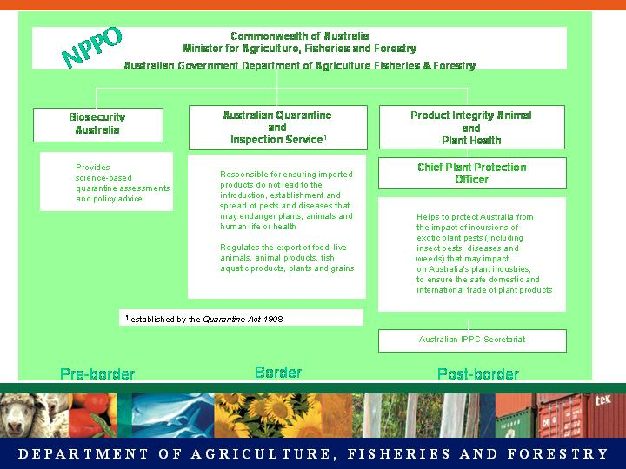

IPPC - Who Does What
Responsibilities – NPPO
Phytosanitary certification – AQIS
- appropriate security after certifications – AQIS
Surveillance of cultivated plants and native flora – NAQS (AQIS), OCPPO + States/Territories
Inspection of imported goods – AQIS
Disinfestation/disinfection of consignments – AQIS
Import risk analysis – Biosecurity Australia
Pest Free Areas – States/Territories
Pest status – NPPO

IPPC Contact Point
Official IPPC Contact Point
- Lois Ransom – Chief Plant Protection Officer

Australian IPPC Secretariat
- Created in 2005 to increase Australia’s participation within IPPC
- Dissemination of requests for information
- Consultation with stakeholders, especially regarding draft standards
- Co-ordination of comments on IPPC issues
- Preparation of Australian response
- Meet information exchange obligations
- Liaison with Codex Australia and OIE Secretariats, SPS section

Phytosanitary Databases
ICON – import conditions database
http://www.aqis.gov.au/icon32/asp/homecontent.asp

PHYTO - plant and plant product export conditions database
http://www.aqis.gov.au/phyto/asp/ex_home.asp

Quarantine information available in other languages including Bahasa Indonesian, Chinese, Hindi, Japanese, Korean, Malay, Punjabi, Thai, Vietnamese

Does Australia meet its information exchange obligations?
Article IV2b report occurrence, outbreak and spread of pests ✓
Article IV4 NPPO description ✓
Article VII2b publish phytosanitary restrictions ✓
Article VII2c make rationale available ✓
Article VII2d publish list of specified ports ✓
Article VII2f notify non-compliance ✓
Article VII2i list of regulated pests [✓]
Article VII2j provide info on pest status [✓]
Article VII6 emergency action ✓
Article VIII1a information exchange ✓
Article VIII2 designate contact point ✓

https://www.ippc.int/servlet/CDSServlet?status=Mj1vcmcuZmFvLndhaWNlbnQuY2RzLm9mLk1haW5QYWdlJjQ9bnBwb2F1JjY9ZW4mMzM9cGVzdF9yZXBvcnQmMzc9a29z

Exchange Of Information Within Australia

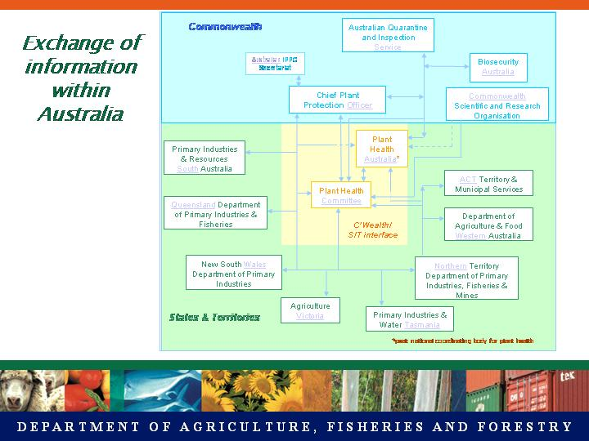

Country Report: Bhutan
Thuji Tshering
Bhutan Agriculture and Food Regulatory Authority
Ministry of Agriculture
Royal Government of Bhutan

Bhutan is a member of the IPPC, CA and OIE
In the process of becoming member of the APPPC

The Bhutan Agriculture and Food Regulatory Authority (BAFRA) was established under the MoA to deal with bio-security measures in the year 2000

Managed by a Management Board with representatives from relevant stakeholders including the Private Sector, Ministry of Trade and Industry, Ministry of Health etc.

Mandated To Implement The Following Acts Partly Or Wholly:
Plant Quarantine Act
- Livestock Act
- Seeds Act
- Pesticides Act
- Forest and Nature Conservation Act
- Biodiversity Act
- Food Act

BAFRA is the focal point for IPPC, CA, SPS
Competent Authority for Biosafety in Bhutan

BAFRA Headed By An Executive Director
2 Divisions:
1. The Quality Control and Quarantine Division
2. The Analytical and Certification Division – NQCL

Bhutan applied for and got password for IPP in June 2006
Nothing to report on the IPP Exchange Program at the moment since there is no progress made in this field at this moment

Problems:
- Lack of qualified/trained personnel in this line of work including Pest Surveillance and PRA
- Although government will is there, lack of resources both financial and technical
- Lack of awareness
- Although the Plant Quarantine Regulations are in place they need to be aligned with international norms
Country Report: China
Plant Protection and Quarantine Division
Crop Production Department
Ministry of Agriculture China

1. Description of NPPO
Ministry of Agriculture of P. R. China
General Administration of Quality Supervision, Inspection and Quarantine of P. R. China
State Forestry Administration of P. R. China

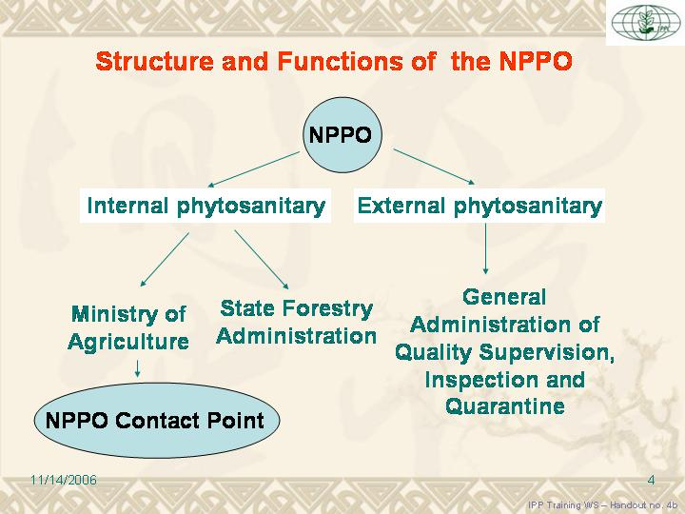

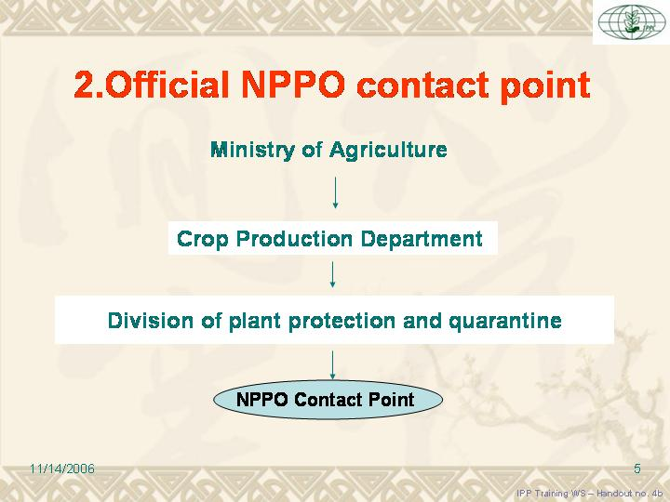

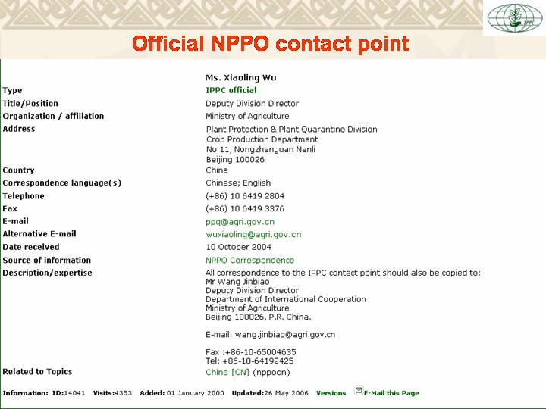

3. Regulated Pest List
Bulletin of MOA China (No. 617)
List of Agricultural Phytosanitary Pest in China (43 species )
http://www.agri.gov.cn/ztzl/zwjy/t20060308_566115.htm

Insects
Acanthoscelides obtectus (Say)
Bactrocera dorsalis (Hendel)
Bactrocera minax (Enderlein)
Bactrocera tsuneonis (Miyake)
Liriomyza trifolii (Burgess)
Brontispa longissima Gestro
Callosobruchus maculates ( Fabricius)
Cydia pomonella (Linnaeus)
Daktulosphaira vitifoliae Fitch
Eriosoma lanigerum (Hausmann)
Hyphantria cunea (Drury)
Leptinotarsa decemlineata (Say)
Lissorhoptrus oryzophilus Kuschel
Opogona sacchari Bojer
Solenopsis invicta Buren
Sternochetus frigidus (Fabricius)
Sternochetus olivieri (Faust)

Nematodes
Aphelenchoides ritzemabosi (Schwartz) Steiner & Buhrer
Ditylenchus destructor Thorne
Radopholus similes (Cobb)Thorne

Bacteria
Acidovorax avenae subsp. citrulli （Schaad et a.） Willems et al
Candidatus liberobacter asiaticum Jagoueix et al
Clavibacter michiganensis subsp. michiganensis (Smith) Davis et al
Pseudomonas syringae pv. maculicola (McCulloch) Young et al
Pseudomonas syringae pv.tomato (Okabe) Young, Dye & Wilkie
Xanthomonas axonopodis pv. citri (Hasse) Vauterin et al
Xanthomonas oryzae pv. oryzicola (Fang et al.) Swings et al

Fungi
Cladosporium cucumerinum Ellis & Arthur
Fusarium oxysporum f.sp. cubense (Smith) Snyder & Hansen Race 4
Peronosclerospora spp．
Phytophthora sojae Kaufmann&Gerdemann
Synchytrium endobioticum (Schilb.) Percival
Venturia inaequalis (Cooke) Winter
Verticillium albo-atrum Reinke & Berthold
Verticillium dahliae Kleb.

Virus
Prunus necrotic ringspot ilarvirus
Tobacco Ringspot nepovirus
Tomato spotted wilt tospovirus

Weeds
Ambrosia spp.
Cuscuta spp.
Lolium temulentum L.
Orobanche spp.
Sorghum halepense (L.) Pers.

Pest Reporting
The Imported Fire Ant, Solenopsis invicta Buren;
Grape Root Louse or Grape Phylloxera. ,Viteus vitifoliae (Fitch).

Occurrence of Fire Ant in China
First found in Guangdong province in September 2004;
Distributed in somewhere of four provinces including Guangdong, Guangxi, Fujian and Hunan province;
The area of occurrence reach 12,880 ha;
Now this pest is controlled well and identified as the important phyto-sanitary insect by MOA in China;

Occurrence of Grape Phylloxera in China
First found in Jiading District of Shanghai,China in July 2005;
Distributed in somewhere of Shanghai and Hunan province;
The area of occurrence reach about 0.67 thousands hectare;
Now this pest is also controlled well and identified as the important phytosanitary insect by MOA in China;

Pest Free Area
Pest: codling moth ，Cydia pomonella (Linnaeus)
Plant: Apple; Citrus
Location: Shandong province, Shanxi Province and Gansu Province

Capacity Building
Network and Web
Legislation on Plant Quarantine
Public Phytosanitary Databases

Network and Web building http://www.agri.gov.cn/
Network and Web building http://www.PPQ.gov.cn/
Network and Web building http://www.aqsiq.gov.cn/
Network and Web building http://www.forest.gov.cn/

Legislation on Plant Quarantine
Law of People's Republic of China on the Entry and Exit of Animal and Plant Quarantine
Regulation on Plant Quarantine (Revising）

Public Phytosanitary Databases
The Agricultural Plant Pest were investigated from 2001 to 2005 in China
The data is now inputting the phytosanitary database to establish the first Agricultural Phytosanitary Database
The databases consist of the occurrence, distribution and damage of the phytosanitary pest, regulated pest and newly found pest in China

List of Entry Points with specific restrictions
At present, there were 253 first grade ports approved by country, including:
Air port：56
Sea port：133
Railway port：17
Road port：47

Country Report: Democratic Peoples’ Republic of Korea

Official Contact Point
moa ecd@silibank.com

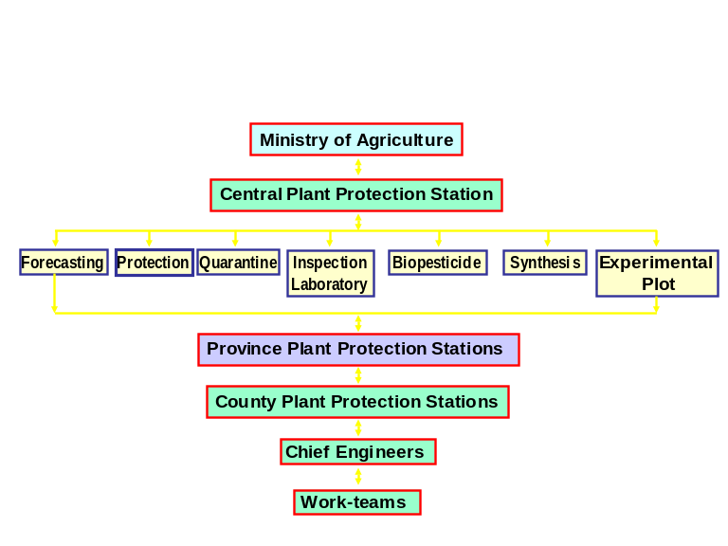

Non-compliance

The DPR of Korea has concluded an agreement on cooperation in the fields of plant quarantine with both of People’s Republic of China and Russia and convened conferences in rotation at intervals of 4~5 years to perform agreement and exchange information on the regulated pests.

The DPR of Korea has concluded an agreement on cooperation in the fields of plant quarantine with both of People’s Republic of China and Russia and convened conferences in rotation at intervals of 4~5 years to perform agreements and exchange information on the regulated pests.

175 pests were regulated as plant quarantine pests by the decision of Standing Committee of the Supreme People's Assembly and Cabinet and instruction of Ministry of Agriculture as follows :

- 63 Fungus, bacteria and virus
- 33 Weeds
- 79 Insect pests and Nematodes

Pest Reporting

- Hyphantria cunea Drury
- Dryocosmus Kuriphilus Yasumatsn
- Trialeurodes vaporariorum Westurod
- Venturia inaequalia inaequalis Winte
- Sclerotinia pseudotuberosa Rehm
- Lissorhoptrus oryzophilus Kuschel
- Ambrosia artemisii folia Linne
- Cera titis capitata Wiedeman
- Potato spindle tuber viroid

Specified Points Of Entry

DPRK does not have points of entry with special restrictions.

Organizational Arrangements For Plant Protection

- Forecasting section
- Protection section
- Quarantine section
- Inspection/laboratory section
- Biopesticide section
- Experiment plot section
- Synthesis section

Phytosanitary Requirements, Restriction And Prohibitions

- Plant Quarantine Legislation and Regulations
  - “Legislations of the Border for Animal and Plant Quarantine ”by the decision of Standing Committee of the Supreme People's Assembly, DPRK, No 89 (16, July, 1997)
  - “Regulations of the Border for Animal and Plant Quarantine” by the decision of Cabinet, DPRK No 4 (14, February, 1998)
  - “Minor Regulations of the Border Animal and Plant Quarantine” by instruction of Ministry of Agriculture No14.
- Rationale for phytosanitary requirements, restrictions and prohibitions
- Phytosanitary Restrictions, Requirements and Prohibitions
Country Report: Malaysia
Crop Protection and Plant Quarantine Division
Department of Agriculture
Jalan Gallagher
50632 Kuala Lumpur

Official Contact Point
Wan Normah Wan Ismail,
Acting Director,
Crop Protection and
Plant Quarantine Division
Department of Agriculture
Jalan Gallagher
50632 Kuala Lumpur

Organization Chart

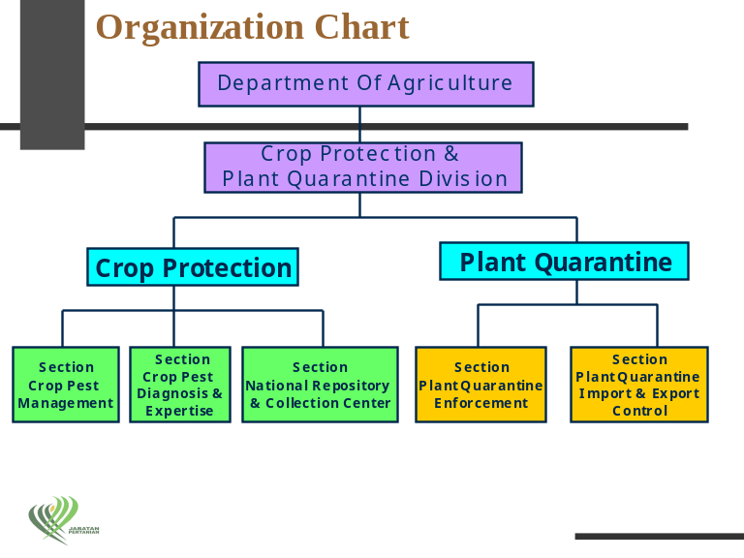

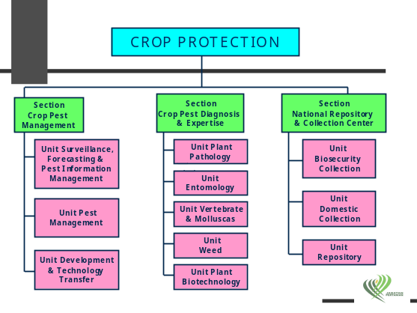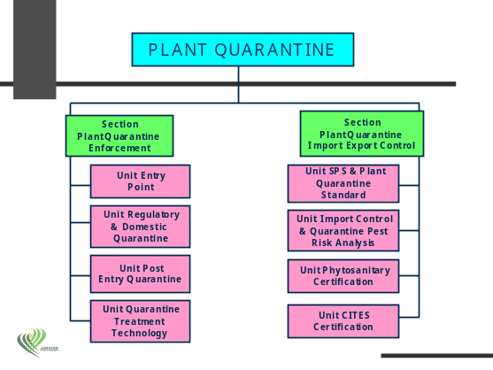

Functions
- Provide information on preventing and control the entry of dangerous pest into the country .
- To facilitate trade
- Control and reduce losses of crop due to pest infestation.

Website - PQnet
Address : http://www.doa.gov.my/pqnet
Launched : On 17 August 2000 by the Minister of Agriculture at Hotel Hilton Kuala Lumpur
Achievement: For the past 2 years, won in the ICT Competition for the Prize in Best Information Management.
Language : Dual-language- English and Malay

Background
Facilities – Every entry point has a connection to the internet
Infrastructure- Using various type of line (lease line, dial up, streamyx and ISDN)
– set up server program using open source.
Training- All officer are trained.
Processing of Information – Working Group
All Section Provide information
Receive and sort the information
Update whenever new issues on Protection & Quarantine and latest news.

Objectives/Purpose
For the stakeholder & International public to know the Protection & Quarantine issues and latest news in Malaysia
To provide information on the legislation and quarantine requirement to the public.
As an information exchange within the staff – Intranet, Mail & Enposys – (As an online program for the entry point to key in information on commodities and pest interception.)
Providing information to local public on pest information & management.

Content
Contacts - HQ, State and Entry point
Services – Downloadable form, Quarantine requirement, Import condition, Legislation, diagnostic service & training.
Information – Pest info & management, IPM, Beneficial organism.
Highlights – latest news (Profile of Important Malaysian Insect Pest)

IPP portal
Strength :
Easy to access
Understandable form

Weakness :
Not user friendly
Difficult to edit some information
Country Report: Peoples’ Republic of Korea
Ministry of Agriculture & Forestry (MAF)

OFFICIAL CONTACT POINT : npqs@npqs.go.kr

History

1992 Quarantine Legislation on Imported
Cherry Trees and Other Fruit Trees

1959 Quarantine Legislation on Imported
Cherry Trees and Other Fruit Trees

1961 Promulgation of Plant Protection Act

1978 Promulgation of Plant Protection Act

1995 Revision of Plant Protection Act

1996 Harmonizing Plant Quarantine with the Regulations
of WTO/SPS, FAO/IPPC, etc.

Organization & Personnel
Headquarter : 5 Divisions (74 persons)
5 Regional Offices (193 persons)
2 Post-Entry Quarantine Stations (24 persons)
22 Branch Offices (142 persons)
- Most of NPQS Offices are located in airports and/or seaports

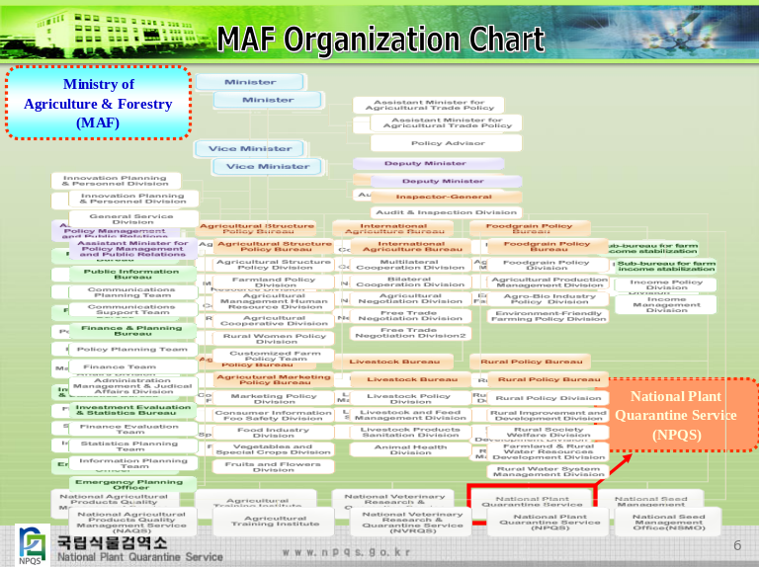

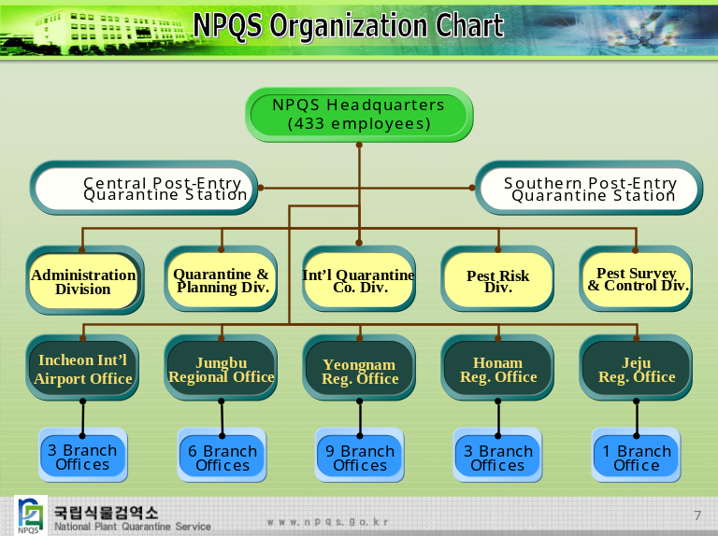

Information Exchange

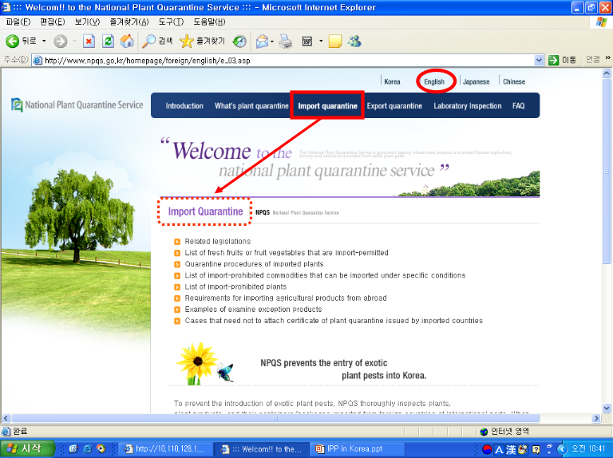

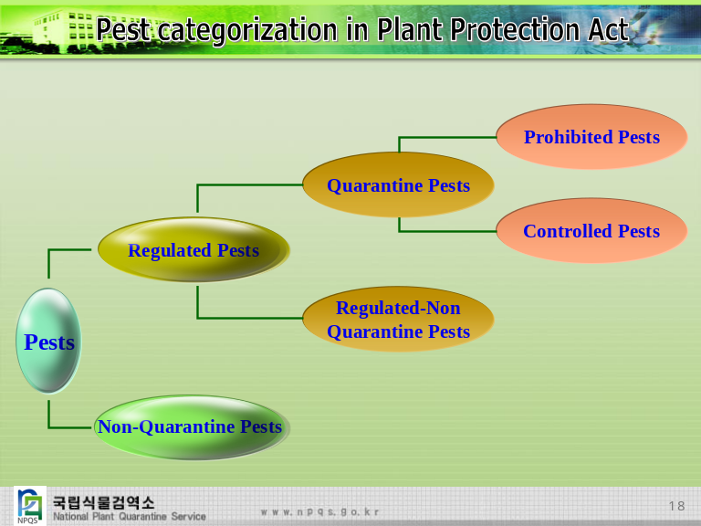

Pest Information System

- Establishment of DB related with pests, host plants, and commodities
  - Statistical analysis program for predicting the quarantine tendency
  - Retrieval of prohibited plants according to the country or commodities
  - Data for Pest Identification and/or Information Manual

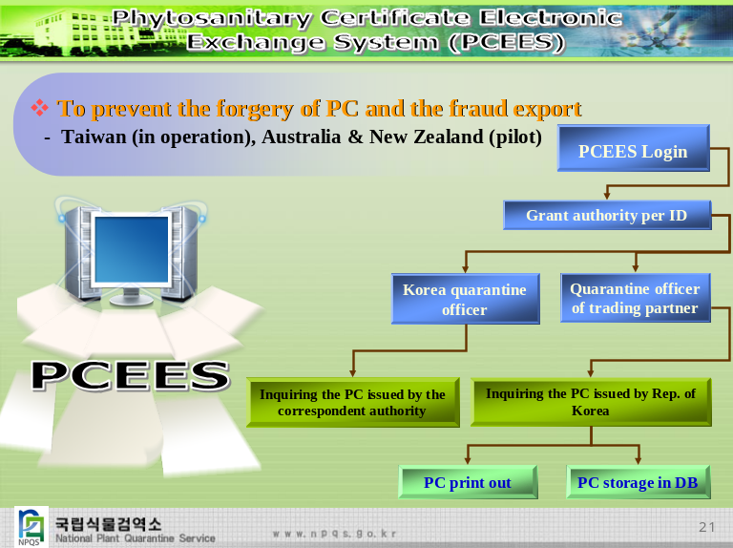

IPP Experiences
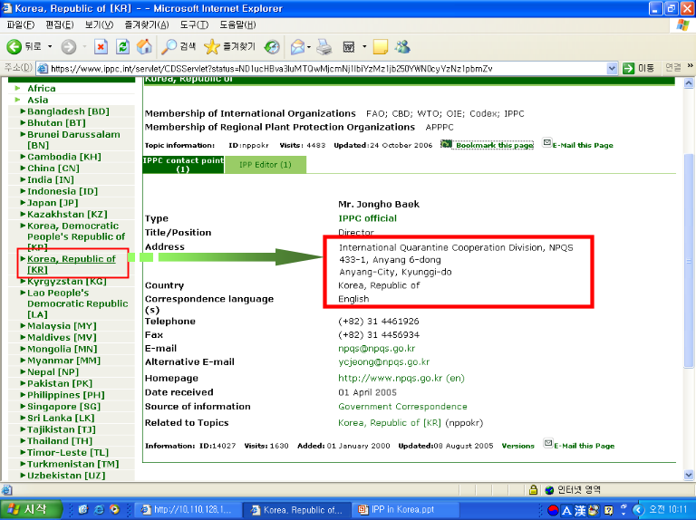

Main Article
- Calendar : easy access, reliability
- ISPMs, Report, and News : download, keyword search
- NPPO Contact Points : official availability

Advantages
- Official information source for IPPC and other countries
- Easy and prompt access, simple categorization

Disadvantages
- Lack of adequate information of other countries
- Lack of conspicuous device (e.g.; flash, colors, audio)
Country Report: Zambia

IPPC contact point Mr. Arundel Sakala
Type IPPC unofficial; IPP Editor
Title/Position Team leader & National Plant Quarantine & Phytosanitary Service (PQPS) Coordinator.
Organisation/Affiliation Ministry of Agriculture and Cooperatives.
Address Zambia Agriculture Research service
Plant Quarantine and Phytosanitary Service
Mount Makulu Research Station
Private Bag 7
Chilanga,
Country Zambia
Correspondence language English

Telephone: (+260) 1 278141/278130
E-mail pqpsmt@zamtel.zm
Alternative E-mail zaridirector@zari.gov.zm

Description Of The NPPO And Changes
The Plant Quarantine and Phytosanitary Service (PQPS) was established in 1951 at Mount Makulu Research Station in Chilanga, 18Km South of Lusaka. It has been serving as the National Plant Protection Organisation (NPPO) of Zambia since 1995. It falls under the Plant Protection and Quarantine Division (PPQD) of the Zambia Agriculture Research Institutive (ZARI) in the Ministry of Agriculture and Co-operatives (MACO).

PQPS has the mandate of preventing the introduction and spread of plant pests, diseases and alien invasive species through the enforcement of Plant Pests and Diseases Act CAP 233 and Noxious weed Act CAP 231 of the Laws of Zambia.

Notification Of Non-Compliance
Zambia as an importing country has in the past informed other countries on non
compliance. She informed the Netherlands on non-compliance with phytosanitary
requirements on seed and USA on Bulgur wheat and donated seed.

List Of Regulated Pests

Pest Reporting
Not much has been done, however few reports have been made to neighboring countries
on Prostephanus truncatus (Larger Grain Borer). Currently, there is no formal system of
reporting pests to IPPC and other organisation.

Exchange Of Information On Plant Pests, Particularly The Reporting Of The
Occurrence, Out Break Or Spread
This is on going

Technical And Biological Information Necessary For PRA
This is not fully implemented because of lack of resources. However, this is done on a
hard-hock basis. Specific surveillance programmes have been carried on following pests:

Cyst forming nematodes (CFN) in potato growing areas of Zambia,
Coffee Wilt Disease,
Cassava mosaic virus Uganda variant.

PQPS has initiated surveys on honey specifically on American and European Foul Brood and other pests occurring on honey.

Specified Points Of Entry
Approved points of entry into Zambia for Plants and plant products

A. Border points

Nakonde border post
Livingstone border post
Kazungla border post
Mwami border post
Kariba border post
Chirundu border post
KasumbaLesa border post
Mukambo border post
Chavuma border post
Sesheke border post
Sakanya border post
Mpulungu border post

B Inland Border points

Lusaka International Airport
Kapiri Mposhi
Mpika

Organisation Arrangement For Plant Protection
See the Plant Protection and Quarantine Division organgrams.

Emergency Action
Currently not functional, but has been put in the draft Plant Protection Act Bill.

Phytosanitary Requirements, Restrictions And Prohibition
Phytosanitary requirements: see addendums to Plant Import Permits (PIPs)
Phytosanitary restrictions; Timber and growing media
Phytosanitary prohibition; Soil

Adequate Information On Pest Status

Need a print out of a database

  - Role of IPPC Official Contact Points

IPPC Contact Points and the Exchange of Official Information
Dave Nowell, IPPC Secretariat, Rome, Italy

Nomination
Article VIII: International Cooperation
Each contracting parties shall designate a contact point for the exchange of information connected with the implementation of this Convention

Role
- Exchange of official information
- Coordination
  - internal
  - trading partners etc.
- Appropriate response
- Official information
  - verification of unofficial data!?
- Bilateral

Functions
NPPO spokesperson / enquiry point
- Relevant authority
- Official information
Distribution point / “post box”
- Incoming
- Outgoing
Meet information exchange obligations under IPPC
- Central to the functioning of the IPPC

Benefits
Single contact person on all IPPC issues
Official status
Improved reliability
Improved transparency
Builds trust
Improved response time

Secretariat
- copies with formal correspondence
- direct communication
  - only point of contact with government
- notifications
- response to queries

A Number of Challenges
- Nomination
- Updating
  - lack of follow-up to changes e.g. tel. & fax.
  - frequent changes in people & office
- Poor functioning
  - lack of response
  - not aware of role and obligations
  - lack of authority
  - not integrated into national IPPC process

Nominations for IPP
- IPPC contact points
  - busy
  - cannot do everything
  - who is going to do data entry in IPP?
- Nomination of IPP “editors”
  - formal nomination by IPPC OCP
  - responsible for OCP data entry

  - Official versus Scientific Information

The Role and Relationship of Scientific and Official Information
Dave Nowell, IPPC Secretariat, Rome, Italy

Information Exchange and the IPPC
- Article VIII provisions
  - cooperate in the exchange of information
  - provide scientific and technical information for PRAs
  - designate Official Contact Point
- Article IV provisions
  - surveillance and reporting of pests

Scientific vs Official Information
Scientific Information
- Biology of the pest:
- Distribution
- Host range
- Vectors
- Biological impact
- Economic impact
- Other data
- Sources of scientific information
  - Refereed journals
  - Non-refereed journals
  - NPPO records
  - Historical records
  - Electronic documentation

Official Information
- Regulatory requirements
- Surveillance data
- Regulated pest lists
- PRAs
- Pest status reporting
- Pest outbreaks
- Restrictions/prohibitions
- Emergency actions
- Source of official information
  - Official Contact Point designated by the Contracting Party

Importing Countries may use pest status information to:
- conduct a PRA on a pest in another country;
- establish phytosanitary regulations;
- and conduct a PRA on a non-quarantine pest in their own territories for purposes of regulating it.

Exporting countries may use pest status information to:
- comply with import regulations of importing countries;
- and meet requests from other countries for the purposes of PRAs.

Importing and exporting countries may use pest status information to:
- conduct PRAs;
- plan national, regional and international pest management programs;
- establish national pest lists;
- establish and maintain pest free areas (PFA).

Dispute Settlement
- Provisions for country consultation under WTO and IPPC
- Use of PRAs in dispute settlement
- Roles of scientific and regulatory experts
- Exchange of information between
  - countries
  - international organizations

The Role of Scientists
- Research and reporting of results
- Responsibility and accountability
- Understand repercussions and impact of pest reporting
- Accuracy in reporting
- Communication and participation with the regulatory community

The Role of Regulators
- Identify needs and gaps in knowledge base on pests of quarantine importance
- Support and encourage the activities of scientists in gathering and disseminating scientific information on plant pests
- Emphasize the importance of accurate and reliable information exchange
- Inform scientists on the role, relevance and impact of pest reporting

Official Contact Points
- Required under the (NRT) IPPC
- Used for the transmittal of official information within a country
- Used for the transmittal of official information between trading partners
- Benefits of OCPs:
  - Avoid confusion or misinterpretations
  - ACCOUNTABILITY
  - TRANSPARENCY

Conclusions
- Both scientific and official information are relevant to agricultural trade
- Accuracy, reliability and accountability are crucial
- Regulators and scientists must recognize and respect the roles of each

  - How Does The SPS-notification System Fit Into This?

The IPPC & The SPS-Agreement
Dave Nowell, IPPC Secretariat, Rome, Italy

WTO system
SPS Agreement
“Members shall notify changes in their sanitary or phytosanitary measures and shall provide information on their sanitary or phytosanitary measures in accordance with the provisions of Annex B.“
Article VII: Transparency

Relationship to the SPS
Art 3 of the SPS (Harmonization)
- members shall base their SPS measures on international standards or justify deviations
- members shall play a full part in the relevant standard setting organization
- relevant standard setting organizations are CAC, OIE, and IPPC

SPS Measures
Should be:
- consistent with international standards
- justified based on scientific principles and evidence
- harmonized to the extent possible
- transparent / notified / non-discriminatory
- only to meet the appropriate level of protection

Enquiry points
3. Each Member shall ensure that one enquiry point exists which is responsible for the provision of answers to all reasonable questions from interested Members as well as for the provision of relevant documents regarding:
(a) any sanitary or phytosanitary regulations adopted or proposed within its territory;
(b) any control and inspection procedures, production and quarantine treatment, pesticide tolerance and food additive approval procedures, which are operated within its territory;
...provide relevant documents on:
(c) risk assessment procedures, factors taken into consideration, as well as the determination of the appropriate level of sanitary or phytosanitary protection;
(d) the membership and participation of the Member, or of relevant bodies within its territory, in international and regional sanitary and phytosanitary organizations and systems, as well as in bilateral and multilateral agreements and arrangements within the scope of this Agreement, and the texts of such agreements and arrangements.

Notification procedures
...Members shall notify the SPS-Secretariat:
-> publish regulations
-> publish a notice on introduction of new regulations
-> notification on changes on regulations, and
-> -on products affected by new regulation, and
-> -on objective and rational

The SPS makes provision for phytosanitary protection in a trade agreement...
The IPPC makes complementary provision for trade in a protection agreement.

Scope
“The coverage of the IPPC definition of pests of plants includes weeds and other species that have indirect effects on plants. Therefore the scope of the Convention applies to the protection of wild flora resulting in an important contribution to the conservation of biological diversity.” (ICPM 2001; CPM 2006)

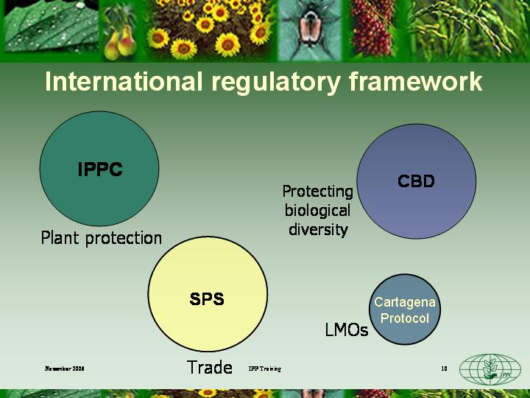

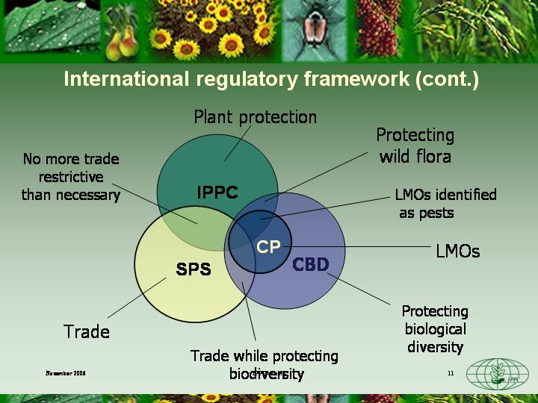

Relationship to the IPPC
- GMOs (LMOs) to the extent that such organisms may be considered pests of plants [CP <-> IPPC]
- Biosafety as it involves Pest Risk Analysis, biocontrol, and the application of phytosanitary measures
- Alien invasive species to the extent that these include pests of plants and plant products [CBD <-> IPPC]

Environmental Hazards
- Expert working group on elaboration of environmental risks
  - Reduction/elimination of endangered or threatened native plant species
  - Reduction/elimination of keystone species
  - Reduction/elimination of plant species that is a major component of native ecosystem
  - Changes to plant biodiversity causing ecosystem destabilization
  - Impacts of control programs

Implementation
SPS Enquiry Point
- separate from IPPC
- narrower than IPPC
Different process from IPPC
Overlap
Need for coordination and cooperation
Meeting IPPC obligations?!
Workshop Evaluation Format

Please enter a rating of 1 – 5, (5 for highest rating) for each of the boxes provided:

- Agenda topics and Workshop Program

1.1 How relevant were the following presentations to the IPP?

Topic | Rating
Presentation of the workshop program | 4.5
Workshop objectives and expected outputs | 4.7
Introduction to information exchange under the IPPC | 4.6
Official vs. optional provision of information | 4.3
SPS agreement | 4.3
NPPO information exchange obligations | 4.55
Role of IPPC official contact points | 4.6
Country Reports on National Information Exchanges processes within the IPPC Framework | 4.05
Introduction to the IPP | 4.7

1.2 Please list other workshop topics that should be included in the facilitators’ presentations:

Suggested topics
- Case study in IPP management (eg. Faults, mistakes, errors)
- Glossary of IPP terms
- Information exchange and computer technology
- PRA training
- Phytosanitary treatment
- Manual for data entry into IPP
- Briefing on ISPMs

 |  | Rating
1.3 | Did you find the handouts useful? | 4.45
1.4 | Suggestions, additional comments in relation to agenda topics:  The topics were well arranged to enable the workshop to meet the expected output.  The workshops needs a step-by-step guide on the process of adding a report

- Practical Sessions

 |  | Rating
2.1 | Was the duration of the practical sessions sufficient? | 4.2
2.2 | Suggest a suitable practical sessions duration:  __________ hours/days/weeks | 1-5 days
2.3 | Was the equipment provided sufficient? | 4.65
2.4 | Was the venue of the workshop suitable? | 4.35
2.5 | Were the facilities provided satisfactory? | 4.55
2.6 | After this workshop, how confident do you feel in your capacity to manage the NPPO information in the IPP? | 4.35
General comments on the practical sessions:

- Suggestion for a temporary access password for training purposes
- Lectures were well detailed to enable the participants full confidence in the handling of the training
- Direct input of data is encouraged, and sufficient preparation of data is important
- Suggestion for participants to work in pairs to help out participants who are slower at grasping computing technology
- Practical sessions were well organized
- Insufficient time was allocated for the practical.
- Suggestion for a manual to enable quick reference for data entry
- Suggest more facilities and more facilitators to guide the participants on IPP usage

- Problems/ limitations of the workshop

  - Please list the problems and limitations you encountered during the workshop:

Problems/ limitations
- Poor participation from the Contracting Parties of the Asia-Pacific Region
- A forum should be provided among participants facing problems with information exchange
- Suggest that a sufficient period of notification be given to the participants prior to the workshop for adequate preparation
- More time is required for practical
- Require detailing of keywords such as regulated pest, quarantine pests, etc.
- Suggest the presentation of a model report from a developed country
- Response time of the internet was insufficient to keep up with the pace of the lecture

  - Please list the strengths and weaknesses of the workshop:

strengths
- Participants have the opportunity to train on the actual website individually
- Participants can better understand the IPPC reporting obligations
- Good practical and hands-on data entry for phytosanitary information
- Gives confidence to the participants to update and manage the IPP
- Good internal arrangement, equipment and management
- Good hospitality from the Facilitator
- Friendly trainer
- Well set out agenda
- Clear presentation
- Good venue

weaknesses
- Lack of case study, namely a model presentation, and frequently made errors
- Lack of information from other Regions of the FAO
- Need to provide a better vision on the achievements through obligations of the IPPC
- Insufficient time for practical
- Slow internet response
- Insufficient facilitators and assistants

- Internal arrangements

Please comment on the following:

 |  | Rating
4.1 | Accommodations | 4.75
4.2 | Meals | 4.85
4.3 | Social events | 4.55
General comments on the internal arrangements:

- Good preparations for workshop
- Good effort from organizers, appreciate field trip and visit to KL Tower
- Suggest an airport transfer be made available
- Good service from the hotel
- Participants require extended training

