Thrips palmi

Annex to ISPM No. 27

INTERNATIONAL STANDARDS FOR
PHYTOSANITARY MEASURES

[PARAGRAPH 1] Annex to ISPM No. 27 (DIAGNOSTIC PROTOCOLS FOR REGULATED PESTS)

[2] Thrips palmi

(200-)

[3] CONTENTS

Endorsement 2
1. Pest Information 2
2. Taxonomic Information 3
3. Detection 3
4. Identification 4
4.1 Morphological identification of the adult thrips 5
4.1.1 Preparation of thrips for microscopic examination 5
4.1.2 Identification of the family Thripidae 5
4.1.3 Identification of the genus Thrips 5
4.1.4 Identification of Thrips palmi 6
4.2 Molecular assays for identifying Thrips palmi 16
4.2.1 SCAR marker-generated sequence-based real-time PCR assay for Thrips palmi 16
4.2.2 COI sequence-based real-time PCR assay for Thrips palmi 17
4.2.3 ITS2 sequence-based PCR-RFLP assay for nine species of thrips including Thrips palmi 17
4.2.4 COI sequence-based PCR-RFLP assay for ten species of thrips including Thrips palmi 17
5. Records 18
6. Contact points for further information 18
7. Acknowledgements 18
8. References 18

[4] Endorsement
This diagnostic protocol was adopted by the Commission on Phytosanitary Measures in ----.

[5] 1. Pest Information
[6] Thrips palmi Karny is a polyphagous plant pest, especially of species in the Cucurbitaceae and Solanaceae. It appears to have originated in Southern Asia and to have spread from there during the latter part of the twentieth century. It is now present throughout Asia and is widespread throughout the Pacific and the Caribbean. Otherwise, it occurs locally in North, Central and South America, Africa and Oceania. For more general information about T. palmi, see EPPO/CABI (1997) or Murai (2002); online pest data sheets are also available from the Pests and Diseases Image Library (PaDIL, 2007) and EPPO (EPPO, 2008).

[7] The species causes economic damage to plant crops both as a direct result of its feeding activity and from its ability to vector tospoviruses such as Groundnut bud necrosis virus, Melon yellow spot virus and Watermelon silver mottle virus. It is extremely polyphagous, and has been recorded from more than 36 plant families. It is an outdoor pest of Benincasa hispida, Capsicum annuum, Citrullus lanatus, Cucumis melo, Cucumis sativus, Cucurbita spp., Glycine max, Gossypium spp., Helianthus annuus, Nicotiana tabacum, Phaseolus vulgaris, Pisum sativum, Sesamum indicum, Solanum melongena, Solanum tuberosum and Vigna unguiculata. In glasshouses, economically important hosts are Capsicum annuum, Chrysanthemum spp., Cucumis sativus, Cyclamen spp., Ficus spp., Orchidaceae and Solanum melongena. The thrips may be carried on plants for planting, cut flowers and fruits of host species, as well as on packing material.

[8] Thrips palmi is almost entirely yellow in coloration (Figures 1–3), and its identification is hampered by both its small size (1.0–1.3 mm) and its great similarity to certain other yellow or predominantly yellow species of Thrips.

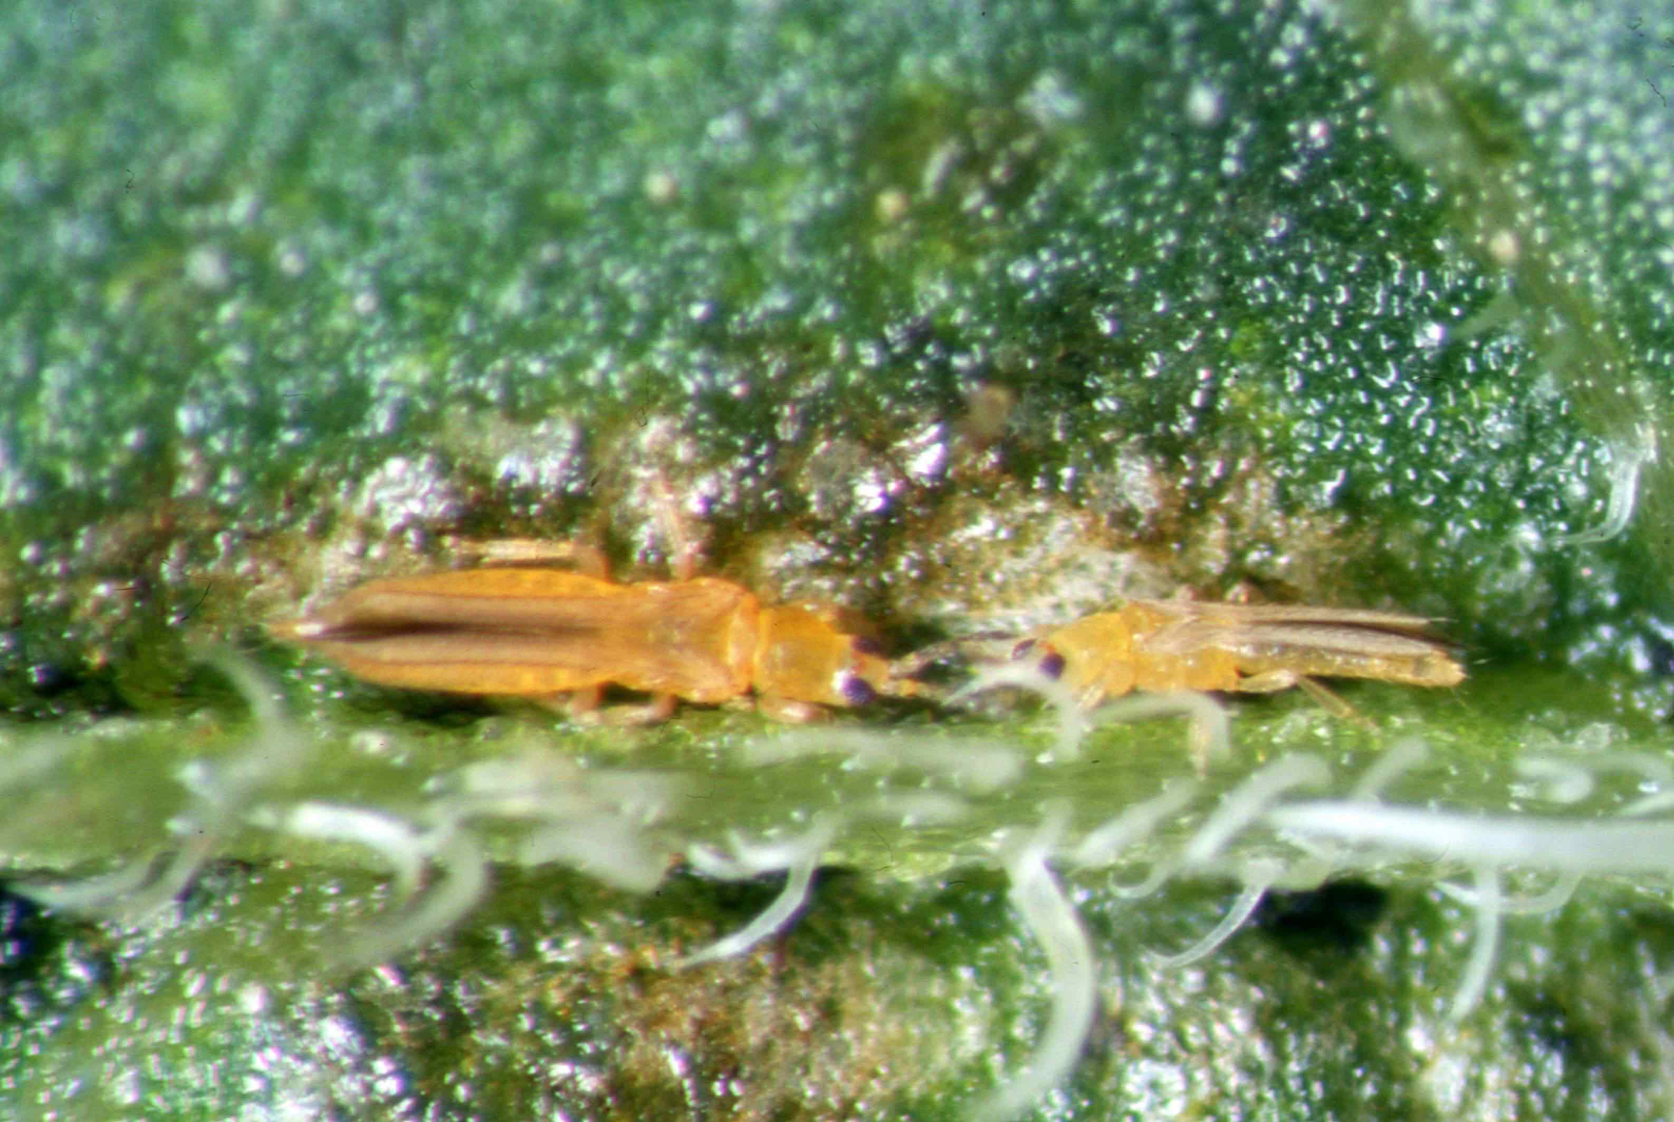

[9] Figure 1: Thrips palmi; female (left) and male (photo: A. J. M. Loomans, PPS, Wageningen, the Netherlands)
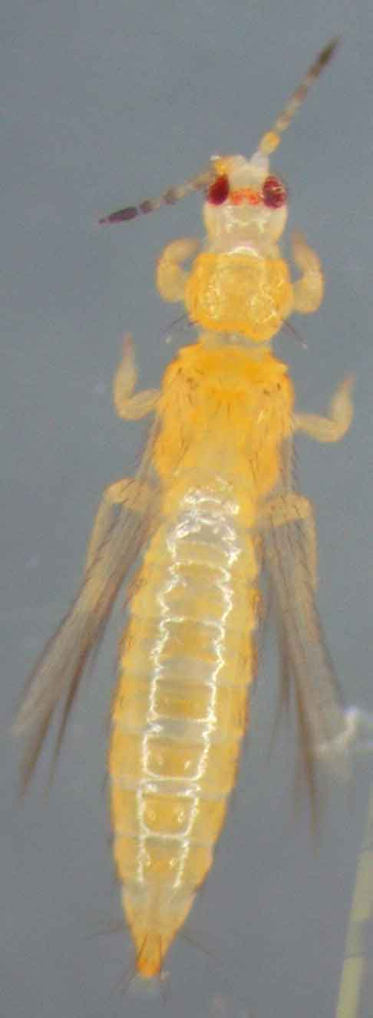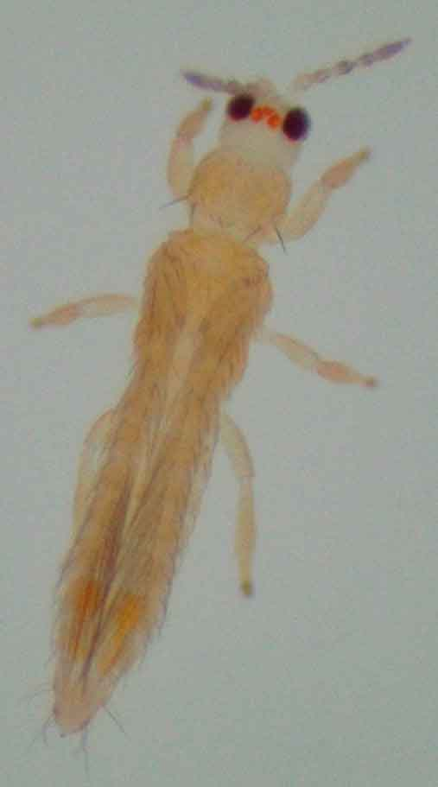

[10] Figure 2: Thrips palmi, female [11] Figure 3: Thrips palmi, male
(Figures 2 and 3 are not to equal scale.)
(photos: W. Zijlstra, PPS, Wageningen, the Netherlands)

[12] 2. Taxonomic Information
[13] - Name: Thrips palmi Karny, 1925
- Synonyms: Thrips clarus Moulton, 1928
Thrips leucadophilus Priesner, 1936
Thrips gossypicola Ramakrishna & Margabandhu, 1939
Chloethrips aureus Ananthakrishnan & Jagadish, 1967
Thrips gracilis Ananthakrishnan & Jagadish, 1968
- Taxonomic position: Insecta, Thysanoptera, Terebrantia, Thripidae
- Common name: melon thrips

[14] 3. Detection
[15] T. palmi may be found in different situations according to the life stages present.
- eggs in the leaf, flower and fruit tissue
- larva I on the leaves, flowers and fruits
- larva II on the leaves, flowers and fruits
- pupa I in the soil
- pupa II in the soil
- adult on the leaves, flowers and fruits

[16] On plant material, T. palmi may potentially be found on most above-ground parts of the plant; the parts of the plant infested can differ according to variables such as the host and the characteristics of each separate T. palmi population.

[17] During visual examination of plant material for the presence of T. palmi, attention must be paid to silvery feeding scars on the leaf surfaces of host plants, especially alongside the midrib and the veins. Heavily infested plants are often characterized by a silvered or bronzed appearance of the leaves, stunted leaves and terminals, or scarred and deformed fruits. Detection may be hampered in the following circumstances:
- low-level infestation, which may produce little or no detectable symptoms
- the presence on the plant of the eggs within the plant tissue only (for example after external treatment which may have removed visible life stages).

[18] Specimens for morphological examination are best collected in a fluid called AGA, which is a mixture of 10 parts of 60% ethanol with 1 part of glycerine and 1 part of acetic acid. If the specimens are to be stored, they should be transferred to 60% ethanol and kept in the dark, preferably in a freezer to prevent loss of colour. However, several laboratories have reported that AGA may act to denature the DNA of the thrips thereby hindering any subsequent molecular work. An alternative is to use 80–95% ethanol as the collecting fluid as any unmounted specimens may then be used for molecular studies. However, in this case specimens must be stored in the freezer until used, or they may prove difficult to slide mount.

[19] Several methods can be used to collect thrips specimens (Mantel and Vierbergen, 1996; modified):
- Thrips may be individually removed from the plant (leaves, flowers or fruit), and transferred into microtubes containing AGA, using a moist, fine brush.
- Thrips may be beaten from plant parts onto a small plastic tray (e.g. a white tray for dark-coloured specimens or a black tray for light-coloured specimens). In cooler conditions, the thrips usually start walking across the tray rather than flying off, allowing time for the thrips to be picked off with a moist fine brush, whereas in tropical areas collection has to be done more rapidly as the thrips are likely to fly off much more quickly. The thrips are easily seen on the tray using just a hand lens, but an experienced observer can also see them easily with the naked eye.
- Plant parts may be sealed in a plastic bag for 24 hours, with a piece of filter paper to absorb condensation. Most thrips will leave the plant parts and can then be collected from the inside of the bag.
- A Berlese funnel can be used to process plant material such as flowers, turf, leaf litter, moss and even dead branches of trees. The funnel contains a sieve on which the plant material is deposited. Beneath the sieve, the bottom of the funnel leads into a receptacle containing 70–96% ethanol. The funnel is placed under an electric lamp (60 W), and the heat and light will cause any thrips present in the plants to escape by heading down towards the receptacle. After an appropriate period (8 hours for cut flowers), the content of the receptacle can then be checked under a stereomicroscope.
- Thrips may be monitored (winged adults only) using coloured sticky traps. The ability of a colour to attract thrips varies for different thrips species, but blue or white traps are good for T. palmi, though yellow traps will also work. For microscope slide preparation and identification, the thrips will have to be removed from the traps using glue-removing fluids based on citrus oils, dichloromethane or a turpentine substitute.

[20] There are no recognized methods for extracting thrips pupae from the soil.

[21] 4. Identification
[22] Identification of thrips species by morphological examination is restricted to adult specimens because there are no adequate keys for the identification of eggs, larvae or pupae. However, the presence of larvae in samples can give important additional information such as confirming their development on the host plants. The primary method of identification of adult material is from morphological characters. In order to achieve species identification, these must be examined using a high-power microscope. Using this protocol with good-quality slide preparations should allow adult T. palmi to be identified with certainty by morphological examination alone.

[23] Molecular assays can be applied to all life stages including the immature stages for which morphological identification to species is not possible. Additionally, in cases where adult specimens are atypical or damaged, molecular assays may provide further relevant information about their identity. However, such information needs to be carefully interpreted because the specificity of molecular assays is limited and these assays have been developed for specific purposes and evaluated against a restricted number of species.

[24] 4.1 Morphological identification of the adult thrips
[25] 4.1.1 Preparation of thrips for microscopic examination
[26] For high-power microscopic examination, adult thrips must be mounted on microscope slides. Material to be kept in a reference collection is best macerated, dehydrated and mounted in Canada balsam; Mound and Kibby (1998) provide a full description of this process. However, the full slide preparation protocol for archival mounts takes three days to complete.

[27] For routine identifications, a water-soluble mountant such as Hoyer’s medium (50 ml water, 30 g gum arabic, 200 g chloral hydrate, 20 ml glycerine) is more rapid and relatively inexpensive. One popular method of routine slide preparation is given by Mound and Kibby (1998) and described below (different laboratories may find that other variants work equally well):

[28] Transfer the specimens from the collecting fluid into clean 70% ethanol; if the specimens are reasonably flexible, attempt to spread the legs, wings and antennae using micropins; transfer a single thrips, ventral side uppermost, to a drop of Hoyer’s medium on a 13 mm diameter cover slip and use micropins to rearrange the thrips if necessary; gently lower a microscope slide onto the mountant so that the cover slip and mountant adhere to the middle of the slide; invert the slide as soon as the mountant has spread to the edges of the cover slip; label the slide with details including locality, date of collection and host plant; place the slide, cover slip up, into a drying oven at 35–40°C and leave for 6 hours before attempting study; leave in the oven for approximately 3 weeks to dry the mountant, before sealing the cover slip with resin or nail varnish.

[29] 4.1.2 Identification of the family Thripidae
[30] Thrips palmi belongs to the family Thripidae, which includes approximately 1850 species in 260 genera. Most species share the characteristics outlined in Table 1.

[31] Table 1: Family Thripidae – shared characteristics
[32] | Body part | Characteristic
[33] | Antennae | seven or eight segments (occasionally nine or six)
 | Antennae | segments III–IV have emergent sense cones (sensoria)
[34] | Forewings (if fully developed) | usually slender, with two longitudinal veins each bearing a series of setae
[35] | Abdomen – female | with a serrated ovipositor, which is turned downwards at the apex
[36] | Median sternites – male | with one or more glandular areas

[37] 4.1.3 Identification of the genus Thrips
[38] The genus Thrips contains more than 280 species from all parts of the world, though the genus is primarily from the Holarctic region and the Old World tropics. Members of the genus share the characteristics outlined in Table 2.

[39] Table 2: Genus Thrips – shared characteristics, adult specimens

[40] | Body part | Characteristic
[41] | Female | macropterous or micropterous
[42] | Antennae | seven or eight segments
 | Antennae | segments III–IV with forked emergent sense cones
[43] | Ocellar setae | only two pairs present (pair I absent)
 | Ocellar setae | pair II shorter (at least no longer) than pair III
[44] | Pronotum | two pairs (rarely one or none) of major posteroangular setae
 | Pronotum | usually three, sometimes four, pairs of posteromarginal setae
[45] | Prosternal basantra | no setae present
[46] | Forewings | setal row on the first vein usually interrupted
 | Forewings | clavus with five veinal setae (rarely six)
[47] | Metascutum | median pair of setae at or behind the anterior margin
 | Metascutum | striate or reticulate sculpturing
 | Metascutum | campaniform sensilla (metanotal pores) present or absent
[48] | Metasternal furca | without a spinula
[49] | Tarsi | two-segmented
[50] | Abdominal tergites and sternites | without posteromarginal craspeda (flanges)
[51] | Abdominal tergites | tergites V–VIII with paired ctenidia laterally (combs – each comprising a submarginal row of microtrichia) (occasionally also on IV)
 | Abdominal tergites | tergite VIII: ctenidia posteromesad to the spiracles
[52] | Abdominal sternites and pleurotergites | with or without discal (accessory) setae

[53] A simplified summary of the main characteristics is given in Table 4 and is accompanied by illustrative line drawings and photomicrographs (Figures 4 to 5.12).

[54] Identification of the adults can be carried out with keys. Mound and Kibby (1998) provided a key to 14 Thrips species of economic importance including Thrips palmi. In addition, a CD-ROM identification aid for thrips is available which includes an identification system to 100 pest species from around the world based on photomicrographs (Moritz et al., 2004).

[55] More comprehensive keys to the genus are available produced on a regional basis (no such key has been produced for the Afrotropical region):
Asia: Bhatti (1980) and Palmer (1992) provide keys for the identification of species of Thrips occurring in the Asian tropics.
Europe: zur Strassen (2003) has produced the most recent comprehensive key to the species of Europe including Thrips (in German).
North, Central and South America: Nakahara (1994) provides a key for Thrips species from the New World. A key to the species of Thrips found in Central America is given by Mound and Marullo (1996) though only one of these species is native to the region. Only species of Thrips that were transported there by the international plant trade are to be found in South America.
Oceania: Mound and Masumoto (2005) provide a key to the Thrips species of Oceania. (The authors of the paper are aware of the error inadvertently introduced on p. 42 in the section “Relationships” whereby a characteristic of T. flavus – ocellar setae III close together behind the first ocellus – is attributed to T. palmi. The correct information is provided in the T. palmi species description immediately above and is illustrated in Figure 72.)

[56] 4.1.4 Identification of Thrips palmi
[57] Morphological characteristics of Thrips palmi
[58] Bhatti (1980), Bournier (1983), Sakimura et al. (1986), zur Strassen (1989), Nakahara (1994) and Mound and Masumoto (2005) all provide detailed descriptions of T. palmi. Sakimura et al. (1986) gave a list of major diagnostic characters to distinguish T. palmi from the other known species of the genus Thrips; a modified version is presented in Table 3.

[59] Thrips palmi can be reliably separated from all other species of the genus Thrips by the possession of all the characters listed in Table 3. Nevertheless, thrips morphology is subject to variation even within a single species and some characters listed here may be subject to occasional slight variation. For instance antennal coloration or the number of distal setae on the forewing can vary from the most commonly observed states. If the specimen differs with respect to one or more of these character states, then the identification should be checked by reference to an appropriate regional key such as those listed in section 4.1.3.

[60] Table 3: A list of morphological characters that collectively distinguish Thrips palmi from other species in the genus Thrips

[61] |  | Morphological character
[62] | 1. | A clear yellow body with no dark areas on the head, thorax or abdomen (slightly thickened blackish body setae); antennal segments, I and II pale, III yellow with apex shaded, IV to VII brown but usually with base of IV–V yellow; forewings uniformly slightly shaded, prominent setae dark
[63] | 2. | Antennae always seven-segmented
[64] | 3. | Postocular setae II and IV much smaller than remaining setae
[65] | 4. | Ocellar setae III standing either just outside of the ocellar triangle, or touching the tangent lines connecting the anterior ocellus and each of the posterior ocelli
[66] | 5. | Metascutum with sculpture converging posteriorly; median pair of setae behind anterior margin; paired campaniform sensilla present
[67] | 6. | Forewing first vein with three (occasionally two) distal setae
[68] | 7. | Abdominal tergite II with four lateral marginal setae
[69] | 8. | Abdominal tergites III to IV with setae S2 dark and subequal to S3
[70] | 9. | Abdominal tergite VIII with complete posteromarginal comb, long and fine
[71] | 10. | Abdominal tergite IX usually with two pairs of pores (campaniform sensilla)
[72] | 11. | Abdominal sternites without discal setae
[73] | 12. | Abdominal pleurotergites without discal setae
[74] | 13. | Male sternites III–VII each with a narrow transverse glandular area

[75] A simplified summary of the main characteristics is given in Table 4 and is accompanied by illustrative line drawings and photomicrographs (Figures 4 to 5.12).

[76] Comparison with similar species (species that are yellow without darker body markings, or predominantly yellow, or sometimes yellow)
[77] For each species listed here, the main character differences by which they may be separated from Thrips palmi are given. If in any doubt, refer to an appropriate regional key such as those listed in section 4.1.3. These also give details of other Thrips species that are not listed below.

[78] Two Indian species (T. alatus Bhatti and T. pallidulus Bagnall) are very similar to T. palmi, although little is known about their biology.
[79] Thrips alatus
[80] | - | antennal segment V uniformly brown
 | - | abdominal tergites III and IV with setae S2 paler and much weaker than S3 in both sexes
 | - | the striate sculpture on the metascutum usually not converging posteriorly
 | - | distribution: India, Nepal.

[81] Thrips pallidulus
[82] | - | antennal segment IV pale
 | - | sculpture on the metascutum medially reticulate, not striate
 | - | distribution: India.

[83] Three common Palearctic species (but also with wider distributions) that may be confused with T. palmi are T. flavus Schrank, T. nigropilosus Uzel and T. tabaci Lindeman.

[84] Thrips flavus
[85] | - | ocellar setae pair III inside the ocellar triangle, just behind the anterior ocellus
 | - | the length of antennal segment VI, 54–60 μm (42–48 μm in T. palmi)
 | - | lines of sculpture on the metascutum not converging posteriorly
 | - | distribution: common flower thrips throughout Asia, Europe.

[86] Thrips nigropilosus
[87] | - | usually with dark markings on the thorax and abdomen
 | - | metascutum with irregular reticulations medially (longitudinal striae in T.palmi) and no campaniform sensilla
 | - | abdominal tergite II with three lateral marginal setae
 | - | abdominal tergites IV–V with median pair of setae (S1) more than 0.5 times as long as the median length of their tergites (less than 0.3 times in T. palmi)
 | - | distribution: common leaf-feeding species, sometimes a pest of plants in the family Compositae; Asia, East Africa, Europe, North America, Oceania.

[88] Thrips tabaci
[89] | - | highly variable in coloration, but usually with more or less brown or greyish markings
 | - | all postocular setae subequal in length
 | - | metascutum with irregular longitudinal reticulations, usually with small wrinkles medially, and no campaniform sensilla
 | - | forewing first vein usually with four (occasionally between two or six) distal setae
 | - | abdominal tergite II with three lateral marginal setae
 | - | abdominal tergite IX with posterior pair of campaniform sensilla only
 | - | abdominal pleurotergites with numerous ciliate microtrichia arising from lines of sculpture
 | - | male: narrow transverse glandular area on abdominal sternites III–V only
 | - | distribution: polyphagous pest with a worldwide distribution.

[90] Two further species, one Palearctic (T. alni Uzel) and one European (T. urticae Fabricius), are less commonly encountered but may be confused with T. palmi. Females of T. alni are particularly similar in morphology to those of T. palmi.

[91] Thrips alni
[92] | - | antennal segment V uniformly brown
 | - | abdominal tergites II–V with setae S2 pale
 | - | abdominal tergite V with seta S2 much weaker than seta S3 (these setae are subequal in T. palmi)
 | - | abdominal tergite VIII with seta S1 subequal to seta S2 (S1 is much weaker than S2 in T. palmi)
 | - | male: abdominal sternites III–VI each with a small oval glandular area
 | - | distribution: restricted to the leaves of Alnus, Betula, Salix; Europe, Siberia, Mongolia.

[93] Thrips urticae
[94] | - | pronotum with a pair of setae on the anterior margin almost twice as long as any of the discal setae (usually more than 30 μm; not so in T. palmi, all less than 25 μm)
 | - | abdominal tergites usually with a grey area medially
 | - | abdominal tergite IX with posterior pair of campaniform sensilla only
 | - | distribution: restricted to Urtica dioica; Europe.

[95] A simplified checklist of the morphological characters used to identify Thrips palmi is presented in Table 4. This is designed to be used in conjunction with the figures.

[96] Table 4: Simplified checklists of the diagnostic features for quick recognition: (a) the genus Thrips; (b) Thrips palmi
(See Figure 4 for the location of the various features.)

[97] | (a) Specimens can be recognized as Thrips by the following combination of characters
[98] | Antenna | with seven or eight distinct segments; segments III and IV with forked sense cones | Figs 5.1, 5.2
[99] | Head | with two pairs of ocellar setae (II and III); pair I missing | Fig. 5.3
[100] | Pronotum | with two pairs of major posteroangular setae | Fig. 5.4
[101] | Forewing | 1st vein – setal row on the first vein interrupted (in most species) | Fig. 5.5
[102] | Abdominal tergites V to VIII | with paired ctenidia | Fig. 5.6
[103] | Abdominal tergite VIII | with ctenidia posteromesad to the spiracles | Fig. 5.6
[104] | (b) Specimens can be identified as Thrips palmi by the presence of the following characters
[105] | Body colour | clear yellow body with no dark areas on the head, thorax or abdomen; antennal segments I and II are pale | Figs 1–3
[106] | Antennal segment V | usually yellowish in basal ⅓ to ½ | Fig. 5.1
[107] | Antennal segment VI | length = 42–48 μm | Fig. 5.1
[108] | Head: ocellar setae pair III | with their bases sited outside of the ocellar triangle or touching the tangent lines connecting the anterior ocellus to each of the posterior ocelli | Fig. 5.3
[109] | Forewing: 1st vein | with three (occasionally two) distal setae | Fig. 5.5
[110] | Metascutum | with a pair of campaniform sensilla; with striate sculpture converging posteriorly | Fig. 5.7
[111] | Abdominal pleurotergites | discal setae absent; lines of sculpture without numerous microtrichia | Fig. 5.8
[112] | Abdominal tergite II | with four lateral marginal setae | Fig. 5.9
[113] | Abdominal tergites III and IV | S2 almost equal to S3 | Fig. 5.10
[114] | Abdominal tergite VIII | with complete posteromarginal comb | Fig. 5.6
[115] | Abdominal tergite IX | with two pairs of pores (anterior and posterior) | Fig. 5.11
[116] | Male: sternites | transverse glandular areas on sternites III to VII | Fig. 5.12

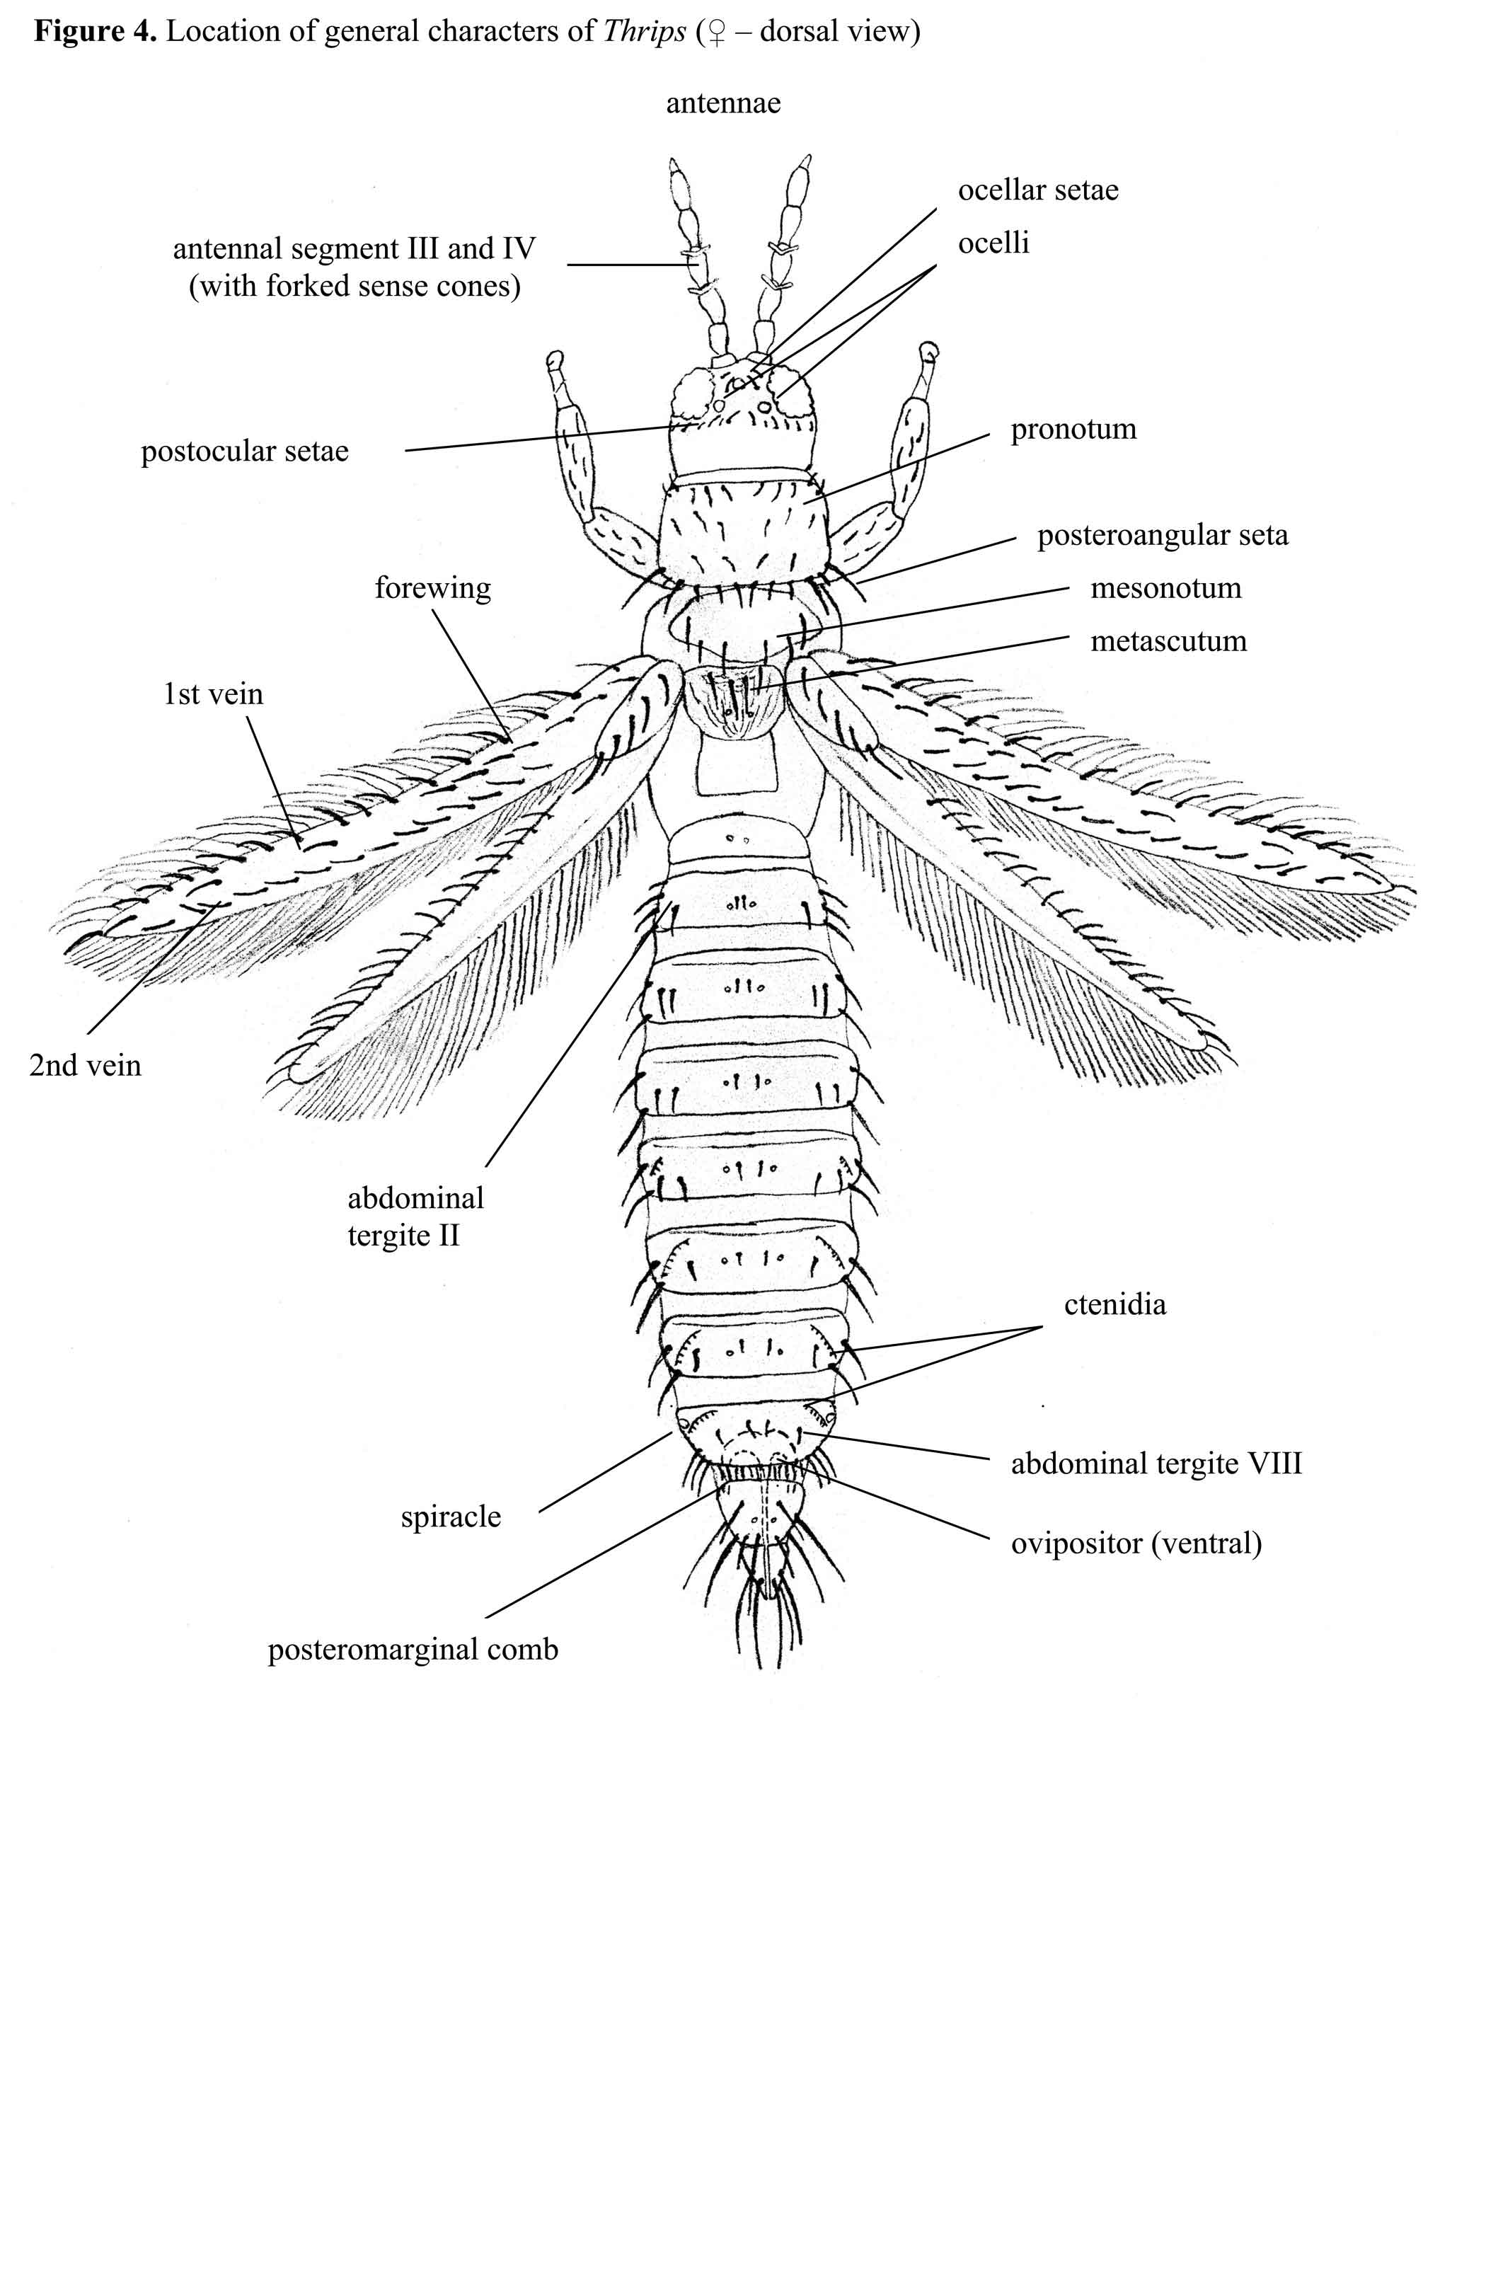
[117] Figure 4: Location of general characters of Thrips (female – dorsal view)

[118] Figure 5 (Figs 5.1 to 5.12): Characters of Thrips palmi (photos: G. Vierbergen, PPS, Netherlands; figures drawn by S. Kobro, Norwegian Crop Protection Institute, Norway)
posteroangular seta
forewing

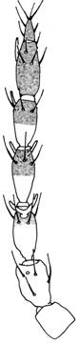
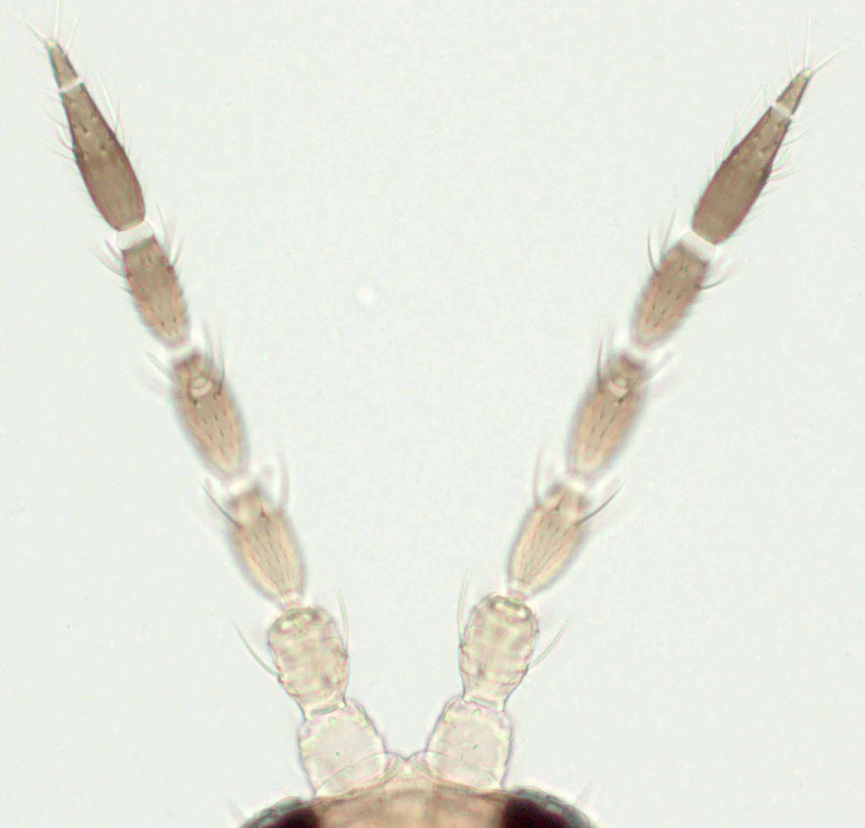
5.1(a)
5.1(b)
VI (42-48 μm)
Fig. 5.1(a), (b): Antenna: seven segments; length of segment VI: 42–48 μm
[119]

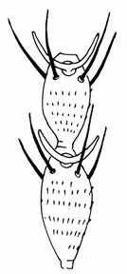
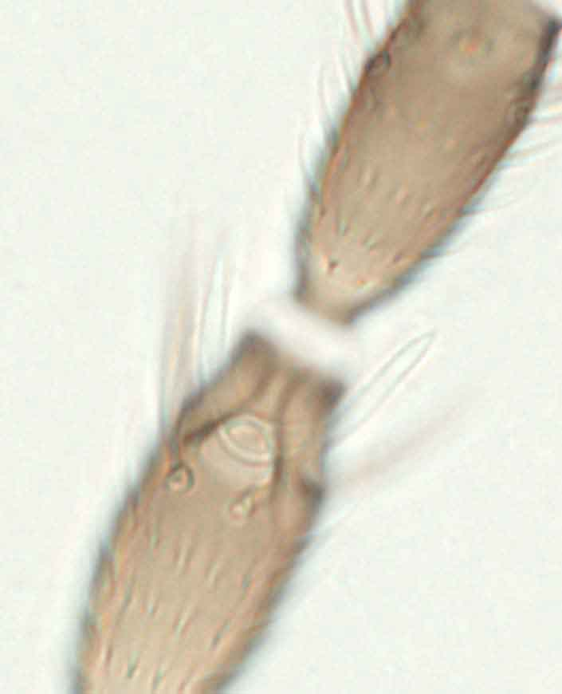
forked sense cones
III
IV
IV
V
5.2(a)
5.2(b)
Fig. 5.2(a), (b): Antenna: segments III and IV with forked sense cones
[120]

Fig. 5 continued.

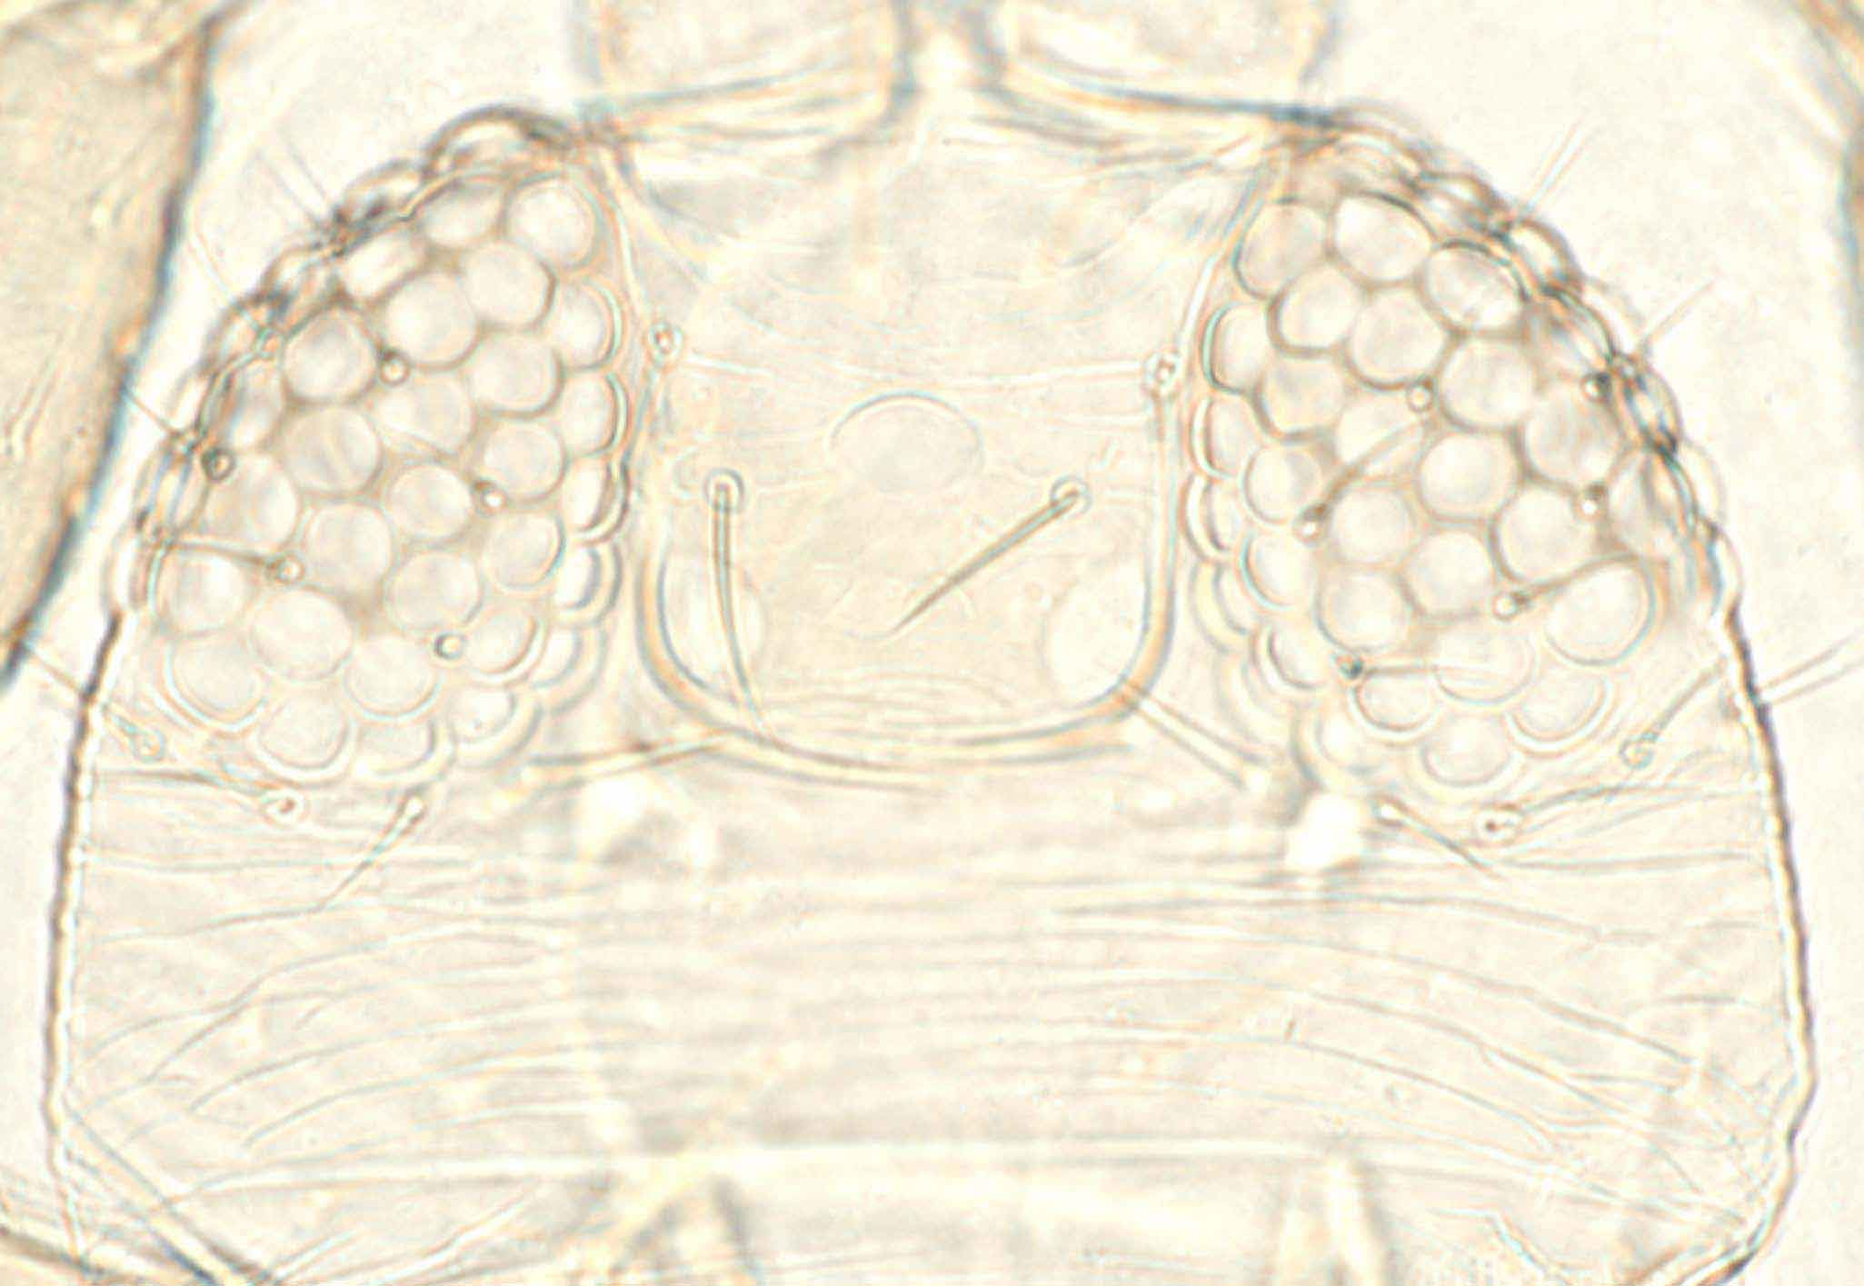
ocellar setae pair II
Ocellar setae pair III outside ocellar
triangle
5.3(a)
5.3(b)
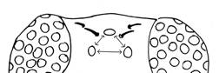
Ocellar triangle
Fig. 5.3(a), (b): Head: with two pairs of ocellar setae (pair I missing). Ocellar setae pair III situated outside of ocellar triangle
[121]

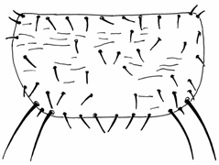
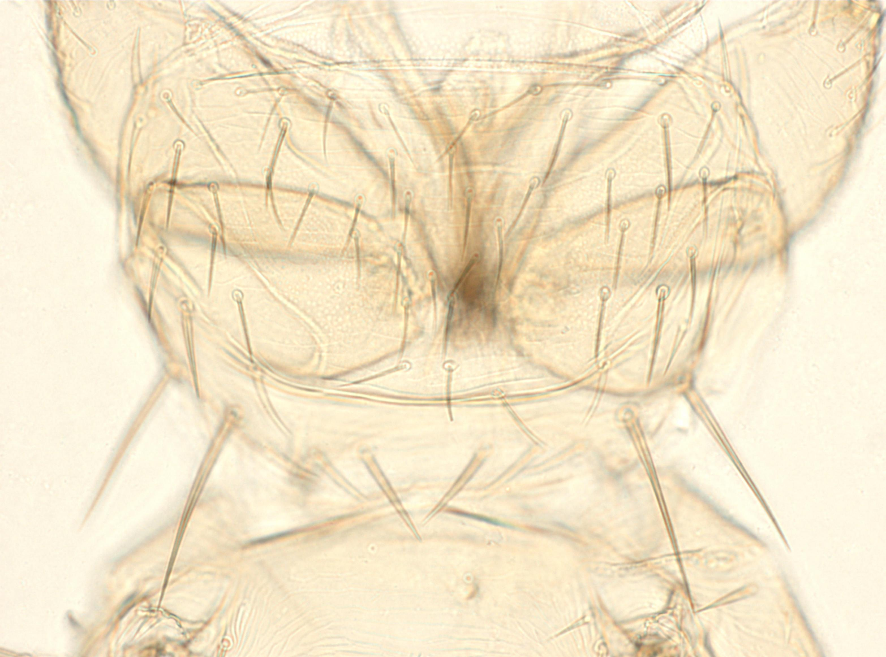
(5) Forewing: first vein – row of setae with gaps in distal half
Posteroangular setae
5.4(a)
5.4(b)
Fig. 5.4(a), (b): Pronotum: two pairs of major posteroangular setae

[122]

Fig. 5 continued

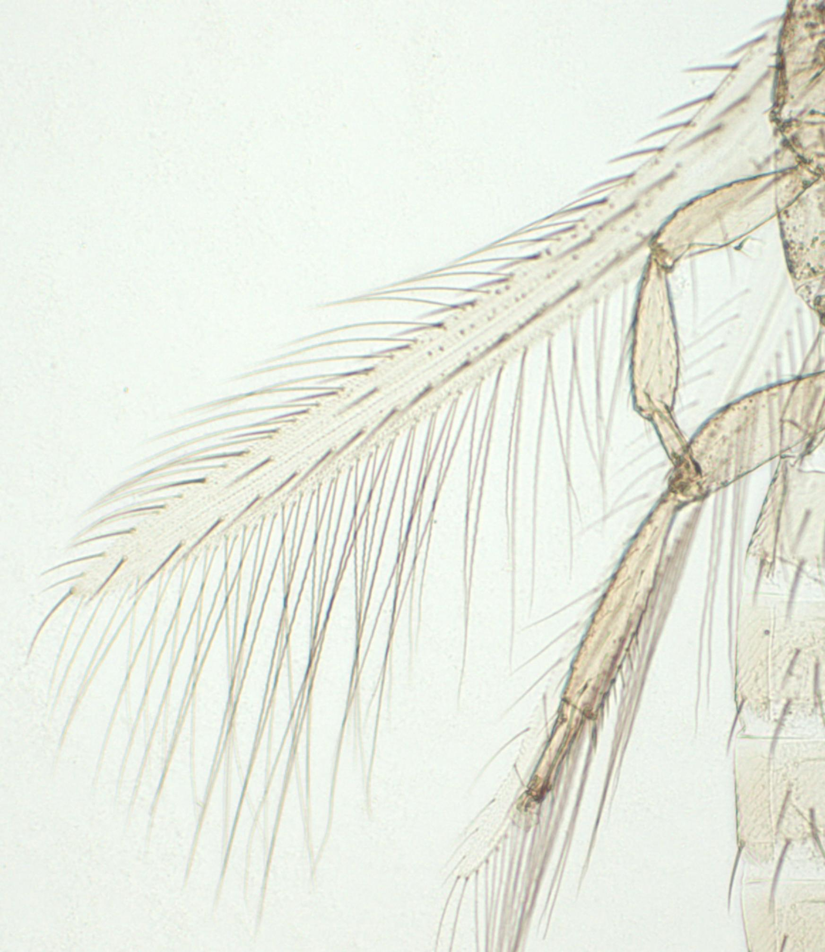
5.5(a)

three distal setae

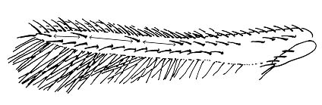
5.5(b)
Forewing 1st vein: three distal setae

Fig. 5.5(a), (b): Forewing: first vein – three setae with gaps in distal half

[123]

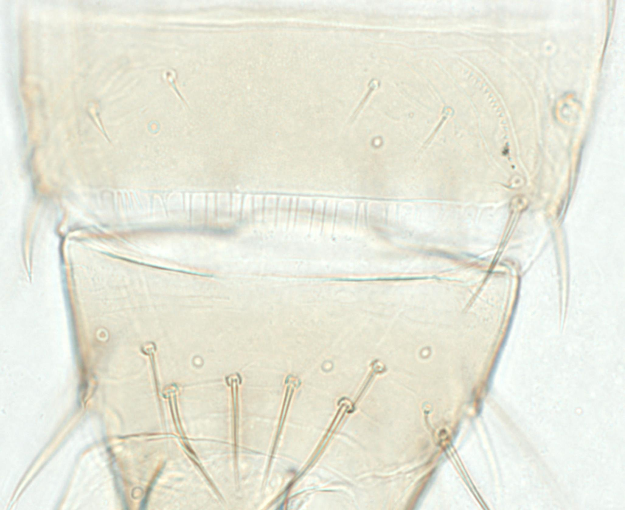
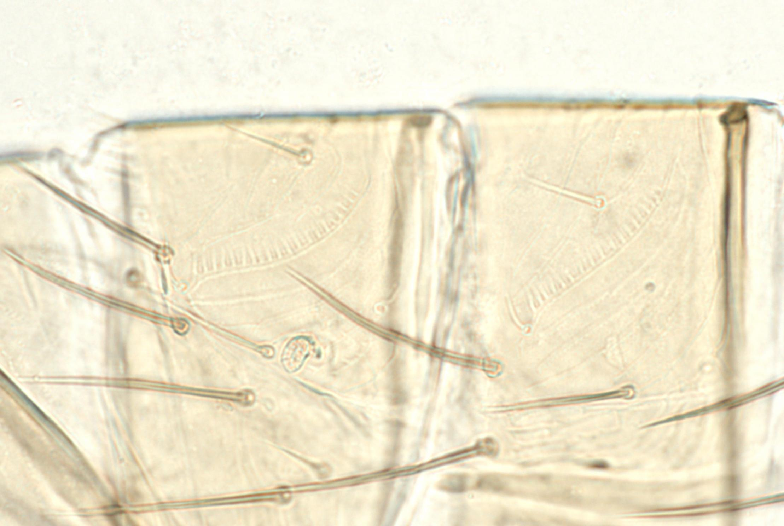
5.6(b)
VIII
VII

VIII

IX

Female abdominal tergites VII and VIII, lateral
5.6(a)

Male abdominal tergites VIII and IX, dorsal

ctenidium
Fig. 5.6(a)–(c): Abdominal tergite VIII: ctenidia posteromesad to the spiracle; posteromarginal comb complete
[124]
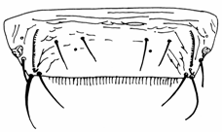
spiracle
Posteromarginal comb complete
5.6(c)

Fig. 5 continued.

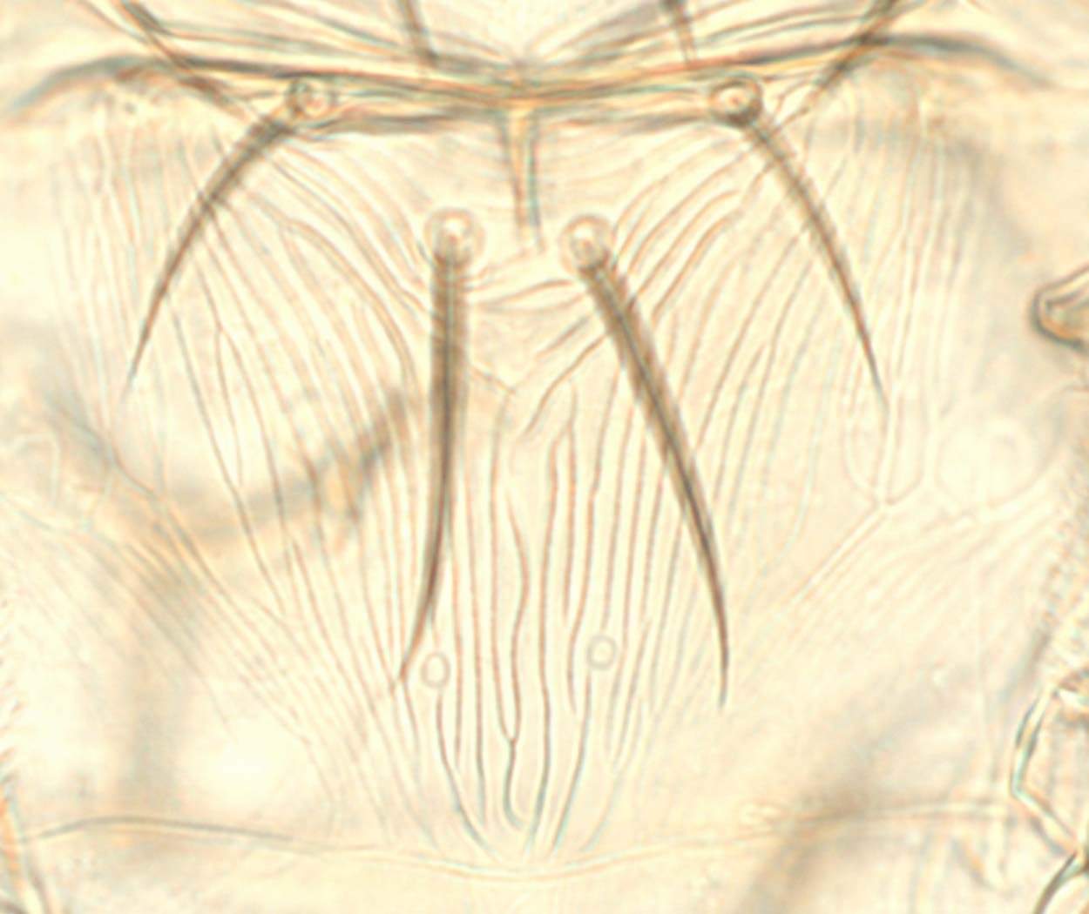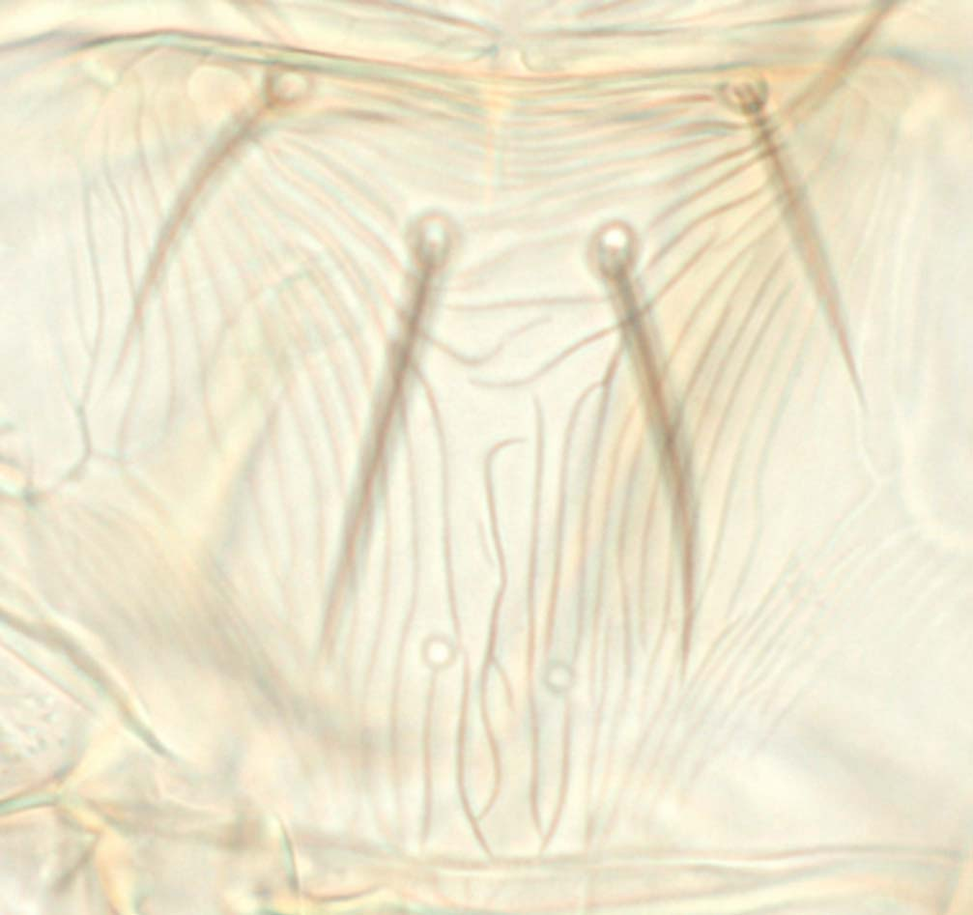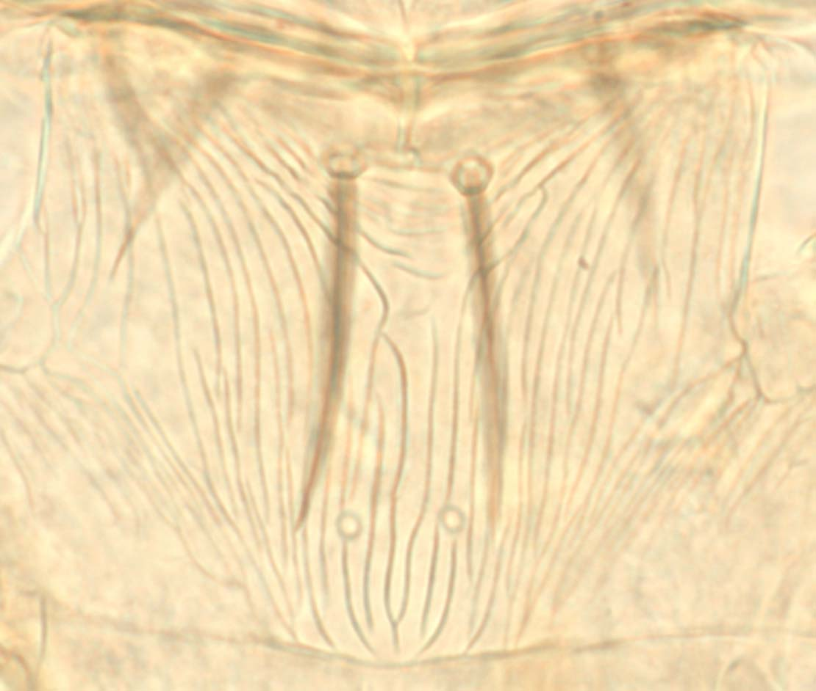
5.7(b)
5.7(a)
5.7(c)

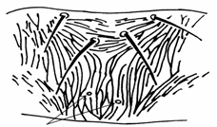
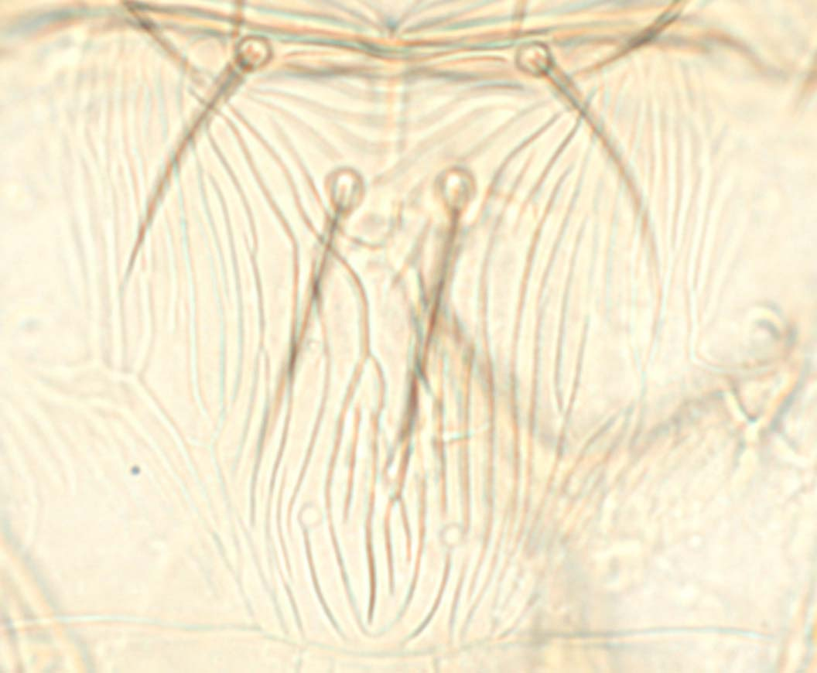
campaniform sensilla
converging sculpture
5.7(d)
5.7(e)
Fig. 5.7(a)–(e): Metascutum, variation in sculpture; campaniform sensilla
[125]

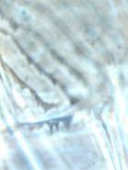
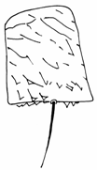
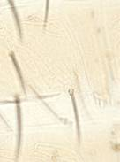
Fig. 5.8(a)–(c): Abdominal pleurotergites: microtrichia and discal setae absent
[126]

V
IV

5.8(c)
5.8(b), phase contrast
5.8(a)

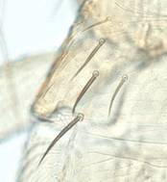
5.9(a)

Fig. 5.9(a), (b): Abdominal tergite II: four lateral marginal setae
[127]
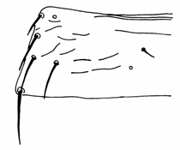

four setae in a row

5.9(b)

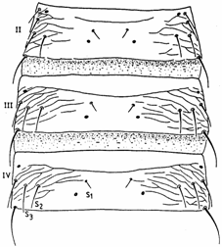
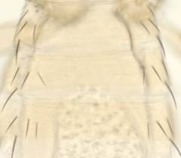
II

III

IV
5.10(a)

Fig. 5.10(a), (b): Tergites II–IV, female: setae S2 about same size as setae S3 (5.10b from zur Strassen, 1989)
5.10(b)
[128]

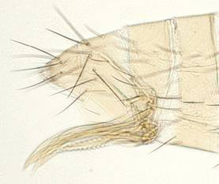
Two pairs of pores (campaniform sensilla)
VII
VIII
IX
X

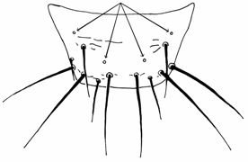
5.11(a), dorsal
5.11(b), lateral

Fig. 5.11(a), (b): Abdominal tergite IX, two pairs of campaniform sensilla
[129]
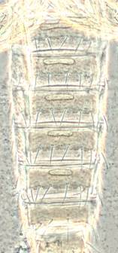
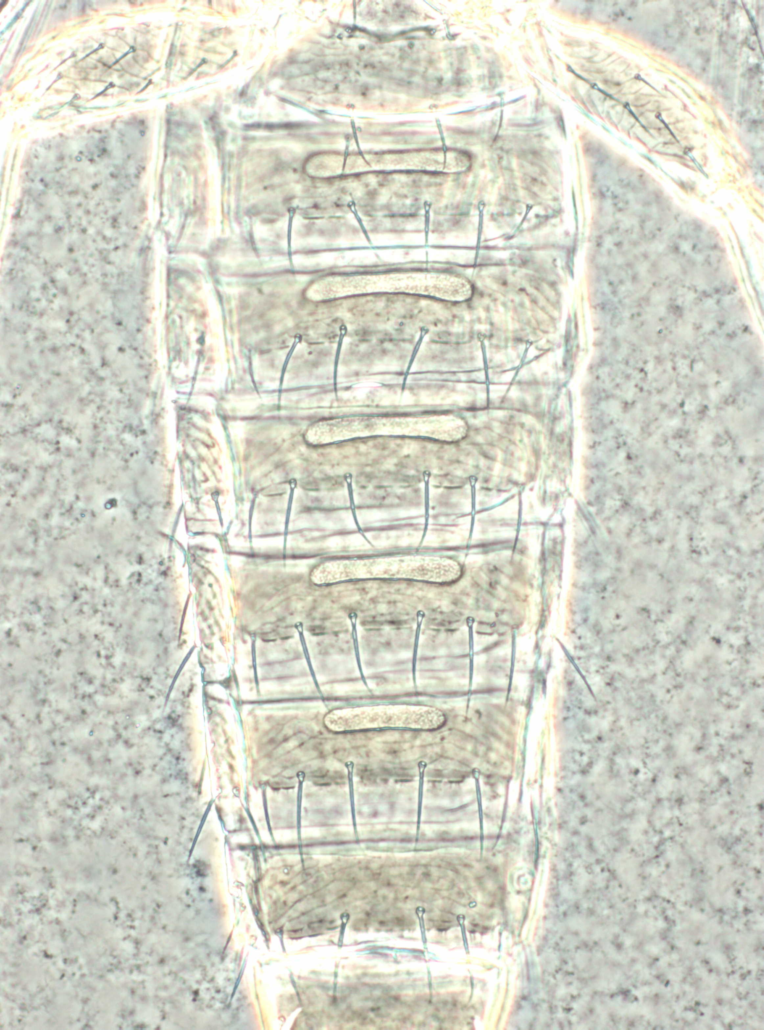

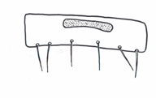
V

5.12(a), sternite V
[130] Fig. 5.12(a)–(c): Male glandular areas
(showing variation) on abdominal
sternites III–VII
5.12(b), phase contrast
5.12(c), phase contrast

[131] 4.2 Molecular assays for identifying Thrips palmi
[132] Four molecular assays have been published that can be used in the discrimination of T. palmi and these are described below. The specificity of each assay is also described. This indicates the thrips species against which each assay was evaluated and the original use for which the assay was designed. A CD-ROM identification system is also available that includes molecular data for a number of thrips species (Moritz et al., 2004).

[133] In this diagnostic protocol, methods (including reference to brand names) are described as published, as these defined the original level of sensitivity, specificity and/or reproducibility achieved.

[134] Requirements for controls
[135] With all molecular methods the use of appropriate controls is essential; a validated T. palmi-positive extract must be included as an additional sample to ensure that amplification has been successful. PCR amplification, either for real-time PCR or PCR-RFLP, must also be performed on a sample with no DNA. This negative control indicates possible reagent contamination and false positives.

[136] DNA extraction
[137] DNA may be extracted from single eggs, adults, pupae or larvae. For each of the assays described below refer to the source paper for the original specific DNA extraction technique used. Laboratories may find that alternative extraction techniques work equally well; DNA may be extracted using any DNA extraction methods suitable for insects. For example:
- The thrips may be ground in a lysis buffer in a microtube using a micropestle, and the homogenate taken through a proteinase-K-based DNA extraction kit according to the appropriate manufacturer’s instructions.
- Alternatively, a thrips may be ground in 50 μl nuclease-free water before the addition of 50 μl of a 1:1 (volume to volume) slurry of Chelex 100 resin, and nuclease-free water, heated to 95ºC for 5 min and centrifuged at 11,000 g for 5 min. The supernatant is transferred to a new microtube and stored at −20ºC.

[138] Several recent papers have described non-destructive techniques for extracting DNA from thrips, which have the advantage that after DNA extraction has been completed a cleared specimen remains available for slide mounting (e.g. Rugman-Jones et al., 2006; Mound and Morris, 2007).

[139] 4.2.1 SCAR marker-generated sequence-based real-time PCR assay for Thrips palmi
[140] This assay of Walsh et al. (2005) was designed as a species-specific assay against T. palmi for use by the phytosanitary authorities in England and Wales. It was evaluated by screening it against 21 other species of Thysanoptera, including ten belonging to the genus Thrips (T. flavus, T. major Uzel, T. minutissimus L., T. nigropilosus, T. sambuci Heeger, T. tabaci, T. trehernei (T. physapus), T. urticae, T. validus Uzel, T. vulgatissimus Haliday). These were predominantly, but not exclusively, European species.

[141] Methodology
[142] The T. palmi-specific PCR primers and TaqMan probe used in this assay were as follows:
PCR primer: P4E8-362F (5′-CCGACAAAATCGGTCTCATGA-3′)
PCR primer: P4E8-439R (5′-GAAAAGTCTCAGGTACAACCCAGTTC-3′)
TaqMan probe: P4E8-385T (FAM 5′-AGACGGATTGACTTAGACGGGAACGGTT-3′ TAMRA).

[143] Real-time PCR reactions were set up using the TaqMan PCR core reagent kit (Applied Biosystems), with 1 μl (10–20 ng) of DNA extract, 7.5 pmol of each primer and 2.5 pmol probe in a total volume of 25 μl. Plates were cycled at generic system conditions (10 min at 95°C and 40 cycles of 1 min at 60°C, 15 s at 95°C) on either of the ABI Prism 7700 or ABI 7900HT Sequence Detection Systems (Applied Biosystems)², using real-time data collection. Ct values lower than 40 indicated the presence of T. palmi DNA.

[144] 4.2.2 COI sequence-based real-time PCR assay for Thrips palmi
[145] This assay of Kox et al. (2005) was designed as a species-specific assay against T. palmi for use by the phytosanitary authorities in the Netherlands. It was evaluated by screening the assay against 23 other species of thrips, including 11 belonging to the genus Thrips (T. alliorum (Priesner), T. alni, T. angusticeps Uzel, T. fuscipennis Haliday, T. latiareus Vierbergen, T. major, T. minutissimus, T. parvispinus (Karny), T. tabaci, T. urticae, T. vulgatissimus). These were predominantly, but not exclusively, European species.

[146] Methodology
[147] The Thrips palmi-specific PCR primers and TaqMan probe used in this assay are as follows:
PCR primer: Tpalmi 139F* (5′-TCA TGC TGG AAT TTC AGT AGA TTT AAC-3′)
PCR primer: Tpalmi 286R* (5′-TCA CAC RAA TAA TCT TAG TTT TTC TCT TG-3′)
TaqMan probe: TpP (6-FAM 5′-TAG CTG GGG TAT CCT CAA-3′ MGB).
* Primers have been adjusted for greater sensitivity since original publication.
(COI sequences that mismatch with the TaqMan probe in this assay have been deposited on GenBank from a number of specimens from India identified as T. palmi on the basis of their morphology (Asokan et al., 2007). These sequences would not produce a positive result using this assay. The taxonomic or phylogenetic significance of this sequence differentiation currently remains unclear.)

[148] The 25 μl reaction mixture contained 12.5 μl of 2X TaqMan Universal Master Mix (Applied Biosystems) 3, 0.9 μM each primer, 0.1 μM TaqMan probe, 1.0 μl DNA. The real-time PCR was performed on either of the ABI Prism 7700 or ABI 7900HT Sequence Detection Systems (Applied Biosystems)⁴ using the following conditions: 10 min at 95°C; then 40 cycles of 1 min at 60°C and 15 s at 94°C. Ct values lower than 40 indicated the presence of T. palmi DNA.

[149] 4.2.3 ITS2 sequence-based PCR-RFLP assay for nine species of thrips including Thrips palmi
[150] This assay (Toda and Komazaki, 2002) was designed to separate nine species of thrips, including T. palmi, that are found in fruit trees in Japan: Frankliniella occidentalis (Pergande), F. intonsa (Trybom), T. hawaiiensis Morgan, T. coloratus Schmutz, T. flavus, T. tabaci, T. palmi, T. setosus Moulton, Scirtothrips dorsalis Hood.

[151] Methodology
[152] The PCR primers (located in the 5.8 S and 28 S regions flanking the ITS2 region of ribosomal DNA) used in this assay were as follows:
5′-TGTGAACTGCAGGACACATGA-3′
5′-GGTAATCTCACCTGAACTGAGGTC-3′.

[153] T. palmi generated a 588-base-pair (bp) PCR product (longer or shorter fragments were produced from the other species). The 20 μl reaction mixture was composed as follows: 1 μM each primer, 250 μM dNTPs, 1 Unit of AmpliTaq Gold DNA polymerase (Applied Biosystems) 5, 2 μl 10X reaction buffer [with 25 mM MgCl₂], 0.5 µl DNA. The PCR was performed in a 9600 DNA thermocycler (Applied Biosytems)⁶, with the following conditions: 9 min at 95ºC, 35 cycles of 1 min at 94ºC, 30 s at 50ºC, and 1 min at 72ºC, followed by a final extension for 7 min at 72ºC and quickly cooled to room temperature. The PCR products were analysed by agarose gel electrophoresis.

[154] 5 μl PCR product (without purification) was digested with the enzyme RsaI according to the manufacturer’s instructions. Digested PCR products were separated by agarose gel electrophoresis.

[155] Restriction fragment sizes produced by T. palmi when the ITS2 fragment is digested with RsaI were as follows: 371, 98, 61 and 58 bp.

[156] 4.2.4 COI sequence-based PCR-RFLP assay for ten species of thrips including Thrips palmi
[157] This assay of Brunner et al. (2002) was designed to separate ten species of thrips, including T. palmi, which are mostly, but not exclusively, pest species found in Europe: Anaphothrips obscurus (Müller), Echinothrips americanus Morgan, Frankliniella occidentalis, Heliothrips haemorrhoidalis (Bouché), Hercinothrips femoralis (Reuter), Parthenothrips dracaenae (Heeger), Taeniothrips picipes (Zetterstedt), Thrips angusticeps Uzel, T. palmi, T. tabaci.

[158] Methodology
[159] The PCR primers (located in the mitochondrial COI gene sequence) used in this assay are as follows:
mtD-7.2F (5′-ATTAGGAGCHCCHGAYATAGCATT-3′)
mtD9.2R (5′-CAGGCAAGATTAAAATATAAACTTCTG-3′).

[160] These primers amplified a 433-bp fragment in all the species separated by this assay. The 50 μl reaction mixture was composed as follows: 0.76 μM each primer, 200 μM dNTPs, 1 Unit Taq DNA polymerase, 5 μl 10X reaction buffer [with 15 mM MgCl₂], 1 µl DNA. The PCR was performed in a standard thermocycler with the following conditions: 1 min 94ºC, 40 cycles of 15 s at 94ºC, 30 s at 55ºC, and 45 s at 72ºC, followed by a final extension for 10 min at 72ºC and quickly cooled to room temperature. To gauge the fragment size produced after amplification, 5 µl of the PCR products were analysed by agarose gel electrophoresis.

[161] 5 µl PCR product (without purification) was digested with the enzymes AluI and Sau3AI in separate reactions according to the manufacturer’s instructions. Digested PCR products were separated by agarose gel electrophoresis.

[162] Restriction fragment sizes produced by T. palmi when the COI fragment is digested with AluI and Sau3AI are as follows:
AluI: 291 and 194 bp
Sau3AI: 93, 104, 70 and 18 bp.

[163] 5. Records
[164] Records and evidence should be retained as described in section 2.5 of ISPM 27 (Diagnostic protocols for regulated pests).

[165] In cases where other contracting parties may be adversely affected by the diagnosis, the records and evidence (in particular, preserved or slide-mounted specimens, photographs of distinctive taxonomic structures, DNA extracts and photographs of gels, as appropriate), should be kept for at least one year.

[166] 6. Contact points for further information
[167] Entomology Section, Department of Diagnostics, Plant Protection Service, P.O. Box 9102, 6700 HC Wageningen, Netherlands. Telephone: +31 317 496824; e-mail: g.vierbergen@minlnv.nl; fax: +31 317 423977.
Pest and Disease Identification Team, Central Science Laboratory, Sand Hutton, York YO41 1LZ, United Kingdom. Telephone: +44 1904 462215; e-mail: dom.collins@csl.gov.uk; fax: +44 1904 462111.
Area Entomología, Departamento Laboratorios Biológicos, Dirección General de Servicios Agrícolas, MGAP, Av. Millán 4703, C. P. 12900, Montevideo, Uruguay. Telephone: +598 2304 3992; e-mail: ifrioni@mgap.gub.uy; fax: +598 2304 3992.

[168] 7. Acknowledgements
[169] The first draft of this protocol was written by D.W. Collins, Pest and Disease Identification Team, Central Science Laboratory, Sand Hutton, York, YO41 1LZ, United Kingdom; G. Vierbergen, Dr. L.F.F. Kox, Plant Protection Service, Section of Entomology, Wageningen, Netherlands; and Ing. Agr. N.C. Vaccaro, Sección Entomología, INTA-EEA Concordia, Argentina. Line drawings for Figure 5 were produced by S. Kobro, Norwegian Crop Protection Institute, Norway.

[170] 8. References
Asokan, R., Krishna Kumar, N.K., Kumar, V. & Ranganath, H.R. 2007. Molecular differences in the mitochondrial cytochrome oxidase I (mtCOI) gene and development of a species-specific marker for onion thrips, Thrips tabaci Lindeman, and melon thrips, T. palmi Karny (Thysanoptera: Thripidae), vectors of tospoviruses (Bunyaviridae). Bulletin of Entomological Research, 97: 461–470.
Bhatti, J.S. 1980. Species of the genus Thrips from India (Thysanoptera). Systematic Entomology, 5: 109–166.
Bournier, J.P. 1983. Un insecte polyphage: Thrips palmi (Karny), important ravageur du cotonnier aux Philippines. Cotonnier et Fibres Tropicales, 38: 286–288.
Brunner, P.C., Fleming, C. & Frey, J.E. 2002. A molecular identification key for economically important thrips species (Thysanoptera: Thripidae) using direct sequencing and a PCR-RFLP-based approach. Agricultural and Forest Entomology, 4: 127–136.
EPPO. 2008. URL: http://www.eppo.org/. Accessed 17 June 2008.
EPPO/CABI. 1997. Thrips palmi. In I.M. Smith, D.G. McNamara, P.R. Scott & M. Holderness, eds. Quarantine Pests for Europe, 2nd edition. Wallingford, UK, CAB International. 1425 pp.
Kox, L.F.F., van den Beld, H.E., Zijlstra, C. & Vierbergen, G. 2005. Real-time PCR assay for the identification of Thrips palmi. Bulletin OEPP/EPPO Bulletin, 35: 141–148.
Mantel, W.P. & Vierbergen, G. 1996. Additional species to the Dutch list of Thysanoptera and new intercepted Thysanoptera on imported plant material. Folia Entomologica Hungarica, 57 (Suppl.): 91–96.
Moritz, G., Mound, L.A., Morris, D.C. & Goldarazena, A. 2004. Pest thrips of the world: visual and molecular identification of pest thrips (CD-ROM), Centre for Biological Information Technology (CBIT), University of Brisbane. ISBN 1-86499-781-8.
Mound, L.A. & Kibby, G. 1998. Thysanoptera. An Identification Guide. 2nd edition. Wallingford, UK, CAB International. 70 pp.
Mound, L.A. & Marullo, R. 1996. The thrips of Central and South America: an introduction (Insecta: Thysanoptera). Memoirs on Entomology, International, 6: 1–488.
Mound, L.A. & Masumoto, M. 2005. The genus Thrips (Thysanoptera, Thripidae) in Australia, New Caledonia and New Zealand. Zootaxa, 1020: 1–64.
Mound, L.A. & Morris, D.C. 2007. A new thrips pest of Myoporum cultivars in California, ina new genus of leaf-galling Australian Phlaeothripidae (Thysanoptera). Zootaxa, 1495: 35-45.
Murai, T. 2002. The pest and vector from the East: Thrips palmi. In R. Marullo, & L.A. Mound, eds. Thrips and Tospoviruses: Proceedings of the 7th International Symposium on Thysanoptera. Italy, 2–7 July 2001, pp. 19–32. Canberra, Australian National Insect Collection.
Nakahara, S. 1994. The genus Thrips Linnaeus (Thysanoptera: Thripidae) of the New World. USDA Technical Bulletin No. 1822. 183 pp.
PaDIL. 2007. Pests and Diseases Image Library. URL: http://www.padil.gov.au. Accessed 18 Oct 2007.
Palmer, J.M. 1992. Thrips (Thysanoptera) from Pakistan to the Pacific: a review. Bulletin of the British Museum (Natural History). Entomology Series, 61: 1–76.
Rugman-Jones, P.F., Hoddle, M.S., Mound, L.A. & Stouthamer, R. 2006. Molecular identification key for pest species of Scirtothrips (Thysanoptera: Thripidae). Journal of Economic Entomology, 99 (5): 1813–1819.
Sakimura, K., Nakahara, L.M. & Denmark, H.A. 1986. A thrips, Thrips palmi Karny (Thysanoptera: Thripidae). Entomology Circular No. 280. Division of Plant Industry, Florida; Dept. of Agriculture and Consumer Services. 4 pp.
Toda, S. & Komazaki, S. 2002. Identification of thrips species (Thysanoptera: Thripidae) on Japanese fruit trees by polymerase chain reaction and restriction fragment length polymorphism of the ribosomal ITS2 region. Bulletin of Entomological Research, 92: 359–363.
Walsh, K., Boonham, N., Barker, I. & Collins, D.W. 2005. Development of a sequence-specific real-time PCR to the melon thrips Thrips palmi (Thysan., Thripidae). Journal of Applied Entomology, 129 (5): 272–279.
zur Strassen, R. 1989. Was ist Thrips palmi? Ein neuer Quarantäne-Schädling in Europa. Gesunde Pflanzen, 41: 63–67.
zur Strassen, R. 2003. Die terebranten Thysanopteren Europas und des Mittelmeer-Gebietes. In Die Tierwelt Deutschlands. Begründet 1925 von Friedrich Dahl, 74: 5–277. Keltern, Goecke & Evers.

^{, 2} The use of the brand Applied Biosystems for the TaqMan PCR core reagent kit and the ABI Prism 7700 or ABI 7900HT Sequence Detection Systems in this diagnostic protocol implies no approval of them to the exclusion of others that may also be suitable. This information is given for the convenience of users of this protocol and does not constitute an endorsement by the CPM of the chemical, reagent and/or equipment named. Equivalent products may be used if they can be shown to lead to the same results.
3^{,4} The use the brand Applied Biosystems for the TaqMan Universal Master Mix and ABI Prism 7700 or ABI 7900HT Sequence Detection Systems in this diagnostic protocol implies no approval of them to the exclusion of others that may also be suitable. This information is given for the convenience of users of this protocol and does not constitute and endorsement by the CPM of the chemical, reagent and/or equipment named. Equivalent products may be used if they can be shown to lead to the same results.
5^{,6} The use of the brand Applied Biosystems AmpliTaq Gold DNA polymerase and 9600 DNA thermocycler in this diagnostic protocol implies no approval of them to the exclusion of others that may be suitable. This information is given for the convenience of users of this protocol and does not constitute and endorsement by the CPM of the chemical, reagent and/or equipment named. Equivalent products may be used if they can be shown to lead to the same results.

