[1]  DRAFT DOCUMENT | Member consultation 2011
[2] | ENGLISH ONLY  5. DRAFT ANNEX: Trogoderma granarium, ISPM 27: 2006
[3]
  Date of this document | 2011-06-20
  Document category | Draft new annex to ISPM 27:2006 (Diagnostic protocols for regulated pests)
  Current document stage | Draft for member consultation 2011.
  Origin | SC added subject:2004-006 under topic:2006-007, Insects and mites
  Major stages | Approved for member consultation by the SC
  Consultation on technical level | The first draft of this diagnostic protocol was written by:  The first draft of this protocol was written by Andras Szito (Department of Agriculture and Food Western Australia, Plant Biosecurity Branch, South Perth, Australia); Witold Karnkowski (Main Inspectorate of Plant Health and Seed Service, Central Laboratory, Toruń, Poland) and Alba Enrique de Briano (Laboratorio de Plagas y Enfermedades de las Plantas, SENASA, Buenos Aires, Argentina).  This proposal has been reviewed by Dr. R. S. Beal Jr (Prescott, USA), Dr Marcin Kadej (Instytut Zoologiczny, Uniwersytet Wrocławski, Wrocław, Poland), Dr Alan V. Barak (USDA, APHIS, PPQ, CPHST- Otis Laboratory, Buzzards Bay MA, USA), Prof. Chris Haines (Natural Resources Institute, University of Greenwich at Medway, Kent, UK) and Dr. C. Ostoja-Starzewski (The Food and Environmental Research Agency, York, United Kingdom)
  Main discussion points during development of the diagnostic protocol | N/A
  Notes | Formatted in template of February 2010. Auto numbered ¶.
[4] | Adoption  This diagnostic protocol was adopted by the Commission on Phytosanitary Measures in 20--.
[5] | 1. Pest Information
[6] | The Khapra beetle, Trogoderma granarium Everts (Coleoptera: Dermestidae), is a stored product pest of great importance. Its importance lies not only in its capabilities of causing serious damage to stored dry commodities but also in that countries having established populations of this pest face export restrictions for their produce.
[7] | Trogoderma granarium is thought to have originated from the Indian subcontinent but it is present in some areas of Asia, the Middle East, Africa and Europe. For more detailed information about T. granarium, see the EPPO PQR database (EPPO, 2007). There have been multiple introductions to the United States and Mexico but these were successfully eradicated. It is one of the very few stored products pests that has limited worldwide distribution. T. granarium has very limited ability to spread without human aid because it is unable to fly. It is very important to distinguish between records that relate to introductions and those of established infestations.
[8] | The Khapra beetle may occur in various dry stored products of primarily vegetable origin. Primary hosts are cereals, buckwheat, cereal products, pulses, alfalfa, various vegetable seeds, herbs, spices and various nuts. It can successfully complete its life cycle in copra, dried fruits, various gums and many different dried products of wholly or partial animal origin such as milk powder, skins, dried dog food, dried blood, dead insects and dried animal carcasses. As a pest it is most prevalent under hot dry conditions where very heavy infestations can develop. In cooler and also in hot and humid conditions it tends to be out-competed as a pest by other species such as Sitophilus spp. and Rhyzopertha dominica (Fabricius). Commodities stored in bags in traditional warehouses are more at risk from this pest than bulk-stored commodities.
[9] | There are important features of T. granarium biology that enable the pest to survive in harsh conditions.
[10] | Khapra beetle can have between one and more than ten generations per year depending on food availability and quality, temperature and humidity. A complete life cycle may be as short as 26 days (temperature 32–35 °C) or as long as 220 days or more in a suboptimal environment. In temperate climates larvae become inactive at temperatures below 5 °C, so the pest is able to survive and breed only in protected environments. However, there are two genetic variations of larvae: those that are able to undergo facultative diapause and those that are unable to do so. Larvae of the first type are stimulated into diapause by adverse conditions such as low or high temperatures and/or lack of food. During diapause their respiration drops to an extremely low level leading to tolerance to fumigation. Diapausing larvae are also cold-hardy and may survive temperatures below −10 °C. Should favourable conditions return, the pest is able to multiply rapidly and cause serious damage to the commodity.
[11] | Trogoderma species other than Khapra beetle may also be found in stored products, but only some of these feed on such products. Among these species the biggest economic losses are caused by T. variabile Ballion, which is recognized as a quarantine pest in some countries. However, most Trogoderma species occurring in stored products appear to be scavengers, feeding on dead bodies of other insects. During a 12-year survey conducted in California, eight species of Trogoderma were found in stored seeds, animal feed and grocery commodities (Strong and Okumura, 1966). Mordkovich and Sokolov (1999) mention other Trogoderma species that may be found in stored products. Among them, T. longisetosum Chao et Lee has been noted as a stored product pest in China. It is very similar to T. glabrum (Herbst). Some tropical Trogoderma species may also be present in stored products (Delobel and Tran, 1993). One of such species is T. cavum, which was described by Beal (1982) after examination of specimens infesting stored rice in Bolivia. Some species occurring in stored products closely resemble T. granarium.
[12] | For more general information on T. granarium, see Hinton (1945), Lindgren et al. (1955), Pasek (1998), EPPO/CABI (1997), Berg (1999a), CABI (2005) and Walker (2008).
[13] | Diagnostic protocols for T. granarium were published by two regional plant protection organizations – COSAVE (1999) and EPPO (2002). The initial point for preparation of this protocol was the document issued by EPPO (2002).
[14] | 2. Taxonomic Information
[15] | Name: Trogoderma granarium Everts, 1898
[16] | Synonyms: Trogoderma albonotatum Reiche in Mulsant et Rey, 1868
[17] | Trogoderma quinquefasciata Leesberg, 1906
[18] | Trogoderma khapra Arrow, 1917
[19] | Trogoderma afrum Priestner, 1951
[20] | Trogoderma granarium ssp. afrum Attia & Kamel, 1965
[21] | Common names: Khapra beetle (English)
[22] | Trogoderme (dermeste) du grain, Dermeste des Grains (French)
[23] | Trogoderma de los granos, Escarabajo Khapra, Gorgojo khapra (Spanish)
[24] | خنفساء الحبوب الشعرية(Arabic)
[25] | Taxonomic position: Insecta: Coleoptera: Dermestidae.
[26] | 3. Detection
[27] | T. granarium has the following life developmental stages: eggs on the surface of grain and other stored products; larvae (5–11 instars) in stored products (larvae may be found in packing material or within storage structures); pupae in stored products, in the last larval exuviae (cast skins); adults in stored products.
[28] | Methods to detect T. granarium infestations include inspection (physical and visual search) and use of food baits or, more importantly, pheromone traps. Often the infested material contains only larvae. There are three reasons for this: (1) adult longevity is usually between 12 and 25 days, but can be as long as 147 days in unfavourable conditions, whereas larval longevity is usually 19–190 days (and can be up to six years should larvae go into diapause); (2) most of the dermestid larvae occurring in the stored product will partially or wholly consume dead adults; and (3) adults are most prevalent when conditions are favourable for population growth. Larval exuviae are usually not consumed so their presence is a clear indication of a possible active infestation. Larvae are extremely cryptic by nature. This is particularly so in the case of diapausing larvae, which can stay inactive for periods in cracks and crevices where they are very difficult or nearly impossible to locate.
[29] | It should be mentioned that many other dermestid species belonging to other genera occur in stored products. Members of Dermestes and Attagenus genera are frequently found feeding on materials of animal origin, such as dog biscuits, dried meat, dried blood, as well as rat, mice and bird carcasses (also in the stores). Anthrenus and Anthrenocerus species can be serious pests of wool and woollen products. In stored products heavily infested by other stored products pests, non-pest Trogoderma will usually feed on these dead insects.
[30] | Searches for this pest are particularly difficult in cases of low-level infestations. In contrast to most other stored products pests, the Khapra beetle prefers hot and dry areas. The larvae of Trogoderma species are very crepuscular, and populations can persist in small quantities of residues that may occur within a structure or mode of transport. Larvae in diapause can survive long periods without food. For diapausing larvae it is important to search under piles of dirt, flaking paint and rust, in empty packaging materials such as hessian bags, tarpaulins, and corrugated cardboard. Larvae are often hiding behind wall panelling, under internal lining, between floorboards, under insulation, on dry ledges, electrical cable trays and conduits, switch boxes etc. Larval exuviae become airborne very easily, and therefore it is always important to check window sills, grilles of venting holes and spider webs for their presence. Rodent traps containing baits should be always inspected.
[31] | Khapra beetle infestations are usually recognized by (1) the presence of the pest (especially feeding larvae and exuviae) and (2) symptoms of infestation. The short-lived adults are sometimes not seen. Damage to the commodities can be a warning sign, but often it is a result of the feeding of other common stored products pests. Larvae usually feed first on the germ portion of cereal seeds and then on the endosperm. The seed coat is eaten in an irregular manner. In bulk commodities infestations usually concentrate in the surface layers, where numerous larval exuviae, broken setae and frass (excrements) are present. However, larvae can occasionally be found as deep as 3–6 m in bulk grain.
[32] | Samples of suspect products have to be visually inspected in a well-lit area, using a 10× magnification hand lens. If no signs of Trogoderma infestation are found then larger samples of the product, whose size corresponds with the size of a given lot, should be passed over sieves with aperture sizes relevant to the particle size of the products. Usually sets of sieves of aperture sizes 1.0, 2.0 and 3.0 mm are used. The sifted material collected on particular sieves should be placed in Petri dishes and examined under at least 10× to 25× magnification through a stereoscopic microscope to detect the pest. This screening technique allows the detection of various developmental stages of the pest. However, some larvae feeding within grains may remain undetected. Therefore, it may become necessary to heat samples to 40 °C to drive pests out of the grains. Visual inspection is preferable because sieving can easily destroy or seriously damage dead adults and larval exuviae rendering the identification very difficult or impossible.
[33] | Insects found should be picked up carefully with small forceps or collected using an aspirator. It is important to collect multiple specimens of the pest. Identification of larvae is difficult, and if the dissection of a single specimen is not successful and serious damage occurs to the mouthparts, then exact identification is impossible. Specimens should be placed in 70% ethyl alcohol.
[34] | Additionally, it is possible to monitor the presence of T. granarium using various traps. Food-baited traps (containing oil seeds, peanuts, wheat germ etc.) or attractant traps (containing wheat germ oil) can be used to attract larvae. Traps can be as simple as offering hiding places for the larvae, such as pieces of corrugated cardboard or hessian bag placed on the floor. After finishing the monitoring, all the traps should be collected and destroyed. Adults may be detected with the use of pheromone traps where the pheromone capsule is combined with a non-drying sticky trap. However, the Trogoderma pheromone traps are not species-specific and attract many species of dermestid beetles (Saplina, 1984; Barak, 1989; Barak et al., 1990; Mordkovich and Sokolov, 2000). Traps baited with pheromone and food bait are commercially available for these species.
[35] | 4. Identification
[36] | The genus Trogoderma includes according to Mroczkowski (1968) 117 species; according to Beal (1982) 115 species; and according to Háva (2003) 130 species. There are many other species of Trogoderma yet to be described. Great caution needs to be exercised with the synonymies established because few of them are based on detailed comparison of the type specimens.
[37] | Identification of Trogoderma eggs and pupae based on external features is currently not possible. Insect eggs and pupae possess very few external features and therefore are poorly studied. Larval identification is difficult. It requires experience in identification and also good skills in dissection of small insects. Pupation takes place in the last larval cast. The larval exuviae can be used for identification, but one needs to be more cautious because the material is brittle. Adults are the easiest to identify, though misidentification by less experienced entomologists is still common.
[38] | Adults in good condition can be identified under a stereomicroscope using 10× to 100× magnification. However, movement of the stored product, particularly cereals, will damage the dead adults. In most cases the legs and antennae will break off and also the setae on elytra and pronotum will be rubbed off. In the case of a damaged specimen with missing body parts or morphological features not visible, it is necessary to examine the genitalia. For reliable identification the genitalia should be always examined. Genitalia should be removed (section 4.2) and mounted on a cavity microscope slide temporarily using glycerol or (for a longer time) using Hoyer’s mounting medium (50 ml water, 30 g gum arabic, 200 g chloral hydrate, 20 ml glycerine).
[39] | For larval identifications the mouthparts should be dissected out (section 4.1). The larval exuviae and dissected mouthparts should be mounted on a cavity microscope slide using Hoyer’s medium (Beal, 1960). Details of mounting procedures are included in section 4.1.
[40] | Adult and larval dissection can be performed under 10× to 40× magnification using a stereomicroscope. For the examination of genitalia and larval mouthparts, particularly the papillae of the epipharynx, a good-quality compound microscope is necessary and must be capable of 400× to 800× magnification in bright field and phase contrast. Depending on the microscope, use of oil immersion may be necessary for satisfactory resolution.
[41] | Methods have been developed for the identification of a limited number of pest Trogoderma species using both immunological (ELISA test) and molecular techniques. These cannot be used yet as quarantine diagnostic techniques for the determination of species within the Trogoderma genus.
[42] | 4.1 Procedure for preparation of larvae and larval exuviae
[43] | Before dissection the larva should be examined under a stereomicroscope. Size, body colour, arrangement and colour of setae should be recorded.
[44] | For identification larvae should be mounted on Hoyer’s medium on a microscope slide using the following method.
[45] | At first place the specimen ventral side up on a microscope slide. Cut open the whole body along the mid-line from under the head capsule to the last abdominal segment using eye surgery scissors. Next put the larva into a test-tube containing 10% potassium hydroxide (KOH) solution and heat in a boiling water bath until it has become clear. Rinse thoroughly in warm distilled water. Remove all internal tissues using a very fine, short hair brush or the convex surface of a hooked tip of a no. 1 insect pin, or a loop formed from a micropin. All setae should be removed from one side of the 7th and 8th abdominal segment. Remove the head capsule and put it back in the hot KOH solution for 5 minutes. Rinse the head capsule in warm distilled water. Dissection of the head can be performed in a few drops of Hoyer’s or glycerol on a microscope slide or in water in an excavated glass block. Turn the head ventral side up and hold it to the glass with a blunt no. 1 insect pin. Remove the mandibles, maxillae and labial palpi using jeweller’s forceps and micropins. Remove the epipharynx and antennae. Mount the head capsule and the mandibles in the cavity of the slide using Hoyer’s. Mount the cleared skin, fully opened on the flat part of the microscope slide, next to the cavity. It is usually best done ventral side up. Epipharynx, antennae, maxillae and labial palpi should be mounted with the skin under the same cover slip. Mount all body parts on the same microscope slide. In the case of larval exuviae, before proceeding with the dissection soak the specimen in a 5% solution of any laboratory detergent (e.g. Decon 90) for about two hours and thoroughly rinse in distilled water. Cut the specimen open anteriorly and dissect out the mouthparts. They can be mounted directly in Hoyer’s without clearing. Label slides immediately after mounting specimens and place them in an oven for a few days at 40 °C. After drying, ring the slides using any lacquer recommended for sealing of microscopic slides (e.g. Glyptol, Brunseal), or at least two layers of nail polish in order to prevent the Hoyer’s from drying and possibly damaging the specimen.
[46] | Permanent slides can be made using Euparal or Canada balsam for mounting, but these require a laborious dehydration process.
[47] | The identification should be performed using a high-powered (at least 400×) compound microscope. Depending on the quality of the microscope, oil immersion may need to be used to achieve satisfactory resolution.
[48] | 4.2 Procedure for preparation of adults
[49] | Adult Trogoderma specimens may need to be cleaned before identification, with any laboratory detergent or by using an ultrasonic cleaner. If the specimen was caught in a sticky trap the glue can be dissolved using a number of solvents e.g. kerosene. These solvents can be removed from the specimen by any laboratory detergent.
[50] | Before beginning the preparation soak the adult in warm distilled water for about an hour. Next remove abdomen while the specimen is still in the water using fine forceps. Dry the specimen and mount it on a cardboard rectangle, preferably laterally. (Gluing it on the side makes the specimen less exposed to damage and accessible for both dorsal and ventral examination.) Next cut the abdomen laterally open, leaving the last abdominal segment untouched. Place it in 10% KOH or sodium hydroxide (NaOH) solution in a hot water bath for about 10 minutes. Rinse the specimen in water and carefully remove the genitalia using hooked micropins. The abdomen should be glued onto the same cardboard rectangle with the insect, ventral side facing up. Usually the genitalia need to be macerated further in the caustic solution. Separate the aedeagus from the periphallic tergum and the 9th abdominal segment using micropins.
[51] | Genitalia can be mounted on a microscope slide using Hoyer’s mounting medium. The aedeagus should be mounted on a cavity microscope slide so it is able to retain its shape. Female genitalia can be mounted on a flat microscope slide.
[52] | Slides and pinned insects should be labelled immediately after mounting the specimens. The slides should be placed in an oven for a few days at 40ºC. After drying all slides should be ringed (see 4.1).
[53] | If there is no need for mounting the genitalia using a permanent or semi-permanent mounting agent they can be examined in a drop of glycerol on a microscope slide. After the identification the organs can be placed in a microvial in a drop of glycerol or glued onto the cardboard rectangle next to the abdomen.
[54] | 4.3 Genera of the family Dermestidae frequently occurring in stored commodities
[55] | Besides Trogoderma, other dermestid genera may also be found in stored products, such as Anthrenus, Anthrenocerus, Attagenus and Dermestes. The first step of diagnosis of collected specimens is identification to genus. Adults, and in some cases larvae, of these beetles can be identiﬁed using at least one of the keys of Mound (1989), Kingsolver (1991), Haines (1991), Banks (1994), Rees (2004) and/or Háva (2004). Genera of the North American Dermestidae can be identified using the key of Kingsolver (2002).
[56] | The following simple keys quickly enable Trogoderma to be distinguished from four other dermestid genera commonly occurring in stored commodities. Distinguishing characters are illustrated in section 9, Figures 1 to 16.
[57] | 4.3.1 Larvae
[58] | (1) Urogomphi present on 9th abdominal segment, 10th segment sclerotized, cylindrical Dermestes spp.
[59] | Urogomphi absent, 10th abdominal segment not sclerotized ...………………………….. 2
[60] | (2) Dorsal surface without hastisetae, maxillary palp 4-segmented Attagenus spp.
[61] | Dorsal surface with hastisetae (Figure 13(A)), maxillary palp 3-segmented ..…………… 3
[62] | (3) Posterior margins of abdominal terga sinuate, or emarginate, tufts of hastisetae placed on posterior membranous parts of terga, 8th abdominal tergum without tufts of hastisetae Anthrenus spp.
[63] | Posterior margins of terga not sinuate or emarginate, tufts of hastisetae placed on sclerotized tergal plates, 8th tergum with tufts of hastisetae ………………………………………… 4
[64] | (4) Second antennal segment about twice as long as last segment, head of hastisetae at least three times as long as wide at the widest point Anthrenocerus spp.
[65] | Second and last antennal segments subequal, head of hastisetae less than three times as long as wide at widest point Trogoderma spp.
[66] | 4.3.2 Adults
[67] | (1) Median ocellus absent Dermestes spp. (Figure 10)
[68] | Median ocellus present………………………………………………………………………………2
[69] | (2) Body covered with scale-like setae; antennal cavity filled by antennae, fully visible from anterior view (Figure 9(A)) Anthrenus spp. (Figure 12)
[70] | Body covered with simple setae, some of them whitish, flattened (ensiform) but never scale-like....3
[71] | (3) Antennal cavity completely closed behind, antennal club 3-segmented and well defined Anthrenocerus spp.
[72] | Antennal cavity open behind or partially delimited by a posterior carina, antennae cavity much wider than antennae, not visible in anterior view (Figure 9(B))…………………………………...4
[73] | (4) Antennal cavity open behind, posterior margin of hind coxa angulate, first segment of posterior tarsus shorter than second segment Attagenus spp. (Figure 11)
[74] | Antennal cavity carinate posteriorly, posterior margin of hind coxa straight, arcuate or sinuate, first segment of posterior tarsus longer than second segment Trogoderma spp. (Figures 1(A), 3, 9(B)).
[75] | 4.4 Identification of Trogoderma larvae
[76] | Unfortunately, so far no key has been published for all known Trogoderma species. Several keys have been published for the economically important species. Banks (1994) published a key to adults and larvae of the genus Trogoderma associated with stored products, as well as keys to larvae and adults of some species found in warehouses. Beal (1960) constructed an identification key to larvae of 14 species of Trogoderma from different parts of the world, including stored products pests. Mitsui (1967) published illustrated keys for identification of larvae and adults of some Japanese Trogoderma species. Kingsolver (1991) and Barak (1995) published keys to adults and larvae of some dermestid beetles, including a few Trogoderma species.
[77] | 4.4.1 Preliminary identification of Trogoderma larvae
[78] | If all of the following features can be observed on the larva or exuviae it is very likely that the specimen is a Trogoderma species, and therefore it is warranted to check the detailed list of features listed in section 4.4.2:
[79] | - elongate, cylindrical, hairy larvae  - hastisetae present on sclerotized part of terga  - pretarsal setae on the ventral side of claws unequal  - antennal segments subequal.
[80] | 4.4.2 Discriminating features of Trogoderma larvae
[81] | Discriminating features of Trogoderma larvae below are adapted from Banks (1994), Beal (1954, 1960), Haines (1991), Hinton (1945), Kingsolver (1991), Lawrence (1991), Lawrence et al. (1999a), Okumura and Blanc (1955), Peacock (1993) and Rees (1943):
[82] | (1) body elongated, cylindrical, somewhat flattened, roughly six times as long as wide, nearly parallel-sided but gradually tapering toward rear  (2) head well developed, sclerotized, and hypognathous  (3) three pairs of jointed legs present  (4) pretarsal setae on the ventral side of claws unequal  (5) very hairy, being covered with different types of setae hastisetae, spicisetae and/or fiscisetae (Figures 13 and 15)  (6) head of hastisetae not more than three times longer than wide (Figure 15)  (7) numerous hastisetae on all nota and terga, with prominent tufts of erect hastisetae inserted on the posterolateral part of the tergal plates of abdominal segments 6 to 8 (in Anthrenus genus the tufts of hastisetae are inserted on the membrane behind the sclerotized part of terga 5, 6 and 7)  (8) urogomphi absent.
[83] | 4.5 Identification of Trogoderma granarium larvae
[84] | 4.5.1 Identification key of Trogoderma granarium larvae
[85] | Larvae of T. granarium (Figures 1(B), 1(C) and 16) may be separated from other Trogoderma species using the following short key. If necessary, larvae of other pest and a few non-pest species can be identified, or at least separated, with reasonable confidence using the keys of Beal (1956, 1960), Banks (1994) and Peacock (1993).
[86] | (1) Epipharynx with 4 distal papillae, usually in a single sensory cup……………………………2
[87] | Epipharynx with 6 distal papillae…………………………………………………………………...3
[88] | (2) Terga uniformly yellowish-brown, without greyish pigmentation at base of large spicisetae; acrotergites weakly sclerotized; antecostal suture on 8th abdominal segment almost always absent (if present, faint and usually broken); setae almost completely encircling basal antennal segment, second segment usually with a single seta, apical segment with sensory pores in basal quarter; hastisetae morphology as in Figure 15(A), (B) Trogoderma granarium Everts
[89] | Terga usually dark greyish-brown, at least at base of major spicisetae; acrotergites brownish, sclerotized; antecostal suture on 8th abdominal segment distinct; second antennal segment without setae; hastisetae morphology as in Figure 15(C), (D) Trogoderma glabrum (Herbst)
[90] | (3) Setae on basal antennal segment grouped on inner and inner-dorsal side leaving the outer and outer-ventral side glabrous; on fully extended antenna setae on basal segment not reaching apex of the second segment, sensory pore(s) on apical antennal segments not in basal quarter; median small spicisetae on acrotergites not long enough to extend over the antecostal suture (Figure 14(C); compare with Figure 14(D)); hastisetae (Figure 15(E), (F)) very sparse on thoracic and anterior abdominal terga (Figure 14(A)); terga with single row of large spicisetae (Figure 14(B)) Trogoderma variabile Ballion
[91] | Specimen without above combination of characters other Trogoderma spp.
[92] | Larval identification should be considered unreliable if it is based only on one specimen, or exuviae or worn specimens. This is because in many species the intraspecific variation is such that in individual specimens features considered specific to the species cannot be seen, while features specific to other species can be. In addition, large numbers of non-pest Trogoderma species occur in stored commodities and many of their characteristics are not well studied.
[93] | 4.5.2 Discriminating features of Trogoderma granarium larvae
[94] | Discriminating features of T. granarium larvae are as follows:
[95] | (1) antennal segments subequal  (2) setae of basal antennal segment almost completely encircling the segment, reaching or surpassing apex of second segment, at least three-fourths as long as the second antennal segment  (3) second antennal segment of last instar usually with one seta  (4) last antennal segment with at least one sensory pore in basal quarter  (5) epipharynx with four papillae in distal sensory cup, usually in a single unit  (6) fiscisetae absent  (7) mesally directed tergal setae absent  (8) at least six small spicisetae on first abdominal tergum posterior to antecostal suture anterior to large spicisetae  (9) anterior-median small spicisetae anterior to antecostal suture not long enough to reach over the suture  (10) large median spicisetae on first abdominal segment smooth or covered with inconspicuous scales with tips smooth for at least four times the diameter of seta  (11) antecostal suture of 8th abdominal tergum almost always absent, but if present, faint and interrupted  (12) antecostal suture on 7th abdominal tergum faint or interrupted  (13) no greyish pigmentation on sides of thoracic and other segments, not even at the base of large lateral spicisetae.
[96] | 4.5.3 Description of Trogoderma granarium larvae
[97] | The first-instar larva (Figure 1(B)) is 1.6–1.8 mm long and 0.25–0.3 mm wide. Body is uniformly yellowish-white, head and hairs are reddish-brown. The mature larva (Figure 1(C)) is 4.5–6 mm long and 1.5 mm wide and body is reddish-brown. The larval body is covered with two kinds of hairs: spicisetae (Figure 13(B)), in which the shaft is covered with tiny, stiff, upwardly directed, pointed scales; and hastisetae (Figure 13(A)), in which the shaft is multi-segmented with spear-headed apex. Spicisetae are scattered over the dorsal surface of the head and body segments. Two groups of long spicisetae on the 9th abdominal segment form the tail. Hastisetae are found on all notal and abdominal segments, but on the last three or four segments they form distinctive, paired, erect tufts (Beal, 1960, 1991; EPPO/CABI, 1997).
[98] | 4.6 Identification of Trogoderma adults
[99] | 4.6.1 Preliminary identification of Trogoderma adults
[100] | If all of the following features can be observed it is very likely that the specimen is a Trogoderma species; therefore it is warranted to check the detailed list of features listed in section 4.6.2:
[101] | - median ocellus present  - antennal cavity well defined by a posterior carina and open laterally  - antennal outline smooth (Figure 5(A)), antennal club at least three-segmented  - body hairy, elytra usually with three transverse bands of pale (ensiform) setae (setae of dead adults often rubbed off).
[102] | 4.6.2 Discriminating features of Trogoderma adults
[103] | The features below are adapted from Banks (1994), Beal (1954, 1960), Haines (1991), Háva (2004), Hinton (1945), Kingsolver (1991), Lawrence and Britton (1991, 1994), Lawrence et al. (1999b), Okumura and Blanc (1955) and Peacock (1993):
[104] | (1) body ovate, densely setose, setae simple, usually 2–3 different types, recumbent, yellowish-white slightly flattened (ensiform) setae  (2) presence of median ocellus  (3) pronotum without lateral carina  (4) antennal cavity of anteroventral surface not, or only slightly visible in anterior view (Figure 9(B))  (5) antennal cavity carinate posteriorly at least to half of length and open laterally  (6) prosternum forming a “collar” anteriorly  (7) mesosternum deeply divided by sulcus  (8) posterior margin of hind coxal plate curved or sinuate, never angulate  (9) first segment of hind tarsus longer than second segment  (10) antennae short, 9–11-segmented, with a 3–8-segmented club, antennal outline usually smooth or rarely flabellate, terminal segment never disproportionately enlarged  (11) tarsi of all legs 5-segmented.
[105] | 4.7 Identification of Trogoderma granarium adults
[106] | The following short key elaborated by Andras Szito should be used to distinguish adult T. granarium from some other Trogoderma species frequently occurring in stored commodities. If necessary, other species can be identified with the keys of Beal (1954, 1956), Banks (1994), Kingsolver (1991) and Mordkovich and Sokolov (1999). These keys include species occurring in stored products and therefore may be used for identification of Trogoderma adults. It should be noted, that identification of adult sex of various Trogoderma species is practically possible only after dissecting of their genitalia (for morphology of male and female genitalia, see Figures 7 and 8). Checking of external distinguishing features as antennal club morphology should be performed on specimens surely identified to sex.
[107] | 4.7.1 Identification key to Trogoderma granarium adults
[108] | (1) Dorsal pubescence unicolorous non-pest Trogoderma spp.
[109] | Dorsal pubescence not unicolorous but with pattern or pubescence completely rubbed off; (ensiform setae in addition to yellowish- and reddish-brown setae) ………………………………..2
[110] | (2) Elytra without well-defined pattern, unicolorous or vaguely mottled …………......…………...3
[111] | Elytra with well-defined lighter and darker areas (Figure 2) ……………………..………………….4
[112] | (3) Integument black, rarely with vague brownish maculation, basal loop, submedian and subapical bands formed by yellowish and whitish, ensiform setae; antennae always 11-segmented, male antennal club 5–7-segmented, female 4–5-segmented; 5th sternite of male with uniform, recumbent setae Trogoderma glabrum (Herbst)
[113] | Integument light reddish-brown, often with indistinct lighter maculation, scattered ensiform setae rarely forming 2–3 indistinct bands; antennae usually 11-, rarely 9- or 10-segmented, male antennal club 4–5-segmented, female 3–4-segmented; 5th sternite of male with apical patch of dense, coarse setae Trogoderma granarium Everts
[114] | (4) Elytral integument with distinct light basal loop ....……………………………………………..5
[115] | Elytral integument with distinct bands and spots only ..…………………………………………….7
[116] | (5) 5. Anterior margin of eyes distinctly emarginated Trogoderma inclusum LeConte
[117] | Anterior margin of eyes straight or slightly sinuate …………………………………………………..6
[118] | (6) Basal loop never connected to the antemedian band Trogoderma variabile Ballion
[119] | Basal loop of elytral maculation connected to the antemedian band by a longitudinal band or bands (T. inclusum with less obvious emargination of eyes may key out here) Trogoderma ornatum (Say),  T. simplex Jayne, T. sternale Jayne, T. versicolor (Creutzer)
[120] | (7) Elytral integument with three well-defined (basal, submedian and apical) fasciae, setae on fasciae largely white, ensiform with very little yellowish recumbent setae Trogoderma angustum (Solier)
[121] | Elytral integument with well-defined basal band and median spot Trogoderma variabile reduced pattern (Figure 4).
[122] | Elytral fasciae usually form a more or less complete basal loop, ante-median and median bands and apical spots. Some specimens have a reduced elytral pattern where the basal loop is indicated by curved anterior band, antemedian and/or median bands by small spots, and apical spots are usually missing.
[123] | For positive identification, all (especially in the case of damaged specimens) of the discriminating features should be observed.
[124] | Genital dissections should be carried out because there is a large number of undescribed Trogoderma species; by examining the genitalia, the chances of misidentifications are significantly reduced.
[125] | Matveeva (2001) provides additional features for separation of adults of Trogoderma granarium from T. variabile (Figures 3, 4) and T. glabrum. Size and morphology of hind wings can be useful for identifying damaged specimens and although considering of these two characteristics is not mandatory it helps to increase the certainty of identification based on other features (Figure 6). During dissection hind wings must be removed and mounted in glycerol or Hoyer’s medium.
[126] | Hind wings of the Khapra beetle are smaller (mean length is 1.9 mm as compared with 2.5 mm for T. variabile and T. glabrum); they are paler in colour with less visible venation; number of setae S1 on costal vein (mean = 10) is half that on T. variabile and T. glabrum (mean = 20–23); number of small setae S2 between costal vein and pterostigma (mean = 2, sometimes absent) is less that for T. variabile and T. glabrum (mean = 8) (Figure 6).
[127] | 4.7.2 Discriminating features of Trogoderma granarium adults
[128] | Adults of T. granarium are oblong-oval beetles, 1.4–3.4 mm long and 0.75–1.9 mm wide. The head is deﬂexed, head and pronotum darker than elytra, legs and abdomen are brownish. The elytra are brown. Females are slightly larger than males and lighter in colour.
[129] | To identify the adult stages of T. granarium correctly, specimens should correspond to the characters used to identify the family Dermestidae, the genus Trogoderma and the species granarium. These characters are as follows:
[130] | (1) elytral cuticle unicoloured, usually light brown or reddish-brown, or vaguely mottled without a clearly deﬁned pattern  (2) elytral setae predominantly brown (Yellowish or white hairs forming no clearly deﬁned banded pattern may also be present; these hairs are gradually rubbed off as the beetle moves around and the adult develops a shiny appearance.)  (3) antennae with 9–11 segments; male antennal club with 4–5 segments; female antennal club with 3–4 segments (Figure 5)  (4) inner eye margin straight or sinuate  (5) male abdominal tergum 8 more or less evenly sclerotized, with setae along its margin sometimes tending to be grouped medially; tergum 9 with proximal margin of broader section almost U-shaped; tergum 10 with many long setae  (6) serrate sclerites of bursa copulatrix of female small, not longer than corrugated part of spermatheca, with 10–15 teeth (Figure 8)  (7) male genitalia with bridge straight, and evenly wide, broader at connections to the parameres (Figure 7(A)).
[131] | 4.7.3 Description of Trogoderma granarium adults
[132] | A T. granarium adult is illustrated in Figure 1(A).
[133] | Adult male
[134] | Body: Length 1.4–2.3 mm (mean 1.99 mm), width 0.75–1.1 (mean 0.95 mm,) mm, ratio of length to width about 2.1:1. Head and pronotum dark reddish-brown; elytra reddish-brown, usually with indistinct lighter reddish-brown fasciae. Venter of thorax and abdomen reddish-brown; legs yellowish-brown.
[135] | Setae: Dorsal surface with evenly distributed, coarse, semi-erect, yellowish-brown and few, scattered, dark reddish-brown setae, with the colour of setae corresponding to the colour of the cuticle beneath; pronotum medially and laterally with indistinct patches of yellowish-white, ensiform setae, elytra with two or three indistinct bands of yellowish-white, ensiform setae. Ventral surface with dense, simple setiferous punctures, which are denser on ventrites, setae fine, short, recumbent, yellowish-brown.
[136] | Head: Punctures large, largest anteriorly, ocellate, separated by a distance of about the diameter of one to five punctures, surface between them shiny. Antennae yellowish-brown, 9-, 10- or 11-segmented with 4- or 5-segmented club. Antennal fossa shallow, loosely filled in by antenna. Eyes medially straight, or sometimes slightly sinuate.
[137] | Thorax: Anterior margin of pronotum with row of yellowish-brown, coarse setae pointing to middle of anterior margin, setae on anterior half of disc pointing backward, on posterior half pointing to the scutellum. Punctures slightly larger and more dense along anterior and lateral margins, and medially, otherwise small, simple on disc and separated by about 2–4 diameters.
[138] | Posterolateral end smooth, shining, otherwise very finely and densely punctured. Prosternum densely punctured, sides of posterior process straight and gradually tapering to apex.
[139] | Elytra densely punctured by setiferous punctures, punctures small, denser laterally, on disc separated by 2–4 diameters, laterally by 1–2 diameters.
[140] | Hind wings with vague venation; mean number of larger setae S1 on costal vein is 10, mean number of small setae S2 between costal vein and pterostigma is 2, but sometimes these missing.
[141] | Tibiae with small spines along outer edge. Proximal segment of hind tarsus about same length as second; distal segment about twice as long as fourth segment.
[142] | Abdomen: First ventrite with or without weak femoral lines. Ventrites covered by fine, yellowish-brown, recumbent setae, posterior half of penultimate ventrite with very dense, coarser, semi-erect, dark yellowish-brown setae.
[143] | Genitalia: Distal end of median lobe of aedeagus shorter than apices of parameres. Parameres wide, with sparse, short setae on inner and outer margins, setae extending to half the length of aedeagus. Paramere bridge is located at about one third of the total length from distal end, straight distally and proximally, bridge is as wide or wider than aedeagus at crossing, basal process is tapered.
[144] | Adult female
[145] | Body: Length 2.1–3.4 mm (mean 2.81 mm); width 1.7–1.9 mm (mean 1.84 mm); ratio of length to width about 1.6:1.
[146] | Antenna sometimes less than 11-segmented, club 3–4-segmented.
[147] | Posterior half of penultimate ventrite without a dense fringe of semi-erect, yellowish-brown, coarse setae.
[148] | Other external morphological characters as in male above.
[149] | Genitalia: Bursa copulatrix with two small, dentate sclerites, length of sclerites equal to or shorter than the length of the corrugated part of spermatheca.
[150] | 5. Records
[151] | Records and evidence should be retained as described in section 2.5 of ISPM 27.
[152] | In cases where other contracting parties may be adversely affected by the diagnosis, the records and evidence (in particular, preserved larvae and adults, slide-mounted specimens, photographs) should be kept for at least one year.
[153] | 6. Contact Points for Further Information
[154] | Further information on this protocol can be obtained from:
[155] | Department of Agriculture and Food Western Australia, Biosecurity & Research Division, Plant Biosecurity Branch, Entomology Unit, 3 Baron-Hay Court, South Perth, WA 6151, Australia (tel: +61 8 9368 3248, +61 8 9368 3965; fax: +61 8 9368 3223, +61 8 9474 2840; e-mail: aszito@agric.wa.gov.au).  Main Inspectorate of Plant Health and Seed Service, Central Laboratory, Żwirki i Wigury 73, 87-100 Toruń, Poland (tel: +48 56 639 1110, +48 56 639 1115; fax: +48 56 639 1115; e-mail: wkarnkowski@piorin.gov.pl).  Laboratorio de Plagas y Enfermedades de las Plantas. Servicio Nacional de Sanidad y Calidad Agroalimentaria (SENASA), Av. Ing. Huergo 1001, C1107AOK Buenos Aires, Argentina (tel: +54 11 4362 1177, extns 117, 118, 129 and 132; fax: +54 11 4362 1177, extn 171; e-mail: albabriano@senasa.gov.ar).
[156] | 7. Acknowledgements
[157] | The first draft of this protocol was written by Andras Szito (Department of Agriculture and Food Western Australia, Plant Biosecurity Branch, South Perth, Australia); Witold Karnkowski (Main Inspectorate of Plant Health and Seed Service, Central Laboratory, Toruń, Poland) and Alba Enrique de Briano (Laboratorio de Plagas y Enfermedades de las Plantas, SENASA, Buenos Aires, Argentina).
[158] | 8. References  Banks, H.J. 1994. Illustrated identification keys for Trogoderma granarium, T. glabrum, T. inclusum and T. variabile (Coleoptera: Dermestidae) and other Trogoderma associated with stored products. CSIRO Division of Entomology Technical Paper, No. 32. Commonwealth Scientific and Industrial Research Organisation, Canberra. 66 pp.  Barak, A.V. 1989. Development of new trap to detect and monitor Khapra beetle (Coleoptera: Dermestidae). Journal of Economic Entomology, 82: 1470–1477.  —— 1995. Chapter 25: Identification of common dermestids.InV. Krischik, G. Cuperus & D. Galliart, eds.Stored product management,pp. 187–196. Oklahoma State University, Cooperative Extension Service Circular No. E-912 (revised).  Barak, A.V., Burkholder, W.E. & Faustini, D.L. 1990. Factors affecting the design of traps for stored-products insects. Journal of the Kansas Entomological Society, 63(4): 466–485.  Beal, R.S. Jr. 1954. Biology and taxonomy of nearctic species of Trogoderma. University of California Publications in Entomology, 10(2): 35–102.  —— 1956. Synopsis of the economic species ofTrogodermaoccurring in the United States with description of new species (Coleoptera: Dermestidae). Annals of the Entomological Society of America, 49: 559–566.  —— 1960.Descriptions, biology and notes on the identification of someTrogodermalarvae (Coleoptera, Dermestidae). Technical Bulletin, United States Department of Agriculture, No. 1226. 26 pp.  —— 1982. A new stored product species ofTrogoderma(Coleoptera: Dermestidae) from Bolivia.The Coleopterists Bulletin, 36(2): 211–215.  —— 1991. Dermestidae (Bostrychoidea) (including Thorictidae, Thylodriidae).InF.W. Stehr, ed. Immature Insects, pp. 434–439. Duboque, Iowa, Michigan State University, Kendall/Hunt. Vol. 2, xvi+ 975 pp.  Berg, G.H. 1999a. Trogoderma granarium Everts. In OIRSA, Hojas de Datos sobre Plagas y Enfermedades de Productos Almacenados de Importancia Cuarentenaria y/o Económica para los Países Miembros del OIRSA, pp. 120–145. El Salvador, OIRSA. Vol. 6. 164 pp.  —— 1999b.Trogoderma variabileBallion.InOIRSA,Hojas de Datos sobre Plagas y Enfermedades de Productos Almacenados de Importancia Cuarentenaria y/o Económica para los Países Miembros del OIRSA, pp. 146–161. El Salvador, OIRSA. Vol. 6. 164 pp.  CABI. 2005. Trogoderma granarium. In Crop Protection Compendium, CD-ROM, Wallingford, UK, CAB International. ISBN 085199086x, http://cabicompendium.org/cpc/home.asp.  COSAVE. 1999. Trogoderma granarium Everts, Ficha de procedimientos y métodos analiticos. COSAVE. 10 pp. (unpublished manuscript)  Delobel, A. & Tran, M. 1993. Les coléopterés des denrées alimentaires entreposeés dans les régions chaudes. Faune tropicale XXXII. Paris, ORSTOM. 424 pp.  EPPO/CABI. 1997. Trogoderma granarium. In I.M. Smith, D.G. McNamara, P.R. Scott, & M. Holderness, eds. Quarantine pests for Europe, 2nd edition. Wallingford, UK. CAB International. 1425 pp.  EPPO. 2002. Diagnostic protocols for regulated pests, Trogoderma granarium. Bulletin OEPP/EPPO Bulletin, 32: 299–310.  —— 2007. Plant Quarantine Data Retrieval System (PQR version 4.6). Paris, EPPO.  Green, M. 1979. The identification of Trogoderma variable Ballion, T. inclusum and T. granarium Everts (Coleoptera, Dermestidae), using characters provided by their genitalia. Entomologists Gazette, 30: 199–204.  Haines, C.P. (ed.) 1991. Insects and arachnids of tropical stored products: their biology and identification (a training manual). Chatham Maritime, UK, Natural Resources Institute. 246 pp.  Háva, J. 2003. World catalogue of the Dermestidae (Coleoptera). Studie a zprávy Okresního muzea Praha-Východ, 1:196 pp.  —— 2004. World keys to the genera and subgenera of Dermestidae (Coleoptera) with descriptions, nomenclature and distributional records.Acta Musei Nationalis Pragae, Series B, Natural History, 60(3–4): 149–164.  Hinton, H.E. 1945. A monograph of the beetles associated with stored products, Vol. 1. London, British Museum (Natural History). 443 pp.  Kingsolver, J.M. 1991. Dermestid beetles (Dermestidae, Coleoptera). In J.R. Gorham, ed. Insect and mite pests in food. An illustrated key, pp. 113–136. Washington, DC, USDA ARS and USDHHS, PHS, Agriculture Handbook No. 655, Vol. 1: 324 pp.  —— 2002. Dermestidae. InR.H. Arnett Jr., M.C. Thomas, P.E. Skelley, & J.H. Frank, eds.American beetles, Vol. 2, pp. 228–232. Boca Raton, Florida, CRC Press. 861 pp.  Lawrence, J.F. 1991. Order Coleoptera. In F.W. Stehr, ed. Immature Insects, 2 vols. 1137 pp. Dubuque, Iowa, Kendall/Hunt, Vol. 2. xvi + 975 pp.  Lawrence, J.F. & Britton, E.B. 1991. Coleoptera (beetles). In C.S.I.R.O. ed. Insects of Australia, 2nd edition, Vol. 2, pp. 543–683. Carlton: Melbourne University Press. 2 vols. 1137 pp.  ——. 1994. Australian beetles.Melbourne: Melbourne University Press. 192 pp.  Lawrence, J.F., Hastings, A.M., Dallwitz, M.J., Paine, T.A. & Zurcher E.J. 1999a. Beetle larvae of the world: descriptions, illustrations, and information retrieval for families and subfamilies. CD-ROM, Version 1.1 for MS-Windows. Melbourne: CSIRO Publishing.  —— 1999b. Beetles of the world: a key and information system for families and subfamilies. CD-ROM, Version 1.0 for MS-Windows. Melbourne: CSIRO Publishing.  Lindgren, D.L., Vincent, L.E. & Krohne, H.E. 1955. The Khapra beetle, Trogoderma granarium Everts. Hilgardia, 24(1): 1–36.  Matveeva, V.I. 2001. Идентификациа капровоґо жука, Защита и карантин растиений, 4: 31.  Mitsui, E. 1967. [On the identification of the Khapra beetle.] Reports of the Japan Food Research Institute, Tokyo, 22: 8–13. (in Japanese)  Mordkovich, Ya.B. & Sokolov, E.A. 1999. Определитель карантинных и других опасных вредителей cырья, продyктов запаса и посевного материала, Колос, Москва: 384.  —— 2000. Выявление капрового жука в складских помещниях, Защита и карантин растиений, 12: 26–27.  Mound, L. (ed.) 1989. Common insect pests of stored food products. A guide to their identification. London, British Museum (Natural History). 68 pp.  Mroczkowski, M. 1968. Distribution of the Dermestidae (Coleoptera) of the world with a catalogue of all known species, Annales Zoologici, 26(3): 1–191.  Okumura, G.T. & Blanc, F.L. 1955. Key to species of Trogoderma and to related genera of Dermestidae commonly encountered in stored grain in California. In California Legislature Joint Interim Committee on Agricultural and Livestock Problems, Special Report on the Khapra Beetle, Trogoderma granarium, pp. 87–89. Sacramento, California.  Pasek, J.E. 1998. Khapra beetle (Trogoderma granarium Everts): pest-initiated pest risk assessment. Raleigh, NC, USDA. 46 pp.  Peacock E.R. 1993. Adults and larvae of hide, larder and carpet beetles and their relatives (Coleoptera: Dermestidae) and of derontid beetles (Coleoptera: Derontidae). Handbooks for the identification of British insects No. 5, Royal Entomological Society, London. 144 pp.  Rees, B.E. 1943. Classification of the Dermestidae (larder, hide, and carpet beetles) based on larval characters, with a key to the North American genera. USDA Miscellaneous Publication No. 511. 18 pp.  Rees, D.P. 2004. Insects of stored products. Melbourne, Australia, CSIRO Publishing; London, UK, Manson Publishing. viii +181 pp.  Saplina, G.S. 1984. Обследование складских помещений c помощью ловушек. Защита растиений, 9: 38.  Strong, R.G. & Okumura, G.T. 1966. Trogoderma species found in California, distribution, relative abundance and food habits. Bulletin, Department of Agriculture, State of California, 55: 23–30.  Varshalovich, A.A. 1963. Капровый жук – опаснейший вредитель пищевых запасов. Сельхоиздат, Москва: 1–52.  Walker, K.2008. Khapra beetle (Trogoderma granarium).Pest and Diseases Image Library (PaDIL), available online:http://www.padil.gov.au/viewPestDiagnosticImages.aspx?id=124, accessed 10 July 2008.
[159] | 9. Figures
[160] | 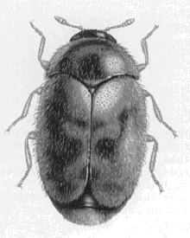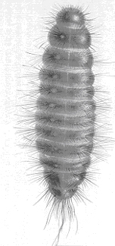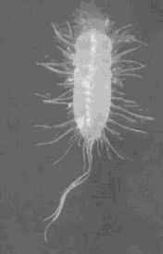  (A)  (C)  (B)  Figure 1:Trogoderma granarium:(A) adult, (B) young larva, (C) mature larva ((A), (C), ICI Plant Protection Division; (B), Cornel Adler, BBA, Germany)
[161] | 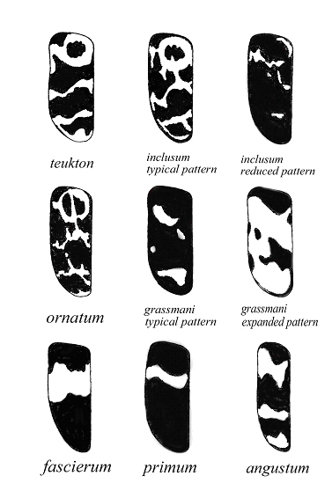  Figure 2:Trogodermaspp. elytral pattern (Beal, 1954)
[162] | 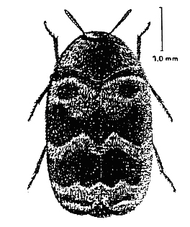  Figure 3: Adult of Trogoderma variabile (Berg, 1999b)
[163] | 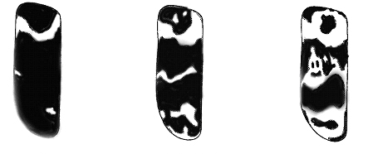  Figure 4: Elytral pattern of Trogoderma variabile (Beal, 1954)
[164] | 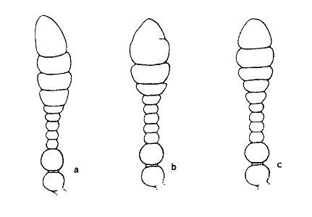
[165] | Figure 5: Antennae of Trogoderma granarium: (A) male antenna with normal number of segments; (B) female antenna with reduced number of segments; (C) female antenna with normal number of segments (Beal, 1956)
[166] | 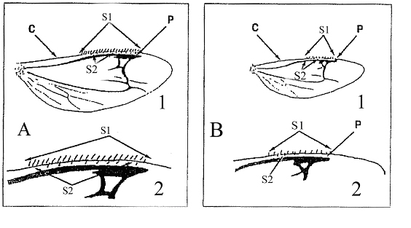  Figure 6: Morphology of hind wing: comparison of morphology of hind wing of (A) Trogoderma variabile and T. glabrum with (B) T. granarium (Matveeva, 2001)
[167] | Details: 1, general morphology of the wing; 2, enlarged anterior part of the wing; C, costal vein; P, pterostigma; S1, setae on costal vein; S2, small setae between costal vein and pterostigma.
[168] | 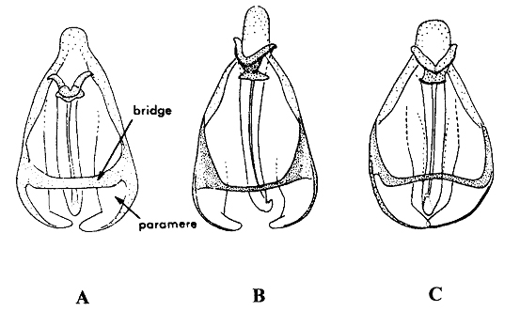  Figure 7: Male genitalia: (A) Trogoderma granarium, (B) T. inclusum, (C) T. variabile (Green, 1979)
[169] | 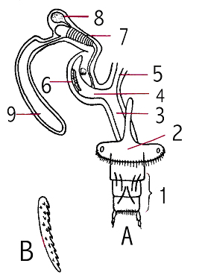  Figure 8: Female genitalia of Trogoderma granarium: (A) general view of genitalia; (B) one of the serrate sclerites from the bursa copulatrix (Varshalovich, 1963)
[170] | Details: 1, ovipositor; 2, 7th abdominal sclerite; 3, vagina; 4, bursa copulatrix; 5, oviduct; 6, two serrate sclerites on bursa copulatrix; 7, corrugated part of spermatheca; 8, spermatheca; 9, accessory glands.
[171] | 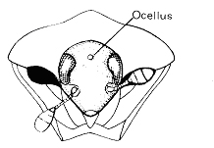  (A)  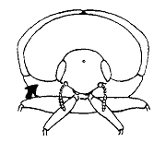  (B)
[172] | Figure 9: Antennal cavity: (A) antennal cavity clearly visible in anterior view (Anthrenus), antennae fully filling the cavity; (B) antennal cavity not visible in anterior view (Trogoderma), antennae loosely fit in the cavity ((A), Mound (1989); copyright: Natural History Museum, London, UK; (B), Kingsolver (1991))
[173] | 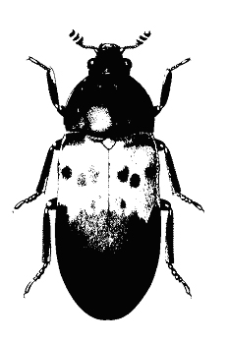  Figure 10: Adult Dermestes lardarius; copyright: Ministry of Agriculture Fisheries and Food, UK (Haines, 1991)
[174] | 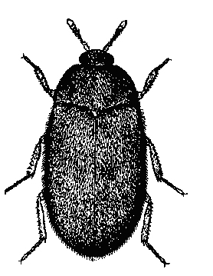  Figure 11: Adult Attagenus sp.; copyright: Natural History Museum, London, UK (Haines, 1991)
[175] | 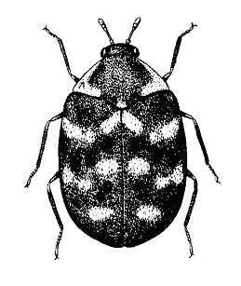  Figure 12: Adult Anthrenus verbasci; copyright: Natural History Museum, London, UK (Haines, 1991)
[176] | 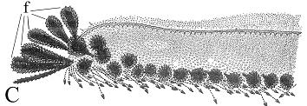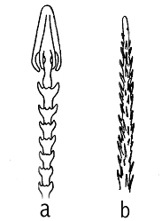  (C)  (B)  (A)  Figure 13: Larval setae: (A) hastiseta, (B) spiciseta, (C) fiscisetae (f) on first abdominal tergum of Trogoderma carteri larva ((A), (B), Varshalovich (1963); (C), Beal (1960))
[177] | 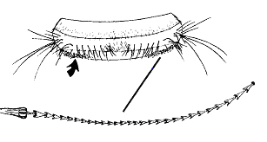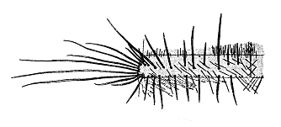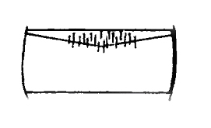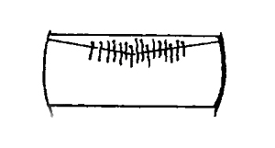  (B)  (C)  (D)  (A)  Figure 14: Abdominal tergite and setae: (A) abdominal tergite of Trogoderma variabile larva with enlarged hastiseta; (B) first abdominal tergite of T. variabile larva; (C) setae of the anterior portion of first abdominal tergite not long enough to extend caudally over the antecostal suture (T. variabile); (D) the same setae long enough to extend caudally through the antecostal suture (T. non-variabile) ((A), Kingsolver (1991); (B), Beal (1954); (C), (D), Berg (1999a))
[178] | 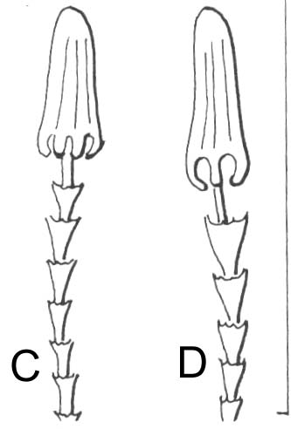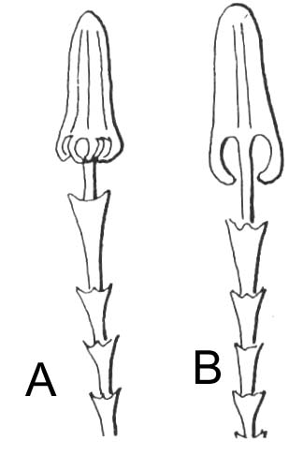  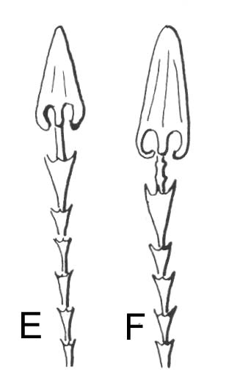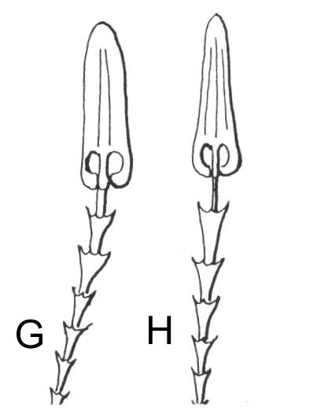  Figure 15: Comparison of hastisetae morphology of various Trogoderma species: (A), (B) T. granarium; (C), (D) T. glabrum; (E), (F) T. variabile; (G), (H) T. inclusum; copyright: Natural History Museum, London, UK (Peacock, 1993)
[179] | 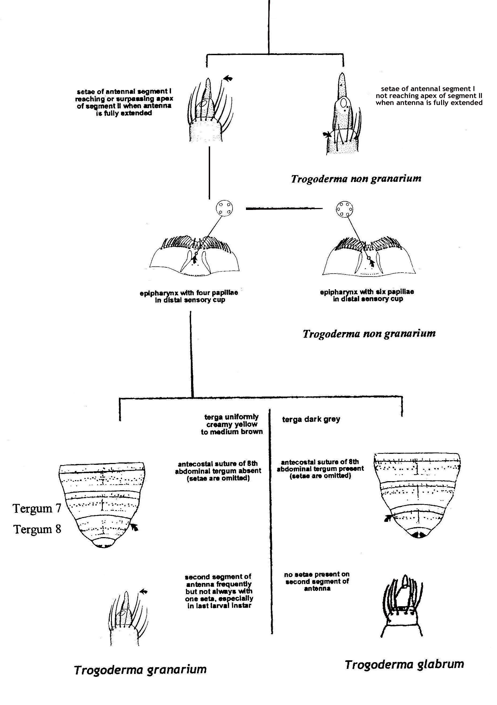  Figure 16: Pictorial key for distinguishing larvae ofTrogoderma granariumfrom otherTrogodermaspp.(Berg (1999a); Kingsolver (1991))

