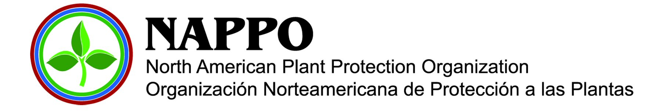

Summaries for NAPPO presentations at 24th RPPO-TC

Title: Pathway Risk Analysis: NAPPO RSPM 31 (2012)

Summary:

This standard has proven to be one of the most challenging, as it is very much uncharted territory. Before going into the details of the stages of pathway risk analysis, these guidelines provide detailed information on the use and possible objectives of a pathway risk analysis, as well as compare it to the better known pest risk (PRA) and commodity risk analyses.

Pathway risk analysis is defined as a process for evaluating the pest risk and risk management options associated with one or more pathways for the introduction or spread of pests. Pathways represent a broad continuum, from pest association with the pathway at the region of origin, through entry, establishment, and finally to spread within the region at risk. Of particular concern to risk assessors are the conditions and events that occur along these pathways which either reduce or increase pest risk.

Types of pathway risk analysis may be: single pathway, single pest; multiple pathways, single pest; single pathway, multiple pests; or multiple pathways, multiple pests. Pathway risk analyses are highly variable. Analyses are inherently unique due to differences in objectives, scope of analysis, data availability, and analytical approach. They may stop at different stages. Their scope may range from specific and narrow (e.g., an imported fruit from a particular country) to general and broad (e.g., wooden handicrafts from China – many types of articles with different pests).

Similar to PRA in ISPMs 2 and 11, a pathway risk analysis make go through up to four phases:
- Initiation phase (Stage 1) consisting of identification of the pathway and pests of concern, identification of the area of analysis, background information, scope and objectives of the analysis, conclusion of initiation;
- Pathway description (Stage 2) consisting of information gathered about the pathway(s) of concern, pathways description and characterization (origin and destinations, relevant events and conditions, limits of the analysis, assumptions, etc.) and conclusion of pathway description;
- Pathway risk assessment (Stage 3) consisting of pathway categorization, pathway mapping and modeling, pests of concern, assessment of pathway events related to the introduction and spread of pests, consequences of pest introduction and spread, pathway comparison, conclusion of the pathway risk assessment; and
- Pathway risk management (Stage 4) consisting of control points; systems approach; uncertainty in risk management; natural dispersal and impact; monitoring effectiveness and conclusion of risk management.

Title: Climate Change and Pest Risk Analysis – Discussion and Position Papers

Summary:

It is now widely accepted within the scientific community that our climate is changing at an unprecedented rate due to human activity, specifically due to anthropogenic emissions of greenhouse gases into the atmosphere. Changes in climate patterns will directly affect both human and biological systems, including the ability of pests and invasive species to establish and spread in new ecosystems. Accordingly, there is a need for governments and organizations at all levels to deal proactively with climate change, examining the ways in which it may affect their mandate and developing mitigation and adaptation measures if needed.

The NAPPO Pest Risk Analysis and Invasive Species Panels prepared a discussion document and respective decision paper to document the ways in which climate change may affect plant protection activities, and specifically to discuss the implications of climate change for pest behaviour and pest risk analysis. Examples of change in rainfall and temperature in North America are provided. Observations on the effects on entry, spread and establishment of invasive species are made. Legal aspects were also taken into account, based on decisions made at the World Trade Organization.

The general recommendation was that NAPPO take a “fit-for-purpose” approach for the inclusion of climate change scenarios and models in PRAs, with the decision made and transparently documented on a case-by-case basis. Emphasis is on evaluating what is probable, not what is possible, and the decision to implement measures for reducing risk should be based on scientific evidence that verify necessity.

Title: NAPPO 2012 report to RPPO – TC on emerging pests

Summary:

NAPPO presented information on Tuta absoluta, Huanglongbing (HLB), Boxwood blight (Cylindrocladium pseudonaviculatum), fruit pests Lobesia botrana and Drosophila suzukii, as well as an update on the topic of bee pollen issues.

There are two protocols currently out on country consultation on each of Tuta absoluta, and Huanglongbing, the former a surveillance protocol and the latter a diagnostic protocol. The NAPPO Citrus Panel is also in the process of preparing a document on area wide management of HLB. OIRSA has been invited to participate in both HLB documents.

Boxwood blight has been found in several eastern states of the US, as well as Oregon. In Canada, it has been found in British Colombia (west) and Ontario (center). It is a serious pest for the landscape industry. Response strategies include research, eradication and producer compliance agreements.

For Lobesia botrana, the European Grapevine Moth, the NAPPO Fruit Panel has prepared a draft proposal to manage the risk of introduction, with recommendations for emergency actions in case of an outbreak, trapping systems and treatments. For Drosophila suzukii, Spotted Winged Drosophila, experts have been consulted to compile information on hosts, IPM measures, postharvest measures, fruit sampling, monitoring, distribution, biology and ecology and determine the potential for spread.

Finally, with regards to bee pollen, the NAPPO Biological Control Panel has drafted a paper covering interceptions of diverted products, a summary of country regulations, the risk for pollen carrying viruses and bees carrying American foulbrood, and a discussion on treatments which in general have been found not to be efficient. There are currently jurisdictional challenges as different countries manage bees and bee products under different departments (Animal Health vs. Plant Health), so that an alternative conformation of experts is being studied.

