Doc. No. NROAG 2014-07/12
NROAG 1st meeting 01-03 July 2014 Agenda point 4.2

General information
Data for the period: 1st June 2013 – 31st May 2014

Table no. 1. General data on the IPP usage.
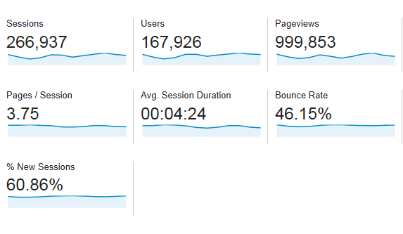

Graph no. 1. Number of sessions (between 20,000 and 40,000) per month.

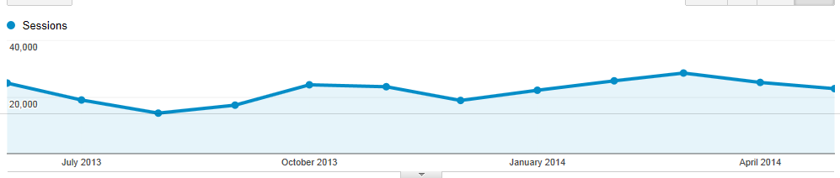
June 2013 → May 2014

Graph no. 2 and Table no.3 Percentage of new and returning visitors.
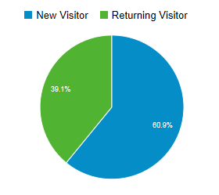
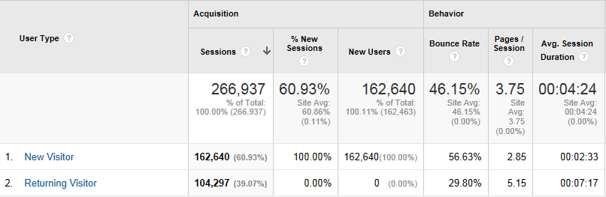

Table no. 3. Language usage (top 10)
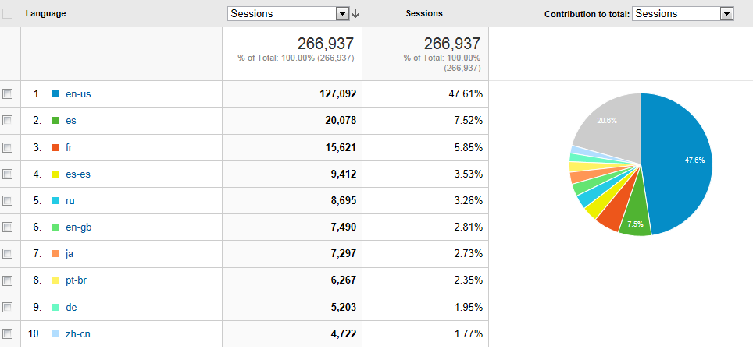
other languages (20,6 %)
*

Table no. 4. Site usage by country location (top 15) – number of sessions

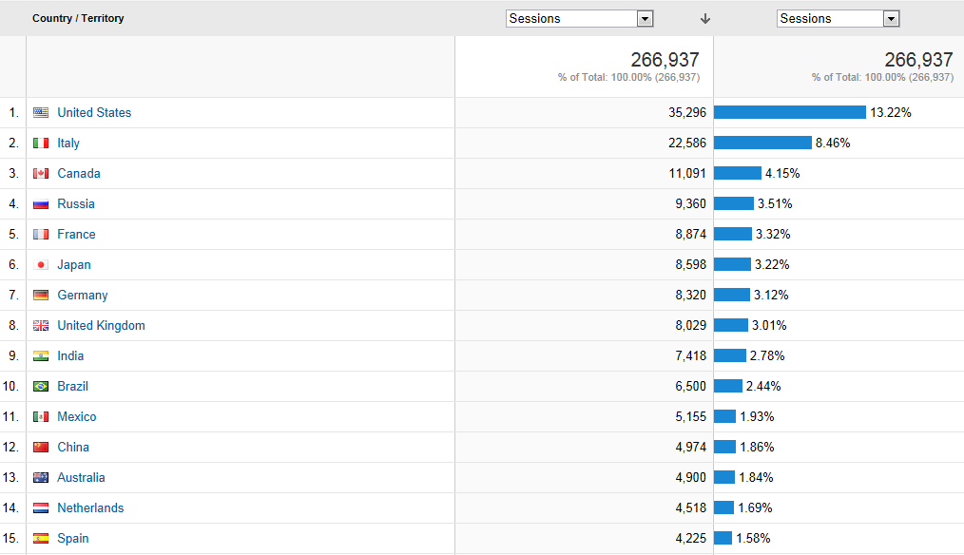

Table no. 5. Site usage by country location (top 15)
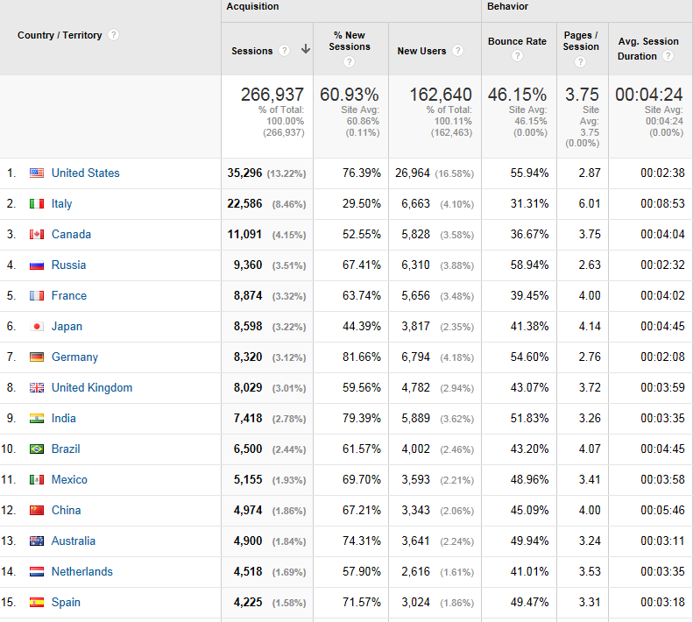

Table no. 6. Total views of IPP pages including first/main landing page (www.ipp.int ) in numbers.

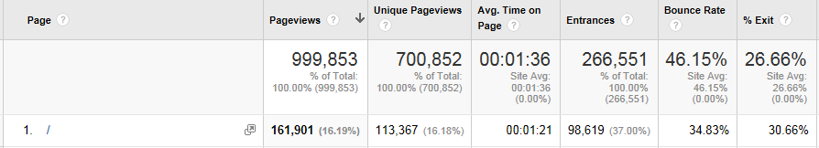

/ - first/main landing page (www.ipp.int )

Graph no. 3. When starting on the first/main landing page (www.ipp.int) users chose the following folders:
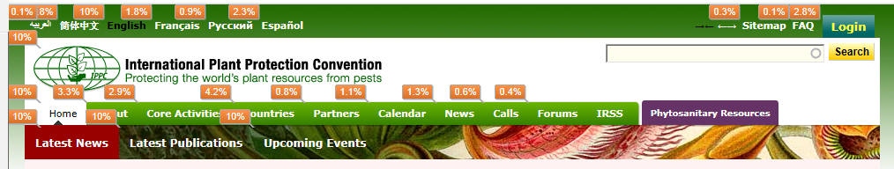

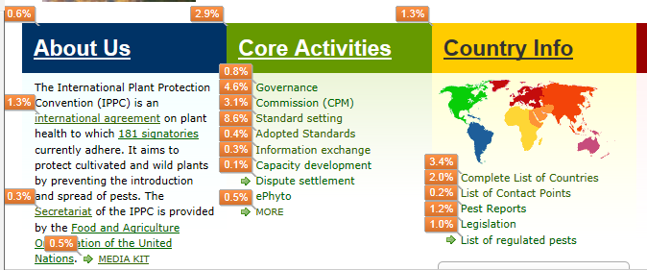
4,2% + 1,3 % Countries overview 2,8 % Login

Table no. 7. Main landing page (www.ipp.int ) in numbers:

Breakdown of pages relating to national reporting obligations (extracted from top 100 most viewed pages) [Tables No. 8-12]
Table 8 List of countries, contact points:
Number on the top 100 list of viewed pages | Pages relating to lists of countries or contact point
 | Page | Pageviews | Unique Pageviews | Avg. Time on Page | Entrances | Bounce Rate | % Exit
8 | /countries/list-countries | 9,137 | 6,180 | 00:00:46 | 505 | 41.75% | 12.67%
15 | /countries/contactpoints/ | 5,617 | 4,790 | 00:02:47 | 2,162 | 70.14% | 50.42%
41 | /countries/contactpoints | 2,079 | 1,731 | 00:02:42 | 339 | 62.90% | 38.67%
65 | /countries/nppodirectory | 1,377 | 1,311 | 00:05:38 | 1,187 | 93.19% | 88.31%
 | Total (in numbers)/average (in minutes or %) | 18,210 | 14,012 | 00:02:58 | 4,193 | 67.00% | 47.52%

Breakdown of pages relating to national reporting obligations (extracted from top 100 most viewed pages) [Tables No. 8-12]
Table 9 Countries overview page
Number on the top 100 list of viewed pages | Pages relating to countries overview
 | Page | Pageviews | Unique Pageviews | Avg. Time on Page | Entrances | Bounce Rate | % Exit
7 | /countries | 9,280 | 6,932 | 00:00:48 | 624 | 20.99% | 10.23%
11 | /nppos | 7,609 | 6,125 | 00:00:45 | 264 | 24.53% | 10.20%
30 | /countries/ | 2,442 | 1,929 | 00:00:50 | 191 | 32.98% | 10.85%
55 | /countries/regions/europe/ | 1,625 | 1,205 | 00:00:25 | 32 | 25.00% | 4.92%
56 | /countries/regions/asia/ | 1,592 | 1,125 | 00:00:25 | 18 | 22.22% | 6.09%
 | Total (in numbers)/average (in minutes or %) | 22,548 | 17,316 | 00:00:39 | 1,129 | 25.14% | 8.46%

Breakdown of pages relating to national reporting obligations (extracted from top 100 most viewed pages) [Tables No. 8-12]
Table 10 The convention text and ISPMs
 | Pages relating to standards and the Convention text
 | Page | Standards | Pageviews | Unique Pageviews | Avg. Time on Page | Entrances | Bounce Rate | % Exit
2 | /core-activities/standards-setting/ispms | List of standards | 44,006 | 25,595 | 00:01:54 | 12,836 | 40.43% | 28.96%
12 | /es/core-activities/standards-setting/ispms | List of standards | 7,595 | 4,356 | 00:02:08 | 2,084 | 55.15% | 31.98%
14 | /publications/regulation-wood-packaging-material-international-trade-0 | ISPM 15 | 7,074 | 4,855 | 00:02:45 | 1,138 | 43.53% | 49.29%
21 | /standards | List of standards | 3,880 | 2,375 | 00:02:07 | 738 | 44.16% | 26.65%
22 | /about/convention-text | Convention text | 3,820 | 2,662 | 00:01:56 | 200 | 28.92% | 24.27%
23 | /publications/glossary-phytosanitary-terms | ISPM 5 | 3,498 | 2,372 | 00:03:04 | 507 | 34.18% | 41.94%
33 | /publications/phytosanitary-certificates | ISPM 12 | 2,394 | 1,674 | 00:02:59 | 264 | 39.33% | 42.56%
38 | /countries/ispm15 | ISPM 15 | 2,140 | 1,483 | 00:02:34 | 396 | 61.15% | 35.56%
40 | /fr/core-activities/standards-setting/ispms | List of standards | 2,081 | 1,103 | 00:02:00 | 342 | 34.88% | 22.92%
44 | /publications/list-adopted-standards-july-2013 | List of standards | 1,941 | 1,238 | 00:01:23 | 48 | 14.00% | 17.36%
54 | /publications/phytosanitary-principles-protection-plants-and-application-phytosanitary-measures | ISPM 1 | 1,637 | 1,017 | 00:01:47 | 83 | 20.24% | 20.34%
75 | /search/node/ispm 15 | ISPM 15 | 1,257 | 969 | 00:00:34 | 23 | 40.91% | 10.02%
91 | /publications/phytosanitary-certification-system | ISPM 7 | 1,113 | 708 | 00:01:49 | 28 | 23.33% | 16.80%
 | Total (in numbers)/average (in minutes or %) |  | 82,436 | 50,407 | 00:02:05 | 18,687 | 36.94% | 28.36%
Breakdown of pages relating to national reporting obligations (extracted from top 100 most viewed pages) [Tables No. 8-12]
Table 11 Actions relating to technical side of reporting obligations
Number on the top 250 list of viewed pages | Pages relating to technical side of reporting obligations
 | Page | Pageviews | Unique Pageviews | Avg. Time on Page | Entrances | Bounce Rate | % Exit
68 | /core-activities/information-exchange (Info on obligations and how to edit) | 1,352 | 1,032 | 00:01:50 | 78 | 34.57% | 15.90%
234 | /publications/ippc-official-contact-point-notification-form | 446 | 298 | 00:02:11 | 41 | 23.81% | 17.94%

Breakdown of pages relating to national reporting obligations (extracted from top 100 most viewed pages) [Tables No. 8-12]

Table 12 Countries reporting obligations
Number on the top 100 list of viewed pages | Pages relating to countries reporting obligations
 | Page | Pageviews | Unique Pageviews | Avg. Time on Page | Entrances | Bounce Rate | % Exit
15 | /countries/contactpoints/ * | 5,617 | 4,790 | 00:02:47 | 2,162 | 70.14% | 50.42%
27 | /countries/regulatedpests/ * | 2,627 | 1,394 | 00:01:00 | 185 | 24.86% | 9.36%
34 | /countries/legislation/ * | 2,378 | 1,656 | 00:01:07 | 83 | 30.12% | 11.98%
39 | /countries/pestreport/ * | 2,135 | 1,498 | 00:02:02 | 346 | 58.91% | 27.45%
41 | /countries/contactpoints | 2,079 | 1,731 | 00:02:42 | 339 | 62.90% | 38.67%
71 | /publications/pest-risk-analysis-quarantine-pests | 1,334 | 880 | 00:02:15 | 123 | 34.15% | 30.43%
72 | /countries/legislation | 1,294 | 833 | 00:01:31 | 76 | 44.00% | 13.60%
74 | /countries/pestreport | 1,266 | 558 | 00:02:15 | 100 | 38.38% | 12.40%
99 | /countries/regulatedpests | 1,048 | 541 | 00:00:52 | 48 | 19.15% | 7.16%
 | Total (in numbers)/average (in minutes or %) | 19,778 | 13,881 | 00:01:50 | 3,462 | 42.51% | 22.39%
* More detailed analysis on the following pages

15 | /countries/contactpoints/
More detailed analysis of the contact points page (see pages no. 15-26)
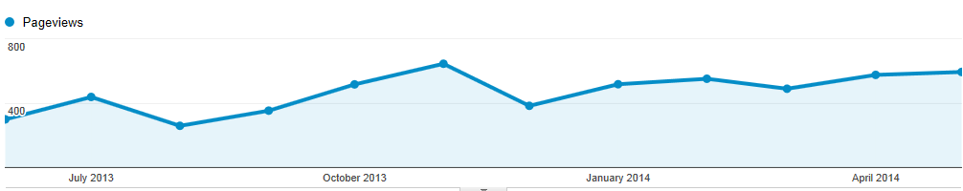

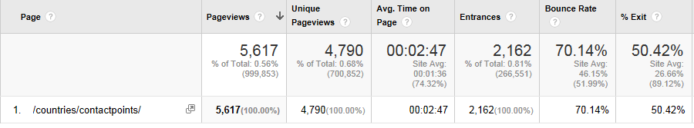

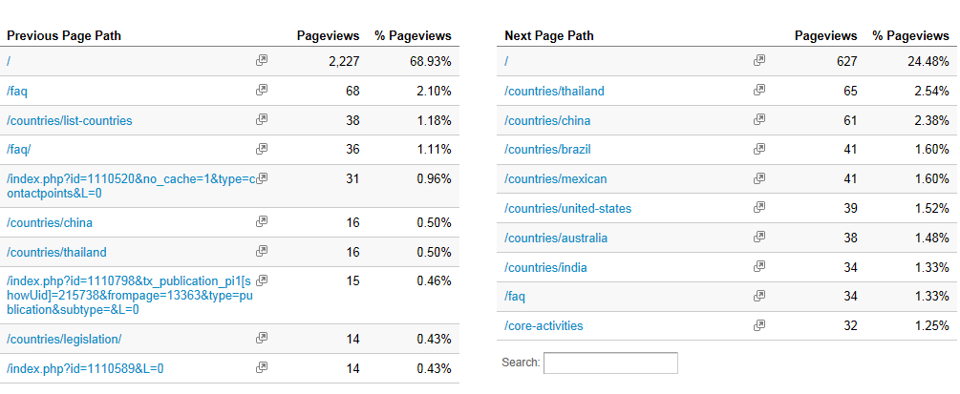

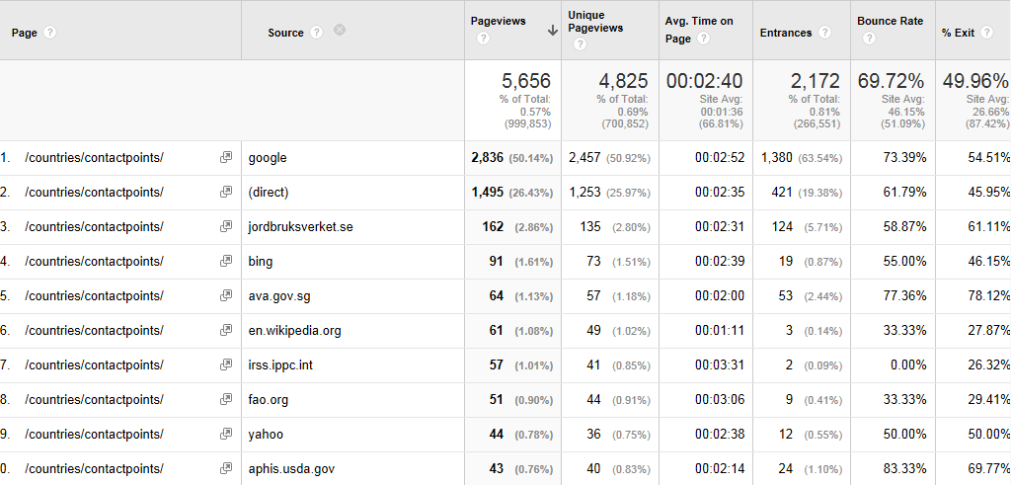

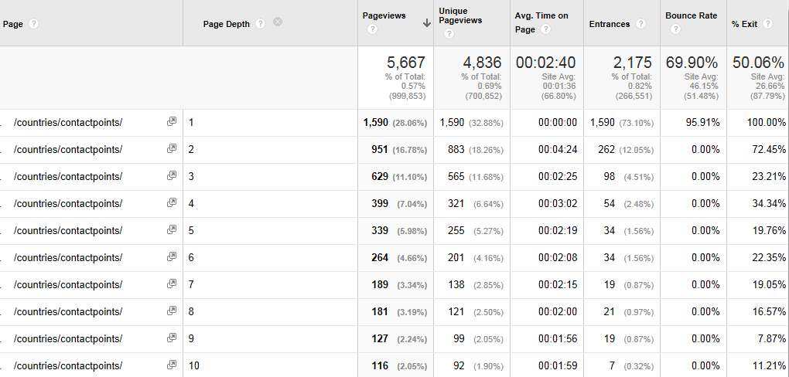

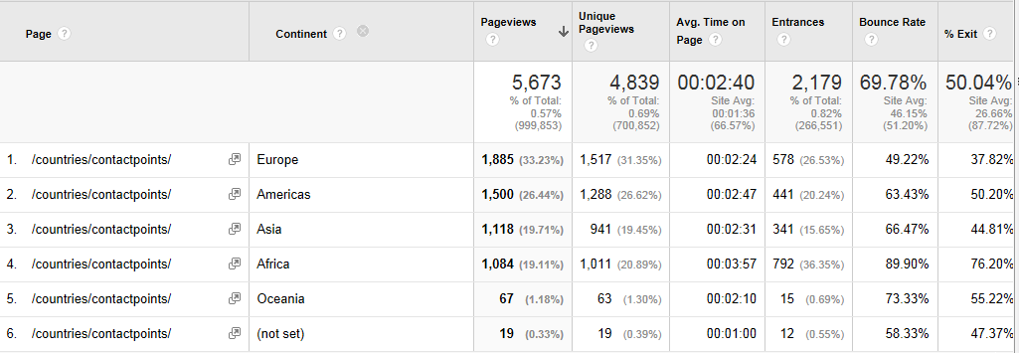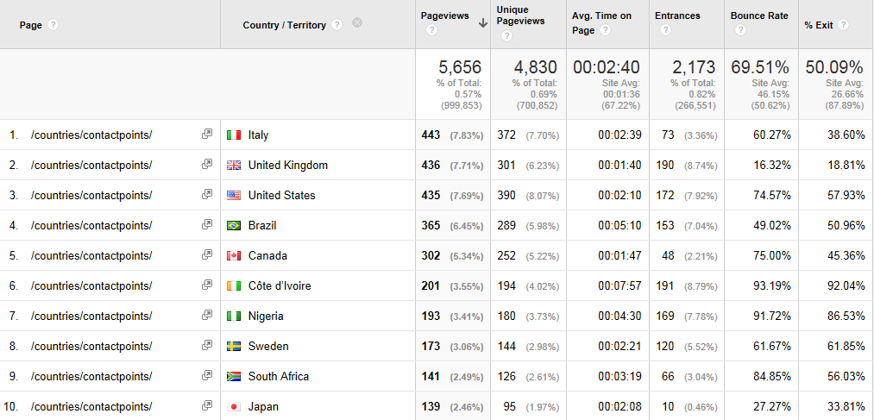
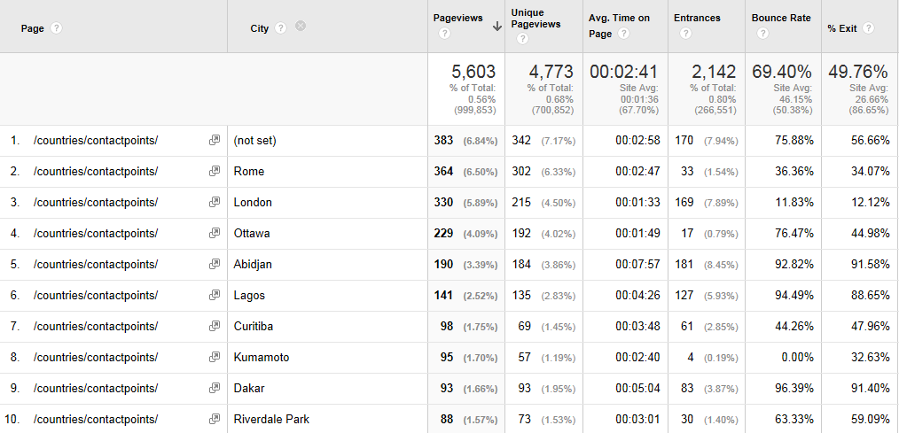

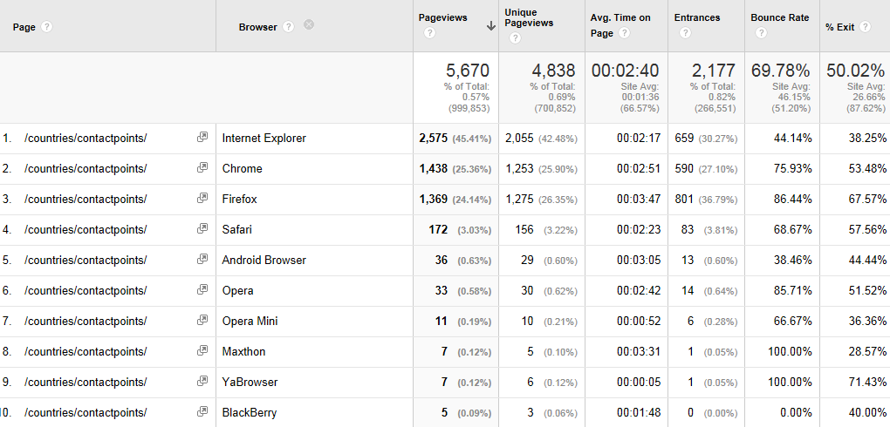
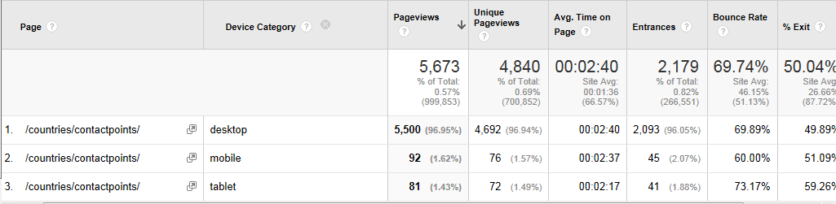
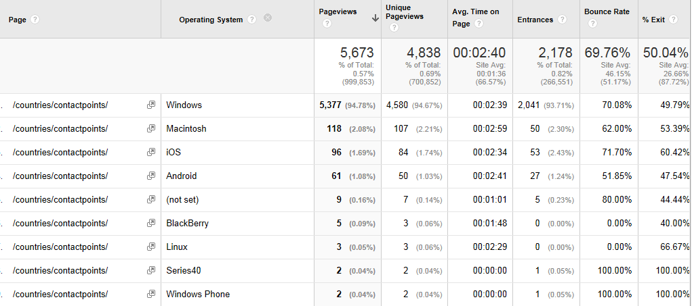
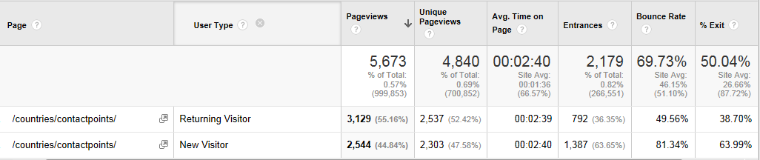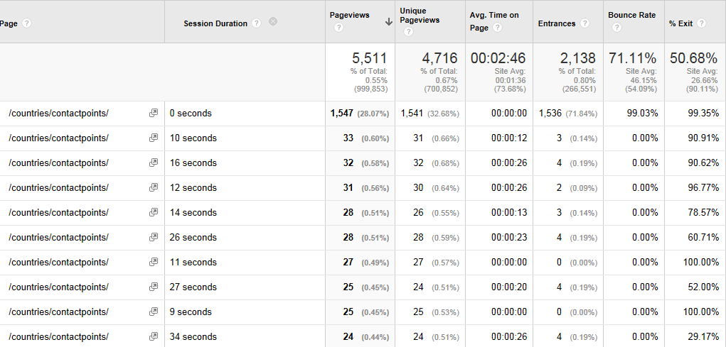

27 | /countries/regulatedpests/ *

More detailed analysis of the regulated pest page (see pages no. 27-38)

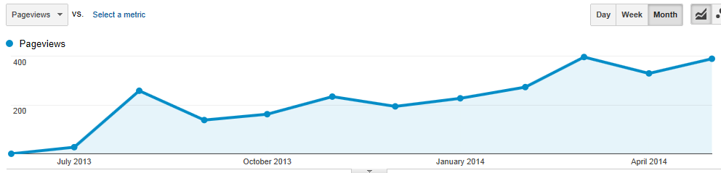
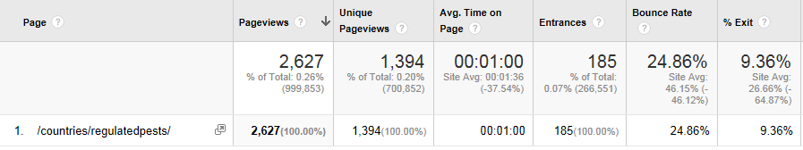
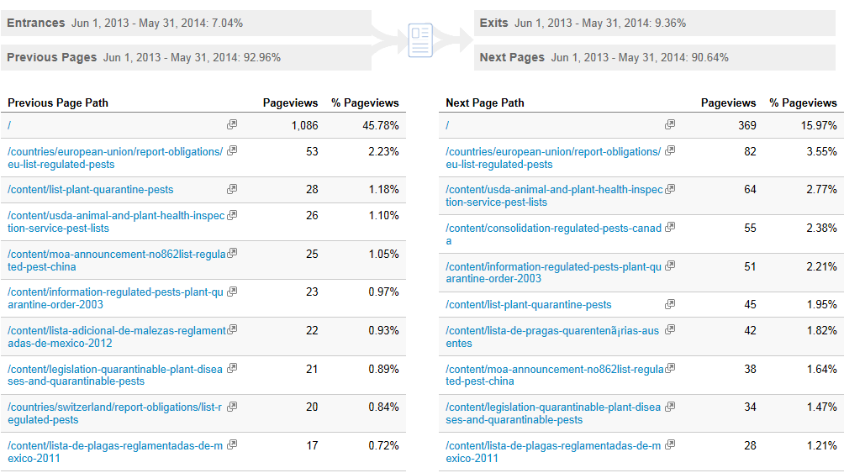

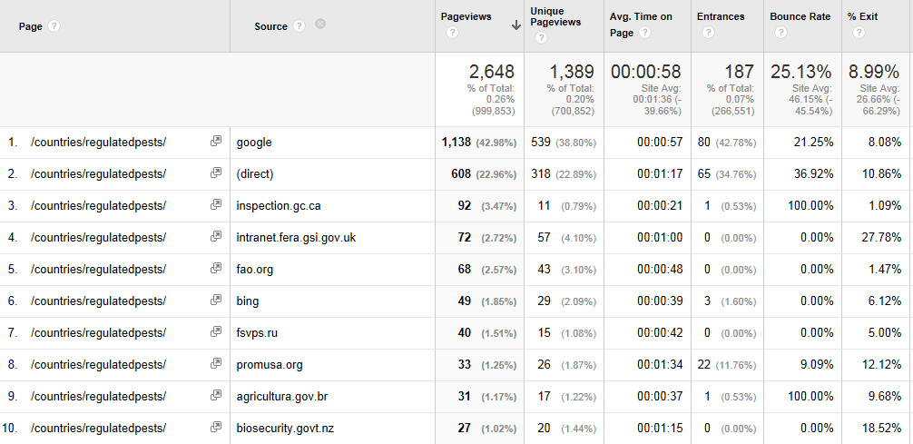
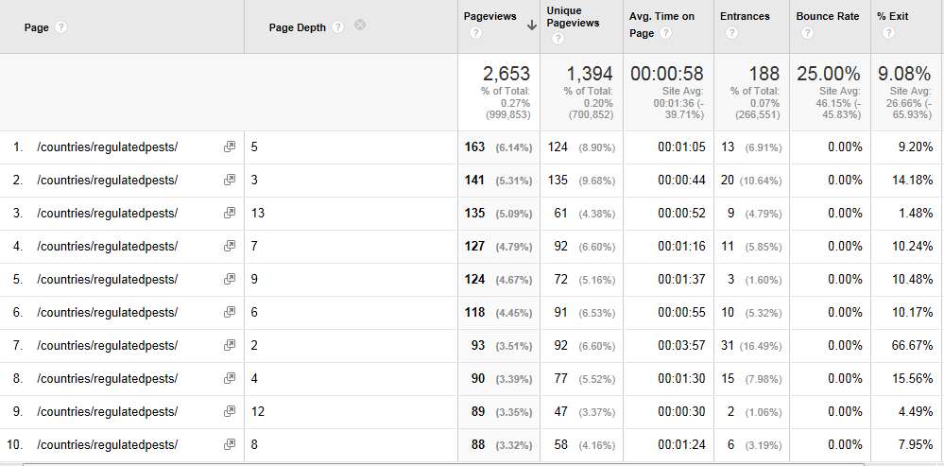

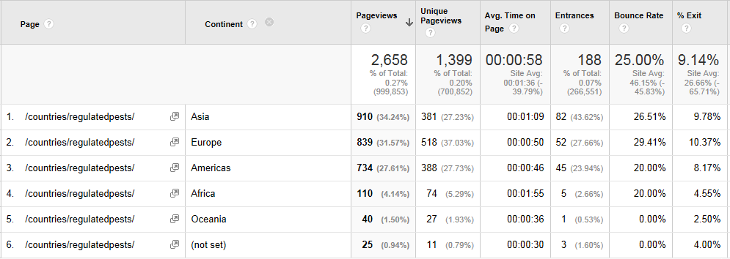
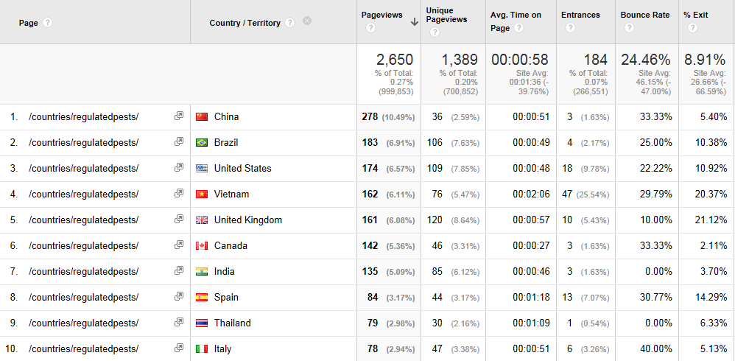
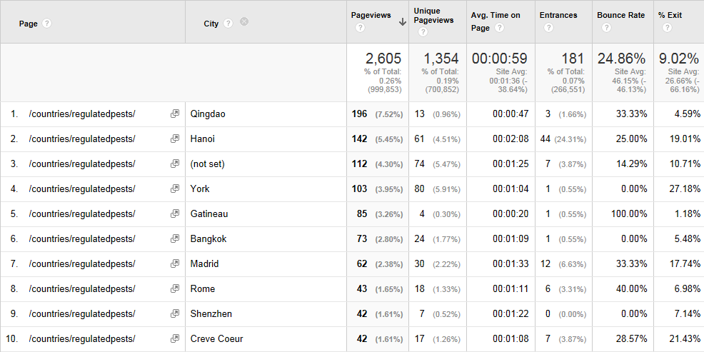
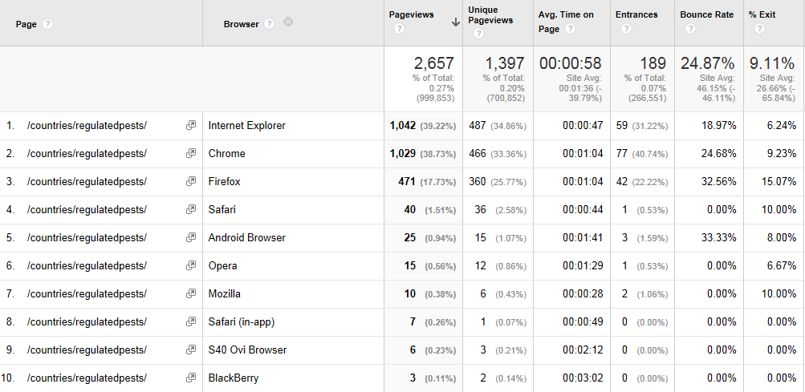
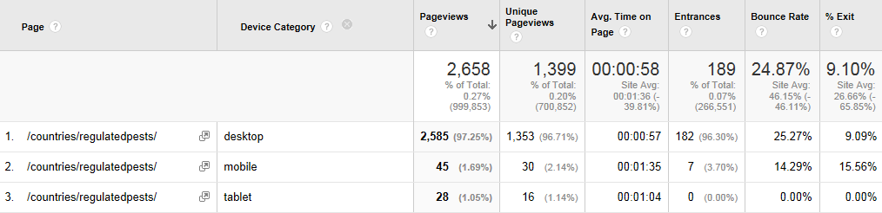

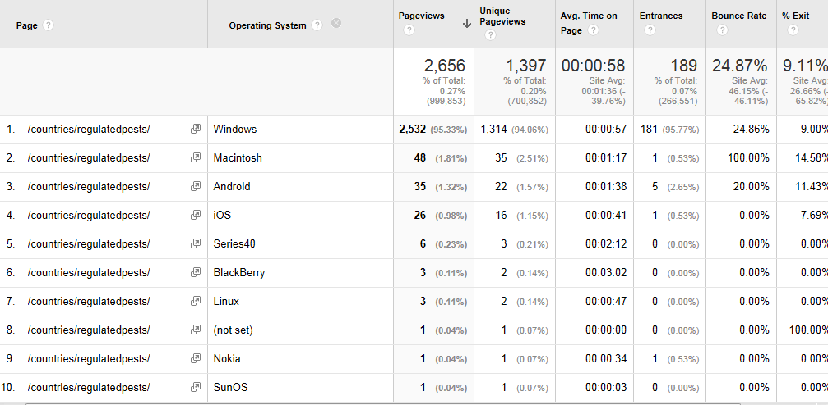
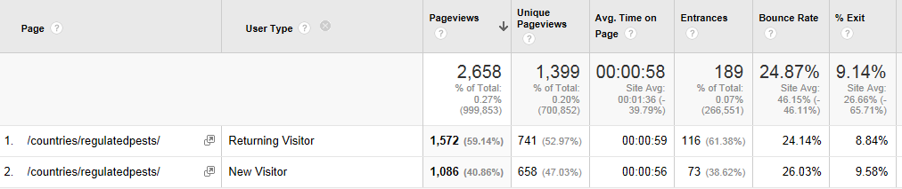
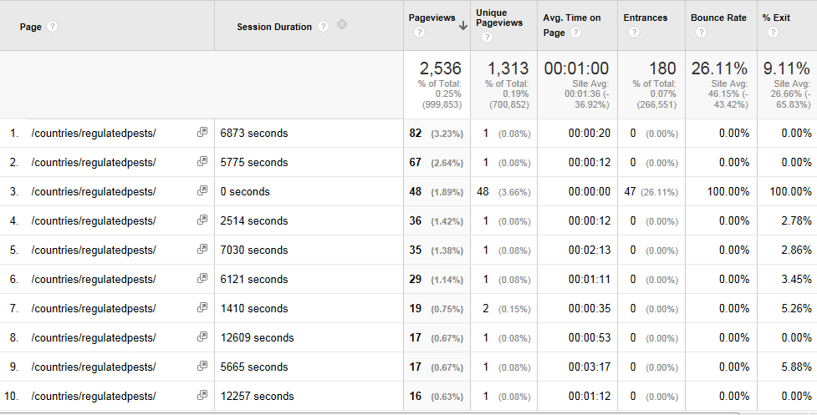

34 | /countries/legislation/ *

More detailed analysis of the legislation page (see pages no. 39-50)

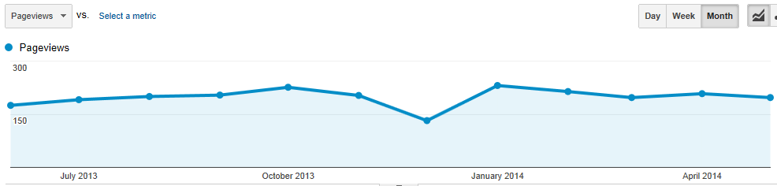

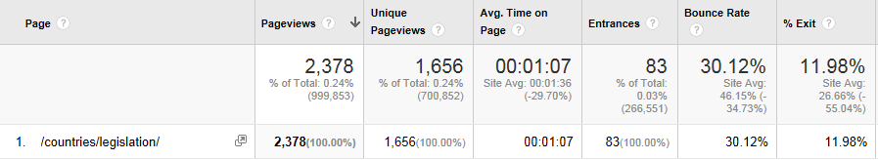

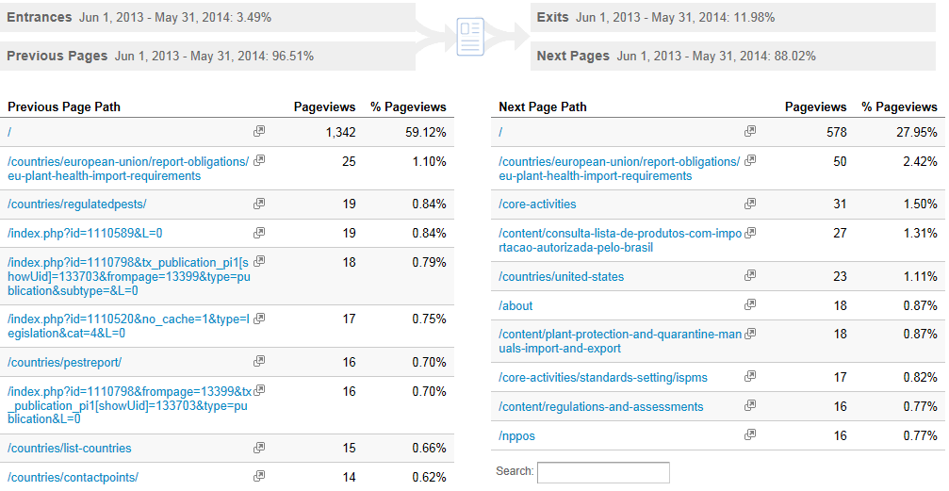
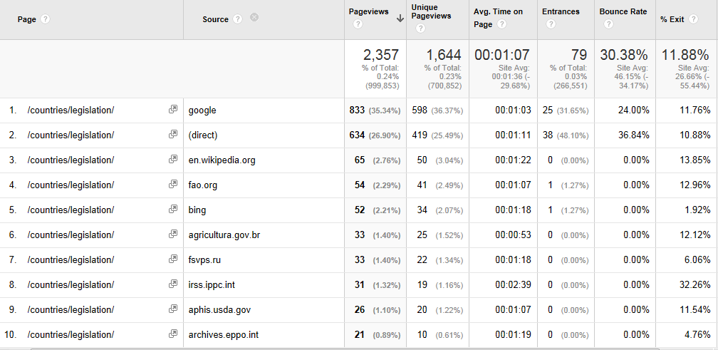

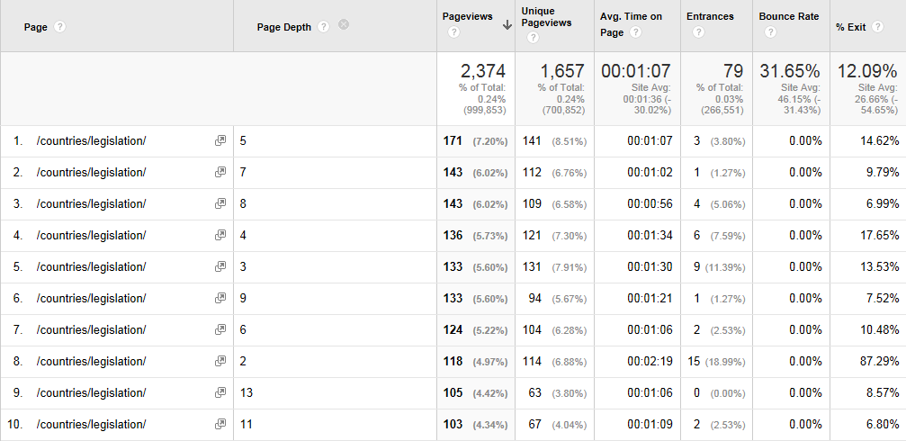

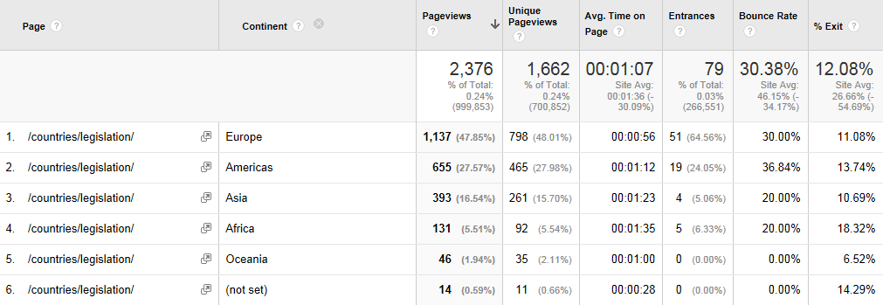

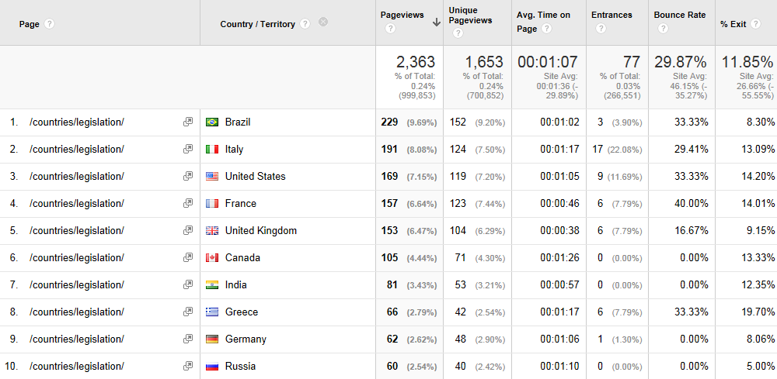

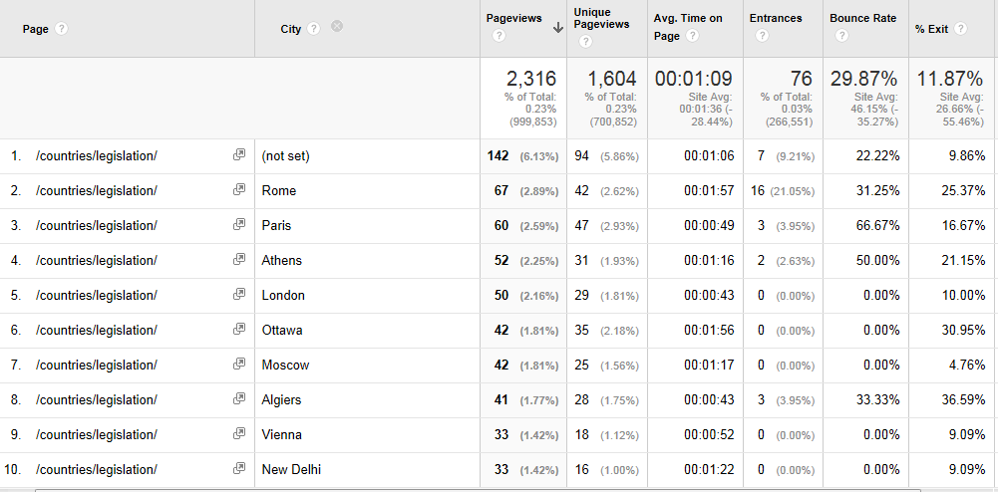

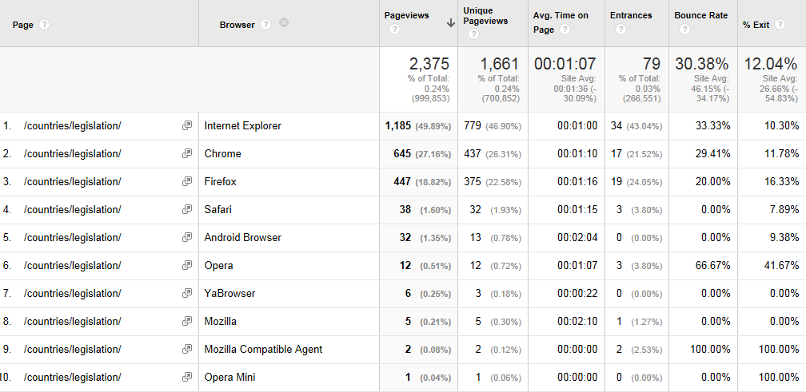

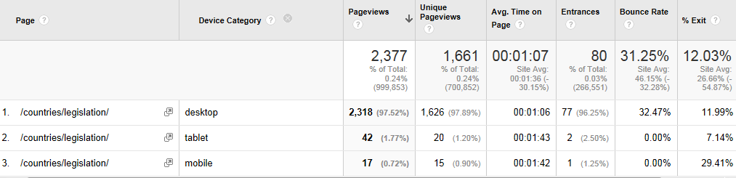

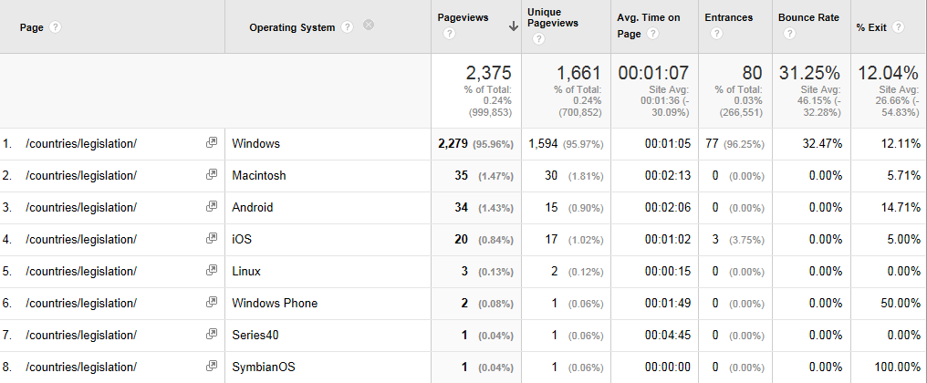

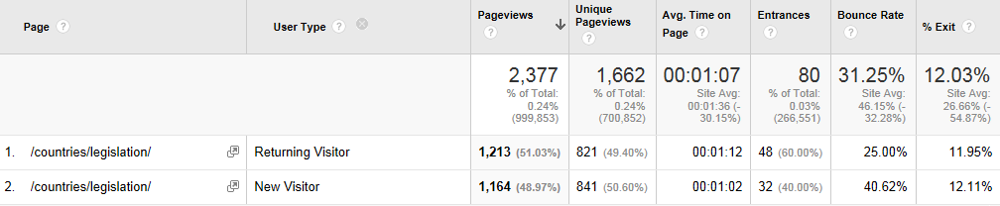

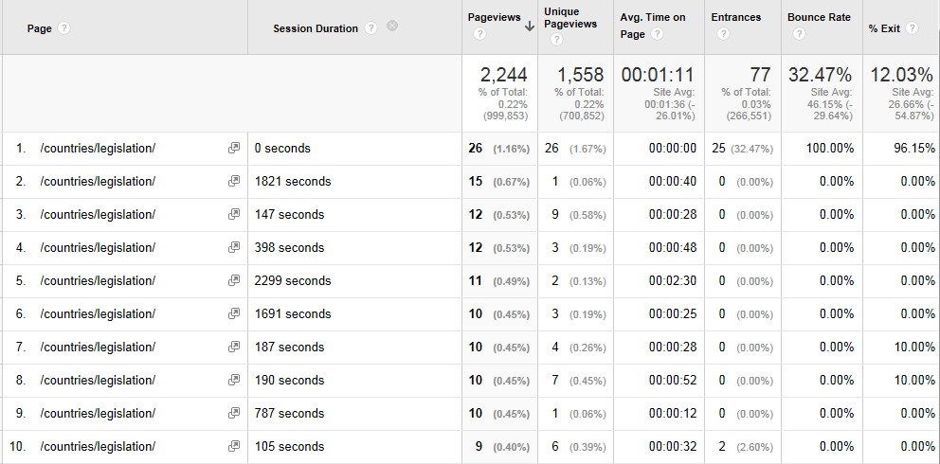

39 | /countries/pestreport/ *

More detailed analysis of the pest report page (see pages no. 51-62)

