New translation process for ispms, including diagnostic protocols

(Prepared by the IPPC Secretariat)

Background

1. At several previous meetings of the Commission on Phytosanitary Measures (CPM) the IPPC Standards Officer informed the CPM that work on Diagnostic Protocols (DPs) by the Technical Panel on Diagnostic Protocols (TPDP) was advancing and extra resources would be needed to process the increasing number of DP coming through the system. This issue was again raised at the June 2014 Bureau meeting. It is now estimated that most of the DPs on the *List of topics for IPPC standards[1]* will be adopted in the next four years (3 in 2014; 4 in 2015; 8 in 2016; 8 in 2017).
2. DPs are only translated after adoption, but contracting parties may request DPs in languages at earlier stages. It should be noted that experts selected by the IPPC Secretariat to develop DPs all use the English versions. To date, the current mechanism to request translations of DPs in languages has not yet been requested.[2] With the planned amount of DPs to be adopted, the cost for translating DPs will increase exponentially over the next four years (from 0 in 2013 to $184.000 in 2016), resulting in a huge impact on the IPPC Secretariat resources, with additional staff time needed to process these DPs.
3. The CPM Bureau expressed concern over this and requested the IPPC Secretariat to develop a paper outlining some possible options for the Bureau to consider at its October 2014 meeting.[3]
4. Additionally, contracting parties have expressed concern about the quality of the translations of standards and CPM papers and about the challenges of translations into additional languages throughout the process.
5. ISPMs (including DPs) are currently translated by the FAO Meeting Programming and Documentation Service (CPAM), which has the responsibility for translation of official FAO documents into the official languages of the Organization (Arabic, Chinese, English, French, Russian and Spanish).
6. Deadlines to translate and revise ISPMs are strictly set by the standard setting procedure adopted by CPM-7 (2012). Nevertheless, several times CPAM has been unable to meet agreed deadlines.
7. Consequently, the Secretariat has explored new ways of dealing with the translation needs by considering different translations management options. This paper outlines factors to be considered with regard to ISPMs translation, highlighting the need for additional resources to comply with the current standard setting work programme and providing different options to modify the current translations workflow.
8. Factors to consider
9. A number of factors, in some cases interrelated, should be taken into account when considering future options for translating ISPMs:
10. Increasing quantity of translations: as per the current work programme, a large number of DPs will be processed over the next four years, resulting in an increasing amount of words to be translated, which will require extra efforts from CPAM and a higher budget for the IPPC Secretariat.
11. Increase of stages of translations and revisions: currently, English Specifications are translated into French and Spanish for member consultation; their translations into French and Spanish are revised when they are approved by the SC. ISPMs and Phytosanitary Treatments (PTs) going for member consultation are translated into French and Spanish, while when submitted to CPM for adoption, they are also translated into Arabic, Chinese and Russian, and their French and Spanish translations are revised. DPs are translated into five languages after adoption, although IPPC members may request translating them also for member consultation. To increase the inclusiveness of all IPPC members throughout the standard setting process, translation into five languages could be done for member consultation and for the substantial concerns commenting period (SCCP).
12. Concerns over quality of translations: concerns have been raised by IPPC contracting parties over the quality of translations[4]. Currently, a language review group process allows Contracting parties to be able to make adjustments to translations of standards, but this is done only after adoption and the original standards are posted on the IPP in the meantime (the LRG process takes one year, so members are forced to use ISPMs with language they do not totally agree with).
13. Concerns over deadlines: the deadlines for submitting the finalized translations to the IPPC Secretariat are negotiated between CPAM and the IPPC Secretariat, but these deadlines are also managed internally within CPAM, resulting in different deadlines that the IPPC did not necessarily agreed to. The Secretariat spends inappropriately amounts of time in following up and soliciting the translations, thus it will normally request briefer deadlines than needed, although this increases costs. CPAM has conflicting deadlines and is not always able to give ISPMs priority.
14. Budget issues: the current budget allocation for translation of ISPMs may not suffice in view of the increasing quantity of DPs foreseen, or in the case where ISPMs are translated into more languages at more stages. Additionally, in 2014 CPAM has requested to charge the Language Review Groups process, which was initially agreed to be done at no cost.
15. Options for stages and management of translations
16. Draft ISPMs (including PTs) under member consultation[5] are processed in English, French and Spanish. In addition, during the substantial concerns commenting period (SCCP), draft ISPMs are only presented in English, as they are SC documents. ISPMs (including PTs) are only translated from English into the other five FAO languages when submitted to CPM for adoption[6], while DPs are translated into five languages after adoption. Nevertheless, in view of a broader inclusiveness of the standard setting process, an effort may be done in increasing translation of ISPMs under consultations into languages.
17. In order to address the needs for a new workflow and the increasing volume of DPs, the IPPC Secretariat has engaged in a series of consultations with international organizations, RPPOs and communities of professional translators, and it has collected and scrutinized around 150 curricula.

Outsourcing entails additional Secretariat resources to manage the process, and a sustainable, long-term financial plan.

**Table 1 – Options for management of translations**

|  |  |  |
| --- | --- | --- |
| **Options** | **Pros** | **Cons** |
| **1. Keeping the current translation system, within FAO** | - Several translators available to ensure translations be done at all times of the year.  - Senior reviser ensures quality of translations according to FAO standards.  - Translators are trained by CPAM  - CPAM has all the translation software they need. | - Issues of quality persist.  - Issues with deadlines persist or increase with the growing amount of DPs.  - Increasing costs.  - Consultation among Head Translators, to ensure consistency across languages, in not ensured. |
| **2. Supporting FAO translations with IPPC-contracted language Reviewers** | - Possible solution of issues related to deadlines and quality.  - Minor HR processing and training for new translators (to work with CPAM).  - No additional software license needed. | - Additional costs for CPAM, Reviewers and Secretariat resources.  - CPAM will need to enter into dialogue with the reviewers and this may not be well received or feasible, considering there will be additional work for CPAM. |
| **3. Outsourcing all ISPM translations (to contracting parties or other providers, for languages where problems were identified or only for DPs)** | - Possible solution of issues related to deadlines and quality.  - Consultation among Head Translators would be done to ensure consistency across languages. | - Identifying the right translators will require time and resources  - Having only one translator to depend on may create problems of unavailability.  - Higher costs (lower for the individual translator but higher because the Secretariat would need additional man hours)  - Learning process may be long and expensive.  - Additional software license may be needed  - Direct translations by countries may result in controversies over interpretation of terms and concepts. |

Below are figures summarizing costs in USD with the different workflow options in an average year (within FAO, with additional hiring of reviewers – one per language, and in case of outsourcing).[7]

Figure 1 – Costs within FAO (average: 0.574 USD per word rate)[8]

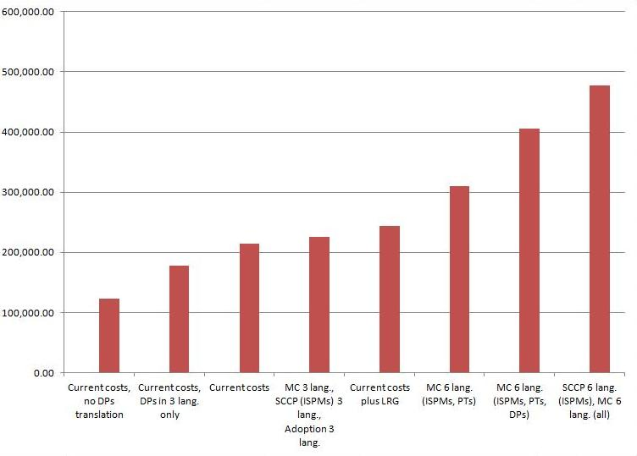

Figure 2 – Costs within FAO plus Reviewers (average: 0.574 USD per word rate)

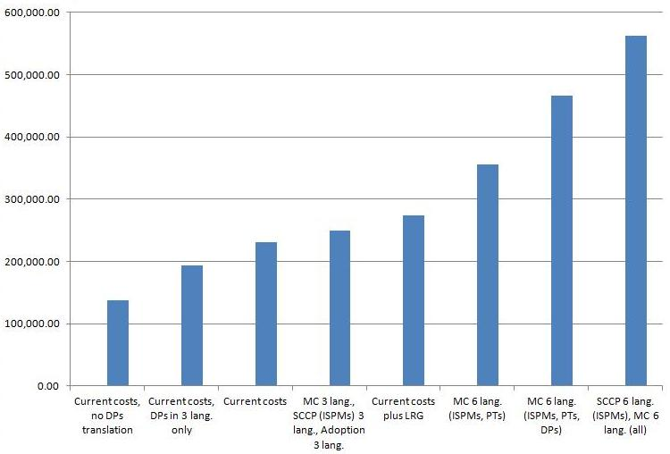

Figure 3 – Costs in case of outsourcing (average: 0.4 USD per word rate)

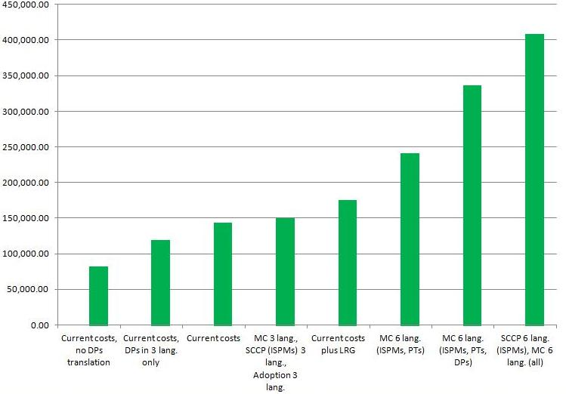

1. The Bureau is invited to:

* *discuss* the issues raised in this document, with a focus on the options for translations stages and on the management of translations;
* *endorse* one of the options identified for the different issues for CPM-10 (2015) and *consider* to identify additional resources to support the decision in the long term.

Annex 1 – Average translation costs (USD) per standard setting document with FAO and current workflow*

|  |  |  |  |  |  |
| --- | --- | --- | --- | --- | --- |
| **Item** | **Stage** | **Languages** | **Word rate**  **(USD)** | **# of words** | **~ Cost**  **(USD)** |
| 1 spec translation | To MC | 2 (Es, Fr) | 0.574 | $ 1 000 | $ 1 150 |
| 1 spec revision | For approval | 2 (Es, Fr) | 0.278 | $ 1 000 | $ 550 |
| **Cost to translate 1 specification** | | | | | $ **1 700** |
| 1 ISPM translation | To MC | 2 (Es, Fr) | 0.574 | $ 4 000 | $ 8 230 |
| 1 ISPM translation | To CPM  for adoption | 3 (Ar, Ru, Zh) | 0.574 | $ 4 000 | $ 6 900 |
| 1 ISPM revision | 2 (Es, Fr) | 0.278 | $ 4 000 | $ 2 220 |
| **Cost to translate 1 ISPM** | | | | | $ **17 350** |
| 1 PT translation | To MC | 2 (Es, Fr) | 0.574 | $ 500 | $ 575 |
| 1 PT translation | To CPM  for adoption | 3 (Ar, Ru, Zh) | 0.574 | $ 500 | $ 860 |
| 1 PT revision | 2 (Es, Fr) | 0.278 | $ 500 | $ 280 |
| **Cost to translate 1 PT** | | | | | $ **1 715** |
| 1 DP translation | To CPM / adoption | 5 (Ar, Es, Fr, Ru, Zh) | 0.574 | $ 8 000 | $ 23 000 |
| **Cost to translate 1 DP** | | | | | $ **23 000** |

* 0.574 USD per word rate for translations, and 0.278 USD per word rate for revisions.

Annex 2 – Average translations costs (USD, average year) within FAO, by document and with new costs**

|  |  |  |  |  |  |  |
| --- | --- | --- | --- | --- | --- | --- |
| **#** | **Average cost** | **Document type / stage** | **Current process** | | **New options** | |
| **Es, Fr** | **Ar, Ru, Zh** | **Es, Fr, Zh** | **Es, Fr, Ar, Ru, Zh** |
| 5 | 2300 | ISPMs for MC | $ 23 000 | / | / | $ 57 500 |
| 5 | 1150/2300 | ISPMs for SCCP | $ 11 500 | / | / | $ 28 750 |
| 5 | 1150/2300 | ISPMS for adoption | $ 46 000 | | / | $ 28 750 |
| 5 | 370 | ISPMs for LRG | / | / | $ 1 850 | / |
| **SUBTOTAL (ISPMs, Year X)** | | | **$ 80 500** | | **$ 116 850** | |
| 6 | 1150 | PTs for MC | $ 3 600 | / | / | $ 9 000 |
| 6 | 150 | PTs for adoption | $ 7 200 | | / | $ 4 500 |
| 5 | 50 | PTs for LRG | / | / | $ 250 | / |
| **SUBTOTAL (PTs, Year X)** | | | **$ 10 800** | | **$** **13 750** | |
| 4 | 4600 | DPs for MC | $ 36 800 | / | / | $ 92 000 |
| 4 | 2300/4600 | DPs for adoption | $ 92 000 | | / | $ 46 000 |
| 3 | 750 | DPs for LRG | / | / | $ 2 250 | / |
| **SUBTOTAL (DPs, Year X)** | | | **$** **92 000** | | **$ 140 250** | |
| 4 | 1150 | Specs for MC | $ 4 600 | / | / | / |
| 4 | 550 | Specs approved | $ 2 200 | / | / | / |
| **SUBTOTAL (Specs, Year X)** | | | **$ 6 800** | | **0** | |
| **Secretariat costs (processing translations)** | | | **$** **25 000** | | **$ 26 000 to $ 55 000** | |
| **TOTAL (Current process)** | | | **$ 215 100** | | **/** | |
| **TOTAL (New options)** | | | **/** | | **$ 244 450 to $ 477 800** | |

** Entries in black are fixed costs as per current process; red entries are new costs. For MC, SCCP and adoption: costs are alternative (either in 3 or in 6 languages).

1. *List of topics for IPPC standards* available at <https://www.ippc.int/core-activities/standards-setting/list-topics-ippc-standards>
2. The current mechanism to translate DPs can be found at <https://www.ippc.int/core-activities/standards-setting/member-consultation-draft-ispms/mechanism-translate-diagnostic-protocols-languages>
3. See 2014 June CPM Bureau Report: <https://www.ippc.int/core-activities/governance/bureau>
4. Concerns about the quality of the translations into Russian have been voiced a number of times in meetings between the Language review groups and FAO and in TPG meetings. Also, at CPM-9 (2014) “a representative of GRULAC made a statement on behalf of GRULAC raising concerns over the quality of the Spanish translation of CPM and CPM-related documents. The representative of the Near East region shared the same concerns about translation into Arabic. The delegate from China also raised concerns about the Chinese translations.”
5. CPM-5 (2010) (Paragraph 85 of the Report) noted that the member consultation period for draft ISPMs is the key comment period.
6. Note CPM and SC rules on languages:

   -CPM-8 (2013) (Rule XII of the Rules of Procedure): Pursuant to Rule XLVII of the General Rules of the Organization, the languages of the Commission and its subsidiary bodies shall be the languages of the Organization.

   -SC Rules of Procedure, Rule 9: The business of the SC shall be conducted in the languages of the organization.
7. Starting from 2014, CPAM will start charging the IPPC Secretariat for revisions under the LRG process. The chart includes additional costs to hold member consultations in 6 languages (including or excluding DPs), and to hold the substantial concerns commenting period in 6 languages. Translating for MC and SCCP into 5 languages will also lead to additional costs for translating comments into languages.
8. Refer to Annex 1 and 2 for further details.