ISPM 15 Implementation in Australia
ISPM 15 specifies that the National Plant Protection Organisation (NPPO) of the exporting country is responsible for ensuring procedures and systems are in place prior to export to verify that the requirements set out in the standard have been met.
The Australian Wood Packaging Certification Scheme (AWPCS) is a certification scheme developed by the Department of Agriculture to enable Australian treatment providers and/or wood packaging manufacturers to produce wood packaging material that meets the requirements of ISPM 15.
Under this scheme, certified wood packaging manufacturers and/or treatment providers who meet the requirements of ISPM 15 are authorised by the Department of Agriculture to apply an internationally recognised mark to wood packaging material.
All applications by wood packaging manufacturers or treatment providers to use the ISPM 15 certification mark under the AWPCS have to be made to an accredited certification body. Certification bodies assess the suitability of manufacturers and treatment providers to apply the ISPM 15 mark.
The flowchart below shows an overview of the AWPCS:

The Australian Government Department of Agriculture
Role: The Australian Government Department of Agriculture (DA) is the National Plant Protection Organisation of Australia, and has overarching responsibility for the AWPCS.
The AWPCS came into effect in 2004. The Department of Agriculture has responsibility for regularly reviewing and updating the AWPCS with requirements of ISPM 15.
The Department of Agriculture (the department) is the lead national government agency in Australia dealing with Agriculture Policy. The department leads the development of policy advice and provide services to improve the productivity, competitiveness and sustainability of agriculture, fisheries, forestry and related industries. The department assists people and goods moving in and out of Australia while managing the risks to the environment and animal, plant and human health.
The department has two planned outcomes for 2013-14:
- Outcome 1: More sustainable, productive, internationally competitive and profitable Australian agricultural, food and fibre industries through policies and initiatives that promote better resource management practices, innovation, self-reliance and improved access to international markets.
- Outcome 2: Safeguard Australia’s animal and plant health status to maintain overseas markets and protect the economy and environment from the impact of exotic pests and diseases, through risk assessment, inspection and certification, and the implementation of emergency response arrangements for Australian agricultural, food and fibre industries.
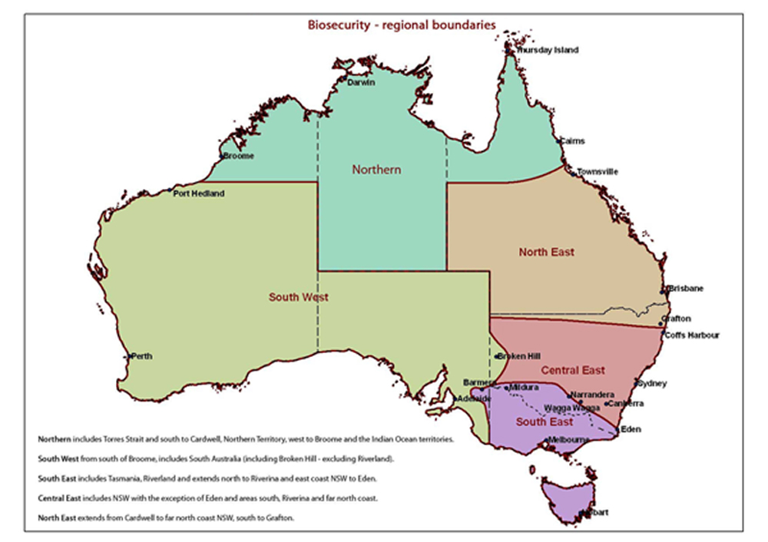
The Department of Agriculture has primary responsibility for managing Australia's biosecurity system. Australia needs a robust biosecurity system because pests and diseases have the potential to cause significant harm to people, animals, plants and other aspects of our unique environment and economy.
The Department of Agriculture has staff located in all capital cities and major regional centres, that are important for market access and trade, across five operational regions that coordinate Australian export and import inspection and certification functions.

Main functions: Department of Agriculture (DA)
DA issues unique certification numbers for use by approved treatment providers and/or manufacturers. In addition to this, other main functions include:
- Responding to technical inquiries
- Maintaining the department website
- Maintaining the AWPCS register that contains publically available details of treatment providers and manufacturers
- Regularly reviewing the AWPCS, and providing updates detailing requirements of ISPM 15
- Interaction with the third party accreditation body, JAS-ANZ, to monitor the implementation and effectiveness of the AWPCS
- Liaison with international government agencies
- Investigating non-compliance, including notifications issued by overseas countries

The Joint Accreditation System of Australia and New Zealand
Role: The Joint Accreditation System of Australia and New Zealand
(JAS-ANZ) accredits third party certification bodies under the AWPCS. They are the organisation approved by DA to accredit certification bodies to audit and certify facilities suitable for ISPM 15 manufacture and treatment of wood packaging material.
JAS-ANZ is the government-appointed accreditation body for Australia and New Zealand and is responsible for providing accreditation of certification bodies in the fields of certification and inspection. Accreditation by JAS-ANZ demonstrates the competence and independence of these certification bodies.
JAS-ANZ was established in 1991 by the Australian and New Zealand governments to strengthen the trading relationship between the two countries and with other countries. The Agreement between Australia and New Zealand establishing the Governing Board, Technical Advisory Council and Accreditation Review Board of the Joint Accreditation System of Australia and New Zealand (the
JAS-ANZ Treaty) requires JAS-ANZ to operate a joint accreditation system and to deliver on four goals relating to Integrity and Confidence, Trade Support, Linkages, and International Acceptance.
JAS-ANZ is a not for profit, self funding international organisation. It is non-discriminatory, in that it will accept applications from conformity assessment bodies operating anywhere in the world. Accreditation programmes are accessible to all conformity assessment bodies, irrespective of size, location or affiliations, whose operations include activities for which accreditation programmes are currently available.
JAS-ANZ accredits 125 “Conformity Assessment Bodies ” (CAB’s) , such as the certification bodies for the AWPCS, who in turn certify some 100,000 organisations. Including accreditations and technical assistance projects, JAS-ANZ provides services in over 20 countries.
If accreditation is approved a Certificate of Accreditation is issued. Once an applicant is accredited regular visits are made to the CAB's offices to assess the CAB's ongoing compliance with the accreditation criteria. JAS-ANZ also selects a sample of CAB auditors and inspectors for witnessing activities. A complete reassessment takes place every four years.
JAS-ANZ is a signatory to a number of bilateral, regional and international agreements. These agreements provide international recognition and acceptance of JAS-ANZ accredited certificates and inspection reports.

Main functions: JAS-ANZ
JAS-ANZ performs the following main functions:
- Accrediting certification bodies to provide certification services under the AWPCS
- Performing on-going monitoring of certification bodies (full re-evaluation every 4 years plus other regular assessments)
- Maintaining consistency of AWPCS certification body audits throughout Australia
- Notifying DA of any changes to accreditation status of certification bodies

AWPCS Certification Bodies
Role: A certification body is a company or organisation accredited by the accreditation body (JAS-ANZ) to assess the suitability of a treatment provider or wood packaging manufacturer for certification under the AWPCS.
All applications for certification under the AWPCS shall be made to an accredited certification body. The certification body then assesses the applications and undertakes onsite audits.
The cost of obtaining and maintaining certification under the AWPCS is determined by the certification body. It is the applicant's responsibility to contact the certification body of their choice to confirm all arrangements, including the costs.
A company's certification under the AWPCS remains valid as long as ongoing compliance with the conditions of certification is demonstrated.
There are currently eight certification bodies across Australia:
- AsureQuality - AsureQuality provides food safety and biosecurity services to the food and primary production sectors worldwide http://www.asurequality.com/
- AUS-QUAL -AUS-QUAL in general operates in the wider Australian, New Zealand and PNG agricultural, horticultural and secondary processing sectors providing conformity assessment services for Quality Management Systems (ISO9001:2008) in Management Systems and Product Certification Systems for; British Retail Consortium (BRC), Safe Quality Foods (SQF), GlobalG.A.P. and Australian Wood Packaging Certification Scheme (AWPCS). http://www.ausqual.com.au/
- BSI (formerly NCSI) - BSI offers services including certification, assessment, training, standards and compliance software solutions in Australia and globally. http://www.bsigroup.com/en-AU/
- EWPAA - Engineered Wood Products Association of Australasia. http://www.ewp.asn.au/
- Global-Mark - Global-Mark is one of the conformity assessment bodies (CABs) in Australia, accredited by JAS-ANZ. With over 2,000 clients internationally, Global-Mark has been providing certification to our clients' management systems and product conformance since 2004, whilst also providing accreditation for the Housing industry since 2009. http://www.global-mark.com.au/
- International Standards Certifications - International Standards Certifications (ISC) is a full scope JAS-ANZ accredited certification body providing independent third party auditing, training and certification to companies, organisations, government departments and enterprises who are seeking recognition of compliance to various national and international Standards. http://www.isc-worldwide.com/
- SAI Global - provides organizations around the world with information services and solutions for managing risk, achieving compliance and driving business improvement.
http://www.saiglobal.com/
- SGS – SGS provides independent services across the globe including industry leading inspection, verification, testing and certification services http://www.sgs.com.au/

Main functions: Certification bodies
One of the main functions of certification bodies is to assess applications and undertake onsite audits of treatment providers and manufacturers. They also perform the following functions:
- Conducting an initial site audit and assessing applications from prospective facilities
- Reviewing the applicant’s quality manual
- Conducting verification audits of each facility at six-monthly intervals and providing a copy to DA
- Notifying DA in writing of any changes to a treatment provider or manufacturer’s status

Treatment Providers and Manufacturers
Role: Treatment providers and manufacturers apply the internationally recognised ISPM 15 mark which includes the Department of Agriculture issued unique certification number to wooden packaging material treated as per the AWPCS.
Facilities can apply through the certification body to become a manufacturer, a treatment provider, or a combination of both at either a fixed or a mobile site.
As of mid-July 2014, we have 210 facilities active in the AWPCS. The following table gives a breakdown of facility type.
Facility type | Numbers
Manufacturer | 112
Mobile Manufacturer | 14
Treatment provider - Fumigation | 13
Mobile treatment provider - Fumigation | 11
Treatment provider - Heat | 12
Manufacturer and treatment provider - Fumigation | 2
Manufacturer and treatment provider - Heat | 43
Treatment provider – Heat and Fumigation | 3

Main functions: Treatment Providers and Manufacturers
Manufacturers must adhere to the requirements of ISPM 15 and the AWPCS. They must also:
- Comply with all relevant legislation, safety codes, or licensing to the State/Territory where the treatment is performed
- Ensure all treatments are performed as specified in the AWPCS
- Ensure all staff are aware of the AWPCS requirements and appropriately trained
- Assist the certification body with audits
- Apply the ISPM 15 certification mark correctly
- Ensure destruction of the ISPM 15 certification mark upon withdrawal or cancellation from the AWPCS.
An example of an ISPM 15 mark:
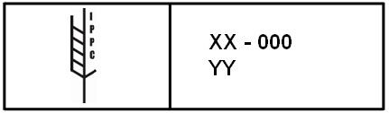

Useful links:
- Exporting Wood Packaging
http://www.daff.gov.au/biosecurity/export/wood-packaging
- Applying for certification under the Australian Wood Packaging Certification Scheme
http://www.daff.gov.au/biosecurity/export/wood-packaging/applying
- Australian Wood Packaging Certification Scheme (AWPCS) Register - List of certified treatment providers and wood packaging manufacturers
http://www.daff.gov.au/biosecurity/export/wood-packaging/awpcs-register
- The Australian Wood Packaging Certificate Scheme for Export V2.2
http://www.daff.gov.au/__data/assets/pdf_file/0005/2169923/the-australian-wood-packaging-certificate-scheme-for-export-version-2-2.pdf

Contact:
Peter Creaser
Director Grain and Seed Export Program
Plant Export Operations
peter.creaser@agriculture.gov.au

