- General information
Updated : On 09.07.2011

Overall executive summary

Introduction
The Directorate of Plant Protection Quarantine and Storage located at Faridabad, Haryana is the National Plant Protection Organization of India. It is headed by the Plant Protection Adviser to the Government of India. The Directorate is responsible for the implementation of plant protection policies and programmes of Department of Agriculture and Cooperation, Ministry of Agriculture, Government of India.

Major activities are exclusion of exotic pests, surveillance and monitoring and control of locusts, registration of pesticides and monitoring of their availability and quality, promotion of integrated pest management approach in plant protection, development of the human resources in plant protection and monitoring of pesticide residues in agricultural commodities.

Plant Quarantine
The Directorate of Plant Protection, Quarantine & Storage, Department of Agriculture & Cooperation administer the Destructive Insects & Pests Act, 1914 (2 of 1914). Plant Quarantine (Regulation of Import into India) Order 2003 issued under the said Act, and amended from time to time, regulates the imports of agricultural commodities and the wood packaging material. Being the National Plant Protection Organization, the Directorate is responsible for implementation of the phytosanitary certification programme. More than 150 plant protection specialists from all over the country have been authorized by NPPO to issue Phytosanitary certificates, in accordance with the requirements of importing countries as per IPPC (list of phytosanitary certificate issuing authorities is available at http://www.plantquarantineindia.org/pdffiles/Appendix-1.pdf). 196,678 phytosanitary certificates were issued during 2010-11 . More than 2,760 pest risk analyses have been carried out so far. A number of quarantine pests had been intercepted in the imported consignments and notifications sent to the exporting countries.

Integrated Pest Management (IPM)
IPM programme is based on crop based Farmers’ Field School approach. Seventy seven (77) IPM packages on major Agricultural/Horticultural crops have been developed. The Government of India encourages the use of bio-control agents. 318 bio-control laboratories are in operation. There is a national programme in operation for monitoring of pesticide residues in food commodities. A project on surveillance on fruit flies has been completed and the data on distribution of different species of fruit flies has been compiled for the States of U.P, Gujarat, Maharashtra & Andhra Pradesh .
A Project on National Invasive Weed Survillence (N.I.W.S) has been completed. Pest free area has been developed and notified for Brown rot (Ralstonia solanacecarum) and Ring rot (Clavibacter michijanesis) of Potato in the State of Punjab.

Pesticide Management
India is a signatory to FAO code of conduct on the distribution and use of pesticides and is implementing its provisions. The Insecticides Act, 1968 regulates the import, manufacture, sale, transport, distribution and use of pesticides with a view to prevent risk to the human beings, animals and the environment. The Central Insecticides Board set up under the Act advises the Government on all aspects relating to management of pesticides. Registration Committee constituted under the Act registers pesticides after satisfying itself regarding claims for bio-efficacy, safety and other parameters. Upto July 2011, 230 pesticides had been registered for use in India. The details of registered pesticides as well as banned pesticides are available at www.cibrc.gov.in.

The State Governments issue licenses for setting up manufacturing facilities of pesticides. There is a system for regular drawal of pesticide samples from manufacturing facilities as well as from the market and their testing in the State Pesticide Testing Laboratories (SPTLs - 68) and the Regional Pesticide Testing Laboratories (RPTLs – 2). In case of dispute in analysis, the samples are referred to the Central Insecticide Laboratory (CIL) for re-analysis.

Plant protection organisation chart

Ministry of Agriculture

Department of Agriculture and Cooperation
Directorate of Plant Protection,
Quarantine and Storage
Plant Quarantine
Central Pesticide Board & Registration Committee

Plant Protection (IPM)
Locust Control
Plant Protection Division
(PPD)
SPS-WTO, IPPC, APPC, Codex, Pesticide Monitoring, MarketAcess

Ministry of Environment and Forests
India’s focal point on Stockholm Convention and Rotterdam Convention.

Color Code:
Phytosanitation
Outbreak Management
Pest Management
Pesticides
NPPO
Organizational Chart for Plant Protection

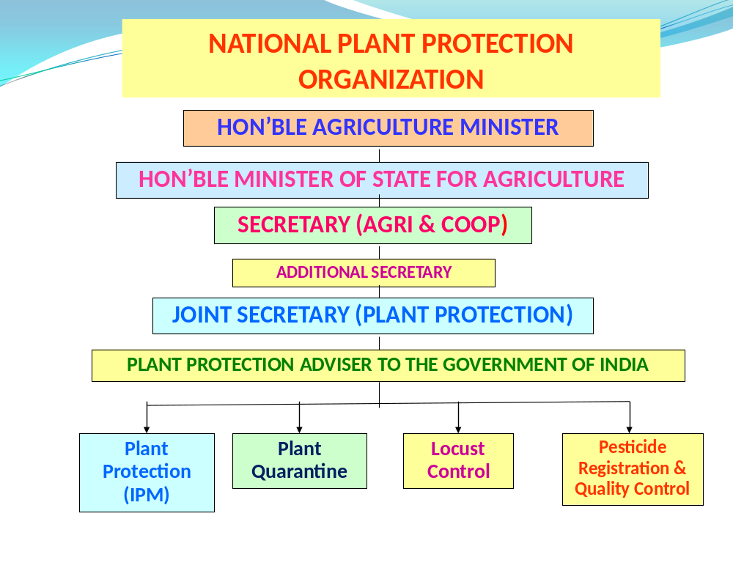

Organizational Chart for Directorate of Plant Protection, Quarantine & Storage (National Plant Protection Organization)

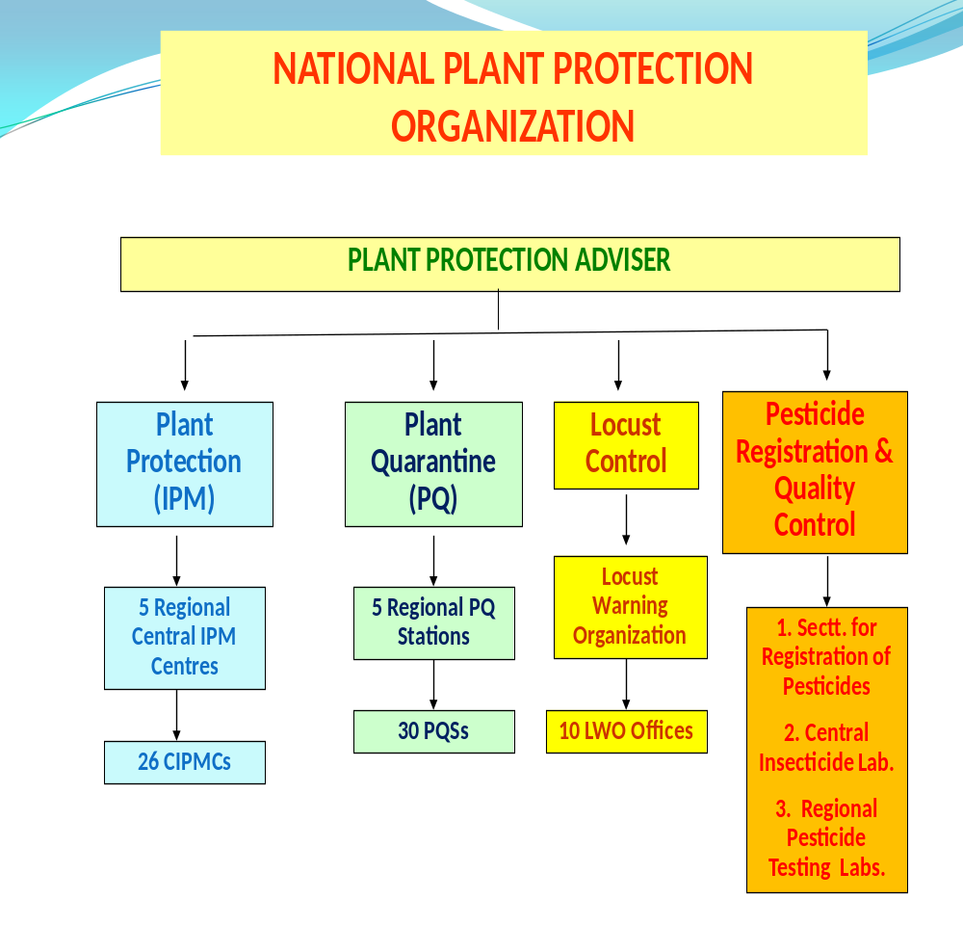
Important contact addresses

Responsible ministry/ministries
Ministry of Agriculture

Responsible department
Department of Agriculture & Cooperation

Plant protection (policy, regulations, pesticide registration, overall management)
Mr. Pankaj Kumar, Joint Secretary (Plant Protection)
Department of Agriculture & Cooperation, Ministry of Agriculture
Room no. 224, A Wing, Krishi Bhawan, Rajendra Prasad Road
New Delhi 110001, India
Tel: (+91) 11-23070306 / (+91) 11-23070916
Fax: (+91) 11-23070306
Email: pankajkumar@nic.in
Websites: http://www.ppqs.gov.in; http://www.plantquarantineindia.org/; http//www.cibrc.gov.in, http://agricoop.nic.in.

Address for nominations
Mr. Pankaj Kumar, Joint Secretary (Plant Protection)
Department of Agriculture & Cooperation, Ministry of Agriculture
Room no. 224, A Wing, Krishi Bhawan, Rajendra Prasad Road
New Delhi 110001, India
Tel: (+91) 11-23070306 / (+91) 11-23070916
Fax: (+91) 11-23070306
Email: pankajkumar@nic.in
Websites: http://www.ppqs.gov.in; http://www.plantquarantineindia.org/; http//www.cibrc.gov.in, http://agricoop.nic.in.

Operational Offices:

Plant protection
Plant quarantine
Surveillance, pest outbreaks and invasive species management
Dr. V.K. Yadava, Plant Protection Advisor
Directorate of Plant Protection, Quarantine & Storage,
N.H-IV., Faridabad – 121 001 (Haryana), India
Tel: (+91) 129-2413985; 129-2418506
Fax: (+91) 129-2412 125
Email: ppa@nic.in
Website: www.plantquarantineindia.org/ ; www.cibrc.gov.in

Pesticide registration
Registration Committee, Directorate of Plant Protection, Quarantine and Storage
Dr. S.K. Khurana, Secretary
Directorate of Plant Protection, Quarantine & Storage,
N.H-IV., Faridabad – 121 001 (Haryana), India
Email: cibsecy@nic.in
Website: http://www.cibrc.nic.in

Official international contact points

National Plant Protection Organization (NPPO) contact point (for IPPC/APPPC)
Department of Agriculture & Cooperation, Ministry of Agriculture
Mr. Pankaj Kumar, Joint Secretary (Plant Protection)
Ministry of Agriculture
Room no.224, A Wing, Krishi Bhawan,
New Delhi 110001, India
Tel/Fax: (+91) 11 23070306/23070916
Emails: pankajkumar@nic.in

WTO-SPS contact point
Department of Agriculture & Cooperation
M.r Pankaj Kumar, Joint Secretary(Plant Protection)
Ministry of Agriculture
Room no.224, A Wing, Krishi Bhawan,
New Delhi 110001, India
Tel/Fax: (+91) 11 23070306/23070916
Emails: pankajkumar@nic.in

Rotterdam Convention (PIC) DNA Pesticides (P)
Mrs. Vandana Jain,
Director (Plant Protection)
Department of Agriculture and Cooperation, Ministry of Agriculture,
Krishi Bhavan, Dr Rajendra Prasad Road
New Delhi 110 001, India
Fax: (+91) 11 23070306/23070916
Email: vandana.jain@nic.in

Stockholm Convention (POP) National Focal Point (P)
Mr Rajiv Gauba
Joint Secretary
Ministry of Environment & Forests
Paryavaran Bhavan
CGO Complex, Lodhi Road
New Delhi – 110003, India
Tel: (+91) 11 2436 0634
Fax: (+91) 11 2436 3577
Email: r.gauba@nic.in

Basel Convention Competent Authority (CA) and Focal Point

Ministry of Environment and Forests  Secretary to the Government of India  CGO Complex, Lodi Road  New Delhi 110 003, India  Tel: (+91)11 24 36 07 21 or 24 36 18 96  Fax: (+91) 11 24 36 27 46 | Hazardous Substances Management Division  Mr Rajiv Gauba, Joint Secretary  Ministry of Environment and Forests  Paryavaran Bhavan  CGO Complex, Lodi Road  New Delhi 110 003, India  Tel: (+91) 11 24 36 06 34  Fax: (+91) 11 24 36 35 77  Email: r.gauba@nic.in

Selected country statistics:
Last updated: December 2010

Agricultural Population 553 million |  | Agricultural Land 170 million ha
GDP US$ 598 966 million | Agric. GDP: 22.7 % | GDP US$ 598 966 million | Undernourishment: 20 %
Main crops grown: --

GDP= Gross Domestic Product; GNI = Gross National Income; Undernourishment = Population below minimum energy requirement
- Plant quarantine
Last updated: June 2011

Executive summary

List of key legislation/regulations/rules

1914 Destructive Insects & Pests Act
2003 Plant Quarantine Order (effective: 1.1.2004) and amendments thereto issued from time to time

Web sources for further information:
http://www.plantquarantineindia.org/law.htm;
http://agricoop.nic.in

Policies regarding plant quarantine | Yes | No | Don’t know
Does phytosanitary legislation cover domestic quarantine? | x
Does phytosanitary legislation cover import quarantine? | x
Does phytosanitary legislation cover export quarantine? |  | x
Does phytosanitary legislation cover living modified organisms? |  | x
Is plant quarantine a separate organization from animal quarantine? | x
Other policy initiatives (under review/progress)
The DIP Act is in the process of being amended but is not likely to result in altered import phytosanitary conditions.
Web source for further information:
http://www.plantquarantineindia.org/abpqo.htm

Organization of plant quarantine functions | Responsible organizational unit*  (Ministry/Department/Unit)
Pest Risk Analysis | MOA/DAC/PPD/ PPQ&S/NBPGR
National standards development | MOA/DAC/PPD/ PPQ&S/
International notifications | MOA/DAC/PPD
Import:
Import permits | MOA/DAC/PPD/PPQ&S/ NBPGR/
Import inspections | MOA/DAC/PPD/PPQ&S/NBPGR
Emergency action | MOA/DAC/PPD/PPQ&S
Export:
Phytosanitary certificates | MOA/DAC/PPD/PPQ&S/ Notified State government authorities/ ICAR/ SAUs.
Treatment of commodities | MOA/DAC/PPD/PPQ&S/ NBPGR/ Accredited agencies.

Infrastructure | Year: 2011
Number of plant quarantine officers authorized to inspect/certify | 151
Total qualified personnel for plant pest risk analysis | 120
Number of quarantine offices | 5 N/RPQS +30PQS=35
entry points (sea/air/land/mail = total) | 133
post-entry plant quarantine containment facilities | 142
other offices | -
Number of quarantine service diagnosis laboratories | 45
In-country recognized pest diagnostics capabilities
(incl. universities, etc.)
Number of laboratories for insect/mite (arthropod) samples | 42
Number of laboratories for bacteria samples | 30
Number of laboratories for virus samples | 5
Number of laboratories for fungus samples | 57
Number of laboratories for mycoplasma samples | 5
Number of laboratories for nematode samples | 4
Number of laboratories for plant/weed samples | 40
Number of laboratories for other pests (snail, slug, rodents, etc.) | 4

Pest-free areas  according to ISPM 10 | Responsible organizational unit*  (Ministry/Department/Unit)
Overall management | MOA/DAC
- surveillance | MOA/DAC/PPQ&S/ ICAR/ State Agricultural Universities
- management | MOA/DAC assisted by PPQ&S
- certification | MOA/DAC/PPQ&S/ ICAR/
List of target pest species and crops ISPM 4
Fruit fly |  | -----
Brown rot on potato, ring rot on potato |  | Punjab State
Stone weevil and pulp weevil on mango |  | Uttar Pradesh State
List of target pest species and crops ISPM 10

Key situation indicators
International trade |  | Year: 2011
Main import plant commodities | Main countries/areas of origin | Quantity (tons)
Pulses and Peas | USA/ Canada/ France/ Australia/ Myanmar | Data not available
Timber | Canada/ Malaysia/ South America/ New Zealand/ Ghana | -do-
Fresh fruits- pome/ stone/ citrus | Australia/ New Zealand, Thailand. | -do-
Main export plant commodities | Main destination countries
Mango | EC/ Japan/ Canada/ Africa/ China, USA | Data not available
Grapes | EC/ Canada/ China/ Middle East | -do-
Basmati Rice | Across the Globe – Majority of the Countries | -do-

Cooperation projects
Title (Purpose/target) | Donor | Amount | Years (start-end)
None
Title of government follow-up programmes |  | Amount | Years (start-end)

Key operation indicators
Institutional functions | Year: 2011
Number of import permits issued | 27,053
Number of import inspections carried out | 61,350
Number of emergency phytosanitary treatments taken on imports | 1,520
Number notifications of non-compliance | 137
Number of conventional phytosanitary certificates issued | 196,678
Number of electronic phytosanitary certificates issued | -

Number of quarantine pests intercepted |  |  |  |  | Year: 2011
Top three commodity |  | Top three pest/commodity |  |  | # of interceptions
Timber |  | Platypus parallebus
Almond |  | Ephestia kuehniella
Coffee beans |  | Oryzaephilus mercator
 | List of regulated pests |  | Year of last update | Insects |  | Pathogens | Plants
 | Number of quarantine pests |  | 2010-2011 | 151
 | Number of regulated non-quarantine pests |  | - | -
 | Number of regulated import articles |  | 2010-2011 | 63 (996 commodities with Import Risk Analyses - cumulative)
Web source for further information:
http://www.plantquarantineindia.org/seeds.htm#
Note: India regulates import seeds and consumption plant species, not pests

Pest risk analysis (PRA) | Insects | Pathogens | Plants
Number of PRA completed and documented (according to ISPM) | 2,760
Web source for further information:
Details are available in website- www.plantquarantineindia.org

Progress and constraints
Main progress in recent years (legislation, policies, infrastructure, investments, training, etc.)
- A new PRA based and continually updated PQ regulation has been put in effect, ie Plant Quarantine Order, 2003, since 1 July 2004.
- SPS principles and transparency requirements being met through notification of proposed phytosanitary measures.
- Uniform Phytosanitary Certification system with enhanced security features has been put into operation
- National Phytosanitary Standards, protocols and guidelines developed in a number of key phytosanitary activities.
- Emphasis on capacity building; training and human resource development through National Institute of Plant Health Management, Hyderabad.
- Accreditation system for treatment providers- both fumigators and ISPM 15 heat treatment providers.
- Modern diagnostic facilities put in place.
- Quarantine treatment facilities using VHT, irradiation and other treatments developed and accreditation/ certification systems developed for these facilities.
- Survey and surveillance programmes undertaken for development and maintenance of pest free areas.
- Pest free area notified for brown rot and ring rot on potato in Punjab.
Main constraints (personnel, infrastructure, administrative, operational, training, etc.)
- Constraints are mainly in form of staff shortage.

Implementation of ISPMs | Relevance |  |  | Implementation |  |  |  | Planned/actual year of full implementation
International measures | low | medium | high | none | partial | most | full | Planned/actual year of full implementation
ISPM 01 Principles of plant quarantine as related to international trade |  |  | X |  |  |  | X
ISPM 02 Guidelines for pest risk analysis |  |  | X |  |  |  | X
ISPM 03 Code of conduct for the import and release of exotic biological control agents |  |  | X |  |  | X
ISPM 04 Requirements for the establishment of pest free areas |  |  | X |  | X
ISPM 05 Glossary of phytosanitary terms |  |  | X |  |  |  | X
ISPM 06 Guidelines for surveillance |  |  | X |  |  | X
ISPM 07 Export certification system |  |  | X |  |  |  | X
ISPM 08 Determination of pest status in an area |  |  | X |  |  | X
ISPM 09 Guidelines for pest eradication programmes |  |  | X |  |  | X
ISPM 10 Requirements for the establishment of pest free places of production and pest free production sites |  |  | X |  |  | X
ISPM 11 Pest risk analysis for quarantine pests |  |  | X |  |  |  | X
ISPM 12 Guidelines for phytosanitary certificates |  |  | X |  |  |  | X
ISPM 13 Guidelines for the notification of noncompliance and emergency action |  |  | X |  |  |  | X
ISPM 14 The use of integrated measures in a systems approach for pest risk management |  |  | X |  |  | X
ISPM 15 Guidelines for regulating wood packaging material in international trade |  |  | X |  |  |  | X
ISPM 16 Regulated non-quarantine pests: concept and application |  |  | X |  |  | X
ISPM 17 Pest reporting |  |  | X |  |  | X
ISPM 18 Guidelines for the use of irradiation as a phytosanitary measure |  |  | X |  |  | X
ISPM 19 Guidelines on lists of regulated pests |  |  | X |  |  | X
ISPM 20 Guidelines for a phytosanitary import regulatory system |  |  | X |  |  | X
ISPM 21 Pest risk analysis for regulated non-quarantine pests |  |  | X |  |  | X
ISPM 22 Requirements for the establishment of areas of low pest prevalence |  |  | X |  | X
ISPM 23 Guidelines for inspection |  |  | X |  |  |  | X
ISPM 24 Guidelines for the determination and recognition of equivalence of phytosanitary measures |  | X |  |  | X
ISPM 25 Consignments in transit |  | X |  |  | X
ISPM 26 Establishment of pest free areas for fruit flies (Tephritidae) |  |  | X |  |  | X
ISPM 27 Diagnostic protocols for regulated pests |  |  | X |  |  | X
ISPM 28 Phytosanitary treatments for regulated pests
ISPM 29 Recognition of pest free areas and areas of low pest prevalence
ISPM 30 Establishment of areas of low pest prevalence for fruit flies (Tephritidae)
ISPM 31 Methodologies for sampling of consignments
ISPM 32 Categorization of commodities according to their pest risk
ISPM 33 Pest free potato (Solanum spp.) micropropagative material and minitubers for international trade
ISPM 34 Design and operation of post-entry quarantine stations for plants
Comments/constraints:
21 National standards on various Plant Quarantine activities have been adopted:
Details at http://www.plantquarantineindia.org/standards.htm

- Surveillance, pest outbreaks and invasive species management
Last updated: June 2011

Executive summary

List of key legislation/regulations/rules for surveillance, pest reporting and emergency actions
DIP Act 1914 and Plant Quarantine (Regulation of Import into India) Order, 2003

Web source for further information:
www.agricoop.nic.in/www.ppqs.gov.in

Policies (regarding invasive/migratory species management) | Yes | No
National strategy to control serious field pest outbreaks? | x
National strategy to control migratory or periodically occurring pests? | x
National strategy to eradicate serious newly invaded exotic pests? | x
Other policies: (e.g. subsidies, etc.): IPM/ GAP/ Survey and Surveillance Project/ NRM
Web source for further information: www.agricoop.nic.in/ www.ppqs.gov.in

Policies regarding invasive/migratory species management | Yes | No | Don’t know
National strategy to control serious field pest outbreaks? | x
National strategy to control migratory or periodically occurring pests? | x
National strategy to eradicate serious newly invaded exotic pests? | x
Other policies: (e.g. subsidies, etc.)
IPM/ GAP/ Survey and Surveillance Project/ NRM
Web source for further information:
www.agricoop.nic.in/ www.ppqs.gov.in
S

Organization of functions related to surveillance pest outbreaks and invasive species management | Responsible organizational unit*  (Ministry/Department/Unit)
Field/storage pest outbreaks | (e. g. BPH, bollworm, etc.)
Response strategy/plans | MOA/DAC/PPQ&S / CIPMC/ LWO/ State Government/ ICAR and SAUs
Surveillance | MOA/DAC/PPQ&S /CIPMC/ State Governments
Control | MOA/DAC/ State Government./PPQ&S/ LWO/ CIPMCs/ ICAR/ SAUs/ Pesticide Industry
Migratory pest outbreaks | (e.g. locusts, birds, armyworm)
Response strategy/plans | MOA/DAC/PPQ&S/Locust Warning Organization (LWO)
Surveillance | MOA/DAC/PPQ&S/LWO/CIPMC/ State Governments
Control | MOA/DAC/ State Government. / PPQ&S/ LWO/ CIPMCs/ ICAR/ SAUs/ Pesticide Industry
New exotic pest eradication | (e.g. coconut beetle)
Response strategy/plans | MOA/DAC/PPQ&S/ CIPMC/ State Government/ ICAR and SAUs
Surveillance | MOA/DAC/ PPQ&S/ CIPMC/ State Governments
Control/eradication | MOA/DAC/ State Government./ PPQ&S/ CIPMCs/ ICAR/ SAUs/ Pesticide Industry
Reporting to bilateral or international organizations | MOA/DAC/PPD

Infrastructure | Year: 2011
Number of designated staff for surveillance of field pests of national importance | > 150,000
Number of designated staff for surveillance of migratory and periodically occurring pests | 11 Locust centers and 31 CIPMCs
Number of designated staff for surveillance of invasive species | > 150,000
Number of designated staff for control of field pests of national importance | >600
Number of designated staff for control of migratory and periodically occurring pests | 11 Locust centers and 31 CIPMCs
Number of designated staff for eradication of invasive species | 76

Key situation and operation indicators
(Outbreaks and invasions in the past 2 years)
New exotic species found established in the country | Insects | Pathogens | Weeds
Total number for 2010 [most recent] Outbreak | 2
Total number for 2009 [year before] Outbreak | 1
Total number on record | 3

Eradication or internal quarantine actions taken against economically important species
Name of species
Year of first discovery
Passway
Location of first discovery
Area affected [ha]
Area treated [ha]
Control method
Expenditures

Pest outbreak actions | Outbreak 1 | Outbreak 2 | Outbreak 3
Name of species | Mealy bug | Tobacco caterpillar | BPH
Year of outbreak | 2007 | 2008 | 2008
Area affected [ha] | 297,640 | 254,828 | 112,750
Estimated damage $
Area treated by government [ha] | 238,100 | 79,497 | 46,100
Expenditures by government [$]
Control method
More information | On cotton in Punjab | on soybean in  Maharashtra | On paddy in  Haryana

Progress and constraints
Main progress in recent years (legislation, policies, infrastructure, investments, training, etc.)
Facilities and manpower in the National Institute of Plant Health Management, Hyderabad are being expanded for training. New legislation on agricultural biosecurity is under preparation.

Main constraints (personnel, infrastructure, administrative, operational, training, etc.)

IV. Pest management
Last updated: June 2011

Executive summary
.....
.....

List of key legislation/regulations/rules for pest management
Insecticides Act, 1968, Insecticides Rules, 1971

Web source for further information:
www.cibrc.gov.in

Policies regarding pest management | Yes | No | Don’t know
Do you have policies encouraging organic or low-pesticide use production | x
Is IPM specifically mentioned in laws or policy documents? | x
Do you have official Good Agricultural Practice (GAP) or any other relevant food safety (ecofood, etc.) standards for pest management? | x
Is pest management extension separate from general extension? |  | x
Other policies: (subsidies, production inputs, etc.)
- Increase in financial support for IPM
- Phasing out subsidies on chemical pesticides
- Emphasis on biocontrol agents, biopesticides and pheromones
- Phasing out, banning or restricting hazardous chemical pesticides
Web source for further information:
www.dacnet.ppin.nic.in

Organization of pest management function | Responsible organizational unit*  (Ministry/Department/Unit)
Policy development | MOA/DAC
Pest management research | MOA/DAC/ ICAR & PPQ&S/SAUs
Control recommendations | MOA/DAC/ ICAR & PPQ&S/SAUs
Pest management extension | States/ PPQ&S
IPM training | States/ PPQ&S
GAP training

Infrastructure | Year: 2011
Number of technical officers for pest management
Number of central, regional, provincial or state offices | 31 Central IPM Centres
Number of district and village level field offices
Number of field/extension agents for pest management advice
Number of field/extension agents trained in IPM-FFS facilitation | 7,213
Number of government biocontrol production/distribution facilities | 177
Number of government biopesticide production/distribution facilities | 177
Number of general extension staff involved in pest management
Number of designated plant protection technical officers for extension

Key situation and operation indicators
Pest management | Yes | No | Don’t know
Does the country have a National IPM program?  If yes, give Name and Address of IPM Programme: Strengthening and Modernisation of Pest Management Approach | x
Does the country have specific IPM extension programs?  If yes, in which crops?:  Vegetables & fruits, cereals, pulses, oilseeds, cotton, sugarcane etc. | x
Does the country have specific IPM research programs?  If yes, in which crops?:  Several crops | x
Does the country have specific GAP extension programs?  If yes, in which crops?:  Grapes, Mangoes | x
Does the country have specific GAP research programs?
If yes, in which crops?:

Market shares (estimated value, volume or area under control) | Year: 2011
Size of chemical pest control market | 43,000 MT
Size of biopesticides market | 3,000 MT
Size of biological control agents market
Major crops requiring most pesticide applications | 1st | 2nd | 3rd
Affected crop | Cotton | Paddy | Vegetables
Name(s) of pest(s)
Estimated crop loss
Affected area
Number of pesticide applications or amount of pesticide used | 40% | 17% | 13%
Government action taken

Cooperation projects
Purpose/target | Donor | Amount | Years (start-end)
Purpose/target of government follow-up programmes |  | Amount | Years (start-end)

Pest management extension | Year: 2010-11
Number of farmers trained in IPM during the year | 45,820
Number of IPM-FFS conducted during the year | 1,542
Number of farmers trained in GAP standards during the year
Area under IPM/low pesticide management [ha]
Area under organic/pesticide-free management [ha]
Crops in which IPM or other ecology friendly programmes are successfully implemented:
77 IPM packages developed
Crops grown organic/pesticide-free: --

Progress and constraints
Main progress in recent Years (legislation, policies, infrastructure, investments, training, etc.)
New legislation on regulation of pesticides under consideration.

Main constraints (personnel, infrastructure, administrative, operational, training, etc.)
Shortage of personnel

V. Pesticide management
Last updated: June 2011

Executive summary

List of key legislation/regulations/rules about pesticide management
Ministry of Agriculture Department of Agriculture & Cooperation
1968 Insecticides Act
1971 Insecticides Rules.
Ministry of Environment & Forest
1986 Environment Protection Act.
Ministry of Health & Family Welfare
2006 Food Safety & Standards Act (residue monitoring, MRLs).
Ministry of Labour
1948 Factories Act.

Web source for further information:
www.cibrc.gov.in

Policies regarding pesticide management | Yes* | No* | Don’t know
Do you have national pesticide reduction targets?  If yes, what is the target:_________ |  | x
Have you ratified the Rotterdam (PIC) Convention? | x
Have you ratified the Stockholm (POP) Convention? | x
Have your ratified the Basel Convention? (hazardous wastes) | x
Have your ratified the Montreal Protocol? (MeBr phasing-out) | x
Have you reported the observance of the Code of Conduct to FAO according to Art. 12 of the Code? | x
Have you adopted Good Laboratory Practices (GLP)? | x
Pesticide registration
Do you require pesticides to conform to relevant FAO or WHO specifications? |  | x
Do you allow the “me-too” registration and sale of generic pesticides? | x
Do you require data on product equivalence for generic registration? | x | x
Do you conduct country-specific risk assessments for…
occupational risks? | x
consumer risks? | x
environmental risks? | x
Have you adopted the Global Harmonized System (GHS) for pesticides hazards evaluation and labelling? | x
Do you accept evaluation results from other countries? | x
Do you accept field studies conducted in other countries? |  | x
Do you require environmental fate studies? | x
Incentives/disincentives
Do you have a special tax on pesticides to cover externality costs? |  | X
Do you subsidize or provide low-cost pesticides? | x
Do you subsidize or provide low-cost biopesticides? | x
Other policies:
Insecticides Act, 1968 being amended
Web source for further information:
www.cibrc.nic.in

Organization of pesticide management function | Responsible organizational unit*  (Ministry/Department/Unit)
Legislation | MOA/DAC
Registration | MOA/DAC/CIB&RC/PPQ&S
Licensing of shops | State Governments
Licensing of field applicators | State Governments
Enforcement/inspections | States, Central Task Force
Testing of pesticide efficacy | RC, IARI, PLT, ICAR,SAUs
Development of pesticide use recommendations | RC
Safe use training/extension | MOA/DAC/PPQ&S/NPPTI
Food residue monitoring | MOA/DAC/PPD & DOH
Environmental monitoring | DOC/ DBT
Health monitoring | DOH
Other Stakeholders:
Pesticide Industry Association | Crop Life India, Indian Pest Control Association, Crop Care Federation of India, Pesticides Manufacturers. & Formulators Association of India
Civil Society Organizations (NGO, etc.) | Center for Science and Environment (CSE), Voluntary Health Association of India

Infrastructure | Year: 2011
Number of registration officers | >20
Number of enforcement officers | >10,000
Number of department quality control laboratories | Central Referral – 1; Regional Labs – 2; State Labs. - 68
Number of quality control laboratory personnel | >300
Number of department residue analysis laboratories | 21 Central Govt. and State Govt. laboratories
Number of residue laboratory personnel | > 150

Key situation indicators
Pesticide trade: 2010 ^{\a} | Tons* | US$ ‘000 Value*
Imports | 29,297 | 321,680
Manufacture
Export | 96,268 | 968,226
Domestic Use/Sales | 43,000
Pesticide use profile: 2010 | Tons  (a.i./formulation to be specified) | US$ ‘000 Value
Agriculture | 43,000
Chem. Insecticides | 56%
Chem. Fungicides | 15%
Chem. Herbicides | 15%
Chem. Others:  e.g.: molluscicide, acaricide | 14%
Other
E.g. Avamectrin, Bt, Neem
Other purposes
TOTAL
\a Or for most recent year for which data are available
* if possible, give in tons a.i. ; if known, also give value in US$ or other currency.

Post registration monitoring
Testing, quality control and effects in the field | Yes | No | Don’t know
Do you have significant problems with low-quality pesticides in the market? | X
Do you have significant problems with pesticide resistance? | X
Do you have a list of pesticides under close observation for problems | x
Source for more information: www.cibrc.gov.in

Health and environmental information | Yes | No | Don’t know
Do you maintain data on pesticide poisoning cases? | X
Do you have a system to monitor pesticide residues in food? | X
Do you have a system to monitor pesticide residues in the environment? | X
Do you have significant problems of environmental contamination from pesticides? |  | X
Do you have data on pesticides effects on wildlife and ecosystems? | X
Source for more information: www.cibrc.gov.in

Pesticide disposal | Yes | No | Don’t know
Do you have system to collect and safely dispose of used containers and small quantities of left-over pesticides? | X
Do you have an inventory of outdated and obsolete pesticides in the country? (eg. banned and no longer traded, but still in storage) | X
Do you have illegal trade in pesticides?  if yes: what is the estimated amount:  Note: No estimates made, but it exists. |  |  | No estimates made
Source for more information: www.cibrc.gov.in

Key operation indicators
Registration/regulation/monitoring | Year: 2010
Registration/regulation/monitoring | a.i.* | Trade names
Number of registered pesticide products | 230
Number of registered biopesticides (Avamectrin, Bt, Neem, etc.) | 19
Number of restricted-use pesticides/formulations | 13
Number of banned pesticides | 28
Number of licensed outlets | 145,173
Number of licensed field applicators (professional and/or farmers) | >300
Number of licensing violations reported during year | 299
Number of quality control analyses conducted during year | 44,226
Number of food samples analyzed for pesticide residues during year | 9,834
Number of samples exceeding MRL | 112
Number of environmental samples analyzed for pesticide residues | 2,751
* active ingredient; **provisional registration

Pesticides restricted in recent years (2009-2010)
Year | Name of active ingredient or hazardous formulation
2009 | Nil
2010 | Nil

Pesticides banned in recent years (2009-2010)
Year | Name of active ingredient
2009 | Nil
2010 | Nil

Cooperation projects
Purpose/target | Donor | Amount | Years (start-end)
Purpose/target of government follow-up programs |  | Amount | Years (start-end)

Progress and constraints
Main progress in recent years (legislation, policies, infrastructure, investments, training, etc.)
Monitoring of pesticide residues at national level, a new national initiative has been started by the Plant Protection Division of the Ministry of Agriculture.
Main constraints (personnel, infrastructure, administrative, operational, training, etc.)
Shortage of personnel.

VI. Additional issues of interest

Genetically Modified Crops
Name of GMO Crop | Area under cultivation [ha]

