

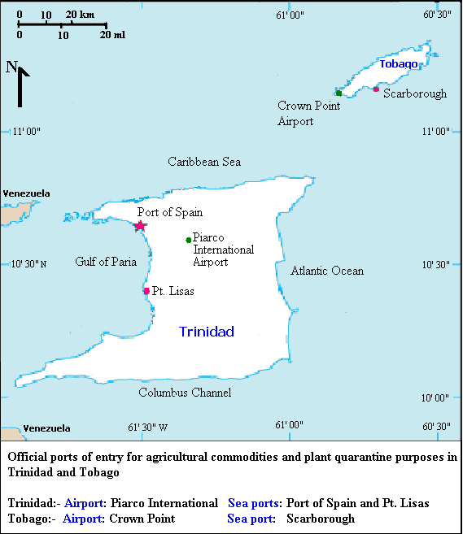

Courtesy: MINISTRY OF AGRICULTURE, LAND AND MARINE RESOURCES
Research Division, Central Experiment Station, Centeno, via Arima P.O.
Tel: 646-4334 – 7/646-1646
e-mail: minalmrdirresearch@tstt.net.tt

