NATIONAL PLANT INSPECTORATE SERVICES

Acknowledgement
We are grateful to the technical and financial support to the following; Gov. of Swaziland, International Energy Atomic Agency (IAEA). We also recognize the following partners; Swaziland Citrus Board and the University of Swaziland.

Preamble,

The Government of Swaziland recognizes the importance of Agriculture in enhancing economic growth. This has been emphasized in Swaziland Vision 2022, the National Development Strategy NDS and many others. The period under review coincided with transition to develop a system of eGovernment and had come at an opportune time when the Plant Protection Legislation is under development. In the past years, great strides have been made to educate legislature (Members of Parliament and Senates) about the Bill and thus contributed to the creation of Regional Plant Protection Posts within the regions.

The immerse contribution of NaPHis to the economy cannot be over emphasized. The Country Agricultural produce (Timber, Citrus, handcraft and Maize) is able to reach international markets due to the diligent efforts by the NaPHIs staff.

The demand for plant inspection and import certification is set to rise in the near future due to introduction of new crops (Seed Potatoe) and the higher standard measures set by the International markets. This is even more critical when one considers maize the staple crop of the country. In the past year the Crop was attacked by fall armyworm and invasive pest origination from South America. In the east Africa another devastating disease of maize has been reported in the form of Maize Lethal Necrosis Disease.

In conclusion the Government recognizes the role of NaPHIS in facilitating the trade of Fresh Fruits and vegetables, timber, Citrus and handcraft locally and internationally

Introduction

Description of the National Plant Inspectorate Services NaPHIs

The National Plant Protection Organization of Swaziland also referred to as the National Plant Health Inspectorate Service (NaPHIS) is a service under the Ministry of Agriculture. It is housed under the Specialist Services Division of the Department of Agricultural Research and Specialist Services with its main office and post entry quarantine facility at Malkerns Research Station.

NaPHIS is mandated to regulate the prevention, introduction and spread of plant pests and to facilitate trade in plants and plant products in accordance with the provisions of the relevant national legal instruments and the International Plant Protection Convention.

The function of the inspectorate includes among others inspection and certification of plants and plant products for export; inspection of imported products in order to minimize introduction of pests; carry out pest risk anlysis and issue import permits; produce and regularly update Swaziland’s pest lists including that of regulated pests; communicate with trading partner and other stakeholders on phytosanitary matters; and represent the country in bilateral, regional and international plant health forums. NaPHIS stakeholders include but not limited to producers, packers, treatment providers, transporters, processors, couriers, retailers, Government ministries and agents, academia, researchers.

Phytosanitary Services

International exchange of germplasm and trade/movement of plants and plant products is crucial in the quest for adequate food production and supply. There being need to ensure that foreign injurious pests, diseases and noxious weeds which do not exist in Kingdom of Eswatini are not introduced in the country. Initial Plant quarantine services were conducted under the Ministry of Agriculture through department of plant Pathology. In 2012,through a bill, the Plant Health and Plant Protection act of 2014, gave the establishment of the National Plant Health & Inspectorate Services was established to vigilant for the Government, business sector, scientists and farmers on all matters related to plant health and quality control of agricultural inputs and produce. Through the activities of NaPHIS, the introduction of plant pests, diseases and noxious weed into the country is prevented or delayed. All phyosanitary measures are based on international standards as in International Plant Protection Convention (IPPC) and World Trade Organisation (WTO) agreement on sanitary and phytosanitary (SPS) regulations and guidelines. The Plant Protection Act of 1981 and the suppression of weeds provide the legal framework through which the department carries out its phytosanitary regulation service.

Import of Plant & Plant Products in the kingdom of Eswatini

Procedures for Importation of Plant Materials

Importation of any form of plant material into the Kingdom of Eswatini is subjected to strict specified conditions outlined below;
- All plant importers intending to bring plant material into Kingdom of Eswatini should obtain a Plant Import Permit from NaPHIS. Plant import permit is issued after careful appraisal of the risk involved in importing the intended plants or plant product. The permit specifies the requirements for plant health, indicating prohibitions, packaging, conditions for release at the point of entry, and other additional declaration with regard to pre-shipment treatments. The original permit must reach the plant health authorities in the country of origin for strict adherence to Kingdom of Eswatini permit requirements.
- Any plant consignment arriving into Kingdom of Eswatini must be accompanied by a copy of a Plant Import Permit and a Phytosanitary Certificate which verifies that a competent authority in the exporting country examined the plant material for pests and diseases prior to their leaving the country and that the plant materials meet the country’s phytosanitary requirements.
- Plant material arriving in Kingdom of Eswatini without authority and correct accompanying documents is not allowed entry and may be destroyed or reshipped at owner's cost.
- All imported plant material must be declared to a plant inspector at any point of entry. Plant inspectors have been stationed at all major entry points into the border posts.
- Any person who contravenes or fails to comply with the regulations shall be guilty of an offence and shall be liable to a fine or imprisonment or both.

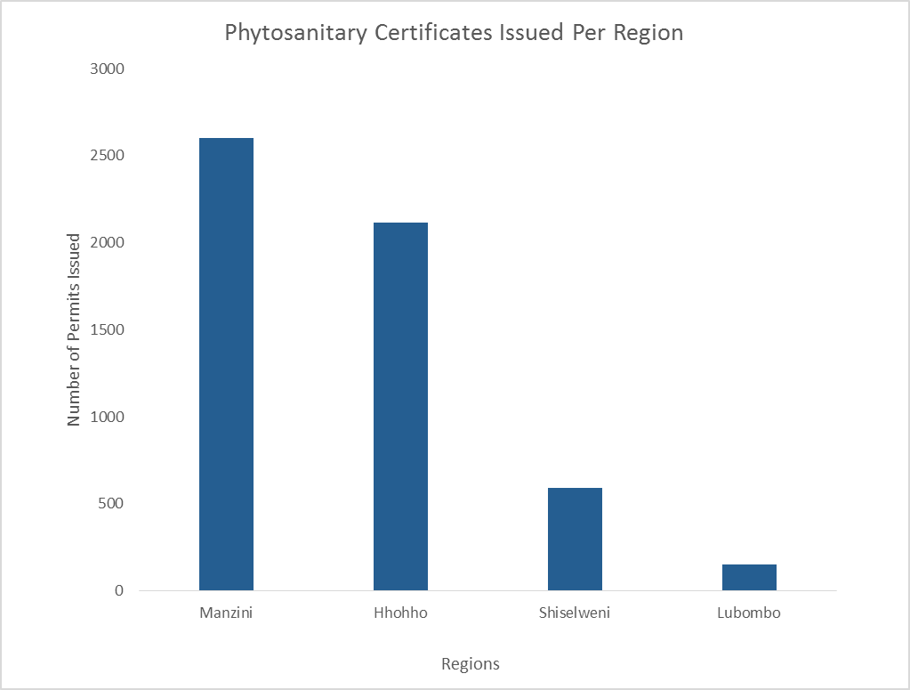

Figure 14.1: summary of import certificates issued.

Quantity and Items Imported during the year
Handcraft and grass woven product continued to be the highest commodity exported out of the country as evidence by the number if import permits issued at Manzini. However late in the year, it was observed that the continued importation, need to be reviewed. As such the Ministry of Tourism and Environmental affairs has issued a directive to the effect from 1st February 2018, all export for protected flora will need to get an export permit from the Ministry of Tourism and Environmental Affairs.

ePhyto Awareness workshop

The NaPHIS managed to host a I day ePhyto awareness workshop on the 30th May 2019 at the Ezulwini Happy valley Conference. About 80 participants were present during the workshop and were drawn from the Fruit and vegetable venders, Estate farm managers, Extension personel and information unit of the Ministry of Agriculture. The workshop was facilitated by Mr Chiluba Mwape who is an international consultant on Plant Health.

Background information on ephtyo
ePhyto” is short for electronic phytosanitary certificate. In simple terms, it is the electronic data contained in a phytosanitary certificate. The ePhyto Solution has two core structural components, the hub and the generic ePhyto national system (GeNS).
The ePhyto Hub is a centralized exchange system for ePhytos that can be used by all national plant protection organizations (NPPOs) once they are connected. The purpose of the GeNS is to allow countries, particularly developing countries without the infrastructure to produce and receive electronic phytosanitary certificates, the ability to connect to the Hub. While some countries may have their own national electronic systems, the GeNS will allow all countries without a national system to produce, send, and receive electronic phytosanitary certificates through the hub. All ePhyto’s are produced in accordance with International Standard on Phytosanitary Measures (ISPM) 12 and its Appendix 1. All ePhyto data is formatted in XML in accordance with international standards on the exchange of electronic data.

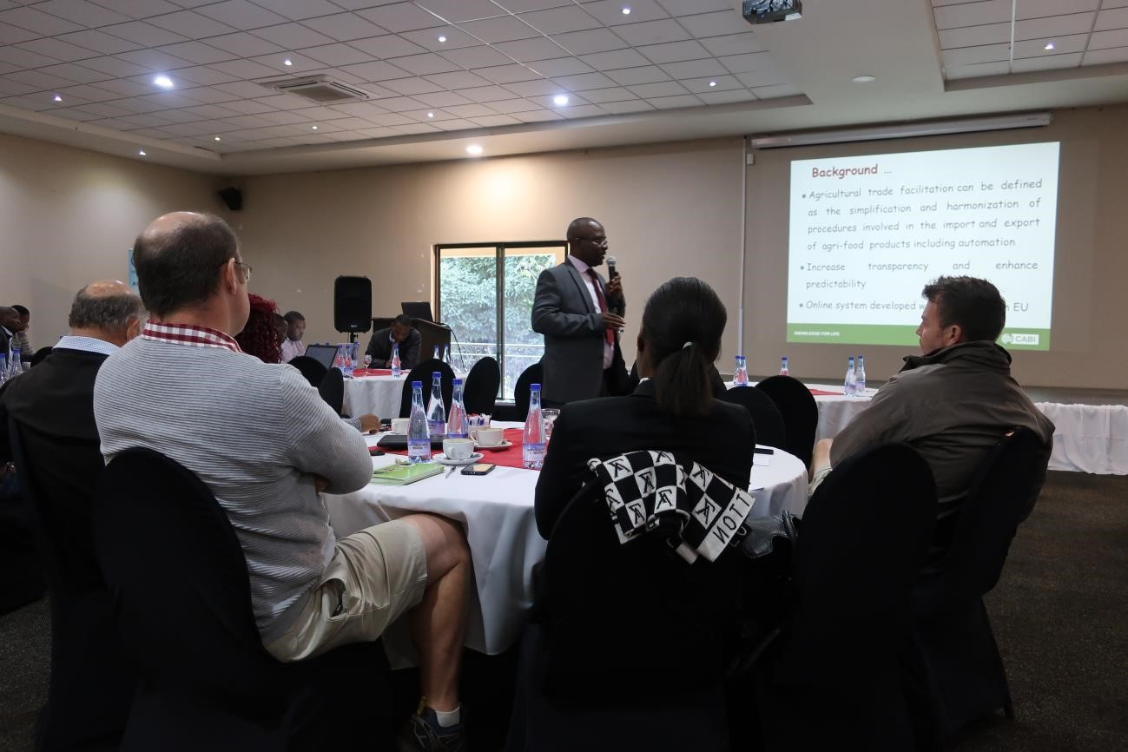
Picture 3: Mr Mwape making a presentation on Pest List and the Importance of Plant health

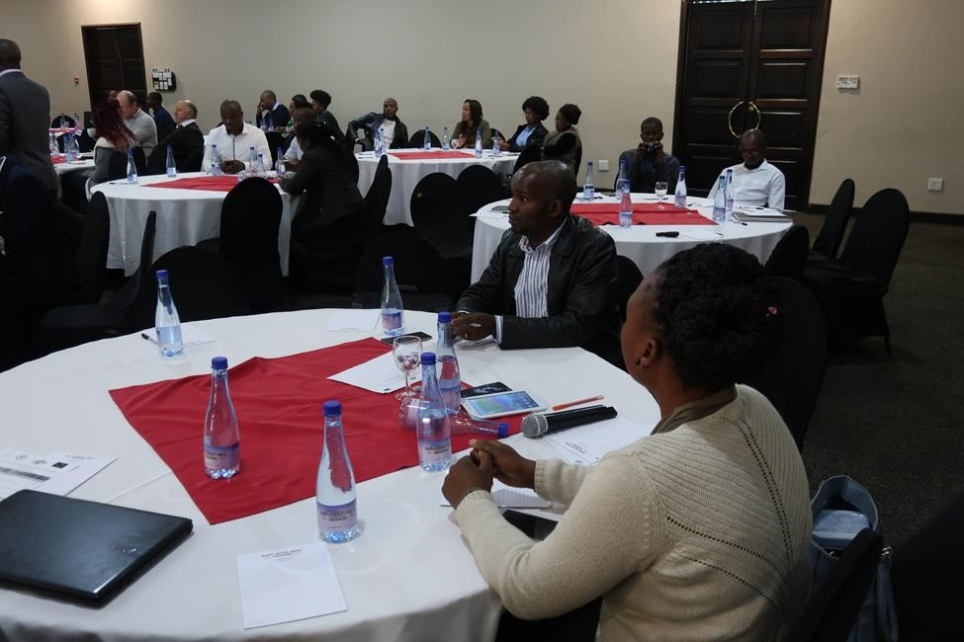

Picture 4: Participants listening attentively as the IT consultant take them through the process of applying for the import permit.

The development of the ePhyto Solution has been noted by the many stakeholders as a critical need. The Ministry of Commerce and trade through Trade Related facility project has provided funding to support development. Through this funding the Unit managed to procure, i) 5 laptops, 5 printers, 5 harddrives , a camera, and extension cables. However, the current funding is only sufficient to permit a limited operation of the Solution. Further donor funding will be required to bridge the gap between development and the operation of the ePhyto Solution. We are now soliciting the financial support from governments and/or industry associations willing to sustain the EPhyto.

Pest Risk Analysis Conducted to facilitate trade
During the period under review, the NPPO undertook PRAs to facilitate trade. The National Plant Protection Organization, (NPPO) further worked, developed a Pest Risk Analysis for Citrus fruit intended for United States of America markets. The process involves developing a dossier for the all insect pests, weeds, and diseases, mollusks, which are present in the citrus producing estates and what management strategies are in place to control them.

New tool to conduct PRA
Two Officer from NaPHIs have been trained on the CABI, invasive species Horizon Scanning Tool (beta), a decision support aid to help users identify potential invasive species threats to a country, state or province. The tool is supported by the US Department of Agriculture (USDA) and the UK Department for International Development (DFID).

The “Risk assessors, plant protection officers, quarantine officers, protected area managers and researchers will find that the invasive species Horizon Scanning Tool provides a quick and user-friendly means of accessing a large volume of relevant data for categorizing and prioritizing potential invasive species.” As such the NAPHIS team had sent names / email of seven officers with one computer IP to access this tool.

Status of the citrus PRA,

In the pest risk assessment (PRA) for importation of fresh citrus fruit, Citrus spp. (C. paradisi, C. sinensis, C. limon, C. reticulata, C. aurantifolia x C. latifolia), from eSwatini into the Continental United States, four tephritids fruit fly were listed as actionable pests. However our department felt the listing of Ceratitis coysra, is questionable hence objections on inclusion of C . coysra in the PRA. About the four references are provided for the listing of C. cosyra as an actionable pest on citrus. These references are:

- Magagula & Ntonifor 2014. Afr. Entomol. 22(2): 320-329 for evidence of presence of C. cosyra in eSwatini
- De Meyer et al. 2002. Documentation Zoologiques 27 : 1-91 for evidence of association of C. cosyra with citrus
- Mwatawala et al. 2009. Bull. Entomol. Res. 99: 629-641 for evidence of association of C. cosyra with citrus
- Norrbom et al. 2016. CoFFHI. Edition 2.0 https://coffhi.cphst.org/ for association of C.
cosyra with fruit of citrus

While evidence of the presence of C. cosyra in eSwatini, specifically in the Manzini region of eSwatini, is clearly demonstrated by trapping surveys and surveys of guava and marula carried out by Magagula & Ntonifor 2014, no clear evidence of natural host association of citrus for C. cosyra was provided in the three other references, as explained below:
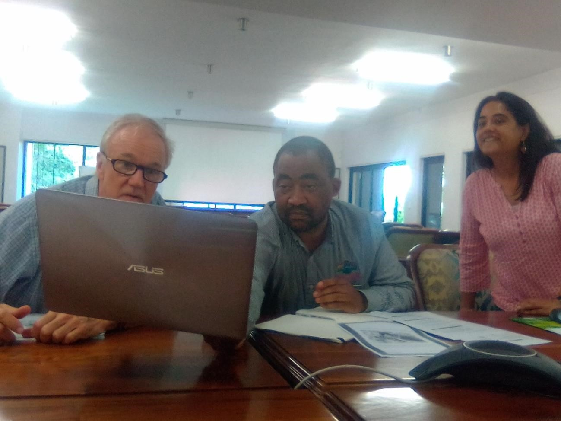

Picture: NaPHIS team in collaboration with Citrus Board, made a presentation on the host status of Ceratitis cosyra in Nelspruit. Additional points for references are indicated below.

- De Meyer et al. 2002 list 28 fruit species from which C. cosyra was reared. The fruit species under the ‘reared list’ include one species under Rutaceae: Citrus aurantium (a citrus species not subjected to this PRA). The reference provided for this record is Malio 1979 (Kenya
Entomologist’s Newsletter 19:7). De Meyer et al. 2002 categorises this record as ‘C’. The authors define ‘category C’ as a record that could not be verified and for which the identification might be questionable. De Meyer et al. 2002 also lists Citrus sp. under the ‘Associations list’. The authors define ‘associations’ as records based on causal observations of a fly on a particular plant or collection with lure traps. Since the record of C. cosyra reared from C. aurantium is questionable and there is no natural host association of C. cosyra on citrus species, host status of citrus for C. cosyra cannot be established by De Meyer et al. 2002.

- In Mwatawala et al. 2009, although C. cosyra was listed as one of the species along with three other fruit fly species reared from Citrus sinensis (sweet orange) in Morogoro, Tanzania, the origin of the sweet orange samples (ground or tree; orchard condition) and the condition of the fruit samples (damaged/undamaged) were not specified. The omission of
these details render the record of Mwatawala et al. 2009 unreliable with regard to the association of C. cosyra with citrus. In previous fruit sampling surveys by Mwatawala et al. 2006 (J. Appl. Entomol. 130: 530-537) in the same Morogoro region, there were no records of C. cosyra from citrus sampled.

The reference cited for association of fruit of citrus with C. cosyra: Norrbom et al. 2016, is a fruit fly host database (CoFFHI) with restricted access. While the database could not be accessed, information contained in the Edition 2.0 database was provided by McQuate & Liquido 2017 (in Int. J. Plant. Biol. Res. 5(4) 1072). According to McQuate & Liquido 2017, CoFFHI provides host information for only 11 fruit fly species which includes Ceratitis capitata as the only species under the Ceratitis genus. Ceratitis cosyra is not among the 11 fruit fly species listed in this database. The reference of Norrbom et al. 2016 for the association of fruit of citrus with C. coysra is therefore incorrect.

Surveillance for major pests

The Department in collaboration with USDA-APHIS managed to develop a project on fall armyworm, titled;
Project Title: Enhancing National Capacity in Fall Armyworm (Spodoptera frugiperda) , tomatoe leaf miner, Tuta Absoluta And fruit fly Bactrocera Dorsalis Management & Early warning system development in the kingdom of Eswatini.

Project summary
Participating Rural Development Areas
The project / trial will be implemented in the three RDA in Lubombo namely Sithobelweni, KaLanga and Shewula. In Shiselweni, the project will be implemented in all Matsanjeni, Kubuta and Somntongo. In the Northern Hhohho the project was implemented at Mayiwane, Madlangempisi and Mhlangatane. The management aspect of these pests will include awareness Introduction

General introduction
Maize is the most important food crop in the kingdom of Eswatini, it is grown on 41% of the country’s arable land (Ministry of Agriculture, 2016), accounts for 54% of the caloric intake of households (Minot, 2010) and is predominantly grown by smallholder farmers (Ngwira, et. al., 1991).In the kingdom Maize is the second most important staple food sugar cane, along with cotton, beans and sorghum. However, the productivity is low since smallholders, who dominate maize production, rely on hand hoes and rain-fed agriculture, with limited access to inputs and technology (Tostão et al., 2010). The average farm size is less than 1.5 hectare, and production is currently estimated to be around 2 tonnes per hectare. In this respect, increasing maize production and productivity would not only contribute to reducing poverty and hunger in rural areas; it would also help to reduce import bills through import substitution (Dias, 2013).
In the 2016/2017 growing season, the maize crop in the country (as well as other southern African countries) has been hit by an unprecedented invasion by fall armyworms (Spodoptera frugiperda). Fall armyworms are larvae of some nocturnal moths, and they originate from Central and South America. They destroy maize by feeding on leaves and ears. At the moment, it is estimated that the pest is present in all the maize producing rural development areas Both the rice and the maize strains are known to have invaded the country. Infestation of as high as 90% has been recorded in most parts of the country. Due to the high damage caused by the pest, over 68,000 hectares required replanting. Efforts to control the pest in all the regions for the past seasons have been mostly dependent on synthetic insecticides, but the results achieved have not been satisfactory.
The fall armyworm is very versatile, polyphagous, voracious, highly prolific, strong at flying and does not normally undergo diapause such that when it gets into an area, it easily becomes an established and very serious problem if not properly managed (De Almeida Sarmentoet al., 2002; Capinera, 2014).Since efforts to manage the pest in the country in the just-ended rainy season have not been satisfactory, there is fear is that the pest may be on its way to become an established and more serious threat to maize production and food security in the three countries. For this reason, it is important that the country coordinate and step up research and management efforts against this pest. It is with this background that this proposal has been developed. Objectives

General
The general objective of this project is to enhance the capacity of farmers, extension officers in trans boundary pests management & early warning systems.

Methodology
The project was designed to build from on on-going / previous work.This project will build on the work already being done on Fall armyworm, Tuta absoluta a and Bactrocera dorsalis - surveillance and monitoring - which aims to prevent or manage the pests in the region. The progress is reported in action plans below;

A. Action Plan Component 1: Transboundary Pests Prevalence & Monitoring

The current situation is that through the, the 2018 Vulnerability Asssessment results in the 2017/2018 planting season revealed that these pests has spread across all the four agro ecological zones and administrative regions. About 67.30% of households were affected by the fall army worm, the highest percentage of the pest detected was in the Hhohho region followed by Lubombo region. The plans for the season 2018/19 include dstrengthening of field monitoring through ,i) distribution of additional traps boxes, ii) Conducting Fall armyworm (FAW) awareness sessions at community level ,iii) Training of additional Extension officers on monitoring of FAW through conducting Crop Watch training for extension staff (Gov, NGOs, parastatals, and private sector).

B. Action plan Component 2: Monitoring & evaluation

Through this training, delivery of an early warning systems will be assured as;Following training for the extension staff to build their capacity on CROP WATCH, there unit will be FAW monitoring by the trained staff. To ensure accurate data collection to inform on the on ground situation and as part of monitoring, Android phones shall be procured for use by the data collection team. These will require being loaded with airtime/data. The officers will be further required to periodically upload data as per the guidance from the Nation training Officer. Additional extension staff shall also be capacitated on FAW especially those engaged under NMC. The (FAW) Technical Working Group shall be instrumental in supporting this initiative in collaboration with other stakeholders. As part of awareness creation, FAW information sheets were multiplied and then be distributed through the respective Rural Development Areas (17 in total) countrywide. The latest FAW materials from the region shall be collated and used for this exercise

C. Action Component 3: FAW Risk Mapping / Hot spots.

There is currently no FAW Risk Map or hot spots for Eswatini hence the unit is appreciative for getting a training that entails developing hot spots. Such maps will be shared with decision makers in relation to food security in the country. Future plans include; Training extensions officers on how to interpret/ use the map through workshop; Data collection or data gathering to build the food security index creation and setting up of early warning systems through development of crop watch software systems.

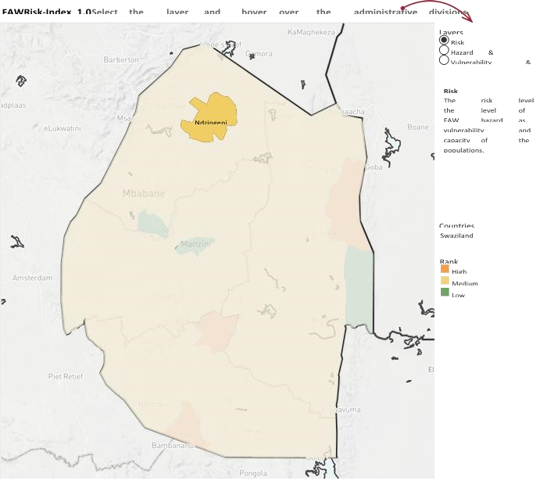
Figure above shows the FAW risk index as of 15th January 2019. In the above figure only Ndzingeni traps had enough tresholds to warrant a high risk areas.

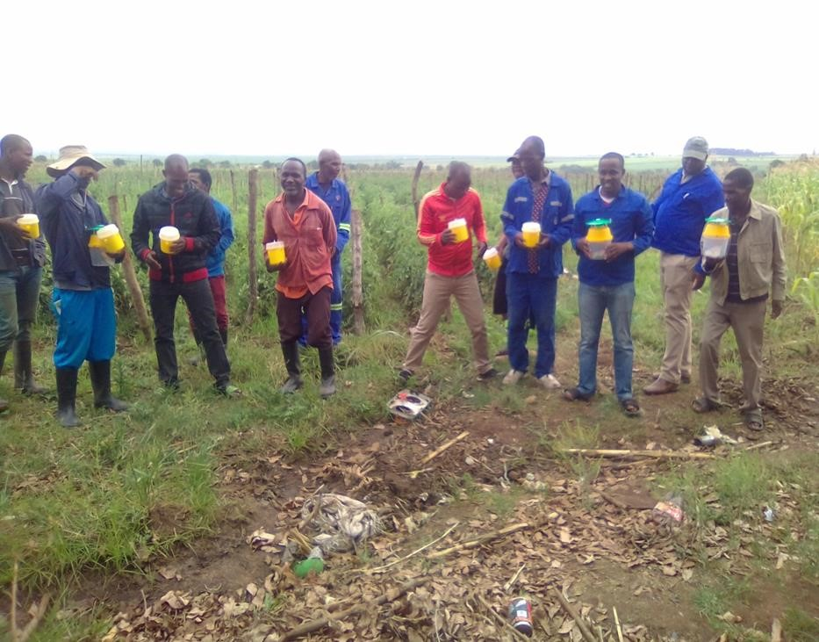
Picture taken from Vuvulane irrigated farms, date 28 October 2018.
Results & Discussions:

Summary
The NPPO managed to bring the pest population to almost negligible levels. This was even evident by the lack or no pest reports from the extension officers or farmers during the season. With regards to pesticides, we observed that there will be a need for more robust enforcement mechanisms of regulatory policy to be put in place. Influx of generic pesticides and the lack of farmer – level monitoring of pesticide use may lead to pest resistance as well as environmental pollution.
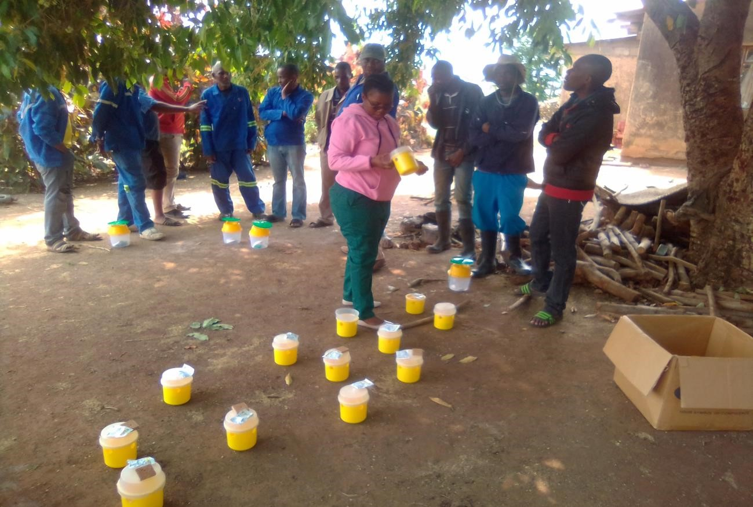

2.0 False Codling Moth
The false Codling moth (FCM) is another pest that will be under close surveillance. The EU has issued a directive on the management of this pest.

Description of the pest
The FCM, Thaumatotibia leucotreata, Tortricidae is a major pest of Citrus and other commercial crops. It attacks fruits at all stages of development. If the attacks occurs early the fruit may ripen prematurely. Amongst the fruit the pest attacks maize, tomatoes, and cotton. The moths of this pest have a similar appearance and characteristics. The wings are patterned with greys, light browns, creams blacks and orange brown and have a span of 1.5cm to 2cm. The adults which seldom ventured away from place of birth are nocturnal.

The NaPHIs in Collaboration with Citrus Research Institute has developed /adopted a management guidelines which shall be used in the upcoming season , FCM control guidelines for the new season .The False Codling Moth Risk Management System (FMS) was implemented for the first time during the 2017/18 season, with resounding success. However, we were fortunate that this coincided with a low-pressure FCM year, which greatly assisted with effective suppression of the pest. This creates a unique opportunity to prevent the populations from again increasing in the next and future production seasons. Therefore, it is strongly recommended that growers initiate FCM control measures early and without compromise in the 2018/19 season. The obviously best approach to FCM control is population suppression, not just fruit protection. Population suppression is most effective when pest levels are at their lowest, thus preventing them from increasing. We therefore now have a golden opportunity to effectively suppress FCM populations, while they are at a very low level and before they have a chance of increasing. Traditionally, FCM management practices have not been initiated earlier than November. However, in the cooler Northen Regions (Tunzini) the first flight peak of the season has been recorded in October, whereas in the warmer Tambuti) regions, this is in all likelihood even earlier. If one has subscribed to the sterile insect release (SIT) programme, then releases would have been initiated in the first week of September. The other effective alternative for population suppression is mating disruption, which should be initiated before the first flight peak of the season. Trials conducted years ago, demonstrated that initiation of mating disruption in October, as opposed to November, could reduce FCM infestation of fruit by a further 57%. Mating disruption could be initiated even earlier in the northern regions. Similarly, spray trials conducted a few years ago with granulovirus products, demonstrated that targeting the first flight peak in October rather than the second one in November/December, could improve FCM control by up to 43%. Consequently, the following practices are highly recommended: Immediately after harvesting in an orchard is completed, ALL fruit remaining in the orchard (hanging and on the orchard floor) MUST be removed and destroyed. This will remove the bridge for FCM to transfer from one season to the next. Prune trees thoroughly in order to maximize the opportunity for optimal spray coverage and penetration during the course of the following season. If SIT is not being used, initiate mating disruption before the first flight peak of the season, which occurs during October in the earlier in the northern regions. A granulovirus spray applied after the spring FCM flight peak can significantly improve FCM control, relative to only initiating such sprays after the November/December flight peak.

Fruit fly, Bactrocera dorsalis
The NaPHIs is currently implementing a collaborative project, titled ‘Strenghthening Exotic and Invasive fruit fly Surveillance with Sterile Insect technique) with other suppression Methods’. The project is funded by the International Atomic Energy Agency (IAEA) to the tune of EU, Euros 480,000.00. The project is aimed at improving fruit fly suppression as such the second batch of equipment and pheromone lures were procured on November 2018.

This project is part of million multi-institution ’SIT’ collaboration that aims to develop a detailed understanding of Bactrocera dorsalis biology as a foundation for effective, environmentally benign and sustainable management practises to combat this major pest, and especially to develop the Sterile Insect Technique (SIT) which shall be rolled later in the project phase . In SIT, millions of sterile male flies are mass-reared and released to disrupt reproduction of wild populations by inducing reproductive failure. Ecological and sexual performance of released flies is key to the success of SIT.

In addition, through Collaboration with UNISWA, a study On Predators and Parasitoids to investigate the potential of an egg parasitoid F. arisanus and a larval parasitoid, D. kraussii to be used in an augmentative biological control program and to complement the sterile insect technique (SIT) is implemented. The study will address key areas of parasitoid biology, behaviour and ecology that will assist us implementing an augmentative biological control program. First, we will determine the floral nectar preferences of F. arisanus and D. kraussii. Knowledge in this area is key in order to sustain parasitoids in the release environment. Secondly, in order to utilise parasitoids effectively in release programs for control of fruit fly, we need to understand their spatial ecology including response to landscape composition and connectivity and the effects of host distribution (including non- Oriental fruit fly hosts). This will aid in the selection of appropriate parasitoid species for differing environments and determine how Ofly populations might most effectively be augmented by inundative biological control. Finally, using the knowledge learned both within this project, and other complementary work occurring, trials will determine the benefits of the combined use of parasitoids and sterile flies to either technique alone. This will allow for informed decisions to be made regarding the release of fruit fly parasitoids in augmentative release programs. The study is implemented in the Northen Hhohho where B. dorsalis is prevalent.

Collaborating partners in this are; NaPHIs, UNISWA Biological Sciences, and
Farmers.

Citrus black spot

Introduction

Citrus black spot (CBS), caused by the fungal pathogen Guignardia citricarpa Kiely (anamorph Phyllosticta citricarpa (McAlpine) Van der Aa), is a foliar and fruit spotting disease of almost all commercially cultivated Citrus spp. excepting sour orange (Citrus aurantium), tahitian lime
(Citrus latifolia) and their hybrids. CBS has been present in South Africa since 1895 and is an economically important disease affecting subtropical citrus production areas. Affected fruits are disfigured by cosmetic lesions on the fruit rind, making them unacceptable for local and overseas fresh fruit markets.

The accurate diagnosis of citrus black spot on citrus fruit and leaves is difficult. Another related fungus Guignardia mangiferae is usually present on citrus rind, and is a harmless endophyte. The discrimination of G. mangiferae and G. citricarpa by morphological and cultural characters is near impossible, even for experienced taxonomists. They can be separated using some cultural characteristics – for instance the rate of growth on specialised media (G. mangiferae grows much more quickly). However isolating pure cultures is time consuming and, in the case of G. citricarpa, many other pathogens present in CBS-like lesions will out-grow G. citricarpa. The success rate for culturing is very low.

In addition to the use of molecular tools in identification, the unit developed or updated a Citrus Black Spot Spray Programme to include options for exports intended to South Korea, and cautionary notice for citrus orchards harvested during October 2018.

Citrus growers were notified about changes in the Maximum residues level MRL tolerarnce for carbendazim and dithiocarbamates (Manzozeb and maneb) on fruits destined for South korea markets. The recommendation suggested that carbendazim cannot be applied after /later that 90 % petal fall on citrus types that may be exported to the Korea.

In case of dithiocarbamates (mancozeb) the MRL has been reduced to 0.01 ppm on all citrus types. A further restriction is that they may not be applied later than end of December. In terms of CBS control this means that Mancozeb must be replaced by an alternative five weeks later especially copper fungicides giving a 5 week protection.

A cautionary note is that orchards with late Valencia were observed to be still harvested in mid- October and destined for the Eu. If this occurs, it results in the exports not meeting the requirements for CBS control in terms of start of spray programmes and it is recommended that such orchards are not registered for the export to the EU.

